Edge Marketplace March 2024

Table of Contents
Edge Marketplace Overview 1
Marketplace - Browse Edge Integrations 2
Marketplace - View Edge Integration Details 5
Edge Marketplace - Getting Started with an Integration 8
Edge Marketplace Informational Tile 11

Edge Marketplace Overview

Marketplace - Browse Edge Integrations
The Edge Marketplace enables administrators to conveniently browse and discover all available integrations.
Organizations may use connectors, which are packaged APIs, to integrate your vendor's system with Cornerstone.
- See Connectors - Tools for Developers.
- How do I use a connector to build an integration with Cornerstone?
To browse all available integrations, go to Admin > Tools > Edge > Marketplace. The Marketplace opens in a new browser tab.
When using any of the Edge services, such as Marketplace or Integrations, administrators can navigate between the services by clicking the Menu icon in the upper-right corner of the page and selecting the desired service:
- Marketplace - See Marketplace - Browse Edge Integrations on page 2 for additional information.
- Integrations - See Integrations - Configure My Edge Integrations.
Permissions
PERMISSION NAME | PERMISSION DESCRIPTION | CATEGORY

Edge Marketplace - Manage | Grants access to the Marketplace service for Edge Integrate, where the administrator can browse integrations that can be used to extend the Cornerstone system. This permission cannot be constrained. This is an administrator permission. | Edge
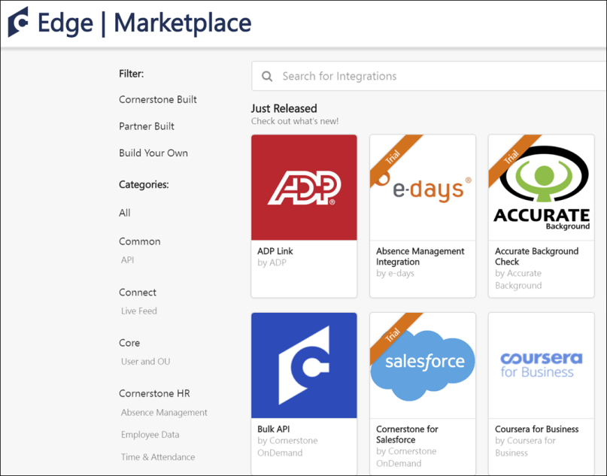
Filter by Type
Several types of integrations are available for the Cornerstone system:
- Cornerstone Built - This option displays integrations that are built by Cornerstone.
- Partner Built - This option displays integrations that are built by Cornerstone partners using Cornerstone connectors and APIs.
- Build Your Own - This option displays APIs and Connectors that your organization can use to build custom integrations.
By default, the Marketplace displays all available integrations. This includes integrations that cannot be purchased directly from Cornerstone.
To filter the integrations to only display a specific type of integration, select the appropriate type. When multiple filters are selected, the page displays integrations that match any of the selected filters.
To remove a type filter that you have selected, select the Remove icon to the right of the selected filter.
Filter by Category
By default, the Marketplace displays all of the available integrations. This includes integrations from all of Cornerstone's solutions.
To filter the integrations to only display integrations from a specific category, such as Virtual Classroom or Job Posting, select the appropriate category. When multiple filters are selected, the page displays integrations that match any of the selected filters.
To remove a category filter that you have selected, select the Remove icon to the right of the selected filter. To remove all selected category filters, click the All link at the top of the Categories section.
Purchased/Trial
If the integration has been purchased, or if an integration with a non-zero price has been enabled in a non-Production portal, a Purchased or Trial banner is displayed on the integration tile. Note: Integrations can be enabled in non-Production portals for no cost. To use integrations with a non-zero price in Production portals, it is necessary to purchase the integration by contacting your Account Manager.
View Integration Details
To view a brief overview of an integration, hover the computer cursor over the integration tile.
To view the details of an integration, select the integration tile. This opens the Integration Details page, which displays all of the details of the integration.

Marketplace - View Edge Integration Details
The Integration Details page displays information about the integration, including information about the vendor and an overview of the functionality provided by the integration.
To view the details of an Edge integration, go to Admin > Tools > Edge > Marketplace. Then from the Marketplace page, select the appropriate Edge integration.
When using any of the Edge services, such as Marketplace or Integrations, administrators can navigate between the services by clicking the Menu icon in the upper-right corner of the page and selecting the desired service:
- Marketplace - See Marketplace - Browse Edge Integrations on page 2 for additional information.
- Integrations - See Integrations - Configure My Edge Integrations.
Permissions
PERMISSION NAME | PERMISSION DESCRIPTION | CATEGORY

Edge Marketplace - Manage | Grants access to the Marketplace service for Edge Integrate, where the administrator can browse integrations that can be used to extend the Cornerstone system. This permission cannot be constrained. This is an administrator permission. | Edge
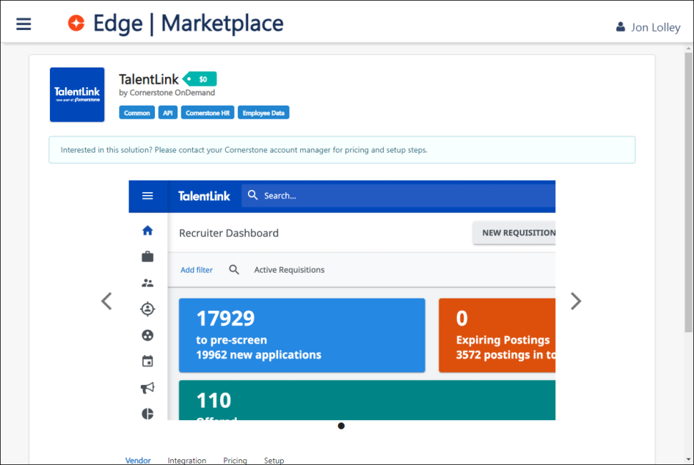
Integration Header
At the top of the page, an overview of the integration is displayed, including the following information:
- Title
- Price
- Vendor associated with the integration
- Categories
Purchase or Try an Integration
Depending on the environment from which the Marketplace is accessed (i.e., Pilot, Stage, Production) and the type of integration, administrators may be able to try the integration.
Customers must contact their Account Managers to purchase or install an integration in a Production environment, This applies to all integrations, regardless of whether they have a cost.
Customers can self-enable integrations in Pilot and Stage environments.
After an integration is purchased or enabled, administrators must then configure the integration.
Integration Preview
A preview of the integration is displayed below the Integration Header. This preview displays sample images of how the integration will be used within the system. Select the Arrow icons to the left or right of the preview image to view additional images.
Integration Details
In depth information about the integration is displayed below the Integration Preview. The Integration Details are separated into four sections. To view a different section, select the appropriate tab. The following sections are available:
- Vendor - This section provides general information about the vendor with which the Cornerstone system is integrating. Additional resources may be provided at the bottom of the page.
- Integration - This section provides an overview of the functionality that is added with the integration.
- Pricing - This section provides the cost of the integration and frequently asked questions related to purchasing or trying the integration.
- Setup - This section provides an overview of what is required to configure and utilize the integration.

Edge Marketplace - Getting Started with an Integration
On the Getting Started tab for an Edge integration, administrators have access to the following help resources, if available for the specific integration:
- Instructional video
- Setup instructions
- Step-by-step guide
To access the Getting Started tab for an integration, go to: Admin > Tools > Edge and click the Edge Marketplace link. Then, click on an integration and click the Getting Started tab for that integration.
Permissions
PERMISSION NAME | PERMISSION DESCRIPTION | CATEGORY

Edge Marketplace - Manage | Grants access to the Marketplace service for Edge Integrate, where the administrator can browse integrations that can be used to extend the Cornerstone system. This permission cannot be constrained. This is an administrator permission. | Edge
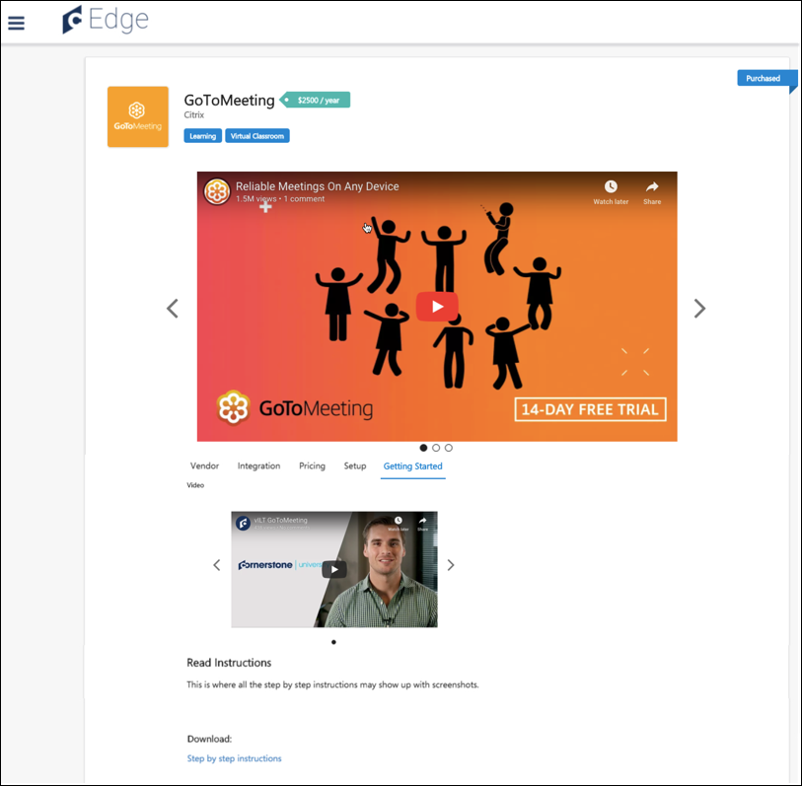
See Video
If available, an instructional video displays in the See Video section. Click the video preview to play the video. If no video is available for the integration, this section does not display.
Read Instructions
If available, setup instructions with related screen shots display in the Read Instructions section. These instructions describe how to configure and use the integration. If no instructions are available for the integration, this section does not display.
Download
To download a step-by-step guide for using the integration, click the Step by step instructions link in the Download section. A pdf document with step-by-step instructions and screen shot images will begin downloading.

Edge Marketplace Informational Tile
Edge Marketplace supports informational tiles, which provide info about an integration built by a Cornerstone partner but cannot be installed by the client. Informational tiles allow customers to learn more about the integration as well as enable customers to express interest to a partner about the integration. Installation and enablement of the integration will be handled directly by the partner who built the integration.
Upon opening the informational tile, the customer will see a Get Started button in the upper-right corner. After filling out the form, the information will be sent to the partner contact, who will be responsible for following up with the customer.
Support is the responsibility of the partner and will not be handled through the Global Customer Support team.

