Edge Import Loads March 2024

Table of Contents
Edge Import 1
Edge Import Homepage 2
Edge Import - Load and Feed Types 6
Edge Import - Capabilities Loads - Overview 7
Edge Import - Compensation Loads Overview 9
Edge Import - Employee Loads and Feeds - Overview 13
Edge Import - Group Loads and Feeds - Overview 18
Edge Import - Learning Loads and Feeds - Overview 20
Edge Import - Organizational Unit (OU) Loads and Feeds - Overview 93
Edge Import - Performance Loads Overview 96
Edge Import - Recruiting Loads Overview 100
Edge Import Configurations Overview 103
Edge Import - Manage Data Load Configurations 104
Edge Import - Create Data Import Configuration 106
Edge Import - Configuration Details Page 111
Edge Import Loads Overview 113
Edge Import - Manage Data Loads 114
Edge Import - Create or Edit Data Load 116
Edge Import - Cancel Load 123
Edge Import Feeds Overview 125
Edge Import - Manage Data Feeds and Settings 126
Edge Import - Create Data Feed 128
Edge Import - Data Feed Runs 134
Data Feeds - Inbound vs. Outbound 136
Key Management - Manage Keys 137
Key Management - Manage Report Encryption Keys 139
Edge Import - Data Load Wizard (DLW) Migration Tool - Overview 141
Data Load Wizard (DLW) Migration Tool - Templates 143
Data Load Wizard (DLW) Migration Tool - Feeds 146
Data Load Wizard (DLW) Migration Tool - Disable DLW 149
Edge Import - Restrict Download Report 151

Edge Import
Edge Import is a robust, intuitive data load tool that enables customers to manage their data loads in a self-service manner. With Edge Import, customers have the ability to map, validate and load data into their Cornerstone application using flat files. Customers can also set up data feeds to automatically load these flat files such as employee or transcript data from an external system into the Cornerstone application.
Frequently Asked Questions (FAQs)
Select this link to access Frequently Asked Questions related to Edge Import in the Knowledge Central.

Edge Import Homepage
The Edge Import Homepage is the central hub for administrators using Edge Import. From this page, administrators can configure their organization's import options and data mappings, initiate a data load, view recent data loads, and view data mapping configurations. Administrators can also access a data template guide to help get started or download a PGP key to encrypt their data load files.
To access the Edge Import Homepage, go to Admin > Tools > Edge > Imports and Feeds.
Permissions
PERMISSION NAME | PERMISSION DESCRIPTION | CATEGORY

Access Edge Import | Grants access to the Edge Import tool, which enables administrators to load data into their portal. This permission cannot be constrained. This is an administrator permission. | Edge Import

Set up Feed | Enables administrator to access the Feed Settings page where the administrator can create and update feeds and schedule feeds. This permission does not grant the ability to activate feeds or manually run feeds. This permission cannot be constrained. This is an administrator permission. | Edge Import
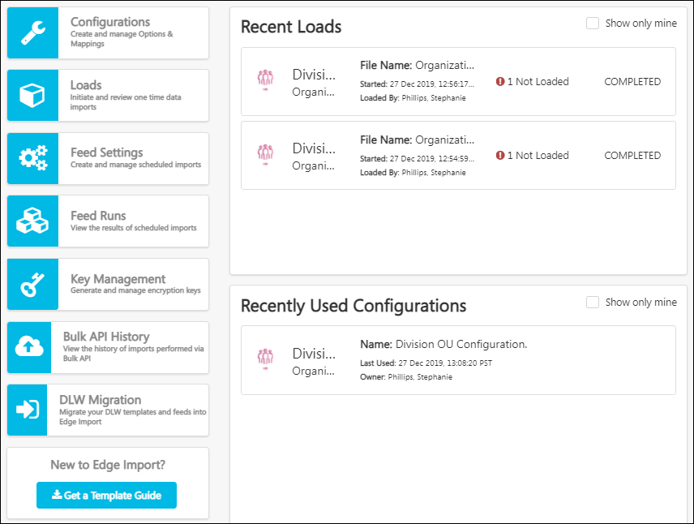
Configurations
A configuration is a template that describes the data you want to import and how the system should interpret, validate, and import the data.
Create Configuration
To create and manage your data load configurations, select the Configurations button. See Edge Import - Manage Data Load Configurations on page 104 for additional information.
Recently Used Configurations
The Recently Used Configurations section displays your organization's most recently used data load configurations. The following information is displayed for each configuration:
- Category and Type - This displays the category and type that is associated with the configuration.
- Name - This displays the name that was provided when the configuration was created.
- Last Used - This displays the last time the configuration was used in a data load. Date and time are displayed in UTC timezone.
- Owner - This displays the name of the user who created the configuration.
Select the data load configuration to view the Configuration Details page. See Edge Import - Configuration Details Page on page 111 for additional information.
Select the Show only mine option to view only data load configurations that you created.
Loads
To create and manage your data loads, select the Loads button. See Edge Import - Manage Data Loads on page 114 for additional information.
The Recent Loads section displays your organization's most recent data loads or validations. The following information is displayed for each load:
- Category and Type - This displays the category and type that is associated with the load.
- File Name - This displays the name of the file that was loaded or validated.
- Started - This displays the date and time at which the data load began.
- Loaded By - This displays the name of the user who initiated the data load.
- Load Results - This displays the results of the data load. For example, if some records were not valid, then the number of invalid records is displayed. If all records were loaded without warnings, then All Successful is displayed.
- Load Status - This displays the processing status of the data load, such as Queued, Loading, or Completed.
Select the data load to view the Load Details page. See Edge Import - Create or Edit Data Load on page 116 for additional information.
Select the Show only mine option to view only data loads that you initiated.
Feeds
A data feed is a way for organizations to automatically load data such as user or transcript data from an external system into the Cornerstone system. For example, if an organization maintains their user data base in an external system, they can configure a data feed to regularly load any new or modified user records into their Cornerstone system.
Feed Settings
To create and manage your data feeds, select the Feed Settings button.
Feed Runs
To view all previous data feed runs, including the details of each feed run, select the Feed Runs button. See Edge Import - Data Feed Runs on page 134 for additional information.
Recent Feed Runs
The Recent Feed Runs section displays your organization's most recently processed data feeds.
Select the Show only mine option to view only data feeds that you created.
Key Management
When importing files with sensitive data, organizations prefer to encrypt the import file, and Cornerstone provides Pretty Good Privacy (PGP) for encryption.
Select the Key Management button to access the Manage Keys page, which enables administrators to create and download PGP keys that are used to encrypt their import files before using them in Edge Import. In addition, administrators can clearly view the expiry date of each PGP key.
See Key Management - Manage Keys on page 137 for additional information.
Bulk API History
Select the Bulk API History button to access the Bulk API History page, which displays a history of all loads performed using the Bulk API. See Bulk API - API History.
Get a Template Guide
Edge Import data templates provide instructions and recommendations for organizing and formatting your data prior to creating your data load file.
See Edge Import - Download a Template Guide.
Download PGP Key
You have the option of using PGP (Pretty Good Privacy) encryption for your data load files. To download a PGP key, select the Download PGP Key button.

Edge Import - Load and Feed Types

Edge Import - Capabilities Loads - Overview
The following Capabilities loads are available for Edge Import:
- Library - See Edge Import - Capabilities Library Load and API on page 8 for additional information.
- User Profile
Each load type has its own required fields and optional fields. Review the latest template guide before initiating a new load.
Permissions
PERMISSION NAME | PERMISSION DESCRIPTION | CATEGORY

Access Capabilities - Library Bulk API | Grants access to load capabilities to the Capabilities Library via API. This permission cannot be constrained. This is an administrator permission. | Edge Import

Access Capabilities - Library Load | Grants access to load capabilities to the Capabilities Library via Edge Import. This permission cannot be constrained. This is an administrator permission. | Edge Import

Access Capabilities - User Profile Bulk API | Grants access to load Skills Profile data via API. This permission cannot be constrained. This is an administrator permission. | Edge Import

Access Capabilities - User Profile Load | Grants access to load Skills Profile data via Edge Import. This permission cannot be constrained. This is an administrator permission. | Edge Import
Select this link to download the Edge Import Starter Guide.
Edge Import - Capabilities Library Load and API
The Capabilities Library load and API is used to add or edit the capabilities in your organization's library.
When importing capabilities using the Library load, Edge Import automatically links imported custom skills to equivalent Skills Graph skills based on title and synonym matching.
Administrators can specify up to three category IDs to tag skills. A pipe character ("|") must separate multiple categories. Categories must already exist in the system before associating them with a skill. The categories provided in the data load will overwrite any categories already associated with the skill in the system. The Capabilities Library load template contains a list of all available categories and the corresponding IDs.
Permissions
PERMISSION NAME | PERMISSION DESCRIPTION | CATEGORY

Access Capabilities - Library Bulk API | Grants access to load capabilities to the Capabilities Library via API. This permission cannot be constrained. This is an administrator permission. | Edge Import

Access Capabilities - Library Load | Grants access to load capabilities to the Capabilities Library via Edge Import. This permission cannot be constrained. This is an administrator permission. | Edge Import
Select this link to download the Edge Import Starter Guide.

Edge Import - Compensation Loads Overview
The Compensation load type supports maintaining Employee Compensation and Salary data, Individual Targets, and Salary Structure data. The available load types are listed in the Supported Load Types section.
Each load type has its own required fields and optional fields. Review the latest template guide before initiating a new load.
Supported Load Types
The following learning load types are supported by Edge Import:
- Employee Compensation
- Employee Salary
- Individual Targets - See Edge Import - Individual Targets Load and Feed on page 10 for additional information.
- Salary Structure - See Edge Import - Salary Structure Load and Feed on page 11 for additional information.
Edge Import - Individual Targets Load and Feed
The Individual Targets data load can be used to import individual targets for Compensation in bulk via manual loads or scheduled feeds using Edge Import. With this load, customers can import records containing bonus and equity target values by user and target date. Feeds are supported with this load type.
Permissions
PERMISSION NAME | PERMISSION DESCRIPTION | CATEGORY

Access Edge Import | Grants access to the Edge Import tool, which enables administrators to load data into their portal. This permission cannot be constrained. This is an administrator permission. | Edge Import

Edge Import - Load Individual Target | Grants access to the individual target load for Compensation via Edge Import. This permission cannot be constrained. This is an administrator permission. | Edge Import
Supported Attributes
The following attributes are supported for individual targets:
- User ID - This field indicates the primary OU for the salary range. This value must be a valid OU ID and of the correct OU type.
- Target Type - This field indicates the type of the target, Bonus or Equity.
- Target Name - This field indicates the name of the individual target, such as RSA, NQO, LTI, Bonus, or custom bonus type. Acceptable target names are included in the template guide.
- Amount or Percent - This field indicates whether the target is a fixed amount or a percentage.
- Amount or Percent Value - This field indicates the individual target value. Amounts are assumed to be in the target user's currency.
- Target Date - This field indicates the date of the individual target.
- Currency - This field indicates the currency associated with the individual target.
Implementation
Organizations must activate Edge Import via the Edge Import tile in Edge Marketplace. To access the Edge Marketplace, go to Admin > Tools > Edge > Marketplace.
- In Pilot and Stage portals, this functionality is available to be tested for free by selecting the Install button.
- In Production portals, this functionality can be purchased and enabled by selecting the Purchase button.
Edge Import - Salary Structure Load and Feed
The Salary Structure data load can be used to import Salary Structures for Compensation in bulk via manual loads or scheduled feeds using Edge Import. With this load, customers can import multiple records, containing data such as minimum, maximum, and market salary values by wage type, and the combination of up to three organizational units (OUs). Feeds are supported with this load type.
Permissions
PERMISSION NAME | PERMISSION DESCRIPTION | CATEGORY

Access Edge Import | Grants access to the Edge Import tool, which enables administrators to load data into their portal. This permission cannot be constrained. This is an administrator permission. | Edge Import

Edge Import - Load Salary Structures | Grants access to the salary structure load for Compensation via Edge Import. This permission cannot be constrained. This is an administrator permission. | Edge Import
Supported Attributes
The following attributes are supported for salary structure:
- Primary OU - This field indicates the primary OU for the salary range. This value must be a valid OU ID and of the correct OU type.
- Secondary OU - This field indicates the secondary OU for the salary range. This value must be a valid OU ID and of the correct OU type. This value is only supported if enabled on the Salary Structure page. This value is required during updates if one was supplied during record creation.
- Tertiary OU - This field indicates the tertiary OU for the salary range. This value must be a valid OU ID and of the correct OU type. This value is only supported if enabled on the Salary Structure page. This value is required during updates if one was supplied during record creation. When it is supplied, a Secondary OU must also be provided.
- Wage Type - This field indicates the wage type for the salary range. This must be a valid wage type. All wage type values within the customer's environment are supported. Acceptable wage types are included in the template guide.
- Minimum Value - This field indicates the minimum value for the salary range. This is a numeric type field.
- Midpoint Value - This field indicates the midpoint value for the salary range. This value is only supported if the Edit Midpoint checkbox on the Salary Structure page is selected. When supported, it is required. This value must be between the minimum and maximum values. This is a numeric type field.
- Maximum Value - This field indicates the maximum value for the salary range. This value must be greater than or equal to the minimum value. This is a numeric type field.
- Market Value - This field indicates the market value for the salary range. This is a numeric type field.
- Currency - This field indicates the currency for the salary range. This must be a valid currency. Acceptable currency types are included in the template guide.
- Annualized Range - This field indicates whether this is an annualized range. This field applies and is supported if the wage type is not Annual; otherwise, it is disregarded. This is a True/False type field.
Implementation
Organizations must activate Edge Import via the Edge Import tile in Edge Marketplace. To access the Edge Marketplace, go to Admin > Tools > Edge > Marketplace.
- In Pilot and Stage portals, this functionality is available to be tested for free by selecting the Install button.
- In Production portals, this functionality can be purchased and enabled by selecting the Purchase button.

Edge Import - Employee Loads and Feeds - Overview
The Employee load type supports maintaining employees' organizational, employment, personal, contact, relational, and user record custom field data.
Permissions
PERMISSION NAME | PERMISSION DESCRIPTION | CATEGORY

Access CHR - Employee Load | Grants access to the Cornerstone HR (CHR) employee data load via Edge Import. This permission and data load type are only available to organizations using CHR. This permission cannot be constrained. This is an administrator permission. | Edge Import

Access Edge Import | Grants access to the Edge Import tool, which enables administrators to load data into their portal. This permission cannot be constrained. This is an administrator permission. | Edge Import

Edge Import - Employee Load Constrained | This permission enables organizations to constrain an administrator's ability to load employee data. Administrators can only load employee data if the employee is within the constraints on this permission. This permission can be constrained by OU. This is an administrator permission. | Edge Import
Select this link to download the Edge Import Starter Guide.
Acceptable Values and Codes
To determine what values are accepted for each field or to view a list of specific codes (e.g., country codes, time zone codes), refer to the latest template guide, which can be downloaded from the Edge Import Homepage.
Unique Identifier
Organizations can choose to use the User ID or Globally Unique Identifier (GUID) as the primary key or identifier for employees in their data loads and feeds.
- User ID is the default identifier, and it can be used to update existing user records or create new user records.
  - If the User ID provided in the data load file already exists in the system, then the data load updates the existing user record. If the User ID does not already exist, then the data load creates a new user record.
  - When a User Name is not specified, the User ID is used as the User Name.
  - User ID and User Name are cross-unique, which means that a user cannot be loaded with a User Name that is already used as a User ID for another user. When a data load is attempted where the User ID and User Name values are not cross-unique, the data load fails.
  - When new users are loaded, a new unique Globally Unique Identifier is automatically generated for these users.
- Globally Unique Identifier (GUID) can also be used to update existing user records or create new user records.
  - Every user record in the Cornerstone system has a GUID.
  - GUID values cannot be updated.
  - When the GUID option is selected for the primary identifier, the following is true:
    - User ID values are not created automatically, and they must be mapped and provided in the data load file.
    - If a GUID value is provided in the data load, then it must match an existing GUID value in the system in order to update the record. If the provided GUID value does not match an existing GUID value, then the data record is invalid and the data is not updated in the system.
    - If a GUID value is not provided in the data load, then the record is treated as a new record and a GUID value is automatically created. This is only true if GUID is selected as the primary identifier.
  - When the GUID (Update Only) option is selected for the primary identifier, all mapped fields become optional, including key fields like the User ID. In this scenario, there will not be a need to provide all "required" fields.
Passwords
All new employee records will be assigned the default corporate password, when configured. As a best practice, users should be required to reset their passwords upon initial login through a setting in Password Preferences. See Password Preferences - General.
Employee Relationships
Cornerstone supports standard employee relationships, such as Self, Manager, etc. Optionally, customers may configure custom employee relationships.
- When validating standard employee relationships, if the related employee does not exist in the system and is successfully created in the same load file, the user relationships will be updated.
- When validating custom relationships, if the related employee does not exist in the system, that user relationship will be skipped even if the user exists in the load file. The user itself will still be imported but with warnings.
Active Status
Active Status information fields can be updated using Edge Import.
- The status information must contain both the Activation Date and Deactivation Date or only the Status.
- If the Deactivation Date is not known, customers may use the maximum value, which can be found in the Acceptable Values section of the Template Guide.
Auto-Inactivate Users
The Inactivate employees not present in file configuration option (Auto-Deactivate) is used to automatically deactivate employee or organizational unit (OU) records that are not in the data feed or one-time data load.
- The Allow Reconciliation user record field allows or prevents a given user from being automatically deactivated by a data feed or one-time data load that uses the Auto-Deactivate feature.
- If Allow Reconciliation is set to Yes for a user, and the Auto-Deactivate feature is enabled, then any user that is not included in the data file is automatically made inactive.
- Allow Reconciliation can be set on the User Record page in the system or in an employee load file.
- By default, the Auto-Deactivate process is skipped if more than 10% of all active records are to be inactivated via Edge Import. This threshold can be increased or decreased by contacting Global Customer Support.
- The Auto-Deactivate functionality should not be used in the following scenarios:
  - Delta feeds
  - Multiple feeds delivering different sets of employees
  - A single feed containing several files for different sets of employees.
Culture
By default, the language selected in the What culture should be used as a default configuration option is used for fields that require culture to insert and update the data in the system. This is relevant for all localized fields.
For example, if a portal's default language is English (US), and the Edge Import configuration's culture is set to German, all fields that require a culture in order to be inserted or updated are updated with the German translation if it is not provided in English (US).
When downloading a template guide for a translation load, the template guide shows only fields that are relevant for the translation load.
Data Retention and GDPR (General Data Protection Regulation)
To insert or update GDPR-related data via one-time loads or data feeds, the following fields need to be considered:
- Active Status - The user needs to be inactive to trigger GDPR-related processes.
- Legal Entity Organizational Unit - This organizational unit type is used to manage data retention settings. This organizational unit type can be inserted and updated via Edge Import as with other organizational unit types.
- Employment Status - This includes User Type, Employment Status, and Termination data.
The Termination Date is the important field driving the GDPR process. To update the Termination Date, the data load needs to provide the User Type, Employment Status, Termination Type, Termination Reason, and Termination Date. These fields are conditionally required when updating the Termination Date.
Tip: Never load an employee's Legal Entity and their Termination Date in one data load. Always first load the Legal Entity with an effective date. Then, in a second load, update the employee with their Termination Date. If you include both in the same load, the anonymization or deletion will not be triggered.
Frequently Asked Questions (FAQs)
What is the maximum number of employee records that are supported in a one-time data load in my Production or Stage portal?
1,000,000 records or rows. If more than the maximum number of allowed records are included in a data load, then Edge Import loads the defined limit and rejects records after the limit is reached.
Which user statuses can be uploaded with Employee loads?
Active and Inactive.
Does the Edge Import validation process validate regular expression (RegEx) patterns for User custom fields?
Yes. Regular expressions define a required format for User custom fields. If a RegEx custom field value does not satisfy the RegEx requirements, the value is not stored, and the field will have a warning.
This functionality is available for Cornerstone HR customers.
Which configuration option controls whether employees with an inactive manager can be loaded?
"Can User Relations accept inactive Users"
Is it possible to load employees marked as Absent?
Yes.
Is it possible to upload employee photos with Edge Import?
No.
Is it possible to load passwords for each user (i.e., from an Excel sheet) via Edge Import?
No. You cannot load passwords via Edge Import.
Is it possible to delete data with Edge Import?
No. Deletion is not supported, but inactivation is supported.
When loading employees, how do I control the language in which their portal appears when the user logs in to the system?
In the Employee data load, you can do one of the following:
- Set the user's display language in the data load.
- Assign the user to a division organizational unit where the organizational unit's default language is set appropriately.
Can I use the Employee load to convert applicants to employees?
Yes. This is possible for organizations using the Recruiting module.
This capability is enabled with the Do you want to convert applicants to employees? option. When this option is set to Yes, the load will process employee and applicant records, and any applicants included in the load file are automatically converted to employees. When this option is set to No, the load will only process employee records, and any applicants included in the load file will return an error message.
Implementation
Organizations must activate Edge Import via the Edge Import tile in Edge Marketplace. To access the Edge Marketplace, go to Admin > Tools > Edge > Marketplace.
- In Pilot and Stage portals, this functionality is available to be tested for free by selecting the Install button.
- In Production portals, this functionality can be purchased and enabled by selecting the Purchase button.

Edge Import - Group Loads and Feeds - Overview
The Group load type supports maintaining Group organizational unit (OU) metadata as well as user membership details. Both manual loads and automated feeds are supported for these two load types.
The Group Load supports the following functionality:
- Create new groups
- Update existing group metadata, including the following:
  - Standard and custom fields
  - Group hierarchy
  - Localization (Translation load)
The Group Membership Load supports the following functionality:
- Assign groups to users
- Remove users from groups

Review the latest template guide before initiating a new organizational unit load.
Permissions
PERMISSION NAME | PERMISSION DESCRIPTION | CATEGORY

Access Edge Import Workflow - Group | Grants access to the Group organizational unit and Group Membership data load via Edge Import. This permission cannot be constrained. This is an administrator permission. | Edge Import

Access Edge Import | Grants access to the Edge Import tool, which enables administrators to load data into their portal. This permission cannot be constrained. This is an administrator permission. | Edge Import
Considerations
- With the legacy Group load in Data Load Wizard, group organization unit data and membership data were managed in a single load type. With Edge Import, this is managed in two separate load types.
- Group loads (both Edge Import and legacy Data Load Wizard) can only be used to upload lists of specific users based on their User IDs. This means the following features are not supported at this time:
  - Dynamic criteria
  - Group membership updates for dynamic and combination groups. While there is no dedicated validation mechanism in the legacy Data Load Wizard to indicate this, the Edge Import Group Membership load is designed to highlight this with an error: "Invalid request. This load supports only operations for static groups."
Remove "User is" Criteria from Group Criteria
The Remove action can remove "User is" criteria from the Group Criteria of a static group when the referenced user is inactive. This applies to static Groups, which are Groups that only contain "User is" criteria. Edge Import Group Membership loads cannot be used to update combination Groups, which are Groups that contain both static and dynamic criteria, or dynamic Groups, which are Groups that contain only dynamic criteria.
Group Membership never includes inactive users and it is not possible to add a "User is" criteria to a static Group if the referenced user is inactive.
Note: If the “User is” criteria references multiple users, Edge will not remove just one referenced user (either active or inactive) from within that string.
- Example: User is Smith, John (jsmith), [ Thomas, Darron (dthomas) (Inactive) ], Roger, Seth (sroger)

Edge Import - Learning Loads and Feeds - Overview
The Learning load type supports maintaining ILT, Online Course, Materials, Curricula, External Training, Video, Tests, Equivalencies, Subjects, and Custom Field data. The available load types are listed in the Supported Load Types section.
Each load type has its own required fields and optional fields. Review the latest template guide before initiating a new load.
Acceptable Values and Codes
To determine what values are accepted for each field or to view a list of specific codes (e.g., country codes, time zone codes), refer to the latest template guide, which can be downloaded from the Edge Import Homepage.
Culture
By default, the language selected in the What culture should be used as a default configuration option is used for fields that require culture to insert and update the data in the system. This is relevant for all localized fields.
For example, if a portal's default language is English (US), and the Edge Import configuration's culture is set to German, all fields that require a culture in order to be inserted or updated are updated with the German translation if it is not provided in English (US).
When downloading a template guide for a translation load, the template guide shows only fields that are relevant for the translation load.
Supported Load Types
The following learning load types are supported by Edge Import:
- Curricula
  - Curriculum - See Edge Import - Curriculum Load and Feed on page 25 for additional information.
  - Curriculum Structure - See Edge Import - Curriculum Structure Load and Feed on page 27 for additional information.
  - Curriculum Transcript - See Edge Import - Curriculum Transcript Load and Feed on page 29 for additional information.
  - Curriculum Transcript Custom Fields
- Evaluation Question Bank - See Edge Import - Evaluation Question Bank Load on page 32 for additional information.
- External Training - See Edge Import - External Training Load and Feed on page 37 for additional information.
- ILT
  - Event Transcript Custom Fields
  - Facility - See Edge Import - Facility Load on page 39 for additional information.
  - ILT Events - See Edge Import - ILT Events Load and Feed on page 40 for additional information.
  - ILT Session Parts - See Edge Import - ILT Session Parts Load and Feed on page 43 for additional information.
  - ILT Sessions - See Edge Import - ILT Sessions Load and Feed on page 45 for additional information.
  - ILT Transcripts - See Edge Import - ILT Transcript Load and Feed on page 49 for additional information.
  - Instructor - See Edge Import - ILT Instructor Load and Feed on page 42 for additional information.
  - Session Transcript Custom Fields
- Learning Object (LO) Equivalencies - See Edge Import - Learning Object (LO) Equivalencies Load on page 54 for additional information.
- Materials
  - Material - See Edge Import - Material Load and Feed on page 55 for additional information.
  - Material Transcript - See Edge Import - Material Transcript Load and Feed on page 58 for additional information.
  - Material Transcript Custom Fields
- Online Content
  - Online Content (OLCO) Metadata
  - Online Content (OLCO) Transcript
  - Online Content (OLCO) Transcript Custom Fields
- Online Course
  - Online Course Assets - See Edge Import - Online Course Assets Load and Feed on page 67 for additional information.
  - Online Course Metadata - See Edge Import - Online Course Metadata Load and Feed on page 69 for additional information.
  - Online Course Transcript - See Edge Import - Online Course Transcript Load and Feed on page 71 for additional information.
  - Online Course Transcript Custom Fields
- Provider - See Edge Import - Provider Load on page 74 for additional information.
- Subject - See Edge Import - Subject Load and Feed on page 77 for additional information.
- Tests
  - Test - See Edge Import - Test Load and Feed on page 78 for additional information.
  - Test Mapping (Test/Question) - See Edge Import - Test Mapping Load and Feed on page 80 for additional information.
  - Test Transcript - See Edge Import - Test Transcript Load and Feed on page 81 for additional information.
  - Test Transcript Custom Fields
  - Question Category - See Edge Import - Question Category Load on page 75 for additional information.
  - Questions - See Edge Import - Questions Load on page 76 for additional information.
- Video
  - Video - See Edge Import - Video Load and Feed on page 88 for additional information.
  - Video Transcript - See Edge Import - Video Transcript Load and Feed on page 90 for additional information.
  - Video Transcript Custom Fields
Column and Row Limits
Please note that the limits for each data load type are listed in the template guides.
Type | Limit
Columns | For data feeds, a maximum of 150 columns can be mapped per file.  For manual data loads, a maximum of 300 columns can be mapped per file.
Rows - Learning Object Loads | This applies to all learning object (LO) load and learning object translation load types.  For Production and Stage portals, a maximum of 100,000 rows can be included.  For Pilot portals, a maximum of 10,000 rows can be included.
Rows - Transcript Loads | This applies to all learning object transcript load types.  For all portals, a maximum of 1,000,000 rows can be included.
Rows - Other Load Types | This applies to all standalone load types, such as Provider and Subject.  For Production and Stage portals, a maximum of 50,000 rows can be included.  For Pilot portals, a maximum of 10,000 rows can be included.
If a load file contains more than the maximum number of rows, Edge Import will load the maximum number of rows and reject any records after the limit is reached.
Data Feeds
Organizations that have Edge Import Learning loads enabled will have Learning feeds enabled by default. However, not all learning data load types have a feed.
Frequently Asked Questions (FAQs)
For fields that accept referential data, is it possible to refer to inactive data?
If not stated differently in the template guide, the data could be active or inactive. For example, fields that accept User ID values may accept User IDs for active or inactive users. Please check the template guide.
Is it possible to automatically create referential data?
If not stated differently in the template guide, automated creation of references is not supported. For example, if the Provider or Subject mentioned in the load file does not exist in the system, then the Provider or Subject in the file will not be auto-created in the system.
Can Edge Import be used to load Transcript records with a future date?
No, this is not supported.
What happens if no availability is set for a learning object?
If no availability is set for a learning object, then no end users can access the training independently via Global Search, Learner Home, and Learning Search.
Can a user be assigned a learning object for which he is not the availability?
Yes, users can be assigned training by a manager or administrator even if the users are not are not included in the training availability.
When loading learning objects via Edge Import, it is possible to load approval workflows to the learning objects?
This is currently not supported via Edge Import.
Is it possible to modify a system-generated Learning Object ID (LOID) using Edge Import?
No, this is not supported.
Is it possible to modify the Provider of an existing learning object?
Yes, this is supported.
Is it possible to load the Thumbnail Image to be displayed in the catalog?
Thumbnail images are not support via Edge Import, but via custom loads. Please contact your Delivery Success Manager or Sales Representative.
If Course Codes are enabled in my portal, is it possible to update Course Codes via Edge Import?
A post process to auto generate Course Codes for new learning objects will be triggered if Course Code functionality is enabled in your portal.
Course Code manual update is not supported via Edge Import.
See Course Code Preferences.
Edge Import - Certification Transcript Update Load
Certification Transcript Update load provides the ability to edit certification due dates, edit certification expiration dates, and archive or unarchive certifications in bulk via manual loads using Edge Import.
The Certification Transcript Update load type supports the following fields:
- User ID
- Certification ID
- Certification Due Date
- Certification Expiry Date
- Certification Archived
Permissions
PERMISSION NAME | PERMISSION DESCRIPTION | CATEGORY

Access LMS - Certification Transcript Update Load | Grants access to the Certification Transcript Update data load via Edge Import. This permission can be constrained by OU. This is an administrator permission. | Edge Import
Considerations
- Feeds and Bulk API are not currently supported. This will be addressed in a future release.
Edge Import - Curriculum Load and Feed
A curriculum is a defined group of learning objects (LOs). Curriculum functionality allows administrators to create blended learning programs that are flexible and easy for learners to manage.
The Curriculum data load can be used to create or update curricula, including metadata such as provider, subjects, owners. At least one child learning object must be added when creating a new curriculum.
Additional updates to the curriculum structure and learning objects can be loaded via the Curriculum Structure data load. See Edge Import - Curriculum Structure Load and Feed on page 27 for additional information.
Permissions
PERMISSION NAME | PERMISSION DESCRIPTION | CATEGORY

Access LMS - Curriculum Load | Grants ability to access load reports and perform Curriculum load and Curriculum Structure loads via Edge Import. This permission cannot be constrained. This is an administrator permission. | Edge Import
Unique Identifiers
When loading curricula data, the unique identifier for curricula can be provided in the following ways:
- Curriculum ID - Select this option when you have Curriculum IDs available and want to import new curricula or update existing curricula.
  - In Custom Reports, the Curriculum ID is displayed as Training ID.
  - Curricula created via the user interface will not have a Curriculum ID. To update curricula created via the user interface, you must use the system-generated Learning Object ID.
- Learning Object ID - Select this option only for updating existing curricula by Learning Object ID.
  - You can create a custom report to locate the Learning Object ID of each curriculum.
Learning Object Availability Settings
Availability for this learning object type is set using the Learning Object (LO) Availability Load.
Only the following availability related criteria can be loaded using this data load type:
- Availability: All Users - When this is set to true, it overrides all other availability settings for the learning object.
- Register Upon Approval
- Pre-approved
- Include Subordinates
Thumbnail Images
An optional Thumbnail field is available which allows administrators to apply thumbnail images to training in bulk. If no value is provided for this field, the Default Training Image Preferences are applied. The thumbnail image file must be placed in the Cornerstone FTP location in the following folder: LMS/[TRAINING LOAD TYPE]/Thumbnail. This FTP folder structure should be created it if does not already exist.
To remove a thumbnail image that is already set for a training item, load the training with a blank value for the Thumbnail field and set the configuration to Apply Default Value for blank values. Following the load, the default thumbnail image will be applied based on Default Training Image Preferences.
Considerations
The following considerations apply to this load type:
- Standard reversioning functionality will not be triggered when updating a curriculum.
- Review the latest template guideline for fields that are not visible in the template but do have default values for new Curricula.
Edge Import - Curriculum Structure Load and Feed
The Curriculum Structure load type is primarily for creating the curriculum structure for a curriculum that was previously created using Edge Import. All referenced Curricula must already be present in the portal prior to using this load. Updates are limited. Refer to the load template for details.
A curriculum load and feed via Edge Import can include Events, Online Courses, Tests, Materials, and Videos.
Permissions
PERMISSION NAME | PERMISSION DESCRIPTION | CATEGORY

Access LMS - Curriculum Load | Grants ability to access load reports and perform Curriculum load and Curriculum Structure loads via Edge Import. This permission cannot be constrained. This is an administrator permission. | Edge Import
Unique Identifiers
When loading curricula data, the unique identifier for curricula can be provided in the following ways:
- Curriculum ID - Select this option when you have Curriculum IDs available and want to update existing curricula.
  - The final unique key fields will be Curriculum ID and Child Learning Object ID.
  - In Custom Reports, the Curriculum ID is displayed as Training ID.
  - Curricula created via the user interface will not have a Curriculum ID. To update curricula created via the user interface, you must use the system-generated Learning Object ID.
- Learning Object ID - Select this option only for updating existing curricula by Learning Object ID.
  - The final unique key fields will be Curriculum Learning Object ID and Child Learning Object ID.
  - You can create a custom report to locate the Learning Object ID of each curriculum.
Example: Section and Course Display Order
In this example, the following data is loaded using the Curriculum Load:
Curriculum ID | Curriculum Title | Section # | Section Name | Child LO ID | Course Display Order
My Curricula | My Curricula | 1 | General | ChildLOID1 | 1
My Curricula | My Curricula | 1 | General | ChildLOID2 | 2
My Curricula | My Curricula | 2 | Quiz | ChildLOID3 | 1
This data load will result in the following curriculum structure:
- Curriculum: My Curricula
  - Section 1: General (2 of 2 required)
    - 1: ChildLOID1
    - 2: ChildLOID2
  - Section 2: Quiz (1 of 1 required)
    - 1: ChildLOID3
Considerations
The following considerations apply to this load type:
- Standard reversioning functionality will not be triggered when updating a curriculum.
- The curriculum structure load must at least contain one section with a child learning object.
- Nested sections and curriculum inside curricula are not supported.
- Child learning objects must be in approved status and active.
- Curriculum structure (i.e., Sections and Display Order of child items) cannot be updated once created.
- Loading the "Auto Register" option as "True" will re-register the user to the already enrolled child LOs.
- Review the latest template guideline for fields that are not visible in the template but do have default values for new Curricula.
Edge Import - Curriculum Transcript Load and Feed
The Curriculum Transcript load and feed enable organizations to load transcript data specific to curriculum learning objects.
Permissions
PERMISSION NAME | PERMISSION DESCRIPTION | CATEGORY

Access LMS - Curriculum Transcripts Load | Grants access to the Curriculum Transcripts data load via Edge Import. This permission can be constrained by OU and Provider. This is an administrator permission. | Edge Import
Unique Identifiers
When loading curriculum transcript data, the following can be used as the unique identifier for each curriculum:
- Curriculum ID - Select this option when you have Curriculum IDs available and want to import new transcripts or update existing transcripts.
  - The final unique key fields will be User ID, Curriculum ID, and Transcript Key.
  - In Custom Reports, the Curriculum ID is displayed as Training ID.
  - Curricula created via the user interface will not have a Curriculum ID. To update transcript records for curricula created via the user interface, you must use the system-generated Learning Object ID.
- Learning Object ID - Select this option if you have the unique system generated Learning Object IDs available and want to import new transcripts or update existing transcripts.
  - The final unique key fields will be User ID, Learning Object ID, and Transcript Key.
  - You can create a custom report to locate the Learning Object ID of each curriculum.
When updating existing transcript data, the following can be used as the unique identifier for each transcript record:
- Registration Date/Time - Select this option to create new or update existing transcript records with previously loaded registration date. Recurrence must be enabled for the learning object in the Course Catalog before adding multiple registrations. The final unique key fields will be User ID, Learning Object ID, and Registration Date/Time.
- Registration Number - Select this option to update existing transcript registrations. A new transcript registration cannot be added using this option. The final unique key fields will be User ID, Learning Object ID, and Registration Number.
How to Make a Curriculum and all Child Items Complete
- Load the child LOs first (i.e., Materials, Online Courses etc.).
- Load the curriculum LO.
- Load the curriculum parts by assigning the child LOs to the curriculum LO.
- Load the transcript records for each child LO in Completed status. If all child LOs are in Completed status, the curriculum LO will be in Completed status.
Supported Transcript Statuses
The following transcript statuses are supported with this load type:
- Completed
- Exempt
- Registered
Note: Edge Import can be used to update a transcript status to "Completed" even if the current transcript status is not supported in Edge Import. For example, Edge Import can update a transcript status from "Registered/Past Due" to "Completed." Some restrictions apply and are included in the updated template guide.
Due Date - Acceptable Format and Default Value
The Due Date field accepts the following format: DATE HH:MM:SS +/- UTC offset.
- If the Due Date time is not provided, the time defaults to 23:59:00.
- If the UTC offset is not provided, the offset defaults to UTC.
The following Due Date formats are accepted and available in the template guide:
- Valid Date Only
  - Due date provided in the file: 01-01-2023
  - Due date complete value processed by system: DATE: 01-01-2023 TIME: 23:59:00 OFFSET: UTC
- Valid Date and Time
  - Due date provided in the file: 01-01-2023 11:11
  - Due date complete value processed by system: DATE: 01-01-2023 TIME: 11:11:00 OFFSET: UTC
- Valid Date with Offset
  - Case 1: Valid offset
    - Due date provided in the file: 01-01-2023 +5
    - Due date complete value processed by system: DATE: 01-01-2023 TIME: 23:59:00 OFFSET: +5
  - Case 2: Offset provided as 0; because 0 is not valid, UTC is used.
    - Due date provided in the file: 01-01-2023 +0
    - Due date complete value processed by system: DATE: 01-01-2023 TIME: 23:59 OFFSET: UTC
- Valid Date and Time with Offset
  - Case 1: Valid offset
    - Due date provided in the file: 01-01-2023 11:11 +5
    - Due date complete value processed by system: DATE: 01-01-2023 TIME: 11:11 PM OFFSET: +5
  - Case 2: Offset provided as 0; because 0 is not valid, UTC is used.
    - Due date provided in the file: 01-01-2023 11:11 +0
    - Due date complete value processed by system: DATE: 01-01-2023 TIME: 11:11 OFFSET: UTC
Considerations
The following considerations apply to this load type:
- A post process to apply transcript rules will be triggered if transcript records are eligible to apply additional business logic. Review the latest template guideline for examples.
- For curricula completion, child items need to be uploaded in Completed status. If all child items are in Completed status, this triggers the curricula transcript status to be completed.
Frequently Asked Questions (FAQs)
Can I load training in a Completed status in which the Completion Date is not greater than or equal to the Request or Registration Date?
Yes.
Can Edge Import be used to load Transcript records with a future date?
No, this is not supported.
Edge Import - Evaluation Question Bank Load
The Course Evaluation module is an effective tool for administrators to measure the value of online learning and instructor-led training.
Based on the first three levels of Kirkpatrick's Evaluation Model, the course evaluation tool includes three separate evaluations to measure the participant's reaction to the course, the amount of knowledge the participant gained, and how well the participant transferred the new knowledge to his or her job. The course evaluation module includes a wide variety of question types and response formats.
The ability to add course-specific second and third level evaluations allows managers and participants to assess the value of a course. Transfer of learning can be measured because participants can take these evaluations both prior to and following the learning experience.
The Evaluation Question Bank load for Edge Import allows customers to create new evaluation questions and update existing evaluation questions, which can be used in Evaluation Administration when creating evaluations. The data loaded will be visible in the portal’s question bank for evaluations, which is accessible via Evaluation Administration.
To access Evaluation Administration, go to Admin > Tools > Learning > Catalog Management >Evaluations.
Permissions
PERMISSION NAME | PERMISSION DESCRIPTION | CATEGORY

Access LMS - Evaluation Question Bank Load | Grants access to the Evaluation Question Bank data load via Edge Import. This load type allows customers to create new evaluation questions and update existing evaluation questions, which can be used in Evaluation Administration when creating evaluations. This permission cannot be constrained. This is an administrator permission. | Edge Import
Unique Identifiers
When loading questions, the following can be used as the unique identifier for each question:
- Question Reference Number - Select this option when you want to reference questions using your organization's own unique reference numbers. These values are not visible in the portal.
- Question ID - Select this option only for updating existing questions by Question ID. These values are visible in the portal.
Considerations
The following considerations apply to this load type:
- Evaluation question categories must already exist before loading evaluation questions.
- This load type does not support the question banks used in Form Management or the Test Engine.
Edge Import - Event Transcript Update Load and Feed
The Event Transcript Update load and feed enable administrators to update or delete due dates from ILT Events transcripts and associated curricula.
This load type includes the following key features:
- Ability to update and delete event due dates
- Ability to update and delete an event’s session due date
- Manage the event's impact on any associated curricula
- Ability to archive or unarchive event transcripts
When updating or deleting a due date, administrators can specify whether the action applies to transcript records for only the event, the event and its sessions, or the event, its sessions, and all associated curricula.
Permissions
PERMISSION NAME | PERMISSION DESCRIPTION | CATEGORY

Access Bulk API - LMS - Event Transcript Update | Grants ability to use the Bulk API to load event transcript update data. This permission cannot be constrained. This is an administrator permission.  This permission is only available when the Bulk API is enabled via Edge Marketplace. | Edge Import

Access LMS - Event Transcript Update Feed | Grants access to the Event Transcript Update data feed via Edge Import. This permission cannot be constrained. This is an administrator permission. | Edge Import

Access LMS - Event Transcript Update Load | Grants access to the Event Transcript Update data load via Edge Import. This permission can be constrained by OU and Provider. This is an administrator permission. | Edge Import
How to use the load
- Download the Template Guide from Edge Import and prepare the import file.
- Create a configuration in Edge Import.
- Initiate a manual Event Transcript Update load to update Event transcripts that exist in the portal.
Due Date Action Use Cases
Due Date | Due Date Action On | Impact on
DATE TIME +/- UTC offset | Only Event | UPDATE ONLY for this standalone Event transcript. (default)​
DATE TIME +/- UTC offset | Event and its Sessions | UPDATE for the Event ​ and ALL Sessions associated to the standalone Event.​
DATE TIME +/- UTC offset | Event, its Sessions and ALL LO associated transcripts | UPDATE for the Event and ALL Sessions associated to the standalone Event and for ALL LO associated transcripts.​
DELETE​ | Only Event | DELETE ONLY for this standalone Event transcript. (default)
DELETE​ | Event and its Sessions | DELETE for the Event ​ and ALL Sessions associated to the standalone Event.
DELETE​ | Event, its Sessions and ALL LO associated transcripts | DELETE for the Event and ALL Sessions associated to the standalone Event and for ALL LO associated transcripts.
Due Date Action on Only Event
Learner transcript has following ILT and Curriculum transcripts state:​
- Event Transcript Due date = 1st Dec 2023 (Event Registration Number = 2)​
  - Completed Session transcript due date = 1st Dec 2023 (Event Registration Number = 1)​
  - Not Completed Session transcript due date = 1st Dec 2023 (Event Registration Number = 2)​
- Event due date in Curriculum1 = 1st Oct 2023 (Event Registration Number = 2)​
- Event due date in Curriculum 2 = 1st Nov 2023 (Event Registration Number = 2)
Use Case 1: Want to update only Event due date to 10th Nov 2023
- Import File:
  - User ID = 123
  - Event ID = EV-01
  - Due Date = 10-11-2023 (In this example, Date Format is DD-MM-YYYY)
  - Due Date Action On = Only Event
- Expected Outcome (Changes in bold. Action only for greatest Registration Number)
  - Event Transcript Due Date = 10th Nov
    - Completed Session transcript due date = 1st Dec
    - Not Completed Session transcript due date = 1st Dec
  - Event due date in Curriculum1 = 1st Oct
  - Event due date in Curriculum2 = 1st Nov
Use Case 2: Want to delete Event due date only
- Import File:
  - User ID = 123
  - Event ID = EV-01
  - Due Date = DELETE
  - Due Date Action On = Only Event
- Expected Outcome (Changes in bold. Action only for greatest Registration Number)
  - Event Transcript Due Date = NO DUE DATE
  - No impact on associated Sessions and Curriculum transcripts
The Due Date change can be seen in the following places:
- Event Transcript record (if outside curriculum or not associated to curriculum)
- Event Training Details page
Due Date Action on Event and its Sessions
Learner transcript has following ILT and Curriculum transcripts state:
- Event Transcript Due date = 1st Dec 2023 (Event Registration Number = 2)​
  - Completed Session transcript due date = 1st Dec 2023 (Event Registration Number = 1)​
  - Not Completed Session transcript due date = 1st Dec 2023 (Event Registration Number = 2)​
- Event due date in Curriculum1 = 1st Oct 2023 (Event Registration Number = 2)​
- Event due date in Curriculum 2 = 1st Nov 2023 (Event Registration Number = 2)
Use Case 1: Want to update due date for Event and all its sessions transcript. Due date to 10th Nov 2023
- Import File:
  - User ID = 123
  - Event ID = EV-01
  - Due Date = 10-11-2023 (In this example, Date Format is DD-MM-YYYY)
  - Due Date Action On = Event and its sessions
- Expected Outcome (Changes in bold. Action only for greatest Registration Number)
  - Event Transcript Due Date = 10th Nov
    - Completed Session transcript due date = 1st Dec
    - Not Completed Session transcript due date = 10th Nov
  - Event due date in Curriculum1 = 1st Oct
  - Event due date in Curriculum2 = 1st Nov
Use Case 2: Want to delete due date from Event and all its session transcripts
- Import File:
  - User ID = 123
  - Event ID = EV-01
  - Due Date = DELETE
  - Due Date Action On = Event and its sessions
- Expected Outcome (Changes in bold. Action only for greatest Registration Number)
  - Event Transcript Due Date = NO DUE DATE
    - Completed Session transcript due date = 1st Dec
    - Not Completed Session transcript due date = NO DUE DATE
  - Event due date in Curriculum1 = 1st Oct
  - Event due date in Curriculum2 = 1st Nov
The Due Date change can be seen in the following places:
- Event Transcript record (if outside curriculum or not associated to curriculum)
- Event Training Details page
- Session Transcript record
- Session Transcript Details page
Due Date Action on Event, its Sessions, and All LO Associated Transcripts
Learner transcript has following ILT and Curriculum transcripts state:
- Event Transcript Due date = 1st Dec 2023 (Event Registration Number = 2)​
  - Completed Session transcript due date = 1st Dec 2023 (Event Registration Number = 1)​
  - Not Completed Session transcript due date = 1st Dec 2023 (Event Registration Number = 2)​
- Event due date in Curriculum1 = 1st Oct 2023 (Event Registration Number = 2)​
- Event due date in Curriculum 2 = 1st Nov 2023 (Event Registration Number = 2)
Use Case 1: Want to update due date for Event and all its associations. Due date to 10th Nov 2023
- Import File:
  - User ID = 123
  - Event ID = EV-01
  - Due Date = 10-11-2023 (In this example, Date Format is DD-MM-YYYY)
  - Due Date Action On = Event and its sessions and All LO associated transcripts
- Expected Outcome (Changes in bold. Action only for greatest Registration Number)
  - Event Transcript Due Date = 10th Nov
    - Completed Session transcript due date = 1st Dec
    - Not Completed Session transcript due date = 10th Nov
  - Event due date in Curriculum1 = 10th Nov
  - Event due date in Curriculum2 = 10th Nov
Use Case 2: Want to delete due date from Event and all its associations
- Import File:
  - User ID = 123
  - Event ID = EV-01
  - Due Date = DELETE
  - Due Date Action On = Event and its sessions and All LO associated transcripts
- Expected Outcome (Changes in bold. Action only for greatest Registration Number)
  - Event Transcript Due Date = NO DUE DATE
    - Completed Session transcript due date = 1st Dec
    - Not Completed Session transcript due date = NO DUE DATE
  - Event due date in Curriculum1 = NO DUE DATE
  - Event due date in Curriculum2 = NO DUE DATE
The Due Date change can be seen in the following places:
- Event Transcript record (if outside curriculum or not associated to curriculum)
- Event Training Details page
- Session Transcript record
- Session Transcript Details page
- Curriculum Transcript Details page
Edge Import - External Training Load and Feed
The External Training load and feed enable organizations to load new or update existing external training transcript records.
Permissions
PERMISSION NAME | PERMISSION DESCRIPTION | CATEGORY

Access LMS - External Training Load | Grants access to the External Training data load via Edge Import. This permission can be constrained by OU. This is an administrator permission. | Edge Import
Unique Identifiers
When loading external training records, the following can be used as the unique identifier for each external training record:
- New - Select this option when you want to import new external training records.
  - The final unique key fields will be User ID, Start Date/Time, Transcript Status, and Training Title
- Existing - Select this option if you want to update an existing external training record.
  - The final unique key field will be Learning Object ID.
  - You can create a custom report to locate the Learning Object ID of each external training.
Supported Transcript Statuses
The following transcript statuses are supported with this load type:
- Completed
- Registered
- Withdrawn
File FTP
If the document name is provided, the actual file needs to be present on the Cornerstone FTP site in a separate dedicated system folder: LMS/ExternalTrainingTranscript.
The external training files will not be removed from the FTP after the one-time load.
Due Date - Acceptable Format and Default Value
The Due Date field accepts the following format: DATE HH:MM:SS +/- UTC offset.
- If the Due Date time is not provided, the time defaults to 23:59:00.
- If the UTC offset is not provided, the offset defaults to UTC.
The following Due Date formats are accepted and available in the template guide:
- Valid Date Only
  - Due date provided in the file: 01-01-2023
  - Due date complete value processed by system: DATE: 01-01-2023 TIME: 23:59:00 OFFSET: UTC
- Valid Date and Time
  - Due date provided in the file: 01-01-2023 11:11
  - Due date complete value processed by system: DATE: 01-01-2023 TIME: 11:11:00 OFFSET: UTC
- Valid Date with Offset
  - Case 1: Valid offset
    - Due date provided in the file: 01-01-2023 +5
    - Due date complete value processed by system: DATE: 01-01-2023 TIME: 23:59:00 OFFSET: +5
  - Case 2: Offset provided as 0; because 0 is not valid, UTC is used.
    - Due date provided in the file: 01-01-2023 +0
    - Due date complete value processed by system: DATE: 01-01-2023 TIME: 23:59 OFFSET: UTC
- Valid Date and Time with Offset
  - Case 1: Valid offset
    - Due date provided in the file: 01-01-2023 11:11 +5
    - Due date complete value processed by system: DATE: 01-01-2023 TIME: 11:11 PM OFFSET: +5
  - Case 2: Offset provided as 0; because 0 is not valid, UTC is used.
    - Due date provided in the file: 01-01-2023 11:11 +0
    - Due date complete value processed by system: DATE: 01-01-2023 TIME: 11:11 OFFSET: UTC
Considerations
- Start Date is only required when updating external training records. It is not required when creating new external training records.
- Request Date/Time defaults to the Start Date or the import date and time in UTC.
- Registration Date/Time defaults to the Start Date or the import date and time in UTC.
- Completion Date/Time defaults to the End Date or the import date and time in UTC.
Edge Import - Facility Load
An ILT Facility is associated with an Instructor Led Training (ILT) Session and indicates where the training is taking place. It can be represented as a Region, City, Building, Floor, Room, Seat/Desk, or Not Specified.
Adding a location from facilities and resources adds this location in your Location organizational unit (OU) hierarchy.
Permissions
PERMISSION NAME | PERMISSION DESCRIPTION | CATEGORY

Access LMS - Facilities Load | Grants access to the Facilities data load via Edge Import. This permission cannot be constrained. This is an administrator permission. | Edge Import
Considerations
The following considerations apply to this load type:
- As per preference settings, "Occupancy" is dependent on "Approval Required," which is further dependent on "On Site."
- Facilities cannot be loaded or updated if the customer is using Cornerstone HR. Cornerstone HR customers should use the Data Load Wizard Location OU load and not the Edge Import LMS Facilities load.
Edge Import - ILT Events Load and Feed
Events are instructor-led training courses that contain general information about the course, such as the description, the objectives, the vendor, and the topics. Because there are typically many instances of one course held at different times and locations by different trainers, every event can occur at a variety of times and places. In the system, these scheduled instances of an event are referred to as sessions.
Permissions
PERMISSION NAME | PERMISSION DESCRIPTION | CATEGORY

Access LMS - Events Load | Grants access to the Events data load via Edge Import. This permission cannot be constrained. This is an administrator permission. | Edge Import
Unique Identifiers
When loading events, the following can be used as the unique identifier for each event:
- Event ID - Select this option when you have Event IDs available and want to import new events or update existing events.
  - To create events, you must provide a unique Event ID.
  - The Event ID is stored in the Event Number field in the user interface.
  - In Custom Reports, the Event ID is also called the Training ID.
- Learning Object ID - Select this option only for updating existing events by Learning Object ID.
  - To update existing events, it is recommended to use the Learning Object ID, as Event Number values do not need to be unique for events created from the user interface.
  - When the Learning Object ID is selected as the unique identifier, only this field is required. All other fields are optional. This allows for easier bulk updates, because only the unique identifier and the updated fields need to be populated in the import file.
  - To locate the Learning Object ID for each event, create a custom report.
Learning Object Availability Settings
Availability for this learning object type is set using the Learning Object (LO) Availability Load.
Only the following availability related criteria can be loaded using this data load type:
- Availability: All Users - When this is set to true, it overrides all other availability settings for the learning object.
- Register Upon Approval
- Pre-approved
- Include Subordinates
Thumbnail Images
An optional Thumbnail field is available which allows administrators to apply thumbnail images to training in bulk. If no value is provided for this field, the Default Training Image Preferences are applied. The thumbnail image file must be placed in the Cornerstone FTP location in the following folder: LMS/[TRAINING LOAD TYPE]/Thumbnail. This FTP folder structure should be created it if does not already exist.
To remove a thumbnail image that is already set for a training item, load the training with a blank value for the Thumbnail field and set the configuration to Apply Default Value for blank values. Following the load, the default thumbnail image will be applied based on Default Training Image Preferences.
Copy Availability to New Sessions
When this value is true for an event, then the following occurs for new sessions created for the event:
- If Availability-related fields have values in the ILT Session load file, the session inherits the event's availability. This availability is appended to the Availability-related fields in the ILT Session load file.
- If Availability-related fields do not have values in the ILT Session load file or are not mapped in the configuration, the session inherits the event's availability.
- If Availability to All Users = True, then this overrides all existing availability criteria from the event and any other Availability-related fields included in the ILT Session load file.
Exclusion: This field has no impact on the LO Availability load as it updates existing session availability, not new sessions.
Considerations
The following considerations apply to this load type:
- Providers are also referred to as vendors.
- Providers need to be loaded or manually created in the portal prior to the Events file load.
- Administrators can update the provider for existing events if the Enable to change provider for events. (Will apply to Events created in the past.) option is selected in ILT Preferences. See ILT Preferences - General.
- If a portal is configured to support both primary and secondary providers for an event, then this load type will also support updating primary and secondary providers.
- If a value is not provided for the Active field, then the Active field value will default to "False."
- When Learning Object ID is selected as the unique identifier for the load, an optional New Event ID field is available. This enables organizations to update the Event ID for events. The Event ID value is only updated if a new Event ID value is provided; it cannot be updated with a blank value. The Event ID value does not need to be unique.
- Review the latest template guideline for fields that are not visible in the template but do have default values for new Events.
Edge Import - ILT Instructor Load and Feed
An ILT Instructor is the person who conducts the Instructor Led Training (ILT) or classroom session of an Event. The ILT Instructor is always associated with an ILT Provider/Vendor. Instructor Led Trainings usually occur in a physical classroom or virtual, online classroom setting (vILT like Webex or GoToMeeting).
Permissions
PERMISSION NAME | PERMISSION DESCRIPTION | CATEGORY

Access Bulk API - LMS - ILT Instructors | Grants ability to use the Bulk API to load ILT instructor data. This permission cannot be constrained. This is an administrator permission.  This permission is only available when the Bulk API is enabled via Edge Marketplace. | Edge Import

Access LMS - ILT Instructors Feed | Grants access to the ILT Instructors data feed via Edge Import. This permission cannot be constrained. This is an administrator permission. | Edge Import

Access LMS - ILT Instructors Load | Grants access to the ILT Instructors data load via Edge Import. This permission cannot be constrained. This is an administrator permission. | Edge Import
Considerations
The following considerations apply to this load type:
- For internal instructors, use the instructor's actual User ID to ensure correct setup. The instructor will be created with the details from the internal user record and not from the file.
- For external instructors, First Name and Last Name are mandatory fields.
- vILT Instructors are not supported via data loads (e.g., Webex, GoToMeeting).
- The Instructor must be associated with a Provider type of ILT.
- Instructors associated with multiple providers or vendors can be loaded in a single file by listing multiple providers or vendors separated by a semicolon.
Edge Import - ILT Session Parts Load and Feed
Session Parts represents different sections or parts of a training session. Each session has at least one default session part created. When creating new sessions using Edge Import, the default session part is named “Historical Data.” Start and end dates and times can be managed separately. Attendance can be independently tracked. Different locations or instructors can be independently maintained.
It is a best practice to load event and session data prior to loading session part data.
Permissions
PERMISSION NAME | PERMISSION DESCRIPTION | CATEGORY

Access LMS - Session Parts Load | Grants access to the Session Parts data load via Edge Import. This permission cannot be constrained. This is an administrator permission. | Edge Import
Unique Identifiers
When loading session part data, the unique identifier for sessions can be provided in the following ways:
- Unique Session ID across all Events - Select this method when you have unique Session IDs available and want to import new session parts or update existing session parts.
- Unique Session ID within each Event - Select this method when you have a unique combination (Event ID + Session ID) available and want to import new session parts or update existing session parts.
- Session Locator Number - Select this method when you want to update existing session parts or when your Session ID is not unique in the portal. Session Locator Number cannot be used to create new session parts.
- Session Learning Object ID
When loading session part data, the unique identifier for events can be provided in the following ways:
- Event ID - Select this option when the existing event in the portal has a unique Event ID.
- Learning Object ID - Select this option when the existing event in the portal does not have an Event ID and Learning Object ID is the only way to reference the event.
Session Part Start and End Date and Time
Session Part start date and time must be less than or equal to Session Part end date and time.
If the time value does not contain a value for HH:MM, 00:00 will be used.
One-day session parts (when the start date and end date are the same) must contain the hours and minutes.
The New Start Date/Time field allows for modifying existing parts without session period restrictions.
The required session part Start Date/Time field is used to create new session parts and identify the existing session part.
Considerations
The following considerations apply to this load type:
- Events must be loaded prior to loading sessions, and sessions must be loaded prior to loading session parts.
- The Session Parts load type can be used to update locations and instructors for a session part.
- Location organizational units (OUs) must be defined in the system prior to the session part load.
- Instructors must be defined in the system prior to the session part load.
- Depending on the configuration, the Session ID or the combination of Event ID and Session ID must be unique.
- Session Part Start Date and Time is always part of the key fields.
- When session parts are loaded, the frequency (part occurrence) will always be set as Once.
- The data load does not check if multiple sessions are being conducted at the same date, time, and location.
- Review the latest template guideline for fields that are not visible in the template but do have default values for new Session Parts.
Edge Import - ILT Sessions Load and Feed
Sessions enable administrators to create any type of scheduled learning event. It is helpful to think of sessions as scheduled instances of instructor-led training courses or individual occurrences of Events. Sessions hold more specific data, including the times, locations, and trainers for a specific course instance.
It is a best practice to load event data prior to loading session data. Session part data should be loaded after loading session data, if necessary.
Permissions
PERMISSION NAME | PERMISSION DESCRIPTION | CATEGORY

Access LMS - Sessions Load | Grants access to the Sessions data load via Edge Import. This permission cannot be constrained. This is an administrator permission. | Edge Import
Unique Identifiers
When loading session data, the unique identifier for sessions can be provided in the following ways:
- Unique Session ID across all Events - Select this method when you have unique Session IDs available and want to import new sessions or update existing sessions.
- Unique Session ID within each Event - Select this method when you have a unique combination (Event ID + Session ID) available and want to import new sessions or update existing sessions.
- Session Locator Number - Select this method when you want to update existing sessions or when your Session ID is not unique in the portal. Session Locator Number cannot be used to create new sessions.
  - When the Session Locator Number is selected as the unique identifier, only this field is required. All other fields are optional. This allows for easier bulk updates, because only the unique identifier and the updated fields need to be populated in the import file.
- Session Learning Object ID
When loading session data, the unique identifier for events can be provided in the following ways:
- Event ID - Select this option when the existing event in the portal has a unique Event ID.
- Learning Object ID - Select this option when the existing event in the portal does not have an Event ID and Learning Object ID is the only way to reference the event.
The following examples show how unique session and event IDs can be used:
- Unique Session ID across all Events - If two events in the system have the same Session ID, then this option would be invalid.
  - Example: If Event A has a Session 1 and Event B has a Session 1, this would be invalid.
  - Example: If Event A has a Session 1 and Event B has a Session 2, this would be valid.
- Unique Session ID within each Event - The new Session ID will be loaded as a combination of Event ID and Session ID (“EventID:SessionID”).
  - Example: If Event A has a Session 1, and Event B has a Session 1, this will be loaded as Event A:Session 1 and Event B:Session 1.
Session Parts
For new sessions, the following occurs:
- One session part is created automatically using the Part Start Date/Time, Part End Date/Time, and Part Timezone provided in the file.
- The part name can be provided. If a part name is not provided, the default part name is "Historical Data."
- The frequency (Part Occurrence) is set as Once. Multiple occurrences is not supported.
Session Part Start and End Date and Time
Part Start Date/Time must be less than or equal to Part End Date/Time.
If the time value does not contain a value for HH:MM, 00:00 will be used.
One-day sessions must contain the hours and minutes.
Event Default Values
For new sessions, the following fields from the event are used as session default values when the fields are not available or not mapped in your configuration:
- General Fields:
  - Availability
  - Available Language
  - Min and Max Registration
- Penalty Fields:
  - Penalty for No Show
  - Penalty Percentage
  - Penalty Amount
  - Penalty Number of Days Prior to Start
- Refund Fields:
  - Refund Percentage
  - Refund Amount
  - Refund Number of Days Prior to Start
Session Status
The Session Status field is available for import which allows importing status in Approved, Completed, and Cancelled.
Using this load type, new sessions can be created in Approved, Completed, or Cancelled status as per the value provided in the Session Status field.
- When creating past-dated sessions with no specified Session Status, the status is set based on the load configuration. A past-dated session is a session with a start date that is earlier than the import date.
- When creating future-dated sessions with no specified Session Status, the status is set to Approved. A future-dated session is a session with a start date that is later than the import date.
Using this load type, the session status for existing sessions can be updated in the following ways:
- Approved to Cancelled
- Tentative to Cancelled
- Completed to Cancelled
- Cancelled: No status updates
An existing session cannot be updated to "Completed." Please use the portal to submit the roster and complete the session.
Learning Object Availability Settings
Availability for this learning object type is set using the Learning Object (LO) Availability Load.
Only the following availability related criteria can be loaded using this data load type:
- Availability: All Users - When this is set to true, it overrides all other availability settings for the learning object.
- Register Upon Approval
- Pre-approved
- Include Subordinates
Copy Availability from its Event
When this value is True for a session, then the following occurs for existing sessions updated for the event:
- If Availability-related fields have values in the ILT Session load file, the session inherits the event's availability. This availability is appended to the Availability-related fields included in the ILT Session load file.
- If Availability-related fields do not have values in the ILT Session load file or are not mapped in the configuration, the session inherits the event's availability.
- If Availability to All Users = True, then this overrides all existing availability criteria from the event and any other Availability-related fields included in the ILT Session load file.
This field is ignored for any new sessions created from the ILT Sessions load. The load respects the Copy Availability to New Sessions value configured for the event.
Exclusion: This field has no impact on the LO Availability load.
Considerations
The following considerations apply to this load type:
- Events must be loaded prior to loading sessions.
- Depending on the configuration, the Session ID or the combination of Event ID and Session ID must be unique.
- Session Period is automatically calculated by Edge Import based on session parts.
- After a session is created, sessions can be updated using Edge Import regardless of the session status (i.e., approved, expired, tentative, or completed).
- Sessions in an Approved status cannot be marked as Completed using Edge Import.
- Session date and time cannot be updated once the session is created.
- The data load does not check for conflicts, which means the data load does not check if multiple sessions are being conducted at the same date, time, and location.
- Providers are also referred to as vendors.
- The Vendor/Provider field can be updated for an existing session, and the Part Instructor must belong to the new Vendor/Provider.
- When Session Locator Number is selected as the unique identifier for the load, an optional New Session ID field is available. This enables organizations to update the Session ID for sessions. The Session ID value is only updated if a new Session ID value is provided; it cannot be updated with a blank value. The Session ID value does not need to be unique.
- Administrators can set the provider for a session when creating new sessions if the Enable to select provider when creating sessions. option is selected in ILT Preferences. See ILT Preferences - General.
- Review the latest template guideline for fields that are not visible in the template but do have default values for new Sessions.
Edge Import - ILT Transcript Load and Feed
The ILT Transcript load and feed enable organizations to load transcript data specific to instructor led training learning objects.
Permissions
PERMISSION NAME | PERMISSION DESCRIPTION | CATEGORY

Access LMS - ILT Transcripts Load | Grants access to the ILT Transcripts data load via Edge Import. This permission can be constrained by OU and Provider. This is an administrator permission. | Edge Import
Unique Identifiers
When loading ILT transcript data, the following can be used as the unique identifier for each session:
- Unique Session ID across all Events - Select this option when you have unique Session IDs available. The final unique key fields will be User ID and Session ID.
- Unique Session ID within each Event - Select this option when you have a unique combination (Event ID and Session ID) available. The final unique key fields will be User ID, Event ID, and Session ID.
- Session Locator Number
- Session Learning Object ID - Select this option when you have a unique Session Learning Object ID available. The final unique key fields will be User ID and Learning Object ID.
Registration Limits
Organizations can configure the Should users be force enrolled into Training by increasing registration limits? setting to allows users to be registered in a session even if the maximum enrollment is met. The following options are available:
- Select Yes to allow users to be registered for a session even if the maximum enrollment is met.
- Select No to prevent users from being registered for a session if the maximum enrollment is met. If the record is being loaded with a status of Completed, then the record is loaded regardless of the registration limit.
Supported Transcript Statuses
The following transcript statuses are supported with this load type:
- Approved
- Cancelled
- Completed
- Exempt
- Incomplete
- No Show
- Registered
- Requested
- Waitlisted
- Withdrawn
Due Date - Acceptable Format and Default Value
The Due Date field accepts the following format: DATE HH:MM:SS +/- UTC offset.
- If the Due Date time is not provided, the time defaults to 23:59:00.
- If the UTC offset is not provided, the offset defaults to UTC.
The following Due Date formats are accepted and available in the template guide:
- Valid Date Only
  - Due date provided in the file: 01-01-2023
  - Due date complete value processed by system: DATE: 01-01-2023 TIME: 23:59:00 OFFSET: UTC
- Valid Date and Time
  - Due date provided in the file: 01-01-2023 11:11
  - Due date complete value processed by system: DATE: 01-01-2023 TIME: 11:11:00 OFFSET: UTC
- Valid Date with Offset
  - Case 1: Valid offset
    - Due date provided in the file: 01-01-2023 +5
    - Due date complete value processed by system: DATE: 01-01-2023 TIME: 23:59:00 OFFSET: +5
  - Case 2: Offset provided as 0; because 0 is not valid, UTC is used.
    - Due date provided in the file: 01-01-2023 +0
    - Due date complete value processed by system: DATE: 01-01-2023 TIME: 23:59 OFFSET: UTC
- Valid Date and Time with Offset
  - Case 1: Valid offset
    - Due date provided in the file: 01-01-2023 11:11 +5
    - Due date complete value processed by system: DATE: 01-01-2023 TIME: 11:11 PM OFFSET: +5
  - Case 2: Offset provided as 0; because 0 is not valid, UTC is used.
    - Due date provided in the file: 01-01-2023 11:11 +0
    - Due date complete value processed by system: DATE: 01-01-2023 TIME: 11:11 OFFSET: UTC
Considerations
The following considerations apply to this load type:
- ILT Transcripts Load allows creating and updating users' transcripts with session learning object records.
- This load type does not support updating values with blank values.
- For the due date, specify "DELETE" to remove the due date from the session transcript only. Specify "USE EVENT" to apply event transcript due date to the session transcript. If "USE EVENT" is specified and the Event Transcript does not have the due date defined, then the due date will be removed from session transcript.
- A blank due date will default the session due date to the event transcript due date.
- A blank request date will default the request date to the session start date.
- A blank registration date will default the registration date to the session start date.
- A blank completion date will default the completion date to the session end date.
- If the Transcript Status is set to Complete, this marks all sessions parts as attended.
- It is not possible to update only specific session parts with some attendance.
- For load configurations created after the November 2023 release, the Comments field is required to be mapped when the Due Date field is mapped. Existing load configurations created before the November 2023 release that have the Due Date field mapped and do not have the Comments field mapped will continue to work.
Frequently Asked Questions (FAQs)
Can Edge Import be used to load Transcript records with a future date?
No, this is not supported.
Edge Import - Learning Object (LO) Availability Load and Feed
Training can have multiple availability criteria. With the Learning Object (LO) Availability load, it is possible to add, update, and remove availability criteria for training in one load, even when there are multiple availability criteria for a single training or multiple training types included in the file.
This load type supports the following training types:
- Cohort
- Curriculum
- External Content
- ILT Events
- ILT Sessions
- Material
- Online Content
- Online Course
- Playlist
- Program
- Quick Course
- Test
- Video
Permissions
PERMISSION NAME | PERMISSION DESCRIPTION | CATEGORY

Access Bulk API - LMS - LO Availability | Grants access to the LO Availability load in the Bulk API. This permission cannot be constrained. This is an administrator permission. | Edge Import

Access LMS - LO Availability Feed | Grants access to the LO (Learning Object) Availability data feed via Edge Import. This permission cannot be constrained. This is an administrator permission. | Edge Import

Access LMS - LO Availability Load | Grants access to the LO (Learning Object) Availability data load via Edge Import. This permission cannot be constrained. This is an administrator permission. | Edge Import
Edge Import - Learning Object (LO) Catalog Update Load
When an administrator who has created training leaves an organizational unit (OU), this can impact the ability of other administrators in the OU structure to manage that training if there are constraints applied to catalog management and training permissions in the portal.
The LO Catalog Update load enables administrators to update the creator of training in the Course Catalog. The Modification History will reflect when the Created By value is modified via Edge Import.
The future vision is to eventually expand this load to update additional course catalog fields that are common across training types.
Feed and Bulk API methods of import are not currently supported for this new load type.
Permissions
PERMISSION NAME | PERMISSION DESCRIPTION | CATEGORY

Access LMS - LO Catalog Update Load | Grants access to the LO Catalog Update data load via Edge Import. This permission cannot be constrained. This is an administrator permission. | Edge Import

Edge Import Learning - Modify Training Creator | Grants the ability to modify the "created by" value for training in the LO Catalog Update data load via Edge Import. This permission cannot be constrained. This is an administrator permission. | Edge Import
Edge Import - Learning Object (LO) Equivalencies Load
Learning Object Equivalencies map historical learning objects to the equivalent newer learning objects. Equivalency can be set one-directional or bi-directional. In addition, equivalencies can be applied only to future transcript transactions or they can also be applied retroactively depending on the load configuration.
Use a custom report to identify the system-generated Learning Object ID (LOID) and then provide the Learning Object IDs via the data template for Learning Equivalencies.
Permissions
PERMISSION NAME | PERMISSION DESCRIPTION | CATEGORY

Access LMS - Learning Object Equivalencies Load | Grants access to the Learning Object (LO) Equivalencies data load via Edge Import. This permission cannot be constrained. This is an administrator permission. | Edge Import
Edge Import - Material Load and Feed
A material can either be a website URL or an uploaded file such as an image, pdf, Excel file, Word file, etc.
The Material load type supports the creation of new materials as well as updating existing materials in the system. The material load can be used to load materials with or without their content. A file-based material cannot be updated with a URL and vice-versa.
Permissions
PERMISSION NAME | PERMISSION DESCRIPTION | CATEGORY

Access LMS - Material Transcripts Load | Grants access to the Material Transcripts data load via Edge Import. This permission can be constrained by OU and Provider. This is an administrator permission. | Edge Import

Access LMS - Materials Load | Grants access to the Material data load via Edge Import. This permission cannot be constrained. This is an administrator permission. | Edge Import
Unique Identifiers
When loading material data, the unique identifier for materials can be provided in the following ways:
- Material ID - Select this option when you have Material IDs available and want to import new materials or update existing materials.
  - In Custom Reports, the Material ID is displayed as Training ID.
  - Materials created via the user interface will not have a Material ID. To update materials created via the user interface, you must use the system-generated Learning Object ID.
- Learning Object ID - Select this option only for updating existing materials by Learning Object ID.
  - You can create a custom report to locate the Learning Object ID of each material.
File Name or URL
A material record can either have its File Name or URL column populated, but not both. In addition, a material can be created without any content.
- File - The File Name should include the name of the file along with the file type extension that is associated with this material. File types are limited to doc, docx, xls, xlsx, ppt, pptx, pps, ppsx, pdf, jpeg, jpe, jpg, gif, and zip. The actual file needs to be present on the Cornerstone FTP site. Maximum file size is 50 MB.
- URL - The URL must include the protocol (e.g., http://, https://). Maximum URL length is 500.
File FTP
If the file name is provided, the actual file needs to be present on the Cornerstone FTP site in a separate dedicated system folder: LMS/Material.
The material files will not be removed from the FTP after the one-time load.
Files - Insert or Update
- If a new file name is provided for an existing material, the new file replaces the existing file.
- If the file name in the load file is blank, no update happens to existing files.
The following scenarios may occur:
Material LO in the System | File Name in the Load File | Result - Material LO in the System | Result
File1.pdf | File1.pdf | File1.pdf | File 1 updated
File1.pdf | File2.pdf | File2.pdf | File 1 removed  File 2 added
Localization for URL Materials
The file name and URL value is applied with default language only (provided in the file) or with the language selected in the configuration.
The translation load can be used to associate the URL with multiple languages. For example:
Material ID | Material Title | URL | Translation Culture
COM1 | English Website | https://company.com | en-US
COM1 | German Website | https://company.de | de-DE
Localization for File Materials
A material can have multiple files with one for each localization, however they should be not be given in the same load file; it should be given in separate load files. For a material with multiple files, the resource file names cannot be edited once loaded. The File Localization column can be used to associate a file with a language.
As an example, a Material LO should have File1.docx and File2.docx uploaded. File 1 called “Datei1.docx” should be associated to German and French, whereas File 2 called “Arquivo.docx“ should be associated to Portugal and Spain. To accomplish this, there should be two separate load files:
- File 1: Material1.xlsx
  - Material ID: Mat1
  - File Name (FTP): Datei1.docx
  - File Localization: de-de;fr-fr
- File 2: Material2.xlsx
  - MaterialID: Mat1
  - File Name (FTP): Arquivo.docx
  - File Localization: pt-pt;es-es
Versioning
New materials will always be created with version v1.0.
Edge Import will not trigger any reversioning functionalities upon updating a Material.
To update metadata for several versions of a Material, always use the Learning Object IDs (and not the Material ID), and create a record for each version.
Learning Object Availability Settings
Availability for this learning object type is set using the Learning Object (LO) Availability Load.
Only the following availability related criteria can be loaded using this data load type:
- Availability: All Users - When this is set to true, it overrides all other availability settings for the learning object.
- Register Upon Approval
- Pre-approved
- Include Subordinates
Thumbnail Images
An optional Thumbnail field is available which allows administrators to apply thumbnail images to training in bulk. If no value is provided for this field, the Default Training Image Preferences are applied. The thumbnail image file must be placed in the Cornerstone FTP location in the following folder: LMS/[TRAINING LOAD TYPE]/Thumbnail. This FTP folder structure should be created it if does not already exist.
To remove a thumbnail image that is already set for a training item, load the training with a blank value for the Thumbnail field and set the configuration to Apply Default Value for blank values. Following the load, the default thumbnail image will be applied based on Default Training Image Preferences.
Frequently Asked Questions (FAQs)
What will happen if I have a material in my load files which should be retrieved from the FTP server, but the file is not available in the FTP folder?
If a material file should be retrieved from the FTP server, then the optional File Name field should provide the file name, and the file should be in the LMS/Material folder on the FTP server.
The load will fail for material records with missing file attachments.
Can I load pre-work data for my material learning object?
To determine if this is possible, download the template guide to see if there is a column for pre-work.
Edge Import - Material Transcript Load and Feed
The Material Transcript load and feed enable organizations to load transcript data specific to material learning objects.
Permissions
PERMISSION NAME | PERMISSION DESCRIPTION | CATEGORY

Access LMS - Material Transcripts Load | Grants access to the Material Transcripts data load via Edge Import. This permission can be constrained by OU and Provider. This is an administrator permission. | Edge Import
Unique Identifiers
When loading material transcript data, the following can be used as the unique identifier for each material:
- Material ID - Select this option when you have Material IDs available and want to import new transcripts or update existing transcripts.
  - The final unique key fields will be User ID, Material ID, and Transcript Key.
  - In Custom Reports, the Material ID is displayed as Training ID.
  - Materials created via the user interface will not have a Material ID. To update transcript records for materials created via the user interface, you must use the system-generated Learning Object ID.
- Learning Object ID - Select this option if you have the unique system generated Learning Object IDs available and want to import new transcripts or update existing transcripts.
  - The final unique key fields will be User ID, Learning Object ID, and Transcript Key.
  - You can create a custom report to locate the Learning Object ID of each material.
When updating existing transcript data, the following can be used as the unique identifier for each transcript record:
- Registration Date/Time - Select this option to create new or update existing transcript records with previously loaded registration date. Recurrence must be enabled for the learning object in the Course Catalog before adding multiple registrations. The final unique key fields will be User ID, Learning Object ID, and Registration Date/Time.
- Registration Number - Select this option to update existing transcript registrations. A new transcript registration cannot be added using this option. The final unique key fields will be User ID, Learning Object ID, and Registration Number.
Supported Transcript Statuses
The following transcript statuses are supported with this load type:
- Completed
- Exempt
- Registered
Note: Edge Import can be used to update a transcript status to "Completed" even if the current transcript status is not supported in Edge Import. For example, Edge Import can update a transcript status from "Registered/Past Due" to "Completed." Some restrictions apply and are included in the updated template guide.
Due Date Action Type
The optional Due Date Action type field allows administrators to remove due dates or update due dates for learning objects within a curriculum when the due date for the child is updated using Edge Import.
This field accepts the following values:
- Update ONLY for this transcript - This option will update the due date only for the selected learning object type, and it will not update the due date for learning objects within a curriculum.
- Update for ALL LO associated transcript - This option will update the due date for the selected learning object type, including if the learning object is within a curriculum.
- Delete ONLY for this transcript - This option will delete the due date only for the selected learning object type, and it will not delete the due date for learning objects within a curriculum.
- Delete for ALL LO associated transcript - This option will delete the due date for the selected learning object type, including if the learning object is within a curriculum.
Use Case: The Edge Import transcript load is used to update the due date of a training to July 1. This training exists in a curriculum and has a due date in the curriculum of August 6. If the value in the Due Date Action Type field is "Update for ALL LO associated transcript," then the data load updates the training due date to July 1, including the due date within the curriculum.
Due Date - Acceptable Format and Default Value
The Due Date field accepts the following format: DATE HH:MM:SS +/- UTC offset.
- If the Due Date time is not provided, the time defaults to 23:59:00.
- If the UTC offset is not provided, the offset defaults to UTC.
The following Due Date formats are accepted and available in the template guide:
- Valid Date Only
  - Due date provided in the file: 01-01-2023
  - Due date complete value processed by system: DATE: 01-01-2023 TIME: 23:59:00 OFFSET: UTC
- Valid Date and Time
  - Due date provided in the file: 01-01-2023 11:11
  - Due date complete value processed by system: DATE: 01-01-2023 TIME: 11:11:00 OFFSET: UTC
- Valid Date with Offset
  - Case 1: Valid offset
    - Due date provided in the file: 01-01-2023 +5
    - Due date complete value processed by system: DATE: 01-01-2023 TIME: 23:59:00 OFFSET: +5
  - Case 2: Offset provided as 0; because 0 is not valid, UTC is used.
    - Due date provided in the file: 01-01-2023 +0
    - Due date complete value processed by system: DATE: 01-01-2023 TIME: 23:59 OFFSET: UTC
- Valid Date and Time with Offset
  - Case 1: Valid offset
    - Due date provided in the file: 01-01-2023 11:11 +5
    - Due date complete value processed by system: DATE: 01-01-2023 TIME: 11:11 PM OFFSET: +5
  - Case 2: Offset provided as 0; because 0 is not valid, UTC is used.
    - Due date provided in the file: 01-01-2023 11:11 +0
    - Due date complete value processed by system: DATE: 01-01-2023 TIME: 11:11 OFFSET: UTC
Frequently Asked Questions (FAQs)
Can I load training in a Completed status in which the Completion Date is not greater than or equal to the Request or Registration Date?
Yes.
Can Edge Import be used to load Transcript records with a future date?
No, this is not supported.
Edge Import - Online Content (OLCO) Integration Solution
A 1:1 Content Integration solution is available for content vendors who prefer file-based content integrations over an API-based content integration. This integration solution allows syncing content from a content provider and Online Content (OLCO) transcripts. Both manual and automated scheduled feeds are supported.
The Edge Import OLCO Integration Solution includes the following:
- Online Content (OLCO) Feed
  - Create new online content by providing new unique Online Content ID values
  - Update existing online content by providing an existing Online Content ID or Learning Object ID
  - Only import content if the vendor URL matches the approved content vendor list, which is configured during activation
  - Perform manual one-time loads or set up a feed to automate the import of Online Content files
- Online Content (OLCO) Transcript Feed
  - Import learner's registration and completion transcripts
  - Perform manual one-time loads or set up a feed to automate the import of Online Content Transcript files
Benefits for Customer:
- File-based integration solution for content vendors that prefer this method
- Self-serviceable solution
- Edge Import product experienced customers would find it easy to learn and implement this new OLCO integration solution
Benefit for Content Vendor:
- Repeat Value - Following the initial implementation of this integration, content vendors can reuse the knowledge gained to integrate their content with other mutual customers already using Cornerstone Learning CSX
- Market Ready for content integration with other CSX customers
Permissions
PERMISSION NAME | PERMISSION DESCRIPTION | CATEGORY

Access LMS - Online Content (OLCO) Feed | Grants access to the Online Content (OLCO) data feed via Edge Import. This permission cannot be constrained. This is an administrator permission. | Edge Import

Access LMS - Online Content (OLCO) Load | Grants access to the Online Content (OLCO) data load via Edge Import. This permission cannot be constrained. This is an administrator permission. | Edge Import
Frequently Asked Questions (FAQs)
Does Edge Import need to be purchased to use this solution?
Yes, if the customer has not yet purchased Edge Import, they will need to purchase Edge Import.
What is the difference between the Online Content (OLCO) Metadata load and the new Online Content (OLCO) load?
The Online Content (OLCO) Metadata load is used to make edits to the CSX catalog-related fields.
- Target User: Customer or Partner Administrator
- Access to this load is granted by purchasing Edge Import.
The Online Content (OLCO) load is used to create and update Online Content metadata delivered from a third-party content provider through a subscription but hosted on the Content Provider’s servers. This type of training is displayed on the CSX Course Catalog page.
- Target User: Customer Administrator
- Access to this load is granted by purchasing the Edge Import OLCO Integration.
Implementation
This functionality is enabled in two steps:
- The customer and vendor agree on content licensing.
- The customer contacts their Account Manager to initiate onboarding and purchase this integration solution.
Edge Import - Online Content (OLCO) Metadata Load and Feed
Online Content training is created directly via content provider integrations, such as the Coursera and Percipio integrations available in Edge Marketplace.
The Online Content Metadata load enables organizations to update metadata for Online Content that currently exists in the portal’s course catalog.
The following new load types are now available:
- Online Content Transcript Custom Field Load - Use this load type to import custom field values for online content transcripts.
- Online Content Transcript Load - Use this load type to capture registrations and completions for launches from external systems when learners are not registered for the courses in their Cornerstone portal.
Permissions
PERMISSION NAME | PERMISSION DESCRIPTION | CATEGORY

Access LMS - OLCO Metadata Feed | Grants access to the Online Content Metadata data feed via Edge Import. This permission cannot be constrained. This is an administrator permission. | Edge Import

Access LMS - OLCO Metadata Load | Grants access to the Online Content Metadata data load via Edge Import. This permission cannot be constrained. This is an administrator permission. | Edge Import
Thumbnail Images
An optional Thumbnail field is available which allows administrators to apply thumbnail images to training in bulk. If no value is provided for this field, the Default Training Image Preferences are applied. The thumbnail image file must be placed in the Cornerstone FTP location in the following folder: LMS/[TRAINING LOAD TYPE]/Thumbnail. This FTP folder structure should be created it if does not already exist.
To remove a thumbnail image that is already set for a training item, load the training with a blank value for the Thumbnail field and set the configuration to Apply Default Value for blank values. Following the load, the default thumbnail image will be applied based on Default Training Image Preferences.
Considerations
- Bulk API import methods are not supported.
Edge Import - Online Content (OLCO) Transcript Load and Feed
Online Content training is created directly via content provider integrations, such as the Coursera and Percipio integrations available in Edge Marketplace.
The Online Content Transcript load enables organizations to capture registrations and completions for launches from external systems when learners are not registered for the courses in their Cornerstone portal.
Permissions
PERMISSION NAME | PERMISSION DESCRIPTION | CATEGORY

Access LMS - OLCO Transcript Feed | Grants access to the Online Content Transcript and Online Content Transcript Custom Field data feed via Edge Import. This permission cannot be constrained. This is an administrator permission. | Edge Import

Access LMS - OLCO Transcript Load | Grants access to the Online Content Transcript and Online Content Transcript Custom Field data load via Edge Import. This permission can be constrained by OU and Provider. This is an administrator permission. | Edge Import
Considerations
- Future dated registrations are not supported. The Learning Assignment Tool should be used for this purpose.
- Bulk API import methods are not supported.
Due Date Action Type
The optional Due Date Action type field allows administrators to remove due dates or update due dates for learning objects within a curriculum when the due date for the child is updated using Edge Import.
This field accepts the following values:
- Update ONLY for this transcript - This option will update the due date only for the selected learning object type, and it will not update the due date for learning objects within a curriculum.
- Update for ALL LO associated transcript - This option will update the due date for the selected learning object type, including if the learning object is within a curriculum.
- Delete ONLY for this transcript - This option will delete the due date only for the selected learning object type, and it will not delete the due date for learning objects within a curriculum.
- Delete for ALL LO associated transcript - This option will delete the due date for the selected learning object type, including if the learning object is within a curriculum.
Use Case: The Edge Import transcript load is used to update the due date of a training to July 1. This training exists in a curriculum and has a due date in the curriculum of August 6. If the value in the Due Date Action Type field is "Update for ALL LO associated transcript," then the data load updates the training due date to July 1, including the due date within the curriculum.
Due Date - Acceptable Format and Default Value
The Due Date field accepts the following format: DATE HH:MM:SS +/- UTC offset.
- If the Due Date time is not provided, the time defaults to 23:59:00.
- If the UTC offset is not provided, the offset defaults to UTC.
The following Due Date formats are accepted and available in the template guide:
- Valid Date Only
  - Due date provided in the file: 01-01-2023
  - Due date complete value processed by system: DATE: 01-01-2023 TIME: 23:59:00 OFFSET: UTC
- Valid Date and Time
  - Due date provided in the file: 01-01-2023 11:11
  - Due date complete value processed by system: DATE: 01-01-2023 TIME: 11:11:00 OFFSET: UTC
- Valid Date with Offset
  - Case 1: Valid offset
    - Due date provided in the file: 01-01-2023 +5
    - Due date complete value processed by system: DATE: 01-01-2023 TIME: 23:59:00 OFFSET: +5
  - Case 2: Offset provided as 0; because 0 is not valid, UTC is used.
    - Due date provided in the file: 01-01-2023 +0
    - Due date complete value processed by system: DATE: 01-01-2023 TIME: 23:59 OFFSET: UTC
- Valid Date and Time with Offset
  - Case 1: Valid offset
    - Due date provided in the file: 01-01-2023 11:11 +5
    - Due date complete value processed by system: DATE: 01-01-2023 TIME: 11:11 PM OFFSET: +5
  - Case 2: Offset provided as 0; because 0 is not valid, UTC is used.
    - Due date provided in the file: 01-01-2023 11:11 +0
    - Due date complete value processed by system: DATE: 01-01-2023 TIME: 11:11 OFFSET: UTC
Failed Status
The Online Content (OLCO) Transcript load supports the Failed transcript status if your organization has activated the Failed status for Online Classes. Customers must contact Global Customer Support to enable the Failed status for OLCO.
Transcript statuses can be changed from the following statuses to Failed:
- Approved
- Registered
- In Progress
- Approved/Past Due
- Registered/Past Due
- In Progress/Past Due
Transcript statuses can be changed from Failed to Completed.
When the Transcript Status is imported as Failed, the Passed field value in Reporting 2.0 is "No." When the Transcript Status is imported as Completed, the Passed field value in Reporting 2.0 is "Yes."
Frequently Asked Questions (FAQs)
Can Edge Import be used to load Transcript records with a future date?
No, this is not supported.
Edge Import - Online Course Assets Load and Feed
An online course is an electronic learning course that can be completed asynchronously within the system. An online course is comprised of SCORM 1.2, SCORM 2004, AICC, or xAPI compliant files that are bundled into a .zip file.
The Edge Import Online Course load type supports the following:
- Online Course Assets - This includes the creation of new, launchable online courses. It is not currently possible to update existing launchable online courses via Edge Import.
- Online Course Metadata - This includes the creation of new, empty (non-launchable) online courses and the updating of the metadata of existing launchable and non-launchable online courses in the system. For the upload of non-launchable online courses, there is no need to have .zip files available.
Permissions
PERMISSION NAME | PERMISSION DESCRIPTION | CATEGORY

Access LMS - Online Course Assets Feed | Grants access to the Online Course Assets data feed via Edge Import. This permission cannot be constrained. This is an administrator permission. | Edge Import

Access LMS - Online Course Assets Load | Grants access to the Online Course Assets data load via Edge Import. This permission cannot be constrained. This is an administrator permission. | Edge Import
Unique Identifiers
When loading online course assets, the following can be used as the unique identifier for each online course:
- Online Course ID - Provide the unique Online Course ID of the online course to create a launchable online course.
File Mapping and FTP
If the file name is provided, the actual file needs to be present on the Cornerstone FTP site in a separate dedicated system folder: LMS/OnlineCourse.
The files will not be removed from the FTP after the one-time load.
Published Status by Default
New launchable online courses are always loaded in a Published status.
Volume and Size
The maximum file size for each launchable course supported is 2 GB. Note: This is more than the size supported by Course Publisher and Content Uploader.
A single load can have maximum of 2,000 records of launchable online courses.
Metadata
To update the metadata, such as Description, for an existing launchable online course, you can use the Online Course Metadata load.
Learning Object Availability Settings
Availability for this learning object type is set using the Learning Object (LO) Availability Load.
Only the following availability related criteria can be loaded using this data load type:
- Availability: All Users - When this is set to true, it overrides all other availability settings for the learning object.
- Register Upon Approval
- Pre-approved
- Include Subordinates
Considerations
The following considerations apply to this load type:
- File name is mandatory in order to load a launchable course.
- The file name must be unique for all courses and not already exist in the portal.
- Updating the File Name for existing courses is not supported.
- The online course content must be in a zip package format and must have only one course within it. Loading .zip packages with multiple courses is not supported.
- Edge Import will load and publish online courses even if the Content Uploader (user interface) is not enabled or licensed.
- Edge Import cannot be used to update an existing launchable online course with a new .zip package.
- In order to “version” a launchable course loaded by Edge Import, your organization must have the Content Uploader feature activated.
Edge Import - Online Course Metadata Load and Feed
An online course is an electronic learning course that can be completed asynchronously within the system. An online course is comprised of SCORM, AICC,or xAPI compliant files that are bundled into a .zip file.
The Edge Import Online Course load type supports the following:
- Online Course Assets - This includes the creation of new, launchable online courses. It is not currently possible to update existing launchable online courses via Edge Import.
- Online Course Metadata - This includes the creation of new, empty (non-launchable) online courses and the updating of the metadata of existing launchable and non-launchable online courses in the system. For the upload of non-launchable online courses, there is no need to have .zip files available.
Permissions
PERMISSION NAME | PERMISSION DESCRIPTION | CATEGORY

Access LMS - Online Course Metadata Load | Grants access to the Online Course Metadata data load via Edge Import. This permission cannot be constrained. This is an administrator permission. | Edge Import
Unique Identifiers
When loading online course metadata, the following can be used as the unique identifier for each online course:
- Online Course ID - Import new online courses or update metadata of existing online courses using the Online Course ID provided in previous loads.
- Learning Object ID - Update existing online course metadata for courses created from the user interface, previously loaded courses, or courses with many versions.
Create Empty (Non-Launchable) Online Courses
When the Unique Identifier is set to Online Course ID, you have the option to create empty, non-launchable online courses. Online courses with no content are not launchable from the transcript and can be created for historical record purposes only.
Create Launchable Online Courses
The Online Course Metadata load type cannot be used to create a launchable course. However, you can create a launchable course using the Online Course Assets load and then add metadata to the course using the Online Course Metadata load.
Online Course Versioning
- Versioning and “Draft” status are not supported.
- New online courses (launchable and non-launchable) will always be created with version 1.0.
- Edge Import will not trigger any reversioning functionality while updating an online course.
- To update metadata for several versions of an online course, always use the Learning Object ID (not the Online Course ID) and create a record for each version.
Learning Object Availability Settings
Availability for this learning object type is set using the Learning Object (LO) Availability Load.
Only the following availability related criteria can be loaded using this data load type:
- Availability: All Users - When this is set to true, it overrides all other availability settings for the learning object.
- Register Upon Approval
- Pre-approved
- Include Subordinates
Edge Import - Online Course Transcript Load and Feed
The Online Course Transcript load and feed enable organizations to load transcript data specific to online course learning objects.
Permissions
PERMISSION NAME | PERMISSION DESCRIPTION | CATEGORY

Access LMS - Online Transcripts Load | Grants access to the Online Transcripts data load via Edge Import. This permission can be constrained by OU and Provider. This is an administrator permission. | Edge Import
Unique Identifiers
When loading online course transcript data, the following can be used as the unique identifier for each online course:
- Online Course ID - Select this option when you have Online Course IDs available and want to import new transcripts or update existing transcripts.
  - The final unique key fields will be User ID, Online Course ID, and Transcript Key.
  - In Custom Reports, the Online Course ID is displayed as Training ID.
  - Online courses created via the user interface will not have a Online Course ID. To update transcript records for online courses created via the user interface, you must use the system-generated Learning Object ID.
- Learning Object ID - Select this option if you have the unique system generated Learning Object IDs available and want to import new transcripts or update existing transcripts.
  - The final unique key fields will be User ID, Learning Object ID, and Transcript Key.
  - You can create a custom report to locate the Learning Object ID of each online course.
When updating existing transcript data, the following can be used as the unique identifier for each transcript record:
- Registration Date/Time - Select this option to create new or update existing transcript records with previously loaded registration date. Recurrence must be enabled for the learning object in the Course Catalog before adding multiple registrations. The final unique key fields will be User ID, Learning Object ID, and Registration Date/Time.
- Registration Number - Select this option to update existing transcript registrations. A new transcript registration cannot be added using this option. The final unique key fields will be User ID, Learning Object ID, and Registration Number.
Supported Transcript Statuses
The following transcript statuses are supported with this load type:
- Completed
- Exempt
- Failed - Transcript statuses for online courses can be updated in the following ways:
  - From Approved to Failed
  - From Failed to Failed, Completed
  - From Registered to Failed
  - From In Progress to Failed
- Registered
Note: Edge Import can be used to update a transcript status to "Completed" even if the current transcript status is not supported in Edge Import. For example, Edge Import can update a transcript status from "Registered/Past Due" to "Completed." Some restrictions apply and are included in the updated template guide.
Considerations
The following considerations apply to this load type:
- Transcript statuses for online courses cannot be updated from Completed to Failed.
Due Date Action Type
The optional Due Date Action type field allows administrators to remove due dates or update due dates for learning objects within a curriculum when the due date for the child is updated using Edge Import.
This field accepts the following values:
- Update ONLY for this transcript - This option will update the due date only for the selected learning object type, and it will not update the due date for learning objects within a curriculum.
- Update for ALL LO associated transcript - This option will update the due date for the selected learning object type, including if the learning object is within a curriculum.
- Delete ONLY for this transcript - This option will delete the due date only for the selected learning object type, and it will not delete the due date for learning objects within a curriculum.
- Delete for ALL LO associated transcript - This option will delete the due date for the selected learning object type, including if the learning object is within a curriculum.
Use Case: The Edge Import transcript load is used to update the due date of a training to July 1. This training exists in a curriculum and has a due date in the curriculum of August 6. If the value in the Due Date Action Type field is "Update for ALL LO associated transcript," then the data load updates the training due date to July 1, including the due date within the curriculum.
Due Date - Acceptable Format and Default Value
The Due Date field accepts the following format: DATE HH:MM:SS +/- UTC offset.
- If the Due Date time is not provided, the time defaults to 23:59:00.
- If the UTC offset is not provided, the offset defaults to UTC.
The following Due Date formats are accepted and available in the template guide:
- Valid Date Only
  - Due date provided in the file: 01-01-2023
  - Due date complete value processed by system: DATE: 01-01-2023 TIME: 23:59:00 OFFSET: UTC
- Valid Date and Time
  - Due date provided in the file: 01-01-2023 11:11
  - Due date complete value processed by system: DATE: 01-01-2023 TIME: 11:11:00 OFFSET: UTC
- Valid Date with Offset
  - Case 1: Valid offset
    - Due date provided in the file: 01-01-2023 +5
    - Due date complete value processed by system: DATE: 01-01-2023 TIME: 23:59:00 OFFSET: +5
  - Case 2: Offset provided as 0; because 0 is not valid, UTC is used.
    - Due date provided in the file: 01-01-2023 +0
    - Due date complete value processed by system: DATE: 01-01-2023 TIME: 23:59 OFFSET: UTC
- Valid Date and Time with Offset
  - Case 1: Valid offset
    - Due date provided in the file: 01-01-2023 11:11 +5
    - Due date complete value processed by system: DATE: 01-01-2023 TIME: 11:11 PM OFFSET: +5
  - Case 2: Offset provided as 0; because 0 is not valid, UTC is used.
    - Due date provided in the file: 01-01-2023 11:11 +0
    - Due date complete value processed by system: DATE: 01-01-2023 TIME: 11:11 OFFSET: UTC
Frequently Asked Questions (FAQs)
Which key field should be used to load Transcript records for Online Courses that have multiple versions?
Learning Object ID
Can I load training in a Completed status in which the Completion Date is not greater than or equal to the Request or Registration Date?
Yes.
Can Edge Import be used to load Transcript records with a future date?
No, this is not supported.
Edge Import - Provider Load
Providers are the Instructor Led Training vendors who deliver the training. ILT training content must be associated with a Provider.
The following Provider types are supported: ILT (Instructor-Led Training), Online.
Permissions
PERMISSION NAME | PERMISSION DESCRIPTION | CATEGORY

Access LMS - Providers Load | Grants access to the Providers data load via Edge Import. This permission cannot be constrained. This is an administrator permission. | Edge Import
Considerations
The following considerations apply to this load type:
- vILT providers are not supported via the loads (e.g., Webex, GoToMeeting).
- Provider custom fields are not supported.
Edge Import - Question Category Load
Question Categories are associated to Questions to help users to find and filter for questions. Categories can be organized into parent and child relationships to improve the organization of categories. Once a category is created, the Category Name value cannot be updated. Translation updates are supported for question categories.
Permissions
PERMISSION NAME | PERMISSION DESCRIPTION | CATEGORY

Access LMS - Question Category Load | Grants access to the Question Category data load via Edge Import. This permission cannot be constrained. This is an administrator permission. | Edge Import
Unique Identifiers
When loading question categories, the following can be used as the unique identifier for each question category:
- Category Ref - Select this option when you want to reference Question Categories using your organization's own unique reference numbers. These values are not visible in the portal.
- Category ID - Select this option only for updating existing Question Categories by Category ID. These values are visible in the portal.
Edge Import - Questions Load
Edge Import supports the upload of questions to the Question Bank and the upload of Question Categories.
The following question types can be loaded via Edge Import:
- Yes/No
- True/False
- Multiple Choice/Single Answer
- Multiple Choice/Multiple Answer
- Text Only
- Free Form (Essay)
- Image
Permissions
PERMISSION NAME | PERMISSION DESCRIPTION | CATEGORY

Access LMS - Question Category Load | Grants access to the Question Category data load via Edge Import. This permission cannot be constrained. This is an administrator permission. | Edge Import

Access LMS - Question Load | Grants access to the Question data load via Edge Import. This permission cannot be constrained. This is an administrator permission. | Edge Import
Unique Identifiers
When loading questions, the following can be used as the unique identifier for each question:
- Question Reference Number - Select this option when you want to reference questions using your organization's own unique reference numbers. These values are not visible in the portal.
- Question ID - Select this option only for updating existing questions by Question ID. These values are visible in the portal.
Considerations
The following considerations apply to this load type:
- This load type only loads questions for the Test Engine. It does not support loading questions to be used in Form Management or Evaluations.
- Question Categories must already exist or be pre-loaded before loading questions.
- Questions created in the portal can be updated using the unique Question ID from the portal.
Edge Import - Subject Load and Feed
Subjects are associated to learning objects (LOs) to help users to find and filter for learning. Subjects can be organized into parent and child relationships.
Permissions
PERMISSION NAME | PERMISSION DESCRIPTION | CATEGORY

Access Bulk API - LMS - Subjects | Grants ability to use the Bulk API to load subject data. This permission cannot be constrained. This is an administrator permission.  This permission is only available when the Bulk API is enabled via Edge Marketplace. | Edge Import

Access LMS - Subjects Feed | Grants access to the Subjects data feed via Edge Import. This permission cannot be constrained. This is an administrator permission. | Edge Import

Access LMS - Subjects Load | Grants access to the Subjects data load via Edge Import. This permission cannot be constrained. This is an administrator permission. | Edge Import
Unique Identifiers
When loading subjects, the following can be used as the unique identifier for each subject:
- Subject Ref - Select this option when you want to create or update subjects using your organization's own unique reference numbers. These values are not visible in the portal.
- Subject ID - Select this option only for updating existing subjects by Subject ID. These values are visible in the portal.
Considerations
The following considerations apply to this load type:
- This load type does not support updating values with blank values.
- On subject creation, the default language is set based on the selected Configuration culture.
- Subject default culture cannot be updated.
Edge Import - Test Load and Feed
The test learning object (LO) is used to create, categorize, and deliver tests to meet your organization's training goals. By creating tests, administrators can evaluate employee's progress, knowledge, and understanding. Tests can be delivered as stand-alone learning objects or can be associated with any variety of learning objects, such as pre-work, post-work, and curricula.
The following provider types are supported for tests: ILT and Online.
When loading a new test learning object, at least one existing Question ID from the portal must be included. This is because the data load needs to replicate the portal logic where each test must have at least one question associated. Additional questions can be loaded using the Test Mapping load.
Permissions
PERMISSION NAME | PERMISSION DESCRIPTION | CATEGORY

Access LMS - Tests Load | Grants access to the Tests data load via Edge Import. This permission cannot be constrained. This is an administrator permission. | Edge Import
Unique Identifiers
When loading test data, the unique identifier for tests can be provided in the following ways:
- Test ID - Select this option when you have Test IDs available and want to import new tests or update existing tests.
  - In Custom Reports, the Test ID is displayed as Training ID.
  - Tests created via the user interface will not have a Test ID. To update tests created via the user interface, you must use the system-generated Learning Object ID.
- Learning Object ID - Select this option only for updating existing tests by Learning Object ID.
  - You can create a custom report to locate the Learning Object ID of each test.
Learning Object Availability Settings
Availability for this learning object type is set using the Learning Object (LO) Availability Load.
Only the following availability related criteria can be loaded using this data load type:
- Availability: All Users - When this is set to true, it overrides all other availability settings for the learning object.
- Register Upon Approval
- Pre-approved
- Include Subordinates
Thumbnail Images
An optional Thumbnail field is available which allows administrators to apply thumbnail images to training in bulk. If no value is provided for this field, the Default Training Image Preferences are applied. The thumbnail image file must be placed in the Cornerstone FTP location in the following folder: LMS/[TRAINING LOAD TYPE]/Thumbnail. This FTP folder structure should be created it if does not already exist.
To remove a thumbnail image that is already set for a training item, load the training with a blank value for the Thumbnail field and set the configuration to Apply Default Value for blank values. Following the load, the default thumbnail image will be applied based on Default Training Image Preferences.
Edge Import - Test Mapping Load and Feed
The Test Mapping template can be used to provide mapping between test and questions.
Tests and questions must exist in the portal prior to loading the mappings. Question Bank questions can be mapped to a test regardless of whether they were created via Edge Import or via the user interface.
This load can be used to map multiple questions to a test.
Permissions
PERMISSION NAME | PERMISSION DESCRIPTION | CATEGORY

Access LMS - Test Mapping Load | Grants access to the Test Mapping data load via Edge Import. This permission cannot be constrained. This is an administrator permission. | Edge Import
Unique Identifiers
When loading test mappings, the unique identifier for tests can be provided in the following ways:
- Test ID - Select this option when you have Test IDs available.
  - In Custom Reports, the Test ID is displayed as Training ID.
  - Tests created via the user interface will not have a Test ID. To map to tests created via the user interface, you must use the system-generated Learning Object ID.
- Learning Object ID - Select this option only for updating existing tests by Learning Object ID.
  - You can create a custom report to locate the Learning Object ID of each test.
When loading test mappings, the unique identifier for questions can be provided in the following ways:
- Question Reference Number - Select this option when you want to reference questions using your organization's own unique reference numbers. These values are not visible in the portal. This option should only be used when mapping questions that were exclusively created using Edge Import and that have a reference number.
- Question ID - Select this option to reference questions using the ID that is visible in the Question Bank.
Edge Import - Test Transcript Load and Feed
The Test Transcript load and feed enable organizations to load transcript data specific to test learning objects.
Before loading test transcript data, please load all related data first in the logical order:
- Question Categories
- Question Bank
- Test
- Test Mapping (Question and Test)
- Test Transcripts
Permissions
PERMISSION NAME | PERMISSION DESCRIPTION | CATEGORY

Access LMS - Test Transcripts Load | Grants access to the Test Transcripts data load via Edge Import. This permission can be constrained by OU and Provider. This is an administrator permission. | Edge Import
Unique Identifiers
When loading test transcript data, the following can be used as the unique identifier for each test:
- Test ID - Select this option when you have Test IDs available and want to import new transcripts or update existing transcripts.
  - The final unique key fields will be User ID, Test ID, and Transcript Key.
  - In Custom Reports, the Test ID is displayed as Training ID.
  - Tests created via the user interface will not have a Test ID. To update transcript records for tests created via the user interface, you must use the system-generated Learning Object ID.
- Learning Object ID - Select this option if you have the unique system generated Learning Object IDs available and want to import new transcripts or update existing transcripts.
  - The final unique key fields will be User ID, Learning Object ID, and Transcript Key.
  - You can create a custom report to locate the Learning Object ID of each test.
When updating existing transcript data, the following can be used as the unique identifier for each transcript record:
- Registration Date/Time - Select this option to create new or update existing transcript records with previously loaded registration date. Recurrence must be enabled for the learning object in the Course Catalog before adding multiple registrations. The final unique key fields will be User ID, Learning Object ID, and Registration Date/Time.
- Registration Number - Select this option to update existing transcript registrations. A new transcript registration cannot be added using this option. The final unique key fields will be User ID, Learning Object ID, and Registration Number.
Supported Transcript Statuses
The following transcript statuses are supported with this load type:
- Completed
- Exempt
- Registered
Note: Edge Import can be used to update a transcript status to "Completed" even if the current transcript status is not supported in Edge Import. For example, Edge Import can update a transcript status from "Registered/Past Due" to "Completed." Some restrictions apply and are included in the updated template guide.
Considerations
The following considerations apply to this load type:
- Transcript records for test loads can be uploaded using Edge Import when they are in a Registered status. However, the Score field value is not applicable for the Registered test transcript status. If a Score field is provided in the Edge Import load, an error message will result for the record.
Due Date Action Type
The optional Due Date Action type field allows administrators to remove due dates or update due dates for learning objects within a curriculum when the due date for the child is updated using Edge Import.
This field accepts the following values:
- Update ONLY for this transcript - This option will update the due date only for the selected learning object type, and it will not update the due date for learning objects within a curriculum.
- Update for ALL LO associated transcript - This option will update the due date for the selected learning object type, including if the learning object is within a curriculum.
- Delete ONLY for this transcript - This option will delete the due date only for the selected learning object type, and it will not delete the due date for learning objects within a curriculum.
- Delete for ALL LO associated transcript - This option will delete the due date for the selected learning object type, including if the learning object is within a curriculum.
Use Case: The Edge Import transcript load is used to update the due date of a training to July 1. This training exists in a curriculum and has a due date in the curriculum of August 6. If the value in the Due Date Action Type field is "Update for ALL LO associated transcript," then the data load updates the training due date to July 1, including the due date within the curriculum.
Due Date - Acceptable Format and Default Value
The Due Date field accepts the following format: DATE HH:MM:SS +/- UTC offset.
- If the Due Date time is not provided, the time defaults to 23:59:00.
- If the UTC offset is not provided, the offset defaults to UTC.
The following Due Date formats are accepted and available in the template guide:
- Valid Date Only
  - Due date provided in the file: 01-01-2023
  - Due date complete value processed by system: DATE: 01-01-2023 TIME: 23:59:00 OFFSET: UTC
- Valid Date and Time
  - Due date provided in the file: 01-01-2023 11:11
  - Due date complete value processed by system: DATE: 01-01-2023 TIME: 11:11:00 OFFSET: UTC
- Valid Date with Offset
  - Case 1: Valid offset
    - Due date provided in the file: 01-01-2023 +5
    - Due date complete value processed by system: DATE: 01-01-2023 TIME: 23:59:00 OFFSET: +5
  - Case 2: Offset provided as 0; because 0 is not valid, UTC is used.
    - Due date provided in the file: 01-01-2023 +0
    - Due date complete value processed by system: DATE: 01-01-2023 TIME: 23:59 OFFSET: UTC
- Valid Date and Time with Offset
  - Case 1: Valid offset
    - Due date provided in the file: 01-01-2023 11:11 +5
    - Due date complete value processed by system: DATE: 01-01-2023 TIME: 11:11 PM OFFSET: +5
  - Case 2: Offset provided as 0; because 0 is not valid, UTC is used.
    - Due date provided in the file: 01-01-2023 11:11 +0
    - Due date complete value processed by system: DATE: 01-01-2023 TIME: 11:11 OFFSET: UTC
Frequently Asked Questions (FAQs)
Can Edge Import be used to load Transcript records with a future date?
No, this is not supported.
Edge Import - Transcript Loads and Feeds
Edge Import supports the following transcript data loads and feeds:
- Curriculum - See Edge Import - Curriculum Transcript Load and Feed on page 29 for additional information.
- External Training - See Edge Import - External Training Load and Feed on page 37 for additional information.
- ILT - See Edge Import - ILT Transcript Load and Feed on page 49 for additional information.
- Material - See Edge Import - Material Transcript Load and Feed on page 58 for additional information.
- Online Content - See Edge Import - Online Content (OLCO) Transcript Load and Feed on page 64 for additional information.
- Online Course - See Edge Import - Online Course Transcript Load and Feed on page 71 for additional information.
- Test - See Edge Import - Test Transcript Load and Feed on page 81 for additional information.
- Video - See Edge Import - Video Transcript Load and Feed on page 90 for additional information.
Permissions
PERMISSION NAME | PERMISSION DESCRIPTION | CATEGORY

Access LMS - Curriculum Transcripts Load | Grants access to the Curriculum Transcripts data load via Edge Import. This permission can be constrained by OU and Provider. This is an administrator permission. | Edge Import

Access LMS - External Training Load | Grants access to the External Training data load via Edge Import. This permission can be constrained by OU. This is an administrator permission. | Edge Import

Access LMS - ILT Transcripts Load | Grants access to the ILT Transcripts data load via Edge Import. This permission can be constrained by OU and Provider. This is an administrator permission. | Edge Import

Access LMS - Material Transcripts Load | Grants access to the Material Transcripts data load via Edge Import. This permission can be constrained by OU and Provider. This is an administrator permission. | Edge Import

Access LMS - Online Transcripts Load | Grants access to the Online Transcripts data load via Edge Import. This permission can be constrained by OU and Provider. This is an administrator permission. | Edge Import

Access LMS - Test Transcripts Load | Grants access to the Test Transcripts data load via Edge Import. This permission can be constrained by OU and Provider. This is an administrator permission. | Edge Import

Access LMS - Video Transcripts Load | Grants access to the Video Transcripts data load via Edge Import. This permission can be constrained by OU and Provider. This is an administrator permission. | Edge Import
Supported Transcript Statuses
Type | Requested | Approved | Registered | In Progress | Completed | Exempt | Withdrawn
Curriculum |  |  | X |  | X | X
External Training |  |  | X |  | X |  | X
ILT* | X | X | X |  | X | X | X
Material |  |  | X |  | X | X
Online Content |  |  | X |  | X
Online Course |  |  | X |  | X | X
Test |  |  | X |  | X | X
Video |  |  | X |  | X | X
*The ILT Transcript load also supports Cancelled, Waitlisted, Incomplete, and No Show.
Column and Row Limits
Please note that the limits for each data load type are listed in the template guides.
Type | Limit
Columns | For data feeds, a maximum of 150 columns can be mapped per file.  For manual data loads, a maximum of 300 columns can be mapped per file.
Rows - Transcript Loads | This applies to all learning object transcript load types.  For all portals, a maximum of 1,000,000 rows can be included.
Archived Field
The Archived field indicates if the transcript record should be placed on the “Archived” tab of the transcript. A learning object can be moved to the Archive transcript irrespective of transcript status.
The following transcript load types support the Archived field: Online, Material, Video, Test, ILT, Curriculum, External Training.
When Archived is set to true, the following occurs:
- Remove the training from the Active or Completed transcript, and move it into the Archive transcript.
- If the record is already archived in the system, then no action occurs.
When Archived is set to false, the following occurs:
- Remove the training from the Archive transcript, and move it back to the Active or Completed transcript.
- If the record is not currently archived in the system, then no action occurs.
Transcript Updates and Registration Numbers
Transcript records can be updated using the Registration Number. Use a custom report to identify the system-generated Registration Number.
The following transcript load types support updates using the Registration Number as a key field: Online Course Transcript, Material Transcript, Test Transcript, Curriculum Transcript, and Video Transcript
Future Dated Transcript Records
Future dated transcript records cannot be loaded. Request and Registration Dates must range between 01/01/1900 to Today.
ILT transcript records with a session start date in the future can be loaded, but the Request and Registration Date must be in the past.
To load future dated transcript records, organizations can use the Learning Assignment tool (LAT).
Recurrence Rules
Recurrences are sorted and loaded oldest to newest by registration date.
Recurrence always goes from Completed recurrences to Non-Completed recurrences. It is not possible to start a new recurrence until last recurrence is complete. For example, if you attempt to load three assignments for a single training (e.g., 5 January 2017, 5 January 2018, and 5 January 2019), but the second assignment is not yet complete, then the first two assignments will be loaded, but the latest assignment cannot be loaded.
Custom Fields
Special load types and template guides are available to update Transcript custom fields. The transcript record must already exist.
For transcript custom field load types, the Training ID is the corresponding training type ID, such as Material ID, Online Course ID, Video ID, Test ID, or Curriculum ID.
Translations are not supported for Transcript Custom Field loads.
Considerations
The following considerations apply to this load type:
- If the load file contains duplicate records or multiple records with the same unique identifier, the first record in the file will be loaded and the rest will receive an error.
- If the Registration Date/Time provided in the file does not exist in the system, a new assignment will be added.
- Registration Date/Time cannot be updated once the transcript record is created.
- If the Registration Date/Time provided in the file matches with the assignment in the system, the transcript can be updated to Completed if a completion date and time is provided.
- Request and Completion Date/Time can be updated.
- Request Date/Time should be less than or equal to Registered Date/Time, and the Registered Date/Time should be less than or equal to the Completion Date/Time.
- Transcript load does not check user availability for the learning object (LO) before the load.
- Transcript load with Learning Object IDs (LOID) will associate the user to the LOID provided.
- The Learning Object ID can be active or inactive.
- To load transcripts for learning objects that have multiple versions, such as materials or online courses, always use the Learning Object ID.
- Transcript status cannot be updated from Completed to Exempt.
- Training launched from the user interface should be completed or updated from the portal.
Frequently Asked Questions (FAQs)
Can a user be assigned to an inactive learning object in a Transcript load?
Yes, this is possible.
Is it possible to update Transcript records that are in a Completed status? For example, can I update the completion date or the score?
Yes, this is possible. Provide the same Registration Date as the key field to update the completed transcript record.
Transcript records cannot be changed from a Completed to a non-Completed status.
Edge Import - Video Load and Feed
A video learning object can be a video file or a YouTube URL. The data load can have its file name or URL column populated, but not both.
For videos with a video file, the following limitations apply:
- The supported file types are .mpg, .mpeg, .wmv, .flv, .m4v, and .mp4.
- Video loads respect the file size limit set for the portal.
For videos with a URL, only YouTube URLs are supported. No other video platforms are supported.
Permissions
PERMISSION NAME | PERMISSION DESCRIPTION | CATEGORY

Access LMS - Videos Load | Grants access to the Videos data load via Edge Import. This permission cannot be constrained. This is an administrator permission. | Edge Import
Unique Identifiers
When loading videos, the following can be used as the unique identifier for each video:
- Video ID - Select this option when you have Video IDs available and want to import new videos or update existing videos.
  - In Custom Reports, the Video ID is displayed as Training ID.
  - Videos created via the user interface will not have a Video ID. To update videos created via the user interface, you must use the system-generated Learning Object ID.
- Learning Object ID - Select this option only for updating existing videos by Learning Object ID.
  - You can create a custom report to locate the Learning Object ID of each video.
Video File FTP
If the file name is provided, the actual file needs to be present on the Cornerstone FTP site in a separate dedicated system folder: LMS/Video.
The video files will not be removed from the FTP after the one-time load.
Learning Object Availability Settings
Availability for this learning object type is set using the Learning Object (LO) Availability Load.
Only the following availability related criteria can be loaded using this data load type:
- Availability: All Users - When this is set to true, it overrides all other availability settings for the learning object.
- Register Upon Approval
- Pre-approved
- Include Subordinates
Thumbnail Images
An optional Thumbnail field is available which allows administrators to apply thumbnail images to training in bulk. If no value is provided for this field, the Default Training Image Preferences are applied. The thumbnail image file must be placed in the Cornerstone FTP location in the following folder: LMS/[TRAINING LOAD TYPE]/Thumbnail. This FTP folder structure should be created it if does not already exist.
To remove a thumbnail image that is already set for a training item, load the training with a blank value for the Thumbnail field and set the configuration to Apply Default Value for blank values. Following the load, the default thumbnail image will be applied based on Default Training Image Preferences.
Edge Import - Video Transcript Load and Feed
The Video Transcript load and feed enable organizations to load transcript data specific to video learning objects.
Permissions
PERMISSION NAME | PERMISSION DESCRIPTION | CATEGORY

Access LMS - Video Transcripts Load | Grants access to the Video Transcripts data load via Edge Import. This permission can be constrained by OU and Provider. This is an administrator permission. | Edge Import
Unique Identifiers
When loading video transcript data, the following can be used as the unique identifier for each video:
- Video ID - Select this option when you have Video IDs available and want to import new transcripts or update existing transcripts.
  - The final unique key fields will be User ID, Video ID, and Transcript Key.
  - In Custom Reports, the Video ID is displayed as Training ID.
  - Videos created via the user interface will not have a Video ID. To update transcript records for videos created via the user interface, you must use the system-generated Learning Object ID.
- Learning Object ID - Select this option if you have the unique system generated Learning Object IDs available and want to import new transcripts or update existing transcripts.
  - The final unique key fields will be User ID, Learning Object ID, and Transcript Key.
  - You can create a custom report to locate the Learning Object ID of each video.
When updating existing transcript data, the following can be used as the unique identifier for each transcript record:
- Registration Date/Time - Select this option to create new or update existing transcript records with previously loaded registration date. Recurrence must be enabled for the learning object in the Course Catalog before adding multiple registrations. The final unique key fields will be User ID, Learning Object ID, and Registration Date/Time.
- Registration Number - Select this option to update existing transcript registrations. A new transcript registration cannot be added using this option. The final unique key fields will be User ID, Learning Object ID, and Registration Number.
Supported Transcript Statuses
The following transcript statuses are supported with this load type:
- Completed
- Exempt
- Registered
Note: Edge Import can be used to update a transcript status to "Completed" even if the current transcript status is not supported in Edge Import. For example, Edge Import can update a transcript status from "Registered/Past Due" to "Completed." Some restrictions apply and are included in the updated template guide.
Due Date Action Type
The optional Due Date Action type field allows administrators to remove due dates or update due dates for learning objects within a curriculum when the due date for the child is updated using Edge Import.
This field accepts the following values:
- Update ONLY for this transcript - This option will update the due date only for the selected learning object type, and it will not update the due date for learning objects within a curriculum.
- Update for ALL LO associated transcript - This option will update the due date for the selected learning object type, including if the learning object is within a curriculum.
- Delete ONLY for this transcript - This option will delete the due date only for the selected learning object type, and it will not delete the due date for learning objects within a curriculum.
- Delete for ALL LO associated transcript - This option will delete the due date for the selected learning object type, including if the learning object is within a curriculum.
Use Case: The Edge Import transcript load is used to update the due date of a training to July 1. This training exists in a curriculum and has a due date in the curriculum of August 6. If the value in the Due Date Action Type field is "Update for ALL LO associated transcript," then the data load updates the training due date to July 1, including the due date within the curriculum.
Due Date - Acceptable Format and Default Value
The Due Date field accepts the following format: DATE HH:MM:SS +/- UTC offset.
- If the Due Date time is not provided, the time defaults to 23:59:00.
- If the UTC offset is not provided, the offset defaults to UTC.
The following Due Date formats are accepted and available in the template guide:
- Valid Date Only
  - Due date provided in the file: 01-01-2023
  - Due date complete value processed by system: DATE: 01-01-2023 TIME: 23:59:00 OFFSET: UTC
- Valid Date and Time
  - Due date provided in the file: 01-01-2023 11:11
  - Due date complete value processed by system: DATE: 01-01-2023 TIME: 11:11:00 OFFSET: UTC
- Valid Date with Offset
  - Case 1: Valid offset
    - Due date provided in the file: 01-01-2023 +5
    - Due date complete value processed by system: DATE: 01-01-2023 TIME: 23:59:00 OFFSET: +5
  - Case 2: Offset provided as 0; because 0 is not valid, UTC is used.
    - Due date provided in the file: 01-01-2023 +0
    - Due date complete value processed by system: DATE: 01-01-2023 TIME: 23:59 OFFSET: UTC
- Valid Date and Time with Offset
  - Case 1: Valid offset
    - Due date provided in the file: 01-01-2023 11:11 +5
    - Due date complete value processed by system: DATE: 01-01-2023 TIME: 11:11 PM OFFSET: +5
  - Case 2: Offset provided as 0; because 0 is not valid, UTC is used.
    - Due date provided in the file: 01-01-2023 11:11 +0
    - Due date complete value processed by system: DATE: 01-01-2023 TIME: 11:11 OFFSET: UTC
Frequently Asked Questions (FAQs)
Can I load training in a Completed status in which the Completion Date is not greater than or equal to the Request or Registration Date?
Yes.
Can Edge Import be used to load Transcript records with a future date?
No, this is not supported.

Edge Import - Organizational Unit (OU) Loads and Feeds - Overview
The Organizational Unit load type supports maintaining Division, Position, Location, Cost Center, Grade, Legal Entity, and custom organizational unit data. This load type also supports maintaining organizational unit custom field and translation data.
Each organizational unit load type has its own required fields and optional fields. However, the OU ID and OU Name are always required. Review the latest template guide before initiating a new organizational unit load.
Permissions
PERMISSION NAME | PERMISSION DESCRIPTION | CATEGORY

Access Edge Import Workflow - Cost Center | Grants access to the Cost Center organizational unit data load via Edge Import. This permission cannot be constrained. This is an administrator permission. | Edge Import

Access Edge Import Workflow - Custom OU | Grants access to the Custom organizational unit data load via Edge Import. This permission cannot be constrained. This is an administrator permission. | Edge Import

Access Edge Import Workflow - Division | Grants access to the Division organizational unit data load via Edge Import. This permission cannot be constrained. This is an administrator permission. | Edge Import

Access Edge Import Workflow - Grade | Grants access to the Grade organizational unit data load via Edge Import. This permission cannot be constrained. This is an administrator permission. | Edge Import

Access Edge Import Workflow - Legal Entity | Grants access to the Legal Entity organizational unit data load via Edge Import. This permission cannot be constrained. This is an administrator permission. | Edge Import

Access Edge Import Workflow - Location | Grants access to the Location organizational unit data load via Edge Import. This permission cannot be constrained. This is an administrator permission. | Edge Import

Access Edge Import Workflow - Position | Grants access to the Position organizational unit data load via Edge Import. This permission cannot be constrained. This is an administrator permission. | Edge Import

Access Edge Import | Grants access to the Edge Import tool, which enables administrators to load data into their portal. This permission cannot be constrained. This is an administrator permission. | Edge Import
Considerations
- Edge Import cannot be used to load group or peer group data.
- Organizational unit IDs are required and must be unique within its respective organizational unit type.
- IDs associated to a user record must match an existing unique ID value that is already in the portal or is provided for creation in the current load file.
- All custom fields referenced in the load file must be previously set up in the portal and available to the user performing the load.
Acceptable Values and Codes
To determine what values are accepted for each field or to view a list of specific codes (e.g., country codes, time zone codes), refer to the latest template guide, which can be downloaded from the Edge Import Homepage.
Culture
By default, the language selected in the What culture should be used as a default configuration option is used for fields that require culture to insert and update the data in the system. This is relevant for all localized fields.
For example, if a portal's default language is English (US), and the Edge Import configuration's culture is set to German, all fields that require a culture in order to be inserted or updated are updated with the German translation if it is not provided in English (US).
When downloading a template guide for a translation load, the template guide shows only fields that are relevant for the translation load.
Frequently Asked Questions (FAQs)
What is the maximum number of organizational unit records that are supported in a one-time data load in my Production or Stage portal?
1,000,000 records or rows. If more than the maximum number of allowed records are included in a data load, then Edge Import loads the defined limit and rejects records after the limit is reached.
For an Organizational Unit data load, is it possible to assign inactive parent OUs?
Yes. This is dependent on the "Allow relationships with inactive users and OUs" configuration option.
How can employees be prevented from being associated to inactive OUs when Edge Import is used?
Enable the Edge Import option to prevent employees from being associated to inactive organizational units.
Can I load translations for organizational unit names using Edge Import?
Yes. You can load translations for organization unit names and descriptions.
Can additional Position organizational unit attributes like Responsibilities, Attributes, and Competencies be loaded via Edge Import?
No.
Implementation
Organizations must activate Edge Import via the Edge Import tile in Edge Marketplace. To access the Edge Marketplace, go to Admin > Tools > Edge > Marketplace.
- In Pilot and Stage portals, this functionality is available to be tested for free by selecting the Install button.
- In Production portals, this functionality can be purchased and enabled by selecting the Purchase button.

Edge Import - Performance Loads Overview
The following Performance loads are available for Edge Import:
- Reviews
- User Goals - See Edge Import - User Goals Load on page 99 for additional information.
Each load type has its own required fields and optional fields. Review the latest template guide before initiating a new load.
Permissions
PERMISSION NAME | PERMISSION DESCRIPTION | CATEGORY

Edge Import - Load Review Scores and PDFs | Grants access to load performance review scores and PDFs via Edge Import. This permission cannot be constrained. This is an administrator permission. | Edge Import

Edge Import - User Goal Load | Grants access to the User Goal Load via Edge Import. This permission cannot be constrained. This is an administrator permission. | Edge Import
Select this link to download the Edge Import Starter Guide.
Edge Import - Competency Bank Load
The Competency Bank load enables administrators to load Competency general information or associate Behaviors or Items to Competencies.
Permissions
PERMISSION NAME | PERMISSION DESCRIPTION | CATEGORY

Edge Import - Competency Bank Load | This permission enables administrators to load competency data via Edge Import. This permission cannot be constrained. This is an administrator permission. | Edge Import
Considerations
Competency Bank Training, Feedback, and Development Actions are not supported. Localization is not supported.
Frequently Asked Questions (FAQs)
Why don’t I see loaded competencies using Edge Import in the system interface?
Competencies are not visible in the system until Items or Behaviors are associated with the Competency.
Competency Category Type does not display all available categories in the template.
The template only includes active categories for Competency Category Types.
Why can’t I update some competencies?
The Edge Import Competency load cannot update a Competency if the Competency is associated with a locked Skills Matrix role or contained within a model used in a locked Task or Checklist.
Edge Import - Reviews Score Load
The Reviews Score load type enables administrators to upload or override the rating score for reviewees via Edge Import. This load can be used for standard and off-cycle tasks. This load type provides the ability to upload the rating score of reviewees in bulk for multiple tasks at a time without needing to submit a work order.
There is no limitation to the number of review steps or the kind of sections in a review step. The task status can be Not Started, In Progress, or Completed.
Permissions
PERMISSION NAME | PERMISSION DESCRIPTION | CATEGORY

Edge Import - Load Review Scores | Grants access to upload or override the rating score for reviewees via Edge Import. This permission cannot be constrained. This is an administrator permission. | Edge Import
Edge Import - User Goals Load
Goals allow users and managers to set action-oriented tasks and track results.
The User Goals load type allows customers to create user goals with no tasks or targets.
Note: This load type does not currently allow you to update existing goals, only create new goals.
The User Goals load type supports the following fields:
- User ID
- Goal ID
- Goal Title
- Goal Description
- Goal Start Date
- Goal End Date
- Goal % Completion
- Goal Weight
- Perspective
- Category
- Allow Subordinates to Align
- Lock Goals
Permissions
PERMISSION NAME | PERMISSION DESCRIPTION | CATEGORY

Edge Import - User Goal Load | Grants access to the User Goal Load via Edge Import. This permission cannot be constrained. This is an administrator permission. | Edge Import
Select this link to download the Edge Import Starter Guide.
Considerations
- Goal ID values in the load file must be unique for each record.
- Organizations cannot include tasks or targets with a goal via the User Goal Load.
- When loading perspective and category values, the ID value must be used.
- A goal may only have a single perspective associated with it.
- Goal weight uses the precision value configured for the portal.
- Depending on a portal’s configuration, the total weight of all goals for a user may be required to be less than or equal to 100%.
- The Edge Import User Goal Load will override the portal setting that restricts the number of goals assigned to a user.
- Edge Import cannot be used to cancel goals. This can only be done within the Cornerstone system.
- Feeds are not supported.

Edge Import - Recruiting Loads Overview
The Recruiting load type supports maintaining Requisition Template data. The available load types are listed in the Supported Load Types section.
Each load type has its own required fields and optional fields. Review the latest template guide before initiating a new load.
Supported Load Types
The following learning load types are supported by Edge Import:
- Requisition Templates - See Edge Import - Requisition Templates Load and Feed on page 101 for additional information.
Edge Import - Requisition Templates Load and Feed
The Requisition Template load is a powerful tool that allows organizations to manage their requisition templates in bulk. Administrators can easily and intuitively upload data into the Cornerstone system, reducing the need to insert or update individual records manually.
The Requisition Templates data load and feed can be used to create and update requisition templates for Recruiting in bulk.
Permissions
PERMISSION NAME | PERMISSION DESCRIPTION | CATEGORY

Access REC - Requisition Template Load | Grants access to the Requisition Template load for Recruiting via Edge Import. This permission cannot be constrained. This is an administrator permission. | Edge Import

Access Edge Import | Grants access to the Edge Import tool, which enables administrators to load data into their portal. This permission cannot be constrained. This is an administrator permission. | Edge Import
Supported Attributes
The Requisition Template load type supports the following fields:
- Active
- Address - City
- Address - Country
- Address - Line 1
- Address - Line 2
- Address - Postal Code
- Address - State/Province
- Agency Workflow
- Applicant Reviewers
- Compensation Type
- Contact Phone
- Cost Center OU
- Currency
- Culture Id
- Display Job Title
- Division OU
- EEO Category
- Employment Status
- Employment Status Type (full/part time)
- Employment Type
- External Applicant Workflow
- External Description
- External Job Ad
- Grade OU
- Hiring Manager
- Id (ref)
- Internal Applicant Workflow
- Internal Description
- Internal Job Ad
- Keywords
- Location OU
- Minimum Qualifications
- Owners
- Position OU
- Primary Owner
- Referral Bonus
- Reviewers
- Salary Range High
- Salary Range Low
- Template Description
- Template Title
- Custom Fields
Considerations
- This load type does not currently support updating Position OUs.
- Requisition templates with a Reference ID can be created or updated through Edge Import. This means that any template created through Data Load Wizard can be updated from Edge Import as long as the customer has the Reference ID used when creating the template.
- Requisitions with a Template ID can be updated through Edge Import. When using Requisition Template ID as the primary identifier, administrators can update any fields of a requisition template in Edge Import without providing an internal and external description each time even when they are not being updated. The Internal Description and External Description fields are optional when using Requisition Template ID as the primary identifier.
- Bulk API are not currently supported.
- Clone External Description, Clone External Site (Job Ad) and Clone External Applicant Workflow are not checked by default with Requisition Template load. When creating a requisition, if you update any of these fields for external career sites they are NOT updated automatically for internal career sites.
Implementation
Organizations must activate Edge Import via the Edge Import tile in Edge Marketplace. To access the Edge Marketplace, go to Admin > Tools > Edge > Marketplace.
- In Pilot and Stage portals, this functionality is available to be tested for free by selecting the Install button.
- In Production portals, this functionality can be purchased and enabled by selecting the Purchase button.

Edge Import Configurations Overview
A configuration is a template that describes the data you want to import and how the system should interpret, validate, and import the data.

Edge Import - Manage Data Load Configurations
A configuration is a template that describes the data you want to import and how the system should interpret, validate, and import the data. The Configurations page enables you to create and manage your organization's data load configurations.
To access the Manage Data Load Configurations page, go to Admin > Tools > Edge > Imports and Feeds. Then, select the Configurations button.
Permissions
PERMISSION NAME | PERMISSION DESCRIPTION | CATEGORY

Access Edge Import | Grants access to the Edge Import tool, which enables administrators to load data into their portal. This permission cannot be constrained. This is an administrator permission. | Edge Import

Create/Update Configurations | Grants ability to create and update Edge Import configurations. This permission cannot be constrained. This is an administrator permission. | Edge Import
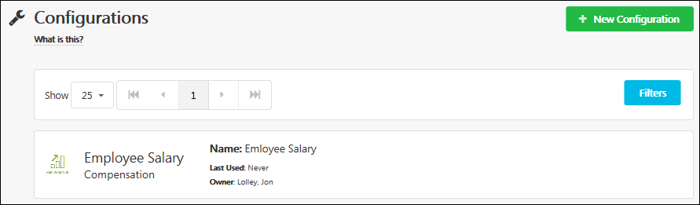
Create New Configuration
To create a new data load configuration, select the New Configuration button. This opens the New Configuration flyout, which guides you through a multi-step process to create a new configuration. See Edge Import - Create Data Import Configuration on page 106 for additional information.
Filters
To filter which configurations are displayed in the table, select the Filters button. This opens the Configurations Filter flyout. The following options are available:
- Category and Type - Select an option to view only configurations of the selected category and type.
- Filter by Owner - Select a user to view only configurations for which the selected user is the owner.
- Only show configurations used in feeds? - Select Yes to view only configurations that are used in a data feed. Or, select No to view all available configurations.
Select the Apply button to apply the selected filters to the Loads list.
Configurations List
The page displays all configurations that match the selected filters, if applicable. The following information is displayed for each configuration:
- Category and Type - This displays the category and type that is associated with the configuration.
- Name - This displays the name that was provided when the configuration was created.
- Last Used - This displays the last time the configuration was used in a data load. Date and time are displayed in UTC timezone.
- Owner - This displays the name of the user who created the configuration.
Select the data load configuration to view the Configuration Details page. See Edge Import - Configuration Details Page on page 111 for additional information.

Edge Import - Create Data Import Configuration
A configuration is a template that describes the data you want to import and how the system should interpret, validate, and import the data. A configuration can be used when importing data or for a feed.
To create a new data import configuration, go to Admin > Tools > Edge > Imports and Feeds. Select the Configurations panel. Then, select the New Configuration button. This opens the New Configuration flyout, which guides you through a multi-step process to create a new configuration.
Permissions
PERMISSION NAME | PERMISSION DESCRIPTION | CATEGORY

Access Edge Import | Grants access to the Edge Import tool, which enables administrators to load data into their portal. This permission cannot be constrained. This is an administrator permission. | Edge Import

Create/Update Configurations | Grants ability to create and update Edge Import configurations. This permission cannot be constrained. This is an administrator permission. | Edge Import
Upload Step
In this step, you will upload a file is used to create your configuration.
- Category and Type - From this drop-down menu, select the data type that applies to the configuration you are creating. This drop-down only includes the data import types for which the administrators has permission to access. For example, the Employee Salary load type only appears if the administrator has the Load Employee Salary permission.
- Select File - In this field, upload a file that contains the data headers that you will use for data imports. You can do this by dragging and dropping a file in to the field or by selecting the Pick a File button to browse for and select a file from your computer. See the File Format Information section below for additional information.
- Encryption Key - From this drop-down, select the appropriate encryption key that corresponds with the selected file. This field is only available after a file is selected, and it is only available if a .PGP file is selected. This field is not available if a non-PGP encrypted file is selected. The encryption key selection is not actually saved within the configuration, and the key must be selected when initiating a data load. This is because PGP keys expire every 180 days and should be selected with each data load to ensure accuracy. This also allows the data load configuration to be used with PGP encrypted files as well as non-encrypted files.
  - Encryption keys are created on the Manage Keys page. See Key Management - Manage Keys on page 137 for additional information.
- Select the Upload button.
Options Step
In this step, you will set the processing options that help the system properly process your data imports.
- In the General Questions section, answer the following questions:
  - When an Excel file has multiple sheets, which one should we use? - This question is only active if you uploaded an Excel file. Only one worksheet can be uploaded, so select the worksheet that contains the data that should be used to create your configuration. The drop-down contains all of the worksheets that exist within the file that you uploaded in the Upload step.
  - Does your file have headers? - Edge Import can use the first row of the uploaded file as headers.
    - Select Yes if the first row of your file contains headings. On the Mapping step, the Column Header column displays column titles from the first row of your uploaded file.
    - Select No if the first row of your file contains data. On the Mapping step, the Column Header column displays the first row of data from your uploaded file. Best Practice: If your uploaded file does not have headers, it is recommended that there is data in the first row of all columns to make it easier to map your file to fields in the system.
  - What should we do with blank values? - This option determines what action Edge Import takes if an optional field has a blank value in the uploaded file. For example, if an Address column is included in the uploaded file, and it is mapped to the optional Address field in the system, then what action should Edge Import take if the Address column is not populated for a user in the uploaded file? The following options are available:
    - Apply Default Value - Select this option if you want Edge Import to update the existing record in the system with the default value for that field. The default values for standard system fields are provided in the template guide for the import type.
    - Do nothing - Select this option if you do not want Edge Import to update the values in the system when a blank value is provided in the uploaded file.
See the Blank Value Examples section below for additional information.
Note: When records are created via Edge Import, the import process applies default values for all mapped or unmapped fields associated with the record unless a value is provided in the imported file.
- In the Format Questions section, answer the following questions:
  - How are your dates ordered? - Edge Import supports all date formats. However, the system must know how the dates are ordered. From the drop-down menu, select how dates are ordered in your data files. The following options are available:
    - Month first - Select this option if the month appears first in your dates (e.g., MM.DD.YYYY, MM-DD-YYYY, MM/DD/YYYY).
    - Date first - Select this option if the date appears first in your dates (e.g., DD.MM.YYYY, DD-MM-YYYY, DD/MM/YYYY).
    - Year first - Select this option if the year appears first in your dates (e.g., YYYY.MM.DD, YYYY-MM-DD, YYYY/MM/DD). If this option is selected, the year must be four digits.
Best Practice: The year value should always be four digits (YYYY). If the year is provided as two digits (YY), the system processes the year as 19YY. For example, 01.01.30 is loaded as 01.01.1930.
  - How are your numbers formatted? - Edge Import supports number formats from all cultures. However, the system must know how the numbers are formatted. From the drop-down menu, select how numbers are formatted in your data files. The following options are available:
    - Decimals are separated with a dot "." (e.g., 1,234.56 or 1234.56)
    - Decimals are separated with a comma "," (e.g., 1 234,56 or 1234,56)
    - Decimals are separated with a comma "," AND thousands are grouped with a dot "." (e.g., 1.234,56)
Note: The limit on the number of digits that are allowed following the decimal and the logic used when additional decimal places are provided (e.g., are additional decimals rounded up or truncated) is dependent on the load type.
Mapping Step
In this step, you will map the data columns in your uploaded file to the system fields. A data field in the source file can only be mapped to one system field.
The system reviews the uploaded file and may automatically match some fields. To match a data column with a system field, select the drop-down in the Map To Field column and select the appropriate system field. An asterisk displays next to a system field that must be mapped to a column in your file.
- The following information is displayed in the table:
  - Status - This indicates whether the column is mapped to a system field.
  - Column Header - This displays the column titles from the first row of your uploaded file.
  - Map To Field - This displays the system field to which the data column is mapped. You can select the drop-down to set or modify the mapping.
  - Description - This displays the description of the selected system field. If no system field is selected in the Map To Field column, then this field is empty.
- By default, all column headers from your file are displayed in the table. To filter which columns are displayed in the table, select the drop-down menu above the table.
- If a system field is not matched to a data column from your file, the system field appears in the Unmatched Fields section. By default, only required unmatched fields are displayed in the Unmatched Fields section. To filter which fields are displayed in this section, select the drop-down menu in the upper-right corner of the page.
Note: If the administrator does not have permission to view a field, then that field is not available for mapping.
Save Step
In this step, you will provide a name for the configuration and save it for future use.
- Enter a unique name for your configuration, up to 50 characters. This name should clearly indicate its purpose so that it is clear to all administrators when the configuration should be used.
- Select the Save button. This opens the Configuration Details page where you can view the details of the configuration and initiate a new data load. See Edge Import - Configuration Details Page on page 111 for additional information.
If the configuration's Options and Mapping settings match an existing configuration, then you are given the following options:
- Use an existing saved configuration - this is recommended to reduce duplicate configurations
- Create a duplicate configuration
Blank Value Examples
This table shows how the system is updated depending on what option is selected for the "What should we do with blank values" setting and the value in the uploaded file.
Preference Selected | Value in File | Value in System | System-defined Default Value | Result
Apply Default Value | Value 1 | Blank | Blank | Value 1
 | Value 2 | Value 1 | Blank | Value 2
 | Blank | Value 2 | Blank | Blank
 | Value 1 | Blank | Value 3 | Value 1
 | Value 2 | Value 1 | Value 3 | Value 2
 | Blank | Value 2 | Value 3 | Value 3
Do Nothing | Value 1 | Blank | Blank | Value 1
 | Value 2 | Value 1 | Blank | Value 2
 | Blank | Value 2 | Blank | Value 2
 | Value 1 | Blank | Value 3 | Value 1
 | Value 2 | Value 1 | Value 3 | Value 2
 | Blank | Value 2 | Value 3 | Value 2
Multiple Checkbox Custom Field Example
For multiple checkbox custom fields, values in the file override values in the system; they do not append them. In order to set multiple values for a multiple checkbox custom field, the file must include all appropriate values.
Supported Custom Field Types
The following custom field types are not supported by Edge Import:
- Branched Drop-down
- Conditional Numeric Field
- Hierarchy
File Format Information
The following file types are supported:
File Type | Details
Text File | - File name is flexible  - File extension: .CSV or .TXT  - Columns names are flexible  - One row equals one record  - Supported Delimiter: TAB, COMMA or PIPE  - File should be UTF-8 encoded - Note: When using accented or umlaut characters in data feeds, files should be UTF-8 encoded with BOM (Byte Order Mark) to ensure the characters display properly in the system.
Excel File | - File name is flexible  - File extension: .XLS or .XLSX  - Columns names are flexible  - One row equals one record  - Only one worksheet can be loaded at a time
PGP and GPG encrypted files are supported for data feeds and one-time loads. It is important to note that when encrypted data is loaded, the data in the load report is also encrypted. It is recommended to keep a copy of the original plain text file before encryption from your source data system.
Edge Import supports text and Excel files with and without column headers. The first row in the file should be the header with column names. As a best practice, use column headers to make the configuration and maintenance process more user-friendly and less vulnerable to errors.

Edge Import - Configuration Details Page
A configuration is a template that describes the data you want to import and how the system should interpret, validate, and import the data. The Configuration Details page displays the configuration's settings and enables you to initiate a data load using the configuration.
To access the Configuration Details page, go to Admin > Tools > Edge > Imports and Feeds. Select the Configurations panel. Then, select the appropriate configuration in the table.
Permissions
PERMISSION NAME | PERMISSION DESCRIPTION | CATEGORY

Access Edge Import | Grants access to the Edge Import tool, which enables administrators to load data into their portal. This permission cannot be constrained. This is an administrator permission. | Edge Import

Delete Configurations | Grants ability to delete Edge Import configurations. Users with this permission can delete configurations created by anyone for all types of data imports. This permission cannot be constrained. This is an administrator permission. | Edge Import
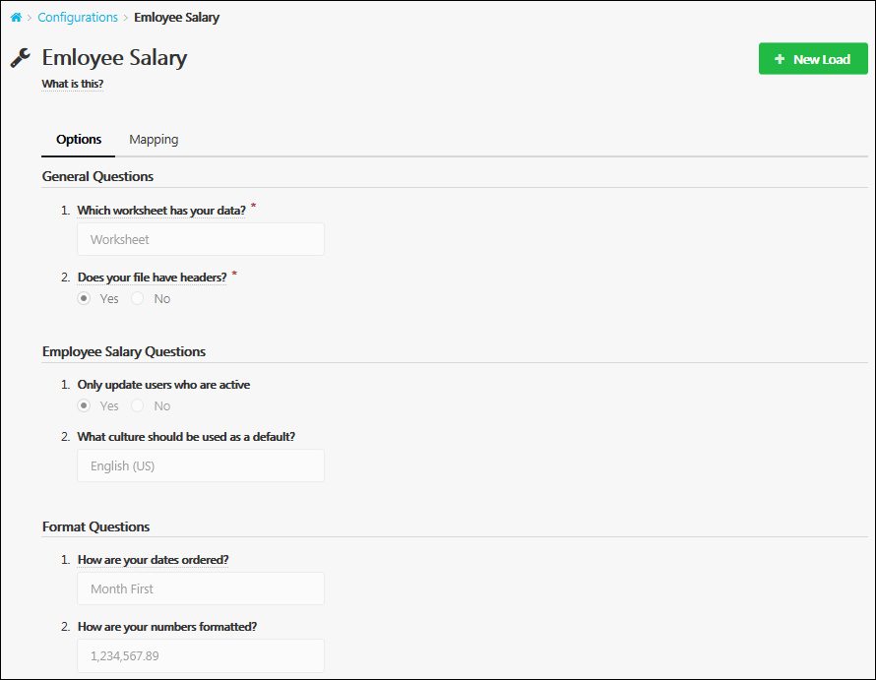
Start New Data Load
Select the New Load button to initiate a new data load using the selected configuration. See Edge Import - Create or Edit Data Load on page 116 for additional information.
Options
The Options tab displays the options that were selected on the Options step when the configuration was created. See Edge Import - Create Data Import Configuration on page 106 for additional information.
Mapping
The Mappings tab displays how data will be mapped to system fields with the configuration. This mapping was set on the Mapping step when the configuration was created. See Edge Import - Create Data Import Configuration on page 106 for additional information.
Delete this configuration
If a configuration is not being used in a data feed, then administrators with the appropriate permissions can delete the configuration. To delete a configuration, select the Delete this configuration button.

Edge Import Loads Overview

Edge Import - Manage Data Loads
The Loads page enables you to view your organization's data loads and initiate new data loads.
To access the Manage Data Loads page, go to Admin > Tools > Edge > Imports and Feeds. Then, select the Loads panel.
Permissions
PERMISSION NAME | PERMISSION DESCRIPTION | CATEGORY

Access Edge Import | Grants access to the Edge Import tool, which enables administrators to load data into their portal. This permission cannot be constrained. This is an administrator permission. | Edge Import
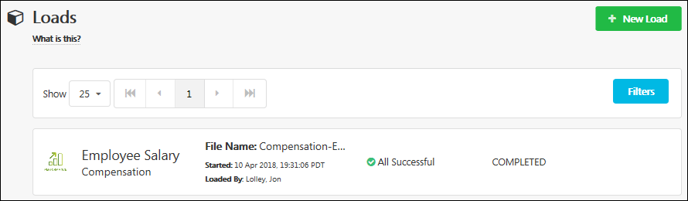
Create New Data Load
To create a new data load, select the New Load button. This opens the New Load page. See Edge Import - Create or Edit Data Load on page 116 for additional information.
Filters
To filter which loads are displayed in the table, select the Filters button. This opens the Loads Filter flyout. The following options are available:
- Category and Type - Select an option to view only loads of the selected category and type.
- Filter by User - Select a user to view only loads that were performed by the selected user.
- Filter by Action - Select the Load option to view In Progress and Completed loads. Select the Validate option to view In Progress and Completed validations.
Select the Apply button to apply the selected filters to the Loads list.
Loads and Validations List
The page displays all data loads and validations that match the selected filters, if applicable. The following information is displayed for each load:
- Category and Type - This displays the category and type that is associated with the load.
- File Name - This displays the name of the file that was loaded or validated.
- Started - This displays the date and time at which the data load began.
- Loaded By - This displays the name of the user who initiated the data load.
- Load Results - This displays the results of the data load. For example, if some records were not valid, then the number of invalid records is displayed. If all records were loaded without warnings, then All Successful is displayed.
- Load Status - This displays the processing status of the data load, such as Queued, Loading, or Completed.
Select the data load to view the Load Details page. See Edge Import - Create or Edit Data Load on page 116 for additional information.

Edge Import - Create or Edit Data Load
The New Load page enables you to either perform a one-time bulk import or validate your data. Following the validation or data load, an overview of the process is displayed.
To create a new data load, go to Admin > Tools > Edge > Imports and Feeds. Select the Loads panel. Then, select the New Load button. This opens the New Load page.
Permissions
PERMISSION NAME | PERMISSION DESCRIPTION | CATEGORY

Access Edge Import | Grants access to the Edge Import tool, which enables administrators to load data into their portal. This permission cannot be constrained. This is an administrator permission. | Edge Import

Create/Update Configurations | Grants ability to create and update Edge Import configurations. This permission cannot be constrained. This is an administrator permission. | Edge Import

Download Reports Access when portal opts-in for Restrict reports access - Edge Import | Grants ability to download Edge Import load details reports for loads performed by others.  Users who do not have this permission cannot download load import results for loads performed by others. In addition, users without this permission cannot load data for someone who has previously only validated their data.  This permission cannot be constrained. This is an administrator permission.  This permission is only available and applicable when the portal has enabled the restriction for Edge Import load details report access. | Edge
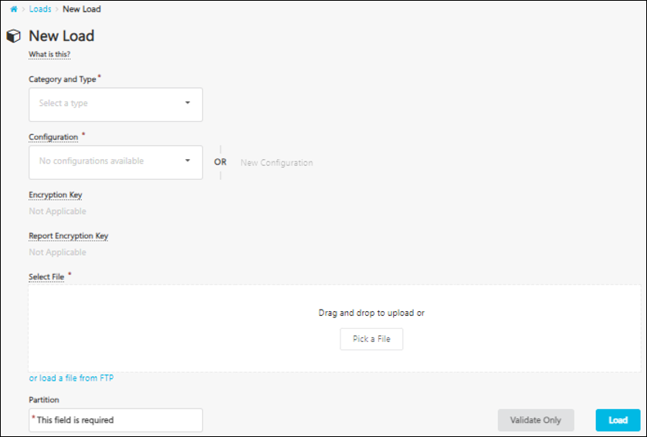
Limits and Best Practices
What is the max file size limit for Edge Import and how can I reduce the impact?
New Load
- Category and Type - From this drop-down menu, select the data type that applies to the data you are loading. This drop-down only includes the data import types for which the administrators has permission to access. For example, the Employee Salary load type only appears if the administrator has the Load Employee Salary permission.
- Configuration - In this field, you have two options for selecting a configuration for your data load. Note: Administrators must have the appropriate permissions to modify or create a configuration.
  - From the drop-down menu, select the configuration that most closely matches your data. You can modify the default Options and Mapping settings from the configuration for your data load by selecting the Modify button, but the modifications are not saved to the selected configuration.
  - If none of the available configurations match your data, then select the New Configuration button to create a new configuration. See Edge Import - Create Data Import Configuration on page 106 for additional information.
- Encryption Key - From this drop-down, select the encryption key that is used with the data load. Encryption keys are created on the Manage Keys page. See Key Management - Manage Keys on page 137 for additional information.
- Report Encryption Key - From this drop-down, select the report encryption key that is used to decrypt PGP-encrypted load report. Report Encryption Keys are created on the Report Manage Keys page. See Key Management - Manage Report Encryption Keys on page 139 for additional information.
- Select File - In this field, select the file that contains the data that you are loading. See the File Format Information section below for additional information. Files can be selected in the following ways:
  - Pick a File - Pick a file from your computer by dragging and dropping a file into the field or by selecting the Pick a File button to browse for and select a file from your computer. With this method, the maximum file size is 20 MB.
  - Select from FTP - Select a file from your Cornerstone FTP location by selecting the or load a file from FTP link. Then, specify the FTP path. All paths are relative to the FTP directory. If the file is located in the root of the FTP directory, only the file name needs to be provided. With this method, the maximum file size is 25 GB for .xls, .xlsx, .csv and .txt files. Up to 150 columns (data feed) and 300 columns (manual load) can be loaded per file. The number of records you can load varies by environment and load type, and are listed in the template guides for each load.
Once the file is loaded and the settings are configured, you have two options:
- Select the Validate Only button to only validate that your data is in the correct format and does not contain errors. When this button is selected, the Validation Details are displayed. See the Validation Details section below for additional information.
- Select the load button to validate the data and load it to the system. See the Load Details section below for additional information. Note: Depending on the portal configuration, if an administrator has only validated their data, another administrator may not able to perform a data load for this data unless they have the appropriate permission.
Validation Details
When you choose to only validate your data, the system analyzes the selected file, and the Validation Details provide an overview of the validation.
The Record Details chart provides a visual overview of the validation progress and the number of records in each status. While data is being processed, the data is displayed as a bar graph. Once the data is fully processed, the data is displayed in a pie chart.
The Information section displays the following details about the validation or load:
- Category
- Type
- File Name - Select this link to download the original file that you uploaded for the Edge Import data load.
  - The link to download the file is only available for 30 days.
  - The link to download the file is accessible even if you were not the person who originally uploaded the file. However, the link respects the existing Download Reports Access when portal opts-in for Restrict reports access - Edge Import permission which is available via a backend setting. If this permission is enabled, then only users who have this permission can download the file.
- Configuration - Select the View link to open a flyout that displays the Options and Mapping settings from the configuration.
- Validated By/Loaded By - This displays the name of the user who initiated the validation or load.
- Started - This displays the date and time at which the validation or load began.
- Completed - This displays the date and time at which the validation or load completed.
The Quick Stats section displays reports that can be downloaded.
- Valid Records - This displays the number of valid records that were processed. Valid records may be processed successfully or with warnings. Any warnings are displayed in the downloaded report so that you can adjust the data, if necessary, prior to loading it.
- Not Valid - This displays the number of invalid records that were processed. Any errors are displayed in the downloaded report so that you can adjust the data and then load it.
- Total - This displays the total number of records that were processed.
To download a report, select the record count in the Download column. Note: Depending on the portal configuration, administrators may only download a report for loads that they performed unless they have the appropriate permission.
The Warning Details section appears if your records have any warnings. This section displays any warnings that occurred and the number of records that encountered the warning.
The Error Details section appears if your records have any errors. This section displays any errors that occurred and the number of records that encountered the error.
Select the Load button to load the data to the system. Note: Depending on the portal configuration, administrators may only perform a data load for data that they validated unless they have the appropriate permission. See the Load Details section below for additional information.
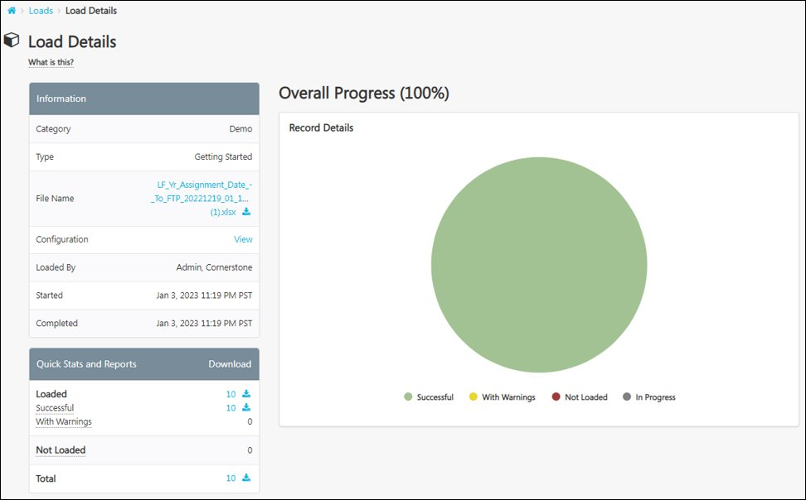
Load Details
When you load your data, the system analyzes the selected file and then attempts to load the data. The Load Details provide an overview of the load.
The Record Details chart provides a visual overview of the load progress and the number of records in each status. While data is being processed, the data is displayed as a bar graph. Once the data is fully processed, the data is displayed in a pie chart.
The Information section displays the following details about the validation or load:
- Category
- Type
- File Name - Select this link to download the original file that you uploaded for the Edge Import data load.
  - The link to download the file is only available for 30 days.
  - The link to download the file is accessible even if you were not the person who originally uploaded the file. However, the link respects the existing Download Reports Access when portal opts-in for Restrict reports access - Edge Import permission which is available via a backend setting. If this permission is enabled, then only users who have this permission can download the file.
- Configuration - Select the View link to open a flyout that displays the Options and Mapping settings from the configuration.
- Validated By/Loaded By - This displays the name of the user who initiated the validation or load.
- Started - This displays the date and time at which the validation or load began.
- Completed - This displays the date and time at which the validation or load completed.
The Quick Stats section displays reports that can be downloaded.
- Loaded - This displays the number of valid records that were processed and loaded. Valid records may be processed successfully or with warnings. Any warnings are displayed in the downloaded report so that you can adjust the data, if necessary, prior to loading it.
- Not Loaded - This displays the number of invalid records that were not loaded. Any errors are displayed in the downloaded report so that you can adjust the data and then load it.
- Total - This displays the total number of records that were processed.
To download a report, select the record count in the Download column. Note: Administrators can only download a report for a load they did not perform if they have permission to access the associated data load type. Depending on the portal configuration, administrators may only download a report for loads that they performed unless they have the appropriate permission.
The Warning Details section appears if your records have any warnings. This section displays any warnings that occurred and the number of records that encountered the warning.
The Error Details section appears if your records have any errors. This section displays any errors that occurred and the number of records that encountered the error.
Frequently Asked Questions (FAQs)
If I add a file to the FTP location for a one-time data load, what happens to the file after the load?
The file remains on the FTP after the load.
Why am I unable to download a load report?
Administrators can always download a report for a data load that they performed.
Administrators can only download a report for a load they did not perform if they have permission to access the associated data load type. In addition, depending on the portal configuration, administrators may only download a report for loads that they performed unless they have the appropriate permission.
File Format Information
The following file types are supported:
File Type | Details
Text File | - File name is flexible  - File extension: .CSV or .TXT  - Columns names are flexible  - One row equals one record  - Supported Delimiter: TAB, COMMA or PIPE  - File should be UTF-8 encoded - Note: When using accented or umlaut characters in data feeds, files should be UTF-8 encoded with BOM (Byte Order Mark) to ensure the characters display properly in the system.
Excel File | - File name is flexible  - File extension: .XLS or .XLSX  - Columns names are flexible  - One row equals one record  - Only one worksheet can be loaded at a time
PGP and GPG encrypted files are supported for data feeds and one-time loads. It is important to note that when encrypted data is loaded, the data in the load report is also encrypted. It is recommended to keep a copy of the original plain text file before encryption from your source data system.
Edge Import supports text and Excel files with and without column headers. The first row in the file should be the header with column names. As a best practice, use column headers to make the configuration and maintenance process more user-friendly and less vulnerable to errors.
Validation Tips
- For non-translation loads, each row needs to be unique.
  - Examples: For employees, this could be User ID or GUID. For OUs, this is the OU ID.
- If more than one record contains the same identity value, the first record will be loaded, and the other records will be marked as duplicate (error).
- Required columns must have a valid value.
- Values need to be acceptable and comply with the maximum field size, follow the latest template guide.
- For enumerated fields, the ID or Code must match the values listed in the relevant template guide.
- Optional fields with invalid data will be omitted, but the record itself will be loaded and logged with warnings.
- Ensure that the format of cells in Excel files are correct.
  - The cell must be in text format for a number that starts with "0.". Example: "00123" must be provided in a cell formatted as 'Text.' If the cell format is defaulted by Excel as 'Number,', it will be incorrectly saved as "123".
- IDs associated to a record must match an existing unique ID value that’s already in the portal or is provided for creation in the current load file.

Edge Import - Cancel Load
Administrators have the ability to cancel a load from the Edge Import - Load Details page.
To cancel an Edge Import load, go to Admin > Tools > Edge > Imports and Feeds. Then, select the Loads panel. Select the appropriate data load. Then, select the Cancel link in the Information section of the Load Details page.
The Cancel option is only available to the person who initiated the load, and it is only available if the import processing has not completed.
Permissions
PERMISSION NAME | PERMISSION DESCRIPTION | CATEGORY

Access Edge Import | Grants access to the Edge Import tool, which enables administrators to load data into their portal. This permission cannot be constrained. This is an administrator permission. | Edge Import
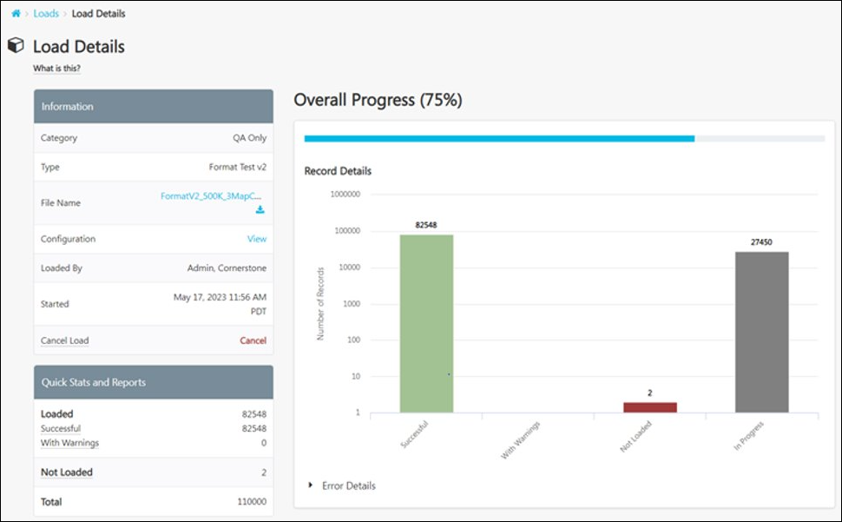
When a load is cancelled, any records that started processing will complete processing and be loaded. These records can be viewed in the report details. Any records that did not start processing will be cancelled.
If the load is cancelled, then the following information is displayed in the Information section:
- Cancelled - This displays the date and time at which the load was cancelled.
- Cancelled By - This displays the name of the user who cancelled the load.
If the load is cancelled, then the following information is displayed in the Error Details section:
- Error: Load has been cancelled.
- Count: The number of records that were cancelled.
Considerations
- Only the person who uploaded the file can cancel the load.
- The load can only be cancelled if the import processing has not completed.
- Once the load is cancelled, remaining records are not imported. However, backend processes will continue to run and complete.
- After the import processing has completed, administrators can view how many records were cancelled in the Error Details section.

Edge Import Feeds Overview
Edge Import is a robust, intuitive data load tool that enables customers to manage their data loads in a self-service manner. With Edge Import, customers have the ability to map, validate and load data into their Cornerstone application using flat files. Customers can also set up data feeds to automatically load these flat files such as employee or transcript data from an external system into the Cornerstone application.
An inbound data feed is a scheduled data feed that can be from an external system to the Cornerstone system. Data files for an Inbound Data Feed can be delivered on a regularly scheduled basis to the Cornerstone FTP server (SFTP/FTPS).
An Edge Import data feed often contains multiple files. For example, a feed may contain several organizational unit data files and an employee data file. Data sets are related to each other, and so a logical import sequence is essential to successfully complete a data feed. For example, Edge import should import and update the organizational unit data before importing and updating employee data. The execution sequence is handled automatically by Edge Import's Dependency Resolution functionality. This system ensures all data files are executed based on their dependencies and data relationships. As a result, some records may appear as "Not Valid" at the start of the processing due to missing relationships which may be included in the remaining files or data. Edge Import will process the records again at a later stage in the processing.
Frequently Asked Questions (FAQs)
Are files automatically removed from the FTP source after a data feed is executed?
Yes. The data feed execution process removes the relevant files from the FTP source.

Edge Import - Manage Data Feeds and Settings
A data feed is a way for organizations to automatically load data such as user or transcript data from an external system into the Cornerstone system. For example, if an organization maintains their user data base in an external system, they can configure a data feed to regularly load any new or modified user records into their Cornerstone system.
To access the Manage Data Feeds and Settings page, go to Admin > Tools > Edge > Imports and Feeds. Then, select the Feed Settings button.
Permissions
PERMISSION NAME | PERMISSION DESCRIPTION | CATEGORY

Access Edge Import | Grants access to the Edge Import tool, which enables administrators to load data into their portal. This permission cannot be constrained. This is an administrator permission. | Edge Import

Set up Feed | Enables administrator to access the Feed Settings page where the administrator can create and update feeds and schedule feeds. This permission does not grant the ability to activate feeds or manually run feeds. This permission cannot be constrained. This is an administrator permission. | Edge Import
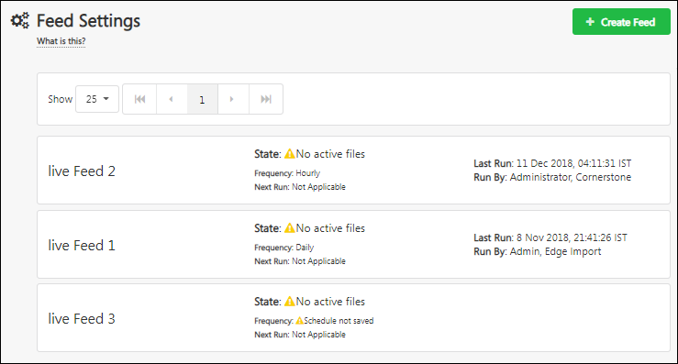
Create New Feed
To create a new data feed, select the Create Feed button. This opens the New Feed page, which guides you through a multi-step process to create a new data feed. See Edge Import - Create Data Feed on page 128 for additional information.
View or Edit Feed Details
To view or edit the feed details, select the appropriate feed. See Edge Import - Create Data Feed on page 128 for additional information.
Data Feeds
The following information is displayed for each data feed:
- Feed name
- State
- Frequency
- Next run
- Last run
- Run by

Edge Import - Create Data Feed
A data feed is a way for organizations to automatically load data such as user or transcript data from an external system into the Cornerstone system. For example, if an organization maintains their user data base in an external system, they can configure a data feed to regularly load any new or modified user records into their Cornerstone system.
Organizations can import one or more data files simultaneously based on a schedule.
To create a new data feed configuration, go to Admin > Tools > Edge > Imports and Feeds. Select the Feed Settings panel. Then, select the Create Feed button.
This opens the New Configuration flyout, which guides you through a multi-step process to create a new configuration.
Permissions
PERMISSION NAME | PERMISSION DESCRIPTION | CATEGORY

Access Edge Import | Grants access to the Edge Import tool, which enables administrators to load data into their portal. This permission cannot be constrained. This is an administrator permission. | Edge Import

Delete Feeds | Grants ability to delete disabled Edge Import feeds. Users with this permission can delete disabled feeds created by anyone for all types of data feeds. This permission cannot be constrained. This is an administrator permission. | Edge Import

Enable/Disable Feeds | Grants ability to enable or disable a data feed in Edge Import. This permission cannot be constrained. This is an administrator permission. | Edge Import

Manual Run Feed | Enables administrator to manually initiate a data feed processing. This permission cannot be constrained. This is an administrator permission. | Edge Import

Set up Feed | Enables administrator to access the Feed Settings page where the administrator can create and update feeds and schedule feeds. This permission does not grant the ability to activate feeds or manually run feeds. This permission cannot be constrained. This is an administrator permission. | Edge Import
Data Feed Name
A default name is given to the feed, but this can be edited. To edit the feed name, click the Edit icon to the right of the feed name.
Enable/Disable Data Feed
Depending on the feed status, an enable/disable toggle may appear next to the feed name.
- If the feed is ready to be enabled, an Enable/Disable toggle appears to the right of the feed name. When this toggle is enabled, the data feed is enabled. This toggle is only available if the administrator has permission to enable or disable feeds.
- If the feed is not ready to be enabled, specific prompts appear to the right of the feed name to help administrators understand what is required to enable the feed. For example, if there are no active files for the feed, then "No active files" is displayed next to the feed name.
Overview Step
The Overview step enables administrators to configure the general settings of the data feed. The following settings and information are available:
- FTP Location - This displays the location where the system will collect the files for the data feed. This is the location where data files should be loaded by the administrator in order to be fed into the Cornerstone system via the data feed. A default file location is displayed.
  - Change FTP Path - Select this link to change the FTP location. The folder location must exist before updating the FTP path. Multiple feeds can have the same FTP path. However, all feeds using the same path must have unique file names. Note: Only Cornerstone FTP account paths can be utilized. External FTP accounts cannot be used.
- Files - This section shows a summary of the files that are added and included in the data feed. At least one file must be added and included in the feed in order to enable the feed.
  - Add File - Select this button to add a file that will be included in the data feed.
- Schedule - This section shows a summary of the schedule that is set for the data feed. A schedule must be set for the feed in order to enable the feed.
  - Set Schedule - Select this button to set the schedule for the data feed.
- Encryption - This section shows a summary of the encryption key that is set for the data feed. Organizations may or may not use encryption keys for their data feeds.
  - Select Key - Select this button to set an encryption key for the data feed. Encryption keys are created on the Manage Keys page. See Key Management - Manage Keys on page 137 for additional information.
- Notification - This section shows a summary of the recipients who are added and enabled to receive email notifications for the data feed.
  - Add Notification - Select this button to add and enable notification recipients.
- Last Run - This section shows a summary of the last time the data feed was run. This section is only populated if the feed has run at least once. Select the View More link to view all of the times the feed has run. See Edge Import - Data Feed Runs on page 134 for additional information.
- Next Run - When the feed is enabled and a schedule is set, this section shows the next date and time at which the feed will run.
- Status - This section shows whether the feed is enabled or disabled. If the feed is ready to be enabled, an Enable/Disable toggle appears to the right of the feed name.
When editing a data feed, administrators with the appropriate permissions have the option to delete the data feed from the Overview tab. See Edge Import - Delete Data Feed.
File Setup Step
The File Setup step enables administrators to configure which files are included in the data feed. Excel and text/CSV file types are supported by data feeds.
If any files have been added for the data feed, they are displayed on this page. Administrators may select a file to modify or remove the file.
File Setup - Add File
To add a file to the data feed, select the Add File button. This opens a flyout in which administrators must provide information about the file. Enter the following information about the data feed file:
- Category and Type - From the drop-down menu, select the data type that applies to the data in the data feed file.
- Configuration - From the drop-down menu, select the configuration that most closely matches your data.
- File Name Starts With - Enter the text that matches the beginning of the file name.
  - This can be full file name with extension (e.g., users.txt) or just the beginning text of the file name (e.g., users). This enables organizations to use dynamic file names.
  - This value must be unique across all files in the feed.
  - When the feed runs, if there are multiple files that match this criteria, the feed does not process and an error is displayed.
- Include in feed - Select whether this file is included in the feed. This enables organizations to temporarily exclude certain files from the feed. A file must be included in the feed in order to have the file's data imported to the system.
- Select the Add File button.
File Setup - Edit File
To edit a file in the data feed, select the file on the File Setup page. This opens a flyout in which administrators can edit the file information. See the File Setup - Add File section for information on each field.
File Setup - Run Feed
When at least one file is included in the feed, a Run Feed button is available on the File Setup step. This button is only available if the administrator has permission to manually run data feeds.
When this button is selected, the feed is initiated and any files that are included in the data feed are processed. In executing a data feed manually, the current user permissions are applied.
File Setup - Check Files
When at least one file is included in the feed, a Check Files button is available on the File Setup step.
When this button is selected, the system checks the files that are included in the feed and confirms whether matching files are available in the FTP location.
- If a matching file is found, a green check mark is displayed next to the file name.
- If a matching file is not found, a red X is displayed next to the file name.
Scheduling Step
The Scheduling step enables administrators to set and view the schedule for when the feed should process.
Scheduling - Set Schedule
To set the frequency and time at which the data feed is processed, select the Set Schedule button. This opens a flyout in which administrators must provide scheduling information.
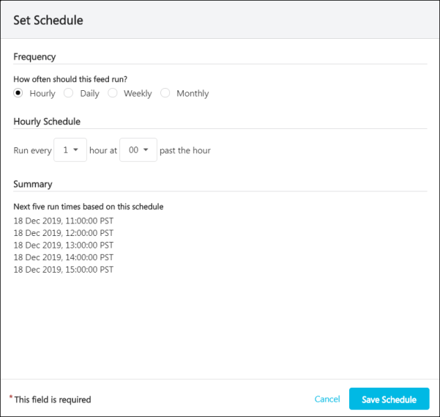
Enter the following information about the data feed schedule:
- Frequency - How often should this feed run? - Select whether the data feed should be processed hourly, daily, weekly, or monthly.
- Schedule - Using the scheduling options, specify when the data feed should be processed. These options vary depending on which frequency is selected.
- Summary - This section displays the next five run times based on the selected frequency and schedule. Administrators should review this schedule to ensure they have configured the data feed schedule as desired.
- Select the Save Schedule button.
Scheduling - Change Schedule
Once a schedule is set, the schedule is displayed on the Scheduling page. To change the schedule, select the Change Schedule button. This opens a flyout in which administrators can edit the scheduling information. See the Scheduling - Set Schedule section for information on each field.
Notifications Step
The Notifications step enables administrators to add and manage who should receive email notifications related to the data feed. Notifications can be triggered on the start and completion of a feed, as well as when there is an error. Notification emails contain links to view the feed run details in Edge Import.
Notifications - Add Notification to Feed
To add a notification for the data feed, select the Add Notification button. This opens a flyout in which administrators must configure the notification.
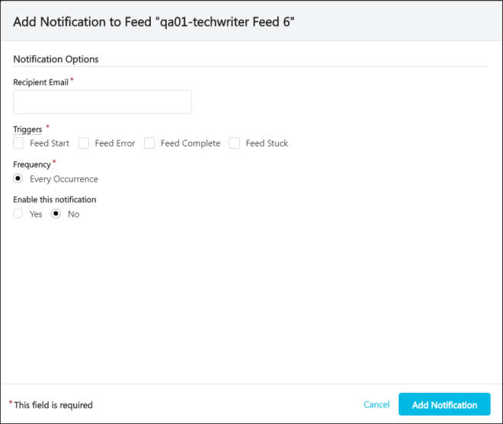
Enter the following information to configure the notification:
- Recipient Email - Enter the email address for the user who will receive the notification, when triggered.
- Triggers - Select which events should trigger the notification.
- Frequency - By default, all notifications are sent for every occurrence of the selected triggers.
- Enable this notification - Notifications can be enabled or disabled. When a notification is disabled, the configured recipient will not be notified when the selected triggers occur for the data feed.
- Select the Add Notification button.
Notification - Update Notification
Once a notification is configured, the setting are displayed on the Notifications page. To update or remove a notification, select the corresponding notification. This opens a flyout in which administrators can edit or remove the notification. See the Notifications - Add Notification to Feed section for information on each field.
Change Log Step
The Change Log step displays a complete modification history for the data feed, including creation and any modifications.
To filter which log items are displayed in the table, select the Filters button. This opens the Feed Runs Filter flyout. The following options are available:
- Changed Area - Select an area to view only changes that were made to the selected area (e.g., General, Files, Schedule, Notifications).
- Changed By - Select a user to view only changes that were performed by the selected user.

Edge Import - Data Feed Runs
The Feed Runs page displays all previous data feed runs, including the details of each feed run. Data feed reports remain available and downloadable for 30 days after the load.
To access the Feed Runs page, go to Admin > Tools > Edge > Imports and Feeds. Then, select the Feed Runs button.
Permissions
PERMISSION NAME | PERMISSION DESCRIPTION | CATEGORY

Access Edge Import | Grants access to the Edge Import tool, which enables administrators to load data into their portal. This permission cannot be constrained. This is an administrator permission. | Edge Import

Set up Feed | Enables administrator to access the Feed Settings page where the administrator can create and update feeds and schedule feeds. This permission does not grant the ability to activate feeds or manually run feeds. This permission cannot be constrained. This is an administrator permission. | Edge Import
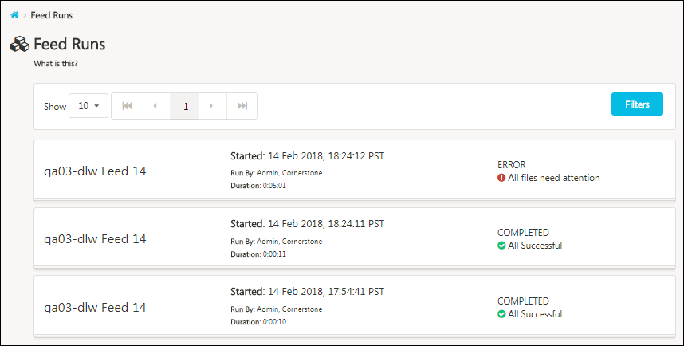
Filters
To filter which data feed runs are displayed in the table, select the Filters button. This opens the Feed Runs Filter flyout. The following options are available:
- Filter by Feed - Select an specific data feed to view only runs from the selected feed.
- Show Feeds Run By - Select a user to view only feed runs that were performed by the selected user.
- Filter by Status - Select a specific status to view only runs in the selected status. This can be useful to view only feed runs that encountered an error.
Select the Apply button to apply the selected filters to the Feeds list.
Feed Runs and Validations List
The following information is displayed for each previous data feed run:
- Feed name
- Started
- Run by
- Duration
- Feed run status
- Feed run results

Data Feeds - Inbound vs. Outbound
In order to ensure both Cornerstone and an organization have the most up-to-date data, inbound and outbound data feeds are used to communicate back and forth.
Inbound Data Feeds
From a organization's perspective, an inbound data feed consists of:
- The organization creates one or more files of comma separated values that are formatted in a specific layout.
- The organization places the file on the secure FTP site on a scheduled basis. The FTP site is hosted by Cornerstone.
- Cornerstone retrieves the file from the secure FTP site on a scheduled basis and applies the data to the organization's Live portal.
Outbound Data Feeds
From a organization's perspective, an outbound data feed consists of:
- Cornerstone creates one or more files of comma separated values containing data from the organization's Live portal. The file is formatted in a specific layout.
- Cornerstone places the file on the secure FTP site on a scheduled basis. The FTP site is hosted by Cornerstone.
- The organization retrieves the file from the secure FTP site on a scheduled basis and processes the file's information as needed.

Key Management - Manage Keys
When importing files with sensitive data, organizations prefer to encrypt the import file, and Cornerstone provides Pretty Good Privacy (PGP) for encryption.
The Manage Keys page enables administrators to create and download PGP keys that are used to encrypt their import files before using them in Edge Import or Bulk API. In addition, administrators can clearly view the expiry date of each PGP key.
Encryption keys can be used in Edge Import and Bulk API.
To manage Encryption Keys, go to Admin > Tools > Edge > Imports and Feeds. Select the Key Management panel. The Encryption Keys tab displays.
Permissions
PERMISSION NAME | PERMISSION DESCRIPTION | CATEGORY

Access Edge Import | Grants access to the Edge Import tool, which enables administrators to load data into their portal. This permission cannot be constrained. This is an administrator permission. | Edge Import
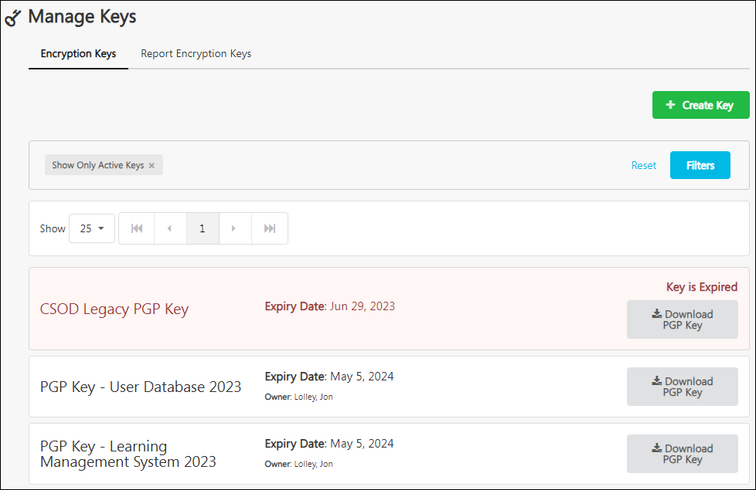
Create PGP Key
In addition to the CSOD Legacy PGP Key, organizations can have a maximum of two active keys per portal. For example, administrators may create a new key when the previous key is about to expire, or administrators may create multiple keys if they want to use separate PGP keys in various domains.
To create a new PGP key, select the Create Key button. A Create Key flyout opens. Enter a name for the key up to 30 characters and select the Create Key button. The expiry date is 180 days from the date the key is created.
The following considerations apply:
- PGP keys can only be used for encrypting .csv and .txt files. They cannot be used for Microsoft Excel files. This is to ensure secured data import of encrypted files is supported.
- PGP keys created here can only be used for importing files used for Edge Import manual loads and feeds and Bulk API.
View Keys
A user can view all keys irrespective of who created them. For each key, the expiry date and key creator is displayed.
Administrators may select the Filters button to enable or disable the Show only active keys filter. By default, only active keys and only your keys are displayed.
Download Key
To download a key, select the Download PGP Key button for the appropriate key. All administrators who have access to Edge Import can download any PGP key.

Key Management - Manage Report Encryption Keys
The Report Encryption Keys tab enables administrators to create keys to add their public key for Cornerstone to encrypt the reports. By supporting a public key that customers specify when they import a file to the Edge Import feed, customers can use their corresponding private key to decrypt the PGP encrypted load report.
The load report can only be decrypted by the customer’s private key associated with that public key. Once decrypted, the user can then see records with errors so they can readily resolve them.
When creating a data load, customers select one of their public keys so Cornerstone can use it to encrypt a report after performing the load. Customers can download the load report and use their private key to decrypt it using their decrypting tool.
Customers are responsible for managing their public and private keys for load reports.
To manage Report Encryption Keys, go to Admin > Tools > Edge > Imports and Feeds. Select the Key Management panel. Then, select the Report Encryption Keys tab.
Permissions
PERMISSION NAME | PERMISSION DESCRIPTION | CATEGORY

Access Edge Import | Grants access to the Edge Import tool, which enables administrators to load data into their portal. This permission cannot be constrained. This is an administrator permission. | Edge Import
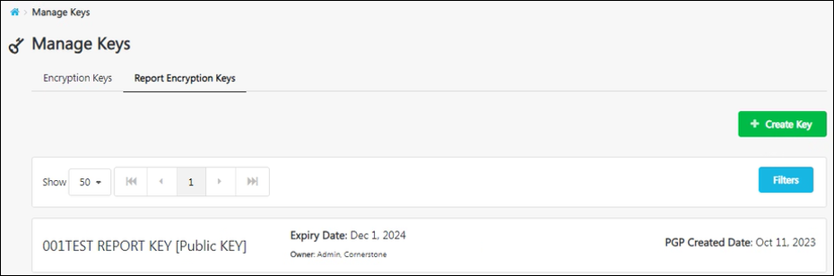
Create Report Encryption Key
To create a Report Encryption key, select the Create Key button. A Create Key flyout opens. Enter a name for the key up to 30 characters and the report encryption key value. Then, select the Create Key button.
A maximum of 20 Report Encryption Keys can be uploaded. Note that once the Report Encryption Key is uploaded, administrators cannot download nor view the value of the Report Encryption Key.
View Keys
A user can view all keys irrespective of who created them. For each key, the expiry date and key creator is displayed.
Administrators may select the Filters button to enable or disable the Show only active keys filter. By default, only active keys and only your keys are displayed.

Edge Import - Data Load Wizard (DLW) Migration Tool - Overview
The DLW Migration page enables administrators to migrate their DLW templates and feeds to Edge Import.
The following loads and feeds can be migrated to Edge Import using the DLW Migration tool:
- Employee Salary Loads
- Learning Loads
- User/OU Loads and Feeds (currently only supported for non-Cornerstone HR clients because effective dated employee loads are not yet supported in Edge Import)
To access the DLW Migration Tool, go to Admin > Tools > Edge > Imports and Feeds. Then, select the DLW Migration button.
Permissions
PERMISSION NAME | PERMISSION DESCRIPTION | CATEGORY

Access Edge Import | Grants access to the Edge Import tool, which enables administrators to load data into their portal. This permission cannot be constrained. This is an administrator permission. | Edge Import

Disable Data Load Wizard | Grants access to the Disable DLW tab within the DLW Migration tool. From the Disable DLW tab, administrators can disable Data Load Wizard for the portal. This permission cannot be constrained. This is an administrator permission.  Important: Disabling a DLW type is a permanent action, and it cannot be undone. It is important to only disable a DLW type once you have fully migrated to the corresponding loads and feeds in Edge Import. | Edge Import

Set up Feed | Enables administrator to access the Feed Settings page where the administrator can create and update feeds and schedule feeds. This permission does not grant the ability to activate feeds or manually run feeds. This permission cannot be constrained. This is an administrator permission. | Edge Import
Users must have the corresponding Edge Import load permissions to migrate a specific template from the DLW.
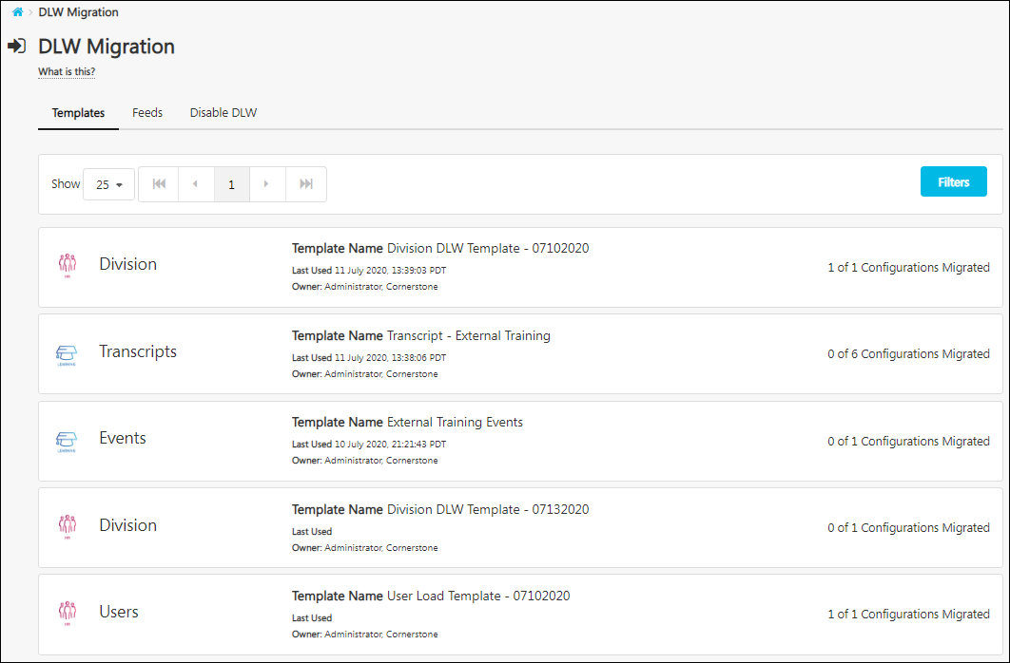
DLW Migration Tool Tabs
The following tabs may be available within the DLW Migration Tool:
- Templates - The DLW Migration Tool - Templates page enables administrators to view and migrate DLW templates to Edge Import. See Data Load Wizard (DLW) Migration Tool - Templates on page 143 for additional information.
- Feeds - The DLW Migration Tool - Feeds page enables administrators to view and migrate DLW data feeds to Edge Import. See Data Load Wizard (DLW) Migration Tool - Feeds on page 146 for additional information.
- Disable DLW - The Disable DLW page enables administrators with the appropriate permission to turn off DLW permanently once all DLW templates and feeds are migrated. See Data Load Wizard (DLW) Migration Tool - Disable DLW on page 149 for additional information.

Data Load Wizard (DLW) Migration Tool - Templates
The DLW Migration Tool - Templates page enables administrators to view and migrate DLW templates to Edge Import. This page displays all of the portal's DLW templates that have been used within the past 90 days or that are being used in an active DLW feed. The most recently used templates are displayed first. Administrators who have permission to access Edge Import are able to view all templates, regardless of their additional Edge Import permissions.
The following loads and feeds can be migrated to Edge Import using the DLW Migration tool:
- Employee Salary Loads
- Learning Loads
- User/OU Loads and Feeds (currently only supported for non-Cornerstone HR clients because effective dated employee loads are not yet supported in Edge Import)
To access the DLW Migration Tool, go to Admin > Tools > Edge > Imports and Feeds. Then, select the DLW Migration button.
Permissions
PERMISSION NAME | PERMISSION DESCRIPTION | CATEGORY

Access Edge Import | Grants access to the Edge Import tool, which enables administrators to load data into their portal. This permission cannot be constrained. This is an administrator permission. | Edge Import
Users must have the corresponding Edge Import load permissions to migrate a specific template from the DLW.
The following information is displayed for each template:
- Template file type
- Template name - Select the template name to view the template details and to create an Edge Import configuration for the template. See the Template Details - Create Configuration section for additional information.
- Last used date
- Template owner
- Whether the template has been migrated from the DLW
Administrators can filter the Templates page by template name by selecting the Filters button.
Template Details - Create Configuration
To view the details of a DLW template, select the template. The template details are displayed in a flyout, which includes the following information:
- Column Headers - This displays the column header name from the import file that is mapped to the system field.
- DLW System Field - This displays the system field that is mapped to a column in the template. Only system fields that have been mapped to a column are displayed.
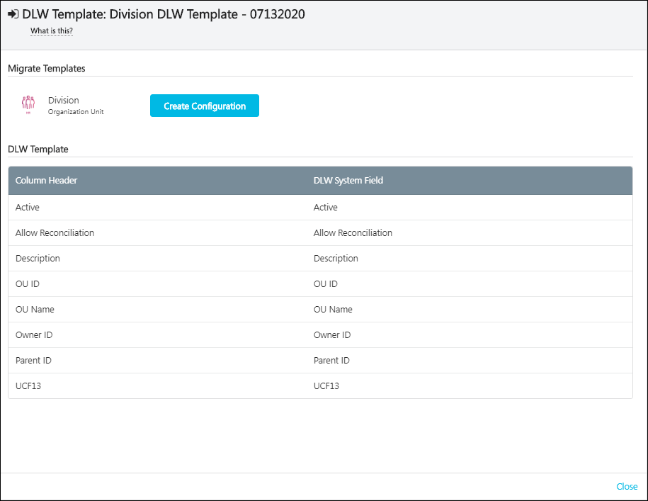
To migrate the DLW template to an Edge Import configuration, select the Create Configuration button at the top of the flyout. Note: This button is disabled if the administrator does not have the corresponding Edge Import load permission, and the button is not available if there is no corresponding Edge Import load.
- If the selected template file type corresponds directly with a specific Edge Import type, then the administrator is navigated to the Options step of the Create Data Import Configuration process.
- If the selected template file type corresponds with more than one Edge Import type, then the administrator must select the Create Configuration button for the appropriate Edge Import type.
See Edge Import - Create Data Import Configuration on page 106 for additional information.

Data Load Wizard (DLW) Migration Tool - Feeds
The DLW Migration Tool - Feeds page enables administrators to view and migrate DLW data feeds to Edge Import. This page displays all the portal's active DLW feeds. The feeds are organized by feed type. Administrators who have permission to access Edge Import can view all templates, regardless of their additional Edge Import permissions.
The following loads and feeds can be migrated to Edge Import using the DLW Migration tool:
- Employee Salary Loads
- Learning Loads
- User/OU Loads and Feeds (currently only supported for non-Cornerstone HR clients because effective dated employee loads are not yet supported in Edge Import)
To access the DLW Migration Tool, go to Admin > Tools > Edge > Imports and Feeds. Then, select the DLW Migration button.
Permissions
PERMISSION NAME | PERMISSION DESCRIPTION | CATEGORY

Access Edge Import | Grants access to the Edge Import tool, which enables administrators to load data into their portal. This permission cannot be constrained. This is an administrator permission. | Edge Import

Set up Feed | Enables administrator to access the Feed Settings page where the administrator can create and update feeds and schedule feeds. This permission does not grant the ability to activate feeds or manually run feeds. This permission cannot be constrained. This is an administrator permission. | Edge Import
Users must have the corresponding Edge Import load permissions to migrate a specific template from the DLW.
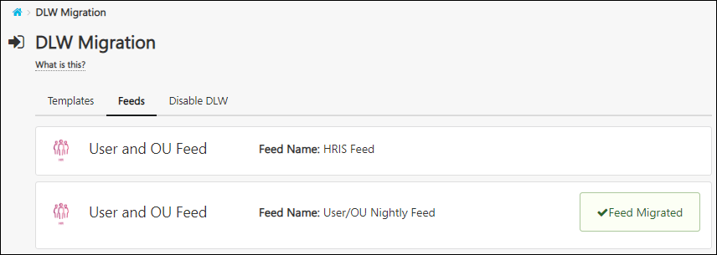
The following information is displayed for each feed:
- Feed type
- Feed name - Select the feed name to view the feed details and to import the feed and configurations to Edge Import. See the Feed Details - Import Feed and Configurations section for additional information.
- Whether the feed has been migrated from the DLW
Feed Details - Migrate Feed
To view the details of a DLW feed, select the feed. The feed details are displayed in a flyout, which includes the following information:
- Schedule - This section displays the frequency at which the data feed is currently processed in the DLW.
- Notifications - This section displays the email addresses that are configured to receive notifications related to the data feed.
- Files - This section displays each of the files that are processed via the data feed.
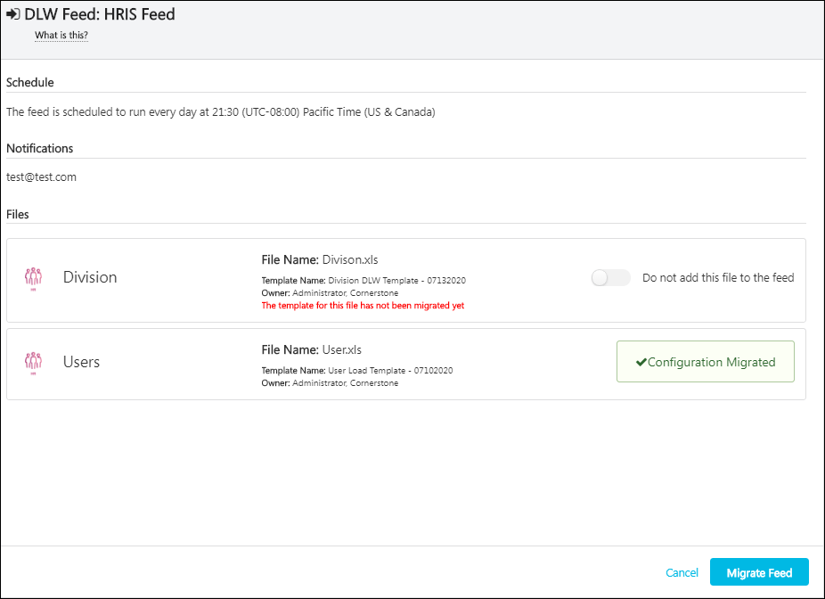
For each file that is included in the feed, the following information is displayed:
- File type
- File name
- Template name
- Template owner
- If the file has not been imported as an Edge Import configuration, a message is displayed
- Toggle to exclude file from feed - This option enables administrators to stop including files that are not being used in the feed.
If one of the files in the DLW feed has not been imported as an Edge Import configuration, a warning message is displayed, and you are unable to include the file in a feed migration. If you want to include the file in your feed, you must first migrate the template from the Templates tab. See Data Load Wizard (DLW) Migration Tool - Templates on page 143 for additional information.
To migrate the data feed into Edge Import, select the Migrate Feed button at the bottom of the flyout. This button is not available if the feed has already been migrated or if the administrator does not have permission to set up a feed. A success message is displayed when the feed is migrated.
- The feed is migrated in disabled state. When you are ready to turn on the feed in Edge Import, be sure to turn on the toggle to enable it.
- Verify details of the feed such as the files included, the schedule, the notification settings, and the FTP file path. These details should have carried over from your current feed in the DLW.

Data Load Wizard (DLW) Migration Tool - Disable DLW
The Disable DLW page enables administrators with the appropriate permission to turn off DLW permanently once all DLW templates and feeds are migrated.
Important: Disabling a DLW type is a permanent action, and it cannot be undone. It is important to only disable a DLW type once you have fully migrated to the corresponding loads and feeds in Edge Import.
To access the DLW Migration Tool, go to Admin > Tools > Edge > Imports and Feeds. Then, select the DLW Migration button.
Permissions
PERMISSION NAME | PERMISSION DESCRIPTION | CATEGORY

Access Edge Import | Grants access to the Edge Import tool, which enables administrators to load data into their portal. This permission cannot be constrained. This is an administrator permission. | Edge Import

Disable Data Load Wizard | Grants access to the Disable DLW tab within the DLW Migration tool. From the Disable DLW tab, administrators can disable Data Load Wizard for the portal. This permission cannot be constrained. This is an administrator permission.  Important: Disabling a DLW type is a permanent action, and it cannot be undone. It is important to only disable a DLW type once you have fully migrated to the corresponding loads and feeds in Edge Import. | Edge Import
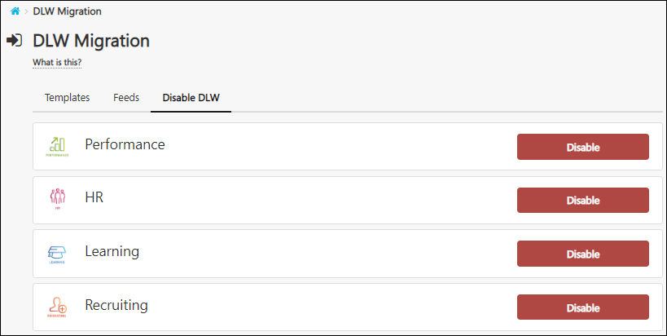
All of the available DLW types are displayed. To disable a DLW type, select the Disable button. A warning message is displayed, and you must confirm the action.
When a DLW type is disabled, all DLW loads and feeds associated with the DLW type are permanently disabled.
Important: Disabling a DLW type is a permanent action, and it cannot be undone. It is important to only disable a DLW type once you have fully migrated to the corresponding loads and feeds in Edge Import.
Note: In order to use the Employee/OU load in Edge Import, you must first disable the HR DLW load. If you attempt to use the Employee/OU load in Edge Import while the HR DLW load is active, you will receive an error message in the load report.
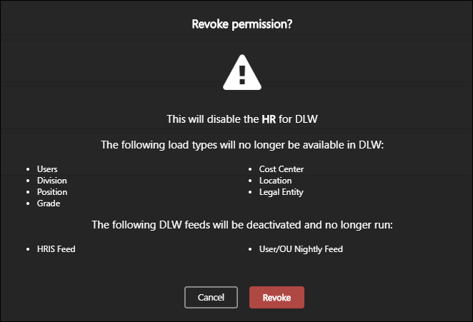

Edge Import - Restrict Download Report
An optional feature is available to limit users to download import result reports for loads only performed by them. This provides the ability to restrict users from downloading reports for loads they did not perform themselves.
Use Cases
A bank has two regional office locations, and each location has a dedicated Edge Import administrator, Jack and Jill, responsible for keeping data between their regional HRIS and Cornerstone systems up to date. Each Edge Import administrator has a separate HRIS system. The organization wants to restrict these administrators so that an administrator can only download and view data for loads that they performed.
The organization contacts Global Customer Support and enables this feature. Both Jack and Jill have access to perform an Employee data load. Jill is granted the permission, but Jack is not.
When Jack, who does not have the permission, logs in to the system, the following occurs:
- He can download reports for loads and feeds that he performed.
- He cannot download reports for loads and feeds performed by Jill.
- He cannot download reports for loads performed via feed by scheduled feed runs.
- He cannot perform a data load for Jill who has previously only validated their data.
When Jill, who does have the permission, logs in to the system, the following occurs:
- She can download reports for loads and feeds that she performed.
- She can download reports for loads and feeds performed by Jack.
- She can download reports for loads performed via feed by scheduled feed runs.
- She can perform a data load for Jack who has previously only validated their data.
Bulk API
When this functionality is enabled, the following end points for the Bulk API are impacted, and they now observe the permission:
- Get reports
- Get import errors
- Get import warnings
Implementation
The availability of this functionality is controlled by a backend setting, which is disabled by default. To enable this functionality, contact Global Customer Support.
Once this functionality is enabled, the Download Reports Access when portal opts-in for Restrict reports access - Edge Import permission is also enabled, and this permission is required to download import results reports for loads performed by others.
Permissions
The following permissions apply to this functionality:
PERMISSION NAME | PERMISSION DESCRIPTION | CATEGORY

Access Edge Import | Grants access to the Edge Import tool, which enables administrators to load data into their portal. This permission cannot be constrained. This is an administrator permission. | Edge Import

Download Reports Access when portal opts-in for Restrict reports access - Edge Import | Grants ability to download Edge Import load details reports for loads performed by others.  Users who do not have this permission cannot download load import results for loads performed by others. In addition, users without this permission cannot load data for someone who has previously only validated their data.  This permission cannot be constrained. This is an administrator permission.  This permission is only available and applicable when the portal has enabled the restriction for Edge Import load details report access. | Edge
Security Roles
The Download Reports Access when portal opts-in for Restrict reports access - Edge Import permission is disabled by default. This permission is only available when the portal has enabled the restriction for Edge Import load details report access. When the permission is enabled, it is automatically granted to the default System Administrator role. Administrators must grant this permission to other roles, if necessary.

