Development Plans March 2024

Table of Contents
Development Plans - Overview 1
Development Plans Administration - Overview 2
Development Plan Activity Types 7
Custom Field Admin - Development Plans 10
Development Plan Preferences 12
Development Plan Objective Categories 20
Development Plan Categories 22
Templates Overview 25
Development Plan Templates 26
Create/Edit Development Plan Template 28
User Development Plans Overview 33
Snapshot - Development Plans 34
Create/Edit Development Plan 39
Create Development Plan from Template 47
Manage/View Development Plan 49
Approve Development Plans 54

Development Plans - Overview

Development Plans Administration - Overview
Development Plans allow users to create plans and manage their growth and development as an employee. Customized development plans allow administrators and managers to more accurately capture the user's strengths, weaknesses, objectives, and resources needed. Users can create objectives which consist of training items from the LMS and free-form, job-related action steps. After creation, users can view and manage those components to track progress.
To access Development Plans, go to Admin > Performance Management. The Development Plan section contains all of the development plan options.
The development plan process is dependent upon an organization's performance management configuration. In its simplest form, there are three main steps:
- User creates a development plan.
- User submits the development plan for approval.
- The approver approves the plan.
You can also allow users to create development plans that do not require a manager's approval. In addition, managers can create and assign a development plan to a user.
If you use the Competency Management functionality, development plans can be created for a user based on a competency assessment, which can then be modified by the user before submitting the plan for approval.
Development Plan Statuses
The workflow that defines statuses for development plans that require approval is different from the workflow for development plans that do not require approval. Both types are provided in the following tables.
Development Plans That Do Not Require Approval
Status | Definition
Draft | A plan is created and saved, but has not been submitted.  If a user submits the plan, the status is changed to In Progress.
In Progress | A plan is created and submitted, but the plan is not yet complete and has not yet reached the due date.  - If a user edits the plan and removes the items that are incomplete, the status is changed to Complete.  - If a user edits the due date of a plan, the status can change to Past Due.
Past Due | A plan is not yet complete, and the due date has passed.  If a user edits the due date of a plan, the status can change to In Progress or Complete.
Cancelled | The plan is cancelled.
Complete | All action steps have 100% progress and all training items are marked as complete.  - If a user creates a plan that consists solely of training that is already complete, the plan status is Complete.  - With recurring training, if a recurring item within a dev plan is complete, the status is locked as complete and will not reset when the training recurs.
Development Plans That Require Approval
Status | Definition
Draft | A plan is created and saved, but has not been submitted.  - If a user submits the plan, the status is changed to Pending Acceptance Approval.
In Progress | A plan is created and approved, but the plan is not yet complete and has not yet reached the due date.  - If a user edits the plan and removes the items that are incomplete, the plan can be submitted for completion approval.  - If a user edits the due date of a plan, once approved, the status can change to Past Due.
Past Due | A plan is not yet complete, cancelled, or is in a Pending status, and the due date has passed.  - If a user edits the due date of a plan, once approved, the status can change to In Progress.
Cancelled | The plan is submitted for cancellation and receives approval.
Complete | All action steps have 100% progress, all training items are marked as complete, and the plan has received completion approval.  - If a user creates a plan that consists solely of training that is already complete, once approved, the plan is In Progress. The plan can then be submitted for completion approval.  - With recurring training, if a recurring item within a dev plan is complete, the status is locked as complete and will not reset when the training recurs.
Pending Acceptance Approval | A plan has been submitted for approval, but has yet to receive approval.
Pending Cancellation Approval | A plan has been cancelled, but has yet to receive cancellation approval.
Pending Completion Approval | In a plan, all action steps are at 100% progress, all training items are marked as complete, and it has been submitted for completion approval, but has not yet received approval.
Acceptance Denied | A plan is submitted for approval and is denied, but is not yet resubmitted for approval.  - Once the plan is edited in any way, the status changes to Pending Acceptance Approval.
Completion Approval Denied | A plan is submitted for completion approval and is denied.  - Once the plan is edited in any way, the status changes to Pending Acceptance Approval or Past Due.
Development Plan Approval
Development plan approval requires another user (manager or approver) to approve a development plan. Because managers and approvers may change, as can the preferences that require approval, the following table outlines situations that may arise as well as the corresponding approval behavior.
Situation | Behavior
User's Approver Changes | If the user's development plan is already approved, the user is not affected. If has a dev plan that is not yet approved, the previous approver is no longer responsible for approval, and the approval request is moved to the new approver's list of plans to approve.
User's Approver is Removed | Any development plan requiring approval is automatically approved.
Preference that Requires Approval is Removed | Any development plan requiring approval is automatically approved.
Preference that Requires Approval is Added | Any dev plan that is in progress remains in progress. Only newly created plans require approval.
Options to Create Development Plans
Dev Plan Type | Created By | Notable Features
Output from competency assessment - suggested menu of options | User/Manager | - Dev plan actions are mapped to competencies. Users view a menu of suggested training and development suggestions that are based on their competency assessment scores.  - User chooses items from the list to populate a development plan. Users/Managers can add additional items to plan also.
Free Form (from scratch) | User/Manager | - Users essentially begin with a blank page and add whatever objectives and action steps they deem appropriate.  - May add items from training catalog or free-form non-training action steps.
Template-Based | User/Manager | - Pre-loaded by administrator with standard objectives and development actions.  - User can add to, edit or delete items to customize the dev plan.
Free Form with suggestions from competency model | User/Manager | - Dev plan actions are mapped to competencies.  - Users creating a free-form dev plan can add suggested training from a competency model.  - This allows them to view and select items from a list of all dev plan suggestions mapped to competencies of a given model.
Output from performance review - with competency section | Manager | - Dev plan actions are mapped to competencies. Competencies are pulled into a performance review as a review section.  - As managers rate each competency they can view and select dev plan steps associated with each competency and accumulate them into a list of items to be added to the employee dev plan upon completion of the performance review.  - Managers can also access the entire training catalog (loaded to portal) from with in the review, to add additional training to dev plan.  - Following creation of the dev plan, users and managers can add to and delete items from the dev plan.
Output from succession planning/talent assessment task | Manager | - Managers can access the entire training catalog (loaded to portal) during an SMP assessment task to add items to dev plan.  - Following creation of the dev plan, users and managers can add to and delete items from the plan.
Output from competency assessment - auto-created | System | - Dev plan actions are mapped to competencies and automatically populate starter development plans for users based on their competency assessment scores.  - Users/Managers can add to, edit, or delete items to customize plan.

Development Plan Activity Types
Use the Activity Types page to manage the development plan activity types that enable users to categorize their development plan activities. Administrators can create, view, edit, and manage development plan activity types.
To access the Activity Types page, go to Admin > Tools > Performance Management, and in the Development Plan section, select the Activity Types link.
Permissions
PERMISSION NAME | PERMISSION DESCRIPTION | CATEGORY

Development Plan Activity Types - Manage | Grants ability to create and edit activity types used in the development plans and templates. This is an administrator permission. | Performance - Administration
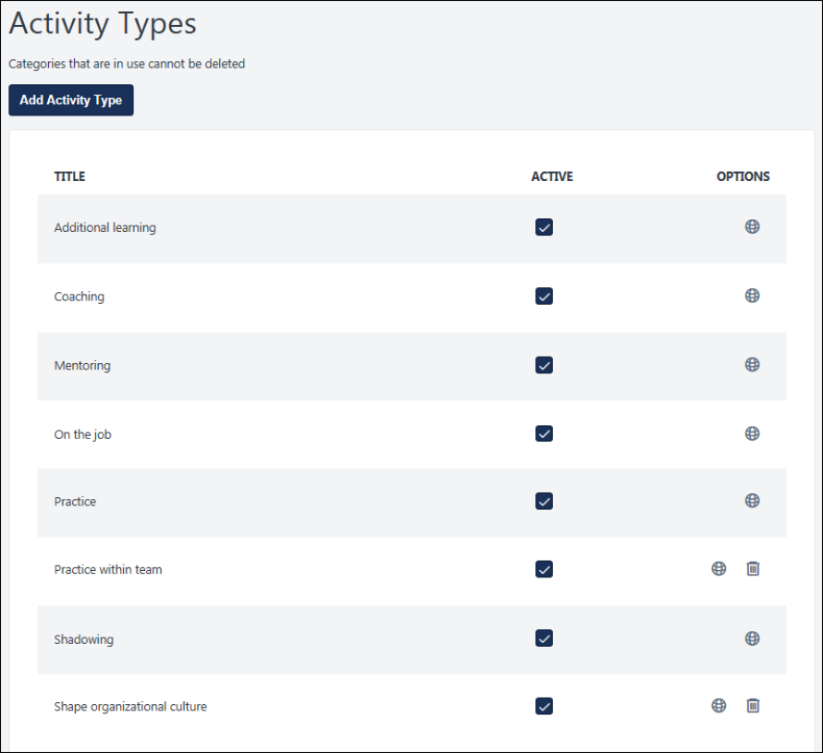
Add Activity Type
To add an activity type:
- Click Add Activity Type.
- On the Add Activity Type flyout, enter the appropriate name. The character limit for this field is 256. If multiple languages are enabled for your portal, you can provide localized content for all available languages. This is a required field.
- Click Save. The new type appears on the Activity Types main page.
After you create an activity type, you must add it in the Activity Types section of Development Plan Preferences to make it available within a development plan. See Development Plan Activity Types on page for additional information.
Activity Types Table
All existing activity types are displayed in this table. The following information is displayed:
- Title - The name of the activity type.
- Active - To make an activity type active or inactive, select or deselect the Active option next to the type. This action is automatically saved. When a type is inactive, it is not available for selection on the Development Plan Preferences page or on a user's development plan.
- Options - For each existing activity type, select the appropriate icon:
  - Localize/Edit - Either the Localize or Edit option is available for each item.
    - Localize - If multiple languages are enabled for your portal, select the Translate icon to translate the field into other available languages. This option also enables you to edit the category name for the default language.
    - Edit - If multi-language is not enabled, select this icon to edit the activity type name. This opens a flyout where you can modify the name.
  - Delete - Select this icon to delete the activity type. A confirmation pop-up opens. This option is only available if the activity type is not active.

Custom Field Admin - Development Plans
The administrator can define custom fields that can be added to a user's development plan. Administrators can also determine a type for each custom field, i.e. numeric, drop-down, radio button, text. This functionality allows the administrator to create more specific development plan templates for OUs by including certain custom fields. The user also has the flexibility to use the custom fields created and included by the administrator when the user creates their own development plan.
Custom fields must be created in Custom Field Administration before they can be added to a development plan or development plan template.
To manage custom fields, go to Admin > Tools > Core Functions > Custom Field Administration. Then select the Development Plans link on the left.
Permissions
PERMISSION NAME | PERMISSION DESCRIPTION | CATEGORY

Development Plan Custom Fields - Manage | Grants access to create and edit custom fields used in development plans and templates. This is an administrator permission. | Performance - Administration
Note: If you have the permission to manage development plan templates, you will automatically have the permission to manage development plan custom fields.
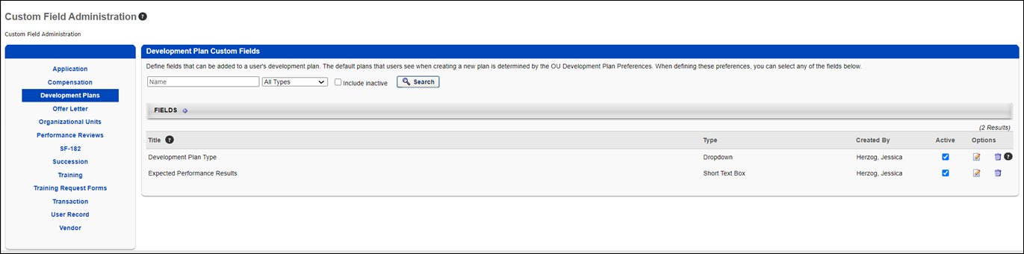
Add Custom Fields
Note: When adding development plan custom fields to development plans, the custom fields are displayed in the order in which they are created in Custom Field Administration.
To add a new custom field:
- Select the Add Field icon . The Define Field page opens.
- Complete the following fields:
  - Name - Enter a name for the custom field that will be visible to end user. The character limit for this field is 50. If multiple languages are enabled for your portal, select the Translate icon to translate the field into other available languages.
  - Type - Select the appropriate custom field type from the drop-down menu. For development plans, Date, Drop-down, Numeric, Radio Button, Scrolling Text Box, and Short Text Box type fields can be created. See Custom Field Admin - Custom Field Type Options for information about the options available when creating and editing custom fields.
  - Active - Select this option to make the field active.
  - Availability - Define which users have the ability to view and access the custom field. The administrator must set the availability of the field if the field is to appear for other administrators and end users in the application. If availability is not set, then the field will not appear in administrator and end user areas of the application. See Setting Availability Overview for additional information.
- Click Save.
Search for a Field
The following filters are available to search for an existing custom field:
- Name - Enter search terms in the filter. The field displays results for a partial or exact match to the search terms.
- Field Type - Select a field type from the drop-down.
- Include Inactive - Check the box to include inactive custom fields in the search.
Once all filters are defined, click Search. This refreshes the fields table with the filtered results.
Add Custom Field
To create a custom field, click the Add Field icon. This opens the Define field page. From here, you can select the type of field you want to create and define the options for the field if applicable. Information about how to create the specific types of custom fields (i.e., branched dropdown, checkbox, etc.) is available on the "Custom Field Type Options" page in Online Help. See Custom Field Admin - Custom Field Type Options.
Fields Table
This table displays all existing custom fields for the field area. The table is sorted in alphabetical order by name. The Title and Created By columns are sortable. The following information displays in the table:
- Title - This column displays the title of the custom field.
- Type - This column displays the field type, such as radio button or short text box.
- Created By - This column displays the name of the administrator who created the field by last name, first name.
- Active - This column defines the active status of the field. To activate the field, check the box in the Active column. To inactivate the field, uncheck the box.
When active, the custom field is available to use by administrators who meet the field's availability requirements. Inactive custom fields are not available to use.
- Options - The following options are available in the Options column:
  - Edit - Click the Edit icon to edit the field. The field type cannot be modified when editing the field. See Custom Field Admin - Custom Field Type Options.
  - Delete - Click the Trash Can icon to delete the field. This option is only available if the custom field has not been used. If a field has been used, then it cannot be deleted and the Trash Can icon does not display. There is no audit history available to view custom fields that were deleted. Please reach out to Global Customer Support if additional details are needed for a deleted custom field.

Development Plan Preferences
Development Plan Preferences enable administrators to configure the way a development plan looks and what options are available for managers and end users.
To manage Development Plan Preferences, go to Admin > Tools > Performance Management > Development Plan Preferences. These preferences are managed by division.
Permissions
PERMISSION NAME | PERMISSION DESCRIPTION | CATEGORY

Development Plan Preferences - Manage | Grants the ability to manage Development Plan Preferences, where various Development Plan features can be enabled or disabled according to the needs of the organization. This is an administrator permission. | Performance - Administration
Emails
EMAIL NAME | EMAIL DESCRIPTION | ACTION TYPE

Development Plan Approval Requested | This email is triggered when a development plan that requires approval has been submitted. The user in the approver role receives the email stating that a new development plan now exists in their list of development plans to approve. If the "Plans must be approved by" preference is not selected, this email is not triggered. | Performance Management
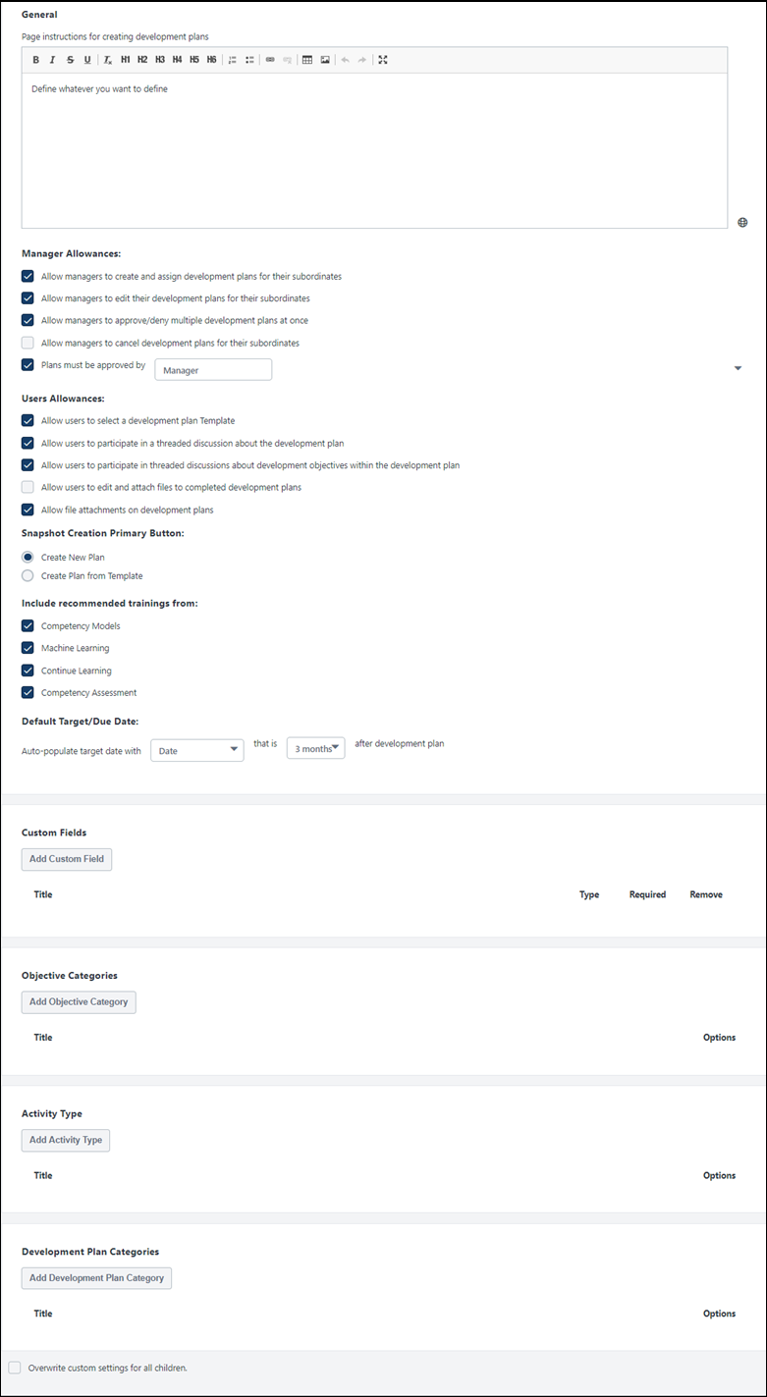
Page instructions for creating development plans
Enter the instructions you want users to see when creating a development plan. The character limit for this field is 10,000 characters. This field does not accept HTML code, so any HTML code is automatically removed when the preferences are saved. This field is required. If multiple languages are enabled for your portal, select the Translate icon to translate the field into other available languages. A Localization flyout opens in which you can provide localized content for all available languages.
Manager Allowances
The Manager Allowances section of the Development Plan Preferences page lets you define how managers can manage development plans for their subordinates.
Select one or more of the following options:
- Allow managers to create and assign development plans for their subordinates - Select this option to enable the Assignment Selection Criteria option on the Create Development Plan page, enabling managers to create and assign development plans to their subordinates.
- Allow managers to edit their development plans for their subordinates - Select this option to allow managers to edit development plans from the Approve Development Plan page. Deselect this option to prevent managers from modifying their subordinate's plans.
- Allow managers to approve/deny multiple development plans at once - Select this option to allow managers with the appropriate permission to approve or deny more than one development plan at a time via the Bulk Approval page. Selecting this option also enables the Check All/Uncheck All option on the Approve Development Plans page. If this option is not selected, managers must approve or deny development plans one at a time.
- Allow managers to cancel development plans for their subordinates - Select this option to allow managers to cancel development plans for their subordinates when necessary. This option is unchecked by default. If this option is selected, Managers will see a "View Development Plan" option when managing a user's development plan.
- Plans must be approved by - Select this option if approval is required for new development plans, edits to existing plans, or to cancel plans. Select the role that is responsible for approving these development plan actions. This person receives an email alert (if the corresponding email is active) when one of these events occurs and an item appears in their Actions > Requests page. This can be set to the user's Manager, Approver, or a custom relationship. If manager or approver is selected, this is the manager or approver that is specified in the user's user record. If no one is assigned to this role, these actions are automatically approved. See Create Role and Permissions for additional information. If this option is not selected, then development plans do not need approval and no emails are triggered and sent to the approver role.
  - If this setting is changed, then this immediately impacts existing plans when the changes are saved. For example, if this setting is changed from requiring approval to not requiring approval, then a plan that was previously awaiting completion approval would become Completed.
  - If the selected approver role changed (e.g., from manager to a custom relationship) and there are existing plans pending approval, the new approver is responsible for approving the plan. If there is no user in the new approver role, then the plan is automatically approved.
  - If the user gets a new manager or if a new person moves into the approver role, the new approver receives an email for any plans still pending approval. The old approver can no longer approve or deny the plans.
User Allowances
The User Allowances section allows you to define what actions users can perform when they are working with development plans.
Select one or more of the following options:
- Allow users to select a Development Plan Template - Select this option to enable the Use a template link when creating a development plan. This link appears on the Manage Development Plan page. Development plan templates can be created by administrators from the Development Plan Templates page.
- Allow users to participate in a threaded discussion about the development plan - Deselect this option to disable users to participate in a threaded discussion within a development plan. This option applies to all development plans of any users within the selected OU. When this option is deselected, all development plans within the selected OU appear without the comment control.
- Allow users to participate in threaded discussions about development objectives within the development plan - Select this option to participate in a threaded discussion about development plan objectives. This option applies to all development plans of any users within the selected OU. When this option is deselected, all development plans within the selected OU appear without the comment control.
- Allow users to edit and attach files to completed development plans - Select this option to allow all users in the OU to attach and edit files to completed development plans.
- Allow file attachments on development plans - Select this option to make it possible for users to add files to development plans.

Snapshot Creation Primary Button
The Snapshot Creation Primary Button section lets you define the options that appear when users need to create a new development plan on the Development Plan Snapshot page.
Note: This option is only available if Allow users to select a development plan Template is selected in the User Allowances section.
Select one of the following options:
- Create New Plan - When this option is selected, the Create New Plan option is available on the Snapshot page.
- Create Plan From Template - When this option is selected, the Create Plan From Template option is available on the Snapshot page. This option allows users to create a new development plan by selecting a pre-defined template.
Include Recommended Trainings From
The Include Recommended Trainings From section lets you select the sources that you'd like to include in the recommended training section or a user's development plan.
Select one or more of the following options:
- Competency Models - When this option is selected, users who are creating a development plan have the option to view development recommendations based on a specific competency model. Users can select a competency model that is available to them, and the system displays recommended training items and development actions based on that competency model. End-user's will see an option to toggle the display to show recommendation carousels informed by the competency defined in the model. When this option is unchecked, the course recommendations will be summarized in one carousel.
- Machine Learning - When this option is selected, users who are creating or editing their own development plan have the option to view training recommendations based on machine learning, such as training based on the user's position, training the user has saved for later, or recommendations based on the user's learning history. These carousels mirror the functionality that is available in Learner Home. See Learner Home - Training and Banner Carousels.
- Continue Learning - When this option is selected, users will see a separate Continue Learning carousel that contains trainings that were started but not completed.
- Competency Assessment - When this option is selected, users who are creating a development plan have the option to view training recommendations based on the results of the user's five most recently completed competency assessments that contain recommendations.
Note: When the Competency Models or Competency Assessment checkboxes are checked, end users can browse and select any learning object associated with the Competency Model/Assessment, even if they are not within the availability of the learning object.
If no recommendation sources are enabled, then the Add Recommended option is not available on the Create Development Plan and Create Development Plan Template page and the Browse Recommended option is not available on the Add Development Objective page.
Default Target/Due Date
The Default Target/Due Date section lets you select a default target due date for action steps or learning objects within an objective.
- The due dates for the individual action steps and training will determine the overall due date for each plan objective.
- The due dates for an objective are defined as the latest due date of any action step or learning objective within that objective.
- The due date for the entire plan is the latest due date for any objective in the plan.
You can select a date relative to the development plan creation date (e.g., 3 months after development plan creation date), the end of the calendar or fiscal year (your system's end of year), or select a specific date (e.g., 06/15/2011).
In the Auto-populate target date with box, select one of the following options:
- Date - Select this option to select a due date that is relative to the development plan creation date (e.g., 3 months after development plan creation date). If you select this option, select one of the following options from the second box:
  - 3 months
  - 6 months
  - 9 months
  - 1 year
- End of the year - Select this option to set the due date to the end of the calendar year. If you select this option, the second box is not available.
- The following date - Select this option to select a specific date (e.g., 06/15/2018). If you select this option, a calendar appears in the second box.
Note: Due dates for objectives are defined as the latest due date for any action step or learning object within that objective. Due dates for development plans are defined as the latest due date for any objective within that development plan.
Custom Fields
The Custom Fields section lets you add pre-defined custom fields to development plans. The selected custom fields are included in development plans that are created by clicking the Create New Plan button on the Development Plans Snapshot page. Note: This does not apply to development plans created from a template.
- To add a custom field, select the Add Custom Field button within the Custom Fields section. The Add Custom Field flyout opens. Select the desired custom fields, and then select the Save button. Note: When adding development plan custom fields to development plans, the custom fields are displayed in the order in which they are created in Custom Field Administration.
- To remove a custom field, select the Remove icon next to the field. If a custom field is removed that exists in a user's development plan, that custom field remains in that development plan.
- Select the Required option next to a custom field to require users to enter information for that field to submit the development plan. If the Required option is not selected, the custom field is optional, and users do not have to complete the field.
Note: An administrator creates these pre-defined fields on Development Plan Custom Fields page.
See Custom Field Admin - Development Plans on page 10 for additional information.
Objective Categories
The Objective Categories section lets you add pre-defined categories to the list users use to select their objectives. You can also delete and set a default category.
- To add an objective category, select the Add Objective Category button. The Add Objective Category flyout opens. Select the desired categories, and select the Select button.
- To remove an objective category, select the Remove icon next to the category. If an objective category is removed that is used in a user's development plan, that category remains in that development plan.
- The Default category is the category that is automatically selected for new development plan objectives. Users can change the category, as needed. To change the Default category, select the Make Default link next to the appropriate category. This change is applied to new objectives that are added after the change is saved. If the default category is removed, the first category in the table is automatically selected as the new default.
Note: An administrator pre-defines these categories on the Objective Categories administration page. See Development Plan Objective Categories on page 20 for additional information.
Activity Type
The Activity Type section lets you add pre-defined activity types that will be available for users to select for their development plan activities.
- To add an activity type, select the Add Activity Type button within the Activity Type section. The Add Activity Type flyout opens. Select the desired activity types and select the Select button.
- To remove an activity type, select the Remove icon next to the activity type. If an activity type is removed that is used in a user's development plan, that activity type remains in that development plan.
- The Default activity type is the activity type that is automatically selected for new development plan activities. Users can change the type, as needed. To change the Default activity type, select the Make Default link next to the appropriate activity type. This change is applied to new activities that are added after the change is saved. If the default activity type is removed, the first activity type in the table is automatically selected as the new default.
Note: An administrator pre-defines these activity types on the Activities Types administration page. See Development Plan Activity Types on page 7 for additional information.
Development Plan Categories
The Development Plan Categories section lets you add pre-defined development plan categories that will be available for users to select from for their development plan.
- To add a development plan category, select the Add Development Plan Category button within the Development Plan Categories section. The Add Development Plan Category flyout opens. Select the desired categories and select the Select button.
- To remove a category, select the Remove icon next to the category. If a category is removed that is used in a user's development plan, that category remains associated with that development plan.
- The Default category is the category that is automatically selected for new development plans. Users can change the category, as needed. To change the Default category, select the Make Default link next to the appropriate category. This change is applied to new development plans that are created after the change is saved. If the default category is removed, the first category in the table is automatically selected as the new default.
Note: An administrator pre-defines these plan categories on the Development Plan Categories administration page. See Development Plan Categories on page 22 for additional information.
Overwrite Settings
Select this option to overwrite custom settings for child division OUs. If you overwrite custom settings for child division OUs, the selected settings are applied to both new and existing child OUs. Any previously customized child OUs are updated with the selected settings.
- If there are no customizations to the child OU, then the parent OU customizations are applied to all child OUs.
- Overwrite custom settings checkbox setting
  - If this option is selected, all child OU customizations are deleted from the database, which means the parent OU customizations will be applied to new and existing child OUs.
  - If this option is unselected, all existing child OU customizations will remain unchanged, and any new child OUs will inherit the parent OU customizations by default.
- If a child OU has been customized to display any widgets, then regardless of the parent OU customizations, the child OU customizations are applied.
- If a child OU has been customized to hide all widgets, then parent OU customizations will take precedence and will be applied.
Save/Cancel
Select the Save button to save all changes to the page. Or, select the Cancel button to discard any unsaved changes.

Development Plan Objective Categories
Use the Objective Categories page to enable users to categorize their development plan objectives. From the Objective Categories page, administrators can create, view, edit, and manage development plan objective categories.
To access the Objective Categories page, go to Admin > Tools > Performance Management, and in the Development Plan section, select Objective Categories.
Permissions
PERMISSION NAME | PERMISSION DESCRIPTION | CATEGORY

Development Plan Objective Categories - Manage | Grants ability to create and edit objective categories used in the development plans and templates. | Performance - Administration
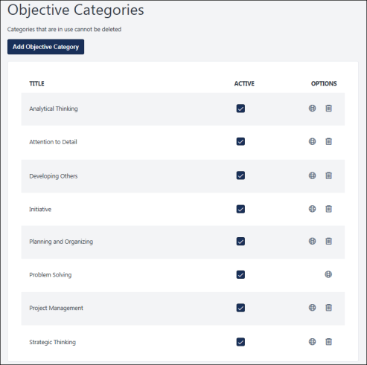
Add Objective Category
To add an objective category:
- Click the Add Objective Category button.
- On the Add Objective Category flyout, enter the objective category name. The character limit for this field is 256. If multiple languages are enabled for your portal, you can provide localized content for all available languages. This is a required field.
- Click the Save button. The new category appears on the Objective Categories main page.
After you create an objective category, you must add them in the Objective Categories section of Development Plan Preferences to make them available within a development plan. See Development Plan Preferences on page 12 for additional information.
Objective Categories Table
- Title - The name of the objective category.
- Active - To make an objective category active or inactive, select or deselect the Active option next to the category. This action is automatically saved. When a category is inactive, it is not available for selection within the system.
- Options - For each existing objective category, select the appropriate icon:
  - Localize/Edit - Either the Localize or Edit option is available for each item.
    - Localize - If multiple languages are enabled for your portal, select the Translate icon to translate the field into other available languages. This option also enables you to edit the category name for the default language.
    - Edit - If multi-language is not enabled, select this icon to edit the objective category name. This opens a flyout in which you can modify the name.
  - Delete - Select this icon to delete the objective category. A confirmation pop-up opens. This option is only available if the objective category is not in use.

Development Plan Categories
Use the Development Plan Categories page to enable users to categorize their development plans. Administrators can create, view, edit, and manage development plan categories.
To access the Development Plan Categories page, go to Admin > Tools > Performance Management, and in the Development Plan section, select Development Plan Categories.
Permissions
PERMISSION NAME | PERMISSION DESCRIPTION | CATEGORY

Development Plan Objective Categories - Manage | Grants ability to create and edit objective categories used in the development plans and templates. | Performance - Administration
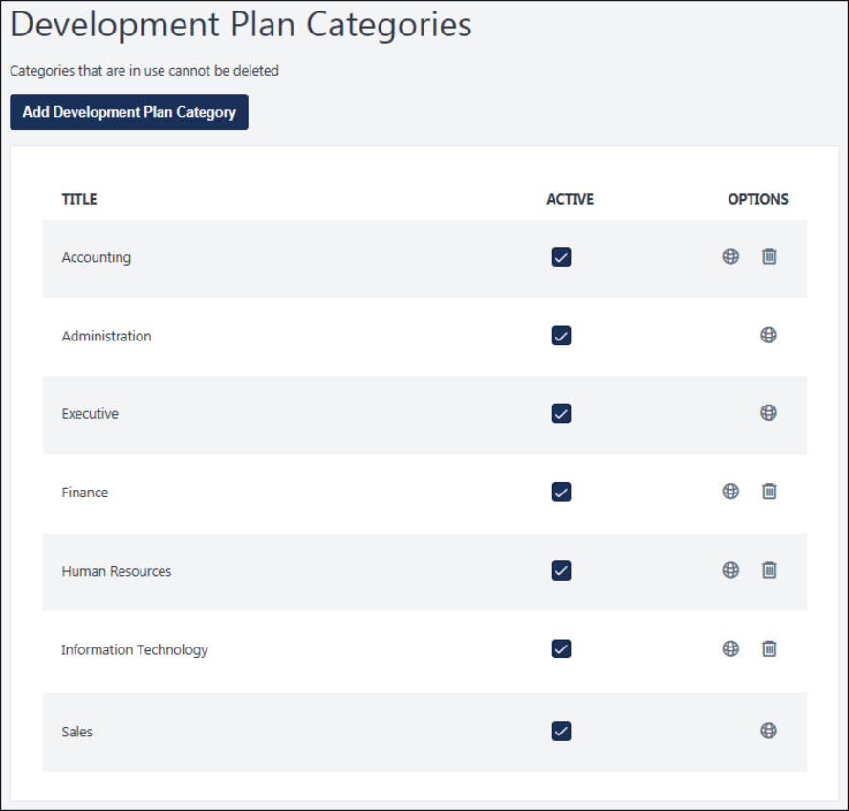
Add Development Plan Category
To add a new development plan category:
- Select the Add Development Plan Category button.
- On the Add Development Plan Category flyout, enter the category name. The character limit for this field is 256. If multiple languages are enabled for your portal, you can provide localized content for all available languages. The category name is a required field.
- Click Save. The new category appears on the Development Plan Categories main page.
After you create a development plan category, you must add them in the Development Plan Categories section of Development Plan Preferences to make them available within a development plan. See Development Plan Categories on page for additional information.
Development Plan Category Table
All existing development plan categories are displayed in this table. The following information is displayed:
- Title - The name of the development plan category.
- Active - To make a development plan category active or inactive, select or deselect the Active option next to the category. This action is automatically saved. When a category is inactive, it is not available for selection within the system.
- Options - For each existing category, select the appropriate icon:
  - Localize/Edit - Either the Localize or Edit option is available for each item.
    - Localize - If multiple languages are enabled for your portal, select the Translate icon to translate the field into other available languages. This option also enables you to edit the category name for the default language.
    - Edit - If multi-language is not enabled, select this icon to edit the category name. This opens a flyout in which you can modify the name.
  - Delete - Select this icon to delete the development plan category. A confirmation pop-up opens. This option is only available if the category is not in use.

Templates Overview

Development Plan Templates
Use development plan templates to create a predefined development plan, including objectives, training, and action items that a user can access and then modify to match their specific needs. When creating a template, the administrator selects a specific user population that can view and request the template. For example, if an administrator is creating a development plan template for managers, they can configure the availability so that it is only available to managers.
The Development Plan Templates page enables administrators to view, manage, and create development plan templates.
To access the Development Plan Templates page, go to Admin > Performance management. In the Development Plan section, select Plan Templates.
Permissions
PERMISSION NAME | PERMISSION DESCRIPTION | CATEGORY

Development Plan Categories - Manage | Grants ability to create and edit categories used to classify development plans. This is an administrator permission. | Performance - Administration

Development Plan Templates - Manage | Grants ability to create and edit development plan templates that can be made available for use by end users. This is an administrator permission. | Performance - Administration
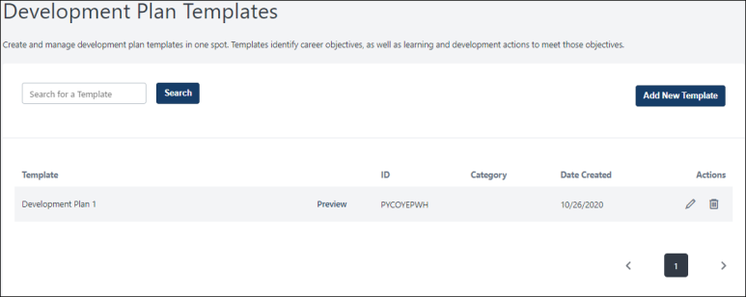
Search
Search for templates by title or description and view the relevant search results in the Template table.
Add New Template
Select this button to create a new development plan template. This opens the Create Development Plan Template page. See Create/Edit Development Plan Template on page 28 for additional information.
Templates Table
All existing templates are displayed in this table. The following information is displayed for each template:
- Template - This is the template title.
- ID - This is the system-generated ID that is associated with the template.
- Category - This is the development plan category that was selected for the template.
- Date Created - This is the date on which the template was created.
Actions
The following actions may be available in the Actions column:
- Edit - Select this option to edit the development plan template. See Create/Edit Development Plan Template on page 28 for additional information.
- Delete - Select this option to delete the development plan template. The deleted template will no longer be available for users to use to create a development plan.

Create/Edit Development Plan Template
Use development plan templates to create a predefined development plan, including objectives, training, and action items that a user can access and then modify to match their specific needs. When creating a template, the administrator selects a specific user population that can view and request the template. For example, if an administrator is creating a development plan template for managers, they can configure the availability so that it is only available to managers.
To create a development plan template, go to Admin > Performance > Plan Templates. Then, click the Add New Template button.
To edit a development plan template, go to Admin > Performance > Plan Templates. Next to the plan you are editing, select the Edit icon.
Permissions
PERMISSION NAME | PERMISSION DESCRIPTION | CATEGORY

Development Plan Templates - Manage | Grants ability to create and edit development plan templates that can be made available for use by end users. This is an administrator permission. | Performance - Administration
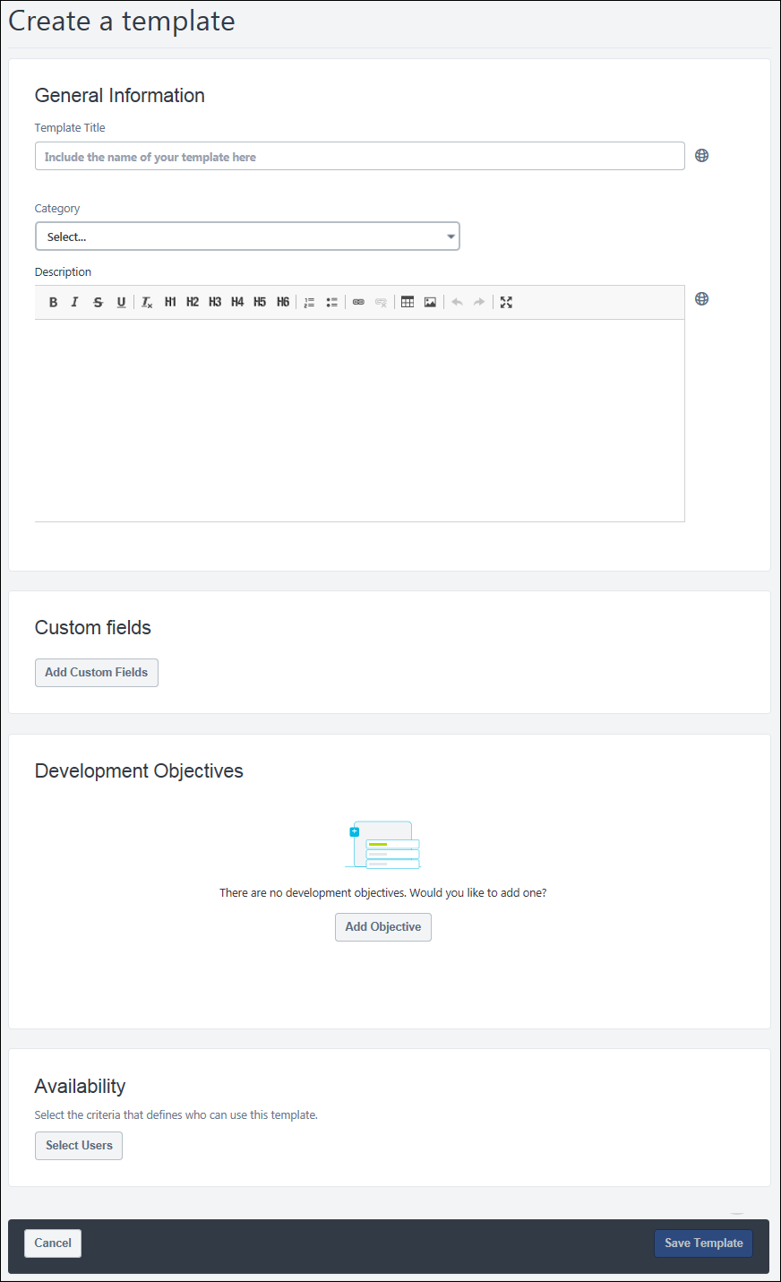
General Information
Begin defining the development plan template by entering the following basic information about the plan:
- Template Title - Enter a title for the development plan template. This title appears on the Development Plan Templates page. The character limit for this field is 3,000 characters. This field is required. If multiple languages are enabled for your portal, select the Translate icon to translate the field into other available languages.
- Category - From the drop-down list, select a category for the development plan template, which is intended to help organize development plans. Selecting a development plan category is optional. Administrators can configure which categories are available to select by configuring the Development Plan Preferences. See Development Plan Preferences on page 12 for additional information.
- Description - Enter an overview of the development plan template, including its purpose or focus. This field can be formatted using the text formatting options. The character limit for this field is 3,000 characters. If multiple languages are enabled for your portal, select the Translate icon to translate the field into other available languages.
Custom Fields
Custom fields can be added to a template by selecting the Add Custom Field button. The selected custom fields are included in any development plan created using this template. The fields must be created first from the Custom Fields area of the system. See Custom Field Admin - Development Plans on page 10 for additional information.
Objectives
Development plans are creating by adding development objectives to outline what you are trying to achieve in your development plan. Objectives are the target areas of the plan. For example, if you are creating a development plan to improve your communication skills, you may create an objective to improve your writing skills. This objective should contain all of the training and actions you need to complete in order to achieve the objective, such as completing writing classes or shadowing a writer at your organization.
To add an objective to the development plan template, select the Add Objective button. This opens the Add Development Objective page where you can define the objective. Begin by providing an overview of the objective:
- Objective Title - Enter a title for the development plan. This title appears on your Snapshot: Development Plans page as well as anywhere else your plan is visible. The character limit for this field is 3,000 characters. For portals with multiple languages enabled, use the Translate icon to localize the title. This field is required.
- Category - From the drop-down list, select a category for the objective, which is intended to help organize development plan objectives. Selecting an objective category is optional. If there no categories available, then this drop-down is hidden. Administrators can configure which categories are available to select by configuring the Development Plan Preferences. See Development Plan Preferences on page 12 for additional information.
- Learning and Development - This section provides different ways for you to add learning and development actions to your plan. The following options may be available:
  - Search for Learning - Select this option to search for learning opportunities that may support your development objective. See the Add Objective - Search for Learning section below for additional information.
  - Add Development Action - Select this option to add an action step that is required to achieve the development objective. See the Add Objective - Add Development Action section below for additional information.
After defining the objective, select one of the following options:
- Save and Return to Plan - Select this button to save the objective and return to the Create a Plan page.
- Save and Add Another - Select this button to save the objective and begin adding another objective to the plan.
Add Objective - Search for Learning
The Search for Learning option is only available to organizations using the Learning functionality. Select this option to search for learning opportunities that may support your development objective. For example, if you are creating an objective to improve your writing skills, you may search for online classes related to writing. The following learning types cannot be added to a development plan: Certification, Cohort, and Playlist.
To search for learning items:
- In the Learning and Development section, select the Search for Learning button.
- From the Add Learning page, select the Add to Objective link for each item you want to add. If a learning item is already in the plan, then "Included in Plan" is displayed.
- Select the Return to Objective button to add the selected items to your development plan.
- Set a due date for the item by selecting the Due Date field. Administrators can configure the default due date by configuring the Development Plan Preferences. See Development Plan Preferences on page 12 for additional information.
  - Note: The overall due date for a development plan is the latest due date for any objective within the development plan. The due date for an objective is the latest due date for any learning item or action step within the objective.
Add Objective - Add Development Action
Select this option to add an action step that is required to achieve the development objective. For example, if you are creating an objective to improve your writing skills, you may add a development action to shadow the Technical Writer in your organization for one hour to learn some of their best practices.
To add a development action:
- In the Learning and Development section, select the Add Development Action button.
- From the Development Action flyout, enter the following information:
  - Description - Enter a description of an action that must be completed to achieve the objective. The character limit is 3,000.
  - Activity Type - From the drop-down menu, select the activity type that corresponds with the action you are adding.
  - Due Date - Set a due date for the item by selecting the Due Date field. Administrators can configure the default due date by configuring the Development Plan Preferences. See Development Plan Preferences on page 12 for additional information.
    - Note: The overall due date for a development plan is the latest due date for any objective within the development plan. The due date for an objective is the latest due date for any learning item or action step within the objective.
  - Progress - If there is already progress made on the action step at the time it is added to the plan, you may update the percentage complete at that time. If the step has not been started, enter 0, and if the step is complete, enter 100.
- Select the Done button to save the development action.
Availability
This section enables you to determine which users can create a development plan using this template.
Select the Select Users button to open the Select Users flyout. From the drop-down menu, select the user criteria type, such as User, Group, and OU type. You can select any combination of criteria to create the availability, and the selected criteria appear in the Selected tab.
Save Template / Cancel
When you are finished creating the template, select the Save Template button. The template will be available to users who are within the configured availability.
To discard the template or any unsaved changes, select the Cancel button.

User Development Plans Overview

Snapshot - Development Plans
The Snapshot Development Plans page enables users to view, create, and manage their development plans.
The Snapshot Development Plans page can be accessed in the following ways:
- Go to Performance > Development Plans.
- Go to Home > Universal Profile. Select the Snapshot tab. Then, select the Development Plans widget.
Permissions
PERMISSION NAME | PERMISSION DESCRIPTION | CATEGORY

Development Plans - Approve | Grants ability to approve or deny development plans that are pending the user's approval. This is a manager/approver permission. | Performance

Snapshot - Development Plans | Enables user to view the Development Plans widget and subpage within the Universal Profile - Snapshot page for users within their permission constraints. This permission can be constrained by OU, User's OU, User Self and Subordinates, User, User's Self, User's Manager, User's Superiors, User's Subordinates, User's Direct Reports, and Employee Relationship. Best Practice: For most users, this permission should be constrained by User Self and Subordinates. | Universal Profile
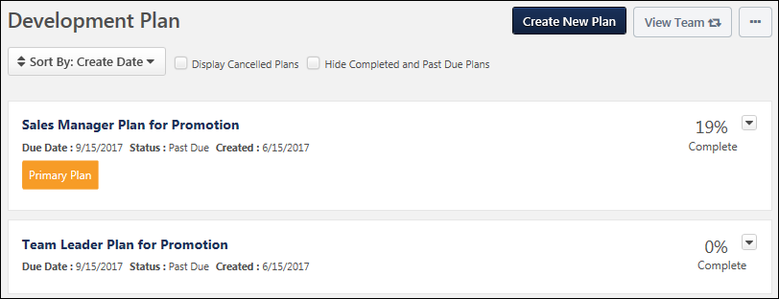
Create New Plan/Create New Plan From Template
- Select the Create New Plan button to create a new development plan. See Create/Edit Development Plan on page 39 for additional information.
- Select the Create New Plan From Template button to create a new development plan using a pre-defined template.
Permission Note: The "Snapshot - Development Plans" permission enables users to access the Development Plans page and view the Create New Plan button. However, users must also have the "Development Plans - Manage" permission to create a development plan.
This button is only available when viewing your own Snapshot: Development Plans page.
View Team
The View Team flyout allows managers, approvers, and custom relationships to quickly navigate between subordinates' profiles and transcripts. When enabled, the View Team flyout is available to managers and dotted line managers on all pages of their Universal Profile and the Universal Profile of their subordinates. This flyout displays the manager's reports visually.
The View Team button displays if enabled in the portal. Administrators may enable or disable this flyout via the My Team Dropdown section within Universal Profile General Preferences. See Universal Profile General Preferences.
See Universal Profile - View Team Flyout.
Options
The following options are available in the Options drop-down menu:
- Create Plan from Template - Select this option to create a development plan from a template. This option is only available if development plan templates are enabled in Development Plan Preferences and if at least one development plan template is available to the user. See Create Development Plan from Template on page 47 for additional information.
- Approve Plans - Select this option to approve development plans. This option is only available if development plans require approval. Also, this option is only available to users who are responsible for approving development plans. See Approve Development Plans on page 54 for additional information.
Primary Plan
If the user has multiple plans, the user's primary plan is displayed separately above the user's other development plans.
A read-only progress bar is displayed for the primary plan to visually and prominently show the primary plan progress. The numeric representation of the progress is displayed below the progress bar.
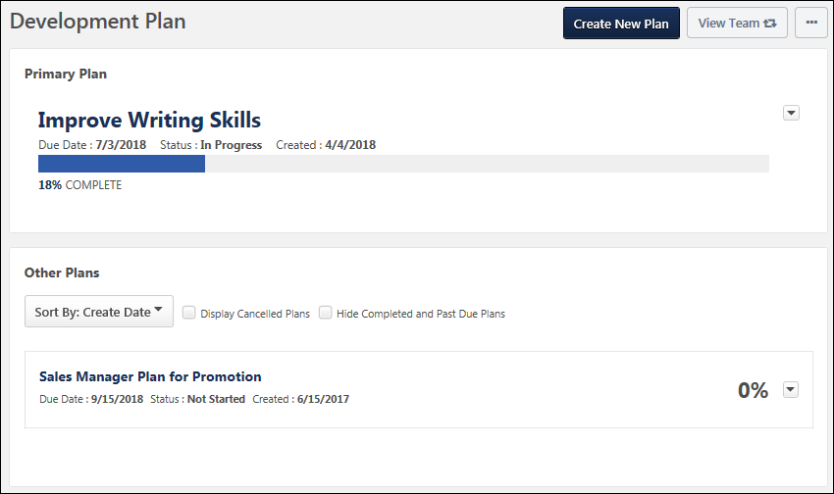
Other Plans
This section displays all other development plans for the user. Plans can be sorted, and the due date, status, and creation date displays for each. Plan actions are also available in the Plan Actions menu. See the below sections for more information.
Sort By
The table of reviews can be sorted using the following sorting options within the Sort By drop-down menu at the top of the Reviews section:
- Create Date - Select this option to sort the plans in chronological order by creation date, with the oldest creation date displayed first. Plans with the same creation date are then sorted alphabetically.
- Due Date - Select this option to sort the plans in chronological order by due date, with the plan with the soonest due date displayed first. Plans that are completed are listed after plans with a due date, with the most recently completed plan displayed first. Plans with the same due date are then sorted alphabetically.
- Status - Select this option to sort the plans by status. Plans with the same status are then sorted alphabetically. Plans are sorted in the following status order:
  - Not Started
  - In Progress
  - Completed
  - Incomplete
Display Cancelled Plans
Select this option to refresh the page and include development plans with a status of Cancelled. When this option is unselected, plans with a status of Cancelled are hidden.
Hide Completed and Past Due Plans
Select this option to refresh the page and hide development plans with a status of Completed or Past Due. When this option is unselected, plans with a status of Completed or Past Due are displayed.
Plans List
Note: Development plans in a status of Deleted are not displayed on the Development Plans page
The following information is displayed for each plan in the Development Plans list:
- Plan Title - Users can select the plan title to view the details of the development plan. See Manage/View Development Plan on page 49 for additional information.
- Status
- Date Created
- Due Date
- Primary Plan - The Primary Plan label appears below the Due Date value for the development plan that is designated as the user's primary plan. Users can designate their primary plan using the Actions drop-down menu to the right of the appropriate plan.
- Percentage Complete - This displays the completion percentage for the development plan.
Plan Actions
Note: Actions are only available for In Progress development plans.
The following plan actions may be available from the actions drop-down menu to the right of the plan:
- View - Select this option to view the Development Plan Details page for the selected development plan. See Manage/View Development Plan on page 49 for additional information.
- Edit - Select this option to edit the development plan. This action is only available to users when viewing their own Development Plans page. This action is not available when viewing another user's Development Plans page. See Create/Edit Development Plan on page 39 for additional information.
If editing a completed plan that requires approval, then editing a plan in Completed status puts the plan in Pending Acceptance Approval or Pending Completion Approval status. The ability to edit a Completed development plan is controlled within Development Plan Preferences. See Development Plan Preferences on page 12 for additional information.
- Cancel - Select this option to cancel the development plan. A confirmation pop-up appears when this option is selected. This action is only available when viewing your own Development Plans page. You can cancel any of your development plans, even your primary plan. This action is not available when viewing another user's Development Plans page.
- Delete - Select this option to delete the draft development plan. This option is only available for draft development plans. A confirmation pop-up appears when this option is selected.
- Export to PDF - Select this option to export the selected development plan as a PDF. This action is only available to users when viewing their own Development Plans page. This action is not available when viewing another user's Development Plans page.
- Designate as Primary Plan - Select this option to designate the plan as the primary plan.

Create/Edit Development Plan
Employees can collaborate online with their managers to create objective-based development plans and can also design a career path by determining proactive developmental activities and tracking and measuring targeted improvements that coincide with an employee's development plan.
Permission Note: The "Snapshot - Development Plans" permission enables users to access the Development Plans page and view the Create New Plan button. However, users must also have the "Development Plans - Manage" permission to create a development plan.
Navigation Warning Message: When creating or editing a development plan or development plan template, if you navigate away from the page without saving your changes, a confirmation pop-up opens to notify you that any unsaved changes will be lost. The pop-up gives you the option to leave the page and lose your unsaved changes, or stay on the page to avoid losing your unsaved changes.
- To create a development plan, go to Performance > Development Plans, and click the Create New Plan button.
- To edit a development plan, go to Performance > Development Plans. Next to the appropriate development plan, select the Options drop-down icon , and select Edit.
Permissions
PERMISSION NAME | PERMISSION DESCRIPTION | CATEGORY

Assign OU Development Plans | Grants ability to create and assign Development Plans to all users within specified organizational units or custom groups. This is an administrator permission. | Performance - Administration

Development Plans - Edit | Grants ability for user to edit a development plan when the Redesigned Development Plans functionality is enabled. The permission constraints determine whose development plans the user can edit. This permission can be constrained by OU, User's OU, User's Self, and User Self and Subordinates. This is an end user permission. | Performance

My Competency Assessments | Enables users to view their own competency assessment results from the Competency Assessment Results screen. In addition, when creating a development plan and adding an objective to the plan, this permission enables users to browse recommended training and developmental actions from competency models, when this functionality is enabled in Development Plan Preferences. This is an end user permission. | Performance

Recommended Learning - View Recommended Learning for Others | Grants ability to view the recommended learning that is generated by machine learning for another user. The availability of this permission is controlled by a backend setting. This permission can be constrained by OU. This is a manager permission. | Performance

Snapshot - Development Plans | Enables user to view the Development Plans widget and subpage within the Universal Profile - Snapshot page for users within their permission constraints. This permission can be constrained by OU, User's OU, User Self and Subordinates, User, User's Self, User's Manager, User's Superiors, User's Subordinates, User's Direct Reports, and Employee Relationship. Best Practice: For most users, this permission should be constrained by User Self and Subordinates. | Universal Profile
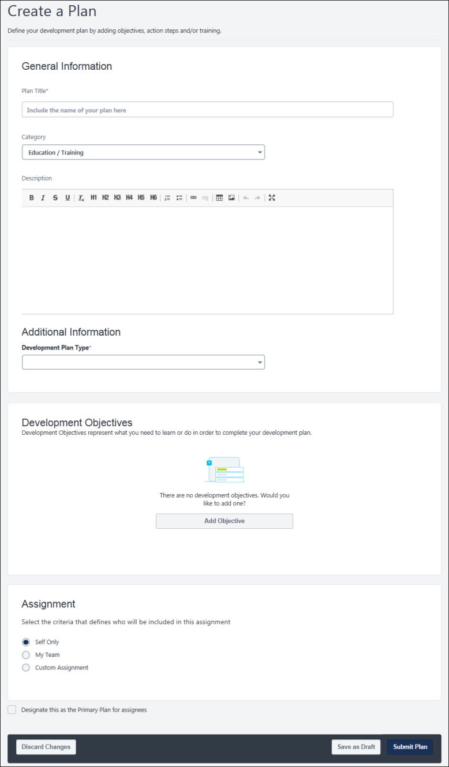
General Information
Begin defining the development plan by entering the following basic information about the plan:
- Plan Title - Title for the development plan. This title appears on your Snapshot: Development Plans page as well as anywhere else your plan is visible. The character limit for this field is 3,000 characters. This field is required.
- Category - Category for the development plan, which is intended to help organize development plans. Selecting a development plan category is optional. If no categories are available, then this field is hidden. Administrators can configure which categories are available to select by configuring the Development Plan Preferences.
- Description - Overview of the development plan, including its purpose or focus. This field can be formatted using the text formatting options. The character limit for this field is 3,000 characters.
Additional Information
An Additional Information section may appear containing additional questions that must be answered.
Administrator Note: When creating a plan from a template, the custom fields within the template override any custom fields that are configured within Development Plan Preferences.
Add Development Objective
Development plans are creating by adding development objectives to outline what you are trying to achieve in your development plan. Objectives are the target areas of the plan. For example, if you are creating a development plan to improve your communication skills, you may create an objective to improve your writing skills. This objective should contain all of the training and actions you need to complete in order to achieve the objective, such as completing writing classes or shadowing a writer at your organization.
To add an objective to the development plan:
- Select the Add Objective button. This opens the Add Development Objective page to define the objective. Complete the following fields:
  - Objective Title - Title for the development plan. This title appears on your Snapshot: Development Plans page as well as anywhere else your plan is visible. The character limit for this field is 3,000 characters. For portals with multiple languages enabled, use the Translate icon to localize the title. This field is required.
  - Category - Category for the objective, which is intended to help organize development plan objectives. Selecting an objective category is optional. If there no categories available, then this drop-down is hidden. Administrators can configure which categories are available to select by configuring the Development Plan Preferences.
  - Learning and Development - Add learning and development actions to your plan. The following options may be available:
    - Search for Learning - Select this option to search for learning opportunities that may support your development objective. See the Add Objective - Search for Learning section below for additional information.
    - Browse Recommended - Select this option to browse all recommended learning and development actions that may support your development objective. See the Add Objective - Browse Recommended section below for additional information.
    - Add Development Action - Select this option to add an action step that is required to achieve the development objective. See the Add Objective - Add Development Action section below for additional information.
- Select one of the following options:
  - Save and Return to Plan - Save the objective and return to the Create a Plan page.
  - Save and Add Another - Save the objective and begin adding another objective to the plan.
Add Objective - Search for Learning
The Search for Learning option is only available to organizations using the Learning functionality. Select this option to search for learning opportunities that may support your development objective. For example, if you are creating an objective to improve your writing skills, you may search for online classes related to writing. The following learning types cannot be added to a development plan: Certification, Cohort, and Playlist.
To search for learning items:
- In the Learning and Development section, select the Search for Learning button.
- From the Add Learning page, select the Add to Objective link for each item you want to add. If a learning item is already in the plan, then "Included in Plan" is displayed.
- Select the Return to Objective button to add the selected items to your development plan.
- Set a due date for the item by selecting the Due Date field. Administrators can configure the default due date by configuring the Development Plan Preferences. See Development Plan Preferences on page 12 for additional information.
  - Note: The overall due date for a development plan is the latest due date for any objective within the development plan. The due date for an objective is the latest due date for any learning item or action step within the objective.
Add Objective - Browse Recommended
The Browse Recommended option is only available if administrators enabled recommendations in Development Plan Preferences. Select this option to browse all recommended learning and development actions that may support your development objective. Recommendations may be based on competency assessments or machine learning. For example, if you have already completed learning items related to business writing, then the system may recommend similar learning items.
To browse recommended learning and development actions:
- In the Learning and Development section, select the Browse Recommended button. On the Recommended Learning & Development Actions page, various carousels of recommendations may be displayed. When editing another user's development plan, the editor can only view recommended learning for another user if they have the appropriate permission.
- Select the Add to Objective link for each item you want to add. If a learning item is already in the plan, then "Included in Plan" is displayed.
- At the top of the page, review the Display Recommendations from option displays all potential sources for recommended training and development actions.
- Select or deselect options to control which recommendations are displayed. Administrators can configure which recommendation sources are available by configuring the Development Plan Preferences. See Development Plan Preferences on page 12 for additional information. The following options may be available:
    - Competency Model - When this option is selected, the page displays a carousel of recommended training and development actions based on a specific competency model even if the user was not assessed using the model. Up to 25 items are available in the carousel. The name of the competency model that is used for the recommendations is displayed above the carousel. By default, the alphanumerically first competency model that is available to the user who is creating the plan is selected. If no competency models are available to the user who is creating the plan, then no competency model carousel is displayed.
      - To select a different competency model, select the Choose Model link below the Competency Model checkbox. This opens the Competency Model flyout, in which you can select a different competency model. The flyout displays all competency models. You can filter the available competency models by category using the Category drop-down menu. Note: If you change competency models, all selections from the original competency model are lost unless they were added to the objective.
    - Competency Assessments - When this option is selected, the page displays a carousel of recommended training based on the results of the user's completed competency assessments. Note: When the Competency Models or Competency Assessment checkboxes are checked, the related carousels will populate with learning objects associated to the Competency Model/Assessment, even if the user is not within the availability of the learning object.
    - Machine Learning - When this option is selected, the page displays a carousel of recommended training based on machine learning, such as training based on the user's position, training the user has saved for later, or recommendations based on the user's learning history.
      - Development plans support the following carousel types, if enabled: Saved for Later, Top Picks for User, Trending for Your Position, Inspired by Your Subjects, Most Popular.
      - The functionality of these carousels mirror the functionality that is available in Learner Home. See Learner Home - Training and Banner Carousels.
- Select the Return to Objective button to add the selected items to your development plan.
- Set a due date for the item by selecting the Due Date field. Administrators can configure the default due date by configuring the Development Plan Preferences.
  - Note: The overall due date for a development plan is the latest due date for any objective within the development plan. The due date for an objective is the latest due date for any learning item or action step within the objective.
  - Competency Assessments - When this option is selected, the page displays a carousel of recommended training based on the results of the user's completed competency assessments.
Add Objective - Add Development Action
Select this option to add an action step that is required to achieve the development objective. For example, if you are creating an objective to improve your writing skills, you may add a development action to shadow the Technical Writer in your organization for one hour to learn some of their best practices.
To add a development action:
- In the Learning and Development section, select the Add Development Action button.
- From the Development Action flyout, enter the following information:
  - Description - Enter a description of an action that must be completed to achieve the objective. The character limit is 3,000.
  - Activity Type - From the drop-down menu, select the activity type that corresponds with the action you are adding.
  - Due Date - Set a due date for the item by selecting the Due Date field. Administrators can configure the default due date by configuring the Development Plan Preferences. See Development Plan Preferences on page 12 for additional information.
    - Note: The overall due date for a development plan is the latest due date for any objective within the development plan. The due date for an objective is the latest due date for any learning item or action step within the objective.
  - Progress - If there is already progress made on the action step at the time it is added to the plan, you may update the percentage complete at that time. If the step has not been started, enter 0, and if the step is complete, enter 100.
- Select the Done button to save the development action.
Assignment
Depending on your role in the organization and your security permissions, you may be able to assign a development plan to other users. This section enables you to determine who is assigned the development plan.
Note: You can only edit this section when editing the plan in Draft status.
Note: When creating a development plan from a talent pool, the Assignment information is automatically set to the users in the talent pool. With this enhancement, the Assignment information cannot be edited, including the Include Subordinates option. This helps ensure the assignment matches the users within the talent pool.
The following assignment options may be available:
- Self Only - Select this option to only assign the plan to you.
- My Team - Select this option to assign the plan to members of your team, which may include you.
- Custom Assignment - Select this option to assign the plan to any combination of users, organizational units (OUs), and groups.
Assignment - My Team
Select this option to assign the plan to members of your team, which may include you. This option is only available if you are a manager with direct reports. Administrators can prevent managers from assigning a development plan to their direct reports by configuring the Development Plan Preferences.
When this option is selected, a table displays all of your direct reports, alphabetized by last name.
- Select the Include Self checkbox to include yourself in the assignment.
- Select the My Team checkbox to automatically select all users on your team.
- Select the checkbox to the left of a direct report to assign the development plan to the user. All direct reports are selected by default.
  - To select all direct reports, select the My Team checkbox. To deselect all direct reports, deselect this checkbox.
- To include a direct report's subordinates in the assignment, select the Include Subordinates checkbox to the right of the user.
  - This option can only be selected for direct reports who are already selected. If a direct report is not selected, the Include Subordinates option for that direct report cannot be selected.
  - To include the subordinates for all selected direct reports, select the Include All checkbox.
Assignment - Custom Assignment
Select this option to assign the plan to any combination of users, organizational units (OUs), and groups.
When this option is selected, a Select Users button is available. Select this button to open the Select Users flyout. From the drop-down menu, select the user criteria type, such as User, Group, and OU type. You can select any combination of criteria to create the assignment, and the selected criteria appear in the Selected tab. You must have permission to assign OU development plans to select an OU type as a criterion.
Designate this as the Primary Plan for Assignees
Select this option to automatically set this development plan as the primary plan for all users who are assigned the plan. This option is only available until the plan is submitted.
Submit Plan / Save as Draft / Discard Changes
When you are finished creating your plan, select the Submit Plan button to send your development plan to the appropriate approving user; the plan status is Pending Approval. If approval is not required, the plan is automatically approved.
If you are creating a plan, but are not ready to submit, select the Save as Draft button. This saves the plan in Draft status and you may continue editing it prior to submission.
To discard the plan or any unsaved changes, select the Discard Changes button.
Navigation Warning: When creating or editing a development plan or development plan template, if you navigate away from the page without saving your changes, a confirmation pop-up opens to notify you that any unsaved changes will be lost. The pop-up gives you the option to leave the page and lose your unsaved changes, or stay on the page to avoid losing your unsaved changes.
Frequently Asked Questions
How does training status work for training items in a development plan?
When viewing training items within a development plan, the training status within the development plan matches the training status within the user's transcript. However, if the training item is completed within the development plan, then the status of that item remains Completed.
What happens if the version of a training item changes while the training is in a development plan?
If a training item version is updated while the item is within a development plan, the newest version of the item is utilized in the development plan unless the item is completed. This will reset progress when a new version is created for a material, online course, or test.

Create Development Plan from Template
Use development plan templates to create a predefined development plan, including objectives, training, and action items that a user can access and then modify to match their specific needs. When creating a template, the administrator selects a specific user population that can view and request the template. For example, if an administrator is creating a development plan template for managers, they can configure the availability so that it is only available to managers.
When development plan templates are created and made available, you can use them to create other development plans. When you select a plan template, all of the information in the template is added to a development plan, and you can modify or remove any of the objectives, learning items, or action steps. The development plan name, description, etc. default to those of the template, but you may modify them as appropriate.
To create a development plan using a template, go to Performance > Development Plans. Select the Options button, and then select the Create Plan from Template link. This option is not available if no templates are available.
Permissions
PERMISSION NAME | PERMISSION DESCRIPTION | CATEGORY

Assign OU Development Plans | Grants ability to create and assign Development Plans to all users within specified organizational units or custom groups. This is an administrator permission. | Performance - Administration

Snapshot - Development Plans | Enables user to view the Development Plans widget and subpage within the Universal Profile - Snapshot page for users within their permission constraints. This permission can be constrained by OU, User's OU, User Self and Subordinates, User, User's Self, User's Manager, User's Superiors, User's Subordinates, User's Direct Reports, and Employee Relationship. Best Practice: For most users, this permission should be constrained by User Self and Subordinates. | Universal Profile
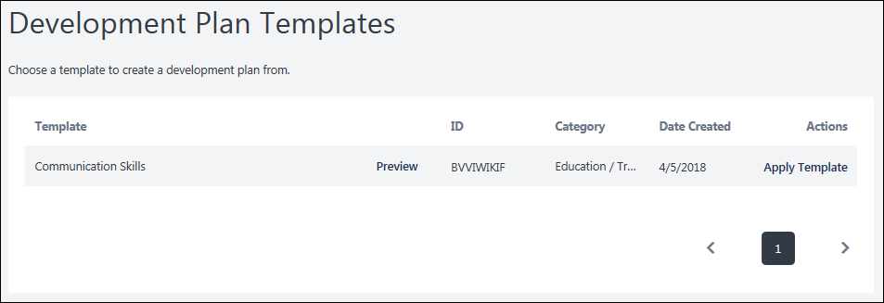
Template Table
- Template - The name of the template.
- Preview - Select the Preview link for the template to view a template before selecting it. A preview of the template opens in a flyout. Select the Apply button create a development plan from the template.
- ID - The identification number for the template. This number is system-generated.
- Category - The type of template.
- Date Created - The date the template was created.
- Actions - Select the Apply Template link to select this template. This creates a new development plan with the information contained in the selected template. You can then modify or remove the information as needed. Any custom fields added to the template appear in the plan, which overrides any custom fields added via Development Plan Preferences.
See Create/Edit Development Plan on page 39 for additional information.

Manage/View Development Plan
Use the Manage Plan page to view overall progress, edit the plan, launch learning items, update plan progress, view and add comments, and add attachments.
To manage an existing development plan, go to Performance > Development Plans. Then, select the title link for the development plan.
Emails
EMAIL NAME | EMAIL DESCRIPTION | ACTION TYPE

Development Plan Comment Added | This email is triggered when a comment is added to a user's development plan. This includes a comment added to the plan, a comment added to an objective, or when any comment receives a reply. This email is not triggered when the designated email recipient is the user who added the comment. For example, if the triggers is configured to send to the approver and the approver adds a comment to the plan, then this email is not triggered since the intended recipient is the one who added the comment. This email is available within the Performance Management action type, and it can be sent as a Notification to Dev Plan Approver or Dev Plan User.  The following tags are available for this email trigger:  - DEVPLAN.APPROVER.FIRST.NAME - This displays the development plan approver's first name.  - DEVPLAN.APPROVER.LAST.NAME - This displays the development plan approver's last name.  - DEVPLAN.TITLE - This displays the development plan title.  - DEVPLAN.LINK - This displays a link to access the development plan.  - DEVPLAN.USER.FIRST.NAME - This displays the development plan user's first name.  - DEVPLAN.USER.LAST.NAME - This displays the development plan user's last name.  - USER.FIRST.NAME - This displays the recipient's first name.  - USER.LAST.NAME - This displays the recipient's last name. | Performance Management
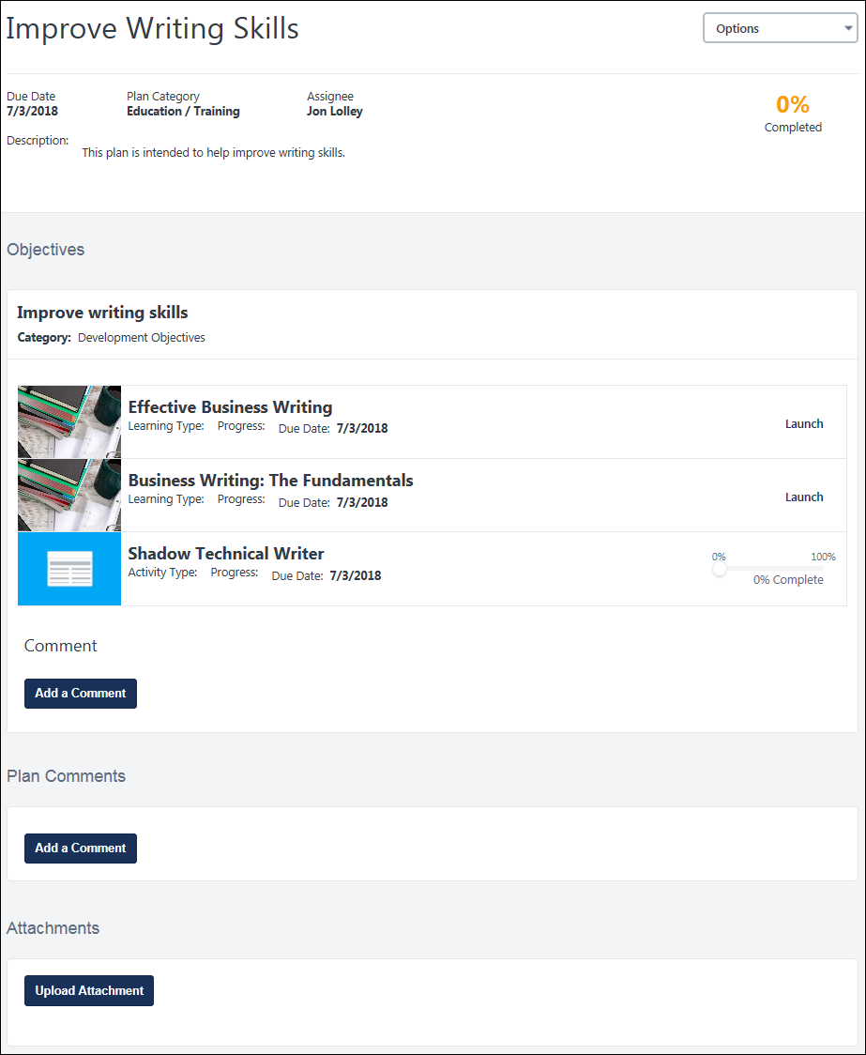
Options
The following options may be available in the Options menu:
- Edit Development Plan - Select this option to edit the details of the plan, such as title, category, description, and objectives. See Create/Edit Development Plan on page 39 for additional information.
This option is also available for users who can edit a development plan that is in a Completed or Pending Completion Approval status. If approvals are required, then editing a plan in Completed status puts the plan in Pending Acceptance Approval or Pending Completion Approval status. The ability to edit a Completed development plan is controlled within Development Plan Preferences.
- Print - This option generates a PDF of the development plan. The PDF includes all plan information, custom fields, objectives, comments, and attachment details.
Plan Overview
At the top of the page, an overview of the development plan is displayed. This includes the following information:
- Due Date - Note: The overall due date for a development plan is the latest due date for any objective within the development plan. The due date for an objective is the latest due date for any learning item or action step within the objective.
- Plan Category
- Assignee
- Description
- Progress
Objectives
This section displays each of the plan's objectives, including the learning items and action steps within the objective.
When managing training within your own development plan, you can perform all of the actions available for the transcript. The primary action for the training item displays as a link, and any additional options are available within an Options menu next to the primary action. When viewing another user's development plan, only the View action is available, and this opens the LO Details page for the training item.
The transcript status is only visible to you, so if you are viewing your own development plan, training Progress shows the transcript status. If you are looking at a subordinate's development plan, you will just see the basic progress statuses of Not Completed or Completed.
- To access a learning item, select the Launch link next to the item.
- To update the progress for an action item, using the progress slider next to the item. When you update the progress, this action is automatically saved by the system, and a confirmation message appears at the top of the page.
- to add comments to an objective, click Add a Comment. These comments should be specific to the objective. The character limit for comments is 5,000. This option is only available if enabled by the administrator in Development Plan Preferences. See Development Plan Preferences on page 12 for additional information.
Note: For Learning Objects (LOs) in Development Objectives, if no training actions are available, the options menu is not visible.
Plan Comments
You can add or reply to comments.
- To add a comment, click Add a Comment button in the Plan Comments section. For example, you may add a comment to explain your recent efforts toward this plan. You manager can then reply to your comments or they can add an unrelated comment. The character limit for comments is 5,000. This option is only available if enabled by the administrator in Development Plan Preferences. See Development Plan Preferences on page 12 for additional information.
- To reply to a comment, select the Reply link below the comment. You can also edit or delete your own comment by selecting the appropriate link. A comment cannot be deleted if there are replies to the comment.
Attachments
You can attach files to your development plan when managing the plan. Each plan is limited to 25MB of attached items or 50 files. Whichever limit is reached first is applied, and no additional attachments are allowed.
The following file types are supported:
- Audio:
  - mid
  - m4a
  - mp3
  - wav
- Compressed
  - zip
- Data
  - xls/xlsx
- Image
  - bmp
  - gif
  - jpeg/jpg
  - png
- Presentation
  - pps/ppsx
  - ppt/pptx
- Project
  - mpp
- Recording
  - arf
- Text
  - doc/docx
  - dot/dotx
  - htm/html - The ability to upload htm/html files is controlled by a backend setting.
  - pdf
  - txt
  - csv
  - rtf
- Video
  - avi
  - flv
  - m4v
  - mpeg/mpg
  - mp4
  - rm
  - wma/wmv
Development Plan History
The History section displays the five most recent modifications to the development plan. Modifications are displayed in chronological order with the most recent events displayed first. Each entry in the History section displays the modification type (created, modified, attachment added, etc.), the date and time at which the modification was made, and the name of the user who modified the plan.
If more than five modifications have been made to the plan, then a Show More link is available. Select this link to view all modifications for the plan.

Approve Development Plans
Use the Development Plan Approval page to manage all development plans that are pending your acceptance, cancellation, or completion approval. You have the option to approve or deny each request individually or in bulk.
To access the Development Plan Approval page:
- From the Welcome Page Inbox, click the View Development Plans link. The Inbox link indicates how many development plans are pending your approval.
- From the Snapshot Development Plans page, select the Approve Plans option from the Options menu.
Note: These options are not available if development plans do not require approval or if you are not responsible for approving development plans.
Permissions
PERMISSION NAME | PERMISSION DESCRIPTION | CATEGORY

Development Plans - Approve | Grants ability to approve or deny development plans that are pending the user's approval. This is a manager/approver permission. | Performance

Bypass Development Plan Approval During Assignment | Grants permission to bypass any development plan approval requirements when submitting or assigning a development plan. This permission does not apply to development plans as part of Reviews. This is a system administration permission. | Performance
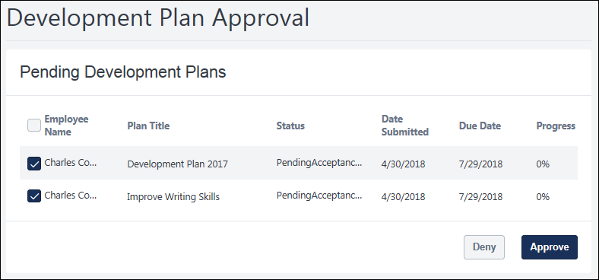
Pending Development Plans Table
- Employee Name - Approve or deny all plans in bulk by selecting the checkbox at the top of the Employee Name column. This Select All checkbox is only available if enabled by the system administrator.
- Plan Title - The title of the plan. Click the title to open the development plan in a new browser tab. This enables you to review the content of the plan. You can approve or deny the plan while viewing it.
- Status - The plan's status options are as follows:
  - Plan Denied - If the plan was denied, then the plan's status is Plan Denied.
  - Not Started - If the plan was approved and progress is 0%, then the plan's status is Not Started.
  - In Progress - If the plan was approved and progress is greater than 0% but less than 100%, then the plan's status is In Progress.
  - Pending Completion Approval - If the plan was approved and progress is 100%, then the plan's status is Pending Completion Approval.
  - Past Due - If the plan was approved and it is past the due date, then the plan's status is Past Due.
  - Cancelled - If the plan was Pending Cancellation Approval and this request was approved, then the plan's status is Cancelled.
- Date submitted - The date the plan is submitted for approval.
- Due Date - The deadline to approve the development plan.
- Progress - Percent complete for the development plan.
Approve/Deny
- To approve a plan, select the checkbox to the left of the employee's name, and then select the Approve.
- To deny a plan, select the checkbox to the left of the employee's name, and then select the Deny.

