Data Load Wizard March 2024

Table of Contents
Load Data Overview 1
Load Group Data Overview 3
Load Group Data - Step 1 - Get Started 4
Load Group Data - Step 2 - Upload 5
Load Group Data - Step 3 - Review 8
Load Group Data - Step 4 - Processing Options 10
Load Group Data - Step 5 - Validate 11
Load Group Data - Template and Validations 14
Load OU Data Overview 17
Load OU Data - Step 1 - Get Started 18
Load OU Data - Step 2 - Select OU Type 19
Load OU Data - Step 3 - Upload 20
Load OU Data - Step 4 - Review 23
Load OU Data - Step 5 - Processing Options 25
Load OU Data - Step 6 - Validate 26
Performance Data Load Overview 29
Load Competency Bank Data 30
Load Resume Data Overview 52
Load Resume Data - Step 1 - Get Started 53
Load Resume Data - Step 2 - Select Type 55
Load Resume Data - Step 3 - Upload 56
Load Resume Data - Step 4 - Review 59
Load Resume Data - Step 5 - Processing Options 61
Load Resume Data - Step 6 - Validate 62
Track Data Loads Overview 65
Data Load Queue 66
Data Load Queue - View Load Details 68
Data Load Queue - View Excel Error Report 70
User Data Load Overview 72
Load User Data Overview 73
Cornerstone HR - Load User Data - Overview 88
Data Load Wizard Templates Overview 103
Load Data - Select Data Load Template 104
Manage Templates 106
Data Load Wizard Template Codes 108
Load Data - Get Existing Data 124
Load Data Statuses 125

Load Data Overview
The Data Load Wizard enables organizations to upload a list or table of information into the system, eliminating the need to manually insert individual records. Data can be loaded to different parts of the system with a consistent process, allowing you to upload, review, and import data.
The Data Load Wizard can import new records or adjustments and export existing data in multiple file formats (.xls, .xlsx .csv, .txt). Note: Files loaded via the Data Load Wizard cannot contain HTML encoding. Editable templates and helpful hints guides are available for each file type for accurate importing.
Reporting is available to provide information regarding error logs and counts of records that are added or updated.
To start the Data Load Wizard, go to Admin > Tools > Core Functions > Data Load Wizard, and then click Load Data. The Data Load Wizard opens to the Get Started tab. Select the type of data you are loading and click Next. The available types of data to load are:
User/OU Load Deprecation
Ability to perform Users and OU data loads and feeds using Data Load Wizard (DLW) was deprecated with an end-of-life in the May ‘22 Release for most customers. End-of-support for most customers occurred in the February ‘22 Release and support for defects related to DLW Users and OU loads and feeds also stopped at this time.
Important: For customers using the following Data Load Wizard features that are not available in Edge Import, we do not recommend migration of Inbound Data Feed (IDF) for Users and OUs from Data Load Wizard to Edge Import at this time:
- Sensitive Personally Identifiable Information (SPII) fields - Date of Birth/SSN
Customers using the above features will be informed when these features are available in Edge Import and will be given at least three months to deprecate.
Contents
Security
The following permissions relate to the Load Data Wizard functionality:
PERMISSION NAME | PERMISSION DESCRIPTION | CATEGORY

Data Load Wizard - Competency Bank | Enables administrator to load competency bank data via the Data Load Wizard. This permission also enables administrators to track data loads and manage data load templates. This is an administrator permission. | Data Load Wizard

Data Load Wizard - Data Load Queue | Enables administrator to access the Data Load Queue screen, which displays all data loads, including current and past loads. Constraints can be applied to this permission. However, these constraints do not impact which data loads are visible to the administrator. This is an administrator permission. | Data Load Wizard

Data Load Wizard - Group Data Load | Enables administrator to load group data via the Data Load Wizard. This permission also enables administrators to track data loads and manage data load templates. This permission cannot be constrained. This is an administrator permission. | Data Load Wizard

Data Load Wizard - OUs | Enables administrator to load OUs. This permission also enables administrators to track data loads and manage data load templates. This is an administrator permission. | Data Load Wizard

Data Load Wizard - Performance | Enables administrator to load performance data via the Data Load Wizard. This permission also enables administrators to track data loads and manage data load templates. This is an administrator permission. | Data Load Wizard

Data Load Wizard - Resume | Enables administrator to load resume data via the Data Load Wizard. This permission also enables administrators to track data loads and manage data load templates. This is an administrator permission. | Data Load Wizard

Data Load Wizard - Set User Password | Enables administrator to set a default password for new users when loading users. This is an administrator permission. | Data Load Wizard

Data Load Wizard - Users | Enables administrator to load users. This permission also enables administrators to track data loads and manage data load templates. This is an administrator permission. | Data Load Wizard
Note: A user's permissions and constraints to create OUs and users outside of the Data Load Wizard are separate permissions. When assigning these permissions please mimic the constraints of those permissions for a consistent user experience. If an administrator attempts to load data which is restricted to them, they receive an error.

Load Group Data Overview
Ability to perform Users and OU data loads and feeds using Data Load Wizard (DLW) was deprecated with an end-of-life in the May ‘22 Release for most customers. End-of-support for most customers occurred in the February ‘22 Release and support for defects related to DLW Users and OU loads and feeds also stopped at this time.
Important: For customers using the following Data Load Wizard features that are not available in Edge Import, we do not recommend migration of Inbound Data Feed (IDF) for Users and OUs from Data Load Wizard to Edge Import at this time:
- Sensitive Personally Identifiable Information (SPII) fields - Date of Birth/SSN
Customers using the above features will be informed when these features are available in Edge Import and will be given at least three months to deprecate.

Load Group Data - Step 1 - Get Started
When you start the wizard, you can select which type of data you are loading. The maximum number of records that can be uploaded in a file is 50,000.
If you are using the Data Load Wizard to set up your portal, you should begin by loading the organizational units, and then users.
To start the Data Load Wizard, go to Admin > Tools > Core Functions > Data Load Wizard, and then click Load Data. The Data Load Wizard opens to the Get Started tab. Select the Groups option and click Next. When uploading group data, you must first select the type of data you are loading. See Load Group Data - Step 2 - Upload on page 5 for additional information.
Permissions
PERMISSION NAME | PERMISSION DESCRIPTION | CATEGORY

Data Load Wizard - Group Data Load | Enables administrator to load group data via the Data Load Wizard. This permission also enables administrators to track data loads and manage data load templates. This permission cannot be constrained. This is an administrator permission. | Data Load Wizard
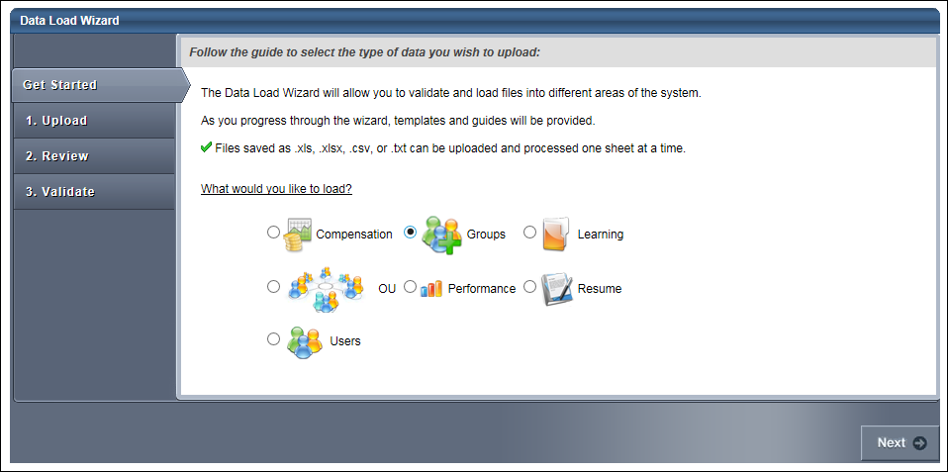

Load Group Data - Step 2 - Upload
If you are uploading new data to the system, first select a template by clicking the Template link in the lower-left corner. This ensures the proper data is included and that it is in the proper format. In the template, columns that are red are required. See Load Data - Select Data Load Template on page 104 for additional information.
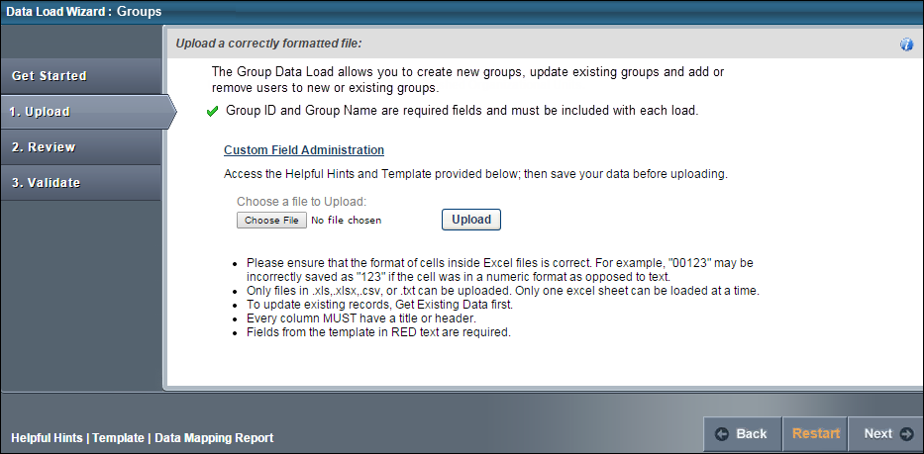
To upload a file of data
- Click the Choose File button and locate the file.
  - You can only upload the following file types: .xls, .xlsx, .csv, .txt.
  - When uploading an Excel file, you can only upload one sheet at a time.
  - Files loaded via the Data Load Wizard cannot contain HTML encoding
- Once the file is selected, click the Upload button. An Upload File pop-up appears with different options depending on the type of file that is uploaded.
  - Excel File (.xls, .xlsx). Select Worksheet (Excel files only) - Only one worksheet can be uploaded at a time, so if the Excel file has multiple worksheets, you must select the worksheet that you are uploading.
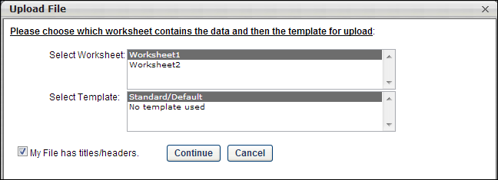
  - Text, Comma, or Pipe Separated File (.txt, .csv). Select Delimiter (Tab, Comma, or Pipe Separated files only) - Select what delimiter (e.g., tab, comma, pipe) is used to separate records within the file. This enables the system to properly extract the data from the file.
- 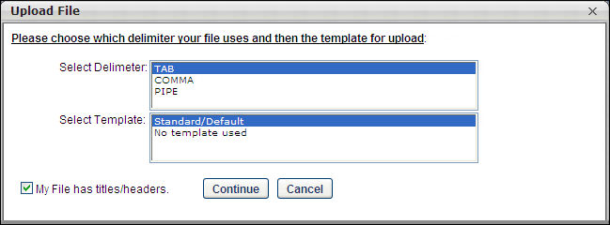
- Select Template - If you used a template to create the file, select the appropriate template. If no template is used, select the "No template used" option. If you have used the Data Load Wizard in the past and saved a template for this file type, that template is available here.
- My File has titles/headers - Data files should have titles or headers for each column of data. If the file you uploaded does not have titles or headers, deselect this option. Deselecting this option modifies the next step in the review process.
- After selecting the appropriate options, click Continue. The file is uploaded and listed on the page.
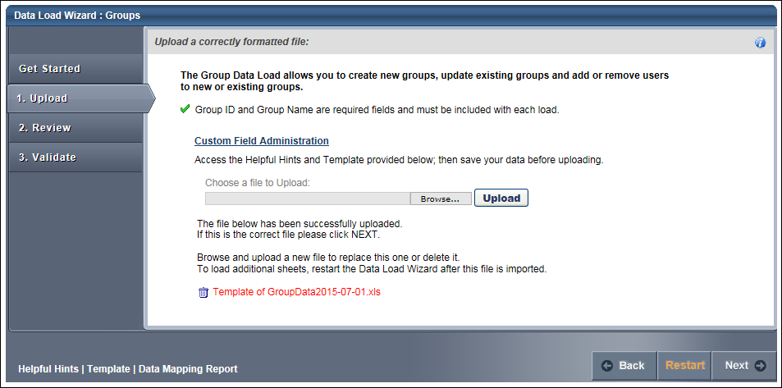
If this is the wrong file or the wrong worksheet within the file, you can delete it by clicking the Remove icon to the left of the file title and upload another file. Alternatively, you can browse and upload a new file. When the correct file is uploaded, click Next to proceed to the Review step. See Load Group Data - Step 3 - Review on page 8 for additional information.

Load Group Data - Step 3 - Review
The Review step of the load process allows you to match the uploaded data to the appropriate data elements within the system.
The wizard automatically reads the headers from the uploaded file and matches some of the data fields to the appropriate system fields. You may adjust the data fields as necessary and also move any unmatched fields to the appropriate system field. Once the fields are all matched, you have the option to save the settings as a template for future uploads.
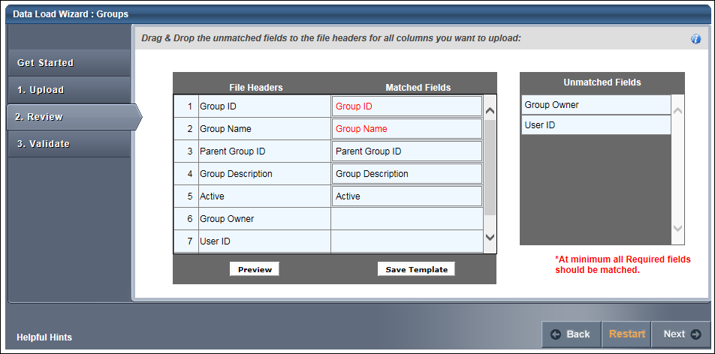
After uploading the file and proceeding to the Review page, the wizard reads the file and displays the column headers from the file. Some data fields may be automatically matched to a file header. If this is the case, the system field is listed in the Matched Fields column immediately to the right of the matching file header. All unmatched system fields are listed on the right in the Unmatched Fields column. Also, fields that the system has mismatched can be moved to the correct file header.
To match the system fields to the file headers, click them from the Unmatched Fields list and drag them to the appropriate row in the Matched Fields column. The items in the Matched Fields column should be directly to the right of the appropriate item in the File Headers column. Once a system field is matched to a file header, it is removed from the Unmatched Fields list.
If the uploaded file does not have titles or headers and the administrator deselected the "My file has titles/headers" option in the Upload step, then each column of data is given a generic header name (e.g., Column 1, Column 2). This enables you to match the data, even though it does not have headers.
All required fields must be paired with one of the file headers in order to proceed. The required system fields are displayed in red, while optional system fields are displayed in black.
Once all items in the File Headers column are matched to the appropriate system field, click the Preview button to verify that the data is properly matched. This displays a preview of up to 20 rows of the data in a pop-up window. The system data field titles are displayed in green, and the uploaded file headers are displayed in blue. If some data is not properly matched, you can then reorganize the fields prior to proceeding. The preview is also helpful to view a sample of the data within a column if you are unsure with what field the file header should be matched.
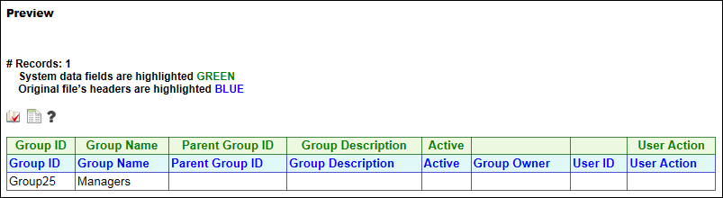
If all fields are properly matched, you may save the pairings as a template. This may be useful if your organization performs multiple data loads of the same file format. In that case, saving the pairings as a template saves you the effort of matching the fields each time. To save the pairings as a template, click the Save Template button. A pop-up appears where you can enter a name for the template. The character limit for template names is 150. Changing the name of a previously saved template creates a new template in the system. Note: All fields that are required by the system must be matched in order to save the parings as a template.
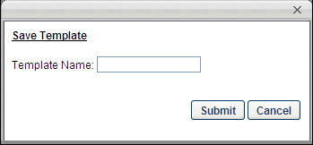
After all fields are properly matched, click the Next button. If all required fields are paired with a file header, some additional options appear prior to moving to the next step. Note: All fields that are required by the system must be matched in order to proceed to the next step.
The Processing Options pop-up appears with additional options. See Load Group Data - Step 4 - Processing Options on page 10 for additional information.
After selecting the appropriate options, click Continue to proceed to the Validate step. See Load Group Data - Step 5 - Validate on page 11 for additional information.

Load Group Data - Step 4 - Processing Options
General Criteria
The following General Criteria options are available when loading data:
Dates are in International (dd/mm/yyyy or dd-mm-yyyy) format
Select this option if the dates within the file are in International format. This allows the system to properly read and interpret the date values when loading them into the system. Many date formats are supported in both American and International versions. Consult the Helpful Hints documents for a full list.
If file is error free, automatically load into system
Select this option to automatically load the data into the system if the data within the uploaded file is error free. The data within the file is still validated during the validation step. But, if there are no formatting or system compatibility errors, you will not have the option to perform a final review before the data is loaded.
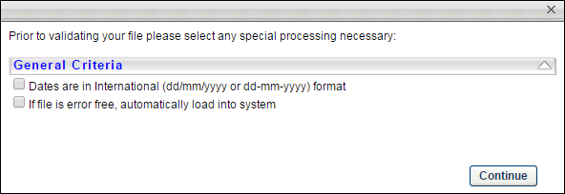
After selecting the appropriate options, click Continue to proceed to the Validate step. See Load Group Data - Step 5 - Validate on page 11 for additional information.

Load Group Data - Step 5 - Validate
The Validate step of the load process is where the system validates the data contained in the uploaded file.
Validation Progress
When you reach the Validate page, the system automatically begins validating the format of the data.
If there are no errors, the wizard automatically begins validating the data's compatibility with existing system data.
Depending on the number of records being loaded, any format and system validation errors can be viewed and the load can be initiated in different locations:
- For data files with 250 or less records, format and system validation errors can be viewed and the load can be initiated on the Validation page of the Data Load Wizard. The detailed error log can be viewed on the Data Load Queue page.
- For data files with over 250 records, format and system validation errors can be viewed and the load can be initiated on the Track Data Loads page of the Data Load Wizard. The system automatically opens this page once the validation begins.
Files with 250 or Less Records
If there are errors in the file, you have the option to view the errors by clicking the View Errors button to the right of the progress bar. This opens a pop-up which displays a list of the errors that exist in the file as well as a description for the error. Error descriptions are found in far right column, and each error contains its own description. This list can be exported to Excel or printed using the icons in the upper-left corner of the table.
After the data format is checked, a summary of the results is displayed, including:
- Number of records that will continue to system validation
- Number of records that have errors and cannot be loaded
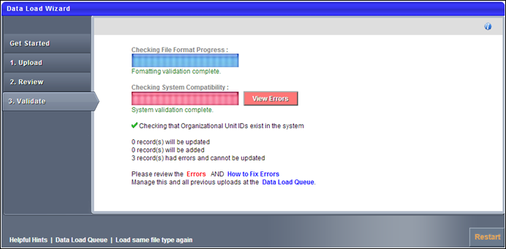
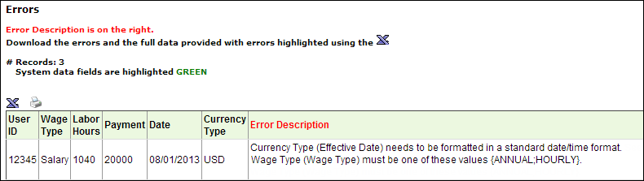
To view how to fix the data errors, on the Validate page, click the How to fix errors link. This opens a document that details how each type of error can be resolved. After resolving the issues in the file, you may click the Load same file type again link or the Restart button to re-attempt the load.
- If more than 50% of the records contain errors, you cannot proceed with the data upload. You must resolve the issues prior to proceeding.
- If less than 50% of the records contain errors, you may continue to load the data, but the data records that contain errors cannot be uploaded and they are skipped.
Once the errors are resolved or there are a minimal number of errors, you may continue the validation process by clicking the Continue Validation button. This begins the process of verifying the data's compatibility with the system. The system then validates the following items:
- OU and User IDs referenced on other records are valid or active
- The administrator has permission to load each record based on constraints
After the system compatibility is checked, a summary of the results is displayed:
- Number of records that will be updated
- Number of records that will be added
- Number of records that have errors and cannot be updated
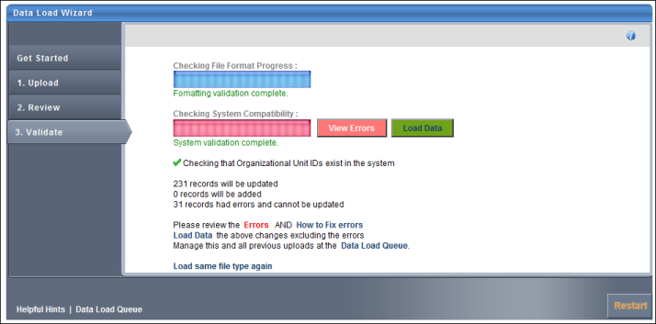
To finalize the data load, click the Load Data button. This adds the data load to the Data Load Queue for processing.
After the data is loaded, the status is updated in the Data Load Queue and the uploaded data is available. See Data Load Queue on page 66 for additional information.

Load Group Data - Template and Validations
The Group template contains all of the fields that can be loaded via the Data Load Wizard. Each Group ID must be unique.
The Group template contains the following data fields:
System Field | Type | Limit | Comments/Rules
Group ID | String | 100 | This field is required. This is the unique identifier for the group. This cannot be updated once it is created.
Group Name | String | 1000 | This field is required. This is the group name, which can be updated after creation. If the data load contains multiple rows of data, then this value must be the same as the first row.
Parent Group ID | String | 100 | This field is optional. This specifies the ID of the parent group, which enables the ability to create a group hierarchy. This must be a valid group ID within the system. For a given group, this cannot be the same as the Group ID. If the data load contains multiple rows of data for the same group, then this value must be the same as the first row.
Group Description | String | 3950 | This field is optional. This is the group description. If the data load contains multiple rows of data, then this value must be the same as the first row.
Active | Boolean | 50 | This field is optional. This sets the status of the group to Active or Inactive. Values must be either True, False, T, F, Yes, No, Y, N, Active, or Inactive. If this field is blank, then it defaults to True. If the data load contains multiple rows of data, then this value must be the same as the first row.
Group Owner | String | 128 | This field is optional. This specifies the User ID of the group owner. This must be a valid User ID within the system. If the data load contains multiple rows of data, then this value must be the same as the first row.
User ID | String | 128 | This field is optional, but it is required if a User Action is provided for the row. This specifies the ID of the user being added or removed from the group. This must be a valid User ID within the system. Only one User ID can be entered per row. The same User ID cannot be entered multiple times for the same group.
User Action | String | 2 | This field is optional, but it is required if a User ID is provided for the row. This specifies whether the user in the User ID column is being added to or removed from the group. Values must be either 1 or 2.  - If "1" is entered, the user in the User ID column is added to the group. A user cannot be added to the group if they are already in the group.  - If "2" is entered, the user in the User ID column is removed from the group. A user cannot be removed from the group if they are not already in the group.
Custom Fields |  |  | Group custom field values can be loaded after the custom field is defined within the system. Once a group custom field is defined in the system, it appears within the template and the mapping page.  The following custom field types are supported:  - Checkbox  - Date Field  - Drop-down  - Numeric Field  - Radio Button  - Scrolling Text Box  - Short Text Box  The following custom field types are not supported:  - Branched Drop-down  - Hierarchy  - Multiple Checkbox
The following custom field types are available:
Custom Field Type | Custom Field Validation
Checkbox | Values must be either True, False, T, F, Yes, No, Y, N, Active, or Inactive.
Date Field | Date format must comply with standard format rules. International dates are supported when the Dates are in International format option is selected in the Processing Options pop-up. See the Domestic Date Formats and International Date Formats sections below for additional information.
Dropdown | The available drop-down options must be configured in the system prior to the data load. Drop-down values can be active or inactive within the system. The ability to load values that are inactive may be determined in the Processing Options.
Numeric Field | Positive and negative values are supported. Decimals are supported. The character limit for this field is 50.
Radio Button | Values must be either True, False, T, F, Yes, No, Y, N, Active, or Inactive.
Scrolling Text Box | The character limit for this field is 3950.
Short Text Box | The character limit for this field is 3950.
Domestic Date Formats
The following domestic date formats are supported:
- M/D/YY
- M/D/YYYY
- M-D-YY
- M-D-YYYY
- MM/DD/YY
- MM/DD/YYYY
- MM-DD-YY
- MM-DD-YYYY
International Date Formats
The following international date formats are supported:
- D/M/YY
- D/M/YYYY
- DD/MM/YY
- DD/MM/YYYY
- DD-MM-YY
- DD-MM-YYYY
- D-M-YY
- D-M-YYYY
- YYYY/D/M
- YYYY/DD/MM
- YYYY/M/D
- YYYY/MM/DD
- YYYY-D-M
- YYYY-DD-MM

Load OU Data Overview
Ability to perform Users and OU data loads and feeds using Data Load Wizard (DLW) was deprecated with an end-of-life in the May ‘22 Release for most customers. End-of-support for most customers occurred in the February ‘22 Release and support for defects related to DLW Users and OU loads and feeds also stopped at this time.
Important: For customers using the following Data Load Wizard features that are not available in Edge Import, we do not recommend migration of Inbound Data Feed (IDF) for Users and OUs from Data Load Wizard to Edge Import at this time:
- Sensitive Personally Identifiable Information (SPII) fields - Date of Birth/SSN
Customers using the above features will be informed when these features are available in Edge Import and will be given at least three months to deprecate.

Load OU Data - Step 1 - Get Started
When you start the wizard, select which type of data you are loading. The maximum number of records that you can upload in a file is 10,000.
If you are using the Data Load Wizard to set up your portal, begin by loading the organizational units, then users.
To start the Data Load Wizard, go to Admin > Tools > Core Functions > Data Load Wizard, and then click Load Data. The Data Load Wizard opens to the Get Started tab. Select the OU option and click Next. When uploading OUs, you must first select the type of OU you are loading. See Load OU Data - Step 2 - Select OU Type on page 19 for additional information.
Permissions
PERMISSION NAME | PERMISSION DESCRIPTION | CATEGORY

Data Load Wizard - OUs | Enables administrator to load OUs. This permission also enables administrators to track data loads and manage data load templates. This is an administrator permission. | Data Load Wizard
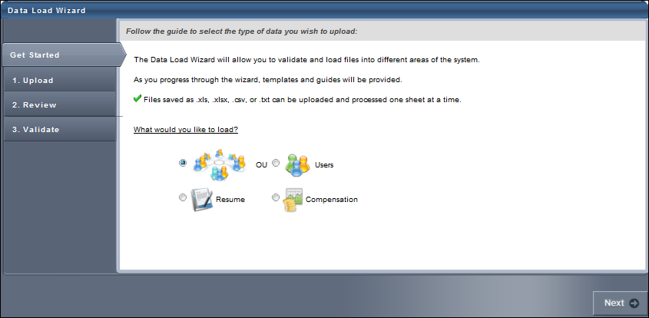

Load OU Data - Step 2 - Select OU Type
To begin loading OU data, you must first select the type of OU data you are loading. This ensures that the data is loaded into the correct location. You can load lists of organizational units to both standard and custom OU Types.
An OU type must already exist in the system for it to appear in this list. For additional custom OU types, contact Global Customer Support or your Implementation Manager. The OU types that are available by default are:
- Division - Divisions, often called departments or business units, are the primary hierarchy to represent an organization's overall structure. Many system preferences are set according to a user's division.
- Location - Locations are typically geographical entities used to group users in the same region, country, city, or building. Training facilities are locations as well.
- Position - Positions are the job titles of every employee in the organization. If your organization has standardized positions, these OUs can be used to target employee development.
- Cost Center - Cost centers are utilized for financial accounting of activities and allow for financial reports. Cost centers can also have a defined Approver who can decide on training cost allocations.
- Grade - Grades are generally pay ranges utilized in performance, succession, and compensation management.
Note: The OU types displayed in this documentation may not match the OU types in your system. Contact Global Customer Support to modify OU type names or to add additional custom OU types to the system.
After selecting the appropriate OU type, click Next to proceed to the Upload step. See Load OU Data - Step 3 - Upload on page 20 for additional information.
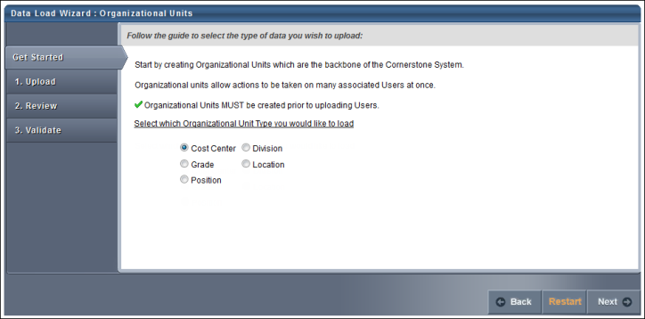

Load OU Data - Step 3 - Upload
Custom Field Administration Link
If you need to add custom fields to the system in order to match them with a data field in your file, click the Custom Field Administration link. This takes you to Custom Field Administration for the selected data type. You can add the necessary custom fields and then return to the Data Load Wizard. Note: This link is only available to users with access to Custom Field Administration.
Template Link
If you are uploading new data to the system, first select a template by clicking the Template link in the lower-left corner. This ensures the proper data is included and that it is in the proper format. In the template, columns that are red are required. See Load Data - Select Data Load Template on page 104 for additional information.
Get Existing Data Link
If you are updating existing data from the system, first download the existing data by clicking the Get Existing Data link in the lower-left corner. This ensures that you have the latest data as it exists in the system. Note: The existing data you are able to export may be restricted by your permission constraints. See Load Data - Get Existing Data on page 124 for additional information.
Helpful Hints Link
As you are updating and formatting your data, prior to uploading the file click the Helpful Hints link in the lower-left corner. This document provides you with all of the proper formatting information for the data as well as necessary information for uploading a data file. When formatting the file of data, each column must have a title or header, which will be associated with a data field in the system. This document can also be used as a guide to adjust a report you may be generating from your HRIS in order to simplify the load process.
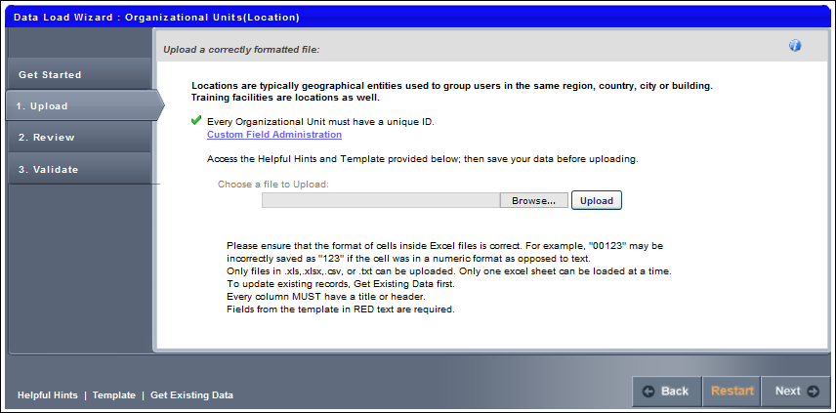
To upload a file of data
- Click the Choose File button and locate the file.
  - You can only upload the following file types: .xls, .xlsx, .csv, .txt.
  - When uploading an Excel file, you can only upload one sheet at a time.
  - Files loaded via the Data Load Wizard cannot contain HTML encoding
- Once the file is selected, click the Upload button. An Upload File pop-up appears with different options depending on the type of file that is uploaded.
  - Excel File (.xls, .xlsx). Select Worksheet (Excel files only) - Only one worksheet can be uploaded at a time, so if the Excel file has multiple worksheets, you must select the worksheet that you are uploading.
  - Text, Comma, or Pipe Separated File (.txt, .csv). Select Delimiter (Tab, Comma, or Pipe Separated files only) - Select what delimiter (e.g., tab, comma, pipe) is used to separate records within the file. This enables the system to properly extract the data from the file.
- Select Template - If you used a template to create the file, select the appropriate template. If no template is used, select the "No template used" option. If you have used the Data Load Wizard in the past and saved a template for this file type, that template is available here.
- My File has titles/headers - Data files should have titles or headers for each column of data. If the file you uploaded does not have titles or headers, deselect this option. Deselecting this option modifies the next step in the review process.
- After selecting the appropriate options, click Continue. The file is uploaded and listed on the page.
If this is the wrong file or the wrong worksheet within the file, you can delete it by clicking the Remove icon to the left of the file title and upload another file. Alternatively, you can browse and upload a new file. When the correct file is uploaded, click Next to proceed to the Review step. See Load OU Data - Step 4 - Review on page 23 for additional information.

Load OU Data - Step 4 - Review
The Review step of the load process allows you to match the uploaded data to the appropriate data elements within the system.
The wizard automatically reads the headers from the uploaded file and matches some of the data fields to the appropriate system fields. You may adjust the data fields as necessary and also move any unmatched fields to the appropriate system field. Once the fields are all matched, you have the option to save the settings as a template for future uploads.
After uploading the file and proceeding to the Review page, the wizard reads the file and displays the column headers from the file. Some data fields may be automatically matched to a file header. If this is the case, the system field is listed in the Matched Fields column immediately to the right of the matching file header. All unmatched system fields are listed on the right in the Unmatched Fields column. Also, fields that the system has mismatched can be moved to the correct file header.
To match the system fields to the file headers, click them from the Unmatched Fields list and drag them to the appropriate row in the Matched Fields column. The items in the Matched Fields column should be directly to the right of the appropriate item in the File Headers column. Once a system field is matched to a file header, it is removed from the Unmatched Fields list.
If the uploaded file does not have titles or headers and the administrator deselected the "My file has titles/headers" option in the Upload step, then each column of data is given a generic header name (e.g., Column 1, Column 2). This enables you to match the data, even though it does not have headers.
All required fields must be paired with one of the file headers in order to proceed. The required system fields are displayed in red, while optional system fields are displayed in black.
Once all items in the File Headers column are matched to the appropriate system field, click the Preview button to verify that the data is properly matched. This displays a preview of up to 20 rows of the data in a pop-up window. The system data field titles are displayed in green, and the uploaded file headers are displayed in blue. If some data is not properly matched, you can then reorganize the fields prior to proceeding. The preview is also helpful to view a sample of the data within a column if you are unsure with what field the file header should be matched.
If all fields are properly matched, you may save the pairings as a template. This may be useful if your organization performs multiple data loads of the same file format. In that case, saving the pairings as a template saves you the effort of matching the fields each time. To save the pairings as a template, click the Save Template button. A pop-up appears where you can enter a name for the template. The character limit for template names is 150. Changing the name of a previously saved template creates a new template in the system. Note: All fields that are required by the system must be matched in order to save the parings as a template.
After all fields are properly matched, click the Next button. If all required fields are paired with a file header, some additional options appear prior to moving to the next step. Note: All fields that are required by the system must be matched in order to proceed to the next step.
The Processing Options pop-up appears with additional options. See Load OU Data - Step 5 - Processing Options on page 25 for additional information.
After selecting the appropriate options, click Continue to proceed to the Validate step. See Load OU Data - Step 6 - Validate on page 26 for additional information.

Load OU Data - Step 5 - Processing Options
General Criteria
The following General Criteria options are available when loading data:
Dates are in International (dd/mm/yyyy or dd-mm-yyyy) format
Select this option if the dates within the file are in International format. This allows the system to properly read and interpret the date values when loading them into the system. Many date formats are supported in both American and International versions. Consult the Helpful Hints documents for a full list.
If file is error free, automatically load into system
Select this option to automatically load the data into the system if the data within the uploaded file is error free. The data within the file is still validated during the validation step. But, if there are no formatting or system compatibility errors, you will not have the option to perform a final review before the data is loaded.
Blank values should overwrite existing data
Select this option if you want a blank value in the load file to overwrite an existing value within the system. For example, a user record (John Smith) has an email address set in the system (jsmith@email.com), but the email value in the file is blank. If this option is selected, the blank value within the file overwrites the email value set in the system. If this option is not selected, the blank value within the file does not overwrite the email value in the system and John Smith's email address is not affected.
Note: If you select the option to allow blank values to overwrite existing values, and a manager or parent ID is blank within the file, this may cause a hierarchy within the system to break. Also, if the field is a required field, the value cannot be blank within the file.
Do not allow relationships with inactive Users and OUs
Select this option to prevent OUs and users from being associated with inactive OUs or users. This can be used to ensure organizations have a functioning hierarchy between OUs and users. If users and OUs are connected with inactive users or OUs, this may cause breakdowns in system communication such as approvals and reviews.
After selecting the appropriate options, click Continue to proceed to the Validate step. See Load OU Data - Step 6 - Validate on page 26 for additional information.

Load OU Data - Step 6 - Validate
The Validate step of the load process is where the system validates the data contained in the uploaded file. The system first validates the following items:
- Required fields are populated for all rows
- OU, User IDs, and Usernames are unique
- Field lengths and formats are correct (dates, emails, etc.)
- Field values are valid (custom fields, time zones, languages, active, etc.)
When you reach the Validate page, the system automatically begins validating the format of the data.
If there are no errors, the wizard automatically begins validating the data's compatibility with existing system data.
Depending on the number of records being loaded, any format and system validation errors can be viewed and the load can be initiated in different locations:
- For data files with 100 or less records, format and system validation errors can be viewed and the load can be initiated on the Validation page of the Data Load Wizard. The detailed error log can be viewed on the Data Load Queue page.
- For data files with over 100 records, format and system validation errors can be viewed and the load can be initiated on the Data Load Queue page of the Data Load Wizard. The system automatically opens this page once the validation begins.
Files with 100 or Less Records
If there are errors in the file, you have the option to view the errors by clicking the View Errors button to the right of the progress bar. This opens a pop-up which displays a list of the errors that exist in the file as well as a description for the error. Error descriptions are found in far right column, and each error contains its own description. This list can be exported to Excel or printed using the icons in the upper-left corner of the table.
After the data format is checked, a summary of the results is displayed, including:
- Number of records that will continue to system validation
- Number of records that have errors and cannot be loaded
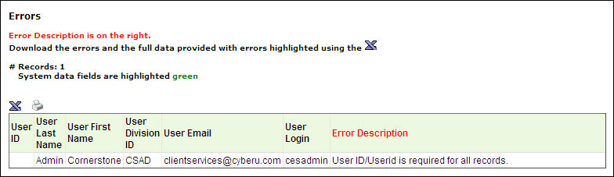
To view how to fix the data errors, on the Validate page, click the How to fix errors link. This opens a document that details how each type of error can be resolved. You may also click the Helpful Hints link in the bottom-left corner of the page for additional information. After resolving the issues in the file, you may click the Load same file type again link or the Restart button to re-attempt the load.
- If more than 50% of the records contain errors, you cannot proceed with the data upload. You must resolve the issues prior to proceeding.
- If less than 50% of the records contain errors, you may continue to load the data, but the data records that contain errors cannot be uploaded and they are skipped.
Once the errors are resolved or there are a minimal number of errors, you may continue the validation process by clicking the Continue Validation button. This begins the process of verifying the data's compatibility with the system. The system then validates the following items:
- OU and User IDs referenced on other records are valid or active
- There are no circular hierarchies for OUs or User relationships
- The administrator has permission to load each record based on constraints
After the system compatibility is checked, a summary of the results is displayed:
- Number of records that will be updated
- Number of records that will be added
- Number of records that have errors and cannot be updated
To finalize the data load, click the Load Data button. This adds the data load to the Data Load Queue for processing.
After the data is loaded, the status is updated in the Data Load Queue and the uploaded data is available. See Data Load Queue on page 66 for additional information.

Performance Data Load Overview

Load Competency Bank Data
Load Competency Bank Data - Step 1 - Get Started
When loading data, you can load a file of competency bank data. When you start the wizard, you can select which type of data you are loading. The maximum number of records that can be uploaded in a Competency Bank file is 10,000.
A competency bank is a repository for competencies. This bank enables administrators to manage competencies, which can be included in competency models. Using the Data Load Wizard, administrators can upload multiple types of competency information, including items, behaviors, training, feedback, development actions, etc.
When a file of competency data is loaded, a unique Ref ID must be specified for each row of data in the file. The Ref ID is the unique identifier for each competency and is defined by the administrator when loading the data. When updating existing competency data, the Ref ID of the existing data must be referenced. Ref IDs are not displayed within the system and must be tracked by the administrator.
To start the Data Load Wizard, go to Admin > Tools > Core Functions > Data Load Wizard, and then click Load Data. The Data Load Wizard opens to the Get Started tab. Select the Performance option and click Next. When uploading competency bank data, you must first select the type of competency data you are loading. See Load Competency Bank Data - Step 2 - Select Type on page 33 for additional information.
Permissions
PERMISSION NAME | PERMISSION DESCRIPTION | CATEGORY

Competency Assessment Model | Grants access to define competency categories, competency model categories, and the default rating scale for competency models. This permission cannot be constrained. This is an administrator permission.  For organizations using the Data Load Wizard Competency Bank Data General Information load, this permission is required to utilize custom fields in the data load. | Performance - Administration

Data Load Wizard - Competency Bank | Enables administrator to load competency bank data via the Data Load Wizard. This permission also enables administrators to track data loads and manage data load templates. This is an administrator permission. | Data Load Wizard

Data Load Wizard - Performance | Enables administrator to load performance data via the Data Load Wizard. This permission also enables administrators to track data loads and manage data load templates. This is an administrator permission. | Data Load Wizard
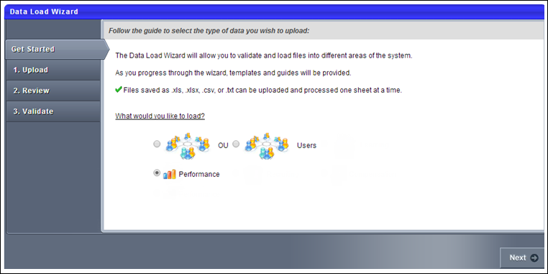
Load Competency Bank Data - Step 2 - Select Type
To begin loading competency data, you must first select the type of competency data you are loading. This ensures that the data is loaded properly.
The following options are available:
- Competency General Information - See Competency Bank Template - General Information on page 42 for additional information.
- Competency Items and Behaviors - See Competency Bank Template - Items and Behaviors on page 45 for additional information.
- Competency Training, Feedback and Development Actions - See Competency Bank Template - Training/Feedback/Development Actions on page 49 for additional information.
After selecting the appropriate data type, click Next to proceed to the Upload step. See Load Competency Bank Data - Step 3 - Upload on page 34 for additional information.
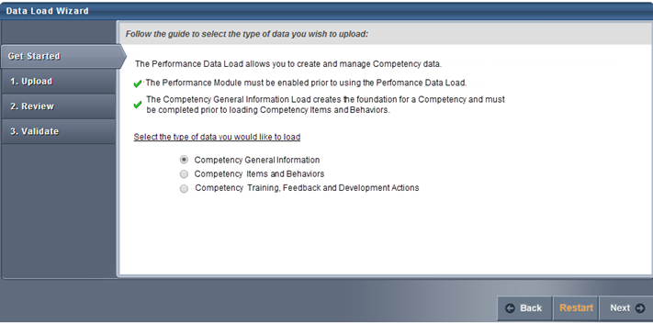
Load Competency Bank Data - Step 3 - Upload
If you are uploading new data to the system, first select a template by clicking the Template link in the lower-left corner. This ensures the proper data is included and that it is in the proper format. In the template, columns that are red are required. See Load Data - Select Data Load Template on page 104 for additional information.
The Data Load Wizard can only update a competency if the competency is not associated with a locked role or task. As a result, only version 1 of a competency can be updated.
The template for competency bank data varies depending on the type of data that is being loaded:
- Competency General Information - See Competency Bank Template - General Information on page 42 for additional information.
- Competency Items and Behaviors - See Competency Bank Template - Items and Behaviors on page 45 for additional information.
- Competency Training, Feedback and Development Actions - See Competency Bank Template - Training/Feedback/Development Actions on page 49 for additional information.
As you are updating and formatting your data, prior to uploading the file click the Helpful Hints link in the lower-left corner. This document provides you with all of the proper formatting information for the data as well as necessary information for uploading a data file. When formatting the file of data, each column must have a title or header, which will be associated with a data field in the system.
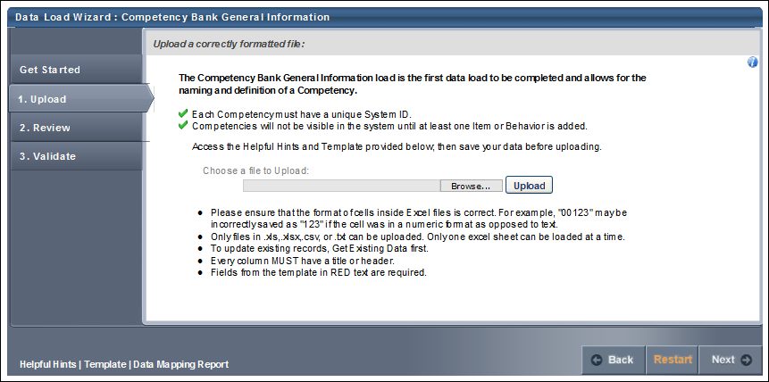
To upload a file of data
- Click the Choose File button and locate the file.
  - You can only upload the following file types: .xls, .xlsx, .csv, .txt.
  - When uploading an Excel file, you can only upload one sheet at a time.
  - Files loaded via the Data Load Wizard cannot contain HTML encoding
- Once the file is selected, click the Upload button. An Upload File pop-up appears with different options depending on the type of file that is uploaded.
  - Excel File (.xls, .xlsx). Select Worksheet (Excel files only) - Only one worksheet can be uploaded at a time, so if the Excel file has multiple worksheets, you must select the worksheet that you are uploading.
  - Text, Comma, or Pipe Separated File (.txt, .csv). Select Delimiter (Tab, Comma, or Pipe Separated files only) - Select what delimiter (e.g., tab, comma, pipe) is used to separate records within the file. This enables the system to properly extract the data from the file.
- Select Template - If you used a template to create the file, select the appropriate template. If no template is used, select the "No template used" option. If you have used the Data Load Wizard in the past and saved a template for this file type, that template is available here.
- My File has titles/headers - Data files should have titles or headers for each column of data. If the file you uploaded does not have titles or headers, deselect this option. Deselecting this option modifies the next step in the review process.
- After selecting the appropriate options, click Continue. The file is uploaded and listed on the page.
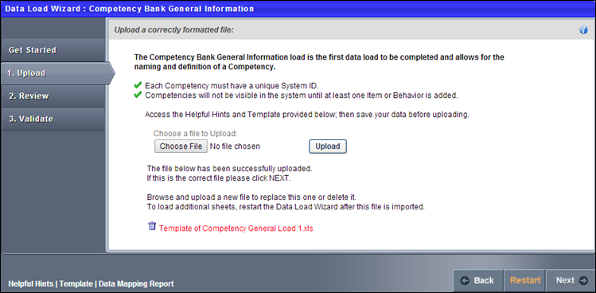
If this is the wrong file or the wrong worksheet within the file, you can delete it by clicking the Remove icon to the left of the file title and upload another file. Alternatively, you can browse and upload a new file. When the correct file is uploaded, click Next to proceed to the Review step. See Load Competency Bank Data - Step 4 - Review on page 37 for additional information.
Load Competency Bank Data - Step 4 - Review
The Review step of the load process allows you to match the uploaded data to the appropriate data elements within the system.
The wizard automatically reads the headers from the uploaded file and matches some of the data fields to the appropriate system fields. You may adjust the data fields as necessary and also move any unmatched fields to the appropriate system field. Once the fields are all matched, you have the option to save the settings as a template for future uploads.
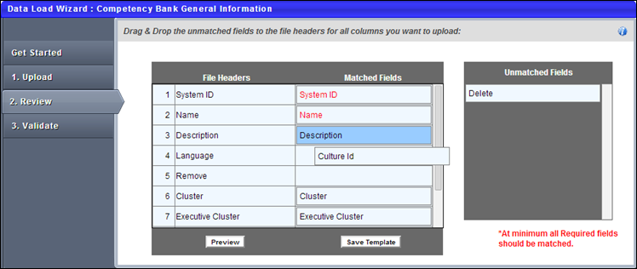
After uploading the file and proceeding to the Review page, the wizard reads the file and displays the column headers from the file. Some data fields may be automatically matched to a file header. If this is the case, the system field is listed in the Matched Fields column immediately to the right of the matching file header. All unmatched system fields are listed on the right in the Unmatched Fields column. Also, fields that the system has mismatched can be moved to the correct file header.
To match the system fields to the file headers, click them from the Unmatched Fields list and drag them to the appropriate row in the Matched Fields column. The items in the Matched Fields column should be directly to the right of the appropriate item in the File Headers column. Once a system field is matched to a file header, it is removed from the Unmatched Fields list.
If the uploaded file does not have titles or headers and the administrator deselected the "My file has titles/headers" option in the Upload step, then each column of data is given a generic header name (e.g., Column 1, Column 2). This enables you to match the data, even though it does not have headers.
All required fields must be paired with one of the file headers in order to proceed. The required system fields are displayed in red, while optional system fields are displayed in black.
Once all items in the File Headers column are matched to the appropriate system field, click the Preview button to verify that the data is properly matched. This displays a preview of up to 20 rows of the data in a pop-up window. The system data field titles are displayed in green, and the uploaded file headers are displayed in blue. If some data is not properly matched, you can then reorganize the fields prior to proceeding. The preview is also helpful to view a sample of the data within a column if you are unsure with what field the file header should be matched.
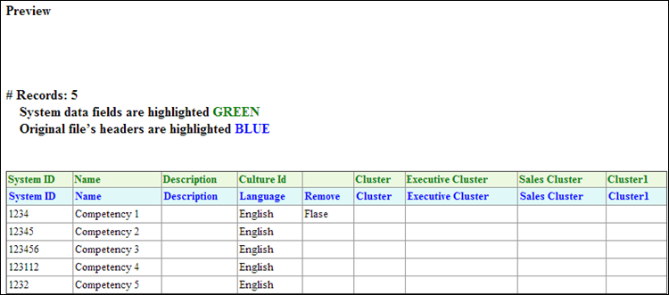
If all fields are properly matched, you may save the pairings as a template. This may be useful if your organization performs multiple data loads of the same file format. In that case, saving the pairings as a template saves you the effort of matching the fields each time. To save the pairings as a template, click the Save Template button. A pop-up appears where you can enter a name for the template. The character limit for template names is 150. Changing the name of a previously saved template creates a new template in the system. Note: All fields that are required by the system must be matched in order to save the parings as a template.
After all fields are properly matched, click the Next button. If all required fields are paired with a file header, some additional options appear prior to moving to the next step. Note: All fields that are required by the system must be matched in order to proceed to the next step.
The Processing Options pop-up appears with additional options. See Load Competency Bank Data - Step 5 - Processing Options on page 39 for additional information.
After selecting the appropriate options, click Continue to proceed to the Validate step. See Load Competency Bank Data - Step 6 - Validate on page 40 for additional information.
Load Competency Bank Data - Step 5 - Processing Options
General Criteria
The available options vary depending on the data template that is being loaded. The following General Criteria options may be available when loading data:
Dates are in International (dd/mm/yyyy or dd-mm-yyyy) format
Select this option if the dates within the file are in International format. This allows the system to properly read and interpret the date values when loading them into the system. Many date formats are supported in both American and International versions. Consult the Helpful Hints documents for a full list.
If file is error free, automatically load into system
Select this option to automatically load the data into the system if the data within the uploaded file is error free. The data within the file is still validated during the validation step. But, if there are no formatting or system compatibility errors, you will not have the option to perform a final review before the data is loaded.
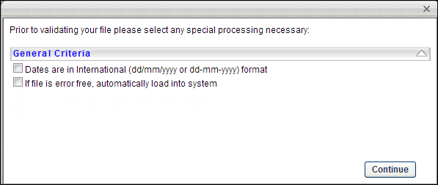
After selecting the appropriate options, click Continue to proceed to the Validate step. See Load Competency Bank Data - Step 6 - Validate on page 40 for additional information.
Load Competency Bank Data - Step 6 - Validate
The Validate step of the load process is where the system validates the data contained in the uploaded file.
Validation Progress
When you reach the Validate page, the system automatically begins validating the format of the data.
If there are no errors, the wizard automatically begins validating the data's compatibility with existing system data.
Depending on the number of records being loaded, any format and system validation errors can be viewed and the load can be initiated in different locations:
- For data files with 250 or less records, format and system validation errors can be viewed and the load can be initiated on the Validation page of the Data Load Wizard. The detailed error log can be viewed on the Data Load Queue page.
- For data files with over 250 records, format and system validation errors can be viewed and the load can be initiated on the Track Data Loads page of the Data Load Wizard. The system automatically opens this page once the validation begins.
Files with 250 or Less Records
If there are errors in the file, you have the option to view the errors by clicking the View Errors button to the right of the progress bar. This opens a pop-up which displays a list of the errors that exist in the file as well as a description for the error. Error descriptions are found in far right column, and each error contains its own description. This list can be exported to Excel or printed using the icons in the upper-left corner of the table.
After the data format is checked, a summary of the results is displayed, including:
- Number of records that will continue to system validation
- Number of records that have errors and cannot be loaded
Competency Bank Template - General Information
The General Information template is one of the templates that is available when loading competency bank information via the Data Load Wizard.
The General Information template for competency bank data contains the naming and definition data for the competency. This template can be used when creating or updating competencies. When loading competencies, the General Information template must be the first template that is loaded. Note: When a new competency is added to the system via the Data Load Wizard, the competency is not visible within the system until items or behaviors are loaded to the competency via the Data Load Wizard. This prevents competencies that do not have items or behaviors from being added to a competency model.
The General Information template contains the following data fields:
Name | Description | Validation Rules
System ID | This is set by the administrator and is used to reference the competency that is being loaded into the system.  When updating existing competency data, the System ID for the data that is being loaded must match the System ID for the existing data.  Data that is manually created in the system has a different System ID format than data that is created in the Data Load Wizard. Data created manually has a System ID prefix of "10-" (e.g., 10-123). This prefix is reserved for data that is manually created in the system. | - This field is required.  - This field must be unique.  - The character limit is 32.  To enable this functionality, contact Global Customer Support.
Culture ID | This determines the culture (language) in which the competency is loaded. The value must match one of the existing Culture IDs within the system. | - This must be a valid Culture ID. See the Helpful Hints for a list of valid Culture IDs.
Name | This is the competency name. | - This field is required.  - The character limit is 250.
Description | This is the competency description | - The character limit is 3,950.
ID | This is a client specified ID and is not required. The ID does not need to be unique and can be used as an additional identifier for the competency. | - The character limit is 100.
Client Configured Category | This value indicates the competency category. This value must match one of the existing competency categories in the system. Category names can be configured by the administrator. | - This must match an existing competency category in the system.  - Active and inactive competency categories can be loaded.
Delete | This is a Boolean field that indicates whether the competency should be deleted. If this is set to True, the competency is deleted from the system. If this is set to False, the competency is not deleted. This can only be set to True for a competency that exists within the system and has a valid System ID. | - This is set to False if blank.  - This must be one of the following values: True, False, T, F, Yes, No, Y, N, Active, Inactive.
Admin Visibility
The Admin Visibility field enables the administrator to define which administrators are able to view the competency in the Competency Bank and when creating competency models and skills matrix roles. Visibility can be set by organizational unit (OU), Group, or specific users.
The Data Load Wizard does not support updating OU availability fields. Because of this, the Admin Visibility cannot be configured in a competency data load. The following occurs when competencies are loaded:
- Competency Created - When a new competency is created via the Data Load Wizard, the Admin Visibility for this competency is automatically set to be visible to all employees. To change the administrator visibility for competencies loaded via the Data Load Wizard, administrators must manually set the Admin Visibility within the Competency Bank.
- Competency Updated - When an existing competency is updated via the Data Load Wizard, the Admin Visibility settings are not updated. The existing settings are maintained.
Active Checkbox
An Active field enables administrators to define the Active status for the competency. When a competency is inactive, it cannot be added to new skills matrix roles and competency models. However, inactive competencies are still available in any competency model, competency assessment, performance review, skills matrix role, or any other place that it is in use by a user. Also, inactive competencies are available in reporting and when selecting competencies from an existing competency model. For example, a Competency performance review section can be configured to allow users to select competencies from a competency model. If inactive competencies exist in the competency model, then they can still be selected.
When loading competencies via the Data Load Wizard, the competency will be loaded to an Active status. The Data Load Wizard does not support loading competencies to an inactive status. To update the status of a competency created via the Data Load Wizard, administrators must manually deselect the Active checkbox for the competency within the Competency Bank.
Competency Bank Template - Items and Behaviors
The Items and Behaviors template is one of the templates that is available when loading competency bank information via the Data Load Wizard.
The Items and Behaviors template for competency bank data contains the items and behaviors that are associated with a competency. This template can be used when adding or updating the items or behaviors that are associated with a competency. When loading competencies, the General Information template must be the first template that is loaded. Note: When a new competency is added to the system via the Data Load Wizard, the competency is not visible within the system until items or behaviors are loaded to the competency via the Data Load Wizard. This prevents competencies that do not have items or behaviors from being added to a competency model.
When loading items and behaviors, all entities must be of the same type for a given competency. For example, only items can be loaded to an item type competency, and only behaviors can be loaded to a behavior type competency.
The Items and Behaviors template contains the following data fields:
Name | Description | Validation Rules
System ID | This is set by the administrator and is used to reference the competency that is being loaded into the system.  When updating existing competency data, the System ID for the data that is being loaded must match the System ID for the existing data.  Data that is manually created in the system has a different System ID format than data that is created in the Data Load Wizard. Data created manually has a System ID prefix of "10-" (e.g., 10-123). This prefix is reserved for data that is manually created in the system. | - This field is required.  - This field must be unique.  - The character limit is 32.  To enable this functionality, contact Global Customer Support.
Culture ID | This determines the culture (language) in which the competency is loaded. The value must match one of the existing Culture IDs within the system. | - This must be a valid Culture ID. See the Helpful Hints for a list of valid Culture IDs.
Assessment Type | This specifies what type of assessment is being loaded, Items or Behaviors. | - This field is required.  - This must be set to Item or Behavior.
Behavior/Item ID | This is the unique ID for the item or behavior. This ID is not currently displayed within the system and must be tracked by the administrator in order to reference the data in the future. The ID will be displayed in the system in a future release. | - This field is required.  - This field must be unique within a competency. A competency cannot have duplicate behavior/item IDs.  - The character limit is 32.
Behavior/Item Name | This is the name of the behavior or item. | - This field is required.  - The character limit is 100.
Behavior Rating | This field only applies when loading behaviors. This is the behavior rating. | - This is required when Assessment Type = Behavior.  - This must be an integer, and must be one of the values configured in the Default Rating Scale.
Delete | This is a Boolean field that indicates whether the item or behavior should be deleted. If this is set to True, the item or behavior is deleted from the system. If this is set to False, the item or behavior is not deleted. This can only be set to True for an item or behavior that exists within the system. When an item or behavior is deleted, any associated trainings are also deleted. | - This is set to False if blank.  - This must be one of the following values: True, False, T, F, Yes, No, Y, N, Active, Inactive.
Use Case 1: Item/Behavior Ordering
The display order of items and behaviors that are loaded via the Data Load Wizard is determined by the order in which the items and behaviors are loaded.
Data in database prior to load:
Item/Competency Order | Competency Ref ID | Assessment Type | Behavior/Item ID | Behavior/Item Name
1 | 123 | Item | 321 | Works well with others
2 | 123 | Item | 322 | Contributes to changes
3 | 123 | Item | 323 | Creative influence
4 | 123 | Item | 324 | Mentors others
5 | 123 | Item | 325 | Facilitates improvement
Data in loaded file:
Competency Ref ID | Assessment Type | Behavior/Item ID | Behavior/Item Name | Delete
123 | Item | 323 | Creative influence | True
123 | Item | 324 | Mentors others | True
123 | Item | 326 | Team player | <null>
Data in database after load:
Item/Competency Order | Competency Ref ID | Assessment Type | Behavior/Item ID | Behavior/Item Name
1 | 123 | Item | 321 | Works well with others
2 | 123 | Item | 322 | Contributes to changes
3 | 123 | Item | 325 | Facilitates improvement
4 | 123 | Item | 326 | Team player
Use Case 2: Item/Behavior IDs Must Be Unique
Data in database prior to load:
Item/Competency Order | Competency Ref ID | Assessment Type | Behavior/Item ID | Behavior/Item Name
1 | 123 | Item | ABC321 | Works well with others
2 | 123 | Item | ABC322 | Contributes to changes
3 | 123 | Item | ABC323 | Creative influence
Data in loaded file:
Competency Ref ID | Assessment Type | Behavior/Item ID | Behavior/Item Name
123 | Item | ABC321 | Strong technical knowledge
321 | Behavior | ABC321 | Contributes to changes
321 | Behavior | ABC322 | Creative influence
321 | Behavior | ABC323 | Handling difficult situations
Data in database after load:
Item/Competency Order | Competency Ref ID | Assessment Type | Behavior/Item ID | Behavior/Item Name | Comments
1 | 123 | Item | ABC321 | Strong technical knowledge | Item name is updated.
2 | 123 | Item | ABC322 | Contributes to changes | No change.
3 | 123 | Item | ABC323 | Creative influence | No change.
4 | 321 | Behavior | ABC321 | Contributes to changes | New behavior.
5 | 321 | Behavior | ABC322 | Creative influence | New behavior.
6 | 321 | Behavior | ABC323 | Handling difficult situations | New behavior.
Competency Bank Template - Training/Feedback/Development Actions
The Training, Feedback, and Development Actions template is one of the templates that is available when loading competency bank information via the Data Load Wizard.
The Training, Feedback, and Development Actions template for competency bank data contains the training equivalences, suggested feedback, and development actions for a competency. This template can be used when adding or updating training, feedback, and development actions that are associated with a competency. When loading competencies, the General Information template must be the first template that is loaded.
Note: Free form training for development actions and assessment trainings is not supported in the Data Load Wizard.
The Items and Behaviors template contains the following data fields:
Name | Description | Validation Rules
System ID | This is set by the administrator and is used to reference the competency that is being loaded into the system.  When updating existing competency data, the System ID for the data that is being loaded must match the System ID for the existing data.  Data that is manually created in the system has a different System ID format than data that is created in the Data Load Wizard. Data created manually has a System ID prefix of "10-" (e.g., 10-123). This prefix is reserved for data that is manually created in the system. | - This field is required.  - This field must be unique.  - The character limit is 32.  To enable this functionality, contact Global Customer Support.
Culture ID | This determines the culture (language) in which the competency is loaded. The value must match one of the existing Culture IDs within the system. | - This must be a valid Culture ID. See the Helpful Hints for a list of valid Culture IDs.
Behavior/Item ID | This is the unique ID for the item or behavior. This ID is not currently displayed within the system and must be tracked by the administrator in order to reference the data in the future. The ID will be displayed in the system in a future release. | - This field is required.  - This field must be unique within a competency. A competency cannot have duplicate behavior/item IDs.  - The character limit is 32.
Type | This specifies what type of training is being loaded:  - Competency Training - This loads training to the Training Equivalencies section of the competency.  - Feedback - This loads comments and comment categories to the Suggested Feedback section of the competency.  - Development - This loads training to the Development Actions section of the competency.  - Behavior or Item Training - This loads training to individual behaviors or items associated with the competency. A Behavior/Item ID must be specified when loading this type of training. | This must be one of the following values:  - Competency Training  - Feedback  - Development  - Behavior or Item Training
Comment | This is the feedback comment text for the Suggested Feedback section of the competency. | - This field is required when Type = Feedback. Otherwise, this field must be empty.  - The character limit is 100.
Comment Category | This is the feedback comment category. | - This must match an existing comment category in the system.  - This field must be empty unless Type = Feedback.
LOID | This is the learning object (LO) ID for the training that is being loaded. | - This field is required when Type = Competency Training, Development, or Assessment Training.  - This must match an existing active or inactive LO ID in the system.  - Only the following LO types are supported: Online Class, Event, Quick Course, Curriculum, Test, Library, Material, and Video.
Rating | This is the rating requirements for the training.  - Competency Training - This is the equivalent ratings for the training.  - Development/Item or Behavior Training - This is the minimum and maximum ratings for the training. | - This is required when Assessment Type = Competency Training, Development, or Item or Behavior Training.  - The minimum and maximum values must be separated by a semicolon (e.g., 1;3).
Delete | This is a Boolean field that indicates whether the training or feedback should be deleted. If this is set to True, the training or feedback is deleted from the system. If this is set to False, the training or feedback is not deleted. This can only be set to True for a training or feedback that exists within the system. | - This is set to False if blank.  - This must be one of the following values: True, False, T, F, Yes, No, Y, N, Active, Inactive.

Load Resume Data Overview

Load Resume Data - Step 1 - Get Started
When you start the wizard, select which type of data you are loading. The maximum number of records that you can upload in a file is 10,000.
If you are using the Data Load Wizard to set up your portal, begin by loading the organizational units, then users.
Using the Data Load Wizard, administrators are able to create new records and update existing records. Administrators can also save files to an FTP location, from which the system can collect the data at a date and time specified by the administrator.
Administrators can upload resume data to a particular resume section. Resume sections can either be pre-configured within the system or defined by the organization. Each resume section can support up to 30 total fields.
Resume data can be loaded into two areas of the system:
- Universal Profile > Bio > Resume
- Recruiting > Application Resume
  - Data can be loaded for candidate applications in order to utilize the Candidate Search functionality within the Recruiting module.
  - Prior to loading resume data into the Recruiting module, the resume sections that are loaded must be mapped to the Recruiting module when configuring the Resume in Succession Management. See Resume for additional information.
When a file of resume data is loaded, a unique Entry ID must be specified for each row of data in the file. The Entry ID is the unique identifier for each row of data and is defined by the administrator when loading the data. When updating existing data for a resume, the Entry ID of the existing data must be referenced. Entry IDs are not displayed within the system and must be tracked by the administrator.
- For example, an administrator loads an undergraduate degree into the Education section for a user. The administrator specifies an Entry ID of 123 for this entry. If the administrator wishes to update the undergraduate degree for the same user, the administrator must reference the Entry ID of 123 in the data load. If the user receives their graduate degree, the administrator can load the additional degree into the Education section for the user by specifying a new Entry ID for the data. Because the graduate degree uses a unique Entry ID, the data is appended to the Education section, rather than replacing the existing undergraduate degree.
To start the Data Load Wizard, go to Admin > Tools > Core Functions > Data Load Wizard, and then click Load Data. The Data Load Wizard opens to the Get Started tab. Select the Resume option and click Next. When uploading resume data, you must first select the resume section to which you are loading. See Load Resume Data - Step 2 - Select Type on page 55 for additional information.
Permissions
PERMISSION NAME | PERMISSION DESCRIPTION | CATEGORY

Data Load Wizard - Resume | Enables administrator to load resume data via the Data Load Wizard. This permission also enables administrators to track data loads and manage data load templates. This is an administrator permission. | Data Load Wizard

Load Resume Data - Step 2 - Select Type
To begin loading resume data, you must first select the resume section to which you are loading. This ensures that the data is loaded into the correct section.
The section types that are available depends on the resume sections that configured in the system. All available resume sections appear as options.
Note: The Competencies resume section is not supported by the Data Load Wizard.
The resume sections must be pre-configured in the system by the system administrator. Administrators can only load data for active resume sections to which they have access. If a resume section is inactive, then it is not available to be selected on this page.
After selecting the appropriate data type, click Next to proceed to the Upload step. See Load Resume Data - Step 3 - Upload on page 56 for additional information.
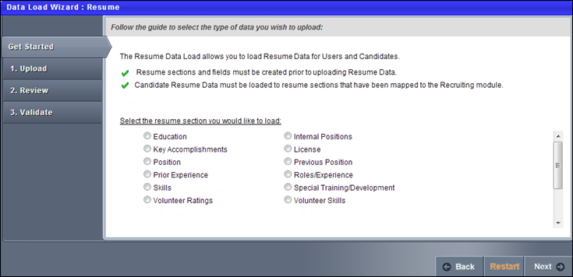

Load Resume Data - Step 3 - Upload
If you are uploading new data to the system, first select a template by clicking the Template link in the lower-left corner. This ensures the proper data is included and that it is in the proper format. In the template, columns that are red are required. See Load Data - Select Data Load Template on page 104 for additional information.
The template for resume data contains the following standard fields:
- User ID - This is used to associate the resume data with a system user. This field is required.
- Entry ID - This is set by the administrator and is used to reference the resume data that is being loaded into the system. Entry IDs are not displayed within the system and must be tracked by the administrator in order to reference the data in the future. This field is required.
  - When loading new resume data, a unique Entry ID must specified.
  - When updating existing resume data, the Entry ID for the data that is being loaded must match the Entry ID for the existing data.
  - Data that is manually created in the system cannot be updated using the Data Load Wizard because this data does not have an Entry ID.
- Culture ID - This specifies to which culture the resume data should be loaded. If a Culture ID is not provided, then the resume data is loaded with the culture of the administrator who is performing the data load.
- Delete - This field enables administrators to delete existing resume data in the system. The resume data that is being deleted must have an Entry ID, and the Entry ID must be provided in the Entry ID column.
  - When this column is set to True, the data for the row is deleted from the database.
  - When this column is set to False, the data for the row is not affected.
  - When this column is empty or if an Entry ID is not provided for the row, the data for the row is not affected.
- All other resume fields can be loaded after they are configured when configuring the Resume in Succession Management.
  - Resume fields can be configured to be required. If a field is required on the Resume configuration page, then the field must be included in the data load.
As you are updating and formatting your data, prior to uploading the file click the Helpful Hints link in the lower-left corner. This document provides you with all of the proper formatting information for the data as well as necessary information for uploading a data file. When formatting the file of data, each column must have a title or header, which will be associated with a data field in the system.
If you need to add custom fields to the system in order to match them with a data field in your file, click the Define Resume Attributes link. This takes you to the Resume Administration page. You can add the necessary custom fields and then return to the Data Load Wizard.
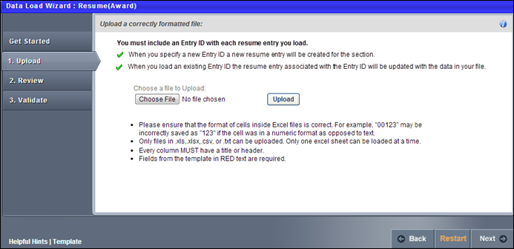
To upload a file of data
- Click the Choose File button and locate the file.
  - You can only upload the following file types: .xls, .xlsx, .csv, .txt.
  - When uploading an Excel file, you can only upload one sheet at a time.
  - Files loaded via the Data Load Wizard cannot contain HTML encoding
- Once the file is selected, click the Upload button. An Upload File pop-up appears with different options depending on the type of file that is uploaded.
  - Excel File (.xls, .xlsx). Select Worksheet (Excel files only) - Only one worksheet can be uploaded at a time, so if the Excel file has multiple worksheets, you must select the worksheet that you are uploading.
  - Text, Comma, or Pipe Separated File (.txt, .csv). Select Delimiter (Tab, Comma, or Pipe Separated files only) - Select what delimiter (e.g., tab, comma, pipe) is used to separate records within the file. This enables the system to properly extract the data from the file.
- Select Template - If you used a template to create the file, select the appropriate template. If no template is used, select the "No template used" option. If you have used the Data Load Wizard in the past and saved a template for this file type, that template is available here.
- My File has titles/headers - Data files should have titles or headers for each column of data. If the file you uploaded does not have titles or headers, deselect this option. Deselecting this option modifies the next step in the review process.
- After selecting the appropriate options, click Continue. The file is uploaded and listed on the page.
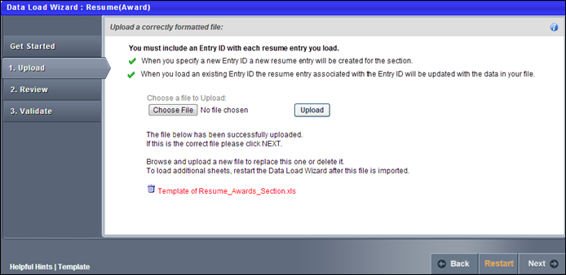
If this is the wrong file or the wrong worksheet within the file, you can delete it by clicking the Remove icon to the left of the file title and upload another file. Alternatively, you can browse and upload a new file. When the correct file is uploaded, click Next to proceed to the Review step. See Load Resume Data - Step 4 - Review on page 59 for additional information.

Load Resume Data - Step 4 - Review
The Review step of the load process allows you to match the uploaded data to the appropriate data elements within the system.
The wizard automatically reads the headers from the uploaded file and matches some of the data fields to the appropriate system fields. You may adjust the data fields as necessary and also move any unmatched fields to the appropriate system field. Once the fields are all matched, you have the option to save the settings as a template for future uploads.
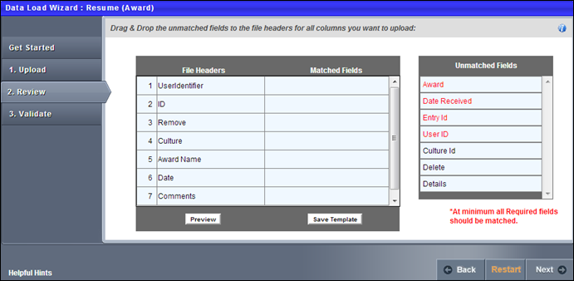
After uploading the file and proceeding to the Review page, the wizard reads the file and displays the column headers from the file. Some data fields may be automatically matched to a file header. If this is the case, the system field is listed in the Matched Fields column immediately to the right of the matching file header. All unmatched system fields are listed on the right in the Unmatched Fields column. Also, fields that the system has mismatched can be moved to the correct file header.
To match the system fields to the file headers, click them from the Unmatched Fields list and drag them to the appropriate row in the Matched Fields column. The items in the Matched Fields column should be directly to the right of the appropriate item in the File Headers column. Once a system field is matched to a file header, it is removed from the Unmatched Fields list.
If the uploaded file does not have titles or headers and the administrator deselected the "My file has titles/headers" option in the Upload step, then each column of data is given a generic header name (e.g., Column 1, Column 2). This enables you to match the data, even though it does not have headers.
All required fields must be paired with one of the file headers in order to proceed. The required system fields are displayed in red, while optional system fields are displayed in black.
Once all items in the File Headers column are matched to the appropriate system field, click the Preview button to verify that the data is properly matched. This displays a preview of up to 20 rows of the data in a pop-up window. The system data field titles are displayed in green, and the uploaded file headers are displayed in blue. If some data is not properly matched, you can then reorganize the fields prior to proceeding. The preview is also helpful to view a sample of the data within a column if you are unsure with what field the file header should be matched.
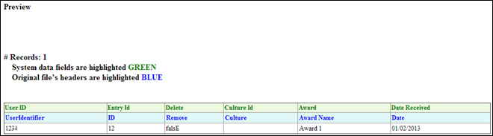
If all fields are properly matched, you may save the pairings as a template. This may be useful if your organization performs multiple data loads of the same file format. In that case, saving the pairings as a template saves you the effort of matching the fields each time. To save the pairings as a template, click the Save Template button. A pop-up appears where you can enter a name for the template. The character limit for template names is 150. Changing the name of a previously saved template creates a new template in the system. Note: All fields that are required by the system must be matched in order to save the parings as a template.
After all fields are properly matched, click the Next button. If all required fields are paired with a file header, some additional options appear prior to moving to the next step. Note: All fields that are required by the system must be matched in order to proceed to the next step.
The Processing Options pop-up appears with additional options. See Load Resume Data - Step 5 - Processing Options on page 61 for additional information.
After selecting the appropriate options, click Continue to proceed to the Validate step. See Load Resume Data - Step 6 - Validate on page 62 for additional information.

Load Resume Data - Step 5 - Processing Options
General Criteria
The following General Criteria options are available when loading data:
Dates are in International (dd/mm/yyyy or dd-mm-yyyy) format
Select this option if the dates within the file are in International format. This allows the system to properly read and interpret the date values when loading them into the system. Many date formats are supported in both American and International versions. Consult the Helpful Hints documents for a full list.
If file is error free, automatically load into system
Select this option to automatically load the data into the system if the data within the uploaded file is error free. The data within the file is still validated during the validation step. But, if there are no formatting or system compatibility errors, you will not have the option to perform a final review before the data is loaded.
Do not allow relationships with inactive Users
Select this option to prevent resume data from being associated with inactive users. This can be used to ensure data is being loaded for active users in the system.
Do not allow relationships with inactive fields or values
Select this option to prevent resume data from being associated with inactive fields, attributes, or drop-down values. This can be used to ensure the data that is being loaded is being loaded to only active fields.
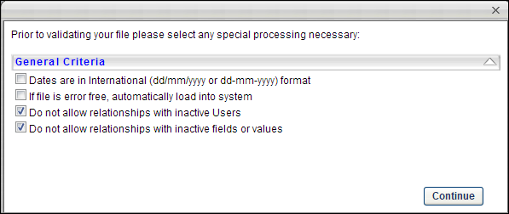
After selecting the appropriate options, click Continue to proceed to the Validate step. See Load Resume Data - Step 6 - Validate on page 62 for additional information.

Load Resume Data - Step 6 - Validate
The Validate step of the load process is where the system validates the data contained in the uploaded file.
Because fields can be created and customized for each resume section, the validations that are performed depend on the field type. Resume fields can be configured to be required. If a field is required on the Resume configuration page, then the field must be included in the data load.
The following field types are available:
Field Type | Validation
Attribute List | The attribute list values must be configured in the system prior to the data load. Values can be active or inactive within the system. The ability to load values that are inactive may be determined in the Processing Options.
Checkbox | Values must be either True, False, T, F, Yes, No, Y, N, Active, or Inactive.
Date Field | Date format must comply with standard format rules. International dates are supported when the Dates are in International format option is selected in the Processing Options pop-up. See the Domestic Date Formats and International Date Formats sections below for additional information.
Dropdown | The available drop-down options must be configured in the system prior to the data load. Drop-down values can be active or inactive within the system. The ability to load values that are inactive may be determined in the Processing Options.
Numeric Field | Positive and negative values are supported. Decimals are supported. The character limit for this field is 7.
Short Text Box | The character limit for this field is 100.
Scrolling Text Box | The character limit for this field is 2000.
Date Range Field | The date may contain a Month, Day, and Year. In addition, when only a Month and Year are entered, the Day value is set to the first day of the month. A Start Date is required. However, an End Date is optional. If an End Date is entered, it must occur after the Start Date.
Domestic Date Formats
The following domestic date formats are supported:
- M/D/YY
- M/D/YYYY
- M-D-YY
- M-D-YYYY
- MM/DD/YY
- MM/DD/YYYY
- MM-DD-YY
- MM-DD-YYYY
International Date Formats
The following international date formats are supported:
- D/M/YY
- D/M/YYYY
- DD/MM/YY
- DD/MM/YYYY
- DD-MM-YY
- DD-MM-YYYY
- D-M-YY
- D-M-YYYY
- YYYY/D/M
- YYYY/DD/MM
- YYYY/M/D
- YYYY/MM/DD
- YYYY-D-M
- YYYY-DD-MM
Validation Progress
When you reach the Validate page, the system automatically begins validating the format of the data.
If there are no errors, the wizard automatically begins validating the data's compatibility with existing system data.
Depending on the number of records being loaded, any format and system validation errors can be viewed and the load can be initiated in different locations:
- For data files with 250 or less records, format and system validation errors can be viewed and the load can be initiated on the Validation page of the Data Load Wizard. The detailed error log can be viewed on the Data Load Queue page.
- For data files with over 250 records, format and system validation errors can be viewed and the load can be initiated on the Track Data Loads page of the Data Load Wizard. The system automatically opens this page once the validation begins.
Files with 250 or Less Records
If there are errors in the file, you have the option to view the errors by clicking the View Errors button to the right of the progress bar. This opens a pop-up which displays a list of the errors that exist in the file as well as a description for the error. Error descriptions are found in far right column, and each error contains its own description. This list can be exported to Excel or printed using the icons in the upper-left corner of the table.
After the data format is checked, a summary of the results is displayed, including:
- Number of records that will continue to system validation
- Number of records that have errors and cannot be loaded

Track Data Loads Overview
Note: Although the Learning, User, and OU data loads are deprecated, the Data Load Wizard itself is not yet deprecated. As a result, the Track Data Loads page will still be available to use to view data loaded using Data Load Wizard in the past, even for Learning, User, and OU loads.

Data Load Queue
The Data Load Queue displays all data loads, including current and past loads.
Note: Although the Learning, User, and OU data loads are deprecated, the Data Load Wizard itself is not yet deprecated. As a result, the Track Data Loads page will still be available to use to view data loaded using Data Load Wizard in the past, even for Learning, User, and OU loads.
To access the Data Load Queue, go to Integration Suite > Data Import Wizard. Then, click the Track Data Loads link.
Permissions
PERMISSION NAME | PERMISSION DESCRIPTION | CATEGORY

Data Load Wizard - Data Load Queue | Enables administrator to access the Data Load Queue screen, which displays all data loads, including current and past loads. Constraints can be applied to this permission. However, these constraints do not impact which data loads are visible to the administrator. This is an administrator permission. | Data Load Wizard

Data Load Wizard - Track Data Loads | Enables administrator to access the Track Data Loads page within the Data Load Wizard. From the Track Data Loads page, administrators can print and download error and archive logs. This permission cannot be constrained. This is an administrator permission. | Data Load Wizard
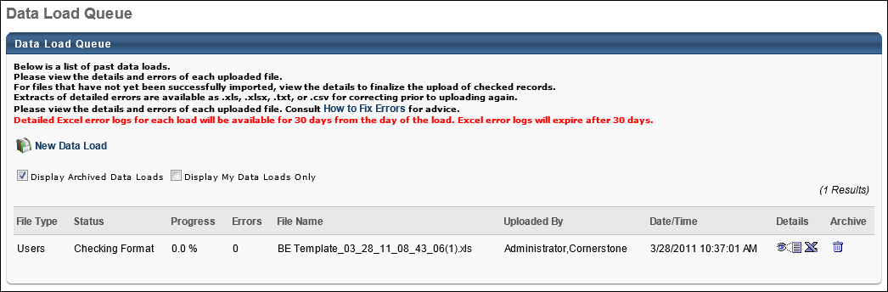
By default, only the data loads that you have performed are visible. To view all available data loads, deselect the Display My Data Loads Only option. The set of data loads that are visible to the user is dependent on the constraints on the Data Load Queue permission.
Archived data loads are not displayed in the Data Load Queue by default. To include archived data loads in the Data Load Queue, select the Display Archived Data Loads option. Data loads are automatically archived after 30 days. Archived files are gray in color. Once a file is archived, the Excel report of data load errors is no longer available.
For each data load, the following information is displayed:
- File Type - The type of file that was data loaded (e.g., Users, Organizational Units). This is based on the selection made during the data load process.
- Status - The status of the data load. If there are errors in the data load, this is displayed in red.
- Progress - This indicates the percentage of records that have been processed. This will be 100% once the load has finished processing even if the data load contains errors. For example, if there are 5000 records in file, it will take some time to process all records, and the Progress percentage increases as more records are processed; when 1000 records are processed the load percentage will be 20%, when 2000 load percentage will be 40% and so on. Additionally, out of the records that have already processed, it is possible for some of the records to have had errors. That information is shown in Errors column.
- Errors - The number of errors contained in the uploaded file. If there are errors in the data load, this is displayed in red.
- File Name - The name of the file that was loaded. This may be the same as other data loads if the same is reused for data loads.
- Uploaded By - The full name of the user that performed the data load.
- Date/Time - If the file is loaded, this is the date and time at which the data is finalized in the system. If the file is not yet finalized, this is the date and time at which the data is verified prior to load. Once the data load is complete, this is updated to the date and time at which the data is finalized in the system.
Details
The Details column contains the following options:
- Preview - This displays a summary of the data load, whether the data load is in progress or complete. See Data Load Queue - View Load Details on page 68 for additional information.
- Excel - This saves a summary of the data load errors to an Excel file, including the details of the record and a description of the error, a list of all records in the loaded file, a list of all matched and unmatched fields, and a list of helpful hints to help diagnose and fix the errors. This option is not available for archived data loads. This report expires 90 days from the data load. See Data Load Queue - View Excel Error Report on page 70 for additional information.
- Print Out - This opens a printable version of a summary of the data load errors, including the details of the record and a description of the error. You can then print the list of errors from that window. If the data load contains no errors, this option is not available.
Note: The Details options are not available for data loads that are in the status Checking Format or Checking System Compatibility.
Archive
The Archive column contains the following options:
- Archive - This archives the data load. Archived data loads appear gray in color, and the error history is no longer saved. Archived data loads are no longer visible in the Data Load Queue by default. To include archived data loads in the Data Load Queue display, select the Display Archived Data Loads option. This option is not available for data loads that are already archived. Once a file is archived, the Excel report of data load errors is no longer available. Note: If this option is selected during a validation or data loading step, the data load is canceled.

Data Load Queue - View Load Details
Click the Preview icon to view a summary of the data load, whether the data load is in progress or complete. The available options vary depending on the status of the data load, but the following information is displayed for all statuses:
- File Name - The name of the file that was loaded.
- Uploaded By - The full name of the user that performed the data load.
- # of records in file - The number of records that are detected in the file
- # of records with formatting errors - The number of records in the file that contain formatting errors
- # of records with system compatibility errors - The number of records in the file that contain system compatibility errors
- # of records that the system failed to load- The number of records in the file that failed to load due to errors
- # of records added - The number of records in the file that are successfully added to the system. This indicates that the record is new to the system and did not previously exist in the system.
- # of records updated - The number of records in the file that are successfully added to the system. This indicates that the record already existed in the system and is now updated with the provided information.
Successful Data Load/Imported Excluding Errors
When a file is loaded successfully or loaded excluding errors, the Upload Details pop-up displays the details of the data load, but there are no options because the data load is complete.
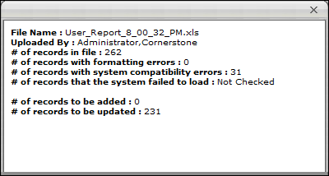
Formatting Errors
Formatting errors arise when the Data Load Wizard expects the data to be in a specific format and the data is not in that format. For example, a date value must be entered in one of the acceptable date formats. If a date value is entered in an unacceptable format, then the data load will receive a formatting error.
When a file is being loaded and the file has formatting errors, but has not yet been checked for system compatibility, the Upload Details pop-up displays the details of the process thus far. The number of formatting errors is displayed, but since the file has not yet been checked for system compatibility, the rest of the analysis is not yet available.
Click Continue to check the file for system compatibility. Note: Only the records that do not have formatting errors are checked for system compatibility.
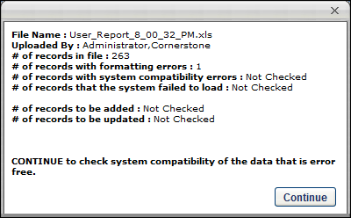
Ready for Import
When a file is being loaded and the file has formatting errors, but the data is compatible with the system, the Upload Details pop-up displays the details of the process thus far. The number of records that will be added and updated is displayed, but the number results of the data load are not yet available.
Click Continue to load the data into the system. Note: Only files with no errors are loaded to the system.
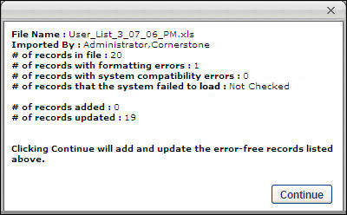

Data Load Queue - View Excel Error Report
Click the Excel icon to open an Excel file that details each of the errors associated with the data load. Once errors are corrected, you can load the records on the Errors Only tab or the entire file again from the All Records worksheet (tab). The Excel Error Report expires 30 days from the data load. This file has four available tabs:
- Errors Only - This tab displays a detailed description of each error within the loaded file. Each row represents a separate error. Along the top row, the file headers that were detected in the loaded file are listed, and the final column provides a detailed description of the error. Errors are listed with both the file header and the system field name for easy reference. Note: If there are more than 10,000 error records, this tab is not included.
- All Records - This tab displays each record that was in the loaded file along with the records that contain errors. The field headers are also provided along the top row. The rows are displayed in the order provided in the data load. A new Error descriptions column can be found on the far right. You can sort by this column to determine the records with errors. Errors are listed with both the file header and the system field name for easy reference.
Note: Once you have fixed the errors from either the Errors Only tab or the All Records tab, you can load that worksheet (tab) from the file once more.
- Matched Fields - For this tab, the first column (System Fields) displays a list of the system fields that are available in the system for the selected data type. The second column (Matched Fields from File) displays the header from the loaded file that was matched to that system field. For example, if you matched the User Division ID header from the loaded file to the Division ID system field, these two fields would appear next to each other. If the Matched Fields from File column does not contain a value, this indicates that you did not match anything to the corresponding system field. Each required field must have a matched field, but all other fields are optional. Note: Only matched fields are loaded.
- Helpful Hints - This tab provides helpful hints for resolving your data load errors based on field name. This helps you to identify the cause of the error and determine how the error can be resolved. The following helpful information is displayed for each system field:
  - Field Name - This displays the field name within the system.
  - Required - This displays whether or not the field is required for each record. If this value is empty, this indicates that the field is optional. If it is required, this value displays additional information as to its requirements.
  - Data Type - This displays the type of data that should be provided for the field. In some instances only certain specific values are accepted. If this is the case, the acceptable values are listed in the Acceptable Values column. Also, if data for a field should be provided in a specific format, this format is listed in the Acceptable Values column.
  - Max Length - This displays the maximum number of characters that the data field accepts.
  - Acceptable Values - This displays important information regarding the field format. This may contain a specific list of acceptable values, a specific range of acceptable values, a list of acceptable formats for the data, or even point you to another resource for more detailed information.
To switch between the tabs, at the bottom of the Excel worksheet you can select the necessary tab.

User Data Load Overview
Ability to perform Users and OU data loads and feeds using Data Load Wizard (DLW) was deprecated with an end-of-life in the May ‘22 Release for most customers. End-of-support for most customers occurred in the February ‘22 Release and support for defects related to DLW Users and OU loads and feeds also stopped at this time.
Important: For customers using the following Data Load Wizard features that are not available in Edge Import, we do not recommend migration of Inbound Data Feed (IDF) for Users and OUs from Data Load Wizard to Edge Import at this time:
- Sensitive Personally Identifiable Information (SPII) fields - Date of Birth/SSN
Customers using the above features will be informed when these features are available in Edge Import and will be given at least three months to deprecate.

Load User Data Overview
Ability to perform Users and OU data loads and feeds using Data Load Wizard (DLW) was deprecated with an end-of-life in the May ‘22 Release for most customers. End-of-support for most customers occurred in the February ‘22 Release and support for defects related to DLW Users and OU loads and feeds also stopped at this time.
Important: For customers using the following Data Load Wizard features that are not available in Edge Import, we do not recommend migration of Inbound Data Feed (IDF) for Users and OUs from Data Load Wizard to Edge Import at this time:
- Sensitive Personally Identifiable Information (SPII) fields - Date of Birth/SSN
Customers using the above features will be informed when these features are available in Edge Import and will be given at least three months to deprecate.
Load User Data - Step 1 - Get Started
When you start the wizard, select which type of data you are loading. The maximum number of records that you can upload in a file is 10,000.
If you are using the Data Load Wizard to set up your portal, begin by loading the organizational units, then users.
User and OU Loads Deprecation: Ability to perform organizational unit and user data loads using Data Load Wizard was deprecated with and end-of-life in the May '22 Release for most customers. Edge Import replaces this functionality.
- For more information on organizational unit loads deprecation, See Load OU Data Overview on page 17 for additional information.
- For more information on user loads deprecation, See User Data Load Overview on page 72 for additional information.
- For information about Edge Import, See Edge Import Homepage.
To start the Data Load Wizard, go to Admin > Tools > Core Functions > Data Load Wizard, and then click Load Data. The Data Load Wizard opens to the Get Started tab. Select the Users option and click Next. See Load User Data - Step 2 - Upload on page 76 for additional information.
Permissions
PERMISSION NAME | PERMISSION DESCRIPTION | CATEGORY

Data Load Wizard - Set User Password | Enables administrator to set a default password for new users when loading users. This is an administrator permission. | Data Load Wizard

Data Load Wizard - Users | Enables administrator to load users. This permission also enables administrators to track data loads and manage data load templates. This is an administrator permission. | Data Load Wizard
Load User Data - Step 2 - Upload
User and OU Loads Deprecation: Ability to perform organizational unit and user data loads using Data Load Wizard was deprecated with and end-of-life in the May '22 Release for most customers. Edge Import replaces this functionality.
- For more information on organizational unit loads deprecation, See Load OU Data Overview on page 17 for additional information.
- For more information on user loads deprecation, See User Data Load Overview on page 72 for additional information.
- For information about Edge Import, See Edge Import Homepage.
Custom Field Administration Link
If you need to add custom fields to the system in order to match them with a data field in your file, click the Custom Field Administration link. This takes you to Custom Field Administration for the selected data type. You can add the necessary custom fields and then return to the Data Load Wizard. Note: This link is only available to users with access to Custom Field Administration.
Template Link
If you are uploading new data to the system, first select a template by clicking the Template link in the lower-left corner. This ensures the proper data is included and that it is in the proper format. In the template, columns that are red are required. See Load Data - Select Data Load Template on page 104 for additional information.
Get Existing Data Link
If you are updating existing data from the system, first download the existing data by clicking the Get Existing Data link in the lower-left corner. This ensures that you have the latest data as it exists in the system. Note: The existing data you are able to export may be restricted by your permission constraints. See Load Data - Get Existing Data on page 124 for additional information.
Helpful Hints Link
As you are updating and formatting your data, prior to uploading the file click the Helpful Hints link in the lower-left corner. This document provides you with all of the proper formatting information for the data as well as necessary information for uploading a data file. When formatting the file of data, each column must have a title or header, which will be associated with a data field in the system. This document can also be used as a guide to adjust a report you may be generating from your HRIS in order to simplify the load process.
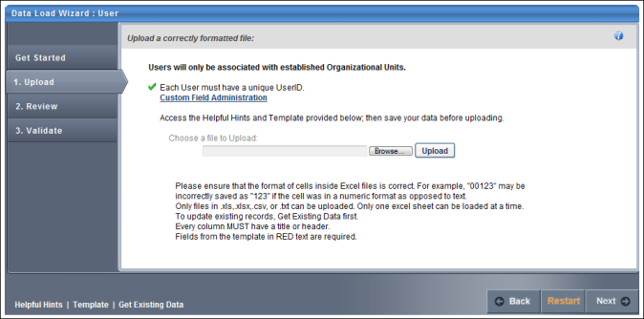
To upload a file of data
- Click the Choose File button and locate the file.
  - You can only upload the following file types: .xls, .xlsx, .csv, .txt.
  - When uploading an Excel file, you can only upload one sheet at a time.
  - Files loaded via the Data Load Wizard cannot contain HTML encoding
- Once the file is selected, click the Upload button. An Upload File pop-up appears with different options depending on the type of file that is uploaded.
  - Excel File (.xls, .xlsx). Select Worksheet (Excel files only) - Only one worksheet can be uploaded at a time, so if the Excel file has multiple worksheets, you must select the worksheet that you are uploading.
  - Text, Comma, or Pipe Separated File (.txt, .csv). Select Delimiter (Tab, Comma, or Pipe Separated files only) - Select what delimiter (e.g., tab, comma, pipe) is used to separate records within the file. This enables the system to properly extract the data from the file.
- Select Template - If you used a template to create the file, select the appropriate template. If no template is used, select the "No template used" option. If you have used the Data Load Wizard in the past and saved a template for this file type, that template is available here.
- My File has titles/headers - Data files should have titles or headers for each column of data. If the file you uploaded does not have titles or headers, deselect this option. Deselecting this option modifies the next step in the review process.
- After selecting the appropriate options, click Continue. The file is uploaded and listed on the page.
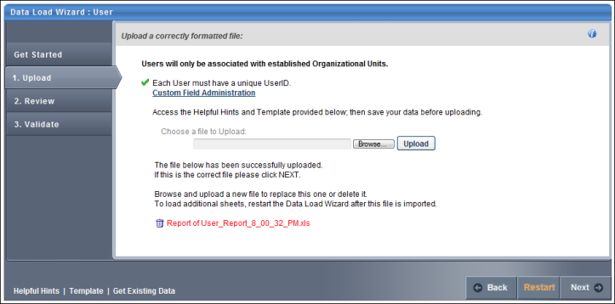
If this is the wrong file or the wrong worksheet within the file, you can delete it by clicking the Remove icon to the left of the file title and upload another file. Alternatively, you can browse and upload a new file. When the correct file is uploaded, click Next to proceed to the Review step. See Load User Data - Step 3 - Review on page 79 for additional information.
Load User Data - Step 3 - Review
User and OU Loads Deprecation: Ability to perform organizational unit and user data loads using Data Load Wizard was deprecated with and end-of-life in the May '22 Release for most customers. Edge Import replaces this functionality.
- For more information on organizational unit loads deprecation, See Load OU Data Overview on page 17 for additional information.
- For more information on user loads deprecation, See User Data Load Overview on page 72 for additional information.
- For information about Edge Import, See Edge Import Homepage.
The Review step of the load process allows you to match the uploaded data to the appropriate data elements within the system.
The wizard automatically reads the headers from the uploaded file and matches some of the data fields to the appropriate system fields. You may adjust the data fields as necessary and also move any unmatched fields to the appropriate system field. Once the fields are all matched, you have the option to save the settings as a template for future uploads.
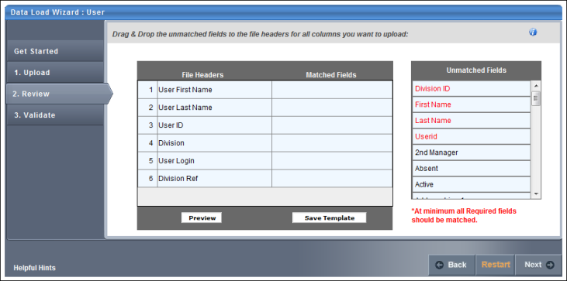
After uploading the file and proceeding to the Review page, the wizard reads the file and displays the column headers from the file. Some data fields may be automatically matched to a file header. If this is the case, the system field is listed in the Matched Fields column immediately to the right of the matching file header. All unmatched system fields are listed on the right in the Unmatched Fields column. Also, fields that the system has mismatched can be moved to the correct file header.
To match the system fields to the file headers, click them from the Unmatched Fields list and drag them to the appropriate row in the Matched Fields column. The items in the Matched Fields column should be directly to the right of the appropriate item in the File Headers column. Once a system field is matched to a file header, it is removed from the Unmatched Fields list.
If the uploaded file does not have titles or headers and the administrator deselected the "My file has titles/headers" option in the Upload step, then each column of data is given a generic header name (e.g., Column 1, Column 2). This enables you to match the data, even though it does not have headers.
All required fields must be paired with one of the file headers in order to proceed. The required system fields are displayed in red, while optional system fields are displayed in black.
Once all items in the File Headers column are matched to the appropriate system field, click the Preview button to verify that the data is properly matched. This displays a preview of up to 20 rows of the data in a pop-up window. The system data field titles are displayed in green, and the uploaded file headers are displayed in blue. If some data is not properly matched, you can then reorganize the fields prior to proceeding. The preview is also helpful to view a sample of the data within a column if you are unsure with what field the file header should be matched.
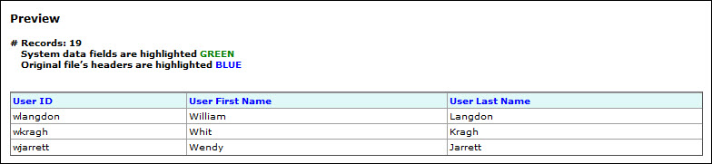
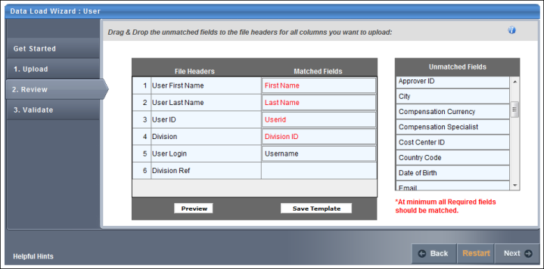
If all fields are properly matched, you may save the pairings as a template. This may be useful if your organization performs multiple data loads of the same file format. In that case, saving the pairings as a template saves you the effort of matching the fields each time. To save the pairings as a template, click the Save Template button. A pop-up appears where you can enter a name for the template. The character limit for template names is 150. Changing the name of a previously saved template creates a new template in the system. Note: All fields that are required by the system must be matched in order to save the parings as a template.
After all fields are properly matched, click the Next button. If all required fields are paired with a file header, some additional options appear prior to moving to the next step. Note: All fields that are required by the system must be matched in order to proceed to the next step.
The Processing Options pop-up appears with additional options. See Load User Data - Step 4 - Processing Options on page 82 for additional information.
After selecting the appropriate options, click Continue to proceed to the Validate step. See Load User Data - Step 5 - Validate on page 84 for additional information.
Load User Data - Step 4 - Processing Options
User and OU Loads Deprecation: Ability to perform organizational unit and user data loads using Data Load Wizard was deprecated with and end-of-life in the May '22 Release for most customers. Edge Import replaces this functionality.
- For more information on organizational unit loads deprecation, See Load OU Data Overview on page 17 for additional information.
- For more information on user loads deprecation, See User Data Load Overview on page 72 for additional information.
- For information about Edge Import, See Edge Import Homepage.
Permissions
PERMISSION NAME | PERMISSION DESCRIPTION | CATEGORY

Data Load Wizard - Set User Password | Enables administrator to set a default password for new users when loading users. This is an administrator permission. | Data Load Wizard
General Criteria
The following General Criteria options are available when loading data:
Dates are in International (dd/mm/yyyy or dd-mm-yyyy) format
Select this option if the dates within the file are in International format. This allows the system to properly read and interpret the date values when loading them into the system. Many date formats are supported in both American and International versions. Consult the Helpful Hints documents for a full list.
If file is error free, automatically load into system
Select this option to automatically load the data into the system if the data within the uploaded file is error free. The data within the file is still validated during the validation step. But, if there are no formatting or system compatibility errors, you will not have the option to perform a final review before the data is loaded.
Blank values should overwrite existing data
Select this option if you want a blank value in the load file to overwrite an existing value within the system. For example, a user record (John Smith) has an email address set in the system (jsmith@email.com), but the email value in the file is blank. If this option is selected, the blank value within the file overwrites the email value set in the system. If this option is not selected, the blank value within the file does not overwrite the email value in the system and John Smith's email address is not affected.
Note: If you select the option to allow blank values to overwrite existing values, and a manager or parent ID is blank within the file, this may cause a hierarchy within the system to break. Also, if the field is a required field, the value cannot be blank within the file.
Do not allow relationships with inactive Users and OUs
Select this option to prevent OUs and users from being associated with inactive OUs or users. This can be used to ensure organizations have a functioning hierarchy between OUs and users. If users and OUs are connected with inactive users or OUs, this may cause breakdowns in system communication such as approvals and reviews.
Assign default password for all new users
Select this option to assign a default password to all new users that are added to the system during the load. If a user is added to the system through an load, a password is not automatically assigned to the user unless this option is selected. Existing users are not affected by this. As a best practice, users should be required to reset their passwords upon initial login through a setting in Password Preferences. Note: This option is only available if you have permission to set user passwords in the Data Load Wizard. This option is selected by default, as it is generally advised for users to have passwords.
- Top Corporate Preference - Select this option to assign new users the default password that is specified in the Password Preferences in the system for the top level Division (Corporation).
- Enter a default temporary password - Select this option to specify a new temporary password for all new users. If this option is selected, you must also enter an appropriate password that will be assigned to all new users that are added during the load. When specifying a default password, be conscious of any password strength requirements that your system may have.
As part of the May '22 Release, customers who have a default password set for the portal cannot provide a custom password for new users created via the Data Load Wizard (DLW). When a default password is enabled for a portal, then this checkbox is selected and disabled, and radio buttons for Top Corporate Password or custom password no longer display for DLW User Loads. Users created via the DLW User Load will have their password set per the default password preferences.
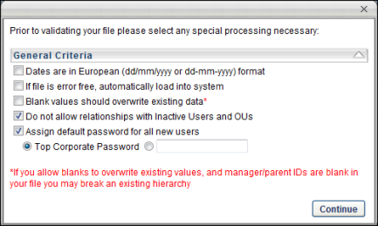
After selecting the appropriate options, click Continue to proceed to the Validate step. See Load OU Data - Step 6 - Validate on page 26 for additional information.
Load User Data - Step 5 - Validate
User and OU Loads Deprecation: Ability to perform organizational unit and user data loads using Data Load Wizard was deprecated with and end-of-life in the May '22 Release for most customers. Edge Import replaces this functionality.
- For more information on organizational unit loads deprecation, See Load OU Data Overview on page 17 for additional information.
- For more information on user loads deprecation, See User Data Load Overview on page 72 for additional information.
- For information about Edge Import, See Edge Import Homepage.
The Validate step of the load process is where the system validates the data contained in the uploaded file. The system first validates the following items:
- Required fields are populated for all rows
- OU, User IDs, and Usernames are unique
- Field lengths and formats are correct (dates, emails, etc.)
- Field values are valid (custom fields, time zones, languages, active, etc.)
When an administrator has the Data Load Wizard - Users Enable GUID permission, the GUID appears in the User Data Load template and can be mapped in the Data Load Wizard. When the GUID is included in the User data load, the GUID is used as the primary key and validates the user record. The GUID must be an existing value within the system. If the GUID is an existing value within the system, the following is true for the corresponding user record:
- The User ID can be updated. The User ID remains a required field and must be a unique value in the system.
- The Username can be updated. Username values must be unique. The Username value may be required, depending on a backend setting.
- All External Candidates or Applicants with a GUID are updated to Internal Users in the system.
- If a GUID is not provided, then either the User ID or Username is used as the primary key, depending on the backend setting.
When the Username is used as the primary key for the user record, the following is true:
- The Username cannot be updated once it is set, and all Username values must be unique.
- The User ID can be updated, but all User ID values are required and must be unique.
Permissions
PERMISSION NAME | PERMISSION DESCRIPTION | CATEGORY

Data Load Wizard - Enable User GUID | Enables the GUID in the Data Load Wizard User Load and mapping template. This enables organizations to include the GUID as the primary key for user data loads. This permission cannot be constrained. | Data Load Wizard
When you reach the Validate page, the system automatically begins validating the format of the data.
If there are no errors, the wizard automatically begins validating the data's compatibility with existing system data.
Depending on the number of records being loaded, any format and system validation errors can be viewed and the load can be initiated in different locations:
- For data files with 100 or less records, format and system validation errors can be viewed and the load can be initiated on the Validation page of the Data Load Wizard. The detailed error log can be viewed on the Data Load Queue page.
- For data files with over 100 records, format and system validation errors can be viewed and the load can be initiated on the Data Load Queue page of the Data Load Wizard. The system automatically opens this page once the validation begins.
Files with 100 or Less Records
If there are errors in the file, you have the option to view the errors by clicking the View Errors button to the right of the progress bar. This opens a pop-up which displays a list of the errors that exist in the file as well as a description for the error. Error descriptions are found in far right column, and each error contains its own description. This list can be exported to Excel or printed using the icons in the upper-left corner of the table.
After the data format is checked, a summary of the results is displayed, including:
- Number of records that will continue to system validation
- Number of records that have errors and cannot be loaded
To view how to fix the data errors, on the Validate page, click the How to fix errors link. This opens a document that details how each type of error can be resolved. You may also click the Helpful Hints link in the bottom-left corner of the page for additional information. After resolving the issues in the file, you may click the Load same file type again link or the Restart button to re-attempt the load.
- If more than 50% of the records contain errors, you cannot proceed with the data upload. You must resolve the issues prior to proceeding.
- If less than 50% of the records contain errors, you may continue to load the data, but the data records that contain errors cannot be uploaded and they are skipped.
Once the errors are resolved or there are a minimal number of errors, you may continue the validation process by clicking the Continue Validation button. This begins the process of verifying the data's compatibility with the system. The system then validates the following items:
- OU and User IDs referenced on other records are valid or active
- There are no circular hierarchies for OUs or User relationships
- The administrator has permission to load each record based on constraints
After the system compatibility is checked, a summary of the results is displayed:
- Number of records that will be updated
- Number of records that will be added
- Number of records that have errors and cannot be updated
To finalize the data load, click the Load Data button. This adds the data load to the Data Load Queue for processing.
After the data is loaded, the status is updated in the Data Load Queue and the uploaded data is available. See Data Load Queue on page 66 for additional information.

Cornerstone HR - Load User Data - Overview
Ability to perform Users and OU data loads and feeds using Data Load Wizard (DLW) was deprecated with an end-of-life in the May ‘22 Release for most customers. End-of-support for most customers occurred in the February ‘22 Release and support for defects related to DLW Users and OU loads and feeds also stopped at this time.
Important: For customers using the following Data Load Wizard features that are not available in Edge Import, we do not recommend migration of Inbound Data Feed (IDF) for Users and OUs from Data Load Wizard to Edge Import at this time:
- Sensitive Personally Identifiable Information (SPII) fields - Date of Birth/SSN
Customers using the above features will be informed when these features are available in Edge Import and will be given at least three months to deprecate.
Use the User Data Load for Cornerstone HR, to load multiple effective dated records for each user in a single load, including effective dated records. This functionality only applies to organizations using Cornerstone HR.
Users cannot be created in the system "as of" a point in time; users can only be created "as of" Right Now. To perform a data load of effective dated information, the users must currently exist in the Cornerstone system.
Effective dating is applied to the entire record. It cannot be applied on a field-by-field basis when loading data using the Data Load Wizard.
Backdating user data before 1901 is not supported.
Use Cases
- Acme Corp. is deprecating an existing HR system that has employee data about the organization for the previous eight years.
- Jeremy is an administrator at Acme Corp., and he is working migrating data from the HR system to the Cornerstone system.
- Jeremy exports the data from his legacy HR system using the reporting tool and formats the data to be loaded into the Cornerstone system.
- With this enhancement, Jeremy can include all eight years of data for his employees in a single load, meaning that it is much easier for him to migrate data from the legacy system into Cornerstone.
Begin Loading User Data
See Cornerstone HR - Load User Data - Step 1 - Load Data on page 89 for additional information.
Cornerstone HR - Load User Data - Step 1 - Load Data
When you start the wizard, select which type of data you are loading. The maximum number of records that you can upload in a file is 10,000.
If you are using the Data Load Wizard to set up your portal, begin by loading the organizational units, then users.
User and OU Loads Deprecation: Ability to perform organizational unit and user data loads using Data Load Wizard was deprecated with and end-of-life in the May '22 Release for most customers. Edge Import replaces this functionality.
- For more information on organizational unit loads deprecation, See Load OU Data Overview on page 17 for additional information.
- For more information on user loads deprecation, See User Data Load Overview on page 72 for additional information.
- For information about Edge Import, See Edge Import Homepage.
To start the Data Load Wizard, go to Admin > Tools > Core Functions > Data Load Wizard, and then click Load Data. The Data Load Wizard opens to the Get Started tab.
Permissions
PERMISSION NAME | PERMISSION DESCRIPTION | CATEGORY

Data Load Wizard - Set User Password | Enables administrator to set a default password for new users when loading users. This is an administrator permission. | Data Load Wizard

Data Load Wizard - Users | Enables administrator to load users. This permission also enables administrators to track data loads and manage data load templates. This is an administrator permission. | Data Load Wizard
Select the Users option and click Next to upload a file. See Cornerstone HR - Load User Data - Step 2 - Upload on page 91 for additional information.
Cornerstone HR - Load User Data - Step 2 - Upload
Use the Upload tab to upload data using a template, existing data, or to match custom fields to the data in your file.
This functionality only applies to organizations that are using Cornerstone HR.
User and OU Loads Deprecation: Ability to perform organizational unit and user data loads using Data Load Wizard was deprecated with and end-of-life in the May '22 Release for most customers. Edge Import replaces this functionality.
- For more information on organizational unit loads deprecation, See Load OU Data Overview on page 17 for additional information.
- For more information on user loads deprecation, See User Data Load Overview on page 72 for additional information.
- For information about Edge Import, See Edge Import Homepage.
Custom Field Administration Link
If you need to add custom fields to the system in order to match them with a data field in your file, click the Custom Field Administration link. This takes you to Custom Field Administration for the selected data type. You can add the necessary custom fields and then return to the Data Load Wizard. Note: This link is only available to users with access to Custom Field Administration.
Template Link
If you are uploading new data to the system, first select a template by clicking the Template link in the lower-left corner. This ensures the proper data is included and that it is in the proper format. In the template, columns that are red are required. See Load Data - Select Data Load Template on page 104 for additional information.
Get Existing Data Link
If you are updating existing data from the system, first download the existing data by clicking the Get Existing Data link in the lower-left corner. This ensures that you have the latest data as it exists in the system. Note: The existing data you are able to export may be restricted by your permission constraints. See Load Data - Get Existing Data on page 124 for additional information.
Helpful Hints Link
As you are updating and formatting your data, prior to uploading the file click the Helpful Hints link in the lower-left corner. This document provides you with all of the proper formatting information for the data as well as necessary information for uploading a data file. When formatting the file of data, each column must have a title or header, which will be associated with a data field in the system. This document can also be used as a guide to adjust a report you may be generating from your HRIS in order to simplify the load process.
To upload a file of data
- Click the Choose File button and locate the file.
  - You can only upload the following file types: .xls, .xlsx, .csv, .txt.
  - When uploading an Excel file, you can only upload one sheet at a time.
  - Files loaded via the Data Load Wizard cannot contain HTML encoding
- Once the file is selected, click the Upload button. An Upload File pop-up appears with different options depending on the type of file that is uploaded.
  - Excel File (.xls, .xlsx). Select Worksheet (Excel files only) - Only one worksheet can be uploaded at a time, so if the Excel file has multiple worksheets, you must select the worksheet that you are uploading.
  - Text, Comma, or Pipe Separated File (.txt, .csv). Select Delimiter (Tab, Comma, or Pipe Separated files only) - Select what delimiter (e.g., tab, comma, pipe) is used to separate records within the file. This enables the system to properly extract the data from the file.
- Select Template - If you used a template to create the file, select the appropriate template. If no template is used, select the "No template used" option. If you have used the Data Load Wizard in the past and saved a template for this file type, that template is available here.
- My File has titles/headers - Data files should have titles or headers for each column of data. If the file you uploaded does not have titles or headers, deselect this option. Deselecting this option modifies the next step in the review process.
- After selecting the appropriate options, click Continue. The file is uploaded and listed on the page.
If this is the wrong file or the wrong worksheet within the file, you can delete it by clicking the Remove icon to the left of the file title and upload another file. Alternatively, you can browse and upload a new file. When the correct file is uploaded, click Next to proceed to the Review step. See Cornerstone HR - Load User Data - Step 3 - Review on page 94 for additional information.
Cornerstone HR - Load User Data - Step 3 - Review
This functionality only applies to organizations that are using Cornerstone HR.
The Review step of the load process allows you to match the uploaded data to the appropriate data elements within the system.
The wizard automatically reads the headers from the uploaded file and matches some of the data fields to the appropriate system fields. You may adjust the data fields as necessary and also move any unmatched fields to the appropriate system field. Once the fields are all matched, you have the option to save the settings as a template for future uploads.
User and OU Loads Deprecation: Ability to perform organizational unit and user data loads using Data Load Wizard was deprecated with and end-of-life in the May '22 Release for most customers. Edge Import replaces this functionality.
- For more information on organizational unit loads deprecation, See Load OU Data Overview on page 17 for additional information.
- For more information on user loads deprecation, See User Data Load Overview on page 72 for additional information.
- For information about Edge Import, See Edge Import Homepage.
After uploading the file and proceeding to the Review page, the wizard reads the file and displays the column headers from the file. Some data fields may be automatically matched to a file header. If this is the case, the system field is listed in the Matched Fields column immediately to the right of the matching file header. All unmatched system fields are listed on the right in the Unmatched Fields column. Also, fields that the system has mismatched can be moved to the correct file header.
To match the system fields to the file headers, click them from the Unmatched Fields list and drag them to the appropriate row in the Matched Fields column. The items in the Matched Fields column should be directly to the right of the appropriate item in the File Headers column. Once a system field is matched to a file header, it is removed from the Unmatched Fields list.
If the uploaded file does not have titles or headers and the administrator deselected the "My file has titles/headers" option in the Upload step, then each column of data is given a generic header name (e.g., Column 1, Column 2). This enables you to match the data, even though it does not have headers.
All required fields must be paired with one of the file headers in order to proceed. The required system fields are displayed in red, while optional system fields are displayed in black.
Once all items in the File Headers column are matched to the appropriate system field, click the Preview button to verify that the data is properly matched. This displays a preview of up to 20 rows of the data in a pop-up window. The system data field titles are displayed in green, and the uploaded file headers are displayed in blue. If some data is not properly matched, you can then reorganize the fields prior to proceeding. The preview is also helpful to view a sample of the data within a column if you are unsure with what field the file header should be matched.
If all fields are properly matched, you may save the pairings as a template. This may be useful if your organization performs multiple data loads of the same file format. In that case, saving the pairings as a template saves you the effort of matching the fields each time. To save the pairings as a template, click the Save Template button. A pop-up appears where you can enter a name for the template. The character limit for template names is 150. Changing the name of a previously saved template creates a new template in the system. Note: All fields that are required by the system must be matched in order to save the parings as a template.
After all fields are properly matched, click the Next button. If all required fields are paired with a file header, some additional options appear prior to moving to the next step. Note: All fields that are required by the system must be matched in order to proceed to the next step.
The Processing Options pop-up appears with additional options. See Cornerstone HR Load User Data - Step 4 - Processing Options on page 97 for additional information.
After selecting the appropriate options, click Continue to proceed to the Validate step. See Cornerstone HR Load User Data - Step 5 - Validate on page 99 for additional information.
Cornerstone HR Load User Data - Step 4 - Processing Options
This functionality only applies to organizations that are using Cornerstone HR.
User and OU Loads Deprecation: Ability to perform organizational unit and user data loads using Data Load Wizard was deprecated with and end-of-life in the May '22 Release for most customers. Edge Import replaces this functionality.
- For more information on organizational unit loads deprecation, See Load OU Data Overview on page 17 for additional information.
- For more information on user loads deprecation, See User Data Load Overview on page 72 for additional information.
- For information about Edge Import, See Edge Import Homepage.
Permissions
PERMISSION NAME | PERMISSION DESCRIPTION | CATEGORY

Data Load Wizard - Set User Password | Enables administrator to set a default password for new users when loading users. This is an administrator permission. | Data Load Wizard
General Criteria
The following General Criteria options are available when loading data:
Dates are in International (dd/mm/yyyy or dd-mm-yyyy) format
Select this option if the dates within the file are in International format. This allows the system to properly read and interpret the date values when loading them into the system. Many date formats are supported in both American and International versions. Consult the Helpful Hints documents for a full list.
If file is error free, automatically load into system
Select this option to automatically load the data into the system if the data within the uploaded file is error free. The data within the file is still validated during the validation step. But, if there are no formatting or system compatibility errors, you will not have the option to perform a final review before the data is loaded.
Blank values should overwrite existing data
Select this option if you want a blank value in the load file to overwrite an existing value within the system. For example, a user record (John Smith) has an email address set in the system (jsmith@email.com), but the email value in the file is blank. If this option is selected, the blank value within the file overwrites the email value set in the system. If this option is not selected, the blank value within the file does not overwrite the email value in the system and John Smith's email address is not affected.
Note: If you select the option to allow blank values to overwrite existing values, and a manager or parent ID is blank within the file, this may cause a hierarchy within the system to break. Also, if the field is a required field, the value cannot be blank within the file.
Do not allow relationships with inactive Users and OUs
Select this option to prevent OUs and users from being associated with inactive OUs or users. This can be used to ensure organizations have a functioning hierarchy between OUs and users. If users and OUs are connected with inactive users or OUs, this may cause breakdowns in system communication such as approvals and reviews.
Assign default password for all new users
Select this option to assign a default password to all new users that are added to the system during the load. If a user is added to the system through an load, a password is not automatically assigned to the user unless this option is selected. Existing users are not affected by this. As a best practice, users should be required to reset their passwords upon initial login through a setting in Password Preferences. Note: This option is only available if you have permission to set user passwords in the Data Load Wizard. This option is selected by default, as it is generally advised for users to have passwords.
- Top Corporate Preference - Select this option to assign new users the default password that is specified in the Password Preferences in the system for the top level Division (Corporation).
- Enter a default temporary password - Select this option to specify a new temporary password for all new users. If this option is selected, you must also enter an appropriate password that will be assigned to all new users that are added during the load. When specifying a default password, be conscious of any password strength requirements that your system may have.
As part of the May '22 Release, customers who have a default password set for the portal cannot provide a custom password for new users created via the Data Load Wizard (DLW). When a default password is enabled for a portal, then this checkbox is selected and disabled, and radio buttons for Top Corporate Password or custom password no longer display for DLW User Loads. Users created via the DLW User Load will have their password set per the default password preferences.
After selecting the appropriate options, click Continue to proceed to the Validate step. See Cornerstone HR Load User Data - Step 5 - Validate on page 99 for additional information.
Cornerstone HR Load User Data - Step 5 - Validate
This functionality only applies to organizations that are using Cornerstone HR.
User and OU Loads Deprecation: Ability to perform organizational unit and user data loads using Data Load Wizard was deprecated with and end-of-life in the May '22 Release for most customers. Edge Import replaces this functionality.
- For more information on organizational unit loads deprecation, See Load OU Data Overview on page 17 for additional information.
- For more information on user loads deprecation, See User Data Load Overview on page 72 for additional information.
- For information about Edge Import, See Edge Import Homepage.
Permissions
PERMISSION NAME | PERMISSION DESCRIPTION | CATEGORY

Data Load Wizard - Enable User GUID | Enables the GUID in the Data Load Wizard User Load and mapping template. This enables organizations to include the GUID as the primary key for user data loads. This permission cannot be constrained. | Data Load Wizard
The Validate step of the load process is where the system validates the data contained in the uploaded file. The system first validates the following items:
- Required fields are populated for all rows
- OU, User IDs, and Usernames are unique
- Field lengths and formats are correct (dates, emails, etc.)
- Field values are valid (custom fields, time zones, languages, active, etc.)
When the Username is used as the primary key for the user record, the following is true:
- The Username cannot be updated once it is set, and all Username values must be unique.
- The User ID can be updated, but all User ID values are required and must be unique.
The Local System ID standard field enables organizations to capture an identifier from a local system. However, this value does not need to be unique, and it is not used to validate whether users exist in the system. This field would typically be used when Cornerstone is generating User IDs for users and the organization wants to store the identifier from their local Human Resources (HR) or Payroll system in the Cornerstone system. The character limit is 100. This field is optional. The availability of this field is controlled by a backend setting.
For organizations that have enabled the User ID field within the system, the following scenarios may occur:
- When user data is provided with a User ID, then the system checks to see if the user exists in the system.
  - If the user already exists in the system, then the DLW updates the user record with the loaded information.
  - If the user does not exist in the system, then the DLW creates a new user record using the specified User ID.
- When user data is provided without a User ID, the DLW creates a new user record for the user. The system automatically creates a User ID for the user.
- If the data mapping template does not include the User ID field or if the User ID field is not mapped to the template, then the data load can only be used to create new users.
For organizations that have disabled the User ID field within the system, the following scenarios may occur:
- When user data is provided with a Username, then the system checks to see if the user exists in the system.
  - If the user already exists in the system, then the DLW updates the user record with the loaded information.
  - If the user does not exists in the system, then the DLW creates a new user record using the specified Username.
- When a user is provided without a Username, the DLW creates a new user record for the user. The system automatically creates a Username for the user.
Validate Page
When you reach the Validate page, the system automatically begins validating the format of the data.
If there are no errors, the wizard automatically begins validating the data's compatibility with existing system data.
Depending on the number of records being loaded, any format and system validation errors can be viewed and the load can be initiated in different locations:
- For data files with 100 or less records, format and system validation errors can be viewed and the load can be initiated on the Validation page of the Data Load Wizard. The detailed error log can be viewed on the Data Load Queue page.
- For data files with over 100 records, format and system validation errors can be viewed and the load can be initiated on the Data Load Queue page of the Data Load Wizard. The system automatically opens this page once the validation begins.
Files with 100 or Less Records
If there are errors in the file, you have the option to view the errors by clicking the View Errors button to the right of the progress bar. This opens a pop-up which displays a list of the errors that exist in the file as well as a description for the error. Error descriptions are found in far right column, and each error contains its own description. This list can be exported to Excel or printed using the icons in the upper-left corner of the table.
After the data format is checked, a summary of the results is displayed, including:
- Number of records that will continue to system validation
- Number of records that have errors and cannot be loaded
To view how to fix the data errors, on the Validate page, click the How to fix errors link. This opens a document that details how each type of error can be resolved. You may also click the Helpful Hints link in the bottom-left corner of the page for additional information. After resolving the issues in the file, you may click the Load same file type again link or the Restart button to re-attempt the load.
- If more than 50% of the records contain errors, you cannot proceed with the data upload. You must resolve the issues prior to proceeding.
- If less than 50% of the records contain errors, you may continue to load the data, but the data records that contain errors cannot be uploaded and they are skipped.
Once the errors are resolved or there are a minimal number of errors, you may continue the validation process by clicking the Continue Validation button. This begins the process of verifying the data's compatibility with the system. The system then validates the following items:
- OU and User IDs referenced on other records are valid or active
- There are no circular hierarchies for OUs or User relationships
- The administrator has permission to load each record based on constraints
After the system compatibility is checked, a summary of the results is displayed:
- Number of records that will be updated
- Number of records that will be added
- Number of records that have errors and cannot be updated
To finalize the data load, click the Load Data button. This adds the data load to the Data Load Queue for processing.
After the data is loaded, the status is updated in the Data Load Queue and the uploaded data is available. See Data Load Queue on page 66 for additional information.
As of Date (Effective Date)
An As of Date can now be associated with a user record. By setting an effective date for a user record, administrators can set changes that are effective in the past and in the future via the Data Load Wizard. Effective dating is applied to the entire record. It cannot be applied on a field-by-field basis when loading data using the Data Load Wizard.
The As of Date field accepts date values. Backdating user data before 1901 is not supported.
Currently the Data Load Wizard does not support adding a user with multiple effective dated records within the same load file. If a user has multiple effective dated records, the records must be loaded in separate files.
Duplicate User Prevention
When an organization using Link loads new users using the Data Load Wizard, the system can be configured to determine whether the new users are similar to existing user records. This is done in order to prevent the same user from being added to the system more than once.
When loading user using the Data Load Wizard - User Load for Link, the system determines whether the user record is potentially a duplicate user record.

Data Load Wizard Templates Overview

Load Data - Select Data Load Template
Data Load templates are valuable when loading data to your system. The templates enable you to format your data in the proper manner so that data is loaded properly with all of the necessary information. Each data type that can be loaded using the Data Load Wizard has its own system template that can be used to format data.
The default system templates provided are Excel spreadsheets with all of the appropriate data fields that correspond to field names in the system. The spreadsheet is compatible with Microsoft Excel 2004, 2007, and 2010. Each available data field title is listed in its own column along the first row of the spreadsheet. Required fields are displayed in red and optional fields are displayed in black.
To download a template, open the Data Load Wizard, select the type of data you are loading, and on the Upload page click the Template link in the lower-left corner. You are provided the opportunity to save the template to your computer and then you can open the template.
Copy your data into the appropriate columns of the template. The data must be formatted properly in order to accurately load into the system. Be sure the data is formatted properly by viewing the Helpful Hints, which is available by clicking the Helpful Hints tab in the lower-left corner of the Template Excel document.
The Helpful Hints of the document has an overview of field requirements for quick reference. This tab provides helpful hints for formatting the data based on field name. This helps you avoid errors when loading your data. The following helpful information is displayed for each system field:
- Field Name - This displays the field name within the system.
- Required - This displays whether or not the field is required for each record. If this value is empty, this indicates that the field is optional. If it is required, this value displays additional information as to its requirements.
- Data Type - This displays the type of data that should be provided for the field. In some instances only certain specific values are accepted. If this is the case, the acceptable values are listed in the Acceptable Values column. Also, if data for a field should be provided in a specific format, this format is listed in the Acceptable Values column.
- Max Length - This displays the maximum number of characters that the data field accepts.
- Acceptable Values - This displays important information regarding the field format. This may contain a specific list of acceptable values, a specific range of acceptable values, a list of acceptable formats for the data, or even point you to another resource for more detailed information.
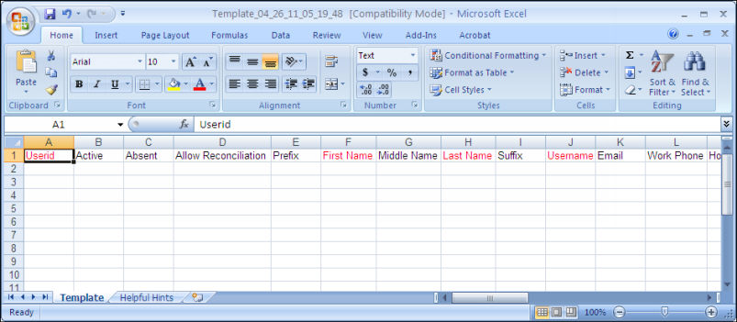

Manage Templates
The Manage Templates page enables administrators to manage the templates that have been added via the Data Load Wizard.
To manage data load templates, go to Admin > Configuration Tools > Data Load Wizard. Then click the Manage Templates link.
Permissions
PERMISSION NAME | PERMISSION DESCRIPTION | CATEGORY

Data Load Wizard - Manage Templates | Enables administrator to access the Manage Templates page within the Data Load Wizard. From the Manage Templates page, administrators can view, download, and archive templates. This permission cannot be constrained. This is an administrator permission. | Data Load Wizard
To access the Manage Templates page, you must have one of the Data Load Wizard permissions.
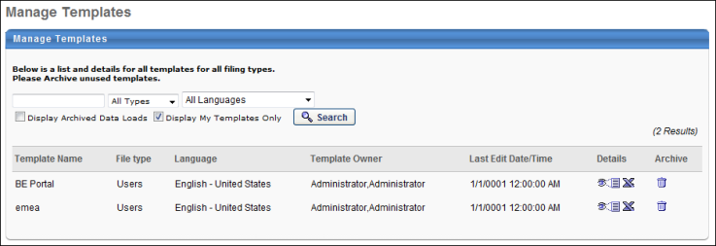
To search for an existing template, enter the template name in the Search field, select the appropriate template type from the drop-down list, select the template language, and click the Search button. To display archived data loads or only templates that you have created, select the appropriate search filter options. The page refreshes to display only templates that match the search criteria and search filters.
The template table displays the following information:
- Template Name
- File Template
- Language
- Template Owner
- Last Edit Date/Time
The following options are available in the Details and Archive columns:
- Preview - Click to preview the template in a pop-up window.
- Export to Excel - Click to export the template to Excel.
- Archive - Click to archive a template if it is no longer being used.

Data Load Wizard Template Codes
Time Zone Details
Select the below link to download an Excel document that contains a list of all time zones, IDs, UTC offsets, and whether they support Daylight Saving Time. Note: If a time zone does not support Daylight Saving Time, this means that the time zone does not adjust their time to alter which hours experience daylight.
- Time Zone Details (last updated on 20 March 2019)
Note: If you are using Edge Import, use the Numeric ID, not the three-letter code for the time zone.
Data Load Wizard - Country Codes
The following table contains a list of country codes to help you fill out your template with the proper data. Two or three letter codes are acceptable.
Code Options |  |  | Country Name
AW |  | ABW | Aruba
AF |  | AFG | Afghanistan
AO |  | AGO | Angola
AI |  | AIA | Anguilla
AX |  | ALA | Aland Islands
AL |  | ALB | Albania
AD |  | AND | Andorra
AN |  | ANT | Netherlands Antilles
AE |  | ARE | United Arab Emirates
AR |  | ARG | Argentina
AM |  | ARM | Armenia
AS |  | ASM | American Samoa
AQ |  | ATA | Antarctica
TF |  | ATF | French Southern Territories
AG |  | ATG | Antigua and Barbuda
AU |  | AUS | Australia
AT |  | AUT | Austria
AZ |  | AZE | Azerbaijan
BI |  | BDI | Burundi
BE |  | BEL | Belgium
BJ |  | BEN | Benin
BQ |  | BES | Bonaire, Saint Eustatius and Saba
BF |  | BFA | Burkina Faso
BD |  | BGD | Bangladesh
BG |  | BGR | Bulgaria
BH |  | BHR | Bahrain
BS |  | BHS | Bahamas
BA |  | BIH | Bosnia and Herzevina
BL |  | BLM | Saint Barthélemy
BY |  | BLR | Belarus
BZ |  | BLZ | Belize
BM |  | BMU | Bermuda
BO |  | BOL | Bolivia, Plurinational State
BR |  | BRA | Brazil
BB |  | BRB | Barbados
BN |  | BRN | Brunei Darussalam
BT |  | BTN | Bhutan
BV |  | BVT | Bouvet Island
BW |  | BWA | Botswana
CF |  | CAF | Central African Republic
CA |  | CAN | Canada
CC |  | CCK | Cocos (Keeling) Islands
CH |  | CHE | Switzerland
CL |  | CHL | Chile
CN |  | CHN | China
CI |  | CIV | Côte d’Ivoire
CM |  | CMR | Cameroon
CD |  | COD | Congo, the Democratic
CG |  | COG | Congo
CK |  | COK | Cook Islands
CO |  | COL | Colombia
KM |  | COM | Comoros
CV |  | CPV | Cape Verde
CR |  | CRI | Costa Rica
CU |  | CUB | Cuba
CW |  | CUW | Curacao
CX |  | CXR | Christmas Island
KY |  | CYM | Cayman Islands
CY |  | CYP | Cyprus
CZ |  | CZE | Czech Republic
DE |  | DEU | Germany
DJ |  | DJI | Djibouti
DM |  | DMA | Dominica
DK |  | DNK | Denmark
DO |  | DOM | Dominican Republic
DZ |  | DZA | Algeria
EC |  | ECU | Ecuador
EG |  | EGY | Egypt
ER |  | ERI | Eritrea
EH |  | ESH | Western Sahara
ES |  | ESP | Spain
EE |  | EST | Estonia
ET |  | ETH | Ethiopia
FI |  | FIN | Finland
FJ |  | FJI | Fiji
FK |  | FLK | Falkland Islands (Malvinas)
FR |  | FRA | France
FO |  | FRO | Faroe Islands
FM |  | FSM | Micronesia, Federated States
GA |  | GAB | Gabon
GB |  | GBR | United Kingdom
GE |  | GEO | Georgia
GG |  | GGY | Guernsey
GH |  | GHA | Ghana
GI |  | GIB | Gibraltar
GN |  | GIN | Guinea
GP |  | GLP | Guadeloupe
GM |  | GMB | Gambia
GW |  | GNB | Guinea-Bissau
GQ |  | GNQ | Equatorial Guinea
GR |  | GRC | Greece
GD |  | GRD | Grenada
GL |  | GRL | Greenland
GT |  | GTM | Guatemala
GF |  | GUF | French Guiana
GU |  | GUM | Guam
GY |  | GUY | Guyana
HK |  | HKG | Hong Kong
HM |  | HMD | Heard Island and McDonald Islands
HN |  | HND | Honduras
HR |  | HRV | Croatia
HT |  | HTI | Haiti
HU |  | HUN | Hungary
ID |  | IDN | Indonesia
IM |  | IMN | Isle of Man
IN |  | IND | India
IO |  | IOT | British Indian Ocean Territory
IE |  | IRL | Ireland
IR |  | IRN | Iran, Islamic Republic
IQ |  | IRQ | Iraq
IS |  | ISL | Iceland
IL |  | ISR | Israel
IT |  | ITA | Italy
JM |  | JAM | Jamaica
JE |  | JEY | Jersey
JO |  | JOR | Jordan
JP |  | JPN | Japan
KZ |  | KAZ | Kazakhstan
KE |  | KEN | Kenya
KG |  | KGZ | Kyrgystan
KH |  | KHM | Cambodia
KI |  | KIR | Kiribati
KN |  | KNA | Saint Kitts and Nevis
KP |  | PRK | Korea, Democratic People's Republic of
KR |  | KOR | Korea, Republic of
KW |  | KWT | Kuwait
LA |  | LAO | Lao People’s Democratic Republic
LB |  | LBN | Lebanon
LR |  | LBR | Liberia
LY |  | LBY | Libyan Arab Jamahiriya
LC |  | LCA | Saint Lucia
LI |  | LIE | Liechtenstein
LK |  | LKA | Sri Lanka
LS |  | LSO | Lesotho
LT |  | LTU | Lithuania
LU |  | LUX | Luxembourg
LV |  | LVA | Latvia
MO |  | MAC | Macao
MF |  | MAF | Saint Martin (French part)
MA |  | MAR | Morocco
MC |  | MCO | Monaco
MD |  | MDA | Moldova, Republic of
MG |  | MDG | Madagascar
MV |  | MDV | Maldives
MX |  | MEX | Mexico
MH |  | MHL | Marshall Islands
MK |  | MKD | Macedonia, the former Yuslav Republic of
ML |  | MLI | Mali
MT |  | MLT | Malta
MM |  | MMR | Myanmar
ME |  | MNE | Montenegro
MN |  | MNG | Monlia
MP |  | MNP | Northern Mariana Islands
MZ |  | MOZ | Mozambique
MR |  | MRT | Mauritania
MS |  | MSR | Montserrat
MQ |  | MTQ | Martinique
MU |  | MUS | Mauritius
MW |  | MWI | Malawi
MY |  | MYS | Malaysia
YT |  | MYT | Mayotte
NA |  | NAM | Namibia
NL |  | NLD | Netherlands
NC |  | NCL | New Caledonia
NE |  | NER | Niger
NG |  | NGA | Nigeria
NI |  | NIC | Nicaragua
NU |  | NIU | Niue
NF |  | NFK | Norfolk Island
NO |  | NOR | Norway
NP |  | NPL | Nepal
NR |  | NRU | Nauru
NZ |  | NZL | New Zealand
OM |  | OMN | Oman
PK |  | PAK | Pakistan
PA |  | PAN | Panama
PN |  | PCN | Pitcairn
PE |  | PER | Peru
PH |  | PHL | Philippines
PW |  | PLW | Palau
PG |  | PNG | Papua New Guinea
PL |  | POL | Poland
PR |  | PRI | Puerto Rico
PT |  | PRT | Portugal
PY |  | PRY | Paraguay
PS |  | PSE | Palestinian Territory, Occupied
PF |  | PYF | French Polynesia
QA |  | QAT | Qatar
RE |  | REU | Réunion
RO |  | ROU | Romania
RU |  | RUS | Russian Federation
RW |  | RWA | Rwanda
SA |  | SAU | Saudi Arabia
SD |  | SDN | Sudan
SN |  | SEN | Senegal
SG |  | SGP | Singapore
GS |  | SGS | South Georgia and the South Sandwich Islands
SH |  | SHN | Saint Helena
SJ |  | SJM | Svalbard and Jan Mayen
SB |  | SLB | Solomon Islands
SL |  | SLE | Sierra Leone
SV |  | SLV | El Salvador
SM |  | SMR | San Marino
SO |  | SOM | Somalia
PM |  | SPM | Saint Pierre and Miquelon
RS |  | SRB | Serbia
ST |  | STP | Sao Tome and Principe
SR |  | SUR | Suriname
SK |  | SVK | Slovakia
SI |  | SVN | Slovenia
SE |  | SWE | Sweden
SZ |  | SWZ | Swaziland
SX |  | SXM | Saint Maarten (Dutch part)
SC |  | SYC | Seychelles
SY |  | SYR | Syrian Arab Republic
TG |  | TGO | Togo
TC |  | TCA | Turks and Caicos Islands
TD |  | TCD | Chad
TH |  | THA | Thailand
TJ |  | TJK | Tajikistan
TK |  | TKL | Tokelau
TM |  | TKM | Turkmenistan
Tl |  | TLS | Timor-Leste
TO |  | TON | Tonga
TT |  | TTO | Trinidad and Toba
TN |  | TUN | Tunisia
TR |  | TUR | Turkey
TV |  | TUV | Tuvalu
TW |  | TWN | Taiwan, Province of China
TZ |  | TZA | Tanzania, United Republic of
UG |  | UGA | Uganda
UA |  | UKR | Ukraine
UM |  | UMI | United States Minor Outlying Islands
UY |  | URY | Uruguay
US |  | USA | United States
UZ |  | UZB | Uzbekistan
VA |  | VAT | Holy See (Vatican City State)
VC |  | VCT | Saint Vincent and the Grenadines
VE |  | VEN | Venezuela, Bolivarian Republic of
VG |  | VGB | Virgin Islands, British
VI |  | VIR | Virgin Islands, U.S.
VN |  | VNM | Vietnam
VU |  | VUT | Vanuatu
WF |  | WLF | Wallis and Funtuna
WS |  | WSM | Samoa
YE |  | YEM | Yemen
ZA |  | ZAF | South Africa
ZM |  | ZMB | Zambia
ZW |  | ZWE | Zimbabwe
Data Load Wizard - Date Formats
The following table contains a list of all date and time formats that are acceptable in the Data Load Wizard. Please consult your integration consultant for a list of date formats acceptable for the data feed.
When using time, a 24-hour clock should be used to distinguish between morning and evening hours. For example, 2:00 PM should be provided as 14:00.
Two-digit year formats are not supported by the Data Load Wizard. Year values must be four digits.
Note: The maximum date supported for custom date fields is November 2077.
U.S. Date and Time Formats | European Date and Time Formats
MM/dd/yyyy | dd/MM/yyyy
M/d/yyyy | d/M/yyyy
MM-dd-yyyy | dd-MM-yyyy
M-d-yyyy | d-M-yyyy
yyyy-MM-dd | yyyy-dd-MM
yyyy-M-d | yyyy-d-M
yyyy/MM/dd | yyyy/dd/MM
yyyy/M/d | yyyy/d/M
MM/dd/yyyy HH:mm | dd/MM/yyyy HH:mm
M/d/yyyy HH:mm | d/M/yyyy HH:mm
MM-dd-yyyy HH:mm | dd-MM-yyyy HH:mm
M-d-yyyy HH:mm | d-M-yyyy HH:mm
yyyy-MM-dd HH:mm | yyyy-dd-MM HH:mm
yyyy-M-d HH:mm | yyyy-d-M HH:mm
yyyy/MM/dd HH:mm | yyyy/dd/MM HH:mm
yyyy/M/d HH:mm | yyyy/d/M HH:mm
MM/dd/yyyy H:mm | dd/MM/yyyy H:mm
M/d/yyyy H:mm | d/M/yyyy H:mm
MM-dd-yyyy H:mm | dd-MM-yyyy H:mm
M-d-yyyy H:mm | d-M-yyyy H:mm
yyyy-MM-dd H:mm | yyyy-dd-MM H:mm
yyyy-M-d H:mm | yyyy-d-M H:mm
yyyy/MM/dd H:mm | yyyy/dd/MM H:mm
yyyy/M/d H:mm | yyyy/d/M H:mm
Data Load Wizard - Currency Codes
The following table contains a list of currency codes to help you fill out your template with the proper data. ONLY active currencies will be accepted by the Data Load Wizard.
Code | Currency
DZD | Algerian Dinar
ARS | Argentina Peso
AUD | Australia Dollar
AZN | Azerbaijanian Manat
BHD | Bahraini Dinar
BYR | Belarussian Ruble
BRL | Brazil Real
BGN | Bulgarian Iev
CAD | Canada Dollar
XOF | CFA Franc BCEAO
CLP | Chilean Peso
CNY | China Yuan
COP | Colombian Peso
HRK | Croatian Kuna
CYP | Cyprus Pound
CZK | Czech Republic Koruna
DKK | Danish Krone
EGP | Egyptian Pound
EEK | Estonian kroon
EUR | Euro
HKD | Hong Kong Dollar
HUF | Hungarian Forint
INR | India Rupee
IDR | Indonesia Rupiah
IRR | Iranian Rial
JPY | Japan Yen
JOD | Jordanian Dinar
KWD | Kuwaiti Dinar
LVL | Latvian Lats
LBP | Lebanese Pound
LYD | Libyan Dinar
LTL | Lithuanian Litas
MYR | Malaysia Ringgit
MXN | Mexico Peso
MAD | Moroccan Dirham
MZM | Mozambique Metical
NAD | Namibia Dollar
NZD | New Zealand Dollar
NOK | Norwegian Krone
OMR | Omani Rial
PKR | Pakistani rupee
UYU | Peso Uruguayo
PHP | Philippine Peso
PLN | Polish Zloty
QAR | Qatar Riyal
RON | Romanian Leu
RUB | Russian Ruble
SAR | Saudi Riyal
RSD | Serbian Dinar
SGD | Singapore Dollar
SKK | Slovak Koruna
ZAR | South Africa Rand
KRW | South Korea Won
SEK | Swedish Krona
CHF | Switzerland Franc
TWD | Taiwan Dollar
TZS | Tanzanian Shilingi
KZT | Tenge
THB | Thailand Baht
TND | Tunisian Dinar
TRY | Turkey Lira
AED | UAE Dirham
UAH | Ukrainian hryvnia
GBP | United Kingdom Pound
USD | United States Dollar
VND | Vietnam Dong
Data Load Wizard - Language Codes
The following table contains a list of language codes to help you fill out your template with the proper data. ONLY active languages will be accepted by the Data Load Wizard.
Code | Language
en-US | English - United States
en-GB | English - United Kingdom
en-AU | English - Australian
ar-AE | Arabic - Saudi Arabia
hy-AM | Armenian - Armenia
ms-MY | Bahasa Malaysia (Malaysia)
bg-BG | Bulgarian - Bulgaria
zh-CN | Chinese - China
zh-Hant | Chinese - Traditional
hr-HR | Croatian - Croatia
cs-CZ | Czech - Czech Republic
da-DK | Danish - Denmark
nl-NL | Dutch - The Netherlands
et-EE | Estonian - Estonia
fi-FI | Finnish - Finland
fr-CA | French - Canada
fr-FR | French - France
de-DE | German - Germany
el-GR | Greek - Greece
he-IL | Hebrew - Israel
hi-IN | Hindi - India
hu-HU | Hungarian - Hungary
id-ID | Indonesian - Indonesia
it-IT | Italian - Italy
ja-JP | Japanese - Japan
ko-KR | Korean - Korea
lv-LV | Latvian - Latvia
lt-LT | Lithuanian - Lithuania
nb-NO | Norwegian - Bokml
pl-PL | Polish - Poland
pt-BR | Portuguese - Brazil
pt-PT | Portuguese - Portugal
ro-RO | Romanian - Romania
ru-RU | Russian - Russia
sr-Latn-RS | Serbian - Latin
sk-SK | Slovak - Slovakia
sl-SI | Slovenian - Slovenia
es-MX | Spanish - Mexico
es-ES | Spanish - Spain
sv-SE | Swedish - Sweden
th-TH | Thai - Thailand
tr-TR | Turkish - Turkey
uk-UA | Ukrainian - Ukraine
vi-VN | Vietnamese - Vietnam

Load Data - Get Existing Data
When you are updating existing data in the system, it is best to first download the existing data. This ensures that you have the most recent data from within the system, which helps ensure accuracy.
To download the existing data, open the Data Load Wizard, select the type of data you are loading, and on the Upload page click the Get Existing Data link in the lower-left corner. This takes you to the appropriate report page for the selected data type, if available.
When getting existing data, please consult the system requirements outlined in the Helpful Hints to ensure that the data is ready for loading.

Load Data Statuses
The following data load statuses are available:
Feature | Action
Checking Format | The system is checking the formatting of the data within the file. The data load can still be canceled at this point.
Formatting Errors | The file contains formatting errors and some data cannot be loaded. The system has not yet checked for system compatibility. It is possible that not all data contains errors. If the number of errors is small, you may be able to continue to check the valid data for system compatibility from the Details pop-up window. Also, you can correct the errors or remove the data containing errors and attempt to load the data again.
Checking System Compatibility | The system is checking the compatibility of the data with the system.
System Compatibility Errors | The file contains no formatting errors, but the data has some compatibility errors with the system. It is possible that not all data contains errors. If the number of errors is small, you may be able to load the valid data from the Details pop-up window. Also, you can correct the errors or remove the data containing errors and attempt to load the data again.
Ready for Import | The data within the file is fully validated and can now be loaded. To finalize the data load, click the Preview icon in the Details column and click Continue.
In Queue for Import | The files are waiting to be loaded, but the data load process has not yet begun. The data load can still be canceled at this point.
Being Imported | The data load has been initiated, but is not yet completed. The amount of time it takes for the data to be loaded is dependent on the size of the data load and the number of items in the Import Queue.
Imported Excluding Errors | The file has been loaded, but records with either formatting or system compatibility errors we excluded. You can correct the errors and load the data again.
Successful Import | The data is successfully loaded to the system with no errors.
Data Load Errors | During the data load, there was a system error not related to the data. You must reload the file and attempt to load the data again.

