Course Console March 2024

Table of Contents
Course Console - Overview 1
Course Console - Details 7
Course Console - Availability 28
Course Console - Report Widget Status Equivalents 34
Metadata Preservation for​ Content Subscriptions and Integrations 36
Pinned Links 38

Course Console - Overview
Administrators have access to a Course Console page for each training item in the Course Catalog, which allows them to manage various aspects of a training item from one central location.
The following sections are available within the Course Console:
- Details - This includes all of the details of the course except for the Availability. See on page 6 for additional information.
- Availability - See Course Console - Availability on page 28 for additional information.
Permissions
PERMISSION NAME | PERMISSION DESCRIPTION | CATEGORY

Course Catalog - Update | Grants ability to manage and edit training items listed in the Course Catalog and also grants access to the Course Console, where training can also be managed and edited. This permission also grants access to the Popular Requests and Highest Rated widgets on the Learning Admin Console (in conjunction with the Learning Admin Console - View permission). This permission also allows administrators to reversion online courses via the Course Console page. This permission also allows administrators to access an Edit Training option for training items included as objectives in Development plans.  This permission can be constrained by OU, User's OU, Training Type, Training Item, Provider, ILT Provider, User's ILT Provider, User, User Self and Subordinates, and User's LO Availability. This is an administrator permission.  Note: Adding an OU constraint and a provider constraint to this permission results in an "AND" statement. | Learning - Administration

Course Catalog - View | Grants access to view the learning objects in the course catalog and enables administrators to view the Course Console and the Popular Requests and Highest Rated widgets on the Learning Admin Console (in conjunction with the Learning Admin Console - View permission). This permission can be constrained by OU, User's OU, Training Type, Training Item, Provider, ILT Provider, User's ILT Provider, and User's LO Availability. This is an administrator permission.  Adding an OU constraint and a provider constraint to this permission results in an "AND" statement. | Learning - Administration

Emails by Learning Object - Manage | Grants access to create, edit and delete custom email templates/triggers at the learning object level. When viewing Course Console, this permission also grants ability to view and manage email triggers at the LO level. This permission works in conjunction with the Course Catalog - Update and Course Catalog - View permissions. This permission can be constrained by OU, User's OU, User's Self and Subordinates, and User. This is an administrator permission. | Learning - Administration

Emails by Learning Object - View | Grants access to view custom email triggers at the learning object level. When viewing Course Console, this permission also grants ability to view email triggers at the LO level. This permission works in conjunction with the Course Catalog - Update and Course Catalog - View permissions. This permission can be constrained by OU, User's OU, User's Self and Subordinates, and User. This is an administrator permission. | Learning - Administration

Level 1 Evaluations - Manage | Grants ability to create and edit Level 1 (Reaction) learning evaluations that can be associated with learning objects. When viewing Course Console, this permission also grants the ability to view the status of Level 1 Evaluations. This permission works in conjunction with the Level 1 Evaluation Administration, Course Catalog - Update, and Course Catalog - View permissions. This permission cannot be constrained. This is an administrator permission. | Learning - Administration

Level 2 Evaluations - Manage | Grants ability to create and edit Level 2 learning evaluations that can be associated with learning objects. When viewing Course Console, this permission also grants the ability to view the status of Level 2 Evaluations. This permission works in conjunction with the Level 2 Evaluation Administration (knowledge and scored), Course Catalog - Update, and Course Catalog - View permissions. This permission cannot be constrained. This is an administrator permission. | Learning - Administration

Level 3 Evaluation - Manage | Grants ability to create and edit Level 3 (Behavior) learning evaluations that can be associated with learning objects. When viewing Course Console, this permission also grants the ability to view the status of Level 3 Evaluations. This permission works in conjunction with the Level 3 Evaluation Administration, Course Catalog - Update, and Course Catalog - View permissions. This permission cannot be constrained. This is an administrator permission. | Learning - Administration

LO Required Approvals - Manage | Grants ability, when editing a learning object (LO) via the course catalog, to specify number of approvals required when users request that learning object. When viewing the Course Console, this permission also grants the ability to view the number of training approvals a user must receive when requesting the LO. This permission works in conjunction with the Course Catalog - Update and Course Catalog - View permissions. This is an administrator permission. | Learning - Administration

Pricing By OU | Grants access to create and maintain differing pricing for learning objects (LOs) based on OU or Group, when editing learning objects via the Course Catalog. This permission works in conjunction with the Course Catalog - Update and Course Catalog - View permissions. This permission cannot be constrained. This is an administrator permission. | Learning - Administration

Assignment Tool - Restrict to Users' LO Availability | This permission does not grant ability to any specific functionality and can only be constrained by Users' LO Availability. If this permission is constrained, then the user creating the Learning Assignment can only select and assign training that is within the users own availability. This permission is dependent on the Assignment Tool - Standard, Assignment Tool - Standard and Dynamic, and Assignment Tool - Standard and Dynamic - Recurrence permissions. This is an administrator permission. | Learning - Administration

Assignment Tool - Standard and Dynamic - Recurrence | Grants ability to create Standard (one-time) and Dynamic (continuous) Learning Assignments to directly assign training to users. Also grants ability to enable/disable Recurrence when creating a Dynamic Learning Assignment. This permission can be constrained by OU, Provider, Training Item, Training Type, User, User Self and Subordinates, and User's OU. If this permission is constrained by Location, Provider, Training Type, or Training Item, then they can only assign training within the constraints. If this permission is constrained by OU, User, User Self and Subordinates, or User's OU, then they can only assign to and view assignments created by users within the constraints. This is an administrator permission. | Learning - Administration

Assignment Tool - Standard and Dynamic | Grants ability to create Standard (one-time) and Dynamic (continuous) Learning Assignments to directly assign training to users. This permission can be constrained by OU, Provider, Training Item, Training Type, User, User Self and Subordinates, and User's OU. If this permission is constrained by Location, Provider, Training Type, or Training Item, then they can only assign training within the constraints. If this permission is constrained by OU, User, User Self and Subordinates, or User's OU, then they can only assign to and view assignments created by users within the constraints. This is an administrator permission. | Learning - Administration

Assignment Tool - Standard | Grants ability to create Standard (one-time) Learning Assignments to directly assign training to users. This permission can be constrained by OU, Provider, Training Item, Training Type, User, User Self and Subordinates, and User's OU. If this permission is constrained by Location, Provider, Training Type, or Training Item, then they can only assign training within the constraints. If this permission is constrained by OU, User, User Self and Subordinates, or User's OU, then they can only assign to and view assignments created by users within the constraints. This is an administrator permission. | Learning - Administration

Training Mobile - Manage | Grants ability to configure the Mobile field for a training in the Catalog. This permission is dependent on the Course Catalog - View permission. This permission cannot be constrained. This is an administrator permission.  With the May '17 release, this permission also grants the ability to modify the Mobile setting on the Course Console page. | Learning - Administration
Use Case
Hallie is a Learning Administrator for a large company. Her main focus is on managing and delivering training to users in over 100 Organizational Units (OUs). This requires her to spend most of her work hours in the administrative areas of the Learning Management System.
She logs in to Cornerstone and navigates to the Learning Admin Console, where she is able to view all the training across her OUs, access her recently viewed pages, search for training, and create training. Hallie needs to assign one specific training item to users, but wants to confirm that evaluations are enabled for it. She searches for the training from the Learning Admin Console and is navigated to the Course Catalog search results page.
She clicks the title of the training she needs to manage. The system navigates her to the new Course Console, which allows her to manage all aspects of the learning object (LO) from one location. She’s able to see general metadata, insights, and what features are enabled for the training, including Availability, Emails, Evaluations, etc. She can also easily edit the LO, view its details, preview it, and create a learning assignment for the training.
Considerations
The Course Console is not available for certifications, cohorts, external training, or sessions.
Some features of the Course Console are not available for Program LOs, as Program LOs do not support all the same features as other LO types.
Access Course Console
On the Course Catalog page, after conducting a search for training, click the title of the LO to access the Course Console for that LO. Note: The Course Console is only accessible to portals using Course Catalog New UI, with one exception. The Course Console cannot be accessed from the Course Catalog Old UI page, but the Course Console can be accessed for the four training items contained in the Popular Requests widget on the Learning Admin Console page. See on page 6 for additional information.
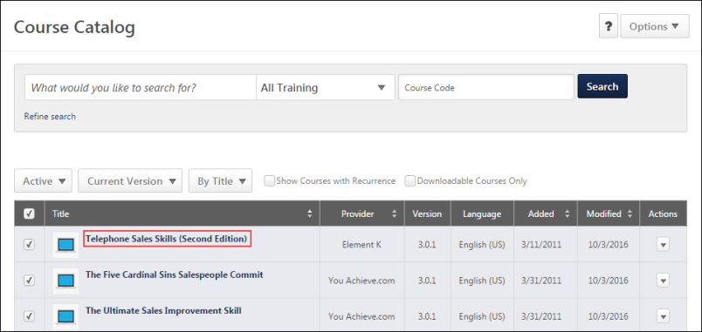

Course Console - Details
The Course Console displays a variety of general information for a selected learning object (LO), some of which can be edited directly from the Course Console page. The Course Console also provides access to options for managing training, settings, and data widgets for the training.
To access the Course Console, go to Admin > Tools > Learning > Catalog management > course catalog and then search for a specific LO using the Search the Catalog field. After you have found the LO for which you want to view the Course Console, click the LO's title. This navigates you to the Course Console page for that LO.
Permissions
PERMISSION NAME | PERMISSION DESCRIPTION | CATEGORY

Assignment Tool - Restrict to Users' LO Availability | This permission does not grant ability to any specific functionality and can only be constrained by Users' LO Availability. If this permission is constrained, then the user creating the Learning Assignment can only select and assign training that is within the users own availability. This permission is dependent on the Assignment Tool - Standard, Assignment Tool - Standard and Dynamic, and Assignment Tool - Standard and Dynamic - Recurrence permissions. This is an administrator permission. | Learning - Administration

Assignment Tool - Standard and Dynamic - Recurrence | Grants ability to create Standard (one-time) and Dynamic (continuous) Learning Assignments to directly assign training to users. Also grants ability to enable/disable Recurrence when creating a Dynamic Learning Assignment. This permission can be constrained by OU, Provider, Training Item, Training Type, User, User Self and Subordinates, and User's OU. If this permission is constrained by Location, Provider, Training Type, or Training Item, then they can only assign training within the constraints. If this permission is constrained by OU, User, User Self and Subordinates, or User's OU, then they can only assign to and view assignments created by users within the constraints. This is an administrator permission. | Learning - Administration

Assignment Tool - Standard and Dynamic | Grants ability to create Standard (one-time) and Dynamic (continuous) Learning Assignments to directly assign training to users. This permission can be constrained by OU, Provider, Training Item, Training Type, User, User Self and Subordinates, and User's OU. If this permission is constrained by Location, Provider, Training Type, or Training Item, then they can only assign training within the constraints. If this permission is constrained by OU, User, User Self and Subordinates, or User's OU, then they can only assign to and view assignments created by users within the constraints. This is an administrator permission. | Learning - Administration

Assignment Tool - Standard | Grants ability to create Standard (one-time) Learning Assignments to directly assign training to users. This permission can be constrained by OU, Provider, Training Item, Training Type, User, User Self and Subordinates, and User's OU. If this permission is constrained by Location, Provider, Training Type, or Training Item, then they can only assign training within the constraints. If this permission is constrained by OU, User, User Self and Subordinates, or User's OU, then they can only assign to and view assignments created by users within the constraints. This is an administrator permission. | Learning - Administration

Course Catalog - Update | Grants ability to manage and edit training items listed in the Course Catalog and also grants access to the Course Console, where training can also be managed and edited. This permission also grants access to the Popular Requests and Highest Rated widgets on the Learning Admin Console (in conjunction with the Learning Admin Console - View permission). This permission also allows administrators to reversion online courses via the Course Console page. This permission also allows administrators to access an Edit Training option for training items included as objectives in Development plans.  This permission can be constrained by OU, User's OU, Training Type, Training Item, Provider, ILT Provider, User's ILT Provider, User, User Self and Subordinates, and User's LO Availability. This is an administrator permission.  Note: Adding an OU constraint and a provider constraint to this permission results in an "AND" statement. | Learning - Administration

Course Catalog - View | Grants access to view the learning objects in the course catalog and enables administrators to view the Course Console and the Popular Requests and Highest Rated widgets on the Learning Admin Console (in conjunction with the Learning Admin Console - View permission). This permission can be constrained by OU, User's OU, Training Type, Training Item, Provider, ILT Provider, User's ILT Provider, and User's LO Availability. This is an administrator permission.  Adding an OU constraint and a provider constraint to this permission results in an "AND" statement. | Learning - Administration

Emails by Learning Object - Manage | Grants access to create, edit and delete custom email templates/triggers at the learning object level. When viewing Course Console, this permission also grants ability to view and manage email triggers at the LO level. This permission works in conjunction with the Course Catalog - Update and Course Catalog - View permissions. This permission can be constrained by OU, User's OU, User's Self and Subordinates, and User. This is an administrator permission. | Learning - Administration

Emails by Learning Object - View | Grants access to view custom email triggers at the learning object level. When viewing Course Console, this permission also grants ability to view email triggers at the LO level. This permission works in conjunction with the Course Catalog - Update and Course Catalog - View permissions. This permission can be constrained by OU, User's OU, User's Self and Subordinates, and User. This is an administrator permission. | Learning - Administration

Level 1 Evaluations - Manage | Grants ability to create and edit Level 1 (Reaction) learning evaluations that can be associated with learning objects. When viewing Course Console, this permission also grants the ability to view the status of Level 1 Evaluations. This permission works in conjunction with the Level 1 Evaluation Administration, Course Catalog - Update, and Course Catalog - View permissions. This permission cannot be constrained. This is an administrator permission. | Learning - Administration

Level 2 Evaluations - Manage | Grants ability to create and edit Level 2 learning evaluations that can be associated with learning objects. When viewing Course Console, this permission also grants the ability to view the status of Level 2 Evaluations. This permission works in conjunction with the Level 2 Evaluation Administration (knowledge and scored), Course Catalog - Update, and Course Catalog - View permissions. This permission cannot be constrained. This is an administrator permission. | Learning - Administration

Level 3 Evaluation - Manage | Grants ability to create and edit Level 3 (Behavior) learning evaluations that can be associated with learning objects. When viewing Course Console, this permission also grants the ability to view the status of Level 3 Evaluations. This permission works in conjunction with the Level 3 Evaluation Administration, Course Catalog - Update, and Course Catalog - View permissions. This permission cannot be constrained. This is an administrator permission. | Learning - Administration

LO Required Approvals - Manage | Grants ability, when editing a learning object (LO) via the course catalog, to specify number of approvals required when users request that learning object. When viewing the Course Console, this permission also grants the ability to view the number of training approvals a user must receive when requesting the LO. This permission works in conjunction with the Course Catalog - Update and Course Catalog - View permissions. This is an administrator permission. | Learning - Administration

Online Class - Download Files | Grants access to the download option in Course Console for administrators to download Online Class zip files. | Learning - Administration

Pricing By OU | Grants access to create and maintain differing pricing for learning objects (LOs) based on OU or Group, when editing learning objects via the Course Catalog. This permission works in conjunction with the Course Catalog - Update and Course Catalog - View permissions. This permission cannot be constrained. This is an administrator permission. | Learning - Administration
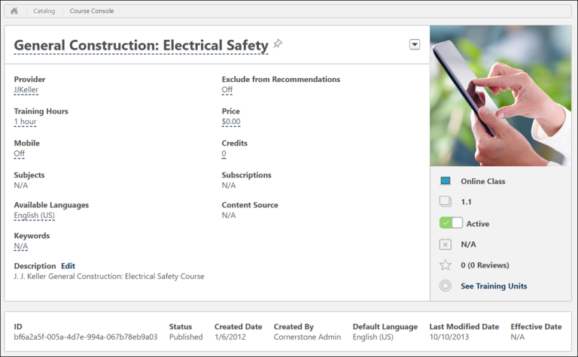
Publish
For online courses that are in Draft status, a Publish button is available to the right of the course title.
Course Console Header
The following fields display in the Course Console header:
- Title - The title of the LO (editable via an inline pop-up).
- Thumbnail Image - The image associated with the LO.
- Provider - The training provider selected for the LO (editable via an inline pop-up for select LO types. Important: The Provider field is not editable for courses added to the Course Catalog via a content subscription. The administrator cannot change or delete the provider for subscription content.).
- Price - The default price of the LO, if applicable (editable via an inline pop-up). Note: If the training is a curriculum AND the pricing is set to "Incremental Pricing," the value displays as "Incremental Pricing" instead. This is because the Price is determined by the pricing rules of the contents within.
- Training Hours - The number of training hours earned by the user when the LO is completed (editable via an inline pop-up)
- Credits - The number of credits earned by completing the LO (editable via an inline pop-up)
- Capabilities (Skills) - The Capabilities (Skills) field displays a list of the Auto-Tagged and Admin-Tagged skills associated with the training item. This field only appears on the Course Console when Content Skills Tagging is enabled in the portal. See Training Capabilities - Content Skills Tagging.
- Mobile - Turning this option on makes the LO available for mobile consumption. Option can only be turned on for online classes, quick courses, materials, playlists, and videos (editable via an inline pop-up)
- Exclude from Recommendations - Turning this option on prevents the LO from being included in recommended training suggestions for users who access the Training Completion page or Browse for Training (editable via an inline pop-up)
- Subjects - Subjects associated with the LO for searching, categorization, and filtering purposes
- Available Languages - The languages in which the LO is available (editable via an inline pop-up)
- Keywords - Terms or phrases that have been associated with the LO for searching purposes, limited to 2,000 characters (editable via an inline pop-up). End user search functionality supports results for up to 38 characters per keyword.
- Description - The description of the LO (editable via an inline pop-up).
- Modality - If modalities have been enabled in the portal, an editable Modality field displays on the Course Console page. To edit modalities for a training item, click the Modality field. This opens a drop-down menu. From the menu, check the boxes for any modalities which should be associated with the training item. When you have finished selecting modalities, click the green checkmark icon to apply your changes to the training item. For more information about learning modalities: See Modality Preferences.
- Type - The type of LO (i.e. online course, test, curriculum, etc.)
- Version - The current version of the LO
- Active - If the LO is currently active in the system, this toggle will be set to the Active (green) position. You can deactivate the LO by toggling the switch to the Inactive (gray) position. When you attempt to deactivate an LO via the Course Console, a validation message appears, asking if you are sure you want to deactivate the training. Click the Yes option to deactivate the training, or click the Cancel option to keep the training active.
- Deactivation Date - The date the LO will be automatically deactivated and no longer available to search or request, if applicable
- Ratings & Reviews - The ratings and reviews users have given the LO
- Training Units - The Training Units of the LO, if applicable
Note: If no data is available for a field, "N/A" displays next to the field.
Note: The above fields cannot be localized via the Course Console.
Inline Editing - Header
The following Header fields can be edited from the Course Console page:
- Title (Edits are made to the appropriate language. For example, if the logged-in user is French, the edits are made to the French title of the training)
- Provider (Only editable for online classes or video LOs. The user must have permission to edit training providers in order to edit this field)
- Price (Only the default price is editable. This field does not support pricing by OU. This field is only editable for curricula, events, libraries, materials, online courses, quick courses, and tests. In order to edit this field, the user must have permission to edit pricing by OU).
- Training Hours (Editable for all training types. This field is only editable for curricula if the corp setting for the display of curriculum training hours is set to False)
- Credits (Editable for all training types, including curricula)
- Capabilities (Skills) - This field only appears on the Course Console when Content Skills Tagging is enabled in the portal. Click Edit to open the Edit Capabilities (Skills) flyout where you can edit skills for the LO and check suggested skills. See Training Capabilities - Content Skills Tagging.
- Subscriptions - The Subscriptions field displays any Content Anytime subscriptions with which the training is associated.
- Mobile (Users must have permission to manage mobile training in order to see this field for online classes and videos)
- Exclude from Recommendations
- Available Languages
- Keywords
- Description (Editable via a flyout which supports rich text and HTML. Any HTML provided is rendered on the Course Console)
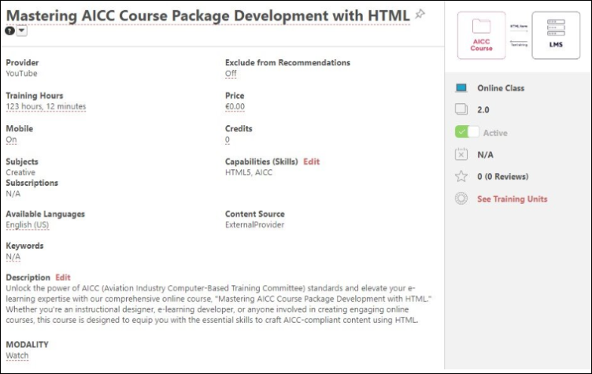
Note: The Provider field only appears as editable for online classes and videos when the user has the permission to edit training providers.
To modify one of the above fields from the Course Console:
- Click the editable field. An inline editing pop-up box appears. Depending on the field type, a new field value may be configured using a text box, numeric field, drop-down menu, or multiple choice radio buttons.
- Enter or select a new value for the field, depending on the editing options provided for the field.
- Click the green check mark icon to save the new field value, or click the red X icon to cancel the edit and close the inline pop-up without making changes.
- If the new value is saved, the edited field displays the new value on the Course Console page immediately.
Pin Link
Using the Pin icon next to the training title, you can save a link to the LO's Course Console page, which is displayed in the Pinned Links widget on the Learning Admin Console page and the Pinned Links section of the Admin Tools pages. This allows you to quickly navigate to pages you frequently need to access. To pin or unpin a Course Console page from the Pinned Links widget, click the Pin icon next to the training title. For more information about Pinned Links, please
Options
The Options drop-down menu to the far right of the LO title provides the administrator with various actions for managing the LO.
- Edit - Select this link to navigate to the Course Catalog - Edit page for the LO. From the Edit page, you can make changes to any of the training metadata, and applicable data will be updated on the Course Console page for the LO after the edits are saved. For courses added to the Course Catalog via a content subscription, any metadata update made by the content provider overwrites the existing metadata changes made manually by the administrator. To preserve manual changes on metadata, please See Metadata Preservation for​ Content Subscriptions and Integrations on page 36 for additional information. Note: This field only displays if the administrator has the permission to update the Course Catalog.
- Assign - Select this link to assign the LO to users using the Learning Assignment Tool. Clicking the Assign link navigates you to the Setup step of the learning assignment creation process. The LO associated with the Course Console page from which you click the Assign link will be automatically selected as the learning assignment training. Note: This field only displays if the administrator has the appropriate learning assignment permissions and is within the applicable constraints.
- User View - Select this link to view the Training Details page for the LO as an end user. This option is available for published training.
- View Details - To preview the Training Details for a draft online course, click the View Details link. You will then be directed to a preview of the Training Details page for the draft online course.
- Structure History - Select this link to access the Structure Modification History page for a curriculum. This option is ONLY available for curricula. The Structure Modification History page captures an audit trail of changes made to the curriculum's structure. See Curriculum Structure History.
- Preview - Select this link to launch the LO in a separate window and view it as an end user. Note: The Preview link is ONLY available for material and video LOs.
- Create Version - Select this link to begin reversioning an online course. This option is only available for online courses, and redirects the administrator to the versioning process. Note: Create Version should not be selected for non-launchable placeholder courses created as part of a Historic Data Load. See Online Course Versioning vs. Modifying - Overview for more information.
- Generate Audit PDF - Select this link to generate an audit PDF for the training item. See Generate Audit PDF.
Essential Data
The Essential Data section below the header of the Course Console displays the following read-only information:
- ID - Previously referred to as the Learning Object (LO) ID
- Status - The current status of the LO. Possible statuses include:
  - Published - Training is the current version, and will display to users if active and within their availability.
  - Completed - Training has a roster that has been successfully submitted.
  - Cancelled - ILT Session has been cancelled.
  - Confirmed - Note used for training.
  - Disapproved - “Soft” deleted status primarily used by CRT to forcefully remove a training from the catalog.
  - Deleted - “Soft” deleted status used when deleting an Online Course in Draft status or a Video.
  - Denied - Not used for training.
  - Previous Version - Version is an older, previous version. A more recent version of the training currently exists. A training in this status can still be on a user’s active transcript, depending on whether the users were upgraded.
  - Final - Not used for training.
  - Granted - Not used for training.
  - Requested - Not used for training.
  - Draft - Session is created in Draft status, and remains in a Draft status until the facility, equipment, and instructor are all confirmed. Online courses created in Draft status remain in a draft status until the administrator uses the Publish option.
  - Pending Version - Version has been created, but is not yet effective (or the versioning has failed). On the effective date (or when the versioning is successful), it will become Published.
- Created Date - The date the LO was created
- Created By - The name of the system user who created the LO
- Default Language - The default language specified for the LO
- Last Modified - The date the LO was last modified by an administrator
- Effective Date - The effective date of the LO (displays N/A if the LO has not been reversioned)
Note: Only the following statuses listed above display in the Course Catalog: Published, Previous Version, Draft, Pending Version.
Version
A section with version information about the LO (if it is an online course) displays on the Course Console page for the course, if applicable, and fields regarding versioning appear only when the second version has been created. The following information displays in the Version section:
- Version Option - This field indicates whether the course was reversioned using the Versioning with Append workflow or with the Modify Version workflow.
- Version Start Date - This field displays the date on which the version of the online course became or becomes effective. This field can be edited if no version start date has yet been entered. Click the Edit link to enter a Version Start Date.
- Version End Date - This field displays the date on which the version of the online course expired or expires.
- Version Equivalency - This field indicates whether the online course version is equivalent to any other version. To edit the version equivalency for a training item via the Course Console, click the Edit link for the Version Equivalency field. Clicking the Edit link causes a message to appear, prompting the administrator to confirm the version equivalence action. If the administrator confirms the version equivalency, this equivalence will be retroactively applied to update relevant user transcript statuses to a Completed Equivalent status. If the administrator denies the version equivalence action, no changes are made to the version equivalence settings. For more information about Version Equivalency, see the Version Equivalency Considerations and the Version Equivalency FAQs sections below.
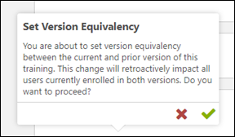
- Allow Download for Network Player - This field indicates whether or not the online course version can be downloaded by users.
Note: If no information is available for a field in the Version section, "N/A" displays for the field.
Version Equivalency Considerations
- If version equivalency already exists, the equivalent version number displays as a link on the Course Console page. This is existing behavior.
- If version equivalency does NOT exist, "N/A" displays in the Version Equivalency field with an Edit link. After clicking the Edit link, an inline notification displays, offering the administrator the option to reset equivalency to the prior active version.
- While user transcripts are being updated, a Processing status displays in the Version Equivalency field. When complete, the equivalent version number displays as a link. The administrator is required to manually refresh the page to view the latest state.
Version Equivalency FAQs
- Question: When I set version equivalency from the Course Console, does it apply to all prior versions, or only the previous version?
  - Answer: The version equivalency applies to ONLY the prior active version of the training.
- Question: What is the “Prior Active Version” of a training item?
  - Answer: The Prior Active Version is the active version directly before the current version of the training. Example: If the current training is 5.0, the Prior Active Version is typically 4.0. If the training before the current version (4.0) has been manually deactivated, then the Prior Active Version is 3.0. This does not apply to versions which have become the "old version" of training due to a higher version being created.
- Question: Am I able to apply version equivalency between two versions if neither of them are the current version? Example: If the current version is 5.0, can I set equivalency between 4.0 and 3.0?
  - Answer: Yes, this is possible by navigating to the Course Console for version 4.0 of the training.
Content
The Content section of the Course Console displays the learning object (LO) source file or URL, as well as related information, for material, video, and online course LOs in a read-only format. The Content section displays the following information for material, video, and online class LOs:
- Content Source - This field displays the title of the file source or the name of the URL for the LO.
- Content Type - This field displays the file type, such as .doc, .xls, .mpg, SCORM 1.2, URL, etc.
- File Name - This field displays the name of the file. Note: This field is only applicable to LOs with a file source and will not display for URL sources.
- Publication Id - It displays the publication Id of the file.
- Download - Click Generate Download Link to download course file.
- Language - The language specified for the material source. Note: This field is only applicable to material and video LOs and does not display for online classes.
- Options - The following options may be available in the Options drop-down menu for online courses:
  - Modify Content - Click this link to begin modifying the files for the online course, which is a suitable process when you need to make only minor updates to the course files. See Modify an Online Course.
  - Resume - If an administrator began uploading new course files for the online course, but did not complete the process, the process may be resumed by clicking this link.
  - View Modification History - Click this link to access the Modification History page, which allows you to view the previous uploads that have been made for the course. See Online Course - Modification History for more information.
  - Allow Download - If the online course should be available for users to download, the administrator can click the Allow Download link from the Options drop-down menu.
Note: The fields in the Content section are read-only and cannot be edited from the Course Console page.
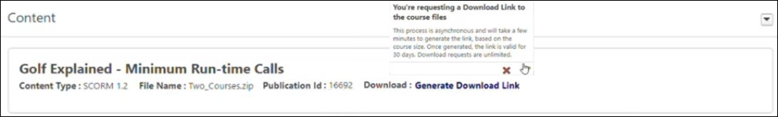
A download link is available to users with the “Online Class - Download Files” permission. The download process allows downloading a zip file of the Publication folder containing the requested course. The Publication file might include one or more courses, depending on what was originally uploaded.
The download process includes four stages:
- Generate Download Link
- Processing
- Download Ready
- View Errors | Retry
Generate Download Link
Click Generate Download Link to trigger a disclaimer, after which the download process starts. The download process is asynchronous and takes a few minutes or more, depending on the course size.
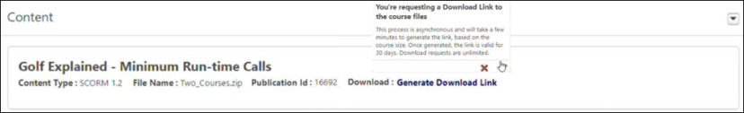
Processing
The download status moves to “Processing” until the file is ready to be downloaded. Use the “Refresh” option next to the “Processing” text to see the latest status. The page can be left and returned to later. The download status moves to “Download Ready” after processing.
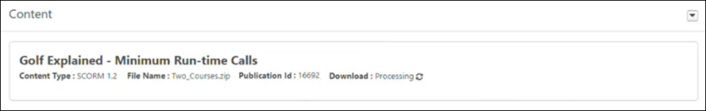
Download Ready
Click Download Ready to download a zip file of the content locally. A few points to remember are as follows:
- The “Download Ready” status is valid for 30 days. After 30 days, the “Download Ready” status resets to “Generate Download Link.”
- Generating the Download is an unlimited action.
- The “Download Ready” status allows users with the “Online Class - Download Files” permission to download the files.
- Modifying the course using the “Modify Content” option resets the download status to “Generate Download Link.”
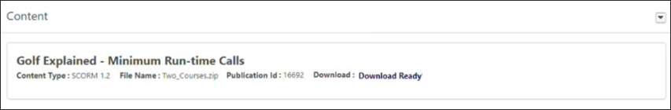
View Errors | Retry
You can retry the download request if errors occur.
- Click View Errors to display the errors encountered.
- Click Retry to move the Download status back to “Processing.”
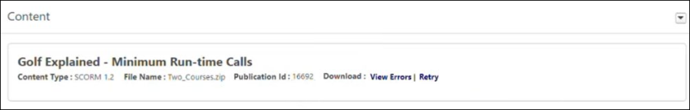
The downloaded zip file name will be TrainingObjectID_filename.zip if the requested course was the only course inside the zip file initially uploaded. The content of the downloaded zip file will include the course files of the requested course. The downloaded file name will be PublicationID_filename.zip if the requested course was one of multiple courses inside the zip file initially uploaded. The content of this downloaded file will include the course files of all the courses uploaded in the same Publication as the requested course, including the requested course.
Courses uploaded as part of the same Publication will all have a “Download Ready” status if one of the courses in the Publication had a successful download generated by an administrator.
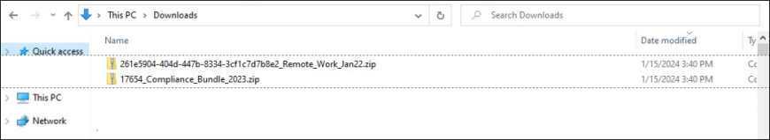
Considerations
The following are excluded from having a download option in the Course Console:
- Learning Objects that are not Online Class LO Type
- Content Anytime Subscription Courses
- Á La Carte (ALC) Subscription Courses
- Online Content LO types (Percipio, Coursera, etc.)
- LinkedIn Learning courses
- Courses in Draft status
- Historical Data Load (HDL) courses
Note: To enable “Online Class - Download Files” permission, please contact Global Customer Support
Settings
The Settings widget on the Course Console displays an overview of various features related to the learning object (LO) and provides quick access to each object's Edit page. Visibility of fields in this section of the Course Console is dependent on whether or not related functionality is active in the portal and whether or not the administrator has permissions to view or manage related functionality.
Availability
Learning administrators can view and set availability for learning content via the Course Console page, allowing them to manage even more training metadata from one central location.
Options
Clicking the Options drop-down menu in the upper right corner of any tile in the Settings widget allows you to select the Edit link, which navigates you to the Course Catalog - Edit page for that feature. Only tiles for functionality the administrator has the appropriate permissions for display in the Settings widget.
The Settings widget provides an overview and editing access for the following objects:
- Emails - This tile displays whether or not Email functionality for the LO is currently enabled. The tile also displays the email option selected for the LO (i.e. System Defaults, Custom Emails, or No Emails). If emails are not available for the LO type, "N/A" displays on the tile instead. If an administrator does not have the permission to manage or view emails by LO, this tile does not display.
- Availability - This tile displays an overview of the availability set for the OU. This tile will show one of the following:
  - All Users - This phrase appears when availability has been set to all system users or all employees.
  - Select Users - This phrase appears when availability has been set to a select group of users, such as a specific OU.
  - No Users - This phrase appears when availability has not been set for the LO.
- Registration - This tile displays how many training approvals the LO is set to require before a user can be registered for the training, and the tile also displays whether or not recurrence is currently active for the LO (allows a user to request the training more than once). If no value has been entered into the Approvals field for the LO, or recurrence is not available for the LO, "N/A" displays. If the administrator does not have the permission to manage LO approvals, the field does not display. If Recurrence functionality is not active in the portal, the field does not display. If the administrator does not have permissions to manage LO approvals AND the Recurrence functionality is not active in the portal, the tile does not display Note: the Recurrence field does not take into account whether the training can be assigned more than once.
- Evaluations - This tile displays whether or not Level 1, Level 2, and/or Level 3 evaluations are currently enabled for the LO. Administrators must have the appropriate evaluations permissions to view data in this widget. Note: Evaluations cannot be associated with Program LOs. When viewing the Course Console for a Program LO, "N/A" appears for all three evaluation types in this tile.
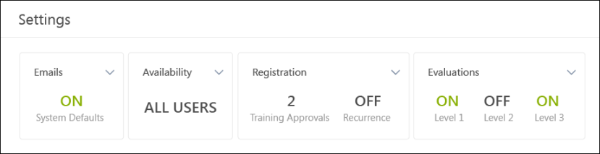
Data Widgets
Several dynamic data widgets display on the Course Console, allowing administrators to quickly view helpful training data and learning assignment data related to a specific learning object (LO) in the system.
Training Over Time
The Training Over Time widget on the Course Console allows you to see how many times a specific LO has been registered for and completed in the portal (broken down by month) over the last 12 months. The time filter cannot be changed. The legend of the widget shows the graph colors associated with both registration data and completion data.
Considerations
The Training Over Time widget EXCLUDES the following:
- Training removed from users’ transcripts
- Other versions of the training (i.e. the graph on the Course Console of Version 2.0 will not display data from Version 1.0 or Version 3.0 if it exists)
- Any pre-registration statuses (e.g. Approved, Registration Pending, Waitlisted, as these do not have a Registration Date or Completion Date)
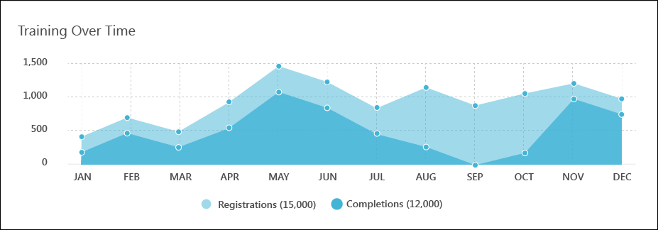
Training Status
The Training Status widget visually represents a breakdown of all the various statuses each instance of the LO is currently in on users' transcripts, during a selected timeframe. The features of the Training Status widget include:
- Title - This field displays the name of the widget.
- Timeframe - This field displays the amount of time captured by the report.
- Options drop-down - This drop-down lets you select from the following time filter options: Last 30 Days, Last 60 Days (default), Last 90 Days, Last 120 Days. When a new time filter is selected, the widget refreshes to show data from the updated timeframe.
- Chart - This chart provides a graphical representation of the different statuses of all training items assigned to or requested by users within the specified timeframe.
- Chart Key - This section of the widget clarifies which training status is represented by each color on the graphic chart, and also displays the specific number of training items in each status.
Considerations
The following types of training data are NOT included in the Training Status widget:
- Training removed from users’ transcripts
- Other versions of the training (i.e. the graph on the Course Console of Version 2.0 will not display data from Version 1.0 or Version 3.0 if it exists)
- Training in statuses that are not equivalent to Not Started, In Progress, or Completed
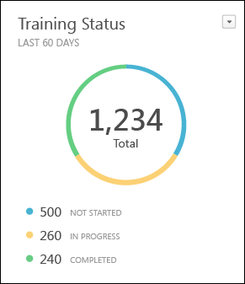
Training Statistics
The Training Statistics widget displays how many times an LO has been requested, assigned, and completed during its lifetime in the portal. The features of the Training Statistics widget include:
- Title - This field displays the name of the widget.
- Timeframe - This field displays how much time is captured by the widget. The Training Statistics widget captures training statistics for all time in the portal. This time filter cannot be edited.
- Requests - This section of the widget displays how many times the LO has been requested since it was added to the portal.
- Assignments - This section of the widget displays how many times the LO has been assigned to since it was added to the portal.
- Completions - This section of the widget displays how many times the LO has been completed since it was added to the portal.
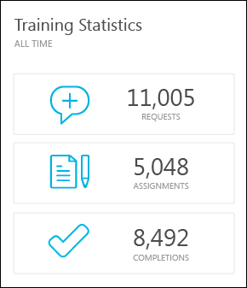
Learning Assignments
The Learning Assignments widget displays a graphical analysis of the different learning assignments created for the LO via the Learning Assignment Tool. Administrators can only view learning assignment data for assignment types and organizational units (OUs) for which they have permissions and constraints. If the administrator does not have any learning assignment permissions, this widget does not display for them on the Course Console.
The features of the Learning Assignments widget include:
- Title - This field displays the name of the widget. Clicking this field navigates you to the Manage Learning Assignments page, where learning assignments are filtered by the training title and selected time filter.
- Timeframe - This field displays the amount of time captured by the report.
- Options drop-down - From this drop-down, you can select from four time filters, including This Week, Last Week, This Month, and Last Month. Selecting a new time filter causes the report to refresh and show data for that timeframe.
- Chart - This chart provides a graphical analysis of the different learning assignment types that have been created for the LO.
- Chart Legend - This section of the widget clarifies which learning assignment type is represented by each color on the graphic chart, and also displays how many of each type of learning assignment have been created for the LO. The values contained in the legend are clickable and navigate you to the Manage Learning Assignments page, where assignments are filtered by the training title, assignment type, and time filters selected.
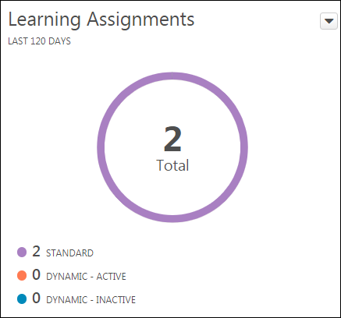
Associated Training
If the LO has any training associated with it as a prerequisite, pre-work, or post-work, each associated LO appears in the Associated Training widget. The widget displays six associated training items at a time, but if an LO has more than six associated training items, you can navigate to additional pages of the widget to view all items. Each LO tile in the Associated Training widget contains the following:
- LO Type Icon - Each tile features an icon which denotes the LO type of each associated training item (i.e. online course, material, video, etc.). This icon is clickable and navigates you to the Course Console page for the LO. Note: If the associated training is external training, the icon and title are not clickable, and there is no Course Console page for the external training.
- Training Title - Each tile provides the title of the associated training item. This title is clickable and navigates you to the Course Console page for the LO.
- Associated Training Type - Each tile displays the type of associated training (i.e. Prerequisite, Pre-work, or Post-work).
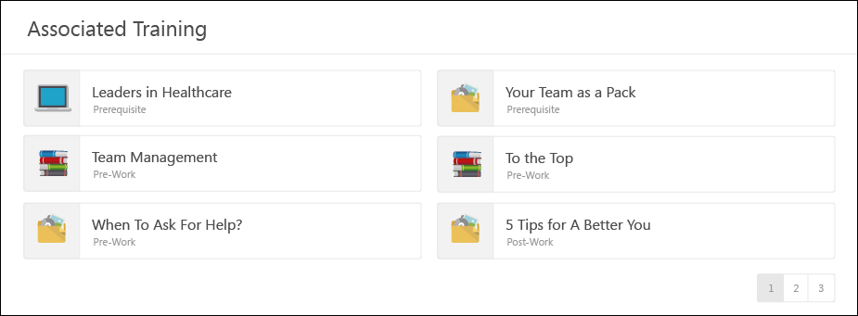

Course Console - Availability
Learning administrators can view and set availability for learning content via the Course Console page, allowing them to manage even more training metadata from one central location.
To access availability information for training content via the Course Console, go to Admin > Tools > Learning > Catalog Management > Course Catalog and search for the specific training item. Then, click the title of the training item you want to edit.
Permissions
PERMISSION NAME | PERMISSION DESCRIPTION | CATEGORY

Course Catalog - Update | Grants ability to manage and edit training items listed in the Course Catalog and also grants access to the Course Console, where training can also be managed and edited. This permission also grants access to the Popular Requests and Highest Rated widgets on the Learning Admin Console (in conjunction with the Learning Admin Console - View permission). This permission also allows administrators to reversion online courses via the Course Console page. This permission also allows administrators to access an Edit Training option for training items included as objectives in Development plans.  This permission can be constrained by OU, User's OU, Training Type, Training Item, Provider, ILT Provider, User's ILT Provider, User, User Self and Subordinates, and User's LO Availability. This is an administrator permission.  Note: Adding an OU constraint and a provider constraint to this permission results in an "AND" statement. | Learning - Administration

Course Catalog - View | Grants access to view the learning objects in the course catalog and enables administrators to view the Course Console and the Popular Requests and Highest Rated widgets on the Learning Admin Console (in conjunction with the Learning Admin Console - View permission). This permission can be constrained by OU, User's OU, Training Type, Training Item, Provider, ILT Provider, User's ILT Provider, and User's LO Availability. This is an administrator permission.  Adding an OU constraint and a provider constraint to this permission results in an "AND" statement. | Learning - Administration

Training Request Form - Manage | Grant access to create and edit training request forms, manage request form statuses, and manage form statuses for users. This is an administrator permission. | Training Forms Administration
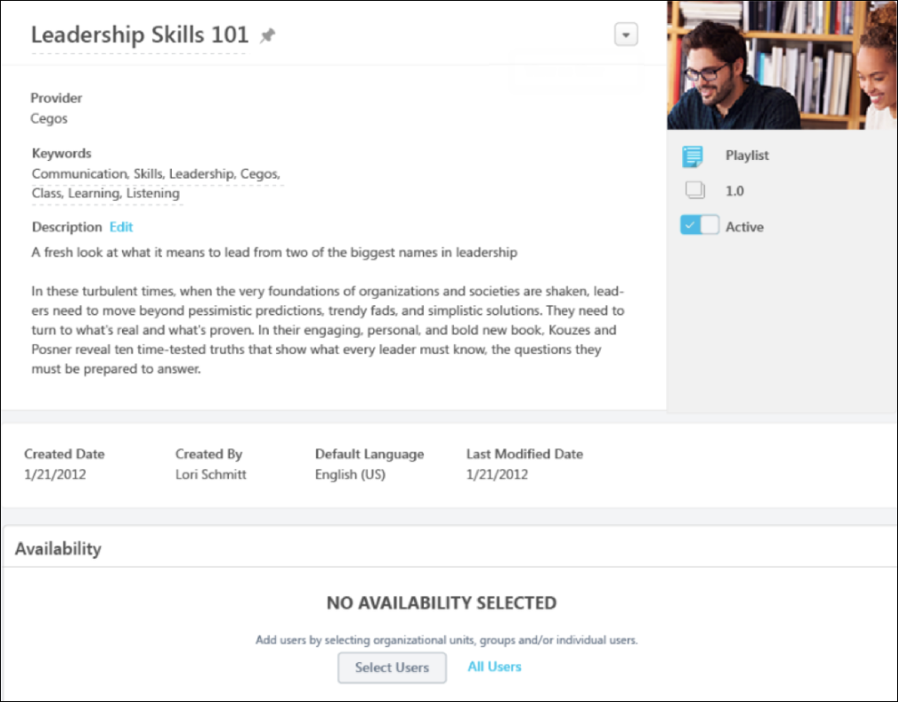
Availability
The Availability section is located above the Training Over Time section of the Course Console. If no availability has yet been configured for the training item, "No Availability Selected" displays in the section, along with options for adding availability criteria. The following options are available for selecting criteria:
- Select Users - Click Select Users button to search for and select organizational units (OUs) or groups for which to set availability. See the Select Users section below for more information.
- All Users - Click this link to make the training available to all users in the system. See the All Users section below for more information.
Select Users
To configure availability for specific OUs or groups:
- Click the Select Users button. This opens a Select Users flyout.
- From the drop-down menu, select the user criteria type. Available types include:
  - Cost Center
  - Division
  - Position
  - Grade
  - Group
  - Location
  - Position
  - Self Registration Group
  - Custom OUs
  - Users
- Use search fields to find the desired OU or users. Available filters differ for OUs and users:
  - OU search filters:
    - OU Title
    - OU ID
    - OU Owner First Name or Last Name
    - OU Description
  - User search filters:
    - User First Name or Last Name
    - User ID
    - Username
    - Manager's First Name or Last Name
    - Position
    - Division
    - Location
- Up to twenty search results display on each page of the Select Users flyout. To view additional pages of search results, click a page number or the navigation arrows near the bottom of the flyout.
- Filter the search results if needed.
- Each relevant user or OU appears in the search results as a tile with related information about the user or OU. If the OU has any child OUs, you can view them by clicking the arrow on the right side of the tile.
- Check the box on the left side of the tile for the user or OU you wish to add to the availability. You may switch between user criteria type using the drop-down and then multi-select as many OUs or users as needed.
- If you wish to review your selections before adding them to the training's availability, click the Selected tab at the top of the flyout.
- Click the Select button at the bottom of the flyout. Your selections will be added to the Availability section in alphabetical order. If more than five criterion are added to the Availability section, the Availability section becomes paginated, and up to five criteria can display per page.
All Users
To make the training available to all users in the system, click the All Users link.
Note: If an administrator selects All Users but their permission to update the Course Catalog is constrained, only users within the administrator's constraints are included in the availability for the training.
Availability Criteria
After searching for and selecting availability criteria, each OU, group, or separate user appears in the Availability section with the appropriate metadata and configuration options. The options shown are not the same for all training types, but the metadata and configuration options can include the following fields and options:
- Name - The name of the selected OU, group, or user appears at the top of each criteria tile.
- ID - The ID of the OU, if available
- Type - The OU type (i.e. division, location, etc.)
- Manager - The manager of the OU
- Owner - The owner of the OU
- Include Subordinates - Check this box to include the OU's child OUs in the availability for the training. Note: This option does not display when the All Users option is selected for the availability criteria.
- Pre-Approved - Check this box to pre-approve users in the OU for the training item. Users in this OU will not need to receive approval from an approver prior to being able to register for the training.
- Register Upon Approval - Check this box to automatically register users in the OU into the training.
- Availability Type - Select an availability type from the drop-down menu:
  - None
  - Suggested - If the learning object is set to Suggested, it appears on the Welcome page under Suggested Training (if Suggested Training is active on the Welcome page).
  - Required - If the LO is set to Required, it appears on the Welcome page under Your Assigned Training or Required Training (if the Assigned Training widget or the Required Training widget is active on the Welcome Page). Note: Training set to Required is not actually assigned and must still be requested by the user.
  - Featured - If a learning object is set to Featured, the training item appears to the selected users in the Featured Training widget and also when users select Featured from the Training filter on the Browse for Training page.
- Training Request Form - From the drop-down, select a Training Form to be attached to this LO, if appropriate. Visibility of this option is controlled by the permission to manage training request forms.
Note: When adding criteria to training, the criteria is limited by any constraints applied to the administrator's permission to update the Course Catalog. If constraints are applied to the administrator's permission to update the Course Catalog, a system notification appears when they add availability criteria, alerting them that their selections are limited by their constraints.
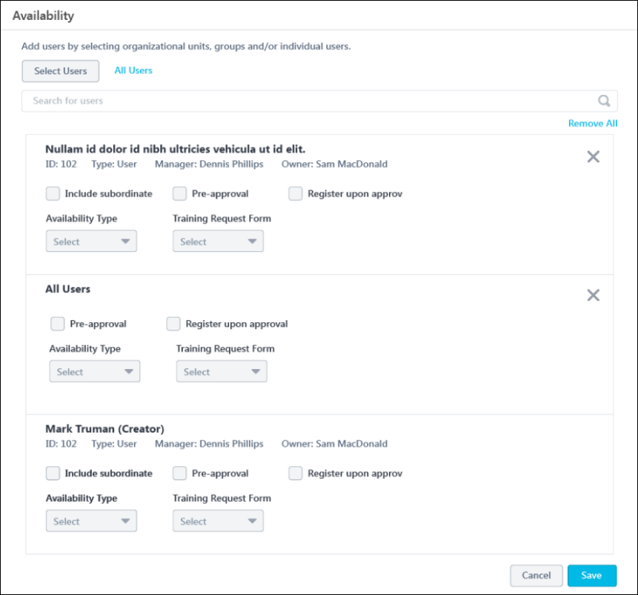
Search Added Criteria
Administrators are able to perform searches on sets of selected criteria. For example, if an administrator has added many specific users to the availability of a training item, they may wish to search for a specific user within the selected criteria to make changes to that user's availability configurations.
To search for specific criteria within your availability selections, enter a search term into the Search bar and press the Enter key on your computer. The selections in the Availability section will be filtered based on the entered criteria, and you can edit or remove criteria selections as needed. Ensure that you are viewing the Availability section in Edit mode if you wish to make changes to the criteria (See the Edit section below for more information).
Note: The Search bar is hidden if no availability criteria has been selected.
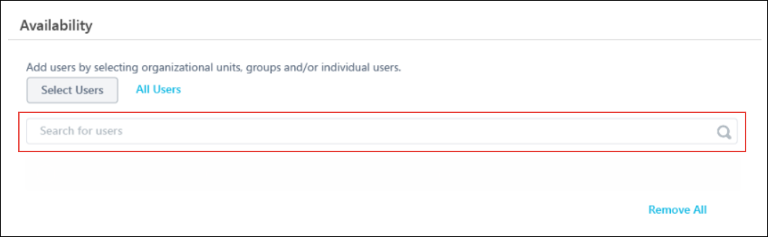
Save
After configuring all availability criteria, click the Save button at the bottom of the Availability section. The availability criteria will be applied to the training. If you wish to cancel any changes you have made to the availability criteria before saving, click the Cancel button. Any changes you made will be reverted to the previous saved state.
After saving the availability selections, the criteria is converted to read-only format.
Edit
To edit the Availability section when criteria has already been saved, click the Edit link in the upper-right corner of the Availability section. The criteria is converted to an editable format, and criteria can be added and removed from the section.
Remove Criteria
If needed, you can remove criteria from the availability section by clicking the Delete icon in the upper-right corner of the specific criteria tile, or you can delete all existing criteria by clicking the Remove All link. These options are only available when the Availability section is in the editable format.

Course Console - Report Widget Status Equivalents
For reporting simplicity, all possible training statuses have been consolidated into three main statuses which appear in Course Console reporting widgets.
The following statuses are equivalent to Completed for the purpose of Course Console widgets:
- Completed
- Completed Equivalent
- Equivalent
- Exempt
- Exempt-Internal
The following statuses are equivalent to In Progress for the purpose of Course Console widgets:
- Completion Approval Denied
- Completion Approval Denied/Past Due
- Failed
- Failed/Past Due
- In Progress
- In Progress/Past Due
- Past Due
- Pending Acknowledgment
- Pending Acknowledgment/Past Due
- Pending Completion/Past Due
- Pending Completion Approval
- Pending Completion Signature
- Pending Completion Signature/Past Due
- Pending Evaluation
- Pending Evaluation/Past Due
- Pending Grade
- Pending Grade/Past Due
- Pending OJT Completion
- Pending OJT Completion/Not Available
- Pending OJT Completion/Not Available/Past Due
- Pending OJT Completion/Past Due
- Pending Post-Work
- Pending Post-Work/Past Due
- Pending SF-182 Form Approval
- SF-182 Form Denied
The following statuses are equivalent to Not Started for the purpose of Course Console widgets:
- Approved
- Approved/Past Due
- Exception Requested
- Exception Requested/Past Due
- Exception Requested/Waitlisted
- Exception Requested/Waitlisted/Past Due
- Not Available
- Not Started
- Not Started/Past Due
- Payment Denied
- Payment Denied/Past Due
- Payment Refunded
- Payment Refunded/Past Due
- Pending Approval
- Pending Approval/Past Due
- Pending Approval/Waitlisted
- Pending Approval/Waitlisted/Past Due
- Pending Payment
- Pending Payment/Past Due
- Pending Prerequisite
- Pending Prerequisite/Past Due
- Pending Pre-Work
- Pending Pre-Work/Past Due
- Pending Prior Training
- Registered
- Registered/Not Available
- Registered/Not Available/Past Due
- Registered/Past Due
- Registration Pending
- Registration Pending/Past Due
- Waitlist Expired
- Waitlist Expired/Past Due
- Withdrawn
- Withdrawn/Past Due
Training items in the following statuses on users’ transcripts are NOT incorporated into Course Console widgets:
- Cancelled
- Cancelled/Past Due
- Denied
- Denied/Past Due
- Discontinued
- Discontinued/Past Due
- Expired
- Expired/Past Due
- Not Activated
- Old Version
- Subscription Expired

Metadata Preservation for​ Content Subscriptions and Integrations
When a customer purchases a Content Subscription or Integration, the courses are automatically added to their portal via the Content Delivery System (CDS). These courses are added with rich metadata such as title, description, keywords, etc., pre-populated by the Content Provider and Cornerstone's curation team. Once these courses are delivered to the portal, the administrator can manually update some fields of course metadata.
However, when the Content Provider made metadata updates to their courses, those updates overwrote any metadata changes the customer made manually during subsequent synchronizations with the CDS.
To prevent manual metadata changes from being overwritten by changes provided by Content Providers, Cornerstone has introduced a backend setting that allows administrators to choose whether to allow overwrites or to preserve manual changes made to the course metadata when the updates to a course are available from the Course Provider. When the backend setting is enabled, administrators can confidently customize the Title, Description, and Keywords (and any localizations associated with those fields) without fear of their changes being overwritten when course updates are received.
To enable the backend setting, please contact Global Customer Support. The default setting enables course updates from your content subscriptions and integrations to flow into your CSX portal.
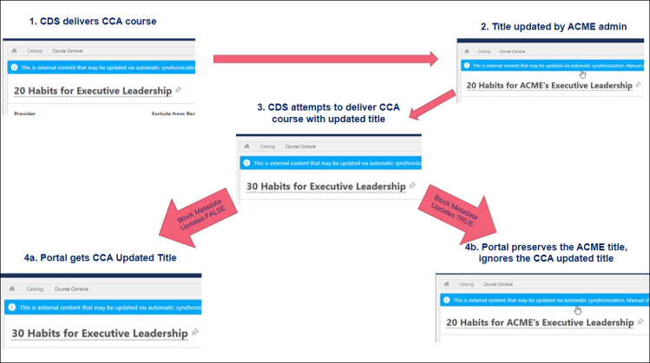
Considerations
- Title, Description, and Keywords are the only metadata fields preserved when the backend setting is enabled. All other metadata fields are overwritten even with the setting enabled
- Subjects are never overwritten. Subjects from CDS course updates are appended to the existing Subjects in the portal.
- The backend setting applies to both Online Courses and Online Content.
- The LinkedIn Learning integration is not affected by this change. This integration uses an older delivery system, not CDS.

Pinned Links
The Pinned Links widget allows administrators to save links to frequently used admin pages and Course Console pages for training.
Permissions
PERMISSION NAME | PERMISSION DESCRIPTION | CATEGORY

Learning Admin Console - View | Allows users to view the Learning Admin Console. This permission cannot be constrained. This is an administrator permission. | Learning - Administration
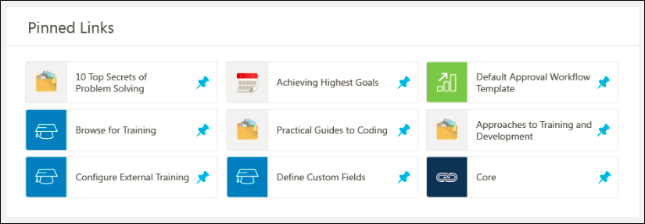
Pinned Links
You can add admin page links to your Pinned Links widget by navigating to Configuration Tools and clicking the Pin icon next to pages you frequently use. You can add Course Console pages for training by navigating to the learning object’s (LO’s) Course Console page and clicking the Pin icon . Up to nine links can be added to the Pinned Links widget. If you attempt to pin more than nine links, an error message appears.
Saved links appear in the Pinned Links widget with an image that represents the page, along with a clickable link that navigates you to the pinned system page.
Unpin Link
Administrators can remove pins from the widget by unpinning it from the Configuration Tools page or by unpinning it from the Pinned Links widget itself. To remove a pinned link from the widget, click the Pin icon next to the link. This opens the Unpin Link pop-up. Unpinning the link will also unpin the link from the Configuration Tools page.
Click the Unpin button to remove the link from Pinned Links, or click Cancel to exit the Unpin Link pop-up without removing the link.
Note: If the permission for a link is removed from an administrator’s permissions, the link is automatically removed from the Pinned Links widget if it was previously saved.
