Connect March 2024

Table of Contents
Connect Overview 1
New Connect Preferences Overview 2
Connect Preferences (New) 3
Action Groups - Manage 8
Action Group - Create/Edit 10
Collaborative Learning - Community Templates 14
Manage Community Templates 15
Community Template - Create/Edit 17
Community Template - Administrator View 20
Community Template Topic - Create/Edit 22
Community Template - Topic Details Page 24
Dynamic Teams Overview 27
Dynamic Team Administration 28
Dynamic Team - Create 30
Dynamic Team - Manage Members 32
Connect Overview 34
Communities Overview 35
Connections Overview 133
Knowledge Bank/Community - Availability and Action Groups 148
Knowledge Bank Overview 151
Connect - Live Feed Overview 168
Postings Overview 195
Connect Teams Overview 256
Connect Preferences Overview 291
Connect Preferences (Old) 292
Posting Type Preferences (Old) 295
Connect Overview (Old) 297
Connect Preferences (Old) 299
Posting Type Preferences (Old) 302
Connect Topic Administration (Old) 305
Connect Community Administration (Old) 307
Create Connect Community (Old) 309
Manage Connect Community Layout (Old) 310

Connect Overview

New Connect Preferences Overview

Connect Preferences (New)
The Connect Preferences page for the New Connect functionality enables administrators to manage feed options, manage what activity updates display on the Live Feed, and manage team options.
To access the Connect Preferences page for Redesigned Connect, go to Admin > Tools > Connect > New Connect Administration > Connect Preferences.
Permissions
PERMISSION NAME | PERMISSION DESCRIPTION | CATEGORY

Global Search - People | Grants ability to search for people via Global Search. If this permission is constrained to a specific OU, then that constraint is automatically applied within Global Search, including search filters and search results. This is an end user permission. The availability of this permission is controlled by a backend setting.  Note: In Universal Profile > Bio > Career Preferences, this permission is required for users to search for jobs. | Core

View New Connect Preferences | Grants ability to view and manage the New Connect Preferences. This permission can be constrained by OU and User's OU. | New Connect
Feed Options
- Allow users to post user updates and attach links - Select this option to allow users to add updates to their Live Feed in the portal and Cornerstone Mobile®. Users can also attach links to these updates. Others can then view and add comments to the update.
- Allow users to attach files to user updates - Select this option to allow users to add files to their updates. This enables the Attach File button when adding an update. These updates appear on the Live Feed.
- Broadcasts expire after XXX days - Select this option to set an expiration date for broadcasts or updates in the portal and Cornerstone Mobile®. In the field, enter the number of days after which the broadcast will expire and no longer appear in Connect. This field accepts up to three numeric characters.
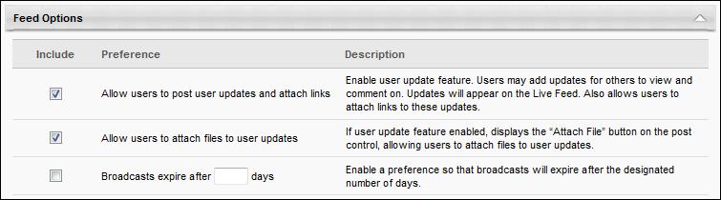
Connect Activity Updates Display Options
- Created task (visible to all team members) - When this option is selected, a Connect update is posted whenever a user creates a Connect team task in the portal or Cornerstone Mobile®.
- Created and assigned task (visible to all team members) - When this option is selected, a Connect update is posted whenever a user creates and assigns a Connect team task in the portal or Cornerstone Mobile®.
- Completed task (visible to all team members) - When this option is selected, a Connect update is posted whenever a user marks a Connect team task as complete in the portal or Cornerstone Mobile®.
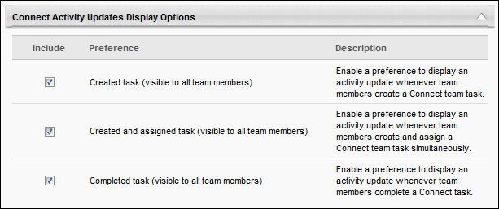
Communities Activity Update Display Options
This section controls which community activity updates are included in the Live Feed.
The following options are available:
- New posting created (visible to all community members) - When this option is selected, an activity update is added to the Live Feed when a new posting is created. In addition, the activity update is moved to the top of the Live Feed when a reply is added to the original posting. These postings are visible to members of the community in which it is posted. A posting is not moved to the top of the feed if a user replies to an existing reply. This prevents the posting from appearing in the feed multiple times, which enables other postings to appear to users in the feed. This option is selected by default. This option only applies to the Live Feed; this type of activity cannot be hidden from the Community Feed.
- New posting created for followers (visible to all following users) - When this option is selected, an activity update will appear in the Live Feed for a user if the user is following the community or topic in which a posting is created.
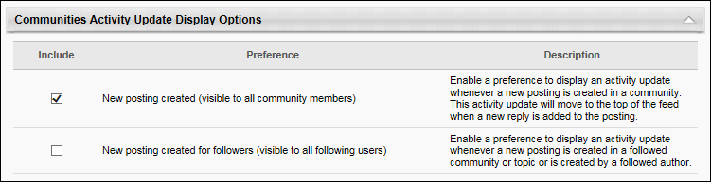
Universal Profile Activity Updates Options
- Completed goal (visible to owner and his/her managers) - When this option is selected, a Connect update is posted whenever a goal is published to the Universal Profile - Feedback page in the portal or Cornerstone Mobile® for a user.
- Received badge (visible to connections and all team members) - When this option is selected, a Connect update is posted whenever a user receives a badge in the portal or Cornerstone Mobile® on the Universal Profile - Feedback page.
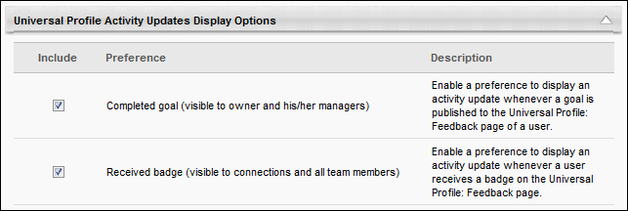
Learning Activity Updates Display Options
- Rated learning object (visible to connections and all team members) - When this option is selected, a Connect update is posted whenever a user rates a learning object within the system. Activity updates are not generated when a user edits an existing course rating or anonymously rates a learning object. The update is only visible to a user if the rated learning object is available to the user.
- Completed learning object (visible to user who completed the learning object and his/her managers) - When this option is selected, a Connect update is posted whenever a user completes a learning object in the portal or Cornerstone Mobile®. This update is visible to the user and the user's direct and indirect managers.
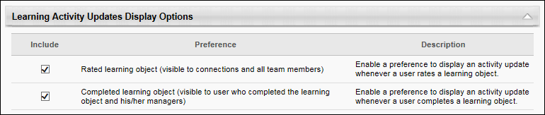
Performance Activity Update Display Options
- Completed performance review (visible to reviewer and his/her managers) - When this option is selected, a Connect update is posted whenever a user completes a performance review in the portal or Cornerstone Mobile®.
- Completed development plan (visible to assignee and his/her managers) - When this option is selected, a Connect update is posted whenever a user completes a development plan in the portal or Cornerstone Mobile®.
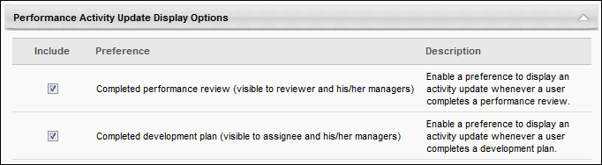
Team and Task Options
- Allow non-lead team members to create and edit tasks - Select this option to enable the Create New Task button on the Team Tasks page and the Edit option on the Task Details page for non-lead team members. If this option is not selected, then these options are only available for lead team members.
- Allow non-lead team members to invite new members - Select this option to enable the Invite New Members button on the Team Members page for non-lead team members. If this option is not selected, then this option is only available for lead team members.
- Allow non-lead team members to priority flag tasks - Select this option to allow non-lead team members to set the priority flag for tasks. If this option is not selected, then this option is only available for lead team members.
- Allow non-lead team members to delete tasks - Select this option to allow non-lead team members to set the priority flag for tasks. If this option is not selected, then this option is only available for lead team members.
- Allow non-lead team members to create goals and add to goals - Select this option to allow non-lead team members to set the priority flag for tasks. If this option is not selected, then this option is only available for lead team members.
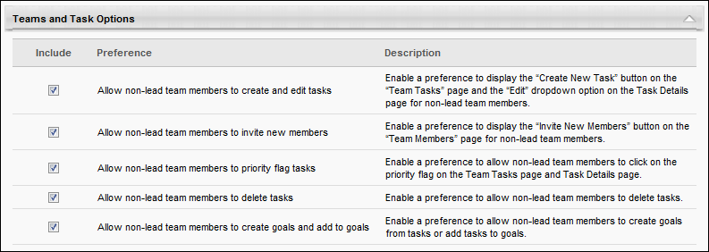
Overwrite Settings
Select this option to overwrite custom settings for child division OUs. If you overwrite custom settings for child division OUs, the selected settings are applied to both new and existing child OUs. Any previously customized child OUs are updated with the selected settings.
- If there are no customizations to the child OU, then the parent OU customizations are applied to all child OUs.
- Overwrite custom settings checkbox setting
  - If this option is selected, all child OU customizations are deleted from the database, which means the parent OU customizations will be applied to new and existing child OUs.
  - If this option is unselected, all existing child OU customizations will remain unchanged, and any new child OUs will inherit the parent OU customizations by default.
- If a child OU has been customized to display any widgets, then regardless of the parent OU customizations, the child OU customizations are applied.
- If a child OU has been customized to hide all widgets, then parent OU customizations will take precedence and will be applied.
Submit and Cancel
Click the Submit button to submit all preference settings, or click Cancel to discard any unsaved changes.

Action Groups - Manage
Within Connect, action groups are used to grant users certain permissions within a community or topic. When availability is set for a community or topic, each criterion is associated with an action group, which enables users within the selected availability criterion to perform the actions associated with the selected action group.
The Manage Action Groups page allows administrators to define and configure custom action groups. All administrator-defined and system-defined action groups are available when creating or editing a community or topic.
To manage action groups for Connect, go to Admin > Tools > Connect > Action Groups.
Permissions
PERMISSION NAME | PERMISSION DESCRIPTION | CATEGORY

Manage Knowledge Bank/Communities Administration | Grants ability to view the New Knowledge Bank Administration page and manage Action Groups. Based on permission constraints, administrators with this permission can create and delete topics and subtopics. Administrators with this permission can view all communities, topics, sub-topics and postings, regardless of availability. In addition, administrators can add a posting to the Course Catalog. When creating a topic, the constraints on this permission are automatically applied to the topic's availability. This permission can be constrained by OU and User's OU. This permission is assigned to the default Administrator role by default. | New Connect
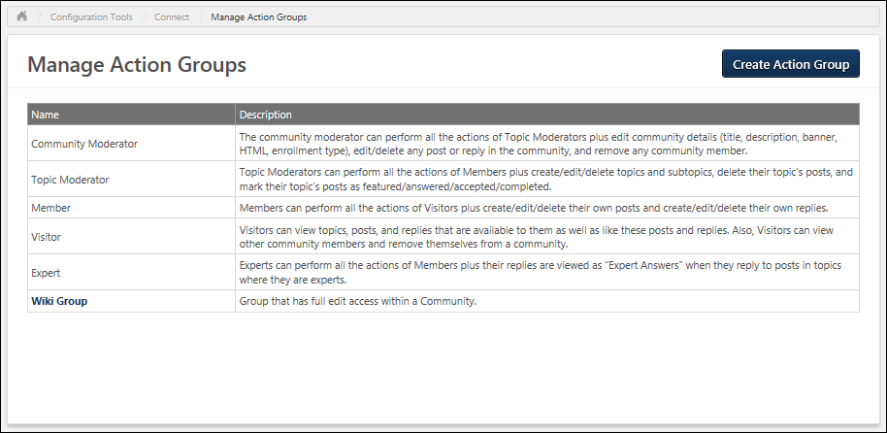
Action Group - Create
To create a custom action group, click the Create Action Group button. See Action Group - Create.
Action Group - Edit
To edit an existing custom action group, click the action group name in the table. When a change to an action group is made, it will apply immediately to all members of the action group. See Action Group - Create.
Note: System-defined action groups cannot be edited.
Action Groups Table
The Manage Action Groups page displays all existing action groups, including all system-defined and custom action groups.
The following information is displayed for each action group:
- Name - This is the name of the action group. The names of system-defined action groups are not clickable because they cannot be modified. The names of administrator-defined action groups are clickable and editable.
- Description - This column displays the description provided for each action group.

Action Group - Create/Edit
Within Connect, action groups are used to grant users certain permissions with regards to a community or topic. When availability is set for a community or topic, each criterion is associated with an action group, which enables the users within the selected availability criterion to perform the actions associated with the selected action group.
Administrators can create action groups to grant a group of users certain permissions within a community or topic.
To create an action group for Connect, go to Admin > Tools > Connect > Action Groups. Then, click the Create Action Group button.
Permissions
PERMISSION NAME | PERMISSION DESCRIPTION | CATEGORY

Manage Knowledge Bank/Communities Administration | Grants ability to view the New Knowledge Bank Administration page and manage Action Groups. Based on permission constraints, administrators with this permission can create and delete topics and subtopics. Administrators with this permission can view all communities, topics, sub-topics and postings, regardless of availability. In addition, administrators can add a posting to the Course Catalog. When creating a topic, the constraints on this permission are automatically applied to the topic's availability. This permission can be constrained by OU and User's OU. This permission is assigned to the default Administrator role by default. | New Connect
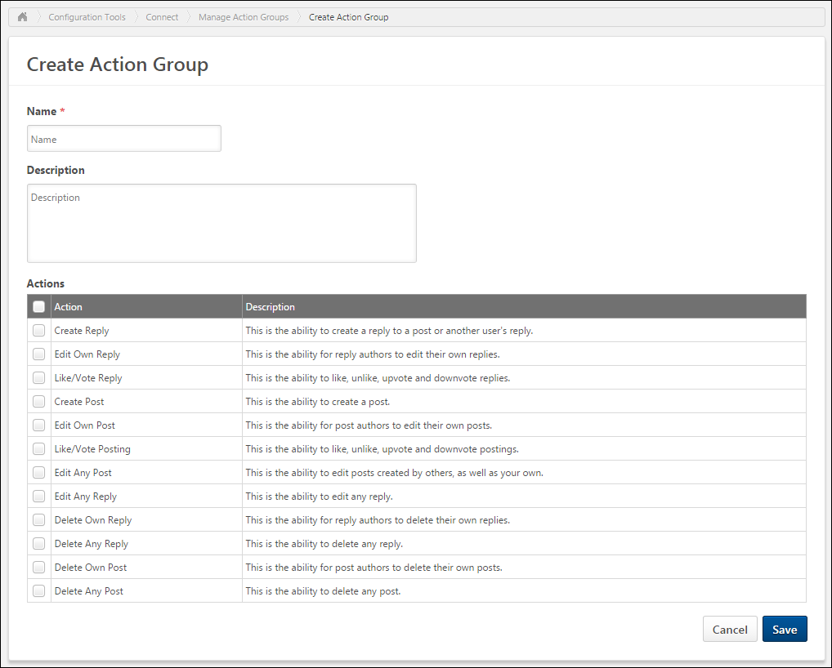
Clicking the Create Action Group button opens the Create Action Group page, where you can provide information for the new group. Enter the following information for the action group:
- Name - Enter a descriptive name for the action group. This name will be displayed when defining availability for a Connect community or topic. The character limit is 70.
- Description - Enter a meaningful description for the action group that describes the group's purpose. This description is only displayed on the Manage Action Groups page. The description is not displayed when defining availability for a Connect community or topic. The character limit is 1,000.
- Actions - In this section, select which actions are available to users within the action group.
Action Group Actions
Note: Users with the Manage Knowledge Bank/Communities Administration permission can always perform any of the below actions, regardless of their action group settings.
The following actions are available when configuring an action group:
- Create Reply - This action enables users to reply to a posting within the community or topic. When this option is not selected, users cannot participate in posting discussions.
  - Within system-defined action groups, this action is disabled for Visitors and enabled for all others.
- Edit Own Reply - This action enables users to edit text they have posted in reply to a posting within the community or topic. When this option is not selected, users do not have the option to edit a reply they have added to a posting. This includes any replies the user has added to the posting or to another comment within the posting.
  - Within system-defined action groups, this action is disabled for Visitors and enabled for all others.
- Like/Vote Reply - This action enables users to provide feedback on replies by liking or voting on a posting reply within the community or topic. When this option is not selected, the Like or Vote options are not available when viewing a posting reply. Users are always able to view the number of likes or votes a reply has received even if they cannot like or vote for the reply.
  - Within system-defined action groups, this action is enabled for all action groups.
- Create Post - This action enables users to create posts within the community or topic. When this option is not selected, the option to create a posting is not available when viewing a topic. This applies to all posting types.
  - Within system-defined action groups, this action is disabled for Visitors and enabled for all others.
- Edit Own Post - This action enables users to edit a posting that they have created. When this option is not selected, user do not have the option to edit their posting once they have created it.
  - Within system-defined action groups, this action is disabled for Visitors and enabled for all others.
- Like/Vote Posting - This action enables users to provide feedback on postings by liking or voting on a posting within the community or topic. When this option is not selected, the Like or Vote options are not available when viewing a posting. Users are always able to view the number of likes or votes a posting has received even if they cannot like or vote for the posting.
  - Within system-defined action groups, this action is enabled for all action groups.
- Edit Any Post - This action enables users to edit any posting within the community or topic. When this option is not selected, users can only edit postings based on their other available actions. For example, users may be granted the ability to edit their own posts.
  - Within system-defined action groups, this action is enabled for Community Moderators and disabled for all others.
- Edit Any Reply - This action enables users to edit any posting reply within the community or topic. When this option is not selected, users can only edit posting replies based on their other available actions. For example, users may be granted the ability to edit their own post replies.
  - Within system-defined action groups, this action is enabled for Community Moderators and disabled for all others.
- Delete Own Reply - This action enables users to delete a posting reply they have added within the community or topic. When this option is not selected, users do not have the option to delete a reply they have added to a posting.
  - Within system-defined action groups, this action is disabled for Visitors and enabled for all others.
- Delete Any Reply - This action enables users to delete any posting reply within the community or topic. When this option is not selected, users can only delete posting replies based on their other available actions. For example, users may be granted the ability to delete their own posting replies.
  - Within system-defined action groups, this action is enabled for Community Moderators and disabled for all others.
- Delete Own Post - This action enables users to delete their own postings within the community or topic. When this option is not selected, users do not have the option to delete a posting that they have created.
  - Within system-defined action groups, this action is disabled for Visitors and enabled for all others.
- Delete Any Post - This action enables users to delete any postings within the community or topic. When this option is not selected, users can only delete postings based on their other available actions. For example, users may be granted the ability to delete their own postings.
  - Within system-defined action groups, this action is enabled for Community Moderators and disabled for all others.
When a change to an action group is made, it is immediately applied to all members of the action group.
Save/Cancel
Click Save to create the action group or save any changes made to the group while editing.
Click Cancel to discard any unsaved changes.

Collaborative Learning - Community Templates
Collaborative learning provides a collaborative, classroom-like, online learning experience where learners can collaborate with each other and communicate with an instructor.
Collaborative learning utilizes program and cohort learning objects (LOs). A cohort LO is a combination of a Connect community and a curriculum, where users can complete training within a curriculum structure and collaborate with other learners who are in the same cohort. A program LO is essentially a template for cohort LOs so that new cohort instances can be quickly created with a consistent structure.
Administrators can create community templates for use with programs and cohorts. A community template contains default content, including a banner, an HTML widget, topics, and postings. A community template is created in order to be used with a cohort LO, and when a cohort LO is created using a community template, a cohort community is created with all of the default content from the community template. This enables administrators to quickly create new cohort communities for each new cohort, allowing each cohort to have their own unique experience.
A cohort community contains all of the traditional community functionality, but also contains a Learning tab where users can view and complete training and an Instructor tab where instructors can engage with learners.
- For information about creating a program, see Program-Create/Edit Overview.
- For information about cohort management, see Manage Cohorts.
- For information about creating cohorts, see Cohort - Create/Edit Overview.
- For information about managing a cohort roster, see Cohort Roster.

Manage Community Templates
The Manage Community Templates page enables administrators to view, create, and edit community templates.
A community template contains default content, including a banner, an HTML widget, topics, and postings. A community template is created in order to be used with a cohort learning object (LO), and when a cohort LO is created using a community template, a cohort community is created with all of the default content from the community template. This enables administrators to quickly create new cohort communities for each new cohort, allowing each cohort to have their own unique experience.
To manage community templates, go to Admin > Tools > Connect > Community Templates.
Permissions
PERMISSION NAME | PERMISSION DESCRIPTION | CATEGORY

Bio About - View | Enables user to view the Bio page for users within their permission constraints. This permission must be enabled to view the Transcript page within Universal Profile. If a user does not have this permission and they click a person's name or user photo within the Universal Profile, then the Bio page will not open.  On the Learner Home page, this permission also allows end users to view the Completions & Hours field, the training sidebar, and the Continue Learning carousel.  This permission can be constrained by Employee Relationship, OU, User's OU, User's Direct Reports, User Self and Subordinates, and User. Note: For security purposes, this permission is constrained to User Self and Subordinates by default. However, the permission constraints can be modified to allow users to view the Bio About page for other users. | Universal Profile

Manage Knowledge Bank/Communities Administration | Grants ability to view the New Knowledge Bank Administration page and manage Action Groups. Based on permission constraints, administrators with this permission can create and delete topics and subtopics. Administrators with this permission can view all communities, topics, sub-topics and postings, regardless of availability. In addition, administrators can add a posting to the Course Catalog. When creating a topic, the constraints on this permission are automatically applied to the topic's availability. This permission can be constrained by OU and User's OU. This permission is assigned to the default Administrator role by default. | New Connect
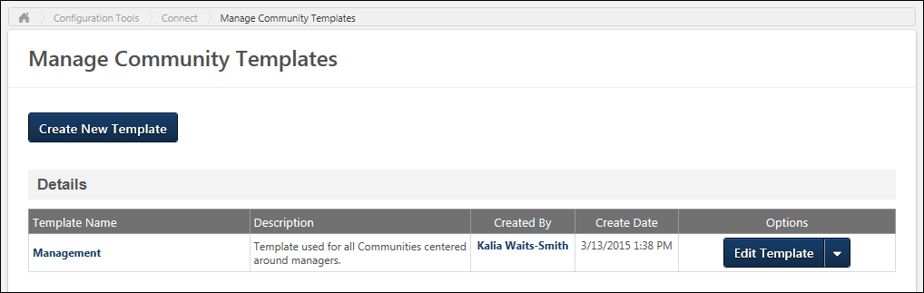
Create New Template
To create a new community template, click the Create New Template button. See Community Template - Create/Edit on page 17 for additional information.
Community Templates Table
The following information is displayed for each existing community template in the Templates table:
- Template Name - Community templates are displayed in alphabetical order by template name. Click the template name to view the template. See Community Template - Administrator View on page 20 for additional information.
- Description - The first 200 characters of the template description are displayed. If the description contains HTML, the HTML is not displayed in the table.
- Created By - Click the user's name to view their Universal Profile. If the administrator does not have permission to view the user's Universal Profile - Bio page, they receive an error message.
- Create Date
Community Template Options
The Options drop-down enables users to perform actions on the template. Click the left side of the drop-down to perform the displayed action. Or, click the drop-down arrow to select a secondary action. The following options may be available for the template:
- Edit Template - Select this option to edit the community template. See Community Template - Create/Edit on page 17 for additional information.
- Delete Template - Select this option to delete the community template. A confirmation pop-up is displayed. When a community template is deleted, all default topics and postings that are contained within the community template are also deleted.

Community Template - Create/Edit
A community template contains default content, including a banner, an HTML widget, topics, and postings. A community template is created in order to be used with a cohort learning object (LO), and when a cohort LO is created using a community template, a cohort community is created with all of the default content from the community template. This enables administrators to quickly create new cohort communities for each new cohort, allowing each cohort to have their own unique experience.
When a cohort community is created, the cohort community has the same title as the cohort. All users on the cohort's roster are automatically members of the cohort community. The cohort instructors are designated as experts for the cohort community, and the cohort owners are designated as moderators for the cohort community.
- To create a new community template, click the Create New Template button on the Manage Community Templates page.
- To edit a community template, click the Edit Template button on the Manage Community Templates page, or click the Edit Details button on the Administrator View of the Community Template.
Permissions
PERMISSION NAME | PERMISSION DESCRIPTION | CATEGORY

Manage Knowledge Bank/Communities Administration | Grants ability to view the New Knowledge Bank Administration page and manage Action Groups. Based on permission constraints, administrators with this permission can create and delete topics and subtopics. Administrators with this permission can view all communities, topics, sub-topics and postings, regardless of availability. In addition, administrators can add a posting to the Course Catalog. When creating a topic, the constraints on this permission are automatically applied to the topic's availability. This permission can be constrained by OU and User's OU. This permission is assigned to the default Administrator role by default. | New Connect
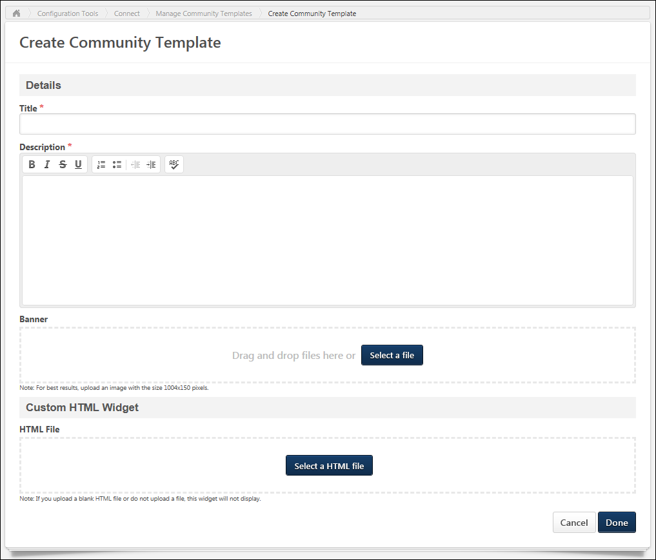
Details
Enter the following information for the community template:
- Title - Enter a title for the community template, up to 70 characters. This title will appear at the top of the community template.
- Description - Enter the community template description up to 3000 characters. This field includes rich text editing options.
- Banner - The banner image appears at the top of the community template and at the top of each community template posting. Add a banner file by dragging and dropping a file into the Attachment area. You can also attach a file by clicking the Select a file button and select a file from your computer. Note: The drag-and-drop functionality is not supported by Internet Explorer browsers. For best results, the banner image should be 1004 x 150 pixels. The Image Restrictions section below provides a complete list of image attachment restrictions.
Custom HTML Widget
The default custom HTML widget will be included in all communities that are created using the community template.
The Custom HTML Widget section is only available if enabled by a backend setting. This section enables administrators to upload an HTML file (.htm or .html), up to 5 MB in size. Once the community template is saved, the HTML data is rendered and displayed in the upper-left corner of communities created using the community template.
Add an HTML file by dragging and dropping the file into the Attachment area. You can also attach a file by clicking the Select a file button and select a file from your computer. Note: The drag-and-drop functionality is not supported by Internet Explorer browsers. Once the file is selected, a preview of the HTML widget is displayed in the section. If an empty file or no file is selected, then the HTML widget does not appear on the community template homepage.
Important: All HTML tags are accepted by the Custom HTML widget. Because malicious HTML files may be uploaded, this is a potential security risk and organizations may choose to disable this functionality.
Done or Cancel
After populating the necessary fields, click Done to create the community template. Otherwise, click Cancel to cancel the community template creation.
Image Restrictions
The following file types are allowed:
File Type | Extension
Image | - bmp  - gif  - jpeg/jpg  - png

Community Template - Administrator View
The administrator view of a community template enables administrators to view the default topics within the community template, create new topics for the community template, and edit the community template.
A community template contains default content, including a banner, an HTML widget, topics, and postings. A community template is created in order to be used with a cohort learning object (LO), and when a cohort LO is created using a community template, a cohort community is created with all of the default content from the community template. This enables administrators to quickly create new cohort communities for each new cohort, allowing each cohort to have their own unique experience.
To access the administrator view of a community template, go to Admin > Tools > Connect > Community Templates. Then, click the community template name.
Permissions
PERMISSION NAME | PERMISSION DESCRIPTION | CATEGORY

Manage Knowledge Bank/Communities Administration | Grants ability to view the New Knowledge Bank Administration page and manage Action Groups. Based on permission constraints, administrators with this permission can create and delete topics and subtopics. Administrators with this permission can view all communities, topics, sub-topics and postings, regardless of availability. In addition, administrators can add a posting to the Course Catalog. When creating a topic, the constraints on this permission are automatically applied to the topic's availability. This permission can be constrained by OU and User's OU. This permission is assigned to the default Administrator role by default. | New Connect
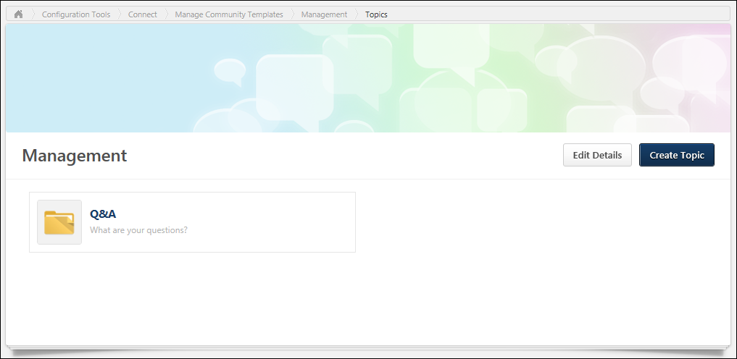
Each top-level topic within the community template is displayed in alphabetical order. When a community template is first created, there are no topics available within the community template.
Edit Community Template Details
To edit the community template details, click the Edit Details button. See Community Template - Create/Edit on page 17 for additional information.
Create Topic
To create a default topic for the community template, click the Create Topic button. See Community Template Topic - Create/Edit on page 22 for additional information.
View Topic Details Page
The Topic Details page displays all of the default subtopics within the topic and all of the default topic postings. Administrators are able to edit or delete the topic, create subtopics, or create postings.
To view the Topic Details page for a topic, click the topic name. See Community Template - Topic Details Page on page 24 for additional information.

Community Template Topic - Create/Edit
When configuring a community template, administrators can create and edit default topics for the community template.
A community template contains default content, including a banner, an HTML widget, topics, and postings. A community template is created in order to be used with a cohort learning object (LO), and when a cohort LO is created using a community template, a cohort community is created with all of the default content from the community template. This enables administrators to quickly create new cohort communities for each new cohort, allowing each cohort to have their own unique experience.
- To create a default topic within a community template, click the Create Topic button on the administrator view of the community template.
- To create a default subtopic within a topic, on the Topic Details page, select Create Subtopic from the Manage Topic drop-down menu.
- To edit a default topic, on the Topic Details page, select Edit Topic from the Manage Topic drop-down menu.
Permissions
PERMISSION NAME | PERMISSION DESCRIPTION | CATEGORY

Manage Knowledge Bank/Communities Administration | Grants ability to view the New Knowledge Bank Administration page and manage Action Groups. Based on permission constraints, administrators with this permission can create and delete topics and subtopics. Administrators with this permission can view all communities, topics, sub-topics and postings, regardless of availability. In addition, administrators can add a posting to the Course Catalog. When creating a topic, the constraints on this permission are automatically applied to the topic's availability. This permission can be constrained by OU and User's OU. This permission is assigned to the default Administrator role by default. | New Connect
Details
Enter the following information for the topic:
- Title - Enter a title for the topic, up to 70 characters. This title will appear at the top of the topic.
- Description - Enter the topic description up to 10,000 characters. This field includes rich text editing options. This field is optional.
Done and Cancel
After entering the appropriate information, click Done to create the default topic. Or, click Cancel to cancel the topic creation.
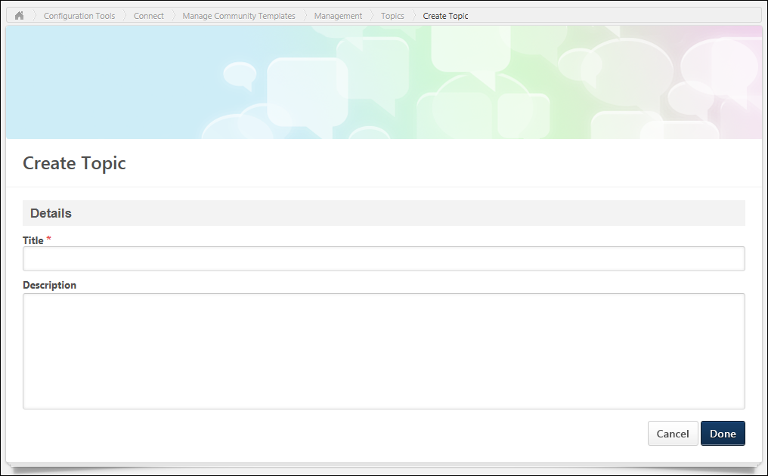

Community Template - Topic Details Page
The Topic Details page displays all of the default subtopics within the topic and all of the default topic postings. Administrators are able to edit or delete the topic, create subtopics, or create postings.
A community template contains default content, including a banner, an HTML widget, topics, and postings. A community template is created in order to be used with a cohort learning object (LO), and when a cohort LO is created using a community template, a cohort community is created with all of the default content from the community template. This enables administrators to quickly create new cohort communities for each new cohort, allowing each cohort to have their own unique experience.
To view the Topic Details page for a community template topic, click the topic title from the administrator view of the community template.
Permissions
PERMISSION NAME | PERMISSION DESCRIPTION | CATEGORY

Bio About - View | Enables user to view the Bio page for users within their permission constraints. This permission must be enabled to view the Transcript page within Universal Profile. If a user does not have this permission and they click a person's name or user photo within the Universal Profile, then the Bio page will not open.  On the Learner Home page, this permission also allows end users to view the Completions & Hours field, the training sidebar, and the Continue Learning carousel.  This permission can be constrained by Employee Relationship, OU, User's OU, User's Direct Reports, User Self and Subordinates, and User. Note: For security purposes, this permission is constrained to User Self and Subordinates by default. However, the permission constraints can be modified to allow users to view the Bio About page for other users. | Universal Profile

Manage Knowledge Bank/Communities Administration | Grants ability to view the New Knowledge Bank Administration page and manage Action Groups. Based on permission constraints, administrators with this permission can create and delete topics and subtopics. Administrators with this permission can view all communities, topics, sub-topics and postings, regardless of availability. In addition, administrators can add a posting to the Course Catalog. When creating a topic, the constraints on this permission are automatically applied to the topic's availability. This permission can be constrained by OU and User's OU. This permission is assigned to the default Administrator role by default. | New Connect
Manage Topic
The following options are available in the Manage Topic drop-down menu:
- Create Subtopic - Select this option to create a default subtopic within the topic. See Community Template Topic - Create/Edit on page 22 for additional information.
- Edit Topic - Select this option to edit the default topic. See Community Template Topic - Create/Edit on page 22 for additional information.
- Delete Topic - Select this option to delete the default topic. A confirmation pop-up is displayed. When a default topic is deleted, all subtopics and postings that are contained within the default topic are also deleted.
Create Posting
The following options are available in the Create Posting drop-down menu:
- Create Discussion - Select this option to create a discussion posting within the topic. See Posting Type - Discussion - Create on page 210 for additional information.
- Create File - Select this option to create a file posting within the topic. See Posting Type - File - Create on page 221 for additional information.
- Create Q&A - Select this option to create a Q&A posting within the topic. See Posting Type - Q&A - Create on page 232 for additional information.
- Create Suggestion - Select this option to create a suggestion posting within the topic. See Posting Type - Suggestion - Create on page 244 for additional information.
Subtopics
If the default topic has at least one default subtopic, then the subtopics are displayed above the Postings table in alphabetical order.
For each subtopic, the title and description are displayed. Users can click a subtopic name to view the corresponding Topic Details page.
Postings
This section is only displayed if the default topic has at least one default posting. All of the postings within the topic are displayed in the Postings table.
Featured postings are displayed at the top of the table and have a beige background color. Following any featured postings, the posting that was most recently created is displayed first.
The following information is displayed for each posting in the Postings table:
- Posting Icon - An icon is displayed to the left of the posting title. This icon reflects the posting type.
- Posting Title - This displays the posting title. Click the posting title to view the posting.
- Author - This displays the posting author's photo and name and when the original posting was created. Click the user's name to view their Universal Profile. If the administrator does not have permission to view the user's Universal Profile - Bio page, they receive an error message.
Posting Options
The following options may be available for the posting in the Options drop-down menu:
- Edit Posting - Select this option to edit the default posting.
- Mark as Featured - Select this option to make the default posting a featured posting. When a posting is featured, the posting is displayed above non-featured postings in the Postings table on the Topic Details page to which the posting belongs. The posting also appears in the Featured widget on the main page of the cohort community to which the posting belongs.
- Delete Posting - Select this option to delete the default posting. A confirmation pop-up is displayed.
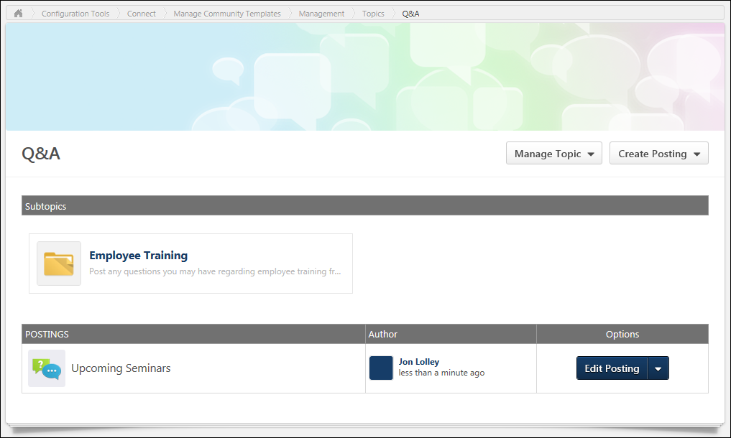

Dynamic Teams Overview

Dynamic Team Administration
Dynamic teams can be comprised of hand-picked members, organizational units (OUs), or both. When a team is created, a Team Page is added to Connect, which enables all members of the team to view and manage team tasks. A team feed allows team members to share knowledge each other and stay informed on team member activities.
Use Case: In preparation for the annual client conference, several members of the Marketing department set up a team in order to work on a presentation. The team members share information on the Team Feed, and they create and manage the various tasks needed to deliver the presentation on the Team Tasks page.
The Dynamic Team Administration page enables administrators to create and manage dynamic teams within New Connect.
To access the Dynamic Team Administration page, go to Admin > Tools > Connect > New Connect Administration > Dynamic Teams.
Permissions
PERMISSION NAME | PERMISSION DESCRIPTION | CATEGORY

Manage Dynamic Teams | Grants ability to manage and create dynamic Connect teams. This permission can be constrained by Facilities Owned by User, OU, and User's OU. The constraints on this permission determine which teams the user can manage on the Manage Dynamic Teams page. The constraints on this permission do not determine which users can be added or removed from a team. | New Connect
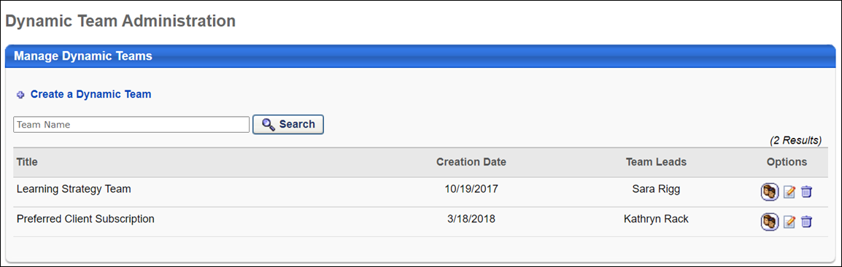
Manage Dynamic Teams
- Create a Dynamic Team - Click the Create a Dynamic Team link to create a dynamic team. See Dynamic Team - Create on page 30 for additional information.
- Search - Search for existing dynamic teams by entering the team name in the search field and click the Search button.
- Manage Dynamic Teams - The following information displays for each dynamic team:
  - Title - This column displays the title of the dynamic team. Teams are displayed in alphabetical order by title.
  - Creation Date - This column displays the date on which the dynamic team was created.
  - Team Leads - This column displays the team leads for the dynamic team.
- Options - The following options are available in the Options column:
  - Manage Members - Click the Manage Members icon to access the Manage Members page. See Dynamic Team - Manage Members on page 32 for additional information.
  - Edit - Click the Edit icon to edit the dynamic team.
  - Delete - Click the Delete icon to delete the dynamic team. Note: If you delete a dynamic team, that dynamic team will no longer be selectable as an OU via the Attendees page of the Express Class creation process. See Create Express Class - Attendees.

Dynamic Team - Create
Dynamic teams can be comprised of hand-picked members, organizational units (OUs), or both. When a team is created, a Team Page is added to Connect, which enables all members of the team to view and manage team tasks. A team feed allows team members to share knowledge each other and stay informed on team member activities.
Use Case: In preparation for the annual client conference, several members of the Marketing department set up a team in order to work on a presentation. The team members share information on the Team Feed, and they create and manage the various tasks needed to deliver the presentation on the Team Tasks page.
To create a dynamic team, go to Admin > Tools > Connect > New Connect Administration > Dynamic Teams. Then, click the Create a Dynamic Team link.
Permissions
PERMISSION NAME | PERMISSION DESCRIPTION | CATEGORY

Manage Dynamic Teams | Grants ability to manage and create dynamic Connect teams. This permission can be constrained by Facilities Owned by User, OU, and User's OU. The constraints on this permission determine which teams the user can manage on the Manage Dynamic Teams page. The constraints on this permission do not determine which users can be added or removed from a team. | New Connect
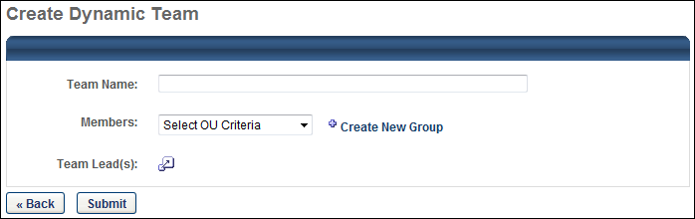
Create Dynamic Team
Enter the following information for the team:
- Team Name - Enter a name for the dynamic team, up to 70 characters.
- Members - Select the OUs, groups, or users who are members of the dynamic team. You can also click the Create New Group link to create a new group for these criteria. If OUs or groups are selected, then this criterion is dynamic. This means that if a new user enters the OU or group in the future, then the user is automatically added to the dynamic team. In addition, if a user leaves the OU or group in the future, then the user is automatically removed from the group.
- Team Leads - Team leads have additional abilities within the team, which may include moving team tasks, creating and editing tasks, inviting new members, and setting task priority. Click the Select User icon to select one or more team leads.
Back and Submit
Click Submit to finalize the dynamic team settings, or click Back to cancel the team creation and discard any unsaved changes.

Dynamic Team - Manage Members
The Manage Members page enables administrators to view the users in a dynamic team. Note: When creating a dynamic team it may take up to 15 minutes for the team members to appear on the Manage Members page.
To view the Manage Members page for a dynamic team, go to Admin > Tools > Connect > New Connect Administration > Dynamic Teams. Then, click the Manage Members icon in the Options column for the appropriate dynamic team.
Permissions
PERMISSION NAME | PERMISSION DESCRIPTION | CATEGORY

Manage Dynamic Teams | Grants ability to manage and create dynamic Connect teams. This permission can be constrained by Facilities Owned by User, OU, and User's OU. The constraints on this permission determine which teams the user can manage on the Manage Dynamic Teams page. The constraints on this permission do not determine which users can be added or removed from a team. | New Connect
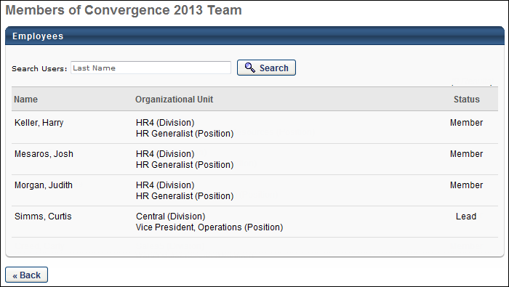
Employees
To search for a team member, enter the user's last name in the search field and click the Search button.
The following information displays for each team member:
- Name - This column displays the team member's name.
- Organizational Unit - This column displays the organizational unit criteria that enabled them to be members of the team. For example, if the membership criterion is based on division, this column displays the user's division. If the user is a member of several of the criteria OUs, then all matching OUs are listed.
- Status - This column displays whether the user is a team member or team lead.
Back
Click Back to return to the Dynamic Team Administration page.

Connect Overview

Communities Overview
All Communities
The All Communities page displays all of the active communities to which a user belongs. This page also displays all of the communities that the user is able to view and join.
To view the All Communities page, go to Connect > Communities.
Permissions
PERMISSION NAME | PERMISSION DESCRIPTION | CATEGORY

Course Catalog - View | Grants access to view the learning objects in the course catalog and enables administrators to view the Course Console and the Popular Requests and Highest Rated widgets on the Learning Admin Console (in conjunction with the Learning Admin Console - View permission). This permission can be constrained by OU, User's OU, Training Type, Training Item, Provider, ILT Provider, User's ILT Provider, and User's LO Availability. This is an administrator permission.  Adding an OU constraint and a provider constraint to this permission results in an "AND" statement. | Learning - Administration

Manage Knowledge Bank/Communities Administration | Grants ability to view the New Knowledge Bank Administration page and manage Action Groups. Based on permission constraints, administrators with this permission can create and delete topics and subtopics. Administrators with this permission can view all communities, topics, sub-topics and postings, regardless of availability. In addition, administrators can add a posting to the Course Catalog. When creating a topic, the constraints on this permission are automatically applied to the topic's availability. This permission can be constrained by OU and User's OU. This permission is assigned to the default Administrator role by default. | New Connect

View Knowledge Bank/Communities | Grants ability to view the Knowledge Bank and Communities pages. This permission can be constrained by OU and User's OU. This permission is assigned to the default Administrator role by default. | New Connect
Create Community
To create a new community, select one of the following options from the New Community drop-down menu:
- Community - Select this option to create a new community. See Community - Create/Edit on page 79 for additional information.
- Learning Community - Select this option to create a new community that is tailored for informal learning. This option is only available for users who have permission to view the Course Catalog. See Learning Community - Create/Edit on page 97 for additional information.
The New Community menu is only available to users with permission to manage communities.
My Communities
This section displays all of the active communities to which the user belongs in alphabetical order. The community name and description is displayed for each community. The user can click the community name to view the community. See Community - Main on page 85 for additional information. Note: This section is not available if the user belongs to no communities and has not been invited to join any communities.
To the right of the community name, a photo of each member of the community is displayed. The community moderators are displayed first in order of the date they joined the community. After the community moderators, community members are displayed in order of the date they joined the community. Up to five photos display. If the community has more than five members, then only four photos are displayed and the fifth photo slot displays how many additional members the community has. Click the photograph to open the Universal Profile - Bio page for the user.
Browse Communities
This section displays all active communities that are available to the user and to which the user does not yet belong. These communities are displayed in alphabetical order. The community name and description is displayed for each community. The user can click the community name to view the community. See Community - Main on page 85 for additional information.
To the right of the community name, a photo of each member of the community is displayed. The community moderators are displayed first in order of the date they joined the community. After the community moderators, community members are displayed in order of the date they joined the community. Up to five photos display. If the community has more than five members, then only four photos are displayed and the fifth photo slot displays how many additional members the community has. Click the photograph to open the Universal Profile - Bio page for the user.
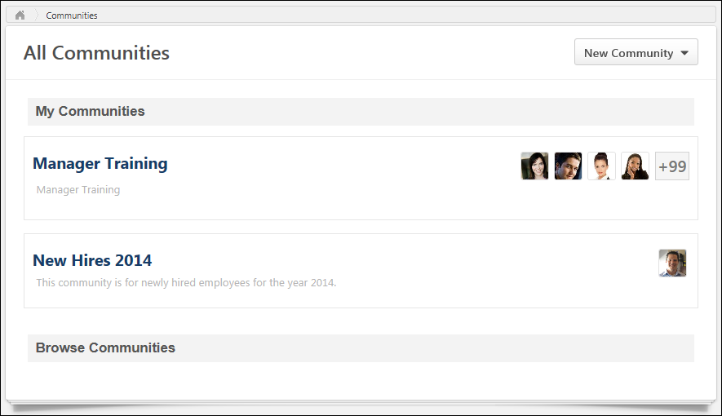
Cohort Community - Edit
A community template contains default content, including a banner, an HTML widget, topics, and postings. A community template is created in order to be used with a cohort learning object (LO), and when a cohort LO is created using a community template, a cohort community is created with all of the default content from the community template. This enables administrators to quickly create new cohort communities for each new cohort, allowing each cohort to have their own unique experience.
When a cohort is created, a cohort community is simultaneously created for the cohort within Connect. The cohort community has the same title as the cohort, and all cohort owners are designated as community moderators for the cohort community. Community moderators are able to edit the community.
To edit a cohort community, on the Community page, select Edit Community from the Options drop-down menu.
Permissions
PERMISSION NAME | PERMISSION DESCRIPTION | CATEGORY

Edit Availability Knowledge Bank/Communities | Grants ability to configure the availability when editing communities or when creating or editing topics. This permission does not grant the ability to edit a community; users can only edit a community or topic if they have the Manage Knowledge Bank/Communities Administration or if they are a moderator for the community or topic. When creating a topic, the constraints on this permission are automatically applied to the topic's availability. If the user also has the Manage Knowledge Bank/Communities Administration permission, then the constraints on that permission are automatically applied to the topic's availability. This permission can be constrained by OU, User's OU, and User's Corporation. | New Connect

Manage Knowledge Bank/Communities Administration | Grants ability to view the New Knowledge Bank Administration page and manage Action Groups. Based on permission constraints, administrators with this permission can create and delete topics and subtopics. Administrators with this permission can view all communities, topics, sub-topics and postings, regardless of availability. In addition, administrators can add a posting to the Course Catalog. When creating a topic, the constraints on this permission are automatically applied to the topic's availability. This permission can be constrained by OU and User's OU. This permission is assigned to the default Administrator role by default. | New Connect

View Knowledge Bank/Communities | Grants ability to view the Knowledge Bank and Communities pages. This permission can be constrained by OU and User's OU. This permission is assigned to the default Administrator role by default. | New Connect
Details
Enter the following information for the community:
- Title - Because the cohort community has the same name as the corresponding cohort LO, the community title cannot be edited.
- Description - Enter the community description up to 3000 characters. This field includes rich text editing options.
- Banner - The banner image appears at the top of the community and at the top of each community posting. Add a banner file by dragging and dropping a file into the Attachment area. You can also attach a file by clicking the Select a file button and select a file from your computer. Note: The drag-and-drop functionality is not supported by Internet Explorer browsers. For best results, the banner image should be 1004 x 150 pixels. The Image Restrictions section below provides a complete list of image attachment restrictions.
Custom HTML Widget
The Custom HTML Widget section is only available if enabled by a backend setting. This section enables administrators to upload an HTML file (.htm or .html), up to 5 MB in size. Once the community is saved, the HTML data is rendered and displayed in the upper-left corner of the community.
Add an HTML file by dragging and dropping the file into the Attachment area. You can also attach a file by clicking the Select a file button and select a file from your computer. Note: The drag-and-drop functionality is not supported by Internet Explorer browsers. Once the file is selected, a preview of the HTML widget is displayed in the section. If an empty file or no file is selected, then the HTML widget does not appear on the community homepage.
Important: All HTML tags are accepted by the Custom HTML widget. Because malicious HTML files may be uploaded, this is a potential security risk and organizations may choose to disable this functionality.
Community Feed
A Community Feed is a feed that is displayed on the Main tab of the community. The Community Feed may display the latest activity for the specific community. In addition, community members may be able to create discussion postings directly from the Community Feed. All updates not posted directly to Community Feed, such as "received a reply" or "has created the discussion" updates, will not display if the update was made more than 365 days ago.
Select whether the Community Feed is enabled for the community. For new communities, the feed is enabled by default.
Availability Selection Criteria
The cohort community's availability is determined by the cohort configuration. Because of this, the community's availability cannot be edited.
When a cohort community is created, all users on the cohort's roster are automatically members of the cohort community, and they appear as a single line item in the Availability Selection Criteria section. The cohort instructors are designated as experts for the cohort community, and the cohort owners are designated as moderators for the cohort community.
See Knowledge Bank/Community - Availability and Action Groups on page 148 for additional information.
Done or Cancel
After entering the appropriate information, click Done to create the community template. Otherwise, click Cancel to cancel the community template creation.
Image Restrictions
The following file types are allowed:
File Type | Extension
Image | - bmp  - gif  - jpeg/jpg  - png
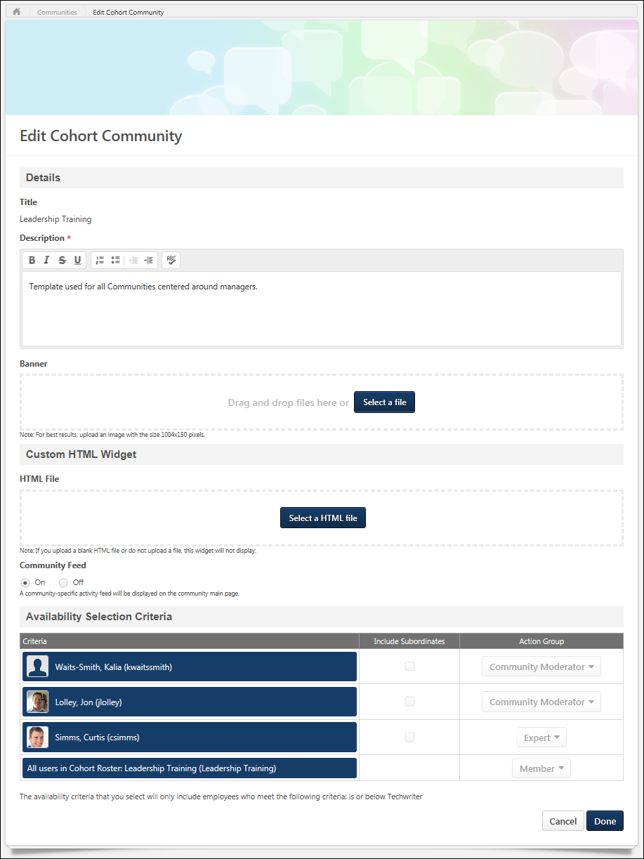
Cohort Community Overview
Cohort Community - Main
When a cohort is created, a cohort community is simultaneously created for the cohort within Connect. The cohort community has the same title as the cohort, and all users on the cohort's roster are automatically members of the cohort community.
The Main tab of the community is the default landing page for the community and displays highlighted and curated content for users. A user can only view a cohort community if the user is enrolled in the corresponding cohort.
To access a community, go to Connect > Communities. Then, click the community title.
Permissions
PERMISSION NAME | PERMISSION DESCRIPTION | CATEGORY

Manage Knowledge Bank/Communities Administration | Grants ability to view the New Knowledge Bank Administration page and manage Action Groups. Based on permission constraints, administrators with this permission can create and delete topics and subtopics. Administrators with this permission can view all communities, topics, sub-topics and postings, regardless of availability. In addition, administrators can add a posting to the Course Catalog. When creating a topic, the constraints on this permission are automatically applied to the topic's availability. This permission can be constrained by OU and User's OU. This permission is assigned to the default Administrator role by default. | New Connect

View Knowledge Bank/Communities | Grants ability to view the Knowledge Bank and Communities pages. This permission can be constrained by OU and User's OU. This permission is assigned to the default Administrator role by default. | New Connect
Emails
EMAIL NAME | EMAIL DESCRIPTION | ACTION TYPE

Knowledge Bank/Communities New Posting Created | This email is triggered when a new Knowledge Bank or community posting is created. This email can be sent as a notification to Community Moderator, Community Members, Follower, or a specific user. A recipient must match the following criteria to receive the email:  - User is within the availability criteria for the corresponding posting's parent topic.  - User is within the constraints of the posting's parent topic's creator constraints.  - User is a member of one of the communities with which the topic is shared. | New Connect
Community Title
The title of the community is displayed in the upper-left corner of the community. This title is the same as the corresponding cohort learning object (LO).
Community Options
The following options are available in the Options drop-down:
- Follow Community - This option is available to all users who are members of the community. When a user is following a community, the user may receive email notifications whenever a posting is created in any of the topics that are available to the user within the community. Also, the community appears in the Following section of the user's Universal Profile: Bio. When a user follows a community, the user implicitly follows all of the topics and subtopics within the community. Because of this, the user does not have the option to follow or unfollow any topic within the community while the user is following the community.
- Unfollow Community - This option is only available when the user is currently following the community. When the user selects this option, the user is no longer following the community or any of the topics within the community. If the user had followed any individual topics within the community prior to following the community, then the user is still following those topics when the community is unfollowed.
- Edit Community - Select this option to edit the community. This option is only available to community moderators and administrators. See Cohort Community - Edit on page 39 for additional information.
Community Tabs
The following tabs are available for the cohort community:
- Main - This tab is the landing page for the community. It displays highlighted and curated content for users.
- Topics - This tab provides access to all topics within the community.
- Members - This tab provides access to all members within the community.
- Learning - This tab allows learners who are enrolled in the cohort to view, complete, and track progress of the learning objects that must be completed as part of the cohort. This tab is opened by default when the cohort is launched from the Transcript.
- Instructor - This tab is only available to the cohort's instructors. This tab enables the cohort's instructor to view comments that have been posted to video learning objects within the cohort.
Search for Postings
To search for postings within a community, enter your search criteria in the Search within community field and either click the Search icon or press [Enter]. This opens the Posting Search Results page. See Posting Search Results on page 130 for additional information.
HTML Widget
Depending on the community configuration, an HTML widget may appear at the top of the Main tab.
Community Feed
The Community Feed may display the latest activity for the specific community. In addition, community members may be able to create discussion postings directly from the Community Feed. All updates not posted directly to Community Feed, such as "received a reply" or "has created the discussion" updates, will not display if the update was made more than 365 days ago.
Community Feed - Activity Update Visibility
The Community Feed is only visible if it is enabled and if the user has joined the community. However, administrators who have the Manage Knowledge Bank/Communities Administration permission can always view the Community Feed.
An update is only visible in the Community Feed if the user has permission to view the corresponding posting.
If a posting or reply is deleted, then the activity update is removed from the Community Feed.
Community Feed - Create Discussion Posting
From the Community Feed, users may be able to create a new discussion posting and select the topic into which the posting will be added. If there are no topics for which the user has permission to create a posting, then this functionality is not available.
To create a discussion posting, select within the Create a discussion posting field. The panel expands to show the Select Topic drop-down and the Post and Cancel options.
See Community Feed - Create Posting on page 116 for additional information.
Community Feed - Activity Updates
The following activities may appear in the Community Feed:
- Posting Created - When a new posting is created in the community, this activity may be displayed in the feed. The first 300 characters of the posting body is displayed in the feed. No HTML is displayed in the feed.
- Posting Reply - When a reply is added to the original posting from the Community Feed or the Posting Details page, the original posting is moved to the top of the feed. A posting is not moved to the top of the feed if a user replies to an existing reply.
Community Feed - Activity Update Options
Users may have the option to like and reply to an activity update. However, the ability to vote for or against a suggestion type posting is not available from the Community Feed.
Any replies or likes that are added to activity updates in the Community Feed will also appear for the activity update in the Live Feed and the Posting Details page.
Community Feed - Show More
When viewing the Community Feed, up to 10 items are displayed. If there are more than 10 items available, then a Show More button is available at the bottom of the feed. Select this button to view 10 more items within the feed.
Community Description
At the top of the furthest right column, the community description is displayed, up to 300 characters. If the description exceeds 300 characters, a more link appears. Click this link to view the full description in a pop-up. The description is configured by the administrator when creating or editing the community.
Featured Panel
The Featured panel displays postings that have been marked as featured postings by the administrator. Only postings that are available to the user are displayed.
The posting that was marked as featured most recently is displayed at the top of the Featured panel.
If a link is attached to the posting, then the URL preview image is displayed. If a user clicks the posting image, they are directed to the posting page.
If a posting that has an embedded image or video file is Featured, then a thumbnail will display for that posting in the Featured and Trending widgets. Postings with embedded image files will use the top-most-position uploaded image file as the image used for the widget. Postings with embedded video files will use the top-most-position uploaded video file as the image used for the widget. However, if a posting includes both an uploaded image and a file, then the top-most eligible file will be used for the widget. This means that after creation, if a new eligible file replaces the top-most file, then the posting's thumbnail on these widgets will be updated to reflect this.
The posting title is displayed as a link. If a user clicks the posting title, they are directed to the posting page.
For the top featured posting, the first line from the posting is displayed below the posting title.
At the bottom of the posting, the Like button or icon is displayed with the date on which the posting was created. Click the Like button or icon to like the posting. Note: If a user clicks the Like button for a posting, this does not affect the trending score until the page is refreshed. See Posting Action - Like a Posting or a Reply on page 205 for additional information.
Popular Tags Panel
The Popular Tags panel displays the most popular tags that are being used within the community. The system determines tag popularity by the number of times any posting that contains the tag is viewed within the community. System-defined tags are not included in the panel. This panel is updated every three hours. This panel is only available when tags are enabled, and this panel is not displayed if there are no tags within a community.
Below each tag, the total number of times a posting that contains the tag has been viewed across the entire community. This calculation includes all postings in the community, even if the user is not able to view the posting.
Click a tag to initiate a search within Global Search for all postings that contain the selected tag. Users can only view postings which they can access. Note: The ability to click a posting tag to initiate a search is only available if the ability to search for Connect postings by tag is enabled via Search Preferences.
Trending Panel
The Trending panel displays postings that are trending within the community. Which topics are trending is determined by the number of times a posting has been viewed, liked, voted for, and replied to. Only postings that are available to the user are displayed.
The posting that is trending the most is featured at the top of the Trending panel.
If a link is attached to the posting, then the URL preview image is displayed. If a user clicks the posting image, they are directed to the posting page.
If a posting that has an embedded image or video file is Trending, then a thumbnail will display for that posting in the Featured and Trending widgets. Postings with embedded image files will use the top-most-position uploaded image file as the image used for the widget. Postings with embedded video files will use the top-most-position uploaded video file as the image used for the widget. However, if a posting includes both an uploaded image and a file, then the top-most eligible file will be used for the widget. This means that after creation, if a new eligible file replaces the top-most file, then the posting's thumbnail on these widgets will be updated to reflect this.
The posting title is displayed as a link. If a user clicks the posting title, they are directed to the posting page.
For the top trending posting, the first line from the posting is displayed below the posting title.
At the bottom of the posting, the Like functionality or Vote functionality is displayed with the date on which the posting was created.
- If the Like functionality is available, users can click the Like button or icon to like the posting. See Posting Action - Like a Posting or a Reply on page 205 for additional information.
- If the Vote functionality is available, users can vote for or against the posting. See Posting Action - Vote Posting or Reply on page 209 for additional information.
Leaderboard Grid
The Leaderboard grid displays the users who post the most topics, up to 21. User can hover over a member's photo to view the member's name and the number of postings the user has created. Click a member's photo to view the member's Universal Profile - Bio page.
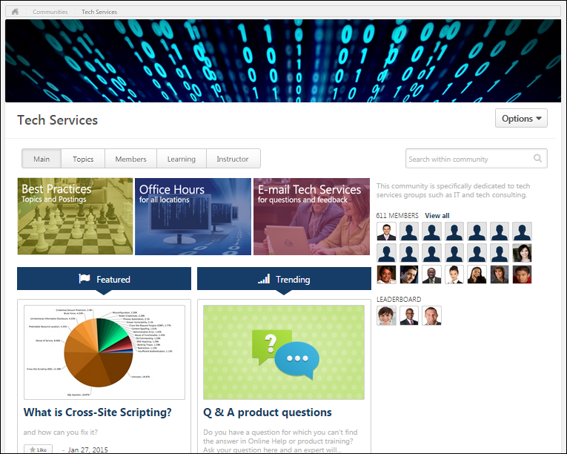
Cohort Community - Members
The Members tab of a community allows users to view the community members. A user can only view a cohort community if the user is enrolled in the corresponding cohort.
To access the Members tab of a community, go to New Connect > All Communities. Click the appropriate community. Then, click the Members tab.
Permissions
PERMISSION NAME | PERMISSION DESCRIPTION | CATEGORY

Bio About - View | Enables user to view the Bio page for users within their permission constraints. This permission must be enabled to view the Transcript page within Universal Profile. If a user does not have this permission and they click a person's name or user photo within the Universal Profile, then the Bio page will not open.  On the Learner Home page, this permission also allows end users to view the Completions & Hours field, the training sidebar, and the Continue Learning carousel.  This permission can be constrained by Employee Relationship, OU, User's OU, User's Direct Reports, User Self and Subordinates, and User. Note: For security purposes, this permission is constrained to User Self and Subordinates by default. However, the permission constraints can be modified to allow users to view the Bio About page for other users. | Universal Profile

View Knowledge Bank/Communities | Grants ability to view the Knowledge Bank and Communities pages. This permission can be constrained by OU and User's OU. This permission is assigned to the default Administrator role by default. | New Connect
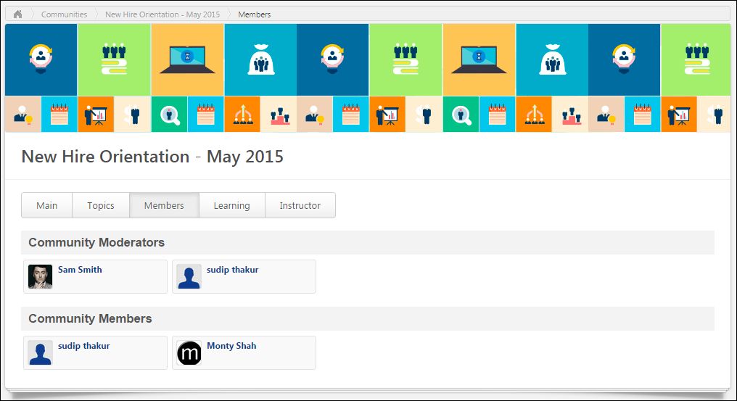
Community Tabs
The following tabs are available for the cohort community:
- Main - This tab is the landing page for the community. It displays highlighted and curated content for users.
- Topics - This tab provides access to all topics within the community.
- Members - This tab provides access to all members within the community.
- Learning - This tab allows learners who are enrolled in the cohort to view, complete, and track progress of the learning objects that must be completed as part of the cohort. This tab is opened by default when the cohort is launched from the Transcript.
- Instructor - This tab is only available to the cohort's instructors. This tab enables the cohort's instructor to view comments that have been posted to video learning objects within the cohort.
Community Moderators
This section displays all cohort owners for the cohort in the order in which they joined the cohort. Click the photograph to open the Universal Profile - Bio page for the user.
Community Members
This section displays all community members who are not community moderators in the order in which they joined the cohort. Click the photograph to open the Universal Profile - Bio page for the user.
Cohort Community - Topics
The Topics tab of a community allows users to view the top-level topics that are available to the user. A user can only view a cohort community if the user is enrolled in the corresponding cohort.
To access the Topics tab of a community, go to Connect > All Communities. Click the community title, and then click the Topics tab.
Permissions
PERMISSION NAME | PERMISSION DESCRIPTION | CATEGORY

Manage Knowledge Bank/Communities Administration | Grants ability to view the New Knowledge Bank Administration page and manage Action Groups. Based on permission constraints, administrators with this permission can create and delete topics and subtopics. Administrators with this permission can view all communities, topics, sub-topics and postings, regardless of availability. In addition, administrators can add a posting to the Course Catalog. When creating a topic, the constraints on this permission are automatically applied to the topic's availability. This permission can be constrained by OU and User's OU. This permission is assigned to the default Administrator role by default. | New Connect

View Knowledge Bank/Communities | Grants ability to view the Knowledge Bank and Communities pages. This permission can be constrained by OU and User's OU. This permission is assigned to the default Administrator role by default. | New Connect
Emails
EMAIL NAME | EMAIL DESCRIPTION | ACTION TYPE

Knowledge Bank/Communities New Posting Created | This email is triggered when a new Knowledge Bank or community posting is created. This email can be sent as a notification to Community Moderator, Community Members, Follower, or a specific user. A recipient must match the following criteria to receive the email:  - User is within the availability criteria for the corresponding posting's parent topic.  - User is within the constraints of the posting's parent topic's creator constraints.  - User is a member of one of the communities with which the topic is shared. | New Connect
Each top-level topic within the community is displayed in alphabetical order.
The availability of a topic within a community is determined by the availability settings of the community. Users can view all topics within a community if they have access to the community.
Community Tabs
The following tabs are available for the cohort community:
- Main - This tab is the landing page for the community. It displays highlighted and curated content for users.
- Topics - This tab provides access to all topics within the community.
- Members - This tab provides access to all members within the community.
- Learning - This tab allows learners who are enrolled in the cohort to view, complete, and track progress of the learning objects that must be completed as part of the cohort. This tab is opened by default when the cohort is launched from the Transcript.
- Instructor - This tab is only available to the cohort's instructors. This tab enables the cohort's instructor to view comments that have been posted to video learning objects within the cohort.
Search for Postings
To search for postings within a community, enter your search criteria in the Search within community field and either click the Search icon or press [Enter]. This opens the Posting Search Results page. See Posting Search Results on page 130 for additional information.
Community Options
The following options are available in the Options drop-down:
- Follow Community - This option is available to all users who are members of the community. When a user is following a community, the user may receive email notifications whenever a posting is created in any of the topics that are available to the user within the community. Also, the community appears in the Following section of the user's Universal Profile: Bio. When a user follows a community, the user implicitly follows all of the topics and subtopics within the community.
- Unfollow Community - This option is only available when the user is currently following the community. When the user selects this option, the user is no longer following the community or any of the topics within the community. If the user had followed any individual topics within the community prior to following the community, then the user is still following those topics when the community is unfollowed.
- Create Topic - Select this option to create a topic. The ability to create, edit, or delete a community topic is only available to administrators and community moderators. See Community Topic - Create/Edit on page 118 for additional information.
View Topic Details Page
The Topic Details page displays all of the subtopics within the topic and all of the topic postings. Topic Moderators are able to edit the topic and create and edit subtopics. Topic members are able to create postings. Users can click a topic name to view the corresponding Topic Details page. See Community Topic - Topic Details Page on page 123 for additional information.
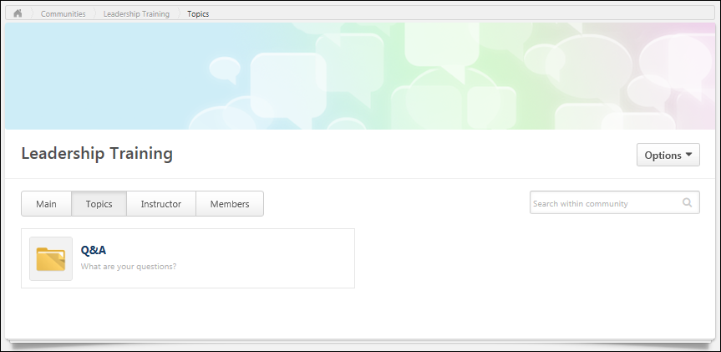
Cohort Community - Learning
The Learning tab of the cohort community allows learners who are enrolled in the cohort to view, complete, and track progress of the learning objects that must be completed as part of the cohort. A user can only view a cohort community if the user is enrolled in the corresponding cohort. The Learning tab is only available to the cohort instructors if the instructors are also enrolled in the cohort.
To access the Learning tab of a community, go to Connect > All Communities. Click the community title, and then click the Learning tab.
Permissions
PERMISSION NAME | PERMISSION DESCRIPTION | CATEGORY

Manage Knowledge Bank/Communities Administration | Grants ability to view the New Knowledge Bank Administration page and manage Action Groups. Based on permission constraints, administrators with this permission can create and delete topics and subtopics. Administrators with this permission can view all communities, topics, sub-topics and postings, regardless of availability. In addition, administrators can add a posting to the Course Catalog. When creating a topic, the constraints on this permission are automatically applied to the topic's availability. This permission can be constrained by OU and User's OU. This permission is assigned to the default Administrator role by default. | New Connect

View Knowledge Bank/Communities | Grants ability to view the Knowledge Bank and Communities pages. This permission can be constrained by OU and User's OU. This permission is assigned to the default Administrator role by default. | New Connect
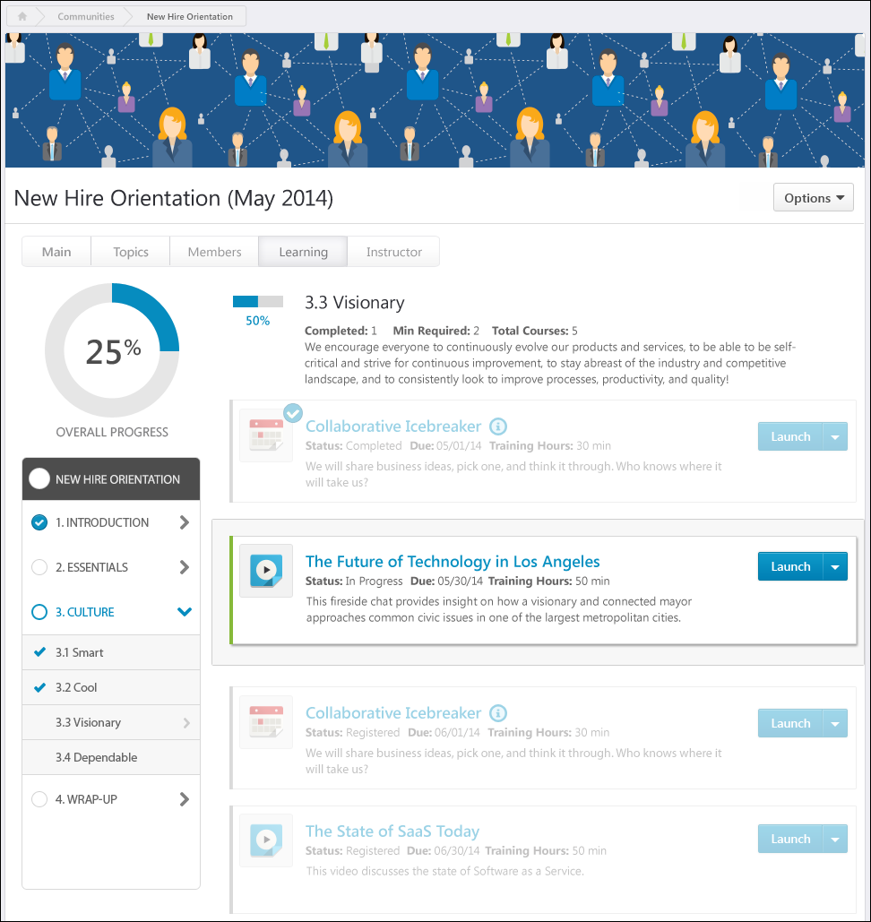
Options
The following options may be available from the Options drop-down:
- View Completion Page - This opens the Training Completion page for the cohort. This option is only available once the user has completed all of the required LOs for the cohort. Also, this option is only available if a Training Completion page is enabled for the cohort and if the cohort End Date has passed. See Training Completion Page.
- Training Details - This option opens the Training Details page for the cohort. The Training Details page enables the user to view the entire cohort structure in a single view. See Training Details - View for additional information.
Community Tabs
The following tabs are available for the cohort community:
- Main - This tab is the landing page for the community. It displays highlighted and curated content for users.
- Topics - This tab provides access to all topics within the community.
- Members - This tab provides access to all members within the community.
- Learning - This tab allows learners who are enrolled in the cohort to view, complete, and track progress of the learning objects that must be completed as part of the cohort. This tab is opened by default when the cohort is launched from the Transcript.
- Instructor - This tab is only available to the cohort's instructors. This tab enables the cohort's instructor to view comments that have been posted to video learning objects within the cohort.
Overall Progress
The overall progress for the cohort is displayed as a percentage and as a graphic in the upper-left corner of the Learning tab.
Cohort progress is displayed incrementally based on learning object (LO) completion. That is, each time a required LO is completed, the section and overall cohort completion percentage is incrementally increased. See Cohort Community - Learning - Progress Display on page 59 for additional information.
If a cohort structure is configured so that no sections are required, then the overall progress is automatically set to 100%.
Cohort Completion
Cohorts are time-bound collections of learning with a start and end date. Users who have completed all cohort requirements will transition to a Completed status on the cohort end date. Note: Cohorts do not transition to a Completed status until the cohort end date, even if a user has completed all required training
At the end date of a Cohort, the system registers learners for all the child LOs.
Cohort Structure - Section Navigation
On the left side of the cohort structure, the navigation menu displays all sections along with their completion status. Users can navigate through sections of the cohort structure by clicking the appropriate section or subsection. If a cohort has no sections, then the navigation menu does not appear. See Cohort Community - Learning - Sections on page 68 for additional information.
Cohort/Section Details
Users can click the cohort title to view the root level details of the cohort. Users can click a section title in the navigation menu to view the section overview. The cohort or section overview displays the section information, progress, and contents. The order in which items are displayed is dependent on the cohort structure, which is set by the administrator.
- Cohort Overview Page - The overview page for the entire cohort displays the sections and LOs that are at the root-level of the cohort.
- Section Overview Page - The overview page for a section within the cohort displays the sections and LOs that are contained within the section. However, a section summary header is displayed at the top of the page.
See Cohort Community - Learning - Cohort/Section Details on page 70 for additional information.
Cohort Community - Learning - Progress Display
Cohort progress is displayed incrementally based on learning object (LO) completion. That is, each time a required LO is completed, the section and overall cohort completion percentage is incrementally increased.
Completion percentages always round up for all numbers up to 99%. Once 99% completion is reached, the completion percentage remains at 99% until exactly 100% completion is reached. Then, the completion percentage is updated to 100%. 100% is the maximum completion percentage for a cohort.
If a cohort or a section do not have any required items (e.g., 0 of 3 items are required), then the progress for the corresponding cohort or section is automatically 100%.
- The completion of a child section that has no required items does not contribute to the completion percentage of its parent section or cohort unless the parent section or cohort is 100% completed by the child section. For example, if Section 1.1 is a subsection of Section 1, and Section 1.1 has zero required items, then Section 1.1 is automatically 100%. If the completion of Section 1.1 results in Section 1 being completed (i.e., all other requirements for Section 1 have been completed), then Section 1 is 100% complete. However, if Section 1 has other requirements that have not yet been completed, then the progress for Section 1 does not include Section 1.1.
Note: LOs that are not within a section behave as sections when calculating progress.
Cohort Completion
Cohorts are time-bound collections of learning with a start and end date. Even if a user has reached 100% progress completion for the required training items within the cohort, the cohort remains in an In Progress status and transitions to a Completed status on the cohort end date. The cohort end date can be viewed on the Transcript Details page.
Cohort Progress Calculation Details
The examples in this section use the following cohort structure as an example:
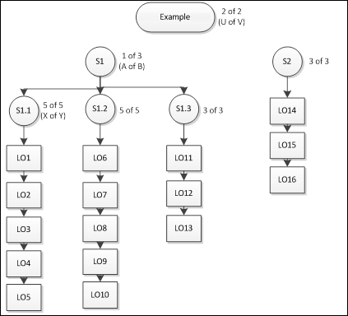
Calculation Rules
When calculating the completion progress for a section that contains only LOs (e.g., section S1.1 in the image), then the section progress is dependent upon the number of LOs that are required to be completed within the section. For example, in section S1.1 in the image there are a total of five LOs in the section, and all five LOs must be completed to complete the section (i.e., 5 of 5, or X of Y).
- Completion Progress = (Number of LOs completed in section / Number of items required for section)
- For example, S1.1 requires 5 of 5 LOs. If 3 have been completed, then the section progress equals (3/5), or 60%.
When calculating the completion progress for a section that contains only subsections (e.g., section S1 in the image), then the section progress is dependent upon the number of subsections that are required to be completed within the section. For example, in section S1 in the image there are three subsections in the section, and one subsection must be completed to complete the section (i.e., 1 of 3 or A of B).
- Completion Progress = Sum of highest progress percentages from required subsections / Number of required subsections
- For example, S1 requires 1 of 3 subsections. If S1.1 is 40% complete, S1.2 is 20% complete, and S1.3 is 34% complete, then the progress for S1 is 40%/1, or 40%. If S1 required 2 of 3 subsections, then the progress for S1 would be (40%+34%)/2, or 37%.
If a cohort or a section does not have any required LOs, then the progress for the corresponding cohort or section is automatically 100%.
- The completion of a child section that has no required items does not contribute to the completion percentage of its parent section or cohort unless the parent section or cohort is 100% completed by the child section.
Use Case 1
LO Completed | Subsection Completion % | Section Completion % | Overall Completion % | Notes
LO1 | S1.1: (1/5)=20%  S1.2: (0/5)=0%  S1.3: (0/3)=0% | S1: 20%/1=20%  S2: 0%/1=0% | Overall % = (S1+S2)/2  (20%+0%)/2=10%
LO6 | S1.1: (1/5)=20%  S1.2: (1/5)=20%  S1.3: (0/3)=0% | S1: 20%/1=20%  S2: 0%/1=0% | (20%+0%)/2=10% | Overall progress is unchanged because progress for S1.1 and S1.2 are the same.
LO2 | S1.1: (2/5)=40%  S1.2: (1/5)=20%  S1.3: (0/3)=0% | S1: 40%/1=40%  S2: 0%/1=0% | (40%+0%)/2=20%
LO7 | S1.1: (2/5)=40%  S1.2: (2/5)=40%  S1.3: (0/3)=0% | S1: 40%/1=40%  S2: 0%/1=0% | (40%+0%)/2=20% | Overall progress is unchanged because progress for S1.1 and S1.2 are the same.
LO3 | S1.1: (3/5)=60%  S1.2: (2/5)=40%  S1.3: (0/3)=0% | S1: 60%/1=60%  S2: 0%/1=0% | (60%+0%)/2=30%
LO4 | S1.1: (4/5)=80%  S1.2: (2/5)=40%  S1.3: (0/3)=0% | S1: 80%/1=80%  S2: 0%/1=0% | (80%+0%)/2=40%
LO5 | S1.1: (5/5)=100%  S1.2: (2/5)=40%  S1.3: (0/3)=0% | S1: 100%/1=100%  S2: 0%/1=0% | (100%+0%)/2=50%
Use Case 2
LO Completed | Subsection Completion % | Section Completion % | Overall Completion % | Notes
LO11 | S1.1: (0/5)=0%  S1.2: (0/5)=0%  S1.3: (1/3)=34% | S1: 34%/1=34%  S2: 0%/1=0% | Overall % = (S1+S2)/2  (34%+0%)/2=17%
LO6 | S1.1: (0/5)=0%  S1.2: (1/5)=20%  S1.3: (1/3)=34% | S1: 34%/1=34%  S2: 0%/1=0% | (34%+0%)/2=17% | Section S1 and Overall progress are unchanged because progress for S1.3 is higher than progress for S1.2 and only one subsection is required for S1.
LO1 | S1.1: (1/5)=20%  S1.2: (1/5)=20%  S1.3: (1/3)=34% | S1: 34%/1=34%  S2: 0%/1=0% | (34%+0%)/2=17% | Section S1 and Overall progress are unchanged because progress for S1.3 is higher than progress for S1.1 and only one subsection is required for S1.
LO12 | S1.1: (1/5)=20%  S1.2: (1/5)=20%  S1.3: (2/3)=67% | S1: 67%/1=67%  S2: 0%/1=0% | (67%+0%)/2=34%
LO13 | S1.1: (1/5)=20%  S1.2: (1/5)=20%  S1.3: (3/3)=100% | S1: 100%/1=100%  S2: 0%/1=0% | (100%+0%)/2=50%
Use Case 3
In this Use Case, the requirement for S1 is increased to 2 of 3.
LO Completed | Subsection Completion % | Section Completion % | Overall Completion % | Notes
LO1 | S1.1: (1/5)=20%  S1.2: (0/5)=0%  S1.3: (0/3)=0% | S1: (20%+0%)/2=10%  S2: 0%/1=0% | Overall % = (S1+S2)/2  (10%+0%)/2=5%
LO6 | S1.1: (1/5)=20%  S1.2: (1/5)=20%  S1.3: (0/3)=0% | S1: (20%+20%)/2=20%  S2: 0%/1=0% | (20%+0%)/2=10% | Since S1.1 and S1.2 are the two highest progress subsections in S1, they both count towards section S1 and Overall progress.
LO2 | S1.1: (2/5)=40%  S1.2: (1/5)=20%  S1.3: (0/3)=0% | S1: (40%+20%)/2=30%  S2: 0%/1=0% | (30%+0%)/2=15% | Since S1.1 and S1.2 are the two highest progress subsections in S1, they both count towards section S1 and Overall progress.
LO7 | S1.1: (2/5)=40%  S1.2: (2/5)=40%  S1.3: (0/3)=0% | S1: (40%+40%)/2=40%  S2: 0%/1=0% | (40%+0%)/2=20% | Since S1.1 and S1.2 are the two highest progress subsections in S1, they both count towards section S1 and Overall progress.
LO11 | S1.1: (2/5)=40%  S1.2: (2/5)=40%  S1.3: (1/3)=34% | S1: (40%+40%)/2=40%  S2: 0%/1=0% | (40%+0%)/2=20% | Since S1.1 and S1.2 remain the two highest progress subsections in S1, they both count towards section S1 and Overall progress.
LO12 | S1.1: (2/5)=40%  S1.2: (2/5)=40%  S1.3: (2/3)=67% | S1: (67%+40%)/2=54%  S2: 0%/1=0% | (54%+0%)/2=27% | Now S1.3 and S1.1 are the two highest subsections in S1.
LO3 | S1.1: (3/5)=60%  S1.2: (2/5)=40%  S1.3: (2/3)=67% | S1: (67%+60%)/2=64%  S2: 0%/1=0% | (64%+0%)/2=32% | Since S1.3 and S1.1 remain the two highest progress subsections in S1, they both count towards section S1 and Overall progress.
LO4 | S1.1: (4/5)=80%  S1.2: (2/5)=40%  S1.3: (2/3)=67% | S1: (67%+80%)/2=74%  S2: 0%/1=0% | (74%+0%)/2=37% | Since S1.3 and S1.1 remain the two highest progress subsections in S1, they both count towards section S1 and Overall progress.
LO5 | S1.1: (5/5)=100%  S1.2: (2/5)=40%  S1.3: (2/3)=67% | S1: (67%+100%)/2=84%  S2: 0%/1=0% | (84%+0%)/2=42% | Since S1.3 and S1.1 remain the two highest progress subsections in S1, they both count towards section S1 and Overall progress.
LO13 | S1.1: (5/5)=100%  S1.2: (2/5)=40%  S1.3: (3/3)=100% | S1: (100%+100%)/2=100%  S2: 0%/1=0% | (100%+0%)/2=50% | Since S1.3 and S1.1 remain the two highest progress subsections in S1, they both count towards section S1 and Overall progress.
Use Case 4
In this Use Case, the requirement for S1 is increased to 3 of 3.
LO Completed | Subsection Completion % | Section Completion % | Overall Completion % | Notes
LO1 | S1.1: (1/5)=20%  S1.2: (0/5)=0%  S1.3: (0/3)=0% | S1: (20%+0%+0%)/3=7%  S2: 0%/1=0% | Overall % = (S1+S2)/2  (7%+0%)/2=4% | All three subsections within S1 count towards section S1 and Overall progress.
LO6 | S1.1: (1/5)=20%  S1.2: (1/5)=20%  S1.3: (0/3)=0% | S1: (20%+20%+0%)/3=12%  S2: 0%/1=0% | (12%+0%)/2=6%
LO2 | S1.1: (2/5)=40%  S1.2: (1/5)=20%  S1.3: (0/3)=0% | S1: (40%+20%+0%)/3=20%  S2: 0%/1=0% | (20%+0%)/2=10%
LO7 | S1.1: (2/5)=40%  S1.2: (2/5)=40%  S1.3: (0/3)=0% | S1: (40%+40%+0%)/3=27%  S2: 0%/1=0% | (27%+0%)/2=14%
LO3 | S1.1: (3/5)=60%  S1.2: (2/5)=40%  S1.3: (0/3)=0% | S1: (60%+40%+0%)/3=34%  S2: 0%/1=0% | (34%+0%)/2=17%
LO4 | S1.1: (4/5)=80%  S1.2: (2/5)=40%  S1.3: (0/3)=0% | S1: (80%+40%+0%)/3=40%  S2: 0%/1=0% | (40%+0%)/2=20%
LO5 | S1.1: (5/5)=100%  S1.2: (2/5)=40%  S1.3: (0/3)=0% | S1: (100%+40%+0%)/3=47%  S2: 0%/1=0% | (47%+0%)/2=24%
LO8 | S1.1: (5/5)=100%  S1.2: (3/5)=60%  S1.3: (0/3)=0% | S1: (100%+60%+0%)/3=54%  S2: 0%/1=0% | (54%+0%)/2=27%
LO9 | S1.1: (5/5)=100%  S1.2: (4/5)=80%  S1.3: (0/3)=0% | S1: (100%+80%+0%)/3=60%  S2: 0%/1=0% | (60%+0%)/2=30%
LO10 | S1.1: (5/5)=100%  S1.2: (5/5)=100%  S1.3: (0/3)=0% | S1: (100%+100%+0%)/3=67%  S2: 0%/1=0% | (67%+0%)/2=34%
LO11 | S1.1: (5/5)=100%  S1.2: (5/5)=100%  S1.3: (1/3)=34% | S1: (100%+100%+34%)/3=78%  S2: 0%/1=0% | (78%+0%)/2=39%
LO12 | S1.1: (5/5)=100%  S1.2: (5/5)=100%  S1.3: (2/3)=67% | S1: (100%+100%+67%)/3=89%  S2: 0%/1=0% | (89%+0%)/2=45%
LO13 | S1.1: (5/5)=100%  S1.2: (5/5)=100%  S1.3: (3/3)=100% | S1: (100%+100%+100%)/3=100%  S2: 0%/1=0% | (100%+0%)/2=50%
Cohort Community - Learning - Sections
On the left side of the cohort structure, the navigation menu displays all sections along with their completion status. Users can navigate through sections of the cohort structure by clicking the appropriate section or subsection. If a cohort has no sections, then the navigation menu does not appear.
Section Navigation
When a section is selected, the section is expanded within the navigation menu to display any subsections within the section. The page displays all learning objects (LOs) within the selected section. See Cohort Community - Learning - Cohort/Section Details on page 70 for additional information.
Any sections that have subsections are indicated with an arrow that points to the right . When a section is expanded, the arrow points downward . The section hierarchy that displays in the navigation panel is limited to three levels. If the cohort structure contains more than three levels of sections, the navigation panel displays the top three levels, and the user can navigate further through the cohort structure by clicking the section titles. See Cohort Community - Learning - Cohort/Section Details on page 70 for additional information.
If there are many sections and subsections within the cohort structure, then a scroll bar is available within the navigation panel so that users can scroll through all sections.
Section Statuses
The icon to the left of the section title indicates the section status:
- Incomplete Section - If a section is not started or is in progress, then this section appears with an empty circle .
- Completed Section - If a section is completed, it appears with a white check mark within a colored circle . A section is considered complete when the requirements for the section are fulfilled.
- Incomplete Subsection - If a subsection is not started or is in progress, then no icon appears to the left of the subsection name.
- Completed Subsection - If a subsection is completed, it appears with a colored checkmark icon . A subsection is considered complete when the requirements for the subsection are fulfilled.
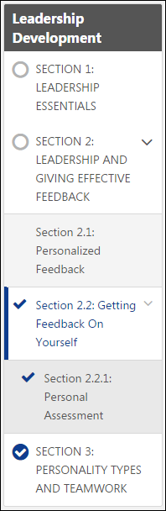
Cohort Community - Learning - Cohort/Section Details
Users can click the cohort title to view the root level details of the cohort. Users can click a section title in the navigation menu to view the section overview. The cohort or section overview displays the section information, progress, and contents. The order in which items are displayed is dependent on the cohort structure, which is set by the administrator.
- Cohort Overview Page - The overview page for the entire cohort displays the sections and LOs that are at the root-level of the cohort.
- Section Overview Page - The overview page for a section within the cohort displays the sections and LOs that are contained within the section. However, a section summary header is displayed at the top of the page.
Permissions
PERMISSION NAME | PERMISSION DESCRIPTION | CATEGORY

View Knowledge Bank/Communities | Grants ability to view the Knowledge Bank and Communities pages. This permission can be constrained by OU and User's OU. This permission is assigned to the default Administrator role by default. | New Connect
Section Item Details
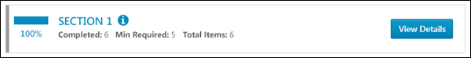
For section items within a cohort structure, the following information is displayed:
- Color Strip - The left edge of the item is color coded to represent the proximity to the due date of the item. For example, if the item due date is past due, then the color strip is red to indicate that item is due immediately. If an item due date is not eminent, then the color strip is green to indicate that item is not due immediately. See the Color Strip Key section below for additional information.
- Section Completion Percentage - This displays the section progress. The maximum value is 100%. See Cohort Community - Learning - Progress Display on page 59 for additional information.
- Section Title - This displays the section title. Users can click the section title to view the section details. The page refreshes and displays the section header and the contents of the section. The navigation panel is also updated to indicate which section has been selected.
- Section Information Icon - Click this icon to view the section instructions in a pop-up. This icon is only available if there are instructions for the section.
- Completed - This displays the number of items within the section that have been completed.
- Min Required - This displays the minimum number of items that must be completed in order to complete the section.
- Total Items - This displays the total number of items that are available within the section.
- View Details - Users can click this button to view the section details. The page refreshes and displays the section header and the contents of the section. The navigation panel is also updated to indicate which section has been selected.
LO Item Details
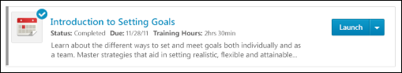
For LO items within a cohort, the following information is displayed:
- Color Strip - The left edge of the item is color coded to represent the proximity to the due date of the item. For example, if the item due date is past due, then the color strip is red to indicate that item is due immediately. If an item due date is not eminent, then the color strip is green to indicate that item is not due immediately. See the Color Strip Key section below for additional information.
- Icon - An LO icon is displayed to indicate the type of LO. Each LO type is represented by a unique icon. When a LO is completed, a checkmark icon appears in the upper-right corner of the LO icon.
- Title - This displays the LO title. Click the LO title to open the Training Details page for the LO. This action is only available once the LO is activated. See Training Details - View for additional information.
- LO Information Icon - Click this icon to view the LO instructions in a pop-up. This icon is only available if there are instructions for the LO.
- Status - This displays the current status of the LO.
- Excused - If a user is excused from the LO, then this is displayed to the right of the Status. If a user is not excused from the LO, then this field does not appear. When a user is excused from the LO, they can complete the LO, but it does not count towards the section or cohort progress. Note: Excused is not a transcript status and therefore does not prevent the user from being required to complete the LO if it is required in another curriculum, cohort, or somewhere else on the transcript. It only excuses the user from the version of the LO that is active in the curriculum or cohort in which it has been marked excused. If the LO is later reversioned, it will no longer be Excused. This is different from Exempt, which is a transcript status and exempts the LO anywhere it is required on the transcript.
- Due - This displays the LO due date.
- Training Hours - This displays how long the training will take to complete. If there are no training hours, then this field does not display.
- Description - The LO description is displayed below the LO status, due date, and training hours. Up to two lines of the description is displayed.
- Action drop-down - This drop-down enables users to perform actions on the LO based on the LO status. Click the left side of the drop-down to perform the displayed action. Or, click the drop-down arrow to select a secondary action. By default, the Action drop-down displays the primary action for the LO. See Transcript (Universal Profile) - Status and Options for additional information.
LO Launch Behavior
When a LO is launched, the LO may open inline within the Learning tab, or it may open in a separate browser window or tab.
The following LO types are launched in a new browser window or tab:
- Online Courses
- Quick Courses
- Events & Sessions
- Tests
- External Training
- Materials
The following LO types are launched inline:
- Postings
- Notes
- Uploaded Video LOs
Color Strip Key
The following colors are available:
- Red - Due today or past due
- Yellow- Due within the next seven days, not including today
- Green - Due after seven days
- Gray - The color strip is gray for all items that do not meet the criteria for the other states (Red, Yellow, Green). The color strip for sections is always gray.
Learning - Video LO Pop-up
Cohort Community - Instructor
When a cohort is created, a cohort community is simultaneously created for the cohort within Connect. The cohort community has the same title as the cohort, and all cohort instructors are designated as experts for the cohort community.
The Instructor tab of the cohort community enables the cohort's instructor to view, respond to, and delete comments that have been posted to video learning objects (LOs) within the cohort.
The Instructor tab is only available to the cohort's instructors.
To access the Instructor tab of a community, go to Connect > All Communities. Click the community title, and then click the Instructor tab.
Permissions
PERMISSION NAME | PERMISSION DESCRIPTION | CATEGORY

Manage Knowledge Bank/Communities Administration | Grants ability to view the New Knowledge Bank Administration page and manage Action Groups. Based on permission constraints, administrators with this permission can create and delete topics and subtopics. Administrators with this permission can view all communities, topics, sub-topics and postings, regardless of availability. In addition, administrators can add a posting to the Course Catalog. When creating a topic, the constraints on this permission are automatically applied to the topic's availability. This permission can be constrained by OU and User's OU. This permission is assigned to the default Administrator role by default. | New Connect

View Knowledge Bank/Communities | Grants ability to view the Knowledge Bank and Communities pages. This permission can be constrained by OU and User's OU. This permission is assigned to the default Administrator role by default. | New Connect
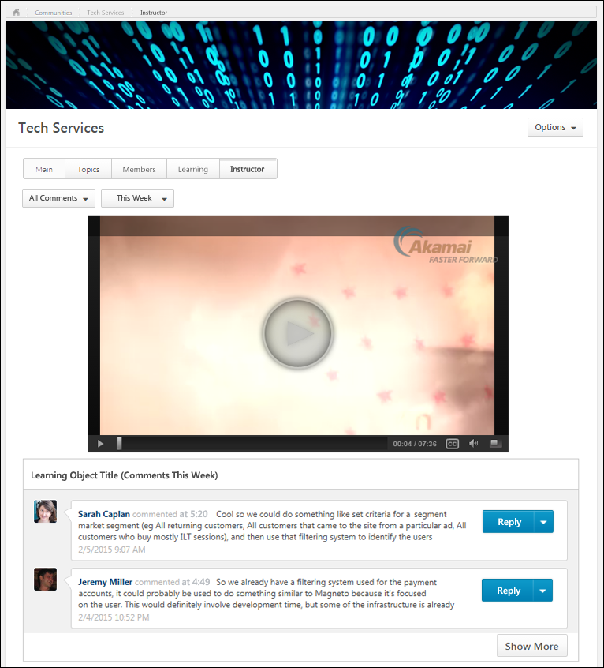
The Instructor tab displays all video learning objects that have comments added to them. If a video LO does not have any comments, then it is not displayed.
Community Options
The following options are available in the Options drop-down:
- Edit Community - Select this option to edit the community. This option is only available to community moderators and administrators. See Cohort Community - Edit on page 39 for additional information.
Community Tabs
The following tabs are available for the cohort community:
- Main - This tab is the landing page for the community. It displays highlighted and curated content for users.
- Topics - This tab provides access to all topics within the community.
- Members - This tab provides access to all members within the community.
- Learning - This tab allows learners who are enrolled in the cohort to view, complete, and track progress of the learning objects that must be completed as part of the cohort. This tab is opened by default when the cohort is launched from the Transcript.
- Instructor - This tab is only available to the cohort's instructors. This tab enables the cohort's instructor to view comments that have been posted to video learning objects within the cohort.
Comments Filter
The Instructor tab displays all video learning objects that have comments added to them. If a video LO does not have any comments, then it is not displayed.
The instructor can use the Comments filter to filter the videos and comments using the following filter options:
- All Comments - This option is selected by default. This option displays all video LOs that have comments, even if the instructor has already responded to the comment.
- Unanswered Only - This option displays only video LOs that have comments that have not yet been responded to by the instructor. If all of a video's comments have been responded to, then the video is not displayed.
Time Filter
The instructor can use the Time filter to filter the videos and comments using the following filter options:
- All Time - This option displays all comments, regardless of when they were made.
- This Month - This option displays only comments that were made within the past 30 days.
- This Week - This option is selected by default. This option displays only comments that were made within the past seven days.
- Today - This option displays only comments that were made within the past 24 hours.
Videos and Comments
The Instructor tab displays all video learning objects that have comments added to them. If a video LO does not have any comments, then it is not displayed.
The videos are sorted by the number of comments the video has within the selected time filter, and the video with the most comments is displayed first. Administrators can play a video LO by clicking the Play button on the video image.
Below the video image, the video LO name, the number of comments, and the comment details are displayed. The following information is displayed for each available comment:
- Author Image and Name - The author's image and name are displayed.
- Video Timestamp - The time of the video at which the comment was made is displayed. For example, if the comment was made one minute after the video started, then "commented at 1:00" would be displayed.
- Comment Text
- Comment Timestamp - The date and time at which the comment was made is displayed.
Reply to Comment
To reply to a comment, click the Reply button to the right of the comment, or click the drop-down arrow and select Reply. This opens the Message pop-up. See the Message Pop-up section below for additional information.
Delete Comment
To delete a comment and all of the comment's replies, click the drop-down arrow the right of the comment and select Delete. This opens a confirmation pop-up to confirm the deletion.
Show More
Click the Show More button to display 10 additional video comments.
Message Pop-up
The Message pop-up displays the original comment and all replies to the comment. The following information is displayed for each comment and reply:
- Author Image and Name - The author's image and name are displayed.
- Video Timestamp - The time of the video at which the comment was made is displayed. For example, if the comment was made one minute after the video started, then "commented at 1:00" would be displayed.
- Comment Text
Instructors can reply to the comment by entering text in the Add a reply field and clicking the Comment icon. When an instructor replies to a comment, the user can view the instructor's reply by reviewing the video. In addition, comments are visible to all users within the cohort who view the video after the comment is added.
Instructors can delete a reply to the original comment by clicking the Remove icon to the right of the reply. The original comment cannot be deleted from the Message pop-up. However, the original comment can be deleted on the Instructor page. See the Delete Comment section above for additional information.
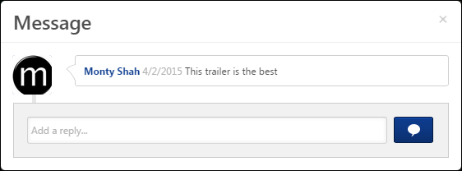
Video LO Pop-up and Comments
As of October 2019, Video LO Pop-up is no longer supported, Cornerstone has migrated video transcoding from Akamai to a new video transcoding service. The new transcoding service, AWS MediaConvert, provides improved scalability, security, and features. Transcoding is a key process during video-file upload, which converts the uploaded video to be compatible with more browsers/video players and enable streaming during playback. However, AWS MediaConvert does not support Cornerstone's Video LO Pop-up functionality at this time.
Since the pop-up does not launch for videos created after October 2019, comments cannot be made inline with these videos and will not show up in the Instructor tab in the cohort. Videos uploaded before October 2019 will continue to see Video LO Pop-up capabilities.
Community - Create/Edit
To create a new community, select Community from the New Community drop-down menu on the All Communities page. This option is only available to community moderators and administrators.
To edit a community, on the Community page, select Edit Community from the Options drop-down menu.
Permissions
PERMISSION NAME | PERMISSION DESCRIPTION | CATEGORY

Edit Availability Knowledge Bank/Communities | Grants ability to configure the availability when editing communities or when creating or editing topics. This permission does not grant the ability to edit a community; users can only edit a community or topic if they have the Manage Knowledge Bank/Communities Administration or if they are a moderator for the community or topic. When creating a topic, the constraints on this permission are automatically applied to the topic's availability. If the user also has the Manage Knowledge Bank/Communities Administration permission, then the constraints on that permission are automatically applied to the topic's availability. This permission can be constrained by OU, User's OU, and User's Corporation. | New Connect

Manage Knowledge Bank/Communities Administration | Grants ability to view the New Knowledge Bank Administration page and manage Action Groups. Based on permission constraints, administrators with this permission can create and delete topics and subtopics. Administrators with this permission can view all communities, topics, sub-topics and postings, regardless of availability. In addition, administrators can add a posting to the Course Catalog. When creating a topic, the constraints on this permission are automatically applied to the topic's availability. This permission can be constrained by OU and User's OU. This permission is assigned to the default Administrator role by default. | New Connect

View Knowledge Bank/Communities | Grants ability to view the Knowledge Bank and Communities pages. This permission can be constrained by OU and User's OU. This permission is assigned to the default Administrator role by default. | New Connect
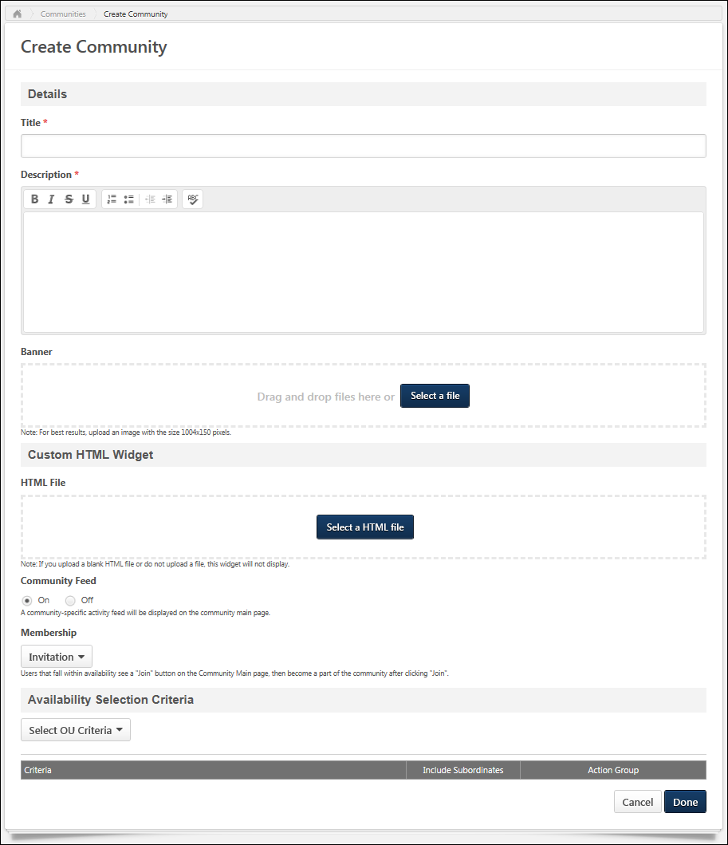
Details
Enter the following information for the community:
- Title - Enter a title for the community, up to 70 characters. This title will appear at the top of the community.
- Description - Enter the community description up to 3,000 characters. This field includes rich text editing options.
- Banner - The banner image appears at the top of the community and at the top of each community posting. Add a banner file by dragging and dropping a file into the Attachment area. You can also attach a file by clicking the Select a file button and select a file from your computer. Note: The drag-and-drop functionality is not supported by Internet Explorer browsers. For best results, the banner image should be 1004 x 150 pixels. The Image Restrictions section below provides a complete list of image attachment restrictions.
Community Feed
A Community Feed is a feed that is displayed on the Main tab of the community. The Community Feed may display the latest activity for the specific community. In addition, community members may be able to create discussion postings directly from the Community Feed. All updates not posted directly to Community Feed, such as "received a reply" or "has created the discussion" updates, will not display if the update was made more than 365 days ago.
Select whether the Community Feed is enabled for the community. For new communities, the feed is enabled by default.
Membership
This option is available when creating and editing a community. This option enables moderators to determine how users become a member of the community. The following options are available:
- Invitation - When this option is selected, users who are within the community availability see a Join button on the Community - Main page. When a user clicks the Join button, they become a member of the community. If enabled, the Joined Community email trigger is activated when the invitee joins the community.
Note: When editing a community, and an administrator changes the membership setting from Invitation to Auto-enrollment, all users who meet the availability selection criteria are automatically enrolled in the community. If the administrator concurrently adds another OU to the availability selection criteria, that OU is also automatically enrolled in the community. Use Case:
Auto-enrollment
When this option is selected, users who are within the community availability are automatically added as members of the community when the community is saved. If enabled, the Joined Community email trigger is activated and an email is sent to the new member.
Note: When editing a community, and an administrator changes the membership setting from Auto-enrollment to Invitation, all users who are currently members of the community will remain members. Any future community members will be required to join via invitation. For example, if the community moderator changes the membership setting from Auto-enrollment to Invitation and concurrently adds a new organizational unit (OU) to the availability selection criteria, that new OU must join the community by accepting an invitation.Use Case:
Custom HTML Widget
The Custom HTML Widget section is only available if enabled by a backend setting. This section enables community moderators to upload an HTML file (.htm or .html), up to 5 MB in size. Once the community is saved, the HTML data is rendered and displayed in the upper-left corner of the community.
Add an HTML file by dragging and dropping the file into the Attachment area. You can also attach a file by clicking the Select a file button and select a file from your computer. Note: The drag-and-drop functionality is not supported by Internet Explorer browsers. Once the file is selected, a preview of the HTML widget is displayed in the section. If an empty file or no file is selected, then the HTML widget does not appear on the community homepage.
Important: All HTML tags are currently accepted by the Custom HTML widget. Because malicious HTML files may be uploaded, this is a potential security risk and organizations may choose to disable this functionality. The style, script, iframe, and img tags are not supported in the HTML area of Communities.
Availability Selection Criteria
Select the availability for the community. Availability can be set by OU, group, or specific users. This determines which users within the system can view the community. See Knowledge Bank/Community - Availability and Action Groups on page 148 for additional information.
This section can only be configured by community moderators or users who have permission to manage communities or edit the availability of communities.
- When editing a community, any existing creator constraints that are automatically applied to the community's availability are displayed at the bottom of the section. This enables administrators and community moderators to fully understand the availability of the community. If the creator constraints change, then the updated constraints are not implemented or displayed.
The following options are available for each selected criterion:
- Remove - Click the X to remove the selected criterion.
- Include Subordinates - Select this option to include all subordinate OUs or users in the availability.
- Action Group - From the drop-down, select the role of the selected users:
  - Visitor - Users within the availability criterion can view postings.
  - Member - Users within the availability criterion can create postings, edit and delete their own postings, and reply to postings.
  - Expert - Users within the availability criterion can serve as experts for Q&A postings. When an expert responds to a Q&A posting, the Q&A posting is automatically marked as Answered and the expert's reply is visually distinguished as an expert response.
  - Community Moderator - Users within the availability criterion can edit, share, and copy the community and create and delete topics.
  - Custom Action Group - Administrators have the ability to create custom action groups with a custom set of community permissions.
Overwrite availability changes for all child topics
This option is not available when creating a community because the new community does not have any topics. Select this option to apply the availability settings of this community to all topics associated with the community. When this option is selected, the availability of all of the community's topics is overwritten with this community's availability settings. Users can only view topics for which they are within the topic availability.
- This option is not available when editing a cohort community.
If this option is selected when editing a community that contains a shared topic, then a warning pop-up is displayed when the community is saved to indicate that the availability of a shared topic will be overwritten. Click OK to overwrite the availability for all topics. Or, click Cancel to not overwrite the availability for all topics.
Done or Cancel
After entering the appropriate information, click Done to create the community. Otherwise, click Cancel to cancel the community creation. If enabled, the Joined Community email is triggered when a user becomes a member of a community.
Emails
EMAIL NAME | EMAIL DESCRIPTION | ACTION TYPE

Joined Community | This email is triggered when a user becomes a member of a community. This email can be sent as a notification to New Member, Community Moderator, or a specific user. Note: For invitation only communities, this email is triggered when the user joins the community. For automatic enrollment communities, this email is triggered when the community settings are saved with the user being added to the availability criteria. | New Connect
Image Restrictions
The following file types are allowed:
File Type | Extension
Image | - bmp  - gif  - jpeg/jpg  - png
Community Overview
Community - Main
The Main tab of the community is the default landing page for the community and displays highlighted and curated content for users. A user can only view a community if the user is within the availability settings for the community.
To access a community, go to Connect > Communities. Then, click the community title.
Permissions
PERMISSION NAME | PERMISSION DESCRIPTION | CATEGORY

Manage Knowledge Bank/Communities Administration | Grants ability to view the New Knowledge Bank Administration page and manage Action Groups. Based on permission constraints, administrators with this permission can create and delete topics and subtopics. Administrators with this permission can view all communities, topics, sub-topics and postings, regardless of availability. In addition, administrators can add a posting to the Course Catalog. When creating a topic, the constraints on this permission are automatically applied to the topic's availability. This permission can be constrained by OU and User's OU. This permission is assigned to the default Administrator role by default. | New Connect

View Knowledge Bank/Communities | Grants ability to view the Knowledge Bank and Communities pages. This permission can be constrained by OU and User's OU. This permission is assigned to the default Administrator role by default. | New Connect
Emails
EMAIL NAME | EMAIL DESCRIPTION | ACTION TYPE

Joined Community | This email is triggered when a user becomes a member of a community. This email can be sent as a notification to New Member, Community Moderator, or a specific user. Note: For invitation only communities, this email is triggered when the user joins the community. For automatic enrollment communities, this email is triggered when the community settings are saved with the user being added to the availability criteria. | New Connect

Knowledge Bank/Communities New Posting Created | This email is triggered when a new Knowledge Bank or community posting is created. This email can be sent as a notification to Community Moderator, Community Members, Follower, or a specific user. A recipient must match the following criteria to receive the email:  - User is within the availability criteria for the corresponding posting's parent topic.  - User is within the constraints of the posting's parent topic's creator constraints.  - User is a member of one of the communities with which the topic is shared. | New Connect
Community Title
The title of the community is displayed in the upper-left corner of the community. This title is configured by the administrator when the community is created.
Join Community
If the user is not yet a member of the community, a Join Community button is available at the top of the page. Click this button to join the community. If enabled, the Joined Community email is triggered when a user becomes a member of a community.
Community Options
The following options are available in the Options drop-down:
- Follow Community - This option is available to all users who are members of the community. When a user is following a community, the user may receive email notifications whenever a posting is created in any of the topics that are available to the user within the community. Also, the community appears in the Following section of the user's Universal Profile: Bio. When a user follows a community, the user implicitly follows all of the topics and subtopics within the community. Because of this, the user does not have the option to follow or unfollow any topic within the community while the user is following the community.
- Unfollow Community - This option is only available when the user is currently following the community. When the user selects this option, the user is no longer following the community or any of the topics within the community. If the user had followed any individual topics within the community prior to following the community, then the user is still following those topics when the community is unfollowed.
- Edit Community - Select this option to edit the community. This option is only available to community moderators and administrators. See Community - Create/Edit on page 79 for additional information.
- Delete Community - Select this option to delete the community. A confirmation pop-up is displayed. When a community is deleted, all topics and postings that are contained within the community are also deleted. This option is only available to administrators. Note: If a community contains a shared topic, then the community cannot be deleted.
- Leave Community - When selected, a pop-up window prompts the user to confirm that they would like to leave the community. Click Yes in the pop-up. This removes the user, and the user is directed to the All Communities Page. Use Case:
Community Tabs
The following tabs are available for the community:
- Main - This tab is the landing page for the community. It displays highlighted and curated content for users.
- Topics - This tab provides access to all topics within the community.
- Members - This tab provides access to all members within the community.
Search for Postings
To search for postings within a community, enter your search criteria in the Search within community field and either click the Search icon or press [Enter]. This opens the Posting Search Results page. See Posting Search Results on page 130 for additional information.
HTML Widget
Depending on the community configuration, an HTML widget may appear at the top of the Main tab.
Community Feed
The Community Feed may display the latest activity for the specific community. In addition, community members may be able to create discussion postings directly from the Community Feed. All updates not posted directly to Community Feed, such as "received a reply" or "has created the discussion" updates, will not display if the update was made more than 365 days ago.
Community Feed - Activity Update Visibility
The Community Feed is only visible if it is enabled and if the user has joined the community. However, administrators who have the Manage Knowledge Bank/Communities Administration permission can always view the Community Feed.
An update is only visible in the Community Feed if the user has permission to view the corresponding posting.
If a posting or reply is deleted, then the activity update is removed from the Community Feed.
Community Feed - Create Discussion Posting
From the Community Feed, users may be able to create a new discussion posting and select the topic into which the posting will be added. If there are no topics for which the user has permission to create a posting, then this functionality is not available.
To create a discussion posting, select within the Create a discussion posting field. The panel expands to show the Select Topic drop-down and the Post and Cancel options.
See Community Feed - Create Posting on page 116 for additional information.
Community Feed - Activity Updates
The following activities may appear in the Community Feed:
- Posting Created - When a new posting is created in the community, this activity may be displayed in the feed. The first 300 characters of the posting body is displayed in the feed. No HTML is displayed in the feed.
- Posting Reply - When a reply is added to the original posting from the Community Feed or the Posting Details page, the original posting is moved to the top of the feed. A posting is not moved to the top of the feed if a user replies to an existing reply.
Community Feed - Activity Update Options
Users may have the option to like and reply to an activity update. However, the ability to vote for or against a suggestion type posting is not available from the Community Feed.
Any replies or likes that are added to activity updates in the Community Feed will also appear for the activity update in the Live Feed and the Posting Details page.
Community Feed - Show More
When viewing the Community Feed, up to 10 items are displayed. If there are more than 10 items available, then a Show More button is available at the bottom of the feed. Select this button to view 10 more items within the feed.
Community Description
At the top of the furthest right column, the community description is displayed, up to 300 characters. If the description exceeds 300 characters, a more link appears. Click this link to view the full description in a pop-up. The description is configured by the administrator when creating or editing the community.
Featured Panel
The Featured panel displays postings that have been marked as featured postings by the administrator. Only postings that are available to the user are displayed.
The posting that was marked as featured most recently is displayed at the top of the Featured panel.
If a link is attached to the posting, then the URL preview image is displayed. If a user clicks the posting image, they are directed to the posting page.
If a posting that has an embedded image or video file is Featured, then a thumbnail will display for that posting in the Featured and Trending widgets. Postings with embedded image files will use the top-most-position uploaded image file as the image used for the widget. Postings with embedded video files will use the top-most-position uploaded video file as the image used for the widget. However, if a posting includes both an uploaded image and a file, then the top-most eligible file will be used for the widget. This means that after creation, if a new eligible file replaces the top-most file, then the posting's thumbnail on these widgets will be updated to reflect this.
The posting title is displayed as a link. If a user clicks the posting title, they are directed to the posting page.
For the top featured posting, the first line from the posting is displayed below the posting title.
At the bottom of the posting, the Like button or icon is displayed with the date on which the posting was created. Click the Like button or icon to like the posting. Note: If a user clicks the Like button for a posting, this does not affect the trending score until the page is refreshed. See Posting Action - Like a Posting or a Reply on page 205 for additional information.
Popular Tags Panel
The Popular Tags panel displays the most popular tags that are being used within the community. The system determines tag popularity by the number of times any posting that contains the tag is viewed within the community. System-defined tags are not included in the panel. This panel is updated every three hours. This panel is only available when tags are enabled, and this panel is not displayed if there are no tags within a community.
Below each tag, the total number of times a posting that contains the tag has been viewed across the entire community. This calculation includes all postings in the community, even if the user is not able to view the posting.
Click a tag to initiate a search within Global Search for all postings that contain the selected tag. Users can only view postings which they can access. Note: The ability to click a posting tag to initiate a search is only available if the ability to search for Connect postings by tag is enabled via Search Preferences.
Trending Panel
The Trending panel displays postings that are trending within the community. Which topics are trending is determined by the number of times a posting has been viewed, liked, voted for, and replied to. Only postings that are available to the user are displayed.
The posting that is trending the most is featured at the top of the Trending panel.
If a link is attached to the posting, then the URL preview image is displayed. If a user clicks the posting image, they are directed to the posting page.
If a posting that has an embedded image or video file is Trending, then a thumbnail will display for that posting in the Featured and Trending widgets. Postings with embedded image files will use the top-most-position uploaded image file as the image used for the widget. Postings with embedded video files will use the top-most-position uploaded video file as the image used for the widget. However, if a posting includes both an uploaded image and a file, then the top-most eligible file will be used for the widget. This means that after creation, if a new eligible file replaces the top-most file, then the posting's thumbnail on these widgets will be updated to reflect this.
The posting title is displayed as a link. If a user clicks the posting title, they are directed to the posting page.
For the top trending posting, the first line from the posting is displayed below the posting title.
At the bottom of the posting, the Like functionality or Vote functionality is displayed with the date on which the posting was created.
- If the Like functionality is available, users can click the Like button or icon to like the posting. See Posting Action - Like a Posting or a Reply on page 205 for additional information.
- If the Vote functionality is available, users can vote for or against the posting. See Posting Action - Vote Posting or Reply on page 209 for additional information.
Leaderboard Grid
The Leaderboard grid displays the users who post the most topics, up to 21. User can hover over a member's photo to view the member's name and the number of postings the user has created. Click a member's photo to view the member's Universal Profile - Bio page.
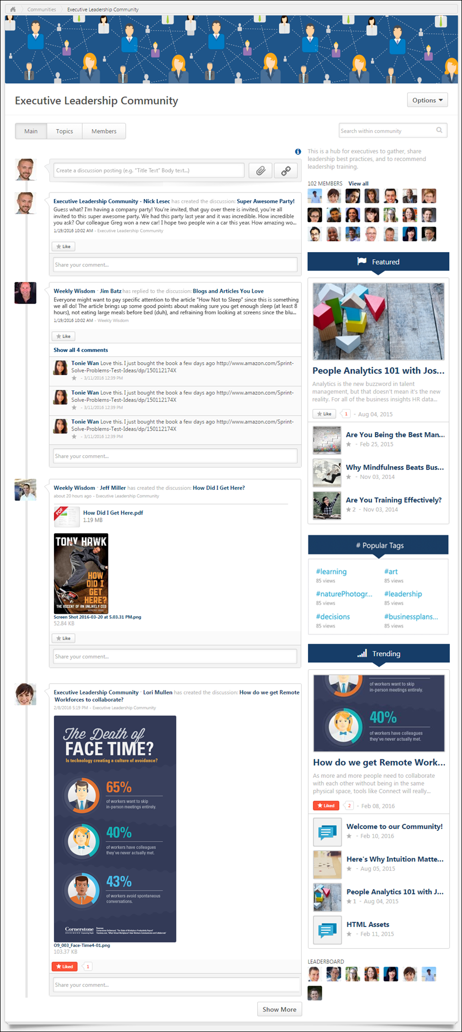
Community - Members
The Members tab of a community allows users to view the community members. A user can only view a community if the user is within the availability settings for the community.
To access the Members tab of a community, go to New Connect > All Communities. Click the appropriate community. Then, click the Members tab.
Permissions
PERMISSION NAME | PERMISSION DESCRIPTION | CATEGORY

View Knowledge Bank/Communities | Grants ability to view the Knowledge Bank and Communities pages. This permission can be constrained by OU and User's OU. This permission is assigned to the default Administrator role by default. | New Connect
Community Tabs
The following tabs are available for the community:
- Main - This tab is the landing page for the community. It displays highlighted and curated content for users.
- Topics - This tab provides access to all topics within the community.
- Members - This tab provides access to all members within the community.
Community Moderators
This section displays all community moderators for the team in the order in which they joined the community. Click the photograph to open the Universal Profile - Bio page for the user.
Community Members
This section displays all community members who are not community moderators in the order in which they joined the community. Click the photograph to open the Universal Profile - Bio page for the user.
Remove User from Community
Change Membership Criteria
Users can be removed from a community by adjusting the Membership criteria for the community. See Community - Create/Edit on page 79 for additional information.
User Remove Self
users can remove themselves from a community by clicking the Remove option from the options drop-down. Clicking Remove opens a confirmation pop-up. Click Yes to confirm the removal. This closes the pop-up and removes the user from the community.
Use Case
A user needs to leave a certain community in which he is no longer active. He navigates to the Members page of the community and sees a drop-down button on his profile tile. He clicks the button and chooses the Remove option. The user is removed from the community and is directed to the All Communities page.
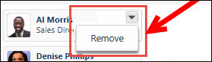
Administrator/Moderator Removes User
Users can be removed from the community by clicking Remove from the options drop-down, which displays to the right of the user’s name. Clicking Remove opens a confirmation pop-up. Click Yes to confirm the removal. This closes the pop-up and removes the user from the community.
Use Case
A community moderator needs to remove a user who should no longer be a member of a certain community. He navigates to the Members page of the community and sees a drop-down button on each member's profile tile. He clicks the drop-down button for the user he desires to remove and chooses the Remove option. He then sees a pop-up window prompting him to confirm his selection to remove the user from the community. Upon confirmation, he remains on the Members page of the community.
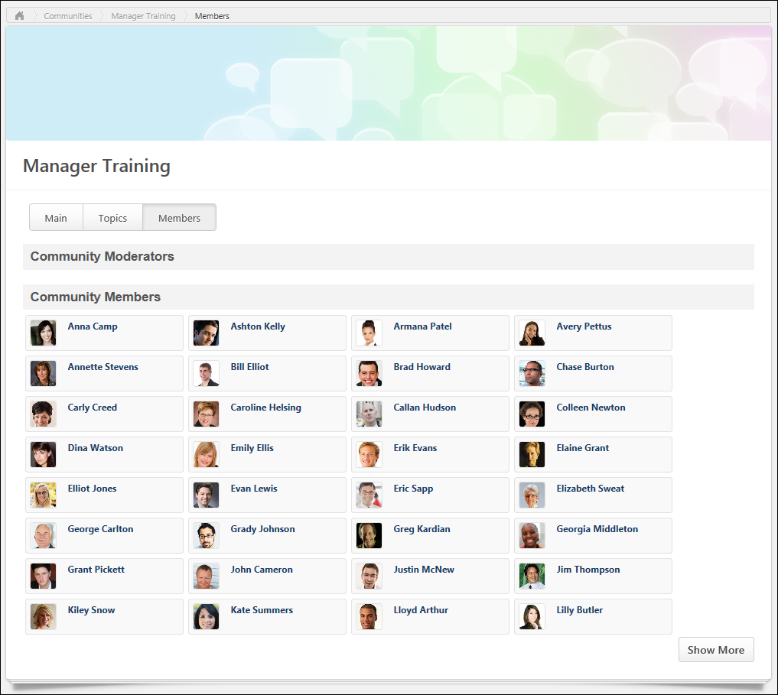
Community - Topics
The Topics tab allows users to view the top-level topics that are available to the user. A user can only view a community if the user is within the availability settings for the community.
To access the Topics tab for a community, go to Connect > All Communities. Click the community title, and then click the Topics tab.
Permissions
PERMISSION NAME | PERMISSION DESCRIPTION | CATEGORY

Manage Knowledge Bank/Communities Administration | Grants ability to view the New Knowledge Bank Administration page and manage Action Groups. Based on permission constraints, administrators with this permission can create and delete topics and subtopics. Administrators with this permission can view all communities, topics, sub-topics and postings, regardless of availability. In addition, administrators can add a posting to the Course Catalog. When creating a topic, the constraints on this permission are automatically applied to the topic's availability. This permission can be constrained by OU and User's OU. This permission is assigned to the default Administrator role by default. | New Connect

View Knowledge Bank/Communities | Grants ability to view the Knowledge Bank and Communities pages. This permission can be constrained by OU and User's OU. This permission is assigned to the default Administrator role by default. | New Connect
Emails
EMAIL NAME | EMAIL DESCRIPTION | ACTION TYPE

Knowledge Bank/Communities New Posting Created | This email is triggered when a new Knowledge Bank or community posting is created. This email can be sent as a notification to Community Moderator, Community Members, Follower, or a specific user. A recipient must match the following criteria to receive the email:  - User is within the availability criteria for the corresponding posting's parent topic.  - User is within the constraints of the posting's parent topic's creator constraints.  - User is a member of one of the communities with which the topic is shared. | New Connect
Each top-level topic within the community is displayed in alphabetical order.
The availability of a topic within a community is determined by the availability settings of the community. Users can view all topics within a community if they have access to the community.
Community Tabs
The following tabs are available for the community:
- Main - This tab is the landing page for the community. It displays highlighted and curated content for users.
- Topics - This tab provides access to all topics within the community.
- Members - This tab provides access to all members within the community.
Search for Postings
To search for postings within a community, enter your search criteria in the Search within community field and either click the Search icon or press [Enter]. This opens the Posting Search Results page. See Posting Search Results on page 130 for additional information.
Community Options
The following options are available in the Options drop-down:
- Follow Community - This option is available to all users who are members of the community. When a user is following a community, the user may receive email notifications whenever a posting is created in any of the topics that are available to the user within the community. Also, the community appears in the Following section of the user's Universal Profile: Bio. When a user follows a community, the user implicitly follows all of the topics and subtopics within the community.
- Unfollow Community - This option is only available when the user is currently following the community. When the user selects this option, the user is no longer following the community or any of the topics within the community. If the user had followed any individual topics within the community prior to following the community, then the user is still following those topics when the community is unfollowed.
- Create Topic - Select this option to create a topic. The ability to create, edit, or delete a community topic is only available to administrators and community moderators. See Community Topic - Create/Edit on page 118 for additional information.
View Topic Details Page
The Topic Details page displays all of the subtopics within the topic and all of the topic postings. Topic Moderators are able to edit the topic and create and edit subtopics. Topic members are able to create postings. Users can click a topic name to view the corresponding Topic Details page. See Community Topic - Topic Details Page on page 123 for additional information.
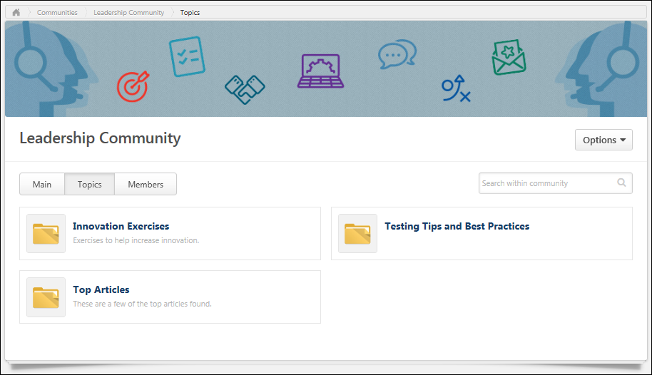
Learning Community - Create/Edit
Learning communities are tailored for informal learning. These communities feature specific learning objects (LOs), and users can view the latest course ratings from other members of the community.
To create a new learning community, select Learning Community from the New Community drop-down menu on the All Communities page. This option is only available to community moderators and administrators who have permission to view the Course Catalog.
To edit a learning community, on the Community page, select Edit Community from the Options drop-down menu.
Permissions
PERMISSION NAME | PERMISSION DESCRIPTION | CATEGORY

Course Catalog - View | Grants access to view the learning objects in the course catalog and enables administrators to view the Course Console and the Popular Requests and Highest Rated widgets on the Learning Admin Console (in conjunction with the Learning Admin Console - View permission). This permission can be constrained by OU, User's OU, Training Type, Training Item, Provider, ILT Provider, User's ILT Provider, and User's LO Availability. This is an administrator permission.  Adding an OU constraint and a provider constraint to this permission results in an "AND" statement. | Learning - Administration

Edit Availability Knowledge Bank/Communities | Grants ability to configure the availability when editing communities or when creating or editing topics. This permission does not grant the ability to edit a community; users can only edit a community or topic if they have the Manage Knowledge Bank/Communities Administration or if they are a moderator for the community or topic. When creating a topic, the constraints on this permission are automatically applied to the topic's availability. If the user also has the Manage Knowledge Bank/Communities Administration permission, then the constraints on that permission are automatically applied to the topic's availability. This permission can be constrained by OU, User's OU, and User's Corporation. | New Connect

Manage Knowledge Bank/Communities Administration | Grants ability to view the New Knowledge Bank Administration page and manage Action Groups. Based on permission constraints, administrators with this permission can create and delete topics and subtopics. Administrators with this permission can view all communities, topics, sub-topics and postings, regardless of availability. In addition, administrators can add a posting to the Course Catalog. When creating a topic, the constraints on this permission are automatically applied to the topic's availability. This permission can be constrained by OU and User's OU. This permission is assigned to the default Administrator role by default. | New Connect

View Knowledge Bank/Communities | Grants ability to view the Knowledge Bank and Communities pages. This permission can be constrained by OU and User's OU. This permission is assigned to the default Administrator role by default. | New Connect
Details
Enter the following information for the community:
- Title - Enter a title for the community, up to 70 characters. This title will appear at the top of the community.
- Description - Enter the community description up to 3,000 characters. This field includes rich text editing options.
- Banner - The banner image appears at the top of the community and at the top of each community posting. Add a banner file by dragging and dropping a file into the Attachment area. You can also attach a file by clicking the Select a file button and select a file from your computer. Note: The drag-and-drop functionality is not supported by Internet Explorer browsers. For best results, the banner image should be 1004 x 150 pixels. The Image Restrictions section below provides a complete list of image attachment restrictions.
Community Feed
A Community Feed is a feed that is displayed on the Main tab of the community. The Community Feed may display the latest activity for the specific community. In addition, community members may be able to create discussion postings directly from the Community Feed. All updates not posted directly to Community Feed, such as "received a reply" or "has created the discussion" updates, will not display if the update was made more than 365 days ago.
Select whether the Community Feed is enabled for the community. For new communities, the feed is enabled by default.
Membership
This option is available when creating and editing a community. This option enables moderators to determine how users become a member of the community. The following options are available:
- Invitation - When this option is selected, users who are within the community availability see a Join button on the Community - Main page. When a user clicks the Join button, they become a member of the community. If enabled, the Joined Community email trigger is activated when the invitee joins the community.
Note: When editing a community, and an administrator changes the membership setting from Invitation to Auto-enrollment, all users who meet the availability selection criteria are automatically enrolled in the community. If the administrator concurrently adds another OU to the availability selection criteria, that OU is also automatically enrolled in the community. Use Case:
Auto-enrollment
When this option is selected, users who are within the community availability are automatically added as members of the community when the community is saved. If enabled, the Joined Community email trigger is activated and an email is sent to the new member.
Note: When editing a community, and an administrator changes the membership setting from Auto-enrollment to Invitation, all users who are currently members of the community will remain members. Any future community members will be required to join via invitation. For example, if the community moderator changes the membership setting from Auto-enrollment to Invitation and concurrently adds a new organizational unit (OU) to the availability selection criteria, that new OU must join the community by accepting an invitation.Use Case:
Custom HTML Widget
The Custom HTML Widget section is only available if enabled by a backend setting. This section enables community moderators to upload an HTML file (.htm or .html), up to 5 MB in size. Once the community is saved, the HTML data is rendered and displayed in the upper-left corner of the community.
Add an HTML file by dragging and dropping the file into the Attachment area. You can also attach a file by clicking the Select a file button and select a file from your computer. Note: The drag-and-drop functionality is not supported by Internet Explorer browsers. Once the file is selected, a preview of the HTML widget is displayed in the section. If an empty file or no file is selected, then the HTML widget does not appear on the community homepage.
Important: All HTML tags are currently accepted by the Custom HTML widget. Because malicious HTML files may be uploaded, this is a potential security risk and organizations may choose to disable this functionality. The style, script, iframe, and img tags are not supported in the HTML area of Communities.
Featured Learning Object (Left)
Learning Object
A learning community features two LOs on the Main tab of the community page. One appears on the left side of the Training widget, and another appears on the right. The LO availability is not overridden for featured LOs. That is, a featured LO is not available to a user if the user is not within the LO availability.
To select the LO that will appear on the left side of the Training widget, click the Select Training button. This opens the Search Training pop-up, in which a single LO can be selected. See Search Training Pop-up for additional information.
The selected LO appears to the right of the Select Training button. To select a different LO, click the Select Training button again, and select the appropriate LO.
Image
On the Main tab of the community page, an image is displayed above the LO icon and name. This image can be used as a way to visually represent the LO or to interest users.
Add an image by dragging and dropping an image file into the Attachment area. You can also attach a file by clicking the Select a file button and selecting a file from your computer. Note: The drag-and-drop functionality is not supported by Internet Explorer browsers. For best results, the image should be 290 x 170 pixels. The Attachment Restrictions section on the Posting Action - Attach File topic provides a complete list of image attachment restrictions. See Posting Action - Attach File on page 196 for additional information.
Featured Learning Object (Right)
Learning Object
A learning community features two LOs on the Main tab of the community page. One appears on the left side of the Training widget, and another appears on the right. The LO availability is not overridden for featured LOs. That is, a featured LO is not available to a user if the user is not within the LO availability.
To select the LO that will appear on the right side of the Training widget, click the Select Training button. This opens the Search Training pop-up, in which a single LO can be selected. See Search Training Pop-up for additional information.
The selected LO appears to the right of the Select Training button. To select a different LO, click the Select Training button again, and select the appropriate LO.
Image
On the Main tab of the community page, an image is displayed above the LO icon and name. This image can be used as a way to visually represent the LO or to interest users.
Add an image by dragging and dropping an image file into the Attachment area. You can also attach a file by clicking the Select a file button and selecting a file from your computer. Note: The drag-and-drop functionality is not supported by Internet Explorer browsers. For best results, the image should be 290 x 170 pixels. The Attachment Restrictions section on the Posting Action - Attach File topic provides a complete list of image attachment restrictions. See Posting Action - Attach File on page 196 for additional information.
Availability Selection Criteria
Select the availability for the community. Availability can be set by OU, group, or specific users. This determines which users within the system can view the community. See Knowledge Bank/Community - Availability and Action Groups on page 148 for additional information.
This section can only be configured by community moderators or users who have permission to manage communities or edit the availability of communities.
- When editing a community, any existing creator constraints that are automatically applied to the community's availability are displayed at the bottom of the section. This enables administrators and community moderators to fully understand the availability of the community. If the creator constraints change, then the updated constraints are not implemented or displayed.
The following options are available for each selected criterion:
- Remove - Click the X to remove the selected criterion.
- Include Subordinates - Select this option to include all subordinate OUs or users in the availability.
- Action Group - From the drop-down, select the role of the selected users:
  - Visitor - Users within the availability criterion can view postings.
  - Member - Users within the availability criterion can create postings, edit and delete their own postings, and reply to postings.
  - Expert - Users within the availability criterion can serve as experts for Q&A postings. When an expert responds to a Q&A posting, the Q&A posting is automatically marked as Answered and the expert's reply is visually distinguished as an expert response.
  - Community Moderator - Users within the availability criterion can edit, share, and copy the community and create and delete topics.
  - Custom Action Group - Administrators have the ability to create custom action groups with a custom set of community permissions.
Overwrite availability changes for all child topics
This option is not available when creating a community because the new community does not have any topics. Select this option to apply the availability settings of this community to all topics associated with the community. When this option is selected, the availability of all of the community's topics is overwritten with this community's availability settings. Users can only view topics for which they are within the topic availability.
- This option is not available when editing a cohort community.
If this option is selected when editing a community that contains a shared topic, then a warning pop-up is displayed when the community is saved to indicate that the availability of a shared topic will be overwritten. Click OK to overwrite the availability for all topics. Or, click Cancel to not overwrite the availability for all topics.
Done or Cancel
After entering the appropriate information, click Done to create the community. Otherwise, click Cancel to cancel the community creation. If enabled, the Joined Community email is triggered when a user becomes a member of a community.
Emails
EMAIL NAME | EMAIL DESCRIPTION | ACTION TYPE

Joined Community | This email is triggered when a user becomes a member of a community. This email can be sent as a notification to New Member, Community Moderator, or a specific user. Note: For invitation only communities, this email is triggered when the user joins the community. For automatic enrollment communities, this email is triggered when the community settings are saved with the user being added to the availability criteria. | New Connect
Image Restrictions
The following file types are allowed:
File Type | Extension
Image | - bmp  - gif  - jpeg/jpg  - png
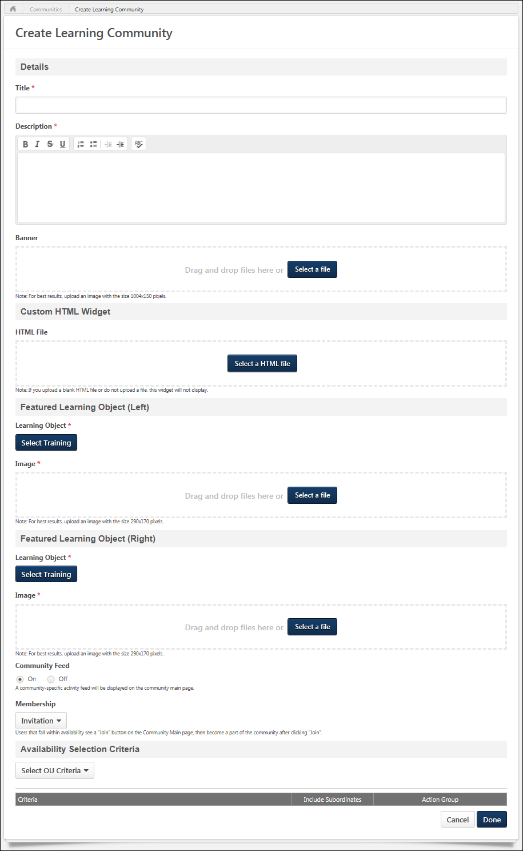
Learning Community Overview
Learning Community - Main
The Main tab of the community is the default landing page for the community and displays highlighted and curated content for users. A user can only view a community if the user is within the availability settings for the community.
To access a community, go to Connect > Communities. Then, click the community title.
Permissions
PERMISSION NAME | PERMISSION DESCRIPTION | CATEGORY

Manage Knowledge Bank/Communities Administration | Grants ability to view the New Knowledge Bank Administration page and manage Action Groups. Based on permission constraints, administrators with this permission can create and delete topics and subtopics. Administrators with this permission can view all communities, topics, sub-topics and postings, regardless of availability. In addition, administrators can add a posting to the Course Catalog. When creating a topic, the constraints on this permission are automatically applied to the topic's availability. This permission can be constrained by OU and User's OU. This permission is assigned to the default Administrator role by default. | New Connect

View Knowledge Bank/Communities | Grants ability to view the Knowledge Bank and Communities pages. This permission can be constrained by OU and User's OU. This permission is assigned to the default Administrator role by default. | New Connect
Emails
EMAIL NAME | EMAIL DESCRIPTION | ACTION TYPE

Joined Community | This email is triggered when a user becomes a member of a community. This email can be sent as a notification to New Member, Community Moderator, or a specific user. Note: For invitation only communities, this email is triggered when the user joins the community. For automatic enrollment communities, this email is triggered when the community settings are saved with the user being added to the availability criteria. | New Connect

Knowledge Bank/Communities New Posting Created | This email is triggered when a new Knowledge Bank or community posting is created. This email can be sent as a notification to Community Moderator, Community Members, Follower, or a specific user. A recipient must match the following criteria to receive the email:  - User is within the availability criteria for the corresponding posting's parent topic.  - User is within the constraints of the posting's parent topic's creator constraints.  - User is a member of one of the communities with which the topic is shared. | New Connect
Community Title
The title of the community is displayed in the upper-left corner of the community. This title is configured by the administrator when the community is created.
Join Community
If the user is not yet a member of the community, a Join Community button is available at the top of the page. Click this button to join the community. If enabled, the Joined Community email is triggered when a user becomes a member of a community.
Community Options
The following options are available in the Options drop-down:
- Follow Community - This option is available to all users who are members of the community. When a user is following a community, the user may receive email notifications whenever a posting is created in any of the topics that are available to the user within the community. Also, the community appears in the Following section of the user's Universal Profile: Bio. When a user follows a community, the user implicitly follows all of the topics and subtopics within the community. Because of this, the user does not have the option to follow or unfollow any topic within the community while the user is following the community.
- Unfollow Community - This option is only available when the user is currently following the community. When the user selects this option, the user is no longer following the community or any of the topics within the community. If the user had followed any individual topics within the community prior to following the community, then the user is still following those topics when the community is unfollowed.
- Edit Community - Select this option to edit the community. This option is only available to community moderators and administrators. See Learning Community - Create/Edit on page 97 for additional information.
- Delete Community - Select this option to delete the community. A confirmation pop-up is displayed. When a community is deleted, all topics and postings that are contained within the community are also deleted. This option is only available to administrators. Note: If a community contains a shared topic, then the community cannot be deleted.
Community Tabs
The following tabs are available for the community:
- Main - This tab is the landing page for the community. It displays highlighted and curated content for users.
- Topics - This tab provides access to all topics within the community.
- Members - This tab provides access to all members within the community.
Search for Postings
To search for postings within a community, enter your search criteria in the Search within community field and either click the Search icon or press [Enter]. This opens the Posting Search Results page. See Posting Search Results on page 130 for additional information.
Training Panel
The Training panel displays two learning objects (LOs) that are featured for the community. The featured training is configured when creating or editing the community. A featured LO does not appear if it is not available to the user.
Click the image or the LO title to open the LO Details page for the LO. See Learning Object (LO) Details Page for additional information.
If course ratings and reviews are enabled, then the LO rating and the number of reviews are displayed below the LO title.
HTML Widget
Depending on the community configuration, an HTML widget may appear at the top of the Main tab.
Community Feed
The Community Feed may display the latest activity for the specific community. In addition, community members may be able to create discussion postings directly from the Community Feed. All updates not posted directly to Community Feed, such as "received a reply" or "has created the discussion" updates, will not display if the update was made more than 365 days ago.
Community Feed - Activity Update Visibility
The Community Feed is only visible if it is enabled and if the user has joined the community. However, administrators who have the Manage Knowledge Bank/Communities Administration permission can always view the Community Feed.
An update is only visible in the Community Feed if the user has permission to view the corresponding posting.
If a posting or reply is deleted, then the activity update is removed from the Community Feed.
Community Feed - Create Discussion Posting
From the Community Feed, users may be able to create a new discussion posting and select the topic into which the posting will be added. If there are no topics for which the user has permission to create a posting, then this functionality is not available.
To create a discussion posting, select within the Create a discussion posting field. The panel expands to show the Select Topic drop-down and the Post and Cancel options.
See Community Feed - Create Posting on page 116 for additional information.
Community Feed - Activity Updates
The following activities may appear in the Community Feed:
- Posting Created - When a new posting is created in the community, this activity may be displayed in the feed. The first 300 characters of the posting body is displayed in the feed. No HTML is displayed in the feed.
- Posting Reply - When a reply is added to the original posting from the Community Feed or the Posting Details page, the original posting is moved to the top of the feed. A posting is not moved to the top of the feed if a user replies to an existing reply.
Community Feed - Activity Update Options
Users may have the option to like and reply to an activity update. However, the ability to vote for or against a suggestion type posting is not available from the Community Feed.
Any replies or likes that are added to activity updates in the Community Feed will also appear for the activity update in the Live Feed and the Posting Details page.
Community Feed - Show More
When viewing the Community Feed, up to 10 items are displayed. If there are more than 10 items available, then a Show More button is available at the bottom of the feed. Select this button to view 10 more items within the feed.
Community Description
At the top of the furthest right column, the community description is displayed, up to 300 characters. If the description exceeds 300 characters, a more link appears. Click this link to view the full description in a pop-up. The description is configured by the administrator when creating or editing the community.
Featured Panel
The Featured panel displays postings that have been marked as featured postings by the administrator. Only postings that are available to the user are displayed.
The posting that was marked as featured most recently is displayed at the top of the Featured panel.
If a link is attached to the posting, then the URL preview image is displayed. If a user clicks the posting image, they are directed to the posting page.
If a posting that has an embedded image or video file is Featured, then a thumbnail will display for that posting in the Featured and Trending widgets. Postings with embedded image files will use the top-most-position uploaded image file as the image used for the widget. Postings with embedded video files will use the top-most-position uploaded video file as the image used for the widget. However, if a posting includes both an uploaded image and a file, then the top-most eligible file will be used for the widget. This means that after creation, if a new eligible file replaces the top-most file, then the posting's thumbnail on these widgets will be updated to reflect this.
The posting title is displayed as a link. If a user clicks the posting title, they are directed to the posting page.
For the top featured posting, the first line from the posting is displayed below the posting title.
At the bottom of the posting, the Like button or icon is displayed with the date on which the posting was created. Click the Like button or icon to like the posting. Note: If a user clicks the Like button for a posting, this does not affect the trending score until the page is refreshed. See Posting Action - Like a Posting or a Reply on page 205 for additional information.
Popular Tags Panel
The Popular Tags panel displays the most popular tags that are being used within the community. The system determines tag popularity by the number of times any posting that contains the tag is viewed within the community. System-defined tags are not included in the panel. This panel is updated every three hours. This panel is only available when tags are enabled, and this panel is not displayed if there are no tags within a community.
Below each tag, the total number of times a posting that contains the tag has been viewed across the entire community. This calculation includes all postings in the community, even if the user is not able to view the posting.
Click a tag to initiate a search within Global Search for all postings that contain the selected tag. Users can only view postings which they can access. Note: The ability to click a posting tag to initiate a search is only available if the ability to search for Connect postings by tag is enabled via Search Preferences.
Trending Panel
The Trending panel displays postings that are trending within the community. Which topics are trending is determined by the number of times a posting has been viewed, liked, voted for, and replied to. Only postings that are available to the user are displayed.
The posting that is trending the most is featured at the top of the Trending panel.
If a link is attached to the posting, then the URL preview image is displayed. If a user clicks the posting image, they are directed to the posting page.
If a posting that has an embedded image or video file is Trending, then a thumbnail will display for that posting in the Featured and Trending widgets. Postings with embedded image files will use the top-most-position uploaded image file as the image used for the widget. Postings with embedded video files will use the top-most-position uploaded video file as the image used for the widget. However, if a posting includes both an uploaded image and a file, then the top-most eligible file will be used for the widget. This means that after creation, if a new eligible file replaces the top-most file, then the posting's thumbnail on these widgets will be updated to reflect this.
The posting title is displayed as a link. If a user clicks the posting title, they are directed to the posting page.
For the top trending posting, the first line from the posting is displayed below the posting title.
At the bottom of the posting, the Like functionality or Vote functionality is displayed with the date on which the posting was created.
- If the Like functionality is available, users can click the Like button or icon to like the posting. See Posting Action - Like a Posting or a Reply on page 205 for additional information.
- If the Vote functionality is available, users can vote for or against the posting. See Posting Action - Vote Posting or Reply on page 209 for additional information.
Leaderboard Grid
The Leaderboard grid displays the users who post the most topics, up to 21. User can hover over a member's photo to view the member's name and the number of postings the user has created. Click a member's photo to view the member's Universal Profile - Bio page.
Course Ratings Panel
If course ratings and reviews are enabled and if there is at least one course rating available to the user, then the Course Ratings panel displays below the Popular Tags widget. This widget displays the five latest course ratings from members of the community. Only ratings for the two featured LOs or their child LOs are displayed. Also, the ratings only appear if the LO is available to the user. The newest ratings are displayed first.
A rating does not appear in the following scenarios:
- The LO is not active, visible, or available to the user.
- The LO cannot be requested by the user.
- The rating is inactive or anonymous.
Click the user's image to open the Universal Profile - Bio page for the user. See Universal Profile - Bio Overview for additional information.
Click the LO title to open the LO Details page for the LO. See Learning Object (LO) Details Page for additional information.
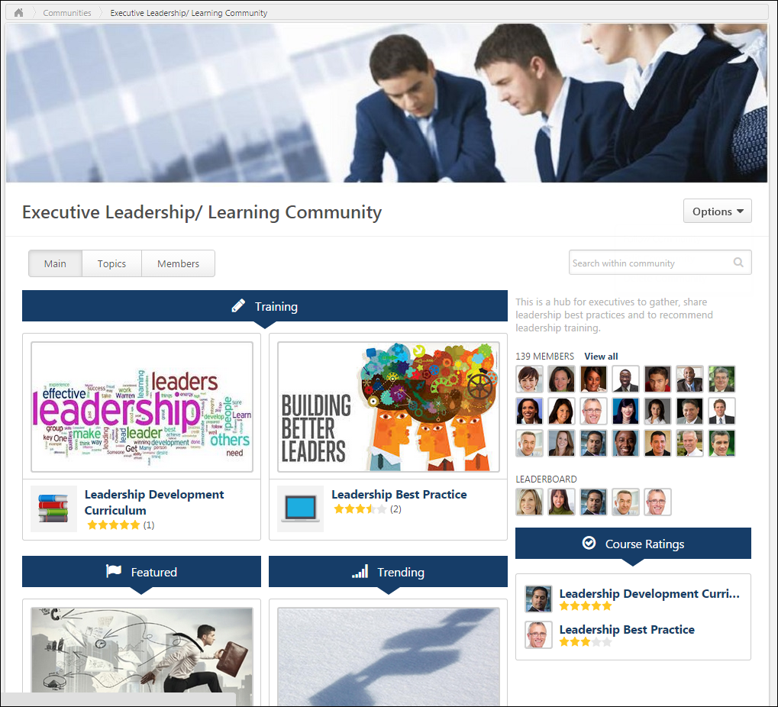
Learning Community - Members
The Members tab of a community allows users to view the community members. A user can only view a community if the user is within the availability settings for the community.
To access the Members tab of a community, go to New Connect > All Communities. Click the appropriate community. Then, click the Members tab.
Permissions
PERMISSION NAME | PERMISSION DESCRIPTION | CATEGORY

View Knowledge Bank/Communities | Grants ability to view the Knowledge Bank and Communities pages. This permission can be constrained by OU and User's OU. This permission is assigned to the default Administrator role by default. | New Connect
Community Tabs
The following tabs are available for the community:
- Main - This tab is the landing page for the community. It displays highlighted and curated content for users.
- Topics - This tab provides access to all topics within the community.
- Members - This tab provides access to all members within the community.
Community Moderators
This section displays all community moderators for the team in the order in which they joined the community. Click the photograph to open the Universal Profile - Bio page for the user.
Community Members
This section displays all community members who are not community moderators in the order in which they joined the community. Click the photograph to open the Universal Profile - Bio page for the user.
Remove User from Community
Users can be removed from a community by adjusting the Membership criteria for the community. See Learning Community - Create/Edit on page 97 for additional information.
Learning Community - Topics
The Topics tab allows users to view the top-level topics that are available to the user. A user can only view a community if the user is within the availability settings for the community.
To access the Topics tab for a community, go to Connect > All Communities. Click the community title, and then click the Topics tab.
Permissions
PERMISSION NAME | PERMISSION DESCRIPTION | CATEGORY

Manage Knowledge Bank/Communities Administration | Grants ability to view the New Knowledge Bank Administration page and manage Action Groups. Based on permission constraints, administrators with this permission can create and delete topics and subtopics. Administrators with this permission can view all communities, topics, sub-topics and postings, regardless of availability. In addition, administrators can add a posting to the Course Catalog. When creating a topic, the constraints on this permission are automatically applied to the topic's availability. This permission can be constrained by OU and User's OU. This permission is assigned to the default Administrator role by default. | New Connect

View Knowledge Bank/Communities | Grants ability to view the Knowledge Bank and Communities pages. This permission can be constrained by OU and User's OU. This permission is assigned to the default Administrator role by default. | New Connect
Emails
EMAIL NAME | EMAIL DESCRIPTION | ACTION TYPE

Knowledge Bank/Communities New Posting Created | This email is triggered when a new Knowledge Bank or community posting is created. This email can be sent as a notification to Community Moderator, Community Members, Follower, or a specific user. A recipient must match the following criteria to receive the email:  - User is within the availability criteria for the corresponding posting's parent topic.  - User is within the constraints of the posting's parent topic's creator constraints.  - User is a member of one of the communities with which the topic is shared. | New Connect
Each top-level topic within the community is displayed in alphabetical order.
The availability of a topic within a community is determined by the availability settings of the community. Users can view all topics within a community if they have access to the community.
Community Tabs
The following tabs are available for the community:
- Main - This tab is the landing page for the community. It displays highlighted and curated content for users.
- Topics - This tab provides access to all topics within the community.
- Members - This tab provides access to all members within the community.
Search for Postings
To search for postings within a community, enter your search criteria in the Search within community field and either click the Search icon or press [Enter]. This opens the Posting Search Results page. See Posting Search Results on page 130 for additional information.
Community Options
The following options are available in the Options drop-down:
- Follow Community - This option is available to all users who are members of the community. When a user is following a community, the user may receive email notifications whenever a posting is created in any of the topics that are available to the user within the community. Also, the community appears in the Following section of the user's Universal Profile: Bio. When a user follows a community, the user implicitly follows all of the topics and subtopics within the community.
- Unfollow Community - This option is only available when the user is currently following the community. When the user selects this option, the user is no longer following the community or any of the topics within the community. If the user had followed any individual topics within the community prior to following the community, then the user is still following those topics when the community is unfollowed.
- Create Topic - Select this option to create a topic. The ability to create, edit, or delete a community topic is only available to administrators and community moderators. See Community Topic - Create/Edit on page 118 for additional information.
View Topic Details Page
The Topic Details page displays all of the subtopics within the topic and all of the topic postings. Topic Moderators are able to edit the topic and create and edit subtopics. Topic members are able to create postings. Users can click a topic name to view the corresponding Topic Details page. See Community Topic - Topic Details Page on page 123 for additional information.
Community Feed - Create Posting
From the Community Feed, users may be able to create a new discussion posting and select the topic into which the posting will be added. If there are no topics for which the user has permission to create a posting, then this functionality is not available.
To create a discussion posting, select within the Create a discussion posting field. The panel expands to show the Select Topic drop-down and the Post and Cancel options.
Permissions
PERMISSION NAME | PERMISSION DESCRIPTION | CATEGORY

Manage Knowledge Bank/Communities Administration | Grants ability to view the New Knowledge Bank Administration page and manage Action Groups. Based on permission constraints, administrators with this permission can create and delete topics and subtopics. Administrators with this permission can view all communities, topics, sub-topics and postings, regardless of availability. In addition, administrators can add a posting to the Course Catalog. When creating a topic, the constraints on this permission are automatically applied to the topic's availability. This permission can be constrained by OU and User's OU. This permission is assigned to the default Administrator role by default. | New Connect

View Knowledge Bank/Communities | Grants ability to view the Knowledge Bank and Communities pages. This permission can be constrained by OU and User's OU. This permission is assigned to the default Administrator role by default. | New Connect
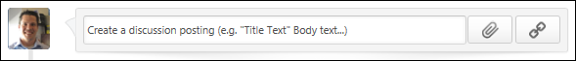
Posting Title and Body
When creating a posting from the Community Feed, users must set a title for the posting and add body text.
To set a title for the posting, enter the posting title in quotation marks. Then, enter the body text for the posting after the posting title. If a title is not provided in quotation marks at the beginning of the posting, then the first 70 characters of the posting text will be used as the title.
Hashtags can be used in the posting body text. A maximum of 10,000 characters can be entered.
For information on how to set the posting title and body text, hover the cursor over the Information icon in the upper-right corner of the Create a discussion posting field.
Attach a File
To attach a file to your posting, click the Attach File button below the right of the Create a discussion posting field. See Live Feed - Attach a File on page 173 for additional information.
Include URL Preview
When creating a posting from the Community Feed, you can include a URL with the post. See Live Feed - Include URL Preview on page 180 for additional information.
Select Topic
A posting must be associated with a topic so that the system knows where the posting should be created.
To set the topic into which the new posting should be created, select the appropriate topic from the Select Topic drop-down list.
Within the drop-down menu, the topics that were most recently selected by the user are displayed first with "(Recent)" appended to the topic title to indicate that it is a topic that was recently selected. Following the recently selected topics, all available topics are displayed in alphabetical order. Topics are only displayed if they are available to the user. Up to 10 topics are displayed in the drop-down menu.
Post or Cancel
After entering the appropriate title and body text, attaching any necessary files, and setting the posting topic, select Post to create the posting, or select Cancel to discard the posting.
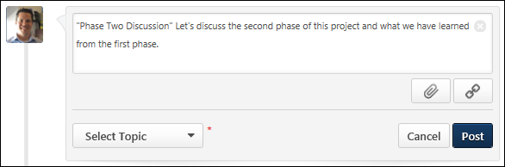
Community Topic - Create/Edit
The ability to create, edit, or delete a community topic is only available to administrators and community moderators.
To create a topic from within a community, click the Create Topic button on the Topics tab of the community.
To create a subtopic within a topic, on the Topic Details page, select Create Subtopic from the Manage Topic drop-down menu. See Community Topic - Topic Details Page on page 123 for additional information.
To edit a topic, on the Topic Details page, select Edit Topic from the Manage Topic drop-down menu. See Community Topic - Topic Details Page on page 123 for additional information.
Permissions
PERMISSION NAME | PERMISSION DESCRIPTION | CATEGORY

Edit Availability Knowledge Bank/Communities | Grants ability to configure the availability when editing communities or when creating or editing topics. This permission does not grant the ability to edit a community; users can only edit a community or topic if they have the Manage Knowledge Bank/Communities Administration or if they are a moderator for the community or topic. When creating a topic, the constraints on this permission are automatically applied to the topic's availability. If the user also has the Manage Knowledge Bank/Communities Administration permission, then the constraints on that permission are automatically applied to the topic's availability. This permission can be constrained by OU, User's OU, and User's Corporation. | New Connect

Manage Knowledge Bank/Communities Administration | Grants ability to view the New Knowledge Bank Administration page and manage Action Groups. Based on permission constraints, administrators with this permission can create and delete topics and subtopics. Administrators with this permission can view all communities, topics, sub-topics and postings, regardless of availability. In addition, administrators can add a posting to the Course Catalog. When creating a topic, the constraints on this permission are automatically applied to the topic's availability. This permission can be constrained by OU and User's OU. This permission is assigned to the default Administrator role by default. | New Connect
Details
Enter the following information for the topic:
- Title - Enter a title for the topic, up to 70 characters. This title will appear at the top of the topic.
- Description - Enter the topic description up to 3000 characters. This field includes rich text editing options. This field is optional.
Shared to Communities
This section is only visible to users with permission to manage the Knowledge Bank and communities.
Note: This section is always available when editing a topic. This section is not available when creating a topic. When creating a subtopic, this section is only available if the parent topic is shared.
This section enables administrators to share a topic across multiple communities. When a topic is shared, all subtopics are also shared. A shared topic can be updated in one location, and the update is applied to the topic in all shared locations. This includes if a topic's subtopics and postings are updated. This enables administrators and moderators to update a posting in one location instead of multiple locations.
This section displays all communities with which the topic is currently being shared.
Share with Community
To share the topic with another community, click the Select icon to the right of the Add Community field. This opens the Select Community pop-up, in which you can search for and select a community. Select a community by clicking the community name within the pop-up.
When a topic is shared with a community, the topic is always shared in the main level of topics within the shared community.
See Topic Sharing - Rules on page 129 for additional information.
Remove Shared Community
If a topic is currently shared with other communities, then the communities with which the topic is currently shared are listed in the Shared to Communities section. To stop sharing a topic with a community, click the Remove icon to the right of the community name. Note: Removing a shared community never impacts the shared topic's availability settings, even if the shared community's availability had previously been added to the shared topic. The added availability remains with the shared topic.
A topic can only be removed from sharing if none of the topic's parent topics are shared.
If the topic is no longer shared with any communities, then the topic is deleted when the changes are saved.
View or Add Availability
If a topic is currently shared with other communities, then the communities with which the topic is currently shared are listed in the Shared to Communities section. Each community may have unique availability settings. To view the availability settings of a community with which the topic is shared, click the View Availability button to the right of the community. This opens a read-only view of the community's availability in a pop-up in which you may choose to add to community's availability to the topic.
See Topic Sharing - Availability Pop-up on page 128 for additional information.
Availability Selection Criteria
Select the availability for the topic. Availability can be set by OU, group, or specific users. This determines which users within the system can view the topic, topic postings, and any subtopics associated with the topic. See Knowledge Bank/Community - Availability and Action Groups on page 148 for additional information.
This section can only be configured by topic moderators or users who have permission to manage communities or edit the availability of communities.
- When creating a topic, the constraints on the user's Edit Availability Knowledge Bank/Communities permission are automatically applied to the topic's availability. If the user also has the Manage Knowledge Bank/Communities Administration permission, then the constraints on that permission are automatically applied to the topic's availability.
- When editing a topic, any existing creator constraints that are automatically applied to the topic's availability are displayed at the bottom of the section. This enables administrators, community moderators, and topic moderators to fully understand the availability of the topic. If the constraints change, then the updated constraints are displayed.
Note: When creating a topic, the availability settings are pre-populated with the availability settings of the parent topic or community. However, when creating a topic at the community level, the Community Moderator is not pre-populated as the Topic Moderator.
When editing a cohort topic, all users on the cohort's roster appear as a single line item in the Availability Selection Criteria section. The Include Subordinates option is not available for this line item.
The following options are available for each selected criterion:
- Remove - Click the X to remove the selected criterion.
- Include Subordinates - Select this option to include all subordinate OUs or users in the availability.
- Action Group - From the drop-down, select the role of the selected users:
  - Visitor - Users within the availability criterion can view postings.
  - Member - Users within the availability criterion can create postings, edit and delete their own postings, and reply to postings.
  - Expert - Users within the availability criterion can serve as experts for Q&A postings. When an expert responds to a Q&A posting, the Q&A posting is automatically marked as Answered and the expert's reply is visually distinguished as an expert response. For cohort community topics, experts can also access the Instructor tab to reply to and manage user comments for video LOs.
  - Topic Moderator - Users within the availability criterion can edit, create, and delete topics.
  - Custom Action Group - Administrators have the ability to create custom action groups with a custom set of community permissions. If custom action groups have been created, they can be selected.
Reset Availability
Administrators can restore the availability settings to the default setting by clicking the Reset Availability button on the right side of the section. By default, the Instructor is in the Expert action group and the entire cohort roster is in the Member action group.
Overwrite availability changes for all of this topic's child topics
Select this option to apply the availability settings of this topic to all subtopics associated with the topic. When this option is selected, the availability of all of the topic's subtopics is overwritten with this topic's availability settings.
- This option is not available when creating a topic because the new topic does not have any subtopics.
- This option is not available when editing a topic within a cohort community.
If this option is selected when editing a topic that has a shared child topic, then a warning pop-up is displayed when the topic is saved to indicate that the availability of a shared topic will be overwritten. Click OK to overwrite the availability for all child topics. Or, click Cancel to not overwrite the availability for all child topics.
Done and Cancel
Click Done to save any unsaved changes.
- If a new community was added to the Share to Communities section, the topic is now shared with the added community with the configured availability settings.
- If a community was removed from the Share to Communities section, the topic and all of its subtopics are no longer shared with the removed community. However, the availability settings for the shared topic are unaffected. If the topic is no longer shared with any communities, then the topic is deleted. A confirmation pop-up opens to confirm the deletion.
- If the Overwrite availability changes for child topics option is selected when editing a topic that has a shared child topic, then a warning pop-up is displayed when the topic is saved to indicate that the availability of a shared topic will be overwritten.
Click Cancel to discard any unsaved changes.
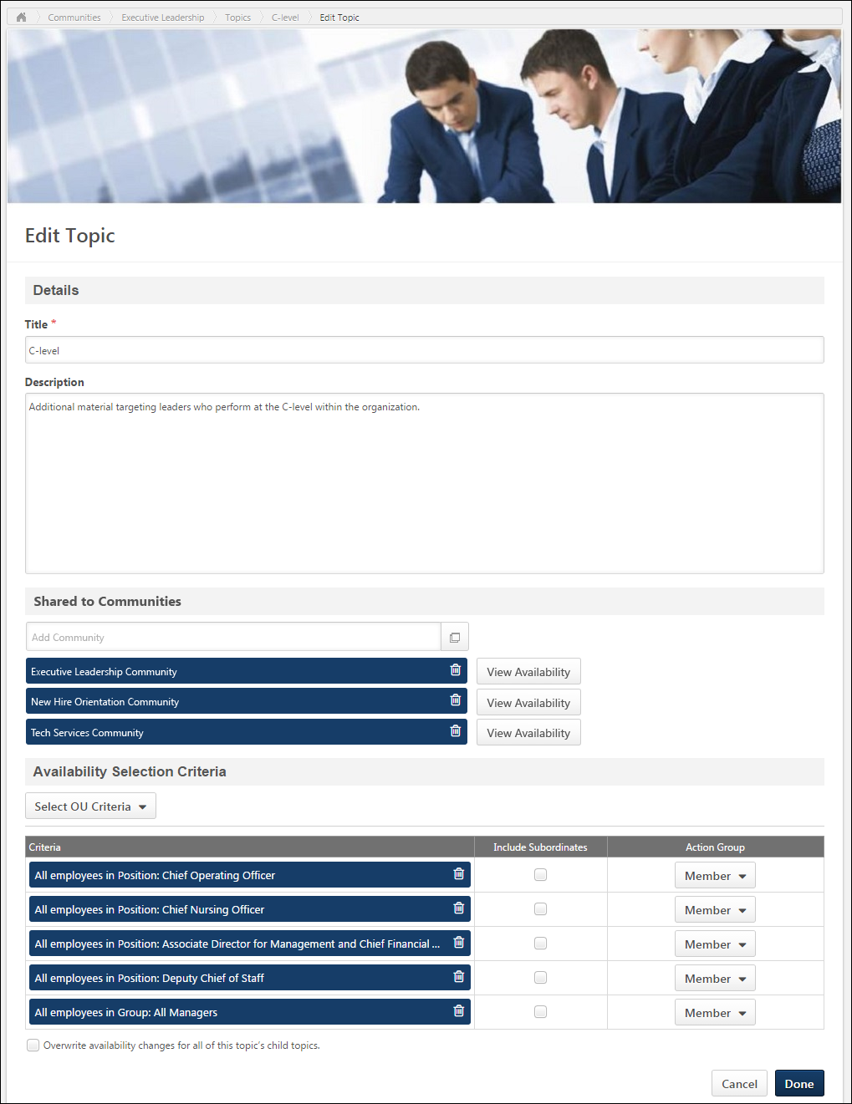
Community Topic - Topic Details Page
The Topic Details page displays all of the subtopics within the topic and all of the topic postings. Topic Moderators are able to edit the topic and create and edit subtopics. Topic members are able to create postings. The availability of a topic within a community is determined by the availability settings of the community. Users can view all topics within a community if they have access to the community.
To view the Topic Details page for a community topic, click the topic title from anywhere in the community.
Permissions
PERMISSION NAME | PERMISSION DESCRIPTION | CATEGORY

Manage Knowledge Bank/Communities Administration | Grants ability to view the New Knowledge Bank Administration page and manage Action Groups. Based on permission constraints, administrators with this permission can create and delete topics and subtopics. Administrators with this permission can view all communities, topics, sub-topics and postings, regardless of availability. In addition, administrators can add a posting to the Course Catalog. When creating a topic, the constraints on this permission are automatically applied to the topic's availability. This permission can be constrained by OU and User's OU. This permission is assigned to the default Administrator role by default. | New Connect

View Knowledge Bank/Communities | Grants ability to view the Knowledge Bank and Communities pages. This permission can be constrained by OU and User's OU. This permission is assigned to the default Administrator role by default. | New Connect
Emails
EMAIL NAME | EMAIL DESCRIPTION | ACTION TYPE

Knowledge Bank/Communities New Posting Created | This email is triggered when a new Knowledge Bank or community posting is created. This email can be sent as a notification to Community Moderator, Community Members, Follower, or a specific user. A recipient must match the following criteria to receive the email:  - User is within the availability criteria for the corresponding posting's parent topic.  - User is within the constraints of the posting's parent topic's creator constraints.  - User is a member of one of the communities with which the topic is shared. | New Connect
Manage Topic
The following options may be available in the Manage Topic drop-down menu:
- Follow Topic - This option is available to all users who are members of the topic's community. When a user is following a topic, the user may receive email notifications whenever a posting is created in the topic or any of the subtopics that are available to the user within the topic. Also, the topic appears in the Following section of the user's Universal Profile: Bio.
  - When a user follows a community, the user implicitly follows all of the topics and subtopics within the community. Because of this, the user does not have the option to follow or unfollow any topic within the community while the user is following the community. Similarly, when a user follows a topic, the user implicitly follows all of the subtopics within the parent topic. Because of this, the user does not have the option to follow or unfollow any subtopic within the parent topic while the user is following the topic.
- Unfollow Topic - When a user selects this option, the user is no longer following the topic or any of the subtopics within the topic. If the user had followed any individual subtopics within the topic prior to following the topic, then the user is still following those subtopics when the parent topic is unfollowed.
- Create Subtopic - Select this option to create a subtopic within the topic. The ability to create, edit, or delete a community topic is only available to administrators and community moderators. See Community Topic - Create/Edit on page 118 for additional information.
- Edit Topic - Select this option to edit the topic. The ability to create, edit, or delete a community topic is only available to administrators and community moderators. See Community Topic - Create/Edit on page 118 for additional information.
- Delete Topic - Select this option to delete the topic. A confirmation pop-up is displayed. When a topic is deleted, all subtopics and postings that are contained within the topic are also deleted. The ability to create, edit, or delete a community topic is only available to administrators and community moderators. Note: If a topic is shared with multiple communities, then the topic cannot be deleted.
Create Posting
The Create Posting drop-down menu is only available to topic members.
The following options are available in the Create Posting drop-down menu:
- Create Discussion - Select this option to create a discussion posting within the topic. See Posting Type - Discussion - Create on page 210 for additional information.
- Create File - Select this option to create a file posting within the topic. See Posting Type - File - Create on page 221 for additional information.
- Create Q&A - Select this option to create a Q&A posting within the topic. See Posting Type - Q&A - Create on page 232 for additional information.
- Create Suggestion - Select this option to create a suggestion posting within the topic. See Posting Type - Suggestion - Create on page 244 for additional information.
Search for Postings
To search for postings within a topic, enter your search criteria in the Search within topic field and either click the Search icon or press [Enter]. This opens the Posting Search Results page. See Posting Search Results on page 130 for additional information.
Subtopics
If the topic has at least one subtopic, then the subtopics are displayed above the Postings table in alphabetical order.
For each subtopic, the title and description are displayed. Users can click a subtopic name to view the corresponding Topic Details page.
Sort Postings
The following sorting options are available from the Sort drop-down menu:
- Sort Alphabetically* - This option sorts and displays all postings in alphabetical order.
- Sort by Create Date* - This option sorts and displays all postings by create date, from newest to oldest.
- Sort by Latest Reply - This option sorts and displays all postings by reply date, from newest to oldest. If there are no replies, then the creation time and date of the posting is used as the latest reply date.
- Sort by Most Likes* - This option sorts and displays all postings by the amount of likes, from most to least.
- Sort by Most Views* - This option sorts and displays all postings by view count, from most to least.
- Sort by Type* - This option sorts and displays all postings by type: Discussion, File, Q&A, Suggestion.
*The secondary sort option is Sort by Latest Reply, from newest to oldest.
Filter by Tag
The Filter by Tag filter displays the top 10 most popular tags for the topic. This filter is only available if there is at least one tag used within the topic's postings. The system determines tag popularity by the number of postings with which the tag is associated.
If there are more than 10 tags used within the topic, then a More Tags option is available within the drop-down. When this option is selected, a Select Tag pop-up opens, which displays all of the tags that are used within the topic.
If a tag is selected, then only postings that are associated with the selected tag are displayed. Users can select system-defined or user-defined tags, and only one tag can be selected. This filter is only applied to the selected topic and does not include postings within any subtopics. The selected tag appears to the right of the Filter by Tag filter. To remove the tag filter, click the Remove icon to the right of the tag name.
Postings
This section is only displayed if the topic has at least one posting. All of the postings within the topic are displayed in the Postings table.
Featured postings are displayed at the top of the table and have a beige background color. Following any featured postings, the posting that was most recently created or replied to is displayed first.
The following information is displayed for each posting in the Postings table:
- Posting Icon - An icon is displayed to the left of the posting title. This icon reflects the posting type.
- Posting Title - This displays the posting title. Click the posting title to view the posting.
- Tags - Any tags associated with the posting are displayed below the posting title. Only one row of tags are displayed; additional tags are only visible when viewing the posting.
  - Users can click a tag to initiate a search within Global Search for all postings that contain the selected tag. Users can only view postings which they can access. Note: The ability to click a posting tag to initiate a search is only available if the ability to search for Connect postings by tag is enabled via Search Preferences.
- Author - This displays the posting author's photo and name and the date on which the original posting was created.
- Replies - This displays the total number of times a reply has been added to the posting.
- Views - This displays the total number of times the posting has been viewed.
- Likes - This displays the total number of users who have liked the posting.
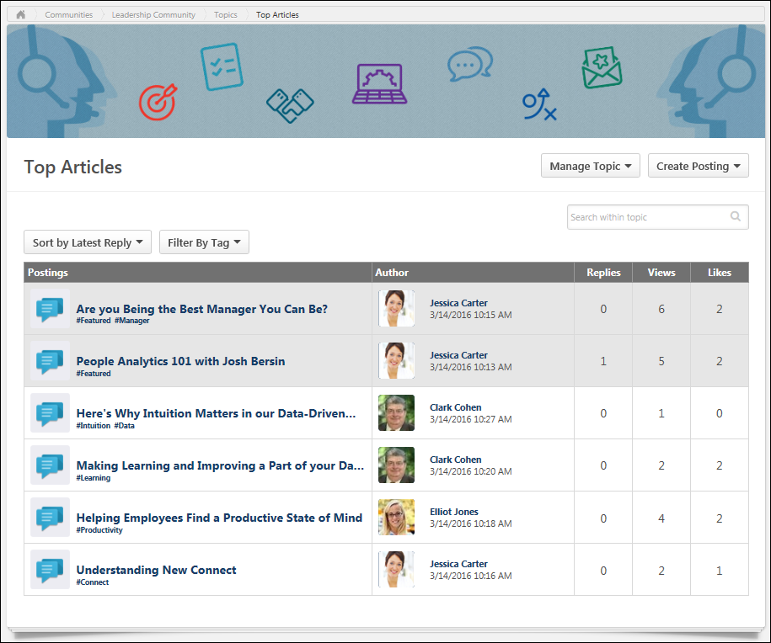
Topic Sharing - Availability Pop-up
If a topic is currently shared with other communities, then the communities with which the topic is currently shared are listed in the Shared to Communities section. Each community may have unique availability settings. To view the availability settings of a community with which the topic is shared, click the View Availability button to the right of the community. This opens a read-only view of the community's availability in a pop-up in which you may choose to add to community's availability to the topic.
By viewing the availability of a community with which a topic is being shared, this enables administrators and moderators to ensure that the availability of the shared topic aligns with the availability of the community.
Add Availability
To add the availability of the community to the availability of the shared topic, click the ADD button within the Availability pop-up. This updates the availability of the shared topic to include the availability of the corresponding community. Note: When adding a large number of users individually to a Community Topic's availability, there is a chance the backend processes will fail as a result of too many simultaneous requests processing at once, in which case no users will be added. As such, it is recommended that instead of adding a large number users to the topic's availability individually, create a group OU and add the relevant users to the group. Then, add the group OU to the topic's availability. This will ensure optimal processing speed and a successful availability update.
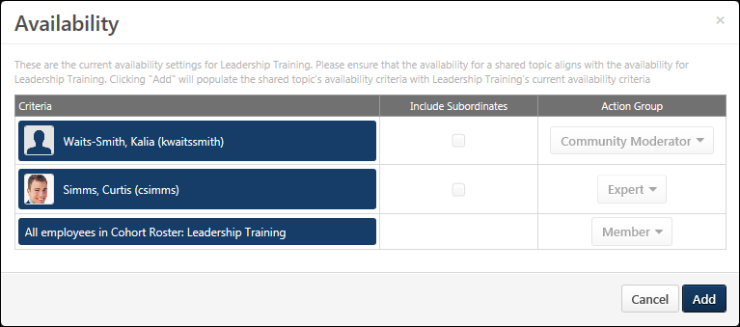
Topic Sharing - Rules
The following rules apply when sharing a topic to another community:
- The topic is always shared in the main level of topics within the shared community.
- The topic's original availability is always retained, regardless of the availability of the shared community. However, the availability of the shared community can be added to the shared topic.
- A topic must be associated with at least two communities to be considered shared. If a topic is only associated with a single community, then the topic is not considered shared.
- Unsharing a topic from all communities deletes the topic.
- When editing a community or topic, the editor can choose to apply the availability settings to all topics within the community or topic. However, a warning message is displayed to confirm the action.
- A shared topic cannot be deleted. Also, if a parent topic has shared subtopics, then the parent topic cannot be deleted.
- A user must match the availability of a shared topic to view the shared topic. However, a user does not need to match the availability of the topic's community to view the shared topic.
- A shared child topic cannot be unshared if the parent topic is shared.
- Creating a child topic within a shared topic automatically shares the child topic.
- Unsharing a parent topic automatically unshares any child topics.
Posting Search Results
Users can search for postings from within a community or topic. The search returns all available postings within the current community or topic that match the user's search criteria.
When searching for postings, the following fields may be searched:
- Title
- Body
- Replies
- File names for attached files
- URL title for attached URLs
- Posting author
- Community name
- Parent topics
- Tags
To search for postings within a community or topic, enter your search criteria in the Search field in the upper-right corner of the community or topic. Then, either click the Search icon or press [Enter]. This opens the Community Search Results page.
Permissions
PERMISSION NAME | PERMISSION DESCRIPTION | CATEGORY

Manage Knowledge Bank/Communities Administration | Grants ability to view the New Knowledge Bank Administration page and manage Action Groups. Based on permission constraints, administrators with this permission can create and delete topics and subtopics. Administrators with this permission can view all communities, topics, sub-topics and postings, regardless of availability. In addition, administrators can add a posting to the Course Catalog. When creating a topic, the constraints on this permission are automatically applied to the topic's availability. This permission can be constrained by OU and User's OU. This permission is assigned to the default Administrator role by default. | New Connect

View Knowledge Bank/Communities | Grants ability to view the Knowledge Bank and Communities pages. This permission can be constrained by OU and User's OU. This permission is assigned to the default Administrator role by default. | New Connect
Back
Click the Back link to return to the Community page or Topic Details page from which you initiated the search.
Search
To initiate a new search, enter your search criteria in the Search field and either click the Search icon or press [Enter]. This refreshes the page with the new search results.
Search Results
In the search results, featured postings are displayed above non-featured postings.
The following information is displayed for each posting that matches your search criteria:
- Posting Icon - An icon is displayed to the left of the posting title. This icon reflects the posting type.
- Posting Title - This displays the posting title. Click the posting title to view the posting.
- Posting Type
- Author - This displays the posting author's photo and name and the date on which the original posting was created.
- Parent Topic - This displays the topic that is associated with the posting.
- Body - This displays the posting text, up to two lines.
- Tags - Any tags that are associated with the posting are displayed below the posting body. System-defined tags are displayed before user-defined tags. User-defined tags are displayed in chronological order. Up to five total tags are displayed.
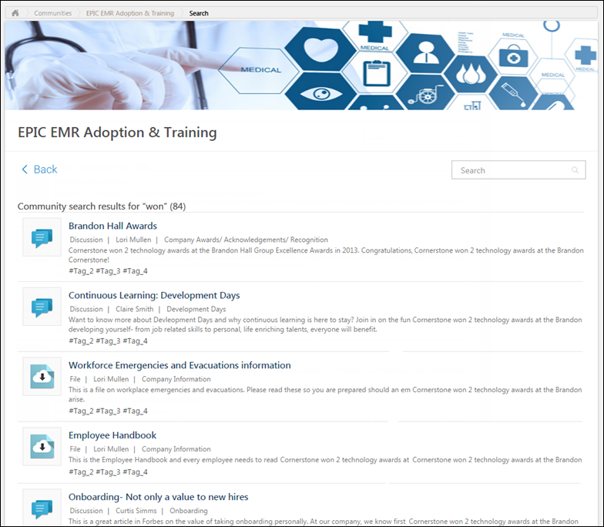

Connections Overview
Connection - Follow
Connecting with a user or requesting to connect with a user automatically follows the user. When sending a connection request, this occurs immediately and does not require the user to accept the connection request. When accepting a connection request, this occurs as soon as the connection is accepted. Similarly, removing a connection automatically unfollows the user.
To access the Bio - About page, go to Home > Universal Profile. Click the Bio tab, and then click the About subtab. Note: The location of this link is configurable by your system administrator.
To access another user's Universal Profile - Bio page, select the user's photograph from any Universal Profile or Global Search page.
Permissions
PERMISSION NAME | PERMISSION DESCRIPTION | CATEGORY

Bio About - View | Enables user to view the Bio page for users within their permission constraints. This permission must be enabled to view the Transcript page within Universal Profile. If a user does not have this permission and they click a person's name or user photo within the Universal Profile, then the Bio page will not open.  On the Learner Home page, this permission also allows end users to view the Completions & Hours field, the training sidebar, and the Continue Learning carousel.  This permission can be constrained by Employee Relationship, OU, User's OU, User's Direct Reports, User Self and Subordinates, and User. Note: For security purposes, this permission is constrained to User Self and Subordinates by default. However, the permission constraints can be modified to allow users to view the Bio About page for other users. | Universal Profile

View New Connect | Grants ability to view the new Connect pages, including Live Feed, All Teams, Team Overview, Team Feed, Team Tasks, Task Details, and Connections. This permission cannot be constrained. | New Connect
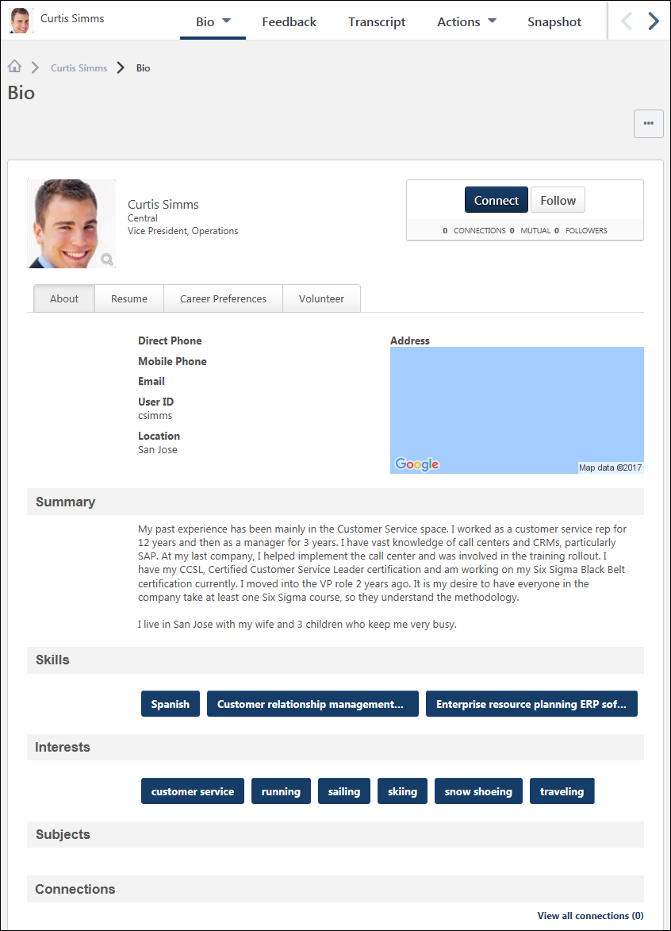
Connecting with a user or requesting to connect with a user automatically follows the user. When sending a connection request, this occurs immediately and does not require the user to accept the connection request. When accepting a connection request, this occurs as soon as the connection is accepted. Similarly, removing a connection automatically unfollows the user.
When viewing the Universal Profile of another user, users can choose to follow the user by selecting the Follow button in the upper-right corner of their profile. If you are already following the user, then Followed is displayed. Select the Followed button to unfollow the user.
Below the Follow button, the widget displays the number of followers the user has.
When following a user, you may receive a notification whenever the user creates a new posting. Also, the author is added to your Following section and the Bio - Following page. See Bio - About - Following.
Connection - Remove
An existing connection can be removed from the Connections page.
To access the Bio - About page, go to Home > Universal Profile. Click the Bio tab, and then click the About subtab. Note: The location of this link is configurable by your system administrator.
To access another user's Universal Profile - Bio page, select the user's photograph from any Universal Profile or Global Search page.
In the Connections section, click the View All link.
Permissions
PERMISSION NAME | PERMISSION DESCRIPTION | CATEGORY

Bio About - View | Enables user to view the Bio page for users within their permission constraints. This permission must be enabled to view the Transcript page within Universal Profile. If a user does not have this permission and they click a person's name or user photo within the Universal Profile, then the Bio page will not open.  On the Learner Home page, this permission also allows end users to view the Completions & Hours field, the training sidebar, and the Continue Learning carousel.  This permission can be constrained by Employee Relationship, OU, User's OU, User's Direct Reports, User Self and Subordinates, and User. Note: For security purposes, this permission is constrained to User Self and Subordinates by default. However, the permission constraints can be modified to allow users to view the Bio About page for other users. | Universal Profile

View New Connect | Grants ability to view the new Connect pages, including Live Feed, All Teams, Team Overview, Team Feed, Team Tasks, Task Details, and Connections. This permission cannot be constrained. | New Connect
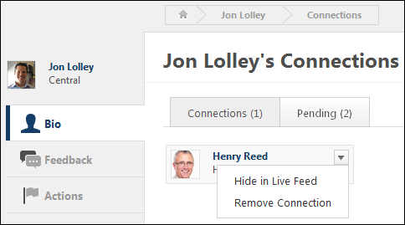
To remove an existing connection, hover the computer cursor over a user ID card. This displays a drop-down in the upper-right corner of the ID card. Select the drop-down icon and select the Remove Connection link. This immediately removes the user as a connection. No notifications are sent to either user.
Connection - View
The Connections page displays a user's connections. Users are only able to view their own pending connections. Users cannot view another user's pending connections.
To access the Bio - About page, go to Home > Universal Profile. Click the Bio tab, and then click the About subtab. Note: The location of this link is configurable by your system administrator.
To access another user's Universal Profile - Bio page, select the user's photograph from any Universal Profile or Global Search page.
In the Connections section, click the View All link.
Permissions
PERMISSION NAME | PERMISSION DESCRIPTION | CATEGORY

Bio About - View | Enables user to view the Bio page for users within their permission constraints. This permission must be enabled to view the Transcript page within Universal Profile. If a user does not have this permission and they click a person's name or user photo within the Universal Profile, then the Bio page will not open.  On the Learner Home page, this permission also allows end users to view the Completions & Hours field, the training sidebar, and the Continue Learning carousel.  This permission can be constrained by Employee Relationship, OU, User's OU, User's Direct Reports, User Self and Subordinates, and User. Note: For security purposes, this permission is constrained to User Self and Subordinates by default. However, the permission constraints can be modified to allow users to view the Bio About page for other users. | Universal Profile

View New Connect | Grants ability to view the new Connect pages, including Live Feed, All Teams, Team Overview, Team Feed, Team Tasks, Task Details, and Connections. This permission cannot be constrained. | New Connect
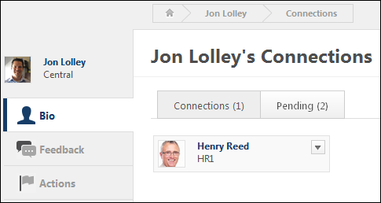
At the top of the page, the following tabs are available:
- Connections - This tab displays the user's number of connections. Click this tab to view all of the user's connections.
- Pending - This tab displays the user's number of pending connections. This includes the number of pending connection requests received plus the number of pending connection requests sent. Click this tab to view your pending connections. Users are only able to view their own pending connections. Users cannot view another user's pending connections.
The following information is displayed for each user ID card that is displayed on the Pending Connections page:
- User Photo
- First and Last Name
- OU Identifier
Remove Connection
An existing connection can be removed from your connections from the Connections page. See Connection - Remove on page 137 for additional information.
Connection Request - Accept or Ignore
Connection requests can be accepted or ignored from the Pending Connections page.
The Pending Connections page can be accessed in the following ways:
- From the Welcome Page, in the Your Inbox widget, select the View connection requests link.
- From the Universal Profile - Bio - About page, in the Connections section, select the View All link. Then, click the Pending tab.
Permissions
PERMISSION NAME | PERMISSION DESCRIPTION | CATEGORY

Bio About - View | Enables user to view the Bio page for users within their permission constraints. This permission must be enabled to view the Transcript page within Universal Profile. If a user does not have this permission and they click a person's name or user photo within the Universal Profile, then the Bio page will not open.  On the Learner Home page, this permission also allows end users to view the Completions & Hours field, the training sidebar, and the Continue Learning carousel.  This permission can be constrained by Employee Relationship, OU, User's OU, User's Direct Reports, User Self and Subordinates, and User. Note: For security purposes, this permission is constrained to User Self and Subordinates by default. However, the permission constraints can be modified to allow users to view the Bio About page for other users. | Universal Profile

View New Connect | Grants ability to view the new Connect pages, including Live Feed, All Teams, Team Overview, Team Feed, Team Tasks, Task Details, and Connections. This permission cannot be constrained. | New Connect
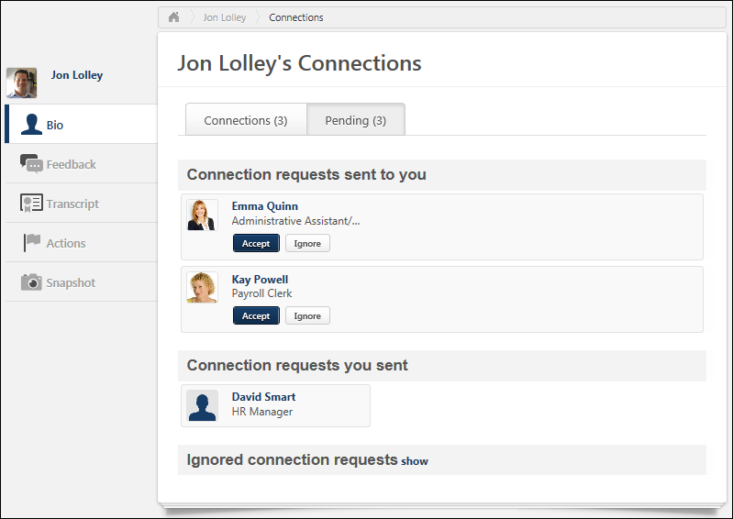
To accept or ignore a pending connection request, select the appropriate button on the user ID card of the pending connection.
- If the request is accepted, the user is added as a connection.
- If the request is ignored, the connection request is moved into the Ignored connection requests section at the bottom of the page.
An ignored connection request can be accepted. To accept an ignored connection request, select the Accept button on the user ID card of the ignored connection.
In addition, a connection request can be accepted when viewing the Universal Profile - Bio page for a user who has sent you a connection request. If the user whose page you are viewing has sent you a connection request, but you have not yet responded, then selecting Accept confirms the connection and you are immediately connected. Accepting a connection request from a user automatically follows the user.
Connection Request - Send
Connection requests can be sent from the Universal Profile - Bio pages. The Connections section of the Bio - About page displays the user's total number of connections and team.
To access the Bio - About page, go to Home > Universal Profile. Click the Bio tab, and then click the About subtab. Note: The location of this link is configurable by your system administrator.
To access another user's Universal Profile - Bio page, select the user's photograph from any Universal Profile or Global Search page.
Permissions
PERMISSION NAME | PERMISSION DESCRIPTION | CATEGORY

Bio About - View | Enables user to view the Bio page for users within their permission constraints. This permission must be enabled to view the Transcript page within Universal Profile. If a user does not have this permission and they click a person's name or user photo within the Universal Profile, then the Bio page will not open.  On the Learner Home page, this permission also allows end users to view the Completions & Hours field, the training sidebar, and the Continue Learning carousel.  This permission can be constrained by Employee Relationship, OU, User's OU, User's Direct Reports, User Self and Subordinates, and User. Note: For security purposes, this permission is constrained to User Self and Subordinates by default. However, the permission constraints can be modified to allow users to view the Bio About page for other users. | Universal Profile

Send Connection Request | Grants ability to send connection requests to other users within the new Connect. This permission can be constrained by OU and User's OU. The constraints that are placed upon this permission determine to whom the user can send connection requests. If a user is constrained by a specific OU, then the user can only send connection requests to users within that OU. | New Connect

View New Connect | Grants ability to view the new Connect pages, including Live Feed, All Teams, Team Overview, Team Feed, Team Tasks, Task Details, and Connections. This permission cannot be constrained. | New Connect
Emails
EMAIL NAME | EMAIL DESCRIPTION | ACTION TYPE

New Connection Request | This email is triggered when a user receives a connection request. This email can be sent as a notification to Request Recipient or a specific user. Note: This email is only triggered for connections within New Connect, not Old Connect. | New Connect
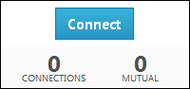
When viewing the Universal Profile - Bio page of another user, you can send a connection request for the user by selecting the Connect button in the upper-right corner of their profile.
- If you are not connected to the user, the Connect button is available. Selecting Connect sends a connection request to the user. If enabled, the New Connection Request email is triggered when a connection request is sent.
- If the user whose page you are viewing has sent you a connection request, but you have not yet responded, then selecting Accept confirms the connection and you are immediately connected. Accepting a connection request from a user automatically follows the user.
- If you are not connected to the user, but you have already sent a connection request to the user, then "Connection Pending" is displayed and the button is disabled.
- If you are already connected to the user, then Connected is displayed and the button is disabled.
- When sending a connection request, this action automatically follows the user. This occurs immediately and does not require the user to accept the connection request.
Below the Connect button, the Bio - Connect widget displays the following information:
- Connections - The number of connections the user has.
- Mutual - The people to whom you are both connected.
- Followers - The number of followers the user has.
Connection Request - View Pending Connections
The Pending Connections page displays a user's pending connection requests. Users are only able to view their own pending connections. Users cannot view another user's pending connections.
The Pending Connections page can be accessed in the following ways:
- From the Welcome Page, in the Your Inbox widget, select the View connection requests link.
- From the Universal Profile - Bio - About page, in the Connections section, select the View All link. Then, click the Pending tab.
Permissions
PERMISSION NAME | PERMISSION DESCRIPTION | CATEGORY

Bio About - View | Enables user to view the Bio page for users within their permission constraints. This permission must be enabled to view the Transcript page within Universal Profile. If a user does not have this permission and they click a person's name or user photo within the Universal Profile, then the Bio page will not open.  On the Learner Home page, this permission also allows end users to view the Completions & Hours field, the training sidebar, and the Continue Learning carousel.  This permission can be constrained by Employee Relationship, OU, User's OU, User's Direct Reports, User Self and Subordinates, and User. Note: For security purposes, this permission is constrained to User Self and Subordinates by default. However, the permission constraints can be modified to allow users to view the Bio About page for other users. | Universal Profile

View New Connect | Grants ability to view the new Connect pages, including Live Feed, All Teams, Team Overview, Team Feed, Team Tasks, Task Details, and Connections. This permission cannot be constrained. | New Connect
At the top of the page, the following tabs are available:
- Connections - This tab displays the user's number of connections. Click this tab to view all of the user's connections.
- Pending - This tab displays the user's number of pending connections. This includes the number of pending connection requests received plus the number of pending connection requests sent. Click this tab to view your pending connections. Users are only able to view their own pending connections. Users cannot view another user's pending connections.
The Pending Connections page is organized into the following categories:
- Connection requests sent to you - This section displays all of the pending connection requests that have been sent to you by others.
- Connection requests you sent - This section displays all of the pending connection requests that you have sent to others.
- Ignored connection requests - This section displays all of the connection requests that you have ignored.
The following information is displayed for each user ID card that is displayed on the Pending Connections page:
- User Photo
- First and Last Name
- OU Identifier
Accept or Ignore a Pending Connection Request
Pending connection requests that have been sent to you can be accepted or ignored from the Pending Connections page. See Connection Request - Accept or Ignore on page 141 for additional information.
Display Ignored Connection Requests
To view the connection requests that have been ignored, click the show link at the bottom of the page. This displays user ID cards for all of the ignored connection requests. Note: This option is not available if the ignored connection requests are currently displayed.
An ignored connection request can be accepted. See Connection Request - Accept or Ignore on page 141 for additional information.
Hide Ignored Connection Requests
To hide the connection requests that have been ignored, click the hide link at the bottom of the page. This hides the user ID cards for all of the ignored connection requests. Note: This option is not available if the ignored connection requests are currently hidden.

Knowledge Bank/Community - Availability and Action Groups
With the Knowledge Bank and Communities functionality, security is managed when setting the availability for topics and communities. When setting the availability for topics and communities, the selected users, OUs, or groups are assigned to an action group. Each system-defined action group has a specific set of abilities.
Typical Actor | Action Group | Default Abilities
Client Administrator | N/A - Administrators are assigned the Manage Knowledge Bank/Communities Administration permission. | - Create Community  - Delete Community  - All of the abilities within the action groups.
Manager/HR | Community Moderator | - Edit Community  - View Community  - Create Topics within a Community  - Edit Topics within a Community  - Delete Topics within a Community  - Mark Postings as Featured within a Community  - Create Postings within a Community  - Edit Postings within a Community  - Delete Postings within a Community  - Create Posting Comments within a Community
Manager/HR | Topic Moderator | - View Community  - Create Subtopic within the Topic  - Edit the Topic  - Mark Postings as Featured within the Topic  - Create Posting within the Topic  - Delete Posting within the Topic  - Create Posting Comment within the Topic
End User | Member - Users within the availability criterion can create postings, edit and delete their own postings, and reply to postings. | - Create Posting within the Community or Topic  - Delete Posting Authored by the User within the Community or Topic  - Create Posting Comment within the Community or Topic
End User | Expert - Users within the availability criterion can serve as experts for Q&A postings. When an expert responds to a Q&A posting, the Q&A posting is automatically marked as Answered and the expert's reply is visually distinguished as an expert response. | - Create Posting within the Community or Topic  - Delete Posting Authored by the User within the Community or Topic  - Create Posting Comment within the Community or Topic  - Replies are designated as "Expert Answers"
External End User | Visitor | - View Community  - View Topic  - View Posting

Knowledge Bank Overview
Knowledge Bank - Edit
To edit the Knowledge Bank, on the Knowledge Bank page, select Edit Knowledge Bank from the Options drop-down menu.
Permissions
PERMISSION NAME | PERMISSION DESCRIPTION | CATEGORY

Manage Knowledge Bank/Communities Administration | Grants ability to view the New Knowledge Bank Administration page and manage Action Groups. Based on permission constraints, administrators with this permission can create and delete topics and subtopics. Administrators with this permission can view all communities, topics, sub-topics and postings, regardless of availability. In addition, administrators can add a posting to the Course Catalog. When creating a topic, the constraints on this permission are automatically applied to the topic's availability. This permission can be constrained by OU and User's OU. This permission is assigned to the default Administrator role by default. | New Connect
Details
Enter the following information for the Knowledge Bank:
- Title - Enter a title for the Knowledge Bank, up to 70 characters. This title will appear at the top of the Knowledge Bank.
- Description - Enter the Knowledge Bank description up to 3000 characters. This field includes rich text editing options. This field is optional.
- Banner - The banner image appears at the top of the Knowledge Bank and at the top of each Knowledge Bank posting. Add a banner file by dragging and dropping a file into the Attachment area. You can also attach a file by clicking the Select a file button and select a file from your computer. Note: The drag-and-drop functionality is not supported by Internet Explorer browsers. For best results, the banner image should be 1004 x 150 pixels.
  - The Attachment Restrictions section on the Posting Action - Attach File topic provides a complete list of image attachment restrictions. See Posting Action - Attach File on page 196 for additional information.
  - Once a banner image is added to the Knowledge Bank, it cannot be removed. It can only be replaced with a new image.
Custom HTML Widget
The Custom HTML Widget section is only available if enabled by a backend setting. This section enables community moderators to upload an HTML file (.htm or .html), up to 5 MB in size. Once the Knowledge Bank is saved, the HTML data is rendered and displayed in the upper-left corner of the Knowledge Bank.
Add an HTML file by dragging and dropping the file into the Attachment area. You can also attach a file by clicking the Select a file button and select a file from your computer. Note: The drag-and-drop functionality is not supported by Internet Explorer browsers. Once the file is selected, a preview of the HTML widget is displayed in the section. If an empty file or no file is selected, then the HTML widget does not appear on the Knowledge Bank homepage.
Important: All HTML tags are accepted by the Custom HTML widget. Because malicious HTML files may be uploaded, this is a potential security risk and organizations may choose to disable this functionality.
Community Feed
A Community Feed is a feed that is displayed on the Main tab of the community. The Community Feed may display the latest activity for the specific community. In addition, community members may be able to create discussion postings directly from the Community Feed. All updates not posted directly to Community Feed, such as "received a reply" or "has created the discussion" updates, will not display if the update was made more than 365 days ago.
Select whether the Community Feed is enabled for the community. For new communities, the feed is enabled by default.
Done and Cancel
After entering the appropriate information, click Done to save the changes to the Knowledge Bank. Otherwise, click Cancel to discard any unsaved changes.
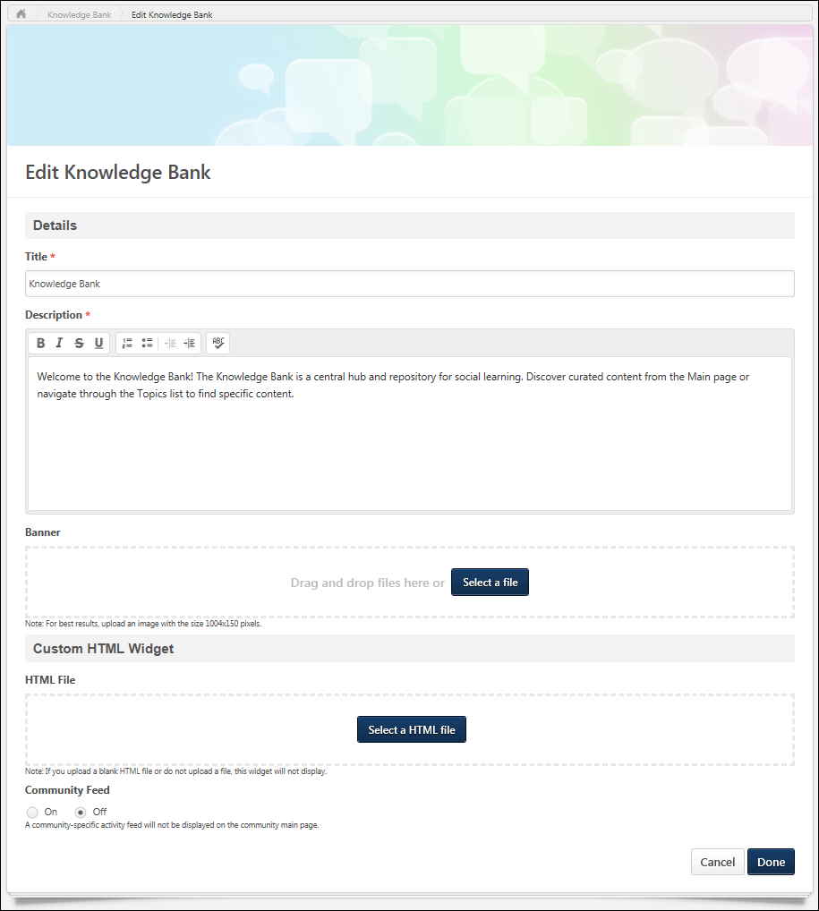
Knowledge Bank - Main
The Main tab of the Knowledge Bank is the default landing page for the Knowledge Bank and displays highlighted and curated content for users.
To access the Knowledge Bank, go to Connect > Knowledge Bank.
Permissions
PERMISSION NAME | PERMISSION DESCRIPTION | CATEGORY

View Knowledge Bank/Communities | Grants ability to view the Knowledge Bank and Communities pages. This permission can be constrained by OU and User's OU. This permission is assigned to the default Administrator role by default. | New Connect
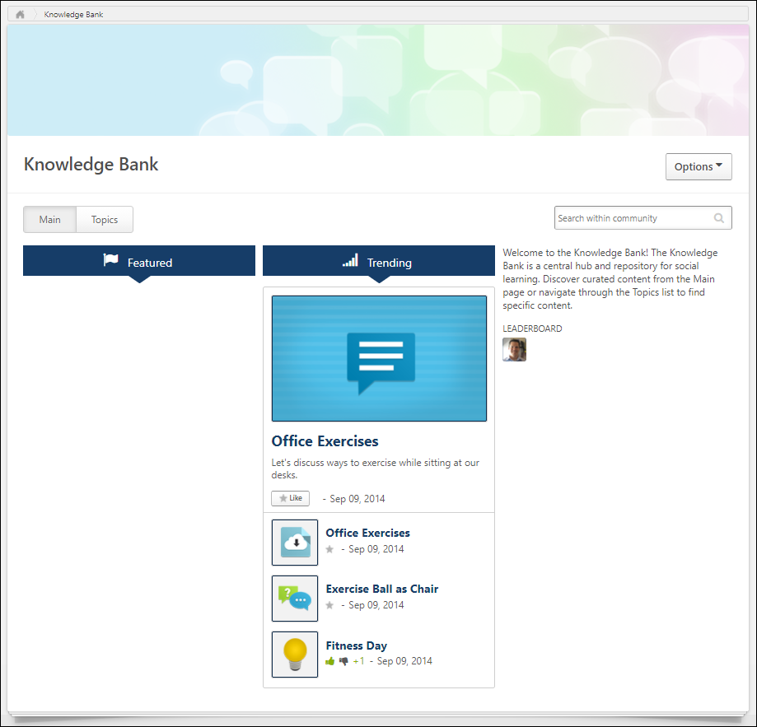
Knowledge Bank Title
The title of the Knowledge Bank is displayed in the upper-left corner of the Knowledge Bank. This title can be configured by the administrator when the community is edited.
Options
The following options are available in the Options drop-down:
- Edit Knowledge Bank - Select this option to edit the Knowledge Bank. Note: Users can only edit the Knowledge Bank if they are a moderator for the Knowledge Bank.See Knowledge Bank - Edit on page 152 for additional information.
Knowledge Bank Tabs
The following tabs are available for the Knowledge Bank:
- Main - This tab is the landing page for the Knowledge Bank. It displays highlighted and curated content for users.
- Topics - This tab provides access to all available topics within the Knowledge Bank.
HTML Widget
Depending on the community configuration, an HTML widget may appear at the top of the Main tab.
Community Feed
The Community Feed may display the latest activity for the specific community. In addition, community members may be able to create discussion postings directly from the Community Feed. All updates not posted directly to Community Feed, such as "received a reply" or "has created the discussion" updates, will not display if the update was made more than 365 days ago.
Community Feed - Activity Update Visibility
The Community Feed is only visible if it is enabled and if the user has joined the community. However, administrators who have the Manage Knowledge Bank/Communities Administration permission can always view the Community Feed.
An update is only visible in the Community Feed if the user has permission to view the corresponding posting.
If a posting or reply is deleted, then the activity update is removed from the Community Feed.
Community Feed - Create Discussion Posting
From the Community Feed, users may be able to create a new discussion posting and select the topic into which the posting will be added. If there are no topics for which the user has permission to create a posting, then this functionality is not available.
To create a discussion posting, select within the Create a discussion posting field. The panel expands to show the Select Topic drop-down and the Post and Cancel options.
See Community Feed - Create Posting on page 116 for additional information.
Community Feed - Activity Updates
The following activities may appear in the Community Feed:
- Posting Created - When a new posting is created in the community, this activity may be displayed in the feed. The first 300 characters of the posting body is displayed in the feed. No HTML is displayed in the feed.
- Posting Reply - When a reply is added to the original posting from the Community Feed or the Posting Details page, the original posting is moved to the top of the feed. A posting is not moved to the top of the feed if a user replies to an existing reply.
Community Feed - Activity Update Options
Users may have the option to like and reply to an activity update. However, the ability to vote for or against a suggestion type posting is not available from the Community Feed.
Any replies or likes that are added to activity updates in the Community Feed will also appear for the activity update in the Live Feed and the Posting Details page.
Community Feed - Show More
When viewing the Community Feed, up to 10 items are displayed. If there are more than 10 items available, then a Show More button is available at the bottom of the feed. Select this button to view 10 more items within the feed.
Community Description
At the top of the furthest right column, the community description is displayed, up to 300 characters. If the description exceeds 300 characters, a more link appears. Click this link to view the full description in a pop-up. The description is configured by the administrator when creating or editing the community.
Featured Panel
The Featured panel displays postings that have been marked as featured postings by the administrator. Only postings that are available to the user are displayed.
The posting that was marked as featured most recently is displayed at the top of the Featured panel.
If a link is attached to the posting, then the URL preview image is displayed. If a user clicks the posting image, they are directed to the posting page.
If a posting that has an embedded image or video file is Featured, then a thumbnail will display for that posting in the Featured and Trending widgets. Postings with embedded image files will use the top-most-position uploaded image file as the image used for the widget. Postings with embedded video files will use the top-most-position uploaded video file as the image used for the widget. However, if a posting includes both an uploaded image and a file, then the top-most eligible file will be used for the widget. This means that after creation, if a new eligible file replaces the top-most file, then the posting's thumbnail on these widgets will be updated to reflect this.
The posting title is displayed as a link. If a user clicks the posting title, they are directed to the posting page.
For the top featured posting, the first line from the posting is displayed below the posting title.
At the bottom of the posting, the Like button or icon is displayed with the date on which the posting was created. Click the Like button or icon to like the posting. Note: If a user clicks the Like button for a posting, this does not affect the trending score until the page is refreshed. See Posting Action - Like a Posting or a Reply on page 205 for additional information.
Popular Tags Panel
The Popular Tags panel displays the most popular tags that are being used within the community. The system determines tag popularity by the number of times any posting that contains the tag is viewed within the community. System-defined tags are not included in the panel. This panel is updated every three hours. This panel is only available when tags are enabled, and this panel is not displayed if there are no tags within a community.
Below each tag, the total number of times a posting that contains the tag has been viewed across the entire community. This calculation includes all postings in the community, even if the user is not able to view the posting.
Click a tag to initiate a search within Global Search for all postings that contain the selected tag. Users can only view postings which they can access. Note: The ability to click a posting tag to initiate a search is only available if the ability to search for Connect postings by tag is enabled via Search Preferences.
Trending Panel
The Trending panel displays postings that are trending within the community. Which topics are trending is determined by the number of times a posting has been viewed, liked, voted for, and replied to. Only postings that are available to the user are displayed.
The posting that is trending the most is featured at the top of the Trending panel.
If a link is attached to the posting, then the URL preview image is displayed. If a user clicks the posting image, they are directed to the posting page.
If a posting that has an embedded image or video file is Trending, then a thumbnail will display for that posting in the Featured and Trending widgets. Postings with embedded image files will use the top-most-position uploaded image file as the image used for the widget. Postings with embedded video files will use the top-most-position uploaded video file as the image used for the widget. However, if a posting includes both an uploaded image and a file, then the top-most eligible file will be used for the widget. This means that after creation, if a new eligible file replaces the top-most file, then the posting's thumbnail on these widgets will be updated to reflect this.
The posting title is displayed as a link. If a user clicks the posting title, they are directed to the posting page.
For the top trending posting, the first line from the posting is displayed below the posting title.
At the bottom of the posting, the Like functionality or Vote functionality is displayed with the date on which the posting was created.
- If the Like functionality is available, users can click the Like button or icon to like the posting. See Posting Action - Like a Posting or a Reply on page 205 for additional information.
- If the Vote functionality is available, users can vote for or against the posting. See Posting Action - Vote Posting or Reply on page 209 for additional information.
Leaderboard Grid
The Leaderboard grid displays the users who post the most topics, up to 21. User can hover over a member's photo to view the member's name and the number of postings the user has created. Click a member's photo to view the member's Universal Profile - Bio page.
Knowledge Bank - Topics
The Topics tab of the Knowledge Bank allows users to view the top-level topics that are available to the user.
To access the Topics tab for the Knowledge Bank, go to Connect > Knowledge Bank. Then, click the Topics tab.
Permissions
PERMISSION NAME | PERMISSION DESCRIPTION | CATEGORY

Manage Knowledge Bank/Communities Administration | Grants ability to view the New Knowledge Bank Administration page and manage Action Groups. Based on permission constraints, administrators with this permission can create and delete topics and subtopics. Administrators with this permission can view all communities, topics, sub-topics and postings, regardless of availability. In addition, administrators can add a posting to the Course Catalog. When creating a topic, the constraints on this permission are automatically applied to the topic's availability. This permission can be constrained by OU and User's OU. This permission is assigned to the default Administrator role by default. | New Connect

View Knowledge Bank/Communities | Grants ability to view the Knowledge Bank and Communities pages. This permission can be constrained by OU and User's OU. This permission is assigned to the default Administrator role by default. | New Connect
Each top-level topic within the Knowledge Bank that is available to the user is displayed in alphabetical order.
Knowledge Bank Tabs
The following tabs are available for the Knowledge Bank:
- Main - This tab is the landing page for the Knowledge Bank. It displays highlighted and curated content for users.
- Topics - This tab provides access to all available topics within the Knowledge Bank.
Create Topic
To create a topic, click the Create Topic button. The ability to create and edit a Knowledge Bank topic is only available to administrators and topic moderators. See Knowledge Bank Topic - Create/Edit on page 162 for additional information.
View Topic Details Page
The Topic Details page displays all of the subtopics within the topic and all of the topic postings. Topic Moderators are able to edit the topic and create and edit subtopics. Topic members are able to create postings. Users can click a topic name to view the corresponding Topic Details page. See Knowledge Bank Topic - Topic Details Page on page 165 for additional information.
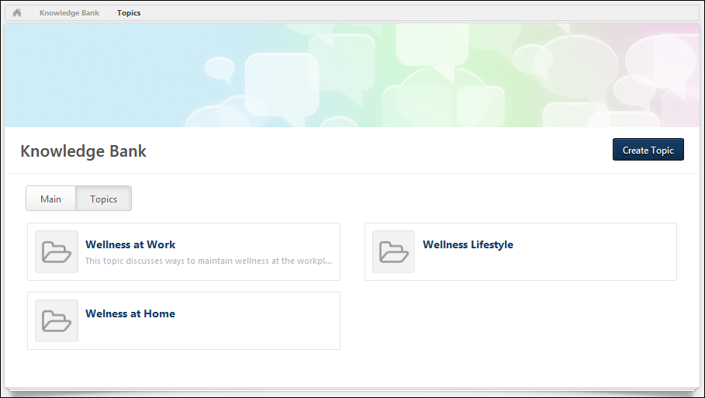
Knowledge Bank Topic - Create/Edit
The ability to create and edit a Knowledge Bank topic is only available to administrators and topic moderators.
To create a Knowledge Bank topic, click the Create Topic button on the Topics tab of the Knowledge Bank. See Knowledge Bank - Topics on page 160 for additional information.
To create a subtopic within a topic, on the Topic Details page, select Create Subtopic from the Manage Topic drop-down menu. See Knowledge Bank Topic - Topic Details Page on page 165 for additional information.
To edit a topic, on the Topic Details page, select Edit Topic from the Manage Topic drop-down menu. See Knowledge Bank Topic - Topic Details Page on page 165 for additional information.
Note: Topics may be able to be deleted from the Topic Details page. See Knowledge Bank Topic - Topic Details Page on page 165 for additional information.
Permissions
PERMISSION NAME | PERMISSION DESCRIPTION | CATEGORY

Edit Availability Knowledge Bank/Communities | Grants ability to configure the availability when editing communities or when creating or editing topics. This permission does not grant the ability to edit a community; users can only edit a community or topic if they have the Manage Knowledge Bank/Communities Administration or if they are a moderator for the community or topic. When creating a topic, the constraints on this permission are automatically applied to the topic's availability. If the user also has the Manage Knowledge Bank/Communities Administration permission, then the constraints on that permission are automatically applied to the topic's availability. This permission can be constrained by OU, User's OU, and User's Corporation. | New Connect

Manage Knowledge Bank/Communities Administration | Grants ability to view the New Knowledge Bank Administration page and manage Action Groups. Based on permission constraints, administrators with this permission can create and delete topics and subtopics. Administrators with this permission can view all communities, topics, sub-topics and postings, regardless of availability. In addition, administrators can add a posting to the Course Catalog. When creating a topic, the constraints on this permission are automatically applied to the topic's availability. This permission can be constrained by OU and User's OU. This permission is assigned to the default Administrator role by default. | New Connect
Details
Enter the following information for the topic:
- Title - Enter a title for the topic, up to 70 characters. This title will appear at the top of the topic.
- Description - Enter the topic description up to 3,000 characters. This field includes rich text editing options. This field is optional.
Availability Selection Criteria
The topic availability determines which users within the system can view the topic.
This section can only be configured by topic moderators or users who have permission to manage communities or edit the availability of communities.
- When creating a topic, the constraints on the user's Edit Availability Knowledge Bank/Communities permission are automatically applied to the topic's availability. If the user also has the Manage Knowledge Bank/Communities Administration permission, then the constraints on that permission are automatically applied to the topic's availability.
- When editing a topic, any existing creator constraints that are automatically applied to the topic's availability are displayed at the bottom of the section. This enables administrators, community moderators, and topic moderators to fully understand the availability of the topic. If the constraints change, then the updated constraints are displayed.
Select the availability for the topic. Availability can be set by OU, group, or specific users. Note: When a subtopic is created, it inherits the availability of the parent topic. However, this availability can be modified.
The following options are available for each selected criterion:
- Remove - Click the X to remove the selected criterion.
- Include Subordinates - Select this option to include all subordinate OUs or users in the availability.
- Action Group - From the drop-down, select the role of the selected users:
  - Visitor - Users within the availability criterion can view postings.
  - Member - Users within the availability criterion can create postings, edit and delete their own postings, and reply to postings.
  - Expert - Users within the availability criterion can serve as experts for Q&A postings. When an expert responds to a Q&A posting, the Q&A posting is automatically marked as Answered and the expert's reply is visually distinguished as an expert response.
  - Community Moderator - Users within the availability criterion can edit, share, and copy the community and create and delete topics.
Overwrite availability changes for all of this topic's child topics - This option is not available when creating a topic because the new topic does not have any subtopics. Select this option to apply the availability settings of this topic to all subtopics associated with the topic. When this option is selected, the availability of all of the topic's subtopics is overwritten with this topic's availability settings.
Done and Cancel
After entering the appropriate information, click Done to create the topic. Otherwise, click Cancel to cancel the topic creation.
Knowledge Bank Topic - Topic Details Page
The Topic Details page displays all of the subtopics within the topic and all of the topic postings. Topic Moderators are able to edit the topic and create and edit subtopics. Topic members are able to create postings.
To view the Topic Details page for a Knowledge Bank topic, click the topic title from anywhere in the Knowledge Bank.
Permissions
PERMISSION NAME | PERMISSION DESCRIPTION | CATEGORY

Manage Knowledge Bank/Communities Administration | Grants ability to view the New Knowledge Bank Administration page and manage Action Groups. Based on permission constraints, administrators with this permission can create and delete topics and subtopics. Administrators with this permission can view all communities, topics, sub-topics and postings, regardless of availability. In addition, administrators can add a posting to the Course Catalog. When creating a topic, the constraints on this permission are automatically applied to the topic's availability. This permission can be constrained by OU and User's OU. This permission is assigned to the default Administrator role by default. | New Connect

View Knowledge Bank/Communities | Grants ability to view the Knowledge Bank and Communities pages. This permission can be constrained by OU and User's OU. This permission is assigned to the default Administrator role by default. | New Connect
Manage Topic
The Manage Topic drop-down menu is only available to users with permission to manage the Knowledge Bank.
The following options are available in the Manage Topic drop-down menu:
- Create Subtopic - Select this option to create a subtopic within the topic. The ability to create and edit a Knowledge Bank topic is only available to administrators and topic moderators. See Knowledge Bank Topic - Create/Edit on page 162 for additional information.
- Edit Topic - Select this option to edit the topic. The ability to create and edit a Knowledge Bank topic is only available to administrators and topic moderators. See Knowledge Bank Topic - Create/Edit on page 162 for additional information.
- Delete Topic - Select this option to delete the topic. A confirmation pop-up is displayed. When a topic is deleted, all subtopics and postings that are contained within the topic are also deleted. The ability to delete a Knowledge Bank topic is only available to administrators.
Create Posting
The Create Posting drop-down menu is only available to topic members, topic moderators, and administrators.
The following options are available in the Create Posting drop-down menu:
- Create Discussion - Select this option to create a discussion posting within the topic. See Posting Type - Discussion - Create on page 210 for additional information.
- Create File - Select this option to create a file posting within the topic. See Posting Type - File - Create on page 221 for additional information.
- Create Q&A - Select this option to create a Q&A posting within the topic. See Posting Type - Q&A - Create on page 232 for additional information.
- Create Suggestion - Select this option to create a suggestion posting within the topic. See Posting Type - Suggestion - Create on page 244 for additional information.
Subtopics
If the topic has at least one subtopic that is available to the user, then the subtopics are displayed above the Postings table in alphabetical order.
For each subtopic, the title and description are displayed. Users can click a subtopic name to view the corresponding Topic Details page.
Postings
This section is only displayed if the topic has at least one posting. All of the postings within the topic are displayed in the Postings table.
Featured postings are displayed at the top of the table and have a beige background color. Following any featured postings, the posting that was most recently created or replied to is displayed first. Currently, there is no way to sort the postings within the topic.
The following information is displayed for each posting in the Postings table:
- Posting Icon - An icon is displayed to the left of the posting title. This icon reflects the posting type.
- Posting Title - This displays the posting title. Click the posting title to view the posting.
- Author - This displays the posting author's photo and name and the date on which the original posting was created.
- Replies - This displays the total number of times a reply has been added to the posting.
- Views - This displays the total number of times the posting has been viewed.
- Likes - This displays the total number of users who have liked the posting. For Suggestion postings, this displays the vote score for the suggestion.
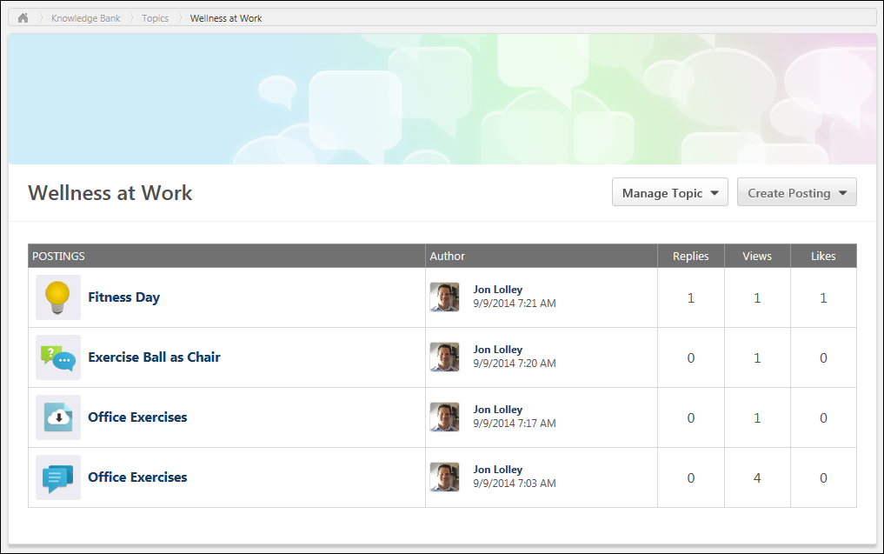

Connect - Live Feed Overview
The Live Feed page is the landing page for Connect. It displays user updates and activity updates from connections, team members, and users who have permission to broadcast company-wide messages.
Which types of updates appear in the feed is dependent upon the preferences set by the system administrator.
To access the Live Feed, go to Connect > Live Feed.
Permissions
PERMISSION NAME | PERMISSION DESCRIPTION | CATEGORY

Delete Connect Post/Comment | Grants ability to delete Connect user posts and comments within the user's permission constraints. This permission does not apply to activity updates. This permission can be constrained by OU, User's OU, User Self and Subordinates, and User's Self. The permission constraints apply to the creator of the post or comment. | New Connect

New Team | Grants ability to create new teams within the new Connect. This permission cannot be constrained. Which users are available is determined by the constraints upon the user's permission to view the Universal Profile - Bio page. | New Connect

Update Broadcast | Grants ability to broadcast organization-wide user updates within the new Connect. This permission cannot be constrained. | New Connect

View New Connect | Grants ability to view the new Connect pages, including Live Feed, All Teams, Team Overview, Team Feed, Team Tasks, Task Details, and Connections. This permission cannot be constrained. | New Connect
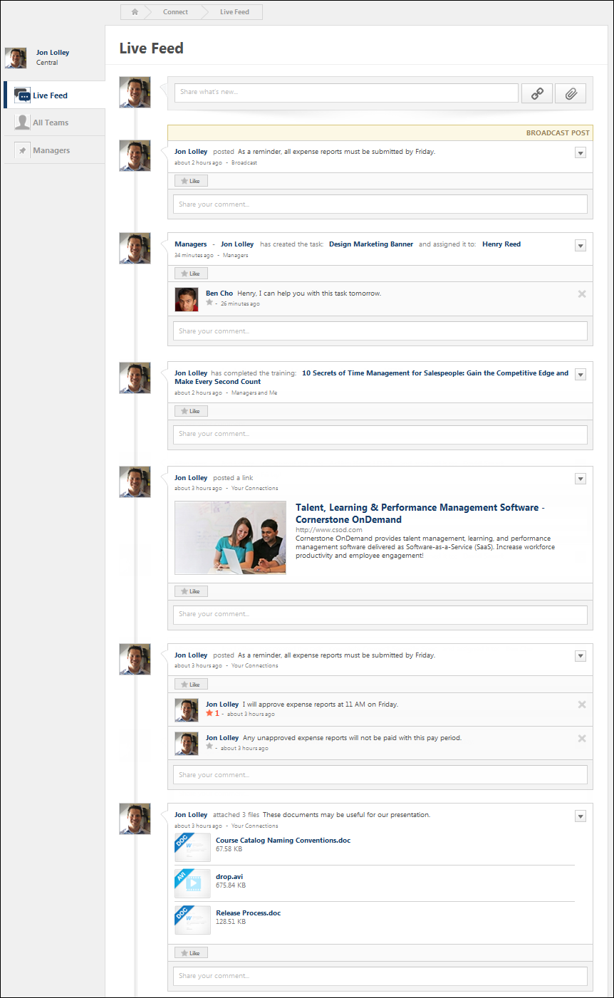
User Photograph
At the top of the page, the user's photograph is displayed. Click the photograph to open the Universal Profile - Bio page for the user. See Universal Profile - Bio Overview for additional information.
Post an Update
Users are able to post an update to their Live Feed. Updates can include file attachments and video attachments. Users can also determine who can see each update. The option to post an update is controlled by the system administrator. See Live Feed - Post an Update on page 183 for additional information.
View Updates/Postings
When someone posts an update that is visible to you, it appears on your Live Feed page. The information that is displayed varies depending on the type of update and what is included in the update. See Live Feed - View Update/Posting on page 185 for additional information.
Live Feed - Activity Updates and Visibility
Activity updates are system generated updates that are triggered by a user's actions within the system. For example, if a user completes a training item, this may trigger an activity update. Activity updates can be configured by the system administrator.
Which types of updates appear in the feed is dependent upon the preferences set by the system administrator. The following actions within the system may trigger an activity update:
Connect Activity Updates
Action | Visibility | User
Joined team | Team members | User who joined the team
Created and assigned task | Team members | Task assigner
Completed task | Team members | User who completed the task
Universal Profile Activity Updates
Action | Visibility | User
Goal (Feedback) | Direct and Indirect Managers and Target User | User who completed the goal
Badge given | Connections and Team | User who gave the badge
Learning Activity Updates
Action | Visibility | User
Rated training | Connections and Team - The update is only visible to a user if the rated learning object is available to the user. | User who rated the training item
Completed training | Direct and Indirect Managers and Target User | User who completed the training
Performance Activity Updates
Action | Visibility | User
Completed performance review | Direct and Indirect Managers and Target User | User who completed the performance review
Completed dev plan | Direct and Indirect Managers and Target User | User who completed the development plan
Live Feed - Add Comment to Update
When viewing another user's Live Feed page, you may be able to comment on a post. Note: The ability to reply to a posting is determined by your action group.
Click the Comment field to expand the Comment area and display your user photo and additional options. Enter your comment in the comment field directly below the post. The character limit is 10,000.
Click Share to add your comment to the update, or click Cancel to discard your comment.
Permissions
PERMISSION NAME | PERMISSION DESCRIPTION | CATEGORY

View New Connect | Grants ability to view the new Connect pages, including Live Feed, All Teams, Team Overview, Team Feed, Team Tasks, Task Details, and Connections. This permission cannot be constrained. | New Connect
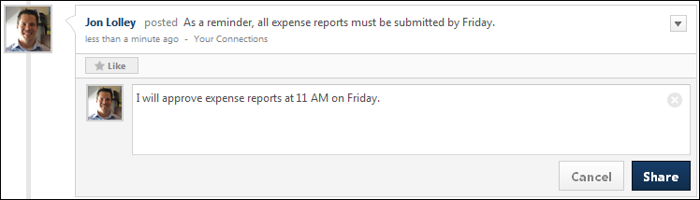
Live Feed - Attach a File
When posting an update to the Live Feed, you have the option to attach a file to the post. This can be done to share documents or provide reference material for your post. The option to attach a file to an update is controlled by the system administrator. See the File Restrictions section below for information on attachment restrictions.
Permissions
PERMISSION NAME | PERMISSION DESCRIPTION | CATEGORY

Create Media User Update | Grants ability to associate links and files with user updates and tasks. This permission cannot be constrained. | New Connect

View New Connect | Grants ability to view the new Connect pages, including Live Feed, All Teams, Team Overview, Team Feed, Team Tasks, Task Details, and Connections. This permission cannot be constrained. | New Connect
To attach a file to a post, click the Attach a File button.
When you click the Attach a File button, the Attachment area expands. You can attach a file by dragging and dropping a file into the Attachment area. You can also attach a file by clicking the Select a file button and select a file from your computer. Note: The drag-and-drop functionality is not supported by Internet Explorer browsers.
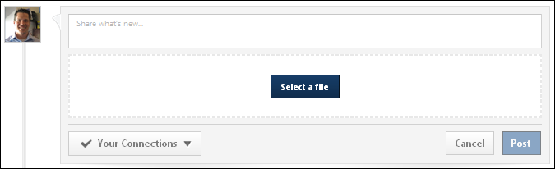
After a file is selected, the progress bar displays as the file is uploaded. After the file has loaded, the attachment appears below the comment box.
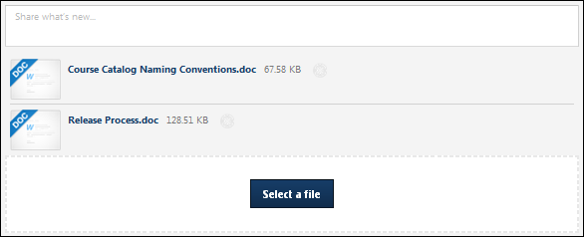
An attachment can be removed by clicking the Cancel icon to the right of the attachment name.
File Restrictions
The following file restrictions apply:
- Up to three files can be added.
- The maximum file size is configured by the system administrator. Administrators can update this maximum file size by contacting Global Customer Support.
- The file name cannot exceed 100 characters.
- Executable files cannot be uploaded.
- Files cannot have a hidden extension or no extension.
The following file types are allowed:
File Type | Extension
Audio | - mid  - m4a  - mp3  - wav
Compressed | - zip
Data | - xls/xlsx
Image | - bmp  - gif  - jpeg/jpg  - png  Image files are embedded in New Connect. If the file format is one of the supported image file types, then once the update, comment, or posting has been posted, the image will display at an enlarged size.  Pixel Limitations  Depending on where the image is being displayed, then it will display at different sizes while maintaining the original image's aspect ratio. If the original image's pixel width is under the maximum pixel width, then the image will display with its true pixel width and height.  If the image's width exceeds 877 pixels, then an enlarged thumbnail image will be saved. The image's aspect ratio will be maintained, but will be resized to have a maximum width of 877 pixels. The following width limitations apply:  image location maximum pixel width  Community Posting 877  Community Posting Comment 845  Community Posting Threaded Comment 802  Task Details 720  Team Overview Update 683  Feed User Update 675  Feed Activity Update 675  Note: .gif images that are larger than the page's parameters will be resized down and will lose any animation. The user can still download the original animated file.
Presentation | - pps/ppsx  - ppt/pptx
Project | - mpp
Recording | - arf
Text | - doc/docx  - dot/dotx  - htm/html - The ability to upload htm/html files is controlled by the system administrator. This limit is controlled by a backend setting,. Organizations may choose to disable the ability to upload HTML files because malicious HTML files may be uploaded, which is a potential security risk.  - pdf  - txt
Vector Graphic | - vsd
Video | - avi  - flv  - m4v  - mov  - mpeg/mpg  - mp4  - rm - This file type is not supported when attaching a video.  - swf - This file type is not supported when attaching a video.  - wma/wmv  Video files are embedded in New Connect. If the file format is a supported video file type, then the video file will be queued for transcoding. Acceptable video types are .mp4, .mov, .flv, and .asf/.wmv.  Once the transcoding process is complete, then the video file will display a small black video thumbnail, which indicates that the video can now be played inline. Clicking on this thumbnail will then display the video player and allow the user to play the video.  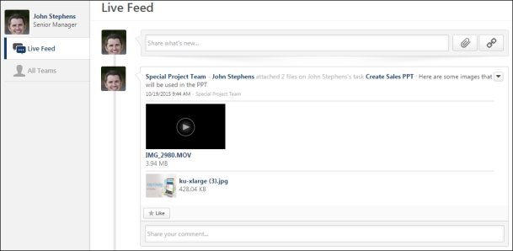  When playing the video, the size of the video player will depend on the page where the video is being displayed. See the Pixel Limitations table in the Image row above for sizing information.
Video Considerations
- Videos that are uploaded to the system can be streamed to the user with minimal buffering and interruptions.
- When uploading a video to the system, there are Internet browser considerations that determine the default format of the video. In addition, when using mp4 videos, organizations must perform additional configurations in order to ensure that mp4 videos play properly. See Video Streaming.
Live Feed - Delete Post or Comment
Users can delete an update post or comment from the Live Feed page. This option is only available if you have permission to delete Connect posts, and you can only delete comments or posts that have been made by users within your permission constraints.
To delete a connect post or activity update, click the drop-down arrow in the upper-right corner of the post. Then, select Delete. When a post is deleted, this also deletes any comments that are added to the post.
To delete a comment, click the Delete icon in the upper-right corner of the comment.
Permissions
PERMISSION NAME | PERMISSION DESCRIPTION | CATEGORY

Delete Activity Update | Grants ability to delete Connect activity updates within the user's permission constraints. This permission does not apply to user posts or comments. This permission can be constrained by OU, User's OU, User Self and Subordinates, and User's Self. The permission constraints apply to the creator of the post or comment. The availability of this permission is controlled by a backend setting. | New Connect

Delete Connect Post/Comment | Grants ability to delete Connect user posts and comments within the user's permission constraints. This permission does not apply to activity updates. This permission can be constrained by OU, User's OU, User Self and Subordinates, and User's Self. The permission constraints apply to the creator of the post or comment. | New Connect

View New Connect | Grants ability to view the new Connect pages, including Live Feed, All Teams, Team Overview, Team Feed, Team Tasks, Task Details, and Connections. This permission cannot be constrained. | New Connect
Delete Connect Post
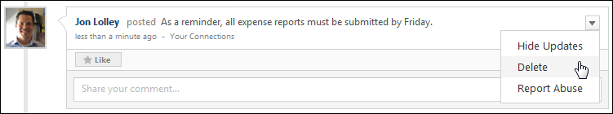
Delete Activity Update
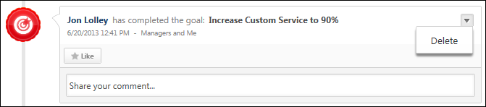
Delete Comment
Live Feed - Include URL Preview
When posting an update to the Live Feed, you can include a URL with the post.
Permissions
PERMISSION NAME | PERMISSION DESCRIPTION | CATEGORY

Create Media User Update | Grants ability to associate links and files with user updates and tasks. This permission cannot be constrained. | New Connect

View New Connect | Grants ability to view the new Connect pages, including Live Feed, All Teams, Team Overview, Team Feed, Team Tasks, Task Details, and Connections. This permission cannot be constrained. | New Connect
To include a URL with your post, click the Attach Link button to the right of the Update field. Then, in the URL field, enter the URL and click the Add button. Connect generates a URL preview that is displayed below the Update field. If the URL is an invalid URL, then no preview is displayed.
The URL preview includes the following information:
- A thumbnail image from the linked web page
- The linked web page name
- The linked URL
- The linked web page description
If Connect finds multiple images from the linked web page, you can select which image is displayed by clicking the Next button.
To exclude the URL preview image, select the No thumbnail checkbox. The URL preview information is still included, but the image is removed.
To remove the entire URL preview, click the Delete icon in the upper-right corner of the URL preview.
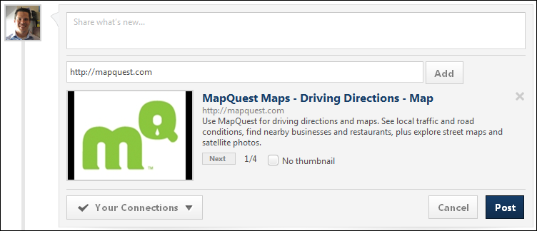
Live Feed - Like an Update or Comment
When viewing another user's Live Feed page, you may be able to like another user's update. This can be done to show users that you like a personal update, a file that was shared, an activity update, or a comment that was added to an update. Note: The ability to like a posting or posting reply is determined by your action group.
Permissions
PERMISSION NAME | PERMISSION DESCRIPTION | CATEGORY

View New Connect | Grants ability to view the new Connect pages, including Live Feed, All Teams, Team Overview, Team Feed, Team Tasks, Task Details, and Connections. This permission cannot be constrained. | New Connect
Updates
To like an update, click the Like button at the bottom of the update.
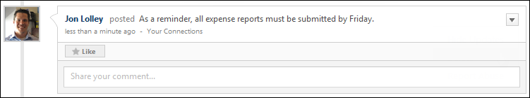
Once you have liked an update, the Like button changes to a Liked button. To unlike the update, click the Liked button.
Comments
To like a comment, click the gray star icon at the bottom of the comment.
Once you have liked a comment, the gray star icon changes to an orange star icon. To unlike the comment, click the orange star icon.
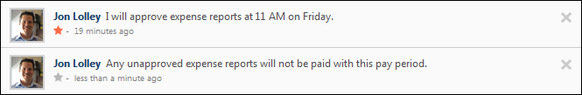
Live Feed - Post an Update
Users are able to post an update to their Live Feed. Updates can include file attachments and video attachments. Users can also determine who can see each update. The option to post an update is controlled by the system administrator.
To post an update, go to Connect > Live Feed. In the Update field, enter a text update. When you click within the Update field, the Update panel expands to show the visibility drop-down and Post and Cancel options.
Permissions
PERMISSION NAME | PERMISSION DESCRIPTION | CATEGORY

Create Media User Update | Grants ability to associate links and files with user updates and tasks. This permission cannot be constrained. | New Connect

Update Broadcast | Grants ability to broadcast organization-wide user updates within the new Connect. This permission cannot be constrained. | New Connect

View New Connect | Grants ability to view the new Connect pages, including Live Feed, All Teams, Team Overview, Team Feed, Team Tasks, Task Details, and Connections. This permission cannot be constrained. | New Connect
Emails
EMAIL NAME | EMAIL DESCRIPTION | ACTION TYPE

Connect Team Feed User Update | This email is triggered when a member of a Connect team posts a user update to the Team Feed. This email can be sent as a notification to Team Members, Team Lead, or a specific user. Note: This email is triggered when a parent post is created, whether it is posted directly from the Team Feed page or through the Live Feed page. Any attached files or links from the user update do not display in the email. | New Connect
Attach a File
To attach a file to your update, click the Attach File button to the right of the Update field. The option to post an update is controlled by the system administrator. See Live Feed - Attach a File on page 173 for additional information.
Include URL Preview
When posting an update to the Live Feed, you can include a URL with the post. See Live Feed - Include URL Preview on page 180 for additional information.
Determine Update Visibility
To determine who can see your update, select the appropriate option from the visibility drop-down list. The visibility applies to your update as well as any comments that are added to your update by others. Note: The visibility drop-down list is only available once you place your cursor in the Update field to expand the Update panel. The following options may be available:
- Your Connections - Select this option to make the update visible to only your connections.
- Team - If you are a member of one or more teams, each team appears in the drop-down list in alphabetical order after the Your connections option. Select a team to make the update visible to only the members of the selected team. This update is also displayed on the Team Feed for that team.
- Your direct and indirect reports - Select this option to make the update visible to all of your direct and indirect reports, regardless of whether they are connected.
- Broadcast - Select this option to make the update visible to all users who view the Live Feed. This includes all users within the organization except self-registered users. Broadcast updates are displayed at the top of the Live Feed between the filter drop-down list and the other user updates. Only one broadcast update is displayed at a time. This option is only available to users with permission to broadcast an update.
Post or Cancel
After entering the appropriate text, attaching any necessary files, and setting the update visibility, click Post to post the update, or click Cancel to discard the update. If enabled, the Connect Team Feed User Update email is triggered when a member of a Connect team posts a user update to the Team Feed.
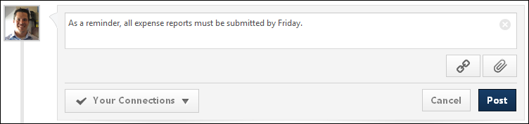
Live Feed - View Update/Posting
When someone posts an update that is visible to you, it appears on your Live Feed page. The information that is displayed varies depending on the type of update and what is included in the update.
Which types of updates appear in the feed is dependent upon the preferences set by the system administrator. The following types of updates may appear in your Live Feed:
- User Update - User updates are made manually by a user. These updates can include text, a URL, files, and videos. See Live Feed - View Update - User Update on page 192 for additional information.
- Activity Update - Activity updates are system generated updates that are triggered by a user's actions within the system. For example, if a user completes a training item, this may trigger an activity update. Activity updates can be configured by the system administrator. See Live Feed - View Update - Activity Update on page 187 for additional information.
- Broadcast Update - Broadcast updates are made manually by a user, similar to a user update. However, broadcast updates are visible to the entire organization except self-registered users. Broadcast updates appear at the top of the Live Feed at all times and can only be made by users with the appropriate permissions. See Live Feed - View Update - Broadcast Update on page 189 for additional information.
Permissions
PERMISSION NAME | PERMISSION DESCRIPTION | CATEGORY

Update Broadcast | Grants ability to broadcast organization-wide user updates within the new Connect. This permission cannot be constrained. | New Connect

View New Connect | Grants ability to view the new Connect pages, including Live Feed, All Teams, Team Overview, Team Feed, Team Tasks, Task Details, and Connections. This permission cannot be constrained. | New Connect
View Comments
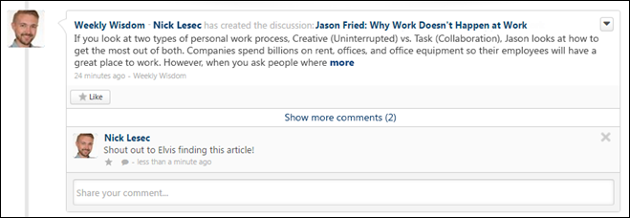
When users add comments to a post, the comments appear below the original post in reverse chronological order with the most recent comments displayed at the bottom. A timestamp is displayed with each comment to indicate when the comment was made. The timestamp is always displayed in the time zone of the user who is viewing the post.
- Show more comments - If a posting has more than one reply at its root level, select this link to view up to 10 of the most recent replies. If 10 comments are displayed and there are additional comments available, then a View full posting link is displayed. Select the link to view the Posting Details page in a new tab where all of the posting replies are visible.
- Show recent replies - If a posting reply has one or more replies,select this link or the Reply icon to view up to 10 of the most recent replies. If 10 comment replies are displayed and there are additional comment replies available, then a View full posting link is displayed. Select the link to view the Posting Details page in a new tab where all of the posting replies are visible.
Add a Comment to an Update
When viewing another user's Live Feed page, you may be able to comment on a post. Note: The ability to reply to a posting is determined by your action group. See Live Feed - Add Comment to Update on page 172 for additional information.
Like an Update or Comment
When viewing another user's Live Feed page, you may be able to like another user's update. This can be done to show users that you like a personal update, a file that was shared, an activity update, or a comment that was added to an update. Note: The ability to like a posting or posting reply is determined by your action group. See Live Feed - Like an Update or Comment on page 182 for additional information.
Delete a Post or Comment
Users can delete an update post or comment from the Live Feed page. This option is only available if you have permission to delete Connect posts, and you can only delete comments or posts that have been made by users within your permission constraints. See Live Feed - Delete Post or Comment on page 178 for additional information.
Live Feed - View Update - Activity Update
Activity updates are system generated updates that are triggered by a user's actions within the system. For example, if a user completes a training item, this may trigger an activity update. Activity updates can be configured by the system administrator. See Live Feed - Activity Updates and Visibility on page 171 for additional information.
Permissions
PERMISSION NAME | PERMISSION DESCRIPTION | CATEGORY

View New Connect | Grants ability to view the new Connect pages, including Live Feed, All Teams, Team Overview, Team Feed, Team Tasks, Task Details, and Connections. This permission cannot be constrained. | New Connect
The following information is displayed with each activity update post:
- User Image - An image of the user who posted the update is displayed next to each post. If the user does not have an image in the system, then a generic image is displayed. Click the photograph to open the Universal Profile - Bio page for the user.
- Team Name - If the update is posted to a Connect team, then the team name appears before the user's name. Click the team name to open the Team Feed page for the team.
- User Name - The name of the user who posted the update is displayed next to the user image. Click the user's name to open the Universal Profile - Bio page for the user.
- Update Text - The system generated update text is displayed next to the user's name.
- Timestamp - A timestamp is displayed with each update post to indicate when the post was made. The timestamp is always displayed in the time zone of the user who is viewing the feedback.
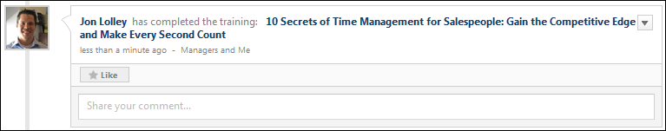
View Comments
When users add comments to a post, the comments appear below the original post in reverse chronological order with the most recent comments displayed at the bottom. A timestamp is displayed with each comment to indicate when the comment was made. The timestamp is always displayed in the time zone of the user who is viewing the post.
- Show more comments - If a posting has more than one reply at its root level, select this link to view up to 10 of the most recent replies. If 10 comments are displayed and there are additional comments available, then a View full posting link is displayed. Select the link to view the Posting Details page in a new tab where all of the posting replies are visible.
- Show recent replies - If a posting reply has one or more replies,select this link or the Reply icon to view up to 10 of the most recent replies. If 10 comment replies are displayed and there are additional comment replies available, then a View full posting link is displayed. Select the link to view the Posting Details page in a new tab where all of the posting replies are visible.
Add a Comment to an Update
When viewing another user's Live Feed page, you may be able to comment on a post. Note: The ability to reply to a posting is determined by your action group. See Live Feed - Add Comment to Update on page 172 for additional information.
Like an Update or Comment
When viewing another user's Live Feed page, you may be able to like another user's update. This can be done to show users that you like a personal update, a file that was shared, an activity update, or a comment that was added to an update. Note: The ability to like a posting or posting reply is determined by your action group. See Live Feed - Like an Update or Comment on page 182 for additional information.
Delete a Post or Comment
Users can delete an update post or comment from the Live Feed page. This option is only available if you have permission to delete Connect posts, and you can only delete comments or posts that have been made by users within your permission constraints. See Live Feed - Delete Post or Comment on page 178 for additional information.
Live Feed - View Update - Broadcast Update
Broadcast updates are made manually by a user, similar to a user update. However, broadcast updates are visible to the entire organization except self-registered users. Broadcast updates appear at the top of the Live Feed at all times and can only be made by users with the appropriate permissions. Only one broadcast update is displayed at a time. In addition, system administrators may set a default expiration date for broadcast updates, at which point the broadcast update is removed from the feed.
Permissions
PERMISSION NAME | PERMISSION DESCRIPTION | CATEGORY

View New Connect | Grants ability to view the new Connect pages, including Live Feed, All Teams, Team Overview, Team Feed, Team Tasks, Task Details, and Connections. This permission cannot be constrained. | New Connect
Similar to user updates, broadcast updates can include text, a URL, files, and videos.
The following information is displayed with a broadcast update post:
- User Image - An image of the user who posted the update is displayed next to each post. If the user does not have an image in the system, then a generic image is displayed. Click the photograph to open the Universal Profile - Bio page for the user.
- User Name - The name of the user who posted the update is displayed next to the user image. Click the user's name to open the Universal Profile - Bio page for the user.
- Update Text - The update text is displayed next to the user's name.
  - URL Preview - If the user included a URL in the update, then a preview of the URL may appear below the update text. Click the URL in the update text or click the URL preview, if included, to navigate to the URL web page.
  - Files - If the user attached files to the update, then the file names appear below the update text. Click the file name to open or download the attachment.
  - Video - If the user attached a video to the update, then a preview of the video may appear below the update text. Click the preview image to expand the video content area. Then, use the video controls to view the video directly on the Live Feed page.
- Timestamp - A timestamp is displayed with each update post to indicate when the post was made. The timestamp is always displayed in the time zone of the user who is viewing the feedback.
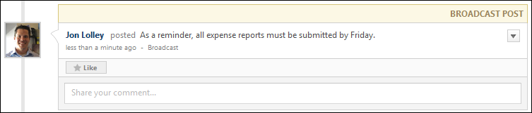
View Comments
When users add comments to a post, the comments appear below the original post in reverse chronological order with the most recent comments displayed at the bottom. A timestamp is displayed with each comment to indicate when the comment was made. The timestamp is always displayed in the time zone of the user who is viewing the post.
- Show more comments - If a posting has more than one reply at its root level, select this link to view up to 10 of the most recent replies. If 10 comments are displayed and there are additional comments available, then a View full posting link is displayed. Select the link to view the Posting Details page in a new tab where all of the posting replies are visible.
- Show recent replies - If a posting reply has one or more replies,select this link or the Reply icon to view up to 10 of the most recent replies. If 10 comment replies are displayed and there are additional comment replies available, then a View full posting link is displayed. Select the link to view the Posting Details page in a new tab where all of the posting replies are visible.
Add a Comment to an Update
When viewing another user's Live Feed page, you may be able to comment on a post. Note: The ability to reply to a posting is determined by your action group. See Live Feed - Add Comment to Update on page 172 for additional information.
Like an Update or Comment
When viewing another user's Live Feed page, you may be able to like another user's update. This can be done to show users that you like a personal update, a file that was shared, an activity update, or a comment that was added to an update. Note: The ability to like a posting or posting reply is determined by your action group. See Live Feed - Like an Update or Comment on page 182 for additional information.
Delete a Post or Comment
Users can delete an update post or comment from the Live Feed page. This option is only available if you have permission to delete Connect posts, and you can only delete comments or posts that have been made by users within your permission constraints. See Live Feed - Delete Post or Comment on page 178 for additional information.
Live Feed - Followed Content
Whenever a posting from a followed author, topic, or community is created, the activity is displayed in the Live feed as long as this activity update is enabled in Connect Preferences and the posting is available to the user.
To access the Live Feed, go to Connect > Live Feed.
Permissions
PERMISSION NAME | PERMISSION DESCRIPTION | CATEGORY

View New Connect | Grants ability to view the new Connect pages, including Live Feed, All Teams, Team Overview, Team Feed, Team Tasks, Task Details, and Connections. This permission cannot be constrained. | New Connect
The following information is displayed with each activity update post:
- User Image - An image of the user who created the posting is displayed next to each post. If the user does not have an image in the system, then a generic image is displayed. Click the photograph to open the Universal Profile - Bio page for the user.
- Community Name - The community in which the posting was created is displayed. Click the community name to open the community's Main page.
- User Name - The name of the user who created the posting is displayed to the right of the community name. Click the user's name to open the Universal Profile - Bio page for the user.
- Posting Name - The posting name is displayed. Click the posting name to open the posting.
- Timestamp - A timestamp is displayed with each update post to indicate when the post was made. The timestamp is always displayed in the time zone of the user who is viewing the posting.
- Visibility - The posting's visibility is displayed to the right of the timestamp.
- File or Link Attachment - If the posting has an attachment, then the attachment is displayed.
Live Feed - View Update - User Update
User updates are made manually by a user. These updates can include text, a URL, files, and videos.
Permissions
PERMISSION NAME | PERMISSION DESCRIPTION | CATEGORY

View New Connect | Grants ability to view the new Connect pages, including Live Feed, All Teams, Team Overview, Team Feed, Team Tasks, Task Details, and Connections. This permission cannot be constrained. | New Connect
The following information is displayed with each user update post:
- User Image - An image of the user who posted the update is displayed next to each post. If the user does not have an image in the system, then a generic image is displayed. Click the photograph to open the Universal Profile - Bio page for the user.
- Team Name - If the update is made visible to a Connect team, then the team name appears before the user's name. Click the team name to open the Team Feed page for the team.
- User Name - The name of the user who posted the update is displayed next to the user image. Click the user's name to open the Universal Profile - Bio page for the user.
- Update Text - The update text is displayed next to the user's name.
  - URL Preview - If the user included a URL in the update, then a preview of the URL may appear below the update text. Click the URL in the update text or click the URL preview, if included, to navigate to the URL web page.
  - Files - If the user attached files to the update, then the file names appear below the update text. Click the file name to open or download the attachment.
  - Video - If the user attached a video to the update, then a preview of the video may appear below the update text. Click the preview image to expand the video content area. Then, use the video controls to view the video directly on the Live Feed page.
- Timestamp - A timestamp is displayed with each update post to indicate when the post was made. The timestamp is always displayed in the time zone of the user who is viewing the feedback.
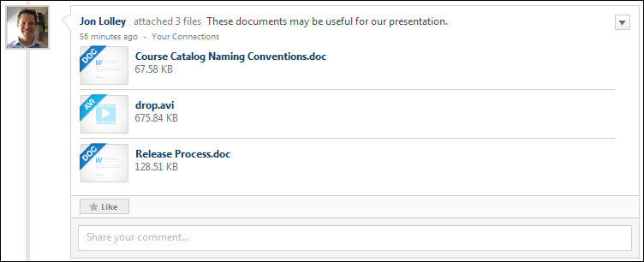
View Comments
When users add comments to a post, the comments appear below the original post in reverse chronological order with the most recent comments displayed at the bottom. A timestamp is displayed with each comment to indicate when the comment was made. The timestamp is always displayed in the time zone of the user who is viewing the post.
- Show more comments - If a posting has more than one reply at its root level, select this link to view up to 10 of the most recent replies. If 10 comments are displayed and there are additional comments available, then a View full posting link is displayed. Select the link to view the Posting Details page in a new tab where all of the posting replies are visible.
- Show recent replies - If a posting reply has one or more replies,select this link or the Reply icon to view up to 10 of the most recent replies. If 10 comment replies are displayed and there are additional comment replies available, then a View full posting link is displayed. Select the link to view the Posting Details page in a new tab where all of the posting replies are visible.
Add a Comment to an Update
When viewing another user's Live Feed page, you may be able to comment on a post. Note: The ability to reply to a posting is determined by your action group. See Live Feed - Add Comment to Update on page 172 for additional information.
Like an Update or Comment
When viewing another user's Live Feed page, you may be able to like another user's update. This can be done to show users that you like a personal update, a file that was shared, an activity update, or a comment that was added to an update. Note: The ability to like a posting or posting reply is determined by your action group. See Live Feed - Like an Update or Comment on page 182 for additional information.
Delete a Post or Comment
Users can delete an update post or comment from the Live Feed page. This option is only available if you have permission to delete Connect posts, and you can only delete comments or posts that have been made by users within your permission constraints. See Live Feed - Delete Post or Comment on page 178 for additional information.

Postings Overview
Posting Action - Attach File
When creating or replying to a posting, you have the option to attach a file to the posting. This can be done to share documents or provide reference material for your post. The option to attach a file to an update is controlled by the system administrator. See the Attachment Restrictions section below for information on attachment restrictions.
Permissions
PERMISSION NAME | PERMISSION DESCRIPTION | CATEGORY

View Knowledge Bank/Communities | Grants ability to view the Knowledge Bank and Communities pages. This permission can be constrained by OU and User's OU. This permission is assigned to the default Administrator role by default. | New Connect
To attach a file to a post, click the Attach a File button.
When you click the Attach a File button, the Attachment area expands. You can attach a file by dragging and dropping a file into the Attachment area. You can also attach a file by clicking the Select a file button and select a file from your computer. Note: The drag-and-drop functionality is not supported by Internet Explorer browsers.
After a file is selected, the progress bar displays as the file is uploaded. After the file has loaded, the attachment appears below the comment box.
An attachment can be removed by clicking the Cancel icon to the right of the attachment name.
Attachment Restrictions
The following attachment restrictions apply:
- Up to three attachments or one video can be added to a post.
- The maximum file size is configured by the system administrator. This limit is controlled by a backend setting, which can be increased up to 1 GB.
- The attachment file name cannot exceed 100 characters.
- Executable files cannot be uploaded.
- Files cannot have a hidden extension or no extension.
The following file types are allowed:
File Type | Extension
Audio | - mid  - m4a  - mp3  - wav
Compressed | - zip
Data | - xls/xlsx
Image | - bmp  - gif  - jpeg/jpg  - png  Image files are embedded in New Connect. If the file format is one of the supported image file types, then once the update, comment, or posting has been posted, the image will display at an enlarged size.  Pixel Limitations  Depending on where the image is being displayed, then it will display at different sizes while maintaining the original image's aspect ratio. If the original image's pixel width is under the maximum pixel width, then the image will display with its true pixel width and height.  If the image's width exceeds 877 pixels, then an enlarged thumbnail image will be saved. The image's aspect ratio will be maintained, but will be resized to have a maximum width of 877 pixels. The following width limitations apply:  image location maximum pixel width  Community Posting 877  Community Posting Comment 845  Community Posting Threaded Comment 802  Task Details 720  Team Overview Update 683  Feed User Update 675  Feed Activity Update 675  Note: .gif images that are larger than the page's parameters will be resized down and will lose any animation. The user can still download the original animated file.
Presentation | - pps/ppsx  - ppt/pptx
Project | - mpp
Recording | - arf
Text | - doc/docx  - dot/dotx  - htm/html - The ability to upload htm/html files is controlled by the system administrator. This limit is controlled by a backend setting,. Organizations may choose to disable the ability to upload HTML files because malicious HTML files may be uploaded, which is a potential security risk.  - pdf  - txt
Vector Graphic | - vsd
Video | - avi  - flv  - m4v  - mov  - mpeg/mpg  - mp4  - rm - This file type is not supported when attaching a video.  - swf - This file type is not supported when attaching a video.  - wma/wmv  Video files are embedded in New Connect. If the file format is a supported video file type, then the video file will be queued for transcoding. Acceptable video types are .mp4, .mov, .flv, and .asf/.wmv.  Once the transcoding process is complete, then the video file will display a small black video thumbnail, which indicates that the video can now be played inline. Clicking on this thumbnail will then display the video player and allow the user to play the video.  When playing the video, the size of the video player will depend on the page where the video is being displayed. See the Pixel Limitations table in the Image row above for sizing information.
Posting Action - Delete Posting or Reply
Users may be able to delete a posting or reply from the posting page. This option is only available to topic moderators, community moderators, administrators, and users who belong to an action group that allows them to delete postings or replies. Users may be able to delete any posting or reply or only postings or replies that they have created. See Action Group - Create/Edit on page 10 for additional information.
Permissions
PERMISSION NAME | PERMISSION DESCRIPTION | CATEGORY

View Knowledge Bank/Communities | Grants ability to view the Knowledge Bank and Communities pages. This permission can be constrained by OU and User's OU. This permission is assigned to the default Administrator role by default. | New Connect
Delete Posting
- To delete a posting, select Delete Posting from the Options drop-down menu. When a posting is deleted, this also deletes any files or replies that are added to the posting.
- To delete a reply, select Delete Comment from the drop-down menu in the upper-right corner of the reply. When a reply is deleted, this also deletes any files that are added to the reply.
A confirmation pop-up appears. Click Delete to confirm the deletion, or click Cancel to cancel the delete action.
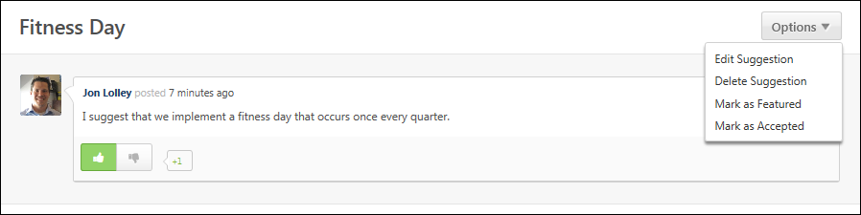
Delete Comment/Reply
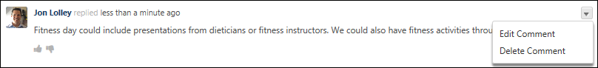
Posting Action - Edit Posting or Reply
Users can edit a posting or reply from the posting page. This option is only available to the author of the posting, community moderators, and users with permission to manage Knowledge Bank and Communities Administration.
- To edit a posting, select Edit Posting from the Options drop-down menu.
- To edit a reply, select Edit Comment from the drop-down menu in the upper-right corner of the reply.
Permissions
PERMISSION NAME | PERMISSION DESCRIPTION | CATEGORY

View Knowledge Bank/Communities | Grants ability to view the Knowledge Bank and Communities pages. This permission can be constrained by OU and User's OU. This permission is assigned to the default Administrator role by default. | New Connect
Edit Posting
Discussion Posting
The user can edit the posting Title and Body fields. The rich text editor is available.
If no file or link were previously attached, then the user has the option to attach a link or file.
If a link was previously attached, then the attachment appears below the Body field. The URL textbox is populated with the attached link.
- Users can attach a new link by entering a new URL in the field and clicking the Add button. The link preview is updated to reflect the new link. Users have the option to change the link preview image or not display a link preview image.
- Users can remove an attached link by clicking the Remove icon in the upper-right corner of the link preview. However, after the link attachment is removed, the user only has the option to attach a new link. The option to attach a file is not available until the posting is saved and then edited again.
If a file was previously attached, then the attachment appears below the Body field.
- Users can attach a new file or additional files by clicking the Select a file button.
- Users can remove an attached file by clicking the Remove icon to the right of the file name and size. However, after the file attachment is removed, the user only has the option to attach a new file. The option to attach a link is not available until the posting is saved and then edited again.
File Posting
The user can edit the posting Title and Body fields. The rich text editor is available.
The attachment appears below the Title field. Users can attach a new file by clicking the Select a file button. Users can remove an attached file by clicking the Remove icon to the right of the file name and size. However, a file must be selected in order to save the posting.
Q&A Posting
The user can edit the posting Title and Body fields. The rich text editor is available.
Suggestion Posting
The user can edit the posting Title and Body fields. The rich text editor is available.
Done or Cancel
After making the necessary changes, click Done to save the changes, or click Cancel to discard any unsaved changes.
Edit Comment/Reply
The user can edit the Comment field. The rich text editor is available.
No Attachment
If no file or link were previously attached, then the user has the option to attach a link or file.
Link Attachment
If a link was previously attached, then the attachment appears below the Comment field. The URL textbox is populated with the attached link.
Users can attach a new link by entering a new URL in the field and clicking the Add button. The link preview is updated to reflect the new link. Users have the option to change the link preview image or not display a link preview image.
Users can remove an attached link by clicking the Remove icon in the upper-right corner of the link preview. However, after the link attachment is removed, the user only has the option to attach a new link. The option to attach a file is not available until the posting is saved and then edited again.
File Attachment
If a file was previously attached, then the attachment appears below the Comment field. Users can attach a new file or additional files by clicking the Select a file button.
Users can remove an attached file by clicking the Remove icon to the right of the file name and size. However, after the file attachment is removed, the user only has the option to attach a new file. The option to attach a link is not available until the posting is saved and then edited again.
Done or Cancel
After making the necessary changes, click Done to save the changes, or click Cancel to discard any unsaved changes.
Posting Action - Include URL Preview
When creating or replying to a posting, you can include a URL with the post.
Permissions
PERMISSION NAME | PERMISSION DESCRIPTION | CATEGORY

View Knowledge Bank/Communities | Grants ability to view the Knowledge Bank and Communities pages. This permission can be constrained by OU and User's OU. This permission is assigned to the default Administrator role by default. | New Connect
To include a URL with your post, click the Attach Link button . Then, in the URL field, enter the URL and click the Add button. Knowledge Bank generates a URL preview that is displayed below the field. If the URL is an invalid URL, then no preview is displayed.
The URL preview includes the following information:
- A thumbnail image from the linked web page
- The linked web page name
- The linked URL
- The linked web page description
If Knowledge Bank finds multiple images from the linked web page, you can select which image is displayed by clicking the Next button.
To exclude the URL preview image, select the No thumbnail checkbox. The URL preview information is still included, but the image is removed.
To remove the entire URL preview, click the Delete icon in the upper-right corner of the URL preview.
Posting Action - Like a Posting or a Reply
Users are able to like another user's posting or reply. This can be done to show users that you like the posting content. Note: The ability to like a posting or posting reply is determined by your action group.
Permissions
PERMISSION NAME | PERMISSION DESCRIPTION | CATEGORY

View Knowledge Bank/Communities | Grants ability to view the Knowledge Bank and Communities pages. This permission can be constrained by OU and User's OU. This permission is assigned to the default Administrator role by default. | New Connect
Postings and Replies
To like a posting or reply, click the Like button at the bottom of the posting or reply. If other users have already liked the posting or reply, then the number of users who currently like it is displayed to the right of the Like button.
Once you have liked a posting or reply, the Like button changes to a Liked button. To unlike the update, click the Liked button.
Comments
To like a comment, click the gray star icon at the bottom of the comment.
Once you have liked a comment, the gray star icon changes to an orange star icon. To unlike the comment, click the orange star icon.
Posting Action - Mark as Featured
Topic moderators, community moderators, and administrators can mark a posting as featured. When a posting is featured, the posting is displayed above non-featured postings in the Postings table on the Topic Details page to which the posting belongs. The posting also appears in the Featured widget on the main page of the Knowledge Bank or the community to which the posting belongs. Also, a Featured tag displays on the posting page.
To mark a posting as featured, select Mark as Featured from the Options drop-down menu. This option is only available to moderators and administrators. If enabled, the Knowledge Bank/Communities New Featured Posting email is triggered when a posting is marked as featured in the Knowledge Bank or community.
Permissions
PERMISSION NAME | PERMISSION DESCRIPTION | CATEGORY

View Knowledge Bank/Communities | Grants ability to view the Knowledge Bank and Communities pages. This permission can be constrained by OU and User's OU. This permission is assigned to the default Administrator role by default. | New Connect
Emails
EMAIL NAME | EMAIL DESCRIPTION | ACTION TYPE

Knowledge Bank/Communities New Featured Posting | This email is triggered when a posting is marked as featured in the Knowledge Bank or a community. This email can be sent as a notification to Posting Creator, Community Moderator, Community Members, or a specific user. Note: This email is triggered any time a posting is marked as featured, even if the posting was unmarked and then remarked as featured. A recipient must match the following criteria to receive the email:  - User is within the availability criteria for the corresponding posting's parent topic.  - User is within the constraints of the posting's parent topic's creator constraints.  - User is a member of one of the communities with which the topic is shared. | New Connect
Posting Action - Reply
Users are able to reply to another user's posting and other posting comments.
To reply to a posting, click the Comment field to expand the Comment section and display additional options. Enter your reply in the field below the posting, up to 10,000 characters.
The reply to an existing reply, click the Comment icon in the lower-left corner of the reply. Doing so opens a text box. The location of the text box depends on the number of existing replies:
- Replying to a reply thread with three or more existing replies opens a text box directly beneath the last threaded reply.
- Replying to a reply thread with two or fewer existing replies opens a text box at the bottom of the page.
You also have the option to attach a URL or file to the reply.
- See Posting Action - Attach File on page 196 for additional information.
- See Posting Action - Include URL Preview on page 204 for additional information.
Hashtags cannot be used to create a tag when commenting on a posting.
Note: To prevent cross site scripting (XSS), any HTML using encoded Javascript will be sanitized.
Click Reply to add your reply to the posting, or click Cancel to discard your reply. If enabled, the Knowledge Bank/Communities Reply email is triggered when a user replies to a posting in the Knowledge Bank or community.
Users may be able to delete a posting or reply from the posting page. This option is only available to topic moderators, community moderators, administrators, and users who belong to an action group that allows them to delete postings or replies. See Posting Action - Delete Posting or Reply on page 200 for additional information.
Permissions
PERMISSION NAME | PERMISSION DESCRIPTION | CATEGORY

View Knowledge Bank/Communities | Grants ability to view the Knowledge Bank and Communities pages. This permission can be constrained by OU and User's OU. This permission is assigned to the default Administrator role by default. | New Connect
Emails
EMAIL NAME | EMAIL DESCRIPTION | ACTION TYPE

Knowledge Bank/Communities Reply | This email is triggered when a user replies to a posting in the Knowledge Bank or a community. This email can be sent as a notification to Author, Community Moderator, Community Members, Follower, or a specific user. If the reply is added directly to the posting, then Author refers to the posting creator. If the reply is added to another reply, then Author refers to the posting creator and the author of the original reply. Note: This email is triggered even if the same user makes multiple replies to the same posting. | New Connect
Posting Action - Vote Posting or Reply
Users may be able to vote for or against a posting or reply by clicking the Upvote or Downvote icons. Voting for or against a posting or reply enables users to indicate whether they support or do not support the posting or reply. Note: The ability to vote for a posting or posting reply is determined by the user's action group.
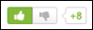
Permissions
PERMISSION NAME | PERMISSION DESCRIPTION | CATEGORY

View Knowledge Bank/Communities | Grants ability to view the Knowledge Bank and Communities pages. This permission can be constrained by OU and User's OU. This permission is assigned to the default Administrator role by default. | New Connect
Upvote
Voting for a posting or reply indicates that you like or agree with the posting or reply. For example, if you vote for a suggestion, this indicates that you support the suggestion and would like to have the suggestion implemented. If you vote for a Q&A reply, this indicates that you agree with the question's answer. Clicking the Upvote icon increases the vote counter by one. Also, the Upvote icon appears selected. Users can click the Upvote icon again to remove their upvote, which also decreases the vote counter by one.
Downvote
Voting against a posting or reply indicates that you dislike or disagree with the posting or reply. For example, if you vote against a suggestion, this indicates that you do not support the suggestion and would not like to have the suggestion implemented. If you vote against a Q&A reply, this indicates that you disagree with the question's answer. Clicking the Downvote icon decreases the vote counter by one. Also, the Downvote icon appears selected. Users can click the Downvote icon again to remove their downvote, which also increases the vote counter by one.
Vote Counter
The vote counter appears to the right of the Upvote/Downvote icons and indicates the overall vote score for the posting or reply. If the vote count is less than zero, then a negative sign (-) appears in front of the vote count. Users can hover the computer cursor over the vote count to view the name of the latest 10 users who voted for or against the suggestion. Note: If the overall vote count is zero, then the vote counter does not appear.
Posting Type - Discussion - Create
Topic members are able to create postings. These postings can include file attachments and URL previews.
To create a discussion posting, click the appropriate topic title from anywhere in the Knowledge Bank or communities. Then, from the Create Posting drop-down menu, select Create Discussion.
Permissions
PERMISSION NAME | PERMISSION DESCRIPTION | CATEGORY

View Knowledge Bank/Communities | Grants ability to view the Knowledge Bank and Communities pages. This permission can be constrained by OU and User's OU. This permission is assigned to the default Administrator role by default. | New Connect
Emails
EMAIL NAME | EMAIL DESCRIPTION | ACTION TYPE

Knowledge Bank/Communities New Posting Created | This email is triggered when a new Knowledge Bank or community posting is created. This email can be sent as a notification to Community Moderator, Community Members, Follower, or a specific user. A recipient must match the following criteria to receive the email:  - User is within the availability criteria for the corresponding posting's parent topic.  - User is within the constraints of the posting's parent topic's creator constraints.  - User is a member of one of the communities with which the topic is shared. | New Connect
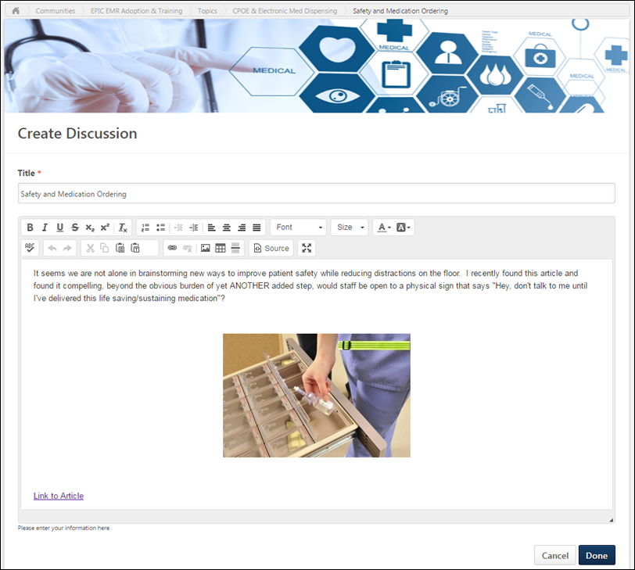
Posting Title and Body
Enter the following information for the discussion:
- Title - Enter a title for the posting, up to 70 characters. This title will appear at the top of the posting page.
- Body - Enter the body of the posting, up to 10,000 characters. When creating or editing the body of a posting, users can use the full text editor to align text, change text font, update text size, add color to text, insert line breaks, embed links, tables, and images in a post, and paste content from Microsoft Word.
Considerations
The full text editor available when creating a the body of a posting is not available in the following areas:
- Replying to a posting
- Posting to the Live Feed
- Posting to the Team Feed
- Posting to the Community Feed
- Editing the community description
- Editing the topic description
Attach a File
To attach a file to your update, click the Attach File button to the right of the Update field. The option to post an update is controlled by the system administrator. The Attachment Restrictions section below provides a complete list of attachment restrictions.
Include URL Preview
When creating or replying to a posting, you can include a URL with the post. See Posting Action - Include URL Preview on page 204 for additional information.
Tags
This section enables users to add tags or keywords to their posting. Once the posting is saved, the tags appears as links on the posting, and users can click a tag to view all postings that have the same tag. For example, if you add a "Time Management" tag to your posting, then clicking this tag will display all postings that include the "Time Management" tag. This is an effective way to categorize your posting. Once the posting is saved, you can use the tag to find other postings that have similar content.
To add a tag, enter the tag name in the field. Multiple tags can be added by adding a comma after each tag or by pressing [Enter] after each tag. Users can add new or existing tags. Tags are not case-sensitive or accent-sensitive, however the tag is captured as it is entered (e.g., Management is the same as management and elephant is the same as élephant). Each tag can contain a maximum of 70 characters, and the character limit for all tags in a posting is 200. Note: If a user enters a tag name that is a system-defined tag such as Featured, then this is added as a user-defined tag, which behaves differently than a system-defined tag.
To select a tag from a list of existing tags, click the Add Existing Tags link. This opens a pop-up, in which all existing user-defined tags are displayed. Note: System-defined tags cannot be selected. These tags are automatically associated with a posting. See Single Item Select Pop-up.
To remove a tag, click the Delete icon to the right of the tag name.
Hashtags
Hashtags can now be used in the body of the posting, and the system will apply the text after the hashtags as tags once the posting submitted.
Hashtags cannot be used within the posting title or within posting comments.
To add a tag to a posting using hashtags, enter a hashtag "#" within the posting body, and the text following the hashtag will be converted into a tag once the posting is submitted.
- Hashtags are not affected by accents on characters. Accents on characters are included in the tag.
- Spaces, new lines, and special characters end a hashtag.
A maximum of 200 tags can be added to a posting. If a posting has reached the maximum number of tags, then no additional tags are added, even if a hashtag is added to the posting body.
In order to remove a hashtag tag, the hashtag must be removed from the body of the posting, and the tag must be removed from the Tags field.
The following are examples of hashtags with spaces and special characters and the resulting tags:
Hashtag | Resulting Tag
#élephant | élephant
#Leadership and Responsibility | Leadership
#fish&chips | fish
#web2.0 | web2
#isn't | isn
#a-b | a
#*.*
#yay! | yay
Administrator Note: Tags in Cohorts
Tags can be added to postings when creating a community template for a program.
When a cohort is created, the tags are added to the postings within the new cohort.
When a tag is removed from a posting within a community template, the tag is not removed from any existing postings within cohorts that have been created from the community template.
Posting Visibility
The visibility of a posting within a topic is determined by the availability settings of the topic. Users can view all postings within a topic if they have access to the topic.
Done or Cancel
After entering the appropriate text and attaching any necessary files, click Done to create the posting, or click Cancel to discard the posting. If enabled, the Knowledge Bank/Communities New Posting Created email is triggered when a posting is created in the Knowledge Bank or community.
Attachment Restrictions
The following attachment restrictions apply:
- Up to three attachments or one video can be added to a post.
- The maximum file size is configured by the system administrator. This limit is controlled by a backend setting, which can be increased up to 1 GB.
- The attachment file name cannot exceed 100 characters.
- Executable files cannot be uploaded.
- Files cannot have a hidden extension or no extension.
The following file types are allowed:
File Type | Extension
Audio | - mid  - m4a  - mp3  - wav
Compressed | - zip
Data | - xls/xlsx
Image | - bmp  - gif  - jpeg/jpg  - png  Image files are embedded in New Connect. If the file format is one of the supported image file types, then once the update, comment, or posting has been posted, the image will display at an enlarged size.  Pixel Limitations  Depending on where the image is being displayed, then it will display at different sizes while maintaining the original image's aspect ratio. If the original image's pixel width is under the maximum pixel width, then the image will display with its true pixel width and height.  If the image's width exceeds 877 pixels, then an enlarged thumbnail image will be saved. The image's aspect ratio will be maintained, but will be resized to have a maximum width of 877 pixels. The following width limitations apply:  image location maximum pixel width  Community Posting 877  Community Posting Comment 845  Community Posting Threaded Comment 802  Task Details 720  Team Overview Update 683  Feed User Update 675  Feed Activity Update 675  Note: .gif images that are larger than the page's parameters will be resized down and will lose any animation. The user can still download the original animated file.
Presentation | - pps/ppsx  - ppt/pptx
Project | - mpp
Recording | - arf
Text | - doc/docx  - dot/dotx  - htm/html - The ability to upload htm/html files is controlled by the system administrator. This limit is controlled by a backend setting,. Organizations may choose to disable the ability to upload HTML files because malicious HTML files may be uploaded, which is a potential security risk.  - pdf  - txt
Vector Graphic | - vsd
Video | - avi  - flv  - m4v  - mov  - mpeg/mpg  - mp4  - rm - This file type is not supported when attaching a video.  - swf - This file type is not supported when attaching a video.  - wma/wmv  Video files are embedded in New Connect. If the file format is a supported video file type, then the video file will be queued for transcoding. Acceptable video types are .mp4, .mov, .flv, and .asf/.wmv.  Once the transcoding process is complete, then the video file will display a small black video thumbnail, which indicates that the video can now be played inline. Clicking on this thumbnail will then display the video player and allow the user to play the video.  When playing the video, the size of the video player will depend on the page where the video is being displayed. See the Pixel Limitations table in the Image row above for sizing information.
Posting Type - Discussion - View
A discussion posting enables multiple users to engage in a discussion. Discussion postings support rich text and can also contain files, videos, and links.
To view a posting, click the posting title from anywhere in the Knowledge Bank or communities.
Permissions
PERMISSION NAME | PERMISSION DESCRIPTION | CATEGORY

Manage Knowledge Bank/Communities Administration | Grants ability to view the New Knowledge Bank Administration page and manage Action Groups. Based on permission constraints, administrators with this permission can create and delete topics and subtopics. Administrators with this permission can view all communities, topics, sub-topics and postings, regardless of availability. In addition, administrators can add a posting to the Course Catalog. When creating a topic, the constraints on this permission are automatically applied to the topic's availability. This permission can be constrained by OU and User's OU. This permission is assigned to the default Administrator role by default. | New Connect

View Knowledge Bank/Communities | Grants ability to view the Knowledge Bank and Communities pages. This permission can be constrained by OU and User's OU. This permission is assigned to the default Administrator role by default. | New Connect
Banner Image
At the top of the posting, the community's banner image is displayed.
Discussion Title
At the top of the page, the discussion title is displayed.
Options
The Options drop-down is only available to a user if the user has access to at least one of the options.
The following options are available in the Options drop-down menu:
- Follow Discussion - This option is available to all users who are members of the posting's community. When this option is selected, the user may receive email notifications whenever a reply is added to the posting. Also, the posting appears in the Following section of the user's Universal Profile: Bio.
- Unfollow Discussion - When this option is selected, the user is no longer following the posting.
- Edit Discussion - Select this option to edit the posting. This option is only available to the author of the posting, community moderators, and users with permission to manage Knowledge Bank and Communities Administration.
- Delete Discussion - Select this option to delete the posting. This option is only available to topic moderators, community moderators, administrators, and users who belong to an action group that allows them to delete postings. See Posting Action - Delete Posting or Reply on page 200 for additional information.
- Mark as Featured - Select this option to mark the posting as a featured posting. This option is only available to topic moderators, community moderators, and administrators. See Posting Action - Mark as Featured on page 206 for additional information.
- Training Details - Select this option to view the LO Details page for the discussion posting, which is a material LO. This option is only available if the posting has already been added to the Course Catalog. See Learning Object (LO) Details Page for additional information.
Original Posting and Responses
The original posting is displayed at the top of the posting, and all responses are displayed below the original post. The oldest responses are displayed first. Secondary replies are indented to denote hierarchy. Secondary replies can be edited, liked, and deleted, but users cannot reply to a secondary reply. If there are three or more existing replies, only two replies are displayed and a View previous replies link displays. Users can click the link to view all previous replies.
The following information is displayed for each post:
- User Image - An image of the user is displayed next to each post. If the user does not have an image in the system, then a generic image is displayed. Click the photograph to open the Universal Profile - Bio page for the user.
- User Name - The name of the user who added the posting is displayed next to the user image. Click the user's name to open the Universal Profile - Bio page for the user.
- Timestamp - A timestamp is displayed with each posting to indicate when it was made. The timestamp is always displayed in the time zone of the user who is viewing the feedback.
- Posting Text - The posting text is displayed below the user's name.
  - URL Preview - If the user included a URL in the posting, then a preview of the URL may appear below the text. Click the URL in the text or click the URL preview, if included, to navigate to the URL web page.
  - Files - If the user attached files to the posting, then the file names appear below the posting text. Click the file name to open or download the attachment.
- Like - Users are able to like another user's posting or reply. This can be done to show users that you like the posting content. Note: The ability to like a posting or posting reply is determined by your action group. See Posting Action - Like a Posting or a Reply on page 205 for additional information.
Posting Tags
Any user-defined tags that are associated with the posting are displayed below the body of the posting. System tags are displayed before user-defined tags.
Users can click one of the tags to initiate a search within Global Search for all postings that contain the selected tag. Users can only view postings which they can access. Note: The ability to click a posting tag to initiate a search is only available if the ability to search for Connect postings by tag is enabled via Search Preferences.
The following system-defined tags may appear below the original posting:
- Featured - This tag is displayed if the posting has been marked as Featured by the moderator or administrator.
- Learning Object - This tag is displayed if the posting has been added to the Course Catalog as a learning object by the administrator.
Reply to Posting or Comment
Users are able to reply to another user's posting and other posting comments. See Posting Action - Reply on page 207 for additional information.
Delete Posting or Reply
Users may be able to delete a posting or reply from the posting page. This option is only available to topic moderators, community moderators, administrators, and users who belong to an action group that allows them to delete postings or replies. See Posting Action - Delete Posting or Reply on page 200 for additional information.
Emails
EMAIL NAME | EMAIL DESCRIPTION | ACTION TYPE

Knowledge Bank/Communities Reply | This email is triggered when a user replies to a posting in the Knowledge Bank or a community. This email can be sent as a notification to Author, Community Moderator, Community Members, Follower, or a specific user. If the reply is added directly to the posting, then Author refers to the posting creator. If the reply is added to another reply, then Author refers to the posting creator and the author of the original reply. Note: This email is triggered even if the same user makes multiple replies to the same posting. | New Connect
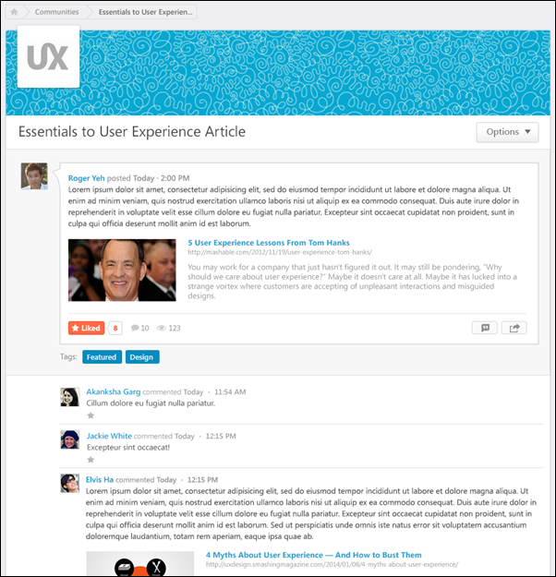
Posting Type - File - Create
Topic members are able to create postings. These postings can include file attachments and URL previews.
When creating a File type posting, only one attachment can be added to the posting.
To create a file posting, click the appropriate topic title from anywhere in the Knowledge Bank or communities. Then, from the Create Posting drop-down menu, select Create Discussion.
Permissions
PERMISSION NAME | PERMISSION DESCRIPTION | CATEGORY

View Knowledge Bank/Communities | Grants ability to view the Knowledge Bank and Communities pages. This permission can be constrained by OU and User's OU. This permission is assigned to the default Administrator role by default. | New Connect
Emails
EMAIL NAME | EMAIL DESCRIPTION | ACTION TYPE

Knowledge Bank/Communities New Posting Created | This email is triggered when a new Knowledge Bank or community posting is created. This email can be sent as a notification to Community Moderator, Community Members, Follower, or a specific user. A recipient must match the following criteria to receive the email:  - User is within the availability criteria for the corresponding posting's parent topic.  - User is within the constraints of the posting's parent topic's creator constraints.  - User is a member of one of the communities with which the topic is shared. | New Connect
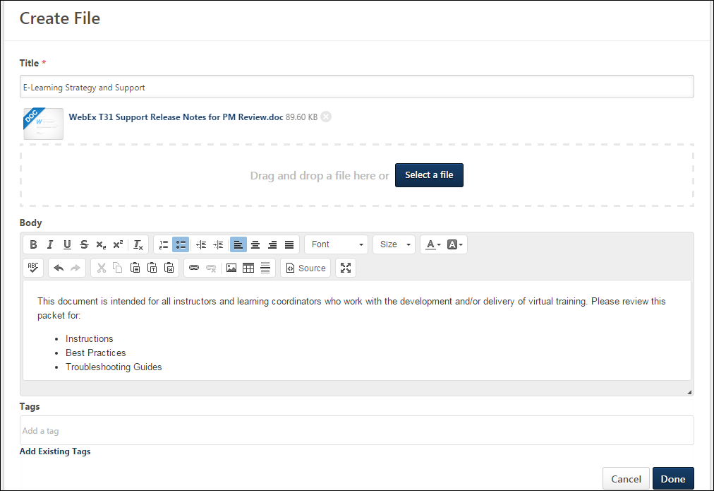
Posting Details
Enter the following information for the posting:
- Title - Enter a title for the posting, up to 70 characters. This title will appear at the top of the posting page. This is required.
- Body - Enter the body of the posting, up to 10,000 characters. When creating or editing the body of a posting, users can use the full text editor to align text, change text font, update text size, add color to text, insert line breaks, embed links, tables, and images in a post, and paste content from Microsoft Word.
Considerations
The full text editor available when creating a the body of a posting is not available in the following areas:
- Replying to a posting
- Posting to the Live Feed
- Posting to the Team Feed
- Posting to the Community Feed
- Editing the community description
- Editing the topic description
Upload
A file must be uploaded in order to create a file posting. Attach a file by dragging and dropping a file into the Attachment area. You can also attach a file by clicking the Select a file button and select a file from your computer. Only one file can be uploaded at a time. Note: The drag-and-drop functionality is not supported by Internet Explorer browsers. The Attachment Restrictions section below provides a complete list of attachment restrictions.
After a file is selected, the progress bar displays as the file is uploaded. After the file has loaded, the file appears in the Upload field.
Tags
This section enables users to add tags or keywords to their posting. Once the posting is saved, the tags appears as links on the posting, and users can click a tag to view all postings that have the same tag. For example, if you add a "Time Management" tag to your posting, then clicking this tag will display all postings that include the "Time Management" tag. This is an effective way to categorize your posting. Once the posting is saved, you can use the tag to find other postings that have similar content.
To add a tag, enter the tag name in the field. Multiple tags can be added by adding a comma after each tag or by pressing [Enter] after each tag. Users can add new or existing tags. Tags are not case-sensitive or accent-sensitive, however the tag is captured as it is entered (e.g., Management is the same as management and elephant is the same as élephant). Each tag can contain a maximum of 70 characters, and the character limit for all tags in a posting is 200. Note: If a user enters a tag name that is a system-defined tag such as Featured, then this is added as a user-defined tag, which behaves differently than a system-defined tag.
To select a tag from a list of existing tags, click the Add Existing Tags link. This opens a pop-up, in which all existing user-defined tags are displayed. Note: System-defined tags cannot be selected. These tags are automatically associated with a posting. See Single Item Select Pop-up.
To remove a tag, click the Delete icon to the right of the tag name.
Hashtags
Hashtags can now be used in the body of the posting, and the system will apply the text after the hashtags as tags once the posting submitted.
Hashtags cannot be used within the posting title or within posting comments.
To add a tag to a posting using hashtags, enter a hashtag "#" within the posting body, and the text following the hashtag will be converted into a tag once the posting is submitted.
- Hashtags are not affected by accents on characters. Accents on characters are included in the tag.
- Spaces, new lines, and special characters end a hashtag.
A maximum of 200 tags can be added to a posting. If a posting has reached the maximum number of tags, then no additional tags are added, even if a hashtag is added to the posting body.
In order to remove a hashtag tag, the hashtag must be removed from the body of the posting, and the tag must be removed from the Tags field.
The following are examples of hashtags with spaces and special characters and the resulting tags:
Hashtag | Resulting Tag
#élephant | élephant
#Leadership and Responsibility | Leadership
#fish&chips | fish
#web2.0 | web2
#isn't | isn
#a-b | a
#*.*
#yay! | yay
Administrator Note: Tags in Cohorts
Tags can be added to postings when creating a community template for a program.
When a cohort is created, the tags are added to the postings within the new cohort.
When a tag is removed from a posting within a community template, the tag is not removed from any existing postings within cohorts that have been created from the community template.
Done or Cancel
After uploading the file and entering the appropriate text, click Done to create the file posting, or click Cancel to discard the posting. If enabled, the Knowledge Bank/Communities New Posting Created email is triggered when a posting is created in the Knowledge Bank or community.
Attachment Restrictions
The following attachment restrictions apply:
- Only one attachment can be added to a file type post.
- The maximum file size is configured by the system administrator. This limit is controlled by a backend setting, which can be increased up to 1 GB.
- The attachment file name cannot exceed 50 characters.
- Executable files cannot be uploaded.
- Files cannot have a hidden extension or no extension.
The following file types are allowed:
File Type | Extension
Audio | - mid  - m4a  - mp3  - wav
Compressed | - zip
Data | - xls/xlsx
Image | - bmp  - gif  - jpeg/jpg  - png  Image files are embedded in New Connect. If the file format is one of the supported image file types, then once the update, comment, or posting has been posted, the image will display at an enlarged size.  Pixel Limitations  Depending on where the image is being displayed, then it will display at different sizes while maintaining the original image's aspect ratio. If the original image's pixel width is under the maximum pixel width, then the image will display with its true pixel width and height.  If the image's width exceeds 877 pixels, then an enlarged thumbnail image will be saved. The image's aspect ratio will be maintained, but will be resized to have a maximum width of 877 pixels. The following width limitations apply:  image location maximum pixel width  Community Posting 877  Community Posting Comment 845  Community Posting Threaded Comment 802  Task Details 720  Team Overview Update 683  Feed User Update 675  Feed Activity Update 675  Note: .gif images that are larger than the page's parameters will be resized down and will lose any animation. The user can still download the original animated file.
Presentation | - pps/ppsx  - ppt/pptx
Project | - mpp
Recording | - arf
Text | - doc/docx  - dot/dotx  - htm/html - The ability to upload htm/html files is controlled by the system administrator. This limit is controlled by a backend setting,. Organizations may choose to disable the ability to upload HTML files because malicious HTML files may be uploaded, which is a potential security risk.  - pdf  - txt
Vector Graphic | - vsd
Video | - avi  - flv  - m4v  - mov  - mpeg/mpg  - mp4  - rm - This file type is not supported when attaching a video.  - swf - This file type is not supported when attaching a video.  - wma/wmv  Video files are embedded in New Connect. If the file format is a supported video file type, then the video file will be queued for transcoding. Acceptable video types are .mp4, .mov, .flv, and .asf/.wmv.  Once the transcoding process is complete, then the video file will display a small black video thumbnail, which indicates that the video can now be played inline. Clicking on this thumbnail will then display the video player and allow the user to play the video.  When playing the video, the size of the video player will depend on the page where the video is being displayed. See the Pixel Limitations table in the Image row above for sizing information.
Posting Type - File - View
A file posting enables users to share a file with other users. Within the posting, users can also discuss the posting. File postings support rich text.
To view a posting, click the posting title from anywhere in the Knowledge Bank or communities.
Permissions
PERMISSION NAME | PERMISSION DESCRIPTION | CATEGORY

Manage Knowledge Bank/Communities Administration | Grants ability to view the New Knowledge Bank Administration page and manage Action Groups. Based on permission constraints, administrators with this permission can create and delete topics and subtopics. Administrators with this permission can view all communities, topics, sub-topics and postings, regardless of availability. In addition, administrators can add a posting to the Course Catalog. When creating a topic, the constraints on this permission are automatically applied to the topic's availability. This permission can be constrained by OU and User's OU. This permission is assigned to the default Administrator role by default. | New Connect

View Knowledge Bank/Communities | Grants ability to view the Knowledge Bank and Communities pages. This permission can be constrained by OU and User's OU. This permission is assigned to the default Administrator role by default. | New Connect
Banner Image
At the top of the posting, the community's banner image is displayed.
File Title
At the top of the page, the file title is displayed.
Options
The Options drop-down is only available to a user if the user has access to at least one of the options.
The following options are available in the Options drop-down menu:
- Follow File - This option is available to all users who are members of the posting's community. When this option is selected, the user may receive email notifications whenever a reply is added to the posting. Also, the posting appears in the Following section of the user's Universal Profile: Bio.
- Unfollow File - When this option is selected, the user is no longer following the posting.
- Edit File - Select this option to edit the posting. This option is only available to the author of the posting, community moderators, and users with permission to manage Knowledge Bank and Communities Administration.
- Delete File - Select this option to delete the posting. This option is only available to topic moderators, community moderators, administrators, and users who belong to an action group that allows them to delete postings. See Posting Action - Delete Posting or Reply on page 200 for additional information.
- Mark as Featured - Select this option to mark the posting as a featured posting. This option is only available to topic moderators, community moderators, and administrators. See Posting Action - Mark as Featured on page 206 for additional information.
- Training Details - Select this option to view the LO Details page for the discussion posting, which is a material LO. This option is only available if the posting has already been added to the Course Catalog. See Learning Object (LO) Details Page for additional information.
Original Posting and Responses
The original posting is displayed at the top of the posting, and all responses are displayed below the original post. The oldest responses are displayed first. Secondary replies are indented to denote hierarchy. Secondary replies can be edited, liked, and deleted, but users cannot reply to a secondary reply. If there are three or more existing replies, only two replies are displayed and a View previous replies link displays. Users can click the link to view all previous replies.
The following information is displayed for each post:
- User Image - An image of the user is displayed next to each post. If the user does not have an image in the system, then a generic image is displayed. Click the photograph to open the Universal Profile - Bio page for the user.
- User Name - The name of the user who added the posting is displayed next to the user image. Click the user's name to open the Universal Profile - Bio page for the user.
- Timestamp - A timestamp is displayed with each posting to indicate when it was made. The timestamp is always displayed in the time zone of the user who is viewing the feedback.
- Posting Content - The original posting file is displayed below the user's name.
  - Posting Text - The original posting text displayed below the posting file.
- Like - Users are able to like another user's posting or reply. This can be done to show users that you like the posting content. Note: The ability to like a posting or posting reply is determined by your action group. See Posting Action - Like a Posting or a Reply on page 205 for additional information.
- Number of Comments - For the original posting, the number of comments are displayed to the right of the Like button.
- Number of Views - For the original posting, the number of views are displayed to the right of the number of comments.
Posting Tags
Any user-defined tags that are associated with the posting are displayed below the body of the posting. System tags are displayed before user-defined tags.
Users can click one of the tags to initiate a search within Global Search for all postings that contain the selected tag. Users can only view postings which they can access. Note: The ability to click a posting tag to initiate a search is only available if the ability to search for Connect postings by tag is enabled via Search Preferences.
The following system-defined tags may appear below the original posting:
- Featured - This tag is displayed if the posting has been marked as Featured by the moderator or administrator.
- Learning Object - This tag is displayed if the posting has been added to the Course Catalog as a learning object by the administrator.
Reply to Posting or Comment
Users are able to reply to another user's posting and other posting comments. See Posting Action - Reply on page 207 for additional information.
Delete Posting or Reply
Users may be able to delete a posting or reply from the posting page. This option is only available to topic moderators, community moderators, administrators, and users who belong to an action group that allows them to delete postings or replies. See Posting Action - Delete Posting or Reply on page 200 for additional information.
Emails
EMAIL NAME | EMAIL DESCRIPTION | ACTION TYPE

Knowledge Bank/Communities Reply | This email is triggered when a user replies to a posting in the Knowledge Bank or a community. This email can be sent as a notification to Author, Community Moderator, Community Members, Follower, or a specific user. If the reply is added directly to the posting, then Author refers to the posting creator. If the reply is added to another reply, then Author refers to the posting creator and the author of the original reply. Note: This email is triggered even if the same user makes multiple replies to the same posting. | New Connect
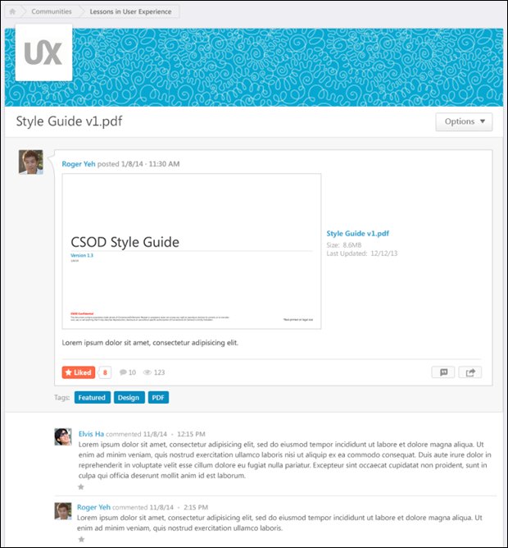
Posting Type - Q&A - Create
Topic members are able to create postings. These postings can include file attachments and URL previews.
To create a Q&A posting, click the appropriate topic title from anywhere in the Knowledge Bank or communities. Then, from the Create Posting drop-down menu, select Create Q&A.
Permissions
PERMISSION NAME | PERMISSION DESCRIPTION | CATEGORY

View Knowledge Bank/Communities | Grants ability to view the Knowledge Bank and Communities pages. This permission can be constrained by OU and User's OU. This permission is assigned to the default Administrator role by default. | New Connect
Emails
EMAIL NAME | EMAIL DESCRIPTION | ACTION TYPE

Knowledge Bank/Communities New Posting Created | This email is triggered when a new Knowledge Bank or community posting is created. This email can be sent as a notification to Community Moderator, Community Members, Follower, or a specific user. A recipient must match the following criteria to receive the email:  - User is within the availability criteria for the corresponding posting's parent topic.  - User is within the constraints of the posting's parent topic's creator constraints.  - User is a member of one of the communities with which the topic is shared. | New Connect
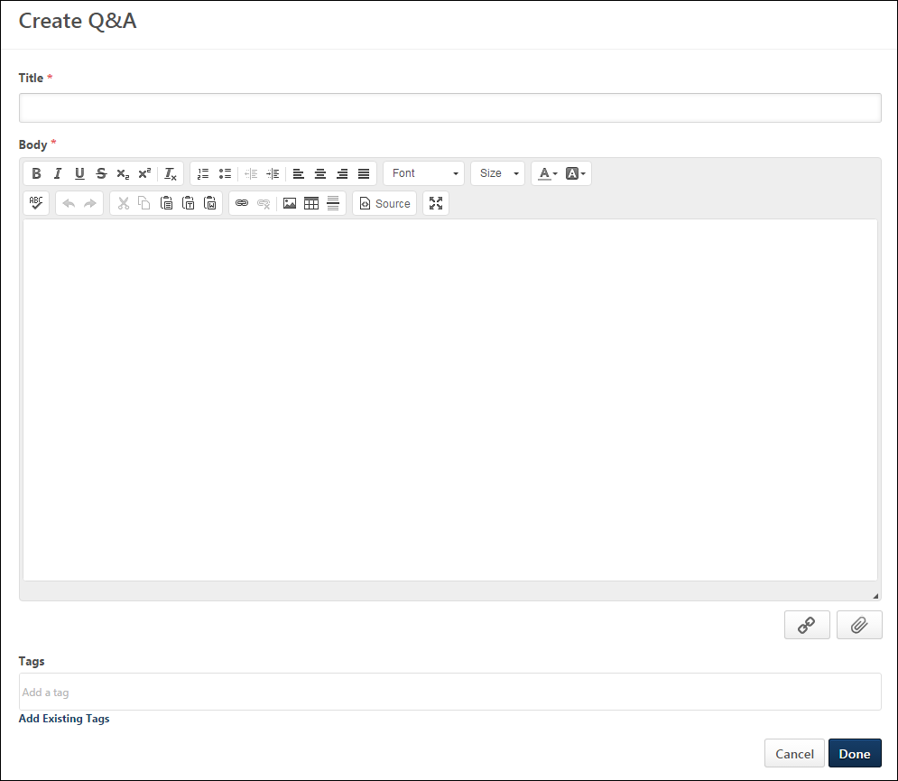
Posting Title and Body
Enter the following information for the discussion:
- Title - Enter a title for the posting, up to 70 characters. This title will appear at the top of the posting page.
- Body - Enter the body of the posting, up to 10,000 characters. When creating or editing the body of a posting, users can use the full text editor to align text, change text font, update text size, add color to text, insert line breaks, embed links, tables, and images in a post, and paste content from Microsoft Word.
Considerations
The full text editor available when creating a the body of a posting is not available in the following areas:
- Replying to a posting
- Posting to the Live Feed
- Posting to the Team Feed
- Posting to the Community Feed
- Editing the community description
- Editing the topic description
Attach a File
To attach a file to your update, click the Attach File button to the right of the Update field. The option to post an update is controlled by the system administrator. The Attachment Restrictions section below provides a complete list of attachment restrictions.
Include URL Preview
When creating or replying to a posting, you can include a URL with the post. See Posting Action - Include URL Preview on page 204 for additional information.
Tags
This section enables users to add tags or keywords to their posting. Once the posting is saved, the tags appears as links on the posting, and users can click a tag to view all postings that have the same tag. For example, if you add a "Time Management" tag to your posting, then clicking this tag will display all postings that include the "Time Management" tag. This is an effective way to categorize your posting. Once the posting is saved, you can use the tag to find other postings that have similar content.
To add a tag, enter the tag name in the field. Multiple tags can be added by adding a comma after each tag or by pressing [Enter] after each tag. Users can add new or existing tags. Tags are not case-sensitive or accent-sensitive, however the tag is captured as it is entered (e.g., Management is the same as management and elephant is the same as élephant). Each tag can contain a maximum of 70 characters, and the character limit for all tags in a posting is 200. Note: If a user enters a tag name that is a system-defined tag such as Featured, then this is added as a user-defined tag, which behaves differently than a system-defined tag.
To select a tag from a list of existing tags, click the Add Existing Tags link. This opens a pop-up, in which all existing user-defined tags are displayed. Note: System-defined tags cannot be selected. These tags are automatically associated with a posting. See Single Item Select Pop-up.
To remove a tag, click the Delete icon to the right of the tag name.
Hashtags
Hashtags can now be used in the body of the posting, and the system will apply the text after the hashtags as tags once the posting submitted.
Hashtags cannot be used within the posting title or within posting comments.
To add a tag to a posting using hashtags, enter a hashtag "#" within the posting body, and the text following the hashtag will be converted into a tag once the posting is submitted.
- Hashtags are not affected by accents on characters. Accents on characters are included in the tag.
- Spaces, new lines, and special characters end a hashtag.
A maximum of 200 tags can be added to a posting. If a posting has reached the maximum number of tags, then no additional tags are added, even if a hashtag is added to the posting body.
In order to remove a hashtag tag, the hashtag must be removed from the body of the posting, and the tag must be removed from the Tags field.
The following are examples of hashtags with spaces and special characters and the resulting tags:
Hashtag | Resulting Tag
#élephant | élephant
#Leadership and Responsibility | Leadership
#fish&chips | fish
#web2.0 | web2
#isn't | isn
#a-b | a
#*.*
#yay! | yay
Administrator Note: Tags in Cohorts
Tags can be added to postings when creating a community template for a program.
When a cohort is created, the tags are added to the postings within the new cohort.
When a tag is removed from a posting within a community template, the tag is not removed from any existing postings within cohorts that have been created from the community template.
Posting Visibility
The visibility of a posting within a topic is determined by the availability settings of the topic. Users can view all postings within a topic if they have access to the topic.
Done or Cancel
After entering the appropriate text and attaching any necessary files, click Done to create the posting, or click Cancel to discard the posting. If enabled, the Knowledge Bank/Communities New Posting Created email is triggered when a posting is created in the Knowledge Bank or community.
If configured by the administrator, creating a Q&A posting triggers the Knowledge Bank/Communities Question Asked email.
Emails
EMAIL NAME | EMAIL DESCRIPTION | ACTION TYPE

Knowledge Bank/Communities Question Asked | This email is triggered when a Q&A posting is created in the Knowledge Bank or a community. This email can be sent as a notification to Expert, Community Moderator, or a specific user. | New Connect
Attachment Restrictions
The following attachment restrictions apply:
- Up to three attachments or one video can be added to a post.
- The maximum file size is configured by the system administrator. This limit is controlled by a backend setting, which can be increased up to 1 GB.
- The attachment file name cannot exceed 100 characters.
- Executable files cannot be uploaded.
- Files cannot have a hidden extension or no extension.
The following file types are allowed:
File Type | Extension
Audio | - mid  - m4a  - mp3  - wav
Compressed | - zip
Data | - xls/xlsx
Image | - bmp  - gif  - jpeg/jpg  - png  Image files are embedded in New Connect. If the file format is one of the supported image file types, then once the update, comment, or posting has been posted, the image will display at an enlarged size.  Pixel Limitations  Depending on where the image is being displayed, then it will display at different sizes while maintaining the original image's aspect ratio. If the original image's pixel width is under the maximum pixel width, then the image will display with its true pixel width and height.  If the image's width exceeds 877 pixels, then an enlarged thumbnail image will be saved. The image's aspect ratio will be maintained, but will be resized to have a maximum width of 877 pixels. The following width limitations apply:  image location maximum pixel width  Community Posting 877  Community Posting Comment 845  Community Posting Threaded Comment 802  Task Details 720  Team Overview Update 683  Feed User Update 675  Feed Activity Update 675  Note: .gif images that are larger than the page's parameters will be resized down and will lose any animation. The user can still download the original animated file.
Presentation | - pps/ppsx  - ppt/pptx
Project | - mpp
Recording | - arf
Text | - doc/docx  - dot/dotx  - htm/html - The ability to upload htm/html files is controlled by the system administrator. This limit is controlled by a backend setting,. Organizations may choose to disable the ability to upload HTML files because malicious HTML files may be uploaded, which is a potential security risk.  - pdf  - txt
Vector Graphic | - vsd
Video | - avi  - flv  - m4v  - mov  - mpeg/mpg  - mp4  - rm - This file type is not supported when attaching a video.  - swf - This file type is not supported when attaching a video.  - wma/wmv  Video files are embedded in New Connect. If the file format is a supported video file type, then the video file will be queued for transcoding. Acceptable video types are .mp4, .mov, .flv, and .asf/.wmv.  Once the transcoding process is complete, then the video file will display a small black video thumbnail, which indicates that the video can now be played inline. Clicking on this thumbnail will then display the video player and allow the user to play the video.  When playing the video, the size of the video player will depend on the page where the video is being displayed. See the Pixel Limitations table in the Image row above for sizing information.
Posting Type - Q&A - View
A Q&A posting enables users to ask questions and receive answers within the Knowledge Bank or a community. If a user who is designated as an Expert responds to a question, then the expert's response is visually distinguished from other responses. In addition, users can vote for or against an answer to the question to indicate whether or not they agree with the answer. Q&A postings support rich text and can also contain files, videos, and links.
To view a posting, click the posting title from anywhere in the Knowledge Bank or communities.
Permissions
PERMISSION NAME | PERMISSION DESCRIPTION | CATEGORY

Manage Knowledge Bank/Communities Administration | Grants ability to view the New Knowledge Bank Administration page and manage Action Groups. Based on permission constraints, administrators with this permission can create and delete topics and subtopics. Administrators with this permission can view all communities, topics, sub-topics and postings, regardless of availability. In addition, administrators can add a posting to the Course Catalog. When creating a topic, the constraints on this permission are automatically applied to the topic's availability. This permission can be constrained by OU and User's OU. This permission is assigned to the default Administrator role by default. | New Connect

View Knowledge Bank/Communities | Grants ability to view the Knowledge Bank and Communities pages. This permission can be constrained by OU and User's OU. This permission is assigned to the default Administrator role by default. | New Connect
Banner Image
At the top of the posting, the community's banner image is displayed.
Question Title
At the top of the page, the question title is displayed.
Options
The Options drop-down is only available to a user if the user has access to at least one of the options.
The following options are available in the Options drop-down menu:
- Follow Q&A - This option is available to all users who are members of the posting's community. When this option is selected, the user may receive email notifications whenever a reply is added to the posting. Also, the posting appears in the Following section of the user's Universal Profile: Bio.
- Unfollow Q&A - When this option is selected, the user is no longer following the posting.
- Edit Q&A - Select this option to edit the posting. This option is only available to the author of the posting, community moderators, and users with permission to manage Knowledge Bank and Communities Administration.
- Delete Q&A - Select this option to delete the posting. This option is only available to topic moderators, community moderators, administrators, and users who belong to an action group that allows them to delete postings. See Posting Action - Delete Posting or Reply on page 200 for additional information.
- Mark as Featured - Select this option to mark the posting as a featured posting. This option is only available to topic moderators, community moderators, and administrators. See Posting Action - Mark as Featured on page 206 for additional information.
- Unmark as Featured - Select this option to remove the Featured tag from the posting. This option is only available if the posting is currently marked as Featured. Also, this option is only available to topic moderators, community moderators, and administrators.
- Mark as Answered - Select this option to mark the question as Answered. This indicates that the question has been properly answered and no additional answers are needed. This option is only available to the posting creator, topic moderators, community moderators, and administrators. If configured by the administrator, this action triggers the Knowledge Bank/Communities Question Answered email.
- Unmark as Answered - Select this option to remove the Answered tag from the posting. This option is only available if the posting is currently marked as Answered. Also, this option is only available to the posting creator, topic moderators, community moderators, and administrators.
Original Posting and Responses
The original posting is displayed at the top of the posting, and all responses are displayed below the original post. The oldest responses are displayed first. Secondary replies are indented to denote hierarchy. Secondary replies can be edited, liked, and deleted, but users cannot reply to a secondary reply. If there are three or more existing replies, only two replies are displayed and a View previous replies link displays. Users can click the link to view all previous replies.
The following information is displayed for each post:
- User Image - An image of the user is displayed next to each post. If the user does not have an image in the system, then a generic image is displayed. Click the photograph to open the Universal Profile - Bio page for the user.
- User Name - The name of the user who added the posting is displayed next to the user image. Click the user's name to open the Universal Profile - Bio page for the user.
- Timestamp - A timestamp is displayed with each posting to indicate when it was made. The timestamp is always displayed in the time zone of the user who is viewing the posting.
- Posting Content - The posting text is displayed below the user's name.
  - URL Preview - If the user included a URL in the posting, then a preview of the URL may appear below the text. Click the URL in the text or click the URL preview, if included, to navigate to the URL web page.
  - Files - If the user attached files to the posting, then the file names appear below the posting text. Click the file name to open or download the attachment.
- Like - Users are able to like another user's posting or reply. This can be done to show users that you like the posting content. Note: The ability to like a posting or posting reply is determined by your action group. See Posting Action - Like a Posting or a Reply on page 205 for additional information.
- Upvote/Downvote - Users may be able to vote for or against a posting or reply by clicking the Upvote or Downvote icons. Voting for or against a posting or reply enables users to indicate whether they support or do not support the posting or reply. Note: The ability to vote for a posting or posting reply is determined by the user's action group. See Posting Action - Vote Posting or Reply on page 209 for additional information.
- Vote Counter - The vote counter appears to the right of the Upvote/Downvote icons and indicates the overall vote score for the posting or reply. If the vote count is less than zero, then a negative sign (-) appears in front of the vote count. Users can hover the computer cursor over the vote count to view the name of the latest 10 users who voted for or against the suggestion. Note: If the overall vote count is zero, then the vote counter does not appear.
Posting Tags
Any user-defined tags that are associated with the posting are displayed below the body of the posting. System tags are displayed before user-defined tags.
Users can click one of the tags to initiate a search within Global Search for all postings that contain the selected tag. Users can only view postings which they can access. Note: The ability to click a posting tag to initiate a search is only available if the ability to search for Connect postings by tag is enabled via Search Preferences.
The following system-defined tags may appear below the original posting:
- Featured - This tag is displayed if the posting has been marked as Featured by the moderator or administrator.
- Answered - This tag is displayed if the posting has been marked as Answered by the posting creator, topic moderator, community moderator, or administrator. This indicates that the question has been properly answered and no additional answers are needed.
Reply to Posting or Comment
Users are able to reply to another user's posting and other posting comments. See Posting Action - Reply on page 207 for additional information.
Delete Posting or Reply
Users may be able to delete a posting or reply from the posting page. This option is only available to topic moderators, community moderators, administrators, and users who belong to an action group that allows them to delete postings or replies. See Posting Action - Delete Posting or Reply on page 200 for additional information.
Emails
EMAIL NAME | EMAIL DESCRIPTION | ACTION TYPE

Knowledge Bank/Communities Question Answered | This email is triggered when a Q&A posting is marked as Answered in the Knowledge Bank or a community. This also applies when a posting is marked as Answered, then unmarked as Answered, and then marked as Answered again. This email can be sent as a notification to Community Moderator, Posting Creator, or a specific user. | New Connect

Knowledge Bank/Communities Reply | This email is triggered when a user replies to a posting in the Knowledge Bank or a community. This email can be sent as a notification to Author, Community Moderator, Community Members, Follower, or a specific user. If the reply is added directly to the posting, then Author refers to the posting creator. If the reply is added to another reply, then Author refers to the posting creator and the author of the original reply. Note: This email is triggered even if the same user makes multiple replies to the same posting. | New Connect
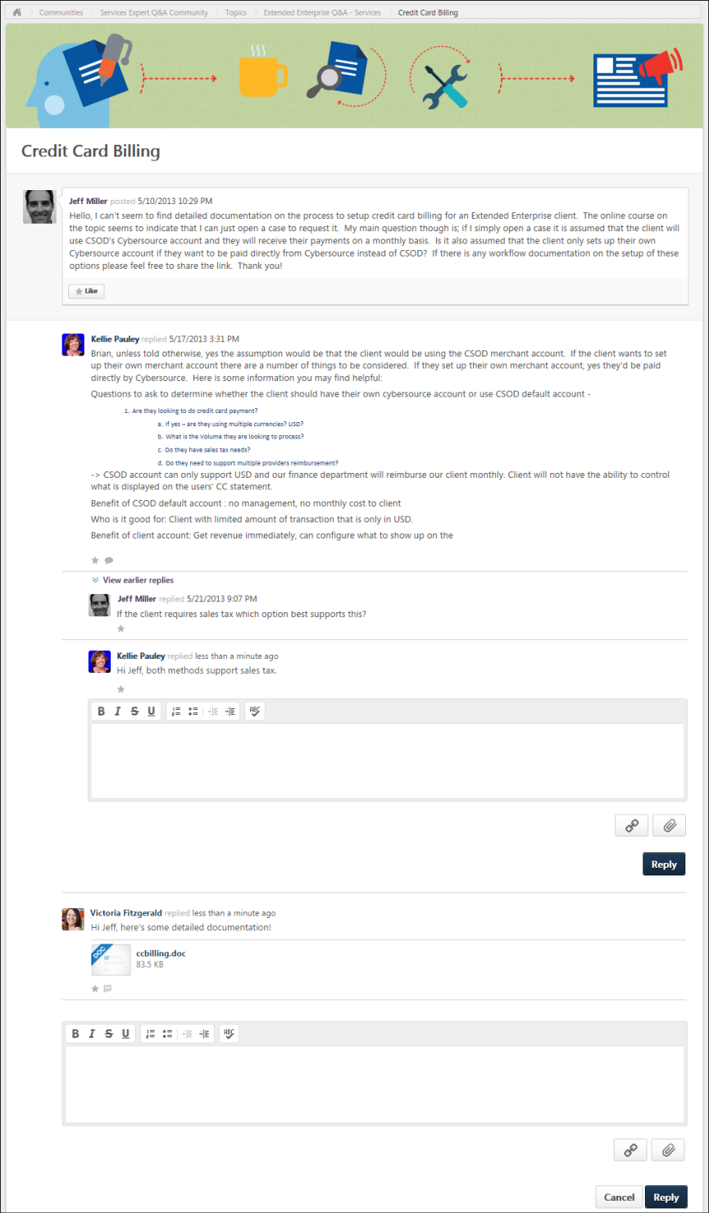
Posting Type - Suggestion - Create
Topic members are able to create postings. These postings can include file attachments and URL previews.
To create a suggestion posting, click the appropriate topic title from anywhere in the Knowledge Bank or communities. Then, from the Create Posting drop-down menu, select Create Suggestion.
Permissions
PERMISSION NAME | PERMISSION DESCRIPTION | CATEGORY

View Knowledge Bank/Communities | Grants ability to view the Knowledge Bank and Communities pages. This permission can be constrained by OU and User's OU. This permission is assigned to the default Administrator role by default. | New Connect
Emails
EMAIL NAME | EMAIL DESCRIPTION | ACTION TYPE

Knowledge Bank/Communities New Posting Created | This email is triggered when a new Knowledge Bank or community posting is created. This email can be sent as a notification to Community Moderator, Community Members, Follower, or a specific user. A recipient must match the following criteria to receive the email:  - User is within the availability criteria for the corresponding posting's parent topic.  - User is within the constraints of the posting's parent topic's creator constraints.  - User is a member of one of the communities with which the topic is shared. | New Connect
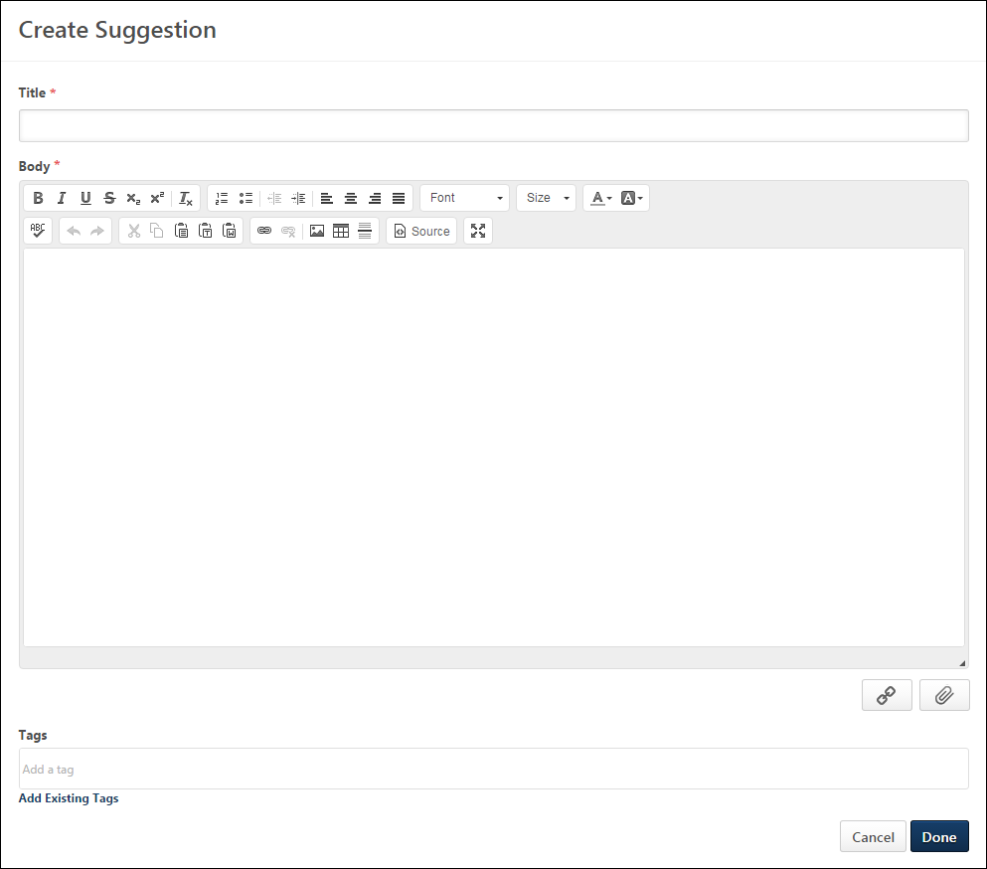
Posting Title and Body
Enter the following information for the discussion:
- Title - Enter a title for the posting, up to 70 characters. This title will appear at the top of the posting page.
- Body - Enter the body of the posting, up to 10,000 characters. When creating or editing the body of a posting, users can use the full text editor to align text, change text font, update text size, add color to text, insert line breaks, embed links, tables, and images in a post, and paste content from Microsoft Word.
Considerations
The full text editor available when creating a the body of a posting is not available in the following areas:
- Replying to a posting
- Posting to the Live Feed
- Posting to the Team Feed
- Posting to the Community Feed
- Editing the community description
- Editing the topic description
Attach a File
To attach a file to your update, click the Attach File button to the right of the Update field. The option to post an update is controlled by the system administrator. The Attachment Restrictions section below provides a complete list of attachment restrictions.
Include URL Preview
When creating or replying to a posting, you can include a URL with the post. See Posting Action - Include URL Preview on page 204 for additional information.
Tags
This section enables users to add tags or keywords to their posting. Once the posting is saved, the tags appears as links on the posting, and users can click a tag to view all postings that have the same tag. For example, if you add a "Time Management" tag to your posting, then clicking this tag will display all postings that include the "Time Management" tag. This is an effective way to categorize your posting. Once the posting is saved, you can use the tag to find other postings that have similar content.
To add a tag, enter the tag name in the field. Multiple tags can be added by adding a comma after each tag or by pressing [Enter] after each tag. Users can add new or existing tags. Tags are not case-sensitive or accent-sensitive, however the tag is captured as it is entered (e.g., Management is the same as management and elephant is the same as élephant). Each tag can contain a maximum of 70 characters, and the character limit for all tags in a posting is 200. Note: If a user enters a tag name that is a system-defined tag such as Featured, then this is added as a user-defined tag, which behaves differently than a system-defined tag.
To select a tag from a list of existing tags, click the Add Existing Tags link. This opens a pop-up, in which all existing user-defined tags are displayed. Note: System-defined tags cannot be selected. These tags are automatically associated with a posting. See Single Item Select Pop-up.
To remove a tag, click the Delete icon to the right of the tag name.
Hashtags
Hashtags can now be used in the body of the posting, and the system will apply the text after the hashtags as tags once the posting submitted.
Hashtags cannot be used within the posting title or within posting comments.
To add a tag to a posting using hashtags, enter a hashtag "#" within the posting body, and the text following the hashtag will be converted into a tag once the posting is submitted.
- Hashtags are not affected by accents on characters. Accents on characters are included in the tag.
- Spaces, new lines, and special characters end a hashtag.
A maximum of 200 tags can be added to a posting. If a posting has reached the maximum number of tags, then no additional tags are added, even if a hashtag is added to the posting body.
In order to remove a hashtag tag, the hashtag must be removed from the body of the posting, and the tag must be removed from the Tags field.
The following are examples of hashtags with spaces and special characters and the resulting tags:
Hashtag | Resulting Tag
#élephant | élephant
#Leadership and Responsibility | Leadership
#fish&chips | fish
#web2.0 | web2
#isn't | isn
#a-b | a
#*.*
#yay! | yay
Administrator Note: Tags in Cohorts
Tags can be added to postings when creating a community template for a program.
When a cohort is created, the tags are added to the postings within the new cohort.
When a tag is removed from a posting within a community template, the tag is not removed from any existing postings within cohorts that have been created from the community template.
Posting Visibility
The visibility of a posting within a topic is determined by the availability settings of the topic. Users can view all postings within a topic if they have access to the topic.
Done or Cancel
After entering the appropriate text and attaching any necessary files, click Done to create the posting, or click Cancel to discard the posting. If enabled, the Knowledge Bank/Communities New Posting Created email is triggered when a posting is created in the Knowledge Bank or community.
Attachment Restrictions
The following attachment restrictions apply:
- Up to three attachments or one video can be added to a post.
- The maximum file size is configured by the system administrator. This limit is controlled by a backend setting, which can be increased up to 1 GB.
- The attachment file name cannot exceed 100 characters.
- Executable files cannot be uploaded.
- Files cannot have a hidden extension or no extension.
The following file types are allowed:
File Type | Extension
Audio | - mid  - m4a  - mp3  - wav
Compressed | - zip
Data | - xls/xlsx
Image | - bmp  - gif  - jpeg/jpg  - png  Image files are embedded in New Connect. If the file format is one of the supported image file types, then once the update, comment, or posting has been posted, the image will display at an enlarged size.  Pixel Limitations  Depending on where the image is being displayed, then it will display at different sizes while maintaining the original image's aspect ratio. If the original image's pixel width is under the maximum pixel width, then the image will display with its true pixel width and height.  If the image's width exceeds 877 pixels, then an enlarged thumbnail image will be saved. The image's aspect ratio will be maintained, but will be resized to have a maximum width of 877 pixels. The following width limitations apply:  image location maximum pixel width  Community Posting 877  Community Posting Comment 845  Community Posting Threaded Comment 802  Task Details 720  Team Overview Update 683  Feed User Update 675  Feed Activity Update 675  Note: .gif images that are larger than the page's parameters will be resized down and will lose any animation. The user can still download the original animated file.
Presentation | - pps/ppsx  - ppt/pptx
Project | - mpp
Recording | - arf
Text | - doc/docx  - dot/dotx  - htm/html - The ability to upload htm/html files is controlled by the system administrator. This limit is controlled by a backend setting,. Organizations may choose to disable the ability to upload HTML files because malicious HTML files may be uploaded, which is a potential security risk.  - pdf  - txt
Vector Graphic | - vsd
Video | - avi  - flv  - m4v  - mov  - mpeg/mpg  - mp4  - rm - This file type is not supported when attaching a video.  - swf - This file type is not supported when attaching a video.  - wma/wmv  Video files are embedded in New Connect. If the file format is a supported video file type, then the video file will be queued for transcoding. Acceptable video types are .mp4, .mov, .flv, and .asf/.wmv.  Once the transcoding process is complete, then the video file will display a small black video thumbnail, which indicates that the video can now be played inline. Clicking on this thumbnail will then display the video player and allow the user to play the video.  When playing the video, the size of the video player will depend on the page where the video is being displayed. See the Pixel Limitations table in the Image row above for sizing information.
Posting Type - Suggestion - View
A suggestion posting enables users to make a suggestion within the Knowledge Bank or a community. Other users can vote for the suggestion if they agree with the suggestion, or they can vote against the suggestion if they disagree with the suggestion. In addition, community moderators can mark the suggestion as accepted if they have decided to implement the suggestion, and they can mark the suggestion as completed when the suggestion has been implemented. Suggestion postings support rich text and can also contain files, videos, and links.
To view a posting, click the posting title from anywhere in the Knowledge Bank or communities.
Permissions
PERMISSION NAME | PERMISSION DESCRIPTION | CATEGORY

Manage Knowledge Bank/Communities Administration | Grants ability to view the New Knowledge Bank Administration page and manage Action Groups. Based on permission constraints, administrators with this permission can create and delete topics and subtopics. Administrators with this permission can view all communities, topics, sub-topics and postings, regardless of availability. In addition, administrators can add a posting to the Course Catalog. When creating a topic, the constraints on this permission are automatically applied to the topic's availability. This permission can be constrained by OU and User's OU. This permission is assigned to the default Administrator role by default. | New Connect

View Knowledge Bank/Communities | Grants ability to view the Knowledge Bank and Communities pages. This permission can be constrained by OU and User's OU. This permission is assigned to the default Administrator role by default. | New Connect
Banner Image
At the top of the posting, the community's banner image is displayed.
Suggestion Title
At the top of the page, the suggestion title is displayed.
Options
The Options drop-down is only available to a user if the user has access to at least one of the options.
The following options are available in the Options drop-down menu:
- Follow Suggestion - This option is available to all users who are members of the posting's community. When this option is selected, the user may receive email notifications whenever a reply is added to the posting. Also, the posting appears in the Following section of the user's Universal Profile: Bio.
- Unfollow Suggestion - When this option is selected, the user is no longer following the posting.
- Edit Suggestion - Select this option to edit the posting. This option is only available to the author of the posting, community moderators, and users with permission to manage Knowledge Bank and Communities Administration.
- Delete Suggestion - Select this option to delete the posting. This option is only available to topic moderators, community moderators, administrators, and users who belong to an action group that allows them to delete postings. See Posting Action - Delete Posting or Reply on page 200 for additional information.
- Mark as Featured - Select this option to mark the posting as a featured posting. This option is only available to topic moderators, community moderators, and administrators. See Posting Action - Mark as Featured on page 206 for additional information.
- Unmark as Featured - Select this option to remove the Featured tag from the posting. This option is only available if the posting is currently marked as Featured. Also, this option is only available to topic moderators, community moderators, and administrators.
- Mark as Accepted - Select this option to mark the suggestion as Accepted. This indicates that the suggestion has been accepted and will be implemented. This option is only available to topic moderators, community moderators, and administrators.
- Unmark as Accepted - Select this option to remove the Accepted tag from the posting. This option is only available if the posting is currently marked as Accepted. Also, this option is only available to topic moderators, community moderators, and administrators.
- Mark as Completed - Select this option to mark the suggestion as Completed. This indicates that the suggestion has been implemented. This option is only available if the posting is currently marked as Accepted. This option is only available to topic moderators, community moderators, and administrators. If configured by the administrator, this action triggers the Knowledge Bank/Communities Completed Suggestion email.
- Unmark as Completed - Select this option to remove the Completed tag from the posting. This option is only available if the posting is currently marked as Completed. Also, this option is only available to topic moderators, community moderators, and administrators.
Original Posting and Responses
The original posting is displayed at the top of the posting, and all responses are displayed below the original post. The oldest responses are displayed first. Secondary replies are indented to denote hierarchy. Secondary replies can be edited, liked, and deleted, but users cannot reply to a secondary reply. If there are three or more existing replies, only two replies are displayed and a View previous replies link displays. Users can click the link to view all previous replies.
The following information is displayed for each post:
- User Image - An image of the user is displayed next to each post. If the user does not have an image in the system, then a generic image is displayed. Click the photograph to open the Universal Profile - Bio page for the user.
- User Name - The name of the user who added the posting is displayed next to the user image. Click the user's name to open the Universal Profile - Bio page for the user.
- Timestamp - A timestamp is displayed with each posting to indicate when it was made. The timestamp is always displayed in the time zone of the user who is viewing the posting.
- Posting Content - The posting text is displayed below the user's name.
  - URL Preview - If the user included a URL in the posting, then a preview of the URL may appear below the text. Click the URL in the text or click the URL preview, if included, to navigate to the URL web page.
  - Files - If the user attached files to the posting, then the file names appear below the posting text. Click the file name to open or download the attachment.
- Upvote/Downvote - Users may be able to vote for or against a posting or reply by clicking the Upvote or Downvote icons. Voting for or against a posting or reply enables users to indicate whether they support or do not support the posting or reply. Note: The ability to vote for a posting or posting reply is determined by the user's action group. See Posting Action - Vote Posting or Reply on page 209 for additional information.
- Vote Counter - The vote counter appears to the right of the Upvote/Downvote icons and indicates the overall vote score for the posting or reply. If the vote count is less than zero, then a negative sign (-) appears in front of the vote count. Users can hover the computer cursor over the vote count to view the name of the latest 10 users who voted for or against the suggestion. Note: If the overall vote count is zero, then the vote counter does not appear.
Posting Tags
Any user-defined tags that are associated with the posting are displayed below the body of the posting. System tags are displayed before user-defined tags.
Users can click one of the tags to initiate a search within Global Search for all postings that contain the selected tag. Users can only view postings which they can access. Note: The ability to click a posting tag to initiate a search is only available if the ability to search for Connect postings by tag is enabled via Search Preferences.
The following system-defined tags may appear below the original posting:
- Featured - This tag is displayed if the posting has been marked as Featured by the moderator or administrator.
- Accepted - This tag is displayed if the posting has been accepted for implementation by the topic moderator, community moderator, or administrator.
- Completed - This tag is displayed if the posting has been accepted and implemented by the topic moderator, community moderator, or administrator.
Reply to Posting or Comment
Users are able to reply to another user's posting and other posting comments. See Posting Action - Reply on page 207 for additional information.
Edit Posting or Reply
Users can edit a posting or reply from the posting page. This option is only available to the author of the posting, community moderators, and users with permission to manage Knowledge Bank and Communities Administration. See Posting Action - Edit Posting or Reply on page 201 for additional information.
Delete Posting or Reply
Users may be able to delete a posting or reply from the posting page. This option is only available to topic moderators, community moderators, administrators, and users who belong to an action group that allows them to delete postings or replies. See Posting Action - Delete Posting or Reply on page 200 for additional information.
Emails
EMAIL NAME | EMAIL DESCRIPTION | ACTION TYPE

Knowledge Bank/Communities New Completed Suggestion | This email is triggered when a suggestion posting is marked as Completed in the Knowledge Bank or a community. This also applies when a posting is marked as Completed, then unmarked as Completed, and then marked as Completed again. This email can be sent as a notification to Posting Creator, Community Moderator, or a specific user. | New Connect

Knowledge Bank/Communities Reply | This email is triggered when a user replies to a posting in the Knowledge Bank or a community. This email can be sent as a notification to Author, Community Moderator, Community Members, Follower, or a specific user. If the reply is added directly to the posting, then Author refers to the posting creator. If the reply is added to another reply, then Author refers to the posting creator and the author of the original reply. Note: This email is triggered even if the same user makes multiple replies to the same posting. | New Connect
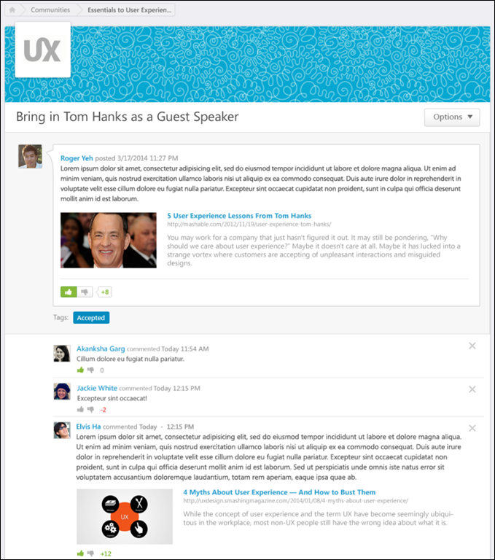

Connect Teams Overview
Teams are a powerful component of Connect. A team can be comprised of hand-picked members, organizational units (OUs), or both.
Each Team Page consists of an Overview page, a Team Feed, a Team Tasks page, and a Members page.
The Overview tab provides a high-level snapshot of what the team is doing; it includes the following information:
- A compact version of the five most recent Team Feed items
- A list of the user's five upcoming tasks
- A list of the team's five upcoming tasks
- A list of team members
The Feed tab allows team members to share knowledge with each other and stay informed on team member activities.
The Tasks tab allows team members to create, view, and manage tasks.
The Members tab allows users to view and manage the team composition.
Permissions
PERMISSION NAME | PERMISSION DESCRIPTION | CATEGORY

Delete Connect Post/Comment | Grants ability to delete Connect user posts and comments within the user's permission constraints. This permission does not apply to activity updates. This permission can be constrained by OU, User's OU, User Self and Subordinates, and User's Self. The permission constraints apply to the creator of the post or comment. | New Connect

New Team | Grants ability to create new teams within the new Connect. This permission cannot be constrained. Which users are available is determined by the constraints upon the user's permission to view the Universal Profile - Bio page. | New Connect

Update Broadcast | Grants ability to broadcast organization-wide user updates within the new Connect. This permission cannot be constrained. | New Connect

View New Connect | Grants ability to view the new Connect pages, including Live Feed, All Teams, Team Overview, Team Feed, Team Tasks, Task Details, and Connections. This permission cannot be constrained. | New Connect
Use Case
In preparation for the annual client conference, several members of the Marketing department set up a team in order to work on a presentation. The team members share information on the Team Feed, and they create and manage the various tasks needed to deliver the presentation on the Team Tasks page.
Teams - All Teams Overview
The All Teams page provides a high-level overview of all of the user's teams. This page also enables the user to create a new team, respond to team invitations, and manage existing teams. Note: This page is viewable even if the user is not a member of any teams.
To access the All Teams page, go to Connect > All Teams.
Permissions
PERMISSION NAME | PERMISSION DESCRIPTION | CATEGORY

New Team | Grants ability to create new teams within the new Connect. This permission cannot be constrained. Which users are available is determined by the constraints upon the user's permission to view the Universal Profile - Bio page. | New Connect

View New Connect | Grants ability to view the new Connect pages, including Live Feed, All Teams, Team Overview, Team Feed, Team Tasks, Task Details, and Connections. This permission cannot be constrained. | New Connect
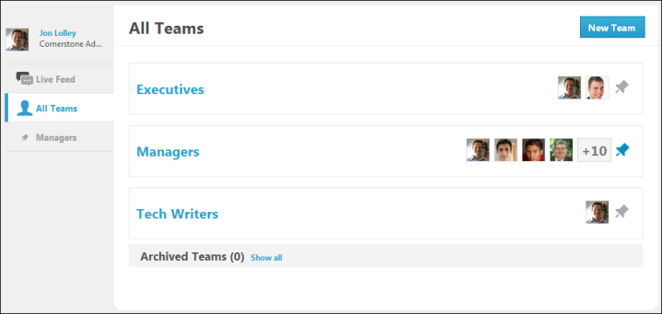
Create Team
Users with the appropriate permissions are able to create new teams. This option is only available if enabled by the system administrator. See Teams - Create Team on page 260 for additional information.
Team Invitations
At the top of the All Teams page, any pending team invitations are displayed in alphabetical order.
To the right of the team name, a photo of each member of the team is displayed. The team leads are displayed first in order of the date they joined the team. After the team leads, team members are displayed in order of the date they joined the team. Up to five photos display. If the team has more than five members, then only four photos are displayed and the fifth photo slot displays how many additional members the team has. Click the photograph to open the Universal Profile - Bio page for the user.
To join the team to which you are invited, click the Join Team button. This adds the user as a member of the team and the team is added to the user's All Teams page. Otherwise, click the No Thanks button to deny the team invitation and remove the invitation from the All Teams page.
Active Teams
Below the team invitations, all of the user's active teams are displayed in alphabetical order.
To the right of the team name, a photo of each member of the team is displayed. The team leads are displayed first in order of the date they joined the team. After the team leads, team members are displayed in order of the date they joined the team. Up to five photos display. If the team has more than five members, then only four photos are displayed and the fifth photo slot displays how many additional members the team has. Click the photograph to open the Universal Profile - Bio page for the user.
To the right of the team photographs, there is a Pin icon. This indicates whether the team is pinned to the Connect sidebar.
- Unpinned - This icon indicates that the team is not currently pinned to the Connect sidebar. Click the icon to pin the team.
- Pinned - This icon indicates that the team is currently pinned to the Connect sidebar. Click the icon to unpin the team.
Archived Teams
Below the user's active teams, the Archived Teams section displays the user's archived teams in alphabetical order. To hide all archived teams from the All Teams page, click the Hide all link at the top of the Archived Teams section. If the archived teams are hidden, you can click the Show all link to show the archived teams.
To the right of the team name, a photo of each member of the team is displayed. The team leads are displayed first in order of the date they joined the team. After the team leads, team members are displayed in order of the date they joined the team. Up to five photos display. If the team has more than five members, then only four photos are displayed and the fifth photo slot displays how many additional members the team has. Click the photograph to open the Universal Profile - Bio page for the user.
Teams - Create Team
Users with the appropriate permissions are able to create new teams. Within Connect, teams are used to allow team members to stay connected and informed of each member's activities. Teams can be created for any purpose, including specific projects, weekly meeting groups, managers, and divisions. Teams can be comprised of specific users, OUs, or both.
A team can be created in the following ways:
- Go to Connect > Live Feed. Then, from the Actions drop-down list, select Create Team.
- Go to Connect > All Teams. Then, click the New Team button.
The option to create a Connect team is only available if enabled by the system administrator. Otherwise, Connect teams can only be created by system administrators in New Connect Administration.
Permissions
PERMISSION NAME | PERMISSION DESCRIPTION | CATEGORY

New Team | Grants ability to create new teams within the new Connect. This permission cannot be constrained. Which users are available is determined by the constraints upon the user's permission to view the Universal Profile - Bio page. | New Connect

Bio About - View | Enables user to view the Bio page for users within their permission constraints. This permission must be enabled to view the Transcript page within Universal Profile. If a user does not have this permission and they click a person's name or user photo within the Universal Profile, then the Bio page will not open.  On the Learner Home page, this permission also allows end users to view the Completions & Hours field, the training sidebar, and the Continue Learning carousel.  This permission can be constrained by Employee Relationship, OU, User's OU, User's Direct Reports, User Self and Subordinates, and User. Note: For security purposes, this permission is constrained to User Self and Subordinates by default. However, the permission constraints can be modified to allow users to view the Bio About page for other users. | Universal Profile

View New Connect | Grants ability to view the new Connect pages, including Live Feed, All Teams, Team Overview, Team Feed, Team Tasks, Task Details, and Connections. This permission cannot be constrained. | New Connect
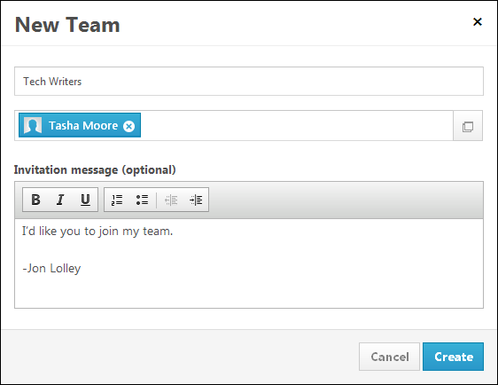
Enter the following information for the team:
- Name the team - In this field, enter a name for the team, up to 70 characters.
- Add team member(s) - In this field, enter the names of the users you are inviting to join the team. As you enter a name, the system attempts to match the name that is entered with a user within the system. Users can also click the Select Users button to view a list of available users, and select users for the team.
  - Which users are available is determined by the constraints upon the user's permission to view the Universal Profile - Bio page.
- Invitation message - In this field, enter the message that is included with the invitation to join the team, up to 3,500 characters. This field is optional.
Create or Cancel
Click Create to create the team. Invitations are sent to all users listed in the Add team member(s) field. The user who creates the team is automatically set as the team leader. The new team appears on the All Teams page.
Click Cancel to discard the new team.
Team Page - Overview Tab
The Overview tab provides a high-level snapshot of what the team is doing; it includes the following information:
- A compact version of the five most recent Team Feed items
- A list of the user's five upcoming tasks
- A list of the team's five upcoming tasks
- A list of team members
Which types of updates appear in the feed is dependent upon the preferences set by the system administrator.
To access the Overview tab of the Team Page, go to Connect > All Teams. Then, click the appropriate team name. The Overview tab opens by default.
Permissions
PERMISSION NAME | PERMISSION DESCRIPTION | CATEGORY

Bio About - View | Enables user to view the Bio page for users within their permission constraints. This permission must be enabled to view the Transcript page within Universal Profile. If a user does not have this permission and they click a person's name or user photo within the Universal Profile, then the Bio page will not open.  On the Learner Home page, this permission also allows end users to view the Completions & Hours field, the training sidebar, and the Continue Learning carousel.  This permission can be constrained by Employee Relationship, OU, User's OU, User's Direct Reports, User Self and Subordinates, and User. Note: For security purposes, this permission is constrained to User Self and Subordinates by default. However, the permission constraints can be modified to allow users to view the Bio About page for other users. | Universal Profile

View New Connect | Grants ability to view the new Connect pages, including Live Feed, All Teams, Team Overview, Team Feed, Team Tasks, Task Details, and Connections. This permission cannot be constrained. | New Connect
Feed Panel
The Feed panel displays the five most recent updates by members of the team. The following information is displayed for each update:
- User Image - An image of the user who posted the update is displayed next to each post. If the user does not have an image in the system, then a generic image is displayed. Click the photograph to open the Universal Profile - Bio page for the user.
- User Name - The name of the user who posted the update is displayed next to the user image.
- Update Text - The content of the update is displayed next to the user's name.
- Timestamp - A timestamp is displayed with each update post to indicate when the post was made. The timestamp is always displayed in the time zone of the user who is viewing the feedback. If the update is more than 24 hours old, then only the date of the update is displayed.
Click the View Feed link at the bottom of the panel to open the Team Page - Feed tab.
Your Tasks Panel
The Your Tasks panel displays five of the user's upcoming incomplete tasks, sorted by due date with the soonest due date displayed first. The following information is displayed for each task:
- Color Strip - The left edge of the action item icon is color coded to represent proximity to the due date of the task. For example, if the action item due date is past due, then the color strip is red to indicate that action is required immediately. If an action item due date is not eminent, then the color strip is green to indicate that action is not required immediately. See the Color Strip Key section below for additional information.
- Checkbox - Click the checkbox next to the task name to mark the task complete.
- Title - This displays the task title. Click the task title to open the Task Details page for the task. See Team Tasks - Task Details Page on page 284 for additional information.
- Due Date - This displays the task due date.
- Comments - This displays the number of new comments that have been posted to the Task Details page since the user last visited the Task Details page.
Click the View All Tasks link at the bottom of the panel to open the Team Page - Tasks tab with the tasks grouped by assignee.
Upcoming Team Tasks Panel
The Upcoming Team Tasks panel displays five of the team's upcoming incomplete tasks that are not assigned to the user, sorted by due date with the soonest due date displayed first. The following information is displayed for each task:
- Color Strip - The left edge of the action item icon is color coded to represent proximity to the due date of the task. For example, if the action item due date is past due, then the color strip is red to indicate that action is required immediately. If an action item due date is not eminent, then the color strip is green to indicate that action is not required immediately. See the Color Strip Key section below for additional information.
- Checkbox - Click the checkbox next to the task name to mark the task complete.
- Title - This displays the task title. Click the task title to open the Task Details page for the task. See Team Tasks - Task Details Page on page 284 for additional information.
- Due Date - This displays the task due date.
- Comments - This displays the number of new comments that have been posted to the Task Details page since the user last visited the Task Details page.
Click the View All Tasks link at the bottom of the panel to open the Team Page - Tasks tab with the tasks grouped by due date.
Members Panel
The Members panel displays the total number of members in the team as well as a photo of each member of the team, up to two rows.
The team leads are displayed first in order of the date they joined the team. After the team leads, team members are displayed in order of the date they joined the team. Up to two rows of photos display. If the team photos fill two rows and there are more members, then the last photo on the second row displays how many additional members the team has. Click the photograph to open the Universal Profile - Bio page for the user.
Color Strip Key
The following colors are available:
- Red - Due today or past due
- Orange - Due within the next seven days, not including today
- Green - Due after seven days
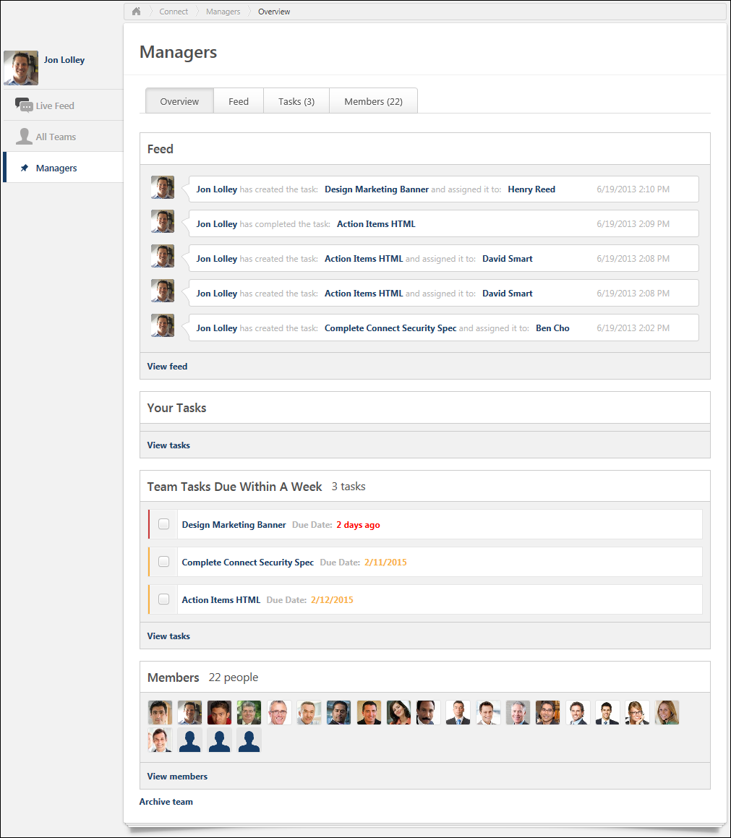
Connect - Team Page
Each Team Page consists of the following tabs:
- Overview
- Feed
- Tasks
- Members
To access the Team Page for a team, go to Connect > All Teams. Then, click the appropriate team name.
Permissions
PERMISSION NAME | PERMISSION DESCRIPTION | CATEGORY

View New Connect | Grants ability to view the new Connect pages, including Live Feed, All Teams, Team Overview, Team Feed, Team Tasks, Task Details, and Connections. This permission cannot be constrained. | New Connect
The Overview tab provides a high-level snapshot of what the team is doing; it includes the following information:
- A compact version of the five most recent Team Feed items
- A list of the user's five upcoming tasks
- A list of the team's five upcoming tasks
- A list of team members
The Feed tab allows team members to share knowledge with each other and stay informed on team member activities.
The Tasks tab allows team members to create, view, and manage tasks.
The Members tab allows users to view and manage the team composition.
Team Page - Feed Tab
The Feed tab allows team members to share knowledge with each other and stay informed on team member activities. The Feed tab displays user updates and activity updates from past and current team members. Unlike the Live Feed, team members can view posts on the Team Feed that existed before the team member joined the team. Which types of updates appear in the feed is dependent upon the preferences set by the system administrator.
To access the Feed tab of the Team Page, go to Connect > All Teams. Then, click a team name and click the Feed tab.
Permissions
PERMISSION NAME | PERMISSION DESCRIPTION | CATEGORY

Bio About - View | Enables user to view the Bio page for users within their permission constraints. This permission must be enabled to view the Transcript page within Universal Profile. If a user does not have this permission and they click a person's name or user photo within the Universal Profile, then the Bio page will not open.  On the Learner Home page, this permission also allows end users to view the Completions & Hours field, the training sidebar, and the Continue Learning carousel.  This permission can be constrained by Employee Relationship, OU, User's OU, User's Direct Reports, User Self and Subordinates, and User. Note: For security purposes, this permission is constrained to User Self and Subordinates by default. However, the permission constraints can be modified to allow users to view the Bio About page for other users. | Universal Profile

View New Connect | Grants ability to view the new Connect pages, including Live Feed, All Teams, Team Overview, Team Feed, Team Tasks, Task Details, and Connections. This permission cannot be constrained. | New Connect
User Photograph
At the top of the page, the user's photograph is displayed. Click the photograph to open the Universal Profile - Bio page for the user. See Universal Profile - Bio Overview for additional information.
Post an Update
Users are able to post an update to their team feed. Updates can include file attachments and video attachments. Users can also determine who can see each update. See Live Feed - Post an Update on page 183 for additional information.
View Updates
When someone within the team posts an update that is visible to the team, it appears on your Team Page - Feed tab. The information that is displayed varies depending on the type of update and what is included in the update. See Live Feed - View Update/Posting on page 185 for additional information.
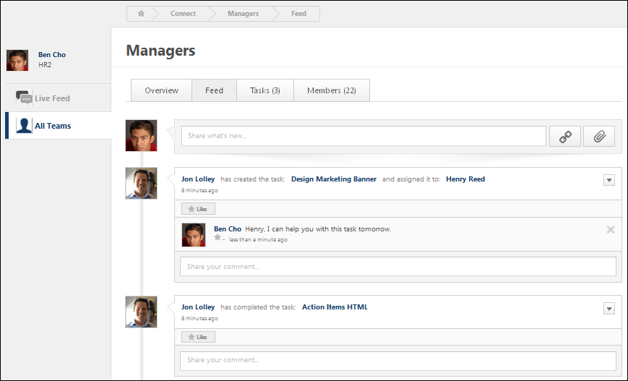
Team Page - Members Tab
The Members tab allows users to view and manage the team composition.
To access the Members tab of the Team Page, go to Connect > All Teams. Then, click the appropriate team name. Then, click the Members tab.
Permissions
PERMISSION NAME | PERMISSION DESCRIPTION | CATEGORY

Bio About - View | Enables user to view the Bio page for users within their permission constraints. This permission must be enabled to view the Transcript page within Universal Profile. If a user does not have this permission and they click a person's name or user photo within the Universal Profile, then the Bio page will not open.  On the Learner Home page, this permission also allows end users to view the Completions & Hours field, the training sidebar, and the Continue Learning carousel.  This permission can be constrained by Employee Relationship, OU, User's OU, User's Direct Reports, User Self and Subordinates, and User. Note: For security purposes, this permission is constrained to User Self and Subordinates by default. However, the permission constraints can be modified to allow users to view the Bio About page for other users. | Universal Profile

View New Connect | Grants ability to view the new Connect pages, including Live Feed, All Teams, Team Overview, Team Feed, Team Tasks, Task Details, and Connections. This permission cannot be constrained. | New Connect
To invite new members to the team, click the Invite New Members button in the upper-right corner of the page. See Team Members - Invite New Members on page 289 for additional information. Note: The Invite New Members button may only be available to team leads, depending upon the preferences set by the system administrator.
Team Leads
This section displays all team leads for the team. Team leads have additional abilities within the team, which may include moving team tasks, creating and editing tasks, inviting new members, and setting task priority.
Team Members
This section displays all team members who are not team leads.
Pending Team Members
This section displays all users who have been invited to the team, but have not yet responded to the invitation.
Make User Team Lead
To make a team member a team lead, click the drop-down icon on the appropriate user's ID card. Then, select Make Team Lead. This option is only available for users in the Team Members section.
Remove User from Team Lead Position
To remove a team member from the team lead position, click the drop-down icon on the appropriate user's ID card. Then, select Remove Team Lead. This option is only available for users in the Team Leads section. In addition, at least one user must be selected as a team lead. If there is only one team lead, then this user cannot be removed from the team lead position unless another user is added as a team lead.
Remove User from Team
To remove a team member from the team, click the drop-down icon on the appropriate user's ID card. Then, select Remove. This option is only available for users in the Team Leads and Team Members sections.
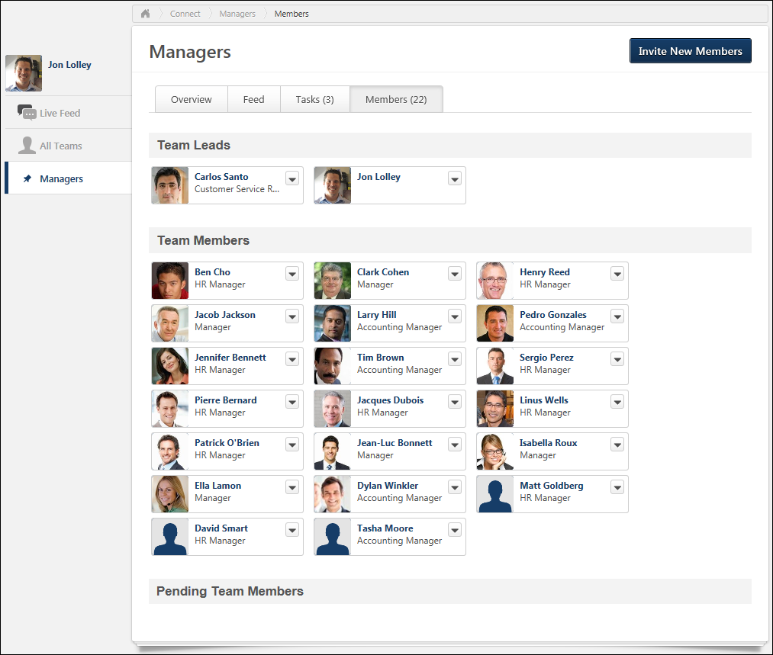
Team Page - Overview Tab
The Overview tab provides a high-level snapshot of what the team is doing; it includes the following information:
- A compact version of the five most recent Team Feed items
- A list of the user's five upcoming tasks
- A list of the team's five upcoming tasks
- A list of team members
Which types of updates appear in the feed is dependent upon the preferences set by the system administrator.
To access the Overview tab of the Team Page, go to Connect > All Teams. Then, click the appropriate team name. The Overview tab opens by default.
Permissions
PERMISSION NAME | PERMISSION DESCRIPTION | CATEGORY

Bio About - View | Enables user to view the Bio page for users within their permission constraints. This permission must be enabled to view the Transcript page within Universal Profile. If a user does not have this permission and they click a person's name or user photo within the Universal Profile, then the Bio page will not open.  On the Learner Home page, this permission also allows end users to view the Completions & Hours field, the training sidebar, and the Continue Learning carousel.  This permission can be constrained by Employee Relationship, OU, User's OU, User's Direct Reports, User Self and Subordinates, and User. Note: For security purposes, this permission is constrained to User Self and Subordinates by default. However, the permission constraints can be modified to allow users to view the Bio About page for other users. | Universal Profile

View New Connect | Grants ability to view the new Connect pages, including Live Feed, All Teams, Team Overview, Team Feed, Team Tasks, Task Details, and Connections. This permission cannot be constrained. | New Connect
Feed Panel
The Feed panel displays the five most recent updates by members of the team. The following information is displayed for each update:
- User Image - An image of the user who posted the update is displayed next to each post. If the user does not have an image in the system, then a generic image is displayed. Click the photograph to open the Universal Profile - Bio page for the user.
- User Name - The name of the user who posted the update is displayed next to the user image.
- Update Text - The content of the update is displayed next to the user's name.
- Timestamp - A timestamp is displayed with each update post to indicate when the post was made. The timestamp is always displayed in the time zone of the user who is viewing the feedback. If the update is more than 24 hours old, then only the date of the update is displayed.
Click the View Feed link at the bottom of the panel to open the Team Page - Feed tab.
Your Tasks Panel
The Your Tasks panel displays five of the user's upcoming incomplete tasks, sorted by due date with the soonest due date displayed first. The following information is displayed for each task:
- Color Strip - The left edge of the action item icon is color coded to represent proximity to the due date of the task. For example, if the action item due date is past due, then the color strip is red to indicate that action is required immediately. If an action item due date is not eminent, then the color strip is green to indicate that action is not required immediately. See the Color Strip Key section below for additional information.
- Checkbox - Click the checkbox next to the task name to mark the task complete.
- Title - This displays the task title. Click the task title to open the Task Details page for the task. See Team Tasks - Task Details Page on page 284 for additional information.
- Due Date - This displays the task due date.
- Comments - This displays the number of new comments that have been posted to the Task Details page since the user last visited the Task Details page.
Click the View All Tasks link at the bottom of the panel to open the Team Page - Tasks tab with the tasks grouped by assignee.
Upcoming Team Tasks Panel
The Upcoming Team Tasks panel displays five of the team's upcoming incomplete tasks that are not assigned to the user, sorted by due date with the soonest due date displayed first. The following information is displayed for each task:
- Color Strip - The left edge of the action item icon is color coded to represent proximity to the due date of the task. For example, if the action item due date is past due, then the color strip is red to indicate that action is required immediately. If an action item due date is not eminent, then the color strip is green to indicate that action is not required immediately. See the Color Strip Key section below for additional information.
- Checkbox - Click the checkbox next to the task name to mark the task complete.
- Title - This displays the task title. Click the task title to open the Task Details page for the task. See Team Tasks - Task Details Page on page 284 for additional information.
- Due Date - This displays the task due date.
- Comments - This displays the number of new comments that have been posted to the Task Details page since the user last visited the Task Details page.
Click the View All Tasks link at the bottom of the panel to open the Team Page - Tasks tab with the tasks grouped by due date.
Members Panel
The Members panel displays the total number of members in the team as well as a photo of each member of the team, up to two rows.
The team leads are displayed first in order of the date they joined the team. After the team leads, team members are displayed in order of the date they joined the team. Up to two rows of photos display. If the team photos fill two rows and there are more members, then the last photo on the second row displays how many additional members the team has. Click the photograph to open the Universal Profile - Bio page for the user.
Color Strip Key
The following colors are available:
- Red - Due today or past due
- Orange - Due within the next seven days, not including today
- Green - Due after seven days
Team Page - Tasks Tab
The Tasks tab allows team members to create, view, and manage tasks. Tasks can be filtered and can be grouped by due date, category, assignee, priority, and creation date.
To access the Tasks tab of the Team Page, go to Connect > All Teams. Then, click the appropriate team name. The Tasks tab opens by default.
Permissions
PERMISSION NAME | PERMISSION DESCRIPTION | CATEGORY

Bio About - View | Enables user to view the Bio page for users within their permission constraints. This permission must be enabled to view the Transcript page within Universal Profile. If a user does not have this permission and they click a person's name or user photo within the Universal Profile, then the Bio page will not open.  On the Learner Home page, this permission also allows end users to view the Completions & Hours field, the training sidebar, and the Continue Learning carousel.  This permission can be constrained by Employee Relationship, OU, User's OU, User's Direct Reports, User Self and Subordinates, and User. Note: For security purposes, this permission is constrained to User Self and Subordinates by default. However, the permission constraints can be modified to allow users to view the Bio About page for other users. | Universal Profile

View New Connect | Grants ability to view the new Connect pages, including Live Feed, All Teams, Team Overview, Team Feed, Team Tasks, Task Details, and Connections. This permission cannot be constrained. | New Connect
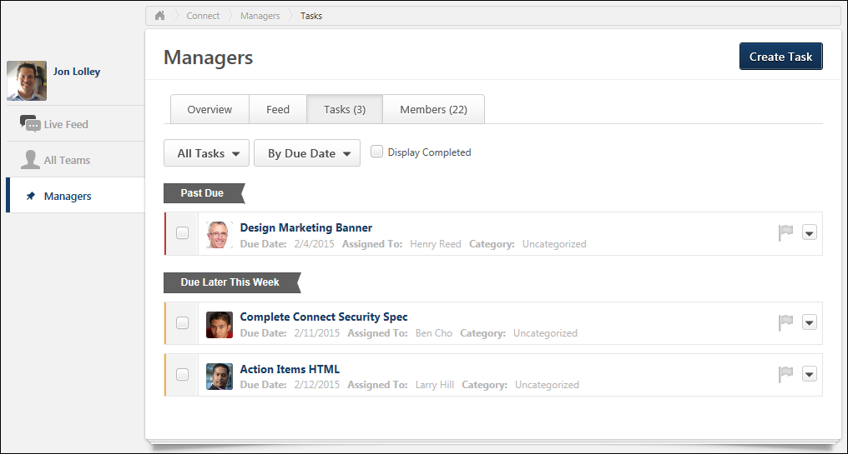
At the top of the page, the system displays the following information:
- New Tasks - This displays the number of new tasks that have been created since the user last visited the Team Page.
- Incomplete Tasks - This displays the number incomplete tasks that are assigned to the user.
Create Task
To create a new task, click the Create Task button in the upper-right corner of the page. The option to create a team task may only be available to lead team members, depending on the preferences set by the system administrator. See Live Feed - Create Task for additional information.
Filter Tasks by Assignee
Users can filter the tasks on the Tasks tab using the Show drop-down list. The following options are available:
- All Tasks - This option displays all tasks for the team.
- Unassigned - This option displays all team tasks that are unassigned.
- Each team member is listed in the drop-down list, including the logged in user. Selecting a specific user name displays all tasks that are assigned to the selected user.
Group Tasks
Users can group the tasks on the Tasks tab using the Group by drop-down list. The following options are available:
- By due date - This option sorts tasks by due date, displaying the most recent due dates at the top. Tasks that have the same due date are sorted alphabetically and then by assignment date. The tasks are placed into the following due date groups:
  - Past Due - This contains all tasks that are past due.
  - Due Today - This contains all tasks that are due today.
  - Due Tomorrow - This contains all tasks that are due on the next day.
  - Due Later This Week - This contains all tasks that are due within the next seven days but are not past due or due today or tomorrow.
  - Due Later - This contains all tasks that are due after seven days from the current date.
- By assignee - This option sorts the tasks by assignee, listing all team members who are assigned tasks in alphabetical order. Tasks that have the same assignee are sorted alphabetically.
- By creation date - This option sorts the tasks by creation date, displaying the tasks with the oldest assignment dates at the top. Tasks that have the same creation date are sorted alphabetically. The tasks are placed into the following creation date groups:
  - Created more than a month ago - This contains all tasks that have a creation date that is more than 30 days before the current date.
  - Created last month - This contains all tasks that were created within the past 30 days, but were not created within the past seven days.
  - Created this week - This contains all tasks that were created within the past seven days.
- By priority - This option sorts the tasks by priority, displaying the priority tasks first. Tasks are then sorted by due date with the most recent due dates at the top. Tasks with the same priority and due date are sorted alphabetically. The tasks are placed into the following priority groups:
  - Flagged
  - Not Flagged
- By category - This option sorts tasks by category. Tasks with the same category are then sorted by due date with the most recent due dates at the top. Tasks with the same category and due date are sorted alphabetically. The tasks are placed into the following type groups:
  - Uncategorized - This contains all tasks that do not have a category.
  - Following the Uncategorized option, each category is listed in the drop-down list alphabetically. Selecting a specific category displays all tasks within the selected category.
Display Completed
Select this option to display both incomplete and complete tasks on the Tasks tab.
Display Latest Comments
Select this option to display the two most recent comments from the Task Details page below each task. When this option is selected, users are able to post additional comments to each task from the Tasks tab.
Mark a Task as Complete
Click the checkbox to the left of the task name to mark the task complete.
Flag a Task as a Priority
The priority flag to the right of the task name allows users to mark tasks as high priority. Priority can be helpful as a visual indicator to users. Also, tasks can be filtered by priority from the filter at the top of the page. When the priority flag is not selected, it is gray . When the priority flag is selected, the action item is high priority and the flag is red . Click the priority flag icon to change the priority status. Note: The ability to change the priority of a task may only be available to team leads, depending upon the preferences set by the system administrator.
Task Actions
To the right of the priority flag, the Actions drop-down contains the following actions:
- View - Select this option to open the Task Details page for the task. See Team Tasks - Task Details Page on page 284 for additional information.
- Create goal - Select this option to create a goal from the task. See Team Tasks - Create Goal from Task on page 281 for additional information.
- Add to goal - Select this option to add the task to an existing goal. See Team Page - Overview Tab on page 272 for additional information.
- Delete - Select this option to delete the task. If a task is assigned to the team lead, then only the team lead can delete the task. However, administrators may also allow non-team leads to delete tasks that they created. This can be enabled in Connect Preferences.
Team Tasks - Add Task to Goal
Team leads can add a task to an existing goal. Also, if enabled by the administrator in Connect Preferences, non-team leads may also be able to add a task to an existing goal
Permissions
PERMISSION NAME | PERMISSION DESCRIPTION | CATEGORY

View New Connect | Grants ability to view the new Connect pages, including Live Feed, All Teams, Team Overview, Team Feed, Team Tasks, Task Details, and Connections. This permission cannot be constrained. | New Connect
To move a task to another team, from the Team Tasks page, from the Actions drop-down list, select Add to goal. This opens the Select Goal pop-up.
The Select Goal page displays all of the user's existing goals for which they are the owner, including goals that have 100% completion percentage. Select the goal to which the task should be added. After selecting the appropriate goal, click Continue to proceed to the Edit Goals page.
On the Edit Goals page, the Connect task is added as a goal task within the Tasks section. The following information is pre-populated for the goal task:
- The goal task title is set to the Connect task title.
- The goal task due date is set to the Connect task due date.
- The goal task weight is set to 0% by default.
- The goal task start date is set to the overall goal start date by default.
- Attachments from the task are not added to the goal.
Click Save to save the goal with the new task, or click Cancel to discard any unsaved changes. See Goal - Create/Edit.
Team Tasks - Create Goal from Task
Team leads can create goals out of Connect tasks. Also, if enabled by the administrator in Connect Preferences, non-team leads may also be able to create goals out of Connect tasks.
Permissions
PERMISSION NAME | PERMISSION DESCRIPTION | CATEGORY

View New Connect | Grants ability to view the new Connect pages, including Live Feed, All Teams, Team Overview, Team Feed, Team Tasks, Task Details, and Connections. This permission cannot be constrained. | New Connect
To create a goal from a team task, navigate to the Team Tasks page. Select the Actions drop-down list to the right of the appropriate task and select Create goal. See Goal - Create/Edit.
On the Create Goals page, the task title is automatically entered in the Title field, the task due date is automatically entered in the Due Date field, and all attachments in the task are added to the Attachments section of the goal.
Team Tasks - Edit Task
Users can edit the title, due date, assignee, recurrence, and category fields for a task. The option to edit a team task may only available to lead team members, depending on the preferences set by the system administrator.
Permissions
PERMISSION NAME | PERMISSION DESCRIPTION | CATEGORY

View New Connect | Grants ability to view the new Connect pages, including Live Feed, All Teams, Team Overview, Team Feed, Team Tasks, Task Details, and Connections. This permission cannot be constrained. | New Connect
To edit a task, from the Team Tasks page, from the Actions drop-down list, select Edit.
Edit the following information for the task:
- Task Name - In the text field, edit the task title, up to 70 characters. This field is required.
- Due Date - Using the calendar tool, select a new due date for the task. The user can also enter a text due date, such as Today, Tomorrow, Monday, Tuesday, etc. Select the No due date link to remove the due date. This field is optional.
- Repeat - From the drop-down list, select how often the task should recur. Note: If a task is set to recur, then a new instance of the task is automatically created when the original task is marked complete or when the original task's due date passes. The following options are available:
  - Never - Select this option for the task to never recur.
  - Daily - Select this option for the task to recur daily.
  - Weekly - Select this option for the task to recur every seven days.
  - Monthly - Select this option for the task to recur on the same day every month. For example, if the task is created on May 15, then the task recurs on the 15th of every month.
    - If the due date of the original task is the last day of the month, then the due date of recurring tasks is also the last day of each month.
    - If the due date of the original task is on a day that the next month does not have (e.g., February 30th will never occur), then the due date of the generated task has a due date of the last day of the month.
  - Yearly - Select this option for the task to recur every 365 days.
  - Periodically - Select this option for the task to recur periodically. In the text field, enter the number of days between recurrences. For example, if "15" is entered, then the task is recreated every 15 days.
- Assigned to - To edit the assignee, users have the option of entering a user's name into the text box or selecting a user from the drop-down list. Select Unassigned to create a task that is not assigned to any users. This field is optional.
- Category - To edit the category, users have the option of selecting a category from the drop-down list or clicking the New button to create a new category. Entering a new category adds the category to the category bank. Select Uncategorized to not associate the task with a category.
Save or Cancel
Click the Save button to save the task modifications, or click Cancel to discard any unsaved changes.
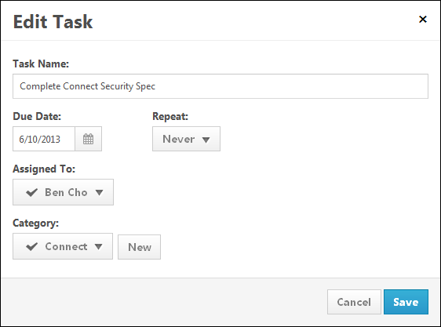
Move Task to Another Team
Request Feedback on Task
Team Tasks - Task Details Page
The Task Details page displays the task, the check-in discussing the task, any files shared regarding the task, and the activity history of the task.
The Task Details page can be accessed in the following ways:
- From the Team Page - Overview tab: Click the task title.
- From the Team Page - Tasks tab: From the Actions drop-down , select View.
Permissions
PERMISSION NAME | PERMISSION DESCRIPTION | CATEGORY

Bio About - View | Enables user to view the Bio page for users within their permission constraints. This permission must be enabled to view the Transcript page within Universal Profile. If a user does not have this permission and they click a person's name or user photo within the Universal Profile, then the Bio page will not open.  On the Learner Home page, this permission also allows end users to view the Completions & Hours field, the training sidebar, and the Continue Learning carousel.  This permission can be constrained by Employee Relationship, OU, User's OU, User's Direct Reports, User Self and Subordinates, and User. Note: For security purposes, this permission is constrained to User Self and Subordinates by default. However, the permission constraints can be modified to allow users to view the Bio About page for other users. | Universal Profile

View New Connect | Grants ability to view the new Connect pages, including Live Feed, All Teams, Team Overview, Team Feed, Team Tasks, Task Details, and Connections. This permission cannot be constrained. | New Connect
Task Overview
At the top of the page, the task overview is displayed, including task title, due date, category, and assignment. The color strip on the left edge of the task is color coded to represent proximity to the due date of the task. For example, if the action item due date is past due, then the color strip is red to indicate that action is required immediately. If an action item due date is not imminent, then the color strip is green to indicate that action is not required immediately. See the Color Strip Key section below for additional information.
Task Comments
Below the task overview, all of the comments that have been added regarding the task are displayed in reverse chronological order with the most recent comments displayed at the bottom.
- Click the user's photograph to navigate to the user's Universal Profile - Bio page. The visibility of a user's photograph is controlled by the system administrator. See Universal Profile - Bio Overview.
- You are able to like another user's update. This can be done to show users that you like a personal update, a file that was shared, an activity update, or a comment that was added to an update. See Live Feed - Like an Update or Comment on page 182 for additional information.
- Up to seven comments are displayed. If the task has more than seven comments, then only the seven most recent comments are displayed and a Show all comments link appears at the top of the comments list. Click this link to view all comments.
Task Activity Updates
Comprehensive task-related activity updates display on the Task Details page. They are interspersed with user updates. The following task related updates may appear on the Task Details page:
- Created task - This occurs when the task is created.
- Assigned task - This occurs when the task is assigned to a user.
- Updated due date - This occurs when the task due date is updated.
- Updated category - This occurs when the task category is updated.
- Completed task - This occurs when the task is completed.
- Marked task incomplete - This occurs when the task is marked incomplete.
Mark a Task as Complete
Click the checkbox to the left of the task name to mark the task complete.
Flag a Task as a Priority
The priority flag to the right of the task name allows users to mark tasks as high priority. Priority can be helpful as a visual indicator to users. Also, tasks can be filtered by priority from the filter at the top of the page. When the priority flag is not selected, it is gray . When the priority flag is selected, the action item is high priority and the flag is red . Click the priority flag icon to change the priority status. Note: The ability to change the priority of a task may only be available to team leads, depending upon the preferences set by the system administrator.
Task Actions
To the right of the priority flag, the Actions drop-down contains the following actions:
- Edit - Select this option to edit the task. See Team Tasks - Edit Task on page 282 for additional information.
- Create goal - Select this option to create a goal from the task. See Team Tasks - Create Goal from Task on page 281 for additional information.
- Add to goal - Select this option to add the task to an existing goal. See Team Page - Overview Tab on page 272 for additional information.
- Delete - Select this option to delete the task. If a task is assigned to the team lead, then only the team lead can delete the task. However, administrators may also allow non-team leads to delete tasks that they created. This can be enabled in Connect Preferences.
Add a Comment
At the bottom of the Task Details page, you are able to add a comment. Enter your comment in the comment field directly below the most recent comment. You also have the option to attach a URL, file, or video to the comment.
- See Live Feed - Attach a File on page 173 for additional information.
- See Live Feed - Include URL Preview on page 180 for additional information.
Click Post to add your comment to the Task Details page, or click Cancel to discard your comment.
Delete a Comment
Users can delete a comment from the Task Details page. This option is only available if you have permission to delete Connect posts, and you can only delete comments that have been made by users within your permission constraints. See Live Feed - Delete Post or Comment on page 178 for additional information.
Color Strip Key
The following colors are available:
- Red - Due today or past due
- Orange - Due within the next seven days, not including today
- Green - Due after seven days
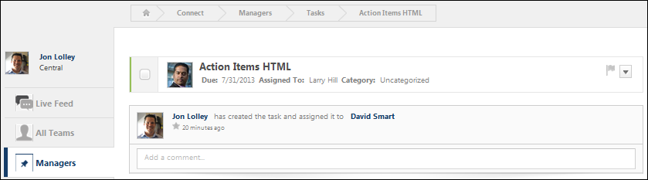
Team Members - Invite New Members
Members of a team are able to invite new members to join the team.
Permissions
PERMISSION NAME | PERMISSION DESCRIPTION | CATEGORY

View New Connect | Grants ability to view the new Connect pages, including Live Feed, All Teams, Team Overview, Team Feed, Team Tasks, Task Details, and Connections. This permission cannot be constrained. | New Connect
To invite new members to the team, from the Team Members page, click the Invite New Members button in the upper-right corner of the page. This opens the Invite Team Members pop-up. Note: The Invite New Members button may only available to team leads, depending upon the preferences set by the system administrator.
Enter the following information:
- Enter team members - In this field, enter the names of the users who you are inviting to join the team.
- Invitation message - In this field, enter the message that is sent to users who receive the invitation. This field is pre-populated by the system, but can be modified.
Click the Invite button to send the invitation to the selected users, or click Cancel to cancel the invitation. Invitations appear in the Your Inbox Widget. If enabled, the Connect Team Invitation email is triggered when a Connect team invitation is sent.
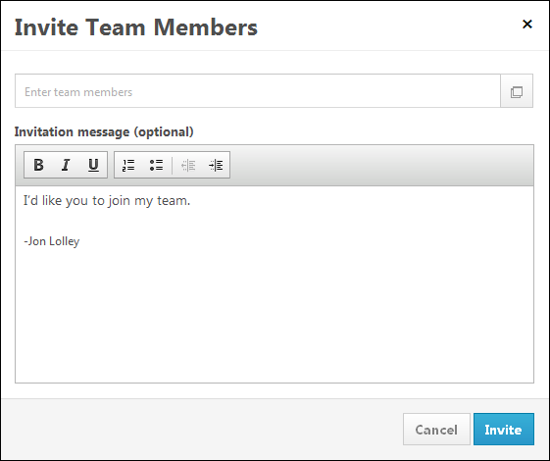
Emails
EMAIL NAME | EMAIL DESCRIPTION | ACTION TYPE

Connect Team Invitation | This email is triggered when a user receives an invitation to a Connect team. This email can be sent as a notification to Invitation Recipient or a specific user. | New Connect

Connect Preferences Overview

Connect Preferences (Old)
Permissions
PERMISSION NAME | PERMISSION DESCRIPTION | CATEGORY

Connect Preferences - Manage | Enables users to configure Connect preferences. This is an administrator permission.  Note: This permission applies to the legacy version of Connect. | Connect - Administration
- Go to Admin page
- Click Preferences link
- Click Connect (by Division) under Connect Preferences
- Find and click applicable division from hierarchy
- User Profile Fields - click the Add User Fields icon
  - Search and select up to 10 fields. Only user record standard and custom fields are available for selection.
  - Position - the fields can be ordered by dragging and dropping them. By hovering over the field, the field will appear highlighted and can be moved
  - Click Save
- User Profile - click icon on bar to expand/collapse the options
  - Display user profiles - check to enable user profiles to be active and visible to users within Connect. Select user fields to display with Profile.
  - Display User photos - check to display user photo in User Profiles and next to user postings and/or comments
  - Allow user to hide profile - check to enable users to hide their profile entirely to other users within Connect
  - Allow users to post profile comments - check to enable users to post comments on other user's profiles and delete comments from their own profile
  - Allow users to post updates to their profile - check to enable user update feature. Users may add updates to their profile for others to view and comment on. Updates will appear within the Live Feed on Connect main page for all connected users.
  - Favorites: Automatic Email Notification - check to send out an email notification when a user indicates a favorite Topic, Author, or Posting.
  - Allow users to create a Connect Display Name - check to allow user to either display their system defined name in Connect or to create a unique Connect Display Name. A Connect display name will appear in all Connect pages where the user name would display. Note - this option is best used for an extended enterprise or retail model, where customers or vendors are self-registering and entering into the client's portal. This model allows those users to have anonymity when sharing ideas in Connect.
  - Allow RSS Feeds - check to enable ability for users to subscribe to receive RSS Feeds on Connect updates. Feeds will display on an external feed reader and within the Connect Profile.
- User Profile Navigational Links - click icon on bar to expand/collapse the options
  - Navigation Links - enter text to change titles of navigation links (limit 20 characters) NOTE: Profile page and View All pages off of profile are the only locations they will see these title changes. For instance, if Postings is changed to News, Connect search drop-down and Connect main page tab within the Live Feed will still say Postings.
  - Translate icon - click to enter translated text into text boxes. (limit 20 characters)
- Additional Options - click icon on bar to expand/collapse the options
  - Allow Rating system -check to enable the 5 start rating system for posting. Users can view ratings and rate postings. Suggestions, if enabled, will always allow ratings regardless of this setting
  - Exclude Community Leaders from Community Members - check to exclude Community Leaders from Community Members. If not checked, this will allow users to view who the leaders of the Community that have been assigned through the Connect Community Administration page. By default, this will not be checked and therefore leaders will appear as members.
  - Allow Users to edit postings - check to enable users the ability to edit their own postings after they have been posted. If enabled, edit icons will appear on user's posting pages when they navigate to them allowing them to edit the posting.
  - Assign recipient to Profile Abuse Reports - check to enable the Report Abuse link on pages. Assign an individual contact to receive profile abuse reports. If specified contact changes their status to Absent, their manager will receive the abuse report email.
  - Featured Blog - Check to display a featured blog on the Connect main page. If no blog is selected as the featured blog, the blog with the most recently created blog entry is displayed as the featured blog.
    - Select a blog - If a blog selected is within a topic that is not visible to the end users, the featured blog widget displays the blog with the most recently created blog entry within a topic that is visible to the user. If there are no blogs within any topics that the user has permission to view, then this widget does not appear on the Connect main page.
  - Featured Author - check to display a featured Author on the Connect main page. If no Author is selected, the most recent posting's Author will appear.
    - Select an author - the list of authors matches the list of authors that appear on the Authors tab of the Connect main page (In the Live Feed panel). If the selected author has not made any postings to a topic and end user can see, then the Featured Author widget will display to that end user instead the author who posted the most recent posting to a topic the end user can see. If there are no topics with any postings that the end user can see, then the widget on the main page does not display.
  - Top Rated Suggestion -check to display the suggestion with the most positive votes. If this option is not checked the Top Rated Suggestion widget does not appear on the Connect main page. If there are no suggestions made or the posting type suggestions are not available for the division or portal, then the widget will not appear, even if the option is checked. The system references the suggestion posting with the most thumbs up votes that is visible to the end user. This means that one end user may see a different top rated suggestion than another end user depending on their availability for various topics.
  - Leader Board - check to display the top 10 users who have created the most postings. If this option is not checked the leader board will not display on the Connect main page. The authors that populate the Authors tab on the live feed, are the authors referenced for the quantity of postings they have each added to Connect. Based on the quantity of postings (for available and not available topics), the top 10 users with the most postings are listed in this widget. The author's name is clickable and navigates the end user to the author's profile page. If the name is gray it means the profile page is private, and the name link is not clickable. The sum of postings is the number of postings that author has created in total, regardless of the end users topic availability.
  - Connect News - check to display a scrolling message across the top of the Connect main page. ( Character limit is 450, text only) If this option is not checked the Connect News widget does not appear on the Connect main page.
  - Tag Cloud - check to display a Tag Cloud on the Topic page or on a Community page. If this option is active, the Tag Cloud by default displays on the Topic page, and becomes an option when defined on a Community page layout.
    - Simple is the frequency of a tag used for one or more topics. A simple tag cloud is determining tag size and display in the cloud by the count/frequency of a tag used for a posting in a topic.
    - Complex considers the tag frequency, the associated posting's number or views, and its ratings. Ratings are weighted heaviest of the 3 components.
Overwrite Settings
Select this option to overwrite custom settings for child division OUs. If you overwrite custom settings for child division OUs, the selected settings are applied to both new and existing child OUs. Any previously customized child OUs are updated with the selected settings.
- If there are no customizations to the child OU, then the parent OU customizations are applied to all child OUs.
- Overwrite custom settings checkbox setting
  - If this option is selected, all child OU customizations are deleted from the database, which means the parent OU customizations will be applied to new and existing child OUs.
  - If this option is unselected, all existing child OU customizations will remain unchanged, and any new child OUs will inherit the parent OU customizations by default.
- If a child OU has been customized to display any widgets, then regardless of the parent OU customizations, the child OU customizations are applied.
- If a child OU has been customized to hide all widgets, then parent OU customizations will take precedence and will be applied.
Click Submit.

Posting Type Preferences (Old)
The Posting Type Preferences page allows administrators to configure preferences for posting types in Old Connect.

Permissions
PERMISSION NAME | PERMISSION DESCRIPTION | CATEGORY

Connect Preferences - Manage | Enables users to configure Connect preferences. This is an administrator permission.  Note: This permission applies to the legacy version of Connect. | Connect - Administration
- Go to Admin page
- Click Preferences link
- Click Posting Type Preferences under Connect Preferences
- Posting Types - check which postings you want enabled. At least one posting must be enabled. If a posting type is available, and then made unavailable, any previously created postings will still be visible in connect, even though a user could not create another posting of that type, or select to search for that specific type.
  - Forum
  - Blog
  - Wiki
  - Suggestion
  - Q&A
  - URL
  - File
  - Podcast
  - Webcast
- Click Submit button to save changes
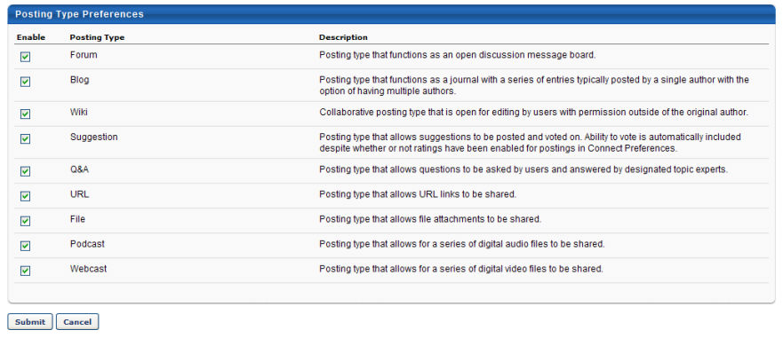

Connect Overview (Old)
Connect brings together the best of Enterprise 2.0 Technologies with the latest in social networking to enable effective workplace collaboration, improve employee performance, and drive innovation from customer and partner communities. By encouraging collaboration and making it easy to join communities of practice, Cornerstone Connect fosters social (informal) learning, organizational memory, professional networking, and better communication across your employee base and the extended enterprises.
Key features:
- Web 2.0 technologies
- Rich user profiles
- Communities of practice
- Blogs, wikis and podcasts
- Discussions
- Tag Clouds
- Rate and share content
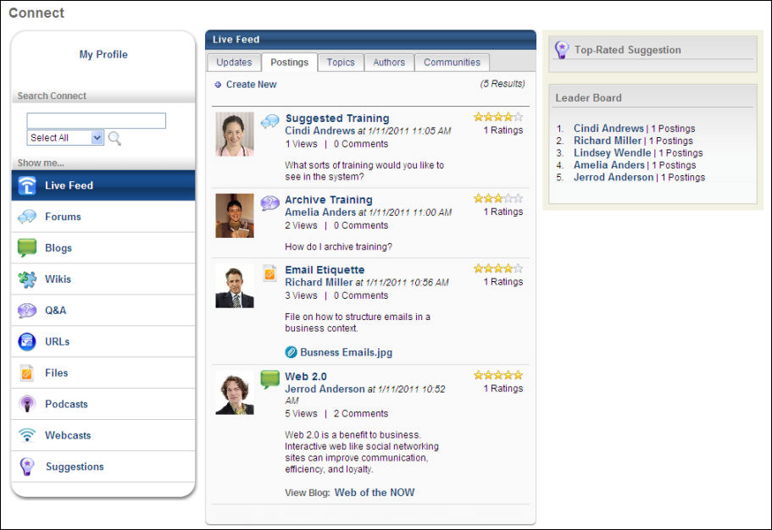
See also:
- Connect Topic Administration
- Connect Community Administration
- Connect Preferences
- Posting Type Preferences

Connect Preferences (Old)
Permissions
PERMISSION NAME | PERMISSION DESCRIPTION | CATEGORY

Connect Preferences - Manage | Enables users to configure Connect preferences. This is an administrator permission.  Note: This permission applies to the legacy version of Connect. | Connect - Administration
- Go to Admin page
- Click Preferences link
- Click Connect (by Division) under Connect Preferences
- Find and click applicable division from hierarchy
- User Profile Fields - click the Add User Fields icon
  - Search and select up to 10 fields. Only user record standard and custom fields are available for selection.
  - Position - the fields can be ordered by dragging and dropping them. By hovering over the field, the field will appear highlighted and can be moved
  - Click Save
- User Profile - click icon on bar to expand/collapse the options
  - Display user profiles - check to enable user profiles to be active and visible to users within Connect. Select user fields to display with Profile.
  - Display User photos - check to display user photo in User Profiles and next to user postings and/or comments
  - Allow user to hide profile - check to enable users to hide their profile entirely to other users within Connect
  - Allow users to post profile comments - check to enable users to post comments on other user's profiles and delete comments from their own profile
  - Allow users to post updates to their profile - check to enable user update feature. Users may add updates to their profile for others to view and comment on. Updates will appear within the Live Feed on Connect main page for all connected users.
  - Favorites: Automatic Email Notification - check to send out an email notification when a user indicates a favorite Topic, Author, or Posting.
  - Allow users to create a Connect Display Name - check to allow user to either display their system defined name in Connect or to create a unique Connect Display Name. A Connect display name will appear in all Connect pages where the user name would display. Note - this option is best used for an extended enterprise or retail model, where customers or vendors are self-registering and entering into the client's portal. This model allows those users to have anonymity when sharing ideas in Connect.
  - Allow RSS Feeds - check to enable ability for users to subscribe to receive RSS Feeds on Connect updates. Feeds will display on an external feed reader and within the Connect Profile.
- User Profile Navigational Links - click icon on bar to expand/collapse the options
  - Navigation Links - enter text to change titles of navigation links (limit 20 characters) NOTE: Profile page and View All pages off of profile are the only locations they will see these title changes. For instance, if Postings is changed to News, Connect search drop-down and Connect main page tab within the Live Feed will still say Postings.
  - Translate icon - click to enter translated text into text boxes. (limit 20 characters)
- Additional Options - click icon on bar to expand/collapse the options
  - Allow Rating system -check to enable the 5 start rating system for posting. Users can view ratings and rate postings. Suggestions, if enabled, will always allow ratings regardless of this setting
  - Exclude Community Leaders from Community Members - check to exclude Community Leaders from Community Members. If not checked, this will allow users to view who the leaders of the Community that have been assigned through the Connect Community Administration page. By default, this will not be checked and therefore leaders will appear as members.
  - Allow Users to edit postings - check to enable users the ability to edit their own postings after they have been posted. If enabled, edit icons will appear on user's posting pages when they navigate to them allowing them to edit the posting.
  - Assign recipient to Profile Abuse Reports - check to enable the Report Abuse link on pages. Assign an individual contact to receive profile abuse reports. If specified contact changes their status to Absent, their manager will receive the abuse report email.
  - Featured Blog - Check to display a featured blog on the Connect main page. If no blog is selected as the featured blog, the blog with the most recently created blog entry is displayed as the featured blog.
    - Select a blog - If a blog selected is within a topic that is not visible to the end users, the featured blog widget displays the blog with the most recently created blog entry within a topic that is visible to the user. If there are no blogs within any topics that the user has permission to view, then this widget does not appear on the Connect main page.
  - Featured Author - check to display a featured Author on the Connect main page. If no Author is selected, the most recent posting's Author will appear.
    - Select an author - the list of authors matches the list of authors that appear on the Authors tab of the Connect main page (In the Live Feed panel). If the selected author has not made any postings to a topic and end user can see, then the Featured Author widget will display to that end user instead the author who posted the most recent posting to a topic the end user can see. If there are no topics with any postings that the end user can see, then the widget on the main page does not display.
  - Top Rated Suggestion -check to display the suggestion with the most positive votes. If this option is not checked the Top Rated Suggestion widget does not appear on the Connect main page. If there are no suggestions made or the posting type suggestions are not available for the division or portal, then the widget will not appear, even if the option is checked. The system references the suggestion posting with the most thumbs up votes that is visible to the end user. This means that one end user may see a different top rated suggestion than another end user depending on their availability for various topics.
  - Leader Board - check to display the top 10 users who have created the most postings. If this option is not checked the leader board will not display on the Connect main page. The authors that populate the Authors tab on the live feed, are the authors referenced for the quantity of postings they have each added to Connect. Based on the quantity of postings (for available and not available topics), the top 10 users with the most postings are listed in this widget. The author's name is clickable and navigates the end user to the author's profile page. If the name is gray it means the profile page is private, and the name link is not clickable. The sum of postings is the number of postings that author has created in total, regardless of the end users topic availability.
  - Connect News - check to display a scrolling message across the top of the Connect main page. ( Character limit is 450, text only) If this option is not checked the Connect News widget does not appear on the Connect main page.
  - Tag Cloud - check to display a Tag Cloud on the Topic page or on a Community page. If this option is active, the Tag Cloud by default displays on the Topic page, and becomes an option when defined on a Community page layout.
    - Simple is the frequency of a tag used for one or more topics. A simple tag cloud is determining tag size and display in the cloud by the count/frequency of a tag used for a posting in a topic.
    - Complex considers the tag frequency, the associated posting's number or views, and its ratings. Ratings are weighted heaviest of the 3 components.
Overwrite Settings
Select this option to overwrite custom settings for child division OUs. If you overwrite custom settings for child division OUs, the selected settings are applied to both new and existing child OUs. Any previously customized child OUs are updated with the selected settings.
- If there are no customizations to the child OU, then the parent OU customizations are applied to all child OUs.
- Overwrite custom settings checkbox setting
  - If this option is selected, all child OU customizations are deleted from the database, which means the parent OU customizations will be applied to new and existing child OUs.
  - If this option is unselected, all existing child OU customizations will remain unchanged, and any new child OUs will inherit the parent OU customizations by default.
- If a child OU has been customized to display any widgets, then regardless of the parent OU customizations, the child OU customizations are applied.
- If a child OU has been customized to hide all widgets, then parent OU customizations will take precedence and will be applied.
Click Submit.

Posting Type Preferences (Old)
The Posting Type Preferences page allows administrators to configure preferences for posting types in Old Connect.

Permissions
PERMISSION NAME | PERMISSION DESCRIPTION | CATEGORY

Connect Preferences - Manage | Enables users to configure Connect preferences. This is an administrator permission.  Note: This permission applies to the legacy version of Connect. | Connect - Administration
- Go to Admin page
- Click Preferences link
- Click Posting Type Preferences under Connect Preferences
- Posting Types - check which postings you want enabled. At least one posting must be enabled. If a posting type is available, and then made unavailable, any previously created postings will still be visible in connect, even though a user could not create another posting of that type, or select to search for that specific type.
  - Forum
  - Blog
  - Wiki
  - Suggestion
  - Q&A
  - URL
  - File
  - Podcast
  - Webcast
- Click Submit button to save changes

Connect Topic Administration (Old)
Permissions
PERMISSION NAME | PERMISSION DESCRIPTION | CATEGORY

Connect Administration | Grants access to create, edit and delete Connect topics, including designating topic moderators, topic availability and posting types allowed within topics. This is an administrator permission.  Note: This permission applies to the legacy version of Connect. | Connect - Administration

Connect Topic Management | Enables users to manage Connect topics which they are designated moderators. This permission should be included in the Connect Topic Moderator security role, which is dynamically assigned to users who are designated as "moderators" for one or more Connect topics.  Note: This permission applies to the legacy version of Connect. | Connect
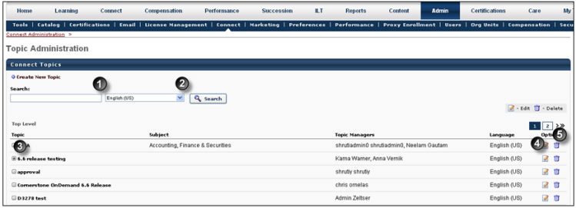
- Search - to search for existing Topics
- Create New Topic - to create a new Topic
- Expand icon - to view subordinate topics under parent topic
- Edit - to make changes to existing topics
- Delete - to remove an existing topic
To access Connect Topic Administration:
- Go to Admin page
- Click Connect Administration
- Click Topic Administration
- Click Create a New Topic
- Topic Details:
  - Topic Title - enter a tile for the topic (required field)
  - Parent Topic (Optional) - select from drop-down list to create a sub-topic of the selected parent
  - Short Description - enter a description (required field)
  - Tags - represent words the user would enter when searching for the topic
  - Topic Moderator - click to select topic moderator/s (required field)
  - Language - select language from drop-down if applicable
  - Posting Types allowed - select which posting types to allow within the topic. At least one posting type must be selected.
  - Click to add a Subject - to associate the topic with a subject category
- Availability Selection Criteria:
  - Choose availability criteria from drop-down list
  - Include Subordinates - check box if applicable
  - Access Level:
    - Read Only - User can view the posts in the topic, but they cannot comment on posts.
    - Read Write - User can view and create posts, post questions to the topic, and create discussions.
    - Read Only w/Question Asking - Users can view posts and post questions to the topic, but they cannot comment on posts.
    - Read Only w/Commenting - User can view posts and comment on them.
- Click Submit
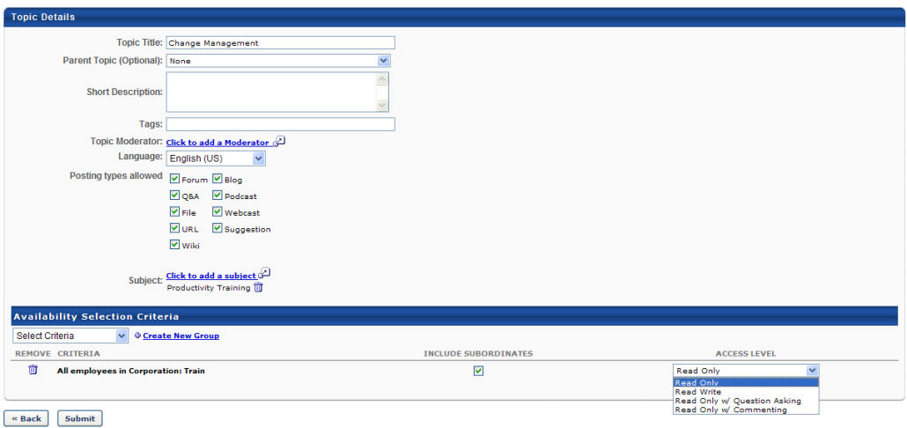

Connect Community Administration (Old)
Communities are groups of users within Connect where users can connect with others to share ideas, procedures, materials, etc.
To access Community Administration, go to: Admin > Tools > Connect > Connect Administration and click the Communities link.
Permissions
PERMISSION NAME | PERMISSION DESCRIPTION | CATEGORY

Connect Community Management | Enables users to manage Connect communities for which they are designated leaders. This permission should be included in the Connect Community Leader security role, which is dynamically assigned to users who are designated as leaders to one or more Connect communities.  Note: This permission applies to the legacy version of Connect. | Connect
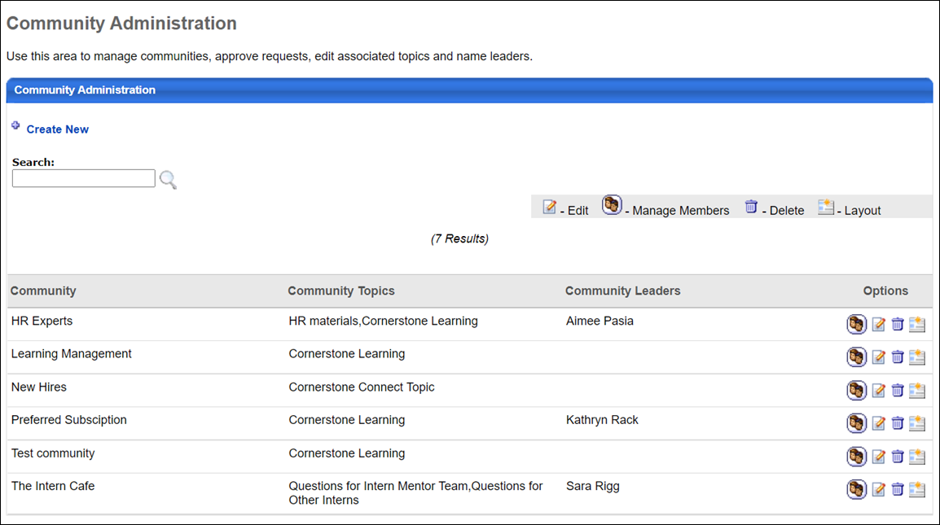
Community Administration
The following features and options are available to administrators on the Community Administration page:
- Search - Use the Search bar to search for existing communities.
- Create New - Click this link to create a new community.
- Manage Members - Click this option to remove members. If a member is removed, they will not be notified and they are not prevented from joining the community again.
- Edit - Click this option to make changes to existing communities.
- Delete - Click this option to delete an existing community.
- Layout - Click this option to manage the layout of the community.

Create Connect Community (Old)
Administrators can create Connect Communities via Community Administration.
To create a connect community, go to Admin > Connect Administration and select Community Administration.
Permissions
PERMISSION NAME | PERMISSION DESCRIPTION | CATEGORY

Connect Community Management | Enables users to manage Connect communities for which they are designated leaders. This permission should be included in the Connect Community Leader security role, which is dynamically assigned to users who are designated as leaders to one or more Connect communities.  Note: This permission applies to the legacy version of Connect. | Connect
Create Community
- From the Community Administration page, click Create New, which opens the Create Community page.
- Enter the following information for the community:
  - Community Name - Enter a name for the community. This is required.
  - Description - Enter a description that displays in search results on the Community main page The character limit is 1000. This is required.
  - Assigned Users - Select the users that are a part of the community. You can also create a new group by clicking the Create New Group link.
  - Leaders - Assign leaders to the community. Leaders can approve or deny member requests.
  - Tags - Enter words the user may enter when searching for the topic. Multiple tags can be entered, separated with a comma.
  - Topic - Either select an existing topic to assign to the community or click the Create New Topic link to create a new topic. If you remove a topic from a community, the topic still exists, but is no longer associated with the community.
  - Access Type - Select the access level for the community. This determines who can view and join the group.
    - Public - Anyone may view and join the community
    - Request Only - Anyone may view the community, but non-members must request membership to be approved or denied by community Leaders or Owner
    - Private - If users are not assigned to the community, they cannot view or join the community
- Click Submit.

Manage Connect Community Layout (Old)
Administrators can customize Connect Community layouts via Connect Administration.
To manage Community layouts, go to: Admin > Tools > Connect > Connect Administration and click the Communities link.
Permissions
PERMISSION NAME | PERMISSION DESCRIPTION | CATEGORY

Manage Knowledge Bank/Communities Administration | Grants ability to view the New Knowledge Bank Administration page and manage Action Groups. Based on permission constraints, administrators with this permission can create and delete topics and subtopics. Administrators with this permission can view all communities, topics, sub-topics and postings, regardless of availability. In addition, administrators can add a posting to the Course Catalog. When creating a topic, the constraints on this permission are automatically applied to the topic's availability. This permission can be constrained by OU and User's OU. This permission is assigned to the default Administrator role by default. | New Connect
Customize Layout
To customize a Connect Communities layout:
- Click the Layout icon in the Options column next to a community.
- Widgets may be dragged and dropped to either two columns in any order.
- The Edit icon on the widget title bar can be used to edit the title and to specify number of items to display.
- To remove a widget from display, drag and drop the widget to the anchor area in the top right of the screen.
- Custom 1 or Custom 2 - To create custom message boxes, drag and drop Custom 1 and/or Custom 2 to the lower section of the screen and click the Edit icon to enter message (HTML friendly).
- Leaders - Drag and drop the Leaders widget to include the widget on the Community's main page. By default the widget will be titled "Leaders," and will display four community leaders.
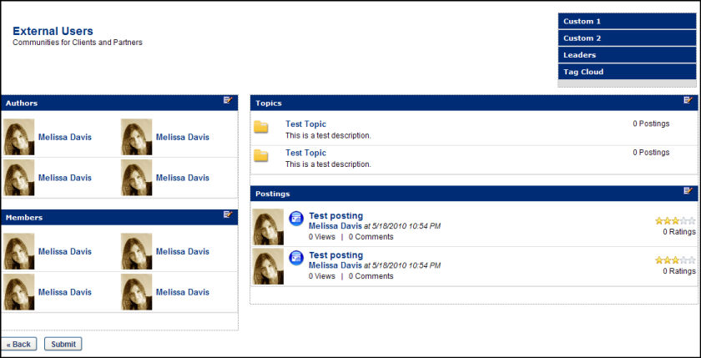

Fred is the administrator for a community. The community he created can only be joined by accepting an invitation. After some internal discussion, it is determined that the community instead needs to be automatically accessible by all employees who meet the availability criteria. Fred edits the community membership setting from Invitation to Auto-enrollment, thereby automatically enrolling every employee who needs to access the community.
Harry is the administrator for a community. The community he created automatically enrolls every employee who meets the availability criteria. Management has decided that, because of the sensitivity of information posted within the community, all future members should not be automatically enrolled but should instead be extended an invitation based on OU selection criteria.
A user needs to leave a certain community in which he is no longer active. He navigates to the homepage of the community and clicks the Options drop-down. He clicks the Leave Community option, and then confirms his selection to leave the community in the confirmation pop-up. Upon confirmation, he is directed to the All Communities page.
Fred is the administrator for a community. The community he created can only be joined by accepting an invitation. After some internal discussion, it is determined that the community instead needs to be automatically accessible by all employees who meet the availability criteria. Fred edits the community membership setting from Invitation to Auto-enrollment, thereby automatically enrolling every employee who needs to access the community.
Harry is the administrator for a community. The community he created automatically enrolls every employee who meets the availability criteria. Management has decided that, because of the sensitivity of information posted within the community, all future members should not be automatically enrolled but should instead be extended an invitation based on OU selection criteria.

