Competencies March 2024

Table of Contents
Competencies Overview 1
Assessment Tasks Overview 2
Competency Assessment Task - Administration Overview 3
Competency Assessment Task - Create Overview 6
Competency Assessment Task - View Details 31
Complete a Competency Assessment 34
Competency Assessment - View Assessment Summary 37
Competency Assessment - Compare Ratings 38
Competency Bank - Overview 39
Competency - Create/Edit 43
Competency - Create/Edit Training Equivalence 46
Competency Category Types Overview 50
Competency and Competency Model Versioning 51
Competency Assessment Models - Overview 53
Competency Assessment Models - Manage 55
Competency Models - Create/Edit 58
Competency Model Category - Create 62
Competency Rating Scale - Define Default 63
Observation Checklists - Overview 65
Observation Checklist Administration 67
Observation Checklist - Create/Edit Overview 71
Observation Checklist - Copy 109
Observation Checklist - View Details 111
Validation Method - Define Default 116
Observation Checklists Complete - Overview 118
Skills Matrix - Overview 148
Skills Matrix - Assign Roles - Select Role 150
Skills Matrix - Assign Roles - Add/Remove Users 152
Skills Matrix - Export to Excel 155
Skills Matrix - Print to PDF 156
Skills Matrix - Request Role 157
Skills Matrix - Role Details Page 159

Competencies Overview

Assessment Tasks Overview

Competency Assessment Task - Administration Overview
The Competency Assessment Task feature allows administrators to create a task to direct your users, managers and peers to assess individuals on competencies.
Administrators must complete the following pages for a Competency Assessment Task:
- General - Create a new assessment task or edit general information for an assessment task. See Competency Assessment Task - Create/Edit General on page 8 for additional information.
- Competency Model - Manage competency models based on model availability. See Competency Assessment Task - Create/Edit Competency Model on page 10 for additional information.
- Competency Preference - Manage assessors, scores, save actions, and development plans for an assessment task. See Competency Assessment Task - Create/Edit Competency Preference on page 12 for additional information.
- Assessment Result - Set who has access to the assessment results and create the format of the Assessment Report. See Competency Assessment Task - Create/Edit Assessment Result on page 16 for additional information.
- Availability - Select the appropriate recipients for the task. See Competency Assessment Task - Create/Edit Availability on page 19 for additional information.
- Confirm - View a summary of the competency assessment task. See Competency Assessment Task - Create/Edit Confirm on page 20 for additional information.
To access Competency Task Administration, go to Admin > Tools > Performance Management > Competency Assessment Tasks.
Permissions
PERMISSION NAME | PERMISSION DESCRIPTION | CATEGORY

Competency Assessment Task Administration | Grants ability to create/assign competency assessment tasks and manage activity within those tasks. This permission can be constrained by OU, User's OU, User Self and Subordinates, and User. This is an administrator permission. | Performance - Administration
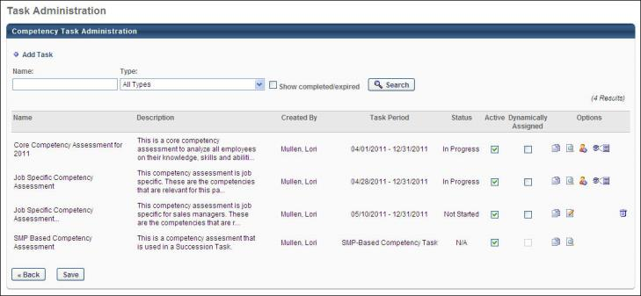
Add Task
To create a new competency assessment task, click the Add Task link. See Competency Assessment Task - Create Overview on page 6 for additional information.
Search Features
Search for an existing competency task using the Name and Type search filters. To include completed or expired tasks in the search results, select the Show completed/expired option.
Competency Task Table
The following information is available for each existing competency task:
- Name - The name of the competency task.
- Description - A description of the competency task.
- Created By - The name of the administrator who created the competency task.
- Task Period - For SMP-based competency tasks, "SMP-Based Competency Task" is displayed. For performance review-based competency tasks, "Performance Review-Based Competency Task" is displayed.
- Status - The current status of the competency task. For SMP-based competency tasks and performance review-based competency tasks, "N/A" is displayed.
- Active - Select this option to make the task active. If a task is made inactive, current or expired tasks are not affected. Inactive tasks cannot be included in reports.
- Dynamically Assigned - If this option is selected, any new users that match the availability defined for the task are assigned the task. If this is not selected, only the users that match the availability at the time of task creation are assigned the task. This option is not available for SMP-based competency tasks and performance review-based competency tasks because any dynamic assignment is done in the SMP or performance review task.
- Options - The following options are available for the selected competency task:
  - Copy - Copy the selected task. This option copies all of the information from the original task to a new task and opens the General page for the copied task. It is recommended that you change the name of the copied task to avoid confusion.
  - Edit - Edit the task. This option is only available if the task is in a status of Not Started.
  - View Settings - Opens to the General, Competency Model, and Confirm settings pages for the selected competency assessment task.
  - Add Users - Add a user to the assessment task or remove a user from the task.
  - View Details - View the task details. This option is only available if the task is assigned to a user. See Competency Assessment Task - View Details on page 31 for additional information.
  - Delete - Remove the task. This option is only available if the task is in a status of Not Started. SMP tasks can be deleted until they are used within an SMP task.

Competency Assessment Task - Create Overview
Prior to creating a competency assessment task, the following tasks should be completed:
- Create Competencies - See Competency - Create/Edit on page 43 for additional information.
- Create Competency Model - See Competency Models - Create/Edit on page 58 for additional information.
Permissions
PERMISSION NAME | PERMISSION DESCRIPTION | CATEGORY

Competency Assessment Task Administration | Grants ability to create/assign competency assessment tasks and manage activity within those tasks. This permission can be constrained by OU, User's OU, User Self and Subordinates, and User. This is an administrator permission. | Performance - Administration
To create a competency assessment task, go to Admin > Tools > Performance Management > Competency Assessment Tasks. Then, click the Add Task link.
Complete the following steps within the Competency Assessment Task:
- General
- Competency Model
- Competency Preference
- Assessment Result
- Availability
- Confirm
ATS Competency Assessment Task
The process for creating an ATS competency assessment task follows a modified workflow. See ATS Competency Assessment Task - Create on page 22 for additional information.
Review Based Competency Assessment Tasks
The process for creating a Review-based competency assessment task follows a modified workflow. See Review-Based Competency Assessment Task - Create on page 25 for additional information.
SMP Based Competency Assessment Tasks
The process for creating an SMP-based competency assessment task follows a modified workflow. See SMP-Based Competency Assessment Task - Create on page 28 for additional information.
Emails
EMAIL NAME | EMAIL DESCRIPTION | ACTION TYPE

Assessor Assessment Task Assigned | This is triggered when a user is selected as an assessor for a competency assessment task. This email is triggered when an assessor is selected during the task configuration, when assessors are selected by a reviewee from within the competency assessment (when approval is not required), and when a selected assessor needing approval is approved. This email can be sent as a confirmation, notification, or a reminder to Assessor(s) or a specific user. | Performance Management
Helpful Hints
Note: Navigating between pages by clicking the section title (e.g., General, Competency Model) does not preserve any unsaved changes. In order to preserve unsaved changes, administrators must click the Back and Next buttons. Lastly, the Save button must be clicked to save any unsaved changes.
Peer Group
- If a peer group is added that allows subordinates, then the Subordinate and Indirect Subordinate assessor group cannot be added to the same task.
- If either the Subordinate or Indirect Subordinate peer group is added, then the peer groups that allow subordinates cannot be added to the same task.
Indirect Manager
- If Indirect Manager is added, indirect manager will be assigned the competency task as a separate assessor group on the competency assessment.
- When a manager becomes inactive, the manager assessment will remain and not be assigned to the indirect manager for completion.
Competency Assessment Task - Create/Edit General
Use the General tab to create a new assessment task or manage general information for an assessment task.
To access competency assessment tasks, go to Admin > Tools > Performance Management > Competency Assessment Tasks.
- To create a new task, click Add Task. You must complete the General tab to move to the Competency Model tab.
- To edit an assessment task, in the Options column, click View Settings for the appropriate assessment task.
Permissions
PERMISSION NAME | PERMISSION DESCRIPTION | CATEGORY

Competency Assessment Task Administration | Grants ability to create/assign competency assessment tasks and manage activity within those tasks. This permission can be constrained by OU, User's OU, User Self and Subordinates, and User. This is an administrator permission. | Performance - Administration
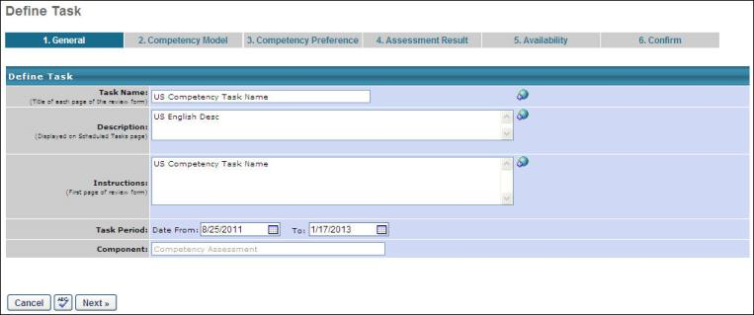
Define Task
Enter or edit the information in this section as defined below.
Task Name
The name that display to users. This field is required and the character limit is 50. If multiple languages are enabled for your portal, select the Translate icon to translate the field into other available languages.
Description
The description that displays on Scheduled Tasks page. The character limit is 500. If multiple languages are enabled for your portal, select the Translate icon to translate the field into other available languages.
Instructions
The instructions that display to the user on the first page of assessment task. The character limit is 3000. If multiple languages are enabled for your portal, select the Translate icon to translate the field into other available languages.
Task Period
The task period that defines the start and end dates of the Assessment Task. The end date corresponds to the end date of the task for the user. Based on the date selected, the task closes at 11:59 PM.
Component
Select one of the following:
- Competency Assessment Task - This configuration has one defined model and recipients for the overall task.
- User-Defined Competency Assessment - This configuration allows an assessee to determine who their assessors will be, and optionally, what model will be used in the assessment.
- SMP Based Competency Task - SMP-based competency tasks are created to be completed as a sub-step within an SMP task. For that reason, the SMP-based task setup is simplified to only include the appropriate options. See SMP-Based Competency Assessment Task - Create on page 28 for additional information.
- ATS Competency Task - ATS competency tasks are created to be completed as a sub-step within an application workflow or job requisition. For that reason, the ATS task setup is simplified to only include the appropriate options. See ATS Competency Assessment Task - Create on page 22 for additional information.
- Review Based Competency Task - Review-based competency tasks are created to be completed as a sub-step within a performance review. For that reason, the Review-based task setup is simplified to only include the appropriate options. See Review-Based Competency Assessment Task - Create on page 25 for additional information.
Cancel/Spell Check/Next
- Click Cancel to close this page.
- Click the spell check icon to check the spelling on this page.
- Click Next to proceed to the Competency Model tab. See Competency Assessment Task - Create/Edit Competency Model on page 10 for additional information.

Competency Assessment Task - Create/Edit Competency Model
Use the Competency Model tab to manage competency models based on model availability.
To access competency assessment tasks, go to Admin > Tools > Performance Management > Competency Assessment Tasks.
- If you are creating a new assessment task and you completed the previous page, you can enter information on this page.
- To edit an assessment task, in the Options column, click View Settings for the appropriate assessment task.
Permissions
PERMISSION NAME | PERMISSION DESCRIPTION | CATEGORY

Competency Assessment Model Admin - Edit | Grants ability to edit competency models. This permission cannot be constrained. This is an administrator permission. | Performance - Administration

Competency Assessment Model Admin - Manage | Grants ability to create, edit, delete, and view competency models. This permission cannot be constrained. This is an administrator permission. | Performance - Administration

Competency Assessment Model Admin - View | Grants ability to view competency models. This permission cannot be constrained. This is an administrator permission. | Performance - Administration
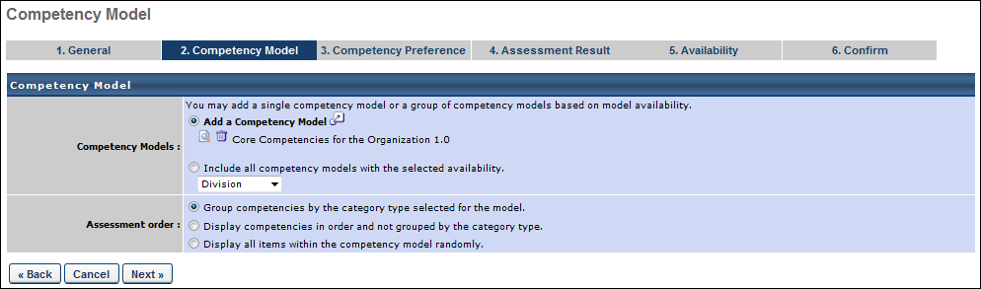
Competency Model
Enter or edit the information in the section as defined below.
Competency Models
Select one of the following:
- Add a Competency Model - Select this option to use a single model from a list of active Competency Models. A pop-up window appears with the organization's current models. Click the Add icon of the model name. This closes the pop-up window and adds the competency model to the list. When selecting a competency model, administrators can only view and select a competency model if they are within the Admin Visibility settings for the competency model and if they have permission to view, edit, or manage competency models.
- Include All Competency Models with the Selected Availability - Select this option to include competency models based on the type of OU selected. Every model associated with the OU type is dynamically assigned to end-users within a single task. If the assessment is user-defined you can allow assessee's to select the competency model used.
Assessment Order
Select one of the following:
- Group Competencies by the category type selected for the model - Select this option to display the competencies grouped by category in an assessment; this only applies to models where the competencies are grouped by category.
- Display Competencies in order and not grouped by category type - Select this option to display competencies in the order defined in the competency model, not grouped by category.
- Display all items within the Competency Model randomly - Select this option to display all items within a model in random order in an assessment, ignoring any categories or competencies in the model. This preference is not available for behavior-based models.
Back/Cancel/Next
- Click Back to return to the previous page.
- Click Cancel to close this page.
- Click Next to proceed to the Competency Preference tab. See Competency Assessment Task - Create/Edit Competency Preference on page 12 for additional information.
Competency Assessment Task - Create/Edit Competency Preference
Use the Competency Preference tab to manage assessors, scores, save actions, and development plans for an assessment task.
To access competency assessment tasks, go to Admin > Tools > Performance Management > Competency Assessment Tasks.
- If you are creating a new assessment task and you completed the previous page, you can enter information on this page.
- To edit an assessment task, in the Options column, click View Settings for the appropriate assessment task.
Permissions
PERMISSION NAME | PERMISSION DESCRIPTION | CATEGORY

Competency Assessment Model Admin - Edit | Grants ability to edit competency models. This permission cannot be constrained. This is an administrator permission. | Performance - Administration

Competency Assessment Model Admin - Manage | Grants ability to create, edit, delete, and view competency models. This permission cannot be constrained. This is an administrator permission. | Performance - Administration

Competency Assessment Model Admin - View | Grants ability to view competency models. This permission cannot be constrained. This is an administrator permission. | Performance - Administration
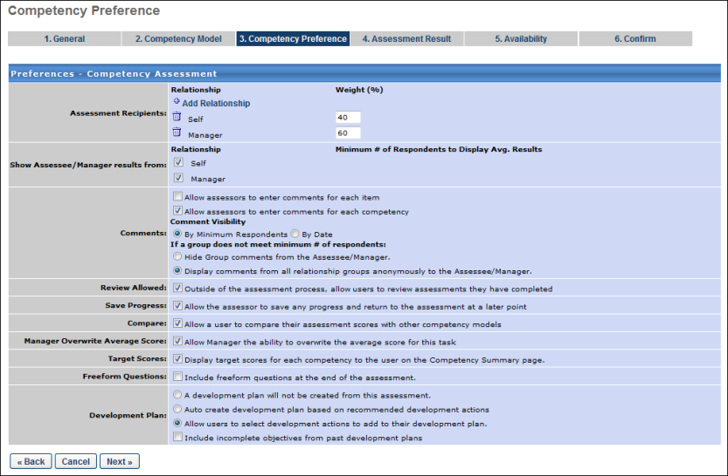
Preferences - Competency Assessment
Enter or edit the information in this section as described below.
Assessment Recipients
Complete the following fields as appropriate:
- Add Relationship - These users are assigned the competency task. Click to select who will be completing an assessment on each assessee. On the Employee Relationships pop-up, select the users to include. Click OK to close the pop-up and return to the step. Up to five different peer groups can be included as assessors. However, only one peer group can contain subordinates. Note: Peer group availability is set in Employee Relationships.
- Weight - This determines how the competency assessment score is calculated. Enter the weight of the response for the assessment for every relationship listed.
Select one of the following options (these are not available for Self, Manager, or Indirect Manager):
- Include all approved assessors - All peer relationships that have been approved based on the type of peer selected will receive the assessment. Note: When selecting this option , ensure that the assessees already have assessors approved or have at least requested assessors in the My Peers area of the system. The system will not send assessments to assessors who are requested after the task deploys.
- Allow Self/Manager to select assessors - Only those relationships selected by the Self/Manager will receive the assessment.
Show Assessee/Manager Results From
Select the appropriate options:
- Relationship - Check which results the assessee should see for every relationship listed. The available options are based on the selected Relationship.
- Minimum # of Respondents to Display Avg. Results - If the relationships include Subordinates, Indirect Subordinates, and any peer groups, choose the minimum number of respondents to display results. If the minimum is not met, the assessee will not see the results, but the scores will still be factored into the assessment.
- Allow assessors to enter in comments for each item - If there are multiple items for each competency, this option allows for comments to be entered on the specific items that are being rated for each competency.
- Allow assessors to enter in comments for each competency This option allows for comments to be entered for each competency.
Note: For the Allow assessors to enter in comments for each item and Allow assessors to enter in comments for each competency options, see the Comments section below to enter details.
Comments
This section defines how comments should appear. Select the appropriate options:
- By Minimum Respondents - Select this option to determine the comment visibility by a minimum number of respondents. If a group does not meet minimum # of respondents - Select whether the comments should be displayed at all or all comments from all peer groups be displayed anonymously to the assessee.
  - Hide Group comments from the Assessee/Manager - Select this option to hide group comments from the assessee/manager.
  - Display comments from all relationship groups anonymously to the Assessee/Manager - Select this option to display comments from all relationship ship groups anonymously to the Assessee Manager. The manager will be restricted on the ratings and comments that are visible on the assessment summary from a particular assessment group based on these rules. When the employee and manager view the ratings/comments for a competency on the assessment summary page, the ratings and comments that appear will be constrained based on the anonymity rules defined for the task.
- By Date - Select this option to determine the comment visibility by date. Note: If this option is selected, there is no option to make the comments anonymous. When this option is selected, the following options appear:
  - Reveal results on the following date - Select this option to make the comments visible to the assessee on a specific date. Then, click the calendar tool to select the date on which the comments should be visible. The selected date must be after the competency assessment task start date.
  - Reveal results X Days/Weeks/Months after task end date - Select this option to make the comments visible to the assessee on a date that is relative to the task end date. From the drop-down list, select the appropriate time measurement and then enter the desired value in the field. The text field accepts values from 1-9. For example, if "2" is entered in the text field and "Weeks" is selected from the drop-down list, then the comments will be visible two weeks after the task end date.
Review Allowed
Select this option to allow users to review assessments that they completed.
Save Progress
Select this option to allow users to save and return to the assessment at any point.
Compare
Select this option to allow users to compare their results with another model.
Manager Overwrite Average Score
Select this option to allow managers to modify an assessee's average score for the task. This allows a manager to override the collective scores collected from all assessees.
Target Scores
Select this option to display the target score of the competency on the Summary page of the assessment.
Freeform Questions
Select this option to allow administrators to add questions that will appear on a separate page before the assessment is submitted by a user.
Add Question - Click the Add Question icon to add a question to the assessment.
- Question - Enter the question text. If multiple languages are enabled for your portal, select the Translate icon to translate the field into other available languages.
- Response Required - Select this option to require the assessor to answer the question.
There is no limit to the number of questions that you can add.
Development Plan
Select one of the following options:
- A development plan will not be created from this assessment - Select this option if you do not want to create a development plan from this task assessment.
- Auto-create a development plan based on recommended development actions - Select this option if you want to generate a development plan based on this assessment task.
- Allow users to select development actions to add to their development plan - Select this option if you want users to be able to add development actions to their development plans.
Include incomplete objectives from past development plans - When allowing development plans to be created, select this option to include incomplete objectives from past development plans in the new development plan.
Back/Cancel/Next
- Click Back to return to the previous page.
- Click Cancel to close this page.
- Click Next to proceed to proceed to the Assessment Results tab. See Competency Assessment Task - Create/Edit Assessment Result on page 16 for additional information.
Competency Assessment Task - Create/Edit Assessment Result
Use the Assessment Result tab to set who has access to the assessment results and create the format of the Assessment Report.
To access competency assessment tasks, go to Admin > Tools > Performance Management > Competency Assessment Tasks.
- If you are creating a new assessment task and you completed the previous page, you can enter information on this page.
- To edit an assessment task, in the Options column, click View Settings for the appropriate assessment task.
Permissions
PERMISSION NAME | PERMISSION DESCRIPTION | CATEGORY

Competency Assessment Model Admin - Edit | Grants ability to edit competency models. This permission cannot be constrained. This is an administrator permission. | Performance - Administration

Competency Assessment Model Admin - Manage | Grants ability to create, edit, delete, and view competency models. This permission cannot be constrained. This is an administrator permission. | Performance - Administration

Competency Assessment Model Admin - View | Grants ability to view competency models. This permission cannot be constrained. This is an administrator permission. | Performance - Administration
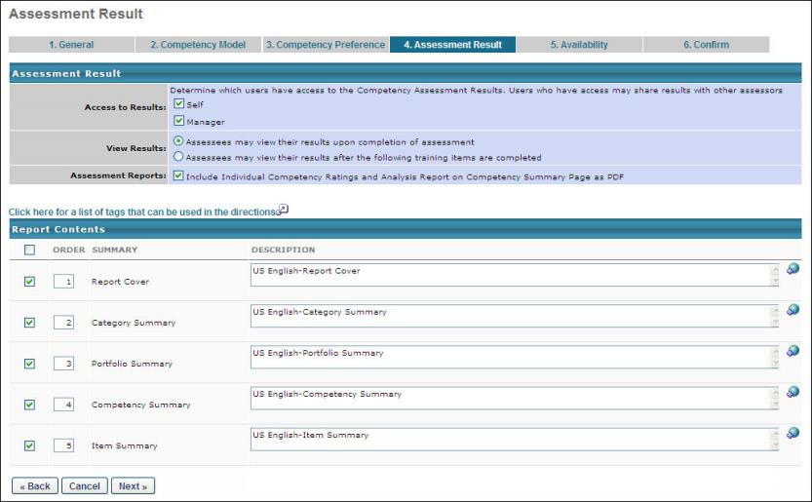
Assessment Result
Enter or edit the information in this section as described below.
Access to Results
- Select if either Self, Manager, or both can access to the Assessment Results. By default both users have access.
  - If only the Self or Manager has access, either user can provide access by clicking on the Share Results link found on the Summary page of the assessment.
View Results
Select one of the following options:
- Assessees may view the results upon completion of assessment - If this option is selected, the results will immediately be available upon completion of the assessment
- Assessees may view their results after the following training items are completed - If this option is selected, the results will be made available after the user has completed required training Learning Objects selected for the task
Assessment Reports
- The administrator can include or exclude any of the summaries.
Report Contents
View or edit information in this section as follows:
- Checkbox - Click to include a report.
- Order - Enter numbers to indicate the order in which the reports should appear.
- Summary - The name of the report summary.
- Description - The descriptions for each of the different summaries indicating to the Assessee what the ratings mean and how to interpret the results.
- If multiple languages are available for the portal, the description for each summary can be localized by clicking the Translate icon to the right of the field.
This report is also an administrative report that can be run for any OU. If the report is included, the report will be included as a link on the assessment summary page.
Back/Cancel/Next
- Click Back to return to the previous page.
- Click Cancel to close this page.
- Click Next to proceed to the Availability tab. See Competency Assessment Task - Create/Edit Availability on page 19 for additional information.
Competency Assessment Task - Create/Edit Availability
Use the Availability tab to select the appropriate recipients for the task.
To access competency assessment tasks, go to Admin > Tools > Performance Management > Competency Assessment Tasks.
- If you are creating a new assessment task and you completed the previous page, you can enter information on this page.
- To edit an assessment task, in the Options column, click View Settings for the appropriate assessment task.
Permissions
PERMISSION NAME | PERMISSION DESCRIPTION | CATEGORY

Competency Assessment Task Administration | Grants ability to create/assign competency assessment tasks and manage activity within those tasks. This permission can be constrained by OU, User's OU, User Self and Subordinates, and User. This is an administrator permission. | Performance - Administration
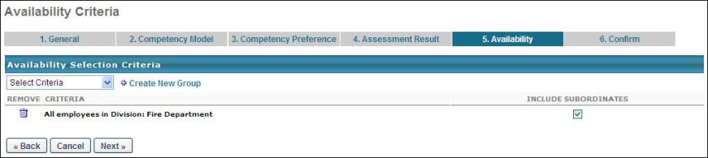
Availability Selection Criteria
Select or edit the following information:
- Select Criteria drop-down - Select the appropriate recipients for this task.
- Create New Group - Create a new group if the current groups do not meet your needs. See
When availability criteria is selected, the Include Subordinates option is unchecked by default. Note: Tasks are sent to approved assessors based on employees selected.
Back/Cancel/Next
- Click Back to return to the previous page.
- Click Cancel to close this page.
- Click Next to proceed to the Confirm tab. See Competency Assessment Task - Create/Edit Confirm on page 20 for additional information.
Competency Assessment Task - Create/Edit Confirm
Use the Confirm tab to view a summary of the competency assessment task.
When a task is saved, it is available to the selected users on the task start period date for the task. The task appears on the user's Welcome page in the Tasks widget or is accessible from the Scheduled Tasks link beneath the Home tab.
To access competency assessment tasks, go to Admin > Tools > Performance Management > Competency Assessment Tasks.
- If you are creating a new assessment task and you completed the previous page, you can view the information on this page.
- To edit an assessment task, in the Options column, click View Settings for the appropriate assessment task.
Permissions
PERMISSION NAME | PERMISSION DESCRIPTION | CATEGORY

Competency Assessment Task Administration | Grants ability to create/assign competency assessment tasks and manage activity within those tasks. This permission can be constrained by OU, User's OU, User Self and Subordinates, and User. This is an administrator permission. | Performance - Administration
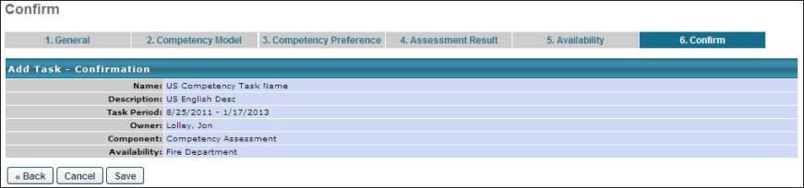
Emails
EMAIL NAME | EMAIL DESCRIPTION | ACTION TYPE

Assessor Assessment Task Assigned | This is triggered when a user is selected as an assessor for a competency assessment task. This email is triggered when an assessor is selected during the task configuration, when assessors are selected by a reviewee from within the competency assessment (when approval is not required), and when a selected assessor needing approval is approved. This email can be sent as a confirmation, notification, or a reminder to Assessor(s) or a specific user. | Performance Management
Back/Cancel/Save
- Click Back to return to the previous page.
- Click Cancel to close this page.
- Click save to save this task.
ATS Competency Assessment Task - Create
When including a competency assessment within an ATS application workflow template or job requisition template, you must create an ATS competency assessment task. Later, when an application workflow or job requisition is being created, if the application workflow template or job requisition template contains a placeholder for an ATS competency assessment task, the ATS competency assessment task can be added within the application workflow or job requisition.
To create an ATS competency assessment task, go to Admin > Tools > Performance Management > Competency Assessment Tasks. Then, click the Add Task link.
Permissions
PERMISSION NAME | PERMISSION DESCRIPTION | CATEGORY

Competency Assessment Model Admin - Edit | Grants ability to edit competency models. This permission cannot be constrained. This is an administrator permission. | Performance - Administration

Competency Assessment Model Admin - Manage | Grants ability to create, edit, delete, and view competency models. This permission cannot be constrained. This is an administrator permission. | Performance - Administration

Competency Assessment Model Admin - View | Grants ability to view competency models. This permission cannot be constrained. This is an administrator permission. | Performance - Administration

Competency Assessment Task Administration | Grants ability to create/assign competency assessment tasks and manage activity within those tasks. This permission can be constrained by OU, User's OU, User Self and Subordinates, and User. This is an administrator permission. | Performance - Administration
General
From the Component drop-down list, select ATS Competency Task. Notice that the Task Period option is removed once this option is selected. This is because the timing of the task is controlled by the application workflow or job requisition with which it is associated.
Note: When creating an ATS competency assessment task, some options are unavailable so that the task can be integrated into an application workflow or job requisition.
Enter the following information about the ATS competency task:
- Task Name - Enter a name that display to users. This field is required and the character limit is 50. If multiple languages are enabled for your portal, select the Translate icon to translate the field into other available languages.
- Description - Enter a description for the task. The character limit for this field is 500. If multiple languages are enabled for your portal, select the Translate icon to translate the field into other available languages.
- Instructions - Enter instructions that display to user on first page of the assessment task. The character limit is 3000. If multiple languages are enabled for your portal, select the Translate icon to translate the field into other available languages.
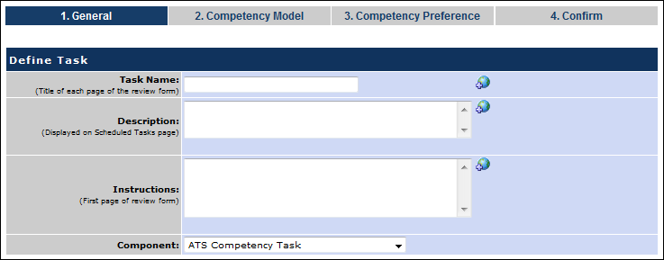
Competency Model
Select the following options:
- Competency Models
  - Add a Competency Model - Select this option and click the pop-up icon to select a model from the list of active competency models. Multiple models can be added. When selecting a competency model, administrators can only view and select a competency model if they are within the Admin Visibility settings for the competency model and if they have permission to view, edit, or manage competency models.
  - Include all competency models with the selected availability - Select this option to include competency models based on the type of OU selected. Every model associated with a position or grade will be dynamically assigned to end users within the task. If the assessment is user-defined, you can allow assesses to select the competency model.
- Assessment Order
  - Group competencies by the category type selected for the model. - This option groups competencies by category within the assessment. This only applies to models in which the competencies are grouped by category.
  - Display competencies in order and not grouped by the category type. - This option displays the competencies in the order defined in the competency model, not grouped by category.
  - Display all items within the competency model randomly. - This displays all items within a model in random order in an assessment, ignoring any categories or competencies in the model. This option is not available for behavior-based models.
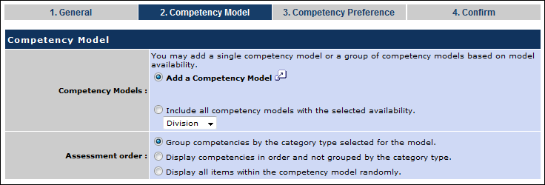
Competency Preference
Select the following options:
- Allow assessors to enter comments for each item
- Allow assessors to enter comments for each competency
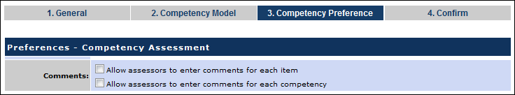
Confirm
This page displays a summary of the competency task. Click Save to finalize the task.
The task can then be added to an application workflow or job requisition, provided that an ATS competency task placeholder has been added to the application workflow template or job requisition template.
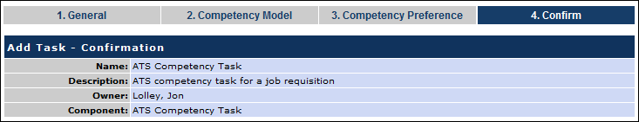
Review-Based Competency Assessment Task - Create
When including a competency assessment within a performance review, you must create a performance review-based competency assessment task. Later, when a performance review task is being created, if a competency assessment review section has been created, the review-based competency assessment task can be added within the task.
To create a performance review-based competency assessment task, go to Admin > Tools > Performance Management > Competency Assessment Tasks. Then, click the Add Task link.
Permissions
PERMISSION NAME | PERMISSION DESCRIPTION | CATEGORY

Competency Assessment Model Admin - Edit | Grants ability to edit competency models. This permission cannot be constrained. This is an administrator permission. | Performance - Administration

Competency Assessment Model Admin - Manage | Grants ability to create, edit, delete, and view competency models. This permission cannot be constrained. This is an administrator permission. | Performance - Administration

Competency Assessment Model Admin - View | Grants ability to view competency models. This permission cannot be constrained. This is an administrator permission. | Performance - Administration

Competency Assessment Task Administration | Grants ability to create/assign competency assessment tasks and manage activity within those tasks. This permission can be constrained by OU, User's OU, User Self and Subordinates, and User. This is an administrator permission. | Performance - Administration
General
From the Component drop-down list, select Review Based Competency Assessment. Notice that the Instructions field and the Task Period option are removed once this option is selected. This is because the instructions are configured during the completion of the competency assessment review form and the timing of the task is controlled by the review task with which it is associated.
Note: When creating a performance review-based competency assessment task, some options are unavailable so that the task can be integrated into a performance review task.
Enter the following information about the review-based competency task:
- Task Name - Enter a name that displays to users. This field is required and the character limit is 50. If multiple languages are enabled for your portal, select the Translate icon to translate the field into other available languages.
- Description - Enter a description that displays on the Scheduled Tasks page. The character limit for this field is 500. If multiple languages are enabled for your portal, select the Translate icon to translate the field into other available languages.
Click Next to proceed to the Competency Model step. Click the Spell Check button to check the spelling of the text that was entered.
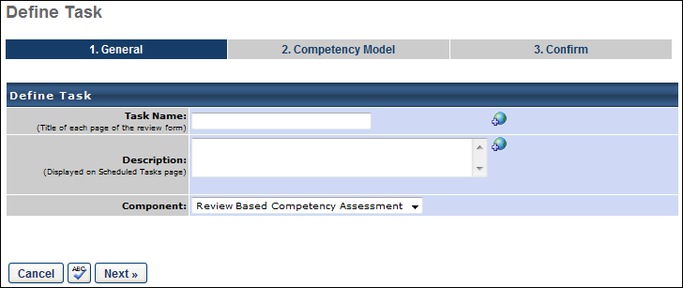
Competency Model
Select the following options:
- Competency Models
  - Add a Competency Model - Select this option and click the pop-up icon to select a model from the list of active competency models. When selecting a competency model, administrators can only view and select a competency model if they are within the Admin Visibility settings for the competency model and if they have permission to view, edit, or manage competency models.
  - Include all competency models with the selected availability - Select this option to include competency models based on the type of OU selected. Every model associated with the OU will be dynamically assigned to the users within the task.
- Assessment Order - Select how the competencies appear within the assessment.
  - Group competencies by the category type selected for the model. - This option groups competencies by category within the assessment. This only applies to models in which the competencies are grouped by category.
  - Display competencies in order and not grouped by the category type. - This option displays the competencies in the order defined in the competency model, not grouped by category.
  - Display all items within the competency model randomly. - This displays all items within a model in random order in an assessment, ignoring any categories or competencies in the model. This option is not available for behavior-based models.
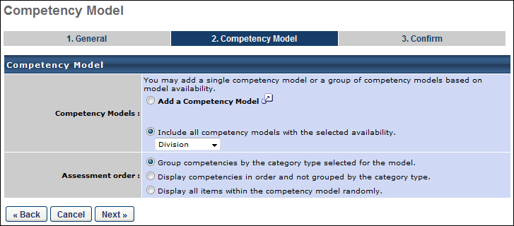
Click Next to proceed to the Confirm step.
Confirm
This page displays a summary of the competency task. Click Save to finalize the task.
The task can then be added to a performance review task, provided that a competency assessment review section has been created.
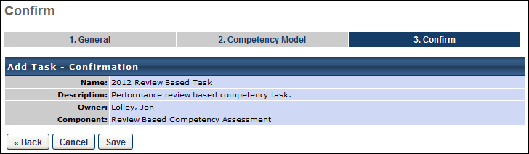
SMP-Based Competency Assessment Task - Create
When including a competency assessment within a Succession Metric Planning (SMP) task, you must create an SMP-based competency assessment task. Later, when an SMP task is being created, if the SMP template contains a placeholder for an SMP-based competency assessment task, the SMP-based competency assessment task can be added within the task.
To create an SMP-based competency assessment task, go to Admin > Tools > Performance Management > Competency Assessment Tasks. Then, click the Add Task link.
Permissions
PERMISSION NAME | PERMISSION DESCRIPTION | CATEGORY

Competency Assessment Model Admin - Edit | Grants ability to edit competency models. This permission cannot be constrained. This is an administrator permission. | Performance - Administration

Competency Assessment Model Admin - Manage | Grants ability to create, edit, delete, and view competency models. This permission cannot be constrained. This is an administrator permission. | Performance - Administration

Competency Assessment Model Admin - View | Grants ability to view competency models. This permission cannot be constrained. This is an administrator permission. | Performance - Administration

Competency Assessment Task Administration | Grants ability to create/assign competency assessment tasks and manage activity within those tasks. This permission can be constrained by OU, User's OU, User Self and Subordinates, and User. This is an administrator permission. | Performance - Administration
General
From the Component drop-down list, select SMP-Based Competency Task. Notice that the Task Period option is removed once this option is selected. This is because the timing of the task is controlled by the SMP task with which it is associated.
Note: When creating an SMP-based competency assessment task, some options are unavailable so that the task can be integrated into an SMP task.
Enter the following information about the SMP-based competency task:
- Task Name - Enter a name that display to users. This field is required and the character limit is 50. If multiple languages are enabled for your portal, select the Translate icon to translate the field into other available languages.
- Description - Enter a description that display on Scheduled Tasks page. The character limit for this field is 500. If multiple languages are enabled for your portal, select the Translate icon to translate the field into other available languages.
- Instructions - Enter instructions that display to user on first page of the assessment task. The character limit is 3000. If multiple languages are enabled for your portal, select the Translate icon to translate the field into other available languages.
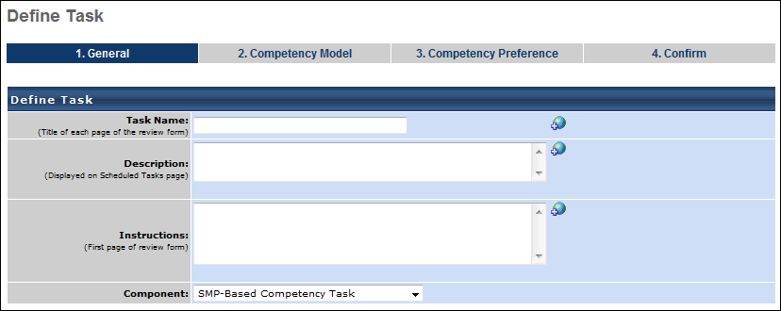
Competency Model
Select the following options:
- Competency Models
  - Add a Competency Model - Select this option and click the pop-up icon to select a model from the list of active competency models. Multiple models can be added. When selecting a competency model, administrators can only view and select a competency model if they are within the Admin Visibility settings for the competency model and if they have permission to view, edit, or manage competency models.
  - Include all competency models with the selected availability - Select this option to include competency models based on the type of OU selected. Every model associated with a position or grade will be dynamically assigned to end users within the task. If the assessment is user-defined, you can allow assesses to select the competency model.
- Assessment Order
  - Group competencies by the category type selected for the model. - This option groups competencies by category within the assessment. This only applies to models in which the competencies are grouped by category.
  - Display competencies in order and not grouped by the category type. - This option displays the competencies in the order defined in the competency model, not grouped by category.
  - Display all items within the competency model randomly. - This displays all items within a model in random order in an assessment, ignoring any categories or competencies in the model. This option is not available for behavior-based models.
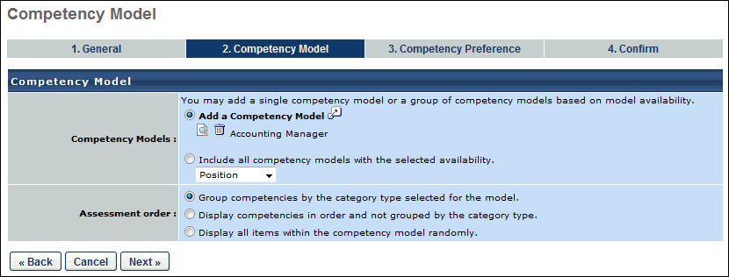
Competency Preference
Select the following options:
- Allow assessors to enter comments for each item
- Allow assessors to enter comments for each competency
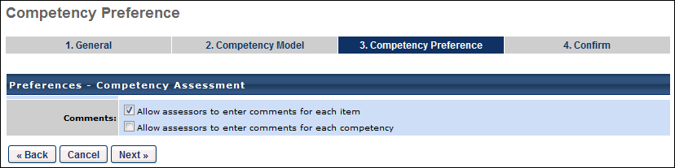
Confirm
This page displays a summary of the competency task. Click Save to finalize the task.
The task can then be added to an SMP task, provided that an SMP-based competency task placeholder has been added to the SMP template.
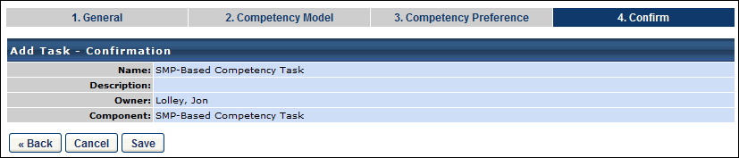

Competency Assessment Task - View Details
- Go to Admin > Tools > Performance Management > Competency Assessment Tasks.
- Click the Competency Assessment Task Administration link.
- Click View Details icon in the Options column.
Reset Completed Competency Tasks
The following page contains a guide for resetting completed competency tasks:
- See How To - Reset Completed Competency Tasks.
Assessee View
View the following information on this page when in Assessee view:
- Assessee - name of employee being assessed
- Assessors - listed based on task set up
- Assessee'sTaskStatus - this covers the assessee's overall task status based on all the responses received from all assessors
- Options
  - Remove - Click this icon to remove the assessee from the assessment.
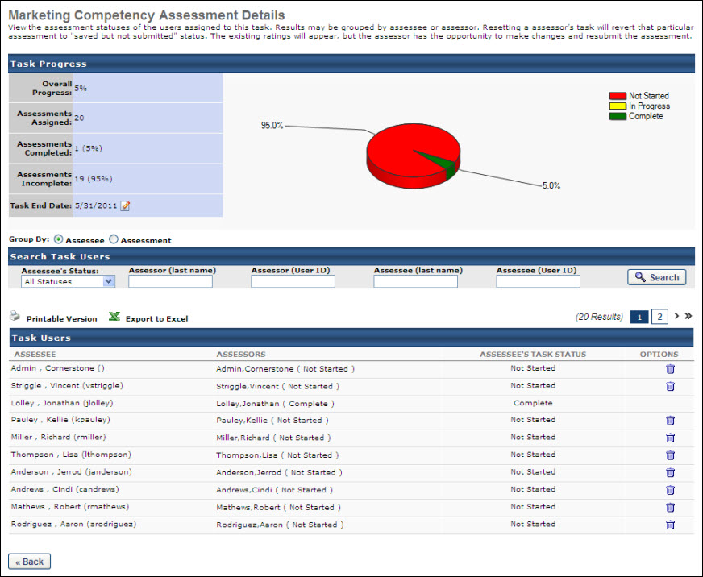
Assessment View
View the following information on this page when in Assessment view:
- Assessor - name of employee approved to perform assessment
- Assessee - name of employee being assessed
- Relationship - defines type of assessor selected for task. For example, Self, Manager, etc.
- Assessment Status - includes Not Started, In Progress, Complete
- Options
  - Reset Assessment - Click this icon (the hammer icon) to reset the task, which reopens the task and allows the assessor to modify their responses. This option is available once the assessment is Complete.
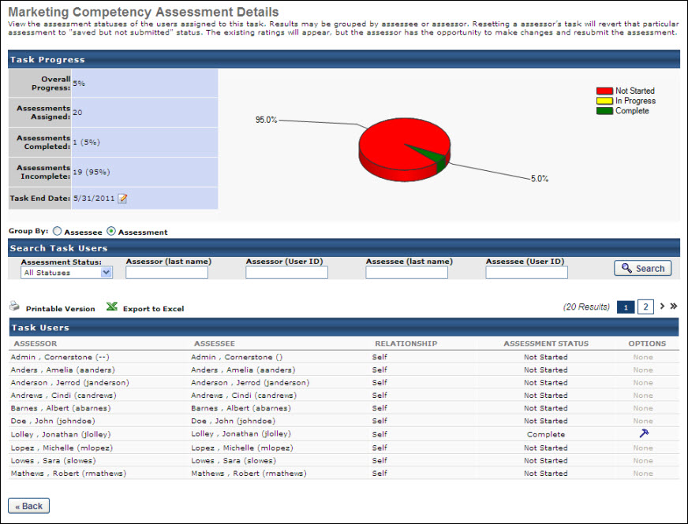

Complete a Competency Assessment
To access a competency assessment, go to Home > Scheduled Tasks. Then, select the title of the appropriate competency assessment task. Note: The location of the Scheduled Tasks page may vary depending on your portal's configuration.
If you are assigned a competency assessment task but find no competencies to rate, contact your manager or organization's system administrator.
Permissions
PERMISSION NAME | PERMISSION DESCRIPTION | CATEGORY

Select Peers and Reviewers | Grants ability to select peers and reviewers in off-cycle performance reviews. This permission can be constrained by User's Corporation, OU, and User's OU. This is an end user permission. | Performance

Task - View | Grants ability to view assigned tasks via Scheduled Tasks screen and Welcome Page My Tasks widget. This is an end user permission. | Core
To complete a competency assessment:
- On the Task Instructions page, click Continue. This opens a page with a list of assessments, which display in the Assessments Due table.
- From the Options column in the Assessments Due table, click Begin to begin the assessment.
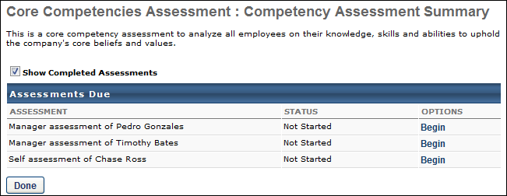
- Click the Add User link to select the assessors you want to include in the assessment form Subordinate or Indirect Subordinate lists. Note: The assessor selector must have the permission to select peers and reviewers. The constraints on this permission determine who the assessor selector can select for the competency assessment. Also, peer group availability is set by the administrator in Employee Relationships. If the user does not have the permission to select peers and reviewers, an error pop-up appears, alerting them that they are not able to select assessors.
  - There is no limitation or constraint on selecting external peers.
  - Any changes to the assessor selector's permissions or constraints after the assessors are selected have no affect on the selection. Once an assessor is selected, the selection is considered final.
- Click Continue.
- Enter a rating for each item. Sample:
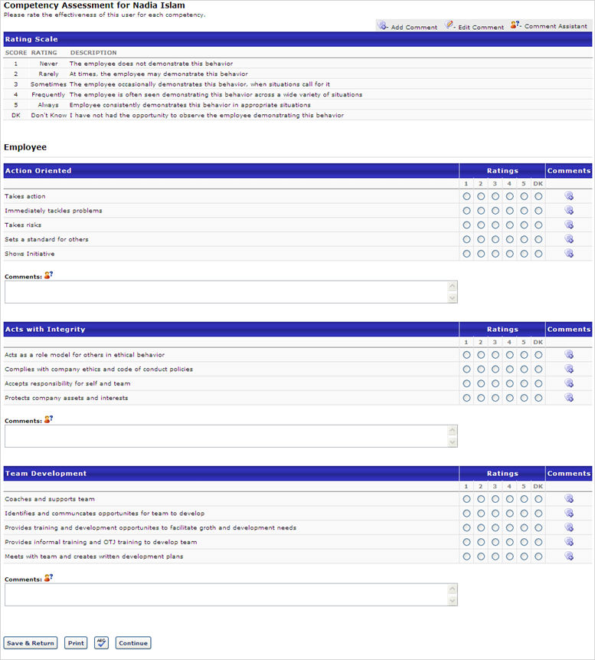
- Click the Comments icon to add comment to individual items.
- Enter additional comments per each category by entering text in the comments field.
  - Click the Comment Assistant icon to help you write comments.
- Use the Spell Check icon to check spelling if applicable.
- If you need to return to make changes, click the Save & Return button.
- If you want to print the assessment, click the Print button.
- Click Continue.
- Enter comments if applicable.
- Use the Spell Check icon to check spelling if applicable.
- If you need to return to make changes, click the Save & Return button.
- If you want to print the assessment, click the Print button.
- Click Submit Assessment button.
Assignment Notes for Administrators:
- If a task is created to assess users against a specific competency model, all users in the task availability are included in the task whether they are mapped to the competency model or not.
- If a task is created to include competency models based on organizational unit (OU) type, then a user may not be evaluated in the task if they are not associated with any competency models.
  - If the competency model assignment is based on position and the employee has no defined position, then no competency assessment is assigned for the employee.
  - If the competency model assignment is based on position but the employee's position has no associated competency model, then no competency assessment is assigned for the employee.
- If the competency model assignment is based on group and an employee belongs to multiple groups that are mapped to differing competency models, the system assigns the competency model for the group to which the user was most recently added.

Competency Assessment - View Assessment Summary
The Assessment Summary displays all sections configured when the task was created.
Permissions
PERMISSION NAME | PERMISSION DESCRIPTION | CATEGORY

My Competency Assessments | Enables users to view their own competency assessment results from the Competency Assessment Results screen. In addition, when creating a development plan and adding an objective to the plan, this permission enables users to browse recommended training and developmental actions from competency models, when this functionality is enabled in Development Plan Preferences. This is an end user permission. | Performance
- Click the View Assessment link.
- Choose Page Layout.
- Click View.
- Open or Save the file.
Note: Assessor comments may or may not be visible, based on the competency assessment task configuration.
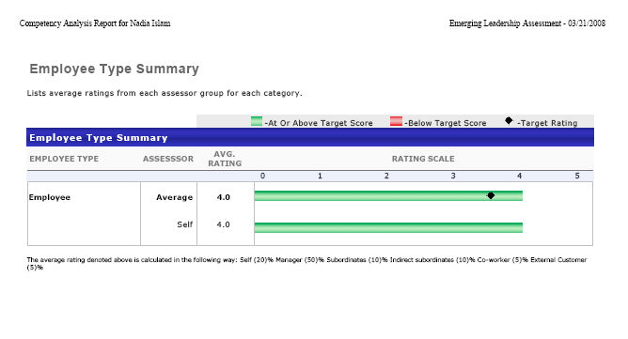

Competency Assessment - Compare Ratings
The Compare Ratings option is only available if the administrators have allowed the ratings for the assessment to be compared to other models when the task was created. You are able to select a different model to compare assessment ratings. This is helpful to see what development actions might need to be taken.
If you are comparing models, select a model that contains competencies upon which you are assessed.
- Click the Compare rating link.
- Click on the search icon to find and select a Competency Model.
- Click Gap Analysis button
- View Gap Analysis.
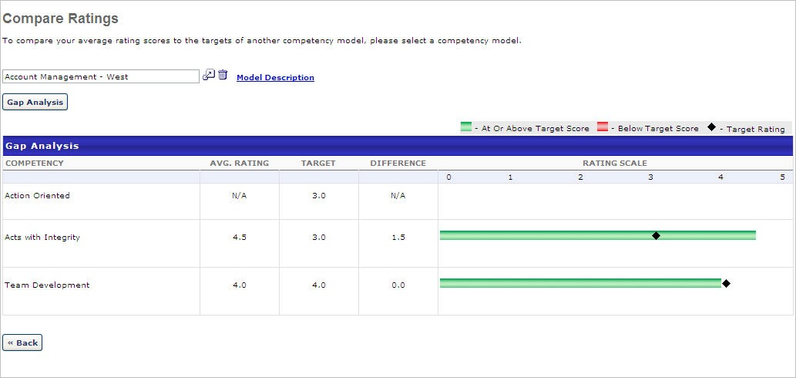

Competency Bank - Overview
Competencies are qualities that employees may possess. You create and store them in the Competency Bank. When you create competency models, you add competencies to describe the qualities you want a position or role to possess.
To access the Competency Bank page, go to Admin > Tools > Performance Management > Competency Bank.
Permissions
PERMISSION NAME | PERMISSION DESCRIPTION | CATEGORY

Competency Assessment Bank Admin - Edit | Grants ability to edit competencies in the Competency Bank. Administrators can only edit a competency if they have this permission and are also included in the Admin Visibility settings for the competency. This permission cannot be constrained. This is an administrator permission. | Performance - Administration

Competency Assessment Bank Admin - Manage | Grants ability to create, copy, edit, view, and delete competencies in the Competency Bank. This permission cannot be constrained. This is an administrator permission. | Performance - Administration

Competency Assessment Bank Admin - View | Grants ability to view competencies in the Competency Bank. Administrators can only view a competency if they have this permission and are also included in the Admin Visibility settings for the competency. This permission cannot be constrained. This is an administrator permission. | Performance - Administration

Competency Assessment Model Admin - Edit | Grants ability to edit competency models. This permission cannot be constrained. This is an administrator permission. | Performance - Administration

Competency Assessment Model Admin - Manage | Grants ability to create, edit, delete, and view competency models. This permission cannot be constrained. This is an administrator permission. | Performance - Administration

Competency Assessment Model Admin - View | Grants ability to view competency models. This permission cannot be constrained. This is an administrator permission. | Performance - Administration

Competency Assessment Model | Grants access to define competency categories, competency model categories, and the default rating scale for competency models. This permission cannot be constrained. This is an administrator permission.  For organizations using the Data Load Wizard Competency Bank Data General Information load, this permission is required to utilize custom fields in the data load. | Performance - Administration
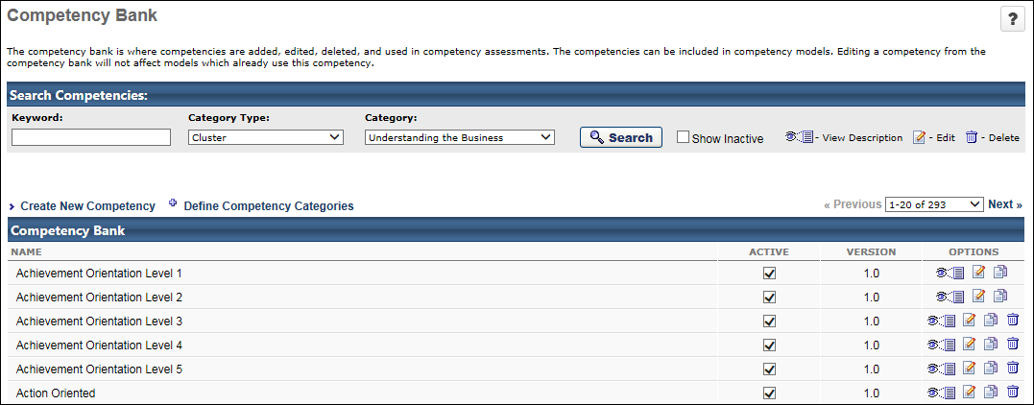
Search Competencies
To search for an existing competency, enter the following search criteria and click Search.
- Keyword - This field searches competencies by name.
- Category Type - This drop-down determines which options are available in the Category drop-down. Select the category type by which you are filtering competencies.
- Category - This drop-down is disabled until a category type is selected from the Category Type drop-down. Once a category type is selected, all available categories from the selected category type are displayed. Select the appropriate category. When the Search button is clicked, only competencies from the selected competency category are displayed. If no category is selected and the Search button is clicked, only competencies that have any category set for the selected category type are displayed.
Show Inactive
When this option is selected, inactive and active competencies are displayed in the Competency Bank table. When this option is not selected, only active competencies are displayed in the Competency Bank table.
Create Competency
To create a new competency, click the Create New Competency link. This link is only available to administrators who have permission to manage competencies. See Competency - Create/Edit on page 43 for additional information.
Define Competency Categories
To define the default competency categories, click the Define Competency Categories link. This link is only available to administrators who have the Competency Assessment Model permission. See Competency Model Category - Create on page 62 for additional information.
Competency Bank Table
The Group By option allows you to organize the competencies in the Competency Bank table by competency category. Select a category from the drop-down to display the competencies in the groups that are associated with the selected category. If a competency is not associated with the category, then the competency appears in a group titled "[Competency Category]:None."
Within the Competency Bank table, a competency is only displayed if the administrator is within the Admin Visibility set for the competency. In addition, the administrator must also have permission to view, edit, or manage competencies.
The following information is displayed for each competency:
- Name - For competencies with multiple versions, an expand icon appears to the left of the competency name. Click this icon to view the additional versions. The following information is displayed for previous versions:
  - Name - This displays the competency name prior to the new version being created.
  - Version - This displays the competency version number.
  - View Description - Select this option to view the competency details, including all items or behaviors for the competency version.
- Version - This column displays the version number for the associated competency.
- Active - This option is only available if the administrator has permission to edit or manage competencies. When this option is not selected, the competency is inactive and cannot be added to new skills matrix roles and competency models. However, inactive competencies are still available in any competency model, competency assessment, performance review, skills matrix role, or any other place that it is in use by a user. Also, inactive competencies are available in reporting and when selecting competencies from an existing competency model. For example, a Competency performance review section can be configured to allow users to select competencies from a competency model. If inactive competencies exist in the competency model, then they can still be selected.
  - If this option is modified for a competency, then the administrator must click the Save button to save the competency's Active status. If the updated Active status is not saved, then the updated status is not implemented.
Competency Bank Options
The following options are available for all existing competencies in the Options column:
- View Description - Select this option to view the competency details, including all items or behaviors for the competency. This option is only available if the administrator has permission to view, edit, or manage competencies.
- Edit - The process of editing a competency is similar to creating a competency. This option is only available if the administrator has permission to edit or manage competencies. See Competency - Create/Edit on page 43 for additional information. When editing a competency or competency model that has been used in a Competency Assessment type performance review section, a warning message is displayed at the top of the Edit Competency Model page. This warning is intended to prevent modifications to the competency model from affecting In Progress or Competed performance reviews.
- Copy - Select this option to copy the competency. This option is only available if the administrator has permission to manage competencies. See Competency - Create/Edit on page 43 for additional information.
- Delete - A competency cannot be deleted if it is used in a competency model, regardless of competency version. This option is only available if the administrator has permission to manage competencies.
Save/Back
To save any changes to the Active status of one or more competencies, click the Save button. Or, do discard any unsaved changes, click the Back button to return to the Admin Tools page.

Competency - Create/Edit
A competency is a quality that employees, positions, or roles may possess. You create and store them in the Competency Bank. You add competencies to competency models to describe these qualities.
- To create a competency, go to Admin > Tools > Performance Management > Competency Bank. Then, click the Create New Competency link.
- To edit a competency, go to Admin > Tools > Performance Management > Competency Bank. Then, click the Edit icon to the right of the appropriate competency.
Permissions
PERMISSION NAME | PERMISSION DESCRIPTION | CATEGORY

Competency Assessment Bank Admin - Edit | Grants ability to edit competencies in the Competency Bank. Administrators can only edit a competency if they have this permission and are also included in the Admin Visibility settings for the competency. This permission cannot be constrained. This is an administrator permission. | Performance - Administration

Competency Assessment Bank Admin - Manage | Grants ability to create, copy, edit, view, and delete competencies in the Competency Bank. This permission cannot be constrained. This is an administrator permission. | Performance - Administration
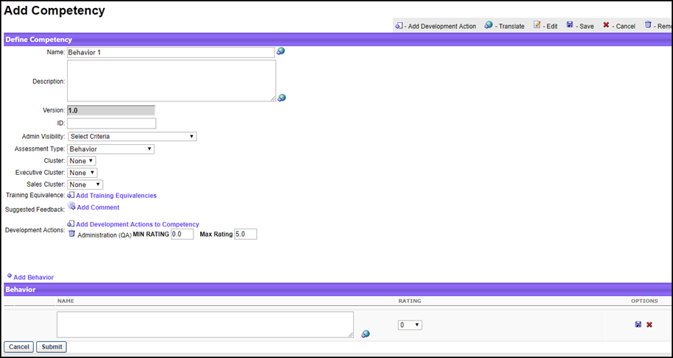
Quick Start Guide for Competencies
Select the following link to view a guide to getting started with competencies, including creating competencies, competency models, and tasks.
See QUICK START GUIDE - Competencies.
Create/Edit Competencies
To create or edit a competency:
- Select an option:
  - To create a new competency, click Create New Competency.
  - To edit, click the edit icon for the appropriate competency. When editing a competency, the changes affect the system in different ways. See Competency and Competency Model Versioning on page 51 for additional information.
- Enter or edit the following information:
  - Name - Descriptive name for the competency. This is required. If multiple languages are enabled for your portal, select the Translate icon to translate the field into other available languages.
  - Description - Description for the competency. If multiple languages are enabled for your portal, select the Translate icon to translate the field into other available languages. The character limit is 5000.
  - Version - Competency version number. This field is read-only.
  - ID - ID designation. This is not required.
  - Admin Visibility - Enables the administrator to define which administrators are able to view the competency in the Competency Bank and when creating competency models and skills matrix roles. Administrators must also have permission to view or manage the competency. This applies to all versions of the competency. Editing this option does not create a new competency version. Visibility can be set by OU, Group, or specific users. Select the Include Subordinates option to include subordinate OUs or users. If no visibility is set, then the competency is visible to all administrators who have permission to view competencies.
  - Assessment Type:
    - Competency Item - Lists the specific behaviors in the competency as items to be rated on a scale for the assessor. This option MUST be selected when creating a competency for observation checklists.
      - Select Add Item to add a competency item. Complete the Name and Rating information and select the save icon.
    - Behavior - Lists a set of behavior descriptions to select from, rather than a rating scale.
      - Select Add Behavior to add a competency item. Complete the Name and Rating information and select the save icon.
After an item or behavior is added, you can add a development action to it by clicking the Add Development Actions icon in the Options column. After selecting development actions, they appear below the item or behavior.
  - Category - Category that can be used to organize competencies. Note: When editing a competency, modifying the category may impact the competency's grouping within a competency model.
  - Cluster - Category that can be used to organize competencies.
  - Competency Provider - Designated provider.
  - Training Equivalence - Define equivalent training for the competency. When equivalent training is set for a competency, users can complete the equivalent training as a method of obtaining a target rating for the competency. See Competency - Create/Edit Training Equivalence on page 46 for additional information.
  - Suggested Feedback - The Add Comments link adds comments that can be selected by assessors when completing a competency assessment. A pop-up window will appear. Note: This does not apply to competencies for observation checklists.
    - Comment - The appropriate suggestive text for the comment. If multiple languages are enabled for your portal, select the Translate icon to translate the field into other available languages.
    - Category - Category of the comment. You can add multiple comments to each category.
    - Click Save.
  - Development Actions - The Add Development Actions to Competency link adds training that is suggested as a result of a user's competency assessment score and/or recommending training items to develop the competency further. This opens the Select Development Actions pop-up. Select from active learning objects from the catalog or add Free Form Training activities to the competency. You can link the following training types to a competency: Curriculum, Event, Library, Material, Online Class, Posting, Quick Course, and Test. Note: This does not apply to competencies for observation checklists.
    - The MIN RATING and MAX RATING necessary to view the activity.
- Click Submit.
Review-Based Competency Assessment
Review-Based Competency Assessment - Behavior Name HTML Safe List
When creating a behavior-based competency within the Competency Bank for use within a Review-Based Competency Assessment Task, an HTML safe list is used for the behavior's Name field. Only HTML tags that are on the safe list will be rendered.
The system only accepts certain customizable HTML elements in the WYSIWYG Editor. Elements that are not acceptable display as text. See Safe Listed Customizable Elements.

Competency - Create/Edit Training Equivalence
Use the Competency Bank to create or edit training equivalencies.
If it is not possible to validate a user for a competency, a user can receive a competency target rating by completing an equivalent learning object (LO). This is particularly useful in role qualification, as competency qualification requirements are achieved through the completion of training.
When creating a competency, administrators define equivalent training for the competency. The following learning object (LO) types are used as a competency equivalence:
- Online Class
- Event
- Quick Course
- Curriculum
- Library
- Test
- Material
- Video
By default, the maximum number of training equivalencies associated with a competency is 5. A backend setting can be enabled to increase the limit to 50. When this backend setting is enabled, the following limitations are applied to Role Requirements and the Skills Matrix page:
- Role Requirements - A maximum of 40 total requirements (competency and training) can be added to a role. When the backend setting is disabled, the maximum is 100.
- Skills Matrix page - A maximum of 25 users can be displayed on the Skills Matrix page. When the backend setting is disabled, the maximum is 100.
If a user completed one or more equivalent trainings for a single competency, then the system applies the highest equivalent rating when determining competency qualification.
Note: The Training Equivalence section is available to all organizations using the Performance and Learning modules. Organizations that are not using the Learning module do not have access to this section.
To add equivalent training to a competency, go to Admin > Tools > Performance Management > Competency Bank. Then, either click the Create New Competency link to create a new competency, or click the Edit icon for an existing competency to edit the competency.
Permissions
PERMISSION NAME | PERMISSION DESCRIPTION | CATEGORY

Competency Assessment Model | Grants access to define competency categories, competency model categories, and the default rating scale for competency models. This permission cannot be constrained. This is an administrator permission.  For organizations using the Data Load Wizard Competency Bank Data General Information load, this permission is required to utilize custom fields in the data load. | Performance - Administration
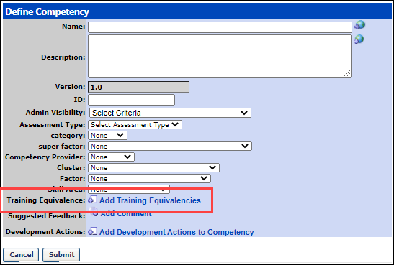
Create/Edit Training Equivalence
To create/edit training equivalence:
- Select one of the following options:
  - To create a new competency and add a training equivalence, select Create New Competency. Adding training equivalence is part of this process. See Competency - Create/Edit on page 43 for additional information.
  - To add or edit training equivalence to an existing competency, select the edit icon for the appropriate competency.
- Click the Add Training Equivalencies link in the Training Equivalence section.
- Select the appropriate training types (LOs) from the Select Training pop-up. Note: All LOs are available to the administrator when selecting equivalencies, regardless of the training availability. The selected LOs appear in the Training Equivalence section.
- Enter a title or keyword and click Search. If you do not enter a title or keyword, all titles display in the search results.
- In the search results, click the add icon for the titles you want to include as training equivalence. All selected titles move to the top of the Select Training pop-up.
- Select Done after you select all of the necessary titles. You are returned to the Define Competency page. The LO title is displayed, and to the right of the LO title, the LO type is displayed in parentheses.
Equivalent Rating

In the Equivalent Rating field, enter the percentage of the maximum available rating that is applied to the competency if the corresponding equivalent training is completed. This field accepts up to three numeric characters. Values greater than 100 are not accepted. The LO must be in Complete status for the system to attribute the competency rating.
Delete Training Equivalence
To delete a training equivalence, click the Delete icon to the left of the appropriate LO in the Training Equivalence section.
Submit
Click Submit to save this page.
Rules for Role Qualification
- Adding or removing a training equivalence automatically adds or removes the equivalent competency rating for all users with the competency. As this pertains to role qualification, the addition or removal of a training equivalence can cause a user to be qualified or unqualified for a role.
- Updates to the Training Equivalence section do not trigger a new version of the competency.
- If a user achieved a competency qualification for a role by completing a training equivalence, the competency qualification is not removed if the user receives a rating from an assessment or checklist that does not meet the target threshold for the role.
- If a training equivalence is completed outside of the role qualification window, the user receives the competency target rating, but the rating does not count towards role qualification.
Use Cases
An administrator at a manufacturing organization uses competencies as qualification requirements for their roles. Rather than conducting competency assessments or observation checklists, the organization uses training completion to acquire competency ratings for their users.
Administrator Adds Training Equivalence
The administrator wants to add the Safety 101 training as a training equivalence for the Manufacturing Safety competency. The administrator knows that the Manufacturing Safety competency is used as a qualification in the Manufacturing Safety role. The target rating for the Manufacturing Safety competency in the Manufacturing Safety role is 70%.
The administrator edits the Manufacturing Safety competency and adds the Safety 101 training as a training equivalence in the Training Equivalence section. Once the training is added, the administrator enters an equivalent rating of 75% for the equivalent training. The administrator then submits the competency changes.
With this configuration, the following occurs:
- All users who complete or have completed the Safety 101 training receive a rating equal to 75% of the maximum available rating for the Manufacturing Safety competency.
- All users with the Manufacturing Safety role who complete or have completed the Safety 101 training satisfy the Manufacturing Safety competency role qualification requirement.
Administrator Removes Training Equivalence
The administrator wants to remove the Safety 100 training as a training equivalence for the Manufacturing Safety competency because it is out of date. The administrator knows that the Manufacturing Safety competency is used as a qualification in the Manufacturing Safety role.
The administrator edits the Manufacturing Safety competency and removes the Safety 100 training as a training equivalence in the Training Equivalence section. The administrator then submits the competency changes.
With this configuration, the following occurs:
- All users who complete or have completed the Safety 100 training no longer receive an equivalent rating for the Manufacturing Safety competency.
- All users with the Manufacturing Safety role who complete or have completed the Safety 100 training no longer satisfy the Manufacturing Safety competency role qualification requirement. Note: This only impacts users who have not been rated for the Manufacturing Safety competency in a competency assessment or observation checklist. Ratings acquired through the completion of a task continue to be used in determining role qualification.
Administrator Modifies Equivalent Rating Value
The administrator wants to change the equivalent rating value for the Safety 101 training from 75% to 65% for the Manufacturing Safety competency. The administrator knows that the Manufacturing Safety competency is used as a qualification in the following roles:
- Manufacturing Safety 1 - Manufacturing Safety competency target = 60%
- Manufacturing Safety 2 - Manufacturing Safety competency target = 70%
The administrator edits the Manufacturing Safety competency and changes the equivalent rating from 75% to 65%. The administrator then submits the competency changes.
With this configuration, the following occurs:
- All users who complete or have completed the Safety 101 training receive a rating equal to 65% of the maximum available rating for the Manufacturing Safety competency.
- All users with the Manufacturing Safety 1 role who complete or have completed the Safety 101 training satisfy the Manufacturing Safety competency role qualification requirement.
- All users with the Manufacturing Safety 2 role who complete or have completed the Safety 101 training do not satisfy the Manufacturing Safety competency role qualification requirement.

Competency Category Types Overview
The Define Competency Category Types page displays all available competency category types.
To access the Define Competency Category Types page, go to Admin > Tools > Performance Management > Competency Bank. Then, click the Define Competency Categories link.
Permissions
PERMISSION NAME | PERMISSION DESCRIPTION | CATEGORY

Competency Assessment Model | Grants access to define competency categories, competency model categories, and the default rating scale for competency models. This permission cannot be constrained. This is an administrator permission.  For organizations using the Data Load Wizard Competency Bank Data General Information load, this permission is required to utilize custom fields in the data load. | Performance - Administration
See Competency Category Type - Create for additional information.
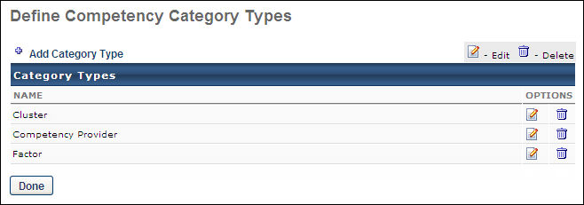

Competency and Competency Model Versioning
Competencies and competency models can be versioned.
- The Competency Bank always displays the most recent version of the competency. When selecting competencies to include in a competency model, only the most recent version of the competency is available for selection.
- The Competency Models page always displays the most recent version of the competency model. When selecting competency models to include in a task, only the most recent version of the competency model is available for selection.
- The versioning behavior for competency models is dependent on whether the competency model is being used in a "locked task."
  - When a competency model is not being used in a locked task, the current model version inherits changes to the model and underlying competencies. The competency model version number does not change.
  - When a competency model is being used in a locked task, changes to the model or underlying competencies result in the creation of a new competency model version. The locked task continues to use the competency model version that was selected at the time the task was created.
Use Cases
See Competency Versioning - Use Cases for additional information.
Locked Tasks
In order to support the versioning of competencies and competency models, the models that are used in the following tasks are considered "locked":
- Competency Assessment
- Nested Competency Assessments
  - Review Based Competency Assessment
  - SMP Based Competency Assessment
  - ATS Based Competency Assessment
- Locked Observation Checklists - The competencies in an observation checklist are locked if the Lock Competency option is selected when the checklist is created or edited.
Competency Versioning - Auto-Versioning Rules
See Competency Versioning - Auto-Versioning Rules for additional information.
Competency Versioning - Impact across System
See Competency Versioning - Impact across System for additional information.
Considerations
- The ordering of competency items and behaviors is removed at the competency model level. Item and behavior ordering now occurs at the competency level.
- Rating value attributes for competency behaviors at the competency level are normalized to match the rating scale used in the competency model. For example, in the scenario where a behavior rating is set to 3 out of 5, the rating value is normalized to 6 in competency models that use a 10 point rating scale.
- The rating value that is attributed to competencies and competency item development actions at the competency level are normalized to match the rating scale used in the competency model. For example, in the scenario where a development action maximum value is set to 3 out of 5, the development action maximum value is normalized to 6 in competency models using a 10 point rating scale.
- When a competency is added to a LO via the Course Catalog, the LO is also added as a development action with no minimum or maximum rating to the current competency version.
- When a LO is removed from a competency development action, the LO is only removed from the current version. If the LO is used in previous versions of the competency, then the LO remains in those versions.
- When a competency is removed from a LO, the LO is removed as a development action from all versions of the competency.
- In the performance review PDF, the competency model version number appears appended to the competency model title.

Competency Assessment Models - Overview
The Performance module is integrated with the Learning module where the tasks completed within Performance can lead back to training activities designed to enhance an employee's training and knowledge within your organization. The Competency Assessment module allows organizations to closely replicate their processes in the system and also to react to process changes with easy reconfigurations.
Competencies can be used to identify competency and skill gaps using 180 and 360 degree feedback, self-assessments, and custom built competency models. The system can dynamically generate an individual development plan and recommend training or developmental activities based on an employee's competency assessment. Competencies can also be included and rated within a performance review.
Administrators can perform the following:
- Associate models with any organizational unit (OU) type.
  - There is no limit to the number of OUs that can be associated with a competency model. However, each OU can only be associated with a single competency model. If the selected OU is already associated with a competency model, an error is displayed.
  - If the competency model is associated with a group, multiple competency models may be assigned to users that belong to multiple groups. When this occurs, the system uses the competency model for the group to which the user was most recently added.
- Group Competencies by categories with a 3-tier structure.
Competencies and competency models can have multiple versions. Certain modifications to competencies and competency models affect other areas of the system in different areas. See Competency and Competency Model Versioning on page 51 for additional information.
Workflow and Rules
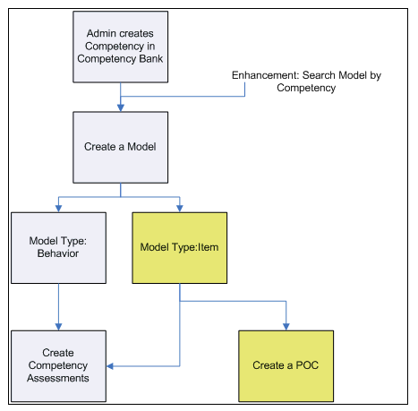
The type of competency model that is used by an organization's HR department is determined by the level of detail they prefer to include. The behavior-based model is more in depth and requires more effort to establish. Some organizations may feel the item-based competency model is adequate and more appropriate for the competencies being evaluated.
- An Item-based competency model rates a competency item on a scale (e.g., 1 to 5, where 1 may be Unacceptable and 5 may be Consistently Excels).
- A Behavior-based competency model rates a competency item by behavior descriptions. The assessor selects the behavior description that best describes the individual being assessed (e.g., "Prefers to let others handle problems and challenges" or "Is consistently creative in problem solving and solutions"). This competency model type is more in-depth and requires more effort to establish.

Competency Assessment Models - Manage
A competency model is a group of competencies that defines the skills and knowledge that are required for a job. It is a collection of competencies that define successful performance for a job.
Use the Competency Models page to create new competency models, define competency model categories, define the default rating scale for competency models, and search for and manage existing competency models.
NOTE: Before creating and managing competency models, administrators must first define their organization's competencies.
Competencies and competence categories are defined through the Competency Bank. See Competency Bank - Overview on page 39 for additional information.
To access the Competency Models page, go to Admin > Tools > Performance Management > Competency Assessment Models. Then, click the Competency Assessment Models link in the Competency Assessments section.
Permissions
PERMISSION NAME | PERMISSION DESCRIPTION | CATEGORY

Competency Assessment Model Admin - Edit | Grants ability to edit competency models. This permission cannot be constrained. This is an administrator permission. | Performance - Administration

Competency Assessment Model Admin - Manage | Grants ability to create, edit, delete, and view competency models. This permission cannot be constrained. This is an administrator permission. | Performance - Administration

Competency Assessment Model Admin - View | Grants ability to view competency models. This permission cannot be constrained. This is an administrator permission. | Performance - Administration

Competency Assessment Model | Grants access to define competency categories, competency model categories, and the default rating scale for competency models. This permission cannot be constrained. This is an administrator permission.  For organizations using the Data Load Wizard Competency Bank Data General Information load, this permission is required to utilize custom fields in the data load. | Performance - Administration
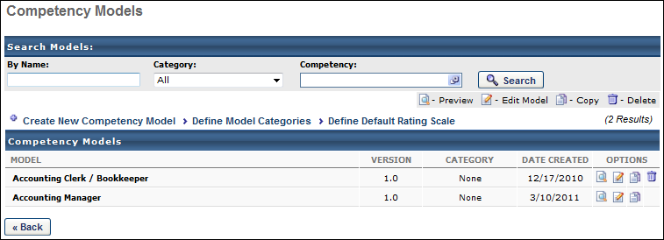
Search Models
Use the search fields to search for an existing competency model by name, category, or competency. The system only returns the most recent version of the competency model that contains the competency.
Create New Competency Model
Click the Create New Competency Model link to create a new competency model. This link is only available to administrators who have permission to manage competency models. See Competency Models - Create/Edit on page 58 for additional information.
Define Model Categories
Click the Define Model Categories link to create or modify competency model categories. This link is only available to administrators who have the Competency Assessment Model permission. See Competency Model Category - Create on page 62 for additional information.
Define Default Rating Scale
Click the Define Default Rating Scale link to create or modify competency model categories. This link is only available to administrators who have the Competency Assessment Model permission. See Competency Rating Scale - Define Default on page 63 for additional information.
Competency Models Table
Within the Competency Models table, a competency model is only displayed if the administrator has Admin Visibility for the competency model. In addition, the administrator must also have permission to view, edit, or manage competency models.
The following information is displayed for each competency model:
- Model - Competency model name. For competency models with multiple versions, an expand icon appears to the left of the competency model name. Click this icon to view the additional versions. The following information is displayed for previous versions:
  - Name - Competency model name prior to the new version being created.
  - Version - Competency model version number.
  - Preview - A read-only version of the competency model settings for the previous version.
- Version - Version number for the associated competency model.
- Category - Group to which this competency model is assigned.
- Date Created - Date the competency model is created.
Competency Model Options
The following options are available for competency models:
- Preview - View a read-only version of the competency model settings. This option is only available if the administrator has permission to view, edit, or manage competency models.
- Edit - Edit a competency model. This option is only available if the administrator has permission to edit or manage competency models. Note: When editing a competency model, administrators can view all of the competencies that have been added to the competency model, regardless of the administrator's permissions and the competencies' Admin Visibility settings. When editing a competency or competency model that has been used in a Competency Assessment type performance review section, a warning message is displayed at the top of the Edit Competency Model page. This warning is intended to prevent modifications to the competency model from affecting In Progress or Competed performance reviews.
- Copy - Copy a competency mode. This option is only available if the administrator has permission to manage competency models.
- Remove - Delete a competency model. This option is only available if the administrator has permission to manage competency models. A competency model cannot be deleted if it is used in a task or if it has been versioned.

Competency Models - Create/Edit
You can create new competency models or edit existing competency models.
To access the Add Competency Model page, go to Admin > Tools > Performance Management > Competency Assessment Models. Then, click the Create New Competency Model link.
When editing a competency model, the changes affect the system in different ways. See Competency and Competency Model Versioning on page 51 for additional information.
Note: Before you can create a competency model, you must define their organization's competencies. Competencies and competency categories are defined using the Competency Bank. See Competency Bank - Overview on page 39 for additional information.
Permissions
PERMISSION NAME | PERMISSION DESCRIPTION | CATEGORY

Competency Assessment Bank Admin - Edit | Grants ability to edit competencies in the Competency Bank. Administrators can only edit a competency if they have this permission and are also included in the Admin Visibility settings for the competency. This permission cannot be constrained. This is an administrator permission. | Performance - Administration

Competency Assessment Bank Admin - Manage | Grants ability to create, copy, edit, view, and delete competencies in the Competency Bank. This permission cannot be constrained. This is an administrator permission. | Performance - Administration

Competency Assessment Bank Admin - View | Grants ability to view competencies in the Competency Bank. Administrators can only view a competency if they have this permission and are also included in the Admin Visibility settings for the competency. This permission cannot be constrained. This is an administrator permission. | Performance - Administration

Competency Assessment Model Admin - Edit | Grants ability to edit competency models. This permission cannot be constrained. This is an administrator permission. | Performance - Administration

Competency Assessment Model Admin - Manage | Grants ability to create, edit, delete, and view competency models. This permission cannot be constrained. This is an administrator permission. | Performance - Administration
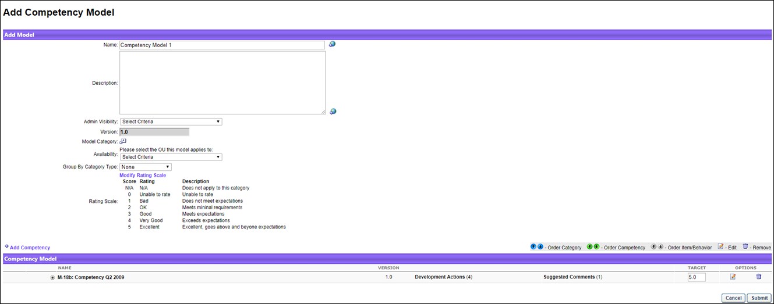
Quick Start Guide for Competencies
Select the following link to view a guide to getting started with competencies, including creating competencies, competency models, and tasks.
See QUICK START GUIDE - Competencies.
Create/Edit Competency Models
- Select an option:
  - To create a new competency model, click Create New Competency Model.
  - To edit, click the edit icon for the appropriate competency model.
- Enter or edit the following information:
  - Name - Name for the model. The name should be descriptive so that other administrators can clearly understand its purpose. This is required. If multiple languages are enabled for your portal, select the Translate icon to translate the field into other available languages.
  - Description - Description that describes the purpose of the competency model. If multiple languages are enabled for your portal, select the Translate icon to translate the field into other available languages.
  - Admin Visibility - Which administrators are able to view and select the competency model throughout the system. Administrators must also have permission to view or manage the competency model. This applies to all versions of the competency model. Editing this option does not create a new competency model version. Visibility can be set by OU, Group, or specific users. Select the Include Subordinates option to include subordinate OUs or users. If no visibility is set, then the competency model is visible to all administrators who have permission to view competency models.
  - Version - This field displays the competency model version number. This field is read-only.
  - Model Category - Category for the model. Competency model categories are created from the Competency Models page. See Competency Model Category - Create on page 62 for additional information.
  - Availability - Available active Organizational Units to associate with the model. Organizations may choose to set the availability for a model by position so that the organization can create a task that deploys competency assessments based on the position or job title of the employee.
    - There is no limit to the number of OUs that can be associated with a competency model. However, each OU can only be associated with a single competency model. If the selected OU is already associated with a competency model, an error is displayed.
    - If the competency model is associated with a group, multiple competency models may be assigned to users that belong to multiple groups. When this occurs, the system uses the competency model for the group to which the user was most recently added.
  - Group by Category Type - Group by category type within the model if category types are created for individual competencies. For example, if the administrator chooses one of the category types, the assessment calculates the output ratings at the item/behavior level, the competency level, and the category level, which can give users insight into how they are doing for a general grouping of competencies. The display will show Category > Competency > Item/Behavior in this view. Otherwise, the system will display Competency > Item/Behavior.
  - Rating Scale - Default rating scale when a new competency model is created. See Competency Rating Scale - Define Default on page 63 for additional information. If the rating scale needs to be modified, click on the Modify Rating Scale link. A pop-up window will appear. Modify the scale as needed, then click on the Save button to confirm your changes. If multiple languages are available for the portal, the rating scale can be localized by selecting the appropriate language from the Language drop-down list. The ratings and descriptions for the administrator's default language must be entered prior to translating the rating and descriptions for other languages.
- Click Submit to save your changes.
Add Competencies
To add competencies to the model, click the Add Competency link. When this option is selected, a pop-up window will appear. Check which competencies need to be included for the model, then click Done to add competency's to the model.
When selecting a competency, administrators can only view and select a competency if they are within the Admin Visibility settings for the competency and if they have permission to view, edit, or manage competencies.
Competency Model Table
- Reorder Competencies - Use the directional arrows to change the order of the competencies. Note: The order of the items or behaviors is only observed by a competency assessment task. Competencies within a performance review task display alphabetically and do not observe the order that is set here.
- Expand Competency - Select this icon to view the items that comprise the competency.
- Target - Enter a number to determine the necessary target for the category, competency, or behavior. This is the rating that the assessee must receive to be At Target. If an assessee achieves a score lower than the target score, they are Below Target. If an assessee achieves a score higher than the target score, they are Above Target.
  - The default score listed is based on the maximum available score of the rating scale.
Administrator can only modify the Min Rating and Max Rating values for development actions that are associated with the competency or competency items. The administrator cannot edit the competency name, description, ID, assessment type, or category. The administrator cannot add or remove suggested feedback, development actions for the competency, competency items or behaviors, or development actions for a competency item or behavior.

Competency Model Category - Create
Competency model categories enable organizations to group and filter competency models. Organizations can group competency models depending on their organizational needs.
To create a competency model category, go to Admin > Tools > Performance Management > Competency Assessment Models. Select Define Model Categories. Then, select the Add New Category link.
Permissions
PERMISSION NAME | PERMISSION DESCRIPTION | CATEGORY

Competency Assessment Model | Grants access to define competency categories, competency model categories, and the default rating scale for competency models. This permission cannot be constrained. This is an administrator permission.  For organizations using the Data Load Wizard Competency Bank Data General Information load, this permission is required to utilize custom fields in the data load. | Performance - Administration
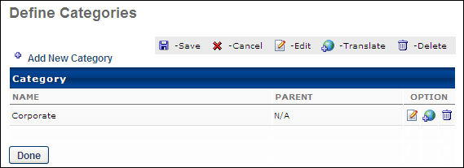
Enter the following information for the category:
- Name - Enter name of the model category.
- Parent - Choose to align the category to an existing category.
Click the Save icon, and then click the Done button.

Competency Rating Scale - Define Default
The rating scale defined in the default rating scale is used when creating a new competency or model. While you can edit the rating scale when defining a model, it is a best practice to use the same rating scale for all competencies and models.
The default competency rating scale only applies to competency models that are created after the default rating scale is set. After defining the default competency rating scale, this default scale will automatically be applied to new competency models that are created. When creating a new competency model, the administrator can modify the rating scale for that individual competency model.
- When the competency model is used within a competency assessment task, the competency model's rating scale is automatically applied to the assessment task.
- When the competency model is used within an observation checklist, the competency model's rating scale is automatically applied to the observation checklist, and this rating scale can be modified for that observation checklist.
To define the default rating scale, go to Admin > Tools > Performance Management > Competency Assessment Models. Then select Define Default Rating Scale.
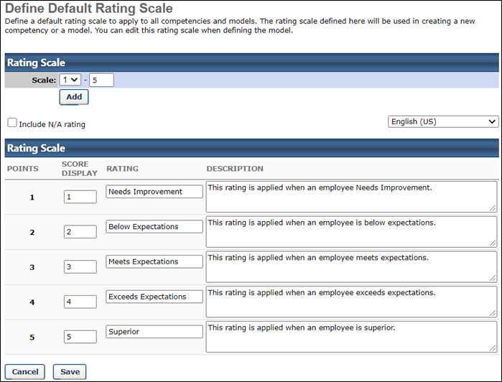
Define Rating Scale Range
The Scale field defines the range of the scale. Enter the maximum rating scale value, and click Add. Additional rows will appear for every point on the scale defined.
Include N/A Rating
When the Include N/A rating option is selected, a scoreless value titled N/A is included in the rating scale. This rating can be used by assessors if they feel that the competency does not apply to the assessee.
Localize the Rating Scale
If multiple languages are available for the portal, the rating scale can be localized by selecting the appropriate language from the Language drop-down list. The ratings and descriptions for the administrator's default language must be entered prior to translating the rating and descriptions for other languages.
Rating Scale Ratings and Descriptions
Enter the following information for the rating scale:
- Points - This is fixed and cannot be changed. This represents the numerical value that is used to calculate a score using this scale.
- Score Display - Enter a score for the rating. This is what the assessors see during the assessment process. Administrators can enter a number, letter, or combination of both to help express what the score is on the rating scale. Typically, this matches the point value of the rating scale.
- Rating - Enter a textual representation of the rating.
- Description - Enter a description for the rating. This is used to explain the rating in greater detail.
Save Default Rating Scale
Click Save to save any modifications to the default rating scale. These changes will be applied to any competency models that are created after your changes are saved.

Observation Checklists - Overview
Observation checklists enable organizations to assess and record an employee's skills and competencies while directly observing specific activities in the field. Automating this process makes it easier to track and validate proficiency in specific skills, as well as gain insight into competency levels across an organization. Observation checklists exist within the Performance Management system and expand on the existing Competency Assessment functionality, leveraging the bank of competencies and competency models.
Different from assessing a user's competency rating, the purpose of an Observation Checklist is to observe and check off if a user is competent in some task or skill. Competencies used in a checklist can be a wide range of activities. Some examples include simple and singular competencies like "Wears a Helmet when driving a forklift," or competencies requiring a series of steps or items or skills that when demonstrated define a nurse competent in "Administration of Medicines."
Usually the observation checklist is used for a simple yes or no documentation; in other words, was the skill performed according to required criteria? Yes or No. However, some organizations need to be able record levels of mastery in an observation checklist, via the use of a rating scale, rather than a simple yes or no response. Observation checklists can be implemented with a Yes or No rating or with a rating scale.
Organizations using observation checklists have the ability to:
- Ensure that regulatory reporting is accurate and timely.
- Use pre-integrated competency models specific to certain industries.
- Specifically define observation ratings and methods.
- Identify gaps and areas in which additional training and support is needed.
- Run reports on-demand for access to completion data, upcoming deadlines, or specific competency achievement by roles or units.
Within observation checklists, a verifier is a user granted the responsibility of checking off a competency for another user. This term is interchangeable with validator or preceptor. A verifier is usually a more experienced peer, subject matter expert, instructor, or manager. For example, a verifier in healthcare may be a senior nurse responsible for training new nurses. A skill is a step contained beneath a competency. A user must demonstrate all skills under a competency to be competent. Skill may also be referred to an item.
Use Cases
Healthcare Example
A hospital is hiring and training new nurses throughout the year. New nurses must complete orientation. Orientation consists of training and to graduate or be compliant the nurse must demonstrate competency in the skills his/her job requires. Currently a paper checklist is used. When regulators call on the hospital to confirm staff competency, gathering evidence from a paper system is difficult. Automating the competency verification process would better aid reporting to regulators and make it possible for the Hospital to quickly assess the competencies of the staff and the distribution of those competencies across the hospital's units.
Manufacturing Example
A manager in a warehouse must review the competencies of his/her workers. The manager observes and checks off that the employees are performing certain functions correctly: functions such as proper equipment or machinery use or demonstration of proper safety protocol. The manager does not carry around a lap top, but the manager does have his/her phone. Instead of having to record what he/she has observed and perform data entry at another time, the manager checks off competencies for the employee he/she is observing on his/her smart phone.
Contents

Observation Checklist Administration
The Checklist Administration page allows administrators to manage checklists as follows:
- Create a checklist assignment
- Define a default validation method list that populates for each new checklist assignment
- Search for checklists by name, competency, and competency model name
- Inactivate or activate a checklist
- Indicate a checklist is dynamic in assignment and indicate the checklist should dynamically remove users from assignment if the user no longer meets the assignment criteria
- Edit or copy a checklist
- View the assignment and progress details of a checklist
The default display lists the most recently created checklist first, using the Date Created column. You can change the sort order by Name, Created By, Type, and Status, and also reverse the Date Created column sort.
Note: When modifying the validators for an observation checklist, the changes do not take effect until the following day because this is done in a nightly process.
To manage observation checklists, go to Admin > Tools > Performance Management > Observation Checklists.
Permissions
PERMISSION NAME | PERMISSION DESCRIPTION | CATEGORY

Observation Checklist - Add Verifier by OU | Grants access to add or remove verifiers (validators) for a Checklist using the Availability control. The user must also have the View or Manage permission for Performance Observation Checklist. This is an administrator permission. | Performance - Administration

Observation Checklist Admin - Manage | Grants access to create and edit Observation Checklists, as well as view progress of users assigned to a given checklist and/or remove users from a checklist. This permission can be constrained by OU and User's OU. This is an administrator permission. | Performance - Administration

Observation Checklists - Edit Validation Details | Grants access to edit a validation record for a competency or item for a user's checklist. This is an administrator permission. | Performance - Administration

Observation Checklist - Verifier | Enables user to serve as the verifier for the observation checklist of another user. This permission should be included in the dynamic security role "Checklist Verifier." The role, when active, is dynamically assigned to any user who is designated as a verifier for one or more checklists. This permission can be constrained by OU and User's OU. This is an end user permission. | Performance

Observation Checklist Admin - View | Grants access to view observation checklists. This permission also enables user to see progress of all users assigned to a given checklist. This is an administrator permission. | Performance - Administration
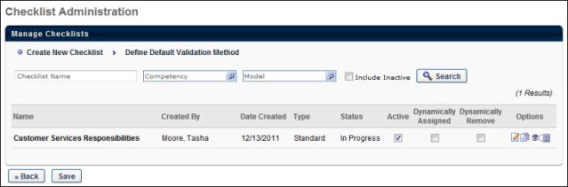
Search for Checklists
The administrator can search the list of checklists by checklist name, competency, and competency model. Inactive checklists can also be included in the search results by selecting the Include Inactive option. The results that display depend on which checklists are visible to the administrator based on permission constraints. The search filters act in combination with other search filters, so only checklists that match each search criteria display.
- Checklist Name - The name of the checklist. A partial name entry returns results that have a partial match in the checklist name.
- Competency/Model - Opens a pop-up where you can select any available criteria. Only one competency and one competency model can be selected for a search.
- Include inactive - When selected, inactive checklists that match the search criteria are also displayed in the search results.
- Search - Click the Search button to display search results based on the selected search options.
Observation Checklist Table
By default, all available checklists are displayed and are ordered by the date on which they were created. The following information displays for each checklist:
- Name - The name of the checklist.
- Created by - The person who created the checklist.
- Date Created - The date the checklist is created.
- Type - The type of checklist, for example Learning Object or Standard.
- Status - The current status of the checklist. Options are: Queued, Not Started, In Progress, Complete, Expired.
- Active - By default, checklists are active and available on the user's Checklist page. Deselect the Active option to deactivate the checklist and remove it from the user's Checklist page. The follow applies:
  - If some competencies are validated in a checklist that is now inactive, those validation records are saved and can be viewed in the All Competencies page.
  - The Competency Detail page indicates whether a checklist is inactive.
  - If a checklist is inactive and no competencies for that checklist are validated, all visual aspects of that checklist are removed from the user's Checklist and Competency Details page.
  - If an active checklist shares a competency with a deactivated checklist and that competency was first validated on the active checklist, then the competency details show only the active checklist and not the now inactive checklist.
  - If an active checklist shares a competency with a deactivated checklist and that competency was first validated on the inactive checklist, when the user views the competency details page accessed from the active checklist, the user sees the checklist table that belongs to both the active and inactive checklist. The inactive checklist displays as inactive.
  - If the checklist is reactivated, the inactive note is removed and the checklist is restored on the user's Checklist page.
- Dynamically Assigned - Select this option to have the checklist automatically assign the checklist to any user that meets the assignment criteria even after the initial assignment is made. When a feed runs for a client, any user that now meets the assignment criteria of the checklist receives the assignment of the checklist. The following applies:
  - If this option is deselected, only users that meet the assignment criteria at the time the checklist is created are assigned the checklist.
  - This option is unavailable for Learning Object type observation checklists.
  - If a checklist is not dynamically assigned, the Dynamically Assign option is not available until the status of the checklist is In Progress. This is to ensure all assignment dates and due dates are consistent for all assigned users.
Note: You cannot modify this option if the checklist is in a Queued or Not Started status because the checklist can be edited to update the dynamic assignment and due dates within the checklist.
- Dynamically Remove - Select this option to automatically remove the checklist from any user that no longer meets the assignment criteria even after the initial assignment is made. When a feed runs for a client, any user that no longer meets the assignment criteria of the checklist is removed from the assignment of the checklist. This option operates independently of the Dynamically Assigned option. If this option is not selected, the system does not automatically remove any users from the checklist assignment. The following applies:
  - If a user's status is Not Started, the checklist is removed from the user as well as all of its competencies.
  - If the user is In Progress as a result of validation propagation (a skill/item for a competency being verified via another checklist containing the same competency), then the dynamically removed checklist is removed and no competencies remain because the propagated verification is visible in the other checklist still assigned to the user.
  - If the user is In Progress as a result of a verifier checking a skill/competency that is unique to this checklist and is not contained in any other checklist, then the checklist is removed but the completed or partially completed competency remains in the All Competencies page.
  - If the user's status is Complete, no change occurs. The checklist remains and displays all of the competencies contained in it.
  - If the user's status is Past Due, the dynamic removal rules depend on the user's status prior to becoming Past Due. For example, if the user's status was Not Started prior to becoming Past Due, the same rules apply as if the user's status is Not Started. If the user's status was In Progress prior to becoming Past Due, the same rules apply as if the user's status is In Progress.
Options
In the options column, you can perform the following actions:
- Edit - Click this icon to edit the checklist. You must have the Observation Checklist - Manage permission to perform this action. All checklists can be edited at any time, regardless of its status. Note: When modifying the validators for an observation checklist, the changes do not take effect until the following day because this is done in a nightly process. See Observation Checklist - Create/Edit Overview on page 71 for additional information.
- Copy - Click this icon to copy the checklist. You must have the Observation Checklist - Manage permission to perform this action. See Observation Checklist - Copy on page 109 for additional information.
- View Details - Click this icon to view the assignment and progress details of a checklist. See Observation Checklist - View Details on page 111 for additional information.

Observation Checklist - Create/Edit Overview
Before you can create an observation checklist, you must complete the following tasks:
- Create Competencies - See Competency - Create/Edit on page 43 for additional information.
- Create Competency Model - See Competency Models - Create/Edit on page 58 for additional information.
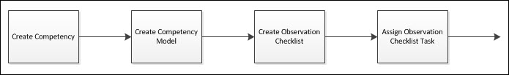
To access observation checklists, go to Admin > Tools > Performance Management > Observation Checklists
- To create a new checklist, select the Create New Checklist link.
- To edit an observation checklist, in the Options column, select the edit icon for the appropriate checklist.
When editing an observation checklist, some settings cannot be modified. Please review the descriptions for each field to determine whether it can be modified when editing an observation checklist.
Permissions
PERMISSION NAME | PERMISSION DESCRIPTION | CATEGORY

Observation Checklist Admin - Manage | Grants access to create and edit Observation Checklists, as well as view progress of users assigned to a given checklist and/or remove users from a checklist. This permission can be constrained by OU and User's OU. This is an administrator permission. | Performance - Administration
The process of creating a checklist is separated into four sections:
- General
- Preferences
- Email
- Confirm
Editing an observation checklist is similar to the creation process. The differences are listed throughout the creation process. Note: Editing a checklist triggers emails if they are enabled on the Observation Checklist - Email page or within Email Administration.
Contents
Observation Checklist - Create/Edit - General Page
Use the General page to specify the general details of the checklist, including competency model, checklist name, availability, and validation method.
If you are creating a new observation checklist, this is the first step in the process.
To access observation checklists, go to Admin > Tools > Performance Management > Observation Checklists
- To create a new checklist, select the Create New Checklist link.
- To edit an observation checklist, in the Options column, select the edit icon for the appropriate checklist.
When editing an observation checklist, some settings cannot be modified. Please review the descriptions for each field to determine whether it can be modified when editing an observation checklist.
Permissions
PERMISSION NAME | PERMISSION DESCRIPTION | CATEGORY

Competency Assessment Model Admin - Edit | Grants ability to edit competency models. This permission cannot be constrained. This is an administrator permission. | Performance - Administration

Competency Assessment Model Admin - Manage | Grants ability to create, edit, delete, and view competency models. This permission cannot be constrained. This is an administrator permission. | Performance - Administration

Competency Assessment Model Admin - View | Grants ability to view competency models. This permission cannot be constrained. This is an administrator permission. | Performance - Administration

Observation Checklist Admin - Manage | Grants access to create and edit Observation Checklists, as well as view progress of users assigned to a given checklist and/or remove users from a checklist. This permission can be constrained by OU and User's OU. This is an administrator permission. | Performance - Administration
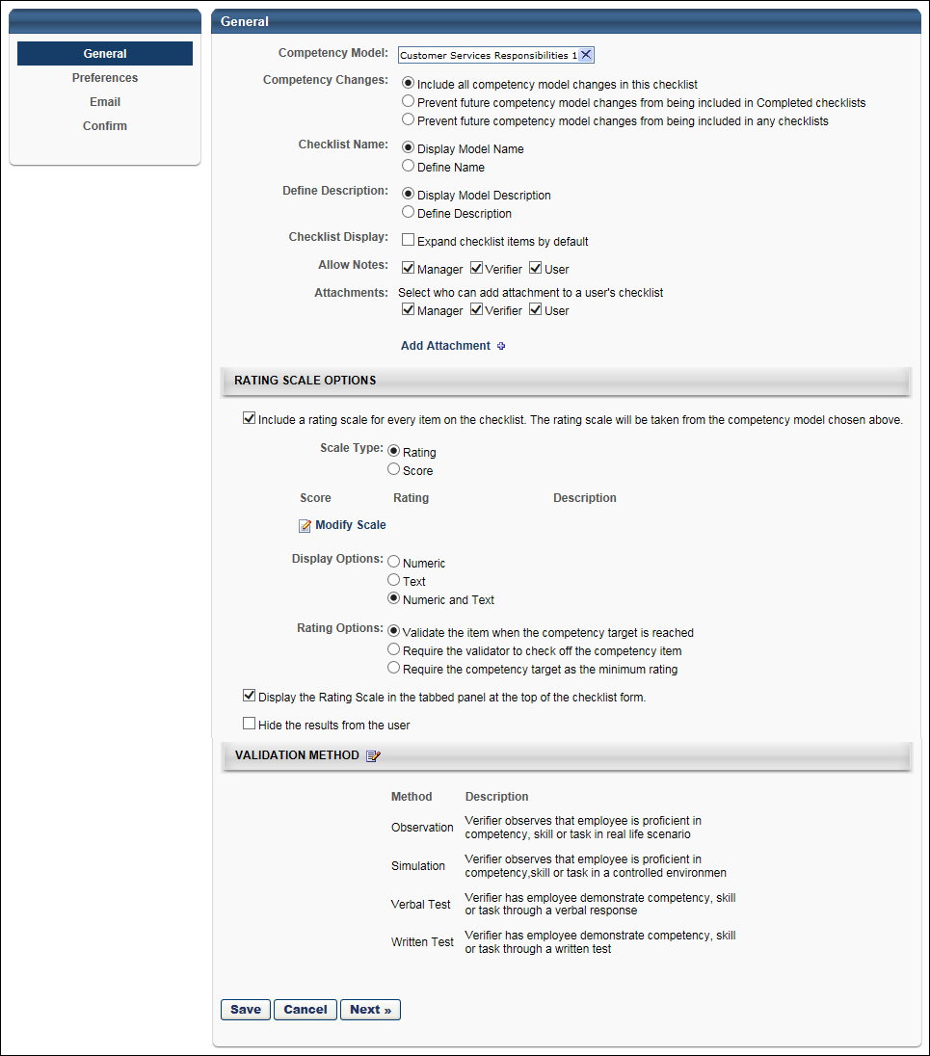
Enter or edit the information in each section as defined below.
General
Competency Model
Click anywhere in the Competency Model field or click the Select icon to select a competency model. Narrow the search results by entering a name in the Competency Model Name field and clicking Search. Or, locate the name on the appropriate page and click the name. The pop-up closes automatically when a competency model name is clicked and the model name then displays in the Competency Model field. Note: The selected model establishes the competencies and skills that are included in the checklist.
- When selecting a competency model, administrators can only view and select a competency model if they are within the Admin Visibility settings for the competency model and if they have permission to view, edit, or manage competency models.
- Only one model can be selected per checklist.
- Only Competency Item type Competency Models can be used in an Observation Checklist. If your Competency Model is a Behavior type Competency Model, it will not appear in the list because it is ineligible to be included.
- Editing: When editing, the competency model cannot be changed. To keep an existing checklist but change the competency model, a best practice is to copy the checklist, and then change the competency model on the General page.
Competency Changes
Select one of the following lock options:
- Include all competency model changes in the checklist - This option is selected by default. When this option is selected, all instances of the checklist are unlocked. Any added competencies to the competency model will cause any users in a Completed status to go to an In Progress status and the added competency item will need to be validated. For example, if a checklist is completed and the checklist contains the "Administration of Medicine" competency and a skill is added to the competency, the checklist will reverse in status from Complete to In Progress. The user must now demonstrate the added skill to return to a status of Completed. However, if you remove an item from the competency via the Competency Bank, the changes do not propagate to any model with that competency, and therefore would not update any checklist.
- Prevent future competency model changes from being included in Completed checklists - When this option is selected, completed instances of the checklist are locked and do not accept any updates to the checklist competencies. Instances of the checklist that are not completed are unlocked and do accept updates to the checklist competencies.
  - If an observation checklist is pending manager approval, then this checklist is not considered completed. In this situation, any changes to the checklist's competency model are propagated to the checklist. If an item or competency is added to the competency model, the user must complete the new item or competency and resubmit the checklist for manager approval.
- Prevent future competency model changes from being included in any checklist - When this option is selected, all instances of the checklist are fully locked.
When an observation checklist is locked, the following competency model changes do not affect an observation checklist:
- Adding or removing an item or behavior from a competency within the checklist's competency model.
- Adding or removing a competency from the checklist's competency model.
Once the observation checklist is deployed to users, the Competency Changes option cannot be changed.
If Learning Object is selected as the checklist type on the Preferences step, then the checklist is automatically set to be locked, regardless of the selected Competency Changes setting.
Note: This option is only available when first creating the checklist. Once it has been created, this option cannot be modified.
Validation Changes
This option determines whether competency validation dates are locked once the checklist is completed.
When this option is selected, competency validation dates are continuously updated with the latest validation date until the checklist is completed. For example, if a competency within the checklist is validated multiple times prior to completing the checklist, then the validation date reflects the latest validation date. However, once the checklist is completed, all validation dates are locked, and they will not be updated if the competency is validated again. If the checklist requires electronic signature for checklist completion, then the observer only signs the checklist when it is completed.
When this option is not selected, competency validation dates are continuously updated with the latest validation date even after the checklist is completed. For example, if a competency within the checklist is validated prior to completing the checklist and is then validated again after the checklist is completed, then the checklist reflects the latest validation date, even after the checklist is completed. If the checklist requires electronic signature for checklist completion, then the observer must sign the checklist each time the validation date is updated after the initial completion.
If the Competency Changes field is set to Include all competency model changes in this checklist, then the Validation Changes option is unselected and cannot be selected. Otherwise, the Validation Changes option is selected by default.
Checklist Name
Display Model Name - Select this option to keep the checklist name the same as the associated competency model.
Define Name - Select this option to define a unique name for the competency model. A blank text field displays below the radio button. Enter the name you would like to use. If multiple languages are enabled for your portal, select the Translate icon to translate the field into other available languages.
- The checklist name appears on the Performance Observation Checklist page for verifiers and end users and also displays on the Competency Details page and in reporting.
- Editing: When editing, the administrator may change the checklist name at any time and it automatically updates for end users, verifiers, and the administrator.
Define Description
Display Model Description - Select this option to keep the checklist description the same as the associated competency model.
Define Description - Select this option to define a unique description for the competency model. A blank text field displays below the radio button. Enter the description you would like to use. If multiple languages are enabled for your portal, select the Translate icon to translate the field into other available languages.
- The checklist description appears when viewing a checklist on the Checklist page and also displays on the Competency Details page and in reporting.
- Editing: When editing, the administrator may change the checklist description at any time and it is automatically updated for end users, verifiers, and the administrator.
Checklist Display
This option enables administrators to control the default display of checklist items on the Verifier view and Employee view of the Checklist Page. When this option is selected, the system expands the observation checklist by default for validator and employee views. If this option is not selected, the observation checklist is collapsed for validator and employee views.
Allow Notes
Select which roles can leave comments or notes at the Competency Details page level: Manager, Verifier, User. If no role is selected, notes and comments are disabled for the checklist.
- Editing: When editing, the Allow Comments selections can be modified. Upon saving, users' checklists are updated.
Attachments
Select which roles can add attachments to a user's checklist. Options are Manager, Verifier, User. If no role is selected, attachments are disabled for the checklist.
Click Add Attachment to add attachments as follows:
- Up to three total attachments can be added to a checklist. For example, if a user adds three attachments to a checklist, the manager and verifier cannot add any attachments because the maximum number has been reached.
- Acceptable file types are: Word, Excel, PowerPoint, pdf, txt, rtf, gif, jpg.
- The maximum file size is 1 MB.
- The administrator is not limited to the number of attachments they can add.
- Editing: When editing, attachment options can be edited at any time. Upon saving, the selected options are applied to checklists that are assigned to users.
  - Changing the Attachment Settings: When editing, if you deselect the User box, users can no longer add attachments. But, any attachments previously added to the checklist by a user remain. A user cannot remove previously added attachments. Administrators always have the ability to add or remove attachments added by any role.
Rating Scale Options
Include a rating scale for every item on the checklist - Check this option to allow users to rate each item within the checklist. Checking the box enables the following additional options:
- Scale Type - When a rating scale is included in the checklist, this option enables administrators to choose whether the results of the observation checklist are displayed as an average rating or a summarized score. When the Rating option is selected, the checklist results are displayed as an average rating based on the user's ratings. When Score is selected, the checklist results are displayed as a summarized score and pass/fail options are available below this field. The Score value is calculated by combining the point value assigned to individual ratings within the competency model to determine the total value.
  - Automatic Failure Threshold - This option only appears if Score is selected in the Scale Type field. Select this option to set an automatic failure threshold. When this option is selected, the administrator must set a specific score or percentage as the threshold. Select whether the threshold is set as a score or percentage from the drop-down list. The pass/fail threshold should represent the minimum number of points or percentage that is required for passing the checklist. Point totals or percentages that are below the threshold result in a fail. Point totals or percentages that meet or exceed the threshold result in a pass. The pass/fail threshold for the observation checklist uses the Total Score achieved during the validation of the competency model. Note: The maximum possible score for the selected competency model is displayed to the right of the Automatic Failure Threshold option. This should be considered when specifying the threshold score. The Automatic Failure Threshold must be less than the maximum possible score.
  - Editing: When editing, the Scale Type cannot be changed.
- Rating Scale - If a competency model is selected in the Competency Model field, then the rating scale for the selected competency model is displayed so that the administrator can view the ratings, points, or scores that are included. Administrators can customize the checklist rating scale and decide which ratings appear to verifiers by clicking the Modify Scale link.
- Display Options - Select how the checklist appears: numerically, textually, or both.
  - Numeric - When Numeric is selected, only the numeric score value is displayed.
  - Text - When Text is selected, only the text rating value is displayed; this option is only available if Rating is selected as the Scale Type.
  - Numeric and Text - The Numeric and Text option displays both the numeric and text rating values.
- Rating Options - Select one of the following options:
  - Validate the item when the competency target is reached - When this option is selected and the minimum rating target is achieved for a competency, then the competency item is automatically considered to be validated and the competency checkbox within the observation checklist is automatically checked by the system. Important: When this option is selected, a competency item can be manually validated even if the minimum rating target is not reached for the competency.
  - Require the validator to check off the competency item - When this option is selected, the verifier is responsible for validating the competency item by checking the competency checkbox within the observation checklist. When the competency checkbox within the observation checklist is checked, the competency item is considered validated even if the competency item rating does not meet the minimum rating target for the competency.
  - Require the competency target as the minimum rating - When this option is selected, a competency item must receive a rating that meets the minimum rating target for the competency in order to be validated. When this option is selected, the following functionality is implemented within the checklist:
    - If the verifier checks the competency item checkbox to validate the item, the rating selection for the competency item is automatically set to the minimum rating target for the competency. The rating can be set to a higher rating until the checklist is saved, if necessary.
    - If the verifier selects a rating for the competency item that is at or above the minimum rating target for the competency, then the competency item checkbox is automatically checked and the item is validated.
    - If the verifier selects a rating for the competency item that is below the minimum rating target for the competency, then the competency item checkbox is disabled and the item cannot be validated until the competency item rating meets the minimum rating target for the competency.
    - When the verifier saves the checklist, all validated competency items are no longer available for rating or validating. However, the Rating drop-down menu remains available for all non-validated competency items.
    - Note: If the observation checklist rating scale includes a N/A rating option and this option is selected, then the verifier can validate an item regardless of whether the minimum target rating is required.
- Display the rating scale in the tabbed panel at the top of the checklist form - Checking this box displays the rating scale on the checklist.
- Hide the results from the user - Choose whether or not the results are visible to the user after the observation is complete by selecting or deselecting the checkbox.
Validation Method
Click the Edit icon to edit the default validation method. See Validation Method - Define Default on page 116 for additional information. The Display Validation Methods table opens, showing the validation methods and descriptions from the default validation method. Here, you can edit the validation name and description and also modify the order the methods display in the drop-down.
- Exclude Method Selection from Checklist - Check this option to not allow users to select a method when creating an observation checklist. If this option is selected, users do not see a method of validation column on the associated checklist or the details of a competency. Verifiers do not see or have the ability to select a method of verification on the Competency Details page. When reporting on this checklist, a method value will not appear in reporting associated with competencies in this checklist.
- Number of Methods - Enter the number of different verification methods to define. This indicates the number of methods available to the verifier. Click Apply to make the methods available for creation. The maximum number of methods is 15.
- If multiple languages are available for the portal, the validation methods can be localized by selecting the appropriate language from the Language drop-down list. The methods and descriptions for the administrator's default language must be entered prior to translating the methods and descriptions for other languages.
- The character limit for a method name is 25 characters, and the character limit for a method description is 100 characters.
- Drag and drop the methods to determine the order in which they display.
- All methods must be defined before the administrator can translate them using the language drop-down. If the administrator does not translate the methods, a task that is created in another language displays the methods defined for the default language.
- When editing, the administrator can modify the validation methods and descriptions, regardless of the checklist status. But, the administrator cannot add validation methods or remove options if the checklist is in a Not Started status.
Modification History
The modification history is collapsed by default and only displays after a checklist is created. It shows a date and time stamp of when the checklist was modified and who made the modification. Click the down arrow to the right of the Modification History heading to display its contents.
Back/Cancel/Next
- Click BACK to return to the previous page.
- Click Cancel to close this page.
- Click Next to proceed to the next tab. See Observation Checklist - Preferences - Checklist Types on page 79 for additional information.
Observation Checklist - Preferences - Checklist Types
When you create a new observation checklist, you select the type of observation checklist you want to create. The type you create determines the fields you must complete on the Preferences page. The types of observation checklists are as follows:
- Standard - This checklist is assigned to users and users complete the checklist once. See Observation Checklist Preferences - Standard Checklist on page 80 for additional information.
- Ad Hoc - This checklists can be launched at any time by any user who has the appropriate permissions and is within the defined verifier availability for the observation checklist. See Observation Checklist Preferences - Ad Hoc Checklist on page 87 for additional information.
- Recurring - This checklist is assigned to users and users complete the checklist multiple times on a recurring basis. See Observation Checklist Preferences - Recurring Checklist on page 93 for additional information.
- Learning Object - This checklist can be added to a curriculum or certification. See Observation Checklist Preferences - Learning Object Checklist on page 100 for additional information.
You can only select a checklist type when creating a new observation checklist.
To access observation checklists, go to Admin > Tools > Performance Management > Observation Checklists
- To create a new checklist, select the Create New Checklist link.
- To edit an observation checklist, in the Options column, select the edit icon for the appropriate checklist.
When editing an observation checklist, some settings cannot be modified. Please review the descriptions for each field to determine whether it can be modified when editing an observation checklist.
Permissions
PERMISSION NAME | PERMISSION DESCRIPTION | CATEGORY

Observation Checklist Admin - Manage | Grants access to create and edit Observation Checklists, as well as view progress of users assigned to a given checklist and/or remove users from a checklist. This permission can be constrained by OU and User's OU. This is an administrator permission. | Performance - Administration

Observation Checklist Preferences - Standard Checklist
The second step in creating an observation checklist is the Preferences step. On the Create - Preferences page, the administrator specifies the checklist type, date criteria, and validation settings.
Depending on the type of observation checklist you are creating, there are different options available on the Preferences page. This topic describes the Preferences page when Standard is selected from the Checklist Type drop-down menu.
To access observation checklists, go to Admin > Tools > Performance Management > Observation Checklists
- To create a new checklist, select the Create New Checklist link.
- To edit an observation checklist, in the Options column, select the edit icon for the appropriate checklist.
When editing an observation checklist, some settings cannot be modified. Please review the descriptions for each field to determine whether it can be modified when editing an observation checklist.
Permissions
PERMISSION NAME | PERMISSION DESCRIPTION | CATEGORY

Observation Checklist Admin - Manage | Grants access to create and edit Observation Checklists, as well as view progress of users assigned to a given checklist and/or remove users from a checklist. This permission can be constrained by OU and User's OU. This is an administrator permission. | Performance - Administration
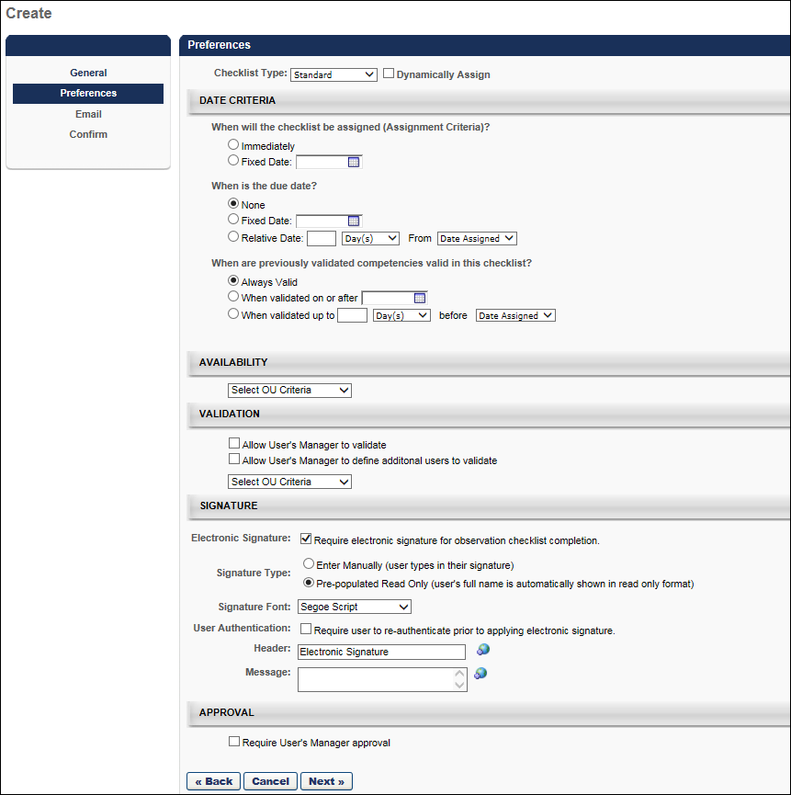
Specify the following for the checklist:
Checklist Type
Select whether the checklist is standard, recurring, or learning object.
- Standard - This indicates that the assigned users only complete the checklist once, therefore the checklist is only assigned once and is only due once.
- Ad Hoc - This type of observation checklists can be launched at any time by any user who has the appropriate permissions and is within the defined verifier availability for the observation checklist. See Observation Checklist Preferences - Ad Hoc Checklist on page 87 for additional information.
- Recurring - This indicates the assigned users will complete the checklist on a repeating basis, so additional options appear in the Date Criteria section in order to define the recurrence. See Observation Checklist Preferences - Recurring Checklist on page 93 for additional information.
- Learning Object - This enables the checklist to be added to a curriculum or certification. Note: For learning object checklist types, the competency model selected on the General step is locked. See Observation Checklist Preferences - Learning Object Checklist on page 100 for additional information.
- Editing: When editing, the checklist type cannot be changed.
Dynamically Assign
Select this option to have the checklist assigned to users on a dynamic basis, meaning that each time the system processes, new users who meet the assignment criteria are assigned to the checklist. For example, if the checklist is dynamically assigned to an OU, any qualifying user that joins the OU after the initial assignment is assigned the checklist upon joining the OU.
- Editing: When editing, the Dynamically Assign option cannot be changed.
When will the checklist be assigned (Assignment Criteria)?
- Immediately - Select this option to assign the checklist to all users that match the availability criteria set in the General step as soon as the checklist is saved and processed.
- Fixed Date - Select this option to specify a date on which the checklist is assigned. This option allows admins to configure a checklist, but not assign it until a future date (e.g., configure the checklist on Friday and have the checklist assigned on Monday).
- Relative Date - This option is only available when the checklist is set to be Dynamically Assigned. Select this option to specify a relative assignment date. Specify the number of days, weeks, or months from some standard or custom date field (e.g., Assign 10 Days from Hire Date). The number entered must be between 1-999.
- Editing: When editing, this can be modified if the checklist status is Not Started. Any changes only impact users that are assigned to the checklist after the changes are made. Therefore, editing this selection is only impactful when the checklist is dynamically assigned. After a checklist is started, this cannot be edited.
When is the due date?
- None - Select this option to indicate that there is no due date for the checklist, which means the checklist will never have a Past Due status.
- Fixed Date - Select this option to specify a date on which the checklist is due.
- Relative Date - Select this option to specify a relative due date. Specify the number of days, weeks, or months from some standard or custom date field (e.g., Due 10 Days from Date Assigned). The number entered must be between 1-999.
- Editing: When editing, the following is true:
  - For recurring checklists, the due date can be modified if the status is Queued or Not Started.
  - For standard checklists, the due date can only be modified if the status is Queued.
  - Any changes only impact users who are assigned to the checklist after the changes are made. Therefore, editing this selection is only impactful when the checklist is dynamically assigned. After a checklist is started, this cannot be edited.
When are previously validated competencies valid in this checklist?
This option determines the validity period for previously validated competencies. The validity period for a checklist is the amount of time a validated competency is considered valid towards the completion of the checklist. This enables administrators to ensure that certain competencies are being validated on a regular basis. Note: This option is not available if the Rating Option is set to "Require the competency target as the minimum rating" on the General page.
- Always Valid - When this option is selected, the competencies are always valid. When this option is selected, any competency in the checklist that has previously been validated for the assessee is automatically validated within this checklist. For example, if the Public Speaking competency was validated for John Smith four years ago and is assigned to John Smith again in an observation checklist that has this option selected, then the Public Speaking competency is automatically validated within this checklist because the competency is always valid for the checklist.
- When validated on or after XX - Select this option to select a fixed validity date. Enter a date in the date field or choose a date from the calendar. When the validity date is fixed, the competencies are valid up to that date. When this option is selected, the validity period is relative to a specific date. Any competency in the checklist that has been previously validated for the assessee on or after the selected date is automatically validated within this checklist. If the competency was validated before the selected date, then the competency must be re-validated. For example, if the Public Speaking competency was validated for John Smith on January 1, 2013 and is assigned to John Smith again in an observation checklist with this option selected and set to February 1, 2013, then this competency is not validated within this checklist because the competency was previously validated outside of the validity period.
- When validated up to - Select this option to specify a relative validity date. Specify the number of days, weeks, or months from some standard or custom date field (e.g., Due 10 Days from Date Assigned). The number entered must be between 1-999. When this option is selected, the competencies are valid up to a certain amount of time before the custom date field selected.
Editing: The option to set the validity period for previously validated competencies is not editable after the task is created.
Availability
Select the users who will be assessed using the checklist. Only users that match the availability criteria are assigned the checklist.
- The availability selections that the administrator can select are limited based on the constraints the administrator has on the permission to manage observation checklists.
- Editing: When editing, the administrator cannot modify the availability for an existing checklist if the checklist status is In Progress or Complete.
  - If the administrator adds criteria while the checklist is in a Not Started status, the new users are only added if Dynamic Assignment is also active. Note: Checking the Dynamically Assign checkbox on the Preferences page activates Dynamic Assignment.
  - If the administrator removes criteria, users that were assigned as a result of those criteria are only removed if Dynamic Removal is active and the checklist is in a Not Started status for the user.
Validation
Use the following options to select who can act as a verifier for a user's checklist. At least one of the options must be defined. Note: When modifying the validators for an observation checklist, the changes do not take effect until the following day because this is done in a nightly process.
- Allow User's Manager to validate
  - Select this option to assign the managers of the end users as verifiers for the checklist. The manager is then able to validate items within the competency and the competency itself within the checklist. When the manager views this checklist, they can check off competencies.
  - If this is the only selected option, only managers can act as verifiers to their employees.
  - Editing: When editing, the administrator may change this setting at any time and it impacts a manager's ability to act as a verifier for the associated checklist as soon as the setting is saved.
- Allow User's Manager to define additional users to validate - This option is independent of the previous option.
  - Select this option to allow managers to add co-planners who can validate competencies when the manager cannot verify themselves.
  - When this option is selected, on the user's checklist page, in the Overview table in the Co-Planner tab, the manager can add co-planners.
  - Users designated as co-planners are delegated access to verify a user's competencies in the associated checklist.
  - If this is the only selected option, there are no verifiers for the checklist until the managers begin adding co-planners for their employee's checklists.
  - Editing: When editing, the administrator may change this setting at any time.
- Select Verifier Availability - This selection criteria allows you to define verifiers for the checklist by OU. You must have the permission to add verifiers in order to view and manage this setting.
  - After making a selection, the Allow user(s) to define additional verifiers option is available for the selection. When this option is selected, the selected verifiers can add co-planners.
  - This selection can be made in addition to selecting the manager as a verifier and allowing the manager to designate co-planners.
  - If the availability OU tool is the only validation preference selected, only users matching the selected criteria are able to validate for the users assigned to the checklist. Therefore, it is possible that a manager could only view a read-only version of the checklist for their employee.
  - Create a group by selecting the plus sign next to Create New Group. For more information on creating groups, see the Create Group section of the Organizational Units topic.
  - Editing: When editing, the administrator may change this setting at any time. Administrators may select additional OUs or users and they may also remove selected verifiers. If a verifier has checked off some competencies for a user and is then removed as a verifier, the competency validations are not removed, but the removed verifier can no longer access the checklist. Note: To add or remove verifiers for an observation checklist using the Availability control, you must have the permission to add verifiers and the permission to manage observation checklists.
Signature
This section enables the administrator to determine whether an electronic signature is required to complete the observation checklist. If an electronic signature is required, then the administrator can configure how the electronic signature is captured.
The following options are available in this section:
- Electronic Signature - Select this option to require an electronic signature to complete a checklist. When this option is selected, the validator must provide an electronic signature after validating the final item in the checklist. The checklist cannot be saved or submitted for approval until the electronic signature is provided.
- Signature Type - Select the method by which the validator provides their electronic signature. The following options are available:
  - Enter Manually - When this option is selected, the validator types their name and selects a Sign button.
  - Pre-populated Read Only - When this option is selected, the validator's name is pre-populated from their Universal Profile Bio page and cannot be edited. The validator must select the Sign button. This prevents the validator from incorrectly entering their name.
- Signature Font - From the drop-down menu, select the font in which the validator's signature is displayed after the electronic signature is provided.
- User Authentication - When this option is selected, the validator must re-authenticate their account before they are able to electronically sign the observation checklist.
- Header - Enter the text that appears at the top of the section in which the validator is prompted to provide their electronic signature. This field is required and the character limit is 100. If multiple languages are enabled for your portal, select the Translate icon to translate the field into other available languages.
- Message - Enter the message that appears in the section in which the validator is prompted to provide their electronic signature. This message should instruct the validator on how to provide their signature. The field is optional and the character limit is 500. If multiple languages are enabled for your portal, select the Translate icon to translate the field into other available languages.
- Editing: For Ad Hoc, Recurring, and Learning Object checklists, all fields can be edited when the checklist is in Not Started or In Queue status. For Standard checklists, all fields can be edited when the checklist is in Queued status. When the checklist can be partially edited, the following fields can be edited: Electronic Signature, Signature Type, Signature Font, and User Authentication.
Approval
Select the Require User's Manager Approval option to require manager approval for the successful completion of an observation checklist. When manager approval is required, once a validator has completed a checklist task, the validator submits the checklist to the employee's manager for review. Then, the manager has the option to either approve or deny the checklist completion. If the checklist completion is approved, the checklist is in a status of Completed. If the checklist completion is denied, the checklist is in a status of Denied, which allows the validator to make changes and resubmit the checklist.
This option does not allow for multiple manager approval steps.
Next
After making your selections, click Next to proceed to the Email step. See Observation Checklist - Create/Edit Email on page 105 for additional information.
Observation Checklist Preferences - Ad Hoc Checklist
The second step in creating an observation checklist is the Preferences step. On the Create - Preferences page, the administrator specifies the checklist type, date criteria, and validation settings.
Depending on the type of observation checklist you are creating, there are different options available on the Preferences page. This topic describes the Preferences page when Ad Hoc is selected from the Checklist Type drop-down menu.
To access observation checklists, go to Admin > Tools > Performance Management > Observation Checklists
- To create a new checklist, select the Create New Checklist link.
- To edit an observation checklist, in the Options column, select the edit icon for the appropriate checklist.
When editing an observation checklist, some settings cannot be modified. Please review the descriptions for each field to determine whether it can be modified when editing an observation checklist.
Permissions
PERMISSION NAME | PERMISSION DESCRIPTION | CATEGORY

Observation Checklist Admin - Manage | Grants access to create and edit Observation Checklists, as well as view progress of users assigned to a given checklist and/or remove users from a checklist. This permission can be constrained by OU and User's OU. This is an administrator permission. | Performance - Administration
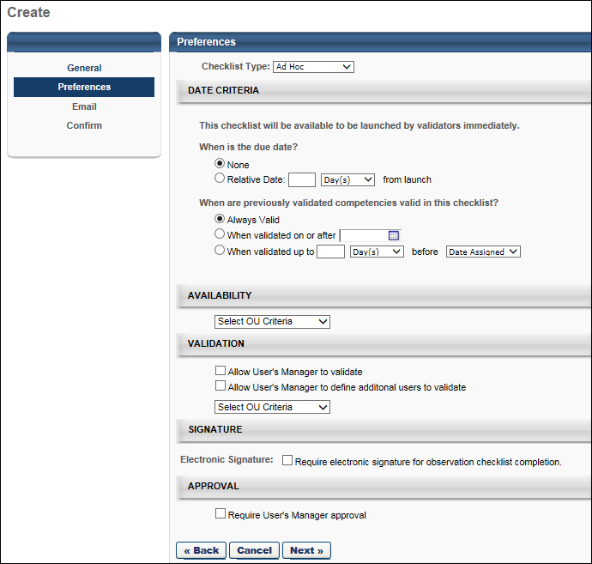
Specify the following for the checklist:
Checklist Type
Select whether the checklist is standard, recurring, or learning object.
- Standard - This indicates that the assigned users only complete the checklist once, therefore the checklist is only assigned once and is only due once. See Observation Checklist Preferences - Standard Checklist on page 80 for additional information.
- Ad Hoc - This type of observation checklists can be launched at any time by any user who has the appropriate permissions and is within the defined verifier availability for the observation checklist.
- Recurring - This indicates the assigned users will complete the checklist on a repeating basis, so additional options appear in the Date Criteria section in order to define the recurrence. See Observation Checklist Preferences - Recurring Checklist on page 93 for additional information.
- Learning Object - This enables the checklist to be added to a curriculum or certification. Note: For learning object checklist types, the competency model selected on the General step is locked. See Observation Checklist Preferences - Learning Object Checklist on page 100 for additional information.
- Editing: When editing, the checklist type cannot be changed.
When is the due date?
- None - Select this option to indicate that there is no due date for the checklist, which means the checklist will never have a Past Due status.
- Relative Date - Select this option to specify a relative due date. Specify the number of days, weeks, or months from when the checklist is launched. The number entered must be between 1-999.
- Editing: When editing, this can be modified if the checklist status is Not Started. Any changes only impact users that are assigned to the checklist after the changes are made. After a checklist is started, this cannot be edited.
When are previously validated competencies valid in this checklist?
This option determines the validity period for previously validated competencies. The validity period for a checklist is the amount of time a validated competency is considered valid towards the completion of the checklist. This enables administrators to ensure that certain competencies are being validated on a regular basis. Note: This option is not available if the Rating Option is set to "Require the competency target as the minimum rating" on the General page.
- Always Valid - When this option is selected, any competency in the checklist that has previously been validated for the assessee is automatically validated within this checklist. For example, if the Public Speaking competency was validated for John Smith four years ago and is assigned to John Smith again in an observation checklist that has this option selected, then the Public Speaking competency is automatically validated within this checklist because the competency is always valid for the checklist.
- When validated on or after XX - When this option is selected, the validity period is relative to a specific date. Any competency in the checklist that has been previously validated for the assessee on or after the selected date is automatically validated within this checklist. If the competency was validated before the selected date, then the competency must be re-validated. For example, if the Public Speaking competency was validated for John Smith on January 1, 2013 and is assigned to John Smith again in an observation checklist with this option selected and set to February 1, 2013, then this competency is not validated within this checklist because the competency was previously validated outside of the validity period.
- When validated XX days/months/years before XX or after - When this option is selected, the validity period is relative to a specific event, such as Date Assigned or Hire Date. Any competency in the checklist that has been previously validated for the assessee on or after the selected relative date is automatically validated within this checklist. If the competency was validated before the selected relative date, then the competency must be re-validated. For example, an ad hoc checklist is set to allow previously validated competencies "1 year before Date Assigned or after." In this example, the validity period is relative to when the checklist is assigned. If the checklist is assigned on January 1, 2015, then the validity period begins one year before that date (i.e., January 1, 2014). Only items that were validated on or after January 1, 2014 are automatically validated in the checklist.
  - The relative date options drop-down automatically contains Date Assigned and Hire Date. This drop-down also contains any user record custom fields that have a Date Field type.
  - If a relative date value does not exist (e.g., no hire date on record), then there is no validity period, and all competencies must be validated.
Editing: The option to set the validity period for previously validated competencies is not editable after the task is created.
Availability
Select the users who can be assessed using the checklist. Only users that match the availability criteria can be assigned the checklist.
- The availability selections that the administrator can select are limited based on the constraints the administrator has on the permission to manage observation checklists.
- Editing: When editing, the administrator cannot modify the availability for an existing checklist if the checklist status is In Progress or Complete.
Validation
Use the following options to select who can act as a verifier for a user's checklist. At least one of the options must be defined. Note: When modifying the validators for an observation checklist, the changes do not take effect until the following day because this is done in a nightly process.
- Allow User's Manager to validate - Select this option to allow the managers of the end users to act as verifiers for the checklist. The manager is then able to validate items within the competency and the competency itself within the checklist.
  - If this is the only selected option, only managers can act as verifiers to their employees.
  - Editing: When editing, the administrator may change this setting at any time and it impacts a manager's ability to act as a verifier for the associated checklist as soon as the setting is saved.
- Allow User's Manager to define additional users to validate - This option is independent of the previous option. Select this option to allow managers to add co-planners who can validate competencies when the manager cannot verify themselves.
  - When this option is selected, on the user's checklist page, in the Overview table in the Co-Planner tab, the manager can add co-planners.
  - Users designated as co-planners are delegated access to verify a user's competencies in the associated checklist.
  - If this is the only selected option, there are no verifiers for the checklist until the managers begin adding co-planners for their employee's checklists.
  - Editing: When editing, the administrator may change this setting at any time.
- Select Verifier Availability - This selection criteria allows you to define which users may act as verifiers for the checklist by OU. You must have the permission to add verifiers in order to view and manage this setting.
  - After making a selection, the Allow user(s) to define additional verifiers option is available for the selection. When this option is selected, the selected verifiers can add co-planners.
  - This selection can be made in addition to selecting the manager as a verifier and allowing the manager to designate co-planners.
  - If the availability OU tool is the only validation preference selected, only users matching the selected criteria are able to validate for the users assigned to the checklist. Therefore, it is possible that a manager could only view a read-only version of the checklist for their employee.
  - Create a group by selecting the plus sign next to Create New Group. See Create Group for additional information.
  - Editing: When editing, the administrator may change this setting at any time. Administrators may select additional OUs or users and they may also remove selected verifiers. If a verifier has validated some competencies for a user and is then removed as a verifier, the competency validations are not removed, but the removed verifier can no longer access the checklist. Note: To add or remove verifiers for an observation checklist using the Availability control, you must have the permission to add verifiers and the permission to manage observation checklists.
Signature
This section enables the administrator to determine whether an electronic signature is required to complete the observation checklist. If an electronic signature is required, then the administrator can configure how the electronic signature is captured.
The following options are available in this section:
- Electronic Signature - Select this option to require an electronic signature to complete a checklist. When this option is selected, the validator must provide an electronic signature after validating the final item in the checklist. The checklist cannot be saved or submitted for approval until the electronic signature is provided.
- Signature Type - Select the method by which the validator provides their electronic signature. The following options are available:
  - Enter Manually - When this option is selected, the validator types their name and selects a Sign button.
  - Pre-populated Read Only - When this option is selected, the validator's name is pre-populated from their Universal Profile Bio page and cannot be edited. The validator must select the Sign button. This prevents the validator from incorrectly entering their name.
- Signature Font - From the drop-down menu, select the font in which the validator's signature is displayed after the electronic signature is provided.
- User Authentication - When this option is selected, the validator must re-authenticate their account before they are able to electronically sign the observation checklist.
- Header - Enter the text that appears at the top of the section in which the validator is prompted to provide their electronic signature. This field is required and the character limit is 100. If multiple languages are enabled for your portal, select the Translate icon to translate the field into other available languages.
- Message - Enter the message that appears in the section in which the validator is prompted to provide their electronic signature. This message should instruct the validator on how to provide their signature. The field is optional and the character limit is 500. If multiple languages are enabled for your portal, select the Translate icon to translate the field into other available languages.
- Editing: For Ad Hoc, Recurring, and Learning Object checklists, all fields can be edited when the checklist is in Not Started or In Queue status. For Standard checklists, all fields can be edited when the checklist is in Queued status. When the checklist can be partially edited, the following fields can be edited: Electronic Signature, Signature Type, Signature Font, and User Authentication.
Approval
Select the Require User's Manager Approval option to require manager approval for the successful completion of an observation checklist. When manager approval is required, once a validator has completed a checklist task, the validator submits the checklist to the employee's manager for review. Then, the manager has the option to either approve or deny the checklist completion. If the checklist completion is approved, the checklist is in a status of Completed. If the checklist completion is denied, the checklist is in a status of Denied, which allows the validator to make changes and resubmit the checklist.
This option does not allow for multiple manager approval steps.
Next
After making your selections, click Next to proceed to the Email step. See Observation Checklist - Create/Edit Email on page 105 for additional information.
Observation Checklist Preferences - Recurring Checklist
The second step in creating an observation checklist is the Preferences step. On the Create - Preferences page, the administrator specifies the checklist type, date criteria, and validation settings.
Depending on the type of observation checklist you are creating, there are different options available on the Preferences page. This topic describes the Preferences page when Recurring is selected from the Checklist Type drop-down menu.
To access observation checklists, go to Admin > Tools > Performance Management > Observation Checklists
- To create a new checklist, select the Create New Checklist link.
- To edit an observation checklist, in the Options column, select the edit icon for the appropriate checklist.
When editing an observation checklist, some settings cannot be modified. Please review the descriptions for each field to determine whether it can be modified when editing an observation checklist.
Permissions
PERMISSION NAME | PERMISSION DESCRIPTION | CATEGORY

Observation Checklist Admin - Manage | Grants access to create and edit Observation Checklists, as well as view progress of users assigned to a given checklist and/or remove users from a checklist. This permission can be constrained by OU and User's OU. This is an administrator permission. | Performance - Administration
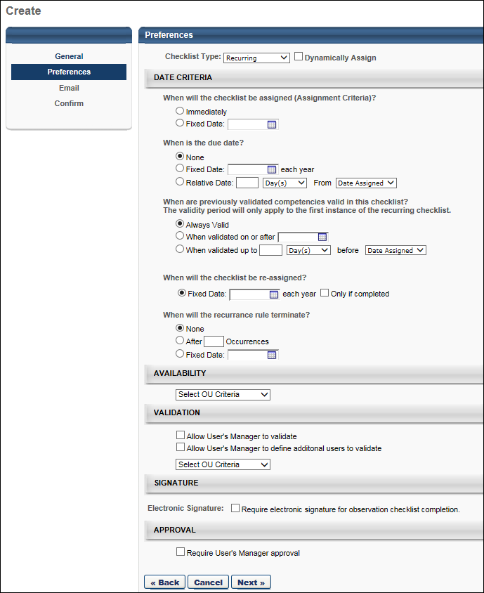
Specify the following for the checklist:
Checklist Type
Select whether the checklist is standard, recurring, or learning object.
- Standard - This indicates that the assigned users only complete the checklist once, therefore the checklist is only assigned once and is only due once. See Observation Checklist Preferences - Standard Checklist on page 80 for additional information.
- Ad Hoc - This type of observation checklists can be launched at any time by any user who has the appropriate permissions and is within the defined verifier availability for the observation checklist. See Observation Checklist Preferences - Ad Hoc Checklist on page 87 for additional information.
- Recurring - This indicates the assigned users will complete the checklist on a repeating basis, so additional options appear in the Date Criteria section in order to define the recurrence.
- Learning Object - This enables the checklist to be added to a curriculum or certification. Note: For learning object checklist types, the competency model selected on the General step is locked. See Observation Checklist Preferences - Learning Object Checklist on page 100 for additional information.
- Editing: When editing, the checklist type cannot be changed.
Dynamically Assign
Select this option to have the checklist assigned to users on a dynamic basis, meaning that each time the system processes, new users who meet the assignment criteria are assigned to the checklist. For example, if the checklist is dynamically assigned to an OU, any qualifying user that joins the OU after the initial assignment is assigned the checklist upon joining the OU.
- Editing: When editing, the Dynamically Assign option cannot be changed.
When will the checklist be assigned (Assignment Criteria)?
- Immediately - Select this option to assign the checklist to all users that match the availability criteria set in the General step as soon as the checklist is saved and processed.
- Fixed Date - Select this option to specify a date on which the checklist is assigned. This option allows admins to configure a checklist, but not assign it until a future date (e.g., configure the checklist on Friday and have the checklist assigned on Monday).
- Relative Date - This option is only available when the checklist is set to be Dynamically Assigned. Select this option to specify a relative assignment date. Specify the number of days, weeks, or months from some standard or custom date field (e.g., Assign 10 Days from Hire Date). The number entered must be between 1-999.
- Editing: When editing, this can be modified if the checklist status is Not Started. Any changes only impact users that are assigned to the checklist after the changes are made. Therefore, editing this selection is only impactful when the checklist is dynamically assigned. After a checklist is started, this cannot be edited.
When is the due date?
- None - Select this option to indicate that there is no due date for the checklist, which means the checklist will never have a Past Due status.
- Fixed Date - Select this option to specify a date on which the checklist is due.
- Relative Date - Select this option to specify a relative due date. Specify the number of days, weeks, or months from some standard or custom date field (e.g., Due 10 Days from Date Assigned). The number entered must be between 1-999.
- Editing: When editing, this can be modified if the checklist status is Not Started. Any changes only impact users that are assigned to the checklist after the changes are made. Therefore, editing this selection is only impactful when the checklist is dynamically assigned. After a checklist is started, this cannot be edited.
When will the checklist be re-assigned?
This option is only available when Recurring is selected from the Checklist Type drop-down.
- Fixed Date - Select this option to specify a date on which each year the checklist is reassigned. This reassignment rule repeats depending on the number of occurrences defined.
- Relative Date - This option is only available when the checklist is set to be Dynamically Assigned. Select this option to specify a relative reassignment date. Specify the number of days, weeks, or months from some standard or custom date field (e.g., Reassign 3 Months from Date Assigned). The number entered must be between 1-999. This reassignment rule repeats depending on the number of occurrences defined.
- Only if completed - Select the option to only reassign the checklist if the initial assignment is complete. When this option is selected, the checklist is not reassigned to users unless their checklist status for the previous instance of the assignment is Completed.
- Editing: When editing, this can be modified if the checklist status is Not Started. Any changes only impact users that are assigned to the checklist after the changes are made. Therefore, editing this selection is only impactful when the checklist is dynamically assigned. After a checklist is started, this cannot be edited.
When will the recurrence rule terminate?
This option is only available when Recurring is selected from the Checklist Type drop-down.
- None - Select this option for the checklist to be reassigned to the users meeting the criteria until the checklist is made inactive on the Checklist Administration page.
- After XX Occurrences - Select this option to specify the number of times the user should be assigned the checklist. This number includes the first assignment. The number entered must be between 1-99.
- Fixed Date - Select this option to specify a date on which the checklist is no longer reassigned.
- Editing: When editing, this can be modified if the checklist status is Not Started. Any changes only impact users that are assigned to the checklist after the changes are made. Therefore, editing this selection is only impactful when the checklist is dynamically assigned. After a checklist is started, this cannot be edited.
Availability
Select the users who will be assessed using the checklist. Only users that match the availability criteria are assigned the checklist.
- The availability selections that the administrator can select are limited based on the constraints the administrator has on the permission to manage observation checklists.
- Editing: When editing, the administrator cannot modify the availability for an existing checklist if the checklist status is In Progress or Complete.
  - If the administrator adds criteria while the checklist is in a Not Started status, the new users are only added if Dynamic Assignment is also active. Note: Checking the Dynamically Assign checkbox on the Preferences page activates Dynamic Assignment.
  - If the administrator removes criteria, users that were assigned as a result of those criteria are only removed if Dynamic Removal is active and the checklist is in a Not Started status for the user.
Validation
Use the following options to select who can act as a verifier for a user's checklist. At least one of the options must be defined. Note: When modifying the validators for an observation checklist, the changes do not take effect until the following day because this is done in a nightly process.
- Allow User's Manager to validate
  - Select this option to assign the managers of the end users as verifiers for the checklist. The manager is then able to validate items within the competency and the competency itself within the checklist. When the manager views this checklist, they can check off competencies.
  - If this is the only selected option, only managers can act as verifiers to their employees.
  - Editing: When editing, the administrator may change this setting at any time and it impacts a manager's ability to act as a verifier for the associated checklist as soon as the setting is saved.
- Allow User's Manager to define additional users to validate - This option is independent of the previous option.
  - Select this option to allow managers to add co-planners who can validate competencies when the manager cannot verify themselves.
  - When this option is selected, on the user's checklist page, in the Overview table in the Co-Planner tab, the manager can add co-planners.
  - Users designated as co-planners are delegated access to verify a user's competencies in the associated checklist.
  - If this is the only selected option, there are no verifiers for the checklist until the managers begin adding co-planners for their employee's checklists.
  - Editing: When editing, the administrator may change this setting at any time.
- Select Verifier Availability - This selection criteria allows you to define verifiers for the checklist by OU. You must have the permission to add verifiers in order to view and manage this setting.
  - After making a selection, the Allow user(s) to define additional verifiers option is available for the selection. When this option is selected, the selected verifiers can add co-planners.
  - This selection can be made in addition to selecting the manager as a verifier and allowing the manager to designate co-planners.
  - If the availability OU tool is the only validation preference selected, only users matching the selected criteria are able to validate for the users assigned to the checklist. Therefore, it is possible that a manager could only view a read-only version of the checklist for their employee.
  - Create a group by selecting the plus sign next to Create New Group. For more information on creating groups, see the Create Group section of the Organizational Units topic.
  - Editing: When editing, the administrator may change this setting at any time. Administrators may select additional OUs or users and they may also remove selected verifiers. If a verifier has checked off some competencies for a user and is then removed as a verifier, the competency validations are not removed, but the removed verifier can no longer access the checklist. Note: To add or remove verifiers for an observation checklist using the Availability control, you must have the permission to add verifiers and the permission to manage observation checklists.
Signature
This section enables the administrator to determine whether an electronic signature is required to complete the observation checklist. If an electronic signature is required, then the administrator can configure how the electronic signature is captured.
The following options are available in this section:
- Electronic Signature - Select this option to require an electronic signature to complete a checklist. When this option is selected, the validator must provide an electronic signature after validating the final item in the checklist. The checklist cannot be saved or submitted for approval until the electronic signature is provided.
- Signature Type - Select the method by which the validator provides their electronic signature. The following options are available:
  - Enter Manually - When this option is selected, the validator types their name and selects a Sign button.
  - Pre-populated Read Only - When this option is selected, the validator's name is pre-populated from their Universal Profile Bio page and cannot be edited. The validator must select the Sign button. This prevents the validator from incorrectly entering their name.
- Signature Font - From the drop-down menu, select the font in which the validator's signature is displayed after the electronic signature is provided.
- User Authentication - When this option is selected, the validator must re-authenticate their account before they are able to electronically sign the observation checklist.
- Header - Enter the text that appears at the top of the section in which the validator is prompted to provide their electronic signature. This field is required and the character limit is 100. If multiple languages are enabled for your portal, select the Translate icon to translate the field into other available languages.
- Message - Enter the message that appears in the section in which the validator is prompted to provide their electronic signature. This message should instruct the validator on how to provide their signature. The field is optional and the character limit is 500. If multiple languages are enabled for your portal, select the Translate icon to translate the field into other available languages.
- Editing: For Ad Hoc, Recurring, and Learning Object checklists, all fields can be edited when the checklist is in Not Started or In Queue status. For Standard checklists, all fields can be edited when the checklist is in Queued status. When the checklist can be partially edited, the following fields can be edited: Electronic Signature, Signature Type, Signature Font, and User Authentication.
Approval
Select the Require User's Manager Approval option to require manager approval for the successful completion of an observation checklist. When manager approval is required, once a validator has completed a checklist task, the validator submits the checklist to the employee's manager for review. Then, the manager has the option to either approve or deny the checklist completion. If the checklist completion is approved, the checklist is in a status of Completed. If the checklist completion is denied, the checklist is in a status of Denied, which allows the validator to make changes and resubmit the checklist.
This option does not allow for multiple manager approval steps.
Next
After making your selections, click Next to proceed to the Email step. See Observation Checklist - Create/Edit Email on page 105 for additional information.
Observation Checklist Preferences - Learning Object Checklist
The second step in creating an observation checklist is the Preferences step. On the Create - Preferences page, the administrator specifies the checklist type, date criteria, and validation settings.
Depending on the type of observation checklist you are creating, there are different options available on the Preferences page. This topic describes the Preferences page when Learning Object is selected from the Checklist Type drop-down menu.
To access observation checklists, go to Admin > Tools > Performance Management > Observation Checklists
- To create a new checklist, select the Create New Checklist link.
- To edit an observation checklist, in the Options column, select the edit icon for the appropriate checklist.
When editing an observation checklist, some settings cannot be modified. Please review the descriptions for each field to determine whether it can be modified when editing an observation checklist.
Permissions
PERMISSION NAME | PERMISSION DESCRIPTION | CATEGORY

Observation Checklist Admin - Manage | Grants access to create and edit Observation Checklists, as well as view progress of users assigned to a given checklist and/or remove users from a checklist. This permission can be constrained by OU and User's OU. This is an administrator permission. | Performance - Administration
Specify the following for the checklist:
Checklist Type
Select whether the checklist is standard, recurring, or learning object.
- Standard - This indicates that the assigned users only complete the checklist once, therefore the checklist is only assigned once and is only due once. See Observation Checklist Preferences - Standard Checklist on page 80 for additional information.
- Ad Hoc - This type of observation checklists can be launched at any time by any user who has the appropriate permissions and is within the defined verifier availability for the observation checklist. See Observation Checklist Preferences - Ad Hoc Checklist on page 87 for additional information.
- Recurring - This indicates the assigned users will complete the checklist on a repeating basis, so additional options appear in the Date Criteria section in order to define the recurrence. See Observation Checklist Preferences - Recurring Checklist on page 93 for additional information.
- Learning Object - This enables the checklist to be added to a curriculum or certification. Note: For learning object checklist types, the competency model selected on the General step is locked.
- Editing: When editing, the checklist type cannot be changed.
Mark checklist within a certification or curriculum Completed even if the user checklist is Completed with a Failed score.
This option controls whether or not a Completed status will be recorded in a curriculum or certification for an LO (Learning Object) based Observation Checklist.
- If this option is checked, even if a checklist is failed, the curriculum/certification is completion/credit and the checklist status shows Completed in the transcript and on the observation checklist pages.
- If this option is not checked and the checklist is failed and is required in a curriculum/certification, the curriculum is never complete/certification will never get credited as long as the checklist is failed. The checklist shows as In Progress when viewing in the curriculum/certification through the transcript but shows Completed Failed on any observation checklist pages.
- If the checklist is failed:
  - If the checklist needs to be re-validated, the administrator can reset the checklist so that the checklist can be validated again by the validator. If the checklist is then validated and is no longer failed, the curriculum/certification is updated with a completed checklist.
  - For a curriculum, an administrator could also re-assign the curriculum with Assign New Occurrence so that the user gets a reset checklist (this would also reset other LOs if they were present) and validate the checklist
  - If the checklist is not being re-validated then leave it as is and the curriculum will never be completed/certification will never get credit as it has a failed checklist. Some situations require that the curriculum/certification checklist remain completed and this will show up in reporting so that remediation can occur.
To reset a checklist, go to Admin - Tools - Performance - Observation Checklists. Click the View Details icon under options, click the competency, and delete at least one item.
When are previously validated competencies valid in this checklist?
This option determines the validity period for previously validated competencies. The validity period for a checklist is the amount of time a validated competency is considered valid towards the completion of the checklist. This enables administrators to ensure that certain competencies are being validated on a regular basis. Note: This option is not available if the Rating Option is set to "Require the competency target as the minimum rating" on the General page.
- Always Valid - When this option is selected, any competency in the checklist that has previously been validated for the assessee is automatically validated within this checklist. For example, if the Public Speaking competency was validated for John Smith four years ago and is assigned to John Smith again in an observation checklist that has this option selected, then the Public Speaking competency is automatically validated within this checklist because the competency is always valid for the checklist.
- When validated on or after XX - When this option is selected, the validity period is relative to a specific date. Any competency in the checklist that has been previously validated for the assessee on or after the selected date is automatically validated within this checklist. If the competency was validated before the selected date, then the competency must be re-validated. For example, if the Public Speaking competency was validated for John Smith on January 1, 2013 and is assigned to John Smith again in an observation checklist with this option selected and set to February 1, 2013, then this competency is not validated within this checklist because the competency was previously validated outside of the validity period.
- When validated XX days/months/years before XX or after - When this option is selected, the validity period is relative to a specific event, such as Date Assigned or Hire Date. Any competency in the checklist that has been previously validated for the assessee on or after the selected relative date is automatically validated within this checklist. If the competency was validated before the selected relative date, then the competency must be re-validated. For example, an ad hoc checklist is set to allow previously validated competencies "1 year before Date Assigned or after." In this example, the validity period is relative to when the checklist is assigned. If the checklist is assigned on January 1, 2015, then the validity period begins one year before that date (i.e., January 1, 2014). Only items that were validated on or after January 1, 2014 are automatically validated in the checklist.
  - The relative date options drop-down automatically contains Date Assigned and Hire Date. This drop-down also contains any user record custom fields that have a Date Field type.
  - If a relative date value does not exist (e.g., no hire date on record), then there is no validity period, and all competencies must be validated.
Editing: The option to set the validity period for previously validated competencies is not editable after the task is created.
Validation
Use the following options to select who can act as a verifier for a user's checklist. At least one of the options must be defined. Note: When modifying the validators for an observation checklist, the changes do not take effect until the following day because this is done in a nightly process.
- Allow User's Manager to validate - Select this option to assign the managers of the end users as verifiers for the checklist. The manager is then able to validate items within the competency and the competency itself within the checklist. When the manager views this checklist, they can check off competencies.
  - If this is the only selected option, only managers can act as verifiers to their employees.
  - Editing: When editing, the administrator may change this setting at any time and it impacts a manager's ability to act as a verifier for the associated checklist as soon as the setting is saved.
- Allow User's Manager to define additional users to validate - This option is independent of the previous option. Select this option to allow managers to add co-planners who can validate competencies when the manager cannot verify themselves.
  - When this option is selected, on the user's checklist page, in the Overview table in the Co-Planner tab, the manager can add co-planners.
  - Users designated as co-planners are delegated access to verify a user's competencies in the associated checklist.
  - If this is the only selected option, there are no verifiers for the checklist until the managers begin adding co-planners for their employee's checklists.
  - Editing: When editing, the administrator may change this setting at any time.
- Select Verifier Availability - This selection criteria allows you to define verifiers for the checklist by OU. You must have the permission to add verifiers in order to view and manage this setting.
  - After making a selection, the Allow user(s) to define additional verifiers option is available for the selection. When this option is selected, the selected verifiers can add co-planners.
  - This selection can be made in addition to selecting the manager as a verifier and allowing the manager to designate co-planners.
  - If the availability OU tool is the only validation preference selected, only users matching the selected criteria are able to validate for the users assigned to the checklist. Therefore, it is possible that a manager could only view a read-only version of the checklist for their employee.
  - Create a group by selecting the plus sign next to Create New Group. See Group - Create/Edit.
  - Editing: When editing, the administrator may change this setting at any time. Administrators may select additional OUs or users and they may also remove selected verifiers. If a verifier has checked off some competencies for a user and is then removed as a verifier, the competency validations are not removed, but the removed verifier can no longer access the checklist. Note: To add or remove verifiers for an observation checklist using the Availability control, you must have the permission to add verifiers and the permission to manage observation checklists.
Signature
This section enables the administrator to determine whether an electronic signature is required to complete the observation checklist. If an electronic signature is required, then the administrator can configure how the electronic signature is captured.
The following options are available in this section:
- Electronic Signature - Select this option to require an electronic signature to complete a checklist. When this option is selected, the validator must provide an electronic signature after validating the final item in the checklist. The checklist cannot be saved or submitted for approval until the electronic signature is provided.
- Signature Type - Select the method by which the validator provides their electronic signature. The following options are available:
  - Enter Manually - When this option is selected, the validator types their name and selects a Sign button.
  - Pre-populated Read Only - When this option is selected, the validator's name is pre-populated from their Universal Profile Bio page and cannot be edited. The validator must select the Sign button. This prevents the validator from incorrectly entering their name.
- Signature Font - From the drop-down menu, select the font in which the validator's signature is displayed after the electronic signature is provided.
- User Authentication - When this option is selected, the validator must re-authenticate their account before they are able to electronically sign the observation checklist.
- Header - Enter the text that appears at the top of the section in which the validator is prompted to provide their electronic signature. This field is required and the character limit is 100. If multiple languages are enabled for your portal, select the Translate icon to translate the field into other available languages.
- Message - Enter the message that appears in the section in which the validator is prompted to provide their electronic signature. This message should instruct the validator on how to provide their signature. The field is optional and the character limit is 500. If multiple languages are enabled for your portal, select the Translate icon to translate the field into other available languages.
- Editing: For Ad Hoc, Recurring, and Learning Object checklists, all fields can be edited when the checklist is in Not Started or In Queue status. For Standard checklists, all fields can be edited when the checklist is in Queued status. When the checklist can be partially edited, the following fields can be edited: Electronic Signature, Signature Type, Signature Font, and User Authentication.
Approval
Select the Require User's Manager Approval option to require manager approval for the successful completion of an observation checklist. When manager approval is required, once a validator has completed a checklist task, the validator submits the checklist to the employee's manager for review. Then, the manager has the option to either approve or deny the checklist completion. If the checklist completion is approved, the checklist is in a status of Completed. If the checklist completion is denied, the checklist is in a status of Denied, which allows the validator to make changes and resubmit the checklist.
This option does not allow for multiple manager approval steps.
Next
After making your selections, click Next to proceed to the Email step. See Observation Checklist - Create/Edit Email on page 105 for additional information.
Observation Checklist - Create/Edit Email
Use the Email page to define email preferences for the observation checklist.
To access observation checklists, go to Admin > Tools > Performance Management > Observation Checklists
- To create a new checklist, select the Create New Checklist link.
- To edit an observation checklist, in the Options column, select the edit icon for the appropriate checklist.
When editing an observation checklist, some settings cannot be modified. Please review the descriptions for each field to determine whether it can be modified when editing an observation checklist.
Permissions
PERMISSION NAME | PERMISSION DESCRIPTION | CATEGORY

Global Email Administration - Manage | Grants ability to manage email trigger templates across all active modules in the portal. Enables creating, editing and deleting email message templates for various system actions and workflows. This permission can be constrained by OU, User's OU, User Self and Subordinates, and User. This is an administrator permission. | Core Administration

Global Email Administration - View | Grants view only access to email templates/triggers and email logs at the global level for the portal. This permission can be constrained by OU, User's OU, User Self and Subordinates, and User. This is an administrator permission. | Core Administration

Observation Checklist Admin - Manage | Grants access to create and edit Observation Checklists, as well as view progress of users assigned to a given checklist and/or remove users from a checklist. This permission can be constrained by OU and User's OU. This is an administrator permission. | Performance - Administration
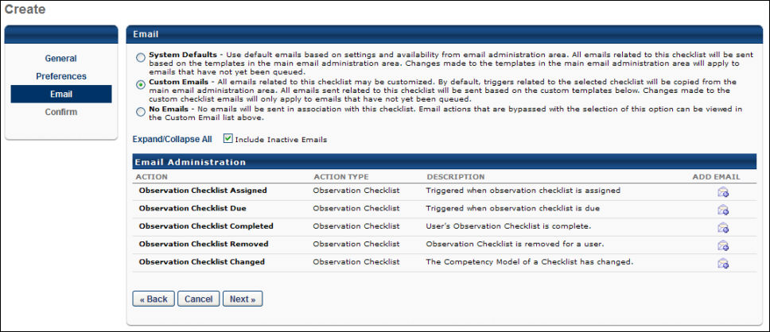
Administrators must have permission to view or manage Global Email Administration in order to select an email option.
You have the following options for emails:
- System Defaults - This selection uses the default emails based on settings and availability from the Email Administration page.
- Custom Emails - This selection allows you to customize the emails. You can change the email text and settings and add and remove emails. The list of customizable emails is listed below in the Email Administration section.
- No Emails - No emails are sent.
The available email triggers are:
EMAIL NAME | EMAIL DESCRIPTION | ACTION TYPE

Observation Checklist Assigned | This email is triggered when an observation checklist task is assigned. | Observation Checklist

Observation Checklist Due | This email is triggered as a reminder when an observation checklist's due date is approaching. | Observation Checklist

Observation Checklist Completed | This email is triggered when an observation checklist is completed. | Observation Checklist

Observation Checklist Removed | This email is triggered when an observation checklist is removed for a user. | Observation Checklist

Observation Checklist Changed | This email is triggered when the competency model of an observation checklist has changed. | Observation Checklist
When editing a checklist, the administrator can edit the email options, but emails that are already triggered or are in queue are not updated. Only newly assigned users or triggers firing after the change recognize the edits made to the email preference.
Note: The above email settings do NOT apply to Observation Checklists in Learning. Observation Checklists (within a curriculum) will send emails based on their default email settings configured in Email Administration.
Back/Cancel/Next
- Click BACK to return to the previous page.
- Click Cancel to close this page.
- Click Next to proceed to the next tab. See Observation Checklist - Create/Edit Confirm on page 108 for additional information.
Troubleshooting Email
The following pages contain troubleshooting guides for using emails:
- See Troubleshooting Guide - Emails.
- See Email Troubleshooting Guide.
Observation Checklist - Create/Edit Confirm
Use the Create - Confirm page to confirms the checklist settings before it is created.
The selected settings are displayed, so the administrator can check them before the checklist is created.
To access observation checklists, go to Admin > Tools > Performance Management > Observation Checklists
- To create a new checklist, select the Create New Checklist link.
- To edit an observation checklist, in the Options column, select the edit icon for the appropriate checklist.
When editing an observation checklist, some settings cannot be modified. Please review the descriptions for each field to determine whether it can be modified when editing an observation checklist.
Permissions
PERMISSION NAME | PERMISSION DESCRIPTION | CATEGORY

Observation Checklist Admin - Manage | Grants access to create and edit Observation Checklists, as well as view progress of users assigned to a given checklist and/or remove users from a checklist. This permission can be constrained by OU and User's OU. This is an administrator permission. | Performance - Administration
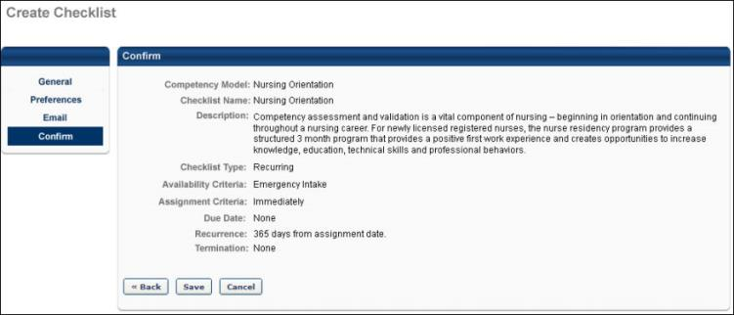
Back/Save/Cancel
- Click BACK to return to the previous page.
- Click save to save this checklist. You are returned to the Checklist Administration page.
- Click cancel to close this page.

Observation Checklist - Copy
Administrators can copy any checklist available to them from the Checklist Administration page.
Copying a checklist creates a new checklist with most options pre-selected based on the original checklist's settings. The same business rules are applied as when creating a checklist.
When you choose to copy an observation checklist, you are taken to the General step, which is the first step in the Create Observation Checklist process. To save a copy of a checklist, the Date Criteria must be valid. If the Date Criteria is valid, you can save the copy without editing any details. Otherwise, you can change the settings in each section before saving.
To copy an observation checklist, go to Admin > Tools > Performance Management > Observation Checklists. Then, click the Copy icon in the Options column next to the checklist.
Permissions
PERMISSION NAME | PERMISSION DESCRIPTION | CATEGORY

Observation Checklist Admin - Manage | Grants access to create and edit Observation Checklists, as well as view progress of users assigned to a given checklist and/or remove users from a checklist. This permission can be constrained by OU and User's OU. This is an administrator permission. | Performance - Administration
The information that is copied is detailed below, separated by section:
General (Step 1)
All General settings are copied. The following are some additional notes:
- Checklist Name: If Define Name is selected in the original checklist, then the name is also copied.
- Description: If Define Description is selected in the original checklist, then the description is also copied.
- Attachment Preferences: The attachment preferences and any attachments added by the administrator are copied.
- Rating Scale Preferences: The rating scale preferences are copied.
Preferences (Step 2)
When copying, the dates may need to be revised, as past dates cannot be used with Fixed dates or Recurring checklist types.
- Checklist Type: Copied
- Assignment Criteria: Copied. If this is set to a fixed date, the selected date cannot be in the past.
- Due Date: Copied. If this is set to a fixed date, the selected date cannot be in the past.
- Recurring Options: If the Checklist Type is Recurring, the recurrence settings are copied. If the Termination date is set to a fixed date, the selected date cannot be in the past.
- If the type is changed from Recurring to Standard, then the recurring date options are hidden. If the type is then changed back to Recurring the recurring date options are set to the system default selections.
- Validation: All Validation settings are copied.
  - If an administrator copies a checklist and does not have the permission to add verifiers, then the previous availabilities are copied, but the administrator cannot expand on the criteria; they can only remove or edit the preference.
  - If the administrator has the permission to add verifiers, but has limited constraints compared to the original checklist creator, the administrator sees the selected settings, but if they remove the setting and add to the availability, the administrator's constraints apply.
  - If an administrator copies a checklist created by another administrator who did not have the permission to add verifiers, then the Validation settings are copied and the new administrator who does have permission to add verifiers can add additional verifiers.
Email (Step 3)
The email selection is copied. Custom emails are also copied if applicable.
Confirm (Step 4)
This information is read-only.

Observation Checklist - View Details
The View Details page displays the overall progress of a checklist as well as all users assigned to the checklist and information specific to the user's progress for each instance of that checklist. Administrators can use this page to manage the checklist and its participants. This page can be exported to Excel or HTML.
To view the details of an observation checklist, go to Admin > Tools > Performance Management > Observation Checklists. Then, click the View Details icon in the Options column next to the checklist.
Permissions
PERMISSION NAME | PERMISSION DESCRIPTION | CATEGORY

Observation Checklist Admin - Manage | Grants access to create and edit Observation Checklists, as well as view progress of users assigned to a given checklist and/or remove users from a checklist. This permission can be constrained by OU and User's OU. This is an administrator permission. | Performance - Administration

Observation Checklist Admin - View | Grants access to view observation checklists. This permission also enables user to see progress of all users assigned to a given checklist. This is an administrator permission. | Performance - Administration
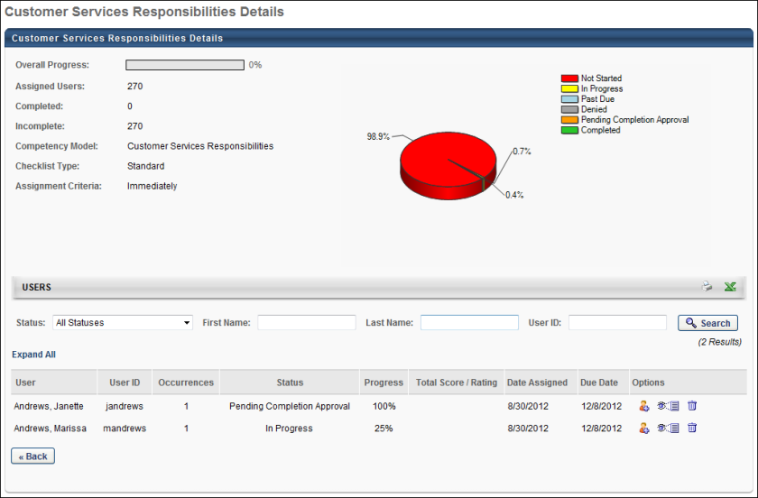
Overall Summary
The Overall Summary displays the following information for the checklist in the upper-left corner of the report:
Field Name | Description
Overall Progress | The progress of the overall checklist. The Percent and bar represents the completion progress of all users assigned to the most recent instance of the checklist.
Assigned Users | The total number of users assigned to the checklist. This number changes as users are added and removed from the checklist.
Complete | The number of users in Complete status.
Incomplete | The number of users that are Not Started, In Progress, and Past Due.
Competency Model | The competency model used for the checklist. This may be the same as the checklist name or could be different depending on the checklist preference.
Checklist Type | Either Standard or Recurring
Assignment Criteria | The date upon which the checklist is assigned: Immediately, Fixed Date, Relative Date.
Recurrence | The recurrence preference for the checklist. This only appears for recurring checklists.
The pie chart graphically represents the statuses of all users assigned to the checklist.
Users Table
In the upper-right corner of the Users section, you can export the checklist details to HTML or Excel.
Using the search filters, you can filter the users displayed in the table by Status, First Name, Last Name, or User ID.
For each user in the table, the following information displays:
Field Name | Description
User | The user's name. A plus icon next to the name indicates the user has multiple instances of the checklist. Click the icon to expand the user's history to view information related to the previous instance. The user's Name and ID always reference the information currently on the user's record.
User ID | The user's system identification.
Occurrences | The number of times a user has been assigned the checklist.
Status | The user's checklist status. The following are the possible statuses:  - Not Started - None of the competencies or skills in the checklist have been validated from this checklist or any checklist that may have the competency in common.  - In Progress - Either this checklist has a competency or skill validated, or another checklist that contains the competency or skill also exists and has been validated on that other checklist.  - Completed - All competencies and skills are verified within the checklist.  - Past Due - The due date has past and the checklist is not complete.
Progress | The percentage of skills verified for the total number of competencies in the checklist.
Total Score/Rating | The user's overall score on the checklist. This column appears if a rating scale was configured to display in the checklist. The score is only displayed if a rating is entered for each item within the competency in the checklist for the user. The rating value appears as it is configured to in the checklist (text, numeric, both).  - The rating score is calculated as an average of each competency average. No weighting is applied. The numeric score is rounded to one decimal place.  - If an item is checked, but is unrated (e.g., rated as N/A), it does not factor into the score but does not prevent the competency from having an overall score, unless all items have an N/A rating.
Date Assigned | The unique assignment date for the user. This can be different for each user that is assigned to the checklist.
Due Date | The unique due date for the user. This can be different for each user that is assigned to the checklist.
Options
The options in the User table are only available for users with the permission to manage observation checklists.
The following options are available:
- View Checklist - Click the View Details icon to view the checklist for that user. You are taken to the Details page of the user's checklist. See Observation Checklists - Competency Details by Checklist on page 136 for additional information.
  - This is the only point an administrator can access a user's checklist without also being defined as a verifier.
  - This option is also available for inactive checklists.
  - The administrator can still validate for a user or remove validations when the checklist is inactive.
  - For recurring checklists, administrators can only view the most recent instance.
  - The administrator does not view the Checklist Summary and therefore cannot view other checklists assigned to the user.
  - The administrator can click the link to view the Checklist Report, but the report output is restricted to only display results for the selected checklist.
  - An administrator who has the permission to manage observation checklists can validate skills and competencies.
  - From the checklist view, the administrator can click the competency name to go to the Competency Details by Checklist page. There, you can validate and overwrite an existing validation record, with the appropriate permission. You can also enter comments by clicking Comments.
  - The administrator can always remove a validation.
- Add Verifier - Click the Add Co-Planner icon to add a co-planner to the checklist, who can verify a checklist without having access to the user's checklist.
  - Added co-planners appear in the Co-Planners tab in the Overview table on the user's checklist.
  - The available co-planners is restricted by the OU constraints on the permission to manage observation checklists.
- Remove User - Click the trash can icon to remove a user from the checklist assignment.
  - The administrator can only remove a current instance of a checklist assignment for a user.
  - The administrator cannot remove a user who has a status of Complete.
  - If the checklist status for the user is Not Started, the entire checklist and its competencies are removed from the user's Checklist page and the verifier's view of the checklist page. The current instance of the user is removed and the previous one becomes the current. If there are no previous instances, the user is removed from the details page for this checklist. If the checklist is dynamic the user will not be reassigned.
  - If the checklist was In Progress and the individual competencies and its skills that are validated do not exist in any other active checklist assigned to that user, then those competencies only appear in the All Competencies page and its Competency Details page. The competency no longer is associated with a checklist.
  - If the checklist was In Progress, one or more individual competencies or skills are validated, and those competencies exist in another active checklist assigned to that user, then they are accessible via the remaining active checklist, and can also be found in the All Competencies view.
  - For Learning Object-based observation checklist assignments, the Remove User option is available when the following criteria is met:
    - The LO checklist is not in a completed status.
    - The LO checklist was assigned to the user through a curriculum or certification that no longer has the checklist as part of the structure.
    - The LO checklist was assigned to the user through a curriculum or certification that was removed from the user and no longer has the checklist as part of the structure.
    - The user does not have the same checklist as part of multiple curricula or certifications.
Deactivated Users
When a user is deactivated after being assigned a checklist task, the View Details page is affected in the following ways:
- If the user's status is Not Started, the inactivated user is removed from the View Details page and the total assigned user count is reduced by one.
- If the user's status is In Progress, the inactivated user is removed from the View Details page and the total assigned user count does not change.
- If the user's status is Complete, the inactivated user remains visible on the View Details page and the total assigned user count does not change.
- If the task itself is complete, the inactivated user is not removed from the View Details page because the system is no longer processing the task.
Deactivated Users and Recurring Checklists
If a user is active for two instances of a checklist and begins the third instance, if the user is inactivated while In Progress or Not Started on the third instance:
- The user is visible on the View Details page because the administrator can see the past completed instances for one and two.
- The user displays with the occurrence number of 2 because the third instance did not apply as the user was inactivated.
- If the user is reactivated, their information for the third instance is restored if they were in a status of In Progress for the third instance.
- If the user is reactivated and the user had a status of Not Started for the third instance, the third instance is not restored. Further, the View Details page only displays the first and second instance.

Validation Method - Define Default
The Default Method scales allow the administrator to set up a standard method scale that would be used for most checklists.
To define a default validation method, click the Define Default Validation Method link from the Observation Checklist Administration page.
Permissions
PERMISSION NAME | PERMISSION DESCRIPTION | CATEGORY

Observation Checklist Admin - Manage | Grants access to create and edit Observation Checklists, as well as view progress of users assigned to a given checklist and/or remove users from a checklist. This permission can be constrained by OU and User's OU. This is an administrator permission. | Performance - Administration
If you do not have the permission to manage observation checklists, the Define Default Validation Method link is not available.
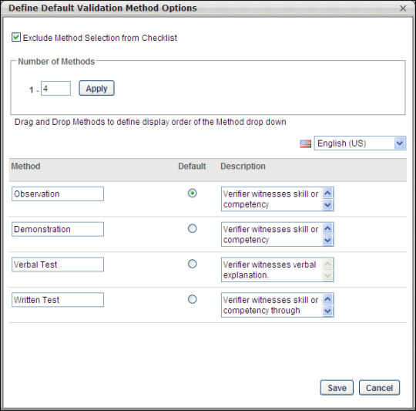
Exclude Method Selection from Checklist
Selecting the Exclude Method Selection from Checklist option prevents users from being able to choose a method when creating an observation checklist. If this option is selected users do not see a method of validation column on the associated checklist or the details of a competency. Verifiers do not see or have the ability to select a method of verification on the Competency Details page. When reporting on this checklist, a method value will not appear in reporting associated with competencies in this checklist.
Number of Methods
In the Number of Methods field, enter the number of different verification methods that should be defined. This indicates the number of methods that should be available to the verifier. Click Apply to make the methods available for creation. The maximum number of methods is 15.
Character Limit
The character limit for a method name is 25 characters and the character limit for a method description is 100 characters.
Ordering the Methods
Drag and drop the methods to determine the order in which they display.
Localization
All methods must be defined before the administrator can translate those methods using the language drop-down. If the administrator does not translate the methods, a task that is created in another language displays the methods defined for the default language.

Observation Checklists Complete - Overview
Manage Observation Checklists - Verifier or Manager
Use the Manage Observation Checklists to access checklists for employees and verifiers to access checklists for which they are assigned as verifiers. You can view personal checklists, launch checklists, view a user's checklist page, and export an observation checklist to Excel.
Managers can view each of their direct reports and select a specific employee and view their checklist page. Verifiers can view a list of users for which they can validate a checklist. A verifier who is also a manager cans see their direct reports in the list. If a verifier or manager also is assigned a checklist as an end user, a link to their own checklist access page is displayed at the top of the page.
Checklists that are completed or inactive do not display on this page. If a verifier completes all checklists or they are made inactive, those users do not appear on this page.
Note: Observation checklists that are inside a curriculum or certification can also be accessed from the Manage Observation Checklists page and appear in the Checklists column for managers and verifiers. For managers, the checklist must be configured by the administrator to allow managers to validate the checklist.
To access the Manage Observation Checklist page, go to Performance > Observation Checklists.
Permissions
PERMISSION NAME | PERMISSION DESCRIPTION | CATEGORY

Launch Ad Hoc Observation Checklist | Enables a user to launch an ad hoc observation checklist. Having this permission does not guarantee that the user can launch an ad hoc observation checklist, only that they will have access to the Launch Observation Checklist page. There must be at least one ad hoc checklist for which the user is defined as a verifier. This permission cannot be constrained. This is an end user permission. | Performance

Observation Checklists - Edit Validation Details | Grants access to edit a validation record for a competency or item for a user's checklist. This is an administrator permission. | Performance - Administration

Observation Checklist - Verifier | Enables user to serve as the verifier for the observation checklist of another user. This permission should be included in the dynamic security role "Checklist Verifier." The role, when active, is dynamically assigned to any user who is designated as a verifier for one or more checklists. This permission can be constrained by OU and User's OU. This is an end user permission. | Performance
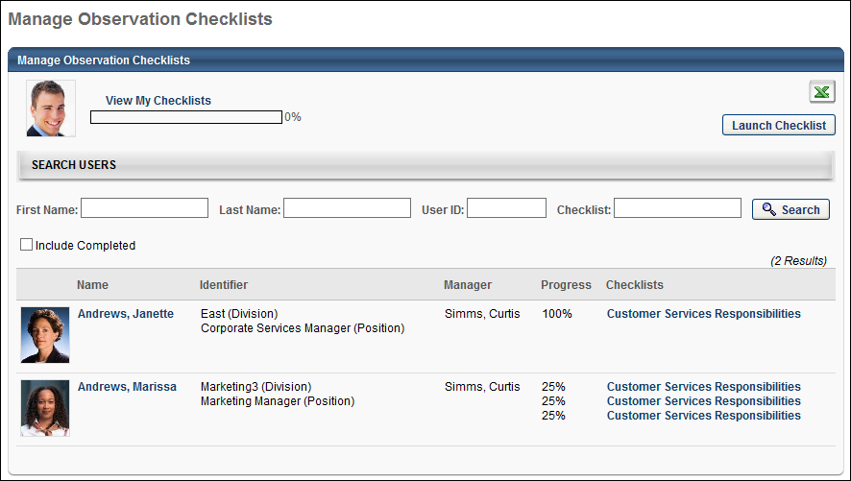
Export
Click the Excel icon to download the information in the user's table to Excel.
View My Checklists
Click the View My Checklists link to access personal checklistsif a manager or verifier is assigned to a checklist. If there are no personal checklists, this link does not appear.
Launch Checklist
Click the Launch Checklist button to launch ad hoc observation checklists and is defined as a verifier for at least one ad hoc observation checklist.
This button opens the Launch Observation Checklist page, where the user can select the appropriate checklist and assessee. See Observation Checklist - Launch on page 122 for additional information.
Search
Use the search options to search for:
- Specific users
- Checklists
The search results appear in the users table.
Click Include Completed if you want to include completed observation checklists in the search results.
Users Table
- For verifiers, displays a list of all users who are assigned a checklist that the verifier can validate.
- For managers, displays a list of all direct and indirect subordinates. The manager can see all checklists the employees are assigned in the checklist column along with their progress for each checklist and total score. The Total Score/Rating column is only available for completed checklists in which a rating is entered for each item in the checklist for a user. If a direct report does not have a checklist assigned to them, they still appear in this table, but without a checklist.
- Verifiers can also be managers, both sets of users appear in the same list.
Sort the list alphabetically by user or manager last name by clicking the Name or Manager column heading. The default view is ascending alphabetically by the user's last name.
By default, completed checklists do not appear in the table.
View User's Checklist Page
To navigate to a user's checklist page, click the user's photo or name. You can also select an individual checklist name from the Checklist column to navigate to the associated user's checklist page with the selected checklist open.
Observation Checklist - Launch
Use the Launch Observation Checklist page to launch an ad hoc observation checklist. The user can select the appropriate ad hoc checklist and the assessee for the checklist.
To launch an ad hoc observation checklist, go to Performance > Observation Checklists. Then, click the Launch Checklist button. This button is available for any user who has permission to launch ad hoc observation checklists and is defined as a verifier for at least one ad hoc observation checklist.
Permissions
PERMISSION NAME | PERMISSION DESCRIPTION | CATEGORY

Launch Ad Hoc Observation Checklist | Enables a user to launch an ad hoc observation checklist. Having this permission does not guarantee that the user can launch an ad hoc observation checklist, only that they will have access to the Launch Observation Checklist page. There must be at least one ad hoc checklist for which the user is defined as a verifier. This permission cannot be constrained. This is an end user permission. | Performance

Observation Checklist - Verifier | Enables user to serve as the verifier for the observation checklist of another user. This permission should be included in the dynamic security role "Checklist Verifier." The role, when active, is dynamically assigned to any user who is designated as a verifier for one or more checklists. This permission can be constrained by OU and User's OU. This is an end user permission. | Performance
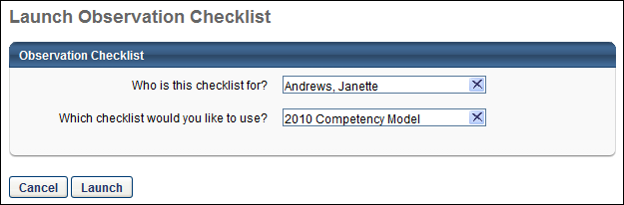
Who is this checklist for?
Determines which user will be observed or assessed by the verifier.
Click in the search box to open the Select User pop-up, which displays the users who can be observed by the verifier (i.e., users who are within the user's Observation Checklist - Verifier permission). Search for or select a user. You are returned to the Launch Observation Checklist page and the selected user appears in this box.
- Only a single user can be selected.
- The verifier cannot select themselves as the assessee.
Which checklist would you like to use?
Determines which observation checklist is used to observe or assess the selected user. This field is only available once a user is selected.
To select the observation checklist, click the Select Checklist field to open the Select Checklist pop-up, and displays the checklists for which the selected user is within the checklist availability. If no observation checklists are available to the selected user, this field is disabled.
- An observation checklist can only be launched if it is active and not in a Queued status.
- If an observation checklist has already been launched for the selected user, then that checklist is not available for selection.
Launch/Cancel
- Click Launch to launch the observation checklist. This button is only available once a user and checklist are selected.
- Click Cancel to cancel the launch action.
My Checklists - Checklist Summary - All Competencies
Use the All Competencies tab of the Checklist Summary to view all the competencies across checklists assigned to the user. This tab also provides access to competencies that are partially or fully validated, but the checklist containing the competency is inactive or removed.
Based on your role, you can view the following:
- Users - View the full list of competencies across all checklists assigned to them.
- Managers - View the full list of competencies assigned to their employee.
- Verifiers - View only the list of competencies that belong to a checklist for which they are a verifier.
To access All Competencies:
- From the My Checklists page, with Checklist Summary selected, click the All Competencies tab.
- End users access their checklists by going to Performance > My Checklists. They are taken to the Checklist Summary - Overall Progress page. The user can then navigate to a specific checklist by clicking the checklist title displayed on the summary page or in the vertical navigation on the left.
- Managers and verifiers access the Checklist Summary page by selecting a user from the Access Checklists page.
Permissions
PERMISSION NAME | PERMISSION DESCRIPTION | CATEGORY

Observation Checklist User - View Checklist | Grants ability to access the My Checklists page and the Checklist Details page. This permission cannot be constrained. | Performance - Administration
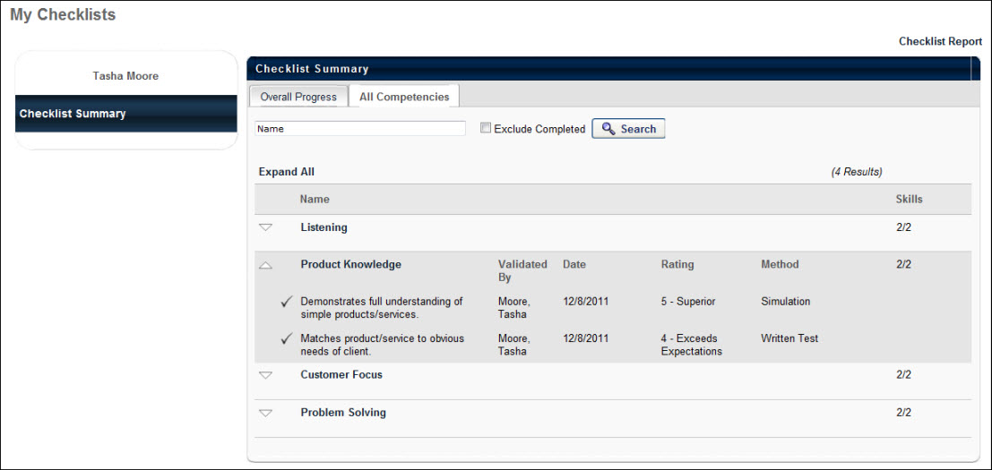
Vertical Navigation
The vertical navigation on the left provides links to the Checklist Summary and any checklists the user is assigned. The Checklist Summary link is always listed first.
- Users can see links to all of their checklists that are in a status of Active, Not Started, In Progress, or Past Due. If a user clicks the title of a Completed checklist from the Checklist Summary, the selected checklist appears in the vertical navigation as well.
- Managers viewing an employee's checklist page can see links to all of the user's checklists that are Active, Not Started, In Progress, or Past Due. If a user clicks the title of a Completed checklist from the Checklist Summary, the selected checklist appears in the vertical navigation as well.
- Verifiers can only see links to the names of the user's checklists for which they are a verifier.
Checklist Report
Click the Checklist Report link to view the checklist report for the user. This link is visible for all roles accessing the checklist page. See Observation Checklists - My Checklists - Checklist Report on page 127 for additional information.
Overall Progress
Click the Overall Progress tab to view a snapshot of the user's Active, Not Started, In Progress, and Past Due checklists. See My Checklists - Checklist Summary - Overall Progress for additional information.
All Competencies
The All Competencies tab displays all the competencies across the checklists that have been assigned to the user. This tab also provides access to competencies that are partially or fully validated, but the checklist containing the competency is inactive or removed.
Search
- Enter a name in the Name search field to search for a specific competency within a checklist. Partial names are accepted.
- Select the Exclude Completed option to exclude competencies that are entirely validated (i.e., all skills are validated) along with non-completed competencies.
- Click the Search button to display selected results in the Checklist Summary table.
Checklist Summary Table
The Competencies table displays the name of each competency in all checklists assigned to the user, along with the number of completed skills for the competency. Click the competency name to open the Competency Details Page, where the details of the competency are displayed. See Observation Checklists - Competency Details by Checklist on page 136 for additional information.
Name - The name of the competency. Click the arrow next to the competency to display each of the skills within the competency. If the skill is validated, a check appears the skill name.
Validated By- Also, the verifier's name is displayed with the validation date and validation method if applicable. If Validation Method is disabled, the Method column does not appear. If no check appears, the skill is not yet validated.
Date - The date the competency is created.
Rating - The score for the competency if a rating scale was included in the checklist settings for at least one of the checklists that display. If the checklist was set to be visible to the user, then the user also sees the Rating column. The score is only displayed if a rating is entered for each item within the competency in the checklist for the user. The rating value appears as it is configured to in the checklist (text, numeric, both).
Method - The type of competency.
Rating - The skill rating for a competency.
The competencies that are listed on this page meet one of the following criteria:
- The competency belongs to an active checklist assigned to a user.
- A skill in the competency is validated, and then removed from the competency model. The user should still have access to the validation record, and therefore can see the competency and the removed skill in it.
- A competency is removed from the model and one or more of its skills is validated. The user should still have access to the validation record, and therefore can see the competency.
- A user is removed from a checklist, but has been validated for a skill of a competency in the checklist. The user should still have access to the validation record, and therefore can see the competency and the removed skill in it.
- A checklist is inactivated and the user has a validation record for one or more skills in the inactivated checklist. The user should still have access to the validation record, and therefore can see the competency and skill from the inactivated checklist.
Observation Checklists - My Checklists - Checklist Report
Use the Checklist Report to enable users to create a printed view of the checklist. This page offers various filters to allow the user to define their desired report output. The Checklist Report is also useful if you require a paper copy of the checklist in order to collect manual validations.
To access the My Checklists - Checklist Report page, go to Performance > My Checklists. Then, click the Checklist Report link in the upper-right corner of the page.
Permissions
PERMISSION NAME | PERMISSION DESCRIPTION | CATEGORY

Observation Checklist User - View Checklist | Grants ability to access the My Checklists page and the Checklist Details page. This permission cannot be constrained. | Performance - Administration

Launch Ad Hoc Observation Checklist | Enables a user to launch an ad hoc observation checklist. Having this permission does not guarantee that the user can launch an ad hoc observation checklist, only that they will have access to the Launch Observation Checklist page. There must be at least one ad hoc checklist for which the user is defined as a verifier. This permission cannot be constrained. This is an end user permission. | Performance
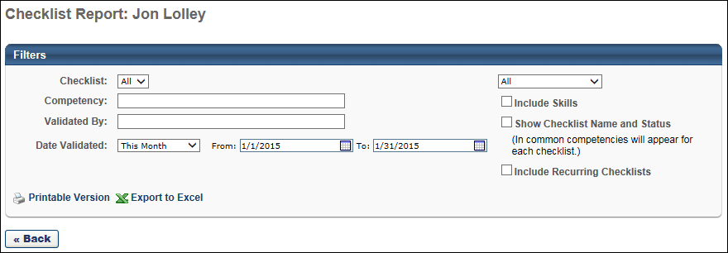
Filters Section
Select the options that you want to display in the checklist report:
- Checklist - Select the appropriate checklist. All of the user's assigned checklists are included except for removed or inactivated checklists. Only the latest instance each recurring checklist is available from the drop-down menu.
- Competency - Enter a specific competency name on which to report. Partial competency names are accepted. Only competencies that match the criteria are returned. If no competency name is entered, the results are not limited by competency name. This field is limited to 50 characters.
- Validated By - Enter a verifier's name on which to report. Partial verifier names are accepted. Only competencies where the selected verifier's name is present for a skill are returned. All skills related to the matching competencies are also included. This field is limited to 100 characters.
- Date Validated - Use the date selection criteria to return competencies with a validation date within the selected date range. Use either the drop-down or select a specific date range using the calendar feature.
- Drop-Down - From the drop-down list in the upper-right corner, choose to display one of the following:
  - All - Include all competencies in the report.
  - Completed Only - Include only competencies that are completely validated.
  - Not Completed Only - Include only competencies that have at least one skill that is not yet validated. This is a good way to view only the competencies a user has left to complete.
- Include Skills - Select this option to include skills in the report output. If this is not selected, only competencies are listed and skills are excluded.
- Show Checklist Name and Status - Select this option to include a Checklist Name and Status column are included in the report output for each competency or skill. If a competency is part of two or more checklist, the competency or skill appears twice in the output. If this is not selected, these columns do not appear.
- Include Recurring Checklists - When this option is selected, recurring checklists are included in the report output.
  - If this option is selected and "All" is selected from the Checklist drop-down, then all instances of any recurring checklist that match the report criteria are included in the report output.
  - If this option is selected and a specific checklist is selected from the Checklist drop-down, then all instances of the selected checklist that match the report criteria are included in the report output.
Printable Version/Export to Excel
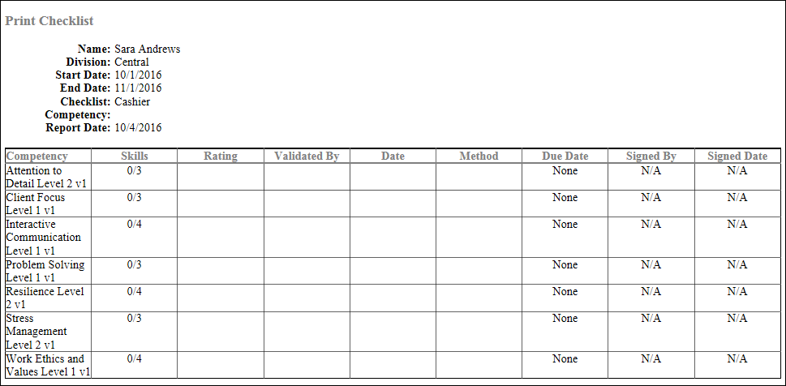
- Click Printable Version to open a version of the output that you can print.
- Click Export to Excel to export the selected information to an Excel spreadsheet.
The following columns may be available in the checklist report:
- Competency
- Skills
- Rating
- Validated By
- Date
- Method
- Due Date
- Signed By - This column displays the name of the validator who electronically signed the checklist. This value is only displayed if the Checklist Status is Completed or Pending Completion Approval. If electronic signature is disabled for the checklist, then N/A is displayed. If electronic signature is enabled but the task is In Progress and a signature has not yet been obtained, then the field is blank.
- Signed Date - This column displays the date on which the validator electronically signed the checklist. This value only displayed if the Checklist Status is Completed or Pending Completion Approval. If electronic signature is disabled for the checklist, then N/A is displayed. If electronic signature is enabled but the task is In Progress and a signature has not yet been obtained, then the field is blank.
View or Manage Checklists
The Checklists page allows users to view details about their checklists and monitor their progress. Managers and Verifiers can also access this page to validate skills and competencies for a user.
- To validate a checklist as a validator, go to Performance > Observation Checklists. Then, select the appropriate checklist.
- To validate a checklist as an administrator, go to Admin > Tools > Performance Management > Observation Checklists. Select the View Details icon for the appropriate checklist. Then, select the View Details icon for the user whose checklist requires validation.
Permissions
PERMISSION NAME | PERMISSION DESCRIPTION | CATEGORY

Observation Checklist - Verifier | Enables user to serve as the verifier for the observation checklist of another user. This permission should be included in the dynamic security role "Checklist Verifier." The role, when active, is dynamically assigned to any user who is designated as a verifier for one or more checklists. This permission can be constrained by OU and User's OU. This is an end user permission. | Performance

Observation Checklists - Edit Validation Details | Grants access to edit a validation record for a competency or item for a user's checklist. This is an administrator permission. | Performance - Administration
Emails
EMAIL NAME | EMAIL DESCRIPTION | ACTION TYPE

Observation Checklist Pending Completion Approval | This email can be configured as a notification. When configured as a notification, the email is triggered immediately after a checklist changes from In Progress status to Pending Completion Approval status. The available recipients in the Send To and CC fields are User's Manager, Checklist Verifier, or Assessee. | Observation Checklist
Users cannot validate their own competencies, regardless of role, so viewing the checklist is a read-only view with tsome features available to the user. A user's manager who is not a verifier may also only view an employee's checklist. When a user or manager views a read-only checklist, they can view competencies and skills within a checklist, navigate to the Checklist Report, and based on preferences set by the administrator, add attachments.
A verifier can see and select the check-boxes associated with a skill, which allows them to authorize the validation of a skill.
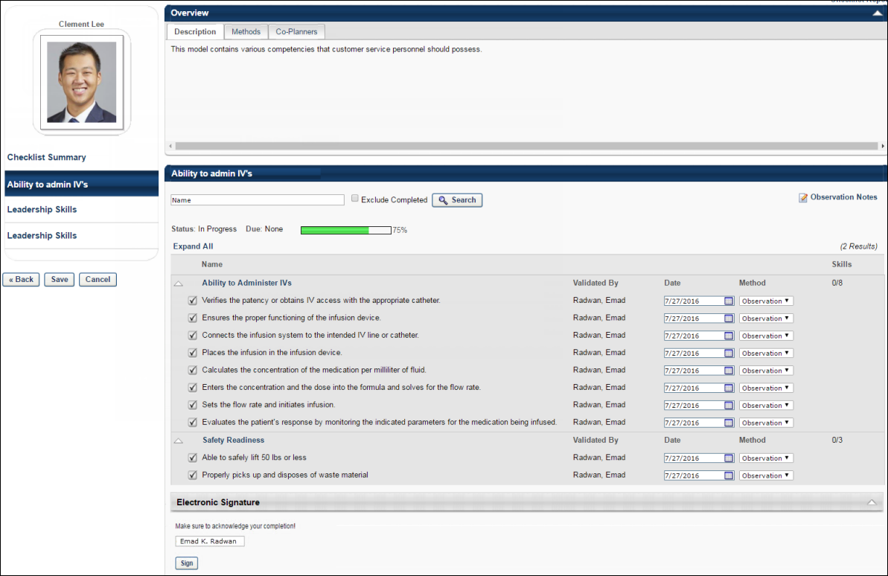
Overview Section
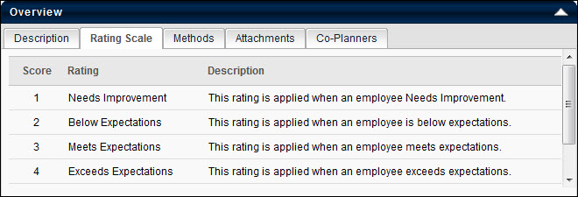
- Description - The competency model description.
- Rating Scale - Displays the scale configured for the competency model, if the checklist is configured to display.
- Method - Displays each possible validation method, along with a description, if a validation method is implemented for the competency.
- Attachments - Displays any attachments to the competency if the Manager, Verifier, or User has appropriate permission. Users with appropriate permissions can add or delete addachments in this area. You can add up to three attachments. If the checklist is recurring, attachments are carried to the next instance of the checklist.
- Co-Planners - Enables managers to add verifiers to the checklist if a manager has appropriate permissions. Existing co-planners are displayed on the Co-Planners tab along with the date they are added and the manager or verifier that added them. Users can remove any co-planner add. If the checklist is recurring, co-planners are carried to the next instance of the checklist.
Name/Exclude Completed/Search
- Name - Search for a specific competency within a checklist. Partial and full names are accepted.
- Search - Initiates the competency name search.
- Exclude Completed check box - Include competencies that are entirely validated (all skills are validated) along with non-completed competencies.
Status
Indicates the status of the checklist. Note: A competency is completed once all of its skills are validated. However, if a target competency rating is implemented, then the competency is not complete unless the minimum rating is achieved.
- The Due date indicates the date by which the checklist is due.
- The progress bar displays the percent compete of the checklist for the user, followed by the numeric percent complete. The calculation for the progress bar is based on the total number of competencies in a checklist, and all competencies have equal weight. The progress bar and percentage reflects competency validation, rather than skill validation. For example, the progress bar will display 0% completion for a checklist until at least one the competencies is validated as a result of all of that competency's skills being validated.
Observation Notes
Click the Observation Notes link to access the Observation Notes page, which enables the validator to compose notes and comments without selecting a competency, add video notes without selecting a competency, and attribute notes to one or more competencies. See Observation Checklist - Observation Notes on page 141 for additional information.
Competencies Table
By default, the Competencies table displays the names of each competency in the checklist along with the number of completed skills for the competency.
- Name - Click the competency name to go to the Competency Details Page, where the details of the competency are displayed. See Observation Checklists - Competency Details by Checklist on page 136 for additional information.
Validate a Competency
To view the checklist items within a competency, expand the competency by clicking the arrow next to the competency name. This enables the validator to validate the competency items. See Observation Checklist - Validate Competency on page 134 for additional information.
Competency Validation Propagation
If a competency appears in two checklists assigned to the same user, when that competency's skill is validated in one checklist, the validation is also propagated to the other checklist.
A recurring checklist does not receive a validation by propagation from a previous instance of the recurred checklist, and it will ignore any validations for the same skill that took place prior to the recurrence of the checklist.
Electronic Signature
If an electronic signature is required for the checklist, then the Electronic Signature section appears after the last item in the checklist is validated. The section title and description may vary depending on the configuration of the observation checklist.
The signature method varies depending on the configuration of the observation checklist. The validator or administrator may be required to enter their full name. Select the Sign button. After a signature is provided, the checklist can no longer be modified. If the checklist does not require approval, then the checklist status is Completed.
Depending on the configuration of the checklist, the validator or administrator may be required to re-authenticate their account prior to electronically signing the checklist. The user may be prompted to enter their Cornerstone system user ID and password, or the user may be redirected to a corporate page where they are prompted to enter their corporate user ID and password when using SSO re-authentication.
If the checklist requires completion approval, then a Submit for Approval button is available after the electronic signature is provided.
When an assessee views a checklist that contains an electronic signature, the assessee can view the signature and the date on which the signature was provided.
An electronic signature is automatically removed if any changes are made to an observation checklist that has already been electronically signed.
Submit for Approval
Based on the configuration of the observation checklist, a checklist may require approval from the employee's direct manager before the observation checklist is complete. If approval is required by the employee's manager, a Submit for Approval button is available at the bottom of the Checklist page once the checklist is completed by the validator. The Submit for Approval button only appears if all items in the observation checklist are validated.
When you click the the Submit for Approval button:
- The checklist status is changed from In Progress to Pending Completion Approval.
- The Submit for Approval button is no longer visible.
- The checklist cannot be modified.
- If configured in email management, the pending completion approval email is triggered. Note: If the validator who completes the checklist is also the user's direct manager, then the manager approval workflow is bypassed.
- An item is added to the History section which indicates that the checklist is submitted for manager approval, including the verifier's name and user ID and the date and time on which the checklist was submitted for manager approval.
Observation Checklist - Validate Competency
Validators can validate the competency items for an Observation Checklist.
To access the Observation Checklist page, go to Performance > Observation Checklists. This page displays checklists in which you are identified as a verifier. Click the appropriate checklist link. You can validate a checklist item, select a competency target, and add a rating.
Permissions
PERMISSION NAME | PERMISSION DESCRIPTION | CATEGORY

Observation Checklist - Verifier | Enables user to serve as the verifier for the observation checklist of another user. This permission should be included in the dynamic security role "Checklist Verifier." The role, when active, is dynamically assigned to any user who is designated as a verifier for one or more checklists. This permission can be constrained by OU and User's OU. This is an end user permission. | Performance

Observation Checklists - Edit Validation Details | Grants access to edit a validation record for a competency or item for a user's checklist. This is an administrator permission. | Performance - Administration

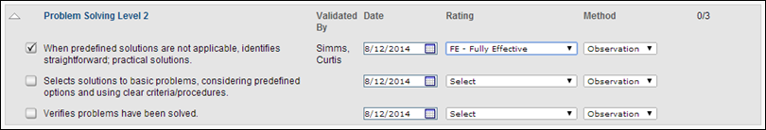
Validate a Checklist Item
Click the check box next to the item and a check appears next to the skill name. Also, the verifier's name displays with the validation date and validation method if applicable. This indicates that the validator believes the user demonstrate the corresponding skill.
- Once a skill is validated, the verifier name is displayed, and the verifier can select the validation date and validation method if applicable. If Validation Method is disabled, the Method column does not appear.
- A competency is not validated until each skill within it is validated.
If a checklist item is not validated, no check appears next to the skill name. A verifier for the checklist sees a check box next to each skill that is not yet validated.
Competency Target
When the option to require the competency target as the minimum rating is selected for the checklist, the following functionality is implemented within the checklist:
- If the verifier checks the competency item checkbox to validate the item, the rating selection for the competency item is automatically set to the minimum rating target for the competency. The rating can be set to a higher rating until the checklist is saved, if necessary.
- If the verifier selects a rating for the competency item that is at or above the minimum rating target for the competency, then the competency item checkbox is automatically checked and the item is validated.
- If the verifier selects a rating for the competency item that is below the minimum rating target for the competency, then the competency item checkbox is disabled and the item cannot be validated until the competency item rating meets the minimum rating target for the competency.
- When the verifier saves the checklist, all validated competency items are no longer available for rating or validating. However, the Rating drop-down menu remains available for all non-validated competency items.
Add Ratings to a Checklist Item
Click the Save button to add ratings to a checklist item and save their ratings without validating the checklist item. The system saves the rating, method, and date settings. After saving the ratings, the validator can open the competencies to view the ratings and make updates if necessary.
When a rating is added or modified from the Rating drop-down list, the system automatically saves the new Rating value.
Save
Click the Save button to save their ratings and validations.
If a checklist item is updated and saved but is not validated, the observation checklist Status and Progress Bar are not affected. The checklist Status is only updated when at least one item is validated. The checklist Progress Bar is updated when at least one competency is validated, which occurs when all items within the competency are validated.
Once the skill is validated, the validator cannot undo the validation.
Manager Approval
If an observation checklist requires manager approval and the approval is denied, when the validator returns to the checklist, all validations are cleared from all checklist items, but the ratings, rating dates, and rating methods are preserved. The validator can then update these fields, validate the checklist items, and resubmit the checklist for approval.
Cancel
Click Cancel to discard all unsaved ratings and validations.
Important Note: Clicking the Cancel button on the checklist page discards unsaved item validations, but preserves item ratings.
Observation Checklists - Competency Details by Checklist
Use the Competency Details by Checklist page provides to manage the following:
- Competency details
- Verification details
- All checklists in which the competency exists
- The ability to validate the entire competency or individual items within the competency
- The history of any changes related to the competency or skill verification
- The ability to view or add comments
To access the Competency Details by Checklist page, go to Performance > Observation Checklists. Click the appropriate checklist link, and then click a competency name.
Permissions
PERMISSION NAME | PERMISSION DESCRIPTION | CATEGORY

Observation Checklist - Verifier | Enables user to serve as the verifier for the observation checklist of another user. This permission should be included in the dynamic security role "Checklist Verifier." The role, when active, is dynamically assigned to any user who is designated as a verifier for one or more checklists. This permission can be constrained by OU and User's OU. This is an end user permission. | Performance
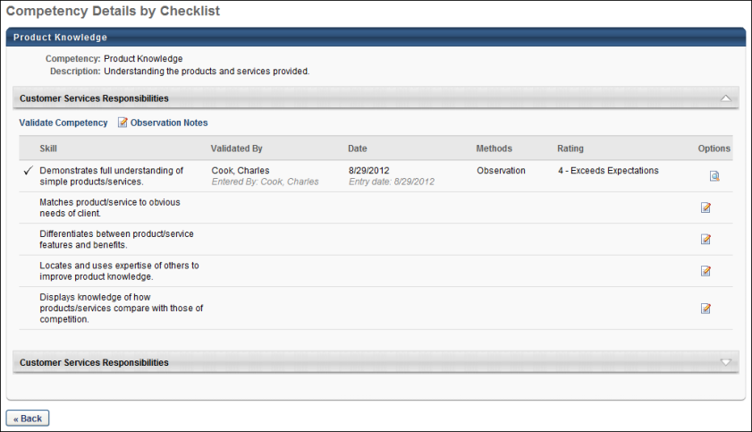
Product Knowledge
- Competency - Competency name.
- Competency Description - Description of the competency.
While the competency name and description remain constant across checklists in which it is contained, a single competency may have different skills for different checklists. When you expand a sub header, you see the list of skills for the competencies as it relates to the checklist you are viewing. If the competency is also in other checklists, additional sub headers appear with the other checklist names.
Competencies that are completed, inactivated, or removed appear at the bottom of the page, below checklists that have a due date and are not started, in progress, or past due.
Validate Competency
Click the Validate Competency link to open the Validate Competency page to batch validate all skills that are not yet validated for the associated checklist. This link appears only to verifiers and administrators.
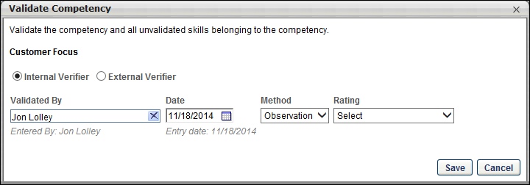
Complete the following options:
- Internal Verifier or External Verifier - Select whether the verifier is an internal user or an external user. Internal verifiers must exist within the system. Select External Verifier if the verifier is a third party When External Verifier is selected, a free form field appears in which the external verifier name must be manually entered.
- Validated By - Select the verifier. The available users are restricted by the OU and User OU constraints for the Edit Validation permission.
- Date - The date the validation is made.
- Method - The validation method used. If the checklist does not include Method, this option does not appear.
- Rating - The rating given to the user for the specific skill. The rating value appears as it is configured to in the checklist (text, numeric , both). Note: This column only appears if a rating scale is used in the checklist. The score is only displayed if a rating is entered for each item within the competency in the checklist for the user. To change a rating after a rating is entered, you must have the permission to edit validation details for observation checklists.
When the option to require the competency target as the minimum rating is selected for the checklist, the following functionality is implemented when validating a competency from the Competency Details by Checklist page:
- If the verifier selects a rating for the competency item that is at or above the minimum rating target for the competency, then the competency item is validated when the Save button is clicked within the Validate Competency pop-up.
- If the verifier selects a rating for the competency item that is below the minimum rating target for the competency, then the verifier receives an error message within the Validate Competency pop-up, and the rating cannot be saved.
- When the verifier saves a rating that is at or above the minimum rating target for the competency, the validated competency item is no longer available for rating.
Note: If the observation checklist rating scale includes a N/A rating option and this option is selected, then the verifier can validate an item regardless of whether the minimum target rating is required.
Observation Notes
If visible, click the Observation Notes link to access the Observation Notes page, which enables the validator to compose notes and comments without selecting a competency, add video notes without selecting a competency, and attribute notes to one or more competencies. See Observation Checklist - Observation Notes on page 141 for additional information.
Skills Table
The skills table lists all skills within the competency along with the following information:
- Skill - Skill name, listed in the order they exist within the competency. If validated, a check mark appears to the left of the skill name.
- Validated By - If the skill is validated, the verifier's name appears. If the skill is not validated, this column is blank for the skill. Below the verifier's name is the name of the person that entered the validation on behalf of the verifier (Proxy Validation). Proxy validation is sometimes necessary if end users demonstrate skills or competencies in front of third party people who are users in the system, and therefore it is necessary for the administrator or verifier with special rights to enter the correct validation information for the third party verifier.
- Date - Date selected by the verifier as the actual day the validation is entered. If the skill is not yet validated, this column is blank for the skill.
- Methods - Validation method.
- Rating - Score given to the user for the specific skill. Note: This column only appears if a rating scale is used in the checklist. The score is only displayed if a rating is entered for each item within the competency in the checklist for the user. The rating value appears as it is configured to in the checklist (text, numeric, both).
- Options - The following options appear in the Options column:
  - Edit - This option only appears for the administrator and verifier. Click the Edit icon to edit the skill validation. The changes made are applied to the Competency Details page.
    - Validators can edit a skill rating for a checklist item and save their ratings without validating the checklist item. The system saves the rating, method, and date settings. After saving the ratings, the validator can then open the competencies to view the ratings and make updates if necessary.
    - If a checklist item is updated and saved but is not validated, the observation checklist Status and Progress Bar are not affected. The checklist Status is only updated when at least one item is validated. The checklist Progress Bar is updated when at least one competency is validated, which occurs when all items within the competency are validated.
    - Important Note: With the October 19 pre-Fall release, checklist item ratings are discarded if an item's checkbox is selected and then the validator clicks the Cancel button. After the November 2 pre-Fall release, clicking the Cancel button in the pop-up discards unsaved item validations, but preserves item ratings.
  - Skill History - Select this option to view the validation history for the associated skill.
  - Remove - This option is only available to administrators. Select this option to remove a completed skill validation. If a skill validation is removed from a skill within a completed competency, the competency validation stamp is also removed and the competency status is now In Progress or Past Due.
Comments
If visible, use the Comments link to add comments.By default, the administrator can add and delete comments left by any role. Users can only delete their own comments.
If the verifier, manager, or user role can add comments, there is an Add Comment icon next to the link, allowing the user to add a comment. All other users can only view comments. If the verifier, manager, and user roles all cannot add comments (as defined when creating the checklist), the link and icon do not appear, even if the administrator has added a comment.
If comments are disabled after a comment has been added, the comments appear as read-only for all roles.
Removed or Inactivated Checklists
Checklists that have a competency in common and are assigned to a user appear in the Competency Details page. If one of these checklists are partially completed and then removed, the checklist sub header appears on the Competency Details page with a (Removed) or (Inactive) tab.
- Removed: Removed means that an administrator removed the checklist for the user from the View Details page in Checklist Administration or the user was dynamically removed as a result of no longer meeting the criteria.
- Inactive: Inactive means that the administrator inactivated the checklist for all participants from Checklist Administration.
Save/Cancel
Click the Save button to add ratings to a checklist item and save their ratings without validating the checklist item. The system saves the rating, method, and date settings. After saving the ratings, the validator can then open the competencies to view the ratings and make updates if necessary. When a rating is added or modified from the Rating drop-down list, the system automatically saves the new Rating value.
If a checklist item is updated and saved but is not validated, the observation checklist Status and Progress Bar are not affected. The checklist Status is only updated when at least one item is validated. The checklist Progress Bar is updated when at least one competency is validated, which occurs when all items within the competency are validated.
- Click the Cancel button to discard unsaved item validations, but preserve item ratings.
Submit for Approval
Based on the configuration of the observation checklist, a checklist may require approval from the employee's direct manager before the observation checklist is complete. If approval is required by the employee's manager, a Submit for Approval button is available at the bottom of the Checklist page once the checklist is completed by the validator. The Submit for Approval button only appears if all items in the observation checklist are validated.
When you click the the Submit for Approval button:
- The checklist status is changed from In Progress to Pending Completion Approval.
- The Submit for Approval button is no longer visible.
- The checklist cannot be modified.
- If configured in email management, the pending completion approval email is triggered. Note: If the validator who completes the checklist is also the user's direct manager, then the manager approval workflow is bypassed.
- An item is added to the History section which indicates that the checklist is submitted for manager approval, including the verifier's name and user ID and the date and time on which the checklist was submitted for manager approval.
Observation Checklist - Observation Notes
Use the Observation Notes page to add notes and comments in a single location. Validators can also add a video as a note or include a video with a note. After entering notes, the validator can associate each note with one or more competencies. In addition, validators can filter notes by competency to view only notes for a certain competency. Note: Users with read-only access can only view comments that have been posted. You can post a note and/or video and add competencies.
To access the Observation Notes page, click the Observation Notes link from either the Checklist page or the Checklist - Competency Details page.
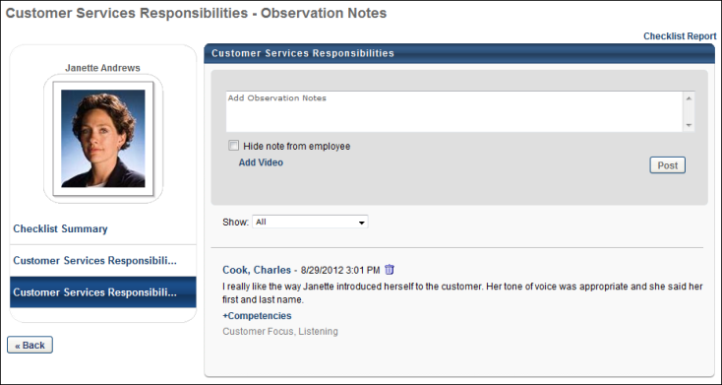
Post a Note
Enter the note text in the Add Observation Notes field. The character limit for this field is 3000. This text box does not support special formatting or HTML.
Videos can be included with a note or comment. To add a video to the post, click the Add Video link. See Add a Video to a Post below for additional information.
A post can consist of only text or only video, but may also contain both. After completing the comment or note, click Post.
When a note is posted, it appears below the text box along with the validator's full name and the date and time on which the note was posted.
- To associate the note or comment with a competency, click the +Competencies link below the note. This link is only available to the validator that posted the note and to administrators.
- To remove a posted note, click the Trash Can icon to the right of the time stamp. This option is only available to the validator that posted the note and to administrators.
- To hide the note from the employee, select the Hide note from employee option to the right of the note. This ensures that the note is not visible to the employee. This option is only available to validators, managers, and administrators. This option is selected by default when adding a note.
- To sort observation notes by competency, select the appropriate competency from the Show drop-down list. This displays only notes that have been associated with the selected competency. All notes are displayed by default. Only competencies that are included in the observation checklist are available in the drop-down list.
Add a Video to a Post
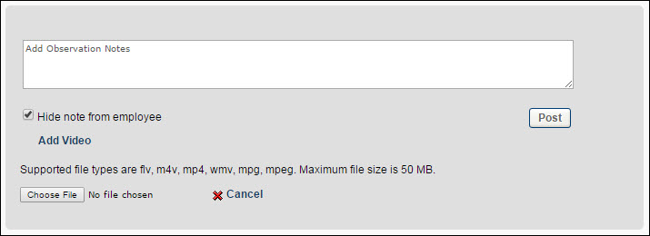
To include a video with a note or comment:
- Click Add Video. This enables additional options.
- Click the Choose File button and select the appropriate video. The supported video file types are .flv, .m4v, .mp4, .wmv, .mpg, and .mpeg. The maximum file size is 50 MB.
The selected video file is uploaded.
Video Considerations
- Videos that are uploaded to the system can be streamed to the user with minimal buffering and interruptions.
- When uploading a video to the system, there are Internet browser considerations that determine the default format of the video. In addition, when using mp4 videos, organizations must perform additional configurations in order to ensure that mp4 videos play properly. See Video Streaming.
Add Competencies to Note
A note can be associated with multiple competencies within the checklist.
To add competencies to a note:
- Click the + Competencies link below the note. This opens the Add Competencies to Note pop-up. Note: This link is only available to the validator that posted the note and to administrators. The pop-up lists all of the competencies in the order in which they are used in the observation checklist.
- Select the checkbox to the left of the appropriate competencies and click Save to add the competencies. The selected competencies are listed below the comment. Further, you can deselect any competencies that should not be associated with the note.
Observation Checklists - Pending Checklists
Use the Pending Checklists page to approve or deny multiple checklists at the same time.
To access the Pending Checklists page, click the Approve Checklists link from the Welcome Page Inbox widget. This page is only available for managers.
Permissions
PERMISSION NAME | PERMISSION DESCRIPTION | CATEGORY

Observation Checklist User - Manage Pending Checklists | Grants ability to access the Pending Checklists page and manage pending checklist approvals. This permission cannot be constrained. This is an administrator permission. | Performance - Administration
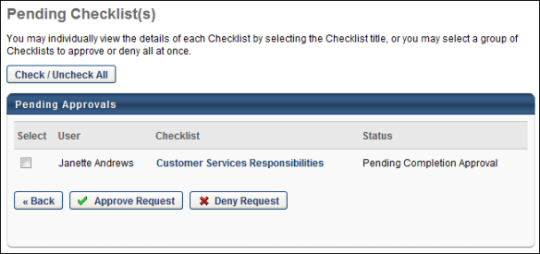
Check/Uncheck All
Select all available observation checklists by clicking the Check/Uncheck All button. When all checklists are selected, clicking the Check/Uncheck All button deselects all observation checklists.
Pending Approvals Section
The following information is displayed for each observation checklist in the Pending Approvals table:
- Select - Click this checkbox to approve or deny the observation checklist.
- User - This displays the name of the employee that was validated in the checklist.
- Checklist - This displays the title of the checklist. Managers can click the observation checklist title to view the corresponding observation checklist where the manager can approve or deny that individual checklist. See Observation Checklist - Approve/Deny on page 145 for additional information.
- Status - This displays the status of the employee's checklist.
Approve Request/Deny Request
- To approve one or more requests, select the appropriate checkbox and click the Approve Request button. A confirmation pop-up appears, which enables the manager to confirm their action.
- To deny one or more requests, select the select the appropriate checkbox and click the Deny Request button at the bottom of the page. A confirmation pop-up appears, which enables the manager to confirm their action.
When an observation checklist is approved or denied, that checklist is removed from the Pending Checklists page. The status for approved checklists is changed from Pending Completion Approval to Completed. The status for denied checklists is changed from Pending Completion Approval to Denied. In both circumstances, a note is added to the History section for the affected checklists, which indicates whether the checklist was approved or denied, including the manager's name and user ID and the date and time on which the checklist was approved or denied. If the manager denied the checklist, the manager's comments are included in the history item.
Observation Checklist - Approve/Deny
A checklist may require approval from the employee's direct manager before the observation checklist is complete. If approval is required by the employee's manager, managers can review a submitted checklist and approve or deny the checklist completion.
Only an employee's manager can approve or deny the employee's observation checklist.
When the checklist is approved or denied, this action is added to the History section which indicates whether the checklist was approved or denied, including the manager's name and user ID and the date and time on which the checklist was approved or denied. If the manager denied the checklist, the manager's comments are included in the history item.
To access approval page, click the observation checklist name on the Pending Checklists page.
Permissions
PERMISSION NAME | PERMISSION DESCRIPTION | CATEGORY

Observation Checklist User - Manage Pending Checklists | Grants ability to access the Pending Checklists page and manage pending checklist approvals. This permission cannot be constrained. This is an administrator permission. | Performance - Administration
Emails
EMAIL NAME | EMAIL DESCRIPTION | ACTION TYPE

Checklist Approval Denied | This email can be configured as a notification. When configured as a notification, the email is triggered immediately after a checklist changes from Pending Completion Approval status to Denied status. The available recipients in the Send To and CC fields are User's Manager, Checklist Verifier, or Assessee. | Observation Checklist

Observation Checklist Pending Completion Approval | This email can be configured as a notification. When configured as a notification, the email is triggered immediately after a checklist changes from In Progress status to Pending Completion Approval status. The available recipients in the Send To and CC fields are User's Manager, Checklist Verifier, or Assessee. | Observation Checklist
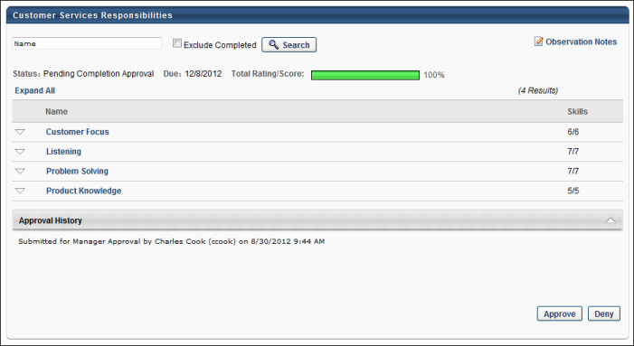
The Approve and Deny buttons only appear after all items in the observation checklist are validated.
Approve
Click Approve to approve the observation checklist completion. When the checklist is approved, the following occurs:
- The checklist status changes from Pending Completion Approval to Completed.
- The Approve and Deny buttons are no longer available.
- Details of the approval are added to the History section.
Deny
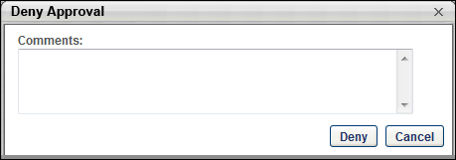
- Click Deny to deny the observation checklist completion. This opens the Deny Approval pop-up.
- In the Comments field, enter comments to explain why the checklist is denied and click Deny. The Comments field is not required.
When the checklist is denied, the following occurs:
- The checklist status changes from Pending Completion Approval to Denied.
- If configured in email management, the approval denied email is triggered.
- Previously validated competencies are no longer validated. Values for Rating, Date, Method, and Validated By remain visible. However, they cannot be edited by the manager.
- The checklist progress bar resets to zero percent.
- The Approve and Deny buttons are no longer available.
- Details of the denial are added to the History section.
After the checklist is denied, the validator must revalidate the checklist:
- The checklist status is Denied.
- The checklist progress is reset to zero percent.
- Previously validated competencies are no longer validated. Values for Rating, Date, and Method are visible and can be edited by the validator. Values for Validated By are reset until they are revalidated by the validator. The Skills column reflects that none of the skills have been validated.
The validator can validate the competencies and select the corresponding Date, Rating, and Method options and click Save. Once all competencies are all validated, the Submit for Approval button is available. After the validator clicks the Submit for Approval button, the checklist status is changed from Denied to Pending Checklist Approval, which reinitiates the manager approval process. If configured in email management, the pending completion approval email is triggered. Note: If the validator who completes the checklist is also the user's direct manager, then the manager approval workflow is bypassed.

Skills Matrix - Overview
The primary purpose of a role is to serve as a container for defining the competence level and training required for an employee to be qualified in a job function. Successful completion of the role's qualification requirements results in the employee being "qualified" for the role. The Skills Matrix is an analytical tool that is designed to provide users, managers, and administrators the ability to view the role qualification status of one or more users for one or more roles.
The Skills Matrix provides the framework for identifying the skills that a role requires, the skills of individual employees, and any gap between the two.
Use Cases
Manager Scenario
A fast food restaurant uses roles in their portal to track user qualifications for their food preparation workstations. A role has been created for each workstation.
A manager at the restaurant has seen a decline in the productivity over the past three months. The manager believes that there may be a gap in the competency or entity knowledge of the team, causing the dip in productivity.
The manager views the Skills Matrix page for his team and selects the appropriate roles. The matrix is generated for all of the employees at the restaurant and all of the food preparation workstations that are used in the restaurant. The manager can see the role qualifications for each employee and immediately recognizes that many of the employees have been assigned to workstations in which they have not been qualified.
With this knowledge, the manager only assigns employees to workstations in which they are qualified.
Administrator Scenario
A fast food restaurant uses roles in their portal to track user qualifications for their food preparation workstations. A role has been created for each workstation.
An administrator wants to see how the trainees are progressing in becoming qualified for the food preparation workstations.
The administrator views the Skills Matrix page and selects the most recent group of trainees. The administrator then selects the roles for which the trainees have been trained. The matrix is generated for all of the selected restaurant trainees and all of the appropriate food preparation workstations. The administrator can see the role qualifications for each trainee and is pleased to see that they have all met the role qualification requirements for the workstations that were used in training.
User Scenario
A user wants to check their role qualification status. The user views the Skills Matrix page and selects Self as the user criterion. In the Roles section, the user selects Display Roles for Position. The matrix is generated for the user and all of the roles that are associated with the user's position.
The user sees that they have met all but one of the role requirements. The user can then choose to complete any necessary assessments or training to meet the qualifications.
Assign Training
A fast food restaurant uses roles to track user qualifications for their food preparation workstations.
The store manager views the Skills Matrix to view the role qualification statuses for a direct report. The manager notices that the employee is In Progress for the Bread Baking role. The manager views the User Role Qualification page for the employee's Bread Baking role and can see that the employee has completed all of the requirements except for the Baking 101 training requirement.
The manager can see that the employee is not registered for the course, so the manager assigns the Bread Baking 101 course to the employee.
Request Training
A fast food restaurant uses roles to track user qualifications for their food preparation workstations.
An employee views the Skills Matrix to view their role qualification status for the Cheese Slicing role. The employee notices that he is In Progress for the Cheese Slicing role. The employee views the User Role Qualification page for the role and can see that he has completed all of the requirements except for the Slicing 101 training requirement.
The employee can see that he has not registered for the course, so he requests the Slicing 101 course.

Skills Matrix - Assign Roles - Select Role
If you are assigning roles, this is the first step in the process.
Managers and administrators can use the Skills Matrix to manually assign roles to direct or indirect reports. When a role is manually assigned to a user, the role remains assigned to the user, regardless of whether the user changes positions. Managers and administrators can only assign a single role to one or more users at a time.
To access the Skills Matrix, go to Performance > Skills Matrix. Note: The location of this link is configurable by your system administrator.
Permissions
PERMISSION NAME | PERMISSION DESCRIPTION | CATEGORY

Assign Roles | Grants ability to assign roles to those for whom the user is a manager or approver. This permission cannot be constrained. This is a manager/approver permission. | Performance

Skills Matrix | Grants access to the Skills Matrix page. This permission can be constrained by OU, User's OU, User's Direct Reports, User, User's Subordinates Only, and User Self and Subordinates. The permission constraints determine which users are available to view in the Skills Matrix. | Performance
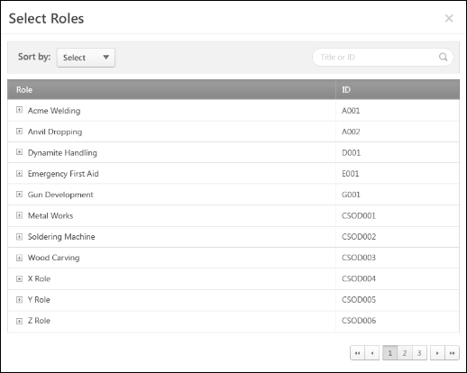
To assign a role to one or more users:
- From the Options drop-down menu, select Assign Roles. This opens the Select Roles pop-up.
- From the pop-up, search for a role by title or ID using the Search field.
- Click the title of a role to select the role and open the Assign Role page to continue. See Skills Matrix - Assign Roles - Add/Remove Users on page 152 for additional information.

Skills Matrix - Assign Roles - Add/Remove Users
If you are assigning roles, this is the second step in the process.
Note: Before you start this step, you must select roles. See Skills Matrix - Assign Roles - Select Role on page 150 for additional information.
You can add direct reports and indirect reports to an assignment or remove them.
Managers and administrators can use the Skills Matrix to manually assign roles to direct or indirect reports. When a role is manually assigned to a user, the role remains assigned to the user, regardless of whether the user changes positions. Managers and administrators can only assign a single role to one or more users at a time.
To access the Skills Matrix, go to Performance > Skills Matrix. Note: The location of this link is configurable by your system administrator.
Permissions
PERMISSION NAME | PERMISSION DESCRIPTION | CATEGORY

Assign Roles | Grants ability to assign roles to those for whom the user is a manager or approver. This permission cannot be constrained. This is a manager/approver permission. | Performance

Skills Matrix | Grants access to the Skills Matrix page. This permission can be constrained by OU, User's OU, User's Direct Reports, User, User's Subordinates Only, and User Self and Subordinates. The permission constraints determine which users are available to view in the Skills Matrix. | Performance
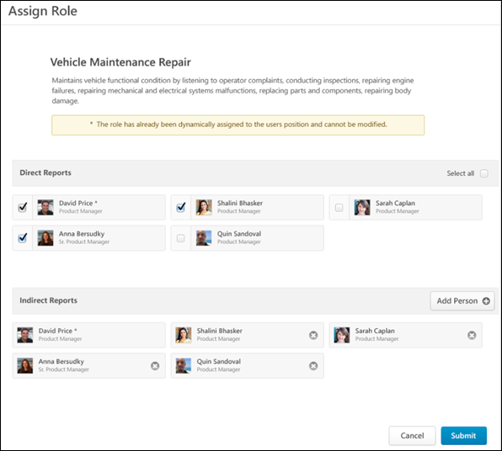
Role Information
Role title and description.
Direct Reports
Displays all of the manager's direct reports in alphabetical order. The direct report's photograph, name, and position title are displayed.
If the user is dynamically assigned to the role based on their position, then an asterisk appears next to their name. These users appear first in the Direct Reports section, and these users cannot be manually assigned to the role. You can add or remove direct reports.
Add Direct Reports to Assignment
- To add a direct report to the assignment, check the checkbox to the left of the user.
- To add all of the direct reports to the assignment, check the Select all checkbox in the upper-right corner of the section.
Remove Direct Reports from Assignment
To remove a direct report from the assignment, uncheck the checkbox to the left of the user.
Note: If a user is manually assigned a role and is later assigned the same role based on their position, then the user retains both a manual and position-assigned status. The manager cannot edit the user's assignment status while the position assignment is active. If the user switches positions and the new position is not associated with the role, then the user reverts to a manual assignment only. The manager can then edit the user's assignment status.
Indirect Reports
Select indirect reports for the role assignment. By default, no users appear in this section unless they have been dynamically assigned to the role due to their position.
If the user is dynamically assigned to the role due to their position, then an asterisk appears next to their name. These users appear first in the Indirect Reports section, and you cannot manually assign them to the role.
Add Indirect Reports to Assignment
Click the Add Person button in the upper-right corner of the section. This opens the Select Indirect Report pop-up, where the manager can search for users by Last Name, First Name, or ID. Click a user's name to add the user to the assignment.
The selected indirect reports appear in the Indirect Reports section in alphabetical order. The indirect report's photograph, name, and position title are displayed.
Remove Indirect Reports from Assignment
To remove an indirect report from the assignment, click the Remove icon to the right of the user's information.
Note: If a user is manually assigned a role and is later assigned the same role based on their position, then the user retains both a manual and position-assigned status. The manager cannot edit the user's assignment status while the position assignment is active. If the user switches positions and the new position is not associated with the role, then the user reverts to a manual assignment only. The manager can then edit the user's assignment status.
Submit /Cancel
- Click Submit to assign the role to the selected users.
- Click Cancel to cancel the role assignment.

Skills Matrix - Export to Excel
The Excel version of the Skills Matrix includes the skills matrix at the top of the output. The criteria that were used to create the skills matrix are displayed at the bottom of the output.
Permissions
PERMISSION NAME | PERMISSION DESCRIPTION | CATEGORY

Skills Matrix | Grants access to the Skills Matrix page. This permission can be constrained by OU, User's OU, User's Direct Reports, User, User's Subordinates Only, and User Self and Subordinates. The permission constraints determine which users are available to view in the Skills Matrix. | Performance
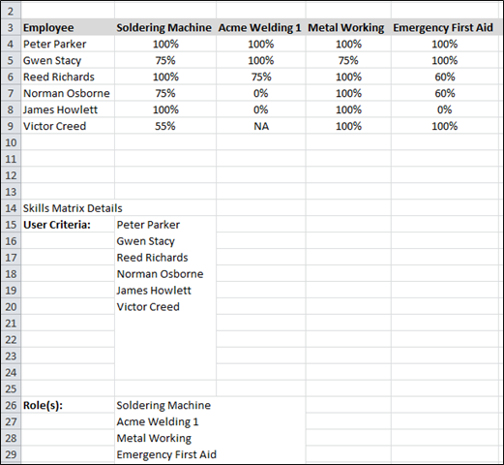
To generate an Excel version of the Skills Matrix:
- Generate a skills matrix on the Skills Matrix page.
- Select Export to Excel from the Options drop-down menu.

Skills Matrix - Print to PDF
The PDF option version of the Skills Matrix includes the skills matrix at the top of the output. The criteria used to create the skills matrix is displayed at the bottom of the output.
Permissions
PERMISSION NAME | PERMISSION DESCRIPTION | CATEGORY

Skills Matrix | Grants access to the Skills Matrix page. This permission can be constrained by OU, User's OU, User's Direct Reports, User, User's Subordinates Only, and User Self and Subordinates. The permission constraints determine which users are available to view in the Skills Matrix. | Performance
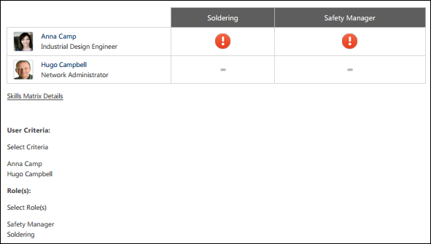
To generate a PDF version of the Skills Matrix:
- Generate a skills matrix on the Skills Matrix page.
- Select Print to PDF from the Options drop-down menu.

Skills Matrix - Request Role
Use the Request Role page to request a role in the Skills Matrix. Note: A user can only request a role for which the user is within the availability.
To request a role, go to Performance > Skills Matrix. Then,
Permissions
PERMISSION NAME | PERMISSION DESCRIPTION | CATEGORY

Request Roles | Grants ability to request a role from the Skills Matrix. Users can only request roles for which they are within the availability. This permission cannot be constrained. This is an end user permission. | Performance

Skills Matrix | Grants access to the Skills Matrix page. This permission can be constrained by OU, User's OU, User's Direct Reports, User, User's Subordinates Only, and User Self and Subordinates. The permission constraints determine which users are available to view in the Skills Matrix. | Performance
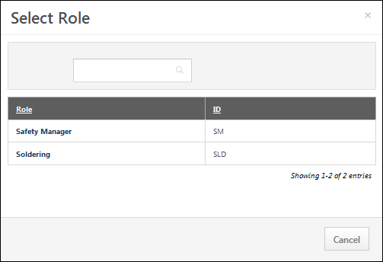
To request a role:
- Select the Request Role option from the Options drop-down menu. The Select Role pop-up opens.
- Select a role. You can only select roles for which the user has availability. The Request Roles page opens and displays the title and description of the role.
- Select one of the following options:
  - To request the role, click the Request button. The user is assigned the selected role and is redirected to the Skills Matrix.If the user has already requested the role, this is indicated by a note below the role description.
  - To cancel the request, click the Cancel button to return to the Skills Matrix.

Skills Matrix - Role Details Page
The Role Details page displays the details of the user's qualifications for the corresponding role, including the status of each competency and training item that is required for the role.
To access the Role Details page for a user and a role, click the cell in the Skills Matrix where the user's row intersects with the appropriate role. Note: This functionality is not available if the user has not been assigned the role.
Permissions
PERMISSION NAME | PERMISSION DESCRIPTION | CATEGORY

Request Roles | Grants ability to request a role from the Skills Matrix. Users can only request roles for which they are within the availability. This permission cannot be constrained. This is an end user permission. | Performance

Skills Matrix | Grants access to the Skills Matrix page. This permission can be constrained by OU, User's OU, User's Direct Reports, User, User's Subordinates Only, and User Self and Subordinates. The permission constraints determine which users are available to view in the Skills Matrix. | Performance
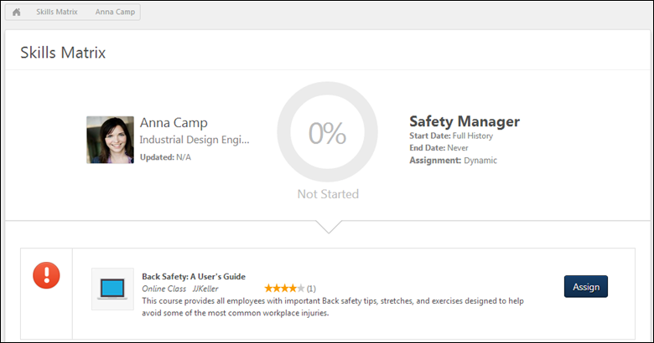
User and Role Overview
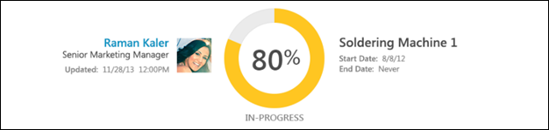
This section displays the following information:
- User's Name - User's name.
- User's Position - User's position in the organization.
- Updated - The last date and time at which a competency was rated in this role or an equivalent training was completed for a competency in this role. A competency rating may be from a completed competency assessment or observation checklist.
- User's Photograph - User's photograph.
- Role progress - Role qualification completion. The circular status indicator is filled based on the percentage of competencies that are completed. This percentage is also displayed in the center of the status indicator. The color of the status indicator represents the employee's qualification status for the role. The user's qualification status for the role is also displayed below the status indicator.The following colors are available:
  - Red - Not Started
  - Yellow - In Progress
  - Green - Completed
- Role Title - Competency role title.
- Start Date - Qualification start date for the role, as configured by the administrator when the role was created. This indicates the date on which the system begins using competency ratings data towards the qualification of the associated role. Any competencies that are completed prior to this date do not apply to the qualification of the role.
- End Date - Qualification end date for the role, as configured by the administrator when the role was created. This indicates the last date on which the system will use competency ratings data towards the qualification of the associated role. Any competencies that are completed after this date do not apply to the qualification of the role.
Competencies and Training
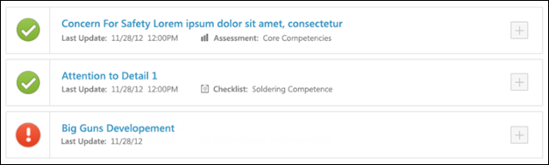
This section displays the competencies and training items required for the role. Competencies and training items are sorted in alphabetical order by title. Note: Training role requirements or competency equivalent training are only displayed to a user if the user is within the LO availability.
By default, the first 20 role requirements display. If the role has more than 20 requirements, then a Show More button is available at the bottom of the page. When this button is clicked, the system displays the next 20 role requirements.
The following information is displayed for each competency:
- Status Icon - This icon indicates the status of the requirement. The following statuses are available:
  - Completed - The green check icon indicates that the employee has met the requirements for the item.
  - In Progress - The yellow clock icon indicates that the employee has started the training, but has not yet completed it.
  - Not Yet Started - The red icon indicates that the employee has not met the competency requirement or has not yet started the training. A competency is not completed if the following are true:
    - The user's competency rating does not meet the target defined for the role.
    - The user has not yet been rated on the competency.
    - An equivalent training has not been completed.
- Title - Title of the training.
- Last Update - Date and time at which the user was credited with a rating, was credited with an equivalent training completion percentage, or completed a required training. If no assessment has been made for the competency, or if the training has not yet been completed, then "N/A" is displayed.
- Completion Method - Method by which the user received a rating for the competency (e.g., competency assessment, observation checklist, online class, event). This is only displayed if the user has met the requirement for the competency.
  - To the right of the completion method, the title of the completion method task or training is displayed. For example, if completion was achieved via a competency assessment, then the title of the competency assessment is displayed. Note: This value is only populated for competencies that are completed after this functionality was released with the December '13 Release.
- Expand - Displays any available training equivalents. If no training equivalents are available for the user, then "No Training Available" is displayed when the competency is expanded. Note: The Expand icon does not appear if the competency does not have any training equivalents. This icon appears for all competencies that have training equivalencies, regardless of whether any of the training equivalents are available for the user.
If a learning object (LO) has multiple versions, users receive credit towards role qualification for completing any version of the required LO. Also, the title and description of the LO will always be from the latest version of the LO, regardless of the title or description in the assigned version of the LO.
Note: While the User Role Qualification page considers a competency or training requirement to be In Progress if the training is in an In Progress status, the Skills Matrix calculates overall status based on competency targets being fully reached or training items being completed. Even if all items within a role are In Progress, the Skills Matrix considers the user to be Not Started since none of the requirements are completed.
Note: If a LO is in a status of Exempt, the LO is considered incomplete on the Skills Matrix. Users with this status do not receive credit for completing the learning requirement.
Request/Assign Training
When viewing an unregistered or incomplete training requirement or when viewing the equivalent training for an unmet competency requirement, an Assign or Request button is available for the training.
- Request - Selecting this button opens the LO Details page for the LO. After the training is requested, the button is replaced with the user's status. Users can only request training items for which they are within the availability. This button is available when the user is viewing their User Role Qualification page.
- Assign - Selecting this button assigns the training to the user. After the training is requested, the button is replaced with the user's status. Matrix viewers can only assign training items that are within availability. If allowed, this button is available when the user is viewing the User Role Qualification page.
If a LO has multiple versions, the most recent version is always requested or assigned.
Competency Details
Displays the competency description, items, and behaviors. This section is collapsed by default. Click the Expand icon to view the competency details.This section is only available when enabled by the administrator.
Training Equivalents
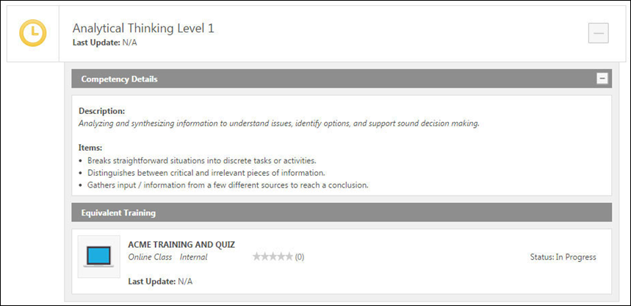
For competencies that have not yet been completed, users can view any training that can be completed to satisfy the competency requirement. To view training equivalents for a competency, click the Expand icon to the right of the competency. Up to five learning objects are displayed. The system only displays equivalent training that is available to the user.

