Check-Ins March 2024

Table of Contents
Check-Ins Overview 1
Check-Ins - Manage Check-Ins Overview 2
Check-Ins Home Page 3
Check-Ins Insights Page 7
Check-Ins - Create a New Check-In Meeting 12
Check-Ins - Manage Meetings and Topics 17
Check-Ins - Manage Settings 39
Check-Ins - View Check-In Discussions from Performance Reviews 43
Check-Ins - Manage Skills 44
Check-Ins - Administrator Overview 49
Check-Ins - Customize the Check-Ins Main Page 50
Check-Ins - Email Digest Management 54
Check-Ins - Manage Templates 57
Check-Ins - Create/Edit a Template 61
Check-Ins Mobile 65
Check-Ins - Reporting 2.0 Fields 72
Check-Ins Integrations 74
Check-Ins Microsoft Teams Integration 75
Check-Ins - Outlook Integration 78
Check-Ins Slack Integration 82

Check-Ins Overview
The Check-Ins tool is a continuous performance management tool to help organizations have ongoing and effective dialogs with their managers and teams to drive alignment, coaching, and continuous performance development.
This tool provides administrators with default templates that can be modified, or administrators can create new templates, add and edit discussion topics, and provide conversation-guiding text.
Once templates are created, employees can use the Check-Ins tool to define goals and career development, as well as provide feedback to managers. Managers and end users can select an appropriate Check-In type, such as a Goals check-in, complete or review the topics in the check-in, and establish a schedule for regular meetings.
The Check-Ins interface is designed to be mobile-responsive, so it can be used on mobile devices.
There are two main pages that administrators can set as the initial Check-Ins page:
- The Check-Ins home page - See Check-Ins Home Page on page 3 for additional information.
- The Check-Ins Insights page - See Check-Ins Insights Page on page 7 for additional information.
Administrator Actions
Administrators can perform the following tasks when working with Check-Ins:
- Create discussion templates to guide discussions for managers and employees. See Check-Ins - Manage Templates on page 57 for additional information.
- View and edit all discussion settings, add, reorder, and edit topics, and update notes as necessary. See Check-Ins - Create/Edit a Template on page 61 for additional information.
User and Manager Actions
Managers and employees can perform the following tasks when working with check-in discussions
- View and manage current discussions and create new discussions. See Check-Ins Home Page on page 3 for additional information.
- Create new discussions, add participants, select a template, add and modify topics, and set discussion frequency. See Check-Ins - Create a New Check-In Meeting on page 12 for additional information.
- Add a new meeting to an existing, manage the topics for that meeting, view a subset of goals and access the complete list of goals.See Check-Ins - Add a New Meeting on page 22 for additional information.
- Manage general, topic, and history for a discussion. See Check-Ins - Manage Settings on page 39 for additional information.
- Manage email sections and email triggers for discussion notifications.

Check-Ins - Manage Check-Ins Overview

Check-Ins Home Page
Use the Check-Ins home page to view and manage meetings and follow-up action items.
From the Check-Ins home page, you can perform the following tasks:
- Create a new Check-Ins discussion - See Check-Ins - Create a New Check-In Meeting on page 12 for additional information.
- View upcoming follow-up action items
- View and open past and recently modified Check-Ins
- View Getting Started Tips (Videos)
Note: The home page is configurable by your administrator, so the content may vary. If your home page is titled Insights, See Check-Ins Insights Page on page 7 for additional information.
To access the Check-Ins Home Page, go to your organization's home page and select Check-Ins.
Permissions
PERMISSION NAME | PERMISSION DESCRIPTION | CATEGORY

Check-Ins - Create | Grants ability for the user to create and update Check-Ins. The permission constraints determine with whom the user can create Check-In discussions. This permission can be constrained by OU, User's OU, User Self and Subordinates, User, User's Subordinates, User's Direct Reports, User's Self, User's Manager, User's Superiors, and Employee Relationship. Users with constraints in the “Check-Ins - Create” permission cannot create a new Check-In with anyone who is not part of the constraints, but can still view and update any Check-In in which they are a participant.  This is an end user permission.  Note: Permission constraint to Employee Relationship grants permission to dotted line or secondary managers to create Check-Ins with users that report to them in the matrix structure. A constraint "Restricted to Employee Relationship: Detail Supervisor" means that the Detail Supervisor can create a Check-In with their indirect subordinate but the indirect subordinate cannot create a Check-In with their Detail Supervisor. | Performance
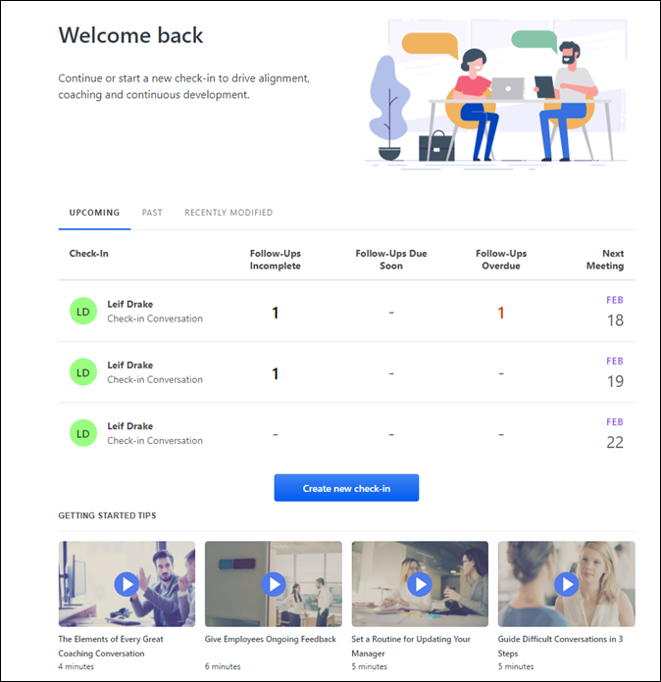
Check-Ins Icons
The following icons are always visible on this page:
Check-Ins Menu- Click this icon to return to the Check-Ins Home Page.
Search- Locate people with whom you want to start a check-ins discussion, search for participants in current discussions or search for previously conducted Check-Ins with participants who are inactive or no longer work for the company. You can also locate participants from archived conversations. Note: You cannot create check-ins with inactive users.
People Sidebar- Displays all participants with whom you had a Check-In discussion. Click any member to view their meeting dates, archive a meeting, or create a new check-in discussion. Participants are filtered as follows:
Users can view everyone they have an active Check-In with ordered by last date modified.​
Welcome/Instructions
This area may contain welcome information or instructions.
Upcoming Tab
The Upcoming tab provides information about the status follow-up action items assigned to you. Incomplete Follow-Ups are color-coded based on the due date:
- Red - Past the assigned due date
- Yellow - Due within seven days
- Black - Any follow-up that's incomplete, regardless of due date
Only meetings that are scheduled in the next seven days display. If no meetings are scheduled in the next seven days, a "You have no meetings planned for the next 7 days" message displays.
Click any follow-up number to open the Follow-Ups flyout where you can change the status of an action item.
Past/Recently Modified Tabs
The Past and Recently Modified tabs provide information about past and recently modified Check-In meetings.
- Past tab - Displays meetings that occurred in the last seven days. If no meetings occurred in the last seven days, a "You haven't had meetings for the last 7 days" message displays.
- Recently Modified tab - Displays meetings that were modified in the last seven days. If no meetings were modified in the last seven days, a "You have no recently modified conversations" message displays.
Each tab contains the following information:
- The name of the user who created the Check-Ins meeting.
- The type of meeting, such as a Goals Check-in.
- The frequency of the meeting, such as weekly or monthly.
- The date of the next meeting.
Note: The Recently Modified tab does not include the date of the next meeting. Instead, it contains the date of the modification.
Click on any Check-Ins meeting to view or add new meetings or manage meeting topics. See Check-Ins - Manage Topics on page 26 for additional information.
Create New Check-In
Click Create new check-in to create a new Check-In discussion and add participants, meeting dates, and topics. See Check-Ins - Create a New Check-In Meeting on page 12 for additional information.
Getting Started Tips
This section may provide helpful micro-learning videos. Click any video to view it.
View Check-Ins
Mobile users can use the View Check-Ins link to access the people bar to select a person and view the appropriate check-in. Note: The View Check-Ins link is not visible if a user has no existing check-ins.

Check-Ins Insights Page
Use the Check-Ins Insights main page to view and manage meetings, notifications and follow-up action items all in the same location.
From the Check-Ins Insights home page, you can perform the following tasks:
- Create a new Check-Ins meeting - See Check-Ins - Create a New Check-In Meeting on page 12 for additional information.
- View and manage upcoming meetings
- View and manage follow-up action items
- View and manage follow-up notifications
Note: This page is configurable by your administrator, so the content may vary. If your home page is not titled Insights, See Check-Ins Home Page on page 3 for additional information.
Permissions
PERMISSION NAME | PERMISSION DESCRIPTION | CATEGORY

Check-Ins - Create | Grants ability for the user to create and update Check-Ins. The permission constraints determine with whom the user can create Check-In discussions. This permission can be constrained by OU, User's OU, User Self and Subordinates, User, User's Subordinates, User's Direct Reports, User's Self, User's Manager, User's Superiors, and Employee Relationship. Users with constraints in the “Check-Ins - Create” permission cannot create a new Check-In with anyone who is not part of the constraints, but can still view and update any Check-In in which they are a participant.  This is an end user permission.  Note: Permission constraint to Employee Relationship grants permission to dotted line or secondary managers to create Check-Ins with users that report to them in the matrix structure. A constraint "Restricted to Employee Relationship: Detail Supervisor" means that the Detail Supervisor can create a Check-In with their indirect subordinate but the indirect subordinate cannot create a Check-In with their Detail Supervisor. | Performance
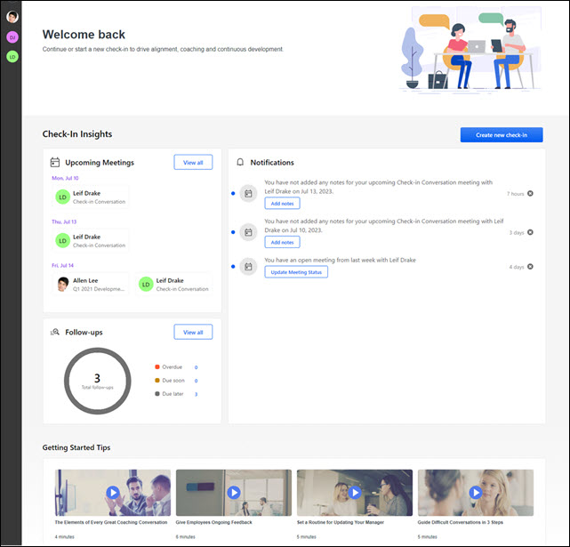
Check-Ins Icons
The following icons are always visible on this page:
Check-Ins Menu- Click this icon to return to the Check-Ins Home Page.
Search- Locate people with whom you want to start a check-ins discussion, search for participants in current discussions or search for previously conducted Check-Ins with participants who are inactive or no longer work for the company. You can also locate participants from archived conversations. Note: You cannot create check-ins with inactive users.
People Sidebar- Displays all participants with whom you had a Check-In discussion. Click any member to view their meeting dates, archive a meeting, or create a new check-in discussion. Participants are filtered as follows:
Users can view everyone they have an active Check-In with ordered by last date modified.​
Welcome/Instructions
This area may contain welcome customized information or instructions.
Create New Check-In Button
Click Create new check-in to create a new Check-In discussion and add participants, meeting dates, and topics. See Check-Ins - Create a New Check-In Meeting on page 12 for additional information.
Upcoming Meetings Section
The Upcoming Meetings section displays up to six upcoming meetings by default. Meetings are ordered by date. If a user has multiple meetings on the same date, the meetings are ordered alphabetically.
- Click the View all button opens the Upcoming Meetings flyout to view all upcoming meetings.
- Click on any meeting listed in this section or the flyout to open the meetings and topic page for the selected meeting. See Check-Ins - Manage Meetings and Topics on page 17 for additional information.
Follow-Ups Section
The Follow-Ups section displays follow-up action items within the upcoming seven days by default, including a graph of follow-up status.
Follow-Up status is as follows:
- Overdue: The number of follow-ups with a due date that is passed.
- Due soon: The number of follow-ups due in the next seven days.
- Due later: The number of follow-ups due after the next seven days.
Follow-Ups Flyout
Click the View All button or any follow-us status number to open the Follow-Ups flyout. The flyout displays all incomplete Follow-Ups by due date and assignees, ordered by status and due date. Click any meeting series name to open the selected follow-up in the meeting.
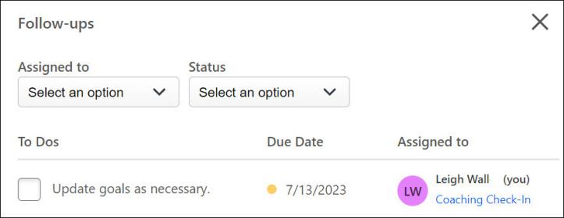
You can perform the following tasks on the flyout:
- Filter follow-ups: Use the Assigned to and Status options to filter follow-ups.
- Mark a follow-up completed: To mark a follow-up complete, check its check-box. Note: While the flyout is open, marking a follow-up complete puts a line through it. Once the flyout is closed, the completed follow-up is removed.
Notifications Section
The Notifications section displays notifications that apply to follow-up action items. Users can also add notes or update their meeting status in this section.
Notifications are ordered by date, and the time the notification was updated is provided. Past or deleted notifications are automatically hidden. Users receive one notification per meeting in a series.
A blue dot indicates that no action has been taken on a notification. Hovering over an unactioned item highlights the item. Once there is action on an item, the blue dot is no longer visible.
You can view the following notifications and take action as noted below:
- A meeting participant rescheduled the meeting: Click the notification to open the rescheduled meeting. If this notification is dismissed, notifications are no longer received for this meeting.
- An upcoming meeting has not been opened or no notes added: Click the Add Notes button to open the upcoming meeting and add a note. If notes are added to the meeting, the notification disappears from the list.
- A meeting participant added notes to a meeting: Click the notification to view the latest note added in the meeting series. If this notification is dismissed, notifications are no longer received for this meeting.
- The meeting status is open for a past meeting: If the open meeting status is within the past seven days, click the Update Meeting Status button to open the Meeting Status flyout to manage the status. Click a participants name open the associated meeting.
- A meeting participant cancels the meeting: Click the notification to open the cancelled meeting. If multiple meetings are cancelled, the most recent cancelled meeting opens.
- A participant reopened a meeting that a user cancelled or completed: Click the notification to open the reopened meeting.
- A user or other meeting participant has overdue follow-ups: Click the notification to open the Follow-Ups flyout filtered by assignee and status.
- A user has a follow-up due soon: Click the notification to open the Follow-Ups flyout filtered by assignee and status.
Notification Buttons
The Notifications sections also provides the following buttons:
- Add Notes: Opens the upcoming meeting to add a note.
- Update Meeting Status: Opens the Meeting Status flyout to manage meeting status.
- Create new Check-In: Create a new Check-In discussion and add participants, meeting dates, and topics.
Getting Started Tips
If available, this section provides helpful micro-learning videos. Click any video to view it.

Check-Ins - Create a New Check-In Meeting
Users can create a new check-in meeting, add participants, select a meeting template, add and modify topics, and schedule meeting dates.
To create a new Check-In, go to Performance > Check-Ins.
- If this is the first time creating a check-in meeting, click the Get Started button on the main page.
- If this is not the first time creating a check-in meeting, click the Create New check-in button on the main page.
Note: Your administrator can change the name of these buttons, so your button names may be different.
Permissions
PERMISSION NAME | PERMISSION DESCRIPTION | CATEGORY

Check-Ins - Create | Grants ability for the user to create and update Check-Ins. The permission constraints determine with whom the user can create Check-In discussions. This permission can be constrained by OU, User's OU, User Self and Subordinates, User, User's Subordinates, User's Direct Reports, User's Self, User's Manager, User's Superiors, and Employee Relationship. Users with constraints in the “Check-Ins - Create” permission cannot create a new Check-In with anyone who is not part of the constraints, but can still view and update any Check-In in which they are a participant.  This is an end user permission.  Note: Permission constraint to Employee Relationship grants permission to dotted line or secondary managers to create Check-Ins with users that report to them in the matrix structure. A constraint "Restricted to Employee Relationship: Detail Supervisor" means that the Detail Supervisor can create a Check-In with their indirect subordinate but the indirect subordinate cannot create a Check-In with their Detail Supervisor. | Performance
Create a New Check-In Meeting
- On the Create a new check-in page, search for and select the user you want to include in this meeting, and then select the Continue button. You can only create a meeting with users who are within your permission constraints. Note: Search results may include inactive users. You cannot create check-ins with inactive users.
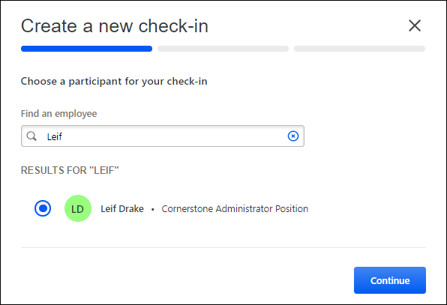
Note: If the selected participant currently exists in this meeting, a notification message appears. Select the View Existing series button to review the existing series.
- Select the button for the template you want to use in this meeting and click Continue. Click Details to view general information and topics for the template. You can only view and select templates to which you have access.
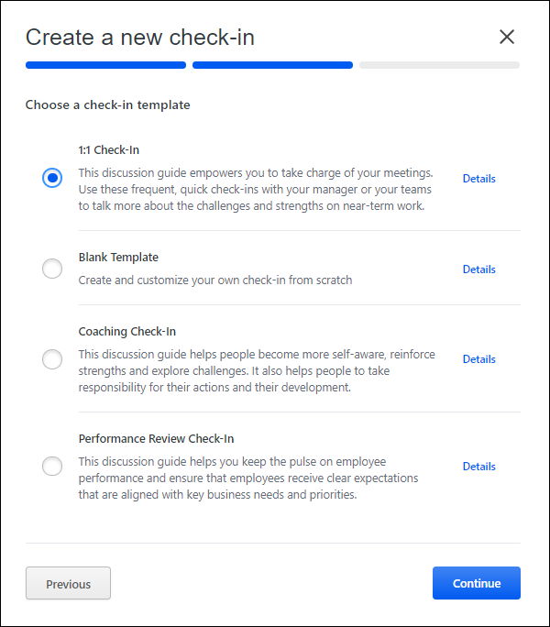
- Complete the meeting schedule:
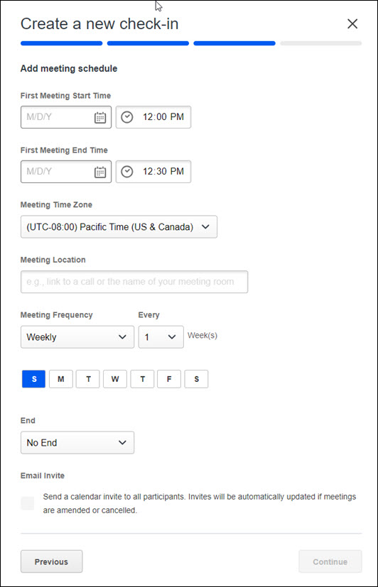
- *First Meeting Start Time and First Meeting End Time - Select meeting times for recurring meetings.
- *Meeting Time Zone - Select the default time zone for this meeting. This is a required field.
- *Meeting Location - Select a location for the meeting series. Add a link to a MSTeams or Zoom call or the name of the meeting room.
- *Meeting Frequency - Select weekly or monthly recurrence options.
- *End - Select to end the meeting series on a specific date. Options are On to end on a specific date, No End to continue indefinitely, or After to end after a specific number of occurrences..
- *Email Invite - Check to send an Outlook calendar invite to both participant in the Check-Ins meeting series. The meeting invite is updated if there are changes to the meeting series. Email invites can be sent on desktop or mobile.
*Complete these fields to send an Outlook calendar invite to participants when creating a new Check-Ins meeting series or for an existing series. Once the meeting is confirmed, the invite is automatically sent to the Outlook calendar for both participants. To enable Outlook calendar invites, See Check-Ins - Outlook Calendar Integration.
- Click Continue review the meeting details.
- Click Confirm to save the meeting.

Check-Ins - Manage Meetings and Topics
Use the Check-Ins meetings and topics page to manage meetings, topics, notes, and settings. With the appropriate permissions, you can also view goals and development plans for participants in the discussion.
From the meetings and topics page, you can perform the following tasks:
- Add a new meeting
- Add Follow-Up action items See Check-Ins - Manage Follow-Ups on page 32 for additional information.
- Archive/restore a meeting
- Delete a meeting
- Download topics, notes, and follow-ups to a .pdf file
- Manage views
- Manage topics See Check-Ins - Manage Topics on page 26 for additional information.
- View settings See Check-Ins - Manage Settings on page 39 for additional information.
- View or add meeting notes
- See Date/Edited/Saved/View History on page 21 for additional information.
- View user goals
- View user Skills Profile
- View user development plans
To view the meetings and topics page, go to Performance > Check-Ins and then click the appropriate check-in on your home page.
Permissions
PERMISSION NAME | PERMISSION DESCRIPTION | CATEGORY

Check-Ins - Create | Grants ability for the user to create and update Check-Ins. The permission constraints determine with whom the user can create Check-In discussions. This permission can be constrained by OU, User's OU, User Self and Subordinates, User, User's Subordinates, User's Direct Reports, User's Self, User's Manager, User's Superiors, and Employee Relationship. Users with constraints in the “Check-Ins - Create” permission cannot create a new Check-In with anyone who is not part of the constraints, but can still view and update any Check-In in which they are a participant.  This is an end user permission.  Note: Permission constraint to Employee Relationship grants permission to dotted line or secondary managers to create Check-Ins with users that report to them in the matrix structure. A constraint "Restricted to Employee Relationship: Detail Supervisor" means that the Detail Supervisor can create a Check-In with their indirect subordinate but the indirect subordinate cannot create a Check-In with their Detail Supervisor. | Performance
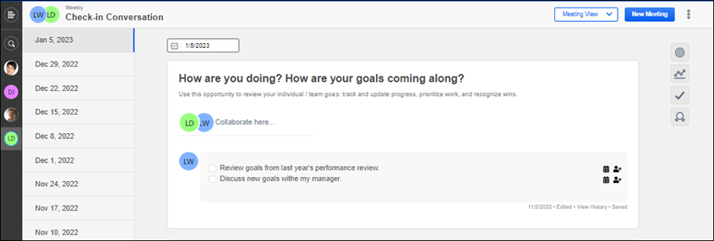
Note: All of the actions you perform on this page are saved automatically.
Check-Ins Icons
The following icons are always visible on this page:
Check-Ins Menu- Click this icon to return to the Check-Ins Home Page.
Search- Locate people with whom you want to start a check-ins discussion, search for participants in current discussions or search for previously conducted Check-Ins with participants who are inactive or no longer work for the company. You can also locate participants from archived conversations. Note: You cannot create check-ins with inactive users.
People Sidebar- Displays all participants with whom you had a Check-In discussion. Click any member to view their meeting dates, archive a meeting, or create a new check-in discussion. Participants are filtered as follows:
Users can view everyone they have an active Check-In with ordered by last date modified.​
Meeting or Topic View
Use the view drop-down to display Meeting View or Topic View.
- Meeting View - Displays meetings in the left pane and all related topics, notes, and follow-ups topics in the left pane. This is the default view. Right click on any meeting to:
  - Mark as completed - Only check-in meetings that have content can be marked as completed.
  - Cancel this meeting - Cancel meetings at anytime.
Participants can edit the notes of a check-in meeting when a meeting is completed or cancelled.
- Topic View - Displays all topics in this meeting in the left pane. Select a topic to view associated notes sorted by meeting dates. Topics are listed in the same order as they appear in the Manage Topics list.
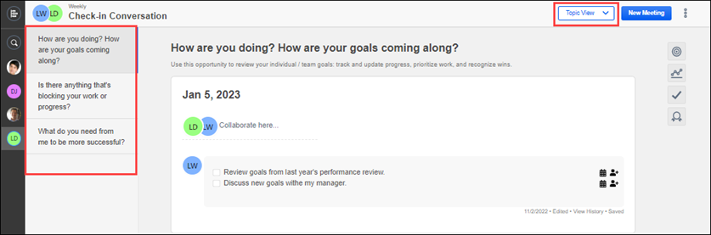
New Meeting
Click the New Meeting button to add a new meeting to this discussion.
There are two ways to create a new meeting:
- If you set a meeting frequency when you created this discussion, when you click New Meeting, the new meeting date appears in the meeting list based on the set frequency.
- Select a meeting date in the date field. The selected date appears in the meeting column.
All meetings associated with the selected template will have the same topics, but you can add and save different notes per meeting. See Check-Ins - Manage Notes on page 29 for additional information.
Options
Click the Options menu to access the following options:
- Archive - Select to archive a check-in series. This item not appears on the Archived tab.
- Share check-in - Share a meeting series with other users.
- Check-In Settings - View the settings pages for this meeting. Settings include:
  - General Settings - View or edit the name, description, or meeting frequency for this discussion.
  - Manage Topics - Manage the topics for this meeting. You can add, edit, move, and archive topics.
  - Modification History - View all changes made to this meeting.
See Check-Ins - Manage Settings on page 39 for additional information.
- Export to PDF - Select to export all topics, notes, and follow-ups for this meeting to a .pdf file. This option is only visible in Meeting View.
- Delete Meeting - Select the appropriate meeting date, click the ellipses, and then click Delete Meeting. The creator of a meeting can delete it, but only if all of the notes or follow-ups were also entered by the creator. If another user entered notes or follow-ups, the meeting cannot be deleted. Deleted Check-In meetings cannot be restored. You can view deleted meeting details on the Check-Ins Modification History page. This option is only visible in Meeting View. See Check-Ins - Manage Settings on page 39 for additional information.
- Download Calendar Invite (Series) - Select to download a series calendar invite.
- Download Calendar Invite (Occurrence) - Select to download a single calendar invite.
Archive/Restore a Meeting
You can archive and restore a check-in meetings.
- To archive a meeting, in the People Bar, click the user icon for the user whose meeting you want to archive. The meeting page opens. Click the ellipses for the appropriate meeting, and then click Archive. Click Confirm on the confirmation message. The meeting is archived and moves to the Archived tab.
- To restore a meeting:
  - In the People Bar, click the user icon for the user whose meeting you want to restore. The meeting page opens. Click the ellipses for the appropriate meeting, and then click Restore. The meeting is now active moves to the Active tab.
  - Select the Restore button in the "This check-in is archived" banner at the top of the page. The meeting is now active moves to the Active tab.
- To view a check-in meeting without restoring it, from the People Sidebar, click a participant's name. Click the Archived tab and select the meeting you want to view. To make any changes to an archived check-in, it must be restored. An archived check-in cannot be shared.
Meeting List/Topic List
This list appears at the left of the window and displays the meeting list or topic list based on the selected view.
Formatting Toolbar
Use the formatting toolbar to add emphasis to any text that you enter on this page. You can bold, italicize, underline, and add numbers or bullets to text. You can also add, delete, or open hyperlinks in a new tab.
The check-mark allows you to add Follow-Up action items to a topic. See Check-Ins - Manage Follow-Ups on page 32 for additional information.
Date Field
Click and select a date to schedule a meeting for this discussion. The selected date appears in the meeting list.
Goals Icon
Click the Goals icon to display a quick view of the current goals for the selected participant. Click the Manage button to view full goal details. You must have the appropriate permissions to view or manage user goals. Note: The Goals Panel applies the same rules that the 'View Goals' permission allows for goals, so Managers can only view goals for their direct reports.
Development Plan Icon
Click the Dev Plan icon to display a quick view of the current development plan for the selected participant. You can click on a Development Objective for more information or click the Manage button to display the full development plan. Note: The Dev Plan panel applies the same rules that the "Snapshot - Development Plans permission allows for development plans, so managers can only view goals for their direct reports.
Follow-Ups Icon
You can add follow-up action items to a meeting topic. Follow-up action items can be assigned a due date and assigned to a user. See Check-Ins - Manage Follow-Ups on page 32 for additional information.
Skills Icon
Click the Skills icon to view a flyout that provides skills information and access to your Skills Profile.
Notes
The meetings and topics page provides a place to write collaborative and individual notes for all participants in the meeting.
- To add a collaborative note, click in the Collaborate here area and enter your notes.
- To add an individual note, scroll down to your personal identifier, click on the note line, and add your notes. Individual notes can only be changed or deleted by the original writer.
Once you click the notes area, you can use the formatting toolbar to customize the look of your notes.
Additionally, you can create follow-up action items in the notes areas. See Check-Ins - Manage Follow-Ups on page 32 for additional information.
Date/Edited/Saved/View History
These fields appear under each group of notes when a participant makes changes. These options only appear if there are changes.
- The date displays when the notes were edited.
- Edited - The notes are changed.
- Saved - The changes are saved to the notes section and the View History page.
- View History - Opens the Edit History page that displays all changes to notes.
Manage Topics
Click Manage Topic to open the Manage Topics page where you can add, edit, move, and archive topics. See Check-Ins - Manage Topics on page 26 for additional information.
Check-Ins - Add a New Meeting
Use the meetings and topics page to add a new meeting to an existing check-in.
To access the meetings and topics page, go to Performance > Check-Ins and select the appropriate meeting.
Permissions
PERMISSION NAME | PERMISSION DESCRIPTION | CATEGORY

Check-Ins - Create | Grants ability for the user to create and update Check-Ins. The permission constraints determine with whom the user can create Check-In discussions. This permission can be constrained by OU, User's OU, User Self and Subordinates, User, User's Subordinates, User's Direct Reports, User's Self, User's Manager, User's Superiors, and Employee Relationship. Users with constraints in the “Check-Ins - Create” permission cannot create a new Check-In with anyone who is not part of the constraints, but can still view and update any Check-In in which they are a participant.  This is an end user permission.  Note: Permission constraint to Employee Relationship grants permission to dotted line or secondary managers to create Check-Ins with users that report to them in the matrix structure. A constraint "Restricted to Employee Relationship: Detail Supervisor" means that the Detail Supervisor can create a Check-In with their indirect subordinate but the indirect subordinate cannot create a Check-In with their Detail Supervisor. | Performance
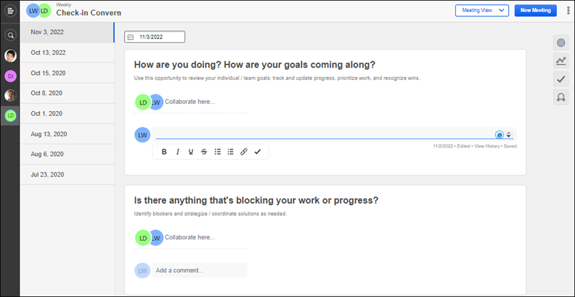
Add a New Meeting
To add a new meeting:
- Open the meeting where you want to add a new meeting date.
- Select one of the following options:
  - To add a new date, select a new date in the in the date selection field . The new date appears in the New Meeting section.
  - To add a new date in the current meeting frequency, click the New Meeting button without selecting a date in the date field. For example, if the current meeting frequency is bi-monthly, the new date is the next bi-monthly date from the last meeting. The selected date appears in the meeting list.

Check-Ins - Delete Meetings
Use the meetings and topics page to delete specific meetings or a user's personal meeting page to delete a series of meetings..
- To open the meetings and topics page, go to Performance > Check-Ins and then click the appropriate check-in on your home page.
- To open your personal meeting page, click your icon on the people bar.
Permissions
PERMISSION NAME | PERMISSION DESCRIPTION | CATEGORY

Check-Ins - Create | Grants ability for the user to create and update Check-Ins. The permission constraints determine with whom the user can create Check-In discussions. This permission can be constrained by OU, User's OU, User Self and Subordinates, User, User's Subordinates, User's Direct Reports, User's Self, User's Manager, User's Superiors, and Employee Relationship. Users with constraints in the “Check-Ins - Create” permission cannot create a new Check-In with anyone who is not part of the constraints, but can still view and update any Check-In in which they are a participant.  This is an end user permission.  Note: Permission constraint to Employee Relationship grants permission to dotted line or secondary managers to create Check-Ins with users that report to them in the matrix structure. A constraint "Restricted to Employee Relationship: Detail Supervisor" means that the Detail Supervisor can create a Check-In with their indirect subordinate but the indirect subordinate cannot create a Check-In with their Detail Supervisor. | Performance
Only the creator of a check-in meeting or meeting series can delete it. If another user entered notes or follow-ups, the creator cannot delete the meetings, but can archive them.
You cannot restore deleted meetings, but deleted meeting details appear on the Check-Ins Modification History page. See Check-Ins - Manage Settings on page 39 for additional information.
Delete a Meeting
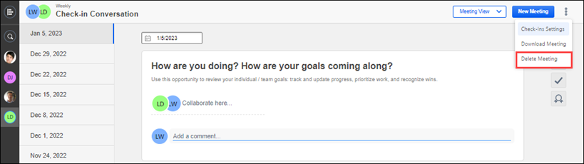
To delete a meeting:
- On the Check-Ins home page, select the meeting you want to delete. The meetings and topics page opens.
- Click the ellipses and select Delete Meeting. If no other participants added notes or follow-ups, it is deleted.
Delete a Meeting Series
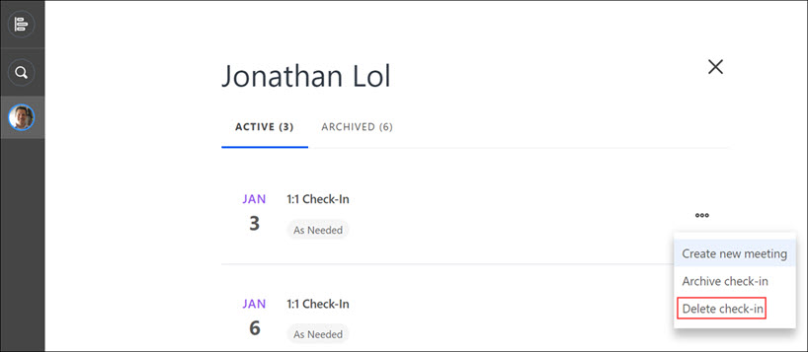
To delete a check-in series:
- On the people bar, select your participant icon. Your check-ins page opens.
- Select the ellipses for the meeting series you want to delete and select Delete check-in.
- On the confirmation panel, select the Confirm button.
If no other participants added notes or follow-ups to this meeting series, it is deleted.

Check-Ins - Manage Topics
Topics are the discussion guide questions or statements that are part of each Check-Ins meeting. Each meeting must have at least one topic.
Note: If you add, remove, or edit topics, the changes apply to all past, present, and future meetings in the selected Check-Ins conversation, not just an individual meeting.
From the Manage Topics settings page, you can perform the following tasks:
- Add a topic
- Edit a topic
- Archive and restore topics
- Change the order of topics
To view the Manage Topics page, go to Performance > Check-Ins and then click the appropriate Check-In on your Home Page. Click the ellipses, click Check-Ins Settings, and then click the Manage Topics tab.
Permissions
PERMISSION NAME | PERMISSION DESCRIPTION | CATEGORY

Check-Ins - Create | Grants ability for the user to create and update Check-Ins. The permission constraints determine with whom the user can create Check-In discussions. This permission can be constrained by OU, User's OU, User Self and Subordinates, User, User's Subordinates, User's Direct Reports, User's Self, User's Manager, User's Superiors, and Employee Relationship. Users with constraints in the “Check-Ins - Create” permission cannot create a new Check-In with anyone who is not part of the constraints, but can still view and update any Check-In in which they are a participant.  This is an end user permission.  Note: Permission constraint to Employee Relationship grants permission to dotted line or secondary managers to create Check-Ins with users that report to them in the matrix structure. A constraint "Restricted to Employee Relationship: Detail Supervisor" means that the Detail Supervisor can create a Check-In with their indirect subordinate but the indirect subordinate cannot create a Check-In with their Detail Supervisor. | Performance
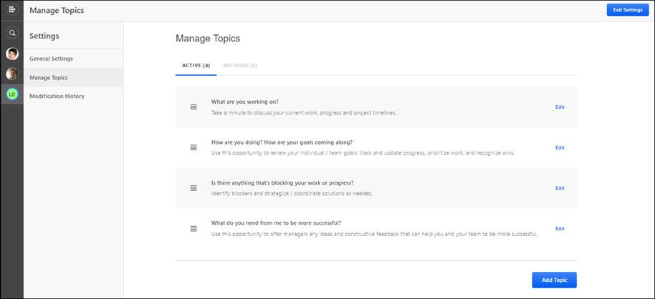
Check-Ins Icons
The following icons are always visible on this page:
Check-Ins Menu- Click this icon to return to the Check-Ins Home Page.
Search- Locate people with whom you want to start a check-ins discussion, search for participants in current discussions or search for previously conducted Check-Ins with participants who are inactive or no longer work for the company. You can also locate participants from archived conversations. Note: You cannot create check-ins with inactive users.
People Sidebar- Displays all participants with whom you had a Check-In discussion. Click any member to view their meeting dates, archive a meeting, or create a new check-in discussion. Participants are filtered as follows:
Users can view everyone they have an active Check-In with ordered by last date modified.​
Add a Topic
- Click the Add Topic button.
- On the Add Topic flyout, complete the following fields:
  - Topic Title (required). Maximum 200 characters.
  - Topic Instructions (optional).
- Click Save to save the new topic to the topic list.
Tip: If you want to add several topics at once, click the Add Another Topic checkbox after you finish the first topic, and then click Save. The topic is saved to the topic list and a blank Add Topic page flyout opens.
Edit a Topic
To edit a topic, click Edit for the appropriate topic. The Edit Topic flyout opens. Edit the appropriate fields and click SAVE.
Archive/Restore a Topic
The Active tab displays all active topics in this discussion. The Archived tab displays all archived topics in this discussion. Once a topic is archived, it is no longer visible in the meeting. Note: If this topic is part of a template, it may be archived for this discussion, but remains active in other discussions that use this template.
- Archive a topic - On the Active tab, click Edit for the appropriate topic. On the Edit Topic fly-out, click the Archive this topic checkbox. The topic is moved to the Archived tab and is not visible for this meeting.
- Restore a topic - On the Archived tab, click Restore for the appropriate topic. The restored topic appears on the Active tab and is visible for this meeting.
Change the Order of Topics
To change the order of a topic, click anywhere on the topic and drag it up or down to the new location in the list.
Check-Ins - Manage Notes
Use the meetings and topics page to enter collaborative, individual, or personal notes for a meeting topic. Participants can also see when a note has been edited, what changes were made to a note, and who made the changes.
You can perform the following tasks for notes:
- Add a collaborative note
- Add an individual note
- Delete an individual note
- Add a personal note
- View the edit date for a note
- View the change history for a note
- Download topics and notes
To view the meetings and topics page, go to Performance > Check-Ins and then click the appropriate check-in on your home page.
Permissions
PERMISSION NAME | PERMISSION DESCRIPTION | CATEGORY

Check-Ins - Create | Grants ability for the user to create and update Check-Ins. The permission constraints determine with whom the user can create Check-In discussions. This permission can be constrained by OU, User's OU, User Self and Subordinates, User, User's Subordinates, User's Direct Reports, User's Self, User's Manager, User's Superiors, and Employee Relationship. Users with constraints in the “Check-Ins - Create” permission cannot create a new Check-In with anyone who is not part of the constraints, but can still view and update any Check-In in which they are a participant.  This is an end user permission.  Note: Permission constraint to Employee Relationship grants permission to dotted line or secondary managers to create Check-Ins with users that report to them in the matrix structure. A constraint "Restricted to Employee Relationship: Detail Supervisor" means that the Detail Supervisor can create a Check-In with their indirect subordinate but the indirect subordinate cannot create a Check-In with their Detail Supervisor. | Performance
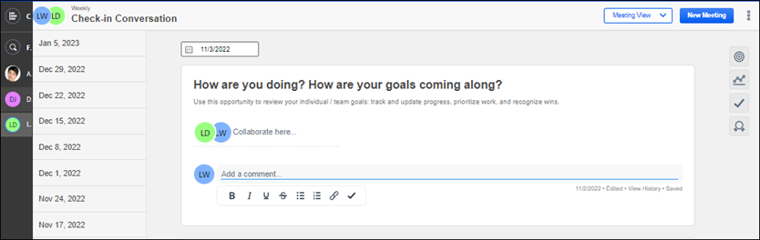
Note: All additions and changes made to this page are saved automatically.
Add a Collaborative Note
To add a collaborative note, click on the Collaborate here line and enter your note.
Collaborative notes can be modified or deleted by any participant in the meeting with appropriate permissions.
Add an Individual Note
To add an individual note, scroll down to your personal identifier for the appropriate topic and add your note. Individual notes can only be modified by the original writer.
Delete an Individual Note
You can delete any individual note that you created. Highlight the text and click the Delete button on your keyboard.
Add a Personal Note
To user personal notes, an administrator must enable the functionality. To enable, a system administrators with the Check-Ins Settings - Manage permission can go to Admin > Performance Management > Check-Ins Settings and
To access the personal meeting note feature, select the note icon. The Personal Notes flyout opens.
- To create a personal note: On the Current Meeting tab, type your note(s). The note is automatically saved. Notes are accessed on the Current Meeting tab only on the day it is created. After that, it displays on the Previous Meeting tab.
- To edit a previous note: Select the Previous Meetings tab. Select a date range to filter the notes. Click the appropriate note to edit it. Click Save when you are done editing. Note: For filtering, there is a range limit of 12 months.
Personal notes are only visible to the writer of the note. Users can view or edit their previous personal notes at any time. The previous notes for the last three months are visible by default.
Date/Edited
The following fields appear under a note when it is edited:
- The date field shows when the last edit was made.
- Edited indicates the note has been edited.
View History
This field only appears under a note if it is edited.
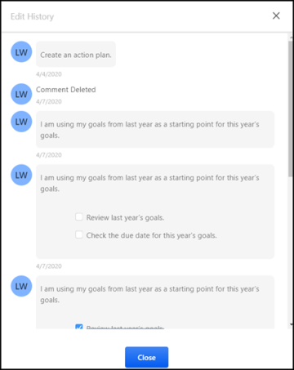
To view all changes for individual or shared notes, click the View History link. An Edit History page opens.
Download Topics and Notes
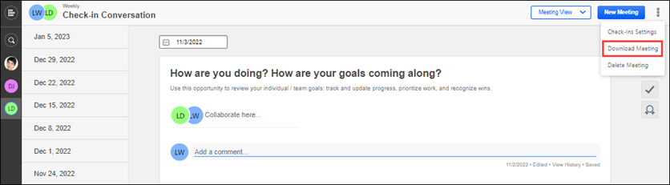
You can download all notes and topics for a selected meeting to a .pdf file. To download, click the ellipses, and then select Download Meeting. This option is only available in Meeting View.
Check-Ins - Manage Follow-Ups
Use the meetings and topics page to create follow-up action items for meeting topics. Once you create follow-up action items, you can assign them to specific participants and set a completion date.
Tip: To view a summary of all follow-ups, click the Upcoming tab on your home page. See Check-Ins Home Page on page 3 for additional information.
You can perform the following tasks for Follow-Ups:
- Create Follow-Ups
- Assign a Follow-Up completion date
- Assign a Follow Up to a user
- Change the Follow-Up status
- View a summary of Follow-Ups
You can also add notes to follow-up topics. See Check-Ins - Manage Notes on page 29 for additional information.
To view the meetings and topics page, go to Performance > Check-Ins and then click the appropriate check-in discussion on your dashboard.
Permissions
PERMISSION NAME | PERMISSION DESCRIPTION | CATEGORY

Check-Ins - Create | Grants ability for the user to create and update Check-Ins. The permission constraints determine with whom the user can create Check-In discussions. This permission can be constrained by OU, User's OU, User Self and Subordinates, User, User's Subordinates, User's Direct Reports, User's Self, User's Manager, User's Superiors, and Employee Relationship. Users with constraints in the “Check-Ins - Create” permission cannot create a new Check-In with anyone who is not part of the constraints, but can still view and update any Check-In in which they are a participant.  This is an end user permission.  Note: Permission constraint to Employee Relationship grants permission to dotted line or secondary managers to create Check-Ins with users that report to them in the matrix structure. A constraint "Restricted to Employee Relationship: Detail Supervisor" means that the Detail Supervisor can create a Check-In with their indirect subordinate but the indirect subordinate cannot create a Check-In with their Detail Supervisor. | Performance
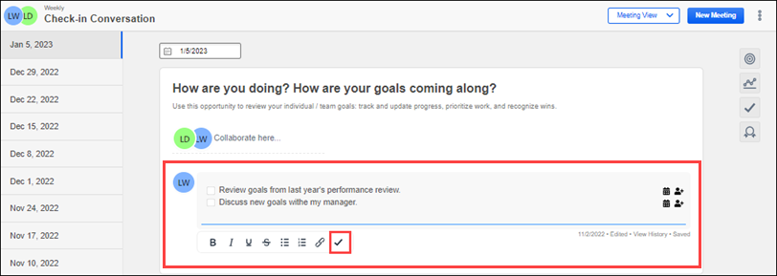
Create Follow-Ups
To create a follow-up action item:
- Put the cursor in the note area where you want to add a follow-up action item. For example, if you want to add a list of follow-up action items to an individual note that you created, put your cursor in that area.
- Type the first follow-up action item, and then click the checkmark on the style toolbar. The action item appears with a checkbox.
Tip: If you want to add another follow-up, after you complete the first follow-up item, press the <Enter> key and type your next action item. Once you finish adding your follow-ups and want to continue adding normal text, press the <Enter> key, then press the <Shift> and <Tab> keys at the same time.
Assign a Follow-Up Completion Date
To add a completion date, hover over an action item, click the calendar and select a date. The date appears after the follow-up.
Assign Follow-Ups to a User
To assign a follow-up to yourself or another participant, hover over an action item, click the add user icon and select a user. The assigned user's Avatar appears.
Change the Follow-Up Status
To mark a follow-up complete, click its checkbox. If a follow-up is not complete, its checkbox remains unchecked.
View a Summary of Follow-Ups
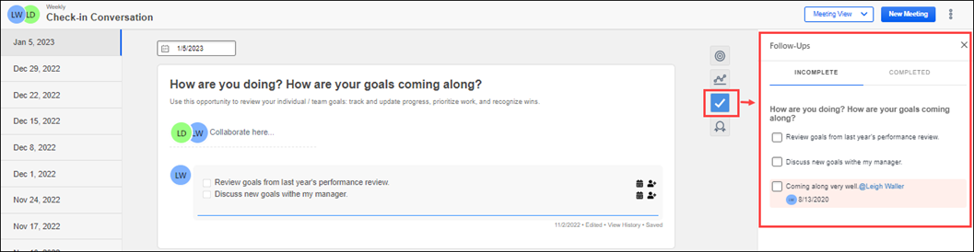
Click the Follow-Ups icon to open the summary flyout. The Follow-Ups flyout has a Completed tab that displays completed action items and an Incomplete tab that displays action items that are not yet complete. The flyout is synced with the main topic display, so any action taken in either area is reflected in both places. Follow-Up items on the summary page are listed by topic.
Check-Ins - Manage Shared Meetings
Users can share Check-In meeting series with other colleagues, such as managers and coaches. Users can perform the following tasks:
- Share a check-ins series
- View shared participants
- Add participants
- Remove participants
- Share archived series
- Share from mobile devices
Permissions
PERMISSION NAME | PERMISSION DESCRIPTION | CATEGORY

Check-Ins - Settings - Manage | Grants ability for the user to update global settings relating to Check-Ins. The permission constraints determine whom can modify the global Check-In settings. This permission can be constrained by OU, User's OU, User Self and Subordinates, User, User's Subordinates, User's Direct Reports, User's Self, User's Manager, User's Superiors, and Employee Relationship.  This is an administrator permission. | Performance
Enable Check-Ins sharing
To use this functionality, an administrator must enable it on the Check-Ins Settings page. To access, go to Admin > Performance Management > Check-Ins Settings. Enable the Check-Ins View Permission option.
Share Check-Ins
Once enabled, an active participant of the Check-In can share the Check-In series with an unlimited number of users in the organization.
To share a check-in series:
- Select an option below:
  - From the People Sidebar, select a user with whom you share an active Check-In. Click the Active tab. Click the action menu, and click Share.
  - From a Check-In Series: Go to the Check-Ins home page and select a meeting that is part of a series. From the options menu, click Share check-in.
- In the Add people to share this check-in with box, start typing a name and select one or more names from the name suggestions. Click Share. The selected people now have read-only access to all meetings in the selected Check-In series. Selected users must be active users. Note: Searching and adding users is based on the constraints applied on Check-Ins - Create permission.
Once the Check-In is shared, a Shared with section appears on the Active tab. Hover over each icon to view the user names.
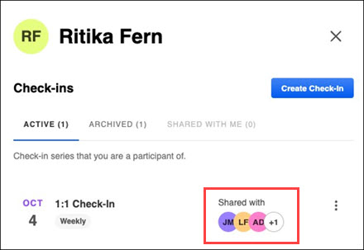
Additionally, a Shared with section now appears on the header of a Check-In series.
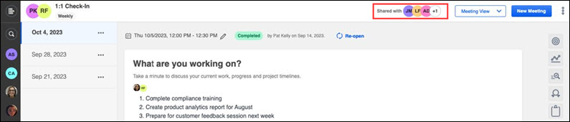
Note: Users on mobile devices can also share a Check-In series on the Active tab and from a Check-Ins meeting series.
View shared participants/users
The Shared with Me tab lists all of the read-only meetings shared with a user. Check-Ins are listed with most recent at the top. Click a Check-In series to view the shared meetings.
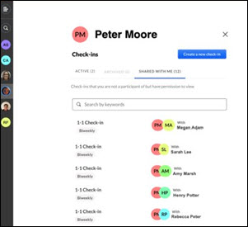
Non-participant Shared Users
Users with shared access who are not participants of the series have read-only access and have limited access to options. These users can view all meetings in the series, view all comments, switch between meeting and topic view and view follow-ups.
Read-only users cannot:
- Add or edit comments​
- Add or edit follow-ups​
- Add a new meeting​
- Download an .ics file​
- View personal notes​
- Update a Check-Ins status​
- Change the meeting date​
- Delete a meeting​
- Archive a meeting series​
- View the skills panel​
Add users
To add a participant to a shared meetings:
- Select the Shared with section of the Active tab or the header of a check-in series.
- Search for the appropriate person, then select the Share button.
Remove users
To remove the read-only permission from a user, on the Share page, click the x next to the appropriate user name. The selected user is no longer able to access the Check-In series. Any series participant can remove a user, even if they did not add them.
Share archived series
Users can now share archived Check-In meeting series without having to restore it first.
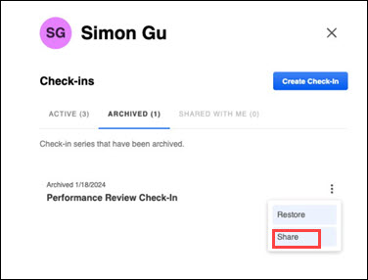
To share an archived meeting series, select the Archived tab for a participant. From the action menu, select Share.
Share from Mobile Devices
Meeting series participants can share a Check-In series through their mobile devices. A series can be shared through the User profile and the Check-In series.
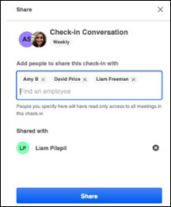

Check-Ins - Manage Settings
Use the Check-Ins settings pages to view information, manage topics, and view modifications. Check-Ins settings pages include the following:
- General Settings - View participants and view/edit the check-in name, description, and meeting frequency.
- Manage Topics - Add, edit, archive, restore, and change the order of topics. See Check-Ins - Manage Topics on page 26 for additional information.
- Modification History - View the modification history for this discussion.
To view the Manage Settings pages, go to Performance > Check-Ins and click the appropriate check-in on your home page. Click the ellipses, and then select Check-Ins Settings.
Permissions
PERMISSION NAME | PERMISSION DESCRIPTION | CATEGORY

Check-Ins - Create | Grants ability for the user to create and update Check-Ins. The permission constraints determine with whom the user can create Check-In discussions. This permission can be constrained by OU, User's OU, User Self and Subordinates, User, User's Subordinates, User's Direct Reports, User's Self, User's Manager, User's Superiors, and Employee Relationship. Users with constraints in the “Check-Ins - Create” permission cannot create a new Check-In with anyone who is not part of the constraints, but can still view and update any Check-In in which they are a participant.  This is an end user permission.  Note: Permission constraint to Employee Relationship grants permission to dotted line or secondary managers to create Check-Ins with users that report to them in the matrix structure. A constraint "Restricted to Employee Relationship: Detail Supervisor" means that the Detail Supervisor can create a Check-In with their indirect subordinate but the indirect subordinate cannot create a Check-In with their Detail Supervisor. | Performance
General Settings Page
Use the General Settings page to view or edit the following information:
- Check-in Name - The name of this check-in meeting.
- Check-in Description - The description of this check-in meeting.
- Meeting Frequency - How often you want to have this meeting. Options are:
  - As Needed
  - Weekly
  - Bi-weekly
  - Monthly
  - Quarterly.
Note: If you change the meeting frequency for an existing discussion, it also changes for all new meetings added to this discussion.
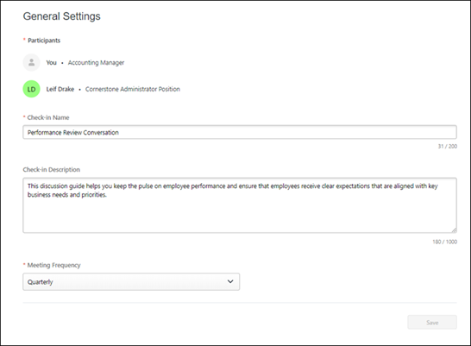
Manage Topics Page
Use the Manage Topics page to add, edit, archive, restore, and change the order of topics. See Check-Ins - Manage Topics on page 26 for additional information.
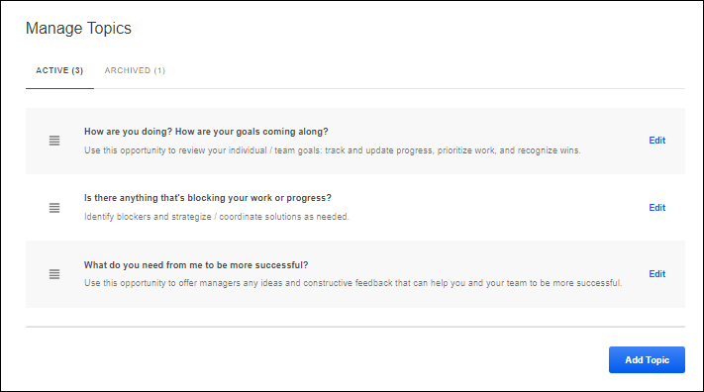
Modification History Page
Use the Modification History page to view a record of all changes made to the meeting. You can also download this information to a .pdf file. This page is read-only.
- Date Range - Select the date range for the changes you want to view.
- User - Select the user whose changes you want to view. You can select All or select a specific user.
- Download icon - Use the download icon to download the modification history to a .pdf file. Once the download is complete, it opens, and you can save it. Note: You must have a .pdf reader installed to download to .pdf.
- Modified on - The date on which the change was made.
- User - The user who made the change.
- Meeting - The meeting date to which the change applies.
- Event - The type of change.
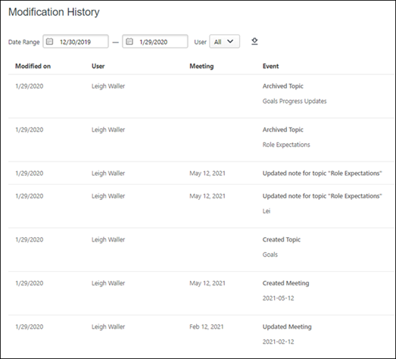
Exit Settings
Click the Exit Settings button to return to the meetings and discussion page.

Check-Ins - View Check-In Discussions from Performance Reviews
With the appropriate permission, reviewers can access Check-In discussions from a Performance Review.
To access the Check-Ins option from a performance review, open a performance review, click the Options drop-down, and select View Check-Ins.
Permissions
PERMISSION NAME | PERMISSION DESCRIPTION | CATEGORY

Check-Ins - Create | Grants ability for the user to create and update Check-Ins. The permission constraints determine with whom the user can create Check-In discussions. This permission can be constrained by OU, User's OU, User Self and Subordinates, User, User's Subordinates, User's Direct Reports, User's Self, User's Manager, User's Superiors, and Employee Relationship. Users with constraints in the “Check-Ins - Create” permission cannot create a new Check-In with anyone who is not part of the constraints, but can still view and update any Check-In in which they are a participant.  This is an end user permission.  Note: Permission constraint to Employee Relationship grants permission to dotted line or secondary managers to create Check-Ins with users that report to them in the matrix structure. A constraint "Restricted to Employee Relationship: Detail Supervisor" means that the Detail Supervisor can create a Check-In with their indirect subordinate but the indirect subordinate cannot create a Check-In with their Detail Supervisor. | Performance
View Check-Ins
The View Check-Ins option is only available if the user has permission to create a Check-In discussion or has had at least one discussion with another person.
- For a reviewer reviewing an employee (such as a manager reviewing an employee):
  - If check-ins between the two are available, this option opens a list of their discussions in a new tab.
  - If the reviewer has not had check-ins with the reviewee, this option opens the Check-Ins landing page in a new tab.
- For self-reviewers, this option opens the Check-Ins landing page in a new tab.

Check-Ins - Manage Skills
End-users can view their Skills Profile during a Check-In meeting to create better skill coaching experiences during Check-In meetings. From the Notes page, users can select the skills icon to access their Skills Profile, add and remove skills, and search for new skills.
To access the Skills Profile flyout, from the Check-Ins meetings and topics page, select the Skills icon.
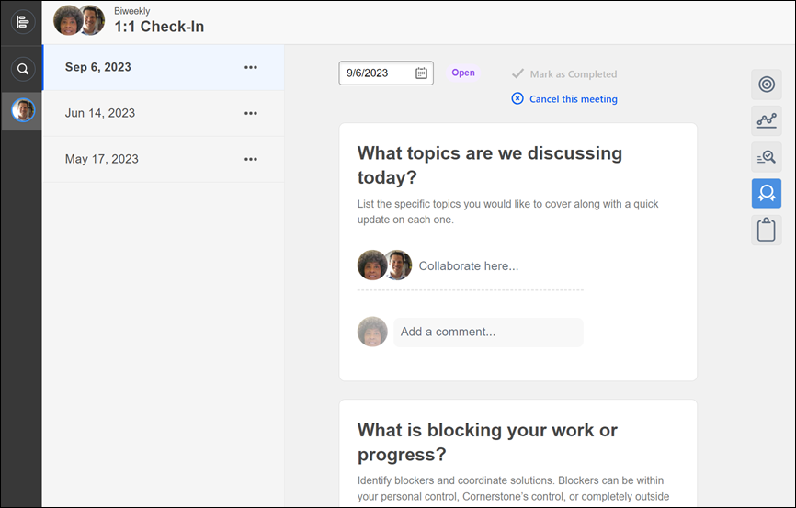
Permissions
PERMISSION NAME | PERMISSION DESCRIPTION | CATEGORY

Check-Ins - Create | Grants ability for the user to create and update Check-Ins. The permission constraints determine with whom the user can create Check-In discussions. This permission can be constrained by OU, User's OU, User Self and Subordinates, User, User's Subordinates, User's Direct Reports, User's Self, User's Manager, User's Superiors, and Employee Relationship. Users with constraints in the “Check-Ins - Create” permission cannot create a new Check-In with anyone who is not part of the constraints, but can still view and update any Check-In in which they are a participant.  This is an end user permission.  Note: Permission constraint to Employee Relationship grants permission to dotted line or secondary managers to create Check-Ins with users that report to them in the matrix structure. A constraint "Restricted to Employee Relationship: Detail Supervisor" means that the Detail Supervisor can create a Check-In with their indirect subordinate but the indirect subordinate cannot create a Check-In with their Detail Supervisor. | Performance

Check-In Templates - Manage | Grants ability to manage Check-Ins Templates. This permission cannot be constrained. This is an administrator permission. | Performance

Capabilities - Skills Profile - View | Grants the ability to view an employee Skills Profile. Users with this permission may view the Skills Profile for anyone in the organization. However, individual ratings have privacy settings that control visibility within the Skills Profile. This permission cannot be constrained. This is an end user permission. | Core Administration
Skills Flyout
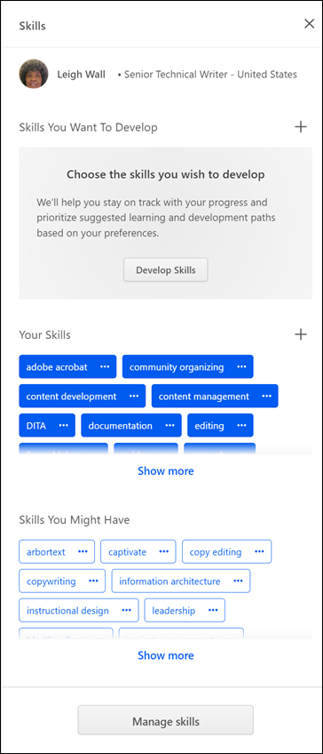
You can perform the following tasks:
- Rate interest in a skill: In the Skills You Want to Develop section, select a skill. From the drop-down, select Rate My Interest. On the self-rating window, click Start and answer the two questions. A user can view their interest ratings and proficiency ratings by opening the skills panel and clicking the skill they have rated. The user must click on self in the graph to view their proficiency and interest ratings as well as any comments related to that skill.
- Rate an employee's proficiency: In the Your Skills section, select a skill. From the drop-down, select Rate Proficiency to rate the employee’s proficiency. Feedback can be private or public. Once the rating is launched, the manager can rate the selected skill.
- Request feedback: From the Skills You Want to Develop section, complete the Request Feedback form and select Save. The recipient of the request can view the request in their Universal Profile on the Actions Tab.

Check-Ins - Administrator Overview
The Check-Ins tool is a continuous performance management tool to help organizations have ongoing and effective dialogs with their managers and teams to drive alignment, coaching, and continuous performance development.
This tool provides administrators with default check-in templates that can be created, modified, add and edit discussion topics, and provide discussion-guiding text.
Once templates are created, employees can use the Check-Ins tool to define goals and career development, as well as provide feedback to managers. Managers and end users can select an appropriate check-in type, such as a Goals check-in, complete or review the topics in the check-in, and establish a schedule for regular check-in meetings.
The Check-Ins interface is designed to be mobile-responsive, so it can be used on mobile devices.
Administrators can perform the following tasks when working with Check-Ins:
- Customize the Home page and Insights page - See Check-Ins - Customize the Check-Ins Main Page on page 50 for additional information.
- Manage templates - Create and edit templates. See Check-Ins - Manage Templates on page 57 for additional information.
- View and edit all check-in settings, add, reorder, and edit topics, and update notes as necessary.
- Manage the email digest - Sent notification emails for Check-Ins and Follow-Ups. See Check-Ins - Email Digest Management on page 54 for additional information.

Check-Ins - Customize the Check-Ins Main Page
Check-Ins administrators can use the Customize Check-Ins Home Page to customize the look and feel of the Check-Ins main pages.
Check-Ins has two different customizable main pages:
- Check-Ins Home Page: View and manage meeting information only. This is the default main page.
- Check-Ins Insights: View and manage meetings, notifications and follow-up action items all on the same screen. Enabling the Insights page replaces the default home page.
The customizable fields are the same for both main pages. You can view one main page at a time and can switch between the pages at anytime.
To open the Customize Check-Ins Home Page, go to Admin > Performance Management. In the Check-Ins section, click Home Page Customization, and then select a division name.
Permissions
PERMISSION NAME | PERMISSION DESCRIPTION | CATEGORY

Check-Ins - Home Page Customization - Manage | Grants ability to manage the Check-Ins Home Page. This permission can be constrained by OU. This is an administrator permission. | Performance

From the Customize Check-Ins Home page, administrators can perform the following tasks:
- Switch the Check-Ins main page
- Select an OU for a customized home page
- Customize a page for new users
- Customize a page for returning users
- Edit or hide home page welcome content
- Hide the welcome graphic
- Edit or hide the instructional steps
- Change the text on the Get Started button
- Change the text on the Create new check-in button
- Hide the Getting Started videos
- Localize content
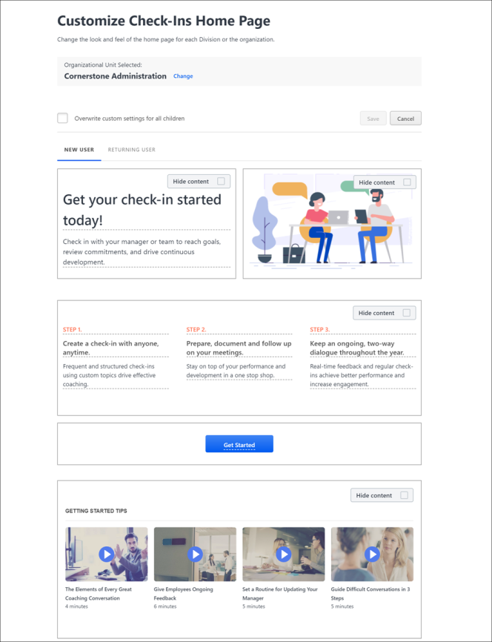
Select an OU
- In the Organizational Unit Selected area, click Change.
- On the Home Page Customization page, select the appropriate OU.
To overwrite the custom page settings for the associated child OUs: Click Edit Page, select Overwrite custom settings for all children, and then click Save.
New User Tab
Click the New User tab to customize a home page that users see when they log into Check-Ins for the first time.
Returning User Tab
- Click the Returning User tab to customize the main page that users see after the first log-in.
- Enable the Enable Check-Ins Insights toggle to view the Check-Ins Insights page. The Insights main page provides a way to view and manage meetings, notifications and follow-up action items all on the same screen.See Check-Ins Insights Page on page 7 for additional information. Note: If you enable the Check-In Insights page, it replaces the Check-Ins Home Page. To switch back to the default Check-Ins Home Page, disable the Enable Check-Ins Insights toggle.
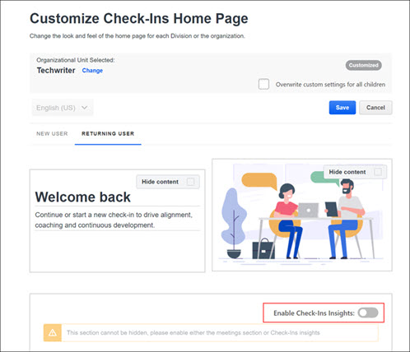
Note: The Returning User tab contains non-editable sections that do not appear on the New User tab.
Welcome Content
Administrators can replace the welcome messages or hide them.
- To replace the welcome messages, overwrite the current welcome message.
- To hide the welcome messages, click Hide content.
Welcome Image
Click Hide content in the image area to hide the welcome image.
Check-Ins Instructions
Administrators can edit the check-ins instructions or hide them. Instructions are only visible on the New User tab.
- To replace the instructions, place the cursor in the instructions area and enter the appropriate changes.
- To hide the instructions, click Hide content. The instructions will not appear on the home page.
Get Started Button
To change the text on the Get Started button, click the button to open edit mode and type your preferred button text. When you are done, click in a blank area outside of the button to save your change. This option is only visible on the New User tab.
Create New Check-In Button
To change the text on the Create new check-in button, click the button to open edit mode and type your preferred button text. When you are done, click in a blank area outside of the button to save your change. This option is only visible on the Returning User tab.
Getting Started Tips
To hide the getting started videos, click Hide content. The videos will not appear on the home page.
Localization
All of the text on the home page can be localized. In edit mode, click the localization globe and enter the appropriate text on the flyout.
Save
Click the Save button at the top of the screen to save all changes on this page.

Check-Ins - Email Digest Management
Creating an Email Digest allows an administrator to send a digest of check-in activities to specific users, OUs, or to all users in the organization. Administrators can also set up an email digest for Follow-Ups.
To create an email digest, go ADMIN > TOOLS > CORE FUNCTIONS > EMAIL DIGEST MANAGEMENT.
Creating an email digest is the same across all areas. See Email Digest - Create/Edit.
Permissions
PERMISSION NAME | PERMISSION DESCRIPTION | CATEGORY

Email Digest Administration - Manage | Grants ability to create, edit, view, and delete email digests. This permission can be constrained by OU, User's OU, User Self and Subordinates, and User. The permission constraints determine which email digests the administrator can edit and delete. This is an administrator permission. | Performance - Administration
Email Digest for Check-Ins
To configure an Email Digest for Check-Ins, administrators need to add the following Sections:
- Missed Check-Ins - This email digest lists the discussions that the user had scheduled but a meeting was not created since the previous email digest. The digest looks at the Meeting Frequency for the scheduled discussions and accordingly informs users of their missed meetings. The recommended frequency for this section is weekly.
- Recent Check-Ins - This email digest lists the user’s recent discussions that have occurred since the previous email digest. For example, if the digest frequency is Weekly, this will include all the meetings scheduled in the last seven days. The recommended frequency for this section is weekly.
- Upcoming Check-Ins - This email digest lists the upcoming discussions for the user that are scheduled prior to the next email digest. The digest looks at the Meeting Frequency for the scheduled discussions and accordingly informs users of their upcoming recurring meetings. The recommended frequency for this section is daily. Note: If this section is included in a daily digest, it is recommended to deactivate the Check-In Created email trigger in Email Administration to avoid duplicate notifications.
Check-Ins Tags
The following tags are available for Check-Ins sections:
- {RECIPIENT.FIRST.NAME} - The email digest recipient’s first name.
- {RECIPIENT.LAST.NAME} - The email digest recipient’s last name.
- {LIST.BEGIN} - A tag that is used to begin a custom formatted activity list. Tags, text, and formatting that are between the {LIST.BEGIN} and {LIST.END} tags will be repeated to create an activity list.
- {LIST.END} - A tag that is used to end a custom formatted activity list. Tags, text, and formatting that are between the {LIST.BEGIN} and {LIST.END} tags will be repeated to create an activity list.
- {CHECK-IN.LINK} - A hyperlink that takes the user to the check-in page.
- {CHECK-IN.PARTICIPANT.FIRST.NAME} - The participant’s first name.
- {CHECK-IN.PARTICIPANT.LAST.NAME} - The participant’s last name.
- {CHECK-IN.MEETING.DATE} - The date on which the meeting is scheduled.
- {CHECK-IN.TITLE} - The name of the check-in.
Email Digest for Follow-Ups
To configure an Email Digest for Follow-Ups, administrators need to add the following Sections:
- Check-Ins Follow-Ups Assigned - This email digest alerts participants that a new Follow-Up action item is assigned. In addition to their individually assigned Follow-ups, the recipient will also receive notice of unassigned Follow-Ups.
- Check-Ins Follow-Ups Overdue - This email digest alerts participants that the due date for a Follow-Up has passed. Follow-Ups that were created more than three months ago will not be included in this digest.
Follow-Ups Tags
The following tags are available for Follow-Ups Sections:
- {CHECK-INS.FOLLOW-UP.CONTENT} - The content of the follow-up.
- {CHECK-INS.FOLLOW-UP.DUE.DATE} - The due date for the Follow-up. Will display "soon" when the Follow-Up has no due date.
- {CHECK-INS.FOLLOW-UP.LINK} - A hyperlink that takes the user to the Check-In meeting where that follow-up was created.
- {CHECK-INS.FOLLOW-UP.ASSIGNEE.FIRST.NAME} - The Follow-Up assignee's first name. Will display "Unassigned" when the Follow-Up has no assignee.
- {CHECK-INS.FOLLOW-UP.ASSIGNEE.LAST.NAME} - The Follow-Up assignee's last name.
Examples
Missed Check-Ins Body
Hi {RECIPIENT.FIRST.NAME},
It looks like you missed a few meetings this past week.
However, you can keep the check-in going. Add new meetings by selecting 'New Meeting' and begin preparing.
{LIST.BEGIN}
{CHECK-IN.PARTICIPANT.FIRST.NAME} {CHECK-IN.PARTICIPANT.LAST.NAME} on {CHECK-IN.MEETING.DATE} about {CHECK-IN.TITLE}.
Click here to view the discussions: {CHECK-IN.LINK}
{LIST.END}
Recent Check-Ins Body
Hi {RECIPIENT.FIRST.NAME},
Here are the recent check-ins that you had this past week.
Let’s keep the discussion going. Select ‘New Meeting' and begin preparing for your upcoming meetings.
{LIST.BEGIN}
{CHECK-IN.PARTICIPANT.FIRST.NAME} {CHECK-IN.PARTICIPANT.LAST.NAME} on {CHECK-IN.MEETING.DATE} about {CHECK-IN.TITLE}.
Click here to view the check-ins: {CHECK-INS.LINK}
{LIST.END}
Upcoming Check-Ins Body
Hi {RECIPIENT.FIRST.NAME},
Here are today's check-ins based on the date and frequency set in your <portalname>.
Don't see a meeting? Add one by selecting 'New Meeting' and begin preparing.
{LIST.BEGIN}
{CHECK-IN.PARTICIPANT.FIRST.NAME} {CHECK-INS.PARTICIPANT.LAST.NAME} on {CHECK-INS.MEETING.DATE} about {CHECK-INS.TITLE}.
Click here to view the check-ins: {CHECK-INS.LINK}
{LIST.END}
Check-Ins Email Digest FAQs
How do I send today’s discussions? There is no separate section for it.
You can use the “Upcoming Check-Ins” section to send today’s check-ins. For this, you must set the Frequency to Daily, and then the email will be sent if there are applicable discussions scheduled for that day. It is recommended to send this as a reminder in the early morning (6 AM) in the recipient’s time zone.

Check-Ins - Manage Templates
Use the Check-Ins Templates page to create, edit and manage the templates that end-users use to create check-in meetings.
From the Check-Ins Templates page, you can perform the following tasks:
- Create a new template See Check-Ins - Create/Edit a Template on page 61 for additional information.
- Edit a template See Check-Ins - Edit a Template
- Copy, preview, activate, deactivate, or delete a template
- Search for templates
- Sort templates
- View active and inactive templates
To access the Check-Ins Templates page, go to ADMIN > TOOLS > PERFORMANCE MANAGEMENT > Check-Ins templates.
Permissions
PERMISSION NAME | PERMISSION DESCRIPTION | CATEGORY

Check-Ins - Create | Grants ability for the user to create and update Check-Ins. The permission constraints determine with whom the user can create Check-In discussions. This permission can be constrained by OU, User's OU, User Self and Subordinates, User, User's Subordinates, User's Direct Reports, User's Self, User's Manager, User's Superiors, and Employee Relationship. Users with constraints in the “Check-Ins - Create” permission cannot create a new Check-In with anyone who is not part of the constraints, but can still view and update any Check-In in which they are a participant.  This is an end user permission.  Note: Permission constraint to Employee Relationship grants permission to dotted line or secondary managers to create Check-Ins with users that report to them in the matrix structure. A constraint "Restricted to Employee Relationship: Detail Supervisor" means that the Detail Supervisor can create a Check-In with their indirect subordinate but the indirect subordinate cannot create a Check-In with their Detail Supervisor. | Performance

Check-In Templates - Manage | Grants ability to manage Check-Ins Templates. This permission cannot be constrained. This is an administrator permission. | Performance
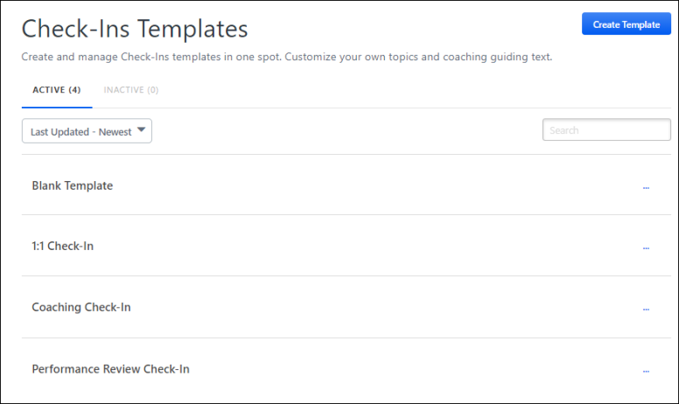
Note: You cannot edit default templates. Administrators can make a copy of the template and make changes to the copy.
Create a Template
Use the Create Template button to create a template that managers and users can use for check-in discussions. See Check-Ins - Create/Edit a Template on page 61 for additional information.
Active/Inactive Tabs
All active templates appear on the Active tab and are available for end-users to use when creating check-in meetings. Inactive templates appear on the Inactive tab and end-users cannot see or use them.
- To view all active templates, click the Active tab.
- To view all inactive templates, click the Inactive tab.
Sort Templates
Click the sort drop-down to sort templates by one of the following options:
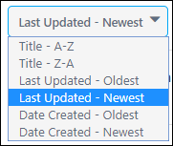
Search
To search for a specific template, enter the name in the search field.
Template Table
The following check-in templates are provided by default:
- 1:1 Check-In - This template is for quick check-ins with your manager or your teams. The default questions discuss general status topics such as what you are working on and what you need to be more successful. These are scheduled weekly by default.
- Blank Template - This template allows users to create templates from scratch. If activated, end users can also use the Blank Template to create check-ins from scratch.
- Checking-In during difficult times - This template is a "best practices" guide to help build trust and facilitate effective one-on-one discussions during difficult circumstances. Note: This template is only available if it is enabled by an administrator.
- Coaching Check-In -This template is for coaching check-ins to help people become more self-aware, reinforce strengths, and explore challenges. The default questions discuss goal setting, current reality, options, and the way forward. These are scheduled bi-weekly by default.
- Performance Review Check-In - This template is for keeping the pulse on employee performance and ensuring employees receive clear expectations. The default questions discuss role expectations, goal progress, feedback, and professional development. These are scheduled quarterly by default.
Template Options
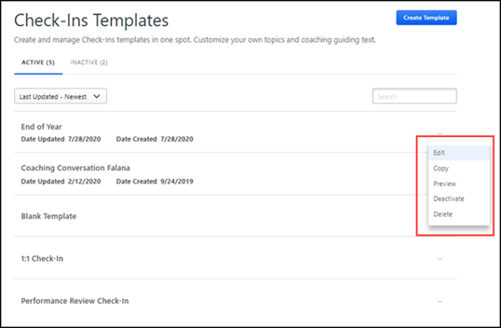
- Edit - Click to make changes to a template. You can also edit the page by clicking on the active template name. Editing a template does not impact any discussions that were created using the template. See Check-Ins - Edit a Template .
- Copy - Click to make a copy of the selected template. The copy of the template appears in the template list with the same name and Copy following it. It is recommended that you change the name of the copied template to avoid confusion.
- Preview - Displays a preview of the template as end-user will see it.
- Activate/Deactivate
  - To deactivate an active template, on the Active page, click the options ellipses for the appropriate template, and select Deactivate. Deactivating a template does not impact any discussions that were created using the template. A deactivated template appears on the Inactive tab and is not available for new discussions.
  - To activate an inactive template, on the Inactive page, click the options ellipses for the appropriate template, and select Activate. The activated template appears on the Active tab.

Check-Ins - Create/Edit a Template
Administrators can use the Check-Ins Template page to create and edit templates.
- To create a template, go to ADMIN > TOOLS > PERFORMANCE MANAGEMENT > Check-Ins templates and click the Create Template button.
- To edit a template, go to ADMIN > TOOLS > PERFORMANCE MANAGEMENT > Check-Ins templates and select a template from the template list.
You can manage the following information:
- Lock - Lock or unlock users ability to make changes to a template.
- Template title - The title of this template.
- Description- Description of this template.
- Meeting frequency - Enter or change the title, description, and how often the meeting is held.
- Topics - Add or remove topics for this template.
- Availability - Add or remove those who can access this template.
- Activate - Activate or deactivate this template.
Permissions
PERMISSION NAME | PERMISSION DESCRIPTION | CATEGORY

Check-In Templates - Manage | Grants ability to manage Check-Ins Templates. This permission cannot be constrained. This is an administrator permission. | Performance

Check-Ins - Create | Grants ability for the user to create and update Check-Ins. The permission constraints determine with whom the user can create Check-In discussions. This permission can be constrained by OU, User's OU, User Self and Subordinates, User, User's Subordinates, User's Direct Reports, User's Self, User's Manager, User's Superiors, and Employee Relationship. Users with constraints in the “Check-Ins - Create” permission cannot create a new Check-In with anyone who is not part of the constraints, but can still view and update any Check-In in which they are a participant.  This is an end user permission.  Note: Permission constraint to Employee Relationship grants permission to dotted line or secondary managers to create Check-Ins with users that report to them in the matrix structure. A constraint "Restricted to Employee Relationship: Detail Supervisor" means that the Detail Supervisor can create a Check-In with their indirect subordinate but the indirect subordinate cannot create a Check-In with their Detail Supervisor. | Performance
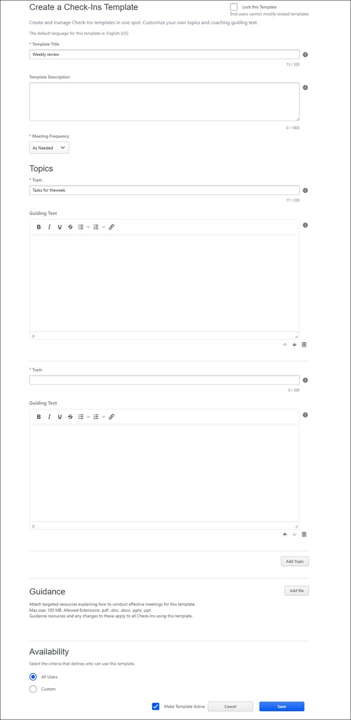
Lock this Template
Check Lock this Template if you do not want end-users to make changes to this template. If unchecked, end-users can modify the topics associated with this template.
Template Title
Enter or edit the title of this template. You can enter up to 200 characters. This is a required field.
Template Description
Enter or edit a description for this template. You can enter up to 1000 characters. This is an optional field.
Meeting Frequency
Select the meeting frequency for this discussion. The meeting frequency that you select determines the default meeting schedule for this discussion. For example, when a manager or user creates a new check-in discussion that has a meeting frequency of Weekly, each time they click the New Meeting button on the meeting and discussion page, the next meeting date is automatically scheduled for a week later. Options are:
- As Needed
- Weekly
- BiWeekly
- Monthly
- Quarter
Topics
Add or delete topic questions or information that may be useful to managers and employees during the discussion. You can add several topics to a discussion, but there must be at least one topic with guiding text per template.
Complete or edit the following fields:
- Topic - Enter the first topic or question for this template. You can enter up to 200 characters. This is a required field.
- Guiding Text - Enter any descriptive text that you want the user to see. You can enter up to 2000 characters. This is an optional field.
To add an additional topic, click the Add Topic button.
Guidance
Add or remove a document for this template. Once you add a document to a template, users who use this template have access to it.
You can add the following document types: .pdf, .doc, .ppts, .ppt. Maximum document size is 100MB. Note: If you add a document to an existing template, it now appears in all meetings that use this template.
- To add a document, click the Add File button, then click the Upload button.
- To change the title of the document, click the ellipses, and then select Edit.
- To delete a document, click the ellipses, and then select Delete.
Note: Based on the size of the document, you may see system messages while you wait for the document to upload. These are informationational messages and you do not have to take any action.
Availability
Select one of the following options to define who can use this template when initiating a check-in:
- All Users - Select this option to make this template available to all users.
- Custom - Select this option to set availability for specific users or by OU criteria. When you select this option, a Select OU Criteria button appears. Click this button to select the appropriate options and then click Save.
Make Template Active
Check Make Template Active if you want end-users to have access to this template. If unchecked, this template is not visible to end-users.
Save
Click Save to save the template. The new template appears on the Check-Ins Templates page.

Check-Ins Mobile
With Check-Ins mobile, users can access all meeting features and resources using a mobile device.
Check-Ins mobile has the following features:
- Meeting series icon: Tap the meeting series icon to open a flyout with a list of all meetings in the series. On this list, you can:
  - Select a specific meeting to view its details.
  - Click the New Meeting button to create a new meeting in the series. This new meeting is based on the current meeting frequency.
  - Click the "x" in the top right of the screen to go to the Check-Ins mobile home page.
- Expanded ellipsis Tap the ellipses on the main page to:
  - Mark a meeting completed
  - Cancel a meeting
  - Create a new meeting
  - Switch to topic view
  - Delete a meeting
  - Access Check-Ins settings
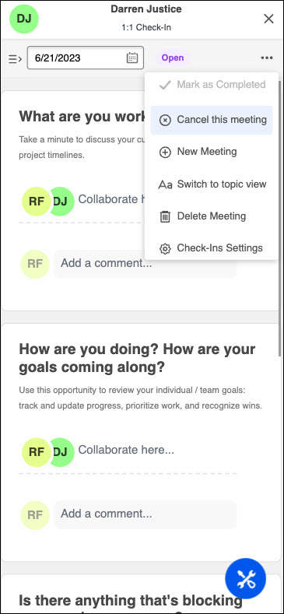
- Meeting view: In topic view, switch to meeting view by tapping Switch to meeting view from the ellipsis.
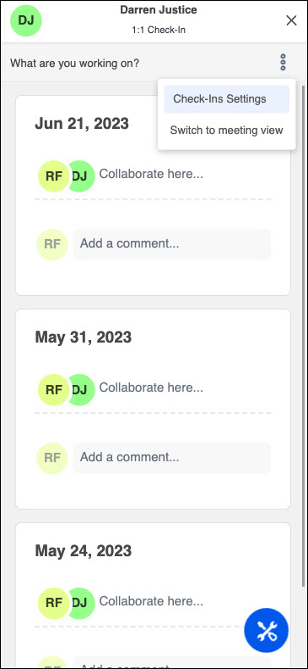
- Resources: Tap the Resources icon to access the appropriate resource page for Goals, Dev Plan, Follow-Ups, Skills, and Personal Notes.
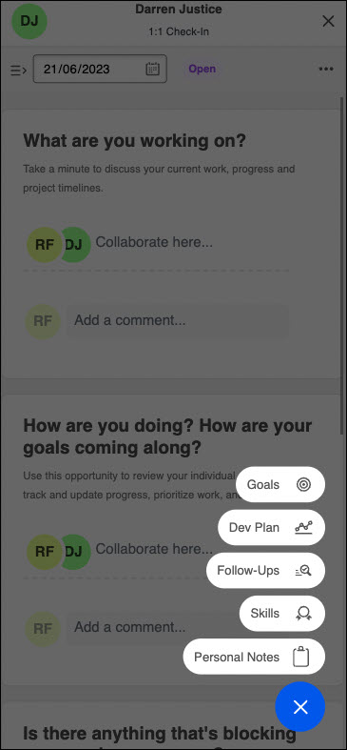
Outlook Calendar Invite
Mobile users can now send email invites to Check-Ins from their mobile devices for both series or individual meetings. Additionally, users can download series and individual calendar invites using their mobile devices.

Check-Ins - Reporting 2.0 Fields
The following fields are available in the Check-Ins section in Reporting 2.0 when building a report using the data map.
FIELD NAME | FIELD DESCRIPTION | FIELD TYPE

Check-In Is Archived | This field displays whether the check-in was archived. | Yes/No

Check-In Created Date | This field displays the date the check-in was created. | Numeric

Check-In Frequency | This field displays the meeting frequency selected by the user who created the check-in. | Text

Check-In Last Activity Date | This field displays the most recent date on which the check-in was opened, and any action was taken. | Numeric

Check-In Last Modified Date | This field displays the most recent date on which a user modified the check-in. | Numeric

Check-In Meeting Date | This field displays the scheduled meeting dates for a selected check-in. | Numeric

Check-In Name | This field displays the name of the check-in. | Text

Check-In Note Has Content | This field displays whether a check-in meeting contains any notes. It can have 3 different values:  - Empty - This is the default state if the notes field is not modified. Modification means adding notes or adding notes and clearing them off completely.  - Yes - "Yes" displays when notes have already been added.  - No - "No" displays when notes were previously added but are already removed. Note: For clarity, be sure to add all the relevant fields to the check-in when generating a report using this field. Remember that each check-in can consist of a list of meetings. Each meeting will have a list of topics. And each topic may or may not have notes.  Best practice: Add the "Meeting Date" and "Topic Title" fields, along with the "Note Has Content" to yield a comprehensive result. | Yes/No

Check-In Template Is Active | This field displays whether a template is currently active. | Yes/No

Check-In Template Title | This field displays the title of the check-in template. This field only displays template titles created by the user. For a system default template, the template title is blank. | Text

Check-In Topic Title | This field displays the topic title contained in a template. | Text
The following new fields are available in the Check-Ins > Check-Ins Creator section in Reporting 2.0 when building a report using the Check-Ins data map.
FIELD NAME | FIELD DESCRIPTION | FIELD TYPE

User Full Name | This field displays the name of the user who created the check-in. | Text

User ID | This field displays the user ID of the user who created the check-in. | Text
The following new fields are available in the Check-Ins > Check-Ins Modifier section in Reporting 2.0 when building a report using the Check-Ins data map.
FIELD NAME | FIELD DESCRIPTION | FIELD TYPE

User Full Name | This field displays the name of the user who last modified the check-in. | Text

User ID | This field displays the user ID of the user who last modified the check-in. | Text
The following new fields are available in the Training > Training Details section in Reporting 2.0 when building a report using the Check-Ins data map.
FIELD NAME | FIELD DESCRIPTION | FIELD TYPE

Check-In ID | This field displays all of the meetings that are included in a specific Check-In discussion. | Text

Check-In Meeting ID | This field displays the meeting ID for a specific meeting or multiple meetings. | Text

Check-Ins Integrations

Check-Ins Microsoft Teams Integration
Users can receive Check-In meetings and Follow-Ups notifications on the MS Teams chat page and click a link to take action, even if not actively logged into Check-Ins.
Users receive a daily, automated update that includes information about their scheduled meetings for the day and any overdue or upcoming follow-ups. If a user has no notifications for the day, they will not receive an update.
Additionally, users receive Check-Ins notifications along with existing learning notifications if they have active Check-Ins. This cannot be turned off.
Permissions
PERMISSION NAME | PERMISSION DESCRIPTION | CATEGORY

Check-Ins - Create | Grants ability for the user to create and update Check-Ins. The permission constraints determine with whom the user can create Check-In discussions. This permission can be constrained by OU, User's OU, User Self and Subordinates, User, User's Subordinates, User's Direct Reports, User's Self, User's Manager, User's Superiors, and Employee Relationship. Users with constraints in the “Check-Ins - Create” permission cannot create a new Check-In with anyone who is not part of the constraints, but can still view and update any Check-In in which they are a participant.  This is an end user permission.  Note: Permission constraint to Employee Relationship grants permission to dotted line or secondary managers to create Check-Ins with users that report to them in the matrix structure. A constraint "Restricted to Employee Relationship: Detail Supervisor" means that the Detail Supervisor can create a Check-In with their indirect subordinate but the indirect subordinate cannot create a Check-In with their Detail Supervisor. | Performance
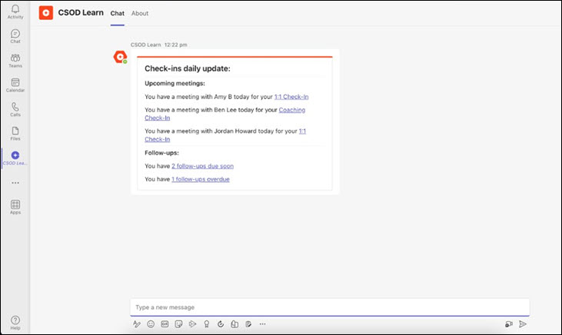
Enable the MS Teams Integration
The CSOD Learn app must be added in MS Teams to use this functionality.
To enable the MS Teams integration:
- Open MS Teams.
- In the left column, select the Apps icon.
- Locate the CSOD Learn option and click Add, then click Add again on the CSOD Learn page.
Note: If you do not see the CSOD Learn app in MS Teams, contact your IT department and ask them to allow this app.
Notifications
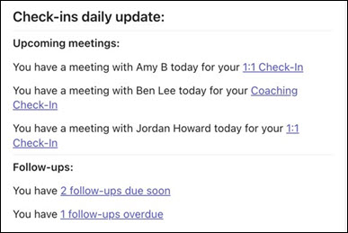
- Upcoming meetings - Both participants in the meeting receive a notification the morning of the meeting. If the user has more than one meetings on a specific day, the participants' names are listed in alphabetical order. Clicking the meeting name opens the Check-In meeting.
- Follow-Ups - The participant assigned the follow-up is notified of the total number of follow-ups due in the next seven days. Users are also notified of past due follow-ups. If the follow-up is unassigned, both participants in the Check-In series receives a notification. Clicking on the follow-up opens the Follow-Up flyout where users can view their information. If a follow-up is unassigned, both participants in the series receive a notification.
Note: Check-Ins Insights must be enabled to view the follow-ups flyout. If Check-Ins Insights is not enabled, clicking on the follow-ups link will redirect the user to the homepage. See Check-Ins Insights Page on page 7 for additional information.​

Check-Ins - Outlook Integration
Users can create a Check-Ins meeting(s) and send an invite to the Outlook calendar of both participants. Users can then easily access their Check-In meetings from their Outlook calendar, and participants in the meeting series can edit the meeting schedule and calendar invite.
An administrator must configure the Outlook calendar invite to use these features.
Permissions
PERMISSION NAME | PERMISSION DESCRIPTION | CATEGORY

Check-Ins - Create | Grants ability for the user to create and update Check-Ins. The permission constraints determine with whom the user can create Check-In discussions. This permission can be constrained by OU, User's OU, User Self and Subordinates, User, User's Subordinates, User's Direct Reports, User's Self, User's Manager, User's Superiors, and Employee Relationship. Users with constraints in the “Check-Ins - Create” permission cannot create a new Check-In with anyone who is not part of the constraints, but can still view and update any Check-In in which they are a participant.  This is an end user permission.  Note: Permission constraint to Employee Relationship grants permission to dotted line or secondary managers to create Check-Ins with users that report to them in the matrix structure. A constraint "Restricted to Employee Relationship: Detail Supervisor" means that the Detail Supervisor can create a Check-In with their indirect subordinate but the indirect subordinate cannot create a Check-In with their Detail Supervisor. | Performance

Email - Edit From Address | Grants ability to edit the "from" address when creating or modifying an email trigger. In addition, the Allow user to change email address option must be selected in Email Preferences. This permission works in conjunction with the Global Email Administration - Manage permission. This is an administrator permission. | Core Administration

Global Email Administration - Manage | Grants ability to manage email trigger templates across all active modules in the portal. Enables creating, editing and deleting email message templates for various system actions and workflows. This permission can be constrained by OU, User's OU, User Self and Subordinates, and User. This is an administrator permission. | Core Administration

Global Email Administration - View | Grants view only access to email templates/triggers and email logs at the global level for the portal. This permission can be constrained by OU, User's OU, User Self and Subordinates, and User. This is an administrator permission. | Core Administration
Enable the Outlook Calendar Invite
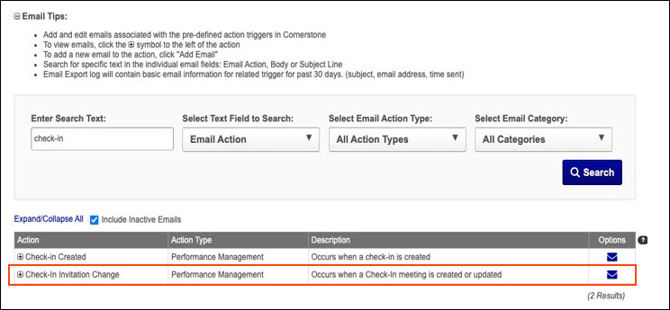
To enable the Outlook Calendar Invite feature, go to Admin > Tools > Core Functions > Email Management​. Complete the following fields:
- Enter Search Text - Type "check-in"
- Select Text Field to Search - Select "Email Action"
- Select Email Action Type - Select "All Action Types"
- Select Email Category - Select "All Categories"
Check the Check-In Invitation Change box.
- The downloading invites functionality is off by default. To enable it, go to Admin > Performance Management > Check-Ins > Check-Ins Settings. Enable the Check-Ins Calendar Invite Download option.
- To use the email invite functionality, an administrator must activate and configure the Check-In Calendar Invitation Change email trigger.
Create a Check-Ins Meeting
To create or edit a new Check-In meeting series, go to Check-Ins Home Page > Create a new Check-In Meeting or open an existing meeting series. See Check-Ins - Create a New Check-In Meeting on page 12 for additional information.
Edit Check-Ins Meetings
Participants can edit the meeting schedule for a series and individual meetings.
Any changes made to the series meeting affects the entire series.
Edit the Series
To edit, go to PERFORMANCE > CHECK-INS and click the appropriate check-in series on your home page. Click the ellipses, select Check-Ins Settings, and then select the Manage Meeting Schedule tab.
- Any changes made on the Manage Meeting Schedule tab will automatically update the future Check-Ins meetings and Outlook calendar invite.
- The Check-Ins Modification History tab provides details of any changes made to the selected meeting series.
- Changes made to the series meeting affects the entire series.
Edit an Individual Meeting
To edit an individual meeting, open a meeting and select the date at the top of the page. On the fly-out, make the necessary changes. The participant calendars will reflect the new changes. Changes to individual meetings do not impact the Check-In series.
Delete a Check-Ins Meeting
If a meeting is deleted from the Outlook calendar, it is not reflected in CSX Check-Ins.
If a Check-In meeting or Check-In series is deleted by a participant, a cancellation invite is automatically sent to the participants to remove the invite from their calendar.​​
Outlook Calendar Invites
The Outlook invite includes the following information:
- Meeting Name: The Check-Ins series name.
- Organiser: This is always CSX.​
- Attendees: The participants in the meeting series.​
- Time:
  - Start time: The meeting start time.​
  - End time: The meeting end time.​
- Date: The meeting date.​
- Location, if specified: The location information.​
- Invite Body: Configured by the administrator.
Outlook calendar invites can be sent automatically or by downloading/importing.
Complete the associated fields and click the Email Invite box when creating or editing a Check-Ins meeting series.
- Administrators must create an email for the "Check-In Calendar Invitation Change" to allow invitations to be sent.
- Users must have their correct email addresses stored in the system to receive emails.
- The default email is noreply@csod.com.
Download and Import Meetings
In Meeting View, open the appropriate meeting series and select the appropriate meeting start and end time. Select the vertical ellipsis and select Download Calendar Invite (Series) or Download Calendar Invite (Occurrence). The meeting is downloaded to the participant's Outlook calendar. Downloading allows users to receive Outlook calendar invites even if the email invite functionality is not configured on their system. Once the ICS file downloads to a browser, the user can drag the invite into their Outlook calendar and import the invite information into Outlook.
Cancel/Reopen/Delete Meetings
The following applies when canceling and reopening meetings:
- If a user cancels an individual meeting, a cancellation invite is sent to the participants to remove the invite from their calendar. ​A cancellation invite is only be sent if the user has selected the email invite option.
- If a user reopens a cancelled meeting, a new calendar invite is sent to the participants to read the invite to their calendar.​ An invite will only be sent if the user has selected the email invite option.
- If a Check-In meeting or Check-In series is deleted by a participant, a cancellation invite is automatically sent to the participants to remove the invite from their calendar.​​​
Considerations
- Any changes must be made in CSX Check-Ins. If a user make changes in Outlook or deletes a Check-Ins meeting in Outlook, those changes are not updated in CSX Check-Ins.
- If a user makes changes through CSX Check-Ins and selects “Send email invite”, all meetings in the Outlook calendar series are updated to reflect the changes. If a user makes changes through CSX, past meetings in Check-Ins will not be updated.
- If a user adds a new meeting to the CSX Check-Ins series after sending the invites, and it is not part of the recurrence, this meeting is not reflected in the participants Outlook calendar.

Check-Ins Slack Integration
Users can receive Check-In meetings and Follow-Ups notifications on Slack and click a link to take action, even if not actively logged into Check-Ins.
Users will receive a daily, automated update that includes information about their scheduled meetings for the day and any overdue or upcoming follow-ups. If a user has no notifications for the day, they will not receive an update.
Permissions
PERMISSION NAME | PERMISSION DESCRIPTION | CATEGORY

Check-Ins - Create | Grants ability for the user to create and update Check-Ins. The permission constraints determine with whom the user can create Check-In discussions. This permission can be constrained by OU, User's OU, User Self and Subordinates, User, User's Subordinates, User's Direct Reports, User's Self, User's Manager, User's Superiors, and Employee Relationship. Users with constraints in the “Check-Ins - Create” permission cannot create a new Check-In with anyone who is not part of the constraints, but can still view and update any Check-In in which they are a participant.  This is an end user permission.  Note: Permission constraint to Employee Relationship grants permission to dotted line or secondary managers to create Check-Ins with users that report to them in the matrix structure. A constraint "Restricted to Employee Relationship: Detail Supervisor" means that the Detail Supervisor can create a Check-In with their indirect subordinate but the indirect subordinate cannot create a Check-In with their Detail Supervisor. | Performance
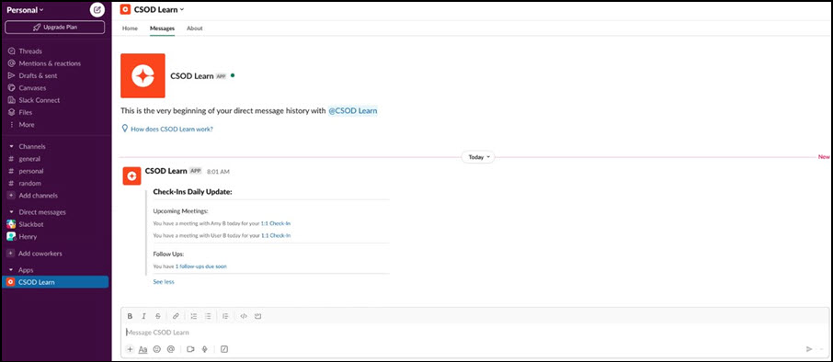
Enable the Slack Integration
Administrators can access the Slack Learning in the Flow integration in the Edge Marketplace.
See the Slack Learning in the Flow Edge Integration Guide.
Notifications
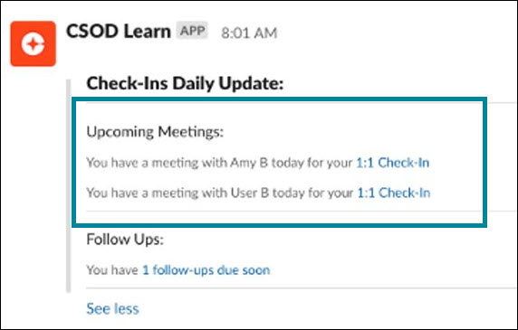
- Upcoming meetings - Both participants will receive a notification the morning of the meeting. If the user has multiple 1:1s on a specific day, the participants' names are listed in alphabetical order. Clicking the meeting name opens the Check-In meeting.
- Follow-Ups
  - Due Soon - The participant assigned the follow-up that is due soon receives the notification.​ If the follow-up is unassigned, both participants in the check-in series receive a notification.​ Clicking on the follow-up opens the Follow-Up flyout where users can view their assigned follow-up information.
  - Overdue - The participant assigned the overdue follow-up will receive the notification. If the follow-up is unassigned, both participants in the check-in series receive a notification. Clicking on the follow-up opens the Follow-Up flyout where users can view their assigned follow-up information. ​
                - Note: Check-Ins Insights must be enabled to view the follow-ups flyout. If Check-Ins Insights is not enabled, clicking on the follow-ups link will redirect the user to the homepage. See Check-Ins Insights Page on page 7 for additional information.

