Certifications March 2024

Table of Contents
Certifications Overview 1
Certification Administration 2
Certifications Redesign Emails 8
Certification Management 10
Certification - Create/Edit 14
Certification Families and Categories 79
View Certification Enrollment 82
Validity Period for Training within Certification 84
Credit Processing for Certification Periods 86
Certifications - Parent and Child Section Credits Workflow 88
Edit Certification Due Date 89
Certification Proxy Enrollment 91
Certification Proxy Enrollment - Create - Select Certification 95
Certification Proxy Enrollment - Create - Enrollment Settings 97
Certification Proxy Enrollment - Create - Confirmation 102
View Certification Proxy Enrollment Details 104
Certification Transcript Issues 106
Certifications Requests Overview 107
Certification Approval Workflow 123
Certification Statuses 124
Certification Bulk Removal 127
Certification Bulk Removal Tool 128
Certification Removal Tool 129
Create a Certification Removal Job 131
Certification Versioning 135
Certification Versioning 138
Certification Versioning Selection Page 141

Certifications Overview
Certifications enable organizations to create and manage internal and external certifications. Depending on the industry, applicable terms might also include compliance, designations, licenses, permits, and accreditation.
For information on enabling certifications for your portal, please contact Global Customer Support.
The tool incorporates the following concepts:
- Certification Family is a group of certifications, such as a Certified Financial Planner.
- Certification Category is another way to categorize certifications, such as financial certifications or medical certifications.
- Certification is a particular instance of a certification, such as a Certified Financial Planner for California.
- Renewal Period is the period during which a certification must be renewed after receiving initial certification. Renewal periods may be required to maintain certification.

Certification Administration
From the Certification Administration page, you can view and manage certifications. Using the search filters, you can search for certifications by title, family, category, or language. You can create certifications and view and manage certification families and categories.
Design Note: This page has an updated interface (UI) that is automatically enabled. However, administrators can still revert to legacy UI via Feature Activation Preferences. The page's functionality is unchanged with the new design. With the July 26, 2024 Release, the new UI will be permanently enabled in all production, stage, and pilot portals, and the legacy UI pages will no longer be available. The new UIs disabled in March will be auto-enabled in July.
To access the Certification Administration screen, select Admin > Tools > Learning > Catalog Management > Certifications.
Permissions
PERMISSION NAME | PERMISSION DESCRIPTION | CATEGORY

Certification - Categories Admin | Grants administrators ability to manage certification categories. This is an administrator permission. | Learning - Administration

Certification - Custom Certificate Update | This permission grants access to the Update Certificate for All Certifications link on the Certification Administration page. The Update Certificate for All Certifications link allows administrators to upload and modify a certificate template for all the certifications in the system at once. This is an administrator permission. This permission cannot be constrained. | Learning - Administration

Certification - Family Admin | Grants administrators ability to manage certification families. This is an administrator permission. | Learning - Administration

Certification - Manage | Grants administrators ability to manage certifications. This permission can be constrained by OU and User's OU. This is an administrator permission. | Learning - Administration

Certification - Owner | Grants user ability to act as the certification owner, which enables them to view and approve requests for the certification, manage users in the certification, and edit the due date/expiration date for users in the certification. This permission can be constrained by OU and User's OU. This is an administrator permission. | Learning - Administration
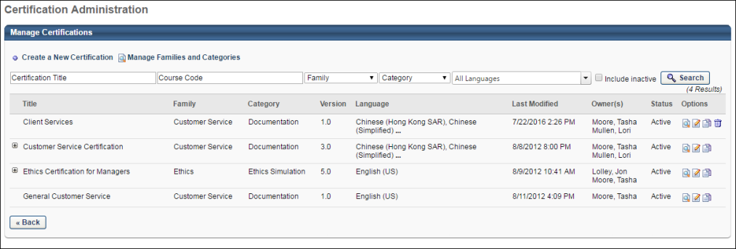
Manage Certifications
The following features are available in the Manage Certifications table:
- Create a New Certification - Click this link to create a new certification. See Certification - Create/Edit on page 14 for additional information.
- Manage Families and Categories - Click this link to view and manage certification families and categories. Families and Categories provide the administrator the ability to categorize certifications in two separate manners. This link is only available to administrators with permission to manage families or categories. Note: The Manage Families and Categories link displays for portals with both certification families and certification categories enabled. For portals with certification families only, the link is titled Manage Families. For portals with certification categories only, the link is titled Manage Categories. See Certification Families and Categories on page 79 for additional information.
- Search - Search for certifications by title, course code, family, or category. Use the language drop-down to filter by languages. Check the Include Inactive box to display inactive certifications.
- Title - Use this field to search for a certification by title.
- Course Code - Use this field to search for a specific certification, using that certification's auto-generated course code (if course code functionality has been activated in your portal).
- Family - Use this field to search for a certification by family.
- Category - Use this field to search for a certification by category.
- Version - This displays the version of the certification you are creating or editing. New certifications begin as version 1.0. This value is automatically updated and cannot be edited.
- Language - The language associated with the certification. All languages enabled for the portal display. Note: If a certification is available in multiple languages, the Language column displays the first two languages in which the certification is available. Hovering over the ellipses displays the other available languages.
- Last Modified - The date the certification was last modified.
- Owner(s) - The owner of the certification is specified during creation and can view and approve requests. Owners can also modify the certification as well as the administrator.
- Status - This field displays the Active status of certifications. The certifications can be inactivated by clearing the checkbox. Inactive certifications are not available for assignment or completion. See Inactivate Certifications on page 4 for additional information.
- Previous Versions - If a certification has previous versions, there is a plus icon to the left of the certification title. Click the plus icon to view all previous versions.
- Certification Options - View, edit, copy, or delete a certification using the available options.
  - View - Click this icon to view the certification framework in a pop-up window.
  - Edit - Currently, if the certification is assigned to a user, only the General section can be modified.
  - Copy - Administrators can copy any current, inactive, or previous version of a certification.
  - Delete - Certifications can be deleted if no users have ever requested it or have ever been assigned to it. Otherwise, the Delete option is not available. Previous versions of a certification cannot be deleted.
Inactivate Certifications
Inactivate certifications by clearing the checkbox under Status column. When inactivating the certifications and their lesser versions, the user is prompted with a message - "There are other versions of this certification that are active. Click on All to inactivate all versions. Click on This Version to inactivate this version only." Click ALL to inactivate the current version and all lesser versions. Click THIS VERSION to inactivate only the current version.
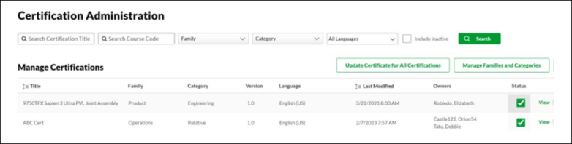
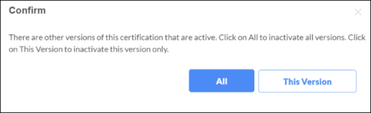
For example, if there are 10 versions of a certification and version 10 is selected for inactivation, clicking ALL inactivates Version 10, 9, 8, 7,6,5,4,3,2,1. However, clicking THIS VERSION inactivates only Version 10. Again, if there are 10 versions of certification and if version 5 is selected for inactivation, then clicking ALL inactivates Version 5,4,3,2,1 while clicking THIS VERSION inactivates only Version 5.
It also applies to activating an inactive certification. The user is prompted with the message - "There are other versions of this certifications that are inactive. Click on All to activate all versions. Click on This Version to activate this version only." Clicking All activates the current version and all lesser versions. Clicking This Version activates only the current version.
Note: This prompt message appears only when there are lesser versions. In case of single versions, no prompt message appears.
Update Certificate for All Certifications
Administrators with the Certification - Custom Certificate Update permission have access to the Update Certificate for all Certifications link on the Certification Administration page.
This option allows customers to update the custom certification certificate, and the certificate should be available for existing and new certifications. If the certificate changes are not available, please open a case with Global Customer Support to ensure the backend setting related to Designation of Custom Certificate is enabled.
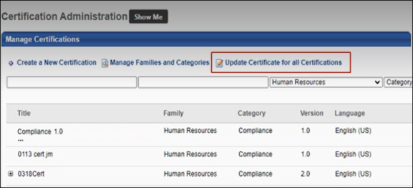
Selecting the Update Certificate for all Certifications link opens the Custom Certificate Advanced Editor page where the administrator can configure a certificate template that will apply to all certifications.
For more information about creating custom certificates: See Create Custom Certificates.
Note: Certification Certificates have different tags than other learning objects, and the editor does not show the View Tags link or the Certificate Title.
The following tags are supported for Certification Certificates.
- [CERTIFICATETITLE]
- [CERTIFICATEDATE]
- [CERTIFICATELONGDATE]
- [USERREFID]
- [USERID]
- [USERNAME]
- [PERIODTITLE]
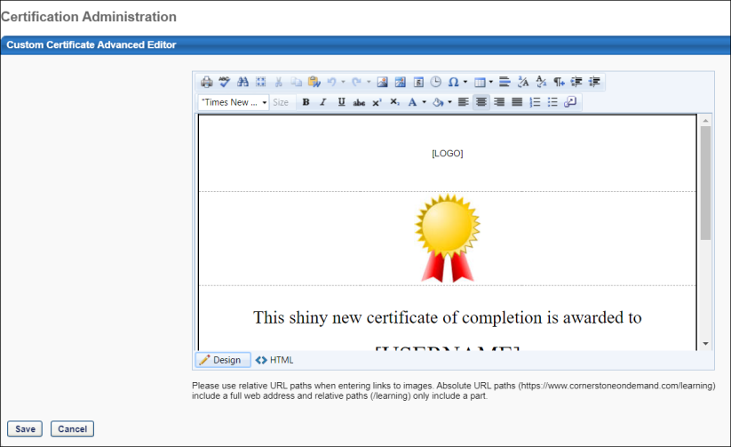
For more information about creating custom certificates: See Create Custom Certificates.
Note: Certification Certificates have different tags than other learning objects, and the editor does not show the View Tags link or the Certificate Title.

Certifications Redesign Emails
All certification emails can be sent to the certification candidate, certification candidate manager, or certification owner.
The following email triggers are available via Email Management in the Certification category:
EMAIL NAME | EMAIL DESCRIPTION | ACTION TYPE

Approve Certification | This email is triggered when a user's request to enroll in a certification is approved. | Certification

Assigned Certification | This email is triggered when a user is assigned a certification; the certification still requires registration and approval. | Certification

Certification Credits Adjusted | This email is triggered when an administrator manually adjusts a user's credits that are applied to a certification from the Certification Report page. | Certification

Certification Credits Received | This email is triggered when a user receives credit for completing a training item that is applied to a certification. If the learning object applies to multiple certifications, only one email is fired. | Certification

Certification External Training Credit Applied | This email is triggered when credit from external training is approved and applied to the certification. | Certification

Certification External Training Credit Submission Confirmation | This email is triggered when a user submits external training for certification credit. | Certification

Certification Period Begin Reminder | This reminder email is triggered when a certification period begins. | Certification

Certification Period Completion Notification | This email is triggered when a user has successfully completed all requirements for a certification period. | Certification

Certification Period Overdue Notification | This email is triggered when a user has not completed the certification requirements by the due date or the certification expiration date. If all requirements are complete, this email is not triggered. | Certification

Deny Certification | This email is triggered when a user's request to enroll in a certification is denied. | Certification

Enrolled in Certification | This email is triggered when a user becomes enrolled in a certification via assignment or proxy enrollment. This email is triggered for the initial enrollment, but is not triggered for renewal periods. | Certification

Remove Certification | This email is triggered when an administrator removes a certification for a user from the Certification Management page using the delete icon (trash can). Bulk Removals done through the certification removal tool or removal triggered through the dynamic removal setting on a dynamic certification proxy enrollment will not trigger the Remove Certification email. | Certification

Request Certification | This email is triggered when a user submits a request to enroll in a certification. | Certification
Troubleshooting Information
The following pages contain troubleshooting guides for using emails:
- See Troubleshooting Guide - Emails.
- See Email Troubleshooting Guide.

Certification Management
The Manage Certifications page enables administrators and managers to perform the following actions:
- Proxy enroll new users in a certification
- View all users currently enrolled in a certification and edit the certification due date
- Manage pending requests and past requests
- Export list of certifications into excel.
To access the Manage Certifications page, go to Learning > Certification Management or Certification > Certification Management. Note: The navigation instructions to access the Certification Management page may vary, as it is configurable by system administrators.
Design Note: This page has an updated interface (UI) that is automatically enabled. However, administrators can still revert to legacy UI via Feature Activation Preferences. The page's functionality is unchanged with the new design. With the July 26, 2024 Release, the new UI will be permanently enabled in all production, stage, and pilot portals, and the legacy UI pages will no longer be available. The new UIs disabled in March will be auto-enabled in July.
Permissions
PERMISSION NAME | PERMISSION DESCRIPTION | CATEGORY

Proxy Enrollment for Certification - Create Dynamic | Grants administrator ability to create dynamic proxy enrollments for certifications. This is an administrator permission. | Learning - Administration

Proxy Enrollment for Certification - Create Standard | Grants administrator ability to create standard proxy enrollments for certifications. This is an administrator permission. | Learning - Administration
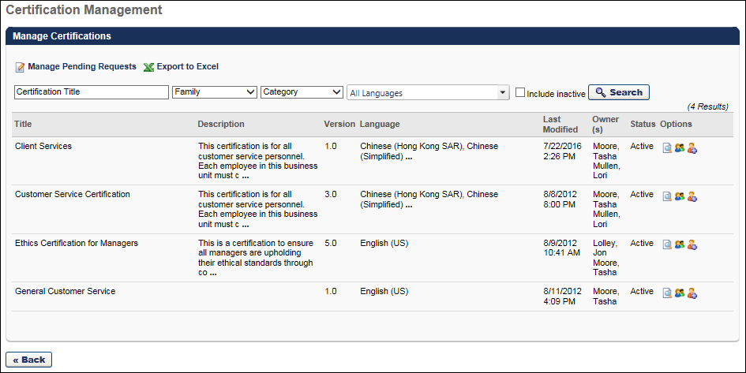
Manage Pending Certification Requests
To manage certification enrollment requests, click the Manage Pending Requests link above the Search criteria. See View Certification Enrollment on page 82 for additional information.
Export to Excel
Click Export to Excel above the Search criteria to export up to the most recent 5000 records at once. The EXPORT TO EXCEL is grayed out if no records exist to export.
Search for Certifications
To search for a certification:
- Enter a title in the Certification Title field.
- Enter a course code, if course codes functionality is active in your portal and a course code was automatically assigned to the certification you are searching for.
- Select a certification family from the Family drop-down.
- Select a category from the Category drop-down.
- Select one or more languages from the language drop-down. All languages enabled for the portal display.
- Check to display inactive certifications in the Include Inactive checkbox.
- Click Search. The results display in the certification table.
Certifications Table
In the certification table, the following information is displayed for each available certification:
- Title - The certification title. For portals with multiple languages enabled, the certification title appears in the language of the administrator viewing the certification, if available. If the administrator's language is not available, the title displays in the default language of the certification.
- Description - The certification description.
- Version - This displays the version of the certification you are creating or editing. New certifications begin as version 1.0. This value is automatically updated and cannot be edited.
- Language - The language or languages associated with the certification. If a certification is available in multiple languages, the Language column displays the first two languages. Hovering over the ellipses displays the other languages.
- Last Modified - The date the certification was last modified.
- Owners - The owner of the certification is specified during creation and has the ability to modify the certification as well as the administrator.
- Status - The Active status. Inactive certifications are not available for assignment or completion.
Use the search criteria to search for a certification by title, family, category, and language. Select the Include Inactive option to include inactive certifications in the search results. By default, only active certifications are displayed.
To activate or deactivate a certification, click the selection box in the Active column. If the Active option is selected, the certificate is active. If the Active option is deselected, the certificate is inactive and is not available for assignment or completion.
Certification Options
To view the certification details, click the View Details icon in the Options column. The certification details are displayed in a pop-up window.
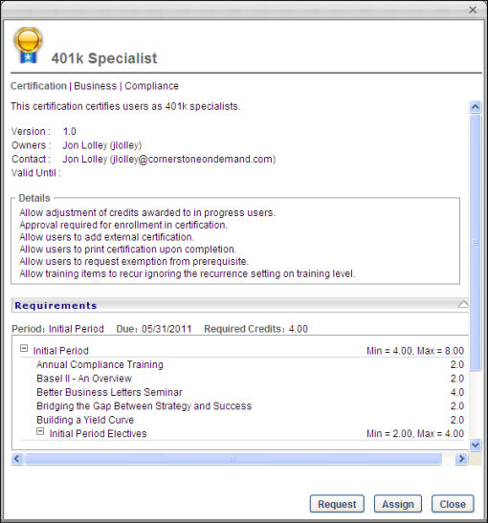
To view the list of users who are currently enrolled in the certification, click the View Users icon in the Options column. This option also enables you to edit the due date for the certification. See View Certification Enrollment on page 82 for additional information.
To add a new user to the certification, click the Add Users icon in the Options column. This begins the proxy enrollment process with the certification already selected. See Certification Proxy Enrollment - Create - Enrollment Settings on page 97 for additional information.

Certification - Create/Edit
When creating a certification, there are five steps:
- General
- Framework
- Scheduling
- Emails
- Confirm
These steps are listed on the left navigation with the current step highlighted. You cannot advance to the next step until each of the required fields has been satisfied. You can return to previous steps once they have been completed or during editing by clicking the appropriate link on the left navigation.
To create a certification:
Go to Admin > Tools > Learning > Catalog Management > Certifications. Then, click the Create a New Certification link or copy an existing certification by clicking the Copy icon in the Options column.
OR, go to Admin > Tools > Learning > Learning Admin Console. Then, click the Create button and click the Certification link.
Complete each of the five steps, beginning with the General step. See Certification - Create - Step 1 - General on page 15 for additional information.
Permissions
PERMISSION NAME | PERMISSION DESCRIPTION | CATEGORY

Certification - Manage | Grants administrators ability to manage certifications. This permission can be constrained by OU and User's OU. This is an administrator permission. | Learning - Administration

Certification - Create - Step 1 - General
The basic parameters of the certification are defined on the General page. The General page is divided into several sections.
To create a certification, go to Admin > Tools > Learning > Catalog Management > Certifications. Then, click the Create a New Certification link or copy an existing certification by clicking the Copy icon in the Options column.
Permissions
PERMISSION NAME | PERMISSION DESCRIPTION | CATEGORY

Certification - Manage | Grants administrators ability to manage certifications. This permission can be constrained by OU and User's OU. This is an administrator permission. | Learning - Administration

Certification - Update Credit | Grants administrator ability to update the number of acquired credits on a user's certification progress report page. This also enables administrators or users to "certify" users by adjusting the number of credits received. This is an administrator permission. | Learning - Administration
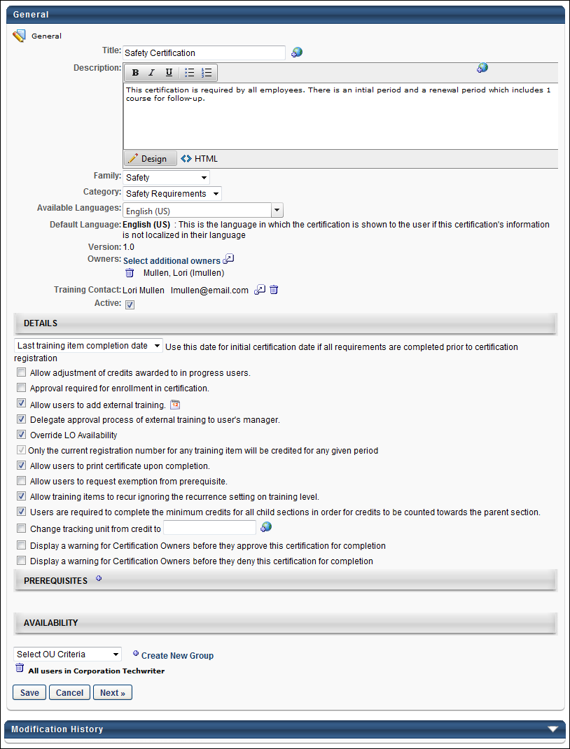
General
Enter the following information in the General section:
- Title - The title of the certification. The character limit is 500. This field is required. For portals with multiple languages enabled, localize the field by using the Translate icon to enter localized text.
- Description - A description of the certification. The character limit is 3500. This field accepts HTML code and is required. Formatting tools are also available for this field. For portals with multiple languages enabled, localize the field by using the Translate icon to enter localized text.
- Family - Families and Categories provide the administrator the ability to categorize certifications in two separate manners. This field is required. See Certification Families and Categories on page 79 for additional information.
- Category - Families and Categories provide the administrator the ability to categorize certifications in two separate manners. This field is required. See Certification Families and Categories on page 79 for additional information.
- Available Language - Select the language or languages associated with the certification.
- Default Language - A read-only field that displays the certification's default language.
- Version - This displays the version of the certification you are creating or editing. New certifications begin as version 1.0. This value is automatically updated and cannot be edited.
- Owners - Select an owner for the certification by clicking the pop-up icon. The certification owner is able to edit and manage the certification. The administrator creating the certification is listed as the owner by default, but this can be changed. Multiple owners can be set for a certification, and they appear in the order in which they are added. To delete an owner, click the Delete icon to the left of the user's name. At least one owner is required for a certification.
- Contact Information - Select a contact person for the certification by clicking the pop-up icon. The selected user is listed as the main contact for the certification. When viewing a certification, the certification contact is visible to end users.
Details
The following options are available in the Details section:
Use this date for initial certification date if all requirements are completed prior to certification registration
If a user registers for a certification or is proxy enrolled into a certification and has already satisfied each requirement for the certification, the certification is marked Complete for that user. However, the completion date that is associated with the certification can be customized. From the drop-down list select one of the following options:
- Last training item completion date - This sets the certification completion date to the completion date for the last certification training item for that period. For example, if the certification has two required training items (learning object (LO) 1 and LO2) and LO1 is completed 30 days prior to certification registration and LO2 is completed 5 days prior to certification registration, the certification period completion date is set to the completion date of LO2 since it is the last item in the certification to be completed.
  - For ILT sessions, the completion date for the session is used, rather than the roster upload date.
  - For Historical Download courses, the completion date specified in the HDL process is used.
  - For courses that are completed through the training upload tool, the identified completion date is used, rather than the date they are uploaded.
- Certification Registration date - This sets the certification completion date to the date on which the user is registered for the certification, regardless of the completion dates of any training items.
Allow adjustment of credits awarded to in progress users
This option may be used if administrators need to adjust the number of credits for a completed item. If an item is not complete, the option to adjust credits is not available. Credits can be adjusted from the Certification Progress Report and is only available for the current period. Note: You must have permission to update certification credit to adjust a user's credits.
Approval required for enrollment in certification
This requires all users to receive approval prior to enrolling in the certification. If this option is selected, when a user requests a certification, an approval request is sent to the certification owner.
Allow users to add external training
This option may be used to allow users to decide the external training that they complete, rather than the administrator predefining external training; users can then manually add the external training themselves and request certification credit for the external training. Selecting this option enables the "Add New External Training" and "Add External Training from Transcript" options on the Certification Details page.
See Training Details Page - Certification for additional information.
External Training Validity Period
To set the validity period for external training within the certification, click the Calendar icon to the right of the Allow users to add external training option. This opens the Validity Period Options pop-up. This is the same pop-up that is used when setting the validity period for other LOs within a certification. Note: Validity period options can be set for external training without having the Allow users to add external training option selected. However, if that option is not selected, users cannot add external training to the certification. See Validity Period for Training within Certification on page 84 for additional information.
- Adding an external training validity period to a certification applies that validity period to all external training that a user or an administrator adds to that certification after the setting is applied. The validity period is calculated based on the external training date. Thus, the date that the training is completed is used, rather than the date on which the training reached a status of Completed. Since training dates can be edited, the date entered for the training at the time it is marked Completed is applied. Any changes to the date afterward does not update the number of credits that are awarded.
Delegate approval process of external training to user's manager
When this option is selected, the responsibility of approving external training that is added to a certification is delegated from the certification owner to the user's manager. This occurs regardless of whether manager approval is required at the LO level for external training. Thus, when this option is selected, either the certification owner or a user's manager can approve the addition of external training to a certification. If an existing certification is edited to include or not include this option, the change affects any external training that still requires approval along with any future external training that is added to the certification. When editing a certification, changes to this option does not create a new version of the certification.
Override LO Availability
When the Override LO Availability option is unchecked, the LO availability settings defined in Course Catalog are not overridden. This allows the availability settings in Course Catalog to determine which LOs are visible to users in the certification. If a user does not meet the availability criteria for a given LO in a certification, then the LO is hidden in the list of LOs in the certification until the user meets the criteria. Once the user meets the availability criteria for an LO, the LO is visible for the user in the certification. Use Case:
Note: If there are not enough LOs available to the user to complete the certification, then the administrator can update the certification to ensure that enough LOs are available to complete the certification.
Considerations
If... | Then...
If the Override LO Availability option is unchecked and the LO subsequently becomes unavailable to the user | the current period is not impacted if the user has the LO on their transcript.  Example:  - A user has two instances of Training 1 (regnum1 and regnum2) already on their transcript (status can be Requested or any stage after).  - The user requests or is assigned a certification that contains Training 1. Training 1 displays in the certification for the user.  - The administrator updates the availability settings for Training 1, and the user no longer meets the criteria.  - If regnum1 of Training 1 satisfies the validity settings, then the current period will still show Training 1 as it was available at the start of the period.  - For the next period, assuming regnum2 of Training 1 satisfies the period validity settings, the renewal period will show Training 1 as it is on the user’s transcript.  - The periods after the first two will not display Training 1, as there is no regnum3 on the user’s transcript and it is not available to the user.
If the Override LO Availability option is unchecked and the LO subsequently becomes unavailable to the user | the current period is impacted if the user does not have the LO on their transcript. The current period will reflect updates to the certification.
If the Override LO Availability option is unchecked and the LO subsequently becomes available to the user | the current period will display the LO to the user when viewing the certification.
If the LO is not available to the user | the user can be assigned or proxy enrolled into the LO. Once the LO is on the user's transcript, the LO becomes visible when viewing the certification.
If there are not enough LOs available to the user to complete the certification | a configuration update is required by the administrator to ensure that enough LOs are available to complete the certification. The administrator can accomplish this in one of the following ways:  - Assign the necessary LOs to the user  - Update the certification  - Unselect the Override LO Availability option to make the LOs available to the user
Only the current registration number for any training item will be credited for any given period
When this option is selected, the affected certification only considers training items on the immediate transcript for any user upon registration, thus the certification will ignore any previously completed registrations of a training item when applying credit to any period (initial and renewal). When editing a certification, this option cannot be modified if the certification has at least one registered user. Select the checkbox to enable the option for the certification, and unselect the checkbox to disable the option for the certification. This option is unselected by default.
- Click here for an example scenario for this option.
Allow users to print certificate upon completion
This gives users the option to print the certificate of completion upon completing the certification. Users may want to print the certificate for their records or to provide validation to outside agencies. If this option is selected, a Print Certificate link appears on the Certification Transcript Details page for the user. Administrators are always able to view and print certifications, regardless of this option.
Allow users to request exemption from prerequisite
When this option is selected, users may request to be enrolled in a certification even though they have not completed the prerequisites. An approval request is then sent to the certification owner, and the owner must approve the prerequisite exemption request before the user is enrolled in the certification. If this option is not selected, users cannot request a certification unless they have completed the prerequisites.
Allow training items to recur ignoring the recurrence setting on training level
This option enables recurrence of the item within the certification, even if recurrence is not allowed outside of the certification. This allows users to complete a training item multiple times if required in renewal periods of the certification.
Users are required to complete the minimum credits for all child sections in order for credits to be counted towards the parent section
When this option is selected, if a certification section has multiple sub-sections, a user must complete the minimum for each sub-section in order for any of the sub-section credits to roll up into the parent section. See Certification Families and Categories on page 79 for additional information.
Note: If using this option, it is important to consider the parent and child sections that are configured in your framework. Review your framework settings to ensure that all sections and items are correctly aligned and configured. Moving items and indenting within a section will affect credit requirements and attainment. To verify the training item's accreditation towards its section you can hover the cursor over the View icon in the scheduling tab.
Change tracking unit from credit to XXXX
This option allows the administrator to change the term "credit" to a different term, if necessary. For example, some organizations use the term "hour" or "unit." If this option is selected and a replacement word is entered, the term that is entered replaces the term "credit" throughout the certification module, including the Certification Framework, Scheduling, and Confirmation page, Certification Reports, Certification Details page, and Certification Transcript. For portals with multiple languages enabled, localize the field by using the Translate icon to enter localized text.
Display a warning for Certification Owners before they approve this certification for completion
This field enables administrators to enter a message that will display to certification owners when approving a certification completion request. The message appears above the Comments box on the Approve/Deny Request page in Certification Management. The box is unchecked by default. When checked, the text editor appears in which administrators can enter a 5000-character limit message. For portals with multiple languages enabled, the text is localizable. When copying a certification, the data in the field is copied.
Note: There may be a delay of a few seconds after selecting the checkbox before the text editor displays.
Display a warning for Certification Owners before they deny this certification for completion
This field enables administrators to enter a message that will display to certification owners when denying a certification completion request. The message appears above the Comments box on the Approve/Deny Request page in Certification Management. The box is unchecked by default. When checked, the text editor appears in which administrators can enter a 5000-character limit message. For portals with multiple languages enabled, the text is can be localized. When copying a certification, the data in the field is copied.
Note: There may be a delay of a few seconds after selecting the checkbox before the text editor displays.
Prerequisites
Click the plus icon to add prerequisites to the certification. Prerequisites are learning objects or certifications that must be completed prior to being able to launch a certification. For example, prior to taking the Advanced CPR certification, people must have completed the Beginner CPR certification. In this case, Beginner CPR should be added as a prerequisite to Advanced CPR.
By default, prerequisites for a certification must be completed prior to being able to request the certification. If a certification has prerequisites that a user has not satisfied, the user will be in a Pending Prerequisite status until they complete the prerequisites. If prerequisite exceptions are enabled, the user is alerted that the certification has prerequisites that have not been satisfied and that by requesting the certification, they are also requesting an exception from the prerequisites. If the appropriate permission is enabled, users may request the certification and prerequisite, and after the request is made, their transcript status for the certification is Pending Prerequisite.
Users who are proxy enrolled into a certification are exempt from the prerequisites.
Note: Enrolling users through proxy enrollment bypasses any prerequisite requirements. If you plan to proxy enroll users into the certification, pre-requisites should be added as a section of the certification and should be required.
Availability
From the drop-down list, select the users for which the certification is available. Only users that match the availability criteria are able to view and request the certification. You can also create a new group by clicking the Create New Group link. The availability selections that the administrator can select are limited based on the constraints of the administrator.
- Once a selection is made, the selection appears in the table below the drop-down list. There, you have the option to include the subordinates in the selection. You can also remove the availability by clicking the Delete icon.
Next
After completing all required items in the General step, click Next to proceed to the Framework step. Note: You must complete all required items before proceeding to the next step. See Certification - Create - Step 2 - Framework on page 23 for additional information.
Modification History
Click the arrow next to the Modification History heading to expand the section and view the modification history for the certification.
Click here to see example of Certification Scenarios.

Certification - Create - Step 2 - Framework
The contents and framework of the certification are defined on the Framework page. On the Framework page, you first add the necessary sections to the certification and then you add the training items to those sections. The sections and the training items can then be reordered as desired. Organizing the certification into sections enables you to establish a layout and sequence for the certification.
Note: After the certification is created and assigned to a user, the certification cannot be modified, including text changes. Please verify all aspects of the certification prior to saving.
To create a certification, go to Admin > Tools > Learning > Catalog Management > Certifications. Then, click the Create a New Certification link or copy an existing certification by clicking the Copy icon in the Options column.
Permissions
PERMISSION NAME | PERMISSION DESCRIPTION | CATEGORY

Certification - Manage | Grants administrators ability to manage certifications. This permission can be constrained by OU and User's OU. This is an administrator permission. | Learning - Administration
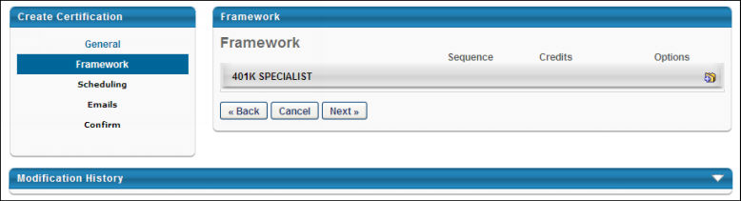
Adding a Section
To begin creating the certification framework, you must first add a section by clicking the Add Section icon in the Add column to the right of the certification title. When you click this icon, a pop-up appears where you can enter the following information about the section:
- Title - The section title. For portals with multiple languages enabled, localize the field by using the Translate icon to enter localized text.
- Credits Required - Enter the minimum number of required credits and a maximum number of allowed credits for each section. See Certifications - Parent and Child Section Credits Workflow on page 88 for additional information.
  - Min - This is the minimum number of credits that must be completed in order to complete the section. If all items in the section are optional, this can be set to 0. For example, if the minimum is set to 4, users must complete enough training items to receive at least four credits to satisfy the section requirements. Once the minimum is received, the section is considered complete and the credits within the section can be counted towards any parent sections if applicable. Additional credits may be received up to the maximum for the section. This allows administrators to ensure users are completing enough training items within each section.
  - Max - This is the maximum number of credits that can be granted within the section. For example, if the maximum is set to 10, users cannot receive more than 10 credits for the section. If they complete training items to accumulate 15 credits for the section, only 10 credits are received for the section. This allows administrators to ensure users are completing a balanced amount of training items within each section. Depending on the administrator settings, users may be able to carry over any overflow credits to subsequent renewal periods. See Certification - Create - Step 3 - Scheduling on page 29 for additional information.
After entering the section information, click Submit. The new section appears within the framework with the appropriate title and credit requirements.
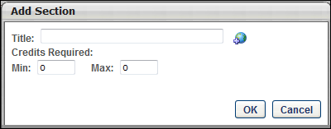
Once a section is added to the certification, you may continue to add any additional sections, or you may begin modifying the section by adding training, modify the validity of the section, or modify the training requirements.
Adding Items to a Section
The following items can be added to a section from the Add Items drop-down:
- Training - Click the Add Training link. This opens the Search for Training pop-up, where you can search for training to add to the certification. The certification items that are available may be limited by the constraints placed on the administrator's permission to manage certifications. After selecting the required items, click Done. The selected items are added to the section.
- External Training - You can add external training to a section if the option to add external training is enabled. To add external training, select the Add External Training link. This opens the External Training pop-up, where you can enter the details of the training. After entering the training details, click OK. The external training item is added to the section.
- Observation Checklist - Observation checklists that are configured in Observation Checklist Administration as a learning object checklist type can be added to a section. To add an observation checklist, click the Add Checklist link. This opens the Observation Checklist pop-up.
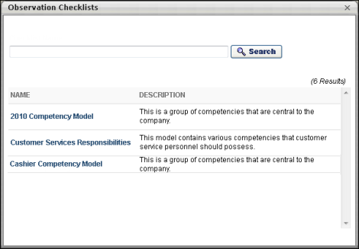
All existing active observation checklists that have a checklist type of Learning Object appear in the pop-up. You can filter the results by entering filter criteria in the Search field and then clicking Search. Select the checklist from the list. This closes the pop-up and adds the checklist to the section.
Note: Training cannot be added outside of a section. All training items must be added within a section. In addition, an expiration date cannot be configured for checklists inside a certification.
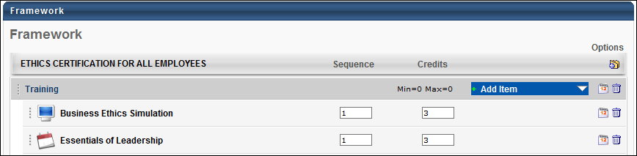
In the Sequence field, enter the sequence number for the item. The sequence number determines the order in which items can be completed. A sequence number of 1 indicates the item must be completed first in the section, and subsequent numbers must be completed in sequential order. If two items have the same sequence number, the two items with the same sequence number can be completed in any order.
In the Credits field next to the training item, enter the number of credits the item is worth towards the certification.
Define Validity for Section or Training Item
The validity period for a training item is the time period during which the training item can be completed and used towards completion of the certification. After the validity period has passed, the training item is expired and no longer counts towards the certification requirement. By default, the item can be counted towards multiple certification periods as long as the item is valid. When defining the validity period, you may choose to set no validity period, in which case the item is always valid during the time the certification is available. You may also set the validity period to a period that is relative to the start or end of the certification period. By default, no validity period is defined for all items.
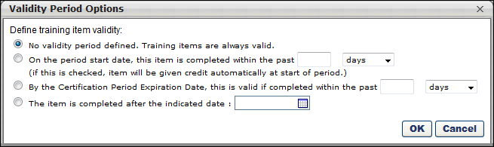
To set the validity period for a section or individual item, click the Calendar icon . The following validity period options are available:
- No validity period defined - This is the default option. The training item is always valid towards the certification. This option is appropriate if the skills and knowledge in the item is not outdated over any renewal periods and do not need to be refreshed. Note: For the item to be used to satisfy requirements for renewal periods, you must also select the Allow training items acquired from previous periods to satisfy requirement if training item is valid option when configuring the training period.
- On the period start date, this item is completed within the past XX days, months, years - When the certification period begins, the system checks if this item is complete. The item must have been completed within the specified amount of time prior to the certification period start date or during the certification period. For example, if this option is selected and set to 2 years, the user must have satisfied the requirement within the previous two years prior to the start of the certification period or during the certification period.
- By the Certification Period end date, this item is valid if completed within the past XX days, months, years - According to the specified time period for this option, prior to the end of the certification period the system checks if this item is complete. If this item is completed outside of the specified period, the user does not receive credit for completing the item. For example, if this option is selected and set to 10 days, the user must satisfy the requirement within 10 days of the end of the certification period. If they completed the item 14 days prior to the end of the period, they receive no credit and they must complete the item again within 10 days of the end of the period.
- The item is completed after the indicated date - If the item was completed after the specified date, the requirement is satisfied.
Note: For a training item to be used towards multiple periods, the option to allow users to use an item towards multiple periods must also be enabled. This option is available while scheduling renewal periods on the Scheduling page. See Certification - Create - Step 3 - Scheduling on page 29 for additional information.
Note: If a user has completed a training item multiple times, each instance of the item can be used to satisfy multiple renewal periods if the item is valid. For example, a user has taken LO1 three times prior to enrolling in the certification, and LO1 is required in the initial certification period and the two subsequent renewal periods. The user receives credit for LO1 for the initial period and the first two renewal periods as long as the item remains valid for those periods.
Edit Section Details
After a section is created, you can edit the section Title and Minimum and Maximum Requirements for the section. To edit the section details, click the section title. This opens a pop-up where the details are editable. For portals with multiple languages enabled, localization of the field is editable by using the Translate icon to edit localized text. After submitting the changes, the section details are updated on the page.
Reordering Sections or Training Items
After adding more than one item to a section or more than one section to a certification, the items can be reordered by dragging and dropping them in to the desired order. Items and sections can also be moved from one section to another via dragging and dropping.
To drag and drop a section or item, click the vertical dotted line to the left of the section title or item icon and drag it into the proper location.
Note: Moving items within a section can be used to rearrange the appearance of the certification, but the sequence is not affected. Moving items to a different section may affect the credit requirements, so be sure to check the accuracy and logic of the item credits and the section credit requirements after moving items. The Users are required to complete the minimum credits for all child sections in order for credits to be counted towards the parent section setting from the General page may also impact how credits are calculated for re-ordered sections.
Removing Sections or Training Items
To remove a section or training item, click the Delete icon next to the appropriate item. Clicking the Delete icon next to a training item removes the training item from the section. Clicking the Delete icon next to a section removes the entire section, including all of the items within it.
Next
After completing all required items in the Framework step, click Next to proceed to the Scheduling step. Note: You must complete all required items before proceeding to the next step. See Certification - Create - Step 3 - Scheduling on page 29 for additional information.
Modification History
Click the arrow next to the Modification History heading to expand the section and view the modification history for the certification.
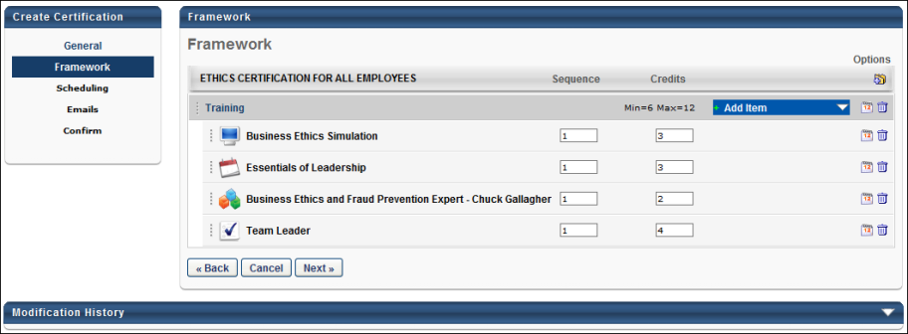

Certification - Create - Step 3 - Scheduling
In the certification creation process, the Scheduling page enables administrators to configure the schedule for the certification. Specifically, administrators can configure how frequently users will be required to complete the certification and due dates for certification periods. If users are required to renew their certification, then administrators can configure how the renewal periods function, such as how many credits are required and whether users can carry over extra credits from a previous period. The administrators can also configure if the users can bypass the need for a completion approval for an expired certification.
Note: After the certification is created and assigned to a user, the certification cannot be modified aside from updating the title of a certification period. Please verify all aspects of the certification prior to saving.
To create a certification, go to Admin > Tools > Learning > Catalog Management > Certifications. Then, click the Create a New Certification link or copy an existing certification by clicking the Copy icon in the Options column.
Permissions
PERMISSION NAME | PERMISSION DESCRIPTION | CATEGORY

Certification - Manage | Grants administrators ability to manage certifications. This permission can be constrained by OU and User's OU. This is an administrator permission. | Learning - Administration
Certification Types
When creating the certification schedule, you must first decide if the certification should have a renewal period. Also, if a renewal period is required, you must decide the type of renewal schedule to use.
The system offers the following types of certifications, and each utilize a different strategy for certifying users.
- One Time Only - This type of certification only certifies a user one time, and it does not have a renewal period. See Certification - Create - Scheduling - One Time Only on page 31 for additional information.
  - Pros: One Time Only is a simple, easy way to create a certification that only needs to be administered one time for any given person. After a user completes the certification, they remain certified forever.
  - Cons: The One Time Only scheduling option is very limited and does not allow any flexibility or automation options for scheduling the certification again or on an ongoing basis.
- Fixed Date - This type of certification requires users to renew their certification on the same date each year, regardless of the user's enrollment or previously certified date. For example, users may be required to renew their certification on January 1st each year. In the United States this is similar to filing taxes, which must be filed by April 15th each year, regardless of when you began working or when you filed your taxes the previous year. See Certification - Create - Scheduling - Fixed Date on page 36 for additional information.
  - Pros: All employees will be re-certified on the same cycle, regardless of when they were hired or received their initial certification.
  - Cons: Some employees may need to complete their renewal certification a very short time after completing the initial certification. This scenario may be less than ideal if the renewal requirements are time consuming.
- Relative - This type of certification requires users to renew their certification on a specific schedule that is relative to the initial certification completion date. For example, users may be required to renew their certification every two years after the user first becomes certified. See Certification - Create - Scheduling - Relative on page 46 for additional information.
  - Pros: Each employee is required to renew their certification on a regular schedule that accommodates their specific certification needs. This type of certification is based around a regular schedule that is standardized for all users, though the certification date is not necessarily the same for all users.
  - Cons: Employees at an organization will all become certified and require renewal certification at different times throughout the year. This scenario may become complex to manage.
- Relative with Rolling period - This type of certification requires users to renew their certification on a specific schedule that is relative to the most recent certification date. Each certification renewal period begins immediately upon the previous certification. For example, if the renewal is required 90 days from the previous certification, then each time a user renews their certification, they are immediately pushed into their next renewal period and the new due date is based around the completion date of the previous period. See Certification - Create - Scheduling - Relative with Rolling Period on page 55 for additional information.
  - Pros: Allows employees to enjoy the full duration of their certification before being required to renew. Users are given the ability to start working on their next certification period immediately after completing the previous period.
  - Cons: Certification renewal cycles will not be consistent, because future renewal assignments will become due relative to the date the employee decided to complete the previous renewal or initial certification.
Certification - Create - Scheduling - One Time Only
A One Time Only certification is a certification that only requires users to become certified one time, and the certification does not require users to renew their certification.
- Pros: One Time Only is a simple, easy way to create a certification that only needs to be administered one time for any given person. After a user completes the certification, they remain certified forever.
- Cons: The One Time Only scheduling option is very limited and does not allow any flexibility or automation options for scheduling the certification again or on an ongoing basis.
To create a certification, go to Admin > Tools > Learning > Catalog Management > Certifications. Then, click the Create a New Certification link or copy an existing certification by clicking the Copy icon in the Options column.
Permissions
PERMISSION NAME | PERMISSION DESCRIPTION | CATEGORY

Certification - Manage | Grants administrators ability to manage certifications. This permission can be constrained by OU and User's OU. This is an administrator permission. | Learning - Administration
Overall Process
When creating a One Time Only certification, complete the following steps:
- Select One Time Only as the certification period type.
- Configure the basic settings for the initial training period.
- Set the due date and expiration date for the certification.
Select Certification Type
When configuring the certification schedule, the first step is to select the type of certification you are creating. The certification type that is selected determines which option are available when configuring the certification schedule.
To create a One Type Only certification, select the Select Period Type field. Then, select the One Time Only option and click Select. This opens the Configure Training Period pop-up.
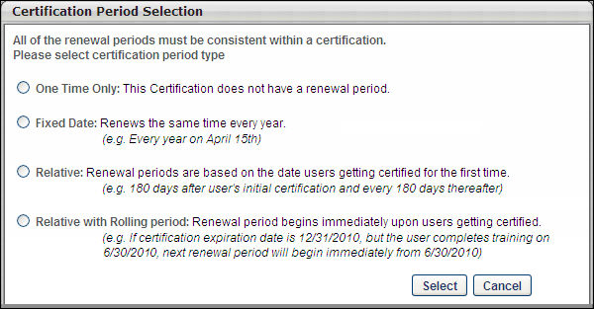
Note: The certification type can be modified after creating the initial period if necessary, but changing the period type erases all previously set up periods. If the certification is assigned to a user, the period type cannot be changed.
Configure Initial Certification Training Period
Enter the following information about the period:
- Certification Period Title - Enter a title for the initial certification period. The character limit for this field is 100. If multiple languages are enabled for your portal, select the Translate icon to translate the field into other available languages.
- Period Required Credits - Enter the number of credits that are required to be completed for the period. This minimum requirement must be reached in order to receive the certification.
- Total Maximum Credits for Selected Sections - The maximum credits that can be obtained from all selected sections. It gets automatically populated based on the sections that are selected under Select Applicable Sections and cannot be less than the Period Required Credits.
- Verification required upon completion of expired period - This option is enabled by default. When it is disabled, the expired certifications do not require completion approvals if the user completes all certification renewal requirements, thus bypassing the need for an approval. The administrators or certification owners can disable this option on one or all certification periods depending on certification renewal requirements. All completion approval requests that have already been generated still need to be approved. The Verification required upon completion of expired period setting can be changed at any time for any existing certifications, and it applies to any expired training completion approvals that are generated after the setting is changed.
- Verification required upon completion of period - Select this option to force certification users to submit evidence of completion to the administrator when they have completed the certification period. The user's status remains In Progress until the administrator verifies completion.
- Select Applicable Sections - Each section in the certification is displayed. Select the sections that should be included in the initial certification period. You may click the plus icon to the left of the section to view the items within, but only sections can be added to a period. Individual training items cannot be added to a period.
Note: If both Verification required upon completion of expired period and Verification required upon completion of period are checked, then it will generate two completion approvals if the user completes requirements for an expired certification. The first completion approval will be for the expired certification and the second completion approval is for validating the completion of expired certification. To know more, See Use Cases - Certification Completion Approval Settings on page 64 for additional information.
Click Select to add the initial period to the schedule. The period appears on the page.
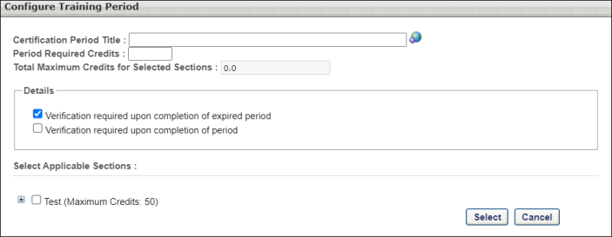
If the number of credits required to complete the certification period is greater than the sum of maximum credits set for all selected sections, a warning appears at the top of the page. The maximum credits for each selected section displays next to each selected section title. The administrator can then correct either the Period Required Credits field or the selected sections and create a certification period which can be successfully completed by users.
The administrator cannot proceed with creating the certification until they have corrected either the Period Required Credits field or the selected sections.
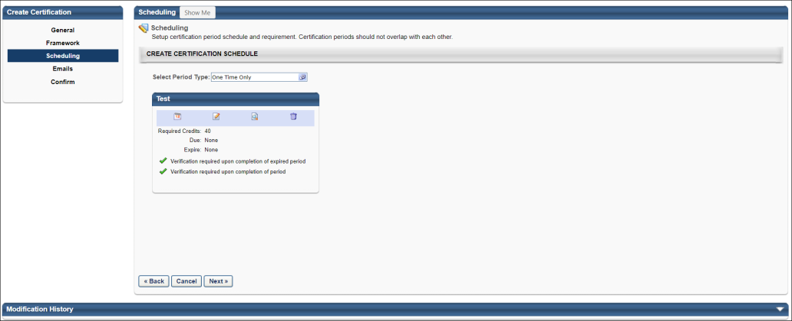
Configure Certification Periods - Due Date and Expiration Date
To configure the due date and expiration date for a certification period, click the Period Date icon below the certification period title. The Configure Certification Period window appears.
If a user has not completed the certification by the due date, the status becomes Past Due. The user may still continue to complete the certification and become certified up to the Expiration date if the expiration date is different from the due date. The Past Due status can be used as a grace period and allows administrators to report and track these users.
If a user has not completed the certification by the expiration date, the status becomes Expired. Depending on the expiration settings set when creating the certification, users may be able to access and complete the certification training, but they are not moved to a Certified status unless they request and receive completion approval. Completion approvals can be approved or denied from the Certification Management page. See Certification Requests - Pending Requests on page 108 for additional information.
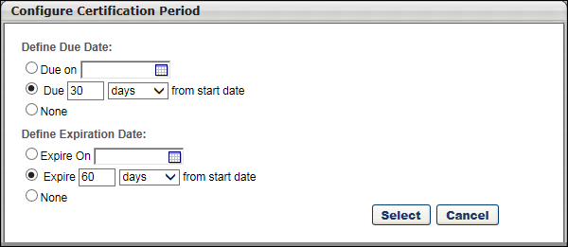
Define Due Date
Note: When setting a due date, the due date must be prior to the expiration date.
- Due on XX/XX/XXXX - Select this option to set the due date to a specific date. Then click the calendar icon to select the due date.
- Due XX days/months/years from start date - Select this option to set the due date to a date that is relative to the start date. Then enter the number of days, months, or years after the start date the period is due.
- None - Select this option to not set a due date for the period.
Define Expiration Date
- Expire on XX/XX/XXXX - Select this option to set the expiration date to a specific date. Then click the calendar icon to select the expiration date.
- Expire XX days/months/years from start date - Select this option to set the expiration date to a date that is relative to the start date. Then enter the number of days, months, or years after the start date the period expires.
- None - Select this option to not set an expiration date for the period.
Edit a Period
To edit a period after it is created, click the Edit icon for the appropriate period. This opens Configure Training Period window where you can edit the details of the period.
View the Training Item Contents of a Period
To view the framework of a period and view which training items are included in a period, hover the cursor over the View icon for the appropriate period. This displays a pop-up that shows the training framework and contents for the period.
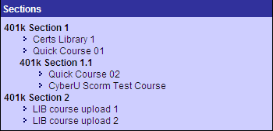
Delete a Period
To delete a period, click the Delete icon for the appropriate period. This deletes the entire period, including the selected settings.
Next
After completing all required items in the Scheduling step, click Next to proceed to the Emails step. Note: You must complete all required items before proceeding to the next step. See Certification - Create - Step 4 - Emails on page 70 for additional information.
Modification History
Click the arrow next to the Modification History heading to expand the section and view the modification history for the certification.
Certification - Create - Scheduling - Fixed Date
A Fixed Date certification is a certification that should be renewed on the same date each year, regardless of the user's enrollment or previously certified date. For example, users may be required to renew their certification on January 1st each year. In the United States this is similar to filing taxes, which must be filed by April 15th each year, regardless of when you began working or when you filed your taxes the previous year.
- Pros: All employees will be re-certified on the same cycle, regardless of when they were hired or received their initial certification.
- Cons: Some employees may need to complete their renewal certification a very short time after completing the initial certification. This scenario may be less than ideal if the renewal requirements are time-consuming.
To create a certification, go to Admin > Tools > Learning > Catalog Management > Certifications. Then, click the Create a New Certification link or copy an existing certification by clicking the Copy icon in the Options column.
Permissions
PERMISSION NAME | PERMISSION DESCRIPTION | CATEGORY

Certification - Manage | Grants administrators ability to manage certifications. This permission can be constrained by OU and User's OU. This is an administrator permission. | Learning - Administration
Overall Process
When creating a Fixed Date certification, complete the following steps:
- Select Fixed Date as the certification period type.
- Configure the basic settings for the initial training period.
- Add the necessary renewal periods.
- Set the due date and expiration date for the initial certification period.
- Configure the renewal behavior for all renewal periods.
Select Certification Type
When configuring the certification schedule, the first step is to select the type of certification you are creating. The certification type that is selected determines which option are available when configuring the certification schedule.
To create a Fixed Date certification, select the Select Period Type field. Then, select the Fixed Date option and click Select. This opens the Configure Training Period pop-up.
Note: The certification type can be modified after creating the initial period if necessary, but changing the period type erases all previously set up periods. If the certification is assigned to a user, the period type cannot be changed.
Configure Initial Certification Training Period
Enter the following information about the period:
- Certification Period Title - Enter a title for the initial certification period. The character limit for this field is 100. If multiple languages are enabled for your portal, select the Translate icon to translate the field into other available languages.
- Period Required Credits - Enter the number of credits that are required to be completed for the period. This minimum requirement must be reached without carry over credits from a previous period. This may vary from period to period.
- Total Maximum Credits for Selected Sections - The maximum credits that can be obtained from all selected sections. It gets automatically populated based on the sections that are selected under Select Applicable Sections and cannot be less than the Period Required Credits.
- Verification required upon completion of expired period - This option is enabled by default. When it is disabled, the expired certifications do not require completion approvals if the user completes all certification renewal requirements, thus bypassing the need for an approval. The administrators or certification owners can disable this option on one or all certification periods depending on certification renewal requirements. All completion approval requests that have already been generated still need to be approved. The Verification required upon completion of expired period setting can be changed at any time for any existing certifications, and it applies to any expired training completion approvals that are generated after the setting is changed.
- Verification required upon completion of period - Select this option to force certification users to submit evidence of completion to the administrator when they have completed the certification period. The user's status remains In Progress until the administrator verifies completion.
- Select Applicable Sections - Each section in the certification is displayed. Select the sections that should be included in the initial certification period. You may click the plus icon to the left of the section to view the items within, but only sections can be added to a period. Individual training items cannot be added to a period.
Note: If both Verification required upon completion of expired period and Verification required upon completion of period are checked, then it will generate two completion approvals if the user completes requirements for an expired certification. The first completion approval will be for the expired certification and the second completion approval is for validating the completion of expired certification. To know more, See Use Cases - Certification Completion Approval Settings on page 64 for additional information.
Click Select to add the initial period to the schedule. The period appears on the page.
If the number of credits required to complete the certification period is greater than the sum of maximum credits set for all selected sections, a warning appears at the top of the page. The maximum credits for each selected section displays next to each selected section title. The administrator can then correct either the Period Required Credits field or the selected sections and create a certification period which can be successfully completed by users.
The administrator cannot proceed with creating the certification until they have corrected either the Period Required Credits field or the selected sections.
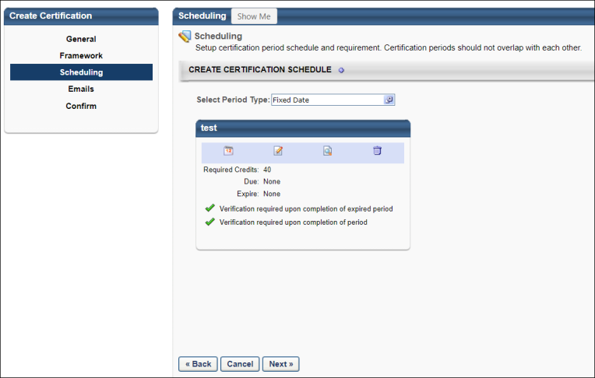
Create Certification Renewal Periods
After creating the initial certification period, you can add a renewal period to the schedule by clicking the plus icon to the right of the Create Certification Schedule section heading. Note: The plus icon is only available after the initial certification period is created.
When you click the plus icon to the right of the Create Certification Schedule heading, the Configure Training Period pop-up opens.
- Certification Period Title - Enter a title for the certification renewal period. The character limit for this field is 100.
- Period Required Credits - Enter the number of credits that are required to be completed for the renewal period. This minimum requirement must be reached without carry over credits from a previous period. This may vary from period to period.
- Total Maximum Credits for Selected Sections - The maximum credits that can be obtained from all selected sections. It gets automatically populated based on the sections that are selected under Select Applicable Sections and cannot be less than the Period Required Credits.
Details
- Verification required upon completion of expired period - This option is enabled by default. When it is disabled, the expired certifications do not require completion approvals if the user completes all certification renewal requirements, thus bypassing the need for an approval. The administrators or certification owners can disable this option on one or all certification periods depending on certification renewal requirements. All completion approval requests that have already been generated still need to be approved. The Verification required upon completion of expired period setting can be changed at any time for any existing certifications, and it applies to any expired training completion approvals that are generated after the setting is changed.
- Verification required upon completion for all future periods - Select this option to force certification users to submit evidence of completion to the administrator when they have completed the certification period. The user's status remains In Progress until the administrator verifies completion.
- Allow training items acquired from previous periods to satisfy requirement if training item is valid - Select this option to allow training items to count towards requirements in multiple periods, provided the training item is valid. For example, a training item may be valid for two years, so if multiple renewal periods occur during those two years the training item may be counted for each of those periods if this option is selected.
- Allow carry over - Select this option to allow users to carry over excess credits from a previous period. This option is only available to users if they completed the certification and completed more than the maximum number of allowed credits.
  - Partial course - This option allows users to carry over all credits that exceed the maximum number of credits allowed for the previous period. For example, if an item is worth 6 credits, but the maximum number of allowed credits is 4, the user may carry over the remaining 2 credits to the subsequent period.
  - Entire course credits from previous items - This option allows users to carry over entire courses worth of excess credits from a previous period. For example, if a user has reached the maximum number of allowed credits and then the user completes an additional course, the user may carry over the course's worth of credits to the subsequent period.
Select Applicable Sections
Each section in the certification is displayed. Select the sections that should be included in the certification renewal period. You may click the plus icon to the left of the section to view the items within, but only sections can be added to a period. Individual training items cannot be added to a period.
Click Select to add the renewal period to the schedule. The period appears on the page.
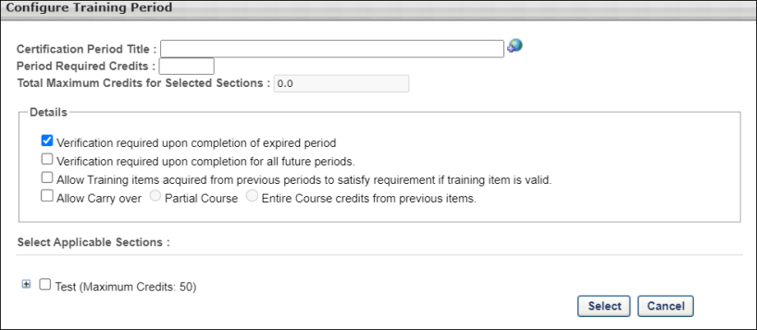
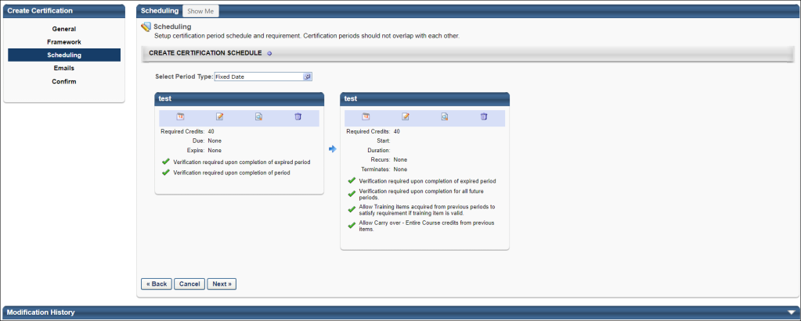
Configure Certification Periods - Due Date and Expiration Date
To configure the due date and expiration date for a certification period, click the Period Date icon below the certification period title. The Configure Certification Period window appears.
If a user has not completed the certification by the due date, the status becomes Past Due. The user may still continue to complete the certification and become certified up to the Expiration date if the expiration date is different from the due date. The Past Due status can be used as a grace period and allows administrators to report and track these users.
If a user has not completed the certification by the expiration date, the status becomes Expired. Depending on the expiration settings set when creating the certification, users may be able to access and complete the certification training, but they are not moved to a Certified status unless they request and receive completion approval. Completion approvals can be approved or denied from the Certification Management page. See Certification Requests - Pending Requests on page 108 for additional information.
When setting the start and end dates for periods, be sure that the periods to not overlap. Multiple renewal periods may be added to a certification, but the start and end dates may not overlap.
For renewal periods, you must also set additional criteria, including expiration date, period duration, and recurrence.
Initial Period
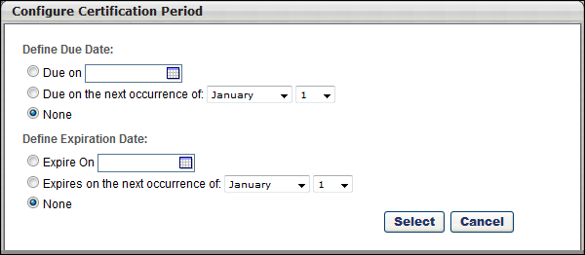
Define Due Date
Note: When setting a due date, the due date must be prior to the expiration date.
- Due on XX/XX/XXXX - Select this option to set the due date to a specific date. Then click the calendar icon to select the due date.
- Due on the next occurrence of Month/Day - Select this option to set a due date that is independent of the year. After selecting this option, select the appropriate month and date from the drop-down lists. When this option is selected, the due date for the fixed period certification is set to the next occurrence of the selected date. For example, the due date is set to the next occurrence of January 1 and a user registers for the certification on January 2, 2012. That user's certification due date is set to the next occurrence of January 1, which in this case is January 1, 2013.
  - Note: Because the certification due date and expiration date can be set relative to the user's registration date, if the certification expiration date occurs before the certification due date, then the certification due date is set to the same date as the expiration date for the initial period of that certification. Also, if "Due on the next occurrence of" is selected as the due date, then the expiration date must be set to either "None" or "Expires on the next occurrence of." Similarly, if the due date is set to "Due on," then the expiration date must be set to either "None" or "Expires on."
- None - Select this option to not set a due date for the period.
Define Expiration Date
- Expire on XX/XX/XXXX - Select this option to set the expiration date to a specific date. Then click the calendar icon to select the expiration date.
- Expires on the next occurrence of Month/Day - Select this option to set a expiration date that is independent of the year. After selecting this option, select the appropriate month and date from the drop-down lists. When this option is selected, the expiration date for the fixed period certification is set to the next occurrence of the selected date relative to the user's registration date. For example, the expiration date is set to the next occurrence of December 31 and a user registers for the certification on December 1, 2012. That user's certification expiration date is set to the next occurrence of December 31, which in this case is December 31, 2012.
  - Note: Because the certification due date and expiration date can be set relative to the user's registration date, if the certification expiration date occurs before the certification due date, then the certification due date is set to the same date as the expiration date for the initial period of that certification. Also, if "Due on the next occurrence of" is selected as the due date, then the expiration date must be set to either "None" or "Expires on the next occurrence of." Similarly, if the due date is set to "Due on," then the expiration date must be set to either "None" or "Expires on."
- None - Select this option to not set an expiration date for the period.
If a due date is set for the initial period and the If previous period is not completed prior to expiration date, adjust start day to actual completion date option is selected, if the initial certification period is overdue, the due date for the initial period is adjusted to the actual completion date.
Renewal Periods
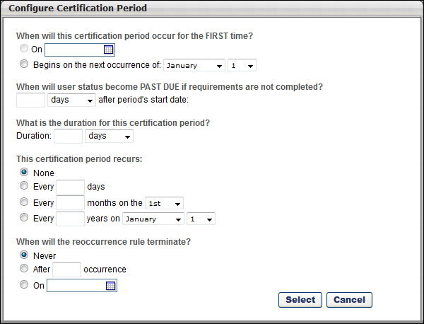
- When will this certification period occur for the FIRST time? - Select when the renewal period begins.
  - On - Select this option to select a specific date on which the renewal period begins.
  - Begins on the next occurrence of - Select this option to set a renewal period start date that is independent of the year. After selecting this option, select the appropriate month and date from the drop-down lists. When this option is selected, the certification renewal period begins for the first time on the next occurrence of the selected date relative to the user's initial period expiration date. For example, the first renewal period is set to begin on the next occurrence of January 1 and a user's initial period expires on December 31, 2012. That user's first certification renewal period start date is set to the next occurrence of January 1, which in this case is January 1, 2013. Note: The selection for the certification's first renewal period start date must match the selection type for the certification's initial period expiration date. For example, if the initial period expiration date is set as a fixed date without a year (e.g., the next occurrence of January 1, rather than 01/01/2012), then the first renewal period start date must also be set as a fixed date with a year.
- When will user status become PAST DUE if requirements are not completed? - Select the amount of time users have to complete the certification period prior to becoming Past Due.
- What is the duration for this certification period? - Select the duration for the renewal period.
- This certification period recurs - Select and specify the frequency at which the certification period recurs. For example, if you select Every 2 Years on January 1, a new iteration of the certification period begins on January 1 two years after the previous period begins. This can be set to any number of days, months, and years. Also, no recurrence can be set.
- When will the reocurrence rule terminate? - Select when the period stops recurring. This can be set to never stop, stop after a certain number of instances, or stop on a specific date.
Edit a Period
To edit a period after it is created, click the Edit icon for the appropriate period. This opens Configure Training Period window where you can edit the details of the period.
View the Training Item Contents of a Period
To view the framework of a period and view which training items are included in a period, hover the cursor over the View icon for the appropriate period. This displays a pop-up that shows the training framework and contents for the period.
Delete a Period
To delete a period, click the Delete icon for the appropriate period. This deletes the entire period, including the selected settings.
Next
After completing all required items in the Scheduling step, click Next to proceed to the Emails step. Note: You must complete all required items before proceeding to the next step. See Certification - Create - Step 4 - Emails on page 70 for additional information.
Modification History
Click the arrow next to the Modification History heading to expand the section and view the modification history for the certification.
Certification - Create - Scheduling - Relative
A Relative certification is a certification that should be renewed on a specific schedule relative to the initial certification completion date. For example, users may be required to renew their certification every two years after the user first becomes certified.
- Pros: Each employee is required to renew their certification on a regular schedule that accommodates their specific certification needs. This type of certification is based around a regular schedule that is standardized for all users, though the certification date is not necessarily the same for all users.
- Cons: Employees at an organization will all become certified and require renewal certification at different times throughout the year. This scenario may become complex to manage.
To create a certification, go to Admin > Tools > Learning > Catalog Management > Certifications. Then, click the Create a New Certification link or copy an existing certification by clicking the Copy icon in the Options column.
Permissions
PERMISSION NAME | PERMISSION DESCRIPTION | CATEGORY

Certification - Manage | Grants administrators ability to manage certifications. This permission can be constrained by OU and User's OU. This is an administrator permission. | Learning - Administration
Overall Process
When creating a Relative certification, complete the following steps:
- Select Relative as the certification period type.
- Configure the basic settings for the initial training period.
- Add the necessary renewal periods.
- Set the due date and expiration date for the initial certification period.
- Configure the renewal behavior for all renewal periods.
Select Certification Type
When configuring the certification schedule, the first step is to select the type of certification you are creating. The certification type that is selected determines which option are available when configuring the certification schedule.
To create a Relative certification, select the Select Period Type field. Then, select the Relative option and click Select. This opens the Certification Period Selection pop-up.
Note: The certification type can be modified after creating the initial period if necessary, but changing the period type erases all previously set up periods. If the certification is assigned to a user, the period type cannot be changed.
Configure Initial Certification Training Period
Enter the following information about the period:
- Certification Period Title - Enter a title for the initial certification period. The character limit for this field is 100. If multiple languages are enabled for your portal, select the Translate icon to translate the field into other available languages.
- Period Required Credits - Enter the number of credits that are required to be completed for the period. This minimum requirement must be reached without carry over credits from a previous period. This may vary from period to period.
- Total Maximum Credits for Selected Sections - The maximum credits that can be obtained from all selected sections. It gets automatically populated based on the sections that are selected under Select Applicable Sections and cannot be less than the Period Required Credits.
- Verification required upon completion of expired period - This option is enabled by default. When it is disabled, the expired certifications do not require completion approvals if the user completes all certification renewal requirements, thus bypassing the need for an approval. The administrators or certification owners can disable this option on one or all certification periods depending on certification renewal requirements. All completion approval requests that have already been generated still need to be approved. The Verification required upon completion of expired period setting can be changed at any time for any existing certifications, and it applies to any expired training completion approvals that are generated after the setting is changed.
- Verification required upon completion of period - Select this option to force certification users to submit evidence of completion to the administrator when they have completed the certification period. The user's status remains In Progress until the administrator verifies completion.
- Select Applicable Sections - Each section in the certification is displayed. Select the sections that should be included in the initial certification period. You may click the plus icon to the left of the section to view the items within, but only sections can be added to a period. Individual training items cannot be added to a period.
Note: If both Verification required upon completion of expired period and Verification required upon completion of period are checked, then it will generate two completion approvals if the user completes requirements for an expired certification. The first completion approval will be for the expired certification and the second completion approval is for validating the completion of expired certification. To know more, See Use Cases - Certification Completion Approval Settings on page 64 for additional information.
Click Select to add the initial period to the schedule. The period appears on the page.
If the number of credits required to complete the certification period is greater than the sum of maximum credits set for all selected sections, a warning appears at the top of the page. The maximum credits for each selected section displays next to each selected section title. The administrator can then correct either the Period Required Credits field or the selected sections and create a certification period which can be successfully completed by users.
The administrator cannot proceed with creating the certification until they have corrected either the Period Required Credits field or the selected sections.
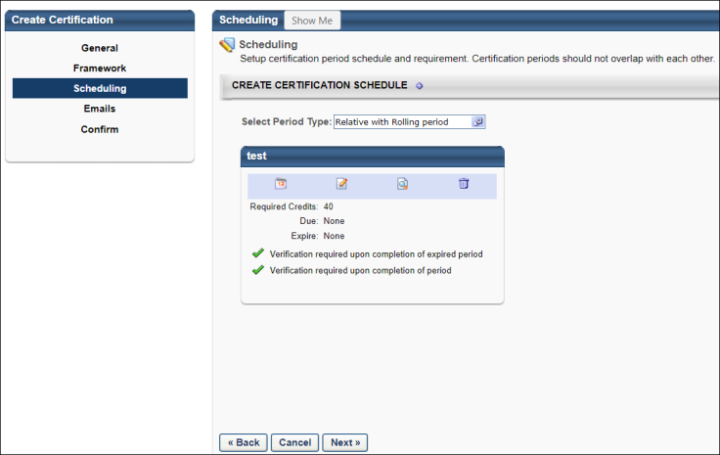
Create Certification Renewal Periods
After creating the initial certification period, you can add a renewal period to the schedule by clicking the plus icon to the right of the Create Certification Schedule section heading. Note: The plus icon is only available after the initial certification period is created.
When you click the plus icon to the right of the Create Certification Schedule heading, the Configure Training Period pop-up opens.
- Certification Period Title - Enter a title for the certification renewal period. The character limit for this field is 100.
- Period Required Credits - Enter the number of credits that are required to be completed for the renewal period. This minimum requirement must be reached without carry over credits from a previous period. This may vary from period to period.
- Total Maximum Credits for Selected Sections - The maximum credits that can be obtained from all selected sections. It gets automatically populated based on the sections that are selected under Select Applicable Sections and cannot be less than the Period Required Credits.
Details
- Verification required upon completion of expired period - This option is enabled by default. When it is disabled, the expired certifications do not require completion approvals if the user completes all certification renewal requirements, thus bypassing the need for an approval. The administrators or certification owners can disable this option on one or all certification periods depending on certification renewal requirements. All completion approval requests that have already been generated still need to be approved. The Verification required upon completion of expired period setting can be changed at any time for any existing certifications, and it applies to any expired training completion approvals that are generated after the setting is changed.
- Verification required upon completion for all future periods - Select this option to force certification users to submit evidence of completion to the administrator when they have completed the certification period. The user's status remains In Progress until the administrator verifies completion.
- If previous period is not completed prior to expiration date, adjust start day to actual completion date - By default, the expiration date is the official end date of the period. Users must complete all training items within the certification by that date, and the subsequent period cannot begin until the previous period is complete. If this option is selected, when a period expires and a user has not completed the certification, the start date for the following renewal period is set to the date on which the previous period is completed. This may be used to more accurately reflect the actual start date of the certification.
- Allow training items acquired from previous periods to satisfy requirement if training item is valid - Select this option to allow training items to count towards requirements in multiple periods, provided the training item is valid. For example, a training item may be valid for two years, so if multiple renewal periods occur during those two years the training item may be counted for each of those periods if this option is selected.
- Allow carry over - Select this option to allow users to carry over excess credits from a previous period. This option is only available to users if they completed the certification and completed more than the maximum number of allowed credits.
  - Partial course - This option allows users to carry over all credits that exceed the maximum number of credits allowed for the previous period. For example, if an item is worth 6 credits, but the maximum number of allowed credits is 4, the user may carry over the remaining 2 credits to the subsequent period.
  - Entire course credits from previous items - This option allows users to carry over entire courses worth of excess credits from a previous period. For example, if a user has reached the maximum number of allowed credits and then the user completes an additional course, the user may carry over the course's worth of credits to the subsequent period.
Select Applicable Sections
Each section in the certification is displayed. Select the sections that should be included in the certification renewal period. You may click the plus icon to the left of the section to view the items within, but only sections can be added to a period. Individual training items cannot be added to a period.
Click Select to add the renewal period to the schedule. The period appears on the page.
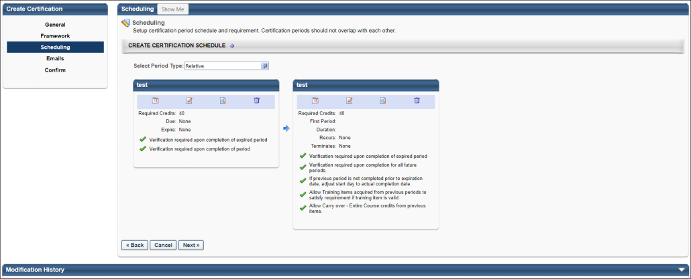
Configure Certification Periods - Due Date and Expiration Date
To configure the due date and expiration date for a certification period, click the Period Date icon below the certification period title. The Configure Certification Period window appears.
If a user has not completed the certification by the due date, the status becomes Past Due. The user may still continue to complete the certification and become certified up to the Expiration date if the expiration date is different from the due date. The Past Due status can be used as a grace period and allows administrators to report and track these users.
If a user has not completed the certification by the expiration date, the status becomes Expired. Depending on the expiration settings set when creating the certification, users may be able to access and complete the certification training, but they are not moved to a Certified status unless they request and receive completion approval. Completion approvals can be approved or denied from the Certification Management page. See Certification Requests - Pending Requests on page 108 for additional information.
When setting the start and end dates for periods, be sure that the periods to not overlap. Multiple renewal periods may be added to a certification, but the start and end dates may not overlap.
For renewal periods, you must also set additional criteria, including expiration date, period duration, and recurrence.
Initial Period
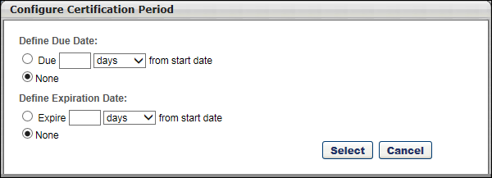
Define Due Date
Note: When setting a due date, the due date must be prior to the expiration date.
- Due XX days/months/years from start date - Select this option to set the due date to a date that is relative to the start date. Then enter the number of days, months, or years after the start date the period is due.
  - Round period Due Date up to next end of month - Select this option to round the certification due date to the last calendar day of the month in which the certification is due. This option does not appear if None is selected as the due date.
- None - Select this option to not set a due date for the period.
Define Expiration Date
- Expire XX days/months/years from start date - Select this option to set the expiration date to a date that is relative to the start date. Then enter the number of days, months, or years after the start date the period expires.
  - Round period Expiration Date up to next end of month - Select this option to round the certification expiration date to the last calendar day of the month in which the certification expires. This option does not appear if None is selected as the expiration date.
- None - Select this option to not set an expiration date for the period.
If a due date is set for the initial period and the If previous period is not completed prior to expiration date, adjust start day to actual completion date option is selected, if the initial certification period is overdue, the due date for the initial period is adjusted to the actual completion date.
Renewal Periods
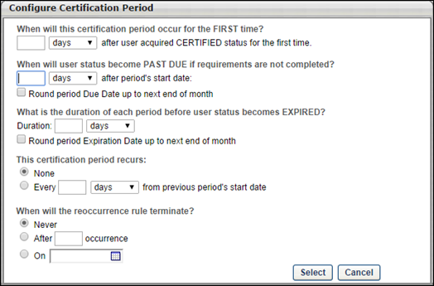
- When will this certification period occur for the FIRST time? - Select the relative date on which the renewal period begins. If a value of 0 is entered, the renewal period starts on the same date that the initial certification period ends.
- When will user status become PAST DUE if requirements are not completed? - Select the amount of time users have to complete the certification period prior to becoming Past Due.
  - Round period Due Date up to the next end of month - Select this option to round the date on which the renewal becomes past due to the last calendar day of the month in which the renewal is due.
- What is the duration of each period before user status becomes EXPIRED? - Select the duration for the renewal periods before the certification period becomes expired. If a value of 0 is entered, the renewal period expires on the same date that the renewal period begins.
  - Round period Expiration Date up to the next end of month - Select this option to round the date on which the renewal becomes expired to the last calendar day of the month in which the renewal expires.
- This certification period recurs - Select and specify the frequency at which the certification period recurs. For example, if you select Every 2 Years on January 1, a new iteration of the certification period begins on January 1 two years after the previous period begins. This can be set to any number of days, months, and years. Also, no recurrence can be set.
- When will the recurrence rule terminate? - Select when the period stops recurring. This can be set to never stop, stop after a certain number of instances, or stop on a specific date.
Edit a Period
To edit a period after it is created, click the Edit icon for the appropriate period. This opens Configure Training Period window where you can edit the details of the period.
View the Training Item Contents of a Period
To view the framework of a period and view which training items are included in a period, hover the cursor over the View icon for the appropriate period. This displays a pop-up that shows the training framework and contents for the period.
Delete a Period
To delete a period, click the Delete icon for the appropriate period. This deletes the entire period, including the selected settings.
Next
After completing all required items in the Scheduling step, click Next to proceed to the Emails step. Note: You must complete all required items before proceeding to the next step. See Certification - Create - Step 4 - Emails on page 70 for additional information.
Modification History
Click the arrow next to the Modification History heading to expand the section and view the modification history for the certification.
Certification - Create - Scheduling - Relative with Rolling Period
A Relative with Rolling Period certification is a certification that should be renewed on a specific schedule relative to the most recent certification date. Each certification renewal period begins immediately upon the previous certification. For example, if the renewal is required 90 days from the previous certification, then each time a user renews their certification, they are immediately pushed into their next renewal period and the new due date is based around the completion date of the previous period.
- Pros: Allows employees to enjoy the full duration of their certification before being required to renew. Users are given the ability to start working on their next certification period immediately after completing the previous period.
- Cons: Certification renewal cycles will not be consistent, because future renewal assignments will become due relative to the date the employee decided to complete the previous renewal or initial certification.
To create a certification, go to Admin > Tools > Learning > Catalog Management > Certifications. Then, click the Create a New Certification link or copy an existing certification by clicking the Copy icon in the Options column.
Permissions
PERMISSION NAME | PERMISSION DESCRIPTION | CATEGORY

Certification - Manage | Grants administrators ability to manage certifications. This permission can be constrained by OU and User's OU. This is an administrator permission. | Learning - Administration
Overall Process
When creating a Relative with Rolling Period certification, complete the following steps:
- Select Relative with Rolling Period as the certification period type.
- Configure the basic settings for the initial training period.
- Add the necessary renewal periods.
- Set the due date and expiration date for the initial certification period.
- Configure the renewal behavior for all renewal periods.
Select Certification Type
When configuring the certification schedule, the first step is to select the type of certification you are creating. The certification type that is selected determines which option are available when configuring the certification schedule.
To create a Relative with Rolling certification, select the Select Period Type field. Then, select the Relative with Rolling option and click SELECT. This opens Certification Period Selection pop-up.

Note: The certification type can be modified after creating the initial period if necessary, but changing the period type erases all previously set up periods. If the certification is assigned to a user, the period type cannot be changed.
Configure Initial Certification Training Period
Enter the following information about the period:
- Certification Period Title - Enter a title for the initial certification period. The character limit for this field is 100. If multiple languages are enabled for your portal, select the Translate icon to translate the field into other available languages.
- Period Required Credits - Enter the number of credits that are required to be completed for the period. This minimum requirement must be reached without carry over credits from a previous period. This may vary from period to period.
- Total Maximum Credits for Selected Sections - The maximum credits that can be obtained from all selected sections. It gets automatically populated based on the sections that are selected under Select Applicable Sections and cannot be less than the Period Required Credits.
- Verification required upon completion of expired period - This option is enabled by default. When it is disabled, the expired certifications do not require completion approvals if the user completes all certification renewal requirements, thus bypassing the need for an approval. The administrators or certification owners can disable this option on one or all certification periods depending on certification renewal requirements. All completion approval requests that have already been generated still need to be approved. The Verification required upon completion of expired period setting can be changed at any time for any existing certifications, and it applies to any expired training completion approvals that are generated after the setting is changed.
- Verification required upon completion of period - Select this option to force certification users to submit evidence of completion to the administrator when they have completed the certification period. The user's status remains In Progress until the administrator verifies completion.
- Select Applicable Sections - Each section in the certification is displayed. Select the sections that should be included in the initial certification period. You may click the plus icon to the left of the section to view the items within, but only sections can be added to a period. Individual training items cannot be added to a period.
Note: If both Verification required upon completion of expired period and Verification required upon completion of period are checked, then it will generate two completion approvals if the user completes requirements for an expired certification. The first completion approval will be for the expired certification and the second completion approval is for validating the completion of expired certification. To know more, See Use Cases - Certification Completion Approval Settings on page 64 for additional information.
Click Select to add the initial period to the schedule. The period appears on the page.
If the number of credits required to complete the certification period is greater than the sum of maximum credits set for all selected sections, a warning appears at the top of the page. The maximum credits for each selected section displays next to each selected section title. The administrator can then correct either the Period Required Credits field or the selected sections and create a certification period which can be successfully completed by users.
The administrator cannot proceed with creating the certification until they have corrected either the Period Required Credits field or the selected sections.
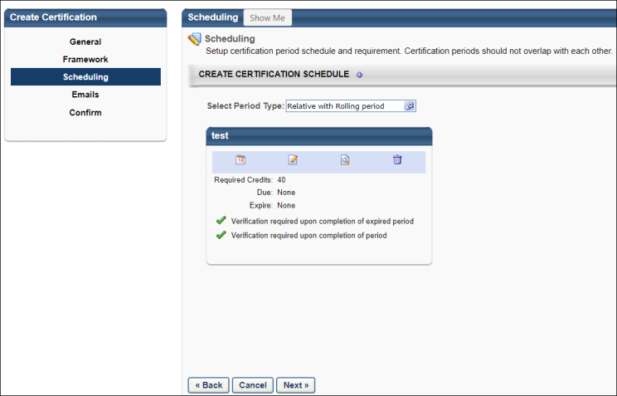
Create Certification Renewal Periods
After creating the initial certification period, you can add a renewal period to the schedule by clicking the plus icon to the right of the Create Certification Schedule section heading. Note: The plus icon is only available after the initial certification period is created.
When you click the plus icon to the right of the Create Certification Schedule heading, the Configure Training Period pop-up opens.
- Certification Period Title - Enter a title for the certification renewal period. The character limit for this field is 100.
- Period Required Credits - Enter the number of credits that are required to be completed for the renewal period. This minimum requirement must be reached without carry over credits from a previous period. This may vary from period to period.
- Total Maximum Credits for Selected Sections - The maximum credits that can be obtained from all selected sections. It gets automatically populated based on the sections that are selected under Select Applicable Sections and cannot be less than the Period Required Credits.
Details
- Verification required upon completion of expired period - This option is enabled by default. When it is disabled, the expired certifications do not require completion approvals if the user completes all certification renewal requirements, thus bypassing the need for an approval. The administrators or certification owners can disable this option on one or all certification periods depending on certification renewal requirements. All completion approval requests that have already been generated still need to be approved. The Verification required upon completion of expired period setting can be changed at any time for any existing certifications, and it applies to any expired training completion approvals that are generated after the setting is changed.
- Verification required upon completion for all future periods - Select this option to force certification users to submit evidence of completion to the administrator when they have completed the certification period. The user's status remains In Progress until the administrator verifies completion.
- If previous period is not completed prior to expiration date, adjust start day to actual completion date - By default, the expiration date is the official end date of the period. Users must complete all training items within the certification by that date, and the subsequent period cannot begin until the previous period is complete. If this option is selected, when a period expires and a user has not completed the certification, the start date for the following renewal period is set to the date on which the previous period is completed. This may be used to more accurately reflect the actual start date of the certification.
- Allow carry over - Select this option to allow users to carry over excess credits from a previous period. This option is only available to users if they completed the certification and completed more than the maximum number of allowed credits.
  - Partial course - This option allows users to carry over all credits that exceed the maximum number of credits allowed for the previous period. For example, if an item is worth 6 credits, but the maximum number of allowed credits is 4, the user may carry over the remaining 2 credits to the subsequent period.
  - Entire course credits from previous items - This option allows users to carry over entire courses worth of excess credits from a previous period. For example, if a user has reached the maximum number of allowed credits and then the user completes an additional course, the user may carry over the course's worth of credits to the subsequent period.
Select Applicable Sections
Each section in the certification is displayed. Select the sections that should be included in the certification renewal period. You may click the plus icon to the left of the section to view the items within, but only sections can be added to a period. Individual training items cannot be added to a period.
Click Select to add the renewal period to the schedule. The period appears on the page.
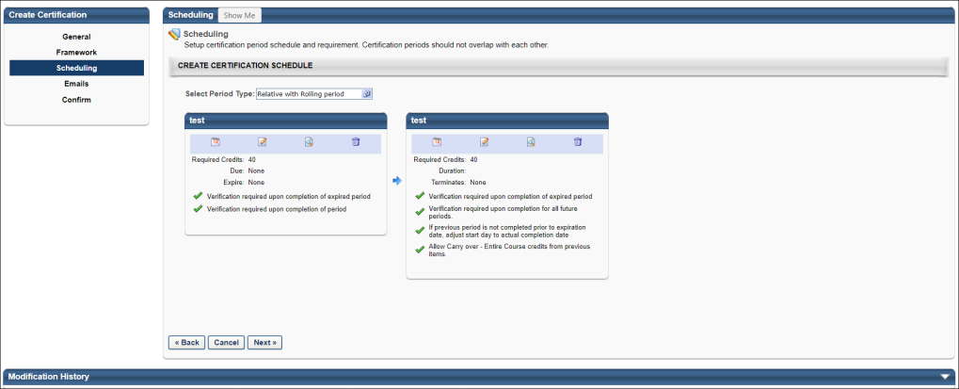
Configure Certification Periods - Due Date and Expiration Date
To configure the due date and expiration date for a certification period, click the Period Date icon below the certification period title. The Configure Certification Period window appears.
If a user has not completed the certification by the due date, the status becomes Past Due. The user may still continue to complete the certification and become certified up to the Expiration date if the expiration date is different from the due date. The Past Due status can be used as a grace period and allows administrators to report and track these users.
If a user has not completed the certification by the expiration date, the status becomes Expired. Depending on the expiration settings set when creating the certification, users may be able to access and complete the certification training, but they are not moved to a Certified status unless they request and receive completion approval. Completion approvals can be approved or denied from the Certification Management page. See Certification Requests - Pending Requests on page 108 for additional information.
When setting the start and end dates for periods, be sure that the periods to not overlap. Multiple renewal periods may be added to a certification, but the start and end dates may not overlap.
For renewal periods, you must also set additional criteria, including expiration date, period duration, and recurrence.
Initial Period
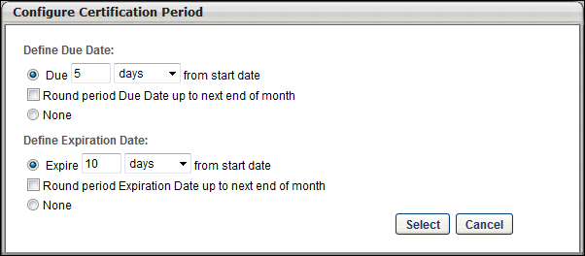
Define Due Date
Note: When setting a due date, the due date must be prior to the expiration date.
- Due XX days/months/years from start date - Select this option to set the due date to a date that is relative to the start date. Then enter the number of days, months, or years after the start date the period is due.
  - Round period Due Date up to next end of month - Select this option to round the certification due date to the last calendar day of the month in which the certification is due. This option does not appear if None is selected as the due date.
- None - Select this option to not set a due date for the period.
Define Expiration Date
- Expire XX days/months/years from start date - Select this option to set the expiration date to a date that is relative to the start date. Then enter the number of days, months, or years after the start date the period expires.
  - Round period Expiration Date up to next end of month - Select this option to round the certification expiration date to the last calendar day of the month in which the certification expires. This option does not appear if None is selected as the expiration date.
- None - Select this option to not set an expiration date for the period.
If a due date is set for the initial period and the If previous period is not completed prior to expiration date, adjust start day to actual completion date option is selected, if the initial certification period is overdue, the due date for the initial period is adjusted to the actual completion date.
Renewal Periods
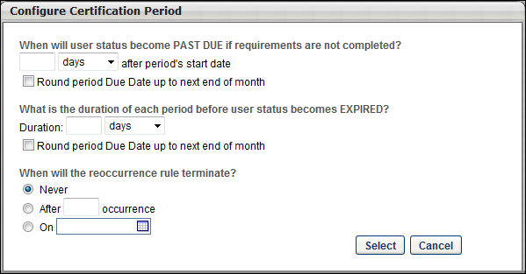
- When will user status become PAST DUE if requirements are not completed? - Select the amount of time users have to complete the certification period prior to becoming Past Due.
  - Round period Due Date up to next end of month - Select this option to round the date on which the renewal becomes past due to the last calendar day of the month in which the renewal is due.
- What is the duration of each period before user status becomes EXPIRED? - Select the duration for the renewal periods before the certification period becomes expired. If a value of 0 is entered, the renewal period expires on the same date that the renewal period begins.
  - Round period Due Date up to next end of month - Select this option to round the date on which the renewal becomes expired to the last calendar day of the month in which the renewal expires.
- When will the recurrence rule terminate? - Select when the period stops recurring. This can be set to never stop, stop after a certain number of instances, or stop on a specific date.
Edit a Period
To edit a period after it is created, click the Edit icon for the appropriate period. This opens Configure Training Period window where you can edit the details of the period.
View the Training Item Contents of a Period
To view the framework of a period and view which training items are included in a period, hover the cursor over the View icon for the appropriate period. This displays a pop-up that shows the training framework and contents for the period.
Delete a Period
To delete a period, click the Delete icon for the appropriate period. This deletes the entire period, including the selected settings.
Next
After completing all required items in the Scheduling step, click Next to proceed to the Emails step. Note: You must complete all required items before proceeding to the next step. See Certification - Create - Step 4 - Emails on page 70 for additional information.
Modification History
Click the arrow next to the Modification History heading to expand the section and view the modification history for the certification.
Use Cases - Certification Completion Approval Settings
While creating new certifications or editing existing certifications, the administrators can configure certification completion approval settings for users. The completion approval settings generate certification completion approval requests when a user completes all certification requirements. The administrator then approves the requests to mark a certification as complete for the user. A user can either complete a certification by due date or after the expiry of the certification. The completion approval settings are as follows:
- Verification required upon completion of expired period - This option is enabled by default. When it is disabled, the expired certifications do not require completion approvals if the user completes all certification renewal requirements, thus bypassing the need for an approval. The administrators or certification owners can disable this option on one or all certification periods depending on certification renewal requirements. All completion approval requests that have already been generated still need to be approved. The Verification required upon completion of expired period setting can be changed at any time for any existing certifications, and it applies to any expired training completion approvals that are generated after the setting is changed.
- Verification required upon completion of period - Select this option to force certification users to submit evidence of completion to the administrator when they have completed the certification period. The user's status remains In Progress until the administrator verifies completion.
If both Verification required upon completion of expired period and Verification required upon completion of period are checked, then it will generate two completion approvals if the user completes requirements for an expired certification. The first completion approval will be for the expired certification and the second completion approval is for validating the completion of expired certification.
An administrator can enable or disable the completion approval settings based on requirements. The following use cases describe different scenarios involving completion approval settings:
Scenario 1
A certification XYZ has both Verification required upon completion of period and Verification required upon completion of expired period enabled. Users A and B has the certification XYZ with due date of 7/27/2023 and expiration date of 7/28/2023.
User A completes certification XYZ on 7/26/2023. So a completion approval request will be generated.
User B completes certification XYZ on 8/1/2023, which means User B completed the certification requirements after the certification XYZ was expired. This will generate two completion requests, one for the expired certification XYZ and one to validate the completion of expired certification XYZ.
Scenario 2
A certification XYZ has Verification required upon completion of period enabled and Verification required upon completion of expired period disabled. Users A and B has the certification XYZ with due date of 7/27/2023 and expiration date of 7/28/2023.
User A completes certification XYZ on 7/26/2023. So a completion approval request will be generated.
User B completes certification XYZ on 8/1/2023 which means User B completed the certification requirements after the certification XYZ was expired. Only one completion request will be generated.
Scenario 3
A certification XYZ has Verification required upon completion of period disabled and Verification required upon completion of expired period enabled. Users A and B has the certification XYZ with due date of 7/27/2023 and expiration date of 7/28/2023.
User A completes certification XYZ on 7/26/2023. No completion approval request will be generated.
User B completes certification XYZ on 8/1/2023, which means User B completed the certification requirements after the certification XYZ was expired. This will generate only one completion request for the expired certification XYZ.
Scenario 4
A certification XYZ has both Verification required upon completion of period disabled and Verification required upon completion of expired period disabled. Users A and B has the certification XYZ with due date of 7/27/2023 and expiration date of 7/28/2023.
User A completes certification XYZ on 7/26/2023. No completion approval request will be generated.
User B completes certification XYZ on 8/1/2023, which means User B completed the certification requirements after the certification XYZ was expired. No completion approval request will be generated.
Permissions
The following are the permissions necessary to create this scenario:
Permissions
PERMISSION NAME | PERMISSION DESCRIPTION | CATEGORY

Certification - Manage | Grants administrators ability to manage certifications. This permission can be constrained by OU and User's OU. This is an administrator permission. | Learning - Administration

Certification - Create - Step 4 - Emails
In the Emails section, define which emails should be triggered regarding the certification.
To create a certification, go to Admin > Tools > Learning > Catalog Management > Certifications. Then, click the Create a New Certification link or copy an existing certification by clicking the Copy icon in the Options column.
Permissions
PERMISSION NAME | PERMISSION DESCRIPTION | CATEGORY

Certification - Manage | Grants administrators ability to manage certifications. This permission can be constrained by OU and User's OU. This is an administrator permission. | Learning - Administration
Emails
EMAIL NAME | EMAIL DESCRIPTION | ACTION TYPE

Approve Certification | This email is triggered when a user's request to enroll in a certification is approved. | Certification

Assigned Certification | This email is triggered when a user is assigned a certification; the certification still requires registration and approval. | Certification

Certification Credits Adjusted | This email is triggered when an administrator manually adjusts a user's credits that are applied to a certification from the Certification Report page. | Certification

Certification Credits Received | This email is triggered when a user receives credit for completing a training item that is applied to a certification. If the learning object applies to multiple certifications, only one email is fired. | Certification

Certification External Training Credit Applied | This email is triggered when credit from external training is approved and applied to the certification. | Certification

Certification External Training Credit Submission Confirmation | This email is triggered when a user submits external training for certification credit. | Certification

Certification Period Begin Reminder | This reminder email is triggered when a certification period begins. | Certification

Certification Period Completion Notification | This email is triggered when a user has successfully completed all requirements for a certification period. | Certification

Certification Period Expiration | This email is triggered as a reminder that the certification period expiration is approaching. | Certification

Certification Period Overdue Notification | This email is triggered when a user has not completed the certification requirements by the due date or the certification expiration date. If all requirements are complete, this email is not triggered. | Certification

Certification Reversioned | This email is triggered when a user has been moved to a new version of a certification. | Certification

Deny Certification | This email is triggered when a user's request to enroll in a certification is denied. | Certification

Enrolled in Certification | This email is triggered when a user becomes enrolled in a certification via assignment or proxy enrollment. This email is triggered for the initial enrollment, but is not triggered for renewal periods. | Certification

Remove Certification | This email is triggered when an administrator removes a certification for a user from the Certification Management page using the delete icon (trash can). Bulk Removals done through the certification removal tool or removal triggered through the dynamic removal setting on a dynamic certification proxy enrollment will not trigger the Remove Certification email. | Certification

Request Certification | This email is triggered when a user submits a request to enroll in a certification. | Certification
Customize email triggers for the certification, use the standard email triggers from the Email Administration page, or disable emails for the certification.
Note: After the certification is created and assigned to a user, the certification cannot be modified, including text changes. Please verify all aspects of the certification prior to saving.
You have the following options for certification emails:
- System Defaults - This selection uses the default emails based on settings and availability from the Email Administration page.
- Custom Emails - This selection allows you to customize the emails for this certification. The list of customizable emails is listed below in the Email Administration section.
- No Emails - No emails are sent regarding this certification. This includes when certifications are assigned and when they are due.
There is no option to disable the Emails step. Also, there is no separate permission for managing emails within the certification creation process.
All certification emails can be sent to the certification candidate, certification candidate manager, or certification owner.
Next
When complete, click Next to continue to the Confirm section. See Certification - Create - Step 5 - Confirm on page 73 for additional information.
Modification History
Click the arrow next to the Modification History heading to expand the section and view the modification history for the certification.
Troubleshooting Information
The following pages contain troubleshooting guides for using emails:
- See Troubleshooting Guide - Emails.
- See Email Troubleshooting Guide.
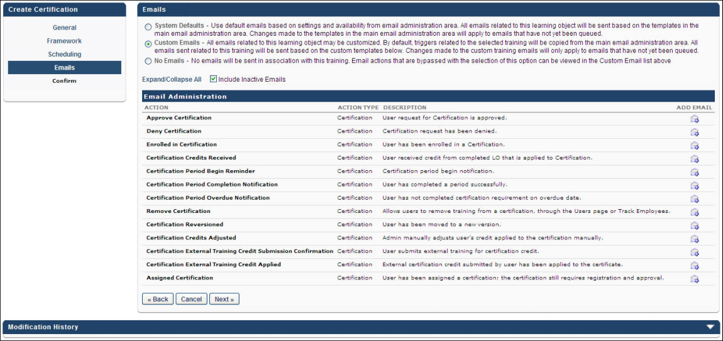

Certification - Create - Step 5 - Confirm
In the Confirm section, an overview of the certification is displayed.
To create a certification, go to Admin > Tools > Learning > Catalog Management > Certifications. Then, click the Create a New Certification link or copy an existing certification by clicking the Copy icon in the Options column.
To view the framework of a period and view which training items are included in a period, click the View icon for the appropriate period. This displays a pop-up that shows the training framework and contents for the period.
Note: After the certification is created and assigned to a user, the certification cannot be modified, including text changes. Please verify all aspects of the certification prior to saving.
Save
Click Save to finalize the certification.
Modification History
Click the arrow next to the Modification History heading to expand the section and view the modification history for the certification.
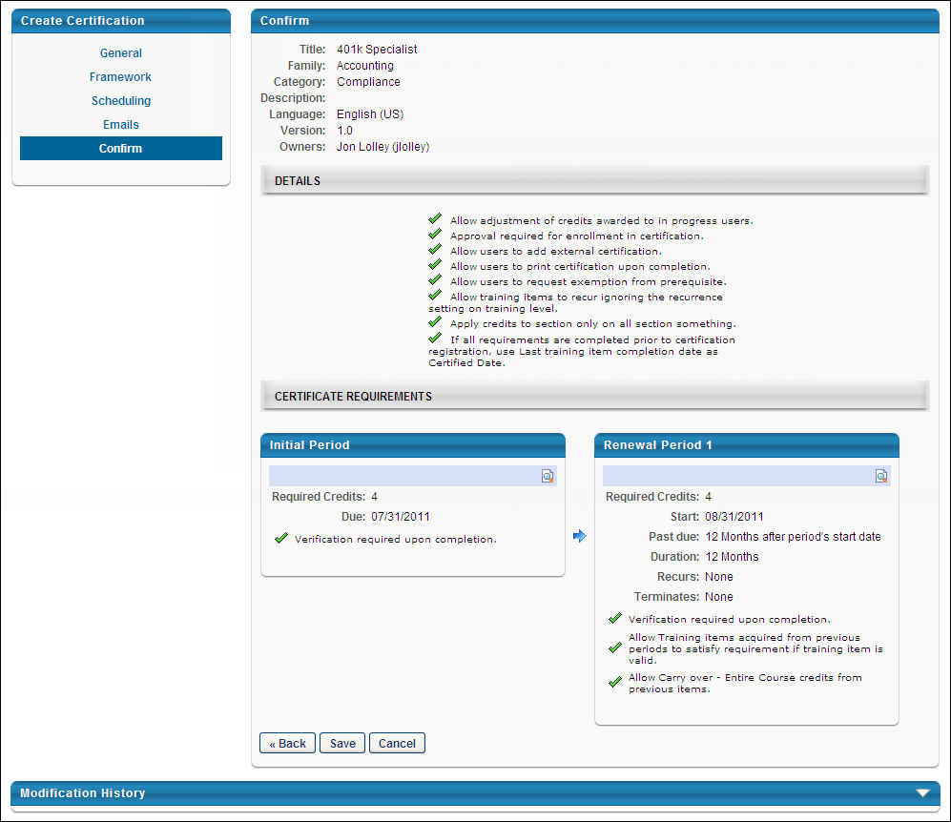

Edit Certification
When editing a certification, the process is similar to the process of creating a certification. After a certification is changed, some certification changes result in a new version of the certification.
After editing a certification, if a new version of the certification is created, you are taken to the Versioning page. See Certification Versioning Selection Page for additional information.
Permissions
PERMISSION NAME | PERMISSION DESCRIPTION | CATEGORY

Certification - Manage | Grants administrators ability to manage certifications. This permission can be constrained by OU and User's OU. This is an administrator permission. | Learning - Administration

Course Code -Edit | Grants ability to edit Training Course Codes. This is an administrator permission. | Learning - Administration

Course Code - View | Grants ability to view Training Course Codes. This is an administrator permission. | Learning - Administration
General
When editing a certification, all items on the General page can be edited.
Editing the following items does not create a new version of the certification:
- Title - When a certification title is changed, the new title is applied to all versions of the certification.
- Course Code - If course code functionality has been activated in your portal, course codes are automatically generated for certifications after they are created. If an administrator has permission to edit course codes, the Course Code field is editable when modifying a certification. If needed, click the Edit icon, make changes to the course code, then click the Save icon.
- Description - Changes are automatically applied to all users when it is saved.
- Family - Changes are automatically applied to all users when it is saved.
- Category - Changes are automatically applied to all users when it is saved.
- Language - Changes are automatically applied to all users when it is saved.
- Owner - When a certification owner is changed, the new owners are applied to all versions of the certification.
- Contact - Changes are automatically applied to all users when it is saved.
- Prerequisites - Changes to this certification affect users only when they register for the certification.
- Availability - Changes are automatically applied to all users when it is saved.
Editing the following item does create a new version of the certification:
- Details - Most changes to details do not create a new version.
  - Users are required to complete the minimum credits - If this option is modified, this creates a new version of the certification because it alters the way the credits are calculated.
Framework
When editing a certification, all items on the Framework page can be edited.
The following actions create a new version of the certification:
- Add New Training - This creates a new version if users are currently using or have previously completed this section.
  - For users that are currently using or have previously completed the affected section, you have the option to move them to the new version or allow them to remain on the old version.
  - For users that are registered for the certification, but are not currently using or not previously completed the affected section, you have the option to move them to the new version or allow them to remain on the old version.
- Remove Training - This creates a new version if users are currently using or have previously completed this section.
  - For users that are currently using or have previously completed the affected section, this change is automatically applied.
  - For users that are registered for the certification, but are not currently using or not previously completed the affected section, you have the option to move them to the new version or allow them to remain on the old version.
- Change Sequence of LO Within a Section - This creates a new version if users are currently using or have previously completed this section.
  - For users that are currently using or have previously completed the affected section, you have the option to move them to the new version or allow them to remain on the old version.
  - For users that are registered for the certification, but are not currently using or not previously completed the affected section, you have the option to move them to the new version or allow them to remain on the old version.
- Change Section Credit - This creates a new version if users are currently using or have previously completed this section.
  - For users that are currently using or have previously completed the affected section, you have the option to move them to the new version or allow them to remain on the old version.
  - For users that are registered for the certification, but are not currently using or not previously completed the affected section, you have the option to move them to the new version or allow them to remain on the old version.
- Change LO Credit - This creates a new version if users are currently using or have previously completed this section.
  - For users that are currently using or have previously completed the affected section, you have the option to move them to the new version or allow them to remain on the old version.
  - For users that are registered for the certification, but are not currently using or not previously completed the affected section, you have the option to move them to the new version or allow them to remain on the old version.
- Add New Section - If a child section is added, then this creates a new version if users are currently using or have previously completed this section. If a parent section is added, this does not create a new version.
  - For users that are currently using or have previously completed the affected section, you have the option to move them to the new version or allow them to remain on the old version.
  - For users that are registered for the certification, but are not currently using or not previously completed the affected section, you have the option to move them to the new version or allow them to remain on the old version.
- Delete Section - This creates a new version if users are currently using or have previously completed this section.
  - For users that are currently using or have previously completed the affected section, you have the option to move them to the new version or allow them to remain on the old version.
  - For users that are registered for the certification, but are not currently using or not previously completed the affected section, you have the option to move them to the new version or allow them to remain on the old version.
- Change Validity Period - If an administrator makes any changes to the validity period of a certification, a new version of the certification is triggered. The administrator will be directed to the Versioning page to complete the creation of the new certification version.
The following actions do not create a new version of the certification:
- Change Display Order Within a Section - Changes are automatically applied to all users when it is saved.
Scheduling
When editing a certification, on the Scheduling page, the Period Type and Period Dates cannot be edited. In addition, periods cannot be added or deleted.
The following actions create a new version of the certification:
- Change Period Require Credits - This creates a new version if users are currently using or have previously completed this period. Users in the old version retain the old value, while users in the new version receive the new value.
- Change Applicable Settings - This creates a new version if users are currently using or have previously completed this period. Users in the old version retain the old value, while users in the new version receive the new value.
The following actions do not create a new version of the certification:
- Change Period Title - Changes are automatically applied to all users when it is saved.
- Change Details - Changes are automatically applied to all users when it is saved.
- Change Applicable Sections - Users currently using the certification retain the old settings.
Emails
When editing a certification, no modifications on the Emails page cause a new version.
- Changes to emails only affect non-queued emails.
- If the content of a queued email is modified, the changes are applied to all emails.
Confirm
When editing a certification, no modifications on the Confirm page cause a new version.

Certification Families and Categories
Families and Categories provide the administrator the ability to categorize certifications in two separate manners. For example, you may wish to categorize certifications by the various areas within the organization (e.g., Financial, Medical) and you may also want to categorize them even further by specific functions (e.g., Wealth Management, CPA).
The name of the page on which to manage families and categories is dependent upon the functionality available in your portal.
- For portals with both certification families and certification categories enabled, the page is titled Manage Families and Categories.
- For portals with certification families only, the page is titled Manage Families.
- For portals with certification categories only, the page is titled Manage Categories.
To access the Manage Families and Categories page, go to Admin > Tools > Learning > Catalog Management > Certifications. Then, click the Manage Families and Categories or Manage Families, or Manage Categories link, depending on the functionality enabled in your portal.
Permissions
PERMISSION NAME | PERMISSION DESCRIPTION | CATEGORY

Certification - Categories Admin | Grants administrators ability to manage certification categories. This is an administrator permission. | Learning - Administration

Certification - Family Admin | Grants administrators ability to manage certification families. This is an administrator permission. | Learning - Administration
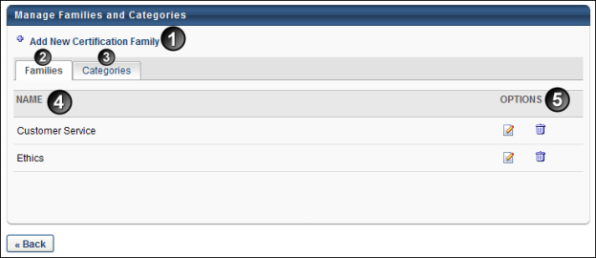
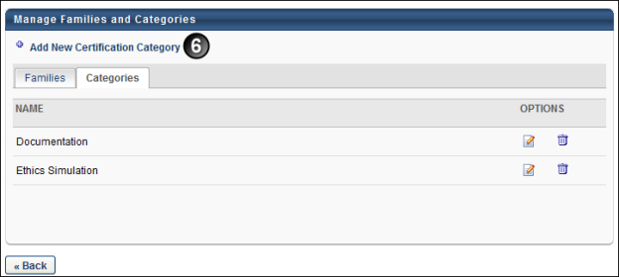
Feature | Description
1. Add New Certification Family | Click the Add New Certification Family link to add a certification family. A new row appears on the page. Enter a name in the Name field. Click the Save icon to save the family or category, or click the Cancel icon to cancel the action.  For portals with multiple languages enabled, the family name is localizable.
2. Families | The Families tab displays for portals with certification families enabled. This tab is the default view when both families and categories are enabled.
3. Categories | Clicking the Categories tab refreshes the page to display all existing certification categories. For portals with only certification categories enabled, the Families tab does not display.
4. Name | Displays the name of the certification family or category. For portals with multiple languages enabled, the name appears in the language of the administrator that created the family or category.
5. Options | The following options are available in the Options column:  - Edit - Click the Edit icon to edit the certification family or category name. The family name becomes editable. Edit the name and click the Save icon to the right of the field.  - Remove - Click the Remove icon to delete the certification family or category. A certification family or category cannot be deleted if it is associated with a certification.
6. Add New Certification Category | Click the Add New Certification Category link to add a certification category. A new row appears on the page. Enter a name in the Name field. Click the Save icon to save the category, or click the Cancel icon to cancel the action.  For portals with multiple languages enabled, the category name is localizable.
Click Back to return to the Certification Administration page.

View Certification Enrollment
The Certification Enrollment page enables administrators and managers to see an overview of the certification and to view the progress details for each user in the certification. Administrators and managers can remove users from a certification. Administrators and certification owners also have the ability to edit the certification due date.
By default, the Certification Enrollment page displays a list of all Active users currently enrolled in the certification and users that are in a Revoked status. To list both Active and Inactive users, click the Include Inactive Users checkbox and click Search.
Design Note: An updated interface is available for this page, which can be enabled by administrators in Feature Activation Preferences. With the new design, the functionality of the page is unchanged.
To access the Certification Enrollment, go to Learning > Certification Management or Certification > Certification Management. Then, next to the appropriate certification, select the View Users icon . Note: The navigation instructions to access the Certification Management page may vary, as it is configurable by system administrators.
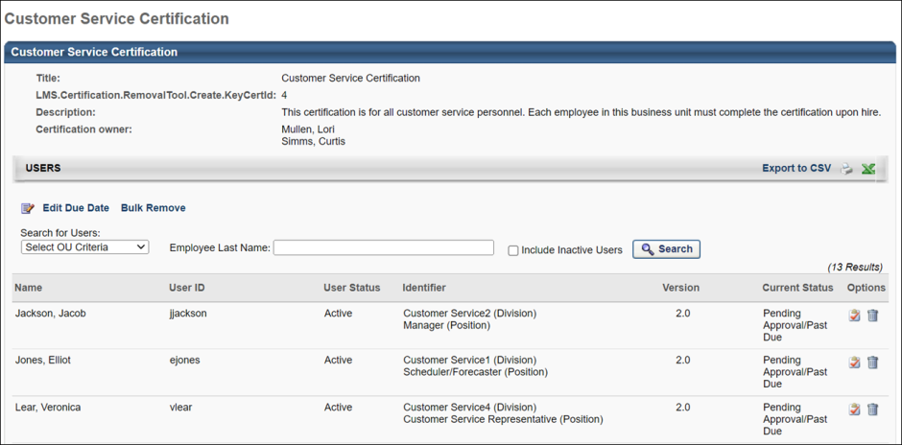
Export to CSV
To export users to a CSV file to be used for Bulk Removal, click the Export to CSV link.
Only users that are displayed on the page will be included in the CSV file. To ensure inactive users are included in the CSV, select the Include Inactive Users option and select the Search button. Then, export the data to CSV.
Edit Due Date
To edit the certification due date, click the Edit Due Date link. Note: This option is only available for one time certifications as well as the initial and renewal periods for fixed date certifications. For fixed date certifications, the change only applies to the current period. See Edit Certification Due Date on page 89 for additional information.
Bulk Remove
To remove multiple users from the certification at the same time, click the Bulk Remove link. See Certification Removal Tool on page 129 for additional information.
Enrolled Users
In the list of users enrolled in the certification, the following information is displayed for each user:
- Name
- User ID
- User Status
- Identifier
- Version
- Current Status
To search for users that are enrolled in the certification, you can search by OU using the Select OU Criteria drop-down list, or you can enter the user's last name in the search field and click the Search button.
To view the user's certification details, click the View Details icon in the Options column for the appropriate user. This loads the certification player for that user's certification.
To remove a user from the certification, click the Delete icon in the Options column. Note: When removing a certification, any learning objects that have already been requested by the user will remain on the user's transcript.

Validity Period for Training within Certification
The validity period for a training item is the time period during which the training item can be completed and used towards completion of the certification. After the validity period has passed, the training item is expired and no longer counts towards the certification requirement. By default, the item can be counted towards multiple certification periods as long as the item is valid. When defining the validity period, you may choose to set no validity period, in which case the item is always valid during the time the certification is available. You may also set the validity period to a period that is relative to the start or end of the certification period. By default, no validity period is defined for all items.
To set the validity period for a section or individual item, click the Calendar icon . The following validity period options are available:
- No validity period defined - This is the default option. The training item is always valid towards the certification. This option is appropriate if the skills and knowledge in the item is not outdated over any renewal periods and do not need to be refreshed. Note: For the item to be used to satisfy requirements for renewal periods, you must also select the Allow training items acquired from previous periods to satisfy requirement if training item is valid option when configuring the training period.
- On the period start date, this item is completed within the past XX days, months, years - When the certification period begins, the system checks if this item is complete. The item must have been completed within the specified amount of time prior to the certification period start date or during the certification period. For example, if this option is selected and set to 2 years, the user must have satisfied the requirement within the previous two years prior to the start of the certification period or during the certification period.
- By the Certification Period end date, this item is valid if completed within the past XX days, months, years - According to the specified time period for this option, prior to the end of the certification period the system checks if this item is complete. If this item is completed outside of the specified period, the user does not receive credit for completing the item. For example, if this option is selected and set to 10 days, the user must satisfy the requirement within 10 days of the end of the certification period. If they completed the item 14 days prior to the end of the period, they receive no credit and they must complete the item again within 10 days of the end of the period.
- The item is completed after the indicated date - If the item was completed after the specified date, the requirement is satisfied.
Note: For a training item to be used towards multiple periods, the option to allow users to use an item towards multiple periods must also be enabled. This option is available while scheduling renewal periods on the Scheduling page. See Certification - Create - Step 3 - Scheduling on page 29 for additional information.
Note: If a user has completed a training item multiple times, each instance of the item can be used to satisfy multiple renewal periods if the item is valid. For example, a user has taken LO1 three times prior to enrolling in the certification, and LO1 is required in the initial certification period and the two subsequent renewal periods. The user receives credit for LO1 for the initial period and the first two renewal periods as long as the item remains valid for those periods.
Click here to see example of Certification Scenarios.

Credit Processing for Certification Periods
All of a user's completed training is eligible to be used for a certification if the training completion date meets the validity period requirements. This does not apply for past registration numbers if the Only the current registration number for any training item will be credited for any given period option is selected for the certification.
When a user registers for a certification, all available training items at the time the user registers for the certification are arranged in chronological order of their completion. These training items are then applied in order to the initial period, assuming they meet any applicable validity periods.
If a user has completed the appropriate amount of training prior to certification registration, and the necessary training completion dates meet the validity period requirements, then the user will become automatically certified upon registration. The certification date is dependent upon the Use this date for initial certification date if all requirements are completed prior to certification registration option on the General page when the certification is created.
- If this option is set to "Certification Registration date," then the user's certification completion date is set to their certification registration date, regardless of when the user completed the training items that are applied to the certification.
- If this option is set to "Last training item completion date," then the user's certification completion date is set to the date on which the last required training item was completed because the training item completion dates are prior to the certification start date.
If the certification has renewal periods, then the renewal period start date depends upon the configuration of the certification.
- If an item is not used because it does not meet a validity period, it continues to be evaluated for every future period to which it may be able to be applied.
- If an item could have applied to a previous period but was not used because there was sufficient training without it, then this item continues to be evaluated for every future period to which it may be able to be applied.
- When a renewal period begins, any completed training that is eligible to be used in the renewal period and has completion dates that meet the validity period requirements are applied to the renewal period.
- If a renewal period begins and the user has already completed enough training that has completion dates that meet the validity period requirements, then the renewal period is automatically completed. If all of the training items have a completion date that is prior to the period start date, then the renewal period completion date is set to the period start date, because all of the training was completed prior to the period start date.
- Users remain in a renewal period until they complete all requirements. This means that a user could potentially be in a status of Expired for a previous renewal period. For example, if it is 2013, the initial period is dated 2010, and the user only has enough items to complete all periods through 2011, then the user is in an Expired status for the 2012 period.
If completed training items are applied to a user's certification after they register for the certification, then these items are applied to certification periods based on which certification period the user is in at the time the training is added. For example, a user is in a renewal period when training items are added to their transcript which have a completion date that is prior to the user's current certification period. These training items are applied to the user's certification; however, the application of these training items begins with their current period. Any items that had been previously applied to earlier periods remain credited for those periods, rather than being replaced by the newly added items.

Certifications - Parent and Child Section Credits Workflow
This section explains how the credits from a child section are rolled up into the parent section.
- Section 1 (Min = 4, Max = 10)
  - Section 1.1 (Min = 2, Max = 4)
    - Training 1 = 1
    - Training 2 = 2
    - Training 3 = 1
  - Section 1.2 (Min = 2, Max = 4)
    - Training 4 = 1
    - Training 5 = 2
    - Training 6 = 4
In this example, Section 1 has two sub-sections (1.1 and 1.2) and each sub-section has three learning objects.
The following is the traditional workflow:
If any root section reaches the minimum required credits, those credits propagate to the certification. For example, once the section minimum for the subsection called Section 1.1 is reached (two credits), those credits are counted toward the certification credits. If a user completes the minimum requirements for the Section 1.1 subsection, those credits are immediately counted toward the total credits earned toward the certification, given that the minimum is met for the parent section. This means that until a user also earns 2 credits for section 1.2, the credits earned in Section 1 will be 0. Credits earned for a section may only range between the minimum and maximum. In this example, credits earned for Section 1 can only range from 4 to 10 credits.
Note: This workflow applies when the "Users are required to complete the minimum credits for all child sections" option is NOT enabled.
The following is the workflow that is followed with the "Users are required to complete the minimum credits for all child sections" option is set in the Details section when creating a certification:
In order for the credits in Section 1.1 to roll up into Section 1 and be applied to the overall certification credit count, the minimum credit limit for all sub-sections must be reached (in this example, 1.1 and 1.2). For Section 1.1 this is set at 2 (e.g., Min = 2), so if a user completes Training 1, Training 2, and Training 3 in Section 1.1, the sub-section requirements are met, but the requirements for sub-section 1.2 are not yet met, so the credits do not roll up into Section 1. Once the section minimum for Section 1.1 and 1.2 is reached, those credits are rolled into Section 1 and they are also counted towards the section credit requirements for Section 1.

Edit Certification Due Date
On the Certification Management page for a certification, certification owners can edit the due date for multiple users. The due date can only be edited for users that are currently enrolled in the certification and have a certification status of Pending Approval, In Progress, In Progress/Past Due, Certified (Renewal In Progress), Pending Completion Approval, Pending Prerequisite, or Certified (Pending Completion Approval). If a certification is Expired or Certified, the user does not appear.
Design Note: An updated interface is available for this page, which can be enabled by administrators in Feature Activation Preferences. With the new design, the functionality of the page is unchanged.
You must be a certification owner to access the Certification Management page for a certification.
To edit the certification due date for multiple users, go to Learning > Certification Management or Certification > Certification Management. Then, select the Edit Due Date link in the Users section. This opens the Edit Certification Due Date page.
- Note: The navigation instructions to access the Certification Management page may vary, as it is configurable by system administrators.
- Note: The option to edit the certification due date for multiple users is only available for one time certifications as well as the initial and renewal periods for fixed date certifications. For fixed date certifications, the change only applies to the current period.
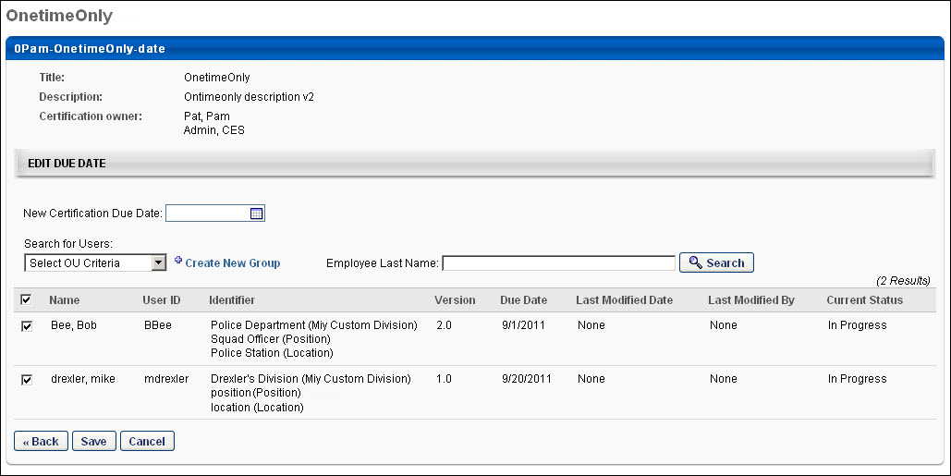
At the top of the page, the certification's title, description, and certification owners are displayed.
Click the New Certification Due Date field to select a new due date for the certification.
- The selected due date must a date in the future that is prior to the certification expiration date.
- The New Certification Due Date field can be left blank, which removes the certification period due date.
After setting the new certification due date, you must select the users that are affected by the due date change. Select a user by selecting the checkbox to the left of the user's name. You can select the checkbox at the top of the list to select all users in the table.
You can search for users by OU using the OU drop-down list or by last name using the Employee Last Name field.
Table of Users
The table of users displays the following information for each user:
- Name - The user's name. Only users with certification status of Pending Approval, In Progress, In Progress/Past Due, Certified (Renewal In Progress), Pending Completion Approval, Pending Prerequisite, or Certified (Pending Completion Approval). If a certification is Expired or Certified, the user does not appear.
- User ID - The user's user ID
- Modifier - This displays the user's Division, Position, and Location
- Version - The version of the certification the user is currently completing
- Due Date - The user's due date for the certification. If no due date is set, the due date appears as "None." When the new certification due date is set, this is updated.
- Last Modified Date - This displays the date on which the certification due date was last modified. If the certification due date has never been modified, the Last Modified Date appears as "None." When the new certification due date is set, this is updated.
- Last Modified By - This displays the user that last modified the certification due date. If the certification due date has never been modified, the Last Modified By value appears as "None." When the new certification due date is set, this is updated.
- Current Status - This displays the user's current certification status.
After setting the new certification due date and selecting the appropriate users, click Save to set the new due date for the selected users. The Certification Management page is updated with the new due date. The Last Modified Date and Last Modified By value is updated.
When a certification due date is modified, the Certification Due Date Changed email is triggered if it is enabled. If the new certification due date is after the time the Certification Period Due email is scheduled to be sent, the Certification Due Date Changed email is not triggered.

Certification Proxy Enrollment
Certification proxy enrollment is used to assign a certification to users' transcripts. The proxy enrollment option for certifications can be accessed from the Learning Assignment Tool.
To access proxy enrollment for certifications, go to: Admin > Tools > Learning > Learning Assignment Tool. On the Manage Learning Assignments page, click the Options button in the upper-right corner of the page and click the Certification Enrollment link. Alternately, go to admin > tools > learning > certification proxy enrollment.
Note: The navigation instructions to access the Certification Management page may vary, as it is configurable by system administrators.
Permissions
PERMISSION NAME | PERMISSION DESCRIPTION | CATEGORY

Certification - Enroll Certified | Grants administrator ability to enroll certified users into a certification. This is an administrator permission. | Learning - Administration

Proxy Enrollment for Certification - Create Dynamic | Grants administrator ability to create dynamic proxy enrollments for certifications. This is an administrator permission. | Learning - Administration

Proxy Enrollment for Certification - Create Standard | Grants administrator ability to create standard proxy enrollments for certifications. This is an administrator permission. | Learning - Administration

Proxy Enrollment for Certification - Dynamic Re-enrollment | Grants access to view and update the Dynamic Re-enroll toggle for certifications on the Proxy Enrollment page. This permission cannot be constrained. This is an administrator permission. | Learning - Administration

Proxy Enrollment for Certification – Remove Dynamic | Grants administrator ability to create a proxy enrollment for certifications in which users are dynamically removed. This is an administrator permission. | Learning - Administration

Proxy Enrollment/Assignment Schedule Time - Manage | Grants ability to configure a Processing Start Time when creating a Proxy Enrollment/Assignment for Training and/or for Certifications. The Processing Start Time is the time of day that the Proxy Enrollment/Assignment will start to process users. This is an administrator permission. | Learning - Administration

Assignment Tool - Dynamic Reassignment | Grants ability to enable/disable Dynamic Re-assignment for an assignment after submission. When Dynamic Re-assignment is enabled, users that meet the User Criteria again (after previously being dynamically removed) are re-assigned. This permission is dependent on the Assignment - Standard, Dynamic - Standard and Dynamic, and Dynamic Assignment - Standard and Dynamic - Recurrence permissions. This permission cannot be constrained. This is an administrator permission. | Learning - Administration

Assignment Tool - Dynamic Removal | Grants ability to enable/disable Dynamic Removal from within the Learning Assignment create workflow and/or the Assignment Summary page. When Dynamic Removal is enabled, users that no longer meet the User Criteria are removed from the Learning Assignment. This permission is dependent on the Assignment Tool - Standard, Assignment Tool - Standard and Dynamic and Assignment Tool - Standard and Dynamic - Recurrence permissions. This permission cannot be constrained. This is an administrator permission. | Learning - Administration
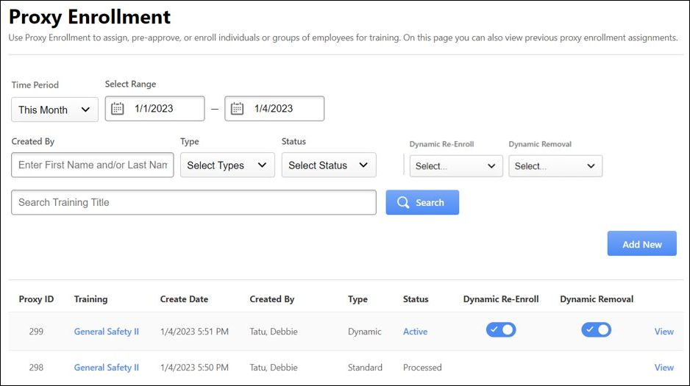
Create a Certification Proxy Enrollment
To create a certification proxy enrollment, go to Admin > Tools > Learning > certification Proxy Enrollment. Then on the Proxy Enrollment page, click the Proxy Enrollment for Certification link. Alternately, you can also click Add New. This opens the Certification Proxy Enrollment page. See Certification Proxy Enrollment - Create - Select Certification on page 95 for additional information.
Dynamic Proxy Enrollment Options
For dynamic proxy enrollments, a few additional options are available from the Proxy Enrollment page:
- Status - The status for dynamic proxy enrollments is a link. Users with permission to create dynamic certification proxy enrollments can click this link to change the Active status for the dynamic proxy enrollment. For example, if the status is Active and it is clicked, the status is changed to Inactive. The status column also contains an indicator that displays the inactive certifications being used by the proxies. To know more about inactive certifications, See Certification Administration on page 2 for additional information.
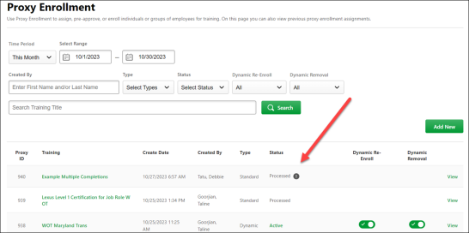
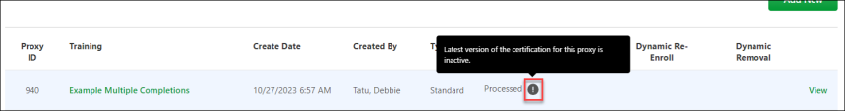
Note: If customers do not wish to have this indicator displayed on the proxy enrollment page, they can open a case with Global Customer Support to have it disabled.
- Dynamic Re-Enroll - This toggle controls whether dynamic re-enrollment is enabled for the assignment. When enabled, the dynamic certification proxy dynamically re-enrolls individuals who have been removed from a certification, allowing them to continue to work on the certification requirements. Administrators must have the permission Proxy Enrollment for Certification - Dynamic Re-enrollment to see and enable the Dynamic Re-enroll toggle.
- Dynamic Removal - This toggle controls whether dynamic removal is enabled for the assignment. When enabled, users are dynamically removed from a certification if they no longer meet the assignment criteria. If the user has permission to set the dynamic removal for a certification proxy enrollment, they can click the Dynamic Removal status to change the status. For example, if the dynamic removal toggle is enabled and it is clicked, the status is changed to OFF. Note: Users who are dynamically removed from a certification are not dynamically re-enrolled if they later match the assignment criteria unless the Dynamic Re-Enroll toggle is also enabled for the dynamic proxy.
Note: If a dynamic proxy for the certification was created with an older version of the certification, then dynamic proxy enrollment will check the current version of the certification to see if it is active or inactive. If the current version of the certification is active, then the current certification version will be assigned through the dynamic proxy. If the current version of the certification is inactive, then no assignment will be done.
View Proxy Enrollment Details
To view the details of a certification proxy enrollment, In the Options column, click the View link. See View Certification Proxy Enrollment Details on page 104 for additional information.
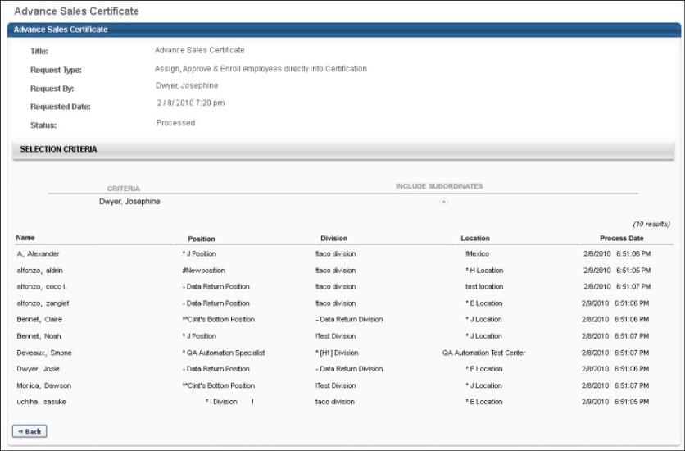

Certification Proxy Enrollment - Create - Select Certification
When creating a proxy enrollment for a certification, the first step is to select the certification.
When you click the Proxy Enrollment for Certification link or add new on the Proxy Enrollment page, you are taken to the Certification Proxy Enrollment page. On this page, you have the following options:
- View the general information of all certificates that are available to you for proxy enrollment
- Search for certifications by title, family, category, and language, and can also include inactive certifications in the search
- Proxy enroll users in a certification
Permissions
PERMISSION NAME | PERMISSION DESCRIPTION | CATEGORY

Proxy Enrollment for Certification - Create Dynamic | Grants administrator ability to create dynamic proxy enrollments for certifications. This is an administrator permission. | Learning - Administration

Proxy Enrollment for Certification - Create Standard | Grants administrator ability to create standard proxy enrollments for certifications. This is an administrator permission. | Learning - Administration

Proxy Enrollment for Certification – Remove Dynamic | Grants administrator ability to create a proxy enrollment for certifications in which users are dynamically removed. This is an administrator permission. | Learning - Administration
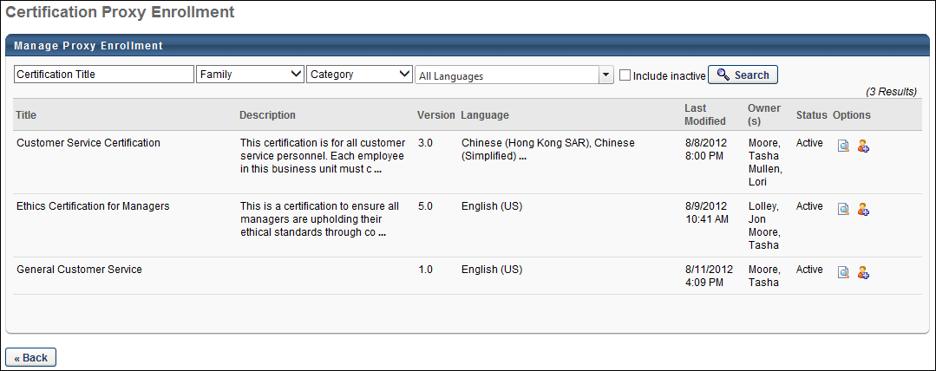
To search for a certification, enter the certification title and filter results by Family, Category, and Language using the drop-down lists. To include inactive certifications in the search results, select the Include Inactive option.
The following information displays for each available certification:
- Title - The certification title
- Description - The certification description
- Version - This displays the version of the certification you are creating or editing. New certifications begin as version 1.0. This value is automatically updated and cannot be edited. During Phase 1, versioning is not available, so all certifications are version 1.0
- Language - The certification language
- Last Modified - The last date on which the certification was modified
- Owner(s) - The certification owners who have administrative rights to the certification
- Active - Displays whether or not the certification is active
To deactivate a certification, deselect the Active option next to the appropriate certification. To re-activate a certification, select the Active option. If the inactive certification is not visible in the search results, be sure the Include Inactive option is selected in the search criteria.
To proxy enroll a user in a certification, in the Options column click the Add Users icon. This opens the next step in the proxy enrollment process. See Certification Proxy Enrollment - Create - Enrollment Settings on page 97 for additional information.

Certification Proxy Enrollment - Create - Enrollment Settings
When creating a proxy enrollment for a certification, the second step is to select the proxy enrollment settings.
Permissions
PERMISSION NAME | PERMISSION DESCRIPTION | CATEGORY

Certification - Enroll Certified | Grants administrator ability to enroll certified users into a certification. This is an administrator permission. | Learning - Administration

Proxy Enrollment for Certification - Create Dynamic | Grants administrator ability to create dynamic proxy enrollments for certifications. This is an administrator permission. | Learning - Administration

Proxy Enrollment for Certification - Create Standard | Grants administrator ability to create standard proxy enrollments for certifications. This is an administrator permission. | Learning - Administration

Proxy Enrollment for Certification – Remove Dynamic | Grants administrator ability to create a proxy enrollment for certifications in which users are dynamically removed. This is an administrator permission. | Learning - Administration

Proxy Enrollment/Assignment Schedule Time - Manage | Grants ability to configure a Processing Start Time when creating a Proxy Enrollment/Assignment for Training and/or for Certifications. The Processing Start Time is the time of day that the Proxy Enrollment/Assignment will start to process users. This is an administrator permission. | Learning - Administration

Proxy Enrollment for Certification - Dynamic Re-enrollment | Grants access to view and update the Dynamic Re-enroll toggle for certifications on the Proxy Enrollment page. This permission cannot be constrained. This is an administrator permission. | Learning - Administration

Assignment Tool - Dynamic Reassignment | Grants ability to enable/disable Dynamic Re-assignment for an assignment after submission. When Dynamic Re-assignment is enabled, users that meet the User Criteria again (after previously being dynamically removed) are re-assigned. This permission is dependent on the Assignment - Standard, Dynamic - Standard and Dynamic, and Dynamic Assignment - Standard and Dynamic - Recurrence permissions. This permission cannot be constrained. This is an administrator permission. | Learning - Administration

Assignment Tool - Dynamic Removal | Grants ability to enable/disable Dynamic Removal from within the Learning Assignment create workflow and/or the Assignment Summary page. When Dynamic Removal is enabled, users that no longer meet the User Criteria are removed from the Learning Assignment. This permission is dependent on the Assignment Tool - Standard, Assignment Tool - Standard and Dynamic and Assignment Tool - Standard and Dynamic - Recurrence permissions. This permission cannot be constrained. This is an administrator permission. | Learning - Administration
From the Proxy Enrollment for Certification Settings page, you have the following options:
Enrollment
Select whether the proxy enrollment is a Standard or Dynamic enrollment.
- Standard - This option enrolls all users that are selected in the Upload Users or Select Users sections as soon as the enrollment begins, but no additional users are added to the proxy enrollment after the initial assignment. For example, if a new user is added to the system after the initial assignment that matches the selection criteria, they are not enrolled in the certification. To receive the assignment the user must meet the availability criteria and must not have the training in their transcript. Users are intentionally excluded from the proxy enrollment assignment when they have the training already on the transcript for a standard proxy enrollment.
- Dynamic - This option enrolls all users that are selected in the Upload Users or Select Users sections as soon as the enrollment begins, and if any users match the selection criteria after the initial assignment, they are dynamically assigned to the proxy enrollment. For example, if a new user is added to the system after the initial assignment that matches the selection criteria, they are dynamically enrolled in the certification. After selecting the Dynamic Enrollment option, Enable Dynamic Re-enrollment and Enable Dynamic Removal toggles appear. The toggles are disabled by default and the administrators can enable them. When Enable Dynamic Removal or Enable Dynamic Re-enrollment is enabled during dynamic proxy creation, it is captured in the modification history of the proxy. The modification history displays the following:
  - Modified by
  - User ID (user's last name, first name)
  - Date time
  - Action
  - Time Zone
Note: For dynamic proxy enrollments, users with permission to set the dynamic removal for a certification proxy enrollment have the option to dynamically remove users from this type of certification from the Proxy Enrollment page.
Note: Though these options can be selected during the dynamic proxy process, the Enable Dynamic Re-enrollment and Enable Dynamic Removal toggles can still be configured after a proxy is created.
- Certified - This option certifies all users that are selected in the Upload Users or Select Users sections. The certification appears on the user's transcript and the status is Certified. If there is a renewal period, the user is placed in the appropriate renewal period. The administrator can then edit the renewal period due date and expiration date. They can also modify the amount of credits required to satisfy the first renewal period. This option is only available if you have permission to enroll certified users into a certification. If a user is enrolled as Certified into a one-time certification or any certification without a renewal period, the expiration and due date will match because as there is no re-certification period for the certification, and will not expire. Note: This option is not available for certifications with a Relative with Rolling Period renewal setup.
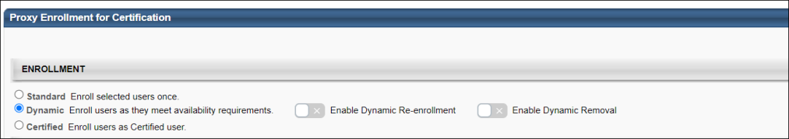
Assignment
Select when the proxy enrollment occurs.
- Immediately - This option proxy enrolls all specified users as soon as the proxy enrollment is finalized.
- Fixed Date - This option proxy enrolls all specified users on the selected date. This must be a future date.
- Initial Certified Date - This option certifies the selected users as of the selected date. The selected date must be a date in the past because the users should have already completed the necessary training. This option is only available when Certified is selected as the Enrollment Type.
Schedule Proxy
This section enables administrators with the appropriate permissions to configure a processing time for a proxy enrollment. Note: If the Assignment Date is set to Immediately, then the Set Proxy Processing Start Time drop-down menu is read-only, and the proxy enrollment will be added to the processing queue immediately after the proxy enrollment is submitted.
This section is only available to administrators with permission to manage proxy enrollment schedule time. Administrators without this permission can view the section configuration when viewing the settings of an existing proxy enrollment.
From the drop-down menu, select the time at which the proxy enrollment should begin processing. Times are available in 30 minute increments. The times are in the time zone of the administrator who is configuring the proxy enrollment.
- The selected time represents the time at which the proxy enrollment begins processing. However, the duration of the proxy enrollment processing varies depending on the amount of records being processed.
- If a proxy processing start time is not selected, then the proxy is added to the processing queue immediately. Also, if the proxy is dynamic, then the proxy is added to the processing queue each day based on the time the proxy enrollment is originally submitted.
- If the administrator selects a time in the past, then the proxy enrollment will be added to the processing queue the next day at the selected time. For example, if the administrator selects 10:00 AM for a proxy enrollment that is submitted at 1:00 PM, then the proxy enrollment will be added to the processing queue the following day at 10:00 AM.
- If an assignment date is selected and a time is selected, then the proxy enrollment is added to the processing queue at the selected time on the selected date. However, if an assignment date is selected and a time is not selected, then the proxy enrollment is added to the processing queue at 12:00 AM on the selected date.
Proxy Enrollment Editing Note: If an assignment date and a processing start time are selected, the processing start time is saved. If the assignment date is then set to be assigned immediately, and is then set back to a specific date, the processing start time is repopulated with the previously selected time.
Proxy Enrollment Copying Note: If the original proxy enrollment has a set processing time and the administrator who is copying the proxy enrollment has permission to manage the proxy enrollment schedule time, then the processing time is copied. However, if the administrator does not have permission to manage the proxy enrollment schedule time, then the schedule time is not copied.
Status
Select the appropriate enrollment status for the users that are proxy enrolled. If approval is required for the certification, the approval is required by the certification owner. Note: The Status options are not available when enrolling certified users.
- Assign Certification - This assigns the certification to the selected users, but the users must still receive approval prior to registering for the certification. The certification is in Pending Approval status until approval is received.
- Assign & Approve Certification - This assigns the certification to the selected users and approves them for registration, but the users must still register for the certification.
Upload Users
Upload Users - Use this option to upload a file of users to be added to the certification. The selected file must be a .csv with one column of user IDs, username, or email addresses. There is a maximum of 2000 users; all users over 2000 are ignored. Click Browse to locate the file on your computer and then click Add to add the users from the selected file.
Select Users
From the drop-down list, select an OU for which the certification is available. Only users that match the selected criteria are enrolled in the certification. The availability selections that the administrator can select are limited based on the constraints of the administrator. Once a selection is made, the selection appears in the table below the drop-down list. The Include Subordinate checkbox also appears which is unchecked by default to prevent over-enrollment of certifications. You can also remove the selection by clicking the Delete icon.
Note: The Include Subordinate applies to all proxy creation for standard, certified, and dynamic proxies.
Next
Note: Enrolling users through proxy enrollment bypasses any prerequisite requirements. If you plan to proxy enroll users into the certification, pre-requisites should be added as a section of the certification and should be required.
Once all settings are selected, click Next to proceed to the Confirmation step. See Certification Proxy Enrollment - Create - Confirmation on page 102 for additional information.
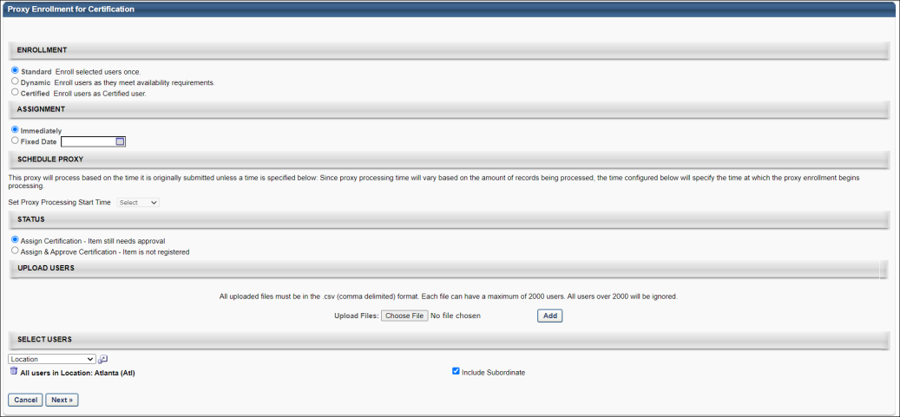

Certification Proxy Enrollment - Create - Confirmation
After selecting the certification for the proxy enrollment and the proxy enrollment settings, the Confirmation screen displays a summary of the proxy enrollment. In the upper section of the Confirmation screen, the certification title and enrollment settings are displayed. Below that, the selection criteria are displayed along with the selected users that match the criteria.
In the list of users that are set to be assigned to the certification, the administrator can manually remove a user from the assignment by deselecting the check box to the left of the user's name.
- With a standard proxy enrollment, users are excluded from the assignment if they already have the training on their transcript.
- With a dynamic proxy enrollment, any new users that match the defined availability are immediately enrolled into the certification.
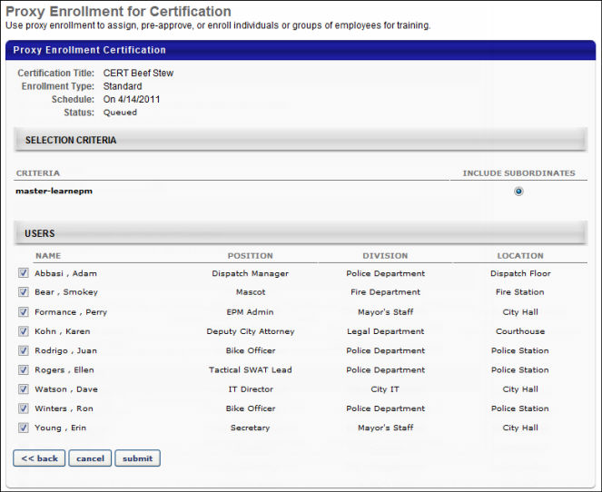
For Certified Proxy Enrollments, the user can add comments regarding the enrollment. If the selected certification has renewal periods, the current renewal period information is displayed, including the initial certified date, certification renewal schedule type, current renewal period name, the number of certification periods that have passed, the period due date, and the period expiration date. The user can modify the period due date and expiration date. They can also credit the enrolled users with an initial amount of acquired credits.
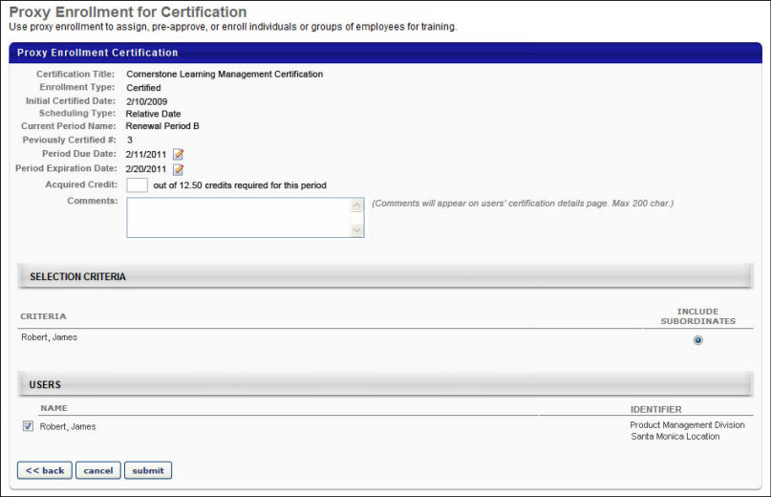
- To modify the renewal period due date, click the Edit icon to the right of the Period Due Date value. By default, the existing period due date is displayed. When editing the due date, the date must be prior to the expiration date. This value is not displayed if a due date is not defined for the period.
- To modify the renewal period expiration date, click the Edit icon to the right of the Period Expiration Date value. By default, the existing period expiration date is displayed. When editing the expiration date, the date must be after the due date. This value is only displayed for Relative renewal periods.
- To specify the number of credits with which the certified users should begin, enter a value in the Acquired Credits field. This allows you to give the users credit for training they may have already completed. The maximum value for this field is 999.99. If no value is entered, the default value is 0.
In the Comments field, you can enter any comments regarding the enrollment. This may be used to explain why the users are being enrolled and provide any details regarding the certification they earned outside of the system. The character limit for this field is 200. These comments appear on the Certification Details page in the Approval History section.
Click Submit to finalize the proxy enrollment. The proxy enrollment is queued until the scheduled enrollment date.

View Certification Proxy Enrollment Details
To access the Proxy Enrollment Details page, go to: Admin > Tools > Learning > Learning Assignment Tool. On the Manage Learning Assignments page, click the Options button in the upper-right corner of the page and click the Certification Enrollment link. Then, select the View link for the appropriate proxy enrollment.
Permissions
PERMISSION NAME | PERMISSION DESCRIPTION | CATEGORY

Certification - Enroll Certified | Grants administrator ability to enroll certified users into a certification. This is an administrator permission. | Learning - Administration

Proxy Enrollment for Certification - Create Dynamic | Grants administrator ability to create dynamic proxy enrollments for certifications. This is an administrator permission. | Learning - Administration

Proxy Enrollment for Certification - Create Standard | Grants administrator ability to create standard proxy enrollments for certifications. This is an administrator permission. | Learning - Administration

Proxy Enrollment for Certification – Remove Dynamic | Grants administrator ability to create a proxy enrollment for certifications in which users are dynamically removed. This is an administrator permission. | Learning - Administration

Proxy Enrollment/Assignment Schedule Time - Manage | Grants ability to configure a Processing Start Time when creating a Proxy Enrollment/Assignment for Training and/or for Certifications. The Processing Start Time is the time of day that the Proxy Enrollment/Assignment will start to process users. This is an administrator permission. | Learning - Administration
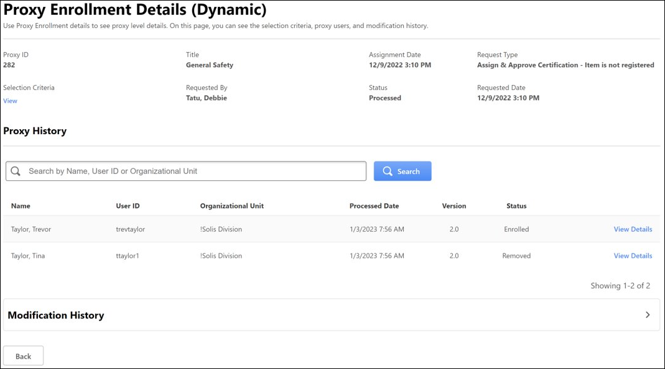
View Selection Criteria for the Proxy Enrollment
To view the selection criteria for the proxy enrollment, select the View link in the Selection Criteria section.
View Proxy User History Details
To view the history details for a user, select the View Details link for the appropriate user.

Certification Transcript Issues

Certifications Requests Overview

Certification Requests - Pending Requests
From the Certification Requests page, certification owners can view current and past certification requests including initial certification, completion, external training, renewal, and exemption requests. The certification owners can also view the details of the request and search for a request by requester name and by date.
The certification owners can then approve or deny requests from this page and also approve pending requests in bulk. See Certification Approval Workflow on page 123 for additional information.
To access the Certification Requests page, go to Certifications > Certification Management, and then click the Manage Pending Requests link.
Permissions
PERMISSION NAME | PERMISSION DESCRIPTION | CATEGORY

Certification - Manage | Grants administrators ability to manage certifications. This permission can be constrained by OU and User's OU. This is an administrator permission. | Learning - Administration

Certification - Owner | Grants user ability to act as the certification owner, which enables them to view and approve requests for the certification, manage users in the certification, and edit the due date/expiration date for users in the certification. This permission can be constrained by OU and User's OU. This is an administrator permission. | Learning - Administration

Certification External Training Approval by Manager | Grants a user's manager the ability to approve external training for a certification. This permission is constrained by Subordinates by default. This is an administrator permission. | Learning - Administration

Certification - Bulk Approval - Manage | Grants the ability to bulk approve certification approval requests. If the administrator or certification owner does not have this permission, the Approve button for bulk approval will not display on the Manage Pending Requests page. This permission can be constrained by OU and User’s OU. This is an administrator permission. | Learning - Administration
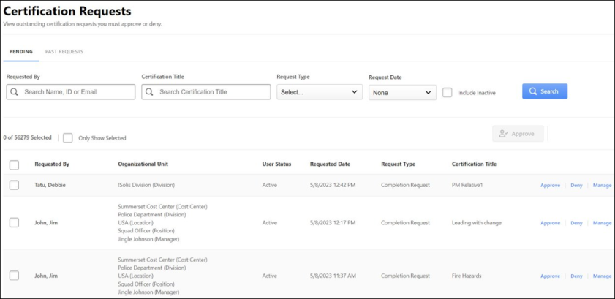
By default, the pending certification requests are displayed. To view past requests, click the Past Requests tab in the Certification Requests page.
To search for pending requests, use the following:
- Requested By - Enter the Username, User ID, or Email
- Certification Title - Enter title of the Certification
- Request Type - From the dropdown, select a specific type of request
- Request Date - Select the date of request
You can also select Include Inactive checkbox to include inactive users and then click search.
The following information displays for each pending certification request:
- Requested By - The user who requested for approval
- Organizational Unit - Organizational entity of the user.
- User Status - It shows if a user is active or inactive. The inactive users appear if you select Include Inactive checkbox.
- Requested Date - The date the request was made.
- Request Type - The type of request made.
- Certification Title - The certificate title for which the approval was requested.
- Options column - The actions to be taken on a request.
The certification owner can approve or deny pending certifications requests individually by clicking the Approve and Deny buttons under Options column.
The pending requests can also be bulk approved by selecting more than one request and clicking the Approve button. To read more about bulk approval, See Certification Requests - Approve or Deny Requests on page 113 for additional information.
To export the list of displayed certification pending requests to Excel, click the Export to Excel. Export to Excel exports up to 5000 users at once. The EXPORT TO EXCEL is grayed out if no records exist to export.
Options
The following options are available in the Options column:
- Approve - Click this button to approve the certification request. This opens the pop-up in which comments can be added and the approval can be confirmed. See Certification Requests - Approve or Deny Requests on page 113 for additional information.
- Deny - Click this button to deny the certification request. This opens the pop-up in which comments can be added and the denial can be confirmed. If the request is denied, the user must then re-request approval if they want credit in the specified section for that external training. See Certification Requests - Approve or Deny Requests on page 113 for additional information.
- Manage - Click this button to view the External Training, Completion, or Renewal request. This option only appears for external training, completion, or renewal requests.
  - See Certification Requests - External Training on page 119 for additional information.
  - See Certification Requests - Completion and Renewal on page 118 for additional information.

Certification Requests - Past Requests
From the View Past Requests page, administrators can view past certification exception requests including the certification owner who made the decision, the decision, and any comments that were made regarding the decision.
The View Past Requests page is accessed from the Manage Certifications page.
To access the View Past Requests page:
- Go to Certifications > Certification Management, and then click the Manage Pending Requests link.
- Click the Past Requests tab.
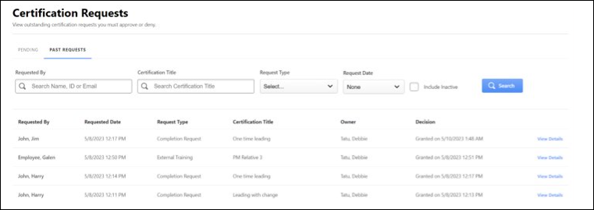
To search for past requests, use the following:
- Requested By - Enter the Username, User ID, or Email
- Certification Title - Enter title of the Certification
- Request Type - From the dropdown, select a specific type of request
- Request Date - Select the date of request
You can also select Include Inactive checkbox to include inactive users and then click search.
The following information displays for each past certification exception request:
- Requested By - The user who requested the exception.
- Requested Date - The date the request was made.
- Request Type - The type of request made.
- Certification Title - The certificate title for which an exception was requested. Click the title to view the details of the title.
- Owner - The owner who responded to the exception request.
- Decision - The decision made by the owner.
- View Details- View Details opens a flyout that includes:
  - User Status
  - Organizational Units
  - Approval or denial comments. It includes any comment left by the owner when responding to the request. If no comment was left, a value of "None" displays.
To export the list of displayed certification past requests to Excel, click the Export to Excel. Export to Excel exports up to 5000 users at once. The EXPORT TO EXCEL is grayed out if no records exist to export.

Certification Requests - Approve or Deny Requests
There are two ways to approve pending requests. The certification owner can either bulk approve pending requests or approve individually.
Permissions
PERMISSION NAME | PERMISSION DESCRIPTION | CATEGORY

Certification - Manage | Grants administrators ability to manage certifications. This permission can be constrained by OU and User's OU. This is an administrator permission. | Learning - Administration

Certification - Owner | Grants user ability to act as the certification owner, which enables them to view and approve requests for the certification, manage users in the certification, and edit the due date/expiration date for users in the certification. This permission can be constrained by OU and User's OU. This is an administrator permission. | Learning - Administration

Certification - Bulk Approval - Manage | Grants the ability to bulk approve certification approval requests. If the administrator or certification owner does not have this permission, the Approve button for bulk approval will not display on the Manage Pending Requests page. This permission can be constrained by OU and User’s OU. This is an administrator permission. | Learning - Administration
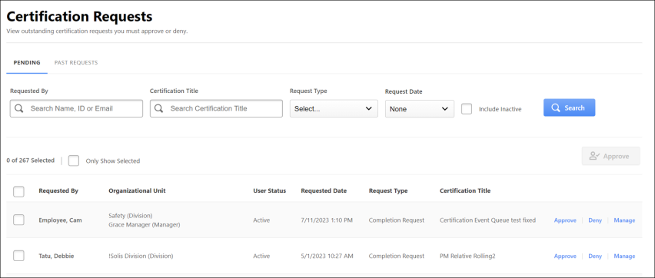
Bulk Approval
The certification owners can bulk approve multiple pending requests with the help of bulk approval feature. To bulk approve certification requests, follow these steps:
- From the Pending Requests tab, select the checkbox next to each request you want to approve. You may also select the checkbox next to the Requested By label in the table header to select all listed users.
- If desired, you may select the ONLY SHOW SELECTED checkbox to only display the requests that have been selected.
- After selecting one or more than one request, the Approve button becomes available. Click APPROVE. After clicking the button, an Approve Request pop-up appears.
- Provide any comments regarding the approval, and then click Approve to confirm the action.
The bulk Approve button is only interactable when selecting one or more items in the pending request list. The Bulk Approval functionality only supports up to 1000 approvals at a time. If there are more than 1000 pending requests that require approval, select requests in batches of 1000. After approving the first batch, select the next batch of pending requests for approval.
The selections made for bulk approval is retained on the pending request page if the certification owner navigates to the past requests tab. Also, the selections made for bulk approval resets if the filters are changed.
Note: Bulk denials are not supported.
Approve or Deny from Options
To approve or deny a request one by one, first view the details of the request by clicking the request title, and then in the Options column, click Approve to approve the request, or click the Deny to deny the request.
The Approve or Deny Request page opens, where you can enter up to 500 characters in the Comments box to explain the approval or denial. Clicking Submit commits the approval or denial. Clicking Cancel returns you to the View Certification Requests page.
When a request is approved or denied, the request is moved to the Past Requests tab and it no longer appears in the Pending tab. The request is also removed from the certification owner's outstanding requests.
Any comments are stored and are displayed to users and administrators in the Approval History section for the certification. The comments also appear in the Comment column of the Past Requests tab on the View Certification Requests page.
When a certification request is approved, the Approve Certification email is triggered (if enabled). If a period begins or is completed as a result of a certification approval, the Period Begin Reminder or Period Completion Notification emails are triggered if enabled.
Approve or Deny Initial Request
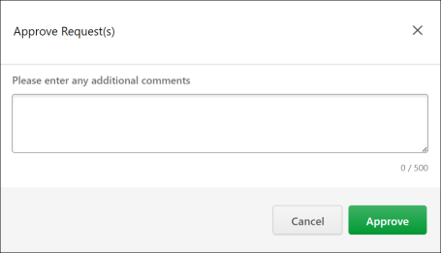
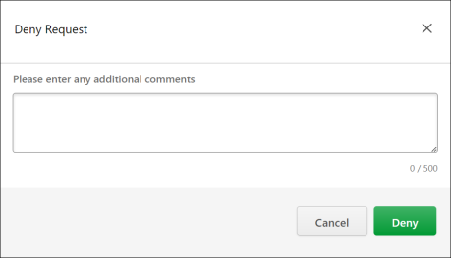
Approve Bulk Requests
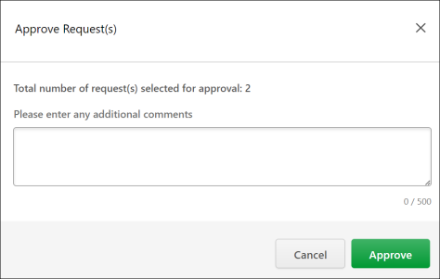
Approve or Deny Completion Request
Note: When a certification section is approved as complete, the completion date is set as the date that the section is actually completed, rather than the date the approver approves the completion.
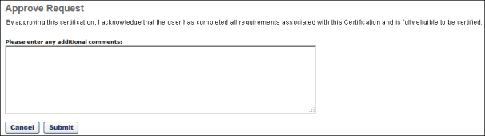
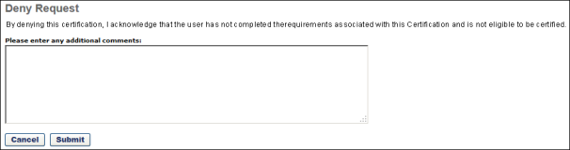
Certification Requests - Completion and Renewal
For completion and renewal requests, you have the option to manage the request by clicking the Manage icon in the Options column. This option is not available for initial certification or prerequisite exemption requests.
- Completion and Renewal Requests - The Manage icon displays the user's Certification Progress Report in a pop-up window.
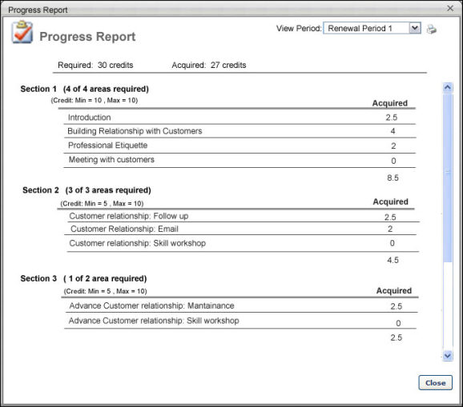
Certification Requests - External Training
To view the details of a certification request for external training, click the External Training icon in the Options column on the Certification Requests page. This option is only available for External Training Requests. When this option is clicked, the Approve/Deny Request pop-up opens.
- At the bottom of the External Training Request pop-up window, you have the option to approve or deny the external training request. You can approve or deny the request in the pop-up or return to the Requests screen and approve or deny the request there, as they both function in the same manner. When an external training request is approved, the credits are applied to the user's certification and the External Training Credit Applied email is triggered if enabled. The approver can also verify the number of credits applied using the Certification Progress Report.
- The certification owner can edit all certification level fields that the user entered.
- To enter a comment regarding the request, enter it in the Comments field. Any submitted comments appear on the Certification Comments page.
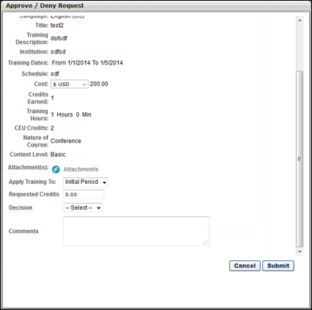
Certification Requests - Managers
The Certification Approval Requests page allows managers to view pending and past certification approval requests for a training item. The requests are separated into two tabs, the Pending tab and the Past Requests tab. The Certification Approval Requests page is only available to managers if they have permission to approve external training for certifications for their subordinates. The manager must also have subordinates that are requesting approval for external training within a certification.
Managers can access the Certification Approval Requests page in two ways:
- Click the Certification Requests icon from the Pending Requests Report page. This icon is only available for external training with a type of Certification Approval.
- Click the Submit button on the Approval Requests page for an external training requiring completion approval that is also associated with a certification that has the Delegate the approval process of external training to user's manager option selected.
Permissions
PERMISSION NAME | PERMISSION DESCRIPTION | CATEGORY

Certification External Training Approval by Manager | Grants a user's manager the ability to approve external training for a certification. This permission is constrained by Subordinates by default. This is an administrator permission. | Learning - Administration
Information Section
The Information section at the top of the page displays information for the manager to reference when approving or denying training requests. The first column displays information about the user whose training is being approved or denied. The second and third columns display information about the training that is being approved or denied. If any field does not have any data, they appear blank on this page.
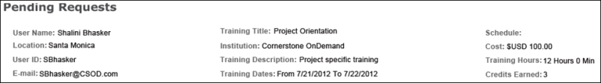
Certification Request Table
The Pending tab of the Certification Request table displays certifications to which the user has requested to add the external training. The Past Requests tab displays a read-only view of past certification requests, which can also be exported to Excel.
Pending Tab
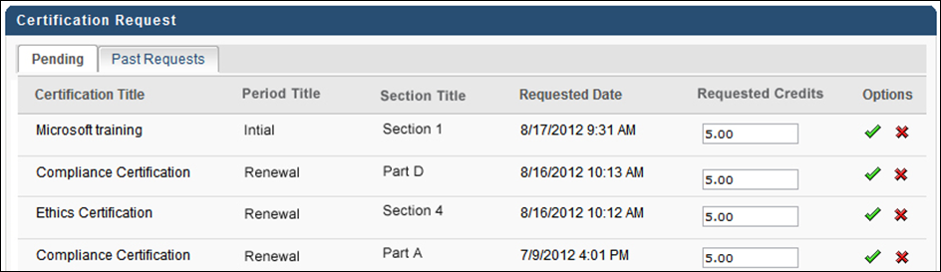
On the Pending tab, the following information is displayed for each request:
- Certification Title - This displays the title of the certification to which the external training is being added. This column can be sorted alphabetically by clicking the column title.
- Period Title - This displays the title of the certification period to which the external training is being added. This column can be sorted alphabetically by clicking the column title.
- Section Title - This displays the section of the certification to which the external training is being added. This column can be sorted alphabetically by clicking the column title.
- Requested Date - This displays the date and time at which the external training reached a status of Completed (Evidence Needed). If the user is requesting approval for the external training for an additional time (i.e., the request was previously denied), the date and time of the latest request is displayed. This column can be sorted in ascending or descending order by clicking the column title. By default, requests on the Pending tab are sorted by the Requested Date.
- Requested Credits - This column contains an editable numeric text field that displays the number of credits that the user requested. Managers can modify the number of credits that are awarded to the user by editing this field. This column can be sorted in ascending or descending order by clicking the column title.
  - Any modifications made to this field are not saved until the manager approves or denies the certification request. If the manager navigates away from this page without approving or denying the request, then any changes are not saved.
  - This field accepts positive numbers with up to two decimal places.
Approve/Deny Request
The following options are available in the Options column:
- Approve - Click this button to approve the certification request. This opens the pop-up in which comments can be added and the approval can be confirmed. See Certification Requests - Approve or Deny Requests on page 113 for additional information.
- Deny - Click this button to deny the certification request. This opens the pop-up in which comments can be added and the denial can be confirmed. If the request is denied, the user must then re-request approval if they want credit in the specified section for that external training. See Certification Requests - Approve or Deny Requests on page 113 for additional information.
- Manage - Click this button to view the External Training, Completion, or Renewal request. This option only appears for external training, completion, or renewal requests.
  - See Certification Requests - External Training on page 119 for additional information.
  - See Certification Requests - Completion and Renewal on page 118 for additional information.
Past Requests Tab
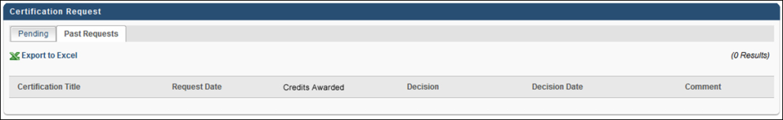
On the Past Requests tab, the following information is displayed for each request:
- Certification Title - This displays the title of the certification to which the external training was added. This column can be sorted alphabetically by clicking the column title.
- Requested Date - This displays the date and time at which the external training reached a status of Completed (Evidence Needed). If the user was requesting approval for the external training for an additional time (i.e., the request was previously denied), the date and time of the latest request is displayed. This column can be sorted in ascending or descending order by clicking the column title.
- Credits Awarded - This displays the number of credits that the user received for the training. This column can be sorted in ascending or descending order by clicking the column title.
- Decision - This displays the decision that was made by either the manager or the certification owner with regards to the external training request. The available options are Approved or Denied. This column can be sorted alphabetically by clicking the column title.
- Decision Date - This displays the date and time at which the training was either approved or denied. This column can be sorted in ascending or descending order by clicking the column title. By default, requests on the Past Requests tab are sorted by the Decision Date.
- Comment - This displays any comment that was made by the manager or certification owner when the request was approved or denied. If no comment was made, then this field is empty.

Certification Approval Workflow
When a certification approval is requested, depending on the request type, the request is sent to the following person:
- Exception (Certification Prerequisite) - Certification Owner
- Exception of Prerequisite of LO item within Certification - Learning Object Approval Workflow
- External Training - Certification Owner
- Completion Item - Learning Object Approval Workflow
- Completion of Certification Period - Certification Owner
- Initial Request (If approval is required) - Certification Owner
Certification availability overwrites learning object (LO) availability but does not overwrite approval requirements. If a user requires approval for a specific item, the item is still subject to approval.
Note: The Certification Owner role is controlled by the Certification Owner permission. The creator constraints on this permission determine the certifications for which the user is the owner, which affects which certifications the user can approve or deny. The certification owner can approve or deny certification requests from users within the permission constraints.

Certification Statuses
The workflow that defines statuses for certifications during the initial period is different from the workflow for certifications during renewal periods. As a result, both definitions are provided in the following tables.
Initial Period
Status | Description
Pending Approval | Certification requires initial approval and is waiting for approval.
Pending Prerequisite | A prerequisite is required for the certification and the user has not completed the prerequisite. The user has submitted an exemption request.
In Progress | Certification is in progress. The status is accompanied by the Manage option. Upon completing the minimum certification requirements, if completion approval is required, the Submit Completion Approval option is also available.
Denied | Certification is denied by the approver. The status is accompanied by the Re-request option.
Pending Completion Approval | The certification requires completion approval and the user has submitted the certification for completion approval.
Certified | The user has completed the certification and has received completion approval is required. This status is accompanied by the Manage option.
Past Due | If a due date is set and the user has not completed the requirements prior to the due date, the user's status becomes Past Due. The user may still access the certification material and complete the training until the Expiration date if different from the Due date. This status is accompanied by the Manage option. Note: This status may not be available based on certification preferences and settings.
Expired | If an expiration date is set and the user has not completed the requirements prior to the expiration date, the user's status becomes Expired. Note: This status may not be available based on certification preferences and settings.
Completion Approval Denied | The certification requires completion approval and the administrator has denied completion. The status is accompanied by the Re-request option.
Revoked | The user receives this certification status if the certification is revoked from their transcript by the certification owner.
Renewal Period
Status | Description
Certified/Renewal In Progress | The user has acquired an initial certification and progress has begun for a renewal period. The status is accompanied by the Manage option. Upon completing the minimum certification renewal requirements, if completion approval is required, the Submit Completion Approval option is also available.
Certified/Pending Completion Approval | The user has acquired an initial certification; the certification renewal requires completion approval and the user has submitted the certification renewal for completion approval. This status is accompanied by the Manage option.
Certified/Renewal Past Due | The user has acquired an initial certification, and the user has not completed the minimum certification renewal requirements prior to the start of the grace period if a grace period is available. This status is accompanied by the Manage option. Note: This status may not be available based on certification preferences and settings.
Certified/Completion Approval Denied | The user has acquired an initial certification; the certification renewal requires completion approval and the administrator has denied completion. The status is accompanied by the Manage and Re-request options.
Expired | Certification renewal requirements are not completed by the renewal expiration date.Note: The Expiration Date is the date when the renewal period officially ends. An expiration date is required if the period recurs.
Expired/Pending Completion Approval | Certification renewal requirements are not completed by the renewal expiration date, so the certification is expired. The certification renewal requires completion approval and the user has submitted the certification for completion approval. This status is accompanied by the Manage option. Note: The user may have completed all items prior to the Expiration date, but has not yet received completion approval.
Expired/Completion Approval Denied | Certification renewal requirements are not completed by the renewal expiration date, so the certification is expired. The certification renewal requires completion approval and the administrator has denied completion. This status is accompanied by the Manage and Re-request options. Note: The user may have completed all items prior to the Expiration date, but has not yet received completion approval.
Revoked | The user receives this certification status if the certification is revoked from their transcript by the certification owner.
Past Due vs. Expired Status
Past Due - When a certification becomes Past Due, this indicates that the due date has passed and that the certification is not yet complete. When a certification is past due, the user may still continue to complete the certification and become Certified up to the Expiration date if the Expiration date is different from the Due date. The Past Due status allows administrators to report and track these users.
Expired - When a certification becomes Expired, this indicates that the expiration date has passed and that the certification is not yet complete. It is always possible for user to complete certification after it has expired, subject to completion approval.

Certification Bulk Removal

Certification Bulk Removal Tool
The Certification Bulk Removal tool allows administrators to remove users from a certification in bulk. Using this tool, administrators can populate a CSV file with the Certification ID and multiple User IDs, then upload this CSV file to the system and allow the users to be processed for bulk removal from the certification.
Considerations
- Only one certification can be processed per file. If you need to remove users in bulk from more than one certification, you will need to create a separate CSV file for each certification.
- The maximum file size is 1MB, and one file can be uploaded at a time.
- Both inactive and active users included in the certification removal file will be removed from the certification.
Implementation
This functionality is automatically enabled in all portals using the Learning module.
Permissions
The following permission applies to this functionality:
PERMISSION NAME | PERMISSION DESCRIPTION | CATEGORY

CSV Bulk Certification Removal - Manage​ | Grants administrators access to the Certification Removal Tool. The Certification Removal tool can be used to remove users from a certification in bulk.  This permission can be constrained by the following: Restrict to User’s Organization Units,​ Restrict to Custom Organizational Units​, Restrict to Organizational Units​, Restrict to Groups.  Any constraints on this permission are applied to the jobs displayed on the Certification Removal Tool job page. The constraints do not apply to the users included in the CSV file.  Constraints Example: Admin A is part of Division A and has this permission constrained to Division: Division B. Admin A would see any certification removal jobs that they created AND any certification removal jobs that were created by administrators that are in Division B. | Learning - Administration

Certification Removal Tool
The Certification Removal tool allows administrators to remove users from a certification in bulk. Using this tool, administrators can populate a CSV file with the Certification ID and multiple User IDs, then upload this CSV file to the system and allow the users to be processed for bulk removal from the certification.
- Only one certification can be processed per file. If you need to remove users in bulk from more than one certification, you will need to create a separate CSV file for each certification.
- The maximum file size is 1MB, and one file can be uploaded at a time.
- Both inactive and active users included in the certification removal file will be removed from the certification.
There are multiple ways to access the Certification Removal Tool. To access the Certification Removal Tool:
- Go to: Admin > Tools > Learning > Training Tools and click on the Certification Removal Tool link.
OR
- Go to: Learning > Certification Management. Then, click on the certification from which you want to remove users. Click the Bulk Removal button in the Users section.
Permissions
PERMISSION NAME | PERMISSION DESCRIPTION | CATEGORY

CSV Bulk Certification Removal - Manage​ | Grants administrators access to the Certification Removal Tool. The Certification Removal tool can be used to remove users from a certification in bulk.  This permission can be constrained by the following: Restrict to User’s Organization Units,​ Restrict to Custom Organizational Units​, Restrict to Organizational Units​, Restrict to Groups.  Any constraints on this permission are applied to the jobs displayed on the Certification Removal Tool job page. The constraints do not apply to the users included in the CSV file.  Constraints Example: Admin A is part of Division A and has this permission constrained to Division: Division B. Admin A would see any certification removal jobs that they created AND any certification removal jobs that were created by administrators that are in Division B. | Learning - Administration
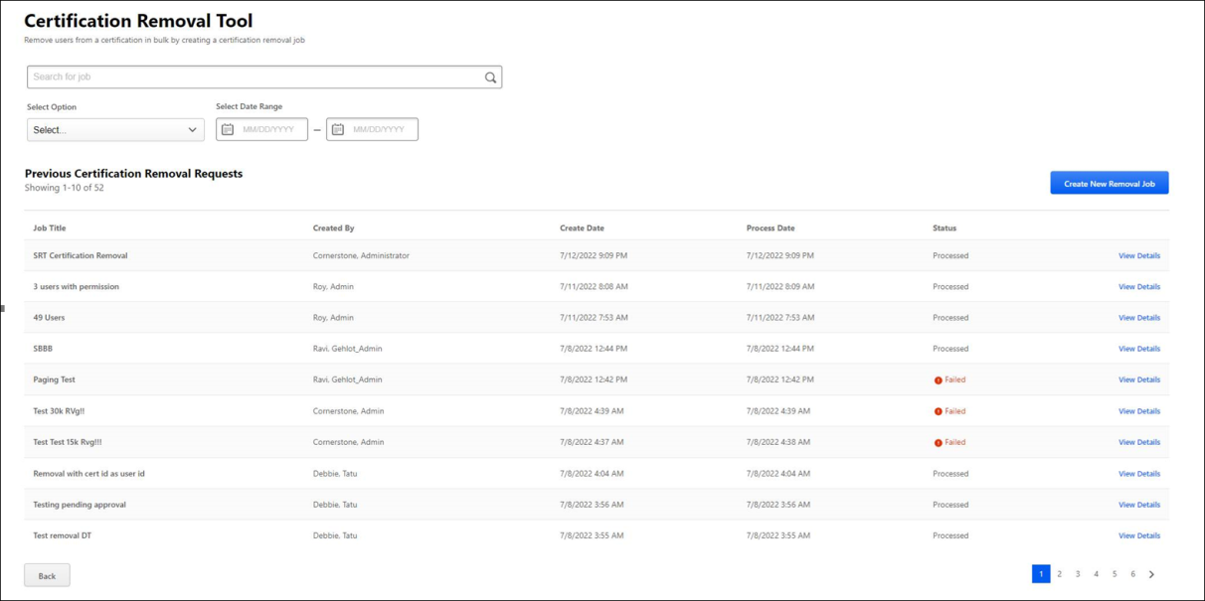
Certification Removal Tool
The Certification Removal Tool page displays the following information and features:
- Search for Job - To search for a previously created certification removal job by title, enter the name of the job into this search bar. Press Enter on your keyboard to return search results.
- Search Filters - The following filters are available to help you narrow down the training removal jobs that display on this page:
  - Select Date - To filter the previously created certification requests that display on this page by a specific date, select a date from this drop-down.
  - Select Date Range - To filter the previously created certification requests that display on this page by a specific date range, select a start date and an end date for the range you wish to search.
- Create New Removal Job - Click this button to begin creating a new certification removal job. See Create a Certification Removal Job on page 131 for additional information.
- Previous Certification Removal Requests - This table displays all previous certification removal jobs with the following information:
  - Job Title - The title entered for the job by the administrator who created the job.
  - Created By - The name of the administrator who created the certification removal job.
  - Created Date - The date the certification removal job was created.
  - Process Date - The date the certification removal job finished processing.
  - Status - The current status of the certification removal job. Possible values for this column include: Queued, In Progress, Processed, and Failed.
  - View Details - Click this link to view the details of the certification removal job.
To navigate back to the previous page, click the Back button at the bottom of the page.

Create a Certification Removal Job
Administrators with permission to manage bulk certification removal can create a certification removal job to remove multiple users from a certification at one time.
To create a certification removal job, go to: Admin > Tools > Learning > Training Tools and click on the Certification Removal Tool link.
Permissions
PERMISSION NAME | PERMISSION DESCRIPTION | CATEGORY

CSV Bulk Certification Removal - Manage​ | Grants administrators access to the Certification Removal Tool. The Certification Removal tool can be used to remove users from a certification in bulk.  This permission can be constrained by the following: Restrict to User’s Organization Units,​ Restrict to Custom Organizational Units​, Restrict to Organizational Units​, Restrict to Groups.  Any constraints on this permission are applied to the jobs displayed on the Certification Removal Tool job page. The constraints do not apply to the users included in the CSV file.  Constraints Example: Admin A is part of Division A and has this permission constrained to Division: Division B. Admin A would see any certification removal jobs that they created AND any certification removal jobs that were created by administrators that are in Division B. | Learning - Administration
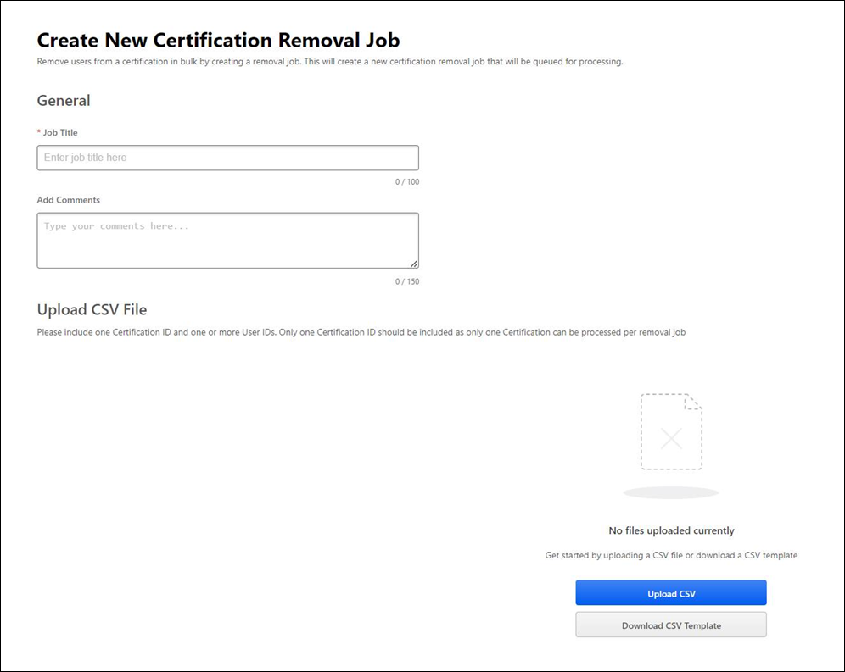
Create new Certification Removal Job
To create a certification removal job:
- Enter a title for the job in the Job Title field. This field can accommodate up to 100 characters. This field is required.
- Enter an optional comment in the Enter Comment field, explaining the purpose of the certification removal job. This comment will be visible to other administrators who view the details of the system's certification removal jobs.
- Next, upload a CSV file containing the Certification ID and the User IDs of the users who should be removed from the certification. To do this, click the Upload CSV button to search for and select the CSV file from your computer. Note: If needed, you can download a CSV template file by clicking the Download CSV Template button. This will provide you with an unpopulated CSV file with the appropriate columns, which you can populate with the Certification ID and User IDs. Alternatively, you can export a CSV file of users directly from the Certification Management > View Users page by clicking on the new Export to CSV option on this page.​
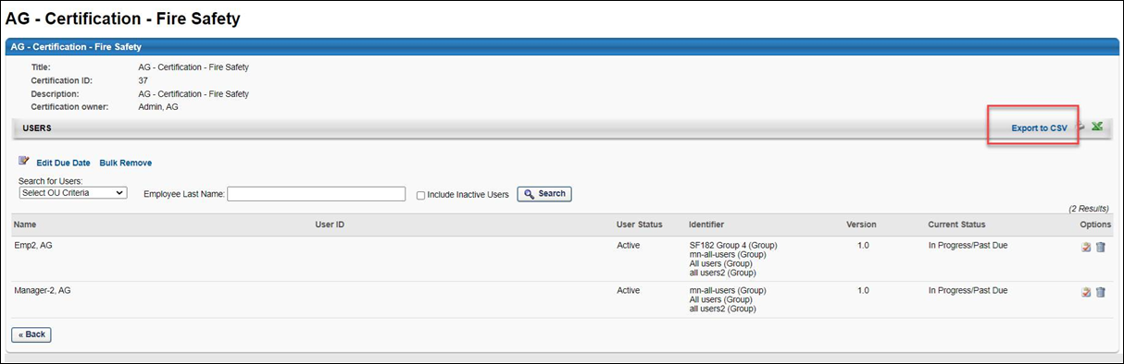
- After you have uploaded a CSV file, the system will validate the file. If the file fails to process, you will receive one of the following errors explaining the reason for the failure:
  - The file size must be 1MB or less​
  - The file is the incorrect file format​
  - The file is empty​
  - The file has invalid columns
  - The file has invalid data formats​
  - User IDs included in the file are invalid or the users are not enrolled in the certification​
  - The Certification ID included in the file is invalid
- If the file is successfully validated, you can then click the Create button at the bottom of the page to create the certification removal job.
- You will be asked to confirm the details of your certification removal job. If the details are correct, click the Remove button. The removal process will begin, and the removal job status will be In Progress. When the job has successfully processed, the removal job will update to Processed. You can view the status and details of the removal job via the Certification Removal Tool main page. See Certification Removal Tool on page 129 for additional information.
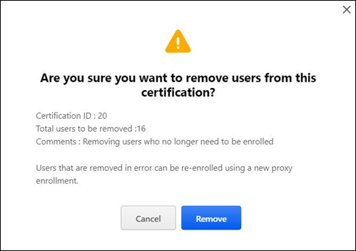​
Considerations
- The Certification ID can be obtained from:
  - The Certification Management (View Users) page
  - The Certification Administration (General) page
  - Running a Reporting 2.0 report for the Certification ID
  - Using the Export to CSV option from the Certification Management (View Users) page
- Only one Certification ID can be included in a CSV file. To remove users from multiple certifications, it is necessary to create a separate CSV file for each certification.
- 1MB is the maximum CSV file size that can be processed by the Certification Removal Tool.
- Only one CSV file can be uploaded per certification removal job.
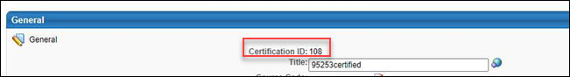

Certification Versioning
Certification versioning enables organizations to track historical certification records. In general, a certification is only re-versioned when one or more users are affected by the change.
Regarding creator constraints, the constraints from the initial certification creator are used for all versions.
When a certification is versioned, any external training that users have mapped to the certification are remapped to the new version.
For information about the certification Versioning page: See Certification Versioning Selection Page on page 141 for additional information.
Workflow
With regards to versioning and determining if a user is affected by a certification change, the following rules apply:
- If a user is Pending Approval or Pending Prerequisites, the user is considered "In Progress" for the certification period.
- If a user is Pending Completion Approval, Certified (Pending Completion Approval), or Expired (Pending Completion Approval), the user is considered "Completed" for the certification period. Changes only appear for the user in the new period.
- If a user is Expired, the user is considered "In Progress" for the certification period.
  - If the changes are pushed to In Progress users, then Expired users get the new version of the period.
  - If the user has completed all new requirements, then the expired user can go from Expired to Expired (Pending Completion Approval).
  - If the changes are applied future users only, then the Expired user is not affected.
- If a user is Denied, then the user has to re-request the certification and is considered a new user. This user receives the newest version of the certification.
- Users in a Revoked status only receive the new version if they re-request the certification or the certification is reassigned to them.
External Training Approvals
When a certification is versioned, approvals and denials associated with external training inside the certification persist to the new version. Approval requests for external training are not re-triggered, and credits earned from external training are maintained when the certification is versioned.
See the table below for more information about how external training within a reversioned certification behavior is updated with this release:
Source of External Training | Status | Old Behavior | New Behavior
User added | Approved | - External training maintains credits  - External training maintains approval | No change:  - External training maintains credits  - External training maintains approval
User added | Denied | Approval is re-triggered automatically | An approval is re-triggered only if a user selects Request Again. An approval is not re-triggered automatically when the certification is reversioned.
Administrator added to framework | Approved | - Approvals are lost  - Credits are lost | - Approval is not re-triggered  - Credit is maintained
Administrator added to framework | Denied | - Approval is re-triggered automatically  - Denial is erased | Denial is maintained. An approval is re-triggered only if a user selects Request Again. An approval is not re-triggered automatically when the certification is reversioned.
Certification Reversioning - Child Training Behaviors
When a training item inside a certification is versioned and the user has not requested or has not activated the previous version of that training item, the lowest active version of the training item displays in the certification transcript. This behavior ensures the user can complete the certification. If a training item inside a certification is activated, the expected behavior is not changed.
Examples
See the table below for different versioning scenarios and their expected outcomes with Replace Versioning and Versioning with Append.
When a training inside a certification is versioned and a user has not activated the previous version, the certification displays the lowest active version. This ensures the user can access and complete the training that is required for their certification.
Replace Behavior:
Certification | Action | Result
Certification (V1)  - Material A (V1)  - Material B (V1) | Material A is reversioned using Replace Versioning | Certification (V1)  - Material A (V2)  - Material B (V1)
Append Behavior:
Certification | Action | Result
Certification (V1)  - Material A (V1)  - Material B (V1) | Material B is reversioned using Versioning with Append  - Material B V1 and Material B V2 are now active | Certification (V1)  - Material A (V1)  - Material B (V1)
Certification (V1)  - Material A (V1)  - Material B (V1) - V2 is also active | Material B is reversioned using Versioning with Append  - Material B V2 and Material B V3 are now active | Certification (V1)  - Material A (V1)  - Material B (V2)
Certification (V1)  - Material A (V1)  - Material B (V2) - V3 is also active | Material B V2 expires based upon end date, such as the start date of V3. | Certification (V1)  - Material A (V1)  - Material B (V3)

Certification Versioning
Certification versioning enables organizations to track historical certification records. In general, a certification is only re-versioned when one or more users are affected by the change.
Regarding creator constraints, the constraints from the initial certification creator are used for all versions.
When a certification is versioned, any external training that users have mapped to the certification are remapped to the new version.
For information about the certification Versioning page: See Certification Versioning Selection Page on page 141 for additional information.
Workflow
With regards to versioning and determining if a user is affected by a certification change, the following rules apply:
- If a user is Pending Approval or Pending Prerequisites, the user is considered "In Progress" for the certification period.
- If a user is Pending Completion Approval, Certified (Pending Completion Approval), or Expired (Pending Completion Approval), the user is considered "Completed" for the certification period. Changes only appear for the user in the new period.
- If a user is Expired, the user is considered "In Progress" for the certification period.
  - If the changes are pushed to In Progress users, then Expired users get the new version of the period.
  - If the user has completed all new requirements, then the expired user can go from Expired to Expired (Pending Completion Approval).
  - If the changes are applied future users only, then the Expired user is not affected.
- If a user is Denied, then the user has to re-request the certification and is considered a new user. This user receives the newest version of the certification.
- Users in a Revoked status only receive the new version if they re-request the certification or the certification is reassigned to them.
External Training Approvals
When a certification is versioned, approvals and denials associated with external training inside the certification persist to the new version. Approval requests for external training are not re-triggered, and credits earned from external training are maintained when the certification is versioned.
See the table below for more information about how external training within a reversioned certification behavior is updated with this release:
Source of External Training | Status | Old Behavior | New Behavior
User added | Approved | - External training maintains credits  - External training maintains approval | No change:  - External training maintains credits  - External training maintains approval
User added | Denied | Approval is re-triggered automatically | An approval is re-triggered only if a user selects Request Again. An approval is not re-triggered automatically when the certification is reversioned.
Administrator added to framework | Approved | - Approvals are lost  - Credits are lost | - Approval is not re-triggered  - Credit is maintained
Administrator added to framework | Denied | - Approval is re-triggered automatically  - Denial is erased | Denial is maintained. An approval is re-triggered only if a user selects Request Again. An approval is not re-triggered automatically when the certification is reversioned.
Certification Reversioning - Child Training Behaviors
When a training item inside a certification is versioned and the user has not requested or has not activated the previous version of that training item, the lowest active version of the training item displays in the certification transcript. This behavior ensures the user can complete the certification. If a training item inside a certification is activated, the expected behavior is not changed.
Examples
See the table below for different versioning scenarios and their expected outcomes with Replace Versioning and Versioning with Append.
When a training inside a certification is versioned and a user has not activated the previous version, the certification displays the lowest active version. This ensures the user can access and complete the training that is required for their certification.
Replace Behavior:
Certification | Action | Result
Certification (V1)  - Material A (V1)  - Material B (V1) | Material A is reversioned using Replace Versioning | Certification (V1)  - Material A (V2)  - Material B (V1)
Append Behavior:
Certification | Action | Result
Certification (V1)  - Material A (V1)  - Material B (V1) | Material B is reversioned using Versioning with Append  - Material B V1 and Material B V2 are now active | Certification (V1)  - Material A (V1)  - Material B (V1)
Certification (V1)  - Material A (V1)  - Material B (V1) - V2 is also active | Material B is reversioned using Versioning with Append  - Material B V2 and Material B V3 are now active | Certification (V1)  - Material A (V1)  - Material B (V2)
Certification (V1)  - Material A (V1)  - Material B (V2) - V3 is also active | Material B V2 expires based upon end date, such as the start date of V3. | Certification (V1)  - Material A (V1)  - Material B (V3)

Certification Versioning Selection Page
When reversioning a certification, the administrator is presented with three different options for which users will be assigned the certification.
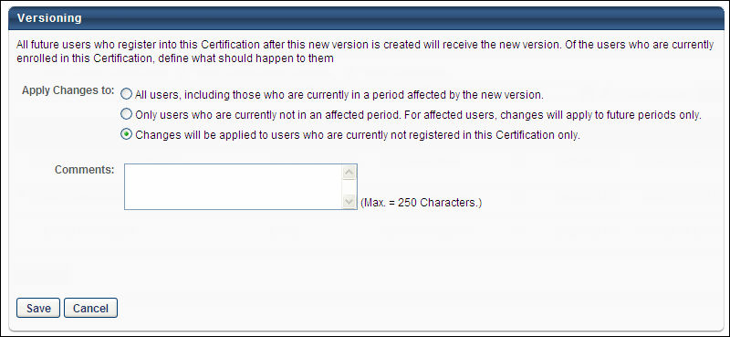
Apply changes to:
- All users, including those who are currently in a period affected by the new version - If an administrator selects this option, they can expect one of the following two outcomes:
  - If the end user has one of the following certification statuses for their current active period, they are expected to receive the latest version:
    - New
    - Pending Prerequisite
    - Pending Approval
    - In Progress
    - Expired
    - Certified Renewal In Progress
    - Expired Pending Completion Approval
    - Revoke
  - If the end user has one of the following certification statuses for their current active period, they are NOT expected to receive the latest version:
    - Expired Pending Renewal Completion Approval
    - Certified Pending Renewal Completion Approval
    - Pending Completion Approval
    - Denied
    - Certified
- Only users who are currently not in an affected period.For affected users, changes will apply to future periods only - If an administrator selects this option, they can expect one of the following two outcomes:
  - If the administrator made modifications to the period schedule, only certified users who are not in the affected period will receive the latest version. All other users are not expected to receive the latest version.
  - If the administrator did not make changes to the period schedule and then reversions the certification, no users are expected to receive the latest version. Users will receive the latest version in the future certification period.
- Changes will be applied to users who are currently not registered in this certification only - Users with a certification status of Denied for their current active period dp not receive the latest version. All other users receive the latest version.
Note: If multiple versions of a certification exist (e.g., v1, v2, v3), and a new version is created (e.g., v4) by editing the first version (v1), when users are moved to the new version, users are moved from all versions (v1, v2, and v3), not just users from v1.
In the Comments field, add a comment regarding the versioning. The purpose of the changes should be mentioned. The character limit for this field is 250.
Click Save to submit the changes and create a new version.
This workflow is intended to ensure that only users who require the latest version of the certification receive it.
External Training Approvals
When a certification is reversioned, approvals and denials associated with external training inside the certification persist to the new version. Approval requests for external training are not re-triggered, and credits earned from external training are maintained when the certification is reversioned.
See the table below for more information about how external training within a reversioned certification behavior is updated with this release:
Source of External Training | Status | Old Behavior | New Behavior
User added | Approved | - External training maintains credits  - External training maintains approval | No change:  - External training maintains credits  - External training maintains approval
User added | Denied | Approval is re-triggered automatically | An approval is re-triggered only if a user selects Request Again. An approval is not re-triggered automatically when the certification is reversioned.
Administrator added to framework | Approved | - Approvals are lost  - Credits are lost | - Approval is not re-triggered  - Credit is maintained
Administrator added to framework | Denied | - Approval is re-triggered automatically  - Denial is erased | Denial is maintained. An approval is re-triggered only if a user selects Request Again. An approval is not re-triggered automatically when the certification is reversioned.

An administrator is creating a certification that will be available to multiple organizational units (OU). The administrator would like users to only be able to complete the LOs in the certification that are within their OU availability. For this reason, the administrator unchecks the Override LO Availability option to ensure that the availability settings defined in Course Catalog for each LO apply to the LOs that are part of the certification.

