Career Site and Career Center March 2024

Table of Contents
Career Site and Career Center Overview 1
Career Center Overview 2
Internal Career Site (Early Adopter) - Overview 4
Internal Career Site Preferences 5
Internal Career Site - Search Jobs 11
Internal Career Site - View Job Details 13
Internal Career Site - Apply to Job 15
Internal Career Site - My Jobs 18
Internal Career Site - Refer Candidates 21
Internal Career Site - My Referrals 25
Career Site Overview 26
Mobile-Friendly Career Site Overview 29
Manage Mobile-Friendly Career Site 30
Mobile-Friendly Career Site - Job Search 43
Frequently Asked Questions for Mobile-Friendly Candidate Experience 58
Career Site - Application Experience 62
Application - Add Note 65
Application - Apply as Guest 66
Application - Apply with LinkedIn 70
Application - Competency Assessment 71
Application - Compliance Questions 72
Application - Forms 75
Application - Integrations 76
Application - Pre-Screening Questions 78
Application - Submit Application 81
Application - Test Learning Objects 82
Application - Training Courses 83
Application - Upload Attachments 84
Indirect Organizational Unit for External Applicants 85
Career Site - My Profile Overview 87
My Profile - Application Status 91
My Profile - Connect to Facebook 95
My Profile - Job Alerts 96
My Profile - My Completed Tasks 98
My Profile - My Pending Tasks 101
My Profile - View and Edit Profile Information 110
My Profile - Saved Jobs 112
My Profile - Change/Remove Photo 114
My Profile - View Application 116
Self Schedule Interview Task 118
Standard Career Site Overview (Legacy) 122
Create Standard Career Site 123
Career Site - Standard Candidate Experience 133

Career Site and Career Center Overview

Career Center Overview
The Career Center contains the tools necessary to take a more active role in your career planning and career development within your organization. The Career Center is the central location for managing your career mobility and development within the organization. You can determine and research your career mobility through career pathing and conduct job searches to seek out opportunities from other areas of the organization. You can pursue internal development and training specific jobs, increasing your readiness for such jobs when those jobs become available.
Permissions
PERMISSION NAME | PERMISSION DESCRIPTION | CATEGORY

Career Center - View | Enables users to view the Career Center, including Career Pathing and Job Search, depending on enabled components and preferences. This permission enables users to view the Internal Job Search widget on the Welcome Page and custom pages. This permission is also required to post a requisition to an internal career site. This is an end user permission. | Talent/Succession
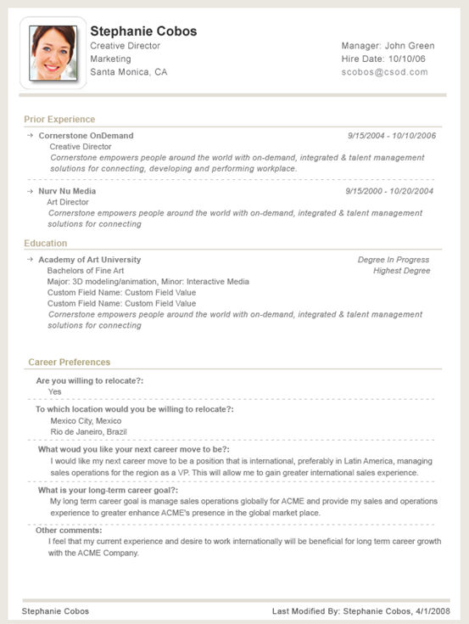

Internal Career Site (Early Adopter) - Overview
The Internal Career Site feature lets administrators upload a custom search banner and configure job search filters by requisition custom fields. On the Internal Career Site Preferences pages, administrations can configure the end-user site to display position OU details, competency information, recommend learning by competency assessment, and recommended learning by position OU. Additionally, administrators can enable users to apply for a position through LinkedIn and create a development plan. Recruiting clients can self-enable this functionality in Feature Activation Preferences.
Internal employees can use the Internal Career Site to search for jobs by many criteria, including job title, keyword, job description, and location. Search results are displayed in an easy-to-read table format, and numerous sorting options and filters are available. Additionally, internal users can view the competencies and recommended learning for the position, if available. Once users locate a position, they can immediately apply for it.
Internal career sites are mobile-friendly, so they can be viewed on smaller devices.
Implementation
The Internal Career Site is in the Early Adopter phase and must be self-enabled in Feature Activation Preferences. See Feature Activation Preferences.

Internal Career Site Preferences
Internal Career Site Preferences allow you to configure options that will be available to users when applying for an internal position.
To access the Internal Career Site Preferences page, go to Admin > Tools > Recruit > Internal Career Site.
Permissions
PERMISSION NAME | PERMISSION DESCRIPTION | CATEGORY

Manage Internal Career Site Preferences | Grants access to set preferences for the Internal Career Site. Assigned by default to the System Administrator, Cornerstone Administrator, and the Recruiting Administrator. This is an administrator permission. | Recruiting
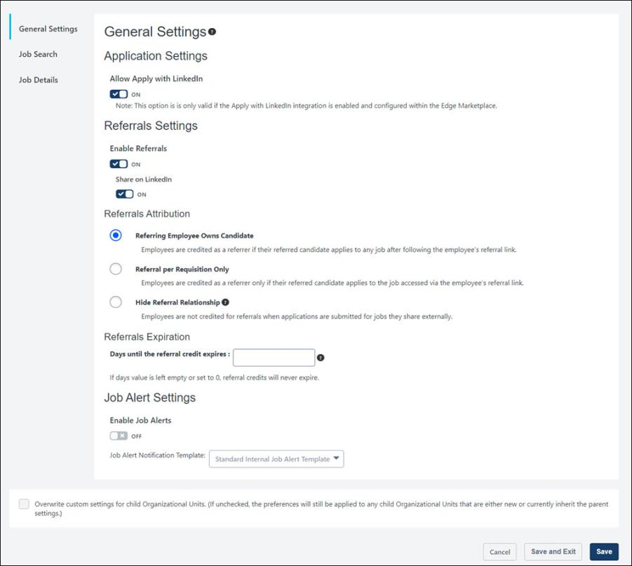
General Settings
The following settings are available in this section:
Application Settings
In this section, you can toggle on or off the ability for candidates to apply with LinkedIn. This option is off by default.
- Toggled On - When the Allow Apply with LinkedIn option is on, candidates can use their LinkedIn profile to apply to the job. An Apply with LinkedIn button appears on the application page to allow candidates to apply using their LinkedIn profile.
- Toggled Off - When this option is off, candidates cannot apply using their LinkedIn profile.
Once you have toggled the option on or off, click Save to save the setting.
Note: The Apply with LinkedIn (with Apply Starters) plugin is needed in order for the Allow Apply with LinkedIn option to be functional for internal career sites. See Apply with LinkedIn (with Apply Starters) Overview.
Referral Settings
The following settings are available in this section:
Enable Referrals
This option lets you enable or disable the email referrals feature for the internal career site. The option is enabled by default.
To disable email referrals, toggle the option to off. When this option is disabled, the options to refer jobs via email are not available on the internal career site. dd
Share on LinkedIn
This option lets Internal employees post jobs on LinkedIn. Once enabled, a Share on LinkedIn button appears on the Internal Career site.
Referrals Attribution
This section lets you determine how referral credit is applied, using the following settings:
- Referring Employee Owns Candidate - When selected, employees are credited as a referrer if their referred candidate applies to any job after using the referral link in the Referral to External User email. Or, the employee is credited if the referred candidate applies using the same email address the employee used for them when sending the job referral. Selecting this option enables the referral credit expiration preferences.
- Referral per Requisition Only - When selected, employees are credited as the referrer only if their referred candidate applies to the job specified in the referral, either by using the referral link in the Referral to External User email or by applying to that job using the same email address the employee used for them when sending the job referral. Selecting this option enables the referral credit expiration preferences.
- Hide Referral Relationship - When selected, employees are not credited for referrals when the referred candidate applies to a job. Note: The relationship question on the employee referral form will still appear when this option is selected.
Referrals Expiration
This section lets you determine when the referral credit expires. The field accepts numeric values only.
Job Alert Settings
This section lets you enable job alerts for an internal career site and select which template to use to send job alert notification email messages. Users are notified via email when relevant jobs are posted to the Internal Career Site that matches the job alert search query criteria and OU.
- To enable job alerts, move the Enable Job Alerts toggle to the On position. Administrators must enable job alerts for each internal career site that requires it.
- To select a template, from the Job Alert Notification Template drop-down, select the appropriate template.
  - If the Standard template is selected:
    - The job alert notification contains standard content (sender, subject, and content) and dynamic content (Job Alert Title, User First Name, User Last Name.
    - A View Job link is provided for each matching job.
    - Users can unsubscribe using the unsubscribe link in the email.
  - If an Internal Job Alert template is selected:
    - The job alert notification email is based on the template.
    - A View Job link is provided for each matching job.
    - Users can unsubscribe using the unsubscribe link in the email.
Job Search
In this section, you can upload a search banner and select custom fields to include as search filters for the job search page. You can also choose to display the hiring manager in search results.
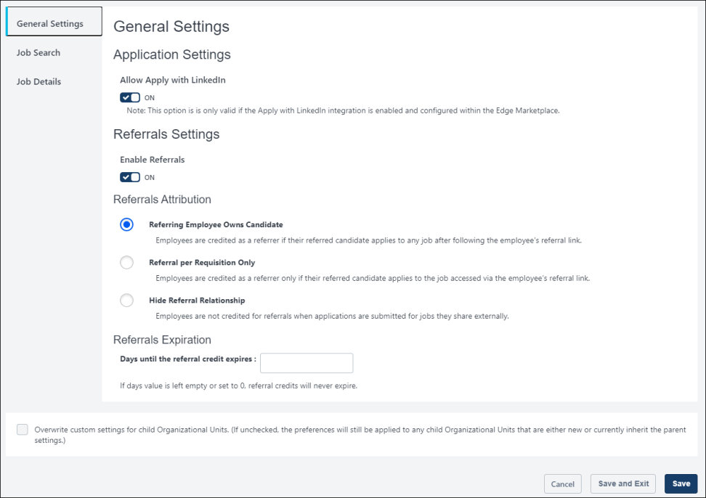
Search Banner
The banner image will appear behind the job search bar and is optional to include. If an image is not added, the banner is gray.
To add an image:
- Click Select Image to search for and select an image from your computer. Note: It is recommended to use a high resolution image with a size ratio of 4.16:1, width to height. Otherwise, the height should be at least 150 pixels, and the width should be greater than the height.
- Click Save on the preferences page to save the banner image to the Internal Career Site's preferences.
Display Hiring Manager in Search Results
The Display Hiring Manager in Search Results option is off by default. When this option is toggled on, the hiring manager's name will display in the search results on the internal career site if a hiring manager is defined on the General tab of the requisition.
Use Case
Rosa is looking to transition from her current role at ACME and into a sales position. She has worked closely with the head of the enterprise sales team and knows she would be suited for a position on that team. She searches for sales jobs on ACME's internal career site and finds many open positions. She sees in the search results that the head of the enterprise sales team is the hiring manager for one of the positions and knows that this is relevant to her interests. She reviews the job details and applies to the job.
Custom Field Filters
This section lets you define the requisition custom fields that will appear in the Filters section on the job search page so that applicants can use the fields to filter their search.
To add fields:
- Click Select Custom Requisition Field Filters. This opens the select fields flyout.
- Check the box next to each desired field.
- Click Save in the flyout. The selected fields appear in a table below the Custom Field Filters section.
- Click Save on the preferences page to save the settings.
You can delete a field as a filter by clicking the Remove Job Function icon in the Remove column.
Note: Custom requisition fields are added and managed in Custom Field Administration. Only dropdown type custom fields may be used as custom field filters on the Internal Career Site.
Note: When candidates search for jobs on the career site, if no posted requisitions match a custom filter's values, then that custom filter will not display. This can happen when a new custom field is configured, but no requisitions have populated values for that field.
Job Details
In this section, you can enable and disable features that appear on the Internal Career Site details page. Additionally, you can add a header to each feature.
The following features are available:
- Display Position Summary - If enabled, a description of the position displays as configured within the job's Position Organizational Unit (OU).
- Display Competency Assessment Chart - If enabled, the Competency Assessment Chart displays on the job details page. This depends on a competency model being associated to the job's Position OU. If no competency model is associated, then this widget will not appear.
- Display Position Learning Carousel - If enabled, a carousel displays with learning titles that apply to the selected position. These learning titles are configured in the job's Position OU.
- Display Competency Model Learning Carousel If enabled, a carousel displays with learning titles that apply to the competency model for the selected position.
- Allow Users to Create Development Plans - If enabled, a Create Development Plans button appears on the job details page.
- Add Custom Header Text - Click this link under the appropriate option above to add a custom section header.
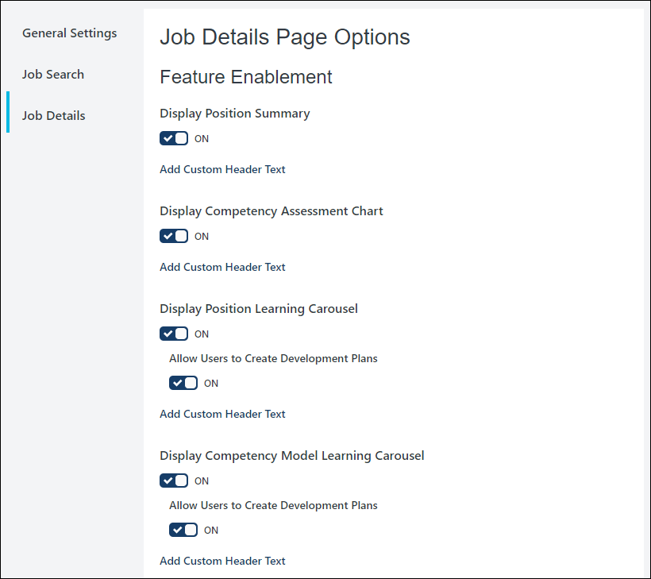
Overwrite custom settings for child Organizational Units
- Overwrite custom settings for child Organizational Units. (If unchecked, the preferences will still be applied to any child Organizational Units that are either new or currently inherit the parent settings. - Check to overwrite any custom settings for child OUs. This option is visible on all of the Internal Career Site Preferences pages.
Save / Save and Exit / Cancel
Click Save to save the changes made to the currently open preferences section.
Click Save and Exit to save the changes made to the currently open preferences section and exit the preferences page.
Click Cancel to cancel the changes to the currently open preferences section and exit the preferences page.

Internal Career Site - Search Jobs
Employees can use the Internal Career Site to search for job opportunities within the organization. Users can select filer criteria and display opportunities based on keywords, posted date, and location. Search results display in an easy-to-read table that provides the number of results, job title, location, and posted date.
To access the Internal Career Site page, go to Home > Internal Career Site.
Permissions
PERMISSION NAME | PERMISSION DESCRIPTION | CATEGORY

Internal Career Site | Enables users to view the internal career site. Assigned by default to the default security role, System Administrator, Cornerstone Administrator, and the Recruiting Administrator. | Recruiting
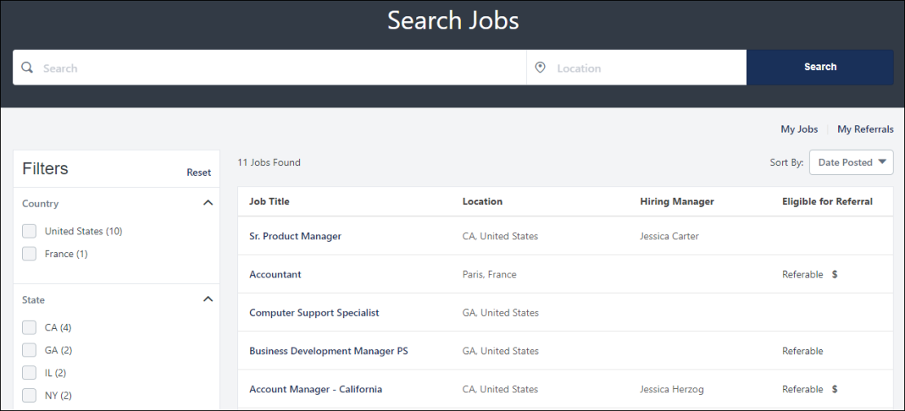
Search and Filter
You can search for jobs by entering search terms into the search bar or using the location filters to narrow your results by job location.
You can also filter by referral eligibility for jobs that are eligible for referral. Jobs are eligible for referral when they are posted to the default external career site for the requisition, as defined on the Postings page for the requisition. The following referral filter options may be available:
- All - When selected, all jobs appear, regardless of whether the job is eligible for referral.
- Referable - When selected, only jobs that are eligible to be referred display.
- Includes Referral Bonus - When selected, the only jobs that display are jobs that are eligible to be referred and include a referral bonus. The referral bonus is determined by the administrator or recruiter when configuring the requisition. Note: If Internal Career Site Preferences are set to hide referral relationships, then this filter option does not display.
Note: If Internal Career Site Preferences are set to hide referral relationships, then the referral bonus symbol in the Eligible for Referral column and the Includes Referral Bonus filter do not display.
Additional filters may display based on the options configured by the administrator.
Job Listings
All job listings that are available appear on the page upon accessing the internal career site. You can sort the results by date posted. Additional sorting options - relevance and distance - are available when you search by keyword or location.
The following information displays for each job:
- Job Title - The job title displays as a link. Click the link to view the job details and access the application.
- Location - This is the geographic location of the job.
- Hiring Manager - This is the name of the hiring manager for the job. This column only displays if enabled by the administrator.
- Eligible for Referral - This indicates whether the job can be referred. Note: If Internal Career Site Preferences are set to hide referral relationships, then the referral bonus symbol does not display.
- Posted Date - This is the date on which the job was posted.
Apply for a Job
Click the job title to open the job details page, from which you can apply to the job. See Internal Career Site - Apply to Job on page 15 for additional information.
My Jobs
From the Search Jobs page, you can also access your internal career site profile. Click My Jobs to view and edit your profile, as well as manage your applications. See Internal Career Site - My Jobs on page 18 for additional information.

Internal Career Site - View Job Details
The job details page displays additional information about the job, and lets the user apply if interested. This page may also include competency information, recommended learning, and access to development plans.
To view the details for a job, go to Home > Internal Career Site. Search for and then select a job in the search results.
Permissions
PERMISSION NAME | PERMISSION DESCRIPTION | CATEGORY

Internal Career Site | Enables users to view the internal career site. Assigned by default to the default security role, System Administrator, Cornerstone Administrator, and the Recruiting Administrator. | Recruiting
Job Title/Location/ID Number
Displays the job title, location, and requisition ID number for the selected job, if applicable.
Apply Now
Select Apply Now to apply for this job. Note: This button may appear at the top and bottom of the details page. See Internal Career Site - Apply to Job on page 15 for additional information.
Refer a Candidate
Select Refer a Candidate to refer the job to someone externally, such as a friend or relative. This option only appears for jobs that are eligible to be referred. See Internal Career Site - Refer Candidates on page 21 for additional information.
Share on LinkedIn
Internal employees can select Share on LinkedIn to post jobs on LinkedIn
Description
This section displays a description and qualifications for the job, if applicable. This section may also include additional information about the job, such as a video.
Competencies for this Job
This section displays the competency and skills targets for this job as follows:
- Competencies - Displays the competencies in the associated competency model. Show more displays additional information about each competency.
- Competency Comparison - If the logged-in user has completed a competency assessment containing any of these competencies, this rating compares their score with the target competency for this position. These scores work with standalone competency assessment tasks and for competency rating sections of performance reviews.
- Difference - Displays the difference between the user's competency rating and the target.
Note: This section is optional and only appears if enabled by an administrator in Internal Career Site Preferences, and the selected job's Position OU has Competency Model data configured.
Recommended Learning for this Position
Displays related recommended learning courses. Click a title to view the learning.
Note: This section is optional and only appears if enabled by an administrator. If clients do not use Learning, these options are not available.
Create Development Plan
Click Create Development Plan to create a development plan. See Create/Edit Development Plan (Redesign).
Note: This section is optional and only appears if enabled by an administrator.

Internal Career Site - Apply to Job
Users apply to internal jobs by clicking Apply Now from the job details page on the internal career site. This opens the job application, from which you can complete and submit the application.
Permissions
PERMISSION NAME | PERMISSION DESCRIPTION | CATEGORY

Internal Career Site | Enables users to view the internal career site. Assigned by default to the default security role, System Administrator, Cornerstone Administrator, and the Recruiting Administrator. | Recruiting
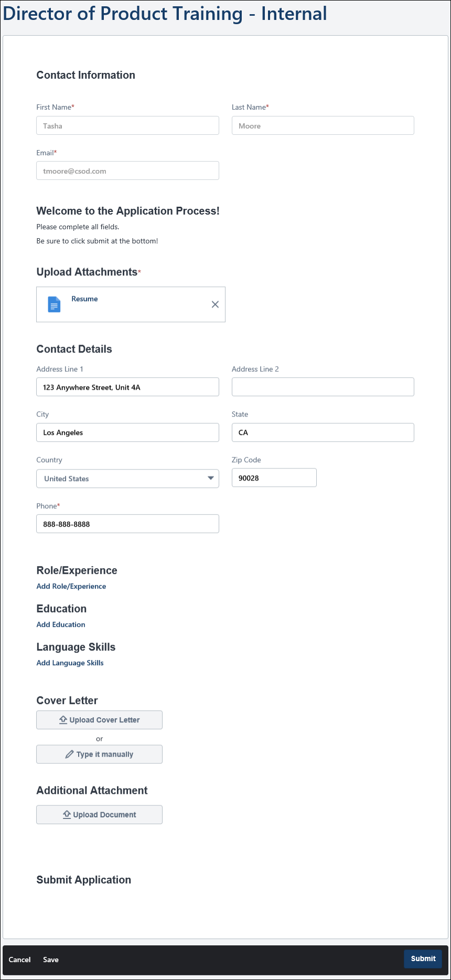
Complete Application Fields
As an internal applicant, your contact information is pre-populated and cannot be modified on the application.
Note: You can modify your name and email address in your profile on the internal career site. See Internal Career Site - My Jobs on page 18 for additional information.
Apply with LinkedIn
An Apply with LinkedIn option may be available at the top of the application. Clicking the button option lets you log in to LInkedIn and apply to the job using your profile.
This option only appears if enabled by an administrator. See Internal Career Site Preferences on page 5 for additional information.
Submit Application
Once you have completed all required application fields, click Submit.
You can view your application by clicking My Jobs from the internal career site search jobs page.

Internal Career Site - My Jobs
The My Jobs page on the internal career site lets applicants view their application status, withdraw an application, and reapply to the same position. Additionally, users can view the resume they submitted.
To access the My Jobs page, click My Jobs in the upper-right corner of the job search page or the My Referrals page.
Permissions
PERMISSION NAME | PERMISSION DESCRIPTION | CATEGORY

Internal Career Site | Enables users to view the internal career site. Assigned by default to the default security role, System Administrator, Cornerstone Administrator, and the Recruiting Administrator. | Recruiting
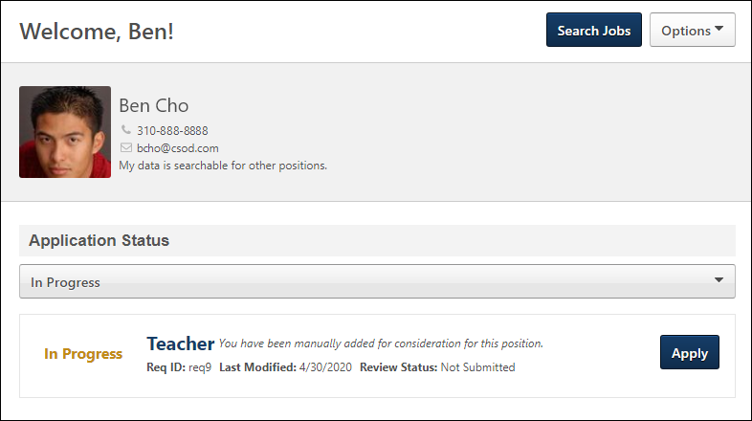
Search Jobs
Click Search Jobs to go to the search jobs page on the internal career site.
Options
From the Options drop-down, click Edit Profile to edit your name and contact information. It is important to note that changes to your profile apply to all other areas of the portal, such as on your universal profile.
Application Status
This section displays the jobs you have applied to and the status of each application. You can also view the job details by clicking the linked job title.
The following are the possible statuses for your application:
- Closed - This status displays if the applicant status is Closed.
- Completed - This status displays when the applicant has submitted their application.
- Hired - This status displays if the applicant status is Hired.
- Initiated by Recruiter - This status displays if the applicant has been submitted by a recruiting agency but has not yet started or completed their application for submission. Note: Previously, this status appeared in the Application Status field.
- In Progress - This status displays if the applicant has started their application but has not yet submitted it.
- In Review - This status displays if the applicant status is In Review.
- Not Submitted - This status displays if the application is not yet completed by the applicant and was not submitted by a method other than the applicant, such as manually moved by a recruiter or submitted from an agency portal.
- Requisition Closed - This status displays if the job requisition is closed.
- Submitted - This status displays if the applicant status is New Submission.
Filter Application Drop-Down
The Filter Application drop-down displays options to filter applications by status. Only 100% completed applications display by default. The following options are available in the drop-down:
- All - Click this option to view the jobs you have applied for and jobs for which the application is in progress but has not yet been submitted.
- In Progress - Click this option to show only applications that are in progress but have not yet been submitted.
- Applied - Click this option to show only applications for jobs you have applied for, meaning that the application has been submitted.
Manage Applications Options
The following options are available to manage applications:
- Continue - This option appears when an applicant has started the application process for a job but has not yet submitted their application.
- Reapply - This option allows applicants to reapply to a job requisition. This option is only available if enabled by an administrator, and the user has already been dispositioned from the requisition.
- View Application - This option allows the application to open a pop-up that displays the application. This option is available even if the requisition is closed.
- View Resume - This option is available if a resume file was not attached and the candidate input resume data into fields manually on the application. Click the option opens the resume. The resume is available even if the requisition is closed.
- View Resume (DOC) - This option is available if the resume file type is anything other than .pdf. Click the option opens the resume. The resume is available even if the requisition is closed.
- View Resume (PDF) - This option is available if the resume was submitted as a .pdf file. Clicking the option opens the resume. The resume is available even if the requisition is closed.
- Withdraw - This option allows the applicant to withdraw their application after it is submitted. The user cannot undo the withdrawal action. The applicant's status is changed to Closed, and their disposition is set to "Voluntary Withdrawal." If configured, the Voluntary Withdrawal email is sent when the application is withdrawn.
My Alerts
The My Alerts section displays job alerts created on internal career sites. Candidates can view, edit title and frequency, and unsubscribe from these job alerts.
- To edit a job alert, click the edit icon. The page expands to allow users to edit the Name and Cadence for the job alert.
- To unsubscribe from a job alert, click the delete icon, and click Unsubscribe on the confirmation message. Once unsubscribed, a job alert cannot be restored.

Internal Career Site - Refer Candidates
The Refer a Candidate option lets employees refer a job by email to a candidate, such as a colleague or relative. This option is only available for jobs that are eligible to be referred. Jobs are eligible for referral when they are posted to the default external career site for the requisition, as defined on the Postings page for the requisition.
If the job is eligible for referral and contains a referral bonus, the referral bonus appears at the top of the job details page. If Internal Career Site Preferences are set to hide referral relationships, then the referral bonus does not display.
Pre-Step Note: At least one email must be configured for the Referral to External Email email in Email Administration in order for users to be able to refer jobs from the internal career site. . The email should include the REFERRAL.LINK email tag so that the referral is linked to the employee who referred the job. This tag also allows the referred candidate quick access to the job details page.
To access the Internal Career Site page, go to Home > Internal Career Site.
Permissions
PERMISSION NAME | PERMISSION DESCRIPTION | CATEGORY

Internal Career Site | Enables users to view the internal career site. Assigned by default to the default security role, System Administrator, Cornerstone Administrator, and the Recruiting Administrator. | Recruiting
Emails
EMAIL NAME | EMAIL DESCRIPTION | ACTION TYPE

Referral to External User | This email is triggered when a user refers a requisition in the internal career site or Career Center (Legacy). The email can be sent to Hiring Manager, Referral Recipient, Requisition Owner(s), Requisition Reviewer(s), or a specific user. This email can be configured as a Notification type email. This email is active by default and can be found in the Recruitment action type section in Email Management.  Note: A custom message can be added by the sender. In order for a custom message to appear to the recipient, the EMAIL.CUSTOM.MESSAGE email tag must be included when configuring the email in Email Administration. | Recruiting
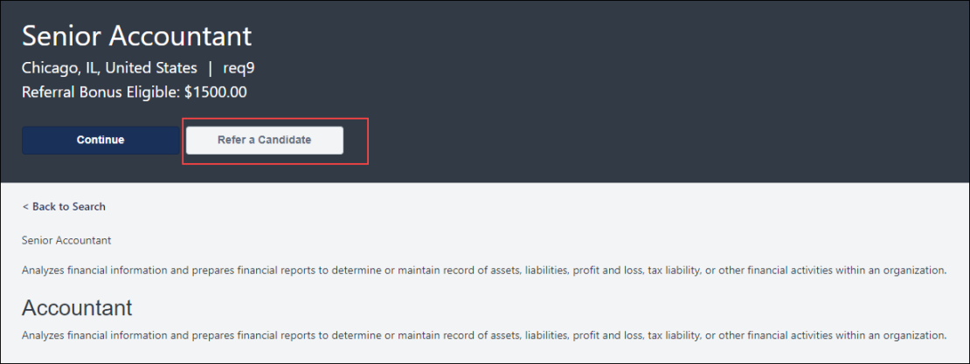
Refer Candidate
To refer a candidate:
- Navigate to the job details page by clicking the name of the job on the job search page of the internal career site.
- Click Refer a Candidate at the top or bottom of the job details page. This opens the Refer a Candidate flyout.
- Enter the email address in the Candidate's Email field. This is the email address of the person you would like to refer.
- Select Yes or No to indicate whether you are related to the candidate.
- Enter a message in the Message to candidate field. This is optional. Note: This message only appears in the email if the administrator configured the email to allow the message to appear. The administrator must include the EMAIL.CUSTOM.MESSAGE email tag in the email.
- Copy the link in the Referral Link field if you would like to use it to refer the candidate via mediums other than email, such as social media platforms. Note: When candidates apply to a job via the copied referral link, they will follow the same referral process as referrals that are sent via email. However, sharing the referral link on a social media platform does not add an entry to your My Referrals page unless a candidate applies via the link.
Use Case
An artist who works at a film company has a significant following on a social media platform. Whenever she becomes aware of new art production jobs, she shares them with her followers. She finds a new job on her organization's internal career site and copies the link from the Refer a Candidate flyout. She pastes the link into a new post on social media. Two of her followers apply to the job, and she can track their referral progress on her My Referrals page.
- Select the language in the Preferred Language field in which you would like the email to appear for the candidate.
- Click Send Email. This emails the job referral to the candidate. Note: The email may have been configured by the administrator to be sent to members of the hiring team as well.
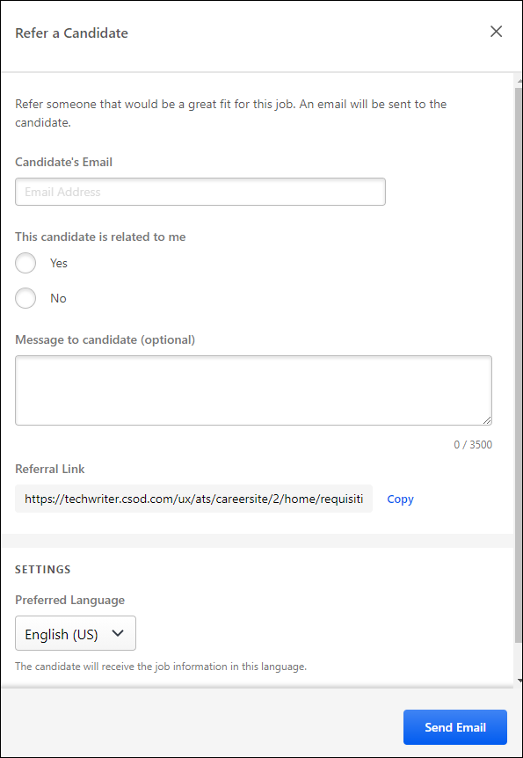
Frequently Asked Questions
How does referral credit work?
Credit for referring a job to a candidate is dependent upon the way your organization has set up referral credit.
- Candidate Applies Via Referral Email - If the candidate you referred applies to the job after clicking the referral link in the referral email, then you will receive credit for the referral.
- Candidate Applies with Email Address Used in Referral - If the candidate you referred applies to the job using the same email address to which the referral was sent, then you will receive credit for the referral.
- Candidate Applies to Any Job After You Refer Them - If your system administrator has enabled the setting that allows the referring employee to essentially "own" the candidate, and the candidate you referred a) applies to any job after clicking the referral link in the referral email, or b) applies to any job using the same email address to which the referral was sent, then you will receive credit for the referral.
What if someone else refers the same candidate? Do I still get referral credit?
If the candidate applies using the referral link in the referral email that you sent, then you are considered the referrer, regardless of how many other employees sent the candidate a referral.
However, if the candidate applies using a different method than the referral link in the email but includes the same email address that was used to send the referral email, then the referral credit goes to the oldest valid referral.
If the recruiter has reason to do so, the referral credit can be changed on the candidate's profile page.
When will I get my referral bonus?
If a bonus is configured for the job you referred, you will need to contact someone within your organization for information about when you my receive the referral bonus.

Internal Career Site - My Referrals
The My Referrals page lists each candidate to whom the user has referred a job.
To access the My Referrals page, click My Referrals in the upper-right corner of the job search page or the My Jobs page.
Permissions
PERMISSION NAME | PERMISSION DESCRIPTION | CATEGORY

Internal Career Site | Enables users to view the internal career site. Assigned by default to the default security role, System Administrator, Cornerstone Administrator, and the Recruiting Administrator. | Recruiting
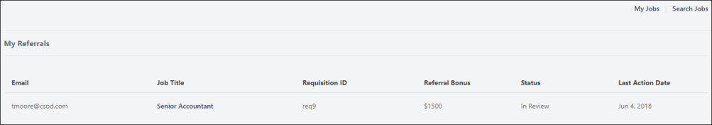
The following information displays for each referral:
- Email - This is the email address of the candidate to whom the job was referred.
- Job Title - This is the name of the job that was referred. The title is linked to the job details for jobs that are still open.
- Requisition ID - This is an internal value that is automatically assigned when a job requisition is created.
- Referral Bonus - This is the referral bonus amount, if available and visible to you. This column is hidden if no referrals are eligible for a bonus.
- Status - This is the application status of the candidate referral you submitted. The following are the possible statuses:
  - Invited to Apply - When the referral email is sent, the status is Invited to Apply.
  - In Review - This status indicates that the candidate applied for the job.
  - Hired - This status indicates that the candidate has been hired for the job.
  - Closed - This status indicates that the candidate's application has been closed or dispositioned (e.g., the candidate failed the pre-screening test).
- Last Action Date - This is the date on which the last action was taken on the candidate's application for the job. For example, if the candidate was interviewed by phone, then the date of the interview appears here.
Quick access options are available in the top-right corner of the page. Click My Jobs to view the jobs to which you have applied or are in the process of applying. Click Search Jobs to go to the job search page.
Note: As part of the October '20 release, the name of the My Profile page is changed to My Jobs.

Career Site Overview
A career site page is where applicants search for jobs from an organization's website.
The Career Site Management page enables administrators to manage all career sites for the organization. Each career site can be customized with a unique appearance, a pointed selection of open positions, and independent preferences. There is no limit to the number of career sites that can be configured for a portal.
From the Career Site Management page, administrators can create, view, edit, delete, and select email templates for career sites.
- Create Mobile-Friendly Career Site
- Create Standard Career Site
To manage career site pages, go to Admin > Tools > Recruit > Career Site.
Permissions
PERMISSION NAME | PERMISSION DESCRIPTION | CATEGORY

Career Site - Manage | Grants ability to access and manage Career Site Management. This permission can be constrained by OU and User's OU. This is an administrator permission. | Recruiting Administration

Career Site - View | Grants ability to access and view Career Site Management. This permission can be constrained by OU and User's OU. This is an administrator permission. | Recruiting Administration
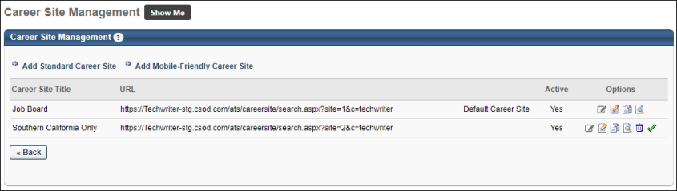
Standard Career Site
Note for New Client Portals Created After May '19 Release: New Recruiting clients whose portals were created after the May '19 release will only be able to create Mobile Friendly Application Workflows and Career Sites. The Standard career site experience for such clients was deprecated as part of the May '19 release.
Standard career sites have fewer mobile-friendly features, and some parts of the application for requisitions that are posted to a standard career site may not be compatible with mobile devices.
Note: If you would like an existing standard application workflow template to be mobile-friendly, self-enable the mobile-friendly candidate experience, and all qualifying application workflows will automatically become mobile-friendly. If the workflow is comprised of mobile-friendly components at the time of self-enablement, applicants will see the mobile-friendly application. Otherwise, they will see a standard application.
Mobile-Friendly Career Site
Mobile-friendly career sites can be easily accessed by applicants using any device and provide a more fully mobile experience.
Click here to view Frequently Asked Questions regarding the mobile-friendly candidate experience.
Career Sites Table
The following information is displayed for existing career sites:
- Career Site Title - Displays the career site title as defined on the Career Builder page. For portals with multiple languages enabled, this displays in the user's language if available. If the user's language is not available, then this displays in the language of the user who defined it. The Career Site Title column is sorted alphabetically.
- URL - Displays the career site URL. Each career site requires a unique URL. This is used on external (non-Cornerstone) pages in order for applicants to access a specific career site. The URL is generated when the administrator creates a new career site page.
- Allow Apply with LinkedIn - Displays whether or not applicants can utilize the Apply with LinkedIn functionality. This includes:
  - Apply with LinkedIn from Job Details page.
  - Sign in or Register with LinkedIn from the Sign In or Registration page.
  - Use LinkedIn resume/CV from the Application/Experience page.
- Active - Displays the Active setting for the career site. Once a career site has jobs posted to it, it cannot be deleted. The Active setting allows the administrator to stop users from posting new openings to a career site. If the Active status is Yes, the career site is available in the Job Postings page of Requisition Management.
Options
The following options are available in the Options column:
- Edit Connect With Us - Click the Edit Connect With Us icon to open the Connect With Us page.
- Edit - Click the Edit icon to open the Career Site Settings page. See Create Standard Career Site on page 123 for additional information.
- Copy - Click the Copy icon to copy the career site. This opens the Custom Page Builder Settings page. All settings can be copied, except for the career site title. See Create Standard Career Site on page 123 for additional information.
Note: For portals with multiple languages enabled, when copying a career site, all translated values are also copied. If the administrator's default language is not checked in the Career Site Language(s) field on the copied career site, then the administrator's language is automatically defined as the default language. Any translations for the previous default language for the copied career site are maintained. For example, a Chinese administrator copies a career site that has English as the default language, and Chinese is not one of the languages selected in the Career Site Language(s) field. When the career site is copied, the default language will be Chinese, and Chinese will be automatically selected in the Career Site Language(s) field. The previous default language of English will also be checked in the Career Site Language(s) field, and any English translations are copied over.
- View History - Click the View History icon to view all actions taken on the selected career site in the Career Site History pop-up. This includes the user, date, and time of the modification.
- Delete - Delete the career site. This option is only available if the career site has never had a job posting.
- Set as Default - The Set as Default option allows you to define a career site as the default site for the Division Organizational Unit (OU). Click the Set as Default icon to set the selected career site as the default site. This opens a confirmation pop-up. Click Yes to set the career site as the default, or click No to cancel the action. The default career site is linked to from the DEFAULT.CAREER.SITE email tag.
  - When a career site is defined as the default site, it cannot be deactivated. Only career sites that are not the default can be deactivated.
  - Careers sites that are inactive cannot be defined as the default.

Mobile-Friendly Career Site Overview

Manage Mobile-Friendly Career Site
Mobile-friendly career sites enable job seekers to search for and apply to jobs on desktop or mobile devices. Applicants will have the same experience on your career site regardless of the device they are using. Google Analytics is also supported on mobile-friendly career sites. You can create a mobile-friendly career site, and create a customized job alert template to send email alerts.
To manage the mobile-friendly career site, go to Admin > Tools > Recruit > Career Sites.​
Job Postings Note: When posting a job requisition to a mobile-friendly career site, the posting can take up to 15 minutes to appear.
Frequently Asked Questions
Click here for Frequently Asked Questions about mobile-friendly candidate experience.
Permissions
PERMISSION NAME | PERMISSION DESCRIPTION | CATEGORY

Career Site - Manage | Grants ability to access and manage Career Site Management. This permission can be constrained by OU and User's OU. This is an administrator permission. | Recruiting Administration

Career Site - View | Grants ability to access and view Career Site Management. This permission can be constrained by OU and User's OU. This is an administrator permission. | Recruiting Administration

Corporate Preferences - Manage | Grants the ability to manage Corporate Preferences, which includes several portal-wide settings. This is an administrator permission. | Core Administration
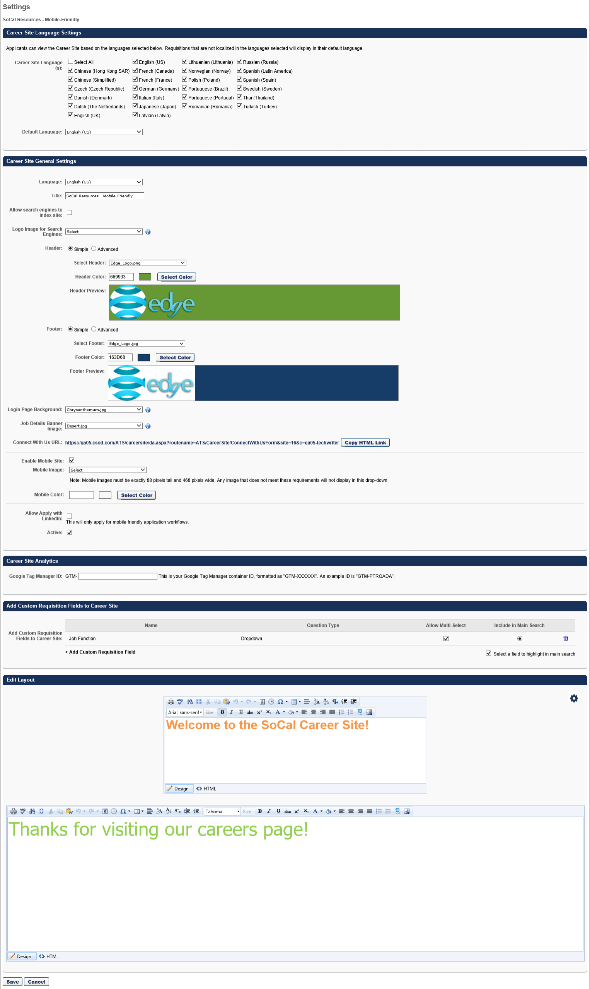
Create Mobile-Friendly Career Sites
- Go to Admin > Tools > Recruit > Career Sites.
- Click the Add Mobile-Friendly Career Site link. Use the information below to complete the fields.
For information about creating mobile-friendly candidate experience application workflows, see the Create Mobile-Friendly Application Workflow (Early Adopter) topic in Online Help.
Edit Mobile-Friendly Career Sites
- In the Career Site Title column, select a mobile-friendly career site.
- Click the edit icon. The Settings page opens.
- Make any necessary changes.
Career Site Language Settings
As with functionality for standard career sites, you can select the languages in which applicants can view the career site. In the Career Site Language(s) field, you can check Select All to select all available languages. Or, check the individual boxes for the languages you would like to include. The languages that are available to select are the languages enabled for the portal.
When applicants view the career site, the languages that you selected will appear in the language drop-down. The career site will then update to display in the selected language.
Title
Enter a title in the Title field, up to 250 characters. The title displays on the Career Site Management page.
Allow Search Engines to Index Site
The Allow search engines to index site option lets you enable or disable the ability for search engines to index the site. When you allow search engines to index your career site, more candidates can find and apply to your jobs. They can use job search methods they are familiar with and see all of your available jobs that match their skills.
This option is checked by default for newly created mobile-friendly career sites. The option is disabled by default for existing career sites that were created before implementation of this enhancement.
Check the box to enable search engine indexing. Jobs that are posted to this career site via the Job Postings page will be searchable on search engines.
When the option is unchecked, candidates will not be able to find the jobs that are posted to this career site on search engines.
How long will it take for my jobs to appear on search engines?
For Google Jobs, jobs can take up to several weeks to appear. This is due to the crawling functionality that Google uses to pick up the jobs and the timing of the next crawl after your requisition is posted to the career site.
For Indeed, your jobs will be eligible to appear as long as their eligibility guidelines are followed. Their eligibility guidelines are available on their help page to ensure that your jobs are eligible to appear.
Is this functionality a replacement for posting on job boards?
No. Your jobs can still be posted to job boards. However, even if you post your jobs to job boards, you may still want them to appear on Google Jobs and Indeed because some job seekers will not visit the job boards.
Which career sites apply to this option?
This option only applies to mobile-friendly career sites. Standard career sites are not impacted.
How does Google Jobs work?
Google Jobs works like any other search in Google. Candidates enter search terms in the Google search bar, and a Jobs section appears in the search results. Your jobs will appear in those results that are targeted by candidates.
Logo Image for Search Engines
Pre-Step Note: There must at least one image added to Corporate Preferences in order to select a logo for your jobs.
With the Logo Image for Search Engines option, you can add a corporate logo, which will appear right next to each job on the search engine. A logo provides immediate recognition for your brand. This can also help candidates identify your jobs more quickly in the future.
To select a logo:
- Click the drop-down to view the list of images. The images that display are the images that were configured in Corporate Preferences.
- Select an image from the drop-down.
If you opt not to define a logo, Google will attribute a default logo to the job posting based on the first letter of your organization's name.
This image will also be used when sharing a job on Facebook and LinkedIn. To see how the shared job will appear, you can copy and paste the URL of a job details page into the post inspector for Facebook and LinkedIn:
- Facebook: https://developers.facebook.com/tools/debug/
- LinkedIn: https://www.linkedin.com/post-inspector/
Career Site General Settings
Mobile-friendly career sites allow you to configure a header and footer, as well as a background image. Also, a Connect With Us URL is automatically generated.
Header and Footer
Header
When configuring the header, you can configure either a simple or advanced header. Note: JavaScript is not accepted by default when creating the header. To enable JavaScript for the header, contact Global Customer Support.
- Simple - The Simple option enables you to select a header image and color.
  - Select Header - From the drop-down list, select a header image for the career site. The selected header is displayed for all career site pages, including Job Search, Job Details, Create a Profile, My Profile, and Application Experience. The available images are taken from the Corporate Preferences images. A preview of the header image is displayed in the Header Preview field. The header is optional.
  - Header Color - Select the header color, which is the color that fills the header in areas that the header image does not fill. You may enter a hex value for the color or select a color by clicking the Select Color button.
  - Header Preview - This displays a preview of what the header will look like on the career site. The selected image is always aligned in the upper-left portion of the header. Any empty space in the header is filled with the selected header color. The selected logo is not resized.
- Advanced - The Advanced career site header option includes HTML configuration options. Selecting the Advanced option opens the WYSIWYG editor. The WYSIWYG (What You See Is What You Get) tool provides configuration tools, such as images, fonts, colors, formatting, and tables. There is also a Copy from Word feature that enables administrators to import from Microsoft Word, preserving the formatting used in the Word document. HTML code can also be used. For more information about the WYSIWYG tool, see the WYSIWYG Tool Considerations section in the Create New Email topic in Online Help.The system only accepts certain customizable HTML elements in the WYSIWYG Editor. Elements that are not acceptable display as text. See Safe Listed Customizable Elements.
The header will adjust to the width of the device's screen. However, if the width of an item in the header, such as an image, is defined using HTML in the Advanced settings, then those size settings will be respected.
Footer
When configuring the footer, you can configure either a simple or advanced footer.
- Simple - The Simple option enables you to select a footer image and color. Note: JavaScript is not accepted by default when creating the footer. To enable JavaScript for the footer, contact Global Customer Support.
  - Select Footer - From the drop-down list, select a footer image for the career site. The selected footer is displayed for all career site pages, including Job Search, Job Details, Create a Profile, My Profile, and Application Experience. The available images are taken from the Corporate Preferences images. A preview of the footer image is displayed in the Footer Preview field.
  - Footer Color - Select the footer color, which is the color that fills the footer in areas that the footer image does not fill. You may enter a hex value for the color or select a color by clicking the Select Color button.
  - Footer Preview - This displays a preview of what the footer will look like on the career site. The selected image is always aligned in the lower-left portion of the footer. Any empty space in the footer is filled with the selected footer color. The selected logo is not resized.
- Advanced - The Advanced career site footer option includes HTML configuration options. Selecting the Advanced option opens the WYSIWYG editor. The WYSIWYG (What You See Is What You Get) tool provides configuration tools, such as images, fonts, colors, formatting, and tables. There is also a Copy from Word feature that enables administrators to import from Microsoft Word, preserving the formatting used in the Word document. HTML code can also be used. For more information about the WYSIWYG tool, see the WYSIWYG Tool Considerations section in the Create New Email topic in Online Help.The system only accepts certain customizable HTML elements in the WYSIWYG Editor. Elements that are not acceptable display as text. See Safe Listed Customizable Elements.
The footer will adjust to the width of the device's screen. However, if the width of an item in the footer, such as an image, is defined using HTML in the Advanced settings, then those size settings will be respected.
Hide Social Sharing
The social sharing options can be hidden by adding additional code to the HTML tab on either the Advanced Header or Advanced Footer. After clicking the HTML tab, enter <style> </style> with one or more of the following lines of code in-between:
Hide “LinkedIn” option on Share Button
.p-button-dropdown-list [title="LinkedIn"] {
display:none;
}

Hide “Facebook” option on Share Button
.p-button-dropdown-list [title="Facebook"] {
display:none;
}
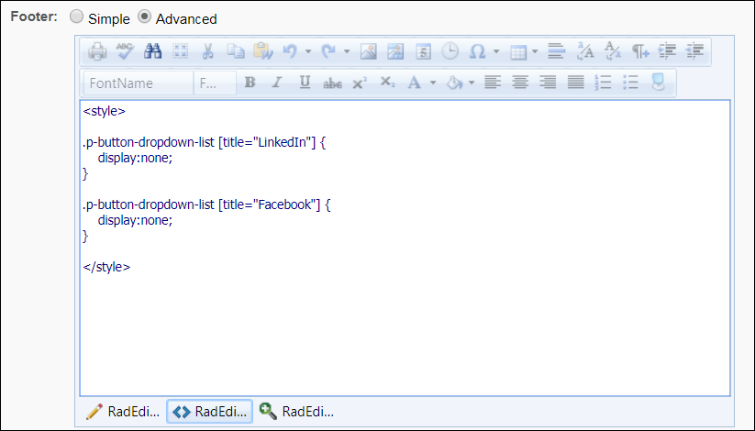
Login Page Background
The Login Page Background field allows you to select an image that will appear as the background on the login page and the Create a Profile page for applicants. This helps to further brand the career site for the organization.
To select an image, click the drop-down and select from available images. The recommended image size is 1920 x 1200 pixels.
Note: If an image is not selected, then the background is white.
Administrators with permission to manage Corporate Preferences can upload new images from the Corporate Preferences page. Once the image is uploaded and the preferences are saved, the image can be selected from the Login Page Background field.
Note: You can still also add a header and footer by using the Header/Footer options.
Job Details Banner Image
The Job Details Banner Image field lets you add a banner image that will appear as a bar behind the job details section on career sites.
To select an image, click the Job Details Banner Image drop-down and select from the available images. The images in the drop-down are pulled from Corporate Preferences. There must be at least one image available in Corporate Preferences in order to add a banner image. Images cannot be uploaded from the Career Site Settings page.
While there is no required image resolution, we recommend that a high resolution image be used, and that the image is wider than it is tall.
Note: If an image is not selected, then the background is gray.
Permission to Manage Corporate Preferences: Administrators with permission to manage Corporate Preferences can upload new images from the Corporate Preferences page. Once the image is uploaded and the preferences are saved, the image can be selected from the Job Details Banner Image field.
Connect With Us URL
A Connect With Us URL is automatically generated for mobile-friendly career sites after the career site is saved. Once the career site is saved, the link allows you to copy a hyperlink configured in HTML <a href = …>.
The following are the two ways that you can use this link:
- You can copy the hyperlink by clicking Copy HTML Link, and then you can paste the link directly into the “HTML” view in the header, footer, banner text, or custom information section to add a "Connect With Us” link to the career site.
- You can also copy the hyperlink by clicking Copy HTML Link, and then use it in emails or other media to help potential applicants apply to your organization.
Enable Job Alerts
Check the Enable Job Alerts box to allow candidates to create and receive job alerts on a mobile-friendly site job search page. Administrators must enable Job Alerts for each mobile-friendly career site that requires it.
Administrators can also select a customized email template from the Job Alert Notification Template drop-down. Note: To create custom email templates, go to ADMIN > TOOLS > RECRUIT > EMAIL TEMPLATES.
Apply with SEEK
Check the Allow Apply withSEEK box to allow candidates to apply with SEEK.
Apply with LinkedIn
Check the Allow Apply with LinkedIn box to allow applicants to apply with LinkedIn. For more information about the Apply with LinkedIn (with Apply Starters) plugin, see the Apply with LinkedIn (with Apply Starters) Overview topic in Online Help.
Active
Select this option to make the career site active. When a career site is active, it can be accessed by applicants and job requisitions can be posted to it.
Career Site Analytics
This section lets you add Google Tag Manager to your career site. Google Tag Manager is a tag management system that allows you to edit and add tracking pixels to web pages without constantly editing HTML code. You can use Google Tag Manager with other tools and marketing vendors to attract and maintain candidates, measure engagement on career sites, identify drop-off points, and much more.
Click here to download the Google Tag Manager starter guide.
Enter your Google Tag Manager ID in the Google Tag Manager ID field. Upon saving the career site settings, the ID will automatically get applied to the job search page and the job details pages in career sites, as well as application workflow pages.
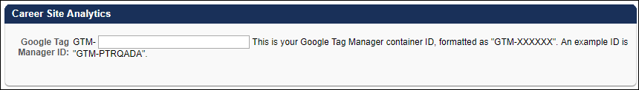
Add Custom Requisition Fields to Career Site
This section lets you add custom requisition fields as filters on the career site. Adding custom fields provides candidates with the filters they need to find jobs that specifically match their job function, compensation type, experience level, etc. Candidates will not need to look through a long list of jobs to find the right fit. The custom field filters will help them to quickly narrow down their search so that they can start applying.
The following field types are available:
- Dropdown
- Radio Button
- Checkbox
To add custom requisition fields:
- Click Add Custom Requisition Field. This opens the Select Custom Requisition Field pop-up.
- Select a field from the list. The field types are Dropdown, Radio Button, and Check Box. Only one field can be selected at a time.
- Selecting a field closes the pop-up and adds the field to the page.
When more than one field is added, you can reorder them by dragging and dropping them into the desired order.
Once a field has been added, the following information and options are available in the panel.:
- Name - This column displays the name of the custom field.
- Question Type - This column display the type of custom field: Dropdown, Radio Button, or Check Box.
- Allow Multi-Select - Check the box to let applicants select more than one option from a drop-down custom field when it appears on the career site. This option is unchecked by default. When this is select, a dropdown field will appear as check boxes on the left rail of a career site.
- Select a field to highlight in main search - Check the box to enable the Include in Main Search option. Having a field highlighted in the main search means that the field will appear in the search bar at the top of the career site. The field will also appear in the Filters section on the left side of the page, but having it at the top helps candidates find the filter quickly and start searching for jobs. This is only available for drop-down fields.
- Include in Main Search - Select this option to display the custom field in the main search. Only one field can be selected.
- Delete - Click the trash can icon to remove the field from the career site.
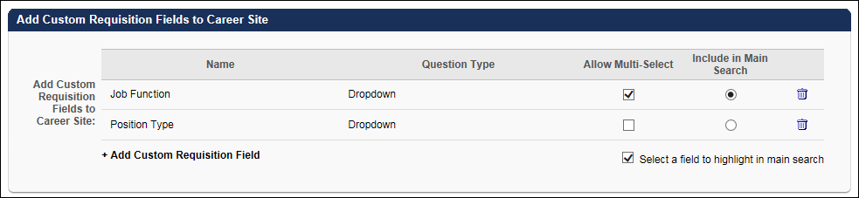
Note: When candidates search for jobs on the career site, if no posted requisitions match a custom filter's values, then that custom filter will not display. This can happen when a new custom field is configured, but no requisitions have populated values for that field.
Frequently Asked Questions - Career Site Custom Requisition Fields
How do I create Custom Requisition Fields?
Custom Requisition Fields are created as Organizational Unit (OU) type custom fields in Custom Field Administration. You must have permission to create OU custom fields.
If I migrate a standard career site to become mobile friendly, and the standard career site had custom requisition fields added, will they carry over?
Not with this release. You will need to edit the career site and add the custom requisition fields again.
What happens if the custom requisition field is made inactive? Will the filter still be available on the career site?
Yes. Historical requisitions will still have this field specified. You can edit the career site at any time to remove the filter if desired.
Who can add custom requisition fields to career sites?
Similar to current functionality, anyone who has the permission to create career sites will have the ability to add custom requisition fields to the career site. This is true even if an administrator does not have the permission to see the custom requisition field at the requisition level.
Edit Layout
In this section, you can add a banner image and banner text. You can also add additional content that will appear above the Filters and Current Openings sections on the career site.
Banner Image
The banner image will appear behind the job search bar and is optional to include.
To add an image:
- Click the Edit Banner Image icon in the upper-right corner of the Edit Layout section. This opens the Edit Banner Image pop-up.
- Click Choose File to search for and select an image from your computer. Note: It is recommended to use a high resolution image with a size ratio of 4.16:1, width to height. Otherwise, the height should be at least 150 pixels, and the width should be greater than the height. The image cannot exceed 5 MB.
- Click UPLOAD on the pop-up to load the image.
- Click Save on the pop-up to confirm.
- Click Save on the preferences page to save the banner image to the career site's preferences.
Banner Text and Custom Content
The top text box allows you to use the WYSIWYG editor to add optional banner text that will appear above the job search bar within the career site banner.
The bottom text box allows you to use the WYSIWYG editor to add custom content, such as videos, that will appear above the Filters and Current Openings sections on the Job Details page in the career site.
The WYSIWYG (What You See Is What You Get) tool provides configuration tools, such as images, fonts, colors, formatting, and tables. There is also a Copy from Word feature that enables administrators to import from Microsoft Word, preserving the formatting used in the Word document. HTML code can also be used. For more information about the WYSIWYG tool, see the WYSIWYG Tool Considerations section in the Create New Email topic in Online Help.
The system only accepts certain customizable HTML elements in the WYSIWYG Editor. Elements that are not acceptable display as text. See Safe Listed Customizable Elements.
JavaScript is not supported for banner text and custom content.
Hide Links and Buttons on Job Details Page
The Back to Search link, Share button, and Save button on the Job Details page can be hidden by adding code to the HTML tab for the Advanced Header or Advanced Footer. After clicking the HTML tab in the Advanced Header section, enter <style> </style> with one or more of the following lines of code in between:
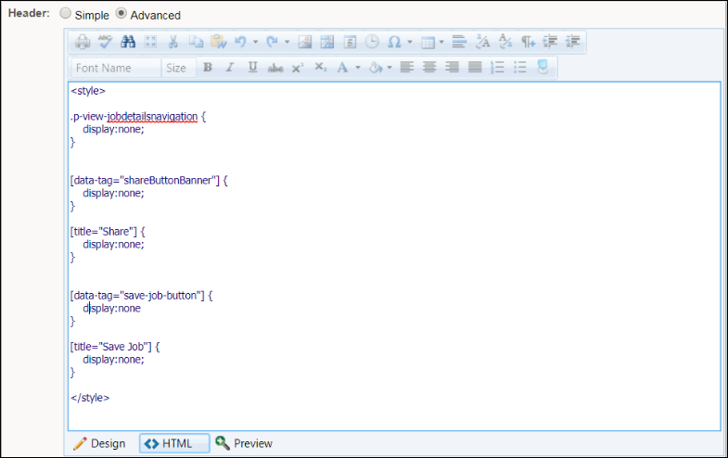
Hide “Back to Search” Link
.p-view-jobdetailsnavigation {
display:none;
}

Hide “Share” Button on Job Details Banner
[data-tag="shareButtonBanner"] {
display:none;
}

Hide “Share” Button at Bottom of Page
[title="Share"] {
display:none;
}

Hide “Email” Option on Share Button
[title="Email"] {
display:none;
}

Hide “LinkedIn” Option on Share Button
[title="LinkedIn"] {
display:none;
}

Hide “Facebook” Option on Share Button
[title="Facebook"] {
display:none;
}

Hide “Save” Button on Job Details Banner
[data-tag="save-job-button"] {
display:none
}

Hide “Save” Button at Bottom of Page
[title="Save Job"] {
display:none;
}
Non-Configurable Options
Mobile-friendly career sites have different configuration settings than standard career sites. The following options are not configured on mobile-friendly career sites:
- Allow Search Engines to Index Site
- Meta Page Title
- Meta Page Description
- Enable Mobile Site
- Mobile Image
- Mobile Color
- Allow Apply with LinkedIn
- Allow Connect with Facebook
- Referrals
- Apply as Guest - Note: The Apply as Guest feature is available for responsive career sites but does not have the ability to be enabled or disabled. It is always enabled. For information about how mobile-friendly applicants claim an account and the importance of configuring the Application Confirmation - As Guest email, see the Application - Apply as Guest topic in Online Help.
Widget Settings
Widgets cannot be added to mobile-friendly career sites. Instead, applicants search for jobs using the job/keyword and location search bar. Images are added using the banner image option and the text box options.
The following search options, which on standard career sites are configured on the Search Jobs Widget Settings pop-up, cannot be configured for mobile-friendly career sites:
- Naming the search page
- Search fields, such as Division, Compensation Type, Employment Type, etc.
- Custom search fields
- Allow advanced search
- Number of results to display (Note: Mobile-friendly career sites display an infinite number of results. As applicants scroll down, more search results appear.)
- Job alerts (Note: Job alerts are not available on mobile-friendly career sites.)
- Allow results sharing
- Results view - List or Table

Mobile-Friendly Career Site - Job Search
Mobile-friendly career sites have some different features than standard career sites, such as predictive searching through a search bar.
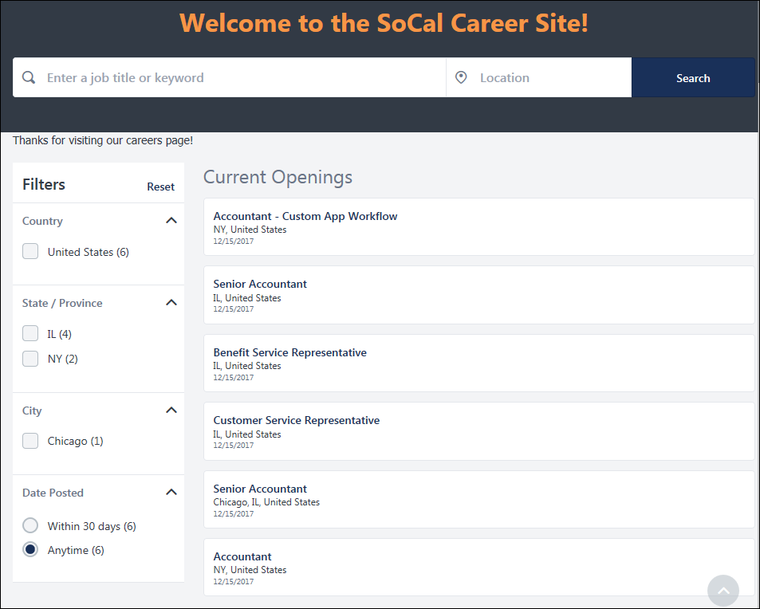
Sign In/Profile Bar
Applicants can sign in or out of the career site using the Sign In/Sign Out option at the top of the page.
The My Profile option lets applicants to access their My Profile page.
The Language drop-down lets applicants choose the language in which to display the career site. By default, when applicants visit a mobile-friendly career site, their language is detected so that the career site appears in the user's language.
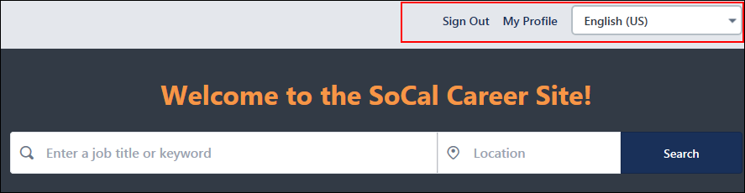
Note:The browser culture is referenced when loading the page. If the browser culture is not supported for the career site, the system identifies the closest match to your browser language and loads the page in that language. If the browser culture is supported or there is a matching language, the page is loaded in the career site's default language.
Job Search Bar
Predictive Keyword Search
Mobile-friendly career sites have a predictive search bar that enables applicants to find matching jobs from an easy to use search method. Applicants can simply enter a job title or keyword, and up to 10 matching items appear below. Clicking a predictive search result populates the search bar.
Location Search
Applicants can use the Location search bar to find jobs in a certain area. The search is predictive and shows location results below based on the applicant's search term. Clicking a predictive search result populates the search bar. Or, click Search to view matching jobs.
Searches for a specific address, postal code, or city are matched with results that are within 100 miles/160 kilometers of the location. Searches for a state/province or country will show all results within the state/province or country entered. The filters are updated to match the available jobs in the search results.
Custom Requisition Fields Search
If enabled by the administrator when configuring the career site, candidates can also look for jobs using the custom requisition field on the search bar. Only one field can be added by the administrator, and the field will appear between the keyword and location fields. Having a custom field filter in the search bar helps candidates find the most relevant filter quickly and start searching for jobs. This field will also be included on the left panel of the career site. When an option is selected in the main search, it will also be displayed on the left panel and vice versa. For filters that appear in the Filters section, each custom field appears as a separate filter. When a dropdown field supports multiple options, candidates will be able to select from check boxes, even though the field type is a drop-down.
The search pulls results based on the Display Job Title, REF, Keywords, and Job Description fields on the requisition.
Filters Section
The Filters section on the left-side of the page provides location filters for job searches. The locations in the filters are automatically configured based on the locations of the jobs that have been posted to the career site. The following filters may display:
- Distance (Note: This option only appears if searching for an address, city, or postal code.)
- Country
- State/Province
- City
- Date Posted
Applicants can check the box to the left of the filter to only view jobs in that location. This is a quick way to find jobs in the exact locations applicants are looking or by the date on which the job was posted. All applicants see the same filters.
Number of Jobs in Filters
Each filter displays the number of jobs in parentheses that match the filter. For example, if there are six jobs in the Ontario province, then (6) displays in parentheses after the province name.
View Filters on Mobile Devices
A Refine Search link appears when an applicant views the career site on a device with a small screen. Clicking the link shows a flyout with all of the filters. Each filter option shows the number of jobs available in that location.
Applicants can select their desired filters, and then click Apply to update to search results.
Job Alerts
Candidates can create job alerts on mobile-friendly career sites using the following search and filter functionality:
- Keywork
- Location
- Filters
To create job alerts, in the search bar, start typing the title of a job for which you want to create an alert. The Create an alert button appears in the upper right corner. Use the filters to narrow the search.
Once the alert is set, candidates receive an email containing matching jobs. The email contains a View job link for each matching job and a See all jobs link for more than 10 matching jobs.
Tip: Once the job alert is created, a confirmation message appears at the top of the screen. To manage job alerts, click the Click here to manage it link to go directly to the My Profile page, Application Status, My Alerts section to view, edit, or unsubscribe from these job alerts.
Note: Job alerts expire 365 days from their creation date. Once a job alert expires, it no longer displays and cannot be restored.
Current Openings
By default, all available jobs display when applicants access the job search page. Up to 25 results display on the search page.
The list updates when applicants use the filters to modify the job search criteria.
To apply for a job, applicants can click the name of the job. This opens the details page for the job.
Mobile-Friendly Career Site - Job Search
Mobile-friendly career sites have some different features than standard career sites, such as predictive searching through a search bar.
Sign In/Profile Bar
Applicants can sign in or out of the career site using the Sign In/Sign Out option at the top of the page.
The My Profile option lets applicants to access their My Profile page.
The Language drop-down lets applicants choose the language in which to display the career site. By default, when applicants visit a mobile-friendly career site, their language is detected so that the career site appears in the user's language.
Note:The browser culture is referenced when loading the page. If the browser culture is not supported for the career site, the system identifies the closest match to your browser language and loads the page in that language. If the browser culture is supported or there is a matching language, the page is loaded in the career site's default language.
Job Search Bar
Predictive Keyword Search
Mobile-friendly career sites have a predictive search bar that enables applicants to find matching jobs from an easy to use search method. Applicants can simply enter a job title or keyword, and up to 10 matching items appear below. Clicking a predictive search result populates the search bar.
Location Search
Applicants can use the Location search bar to find jobs in a certain area. The search is predictive and shows location results below based on the applicant's search term. Clicking a predictive search result populates the search bar. Or, click Search to view matching jobs.
Searches for a specific address, postal code, or city are matched with results that are within 100 miles/160 kilometers of the location. Searches for a state/province or country will show all results within the state/province or country entered. The filters are updated to match the available jobs in the search results.
Custom Requisition Fields Search
If enabled by the administrator when configuring the career site, candidates can also look for jobs using the custom requisition field on the search bar. Only one field can be added by the administrator, and the field will appear between the keyword and location fields. Having a custom field filter in the search bar helps candidates find the most relevant filter quickly and start searching for jobs. This field will also be included on the left panel of the career site. When an option is selected in the main search, it will also be displayed on the left panel and vice versa. For filters that appear in the Filters section, each custom field appears as a separate filter. When a dropdown field supports multiple options, candidates will be able to select from check boxes, even though the field type is a drop-down.
The search pulls results based on the Display Job Title, REF, Keywords, and Job Description fields on the requisition.
Filters Section
The Filters section on the left-side of the page provides location filters for job searches. The locations in the filters are automatically configured based on the locations of the jobs that have been posted to the career site. The following filters may display:
- Distance (Note: This option only appears if searching for an address, city, or postal code.)
- Country
- State/Province
- City
- Date Posted
Applicants can check the box to the left of the filter to only view jobs in that location. This is a quick way to find jobs in the exact locations applicants are looking or by the date on which the job was posted. All applicants see the same filters.
Number of Jobs in Filters
Each filter displays the number of jobs in parentheses that match the filter. For example, if there are six jobs in the Ontario province, then (6) displays in parentheses after the province name.
View Filters on Mobile Devices
A Refine Search link appears when an applicant views the career site on a device with a small screen. Clicking the link shows a flyout with all of the filters. Each filter option shows the number of jobs available in that location.
Applicants can select their desired filters, and then click Apply to update to search results.
Job Alerts
Candidates can create job alerts on mobile-friendly career sites using the following search and filter functionality:
- Keywork
- Location
- Filters
To create job alerts, in the search bar, start typing the title of a job for which you want to create an alert. The Create an alert button appears in the upper right corner. Use the filters to narrow the search.
Once the alert is set, candidates receive an email containing matching jobs. The email contains a View job link for each matching job and a See all jobs link for more than 10 matching jobs.
Tip: Once the job alert is created, a confirmation message appears at the top of the screen. To manage job alerts, click the Click here to manage it link to go directly to the My Profile page, Application Status, My Alerts section to view, edit, or unsubscribe from these job alerts.
Note: Job alerts expire 365 days from their creation date. Once a job alert expires, it no longer displays and cannot be restored.
Current Openings
By default, all available jobs display when applicants access the job search page. Up to 25 results display on the search page.
The list updates when applicants use the filters to modify the job search criteria.
To apply for a job, applicants can click the name of the job. This opens the details page for the job.
Mobile-Friendly Career Site - Job Details
From the details page for jobs on responsive (mobile-friendly) career sites, applicants can apply to the job, as well as share and save the job.
The top of the page displays the job title, location, and requisition number.
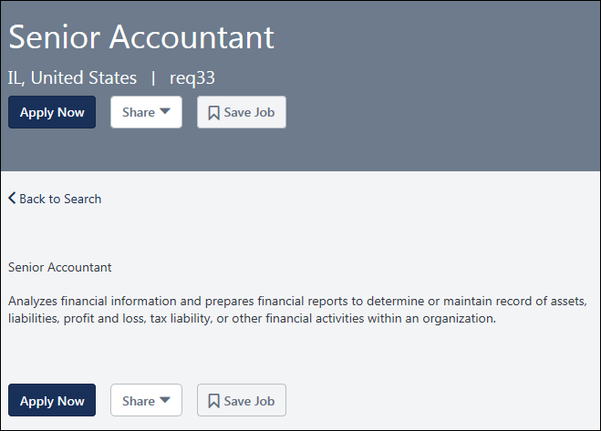
Apply Now
Click Apply Now to apply to the job. This opens the application for the job. See Mobile-Friendly Career Site - Application on page 54 for additional information.
Share Job
Applicants can share jobs on the career site via email, LinkedIn, and Facebook. However, the LinkedIn and Facebook sharing options may not appear if they have been hidden by the administrator.
Note: The source for applicants who apply to a job using a standard workflow via a shared job posting through a social network is either Referral-LinkedIn or Referral-Facebook. Mobile friendly workflows do not support the Referral-LinkedIn or Referral-Facebook sources at this time.
Email
To share via email, click Email from the Share drop-down. This opens an email window through your email provider and allows you to enter an email address and share the job.
A link to the job details page is included in the email.
Share on LinkedIn
To share on LinkedIn:
- Click LinkedIn in the Share drop-down. This opens a LinkedIn pop-up. The Share an update field will be checked by default
- Complete the following information:
  - Share an update - This option is checked by default. If you are entering an update in the text box, then this option needs to be checked so that the update will appear when you share the job.
  - Share Text Box - You can enter an update into the text box. The text will appear in your posting along with the shared job
  - Share With - This option lets you choose with whom you would like to share the job. Select either Public or Connections.
  - Twitter - Check the Twitter box to share the job on Twitter.
  - Post to groups - This option lets you post to your groups.
  - Send to individuals - This option lets you post to individuals.
- Click Share. This shares the job on LinkedIn to the recipients selected in the pop-up. The job title is preceded by the text "Now Hiring: " in the default language of the career site.
Note: The image that appears when sharing a job on LinkedIn is the image set in the Logo Image for Search Engines section of the Career Site Administration page. If the image or post is not appearing as expected, you can validate what is being sent to LinkedIn by pasting the URL of the job details page into LinkedIn's post inspector: https://www.linkedin.com/post-inspector/
Share on Facebook
To share on Facebook:
- Click Facebook in the Share drop-down. This opens the Share on Facebook pop-up.
- Complete the following information:-
  - Say something about this - You can enter a comment into the text box. The text will appear in your posting along with the shared job.
  - Share Options - Select an option from the drop-down in the bottom-right corner to choose with whom you would like to share the job.
- Click Share. This shares the job on Facebook to the recipients selected in the pop-up. A link to the job will be included in the posting, as well as any text you included. The job title is preceded by the text "Now Hiring: " in the default language of the career site.
Note: The Facebook option does not include an additional option to share on Twitter.
Note: The image that appears when sharing a job on Facebook is the image set in the Logo Image for Search Engines section of the career site administration page. If the image or post is not appearing as expected, you can validate what is being sent to Facebook by pasting the URL of the job details page into Facebook's Sharing Debugger: https://developers.facebook.com/tools/debug/
Save Job
To save the job opening to your list of saved jobs, click Save Job.
- If you are logged in with either LinkedIn or system credentials, the job is added to your list of saved jobs on the My Profile page. The Save Job button is then hidden.
- If you are not logged in, you are taken to the Sign In/Self Register page. Upon logging in or creating a new profile, you are taken back to the Job Details page from which you came. See Career Site - Sign In and Self Register for additional information.
- If the job is already in your list of saved jobs, then "Job Saved" displays.
Reapply to Job
On mobile-friendly career sites, applicants can reapply to a job for which they do not have an active application. The Re-Apply button displays on the Job Details page in place of the Apply Now button.
Note: The ability to re-apply is dependent on the configuration of the preference in General Preferences that enables internal and external applicants to re-apply after they have been dispositioned.See General Preferences (by Division).
Visibility of Apply, Share, Save Job Options
There are a few situations in which neither the job ad nor the Apply Now, Save Job, and Share options will be visible. In these cases, job seekers will see "This job is not available," and they will be able to return to the search page by clicking Back to Search.
These cases include:
- If Do not allow to apply is checked on the requisition
- If a requisition is not in Open or Open Pending Reapproval status
- If the requisition is not posted
- If the requisition's postings have not yet become effective
- If the requisition's postings have expired
Mobile-Friendly Career Site - Application
Applicants applying to jobs on responsive (mobile-friendly) career sites will experience some differences in the application process for mobile-friendly applications. The application may appear on a single page, which provides a simplified application process.
In addition, applicants can add attachments to their application, if enabled by the administrator, and save their progress.
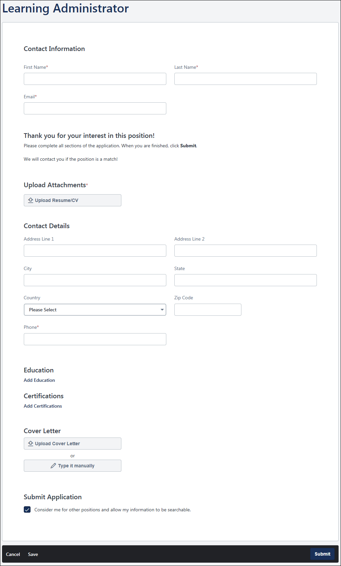
Add Attachments
Applicants completing a mobile-friendly application can add additional attachments to their application, if enabled when the requisition is configured. An "Additional Attachments" section displays on the Upload Attachments page and will let applicants know what types of attachments to upload.
The attachment may be required in order for the applicant to submit the application.
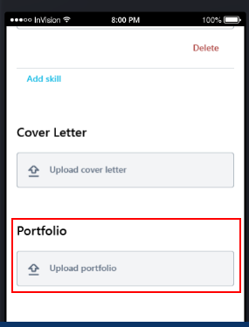
Attachment Specifications
- File Name Length - The maximum file name length is 50 characters.
- File Size - The maximum file size is 5MB.
- File Types - The accepted file types are doc, docx, pdf, txt, JPEG, GIF, BMP and PNG.
Save Application Progress
Applicants can save their progress on mobile-friendly applications by clicking Save at the bottom of the page. All progress is saved, including any attachments that have been uploaded. If an applicant attempts to leave the page, they are also prompted to save their progress.
When progress is saved and the applicant returns to the application, they are taken to the first page of the application.
Saved applications appear as In Progress on the applicant's My Profile page. Applicants can click Continue to continue working on the application. Once the application is submitted, it appears as Complete on their My Profile page.
Use Case
- Steve is on the bus and begins an application workflow on his mobile device. He gets to his stop before finishing his application.
- Steve clicks Save on the footer of the application workflow.
- Steve is a new user, so he is prompted to create an account. Steve creates an account and is then taken to his profile. He closes the career site.
- Steve can finish his application workflow by logging back into his profile.
Log-In/Create Account
If an applicant is not logged in to the career site when they attempt to save their application progress, they are prompted to log in before the application can be saved.
If an applicant does not yet have an account on the career site, then when they attempt to save their application progress, they are prompted to create an account.
The applicant's contact information will populate automatically on the log-in/create account page.
Thank You Page
When an applicant who does not have an account in the career site submits their mobile-friendly application, they are taken to the Thank You page. They can click Create Profile to create an account.
The link does not display for users who applied with LinkedIn or Seek.
Delete In-Progress Application
Applicants can delete a mobile-friendly application that is in an In Progress status. They can click Delete from the options drop-down for the application on their My Profile page.
Requisition Closes/Position Filled
If the requisition closes or the position is filled before the applicant finishes the application, then the status displays as In Progress and Unavailable.

See Also
For detailed information about other areas of the application, such as compliance questions, see the following topics in Online Help:
- Compliance Questions
- Notes
- Prescreening Questions
- Upload Attachments

Frequently Asked Questions for Mobile-Friendly Candidate Experience
The following frequently asked questions (FAQs) can help provide answers to the questions you may have about the mobile-friendly configurations and what the candidate experience will be like for career sites and application workflows.
General and Enablement
What does mobile-friendly mean?
Mobile-friendly means that applicants will get the same experience when viewing your career site on a mobile device or on a desktop. Mobile-friendly career sites can be accessed using any device.
Mobile-friendly also means that the career site is responsive. The page, images, and videos scale to fit the width of the device’s screen. Note: For banners, a high resolution image is recommended. The image height should be at least 150px, and the width should be wider than the height. The image cannot exceed 5 MB.
A standard career site has more limited mobile capabilities, and applicants will not be able to complete some parts of the application when using a mobile device.
What career site pages can be made mobile-friendly?
The following career site pages can be made mobile-friendly:
- Connect With Us - Note: Resume parsing is not mobile-friendly in Connect With Us. For this reason, it is recommended that you disable resume parsing for Connect With Us on mobile-friendly career sites. This will ensure a smoother experience for job-seekers. Resume parsing can be disabled on the Career Site Management > Connect With Us page for each individual career site.
- Create Profile
- Job Details
- My Profile - Note: Pages that are linked from the My Profile page, such as My Tasks, are not mobile-friendly.
- Sign-In
Posting Speed
How long does it take to post a job to a mobile-friendly career site?
The posting can take up to 20 minutes to appear.
When you convert a career site to become mobile-friendly, Cornerstone re-indexes your portal so that all jobs are searchable. During this time, jobs will not appear on your career site. The re-indexing completion time varies by portal size, so we recommend converting a career site to become mobile-friendly later in the day and week to minimize the impact on candidates.
Making Existing Career Sites Mobile-Friendly
How is my application workflow impacted when I make a career site mobile-friendly?
Applicants are automatically directed to mobile-friendly or standard applications based on the workflow contents. If the workflow is comprised of mobile-friendly components, applicants will see the mobile-friendly application. Otherwise, they will see a standard application.
I created a mobile-friendly career site. Do I have to create mobile-friendly application workflows, too?
No. A mobile-friendly career site can:
- Link to a non-mobile-friendly application workflow.
- Link to a mobile-friendly application workflow.
If a mobile-friendly qualifying workflow is published to a Standard career site, the career site will display in the Standard format, but the application workflow will automatically become mobile-friendly. A qualifying application workflow is one that does not contain Forms, Training, or Assessment action items.
Job Search Bar
Can I customize the search results on the career site job search page?
No. All jobs posted to a mobile-friendly career site will be available in the search results under Current Openings on the job search page and can be filtered through the search bar features or filters on the left panel of the page.
Can I add additional search fields to the job search?
Yes. You may add one drop-down custom requisition field to the main search bar. The field can be a single or multi-select drop-down and can be configured in your career site settings.
How does the location search work?
The location search in the search bar on the job search page uses Google Places API to provide a similar experience as Google Maps.
What happens when an applicant enters an address, city, or ZIP code into the search bar?
A specific latitude and longitude is received and is used to perform a radius search. All jobs 100 miles of the location value display by default. Applicants can choose to decrease the radius.
What happens when an applicant enters a state, province, or country into the search bar?
The search will interpret the entry correctly and return results for jobs that match the search terms based on the address fields configured for the requisition. All jobs with a match will appear in the results.
Can applicants filter job results?
Yes, applicants can filter by distance (if searching for an address, city, or postal code), country, state/province, city, date posted, and any additional custom requisition fields added to the career site.
Which jobs display by default on the job search page?
By default, all jobs that have been posted display.
Can administrators determine which fields display on the search results, such as Job Title, Employment Type, etc.?
No. By default, the search results will show job title, location, and posting date.
Why isn't the map appearing on the search page?
The map feature is not yet supported on mobile-friendly career sites.
Job Alerts
Can applicants create job alerts on the new mobile-friendly career sites?
Yes.To create job alerts, in the search bar, start typing the title of a job for which you want to create an alert. The Create an alert button appears in the upper right corner. Use the filters to narrow the search.
Once the alert is set, candidates receive an email containing matching jobs. The email contains a View job link for each matching job and a See all jobs link for more than 10 matching jobs.
Application Workflows
What are mobile-friendly application workflow components? What makes a workflow qualify or not qualify to become mobile-friendly?
If a workflow includes any of the following action items, it qualifies as being mobile-friendly:
- Compliance Questions
- Custom Integrations
- Disclaimers
- Notes
- Prescreening Questions
- Thank You
- Upload Attachments - Note: This includes resume and custom additional attachments.
The action items are not supported in mobile-friendly workflows:
- Assessments
- Competency Assessments
- External Assessments - Note: This refers to SHL assessments.
- Forms (Learning module)
- Training (Learning module)
If a workflow contains any non-supported action items, the workflow will remain in the Standard experience and will not be made mobile-friendly automatically.
Apply As Guest
Will applicants need to create an account before applying to a mobile-friendly workflow?
No. Any time an applicant applies to a position through a mobile-friendly workflow, they will be applying as a guest. This will increase your candidate conversion rate.
Up to 40% of candidates drop off in the candidate experience when forced to create an account before applying. Candidates will be able to create a profile from the Thank You page after applying successfully or by following a link provided in the "Application Confirmation - As Guest" email, provided the email is configured and active in Email Administration.
Will candidates who apply as a guest receive an email letting them know their application was successfully submitted?
Yes, provided that you enable the "Application Confirmation - As Guest" email in Email Administration. This email will be sent to an applicant when they apply as a guest. It is recommended that you also use this email as an opportunity to explain the benefits of creating an account.
Saving Application Progress
Can someone who has not logged in or created an account save their progress in the application workflow?
No. If an applicant is not logged in and clicks Save, they are prompted to create an account or log in.
When an applicant returns to their application after saving their progress, where do they begin?
They are taken to the top of the page on which there is an unanswered question.
Resume Parsing
What are my options for resume parsing on mobile-friendly application workflows?
- Full Resume Parsing - Selecting this option displays all resume sections to applicants (i.e. Work Experience). Once the applicant uploads a resume file, the content from the file will be parsed (populated) on the application workflow in order to help the applicant fill in the resume sections.
- Contact Data Parsing Only - Selecting this option does not display resume sections to applicants. Once the applicant uploads a resume file, the content from the file will be parsed (populated) only on the Contact Details section of the application workflow.
- Disable Resume Parsing - Selecting this option does not display resume sections to applicants. Therefore, once the applicant uploads a resume file, that file will be part of their application but will not populate anything on the application workflow. Note: Resumes that are uploaded without parsing enabled are still searchable on the Quick Search tab in Candidate Search (not on the Advanced Search tab).
Usability Tip: For administrators that want resume sections to be shown on the application workflow but do not want resume files to be parsed, they can select the Full Resume Parsing option on the application workflow configuration and disable the following corp setting, "Allow Resume Parsing." This way, parsing will not happen across all requisitions, but the resume sections will still be displayed so that they can be filled in by applicants.

Career Site - Application Experience
The application experience is where applicants complete their application for open jobs. This page is accessed when a user chooses to apply for a job. It is used to display application content as well as display their progress towards application completion.
The order and content of the screens that display in the application experience is controlled by the application workflow for the position.
Application Sections
The following are the various types of content that can be included in the application experience:
- Competency Assessments
- Compliance Questions
- Forms
- Integrations
- Learning Object Tests
- Notes
- Pre-screening Questions
- Submit Application
- Training Courses
- Upload Attachments
Header
The header appears on every Career Site page for job seekers. The appearance of the page header is configured using the Custom Page Builder. See Create Career Site - Settings for additional information.
Log-In/Profile Bar
The Log-in/Profile Bar appears on every Career Site page for job seekers. The available options depend on whether the user is logged in to the system. See User View: Career Site -Log-in/Profile Bar for additional information.
Below the header and Log-in/Profile Bar, the Job Title and Application Status Bar are displayed.
- Job Title - This displays the title of the job to which the applicant is applying.
- Application Status Bar - This is used to give the applicant a visual representation of the steps involved in the application as well as their completion progress through the application.
  - The status bar is divided into sections as defined in the application workflow for the selected job requisition, including each section title.
  - The width of each section is proportional to the percentage associated with the section within the application workflow. For example, if a section is assigned a percentage of 50%, then that section will span 50% of the application status bar.
  - The section that the user is currently working on is partially highlighted with yellow to indicate to the user where they are in the application process.
  - Completed sections are completely highlighted with green to indicate the section is complete.
At the bottom of the page, the following action buttons may be available, depending on the stage in the application process:
- Back - Click to save any progress made on the current page and return to the previous page in the application process. This option is not available on the first page of the application.
- Save/Return Later - Click to save progress on all application pages and navigate the user to the My Profile page. The saved application is added to the user's Application Status section on the My Profile page.
- Cancel - Click to cancel the application entirely and delete all progress. A confirmation pop-up appears to confirm the action.
- Next - Click to validate all information on the page and proceed to the next step in the application process. This option is not available on the last page of the application.
Localization
When viewing application workflows that include translated values, if a translation is available for the applicant's preferred language, then the field value will display in that language. This includes all fields that are available for translation. If the translated values are not available in the applicant's preferred language, then the fields display in the default language of the recruiter who created the specific field within the application workflow.
Recruiting Agency Submissions
For applicants that are submitted by a recruiting agency, the content from the application that the recruiting agency submitted does not display on the application that is accessed from the career site, with the following exceptions:
- If the application workflow included a form, then the content entered on the form is transferred to the career site application experience.
- If a resume was included, then the resume is transferred to the career site application experience.
Applying to Multiple Jobs in a Single Application
For applicants who are applying to one or more Related Requisitions (Apply to Multiple Jobs), the application workflow is the same for all of the related requisitions. The applicant fills out one application, and the completed application applies to all of the Related Requisitions (Apply to Multiple Jobs) to which the applicant applies in association to the parent.
Save/Return Later Button
The Save/Return Later button does not display on the application for applicants who are applying to two or more Related Requisitions (Apply to Multiple Jobs). The button does display for applicants who are only applying to one Related Requisitions (Apply to Multiple Jobs).
Cancel Button
For applicants who are applying to two or more Related Requisitions (Apply to Multiple Jobs), when clicking the Cancel button to cancel completing the application, a Cancel Application pop-up displays. The pop-up indicates that canceling the application deletes all progress for the application. The application is cancelled for all of the related requisitions to which the applicant selected to apply.
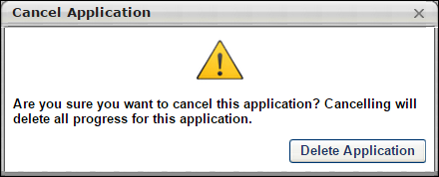
Leaving the Application
For applicants who are applying to two or more Related Requisitions (Apply to Multiple Jobs), the application progress is not saved if the applicant leaves the application without submitting it. A warning message appears on the page, indicating that the application will not be saved unless it is submitted.

Application - Add Note
The Add Note action item enables organizations to display an HTML note within the application process. This note could be a message about the organization, a message about the position, or a general note about the application.
Any instructions that are associated with the note action item display at the top of the window, and the content of the note displays below the instructions.
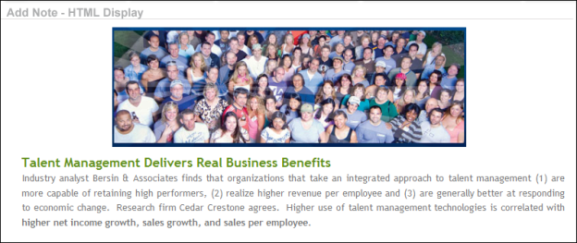

Application - Apply as Guest
Administrators can configure career sites to allow applicants to apply as a guest. Applicants will not be required to create a profile prior to applying or log in to their existing profile, if they have one on the career site.
When a career site is configured for applicants to apply as a guest, the applicant experience changes in the following ways:
- New applicant does not need to create a profile prior to applying
- Existing applicant does not need to log in to their profile prior to applying
- When a guest applicant clicks Apply Now, the first page in the application process is a Contact Information page, rather than Step 1 of the application
- The Submit Application step includes optional password fields that will create a profile for the applicant if a password is entered
- Applicants cannot save their application and return later to complete the application
Note: Internal applicants cannot apply as a guest. If they access the career site without logging in and click Apply Now for a job, the Contact Information page will open. However, when they click Next, an error message displays, indicating that they cannot apply as a guest and must log in to apply to the job.
Contact Information Page
When an applicant applies as a guest, the first page in the application process is a Contact Information page, rather than Step 1 of the application. The Contact Information page opens when the applicant clicks Apply Now from the job details page.
The Contact Information page allows applicants to upload a resume and provide their basic contact details. This information is parsed to the resume within the application. Applicants will have the option within the application workflow to remove the resume and replace it with an different resume.
Note: If the application workflow requires that applicants submit a resume, then the Resume field will be required on the Contact Information page.
Note: The Resume field does not appear for application workflows that do not include an Upload Resume step.
Note: If the Upload Attachments step is the first step in the application workflow (following an Instructions step), then applicants are not required to enter their name and email address on the Contact Information page prior to starting the application.
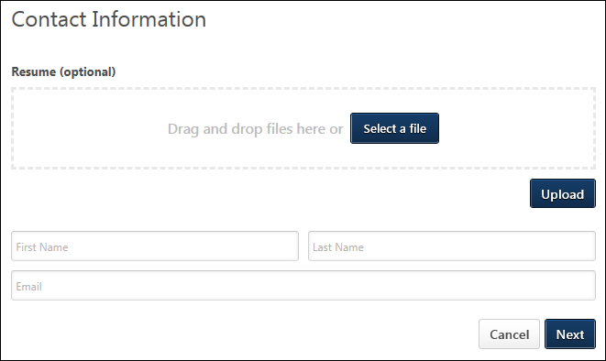
Applicants complete the following fields on the Contact Information page:
- Resume - Drag and drop the resume or click Select a file to select a resume from your files. Then, click Upload to upload the resume to the job application.
- First Name - Enter your first name, up to 200 characters.
- Last Name - Enter your last name, up to 200 characters.
- Email - Enter your email address, up to 120 characters.
Click Next to open the application for the job.
Note: If the browser is closed at any time during the application process but before the application is submitted, all application data is lost.
Existing Applicants
For existing applicants who have a profile on the career site but apply to a job as a guest, their previously uploaded resume (if applicable) is not available to select. Existing applicants will need to upload a resume if a resume is required or if they would like to opt to include a resume.
The contact information and parsed resume fields entered by the applicant as part of this application will not be saved. This behavior is intended to prevent a malicious person from applying as a guest to a job, using an existing applicant's email address, thereby updating the applicant's contact information and resume details to their own and hijacking the applicant's profile.
For applicants who have already applied to the job, they cannot apply again as a guest.
Invited-to-Apply Applicants
Applicants who are invited by a recruiting agency to apply to a job can apply as a guest. The applicant is not required to create a profile on the career site in order to apply.
Manually Added Applicants
Applicants who are manually added to a job and then invited to apply can apply as a guest. The applicant is not required to create a profile on the career site in order to apply.
Reapplying to Same Job
Applicants who apply to a job as a guest can reapply to the same job, provided that the General Preferences are configured to allow applicants to reapply.
Note: If the applicant provided a password when applying to a different job as a guest, then they will need to log in to the career site before they can apply to the job.
Applying to Multiple Jobs
Applicants who apply to a job as a guest can apply to multiple child requisitions at the same time.
Submit Application Step
Applicants who apply as a guest have an opportunity on the Submit Application step to create a profile. They can enter a password in the Password and Confirm password fields, which will create a profile for the applicant.
Once the applicant clicks Submit Application, they are directed to the My Profile page in the career site. If they do not enter a password, then they are directed to the Search Jobs page.
Note: The password option does not display for applicants who have previously created a password for an application or previously submitted any application. The password option will display for applicants who have previously applied to a job as a guest but did not provide a password upon submitting their application.
Note: The password instructions are not editable.
Note: When the applicant logs in to the career site again, their user name will be their email address.
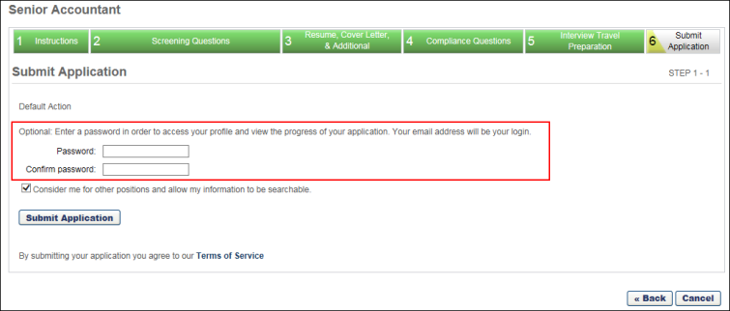
System Email for Submitting the Application
Applicants will receive the Application Confirmation - As Guest email when they submit an application through the Apply as Guest feature. However, the email must be configured and active in Email Administration in order for the system to send the email. When the email is configured and active, all mobile friendly applicants will receive the email when they have successfully applied to a requisition without having created an account.
When configuring the email, tags can be added to customize and brand the experience. Be sure to include the PASSWORD.RESET.URL tag so that applicants can define a password on the career site to create an account. See Email Triggers for more information about configuring this email.
How Applicants Claim their Account on the Career Site
When an applicant who has applied as a guest returns to the company website for the first time to check the status of their application (take an assessment, schedule an interview, etc.) they have two options:
- Option 1 - Create an account. Because they applied as a guest, most likely they will create a new account with the same email from their application because they have not done this yet. When they create an account, their previous application is automatically connected to the newly claimed account. Their profile will display any previous applications tied to this email address.
- Option 2 - Go through the forgot/create password workflow. If a user remembers that they applied as a guest but did not create a password, they can trigger the reset password workflow. They can access this workflow from the Application Confirmation – As Guest email, provided that the PASSWORD.RESET.URL tag is included in the email. Or, they can go to the career site, select the option to create an account, and then select the forgot password option. This also allows applicants to create a new password and log into the career site, where they can see all previous applications.
Offer Letters/Assessments
All emails for offer letters and assessments will remain the same. Applicants will receive anything configured in Email Administration that pertains to them based on actions that trigger the emails. If this is the first time they are accessing their profile, they can create an account with the same email they used to apply, and their application with all tasks will be accessible. They can also go through the reset password workflow as mentioned in Option 2 above.
Cancel
Applicants who apply as a guest can click Cancel on the application workflow to cancel applying to the job. Their data is not saved to the system.
Applicant Source Value
For applicants who apply as a guest, the applicant source that will appear in the Applicant Tracking System is the source from which they applied. For example, if the guest applied from a career site or job board, then the source is the name of the career site or job board.

Application - Apply with LinkedIn
For portals that have enabled the Apply with LinkedIn (with Apply Starters) integration, applicants can apply to the job using the Apply with LinkedIn option the Contact Information page in the application.
Once the applicant clicks Apply with LinkedIn button:
- A confirmation pop-up opens, asking the applicant to confirm that they would like to apply using LinkedIn.
- Click OK. Or, click Cancel to cancel applying with LinkedIn.
- The applicant's information from their LinkedIn profile is populated automatically. This includes contact information and resume details.
- Applicants can review and revise their pre-populated information.
When the Apply with LinkedIn application data is loaded from LinkedIn successfully, a notification appears to let the applicant know that the data fields updated successfully.
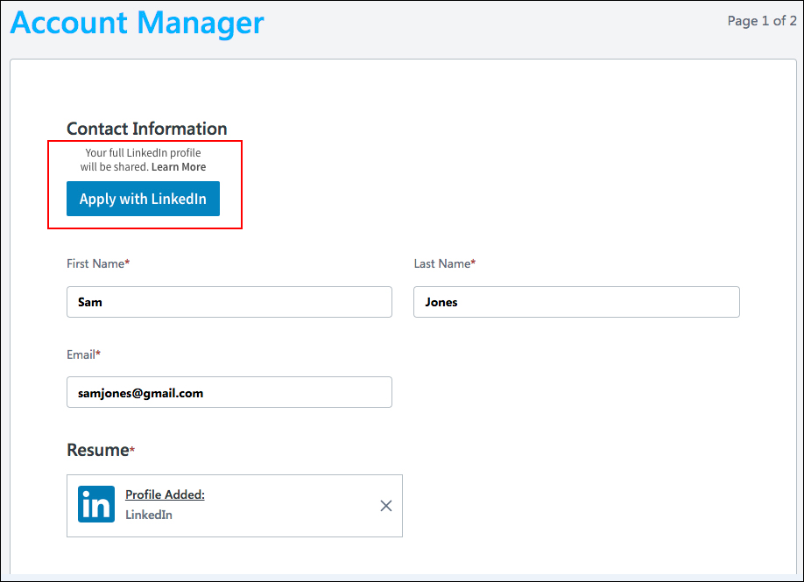

Application - Competency Assessment
Competency assessment action items enable organizations to have applicants complete a self competency assessment during the application process. This information enables organizations to immediately gauge an applicant's competencies prior to advancing the applicant to the next applicant status.
Any instructions that are associated with the assessment action item display at the top of the window, and the content of the assessment displays below the instructions. However, any instructions that are built into the competency assessment are bypassed within the application.
The assessment is contained entirely within the application window.
As long as the competency assessment is complete, the applicant is always able to proceed to the next action item in the application, regardless of their assessment rating.
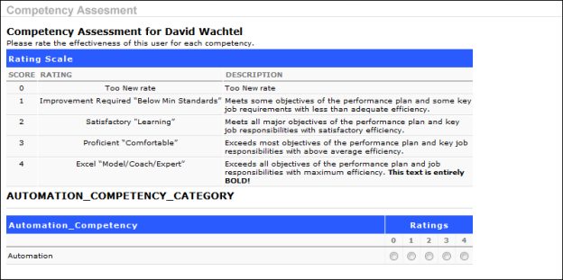

Application - Compliance Questions
Organizations in the United States are required to report to the federal government Equal Employment Opportunity (EEO) information such as gender and ethnicity. To help collect this information, many organizations allow the job applicant to enter the information when applying for a job. These questions can be configured by the administrator to be required for job applicants.
Any instructions that are associated with the questions display immediately before the question.
For portals with multiple languages enabled, compliance questions and responses display in the Compliance Questions tab of the application in the applicant's browser language. If the applicant's language is not defined for the questions and responses, then they display in the question's default language.
Note: All Equal Employment Opportunity compliance questions in mobile-friendly application workflows have labels that are accessible by a screen reader.
Note: The questions that display in the Compliance Questions section on the application are dependent upon the settings in Compliance Enablement Preferences for the requisition's Location OU.
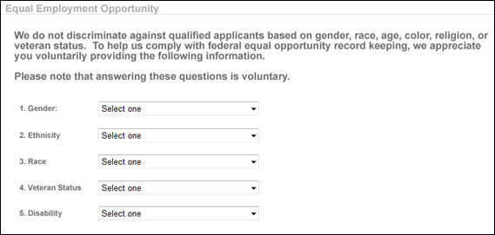
The following are the possible questions included in the Compliance Questions action item and their predefined options:
- Disability
  - I have a disability and would like to be considered under the affirmative action program.
  - I do not have a disability or would not like to be considered under the affirmative action program.
  - Decline to Specify.
- Ethnicity:
  - Hispanic or Latino
  - Other
  - Decline to specify
- Gender:
  - Female
  - Male
  - Decline to specify
- Race: (Note: This question does not appear unless "Other" is selected for Ethnicity. If a response other than "Other" is selected for Ethnicity, this question is not available.)
  - American Native or Alaska Native
  - Asian
  - Black or African American
  - Native Hawaiian or Other Pacific Islander
  - White
  - Two or more races
  - Decline to specify
- Veteran Status
  - Part 60-250 - This option is selected by default. The following values are available to select:
    - I am a veteran of the Vietnam era.
    - I am a special disabled veteran.
    - I am a recently separated veteran.
    - I am an other protected veteran.
    - I am not a veteran.
    - Decline to Specify.
  - Part 60-300 - The following values are available to select:
    - I am a disabled veteran.
    - I am a recently separated veteran.
    - I am an other protected veteran.
    - I am an Armed Forces service medal veteran.
    - I am not a veteran.
    - Decline to Specify.
- Voluntary Self-Identification of Disability - This question allows applicants to voluntarily self-identify that they have a disability. The full text for the question will display as per section 503 of OFCCP. When this question is added to the Compliance Questions section in the application workflow, the question always displays as the first compliance question for applicants.
If there are multiple compliance questions in the Compliance Questions section, then a Next button appears directly at the bottom of the "Voluntary Self-Identification of Disability" question. Applicants click Next to move to the next question. If there are no additional compliance questions, then applicants can click the Next button that displays at the bottom of the application to the right of the Cancel button.
- Custom Questions - If custom questions are configured and enabled for the job requisition, then the questions display in the Compliance Questions step.
Each question may or may not be required, depending on the settings for the question as defined by the administrator in Compliance Enablement Preferences.
Note: The Veteran Status options relate to disabled veterans, veterans of the Vietnam Era, recently separated veterans, other protected veterans, and armed forces service medal veterans.
Note: The instructions at the top of this screenshot are not included in the action item by default. Instructions are configured by the administrator in the application workflow template. See Create Application Workflow Template for additional information.

Application - Forms
Form action items enable organizations to present a questionnaire to the applicant, or a form can be used as an alternative to a resume parser by allowing applicants to complete application fields.
Any instructions that are associated with the form action item display at the top of the window, and the content of the form displays below the instructions. However, any instructions that are built into the form are bypassed within the application.
A user can only have one version of responses to a specific form. So, if a user is asked to complete the same form twice, the form is initially populated with the user's initial set of responses.
Any "userfield" type questions that are included in a form are displayed as read-only.
For recruiting agency submissions, if the application workflow included a form, then the content entered on the form is transferred to the form on the application experience.
As long as the form is complete, the applicant is always able to proceed to the next action item in the application, regardless of responses.
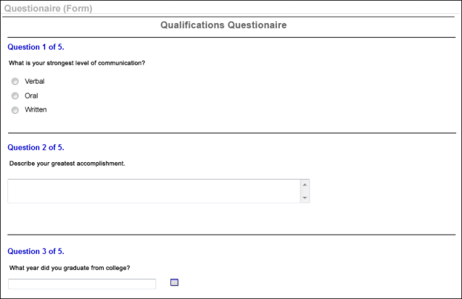

Application - Integrations
When the application workflow for a job requisition includes a custom integration action item, the step displays in the workflow with a Launch button that enables the applicant to launch the action item. The applicant is directed to the third party integration partner's application to complete the step.
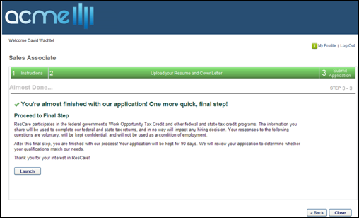
Contact Information
For mobile-friendly candidate experience applicants who are not logged in to the career site, the Contact Information section cannot be modified once the applicant launches the integration.
Note: Contact information is entered automatically for applicants who are logged in to the career site.
Save and Continue Later Button
If the application workflow is configured with integration or Note steps after the Submit Application step, then the Save and Continue Later button is not available on the integration and Note steps.
Cancel Application Button
If the application workflow is configured with integration or Note steps after the Submit Application step, then the Cancel Application button is not available on the integration and Note steps.
Navigating to Previous Application Steps
If the application workflow is configured with integration or Note steps after the Submit Application step, then when the applicant clicks Submit on the Submit Application step, the applicant cannot navigate back to previous steps in the workflow.
Next/Close Button
The last step of an application workflow displays a Close button. Clicking Close closes the application, with all steps completed.
Note: If the last step of the application is a required integration step, then a Close button does not appear so that the applicant must complete the step in order to complete the application.
Required Integration Steps
If an integration step is required to be completed, then the applicant must complete the step in order to move to the next step in the workflow.
Best Practice: If an integration step is required, then it is a best practice to indicate this in the Instructions field when configuring the step in the application workflow.

Application - Pre-Screening Questions
Pre-screening questions are commonly used to prescreen and remove applicants who do not meet the minimum requirements of a job. If an applicant completing the application process answers at least one of the questions incorrectly, then the system excludes that person from the list of submissions for the recruiter to review. A user who answers the pre-screening question wrong is not prevented from completing the application process. The system may be configured to send an email to the applicant after their submission to inform them they are not right for the job.
Some questions may have been configured to have one or more follow-up questions. The follow-up questions will be required or optional for the candidate, depending on how the question was configured. See Application Workflow - Prescreen Questions. Availability Note: The ability to create branched prescreening questions is only available for portals that have self-enabled the Mobile-Friendly Candidate Experienceself-enabled the Mobile-Friendly Candidate Experience. Creating branched questions will be available in Stage portals with the 6 March 2019 Stage release. This functionality will be available in Production portals with the 22 March 2019 patch release.
Note to Administrators and Recruiters: When an applicant fails the pre-screening, you might decide that you would still like to keep the applicant in consideration for the job. You can do this by manually changing the applicant's status on the Manage Applicants page or the Applicant Profile page.
Section Title
For the pre-screening questions action item, the action item title is ignored. The section title for the section that contains the action item is used.
Questions
Each question functions as its own test so that elimination questions can be mixed with regular questions. Once the applicant advances to the next action item, the pre-screening questions become read-only and cannot be modified.
The applicant must complete all questions to advance to the next action item.
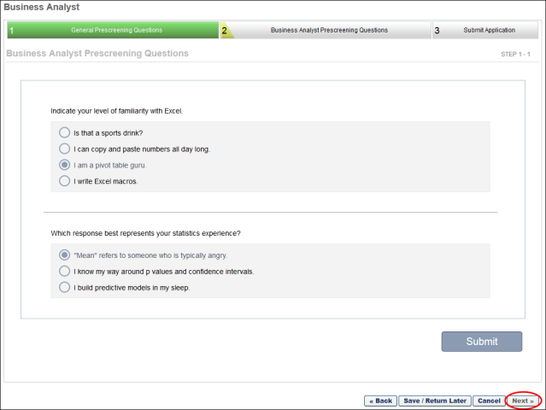
Branched (Follow-Up) Questions
Branched questions appear on the application workflow by starting with the parent question. If an applicant's response triggers the branch of a question, then the next question will appear below.
If any child questions of a branched question are marked as required and they appear for the candidate, then they must be answered before the candidate can move forward.
If a candidate changes their answer to the parent question that has child questions, then their answers to the child questions are lost.
Free-Form Essay Questions
Free form essay questions may be included in the application. Free form questions allow applicants to type their response into a response field, rather than select a correct or incorrect answer. These questions are always optional and appear on a single page in the Pre-Screening Questions step of the application workflow, whether there are multiple free form questions or only one. The character limit for completing the question is 23,000.
Screen Out Questions
One or more questions may be configured by the administrator to screen out applicants who do not answer the question correctly or who provide a response that does not meet the qualifications of the position. If the administrator has configured a question with the screen out option enabled and the applicant does not answer the question correctly, then the applicant's status automatically changes to Closed, and the applicant cannot continue in the application process for the job requisition. Note: Free form questions are not used to screen out applicants. Responding to this type of question does not impact the applicant's ability to move forward in the application process.
Image File Attachments
An image file may be included as part of the question. Applicants can view the image when responding to the question. The following file types may be attached:
- .bmp
- .gif
- .jpg
- .png
Submit
Click Submit to submit to move to the next step in the application workflow. The Next button will be grayed out and not selectable. Note: The applicant can still click Save and Return Later to complete the application at a later time.
Back
Applicants can click Back to return to the previous page in the Pre-Screening Questions section, which allows the applicant to change the answers to questions on previous pages. When using the Back button, the Submit button changes to Resubmit so that applicants can submit their updated responses.

Application - Submit Application
The Submit Application action item enables applicants to submit their finalized application. This action item is required for all application workflows.
Any instructions that are associated with the action item display at the top of the window, and the content of the action item displays below the instructions.
For information about the Submit Application step when the Apply as Guest feature is enabled for the career site, see the Application - Apply as Guest topic in Online Help. This topic also provides considerations for mobile-friendly applications.
Consider Me for Other Positions
Users can select this option to allow organizations to consider them for all open positions within the organization. This option overrides the value that is currently set on the Applicant Profile or on the My Account page in the career site.
Submit Application
Users click Submit Application to apply to the job. As long as the user does not fail the pre-screening questions, the user then appears on Manage Candidates with a status of New Submission.
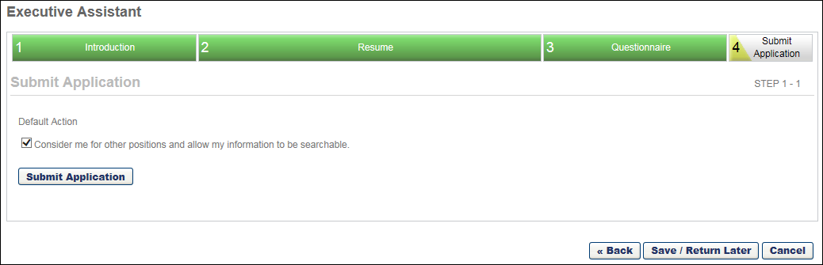

Application - Test Learning Objects
Test learning objects allow organizations to administer a test to the applicants during the application process.
The test is contained entirely within the application window, including the test disclaimer, test content, test review, and test results.
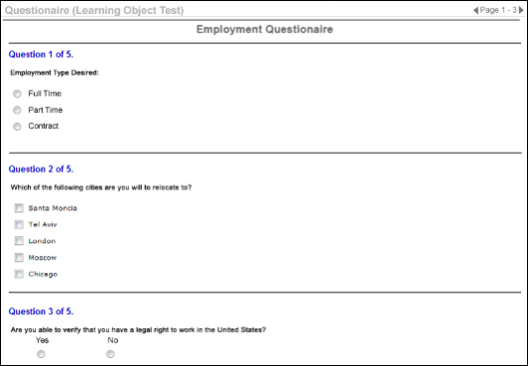
Instructions
Any instructions that are associated with the test action item display at the top of the window, and the content of the test displays below the instructions.
Time Limit
If the test has a time limit and the applicant exceeds the test time limit, they are notified and they are able to proceed to the next step in the application process.
Who Can Take/Approvals
Tests can be taken by any user. The Learning Management System (LMS) approvals and availability are ignored. Also, as long as the test is complete, the applicant is always able to proceed to the next action item in the application, regardless of their test score.
Screening Out Applicants
The test may be configured by the administrator to screen out applicants who do not meet the passing threshold for the test. If the administrator has configured the test with the screen out option enabled and the applicant does not meet the passing threshold for the test, then the applicant's status automatically changes to Closed, and the applicant cannot continue in the application process for the job requisition. See Add Training for additional information.

Application - Training Courses
Training courses allow organizations to deliver training to applicants during the application process. These training courses may be then followed by a test learning object to gauge the learning received from the training.
Any instructions that are associated with the training course action item display at the top of the window and the training course details and Launch button displays below the instructions.
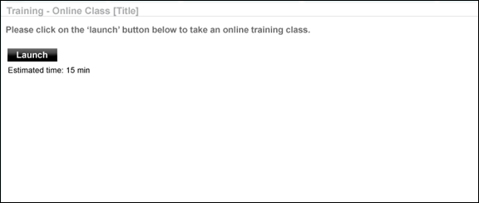

Application - Upload Attachments
The Upload Attachments action item enables administrators to add the ability for job applicants to upload their resume and other attachments. Job applicants can upload their resume to the application and then edit the fields that it populates via the resume parser.
The Upload Attachments action item is separated into two pages.
- Upload Page - This page enables applicants to upload their resume or other attachments. See Upload Attachments - Upload Page for additional information.
- Review Page - This page enables applicants to review and edit their resume information prior to continuing with their application. See Upload Attachments - Review Page for additional information.
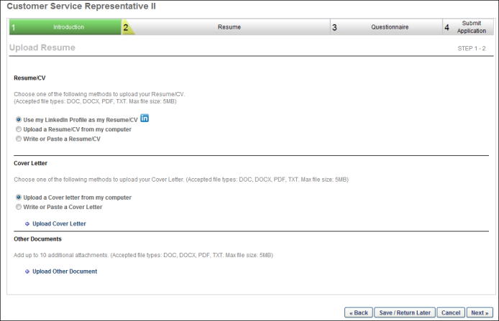

Indirect Organizational Unit for External Applicants
External applicants are dynamically assigned an indirect Division, Position, and/or Location organizational unit (OU) upon applying to a job requisition. The OU assignment is inherited from OU values defined for the requisition. Associating applicants with specific OUs enables standard system settings, such as permission constraints and availability, to be applied to the applicant.
The indirect OU designation also allows external candidates to now be included in talent pools created by administrators and managers with OU constraints placed on the Talent Pools - Manage permission. Previously, external candidates could not be included in talent pools because they were not associated to an OU.
Use Case 1 - Regulatory Requirements
An organization is required by law to segment job applicants by region. By dynamically assigning applicants an indirect OU designation, applicants who apply for jobs in one region are visible or available for consideration in another region.
Use Case 2 - Search Candidates
Janey applies to three jobs at Acme Co. in Texas: Engineering Manager in Dallas, Mechanical Engineer in Austin, and Pipeline Engineer in Houston. Upon applying, she inherits the following indirect OUs based on the job requisition's OU settings:
- Location Dallas
- Division Mechanical Engineering
- Position Pipeline Engineer
Acme recruiters who have the Recruiting: Search Candidates permission use the Search Candidates feature often to search for candidates for their job requisitions. Access to Janey is available to the following recruiters:
Recruiter Name | Organizational Unit | Permission Constraint | Is Janey visible in Search Candidates?
Nick | Location Dallas | Constrained to Location Dallas | Yes
Joe | Division Mechanical Engineering | Constrained to Division Mechanical Engineering | Yes
Recruiting Administrator | N/A | No constraints | Yes
Theresa | Location Alaska & Position Pipeline Engineer | Constrained to Position Pipeline Engineer | Yes
James | Location Alaska | Constrained to Location Alaska | No
Use Case 3 - Talent Pools
A Recruiting administrator for Acme Co. creates a talent pool for accounting related positions. The administrator has the Talent Pools - Manage permission with no constraints, which allows him to add internal candidates across the organization, as well as external candidates who have applied to any Acme Co. job requisition.
The administrator adds 10 internal and external candidates who are in or below the Germany (GE) Location OU, in or below the GE Accounting Position OU, and in or below the GE Accounting Division OU.
The administrator adds 10 internal and external candidates who are in or below the United States (US) location OU, in or below the US Accounting Position OU, and in or below the US Accounting Division OU.
When the administrator views the talent pool, all of the internal and external candidates are visible because the administrator has no constraints placed on the Talent Pools - Manage permission.
The administrator shares the pool with the US Recruiting Manager, Tim Smith. Tim Smith has permission to manage talent pools but is restricted to candidates in or below the US Accounting Position OU and in or below the US Accounting Division OU.
Tim views the talent pool and is able to view the 10 internal and external candidates who are in or below the US Accounting Position OU and in or below the US Accounting Division OU. Tim is not able to view the additional candidates, as they are outside of his permission constraints.
Use Case 4 - Recruitment Emails
External applicants receive emails based on the email language setting and the career site language preference. Email availability does not apply to external applicants.
Application Methods
External applicants apply for requisitions via a career site or by being added manually by a recruiter or administrator. Regardless of the application method, external applicants are dynamically assigned the requisition's current OU values for division, position, and location.
Applying to Multiple Job Requisitions
Applicants inherit all OU values associates with the requisitions to which they apply. For example, if an applicant applies to three requisitions and each requisition has a different Location OU, the applicant is dynamically assigned all three Location OUs.
Transitioning from Candidate to Hired
When an external candidate's status changes to Hired, the indirect OUs associated with the candidate are not applied to the employee user record.
Indirect OU Visibility
Indirect OUs associated with applicants are not visible in the system.
Indirect OU Reporting
Indirect OUs associated with applicants are not reportable in the system.
Indirect OU Removal
Indirect OUs associated with applicants cannot be removed from the applicant.
Editing Requisition Level OUs
If the value in the Job Title, Division, or Location field for a requisition is changed after an applicant applies to the requisition, then the applicant inherits the new OU value. The previous OU value no longer applies to the applicant.

Career Site - My Profile Overview
The My Profile page is the primary portal for applicants to access their profile information. From this page, applicants can:
- Edit profile information
- Change password
- Upload or edit profile image
- Edit applicant consideration preference
- Manage and track tasks associated with applications, such as training, tests, and scheduling a session for an interview event
- Review, apply for, or delete saved jobs
- Review, continue, or delete partially completed applications, including partially completed applications submitted via a mobile device
- Withdraw a submitted application
- Edit and delete job alerts
- Track and manage your interview schedule
Pre-Screening Questions Note: If scoring is configured for a Prescreen Questions section on the application workflow, the applicant's scores do not display when the applicant views their application.
To view the My Profile page, click the My Profile link in the upper-right corner of any page in the Career Site. If an applicant has not yet created a profile, they can click the Create a Profile link in the upper-right corner of any page in the career site.
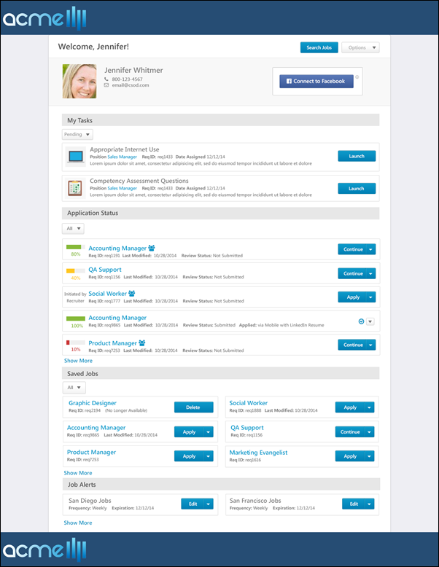
Header/Footer
The header and footer appear on every Career Site page for job seekers. The appearance of the page header and footer is configured using the Custom Page Builder. See Create Career Site - Settings for additional information.
Search Jobs
To open the Job Search page, click the Search Jobs button at the top of the page.
Options
The following options are available in the Options drop-down in the upper-right corner of the page.
- My Profile - Click the link to view the My Profile page. This link is helpful for applicants when they would like to access their My Profile page from the My Resume page.
- Edit Profile - Click the link to edit your contact information, language setting, and consideration for open positions. Applicants can only edit their profile if enabled by the administrator in Requisition and Applicant Preferences. See My Profile - View and Edit Profile Information on page 110 for additional information.
- Change Photo - Click the link to upload a different photo or modify your existing photo. Applicants can only change their photo if enabled by the administrator in Requisition and Applicant Preferences.
- Change Password - Click the link to change your password for the career site. This opens the Change Password pop-up, which provides a list of criteria that the password must meet. Applicants can only change their password if the administrator has enabled the Allow user to change password option in Password Preferences.
Complete the following fields in the Change Password pop-up:
  - Current password - Enter the current password.
  - New password - Enter the new password to use when logging in to the career site. Passwords must meet the requirements defined in the Change Password pop-up.
  - Confirm password - Re-enter the password to confirm it is entered properly.
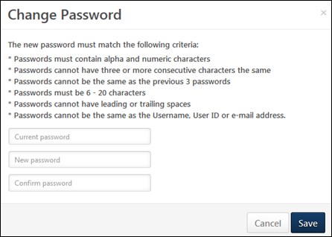
- Logout - This option previously displayed as a link at the top of the page. Click Logout to log out of the career site.

My Profile - Application Status
The Application Status panel on the My Tasks page enables applicants to see the jobs they have applied to, the completion status of an application, the date the application was last modified, and any available options related to the application. Any application that an applicant has begun is displayed here. By default, only applications that are 100% complete display.
From the Application Status panel, applicants can also continue filling out partially completed applications that were started on a mobile device but could not be completed because one or more steps of the application included components that were not accessible on a mobile device.
Note: For applicants who are applying to two or more Related Requisitions (Apply to Multiple Jobs), the application does not appear on the My Profile page until the application is submitted.
To view the My Profile page, click the My Profile link in the upper-right corner of any page in the Career Site. If you have not yet created a profile, click the Create a Profile link in the upper-right corner of any page in the Career Site.
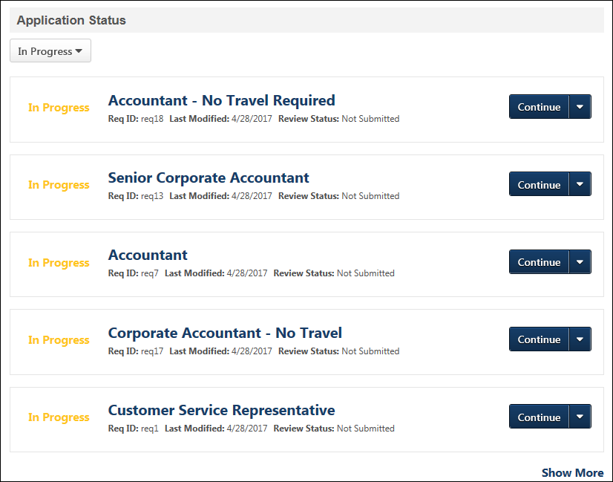
Filter Applications Drop-Down
A drop-down displays at the top of the Application Status section to filter by in progress and completed applications. Only 100% completed applications display by default. The following options are available in the drop-down:
- All - Click this option to view the application status for jobs you have applied for and jobs for which the application is in progress but has not yet been submitted.
- In Progress - Click this option to show only applications that are in progress but have not yet been submitted.
- Applied - Click this option to show only applications for jobs you have applied for, meaning that the application has been submitted.
Show More/Less
Up to five applications display in the Application Status section by default. To view more tasks, click the Show More link, which displays at the bottom of the list of applications. To view fewer applications, click the Show Less link.
Application Status Details
The following information displays for the application status details:
- Progress - While the application is in progress, "In Progress" displays to the left of the job title. Once the application is completed, "Complete" displays.
For portals with Agency Portal enabled, the progress indicates how much of the application that the applicant has completed, not the completion status of the recruiting agency's submission of the applicant.
- Job Title - This field displays the linked title of the position to which the applicant applied or is applying. For portals with multiple languages enabled, this displays in the user's language if available. If the user's language is not available, then this displays in the language of the user who defined it. Click the link to view the Job Details page for the position. For portals with Agency Portal enabled, submissions from a recruiting agency are identified with the Submitted by Recruiting Agency icon . The icon displays to the left of the position title. For applications that include multiple related requisitions to which the applicant applied, viewing the Job Details page displays the details for the current job, as well as lists any other Related Requisitions (Apply to Multiple Jobs) associated to the parent. Note: If the applicant is logged into a career site to which the job is not posted, then the applicant is automatically redirected to the career site where the job details are displayed.
- Manually Added - This indicates that the applicant was added to or moved to the requisition via the Add to Requisition or Move to Requisition action on the Management Applicants page or via the search results in Candidate Search Query or Search Candidates (Old).
- Agency Submission - A new Agency Submission icon displays to the right of the job title for applications submitted by a recruiting agency. The icon displays in the corporate color defined by the administrator in Display Preferences.
- Req ID - This field displays the requisition ID for the position to which the applicant applied or is applying.
- Last Modified - This field displays the date on which the application was last modified. Applications are sorted by Last Modified date with the most recently modified application listed first.
- Review Status - The following statuses are available:
  - Closed - This status displays if the applicant status is Closed.
  - Hired - This status displays if the applicant status is Hired.
  - Initiated by Recruiter - This status displays if the applicant has been submitted by a recruiting agency but has not yet started or completed their application for submission.
  - In Review - This status displays if the applicant status is In Review.
  - Not Submitted - This status displays if the application is not yet completed by the applicant and was not submitted by a method other than the applicant, such as manually moved by a recruiter or submitted from an agency portal.
  - Requisition Closed - This status displays if the job requisition is closed.
  - Submitted - This status displays if the applicant status is New Submission.
- Applied - This field indicates whether the applicant submitted their application via a mobile device, a LinkedIn resume, or both.
Options
The following options may be available to the applicant:
- Apply - This option allows applicants to apply to the requisition if they have not already started their application.
- Continue - This option allows applicants to continue filling out their application.
- Delete - This option allows applicants to delete an application that they have started but have not yet submitted. Clicking the icon opens a warning pop-up, stating that the application is in progress and cannot be recovered once it is withdrawn. The withdrawal action is logged on the History tab of the applicant's profile page as a Change Applicant Status event. The applicant's status is changed to Closed, and their disposition is set to "Voluntary Withdrawal." If configured, the Voluntary Withdrawal email is sent when the application is withdrawn. Note: Applications that are pending completion can only be withdrawn if the applicant has self-applied to the requisition.
- Re-Apply - This option allows applicants to reapply to a job requisition, if enabled by the administrator in General Preferences.
- Unavailable - This displays for job requisitions that were closed before the applicant submitted an application.
- View Application - This option opens a pop-up that displays the application. This option is available even if the requisition is closed. See My Profile - View Application on page 116 for additional information.
- View Resume - This option is available if a resume file was not attached and the candidate input resume data into fields manually on the application. Click the option opens the resume. The resume is available even if the requisition is closed.
- View Resume (DOC) - This option is available if the resume file type is anything other than .pdf. Click the option opens the resume. The resume is available even if the requisition is closed.
- View Resume (PDF) - This option is available if the resume was submitted as a .pdf file. Clicking the option opens the resume. The resume is available even if the requisition is closed.
- Withdraw - This option allows the applicant to withdraw their application once it has been submitted. When the icon is clicked, a warning pop-up appears indicating that the user cannot undo the withdrawal action. The withdrawal action is logged on the History tab of the applicant's profile page as a Change Applicant Status event. The applicant's status is changed to Closed, and their disposition is set to "Voluntary Withdrawal." If configured, the Voluntary Withdrawal email is sent when the application is withdrawn.
Note: If an applicant has started an application, and the job requisition is no longer available on the current career site but is available on another career site, the application options are not affected. The applicant can still complete the application as long as the job is available on the other career site. The application source in the system will be the career site from which the application was originally started.
Applications Submitted Via a Mobile Device
Applications that cannot be completed from the applicant's mobile device display in the Application Status section of the My Profile page. Some applications started on a mobile device cannot be completed because one or more steps of the application include components that are not accessible on a mobile device, such as tests, training, and assessments. The applicant must submit the partially completed application from their mobile device, and then access the application from their My Profile page to complete the remaining steps of the application.
To continue the application, click the Continue button on the My Profile page. This opens the continue application page and allows the applicant to access, complete, and submit the application.
The application's percentage of completion displays, as well as the last modified date and review status for the application. The applicant will be visible as an applicant for the job.
Applications Not Yet Submitted
For applications that are started on a mobile device but not yet submitted by the applicant, the Application Status section records that the application has been started and indicates in the Applied field that the application was started on a mobile device.
However, recruiters are not able to view the applicant until the application is submitted.
Completed Mobile Applications
For applications that include only mobile optimized application workflow components and that are completed and submitted by the applicant, the Application Status section displays the submission. The Applied field identifies the application as a mobile submission.
The application's percentage of completion displays, as well as the last modified date, review status, and the date on which the application was submitted.
In these cases, the applicant is visible for the job requisition in the ATS.

My Profile - Connect to Facebook
Applicants can connect their career site profile with their Facebook page.
To view the My Profile page, click the My Profile link in the upper-right corner of any page in the Career Site. If an applicant has not yet created a profile, they can click the Create a Profile link in the upper-right corner of any page in the career site.
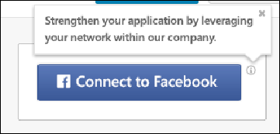
To connect your profile with Facebook, click the Connect to Facebook button. This allows the system to access your basic information and your account email address. The system also compares your friends list against people that work at the company to find common connections.
An information icon displays in the upper-right corner of the Connect to Facebook option to explain the benefit of connecting with Facebook. Applicants can hover over the icon to view the tooltip.

My Profile - Job Alerts
The Job Alerts panel on the My Profile page enables external applicants to view, edit, and delete job alerts.
To view the My Profile page, click the My Profile link in the upper-right corner of any page in the Career Site. If an applicant has not yet created a profile, they can click the Create a Profile link in the upper-right corner of any page in the career site.
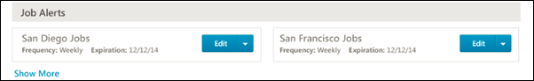
The job alerts that appear on the My Profile page are created on the job search page in the career site. For instructions on creating job alerts, see the Career Site - Job Search topic in Online Help.
Show More/Less
Up to six job alerts display by default. To view more job alerts, click the Show More link, which displays at the bottom of the list. To view fewer job alerts, click the Show Less link.
Job Alerts Details
Job alerts display in alphabetical order in two columns from left to right. The following information displays for each job alert:
- Title - Click the job alert title to view the Job Details page for the position. Note: If the applicant is logged into a career site to which the job is not posted, then the applicant is automatically redirected to the career site where the job details are displayed.
- Frequency - This field displays the frequency of the alert, either Daily or Weekly, as defined by the applicant.
- Expiration - This field displays the date on which the job alert expires. Job alerts expire 90 days from the date on which the job alert was created. The 90 days includes the date of creation. Once a job alert expires, it no longer displays in the Job Alerts panel.
Options
The options that are available display as a drop-down button to the right of the job alert details. The following options are available:
- Edit - Click this option to open the Edit Job Alert pop-up. Within the pop-up, you can edit the title and job alert frequency. Once all edits are completed, click the Edit button. This closes the pop-up and returns you to the My Profile page. Note: Editing the job alert does not affect the expiration date of the job alert.
- Delete - Click this option to delete the job alert. This opens a confirmation pop-up, indicating that the job alert cannot be restored once it is deleted. Click Yes to delete the job alert. Or, click Cancel to close the pop-up without deleting the job alert.
Mobile-Friendly Career Sites
The My Alerts section on My Profile page displays job alerts created on mobile-friendly career sites. Applicants can view, edit title and frequency, and unsubscribe from these job alerts.
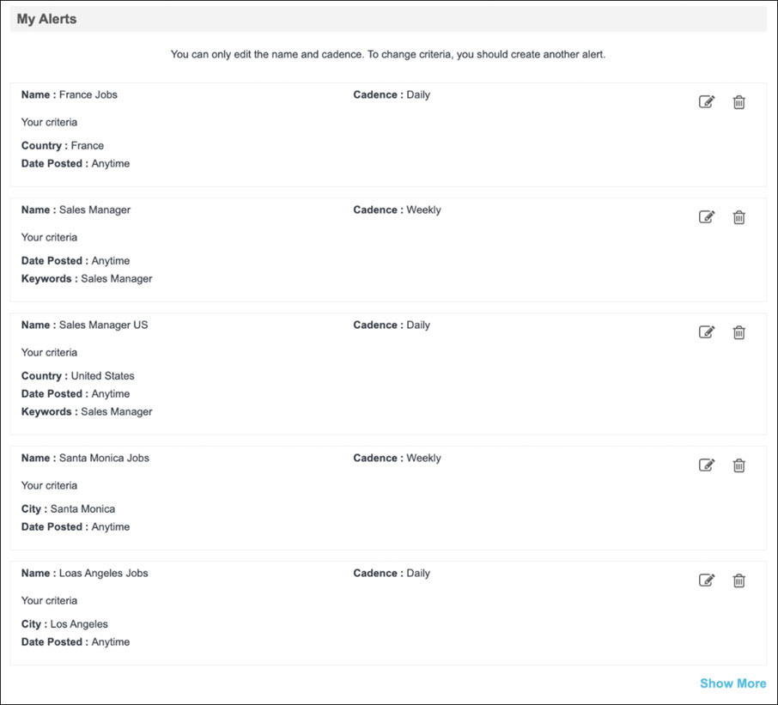
- To edit a job alert, click the edit icon. The page expands to allow users to edit the Name and Cadence for the job alert.
- To unsubscribe from a job alert, click the delete icon, and click Unsubscribe on the confirmation message. Once unsubscribed, a job alert cannot be restored.
Note: Job alerts expire 365 days from their creation date.
To create job alerts, seeSee Mobile-Friendly Career Site - Job Search on page 47 for additional information.

My Profile - My Completed Tasks
Completed tasks in the My Tasks panel are the assigned tasks that the applicant has completed. Tasks are sorted by oldest to newest completed date. The following information displays for each task:
To view the My Profile page, click the My Profile link in the upper-right corner of any page in the Career Site. If an applicant has not yet created a profile, they can click the Create a Profile link in the upper-right corner of any page in the career site.
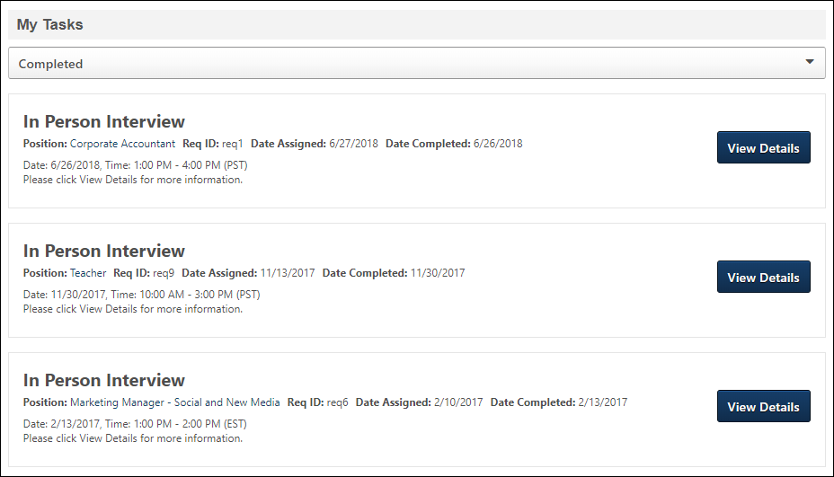
Completed Interview Tasks
Interview tasks automatically move to the Completed Tasks panel when the interview date passes for the interview task. Interview tasks also move to the Completed Tasks panel once the applicant completes the interview in HireVue.
The following information displays in each column of the Completed Tasks panel:
Column | Description
Task Title | This displays the interview type, either In Person, Phone, or Virtual.
Tasks Description | This displays the same information that displays for the column in the Pending Tasks panel.
Position Title | This displays the same information that displays for the column in the Pending Tasks panel. For portals with multiple languages enabled, this displays in the user's language if available. If the user's language is not available, then this displays in the language of the user who defined it.
Date Assigned | This displays the same information that displays for the column in the Pending Tasks panel.
Date Completed | For In Person, Phone, and Live Video interviews, this displays the date on which the interview was scheduled to occur. For On Demand Video interviews, this displays the date on which the applicant completed the interview, as defined by HireVue. (check this with PM)
View Details | Click the View Details button to open the Interview Details pop-up.  Note: For live video interviews, the option to launch the interview is not available. Applicants cannot view a completed live video interview.
Completed Offer Letter Tasks
When a candidate submits a response to an offer, the task changes to Completed. The candidate can view the Job Details page for the requisition by clicking the linked job title in the Position Title column. They can also view the offer and any attachments associated with the offer by clicking the View Details button. This opens the Review Offer pop-up, with all response fields grayed out and not selectable.
Note: It is possible for multiple versions of the same offer letter task to display as Completed. For example, the candidate denies an offer. The denied version changes to Completed. The recruiter sends a new version of the offer. The candidate accepts the new version, which changes the task to Completed. Thus, both the denied version and the accepted version appear as Completed.
Completed Reference Letter Request Tasks
Once the Reference Letter Request task is completed or the applicant is placed into a disposition that automatically completes the task, the task appears Completed. The following information displays for the task:
- Task Title - This displays the task title.
- Task Description - This displays the instructions for completing the task. The instructions are system-defined and cannot be modified by the administrator or recruiter.
- Position Title - This displays the linked job title for the requisition. Selecting the link opens the Job Details page for the requisition.
- Date Assigned - This displays the date on which the Reference Letter Request task was assigned to the applicant.
- Date Completed - This displays the date on which the applicant completed the task.
- View Details - Click the View Details button to view the completed task. This opens the Reference Letter Request page as read-only.
Completed Self Schedule Interview Tasks
Self schedule interview tasks change to Completed if one of the following occurs:
- Applicant schedules session
- Applicant declines invitation
- Applicant requests alternative session
- Event expires
- Applicant's status changes to a status in which an interview is no longer available for them (e.g., applicant is moved into a Closed status)
The following information displays for the task in the My Tasks panel for completed self-scheduled interview tasks:
Column | Description
Task Title | This displays the name of the task, "Self Schedule Interview."
Task Description | This displays the name of the event.
Position Title | This displays the linked job title for the associated requisition to which the applicant has applied. For portals with multiple languages enabled, this displays in the user's language if available. If the user's language is not available, then this displays in the language of the user who defined it. Clicking the link opens the Job Details page for the requisition.
Date Assigned | This displays the date on which the self scheduling invitation was sent to the applicant.
Date Completed | This displays the date on which the task was completed. Click the View Details button to view the details of the self scheduling task. This opens the Self Schedule Interview Details pop-up. The information that displays in the pop-up is dependent upon the following reasons the task was changed to Completed:  - If the applicant scheduled an interview, then the pop-up displays the interview information, such as location, date, and time.  - If the applicant declines the invitation, then the interview event name and location displays, as well as the reason the applicant declined.  - If the applicant requests an alternate interview session, then the interview event and location displays, as well as the reason the applicant is requesting the alternate session.  - If the event expires, then "Details Unavailable" displays in the pop-up.  - If the applicant's status changes to a status in which an interview is no longer available for them, then "Details Unavailable" displays in the pop-up.

My Profile - My Pending Tasks
The My Tasks panel lists the pending and completed tasks associated with the jobs for which you have applied. Tasks may include such items as competency assessments, tests, and online courses. The May Tasks panel only displays if an applicant is assigned at least one task.
To view the My Profile page, click the My Profile link in the upper-right corner of any page in the Career Site. If an applicant has not yet created a profile, they can click the Create a Profile link in the upper-right corner of any page in the career site.
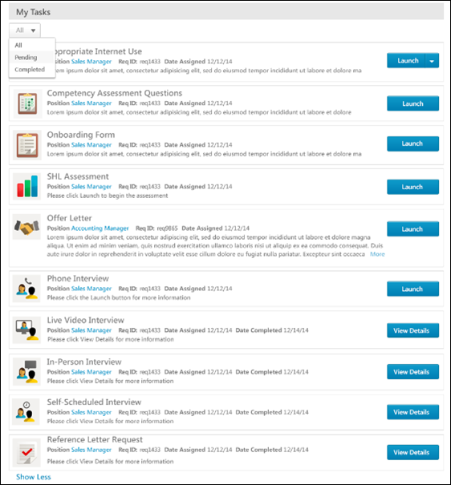
Filter Tasks Drop-Down
A filter drop-down displays at the top of the My Tasks section to filter by pending and completed tasks. The following options are available in the drop-down:
- All - Click this option to view both pending and completed tasks.
- Pending - Click this option to show only pending tasks.
- Completed - Click this option to show only completed tasks.
Show More/Less
Up to four tasks display in the My Tasks section by default. To view more tasks, click Show More, which displays at the bottom of the list of tasks. To view fewer tasks, click Show Less.
Task Details
The following details display for tasks:
- Task Icon - The designated icon for the task displays to the left of the task details. The icon allows applicants to quickly recognize the type of task.
- Task Title - The title of the task displays at the top of the task box.
- Position - This field displays the linked title of the position to which the applicant applied. For portals with multiple languages enabled, this displays in the user's language if available. If the user's language is not available, then this displays in the language of the user who defined it. Click the link to view the Job Details page for the position. Note: If the applicant is logged into a career site to which the job is not posted, then the applicant is automatically redirected to the career site where the job details are displayed.
- Req ID - This field displays the requisition ID for the position to which the applicant applied.
- Date Assigned - This field displays the date on which the task was assigned to the applicant.
- Date Completed - This field displays the date on which the applicant completed the task.
- Task Description - The description for the task display at the bottom of the task box. If the description is longer than the space allows, click More to expand the description, then click Less to collapse the expanded lines of the description.
- Launch - Click Launch to launch the task. When there are additional options available, the options display together in a button drop-down. Note: When launching Tracker I-9 tasks, applicants should not navigate away from the page or the task will not fully load.
- View Details - Click View Details to view the details of the task. When there are additional options available, the options display together in a button drop-down.
Pending Tasks
Pending tasks are assigned tasks that the applicant has not yet completed. Tasks are sorted by oldest to newest date assigned.
Pending Interview Tasks
The Interview task enables applicants to track and manage their interview schedule for requisitions.
The following are the interview task types:
- In Person Interview Scheduled
- Phone Interview Scheduled
- Virtual Interview Scheduled
- On Demand Video Interview Scheduled - Note: With video interviews, applicants can access HireVue directly from their My Profile page to complete the interview.
- Live Video Interview Scheduled
Applicants may have multiple interview tasks, depending on how the various stages of the application process are configured. For example, the applicant could have a Phone, Virtual, and In Person interview task for a single requisition. These could occur on the same day at different times and with multiple different interviewers. Or, the applicant could have three different virtual interviews for a single requisition, each displaying as a separate task.
Interview tasks are assigned to applicants when the applicant is sent a notification that an interview has been scheduled. This notification is sent by the interview scheduler.
For On Demand Video interviews, the task displays in the Pending Tasks panel when the task has not yet been completed or is in progress. Once the applicant completes the interview in HireVue, the task is moved to the Completed Tasks panel.
If the interview task is modified by the scheduler, then the task is updated in the applicant's My Tasks panel. If the task is removed by the scheduler, then the task is removed from the My Tasks panel.
The following information displays in the Pending Tasks panel for interview tasks:
Column | Description
Task Title | This displays the interview task type, either In Person Interview, Phone Interview, Virtual, On Demand Video Interview, or Live Video Interview.
Task Description | In Person/Phone/Virtua/Live Video Interview  For In Person, Phone, and Live Video interviews, this displays the date and start/end time of the interview. The time zone of the interview time displays in parentheses to the right of the time. Important Note: The interview time displays in the time zone of the user who scheduled the interview.  If the interview scheduler entered comments to the applicant when scheduling the interview, the comments display below the date and time. If the scheduler did not provide comments, then this column displays "Please click the Launch link for more details." This refers to the Launch link in the Options column for the interview.  Note: If the comments are longer than the space allows, then the remaining text is replaced with ellipses. The applicant can view the remaining comments by clicking the Launch link in the Options column.  On Demand Video Interview  For On Demand Video interviews, this column displays "Click on the Launch link to complete this video interview." This refers to the Launch link in the Options column for the interview.
Position Title | This displays the title and requisition ID for the requisition. For portals with multiple languages enabled, this displays in the user's language if available. If the user's language is not available, then this displays in the language of the user who defined it.
Date Assigned | This displays the date on which the task was assigned to the applicant.
Launch
The functionality of the Launch button is dependent upon the interview type.
Launch In Person/Phone/Live Video/Virtual Interviews
Clicking Launch opens the Interview Details pop-up. The following information displays in the pop-up:
- Scheduling - The following information displays in the Scheduling section:
  - Date - This field displays the date of the interview.
  - Time - This field displays the interview start and end time. The time zone displays in parentheses to the right of the time. Important Note: The interview time displays in the time zone of the user who scheduled the interview.
  - Type - This field displays the type of interview, either In Person Interview, Phone Interview, Virtual Interview, or Live Video Interview.
  - Location - This field displays the physical location for In Person interviews.
  - Interviewing With - This field displays the names of the interviewers with whom the applicant is interviewing.
  - Number - This field displays the phone number for the interview. This field only displays for Phone interviews.
  - Launch Interview - The Launch Interview link only displays for Live Video interviews. Clicking the link launches the live video interview in HireVue. Note: Live video interviews are interviews that take place via live video with one or more interviewers and the applicant. The HireVue digital interview application is used to conduct the interview. The applicant and all interviewers are visible on the screen.
- Comments - This field displays the comments written to the applicant by the interview scheduler. If comments were not provided by the scheduler, then the Comments box is blank.
Launch On Demand Video Interview
Clicking Launch launches the video interview in HireVue. The applicant completes the interview by responding to questions previously configured for the interview.
Applicants can begin an On Demand Video interview and save their progress so that they can return to the interview and complete it at a later date. When the applicant launches an in-progress interview, HireVue opens the interview to the place where the applicant stopped the interview.
Pending Offer Letter Tasks - Desktop
The Offer Letter task enables candidates to view the details of the organization's job offer and submit a response. The following information displays for the offer:
- Task Title - This displays the title of the offer.
- Task Description - This displays any instructions that were added when the offer was configured.
- Position Title - This displays the job title associated with the task. For portals with multiple languages enabled, this displays in the user's language if available. If the user's language is not available, then this displays in the language of the user who defined it. Click the linked title to open the Job Details page for the requisition.
- Date Assigned - This displays the date on which the task was assigned to the candidate.
- Options - Click Launch to view the offer. This opens the Review Offer Letter pop-up from which the candidate can view the offer details and select to accept or decline the offer. The following information displays in the pop-up:
  - Instructions - This section displays any instructions that were added when the offer was configured to be sent to the candidate's profile.
  - Offer Letter - This section displays a link to the offer letter. Click the link to open the offer letter.
  - Additional Attachments - This section displays links to each additional attachment that was added when the offer was configured to be sent to the candidate's profile.
  - Response - This section displays the decision options from which the candidate can select, either "Accept" or "Decline."
    - Accept - If the candidate selects "Accept," then the candidate can select from following accept methods:
      - Electronic Signature - This option enables the candidate to accept the offer by electronically signing the offer letter. The candidate must enter their full name (up to 200 characters), and then authenticate their signature by entering their email address and password. The candidate must then click Submit to send the offer acceptance.
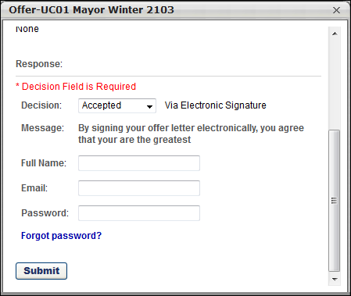
Forgot Password Note: Applicants who do not remember their password can click the Forgot password link in the offer letter acceptance pop-up to reset their password. This opens the Forgot Password pop-up. Applicants must enter their login credentials in the Forgot Password pop-up, and then click Submit. This triggers the Forget Password email, provided that the email is configured by the administrator. The applicant can open the email and click the reset password link in the email to be taken to the reset password page, provided that the PASSWORD.RESET.URL tag is included in the body of the email.
      - Upload Document - This option enables the candidate to accept the offer by uploading a signed copy of the offer letter. The candidate must browse for and select a document, and then upload it to the pop-up. Once uploaded, the candidate must click Submit to send the offer acceptance.
Once submitted, the task moves to the Completed Tasks panel. Submitting the task triggers the Candidate Response Received email, if configured in Email Management.Note: The information in the Message field is configured by the administrator in Offer Letter Preferences.
    - Decline - If the candidate selects "Decline," the candidate must select one or more decline reasons from the Reason drop-down. The candidate can enter a note in the Notes field regarding their decision. The candidate must then click Submit to send the decline response. Once submitted, the task moves to the Completed Tasks panel. Submitting the task triggers the Candidate Response Received email, if configured in Email Management. Note: The values in the Reason drop-down are configured by the administrator in Offer Letter Preferences.
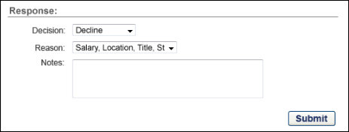
Pending Offer Letter Tasks - Mobile-Friendly Candidate Experience
Note: This feature is only available for portals that have self-enabled Mobile Friendly Candidate Experience, which is done via the Feature Activation Preferences page. The career site must be configured by the administrator as a Mobile-Friendly career site, and not a Standard career site. See Manage Mobile-Friendly Career Site on page 30 for additional information.
Applicants can accept/decline offer letters via a mobile-friendly experience on the candidate’s My Profile page on the career site. Note: On mobile devices, the ability to accept or decline an offer letter is only available for mobile-friendly career sites that are created via the Mobile Friendly Candidate Experience functionality and is not available for Standard career sites.
Use Case
Note: This use case only applies to portals that have enabled the Mobile Friendly Candidate Experience functionality and is not available for Standard career sites.
Meg the Applicant needs to accept her offer letter but does not have a desktop computer. She would like a quick and user friendly way to accept the offer via her mobile device.
- Meg accesses her My Profile page from her mobile device.
- She opens the offer from her Pending Tasks.
- She views, accepts, and signs the offer directly from her mobile device.
To accept or decline an offer letter:
- Open your My Profile page on the career site.
- Tap Launch to open the offer letter page.
- Tap the offer letter icon to view the offer letter.
- Open any additional attachments by tapping the icon for the attachment. Note: This section is hidden if there are no additional attachments.
- Select Accept or Decline from the Response drop-down. Note: You may be asked to upload a signed offer letter document to serve as your acceptance of the offer. In such cases, you cannot submit your offer acceptance until the document is uploaded.
- Enter your name in the Full Name field. This serves as your signature.
- Enter your email address in the Email field.
  - If you are using an email address that is associated with a social network account, then you will be required to create a password in order to sign the offer letter.
- Enter your career site password in the Password field.
  - Forgot Password - If you do not know your password, tap Forgot Password to reset your password. Once you have reset your password, you are redirected back to the offer letter page. Note: The Password field does not display if you are required to upload a signed offer letter document because you are not being asked to sign the document electronically.
  - Email Associated with Social Network - If you are using an email address that is associated with a social network account (i.e., LinkedIn), then you will be required to create a password in order to sign the offer letter.
- Tap Submit. This submits your offer decision.
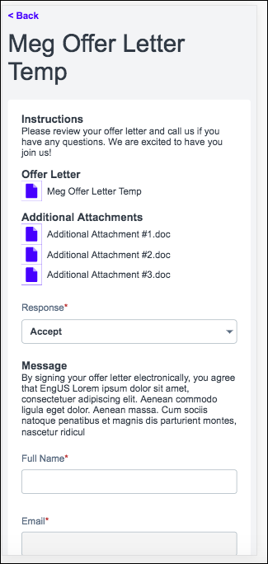
Pending Reference Letter Request Tasks
The following information displays for pending Reference Letter Request tasks:
- Task Title - This displays the task title.
- Task Description - This displays the instructions for completing the task. The instructions are system-defined and cannot be modified by the administrator or recruiter.
- Position Title - This displays the linked job title for the requisition. For portals with multiple languages enabled, this displays in the user's language if available. If the user's language is not available, then this displays in the language of the user who defined it. Selecting the link opens the Job Details page for the requisition.
- Date Assigned - This displays the date on which the Reference Letter Request task was assigned to the applicant.
- Launch - Click Launch to launch the Reference Letter Request task. This opens the Reference Letter Request page from which the applicant enters the name and email address for each reference and submits the task. Once the task is submitted, the referrer information cannot be modified by the applicant.
Pending Self Schedule Interview Tasks
The following information displays for pending self schedule interview tasks:
- Task Title - This displays the name of the task, "Self Schedule Interview."
- Task Description - This displays the name of the event.
- Position Title - This displays the linked job title for the associated requisition to which the applicant has applied. For portals with multiple languages enabled, this displays in the user's language if available. If the user's language is not available, then this displays in the language of the user who defined it. Clicking the link opens the Job Details page for the requisition.
- Date Assigned - This displays the date on which the self scheduling invitation was sent to the applicant.
- Launch - Click Launch to begin the self scheduling process. This opens the self schedule page.
  - If the self schedule page displays "Event no longer available," then the event end date has passed and the applicant can no longer schedule an interview for the event.
  - If the self schedule page displays "No available sessions," then the applicant cannot schedule an interview for the event. However, the applicant can click the request an alternative session link.
  - If the self schedule page displays "Launch Error," then the invitation failed to launch.
Pending SHL Assessment Tasks
SHL assessments that are part of the application workflow display in the My Tasks panel of the My Profile page. Applicants can launch the assessments by clicking Launch. The assessment opens in the vendor's application, and the applicant does not need to log in to the vendor's site.
Once the assessment task is submitted by the applicant and considered complete by the vendor, the assessment is changed to a Completed task, and the description is changed to "Assessment Completed." The Completed Date is the date on which the assessment is considered complete by the vendor. The applicant cannot view the completed assessment.
If the applicant reaches a Closed status while the assessment is in their pending tasks, then the assessment task is automatically removed as a pending tasks. If the applicant reaches a Closed status after completing the assessment, then the assessment remains on the My Tasks panel as a Completed task.

My Profile - View and Edit Profile Information
The Profile Information section displays the applicant's basic profile data. When a user first accesses their profile, this section only displays their name, contact information, photo, and applicant consideration preference.
To view the My Profile page, click the My Profile link in the upper-right corner of any page in the Career Site. If an applicant has not yet created a profile, they can click the Create a Profile link in the upper-right corner of any page in the career site.
Edit Profile
To edit your profile information, click Edit Profile in the Options drop-down. This opens the Edit Profile page from which you can edit your contact information and select your preferred language.
In addition, you may have the option to indicate whether you want to be considered for other positions or deactivate your profile.
Consider Me for Other Positions
Select this option if you would like to be available in the candidate search functionality, which means that you are visible when recruiters search for candidates for other positions. The setting applies to all existing and future applications that you submit. You can uncheck the box to no longer be searchable for other positions.
For applicants submitted by a recruiting agency, checking this option overrides the setting that is available when configuring recruiting agencies that allows applicants submitted by agency users to be available in Candidate Search after a certain timeframe.
Deactivate My Profile
Select this option to deactivate your profile. When you click Save to save the setting, a warning pop-up displays, indicating that deactivating your profile will permanently delete the profile.
If Yes is clicked in the warning pop-up, then you are immediately logged out of the career site and your applicant data is archived and scrambled in the Applicant Tracking System, ensuring that your personal data is irretrievable following deactivation of your profile. Your profile cannot be reactivated, and you will need to create a new profile in order to apply to jobs on the career site.
If No is selected in the warning pop-up, then the pop-up closes without any changes being saved.
Note: The option to deactivate the profile does not display for applicants in a Hired status and is not available for internal applicants. In addition, this option must first be enabled by the administrator in Compliance Enablement Preferences in order to display on the My Profile page.
Save Your Changes
After entering the appropriate information, click Save. This validates the information and refreshes the page with the new information. The profile information is saved in the User Record within the system.
To cancel the changes to the profile, click Cancel.

My Profile - Saved Jobs
The Saved Jobs section on the My Profile page lists all the jobs you have saved. From this section, you can review, apply to, or remove jobs that you have added to this list. These saved jobs are intended to be used by applicants who want to keep track of jobs to which they have not yet applied, but might want to in the future. All saved jobs are listed in alphabetical order.
The Saved Jobs section only displays if an applicant has saved at least one job.
To view the My Profile page, click the My Profile link in the upper-right corner of any page in the Career Site. If an applicant has not yet created a profile, they can click the Create a Profile link in the upper-right corner of any page in the career site.
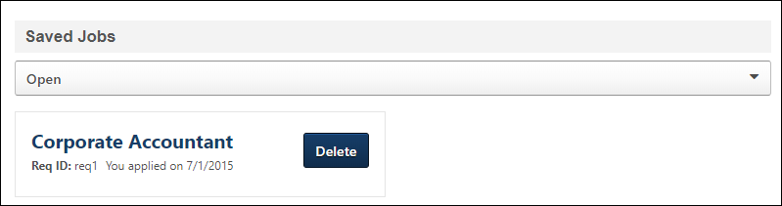
Filter by Open/Closed Jobs
You can filter the Saved Jobs section by open and closed saved jobs. Open jobs appear by default. To view jobs that have closed, click Closed from the filter.
Show More/Less
Up to six saved jobs display by default. If you have more than six saved jobs, click Show More to view more of your saved jobs.
Saved Jobs Details
The following information displays for saved jobs:
- Job Title - Click the job title to view the job details. Note: If the applicant is logged into a career site to which the job is not posted, then the applicant is automatically redirected to the career site where the job details are displayed.
- Req ID - This field displays the requisition ID for the saved job.
- Last Modified - This field displays the date on which the application was last modified for applications that are in progress.
- No Longer Available - This displays if the job is no longer accepting applications.
- You Applied On - "You applied on [date]" displays the date on which you applied to the job.
- Options - The following options may be available for the saved job:
  - Apply - This option allows you to apply to the saved job if you have not already started your application. Clicking Apply opens the first page of the application experience. If the position is no longer open, "No longer available" appears instead of the Apply button.
  - Continue - This option allows you to continue filling out the application for the saved job.
  - Delete - This option allows you to delete the saved job. If you have started the application and delete the saved job, then this also deletes your application for the job.
  - Re-Apply - This option displays if you have been moved into a Closed status for the job. Click Re-Apply to reapply to the job. Note: Applicants can only reapply to a job if enabled by the administrator in General Preferences.

My Profile - Change/Remove Photo
Applicants can upload or remove a photo to their My Profile page by using the Change Photo option in the Options drop-down.
To view the My Profile page, click the My Profile link in the upper-right corner of any page in the Career Site. If an applicant has not yet created a profile, they can click the Create a Profile link in the upper-right corner of any page in the career site.
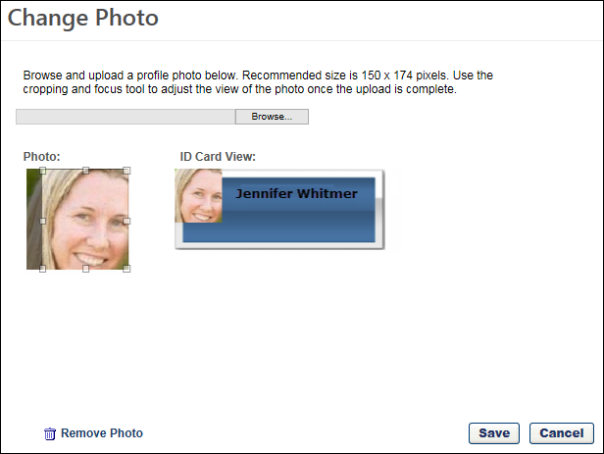
Add/Change Photo
To add or change a profile photo:
- Click Change Photo in the Options drop-down at the top of the My Profile page. This opens the Change Photo pop-up.
- Click Browse to locate the image file. The recommended size for photos is 150 x 174 pixels. The available file types for photos are .jpg, .png, and .gif.
- Click the Upload button, once the image file is selected. The photo appears in the pop-up.
- Crop the photo using the cropping tool, if desired. The tool can be used to move the highlighted area on the photo to determine the desired area of the photo to display. You can also move and crop the photo by dragging the four corners of the highlighted box.
- Click Save. This adds the photo to the image box on the My Profile page.
Remove Photo
To remove the profile photo, click the Change Photo link in the Options drop-down at the top of the My Profile page. This opens the Change Photo pop-up. Click the Remove Photo option at the bottom of the pop-up. This permanently removes the photo from the profile and does not display a confirmation pop-up before the photo is removed.

My Profile - View Application
Applicants can view their application from the My Profile page on the career site. A View Application option displays in the Application status section, which allows applicants to open a pop-up that shows their application.
To view the My Profile page, click the My Profile link in the upper-right corner of any page in the Career Site. If an applicant has not yet created a profile, they can click the Create a Profile link in the upper-right corner of any page in the career site.
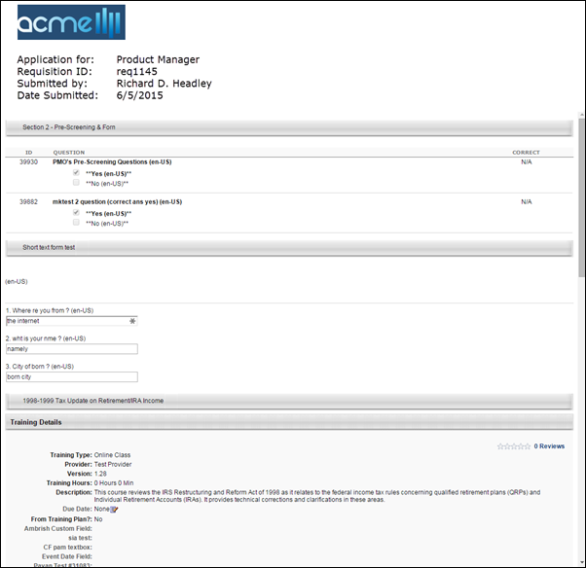
Application Attachments
Additional attachments aside from the resume are not currently accessible from an applicant's profile.
Pre-Screening Questions
If pre-screening questions were included in the application workflow, and the applicant's application includes responses to the questions, any correct answers to the questions do not display when viewing the application pop-up.

Self Schedule Interview Task
When an applicant is invited to self schedule an interview for an interview event, an invite appears as a pending task on their My Profile page. The applicant is also sent the Invitation to Interview Event (Applicant Self Schedule) email, if configured and active in Email Administration.
To schedule an interview, the applicant clicks Launch in the pending task, which opens the self schedule page.
Emails
EMAIL NAME | EMAIL DESCRIPTION | ACTION TYPE

Interview Scheduling Notification - Applicant | This email is triggered when an applicant scheduling notification is sent to the applicant, and is also triggered when an applicant self scheduled an interview for an interview event. The email can be sent to External Applicant, Internal Applicant, or a specific user. This email is active by default and can be found in the Recruitment action type section of Email Management.  Use Case: When a recruiter schedules an interview, they may want to send a notification to the applicant about the scheduled date, time, and interview type. Use this trigger to notify the applicant that an interview session is scheduled. | Recruiting

Invitation to Interview Event (Applicant Self Schedule) | This email is triggered when a recruiter sends a self schedule invitation to an applicant for an interview event. The email can be sent to Applicant, Hiring Manager, Requisition Owner(s), Requisition Reviewer(s), or a specific user. This email can be configured as a Notification or Reminder type email. This email is active by default and can be found in the Recruitment action type section of Email Management.  Use Case: Use this email to send a message to the applicant regarding self scheduling an interview event. With this link, the applicant can schedule themselves into an interview event. | Recruiting
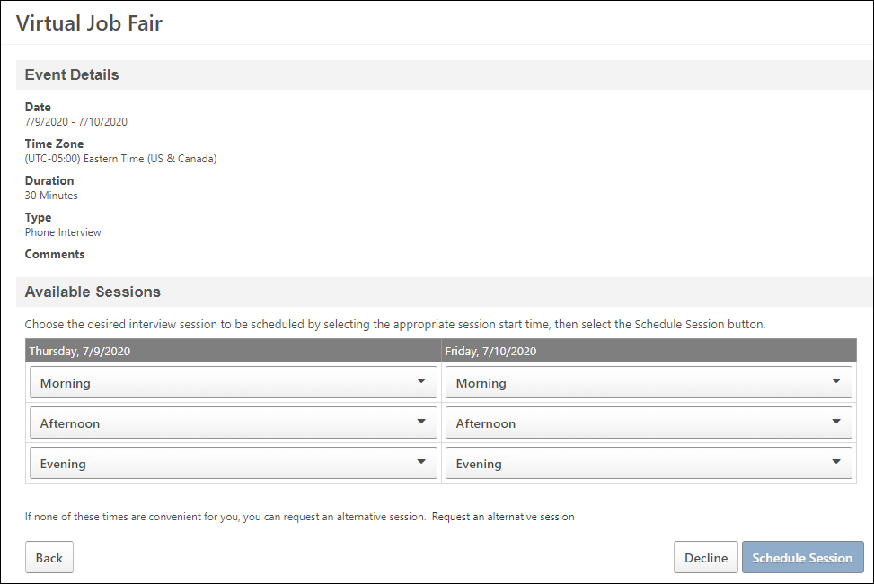
The event details display at the top of the page. If an address is provided, then the address and a map also display. The sessions that are available to the applicant appear in the Available Sessions section.
Schedule Interview
The Available Sessions section displays the interview sessions that are available. The sessions are grouped into blocks based on the time of day or the number of hours in the session.
The date of each session displays as a column. If "Not Available" displays for a date, then there are no sessions available for that date
To schedule an interview:
- Select a time slot from one of the following drop-downs:
  - Morning - This drop-down displays all sessions that are between 12:00 a.m. and 11:59 a.m.
  - Afternoon - This drop-down displays all sessions that are between 12:00 p.m. and 4:59 p.m.
  - Evening - This drop-down displays all sessions that are between 5:00 p.m. and 11:59 p.m.
  - Select Time - If the drop-down is titled "Select Time," then this indicates the sessions are grouped into blocks that are five hours or longer. Click the drop-down to view the available time blocks.
- Click Schedule Session. This schedules the applicant into the interview session.
Once the interview is scheduled, the Interview Scheduling Notification - Applicant email is sent to the applicant, if configured and active in Email Administration. Also, the task is changed from a pending task to a completed task on the My Profile page.
Considerations
- If the selected session is no longer available when the applicant clicks Schedule Session, then a message displays indicating that the session is not available and the applicant will need to select a different session.
- If there are no longer any sessions available when the applicant clicks Schedule Session, then a message displays indicating that there are no sessions left for the event. The applicant can click request an alternative session.
Request Alternative Session
If none of the sessions are convenient for the applicant, then they can request an alternative session by clicking request an alternative session. This opens the Request Alternative Session pop-up.
In the pop-up, applicants enter a new time that works better for them, and then click Request. This closes the pop-up and returns the applicant to their career site profile. The Self Schedule Interview task will appear as Completed on the My Tasks panel.
For recruiters, when an applicant requests an alternative session, the request is visible on the Invites Not Scheduled page.
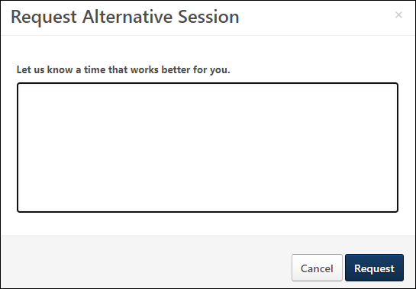
Decline Session
Applicants can decline the interview invitation. To decline an invitation:
- Click Decline on the invitation. This opens the Decline Invitation pop-up.
- Enter the reason for declining the invitation, up to 1000 characters.
- Click Decline. This closes the pop-up and returns the applicant to their career site profile. The Self Schedule Interview task moves to Completed Tasks on the My Profile page.
For recruiters, when an applicant declines an invitation, the reason provided by the applicant is visible on the Invites Not Scheduled page. See Invites Not Scheduled Page.
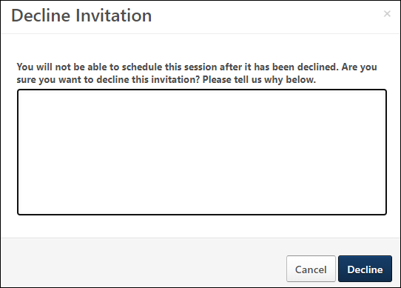

Standard Career Site Overview (Legacy)

Create Standard Career Site
Note for New Client Portals Created After May '19 Release: New Recruiting clients whose portals were created after the May '19 release will only be able to create Mobile Friendly Application Workflows and Career Sites. The Standard career site experience for such clients was deprecated as part of the May '19 release.
Standard career sites enable you to create a general career site that you can post jobs to but that has more limited mobile capabilities. Applicants will not be able to complete some parts of the application using a mobile device.
On the Career Site Settings page for standard career sites, you can configure settings such as the header image, header color, LinkedIn application settings, and Facebook connection settings. You can preview the career site and launch the career site editor from this page, as well.
To create a career site, go to Admin > Tools > Recruit > Career Sites. Then click the Add Career Site link.
Permissions
PERMISSION NAME | PERMISSION DESCRIPTION | CATEGORY

Career Site - Manage | Grants ability to access and manage Career Site Management. This permission can be constrained by OU and User's OU. This is an administrator permission. | Recruiting Administration

Career Site - View | Grants ability to access and view Career Site Management. This permission can be constrained by OU and User's OU. This is an administrator permission. | Recruiting Administration
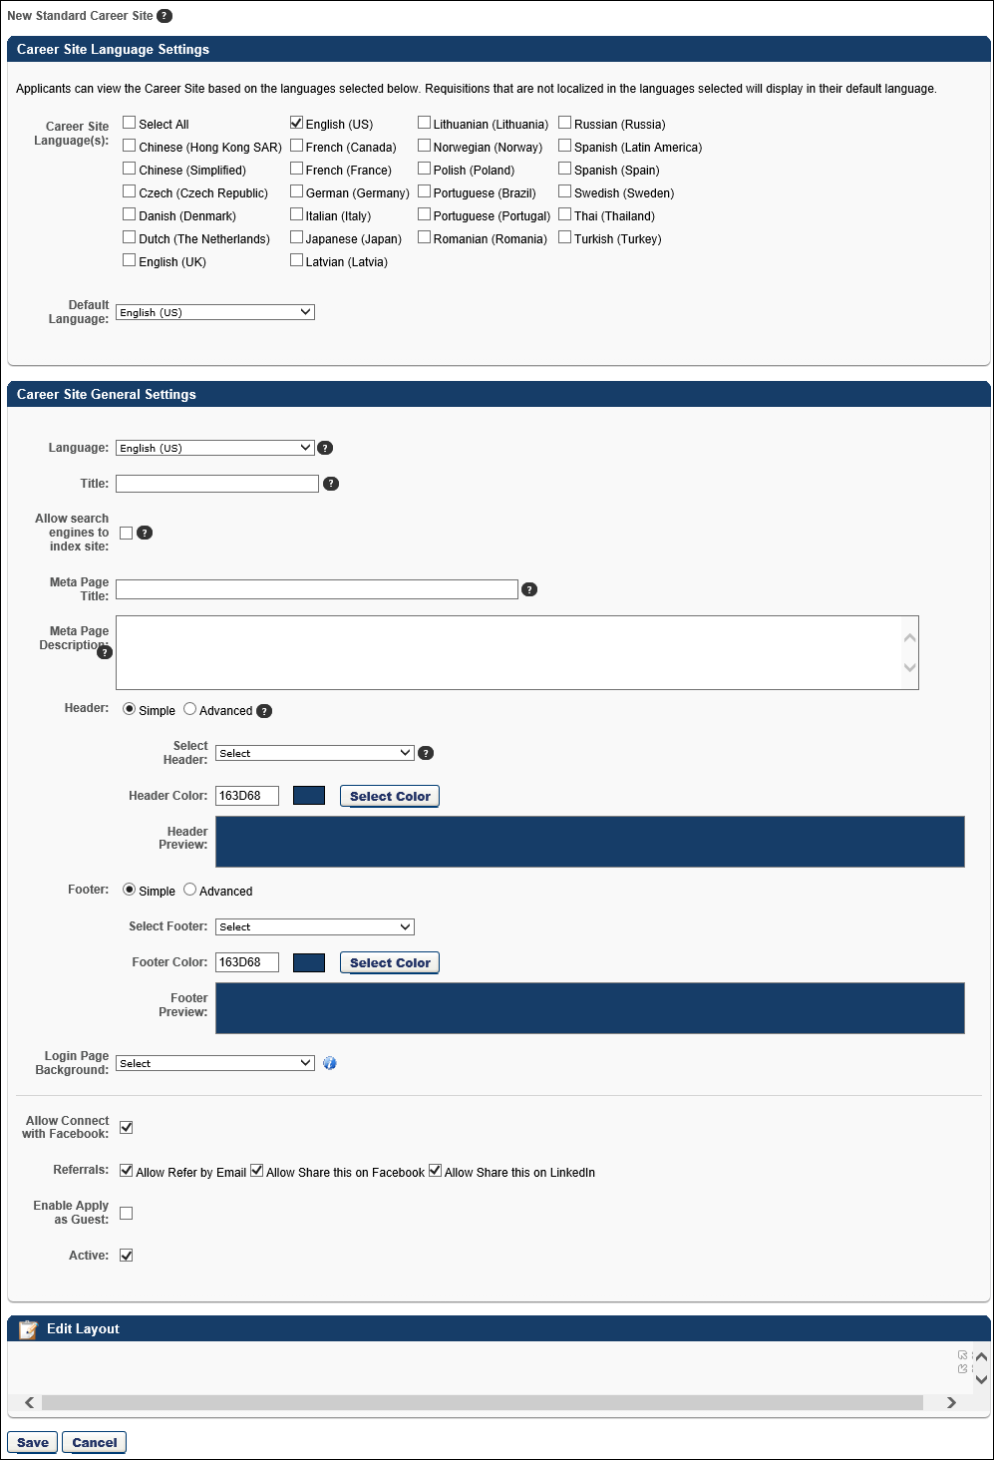
Career Site Language Settings
This section only displays for portals with multiple languages enabled.
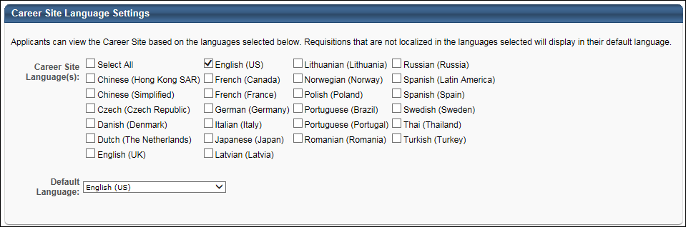
This section allows administrators to select the languages in which applicants can view the career site. In the Career Site Language(s) field, you can check the Select All option to select all available languages, or check the individual boxes for the languages you would like to include. The languages that are available to select are the languages enabled for the portal.
When applicants view the career site, they can select the language from the language drop-down. The career site will then update to display in the selected language.
Note: The default language cannot be deselected from the Career Site Language(s) field.
Language Considerations
Unchecking a Language with Translated Text
When unchecking a language that already has translated text in the Career Site General Settings section, a confirmation pop-up opens to indicate that the language contains translated information. Selecting yes in the pop-up deletes any existing translated text in the career site settings for the deleted language.
Search Jobs Widget Settings
When including multiple languages for a career site, it is a best practice to select the Display Field option in the Selected Search Fields section for all search criteria that you are including on the Search Jobs widget. This ensures that applicants have search features available to find jobs in other languages.
Job Requisitions Not Translated into Applicant's Career Site Preferred Language
Job requisitions that are not translated into the applicant's preferred language that they select on the career site will see the translatable values in the default language of the requisition. The application will not display the translatable values in the applicant's preferred language.
Note: System fields on the application, such as the field names on the Upload Attachments section of the application, display in the language the applicant selects on their My Profile page in the career site.
Career Site General Settings
This section displays for all portals. The following options are available In the Career Site General Settings section:
Language
Select the language from the drop-down for the header/footer. The languages that display in the drop-down are the languages selected in the Career Site Language(s) field in the Career Site Language Settings section. Based on the language selected in the drop-down, administrators can configure header/footer information that applies to the selected language so that applicants see the translated content on the career site when they select to view the career site in the associated language.
Title
Enter a title for the career site. This title is displayed on the Career Site Management page. The character limit for this field is 250. For portals with multiple languages enabled, you can enter a translated value for the title.
Allow search engines to index site
This field is unchecked by the default and allows administrators to select whether or not to allow search engines to index the career site. When unchecked, a meta tag is added to the page meta that prevents search engines from crawling the pages and subpages. When checked, a meta tag is updated to allow search engines to crawl the page.
Meta Page Title
Enter a meta page title, up to 50 characters. The title can be translated into the languages available for the portal by selecting a different language in the Language field and entering the translated meta page title in the field. When applicants search for the job in search engines, the search results will display the job in the applicant's language, if available.
Meta Page Description
Enter a meta page description, up to 150 characters. The description can be translated into the languages available for the portal by selecting a different language in the Language field and entering the translated meta page description in the field. When applicants search for the job in search engines, the search results will display the job in the applicant's language, if available.
Header
When configuring the header, you can configure either a simple or advanced header. Note: JavaScript is not accepted by default when creating the header. To enable JavaScript for the header, contact Global Customer Support.
- Simple - The Simple option enables you to select a header image and color.
  - Select Header - From the drop-down list, select a header image for the career site. The selected header is displayed for all career site pages, including Job Search, Job Details, Login/Self Register, My Profile, and Application Experience. The available images are taken from the Corporate Preferences images. A preview of the header image is displayed in the Header Preview field. The header is optional.
  - Header Color - Select the header color, which is the color that fills the header in areas that the header image does not fill. You may enter a hex value for the color or select a color by clicking the Select Color button.
  - Header Preview - This displays a preview of what the header will look like on the career site. The selected image is always aligned in the upper-left portion of the header. Any empty space in the header is filled with the selected header color. The selected logo is not resized.
- Advanced - The Advanced career site header option includes HTML configuration options. Selecting the Advanced option opens the WYSIWYG editor. The WYSIWYG (What You See Is What You Get) tool provides configuration tools, such as images, fonts, colors, formatting, and tables. There is also a Copy from Word feature that enables administrators to import from Microsoft Word, preserving the formatting used in the Word document. HTML code can also be used. For more information about the WYSIWYG tool, see the WYSIWYG Tool Considerations section in the Create New Email topic in Online Help. The system only accepts certain customizable HTML elements in the WYSIWYG Editor. Elements that are not acceptable display as text. See Safe Listed Customizable Elements.
Footer
When configuring the footer, you can configure either a simple or advanced footer.
- Simple - The Simple option enables you to select a footer image and color. Note: JavaScript is not accepted by default when creating the footer. To enable JavaScript for the footer, contact Global Customer Support.
  - Select Footer - From the drop-down list, select a footer image for the career site. The selected footer is displayed for all career site pages, including Job Search, Job Details, Login/Self Register, My Profile, and Application Experience. The available images are taken from the Corporate Preferences images. A preview of the footer image is displayed in the Footer Preview field.
  - Footer Color - Select the footer color, which is the color that fills the footer in areas that the footer image does not fill. You may enter a hex value for the color or select a color by clicking the Select Color button.
  - Footer Preview - This displays a preview of what the footer will look like on the career site. The selected image is always aligned in the lower-left portion of the footer. Any empty space in the footer is filled with the selected footer color. The selected logo is not resized.
- Advanced - The Advanced career site footer option includes HTML configuration options. Selecting the Advanced option opens the WYSIWYG editor. The WYSIWYG (What You See Is What You Get) tool provides configuration tools, such as images, fonts, colors, formatting, and tables. There is also a Copy from Word feature that enables administrators to import from Microsoft Word, preserving the formatting used in the Word document. HTML code can also be used. For more information about the WYSIWYG tool, see the WYSIWYG Tool Considerations section in the Create New Email topic in Online Help. The system only accepts certain customizable HTML elements in the WYSIWYG Editor. Elements that are not acceptable display as text. See Safe Listed Customizable Elements.
Note: When clicking between the Simple and Advanced options when configuring headers and footers, any settings that you have configured in either option are maintained.
Login Page Background
The Login Page Background field allows you to select an image that will appear as the background on the login page and the Create a Profile page for applicants. This helps to further brand the career site for the organization.
To select an image, click the drop-down and select from available images. The recommended image size is 1920 x 1200 pixels.
Note: If an image is not selected, then the background is white.
Administrators with permission to manage Corporate Preferences can upload new images from the Corporate Preferences page. Once the image is uploaded and the preferences are saved, the image can be selected from the Login Page Background field.
Note: You can still also add a header and footer by using the Header/Footer options.
Enable Mobile Site
The Enable Mobile Site option was retired as part of the October '18 release.
As part of the August '19 release, this option is deprecated for all qualifying career sites. A qualifying career site is a Standard career site that has the Enable Mobile Site option checked. This is being done because all action items that were supported in the old mobile optimized experience are supported in the mobile-friendly experience. In addition, performance has been enhanced, and new features are supported that were once not supported for mobile users, such as resume parsing, Apply with LinkedIn, and localization. Existing Standard career sites will no longer use the old mobile optimized experience so that all candidates can benefit from the new experience. If a mobile-friendly qualifying workflow is published to a Standard career site, the career site will display in the Standard format, but the application workflow will automatically become mobile-friendly. A qualifying application workflow is one that does not contain Forms, Training, or Assessment action items.
The function of the Enable Mobile Site option is to allow a mobile optimized career site to display for applicants accessing the career site from a mobile device.
For more information about the deprecation of the Standard career site experience, see the Frequently Asked Questions - Deprecate Standard Experience page in Online Help.
Mobile Image
This option enables administrators to select a header image for the site. The images that are available in the Mobile Image drop-down are the images defined in Corporate Preferences.
Mobile Color
This option enables administrators to define the color that fills the areas that the header image does not fill. Enter a hex value for the color or select a color by clicking the Select Color button.
Allow Apply with LinkedIn /Sign-In
Select this option to allow LinkedIn Apply/Sign-In functionality. This includes:
- Apply with LinkedIn from Job Details page.
- Sign in or Register with Linked in from the Sign In/Registration page.
- Use LinkedIn resume/CV from Application/Experience page.
Note: LinkedIn is sun-setting their current version of Apply with LinkedIn by the end of 2018. Once this occurs, the Allow Apply with LinkedIn /Sign-In option will no longer be available for standard career sites, and no LinkedIn options will be available to candidates when applying to a job on a standard career site. Clients who have a LinkedIn Recruiter contract, or a LinkedIn corporate account with active LinkedIn job slots, can leverage the new Apply with LinkedIn (With Apply Starters). The new Apply with LinkedIn (With Apply Starters) will only be supported on mobile friendly workflows. See Apply with LinkedIn (with Apply Starters) - Overview.
Allow Apply with Seek
When this option is checked, an Apply with Seek button displays on the career site for applicants and allows them to apply to the job using their Seek profile. This option is unchecked by default. This option only displays for portals with the Apply with Seek integration enabled. Note: To enable the Seek functionality, contact Global Customer Support. Then, you can purchase Seek from the Edge Marketplace for $0.
Allow Connect with Facebook
Select this option to allow applicants to connect their applicant profile with Facebook. This connection enables the system to access their basic information and email address from Facebook. The system also compares your friends list against people that work at the company to find common connections.
Referrals
The Referrals section includes settings to enable or disable the referral options that appear on the career site. If an option is disabled, it does not appear for applicants on the career site.
field | description
Allow Refer by Email | This option is checked by default and enables the Send to a Friend email icon  to display on the job details page on the career site. When unchecked, the email icon does not display for any jobs on the career site, and applicants are unable to refer the job by email.
Allow Share this on Facebook | This option is checked by default and enables the Share this on Facebook icon  to display on the job details page on the career site. When unchecked, the Facebook icon does not display for any jobs on the career site, and applicants are unable to share the job on Facebook.
Allow Share this on LinkedIn | This option is checked by default and enables the Share this on LinkedIn icon  to display on the job details page on the career site. When unchecked, the LinkedIn icon does not display for any jobs on the career site, and applicants are unable to share the job on LinkedIn.
Enable Apply as Guest
This option is disabled by default. Check the Enable Apply as Guest box to enable applicants to apply as a guest to a job on the career site. Applying as a guest means that new applicants do not need to create a profile before applying to a job, and existing applicants to not need to log in to their profile before applying to the job. Leave the box unchecked to disable the Apply as Guest functionality.
Enabling the Enable Apply as Guest option could help to make the application process quicker and easier for applicants and reduce the possibility of applicants choosing not to apply because they do not wish to create a profile on the career site.
The Enable Apply as Guest option only applies to Standard career sites. The Apply as Guest functionality is enabled by default for mobile-friendly career sites.
Mobile Considerations
The Apply as Guest feature is not supported on mobile optimized sites.
Use Case - Scenario 1: Streamline Applicant Workflow and Increase Completed Application Ratio
- Terrance is the Recruiting BPO for Acme Corporation. Acme is a Retail Restaurant Chain.
- Acme is expanding and will be opening new restaurant locations in the early Fall. Acme needs the new locations to be fully staffed in time for targeted opening dates.
- To accomplish the aggressive hiring goals, Terrance knows that the application experience has to be straightforward and simple to complete.
- To provide an experience with the least amount of friction, Terrance configures his requisition to allow applicants to apply within having to log in or create a profile. With the Apply as Guest functionality, Acme career sites can see application completion rates increase as a result of simplified workflows.
- Additionally, Terrance configures contact information-only parsing, which allows applicants to upload their resume and have the system parse and pre-populate contact information fields ( phone, email, etc.) within the application.
- Finally, Terrance wants to make sure he provides a path to account creation for interested applicants. With this requirement in mind, Terrance configures the "Submit" step to allow applicants to create a profile at the time of application submission.
- Terrance applied the following Settings to align with his goals to hire a lot of people very quickly:
  - Apply as Guest Functionality - Allows applicants to apply to open positions without creating an account or logging in to their existing profile.
  - Contact Information-Only Parsing - Resume upload parses and pre-populates contact fields. This setting is ideal for organizations that would like to further streamline the applicant experience.
  - Create Profile in Submit Step - The applicant user can submit their application at the same time as they create an account. This action provides a path to profile creation that can benefit hiring related communication and tracking.
Use Case - Scenario 2: Applicant Completes Application with as Little Interactions as Possible
- Adler recently finished secondary school and is looking for a summer job before he attends university.
- Adler wants to quickly and easily apply to local front-line positions in his hometown. Adler plans to apply to many positions at many companies and will accept the first best offer he receives.
- Adler knows that if he has to log in and set-up a profile on a career site, he will not apply to those jobs.
- Adler looks for opportunities in food service on the Acme Careers page.
- Adler clicks Apply Now for a position he likes.
- He enters contact information and adds his resume to the Contact Information page. Then, he clicks Next. Without having to create a profile, Adler is taken to the first page of the application.
- On this page, he sees his contact details and resume data pre-populate the corresponding fields on the application.
- He proceeds to the Submit Application step of the application.
- Adler notices optional fields on the Submit Application step that he can complete to create an account.
- Adler is in a hurry, but it is not a hassle to enter a password since he is almost done with the application anyway.
- After completing the Submit Application step, Adler's application is complete.
- Since he entered a password on the Submit Application step, Adler can review his career site profile or search for and apply to other jobs.
Active
Select this option to make the career site active. When a career site is active, it can be accessed by applicants and job requisitions can be posted to it.
Edit Layout
The Edit Layout section displays a preview of the career site layout.
To edit the career site layout, click the Edit Layout heading link in the upper-left corner of the Edit Layout section. This opens the custom page builder in a pop-up window. When this link is clicked, the career site settings are saved. See Custom Page Builder. See Search Jobs Widget.
Multi-Select Fields - Default Settings
From the Edit Layout section, administrators can view and configure the default values for drop-down fields that are defined as multi-select fields. Fields are defined as multi-select when configuring the Search Jobs widget.
To view and modify the default settings, open the drop-down for the field. The values that are currently defined as default are checked. Check additional values or uncheck existing values to modify the default settings. Click anywhere outside the drop-down to close the drop-down.
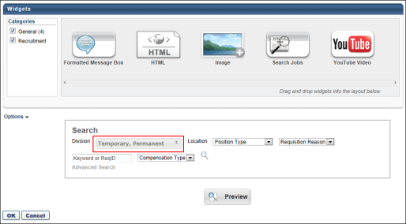
Preview
To view a full screen preview of the career site, click the Full Screen Preview icon in the upper-right corner of the Edit Layout section. This opens a new browser window and displays a full screen preview of the career site, including the header and application settings. If fields are defined as multi-select when configuring the Search Jobs widget, then the drop-down field configurations can be viewed when previewing the career site.
For portals with multiple languages enabled, the career site preview displays in the language selected in the Language field.
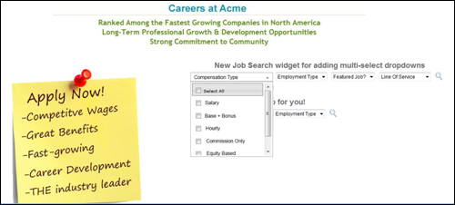
Save
Click Save at the bottom of the page to save the career site settings and return to the Career Site Management page.
Connect With Us
For information about how to add the Connect With Us link to a career site, see the Add Connect With Us Link to a Career Site topic in Online Help.
Career Site Password for Applicants
The password rules that are configured in Password Preferences at the top level Division Organizational Unit (OU) are respected and displayed to applicants when they create an account on the career site. This ensures that applicants meet the minimum password requirements that are defined for users in your organization.

Career Site - Standard Candidate Experience
Career Site - Create a Profile
To create a profile, click Create a Profile in the upper-right corner of any page in the career site. If you have already created a profile and you are logged in, this link is not available.
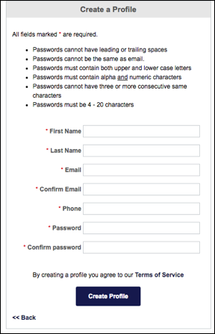
Create Profile
On this page, enter the following information to create a new applicant profile within the system:
- First Name - Enter your first name. The character limit for this field is 100. This is a required field. The following characters are invalid:
  - (
  - )
  - <
  - >
- Last Name - Enter your last name. The character limit for this field is 100. This is a required field. The following characters are invalid:
  - (
  - )
  - <
  - >
- Email - Enter the email address you would like to associate with your profile and use when logging in to the career site. The character limit for this field is 100.
- Confirm Email - Reenter your email address to ensure it is entered correctly. This email address must match the one entered above.
- Phone - Enter the phone number you would like to use as your contact number. The field accepts up to 30 characters. If Requisition and Applicant Preferences are configured by the administrator to require that applicants provide a phone number, then you cannot register without completing the Phone field. Note: The system does not check the validity of the phone number.
- Password - Enter the password you would like to use when logging in to the career site. The minimum criteria for the password is provided on the page.
- Confirm Password - Reenter your password to ensure it is entered correctly. This password must match the one entered above.
- Language - This field only displays for portals with multiple languages enabled. Applicants select the language from the drop-down, and the selection will be the applicant's default language for the career site.
- CAPTCHA - Enter the text from the CAPTCHA box. The text must be entered correctly in order to create a profile. If the information is not entered correctly, the text will refresh and need to be entered again until it is entered correctly. Note: The availability of this functionality is controlled by a security setting which can be managed in the Security Health Check tool.
- Terms of Service - Check the box to agree to the terms of service. The box must be checked in order to create a profile.
Click Create Profile to create a new profile. This creates a new user in the system.
Candidate Email Verification
If email verification is enabled by the administrator in Feature Activation Preferences, candidates may be required to verify their email address prior to having access to their account on the career site. When they click Create Profile, a pop-up appears indicating that an email has been sent to them with a link to verify their email.
Note: The email that is sent to the candidate is not customizable. This is a system-generated email. In order for the email to fire, a default "from" email address must be present in a backend setting. The backend setting can be configured by contacting Global Customer Support.
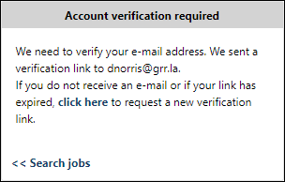
Clicking the link in the email takes them to an account verification confirmation page, which lets them know the verification was successful. Once their email is verified, they can access their My Profile page on the career site.
Potential Duplicate Applicants
If the Prevent Duplicates option is selected by the administrator in Requisition and Applicant Preferences, then the system performs a duplicate applicant check each time an applicant attempts to create a profile on the career site. When Create Profile is clicked, the system checks the applicant's phone number and first and last name against existing applicants.
- If an exact match is found, then the applicant is redirected to the Forgot Password page so that they can log in to the career site with their existing profile to apply to the job.
- If an applicant's phone number has the same numerals as a phone number that is already associated with a profile, the applicant will not be able to create a second profile using that phone number, even if one of the phone numbers includes special characters.
For more information about preventing duplicate applicants, see the Duplicate Applicants - Identify and Reduce topic in Online Help.
Back to Search
Click Back to Search to return to the Job Search or Job Details page from which the user came.
Terms of Service
Click Terms of Service to view the Cornerstone OnDemand terms of service in a new browser window.
Career Site - Sign In and Self Register
The Sign In/Self Register page is the primary page used to create and sign in to applicant profiles. From this page, users can log in using their LinkedIn credentials, log in using their system credentials, or create a new profile.
Note: When applying directly using LinkedIn, the Sign In/Self Register page is bypassed. However, the system still creates a user in the system using a unique profile identifier from LinkedIn. This allows for the user to re-log in using their LinkedIn profile.
Career Site Password for Applicants
The password rules that are configured in Password Preferences at the top level Division Organizational Unit (OU) are respected and displayed to applicants when they create an account on the career site. This ensures that applicants meet the minimum password requirements that are defined for users in your organization.
Access/View Sign-In Page
To access the Sign In page, click the Log In link in the upper-right corner of any Career Site page.
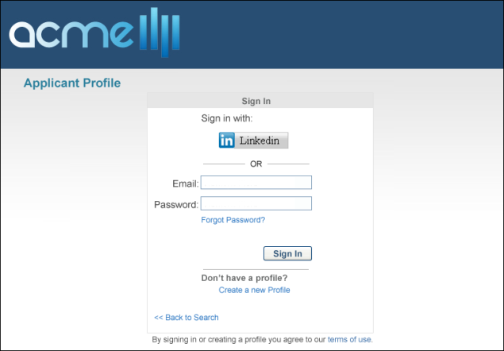
The header appears on every Career Site page for job seekers except the login page. The appearance of the page header is configured using the Custom Page Builder. See Create Career Site - Settings for additional information.
Sign in with LinkedIn
When a user the Sign in with LinkedIn on the Sign In page, the following scenarios occur:
- If the user is not logged in to the career site, then the user must enter their LinkedIn credentials. When the user enters their LinkedIn credentials, the system checks whether the LinkedIn account is already connected with a user within the system.
  - If the LinkedIn profile is already linked to a user account within the system, the system checks whether an email address is stored for the user.
    - If an email address is stored for the user, the user is logged in to the system.
    - If an email address is not stored for the user, the user must enter a contact email address via the Contact Email Address pop-up in order to log in to the system.
  - If the LinkedIn profile is not already linked to a user account within the system, the user must enter a contact email address via the Contact Email Address pop-up in order to log in to the system.
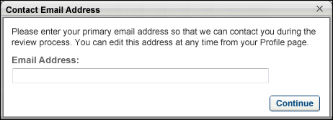
When a users logs in to the system using LinkedIn, the system generates a unique user in the system for that LinkedIn profile. The system pulls the user's First Name, Last Name, and Resume file from their profile. This connection between the system and LinkedIn allows users to return to the system career site and continue to sign in with LinkedIn and access their profile.
This option is only available if the "Allow apply with LinkedIn" option was selected when creating the career site.
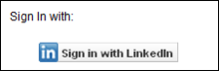
Sign in with Seek
For applicants who already have a profile on the career site but are logged out, they can sign in with Seek if the Apply with Seek integration has been enabled for the portal.
Clicking Sign in with Seek opens the login screen for Seek. Applicants can log in to their Seek profile, and then they are returned to the career site.
If you are already signed in with Seek but are not logged in to the career site, clicking Sign in with Seek will sign you in to the career site without opening the Seek login screen.
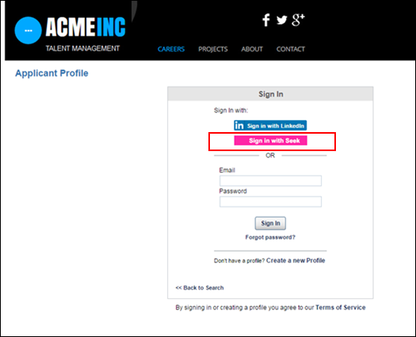
Sign in with System Credentials
To sign in to a profile that was created within the system, enter the email address and password you used to create the profile and click Sign In.
The character limit for the Email filed is 200. The character limit for the Password field is 200.
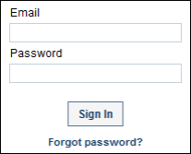
If you forgot your system password, click Forgot password? to retrieve your password. This opens the Forgot Password pop-up. Enter the email you used to create the system profile and click Submit. This triggers the Forget Password email, which enables you to reset your password. The character limit for the Email field is 200.
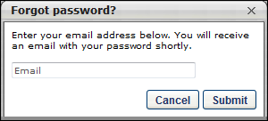
Maximum Log-In Attempts
Applicants have a maximum of five failed log-in attempts. The account is locked when the applicant fails to log in on the sixth attempt.
Create a New Profile
If you have not yet created a profile, click Create a new Profile. This opens the Create a Profile page. See Career Site - Create a Profile on page 133 for additional information.
Back to Search
Click Back to Search to return to the Job Search or Job Details page from which the user came.
Terms of Service
Click Terms of Service to view the Cornerstone OnDemand terms of service in a new browser window.
EMAIL NAME | EMAIL DESCRIPTION | ACTION TYPE

Forget Password | If the Password Reset Option in Password Preferences is set to Reset By Email Notification, then the Forget Password email is triggered when a user clicks Forgot Password? on the Login page. This email can be sent to External User or Internal User. If the user clicks Forgot Password? multiple times and a password reset URL is included in the email, then a new URL is generated for each email and the previous URL is no longer valid.  This email must be configured for administrators to select the "Send Password Reset Email to user's email address" option when resetting a user's password on the Admin - Users page.  The PASSWORD.RESET.URL email tag is a link that opens a page on which the user can create a password. If this email is sent multiple times to the same recipient, then this URL is regenerated each time and the previous URL is no longer valid. Also, the password reset URL is only valid for 48 hours. If the user does not reset their password within the 48-hour validity period, then the user must click Forgot Password? again to get a new password reset URL.  Defining Availability  The availability settings do not apply to external users when External User is added as a recipient in the Send To field.  When Internal User is added to the Send To field, the availability settings defined in the Availability field apply to internal users based on the organizational unit (OU) to which they belong. The following rules apply by OU:  Organizational Unit Rule  Cost Center Cost Center if user is part of the Cost Center  Custom Group Custom group if user is part of the Custom Group  Division Division user belongs to  Grade Grade user belongs to  Location Location user belongs to  Position Position user belongs to  Self-Registration Group Self-Registration group if user is part of the group  User User if user is added individually | System Administration
Career Site - Log-in and Profile Bar
The Log-in/Profile bar is required on all Career Site pages and is used to log in to, log out of, create, and edit a profile. The Log-in/Profile bar cannot be configured and always appears below the page header.
Create a Profile
If the user has not yet created a profile, users can click the Create a Profile link. See Career Site - Sign In and Self Register on page 137 for additional information.
Language
For portals with multiple languages enabled, when applicants are logged in to a career site, a language selector drop-down displays in the upper-right corner of career site pages to enable applicants to view the career site, search for jobs, and view search results and job ads in their preferred language. To choose the language, applicants select the language from the drop-down and click Yes in the confirmation prompt. This updates the career site to display in the selected language.
If the applicant's preferred language is not available, then by default, the career site displays in the default language of the career site.
Note: The header and footer only display in the applicant's language if a value is defined in the applicant's preferred language. If the header/footer is not configured in the applicant's language, then they display in the career site's default language.
Note: The confirmation pop-up does not display for anonymous users.
Change Language
If an applicant changes the selection in the language drop-down, the language on the applicant's My Profile page also changes.
My Profile
To view their profile, users can click My Profile. See Career Site - My Profile Overview on page 87 for additional information.
Log In
If the user has created a profile, but is not logged in, users can click Log In. See Career Site - Sign In and Self Register on page 137 for additional information.
Log Out
To log out of their account, users can click Log Out.
Standard Career Site - Job Search
The Job Search page for standard career sites is where potential applicants search for open positions that are available on an organization's Career Site page. Any job requisition that is marked to be posted to a specific career site is available on the Job Search page.
Note: The appearance of the Job Search page is configured using the Custom Page Builder, including the page header and each of the widgets, and each Job Search page can be unique. See Create Standard Career Site on page 123 for additional information.
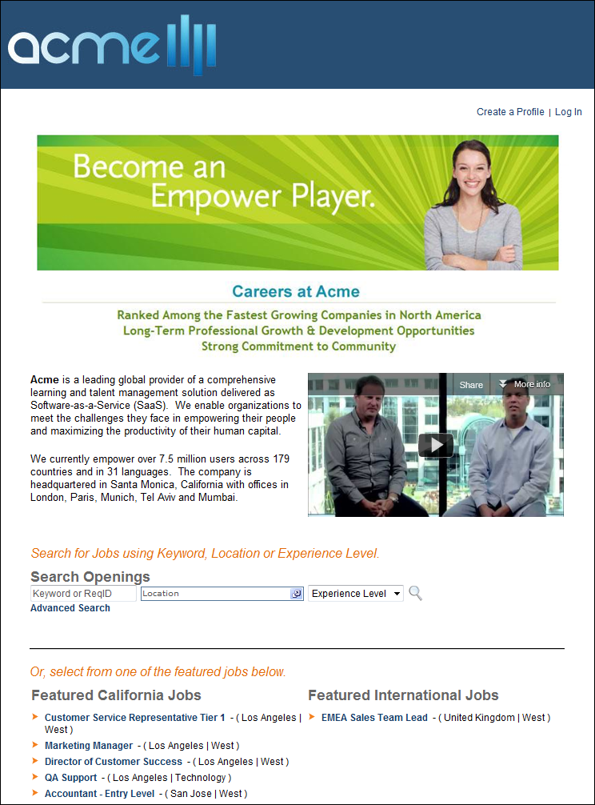
Log In/Profile Bar
The Log In/Profile Bar appears on every Career Site page for job seekers. The available options depend on whether the user is logged in to the system. See Career Site - Log-in and Profile Bar on page 142 for additional information.
Job Search
The Job Search page only displays job postings that are posted to the particular career site. Also, only jobs that are still open and have not expired appear on the career site. Each job page refreshes twice daily at 12PM and 12AM in order to add and remove job openings.
When the Job Search page loads, the page is displayed in the user's system language.
The search options that are available are dependent upon the settings enabled by the administrator when configuring the career site. Some search filters may allow the applicant to select multiple values in the filter drop-down, which provides applicants with additional flexibility when searching for jobs on the career site.
The job search options may include the option to search by radius. Applicants can select from predefined radius options to search for jobs within the selected radius of the location.
Requisition ID
If enabled by the administrator when configuring the career site, the requisition ID displays in parentheses to the right of the job title in the search results. Displaying the requisition ID allows applicants to know the ID for a particular requisition.
Note: The administrator must check the Include in Results box when configuring the career site in order for the requisition ID to display in the search results.
Related Requisition (Apply to Multiple Jobs)
When searching for jobs on the career site, the parent requisition and Related Requisitions (Apply to Multiple Jobs) are searchable. If the user opens the parent requisition, then the list of related requisitions displays on the parent requisition's Job Details page. If the user opens a related requisition, then the related requisitions and parent requisition are listed on the Job Details page for the related requisition.
Search Results
Table Display
If the career site is configured by the administrator to display the job search results as a table, then the search results display in a sortable table format. Applicants can sort the results by each column.
The columns that display are the columns defined by the administrator when configuring the career site. If the Distance column displays, the distance is defined as the number of miles/kilometers that the job is located from the address, city, state/province and postal code search fields.
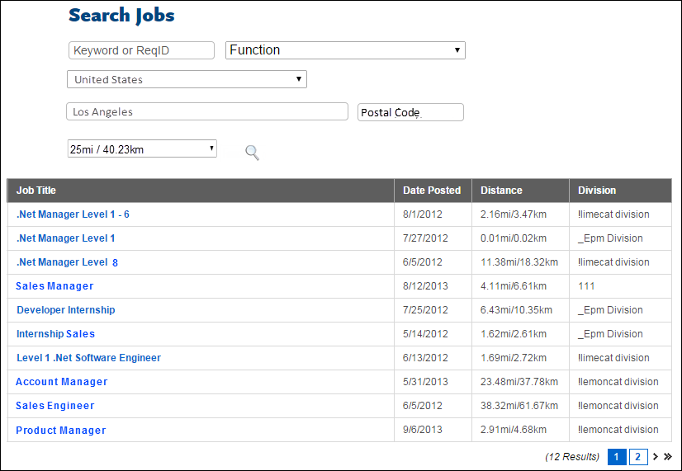
Map & Table Display
If the career site is configured by the administrator to display the job search results as a table, then the search results display in a sortable table format, as well as a map view. The table includes a Map Pinpoint column in addition to the columns that display in the table-only view. The column displays the linked number of the job corresponding to the pinpoint on the map.
Each job requisition within the search radius is numbered on the map. Clicking a number in the map or in the table displays a hover message over that map pinpoint. The job requisition title and address location displays in the hover message. If more than one requisition is located at a single address, then the hover displays the number of requisitions at that location along with the location address.
The map is interactive. Applicants can zoom in or out or re-center the map.
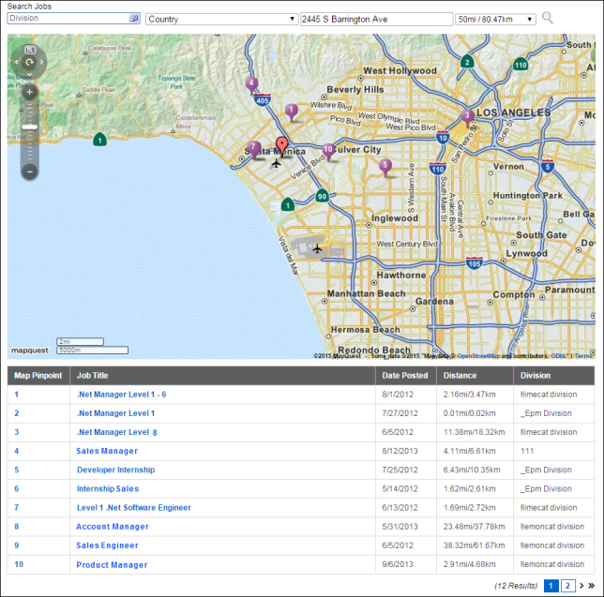
Share Search
Using the Share Search option, you can generate a static link to a list of predefined job search results and can share the link with others or embed the link in a button on the career site landing page. The link opens the job search results that you generated so that you can highlight featured jobs. When the link is accessed, search results are displayed immediately based on the predefined criteria. Users do not have to click Search in order for the search results to display.
Note: The Share Search link is only available if enabled by the administrator in the Search Jobs Widget settings.
To generate a link:
- Conduct a job search on the career site.
- Once the search results display, click Share Search.
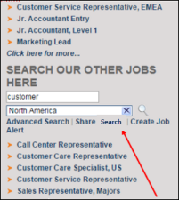
- Clicking Share Search opens a Share Search pop-up. The link displays in a text box in the pop-up. Copy the link in the text box.
- Click Done.
You can now share the link or embed it in a button, perhaps on the career site landing page or another page in order to feature jobs based on the linked search criteria. This can be done by configuring the HTML on the page to include this link as the target when the button is clicked. When the link is accessed, the job search results display based on the search criteria associated with the link.
Note: If the content or status of the jobs changes after the link is generated, the search criteria associated with the link may not generate the same exact results that were present when the link was created.
Job Alerts
If enabled by the administrator, applicants can create job alerts from the career site to inform them of upcoming open jobs that match their career interests. The job alerts are matched to the search criteria that the applicant defines on the Job Search page.
The job alerts are specific to the career site from which the applicant created the job alert.
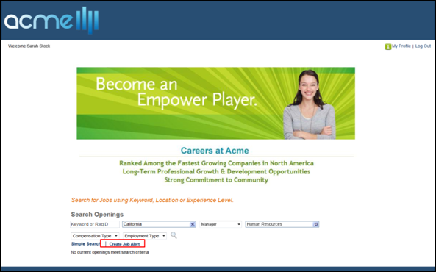
Create Job Alert
To create a job alert:
- Define at least one job search criterion in the search fields. At least one criterion must be defined. Note: If the career site displays a list of featured jobs instead of job search options, then defining search criteria is not required. The job search is created based on the list of featured jobs.
- Click Create Job Alert on the career site homepage. This opens the Create Job Alert pop-up. Note: If the applicant is not logged in to the site, then this opens the Login page. The applicant must log in to the site or create a profile if they do not currently have a profile. When the applicant returns to the search jobs page, if they defined search criteria prior to clicking the Create Job Alert link, then the search criteria displays. See Career Site - Sign In and Self Register on page 137 for additional information.See Career Site - Create a Profile on page 133 for additional information.
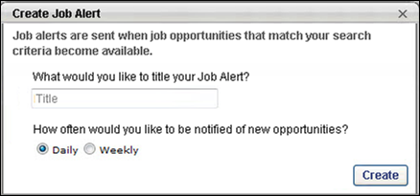
- Complete the following fields in the Create Job Alert pop-up:
  - What would you like to title your Job Alert? - Enter a title, up to 60 characters. This is a required field.
  - How often would you like to be notified of new opportunities? - Select from the following options to define the frequency of the job alert:
    - Daily - Select this option to receive job alerts on a daily basis. Job alerts are sent at 1:00am PST on each day for which there is at least one requisition that meets the criteria the applicant defined for the job alert. This option is selected by default.
    - Weekly - Select this option to receive job alerts on a weekly basis. Job alerts are sent each week at 1:00am PST beginning one week from the date on which the job alert is created and only if there is at least one requisition that meets the criteria the applicant defined for the job alert.
- Click Create. This closes the Create Job Alert pop-up and returns the applicant to the Job Search page.
Once the job search is created, the criteria defined on the search jobs page are matched against the organization's open positions. A job alert email is sent on either a daily or weekly basis that includes links to the available jobs that match the applicant's job search criteria.
Note: Job alerts only apply to the career site on which the job alert applies to all of an organization's career sites. It is not necessary for the applicant to create a separate job alert on each of an organization's career sites.
Job Alert Expiration
Job alerts expire 90 days from the date of creation. The 90 days includes the date of creation.
Search Jobs with Multiple Locations
When a job requisition is configured with multiple locations, applicants will be able to find the job by viewing the additional locations that are associated to the parent requisition, as well as using the Location filter to search for specific locations.
The following considerations apply based on the search:
Search Jobs - List View
When viewing the search results in list view, the value in the Primary Location field on the requisition displays as the main location for the job in the career site. Applicants can view the additional locations by clicking More to the right of the primary location. This opens the Job Locations pop-up, displaying the additional locations.
Search Jobs - Location Filter
When using the Location filter to search for jobs, and there is an exact match for the location, then the search results will display the job that is the exact location match. This is also true for job requisitions with multiple locations. If an applicant searches for a specific location using the Location filter, and a job with multiple locations has an exact location match, then the search results will display the job with its matching location indicated. The city in the Location City column, if displayed, corresponds to the displayed location.
However, the displayed location may not be the primary location, but rather the most relevant location based on the search criteria. A More link will also display to the right of the location so that applicants can view all additional locations that are configured for the requisition. Similarly, a More link will display to the right of the city in the Location City column so that applicants can view all cities that correspond with the locations that are configured for the requisition.
Search Jobs - Geolocation Filter
When applicants use the geolocation filter, if there are additional locations configured for the requisition, the locations will display when the applicant clicks the More link to the right of the location that matches the geolocation search.
For jobs with multiple locations, the pin drop on the map, and the distance in the Distance column of the table, if displayed, is based on the closest location to the value defined in the geolocation filter. If there is no city configured for the location in the requisition, then a View All link will display, allowing applicants to view the other locations that are configured for the job.
Search Examples
- Example 1: Parent Location OU Is Not Associated with Requisition - An applicant selects California in the Location filter. A job requisition has Los Angeles, San Diego, and New York configured as additional locations. The searched location, California, is not associated with the requisition, though it is the parent location organizational unit (OU) of Los Angeles and San Diego, as configured in the OU settings. The search results will display that job with either Los Angeles or San Diego as the as the location. The More link will display next to the location. When the applicant clicks More, the list of locations will display in alphabetical order as Los Angeles, New York, and San Diego, but California will not display as a location. Locations are listed in alphabetical order.
- Example 2: Parent Location Is Associated with Requisition - An applicant selects California in the Location filter. The California location is the primary location for a requisition and is the parent to Los Angeles and San Diego. This requisition also has New York as an additional location. The search results will display this job with California as the displayed location. The "More" link will display next to the location. When the applicant clicks More, the list of locations will display in alphabetical order as California, Los Angeles, New York, and San Diego.
- Example 3: Parent Location Is Associated with Requisition - An applicant selects Los Angeles in the Location filter. The Los Angeles location is a child location of California, and California is the primary location for a requisition. The requisition also has San Diego and New York as additional locations. The search results will display the job with Los Angeles as the displayed location. The "More" link will display next to the location. When the applicant clicks More, the list of locations will display in alphabetical order as California, Los Angeles, New York, and San Diego.
Job Alerts for Requisitions with Multiple Locations
When applicants create job alerts, the job alert considers any additional locations that are configured for the requisition so that applicants receive alerts for requisitions that are related to their preferred location. However, alerts for a multi-location requisition will not be sent if a location OU is used in the criteria and the requisition does not have that OU associated with it, even if subordinate location OUs are associated with the requisition.
- Example: Parent Location Is Not Associated with Requisition - An applicant selects California in the Location filter and chooses to have job alerts sent for matched positions. The Los Angeles location is a child location of the chosen California location OU, and Los Angeles is the primary location for a requisition. The requisition also has San Diego and New York as additional locations. Job alerts for this requisition would trigger based on the California location criteria only if California is a location associated with the requisition. Since it is not directly associated with the requisition, even though its subordinates (Los Angeles and San Diego) are on the requisition, the job alert will not trigger.
Career Site - Job Details
The Job Details page is used to display the full job ad for a position. On the Job Details page, users see the exact job ad that was created as part of the requisition. The left frame of the page contains a static set of tools that are available to the user at all times when viewing a job ad. This set of tools allows the users to:
- Apply for the selected job (with or without LinkedIn).
- Email the selected job opening to a friend.
- Add the selected job opening to their list of saved jobs.
The page is organized into four sections:
Header
The header appears on every Career Site page for job seekers. The appearance of the page header is configured using the Custom Page Builder. See Create Career Site - Settings for additional information.
Log-in/Profile Bar
The Log-in/Profile Bar appears on every Career Site page for job seekers. The available options depend on whether the user is logged in to the system. See Career Site - Log-in and Profile Bar for additional information.
Toolset Sidebar
The toolset sidebar is where the user has the ability to take action on a selected job opening.
The following options are available:
Apply with Seek
For portals with Apply with Seek enabled, an Apply with Seek button displays on the job details page of the career site. Applicants can click the button to apply to the job using their Seek profile. This opens a Seek pop-up that allows the applicant to sign in to Seek and apply. Once signed in to Seek, the applicant is taken to the first step in the application workflow for the job.
As soon as an applicant signs in to Seek from the career site, the a candidate profile is created for the user in the organization's portal.
Apply Now
Click this option to begin applying for the position without using information from LinkedIn.
- If the user is logged in either with LinkedIn or system credentials, the user is taken to the first step in the application process.
- If the user is not logged in, the user is taken to the Sign In/Self Register page. Upon logging in or creating a new profile, the user is taken immediately to the Application page for the selected job. See Career Site - Sign In and Self Register for additional information.
- If the user is logged in and has already completed the application for the position, this option is not available. Instead, a message displays the date on which the user applied for the position.
- If the user is logged in and has partially completed the application for the position, this option is not available. Instead, the user's completion percentage is displayed and a Continue Application button appears.
Continue Application
This option appears if the user is logged in and has partially completed the application for the position. The user's completion percentage is displayed below the button. Click the Continue Application button to return to the last completed page in the application process.
Complete Application
For applicants that are submitted by a recruiting agency, a Complete Application button displays instead of an Apply Now button. Clicking the button opens the application workflow. Further, the Job Details page identifies the requisition as an agency submission below the Complete Application button. The date on which the submission was submitted also displays.
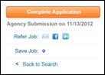
Refer Job
The Refer Job field allows applicants to refer the job. The referral options that are available are determined by the administrator. The following options may be available:
- Send to a Friend - Click the Send to a Friend icon to email a job referral. This opens the Send to a Friend pop-up box. Note: The content of the email is defined by the administrator and cannot be modified by the sender. Typically, the email indicates that a friend is referring the job and also includes a link to the Job Details page on the career site, as well as the job ad for the position.
- Recipient email address(es) - Enter the email address of the friend to whom you are sending the job ad. You can send the job ad to multiple friends at once by entering multiple email addresses in this field, separating each address with a comma. The character limit for this field is 250.
- Your First Name - Enter your first name, up to 100 characters.
- Your Last Name - Enter your last name, up to 100 characters.
- Language - Use the drop-down to select the language in which the email should be sent. Administrator Note: The languages available in the drop-down are the languages configured for each instance of the Referral to External User email in Email Management. If the email is configured in multiple languages, then each available language displays in the drop-down.
- CAPTCHA - Enter the text from the CAPTCHA box. The text must be entered correctly in order to create a profile. If the information is not entered correctly, the text will refresh and need to be entered again until it is entered correctly. Note: The availability of this functionality is controlled by a security setting which can be managed in the Security Health Check tool.
Once all fields are completed, click Send. This sends the Referral to External User email to the recipients. The content of the email is configured by the administrator and cannot be viewed or changed by the applicant referring the job. Note: A confirmation email is not sent to the referrer.
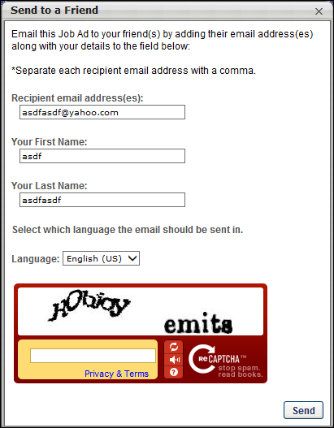
- After entering both email addresses, click Send. A notification bar appears at the top of the page, indicating the email has been sent.
- Share this Job on Facebook - Click the Share this Job on Facebook icon to share the job with their Facebook friends. See the Share Column section in the Search Other Jobs - Job Details topic for information on sharing a job with Facebook friends. Note: If the image or post is not appearing as expected, you can validate what is being sent to Facebook by pasting the URL of the job details page into Facebook's sharing debugger: https://developers.facebook.com/tools/debug/
- Share this Job on LinkedIn - Click the Share this Job on LinkedIn icon to share the job with their LinkedIn network. See the Share Column section in the Search Other Jobs - Job Details topic for information on sharing a job with LinkedIn connections. Note: If the image or post is not appearing as expected, you can validate what is being sent to LinkedIn by pasting the URL of the job details page into Facebook's sharing debugger: https://www.linkedin.com/post-inspector/
Save Job
To save the job opening to your list of saved jobs, click Add to Saved Jobs.
- If you are logged in either with LinkedIn or system credentials, the job is added to your list of saved jobs on the My Profile page. The link is then hidden.
- If you are not logged in, you are taken to the Sign In/Self Register page. Upon logging in or creating a new profile, you are taken back to the Job Details page from which you came. See Career Site - Sign In and Self Register for additional information.
- If the job is already in your list of saved jobs, this option is not available.
Back to Search
Click Back to Search to return to the Job Search page from which you came.
Note about Applying with LinkedIn: For portals that have Apply with LinkedIn (With Apply Starters) enabled, applicants can apply to the job using LinkedIn once they are in the application workflow. See Application - Apply with LinkedIn on page 70 for additional information.
Related Jobs
If the job requisition is configured to have a parent-child hierarchical relationship, then a Related Jobs section displays in the left panel of the job details page. This section lists all job requisitions that are child requisitions of the parent. Applicants can view the job details for the child requisitions by selecting the job requisition name.
The child requisitions display in descending order of requisition ID. In order for the child requisition to display, the child requisition must be open and not expired.
If there are no child requisitions available, then the Related Jobs section displays "No related jobs."
Apply to a Single Related Job
Some related jobs are configured so that applicants can only apply to one of the related jobs at a time. For these related jobs, applicants can apply to the related job when viewing the Job Details page of the related job.
Apply to Multiple Related Jobs
Some related jobs are configured so that applicants can apply to more than one of the related jobs in a single application. For this type of requisition, applicants can apply to up to 10 related requisitions at the same time. Applicants can also apply to the parent requisition if configured to allow applicants to apply, but can then only apply to up to nine related requisitions.
To apply to multiple related requisitions, applicants access the Job Details page on the career site for the parent or a related requisition. The related requisitions are listed in the left panel on the Job Details page under the heading "Select All Jobs of Interest to Apply." Clicking the job title opens the Job Details page for the related requisition.
Note: When viewing the Job Details page for a related requisition, if applicants are allowed to apply to the parent requisition, then the parent always displays first in the list of related requisitions. If applicants are not allowed to apply to the parent, then the parent does not display in the list of related requisitions and the related requisitions display in order of highest to lowest priority.
Note: Related requisitions only display if the requisitions are in an Open status and their posting dates have not expired.
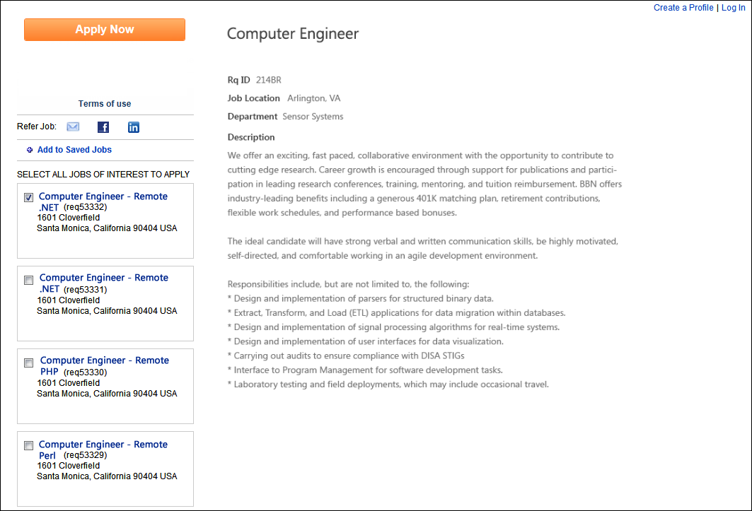
The following information displays for each related requisition:
- Job Title
- Requisition ID
- Street Address
- City/State/Region
- Postal Code
- Country/Country Code
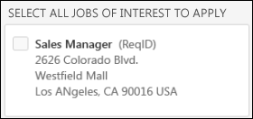
If the applicant has already applied to any of the related requisitions, the status of the application displays for the requisition.
A checkbox also displays for each related requisition. Applicants check the box next to each related requisition to which they would like to apply. Note: When viewing the Job Details page of a related requisition, if the parent requisition is configured not to allow applicants to apply, then the parent requisition does not display in the list of related requisitions.
Once the applicant has checked the requisitions to which they would like to apply, the applicant clicks Apply Now. This opens the application, and allows the applicant to apply to all of the selected jobs by completing a single application. The date on which the applicant applied displays in the related requisitions list on the Job Details page for each related requisition to which the applicant applied.
Re-Applying to Related Requisitions
If the administrator has configured General Preferences so that applicants cannot re-apply to jobs, then once the applicant applies to the selected jobs, the option to re-apply is not available. The date on which the applicant applied to the related requisition displays in the related requisitions list on the Job Details page.
Recruiting Agency Submissions
For applicants submitted by a recruiting agency to apply to a Related Requisitions (Apply to Multiple Jobs), the applicant can only apply to the current requisition. A Continue Application link displays in the left panel for the related requisition, allowing the applicant to access and complete the application. The date on which the applicant was submitted by the agency also displays.
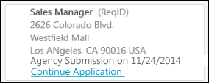
Applicants submitted by a recruiting agency can re-apply to the requisition if the administrator has configured General Preferences so that applicants can re-apply to jobs.
Incomplete Application
For applicants applying to a single Related Requisitions (Apply to Multiple Jobs) who have not yet submitted an application that they started, a Continue Application link displays in the left panel for the requisition, allowing the applicant to access and complete the application.
Refer Job
When using the refer job options on the Job Details page, the job that is being referred is the current job on the page. The related requisitions are not included in the referral.
Save Job
When using the Save Job option on the Job Details page, the job that is saved is the current job on the page. The related requisitions are not also saved, regardless of whether or not any related requisitions are selected.
Applicants Not Allowed to Apply to Parent Job Requisition
If the parent job requisition is configured by the recruiter not to allow applicants to apply to the parent, then applicants can only apply to the child requisitions that are associated with the parent. Applicants can use the Related Jobs list to find and apply to one or more related requisitions. An option to apply to the parent requisition will not be available.
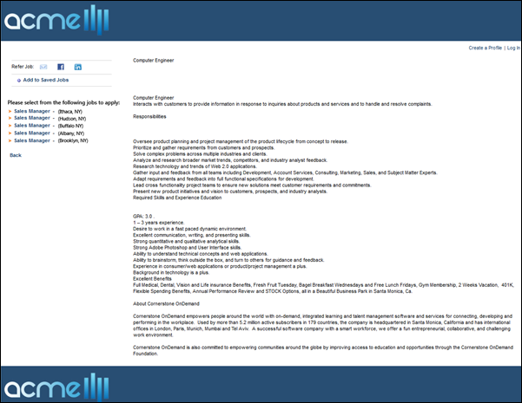
Job Ad Display
The job ad displays exactly as it is configured on the External Site tab of the Job Ad step when creating the job requisition. See Create Job Requisition - Job Ad for additional information.
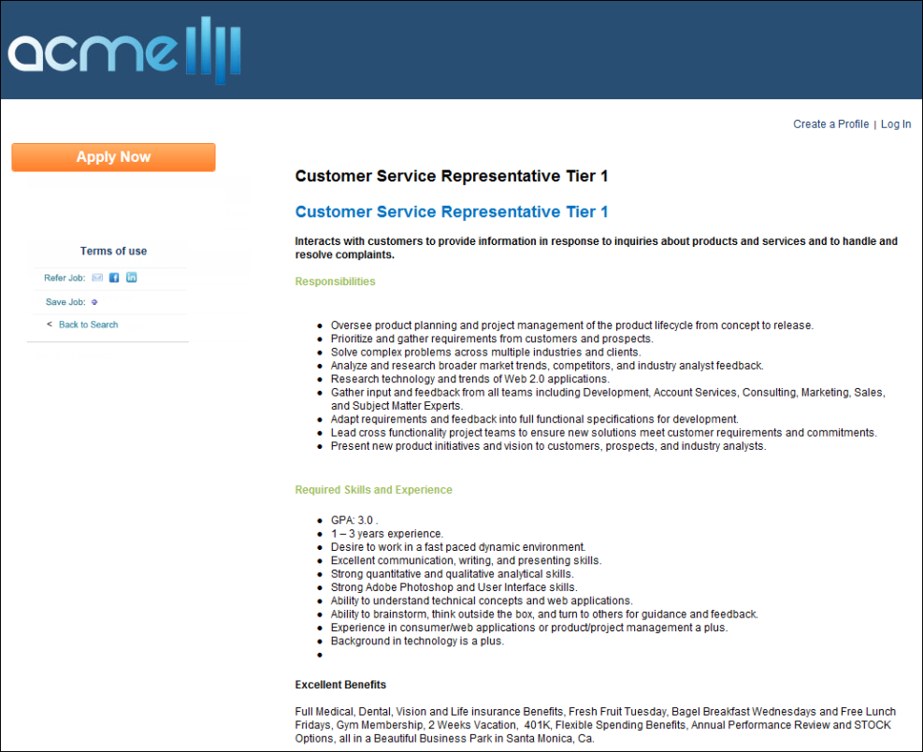
Career Site - Connect With Us
The Connect With Us page allows applicants to apply to an organization directly, rather than applying to a specific job requisition. Applicants fill out the form and submit their information. Once submitted, applicants can be emailed when a position that is seen as a good fit for the applicant opens in the organization.
To access the Connect With Us page, applicants click the Connect With Us link, which appears under the career site name on the career site homepage.
Note: The name of the Connect With Us form may vary, depending on the administrator's configuration of the form. The form description and background image may also vary.
Emails
EMAIL NAME | EMAIL DESCRIPTION | ACTION TYPE

Connect With Us New User | This email is triggered when a user submits their information via Connect With Us. The email can be sent to External Users. This email can be configured as a Notification type email. This email is active by default and can be found in the Recruitment t action type section of Email Management. | Recruiting
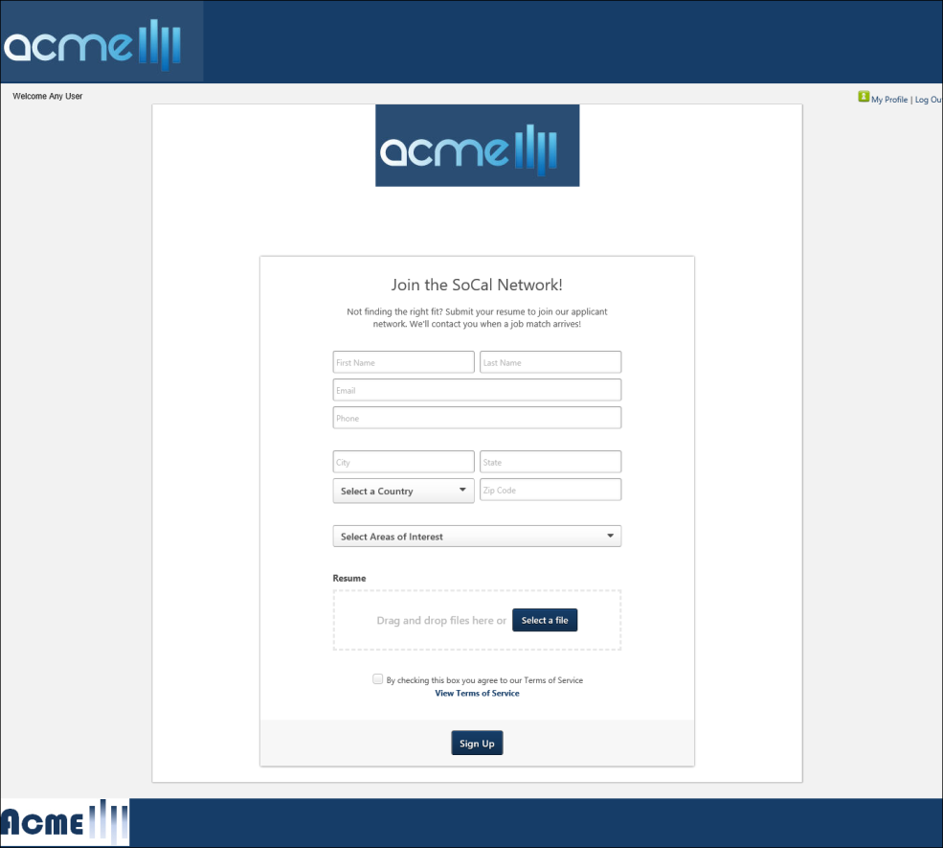
Apply with LinkedIn/Seek
The Apply with LinkedIn and Apply with Seek options are only available if enabled by the administrator. Applicants can click the button to use their LinkedIn or Seek profile to apply to the organization. This opens a pop-up that allows the applicant to log in to their LinkedIn or Seek profile.
Once logged in to their LinkedIn or Seek profile, their applicable profile data populates the Connect With Us form. If the option to include a resume is available on the form (enabled by the administrator on the Connect With Us page), then the applicant's LinkedIn or Seek profile serves as their resume.
Applicants can modify their parsed data in the Connect With Us form fields, and then click Sign Up to apply to the organization, which also creates a profile for the applicant in the career site and a user in your portal.
Note: Using one of these options does not allow an applicant to apply directly to a job requisition. These options are only used to provide applicant data for the Connect With Us functionality.
Note: If the administrator has disabled the option to parse the resume, then the applicant's LinkedIn or Seek profile data does not automatically populate the Connect With Us form fields. The applicant will need to fill out the fields manually, including attaching a resume, if the option to include a resume is enabled by the administrator.
Duplicate Applicant Prevention
For existing applicants who already have a profile in the career site but who attempt to apply with their LinkedIn or Seek profile via Connect With Us, a message will display to indicate that they are already connected with the organization. This prevents applicants from creating duplicate profiles.
Form Fields
Complete the following fields on the Connect With Us form. Some fields may not be available if they are disabled by the administrator when configuring the Connect With Us page.
- First Name - Enter your first name, up to 100 characters.
- Last Name - Enter your last name, up to 100 characters.
- Email - Enter the email address you would like to associate with your profile and use when logging in to the career site. The character limit for this field is 100.
- Phone - Enter the phone number you would like to use as your contact number, up to 30 characters.
- City - Enter your city name, up to 35 characters.
- State - Enter your state, up to 30 characters.
- Select a Country - Select a country from the drop-down.
- Zip Code - Enter your ZIP Code, up to 20 characters. This field is optional.
- Select Areas of Interest - Click the drop-down and check all areas of interest that apply to you. The areas of interest are a feature that recruiters use to search for applicants for open positions. The list displays in alphabetical order.
- Resume - Drag and drop your resume file to the field. Or, click Select a file to upload a resume.
Click Sign Up to submit the form. This opens a Thank You page, from which you can create a profile in the career site.

