APIs March 2024

Table of Contents
APIs (Web Services) - Overview 1
Edge - Developer Portal Overview 5
API (Web Services) Technical Specifications 6
API (Web Services) Throttling 14
Edge API - Purchase Inquiry 16
Bulk API 19
Bulk API - API History 26
API Management 29
API Authentication - OAuth 2.0 - Granular Scopes 32
APIs for Core/General - Overview 34
Approvals API 35
Capabilities Library and User Profile Bulk API 36
Employee API v1 37
Employee/OU API 38
Global Search API 41
APIs for Learning - Overview 42
Catalog Search API 43
Certification API 44
Certification Details API 45
Certification Transcript API 46
Custom Field API 47
Express Class API 48
Learning Assignment API 50
Learning Object (LO) API 52
Learning Object (LO) Transcript API 54
Session Roster API 55
Tin Can (xAPI) 56
Training Unit API 62
Transcript and Task API 63
Transcript API 64
Transcript Search API 65
APIs for Performance - Overview 66
Goal API 67
Performance Review API 68
APIs for Recruiting - Overview 69
Application Workflow API 70
Candidate API - Overview 71
Job Application API (Early Adopter) - Overview 75
Recruiting API 81
Structured Resume Details API 82
APIs for Reporting - Overview 83
Data Exporter API - Access Core Objects Over API 84
Relationship Diagrams for Data Exporter API 87
Reporting API 90

APIs (Web Services) - Overview
Cornerstone provides our customers and partners the ability to easily integrate with Cornerstone using APIs (web services). APIs provide instant and programmatic access to Cornerstone data to support domain and reporting use cases. This includes on-demand access to do the following:
- Read data from Cornerstone.
- Create and update data in Cornerstone.
Implementation
The customer is responsible for any infrastructure and development to call or execute Cornerstone APIs. Cornerstone does not offer to develop custom code or custom APIs, and Cornerstone does not develop or debug customer's source code.
Terminology
The following terms are commonly used when discussing APIs:
- REST (Representational State Transfer) - An architectural style for providing standards between systems on the web, making it easier for systems to communicate with each other.
- OData (Open Data Protocol) - An open protocol (OASIS standard) that defines best practices for building and consuming RESTful APIs.
- SOAP (Simple Object Access Protocol) - An XML-based protocol for exchanging structured information across domains.
- JSON (JavaScript Object Notation) - A lightweight and text-based data-interchange format. JSON has become one of the fundamental industry standards to exchange data via web services because it is easy for humans to read and write and also easy for machines/browsers to parse and generate.
- OAuth 2.0 (Open Authorization) - An industry standard authorization framework that supports the consumption of RESTful APIs.
  - Any new integrations built using Cornerstone's APIs must use OAuth 2.0.
  - For more information, please visit: http://apiexplorer.csod.com/apiconnectorweb/apiexplorer#/oauth
API Explorer
API Explorer contains the most up-to-date documentation for all REST APIs. API Explorer enables developers and partners to easily browse all available REST APIs. Developers can learn about supported features, methods, and metadata. Developers can also download guidelines and access links to sample code.
To access the Developer Portal, go to Admin > Tools > Edge > Develop > Developer Portal. Developer Portal can also be accessed directly at the following URL: https://csod.dev
Release Strategy
All clients reside on the same and latest web services version. New web services will be developed and deployed as part of the roadmap. Cornerstone does not support building custom APIs for each customer use case.
All new APIs will be developed as RESTful APIs. Any legacy SOAP web services that are still available are maintained, but they will not be further developed.
Trial Period
An unlimited trial period is available to try the Cornerstone APIs, Reporting APIs, or Bulk APIs. The trial period is available for non-productive environments (i.e., pilot, stage, and demo environments). To try an API, simply instal the integration in your Pilot, Stage, or Demo environment. The integration must be configured in each environment separately.
Pagination
To increase performance and to minimize the response size, Cornerstone web services utilize paging in its response. This means the caller will only retrieve a page of results, and not all the entities. Please review the API Explorer for the default and the maximum paging values per web service request.
- Cornerstone API - The Cornerstone API must be sequentially called by incrementing the page number attribute in the URL query until Cornerstone stops returning results.
- Reporting API - The Reporting API implements OData server-driven paging protocol. The service will inject a link into the page response to retrieve the next page of results.
- Employee/OU API - Customers can control the number of records per page through the pageSize query parameter. The service will inject into the page response an encoded string named nextPageToken that is used to retrieve the next page of results. The nextPageToken has a time to live (TTL) of five minutes.
Registering an Application
Every application that you intend to integrate using Cornerstone's APIs and OAuth 2.0 must be registered within the Cornerstone Edge API Management page. This can be done by going to Admin > Tools > Edge > API management > Manage OAuth 2.0 applications > Register New Application
You can register multiple applications with Cornerstone to get a distinct client ID and secret for each application. A client ID and client secret are required to consume RESTful APIs. Note: The client secret is only displayed once, so be sure to copy it after registering an application. If you misplace the client secret, you must regenerate it in the Cornerstone portal.
Access can be provided to multiple APIs (e.g., Cornerstone APIs and Reporting APIs) at the same time. This can be specified when registering the application.
When registering an application, the OAuth 2.0 access token validity period can be configured.
Sample Code
The Cornerstone GitHub repository contains sample code for several APIs and in popular development languages.
https://github.com/cornerstoneedge
OAuth 2.0 Scopes, Security Permissions, and Constraints
Using Scopes, organizations can control the API endpoints to which an application has access and the HTTP operations (GET, POST, PUT, PATCH) which can be performed against those endpoints. For example, an organization may grant their application access to only read employee data.
Scopes are available for all RESTful APIs. The API Explorer contains which scope is required to execute a specific endpoint or HTTP operation. See Edge - API Explorer.
Certain APIs allow organizations to further restrict an application's access using security permissions and constraints. For example, with the Express Class API, organizations can choose to allow their application to create express class records users from a specific division or geographical region. To determine whether an API requires permissions and supports constraints, review the list of permissions required for each API and the descriptions of each permission. See API (Web Services) Technical Specifications on page 6 for additional information.
The following HTTP operations may be available for an API:
- GET - Read data
- POST - Create new data
- PATCH/PUT - Update existing data
  - In Cornerstone, some web services supporting PATCH, others are supporting PUT to update data. With PUT request, you must send the full payload as the request whereas with PATCH, you only send the parameters which you want to update.
The OAuth 2.0 framework describes several grant flows or methods for acquiring an API access token. Cornerstone only supports the Client Credentials grant flow.
Frequently Asked Questions (FAQs)
Is it possible to provide an application only with access to create and retrieve learning data from Cornerstone, but not to retrieve Employee data?
Yes, this can be done by selecting only the API endpoints required to create or retrieve learning data.
Is it possible to restrict access for an endpoint to specific data only?
Certain endpoints allow you to further restrict your application’s access using security permissions and constraints.
If a specific endpoint does not support constraints, this type of security must be managed by the customer.
Why do the custom field names look different in the API explorer per portal?
The API explorer shows the current portals’ configuration.
What is the difference between a scope and a permission?
Not all APIs have permissions, but all APIs have scopes.
Most APIs require both: A scope to be assigned to the OAuth 2.0 application and token and security permissions to be assigned to the user tied to the OAuth 2.0 application
Where can I find the legacy SOAP documentation?
All Cornerstone SOAP APIs will be deprecated in Q4 of 2023.
See SOAP APIs.
Are API keys overwritten during a copy down?
No, copy downs do not impact API keys or any Edge integrations.

Edge - Developer Portal Overview
The Developer Portal is one-stop shop for API and connector documentations and examples.
The Developer Portal can be accessed via https://csod.dev and from within Cornerstone portals by navigating to Admin > Tools > Edge > Develop > Developer Portal. Once inside, click Learn more to get started.
- Users attempting to navigate to the API Explorer (https://apiexplorer.csod.com/) will automatically be redirected to the Developer Portal.
- API Explorer is accessible via a footer link on the Developer Portal.
- Full deprecation of the API Explorer is scheduled for an upcoming release.
Considerations
The Connector Tools page in API Explorer is not supported in the Developer Portal. This is true for all Connector types. Instead, integrations can be tested directly within the Cornerstone portal.
Not all Reporting endpoints available are displayed in the Developer Portal. Cornerstone is working to get them added. In the meantime, you can reference the API Explorer for the complete list of endpoints.

API (Web Services) Technical Specifications
This page displays a list of available APIs (web services).
All API technical specifications are available within the Developer Portal.
To access the Developer Portal, go to Admin > Tools > Edge > Develop > Developer Portal. Developer Portal can also be accessed directly at the following URL: https://csod.dev
Permissions
PERMISSION NAME | PERMISSION DESCRIPTION | CATEGORY

Edge Develop - API Explorer | Grants access to the API Explorer, which provides access to help documentation for various API applications. | Edge
Additional permissions may be required for each API. These permissions are listed in the API specification within the Developer Portal.
API Bundles
The following API bundles are available:
- Cornerstone API (Foundational APIs) includes the following APIs:
  - Core APIs
  - Learning APIs
  - Performance APIs
  - Recruiting APIs
- Reporting API
  - Reporting API
  - Data Exporter API
- Bulk API - Large data loads
  - Employee/OU
Core APIs
REST API Name | Description
Approvals | The Approvals API includes the following services:  - Get Approval Details - Get all pending approval items for the supported approval types for a given user.  - Post Approval Details - Approve or deny a pending approval item.  See Approvals API on page 35 for additional information.
Capabilities Library and User Profile Bulk API | See Capabilities Library and User Profile Bulk API on page 36 for additional information.
Employee API v1 | The Employee APIs allow you to create, update, and fetch user details from Cornerstone.  Note that there is a newer version of the Employee API (Employee/OU API). If you currently use the v1 version, we highly encourage you to switch to v2. The v2 endpoints have, better performance with modular endpoints, higher throttling limits, and better ability to search for an employee. See Employee/OU API on page 38 for additional information.
Global Search | The Global Search API includes the following service:  - Global Search - Use this service to get details for people, training, and certifications in the system.  This service supports the following types of searches:  - People - Search for any employees in your portal.  - Training - Search for any learning objects in your portal.  - Certifications - Search for any certifications in your portal.  - Everything - Search for people, training, and certifications in a single query.  See Global Search API on page 41 for additional information.
Organizational Unit (OU) | The Organizational Unit API includes the following services:  - Get - Get organizational unit details  - Set - Insert or update organizational unit records  See Employee/OU API on page 38 for additional information.
Users / Employees | The Employee API includes the following services:  - Get - Return User record details including Effective Date (CHR) support.  - Create/Update - Insert or update user records including Effective Date (CHR) and custom fields support. This includes data related to employee termination (e.g., employment status, termination date).  - Activation Period - Return and update the activation period of an employee record.  - User Effective Dates - Return all effective dates associated to a user record.  - Custom Fields - Return custom field data for employees.  - Groups - Return employees and the groups in their employee profile.  - User type and Employment Status -  - Return User type and Employment status details including Effective Date (CHR) support Employment status.  - Insert and update User type and Employment status data incl. Effective Date (CHR) support.  See Employee/OU API on page 38 for additional information.
Learning and Extended Enterprise APIs
REST API Name | Description
Catalog Search | The Catalog Search API includes the following service:  - Catalog Search - This service searches training data as per the input parameters of the request call. For example, a customer can search for trainings by title, description, and provider name.  See Catalog Search API on page 43 for additional information.
Certification | The Certification API includes the following service:  - Delete Certification - The purpose of the service is to remove certifications that are assigned to users.  - If there are two certifications with the same title and both are assigned to the user, then both will be removed.  - If there are two certifications with the same title and one is assigned to the user, then the assigned certification will be removed.  See Certification API on page 44 for additional information.
Certification Details | The Certification Details API includes the following service:  - Certification Details - Use this API to retrieve a certification's details, including section-level details.  See Certification Details API on page 45 for additional information.
Certification Transcript | The Certification Transcript API includes the following service:  - Transcript Details - Use this service to retrieve certification details from a user's transcript.  See Certification Transcript API on page 46 for additional information.
Custom Field | The Custom Field API includes the following service:  - Custom Field - Use this service to update training custom fields at either the learning object level or the transcript level.  See Custom Field API on page 47 for additional information.
Express Class | The Express Class API includes the following services:  - Create Express Class - This service creates an Express Class process and, in turn, creates a completed transcript record for users. The following learning object types are supported:  - Event (using Express Class, it is possible to complete an event without completing a session)  - Material  - Online Class  - Test  - Video  See Express Class API on page 48 for additional information.
Learning Assignment | The Learning Assignment API includes the following services:  - Create Standard Assignment - Use this endpoint to create a standard learning assignment in Cornerstone. You can add training to users' transcripts in Approved, Assigned, and Registered status using this API.  - Get Assignment - Once you submit a learning assignment, you can check the status of your assignment using this endpoint.  - Get Remaining Count - Use this endpoint to identify the count of remaining user assignments per day for the date provided. This helps manage throttling limits.  - Search Assignments - Use this endpoint to search for and retrieve details on an assignment created via the API or the Learning Assignment Tool.  See Learning Assignment API on page 50 for additional information.
Learning Object | The Learning Object (LO) API includes the following services:  - Get LO - Obtain details of a learning object available to an active user in the portal. The API only supports the following learning types: Curriculum, Event, Session, Material, Test, Video, and Online Course  - Create LO - Create a new learning object. All business rules configured in the portal are observed for this call. The actual payload can vary depending on the type of learning object.  - Event  - Session  - Online Course - This is a shell course; it is not launchable  - Material - This is a URL without versioning functionality.  - Update LO - Use this endpoint to update existing ILT Sessions in Cornerstone Learning. You cannot update learning objects of type other than ILT Sessions using this endpoint.  See Learning Object (LO) API on page 52 for additional information.
Learning (Transcript) | The Learning Object (LO) Transcript API includes the following service:  - Transcript Search - This service gives you the ability to retrieve users’ transcript information from Cornerstone Learning.  See Learning Object (LO) Transcript API on page 54 for additional information.
Session Roster | The Session Roster API includes the following services:  - Create - This services allows customers to update the session attendance roster and complete the session.  - Get Details - This service allows customers to get the details of a session. The service will provide all the details of a particular session for which the Session ID or Locator ID is provided in the request.  See Session Roster API on page 55 for additional information.
Training Unit | The Training Unit API includes the following service:  - Create Training Unit Assignment - This service enables customers to create new training unit assignments in the application for extended enterprise (EXE) customers. All business rules configured in the portal are observed for this call.  See Training Unit API on page 62 for additional information.
Transcript and Task | The Transcript and Task API includes the following services:  - Get Inbox Items - This retrieves all items in the user’s inbox as shown on the Welcome page widget.  - Get Suggested Training - This returns suggested training. This does not return playlists. It does not return requested, registered, or approved training. To retrieve this type of training, use the Get Transcripts service.  - Get Tasks - This represents all incomplete tasks assigned to the user.  - Get Approvals - If approvals are used in the system and the user is a manager or approver, this represents the pending approvals for his or her subordinates.  - Get Assigned Trainings - This service returns all the transcripts assigned to users, along with their statuses and due dates as applicable.  - Get Sessions - Get the upcoming sessions in a user's transcript.  - Get Transcripts - This service represents all transcript items currently in the user’s transcript. Each response can return a maximum of 50 transcript records. There is a pageNumber attribute that can be incremented to get the next batch of 50 transcript records.  See Transcript and Task API on page 63 for additional information.
Transcript Search | The Transcript Search API includes the following service:  - Get - Search transcript data as per the search criteria.  See Transcript Search API on page 65 for additional information.
Performance APIs
REST API Name | Description
Goal | The Goal API includes the following services:  - Create - Use this endpoint to create new user goals.  - Update - Use this endpoint to update existing user goals in your Cornerstone portal.  - Update Goal Progress - Use this endpoint to update goal progress, one goal at a time.  - Details - Use this endpoint to retrieve details of user goals from your Cornerstone portal.  - Cancel Goal - Use this endpoint to update goal statuses to cancelled, one goal at a time.  - Lock Goals - Use this endpoint to lock or unlock goals, one goal at a time.  The same rules that the Cornerstone UI enforces while creating or updating goals also apply for the API.  See Goal API on page 67 for additional information.
Performance Review | The Performance Review API includes the following service:  - Get Details - This web service extracts performance review ratings, goals, and competency data that is associated with a performance review task  See Performance Review API on page 68 for additional information.
Recruiting APIs
REST API Name | Description
Application Workflow | The Application Workflow API includes the following service:  - Get - Get a requisition's full application workflow, including pre-screening questions, compliance questions, disclaimers, notes, and attachments.  See Application Workflow API on page 70 for additional information.
Candidate | The Candidate API includes the following service:  - Create - Create application and candidate records.  See Candidate API - Overview on page 71 for additional information.
Job Application | The Job Application API includes the following service:  - Create - Create new job applications, facilitating a one-click apply use case in a job board by allowing candidates to apply to jobs directly from the job board.  See Job Application API (Early Adopter) - Overview on page 75 for additional information.
Recruiting | The Recruiting API includes the following services:  - Get Job Requisition - This API allows you to retrieve job requisition details from Cornerstone Recruiting.  - Get Job Requisition Ad Details - This API allows you to retrieve internal, external, and mobile job ads for a given job requisition.  - Get Job Requisition Custom Field - This API allows you to retrieve custom fields for a given job requisition.  - Get Job Applicant - This API allows you to retrieve job applicants in a given status. Note that this API does not include applicant custom fields in the response.  - Get Job Applicant with Custom Fields - This API allows you to retrieve job applicant details including applicant custom fields. You can either retrieve details for all applicants in a given requisition or you can retrieve details for a single applicant across requisitions.  - Update Job Applicant Status - This API allows you to update an applicant's status in your Cornerstone Recruiting portal.  See Recruiting API on page 81 for additional information.
Reporting
API Name | Description
Data Exporter | The Data Exporter API is available to organizations that use the Reporting API, and it provides access to Core objects, which are enhanced versions of views that are more performant at scale.  See Data Exporter API - Access Core Objects Over API on page 84 for additional information.
Reporting | The Reporting API is a public facing web service that allows clients read-only access to their Cornerstone data via the Real Time Data Warehouse (RTDW). It adheres to the OData protocol (http://www.odata.org/) and dynamically adjusts to reflect any client's schema. Currently, it allows access to all the reporting views in the report schema (report.vw_rpt_*), which are the data source for custom reporting in the Cornerstone application.  See Reporting API on page 90 for additional information.

API (Web Services) Throttling
To increase the performance and reliability of the system, throttling is implemented.
Throttle limits are for each environment. For example, if an API has a limit of 1,000 requests per hour, that means you can make 1,000 requests each in Pilot, Stage, and Production environments.
If a request is made after the throttle limit is reached, Cornerstone will respond with the following HTTP 429 error:
- Cornerstone recommends that your applications queue such requests until the throttle limit duration has passed after which the request can be re-sent.
The throttling limits vary per API and are listed in the specific documentation for the API within the Developer Portal.
To access the Developer Portal, go to Admin > Tools > Edge > Develop > Developer Portal. Developer Portal can also be accessed directly at the following URL: https://csod.dev
REST APIs
The throttling limit for REST APIs varies by endpoint. Please check the documentation in the Developer Portal for additional details. For example, the following throttling limits exist:
- Employee API v1
  - GET (Single User) - 6K/hour
  - GET (Bulk) - 3K/hour
- Employe/OU API (v2)
  - GET (Single User) - 9K/hour
  - GET (Bulk) - 4.5K/hour
- Reporting API
  - GET - 24K/hour
- Cornerstone API (Foundational APIs)
  - The throttling limit across all Foundational APIs is 25,000 requests per hour. Note that certain Foundational APIs, such as the Proxy Enrollment API, have distinct throttling limit which are specified in API Explorer.
SOAP APIs
All Cornerstone SOAP APIs will be deprecated in Q4 of 2023. This will impact only a subset of API customers. If you are impacted by this upcoming change, you will receive an email from Cornerstone in November 2022 with information detailing the actions you will need to take prior to this deprecation.
To provide better API functionality and experience, Cornerstone has migrated almost all APIs to REST APIs.
The maximum request rate for all SOAP services is 35K requests per hour per organization, meaning that an organization cannot make more than 35K requests within an hour. Other limits include:
If the request count exceeds the request threshold, the SOAP API does not execute any action, and "Throttle rate exceeded" is displayed in the API response. The request count is reset an hour after the initial request.
This only impacts organizations using SOAP APIs.

Edge API - Purchase Inquiry
Edge administrators may submit a purchase inquiry for the Cornerstone API or the Reporting API, which are available in the Edge Marketplace.
To access the Edge Marketplace, go to Admin > Tools > Edge and click on the Marketplace link.
Permissions
PERMISSION NAME | PERMISSION DESCRIPTION | CATEGORY

Edge Marketplace - Manage | Grants access to the Marketplace service for Edge Integrate, where the administrator can browse integrations that can be used to extend the Cornerstone system. This permission cannot be constrained. This is an administrator permission. | Edge
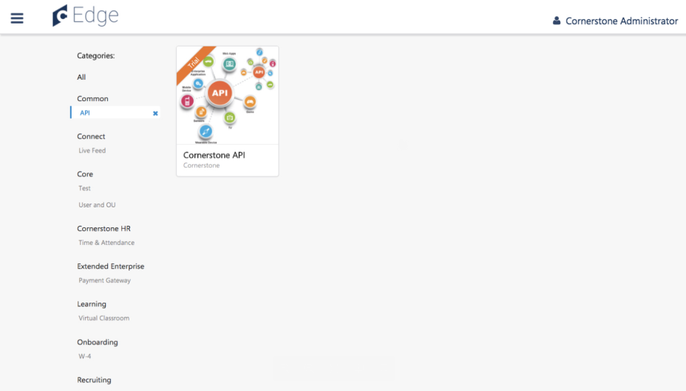
Purchase Inquiry
To create and submit a purchase inquiry, search for and click the Cornerstone API or the Reporting API in the Edge Marketplace. After clicking the API, you are able to view additional information about the API, contact CSOD for pricing information, and create a purchase inquiry.
Click the Purchase inquiry Inquiry button in the upper-right corner of the page. This will open a form.
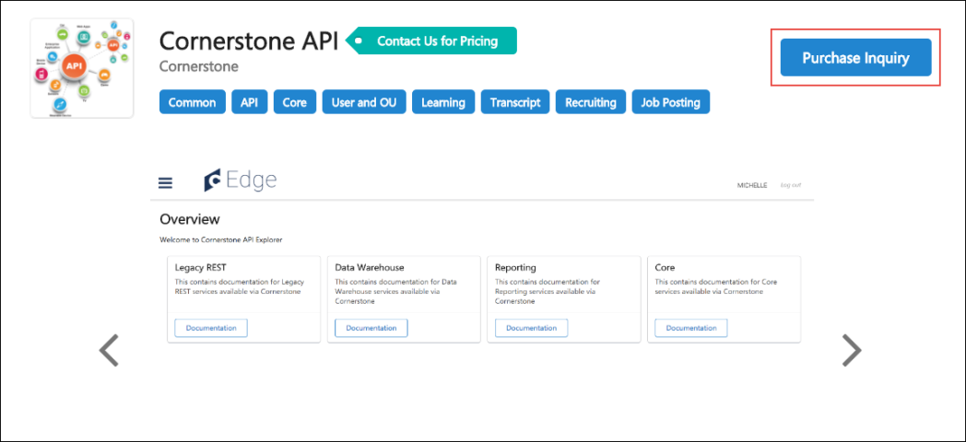
Complete the Purchase Inquiry form by providing the following information about yourself and your organization:
- First Name
- Last Name
- Company Name
- Company Address
- City
- State
- Zip Code
- Country
- Contact Email
- Contact Phone Number
- Best Time to Contact
After populating all required fields on the form, click the Submit button to submit the form. Clicking the Cancel button will close the form without submitting or saving any input data. Once you have submitted a form, your Client Executive will contact you with the next steps for completing the purchase and enablement process.
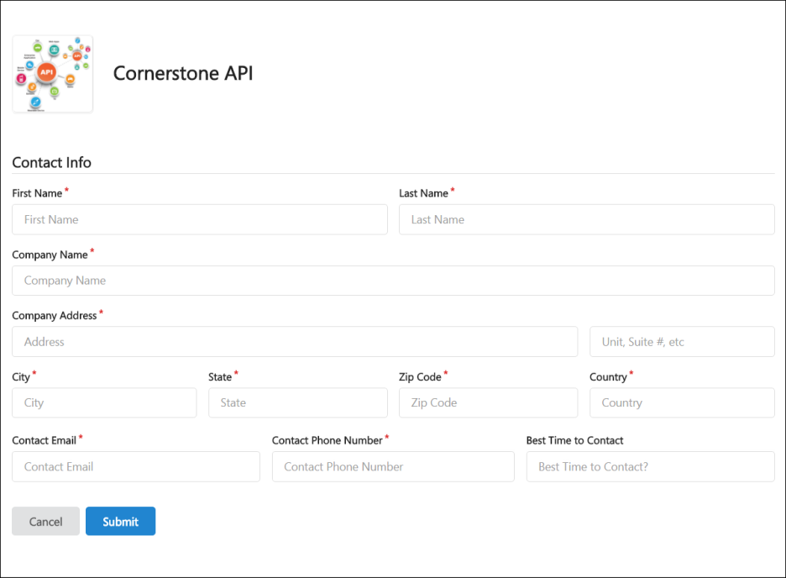

Bulk API
The Bulk API is available for user, organizational unit (OU), and learning loads. Bulk APIs provide organizations the ability to leverage a highly scalable and resilient framework to create and update data in Cornerstone via APIs.
- It is optimized for loading large data sets in an asynchronous, queued model. It is ideal for bulk load use cases where there is a need to create or update data into your Cornerstone portal using APIs. For example, you can use Bulk APIs to keep employee and OU data in sync from your HRIS into Cornerstone.
- It supports the OAuth 2.0 authentication framework.
- It supports the portal configurations including custom fields, custom employee relationships, and availability settings for custom fields.
Use the API to retrieve the status of your loads as well as obtain a full report of the load performed including errors and warnings. Additionally, all the loads performed using the Bulk API are visible in the Bulk API History page in Edge. The Bulk API History page is only visible to users who have the new Access Edge Bulk API History permission. Additional load-type specific permissions control the downloading of reports from the history page.
See Bulk API - API History on page 26 for additional information.
How Does this Enhancement Benefit My Organization?
This API enables organizations to keep their employee, organizational unit (OU), and learning information in Cornerstone up-to-date by loading data in bulk with a modern, scalable REST API.
API Explorer
API Explorer contains the most up-to-date documentation for all REST APIs. API Explorer enables developers and partners to easily browse all available REST APIs. Developers can learn about supported features, methods, and metadata. Developers can also download guidelines and access links to sample code.
To access the Developer Portal, go to Admin > Tools > Edge > Develop > Developer Portal. Developer Portal can also be accessed directly at the following URL: https://csod.dev
Considerations
- Organizations using Cornerstone HR cannot use the Bulk API to load employee data since effective dating is not yet supported by the Bulk API.
- SPII fields and secure custom fields are not supported by the Bulk API.
- There are new OAuth 2.0 scopes for Bulk API endpoints which is visible while registering a new OAuth 2.0 application or modifying an existing OAuth 2.0 application. Organizations with existing OAuth 2.0 applications must explicitly select the Bulk API scopes before utilizing the Bulk API endpoints.
Implementation
Organizations can self-activate the Bulk API for users, OUs, and learning loads via the Edge Marketplace in Pilot and Stage environments.
Organizations wanting to use the Bulk API in Production must submit a purchase inquiry via the Edge Marketplace. See Edge API - Purchase Inquiry on page 16 for additional information.
The Access Edge Bulk API History permission is assigned the System Administrator role by default. The remaining permissions are enabled upon activation. Additional documentation is available in the API Explorer.
Permissions
The following permissions apply to this functionality:
PERMISSION NAME | PERMISSION DESCRIPTION | CATEGORY

Access Bulk API - LMS - Curriculum Transcripts | Grants ability to use the Bulk API to load curriculum transcript data. This permission cannot be constrained. This is an administrator permission.  This permission is only available when the Bulk API is enabled via Edge Marketplace. | Edge Import

Access Bulk API - LMS - Curriculum | Grants ability to use the Bulk API to load curriculum learning object and structure data. This permission cannot be constrained. This is an administrator permission.  This permission is only available when the Bulk API is enabled via Edge Marketplace. | Edge Import

Access Bulk API - LMS - Events | Grants ability to use the Bulk API to load event learning object data. This permission cannot be constrained. This is an administrator permission.  This permission is only available when the Bulk API is enabled via Edge Marketplace. | Edge Import

Access Bulk API - LMS - External Training Transcripts | Grants ability to use the Bulk API to load external training transcript data. This permission cannot be constrained. This is an administrator permission.  This permission is only available when the Bulk API is enabled via Edge Marketplace. | Edge Import

Access Bulk API - LMS - ILT Transcripts | Grants ability to use the Bulk API to load instructor-led training (ILT) transcript data, session transcript custom fields data, and event transcript custom fields data. This permission cannot be constrained. This is an administrator permission.  This permission is only available when the Bulk API is enabled via Edge Marketplace. | Edge Import

Access Bulk API - LMS - Material Transcripts | Grants ability to use the Bulk API to load material transcript data. This permission cannot be constrained. This is an administrator permission.  This permission is only available when the Bulk API is enabled via Edge Marketplace. | Edge Import

Access Bulk API - LMS - Material | Grants ability to use the Bulk API to load material learning object data. This permission cannot be constrained. This is an administrator permission.  This permission is only available when the Bulk API is enabled via Edge Marketplace. | Edge Import

Access Bulk API - LMS - Online Course | Grants ability to use the Bulk API to load online course learning object data. This permission cannot be constrained. This is an administrator permission.  This permission is only available when the Bulk API is enabled via Edge Marketplace. | Edge Import

Access Bulk API - LMS - Online Transcripts | Grants ability to use the Bulk API to load online transcripts data. This permission cannot be constrained. This is an administrator permission.  This permission is only available when the Bulk API is enabled via Edge Marketplace. | Edge Import

Access Bulk API - LMS - Session Parts | Grants ability to use the Bulk API to load session parts data. This permission cannot be constrained. This is an administrator permission.  This permission is only available when the Bulk API is enabled via Edge Marketplace. | Edge Import

Access Bulk API - LMS - Sessions | Grants ability to use the Bulk API to load event session data. This permission cannot be constrained. This is an administrator permission.  This permission is only available when the Bulk API is enabled via Edge Marketplace. | Edge Import

Access Bulk API - LMS - Test Mapping | Grants ability to use the Bulk API to load test mapping data. This permission cannot be constrained. This is an administrator permission.  This permission is only available when the Bulk API is enabled via Edge Marketplace. | Edge Import

Access Bulk API - LMS - Test Transcripts | Grants ability to use the Bulk API to load test transcript data. This permission cannot be constrained. This is an administrator permission.  This permission is only available when the Bulk API is enabled via Edge Marketplace. | Edge Import

Access Bulk API - LMS - Test | Grants ability to use the Bulk API to load test learning object data. This permission cannot be constrained. This is an administrator permission.  This permission is only available when the Bulk API is enabled via Edge Marketplace. | Edge Import

Access Bulk API - LMS - Video Transcripts | Grants ability to use the Bulk API to load video transcript data. This permission cannot be constrained. This is an administrator permission.  This permission is only available when the Bulk API is enabled via Edge Marketplace. | Edge Import

Access Bulk API - LMS - Video | Grants ability to use the Bulk API to load video learning object data. This permission cannot be constrained. This is an administrator permission.  This permission is only available when the Bulk API is enabled via Edge Marketplace. | Edge Import

Access Edge Bulk API History | Grants access to the Bulk API History page, which displays all the loads that have been performed using the Bulk API. Administrators can select a load to view additional details of the load, including the results. This permission cannot be constrained. This is an administrator permission. | Edge

Access Edge Bulk API | Grants ability to access and utilize the Bulk API. This permission cannot be constrained. This is an administrator permission.  This permission is only available when the Bulk API is enabled via Edge Marketplace. | Edge

Bulk API - Cost Center OU | Grants ability to use the Bulk API to load cost center organizational unit (OU) data. This permission cannot be constrained. This is an administrator permission.  This permission is only available when the Bulk API is enabled via Edge Marketplace. | Edge

Bulk API - Custom OU | Grants ability to use the Bulk API to load custom organizational unit (OU) data. This permission cannot be constrained. This is an administrator permission.  This permission is only available when the Bulk API is enabled via Edge Marketplace. | Edge

Bulk API - Division OU | Grants ability to use the Bulk API to load division organizational unit (OU) data. This permission cannot be constrained. This is an administrator permission.  This permission is only available when the Bulk API is enabled via Edge Marketplace. | Edge

Bulk API - Employee | Grants ability to use the Bulk API to load employee data. This permission cannot be constrained. This is an administrator permission.  This permission is only available when the Bulk API is enabled via Edge Marketplace. | Edge

Bulk API - Grade OU | Grants ability to use the Bulk API to load grade organizational unit (OU) data. This permission cannot be constrained. This is an administrator permission.  This permission is only available when the Bulk API is enabled via Edge Marketplace. | Edge

Bulk API - Legal Entity OU | Grants ability to use the Bulk API to load legal entity organizational unit (OU) data. This permission cannot be constrained. This is an administrator permission.  This permission is only available when the Bulk API is enabled via Edge Marketplace. | Edge

Bulk API - Location OU | Grants ability to use the Bulk API to load location organizational unit (OU) data. This permission cannot be constrained. This is an administrator permission.  This permission is only available when the Bulk API is enabled via Edge Marketplace. | Edge

Bulk API - Position OU | Grants ability to use the Bulk API to load position organizational unit (OU) data. This permission cannot be constrained. This is an administrator permission.  This permission is only available when the Bulk API is enabled via Edge Marketplace. | Edge
Security Roles
The Edge Bulk API History permission is automatically granted to the default System Administrator role. Administrators must grant this permission with the appropriate constraints to other roles, if necessary.
The remaining Bulk API permissions are disabled until the Bulk API is enabled through Edge Marketplace, at which time they are granted to the default System Administrator role.
Supported Learning Load Types
The Bulk API supports the following load types:
- Online course
  - Online Course Metadata
  - Online Course Transcript
  - Online Course Transcript custom fields
- ILT
  - Events
  - Sessions
  - Session Parts
  - Events Transcript custom fields
  - Sessions Transcript
  - Sessions Transcript custom fields
- Material
  - Material
  - Material Transcript
  - Material Transcript custom fields
- Video
  - Video
  - Video Transcript
  - Video Transcript custom fields
- Test
  - Test
  - Test Mapping
  - Test Transcript
  - Test Transcript custom fields
- Curriculum
  - Curriculum
  - Curriculum Structure
  - Curriculum Transcript
  - Curriculum Transcript custom fields
- External Training
  - External Training Transcript

Bulk API - API History
The Bulk API History page displays a history of all loads performed using the Bulk API.
Note: Encryption keys can be used in Bulk API, and these keys can be managed from the Manage Keys page.
See Key Management - Manage Keys.
The API History page can be accessed in the following ways:
- Go to Admin > Tools > Edge. Then, select the Bulk API History link in the Develop section.
- Go to Admin > Tools > Edge > Imports and Feeds. Then, select the Bulk API History button.
Permissions
PERMISSION NAME | PERMISSION DESCRIPTION | CATEGORY

Access Edge Bulk API History | Grants access to the Bulk API History page, which displays all the loads that have been performed using the Bulk API. Administrators can select a load to view additional details of the load, including the results. This permission cannot be constrained. This is an administrator permission. | Edge

Access Edge Bulk API | Grants ability to access and utilize the Bulk API. This permission cannot be constrained. This is an administrator permission.  This permission is only available when the Bulk API is enabled via Edge Marketplace. | Edge

Access Edge Import | Grants access to the Edge Import tool, which enables administrators to load data into their portal. This permission cannot be constrained. This is an administrator permission. | Edge Import

Bulk API - Cost Center OU | Grants ability to use the Bulk API to load cost center organizational unit (OU) data. This permission cannot be constrained. This is an administrator permission.  This permission is only available when the Bulk API is enabled via Edge Marketplace. | Edge

Bulk API - Custom OU | Grants ability to use the Bulk API to load custom organizational unit (OU) data. This permission cannot be constrained. This is an administrator permission.  This permission is only available when the Bulk API is enabled via Edge Marketplace. | Edge

Bulk API - Division OU | Grants ability to use the Bulk API to load division organizational unit (OU) data. This permission cannot be constrained. This is an administrator permission.  This permission is only available when the Bulk API is enabled via Edge Marketplace. | Edge

Bulk API - Employee | Grants ability to use the Bulk API to load employee data. This permission cannot be constrained. This is an administrator permission.  This permission is only available when the Bulk API is enabled via Edge Marketplace. | Edge

Bulk API - Grade OU | Grants ability to use the Bulk API to load grade organizational unit (OU) data. This permission cannot be constrained. This is an administrator permission.  This permission is only available when the Bulk API is enabled via Edge Marketplace. | Edge

Bulk API - Legal Entity OU | Grants ability to use the Bulk API to load legal entity organizational unit (OU) data. This permission cannot be constrained. This is an administrator permission.  This permission is only available when the Bulk API is enabled via Edge Marketplace. | Edge

Bulk API - Location OU | Grants ability to use the Bulk API to load location organizational unit (OU) data. This permission cannot be constrained. This is an administrator permission.  This permission is only available when the Bulk API is enabled via Edge Marketplace. | Edge

Bulk API - Position OU | Grants ability to use the Bulk API to load position organizational unit (OU) data. This permission cannot be constrained. This is an administrator permission.  This permission is only available when the Bulk API is enabled via Edge Marketplace. | Edge
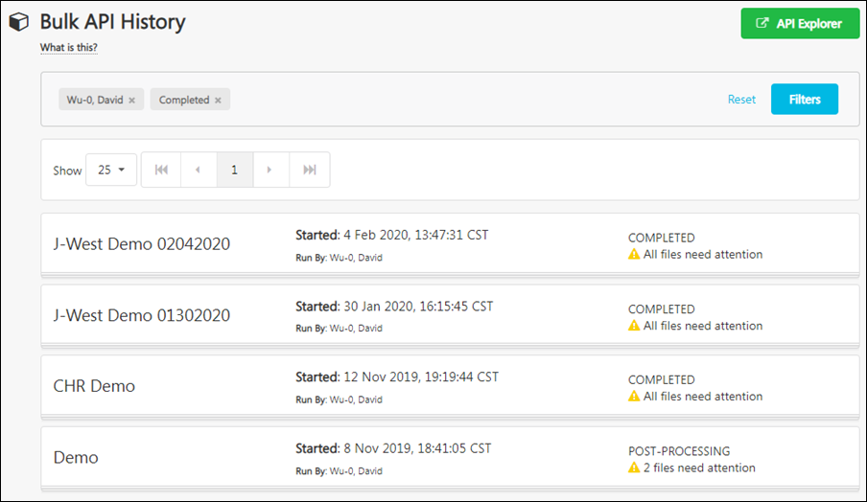
API Explorer
Documentation for the Bulk API is available in the API Explorer.
- API Explorer - https://apiexplorer.csod.com/apiconnectorweb/apiexplorer#/
Bulk API History
The following information is displayed for each previous Bulk API run:
- Load name - Administrators can select a feed to view additional details about the load. Note: Administrators must have the corresponding Bulk API permission to view the details for a load type. For example, you must have the Bulk API - Division OU permission to view the details of a Division OU load.
- Started
- Run by
- Import status
- Import results

API Management
The API Management page provides access to the following tabs:
- Manage APIs - This page allows you to enable and disable purchased API products
- Manage OAuth 2.0 Applications - This page allows you to manage OAuth 2.0 applications
- Manage STS Keys - This page allows you to retrieve API keys for Cornerstone's legacy STS authentication framework (STS is being deprecated and will be fully retired in Feb 2021)
To access the API Management page, go to: Admin > Tools > Edge and click the API Management link. On the Edge Integrate page, select the Manage Applications tab.
Permissions
PERMISSION NAME | PERMISSION DESCRIPTION | CATEGORY

Edge APIs - Manage | Grants ability to manage Edge APIs on the API Management page. | Edge
Manage APIs
From the Manage APIs tab, you can manage any APIs that your organization has purchased.
- To disable a purchased API, toggle the switch next to the integration to the Off position.
- To enable a purchased API, toggle the switch next to the integration to the On position.
Manage OAuth 2.0 Applications
On the Manage OAuth 2.0 Applications page, you can register new OAuth 2.0 applications or manage existing OAuth 2.0 applications.
You can enable and disable existing applications by toggling the switch next to the application to the On or Off position.
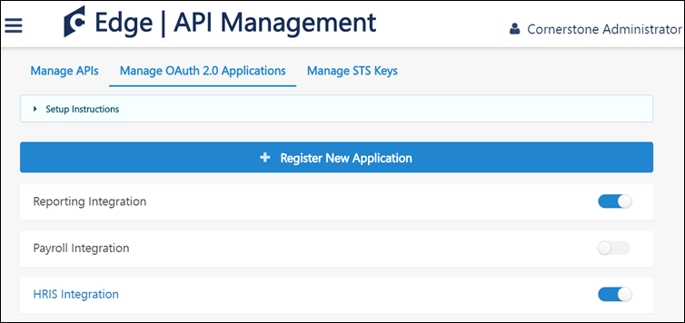
To register an application:
- Click the Register New Application button.
- Populate the fields on the Register New Application page, including the Application Name, Username, and a validity period, if applicable.
  - Each registered application must be associated with an existing user account, which functions as a service account. This user account is bound to the application and to the client ID and secret.
  - The validity period defines the time period, in seconds, for which an access token is issued. This field is optional. If no value is entered, access tokens will be assigned a default validity period of one hour. The maximum value that can be entered in this field is 86,400 seconds (one day). The minimum value is 300 seconds.
- Click the Register Application button.
- Copy the client ID and secret generated by Cornerstone to use when building your API-based integration. Be sure to save this information for your use, as you will only be shown the secret once.
Note: If needed, a registered integration can be deactivated from the Manage Integrations tab by toggling the Active switch to the Inactive position.
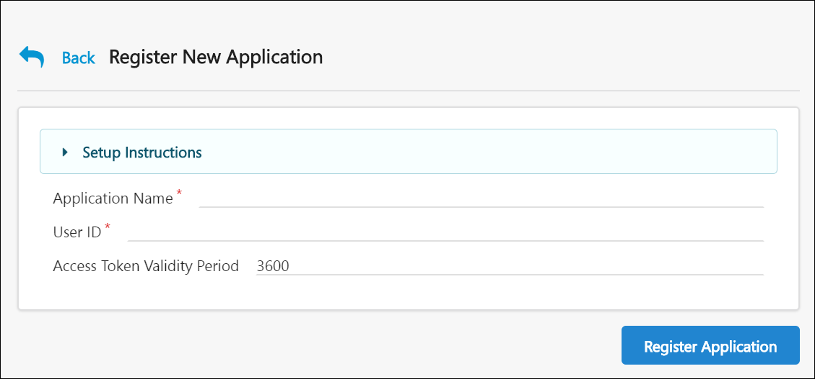
Manage STS Keys
Cornerstone's custom authentication framework, Session Token Service (STS), will be deprecated in February 2020 and will be fully retired and unavailable in February 2021. During the deprecation phase, Cornerstone will stop supporting STS. The STS endpoint will still be available during the deprecation phase, but Cornerstone will no longer address any defects or enhance this endpoint. Any requests to the endpoint will fail starting February 2021, when STS is fully retired.
Organizations will need to modify their code for existing integrations that use Cornerstone's API and switch to OAuth 2.0 from STS by February 2021. This only impacts Cornerstone's RESTful APIs, which includes the following:
- Cornerstone's Foundational APIs (i.e. Cornerstone REST services)
- Reporting API
- Employee API (i.e. Cornerstone Core/CHR services)
- Express Class API
- Job Application API
The following are NOT currently impacted:
- xAPIs
- SOAP APIs
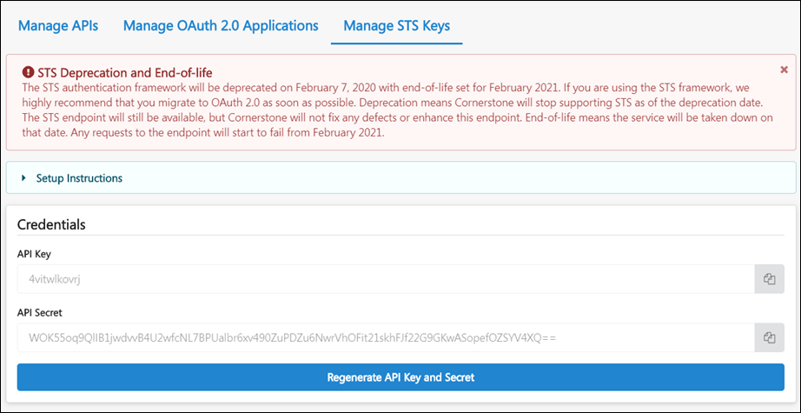

API Authentication - OAuth 2.0 - Granular Scopes
Edge Administrators can select granular scopes, allowing organizations to control the methods and endpoints an application can access through Cornerstone's APIs using the OAuth 2.0 API credentials. A "scope" is a mechanism in OAuth 2.0 which is used to limit an external application's access. OAuth 2.0 is an industry-standard authentication and authorization protocol for APIs. Using this protocol reduces the time and effort needed by external developers to integrate with the Cornerstone system.
This means organizations can specify applications' access to individual calls. For example, an organization can specify an application's access to GET /services/api/Recruiting/JobApplicant by choosing the get_jobApplicant scope.
Implementation
This functionality is available to any organization that has purchased Cornerstone APIs or the Reporting API. A purchase inquiry for Cornerstone APIs or the Reporting API can be submitted through the Edge Marketplace.
To access Cornerstone APIs or the Reporting API in the Edge Marketplace, go to: Admin > Tools > Edge and click the Marketplace link. Search for and click the Cornerstone API tile. Click the Setup tab for setup instructions for the API.
Additional information about scopes is available in the API Explorer: https://apiexplorer.csod.com/apiconnectorweb/apiexplorer#/
API Management - Scopes
The Scopes for an API can be added when registering a new OAuth 2.0 application from the API Management page in Edge.
To access the API Management page, go to: Admin > Tools > Edge and click the API Management link. Click the Manage OAuth 2.0 Applications tab.
Permissions
PERMISSION NAME | PERMISSION DESCRIPTION | CATEGORY

Edge APIs - Manage | Grants ability to manage Edge APIs on the API Management page. | Edge
Register New Application
Scopes can be configured during the application registration process. To register an application:
- Click the Register New Application button.
- Populate the fields on the Register New Application page, including the Application Name, Username, and a validity period, if applicable.
  - Each registered application must be associated with an existing user account, which functions as a service account. This user account is bound to the application and to the client ID and secret.
  - The validity period defines the time period, in seconds, for which an access token is issued. This field is optional. If no value is entered, access tokens will be assigned a default validity period of one hour. The maximum value that can be entered in this field is 86,400 seconds (one day). The minimum value is 300 seconds.
- Configure the application's scopes. The Scopes section contains a list of endpoints and operations to which the application needs access. The external application will not be able to access an endpoint or operation if it is not selected on this page. Select any necessary scopes.
- Click the Register Application button.
- Copy the client ID and secret generated by Cornerstone to use when building your API-based integration. Be sure to save this information for your use, as you will only be shown the secret once.
- For more information about managing APIs: See API Management on page 29 for additional information.
- For more information about specific APIs, go to the API Explorer in Edge: https://apiexplorer.csod.com/apiconnectorweb/apiexplorer#/

APIs for Core/General - Overview

Approvals API
The Approvals API enables users to view, approve, and deny requests on the user's Universal profile page. Using this API, organizations can review and manage approvals for development plans, forms, goals, offer letters, peers, requisition approval, requisition requests, and training forms.
The Approvals API can be used with the following approval types:
- Development Plans
- Forms
- Goals
- Offer Letters
- Peers
- Requisition Approval
- Requisition Requests
- Training Forms
The Approvals API includes the following services:
- Get Approval Details - Get all pending approval items for the supported approval types for a given user.
- Post Approval Details - Approve or deny a pending approval item.
The user included in the request must have permission to access the Request tab in Universal Profile.
Permissions
PERMISSION NAME | PERMISSION DESCRIPTION | CATEGORY

Request Items - View | Allows user to access the Requests tab on the Universal Profile > Actions tab. This permission cannot be constrained. | Universal Profile
Implementation
For full documentation about the API, please see the API Explorer: https://apiexplorer.csod.com/apiconnectorweb/apiexplorer#/

Capabilities Library and User Profile Bulk API
With the Capabilities Library and User Profile Bulk API, the same transactions, fields, and validations that exist with the Edge Import Capabilities Library and User Profile loads are available as an API endpoint for custom integrations. Customers can retrieve the schema with request fields directly from the API. Transactions can be saved as “jobs” and are viewable through Edge Import.
How Does this Enhancement Benefit My Organization?
For customers who want to build custom integrations, the Capabilities Bulk API allows customers to load the same Capabilities Library and User Profile data as Edge Import using API calls instead of a CSV upload.
Considerations
The Capabilities Bulk API is designed to update one or more records at a time. For customers who want to read data, the same fields are provided through the Data Exporter API.
The Capabilities Bulk API is intended to facilitate larger, periodic updates to skills data in Cornerstone, but not real-time transactions. Cornerstone is looking in to possibly support real-time 2-way transactions in the future with a different transactional API.
Implementation
The Capabilities Bulk API is included with the Bulk API that is available in the Edge Marketplace. Additional documentation is available in the API Explorer. Edge Import must also be installed in a portal in order to use this API.

Employee API v1
The Employee APIs allow you to create, update, and fetch user details from Cornerstone.
Note that there is a newer version of the Employee API. If you currently use the v1 version, we highly encourage you to switch to v2. The v2 endpoints have, better performance with modular endpoints, higher throttling limits, and better ability to search for an employee.
See Employee/OU API on page 38 for additional information.

Employee/OU API
The Employee/OU API allows organizations to create, update, and fetch employee and organizational unit (OU) details from Cornerstone. The Employee/OU API appears as a single tile in API Explorer, and it includes two APIs:
- Employee API v2 contains the following enhancements:
  - Host of additional endpoints to get employee metadata information.
  - Targeted, modular calls to allow fetching smaller payloads of specific datasets.
  - Improved response times by ~30% for PUT/PATCH/POST and ~50% for GET endpoints.
  - Increase throttling limit by 50% (from 100/min to 150/min, for all non-bulk endpoints).
  - A closely coupled OU API, that will allow consumers to serve a much broader set of use-cases to create, update, and fetch employee data for specific OU's.
- The Organizational Unit (OU) API provides robust handling for full feature management of OUs. The OU API is now in General Availability with the release of Employee API v2. Detailed API documentation can be found in the Edge API Explorer.
Organizations are highly encouraged to move to Employee API v2 and start planning to move off both Employee API v1 REST API and the SOAP services.
At this time, Cornerstone has not deprecated the SOAP User/OU API, the Employee API v1, or the GET OU API. Cornerstone will continue to address defects and questions with these endpoints; however, any enhancements will only be made to the Bulk API and the Employee/OU API.
Employee API
The Employee API includes the following services:
- Get - Return User record details including Effective Date (CHR) support.
- Create/Update - Insert or update user records including Effective Date (CHR) and custom fields support. This includes data related to employee termination (e.g., employment status, termination date).
- Activation Period - Return and update the activation period of an employee record.
- User Effective Dates - Return all effective dates associated to a user record.
- Custom Fields - Return custom field data for employees.
- Groups - Return employees and the groups in their employee profile.
- User type and Employment Status -
  - Return User type and Employment status details including Effective Date (CHR) support Employment status.
  - Insert and update User type and Employment status data incl. Effective Date (CHR) support.
Organizational Unit API
The Organizational Unit API includes the following services:
- Get - Get organizational unit details
- Set - Insert or update organizational unit records
API Explorer
Documentation for all available APIs is available in the API Explorer for general access.
- https://apiexplorer.csod.com/apiconnectorweb/apiexplorer#/
Considerations
- Access to data via the Employee API v2 can be constrained using the Employee API - View - Constrained permission.
- The OU API leverages the same permissions and constraints required to manage OUs in the portal.
- Group management is not supported with this API.
Implementation
Organizations can purchase and enable the Employee/OU API through the Edge Marketplace as a part of Cornerstone Foundational APIs. There are new scopes for API endpoints.
For full documentation about the API, please see the API Explorer: https://apiexplorer.csod.com/apiconnectorweb/apiexplorer#/
Permissions
The API respects the same permissions and constraints on the following permissions:
PERMISSION NAME | PERMISSION DESCRIPTION | CATEGORY

Employee API - Edit | Grants ability to use the Employee API v2 to create and update users. This permission can be constrained by OU and User's OU. The constraints on this permission limit what data is accessible via the Employee API v2. This is an administrator permission.  This permission is only available when the Employee API v2 is enabled via Edge Marketplace. | Edge

Employee API - View - Constrained | Grants ability to use the Employee API v2 to view employee data with constraints. This permission can be constrained by User, OU, and User's OU. The constraints on this permission limit what data is accessible via the Employee API v2. This is an administrator permission.  This permission is only available when the Employee API v2 is enabled via Edge Marketplace. | Edge

Employee API - View | Grants ability to use the Employee API v2 to view employee data. This permission can be constrained by OU, and User's OU. The constraints on this permission limit what data is accessible via the Employee API v2. This is an administrator permission.  This permission is only available when the Employee API v2 is enabled via Edge Marketplace. | Edge

OU Hierarchy - Manage | Grants ability to create and update/edit organizational units. This permission grants access to all OU types, both standard and custom. This permission can be constrained by OU and User's OU. This is an administrator permission. | Core Administration

Grades - View | Grants ability to view the Grade Organizational Unit throughout the system, such as in availability drop down selectors, when editing users, etc. Those without this permission do not see the Grade OU on any screen. This is primarily an administrator permission, although organizational policy should determine whether the Grade OU should be visible to end users on reporting screens, etc. | Core Administration

Global Search API
The purpose of this service is to get People, Training, and Certification details from the system.
The Global Search API includes the following service:
- Global Search - Use this service to get details for people, training, and certifications in the system.
This service supports the following types of searches:
- People - Search for any employees in your portal.
- Training - Search for any learning objects in your portal.
- Certifications - Search for any certifications in your portal.
- Everything - Search for people, training, and certifications in a single query.
Implementation
For full documentation about the API, please see the API Explorer: https://apiexplorer.csod.com/apiconnectorweb/apiexplorer#/

APIs for Learning - Overview

Catalog Search API
Use this endpoint to retrieve all training from a portal.
The Catalog Search API includes the following service:
- Catalog Search - This service searches training data as per the input parameters of the request call. For example, a customer can search for trainings by title, description, and provider name.
Permissions
PERMISSION NAME | PERMISSION DESCRIPTION | CATEGORY

Course Catalog - View | Grants access to view the learning objects in the course catalog and enables administrators to view the Course Console and the Popular Requests and Highest Rated widgets on the Learning Admin Console (in conjunction with the Learning Admin Console - View permission). This permission can be constrained by OU, User's OU, Training Type, Training Item, Provider, ILT Provider, User's ILT Provider, and User's LO Availability. This is an administrator permission.  Adding an OU constraint and a provider constraint to this permission results in an "AND" statement. | Learning - Administration
Implementation
For full documentation about the API, please see the Developer Portal: https://csod.dev

Certification API
Use this API to remove certifications that are assigned to users.
The Certification API includes the following service:
- Delete Certification - The purpose of the service is to remove certifications that are assigned to users.
  - If there are two certifications with the same title and both are assigned to the user, then both will be removed.
  - If there are two certifications with the same title and one is assigned to the user, then the assigned certification will be removed.
Permissions
PERMISSION NAME | PERMISSION DESCRIPTION | CATEGORY

Certification - Manage | Grants administrators ability to manage certifications. This permission can be constrained by OU and User's OU. This is an administrator permission. | Learning - Administration
Implementation
For full documentation about the API, please see the API Explorer: https://apiexplorer.csod.com/apiconnectorweb/apiexplorer#/

Certification Details API
Use this API to retrieve a certification's details from Cornerstone Learning.
The Certification Details API includes the following service:
- Certification Details - Use this API to retrieve a certification's details, including section-level details.
Permissions
PERMISSION NAME | PERMISSION DESCRIPTION | CATEGORY

Certification - Manage | Grants administrators ability to manage certifications. This permission can be constrained by OU and User's OU. This is an administrator permission. | Learning - Administration
Implementation
For full documentation about the API, please see the API Explorer: https://apiexplorer.csod.com/apiconnectorweb/apiexplorer#/

Certification Transcript API
Use this API to retrieve certification details from a user's transcript.
- The API observes all the business rules configured in your portal.
- Only data for active users can be retrieved.
- Only transcript records that you see in the Active tab on the Transcript page in Cornerstone Learning will be returned.
- Date and time attributes are in Coordinated Universal Time (UTC).
The Certification Transcript API includes the following service:
- Transcript Details - Use this service to retrieve certification details from a user's transcript.
Permissions
PERMISSION NAME | PERMISSION DESCRIPTION | CATEGORY

View Transcript Item | Grants ability to view details of learning objects that appear on the transcript (training record), by clicking on the name of the learning object. Users must also have the Bio About - View permission in order to access the transcript within Universal Profile. This permission can be constrained by OU, User's OU, User Self and Subordinates, User, or User's Self. This is an end user permission. | Learning - Administration
Implementation
For full documentation about the API, please see the API Explorer: https://apiexplorer.csod.com/apiconnectorweb/apiexplorer#/

Custom Field API
Use this API to update Training and Transcript custom field values
- A maximum of 50 records can be in each request.
- Each request can update either the LO level custom field or the Transcript level Custom field, but not both. In other words, updates for the LO level custom fields and the updates for the Transcript level custom fields must be made in separate API calls.
- Blank values do not overwrite populated values.
The Custom Field API includes the following service:
- Custom Field - Use this service to update training custom fields at either the learning object level or the transcript level.
Permissions
PERMISSION NAME | PERMISSION DESCRIPTION | CATEGORY

Training Custom Fields | Grants ability to create and edit custom fields to be used for one or more learning object types. This is an administrator permission. | Learning - Administration
Implementation
For full documentation about the API, please see the API Explorer: https://apiexplorer.csod.com/apiconnectorweb/apiexplorer#/

Express Class API
The Express Class API provides the ability to easily document gathered learning after the learning takes place and give transcript credit to the learners.
The Express Class API includes the following services:
- Create Express Class - This service creates an Express Class process and, in turn, creates a completed transcript record for users. The following learning object types are supported:
  - Event (using Express Class, it is possible to complete an event without completing a session)
  - Material
  - Online Class
  - Test
  - Video
Use Cases
Use case #1: Training Capture via Badge Scanning
Richard is an L&D Leader at ACME and prefers that his training facilitators access Express Class functionality within their current systems. His training facilitators usually have attendees scan their RFID badges and then they record those users for a selected training item. With the public API, Richard’s IT resources can integrate the necessary components of Express Class into their current systems to accomplish their use cases without requiring his facilitators to access and use Cornerstone’s Express Class user interface.
Use case #2: Just in Time Training
Laurie is an IT Leader at ACME, which operates restaurant locations across the country. ACME’s restaurants regularly accommodate new employees who require frequent training, and this consumes a lot of ACME’s resources due to the burden of coordinating group training sessions. With the public API, Laurie’s IT resources can integrate necessary components of Express Class into systems that are at the employee’s fingertips, allowing employees to educate themselves with training content and receive credit for the training. Laurie can reduce ACME’s need for costly group training sessions, increase the efficiency of the organization, and assist in tracking training completions for her compliance needs.
Use case #3: Building a Chatbot
Dinesh is an L&D leader at ACME, a company that uses conversational user interfaces to accomplish many tasks. Dinesh wants to test users and capture their results using a chatbot, which appears after a viewer has completed a training item. Using Express Class’s public API, Dinesh can enable his IT team to build a conversational chatbot which records scores for the training and submits them to the viewer’s transcript in a Complete, Incomplete, or Failed status. The viewer then receives credit for the training without logging into the Learning Management System (LMS).
Use case #4: Supporting Alternate Modalities
Jarod is an Operations Manager at ACME, an organization which uses touchscreen systems for new employees. Dinesh, a new employee, uses the touchscreen system to complete an onboarding evaluation which communicates results to ACME’s Learning Management System. Using Express Class’s public API, ACME is able to integrate Express Class functionality alongside their touchscreen evaluation process, capture the applicant’s score, and store completion information for future reporting.
Considerations
The following considerations apply to this functionality:
- This API is "Create only." It can only submit attendees with a status to the transcript.
- This API does not support read, update, or delete operations at this time.
- The Express Class - Manage permission is required in order to access the Express Class public API
- The constraints applied to the Express Class - Manage permission are also applicable to the Express Class public API. For example, if a user has permission to manage express class, and the permission is constrained to X users, the user can only submit for those users via the public API.
Implementation
This public API requires the purchase of Cornerstone APIs. For organizations which have already purchased Cornerstone APIs, no additional purchase is required. A purchase inquiry for Cornerstone APIs can be submitted through the Edge Marketplace.
To access Cornerstone APIs in the Edge Marketplace, go to: Admin > Tools > Edge and click the Marketplace link. Search for and click the Cornerstone API tile. Click the Setup tab for setup instructions for the API.
Additional documentation about the Express Class API is available in the API Explorer. To access the API Explorer independently of a Cornerstone portal, go to: https://apiexplorer.csod.com/apiconnectorweb/apiexplorer#/
Permissions
The following existing permission applies to this functionality:
PERMISSION NAME | PERMISSION DESCRIPTION | CATEGORY

Express Class - Manage | Grants the ability to create and add users to an Express Class for a facilitated training session. This permission can be constrained by OU, User, User Self and Subordinates, and User's OU. This is an end user permission. | Learning - Administration

Learning Assignment API
The Learning Assignment API provides the ability to create standard learning assignments in Cornerstone Learning. It enables you to build integrations where the goal is to assign training to your learners. Standard learning assignments process and assign training once. An ideal use case for this API is to assign training to users or organizational units based on event triggers that were previously performed manually, or not performed at all due to technical restrictions.
The Learning Assignment API includes the following services:
- Create Standard Assignment - Use this endpoint to create a standard learning assignment in Cornerstone. You can add training to users' transcripts in Approved, Assigned, and Registered status using this API.
- Get Assignment - Once you submit a learning assignment, you can check the status of your assignment using this endpoint.
- Get Remaining Count - Use this endpoint to identify the count of remaining user assignments per day for the date provided. This helps manage throttling limits.
- Search Assignments - Use this endpoint to search for and retrieve details on an assignment created via the API or the Learning Assignment Tool.
Permissions
PERMISSION NAME | PERMISSION DESCRIPTION | CATEGORY

Assignment Tool - Bypass User Payment | Grants ability to bypass user payment when creating a Learning Assignment. When user payment is bypassed, users are automatically registered into the training regardless of whether or not payment is required. This permission is dependent on the Assignment Tool - Standard, Assignment Tool - Standard and Dynamic, and Assignment Tool - Standard and Dynamic - Recurrence permissions. This permission cannot be constrained. This is an administrator permission. | Learning - Administration

Assignment Tool - Email Settings - View | Grants ability to view and select email settings when creating a Learning Assignment. This includes the ability to select Training Specific Emails, Custom Emails, or No Emails but does not grant ability to manage the actual Email Settings (cannot configure Custom Emails or Ad-Hoc Email and cannot enable/disable Assign Training and Register Training email triggers when Training Specific Emails is selected). This permission is dependent on the Assignment Tool - Standard, Assignment Tool - Standard and Dynamic, and Assignment Tool - Standard and Dynamic - Recurrence permissions. This permission can be constrained by OU, User, User Self and Subordinates, and User's OU. If this permission is constrained, then only users within the constraints will receive the emails. This is an administrator permission. | Learning - Administration

Assignment Tool - Standard | Grants ability to create Standard (one-time) Learning Assignments to directly assign training to users. This permission can be constrained by OU, Provider, Training Item, Training Type, User, User Self and Subordinates, and User's OU. If this permission is constrained by Location, Provider, Training Type, or Training Item, then they can only assign training within the constraints. If this permission is constrained by OU, User, User Self and Subordinates, or User's OU, then they can only assign to and view assignments created by users within the constraints. This is an administrator permission. | Learning - Administration
Implementation
For full documentation about the API, please see the Developer Portal: https://csod.dev

Learning Object (LO) API
Use this API to create, update, and fetch training details from Cornerstone Learning.
The Learning Object (LO) API includes the following services:
- Get LO - Obtain details of a learning object available to an active user in the portal. The API only supports the following learning types: Curriculum, Event, Session, Material, Test, Video, and Online Course
- Create LO - Create a new learning object. All business rules configured in the portal are observed for this call. The actual payload can vary depending on the type of learning object.
  - Event
  - Session
  - Online Course - This is a shell course; it is not launchable
  - Material - This is a URL without versioning functionality.
- Update LO - Use this endpoint to update existing ILT Sessions in Cornerstone Learning. You cannot update learning objects of type other than ILT Sessions using this endpoint.
Permissions
PERMISSION NAME | PERMISSION DESCRIPTION | CATEGORY

Course Catalog - Update | Grants ability to manage and edit training items listed in the Course Catalog and also grants access to the Course Console, where training can also be managed and edited. This permission also grants access to the Popular Requests and Highest Rated widgets on the Learning Admin Console (in conjunction with the Learning Admin Console - View permission). This permission also allows administrators to reversion online courses via the Course Console page. This permission also allows administrators to access an Edit Training option for training items included as objectives in Development plans.  This permission can be constrained by OU, User's OU, Training Type, Training Item, Provider, ILT Provider, User's ILT Provider, User, User Self and Subordinates, and User's LO Availability. This is an administrator permission.  Note: Adding an OU constraint and a provider constraint to this permission results in an "AND" statement. | Learning - Administration

Events - Create | Grants ability to create new instructor led training events. This permission works in conjunction with Events - View permission. This permission can be constrained by OU, User's OU, ILT Provider, and User's ILT Provider. This is an administrator permission. | Learning - Administration

LCMS Course Administrator | Grants ability to create and manage online training courses using modules created in the Module Builder. Also requires assignment of LCMS license. This is an administrator permission. | Learning - Administration

Materials Management | Grants ability to view the Material Administration page and create, edit, and copy materials. Once created, these "materials" can be managed like other learning objects via the course catalog. This permission can be constrained by OU, User's OU, and Provider. The constraints on this permission determine which materials the administrator is able to view, edit, copy, and create. This is an administrator permission. | Learning - Administration

Sessions - Create | Grants ability to create new instructor led training sessions. This permission works in conjunction with Events - View and Sessions - View permissions. Administrators can only create sessions for events for which they have the availability to view. When adding users to a session in which the session roster is full, this permission grants the ability to increase the session's available seats. This permission can be constrained by OU, User's OU, Instructor, User as Instructor, Facility, Facilities Owned by User, ILT Provider, User's ILT Provider, User, and User Self and Subordinates. This is an administrator permission.  Note: The "Restrict to User as Instructor" constraint is available, but it does not actually constrain the permission. | Learning - Administration

Sessions - Edit | Grants ability to edit/update existing instructor led training sessions. This permission works in conjunction with Events - View and Sessions - View permissions. Administrators can only edit sessions for which they have the availability to view and edit. When adding users to a session in which the session roster is full, this permission grants the ability to increase the session's available seats. This permission can be constrained by OU, User's OU, Instructor, User as Instructor, Facility, Facilities Owned by User, ILT Provider, User's ILT Provider, User, and User Self and Subordinates. This is an administrator permission. | Learning - Administration
Implementation
For full documentation about the API, please see the API Explorer: https://apiexplorer.csod.com/apiconnectorweb/apiexplorer#/

Learning Object (LO) Transcript API
Use this API to fetch transcript data in bulk.
The Learning Object (LO) Transcript API includes the following service:
- Transcript Search - This service gives you the ability to retrieve users’ transcript information from Cornerstone Learning.
Permissions
PERMISSION NAME | PERMISSION DESCRIPTION | CATEGORY

Users - View | Grants the ability to search for and view summary information about users in the portal via the Admin/Users screen. This permission can be constrained by OU, User's OU, User Self and Subordinates, and Users. If multiple constraints are added, these constraints are considered OR statements. This is an administrator permission. | Core Administration

View Transcript Item | Grants ability to view details of learning objects that appear on the transcript (training record), by clicking on the name of the learning object. Users must also have the Bio About - View permission in order to access the transcript within Universal Profile. This permission can be constrained by OU, User's OU, User Self and Subordinates, User, or User's Self. This is an end user permission. | Learning - Administration
Frequently Asked Questions (FAQs)
How do I create user transcript records or assign learning objects on a user's transcript?
This can be done using either the Learning Assignment API. See Learning Assignment API on page 50 for additional information.
The Express Class API can be used for completion records. See Express Class API on page 48 for additional information.
Implementation
For full documentation about the API, please see the API Explorer: https://apiexplorer.csod.com/apiconnectorweb/apiexplorer#/

Session Roster API
Use this API to update and fetch the roster for Instructor-Led Training (ILT) sessions.
The Session Roster API includes the following services:
- Create - This services allows customers to update the session attendance roster and complete the session.
- Get Details - This service allows customers to get the details of a session. The service will provide all the details of a particular session for which the Session ID or Locator ID is provided in the request.
Permissions
PERMISSION NAME | PERMISSION DESCRIPTION | CATEGORY

Roster - Manage | Grants ability to manage instructor led training session rosters, including updating attendance, and marking the ILT session complete to update student transcripts. A variety of other features are available depending upon additional roster permissions. This permission works in conjunction with Events - View, Sessions - View, and Roster - View permissions. This permission can be constrained by Instructor, User as Instructor, ILT Provider, and User's ILT Provider. This is an administrator permission. | Learning - Administration

Roster - View | Grants view-only access to instructor led training session rosters. This permission works in conjunction with Events - View and Sessions - View permissions. This permission can be constrained by Instructor, ILT Provider, User's ILT Provider, and User as Instructor. This is an administrator permission. | Learning - Administration
Implementation
For full documentation about the API, please see the API Explorer: https://apiexplorer.csod.com/apiconnectorweb/apiexplorer#/

Tin Can (xAPI)
Tin Can is an eLearning protocol that enables recording of a wide range of learning experiences, including native mobile applications and team-based e-learning.
The system is able to record external Tin Can activities on Cornerstone's Learning Record Store (LRS). External Tin Can activities include but are not limited to mobile apps, offline learning, web application, collaborative learning, games, videos, etc. When an external activity needs to be recorded, the application sends secure statements to the LRS to record all statements.
Learning experiences completed through the LRS are automatically recorded on users' completed transcripts in portals using the Learning module.
Customers can export all of their xAPI statements to another LRS and keep both systems in sync. After all statements have been exported from Cornerstone’s LRS, customers that use a 3rd party LRS that supports ingestion can continue to request new statements at predefined time intervals to keep both systems in sync and report on actions performed by users in xAPI courses, find specific information, and view trends.
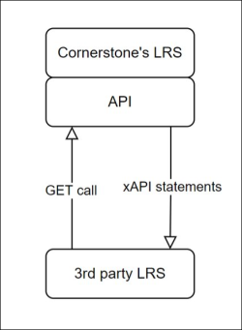
Integration Guidelines
- Exporting xAPI statements can be done via API with up to 32,000 statements per request if no filters or only date filters are used.
- Using paging, more than 32,000 statements can be exported with multiple requests.
- To improve stability, the API has a throttling limit of up to 10 calls per minute.
Implementation
Organizations must configure their content based on Cornerstone's xAPI integration guidelines. Once content is properly configured, contact Cornerstone through a Global Customer Support Request Service case to receive an Access Key.
Permissions
PERMISSION NAME | PERMISSION DESCRIPTION | CATEGORY

xAPI - View Learning Records on Transcript | Allows users to view xAPI Learning Records on the Transcript. | Learning
Learning Record Notification
After completing new learning records in the Learning Record Store, a notification displays at the top of the transcript page in the learning module to confirm that new learning records have been added to the Completed transcript.
The Learning Record notification displays the number of new learning records that have been added to the user’s transcript. The notification also provides a View link, which users can click to be navigated to the Completed page of their transcript. The notification can be dismissed by either clicking the View link or by clicking the Close icon.
Note: Only users viewing their own transcript can see the Learning Record notification. This notification does not display for managers or any other users with permission to view other users’ transcripts.
Considerations
- The number of new learning records included in the notification is limited to unseen learning records that have been added to the transcript in the last 30 days.
- If a user dismisses the learning record notification, the notification will not appear again until new learning records have been added to the transcript.
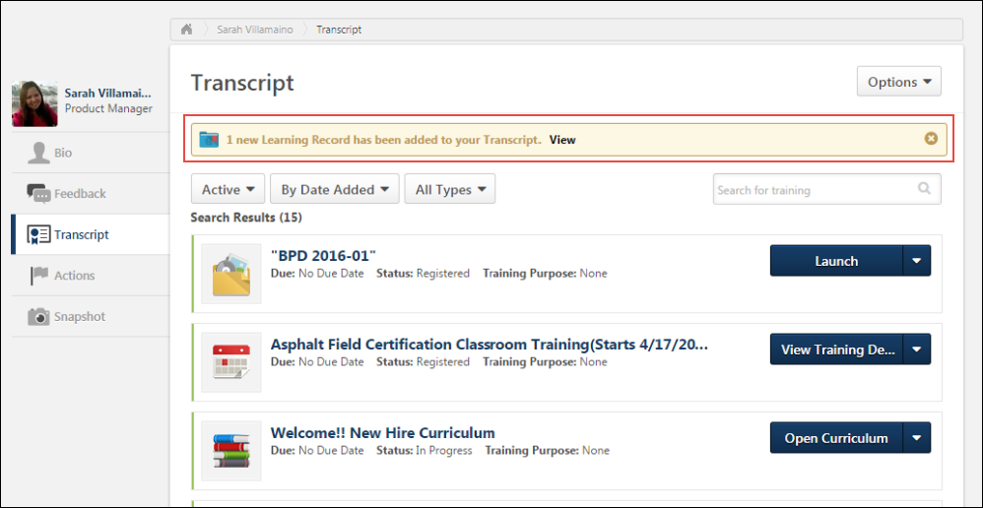
Learning Records on Transcript
Completed learning records display on the Completed page of the transcript with the following information:
- Title - This field displays the name of the xAPI learning record.
- Completed - This field displays the date the xAPI learning record was imported to the LRS.
- Status - This field displays the status of the xAPI learning record. Note: The status for an xAPI learning record will always be set to Complete, because only completed learning records display on the transcript.
- Learning Record Icon - An image of a blue and red folder displays next to xAPI learning records to indicate the training type.
Considerations
- No actions are available for xAPI learning records on the transcript, so no Actions drop-down option appears next to xAPI learning records on the Completed transcript page.
- No due dates display for xAPI learning records.
- No training purposes display for xAPI learning records.
Completion Criteria
In order for xAPI learning records to appear on the Completed page of a user’s transcript, the learning records must display a status that equates to “complete” in the LRS. This prevents irrelevant learning records (such as failed or incomplete activities) from appearing on the Completed page of the transcript in the learning management system.
xAPI learning records must display one of the following verbs in the LRS in order to display on the Completed page of a user’s transcript:
- Attended
- Completed
- Experienced
- Mastered
- Passed
- Read
- Watched
- Viewed
Sort by Training Type - Learning Record
Prior to this enhancement, it was possible to sort the Completed page of the transcript by training type and select a training type to view exclusively. With this enhancement, Learning Record has been added as a training type that can be selected as a filter on the Completed page of the transcript. To quickly find all learning records that have been added to the Completed transcript, choose By Training Type from the sort filter. From the All Types filter, select Learning Records.
Learning records can also be sorted using the following sort criteria:
>Title
>Status (always Completed)
>Date Added (date the learning record was completed in the LRS)
>Training Purpose (always None)
>Due Date (always None)
Print Transcript or Export to PDF
When a user prints a transcript or exports a transcript to PDF, any completed learning records displaying on the Completed page of the transcript are included in the printable or PDF document, along with any learning objects completed in the Learning module.
Note: The user must have the permission to view xAPI learning records on the transcript in order for learning records to be included in the printable and PDF versions of the transcript.
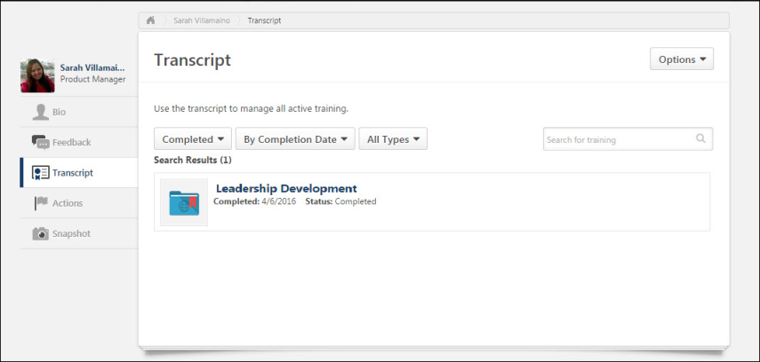
Data Merge
When data merges are performed for a user with any xAPI learning records on their multiple transcripts, the learning records are included in the data merge. After the data merge is complete, all learning records found on the user’s transcripts are consolidated and display on the Completed page of the merged user’s transcript.
Exporting xAPI Statements via API
See Tin Can (xAPI) - Exporting xAPI Statements via API on page 61 for additional information.
Glossary
- Tin Can
- Learning Record Store (LRS)
- Statement (xAPI)
Tin Can (xAPI) - Exporting xAPI Statements via API
Administrators may export xAPI statements from the Learning Record Store to a third party Learning Record Store via API. Integration information can be found in the Cornerstone xAPI (Tin Can) Integration Guidelines, specifically in the Authentication Requirements and Exporting xAPI statements via API sections.
Tin Can (xAPI) Integration Guidelines
See Tin Can (xAPI) on page 56 for additional information.
Considerations
When performing an export, please note the following considerations:
- If no limit is set in the call, the limit of statements per call is set to 1,000.
- A limit of up to 32,000 statements can be set using the <limit> parameter as long as the only parameters used in the call are <since>, <until>, <limit>, and <last_statement_id>.
- If any other parameters are used in the call, the limit reverts to 1,000 unless an even lower limit is set using the <limit> parameter.
- If it is required to export more statements than the current limit, it can be done via multiple requests using pagination with the <last_statement_id> parameter.
- To improve stability, the API has a throttling limit of up to 10 calls per minute.

Training Unit API
Use this API to create training units used in Cornerstone Learning's Extended Enterprise module.
The Training Unit API includes the following service:
- Create Training Unit Assignment - This service enables customers to create new training unit assignments in the application for extended enterprise (EXE) customers. All business rules configured in the portal are observed for this call.
Permissions
PERMISSION NAME | PERMISSION DESCRIPTION | CATEGORY

Training Unit Assignment - View | Grants ability to view assignments of training units without being able to add or edit assignments. This permission can be constrained by OU and User's OU. This is an administrator permission. | eCommerce - Administration
Implementation
For full documentation about the API, please see the API Explorer: https://apiexplorer.csod.com/apiconnectorweb/apiexplorer#/

Transcript and Task API
Use this API to retrieve a user's transcript and task data from Cornerstone Learning.
- All business rules configured in your Cornerstone portal are observed by this API.
- You can only retrieve data for active users using this API.
- You can retrieve data for only one user per request. If you are looking to retrieve transcript data in bulk, consider using the Transcript Search API. See Transcript Search API on page 65 for additional information.
- Removed and archived transcript records cannot be retrieved using this API.
- This API does not include custom field data in the response.
The Transcript and Task API includes the following services:
- Get Inbox Items - This retrieves all items in the user’s inbox as shown on the Welcome page widget.
- Get Suggested Training - This returns suggested training. This does not return playlists. It does not return requested, registered, or approved training. To retrieve this type of training, use the Get Transcripts service.
- Get Tasks - This represents all incomplete tasks assigned to the user.
- Get Approvals - If approvals are used in the system and the user is a manager or approver, this represents the pending approvals for his or her subordinates.
- Get Assigned Trainings - This service returns all the transcripts assigned to users, along with their statuses and due dates as applicable.
- Get Sessions - Get the upcoming sessions in a user's transcript.
- Get Transcripts - This service represents all transcript items currently in the user’s transcript. Each response can return a maximum of 50 transcript records. There is a pageNumber attribute that can be incremented to get the next batch of 50 transcript records.
Legacy Transcript and Task APIs - Optional Constraints
To align with the newer Transcript APIs, the legacy Transcript and Task APIs now support the following Constraints:
- GetAssignedTrainings - /services/api/TranscriptAndTask/Assigned​​
- GetSessions - /services/api/TranscriptAndTask/Session
- GetSuggestedTrainings - /services/api/TranscriptAndTask/SuggestedTraining
- GetTranscripts - /services/api/TranscriptAndTask/Transcript
This setting is optional and can be controlled via an Additional Claim. For more details, check out the developer documentation​ in the Developer Portal: https://csod.dev
Implementation
For full documentation about the API, please see the Developer Portal: https://csod.dev

Transcript API
The Transcript API is a bundle of APIs providing access to the learner's transcript. The APIs follow the same business logic, security, rules, and events from the portal’s configuration.
The Transcript API supports the following features:
- Data APIs (GET): Overview API; Detailed APIs; filters, multi-language support
- Request API: Request training; Employee perspective
- Assign API: Assign training; Manager and Learning Administrator perspective
- Remove API: Remove training; bi-directional
- Register API: Register a training​, Change an “Approved”​ learning record to “Registered"
- Progress API: Change a “Registered”​ learning record to “In Progress"​
- Complete API: Complete a learning record
- Update API: Update transcript data​, Custom Fields​, Form Fields​, Due date
- Archive API: Archive a transcript record, Move an archived record back to its original state
- Approval API: Approve a training request, Deny a training request​
- Withdraw API: Withdraw a user from a session they are registered for
- Exempt API: Exempt a transcript record​
Transcript API (Open Beta) Community
The Transcript API (Open Beta) Community in the Success Center provides the following:
- API overview
- Milestone plan
- Question forum
- Feedback forum
Navigation path: Cornerstone Success Center > All Communities > Cornerstone Beta Community > Topics > Learning > Transcript API (Open Beta)
Implementation
All the Transcript APIs can be self-enabled and tested in all portal environments (production, pilot, stage). Review the API documentation for new permissions, constraints and scopes.

Transcript Search API
The Transcript Search API provides customers, partners, and vendors the ability to retrieve transcript data from Cornerstone.
The Transcript Search API includes the following service:
- Get - Search transcript data as per the search criteria.
Implementation
The Transcript Search API is available to organizations using the Cornerstone API and the Learning module.
For full documentation about the API, please see the API Explorer: https://apiexplorer.csod.com/apiconnectorweb/apiexplorer#/

APIs for Performance - Overview

Goal API
Use this API to create, update, and get a user's goals from Cornerstone Performance. You can also use this API to update a user's progress on a goal.
The Goal API includes the following services:
- Create - Use this endpoint to create new user goals.
- Update - Use this endpoint to update existing user goals in your Cornerstone portal.
- Update Goal Progress - Use this endpoint to update goal progress, one goal at a time.
- Details - Use this endpoint to retrieve details of user goals from your Cornerstone portal.
- Cancel Goal - Use this endpoint to update goal statuses to cancelled, one goal at a time.
- Lock Goals - Use this endpoint to lock or unlock goals, one goal at a time.
The same rules that the Cornerstone UI enforces while creating or updating goals also apply for the API.
Permissions
PERMISSION NAME | PERMISSION DESCRIPTION | CATEGORY

Goals - Create | Grants ability for user to create goals for self, direct reports, and indirect reports only. Any constraint on this permission is operating as an "AND" function. This permission can be constrained by Employee Relationship, OU, User's OU, and User Self and Subordinates. This is an end user permission. | Performance
Implementation
This API is automatically available for organizations using the Cornerstone API and Cornerstone's Performance module. There is no additional cost associated with this functionality when using it in conjunction with the Cornerstone API and the Performance module.
For full documentation about the API, including the endpoint URL, request and response body format, business rules, and validation errors, please see the API Explorer: https://apiexplorer.csod.com/apiconnectorweb/apiexplorer#/

Performance Review API
Use this API to fetch performance review details.
The Performance Review API includes the following service:
- Get Details - This web service extracts performance review ratings, goals, and competency data that is associated with a performance review task
Note: Currently, performance review tasks cannot be created via web services.
Implementation
This API is automatically available for organizations using the Cornerstone API and Cornerstone's Performance module. There is no additional cost associated with this functionality when using it in conjunction with the Cornerstone API and the Performance module.
For full documentation about the API, including the endpoint URL, request and response body format, business rules, and validation errors, please see the API Explorer: https://apiexplorer.csod.com/apiconnectorweb/apiexplorer#/

APIs for Recruiting - Overview

Application Workflow API
The Application Workflow API includes the following service:
- Get - Get a requisition's full application workflow, including pre-screening questions, compliance questions, disclaimers, notes, and attachments.
Implementation
For full documentation about the API, please see the API Explorer: https://apiexplorer.csod.com/apiconnectorweb/apiexplorer#/

Candidate API - Overview
Today, organizations use many tools in addition to their applicant tracking system (ATS) to recruit and hire top talent. The ability to import and export candidate and application data in real time from Cornerstone’s recruiting solution to point solutions is a must for most clients. Having a reliable, easy to use externally facing candidate API will enable clients to maintain data integrity and get the most return from each point solution.
Cornerstone's Candidate APIs provide the ability to get a requisition's full application workflow, including prescreening and compliance questions, disclaimers, notes, and attachments, and then create an application and candidate in your Cornerstone portal. Applications can be posted in a complete or incomplete status. If incomplete, recruiters can invite candidates to finish their application within Cornerstones. Candidates can apply for positions through CAPI that are only on internal career sites (ICS).
Candidate API includes the following endpoints:
- Get Application Workflow - This endpoint retrieves a requisition’s full application workflow, including action items that were previously irretrievable via the legacy Job Application API like Prescreening questions, compliance questions, disclaimers, and notes.
- Post Candidate and application - This endpoint posts a candidate and application to your Cornerstone portal.
These externally facing endpoints are available for both clients and vendors to utilize. With the Candidate API (Early Adopter), the new Get Application Workflow and Post Candidate and Application endpoints enable clients to develop end-to-end integrations with recruiting solutions like chat bots, job boards, candidate relationship management solutions (CRM), marketing tools, and more.
Use Cases
Chat Bots
- John Smith goes to ABC Company's Career Site to search for a Software Engineers job.
- John sees ABC offers a chat feature on their career site.
- Rather than spending time searching for a job, John engages with the chat bot regarding Engineering type roles.
- The chat provider writes to Cornerstone’s Job Requisition APIs (Get Job Requisition, Get Job Ad Details, and Get Job Requisition Custom Fields) so that they can recommend jobs to John based on job descriptions and location.
Tip: We recommend also writing to the Get Job Requisition Custom Fields endpoint, as many clients use custom fields to specify fields unique to their organization.
- The chat provider identifies a Software Engineering (req123) position as a great recommendation and asks if John would like to apply to this position.
- When John replies “Yes,” the chat provider calls the GET Application Workflow endpoint to request the application details for req123. Optionally, the chat provider may also check if the candidate is an internal or external candidate by calling Cornerstone’s Employee Global Search API so that they can request the correct application workflow.
- Rather than sending John to another page to complete the application, all application questions are made available for him within the chat experience, which increases ABC's chance of a successful application submission.
- After answering the last application question, John lets the chat bot know he is ready to submit his application.
- The chat provider calls the second endpoint, POST Application and Candidate, to create a new user in Cornerstone and create John's application.
- In Cornerstone, req123 has been configured previously to ensure that all new applicants go straight to the In Review status rather than the New Submission status. Req123 has also been configured to automatically assign an assessment to all applicants in the In Review status.
- Once John's application is created, he receives ABC's Apply as Guest Application Submission Email Confirmation and is automatically assigned the assessment.
- Recruiters now see that John has applied to req123 and can review his resume, contact details, and all posted application responses. Recruiters can also see that the assessment was successfully assigned.
Job Boards
- Denise goes to her favorite job board, Work4You, to search for Software Engineering jobs in her area.
- Work4You writes to Cornerstone’s Job Requisition APIs (Get Job Requisition, Get Job Ad Details, and Get Job Requisition Custom Fields) to display all jobs posted by their mutual client, ABC.
Tip: It is recommended that you also write to the Get Job Requisition Custom Fields endpoint, as many clients use custom fields to specify fields unique to their organization.
- Denise finds 10 Software Engineering roles matching her zip code.
- After reading the job details, Denise is interested in ABC's Software Engineer (req123) role and clicks Apply Now on the job board.
- Work4You calls the GET Application Workflow endpoint to populate the application, enabling Denise to apply immediately from Work4You without having to navigate to another site.
- Denise clicks Submit after uploading her resume and answering all application questions.
- The application is submitted to the Software Engineer (req123) role.
- Recruiters can see that Denise applied to Req123 and can review her resume and contact details, as well as and all applicable action items.
- Recruiters can also see that Denise's application came from Work4You.
Candidate Relationship Management (CRM) Tools
- Sally Lee is a Recruiter at ABC Company and uses BLITZ, a candidate relationship management tool, to source and maintain relationships with candidates.
- BLITZ already writes to Cornerstone’s requisition endpoints so that recruiters can see open positions in BLITZ without having to navigate to Cornerstone.
- Sally is recruiting for their open Software Engineering (req123) position.
- While looking at her engineering talent pool in BLITZ, Sally spots Jack, a very qualified candidate for req123.
- Rather than manually downloading Jack's resume and adding Jack to req123 in her Cornerstone portal, Sally clicks Add Candidate to Requisition in BLITZ and selects req123.
- BLITZ calls the POST Application and Candidate endpoint and adds Jack and his resume to ABC Company’s Cornerstone portal.
- Sally returns to her Cornerstone portal and sees that Jack has been added to req123 but has an incomplete application.
- Sally invites Jack to apply so that he can finish the application and be considered for req123.
Notes:
- It will be up to the candidate relationship management (CRM) provider (BLITZ in the above scenario) to determine at what point 1) an applicant is added to the applicant tracking system (ATS) in Cornerstone and 2) the POST Application and Candidate endpoint is called.
- The endpoint will create a candidate if the candidate does not exist and will check if the candidate exists by their email.
- If the candidate does not exist, a new candidate and application will be created.
- If an application has already been started but not completed for the specific requisition, the POST Application and Candidate endpoint may be used to complete and or replace the existing application.
API Resources
See the following resources in the Cornerstone Success Center (CSC) for more information about APIs and the API Explorer:
- Introduction to APIs
- API Explorer Overview
Implementation
Clients will use the Candidate API to build and maintain their own integrations with third party recruiting tools. Additional documentation is available in the API Explorer upon release of the Candidate API. See Edge - API Explorer.
Permissions
The following permissions apply to this functionality:
PERMISSION NAME | PERMISSION DESCRIPTION | CATEGORY

Edge Integrations - Manage | Grants access to the Integrations service for Edge Integrate, where the administrator can configure, enable, and disable their third-party integrations used within the Cornerstone system. This permission cannot be constrained. This is an administrator permission. | Edge

Edge Marketplace - Manage | Grants access to the Marketplace service for Edge Integrate, where the administrator can browse integrations that can be used to extend the Cornerstone system. This permission cannot be constrained. This is an administrator permission. | Edge
Compare Candidate API and Job Application API
The legacy Job Application API is built with the intention of integrating with Stepstone and other job boards that would have candidate involvement. The API could also be used for clients with very simple application workflows (i.e., just a resume). If the client has an application workflow with more types of action items, there needs to be candidate interaction so that the candidate can be redirected to the application workflow on the client's career site.
The Candidate API endpoints were created to be flexible in integrating with many different types of outside systems. Not only can customers utilize these endpoints to more deeply integrate with job boards, as more action item types are supported, customers can utilize the POST Application Workflow to submit candidates directly from a CRM in a complete or incomplete status.
Feature | Job Application API | Candidate API
Submitting application with a resume in a completed state | YES | YES
Submitting application in an incomplete state | NO | YES
Redirecting candidates to the career site, if there are unsupported action items | YES | NO
Support Additional Attachments and Cover Letter | YES | YES
Support PSQs | NO | YES
Support Compliance Questions | NO | YES
Support Disclaimers | NO | YES
Support Notes | NO | YES

Job Application API (Early Adopter) - Overview
The Job Application API delivers a seamless candidate experience with the ability to send job board application data to Cornerstone, enabling candidates to apply directly to requisitions using their information from job boards.
Job boards are a key way to source candidates. If a candidate wants to apply to a position from a job board, they are typically redirected to a career site, which can interrupt the candidate experience and decrease conversion rates. The Job Application API is a user-centric interface that allows job seekers to “one-click” apply using their resume details from the job board without having to visit the career site.
The Job Application API includes the following service:
- Create - Create new job applications, facilitating a one-click apply use case in a job board by allowing candidates to apply to jobs directly from the job board.
Is being an Early Adopter right for my organization?
- My organization uses job boards to post jobs
- My organization has simple application workflows. Note: Prescreening questions are targeted to be available for a one-click apply workflow when this enhancement is ready for General Availability (GA).
- My organization would like to see the source of the application, even if the candidate is rerouted to the job board.
- The job board I work with is willing to build to our Job Application API
Considerations
The Job Application API will be generic so that other job boards can use it, in addition to Stepstone job boards.
Frequently Asked Questions
What is a job application API?
An API for job applications connects application data from a job board to your Cornerstone portal. When a candidate applies for a job that was posted to a job board from your Cornerstone Recruiting post jobs page, and the job board is configured for one-click apply functionality, the candidate's data is passed from the external job board to your Cornerstone portal. The candidate is added to the candidate pool, and their resume and contact information are also passed to your portal.
What is a job board?
A job board is a hosting site for your jobs. A job board also lets candidates create an account and store their resume on the site. When a candidate goes onto the job board and finds your jobs, they can apply directly from the job board, without having to be redirected to your career site.
This provides a complete application experience that reduces the amount of time applicants need to spend applying to your jobs.
How do job boards, search engines, and career sites differ in the job search and application process?
- A job board lets candidates apply to your jobs directly from the job board.
- A search engine displays your jobs, but it does not provide an application process. Candidates must apply via your career site.
- A career site can display your jobs and provide a complete application process. However, if a career site is the only place your jobs are listed, then candidates will not have as many opportunities to find your jobs.
What types of action items are eligible for the Job Application API?
- Only contact information, resume, and additional attachments are currently eligible for the Job Application API.
- The following fields are available:
  - First name
  - Last name
  - Primary language
  - Email
  - Phone number
  - Address fields
  - Line 1
  - Line 2
  - Postal Code
  - City
  - State or Province
  - Country Code
  - Resume/CV
  - Cover letter
  - Additional Attachments
What happens to a candidate, if my application has pre-screening questions or any other unsupported action item?
If an application has pre-screening questions, assessments, or other non-supported action items, the application cannot be completed with a one-click experience. Instead, candidates are taken to the client’s career site to continue their application, where they can answer the pre-screening questions and to take assessments.
If the application is utilizing the Mobile-Friendly Candidate Experience, they are taken to the application where their information from the job board is pre-populated in the application fields. Their resume and cover letter are also passed to your portal. The pre-population of fields is only available for Mobile-Friendly application workflows.
What authentication mechanism does the API implement?
OAuth 2.0
Does the API support SSO into the Cornerstone application?
No. If a candidate is redirected to your career site, they will need to create an account or log in before they can proceed with the application process. However, any data passed by the job board through the API will be pre-populated in the application, provided that the application is a mobile-friendly application.
Does the API support sending multiple applications at once?
No. If multiple applications are sent over at one time, the API will send a “INVALID_REQUEST” or “TECHNICAL_ERROR” response.
What happens if I submit the same candidate for different requisitions?
A candidate can only submit one application at a time. The API supports a candidate applying to multiple requisitions, but not at the same time.
If a candidate has multiple phone numbers, can I submit comma separated values for each phone number?
No, this is not supported.
If a candidate has multiple email addresses, can I submit comma separated values for each email address?
No, this is not supported.
Implementation
Job Application API is in the Early Adopter phase and is only available for organizations using Recruiting. For enablement information, See Enable Job Application API on page 78 for additional information.
Permissions
The following permissions apply to this functionality:
PERMISSION NAME | PERMISSION DESCRIPTION | CATEGORY

External Job Application API: Manage | Grants access to manage the Job Application API. This permission is automatically enabled upon enabling either the Cornerstone API bundle or the One-Click Apply with Stepstone integration. Only available if enabled by a backend setting. | Edge

Edge Develop - API Explorer | Grants access to the API Explorer, which provides access to help documentation for various API applications. | Edge

Edge Integrations - Manage | Grants access to the Integrations service for Edge Integrate, where the administrator can configure, enable, and disable their third-party integrations used within the Cornerstone system. This permission cannot be constrained. This is an administrator permission. | Edge

Edge Marketplace - Manage | Grants access to the Marketplace service for Edge Integrate, where the administrator can browse integrations that can be used to extend the Cornerstone system. This permission cannot be constrained. This is an administrator permission. | Edge
Enable Job Application API
What Is Needed?
- Designated Cornerstone user record
- API Key
- API Secret
- External Job Application API - Manage permission
Permissions
PERMISSION NAME | PERMISSION DESCRIPTION | CATEGORY

Edge Develop - API Explorer | Grants access to the API Explorer, which provides access to help documentation for various API applications. | Edge

Edge Integrations - Manage | Grants access to the Integrations service for Edge Integrate, where the administrator can configure, enable, and disable their third-party integrations used within the Cornerstone system. This permission cannot be constrained. This is an administrator permission. | Edge

Edge Marketplace - Manage | Grants access to the Marketplace service for Edge Integrate, where the administrator can browse integrations that can be used to extend the Cornerstone system. This permission cannot be constrained. This is an administrator permission. | Edge

External Job Application API: Manage | Grants access to manage the Job Application API. This permission is automatically enabled upon enabling either the Cornerstone API bundle or the One-Click Apply with Stepstone integration. Only available if enabled by a backend setting. | Edge
Steps to Enable
To enable the Job Application API:
- Navigate to Admin > Tools > Edge > Integrations > Manage APIs to retrieve the API Key and API Secret.
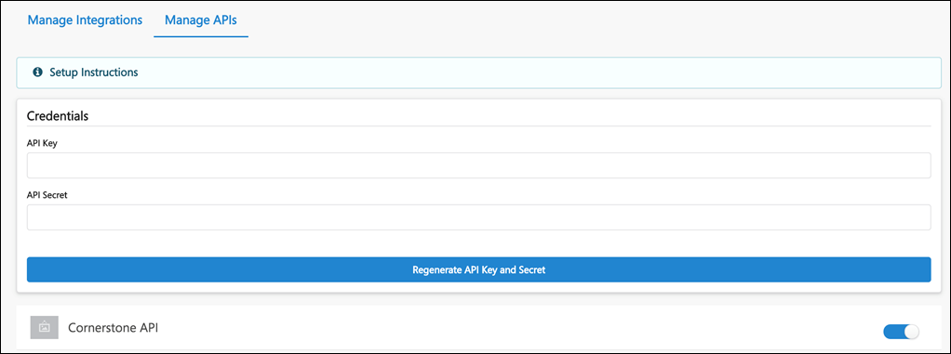
- Create a user record that will function as the Service Account for the job board vendor when the vendor integrations with Cornerstone using the Job Application API. This user is only used to provision the session token during the API authentication process.
- Assign a security role with the External Job Application API - Manage permission, which is needed to access the API.
- Navigate to Admin > Tools > Edge > API Explorer and select Cornerstone Job Application Services. Review the documentation to build the API.
Steps After Enabling
- Set up an integration with a third party job board vendor.
- Provide the job board vendor with the API Key and Secret, as well as the user name for the user record created in Step 2. You will not need to provide the password for the user record because the vendor will not be logging in to your Cornerstone portal.
Job Application API - Candidate Experience
Candidates can apply to your jobs on job boards provided that you have an integration with the job board. You will also need to have Job Application API enabled in your Cornerstone portal in order to pass candidate data from the job board to your portal.
Candidates cannot apply to a job more than once by using the same email address.
One-Click Experience
When candidates apply to your jobs on job boards, they will have a one-click experience when the application only requires basic contact information and a resume.
Once they submit their application, they become an applicant for the job and are visible in job's applicant pool in your portal.
Applications with Prescreening Questions or Assessments - Redirect to Your Career Site
If an application has prescreening questions, assessments, or other non-supported action items, the application cannot be completed with a one-click experience. Candidates are given an option to continue their application on your career sight, where they can answer the prescreening questions and to take assessments.
Candidates will have to log in to the career site or create an account if they do not yet have one. If the application is utilizing the Mobile-Friendly Candidate Experience, they are taken to the application, where their information from the job board is prepopulated into the application fields. Their resume and cover letter are also passed to your portal.
Candidate's Preferred Language
The candidate's preferred language will be respected when their data is passed to your portal.
Candidate Can Re-Apply
Candidates can re-apply to your jobs on Stepstone job boards if you allow applicants to reapply. See General Preferences (by Division).

Recruiting API
Use the recruiting API endpoints to retrieve job requisitions, job ads, and job applicants from Cornerstone Recruiting. You can also update a job applicant's status.
To send job applications from a job board to Cornerstone, refer to the Job Application API. See Job Application API (Early Adopter) - Overview on page 75 for additional information.
The Recruiting API includes the following services:
- Get Job Requisition - This API allows you to retrieve job requisition details from Cornerstone Recruiting.
- Get Job Requisition Ad Details - This API allows you to retrieve internal, external, and mobile job ads for a given job requisition.
- Get Job Requisition Custom Field - This API allows you to retrieve custom fields for a given job requisition.
- Get Job Applicant - This API allows you to retrieve job applicants in a given status. Note that this API does not include applicant custom fields in the response.
- Get Job Applicant with Custom Fields - This API allows you to retrieve job applicant details including applicant custom fields. You can either retrieve details for all applicants in a given requisition or you can retrieve details for a single applicant across requisitions.
- Update Job Applicant Status - This API allows you to update an applicant's status in your Cornerstone Recruiting portal.
Permissions
PERMISSION NAME | PERMISSION DESCRIPTION | CATEGORY

Applicants: Status Change | Grants ability to change applicant status for any applicant to whom the user already has access. This permission cannot be constrained. | Recruiting

Requisition: View/Edit Salary Range | Grants ability to view and edit the salary range on a requisition and also grants visibility to the COMPENSATION.RANGE, JOB.COMPENSATION.RANGE.MAX, and JOB.COMPENSATION.RANGE.MIN tags within the Recruiting functionality. This permission cannot be constrained. | Recruiting
Implementation
For full documentation about the API, please see the API Explorer: https://apiexplorer.csod.com/apiconnectorweb/apiexplorer#/

Structured Resume Details API
Customers need flexibility when processing structured resume data, for example, custom formatting a flattened application.
With this release, the new Structured Resume Details API endpoint queries on the application ID and provides structured resume data as a response. Customers can use this endpoint to fetch the parsed resume data and process it per their requirements.
The end point only fetches the candidate’s structured resume data as updated at the time of submitting the application.
The following sections are provided as part of the response:
- Work Experience
- Education
- Certification
Additional Information
Click here to view the API documentaton.
Implementation
- This functionality is automatically enabled in Production and Stage as of August 29, 2023 to customers using the Cornerstone API.
- To enable the new scope, go to Home > Admin > Edge > API Management > Cornerstone API > jobapplicant:read> /rec-resume/v1/resume/job-application/{jobApplicationId}​.

APIs for Reporting - Overview

Data Exporter API - Access Core Objects Over API
The Data Exporter API is available to organizations that use the Reporting API, and it provides access to Core objects, which are enhanced versions of views that are more performant at scale.
The following benefits are included with the Data Exporter API:
- Max page size increased to 10,000
- Replaces 80 legacy views
- Extended metadata to simplify integrations
  - Descriptions
  - Custom Field Names
  - Relationships between fields and objects (via the Odata Navigation properties)
- All core objects include Last_touched_dt
How Does this Enhancement Benefit My Organization?
Data Exporter core objects are optimized for reliability at scale and improved performance compared to the API views. Organizations attempting to retrieve large numbers of records (>100K) may notice improved performance upon switching to the core objects.
End Point
[Portalname].csod.com/services/api/x/dataexporter/api/objects/
API Documentation
Documentation for all available APIs is available in the API Explorer for general access.
- https://apiexplorer.csod.com/apiconnectorweb/apiexplorer#/
If you are not logged into your Cornerstone portal, you may want to do so since the documentation for certain Reporting API endpoints, such as those related to custom fields, adjust based on your portal's schema.
Implementation
This functionality is available via a new end point for organizations that use the Reporting API. Objects are not 1:1 representations of views, therefore they will require some integration work in order to begin use.
On by default for current Data Exporter API users. Delta for additional objects/endpoints will be added in patches and announced via the RTDW Documentation for Reporting API, RDW, and Data Exporter Community.
OData v4.0 Delta Capabilities for Data Exporter API
OData v4.0 Delta change capabilities are available for the Data Exporter API, starting with the user_ou_core object. OData v4.0 compatible Delta change tracking is available for inserted, updated, and deleted data for the Data Exporter API.
OData v4.0 Delta Change Tracking Key Features
- Inspect results of the $metadata endpoint to see which objects support change tracking
  - If ExtendedMetadata.ObjectSupportsChangeTracking’ = ‘true’, then can proceed with steps below
- Do not need explicit date/time filter
  - Example: https://{corpname}.csod.com/services/api/x/dataexporter/api/objects/user_ou_core
- Insert 'Prefer odata.track-changes’ into initial HTTP header to request that the service return a delta link
  - Response header will include ‘Preference-Applied: odata.track-changes’
  - Next pages will automatically reapply ‘Prefer: odata.track-changes’
  - If object does not support delta, will receive ‘501’ (Not Implemented) error
- Last page of result set will include delta link with delta token
  - Example: "@odata.deltaLink": “user_ou_core?deltatoken=xxxx"
  - Delta token is encoded representation of original query and timestamp
  - Should retain delta link/token for next request and only replace when receive next delta link/token
    - If request is interrupted or otherwise unsuccessful, can use last token to request delta again. You do not need to keep track of timestamps.
- Delta result sets may include two types of records (see sample image below):
  - Records deleted since the timestamp in the delta token. Record will include an ‘id’ field and a ‘reason’ field (with value = ‘deleted’). The ‘id’ field can be used to delete the corresponding record (if it exists) in the customer’s local database.
  - Records inserted/updated since the timestamp in the delta token. Customers should continue to use the current MERGE or UPSERT process used to process Data Exporter API data.
- Records for data deleted in Cornerstone CSX will be maintained (primary keys only) for 15 days before hard deletion. Therefore, delta links/tokens are only valid for 15 days. After 15 days a new request for a full extract will be required
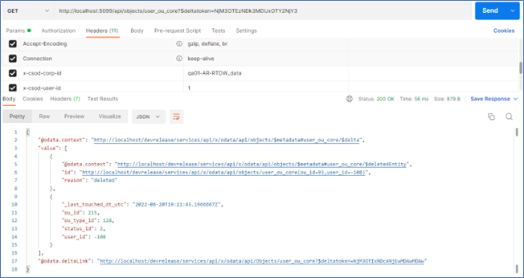

Relationship Diagrams for Data Exporter API
Customers who use the Data Exporter API (DE API) can generate diagrams that show the relationship between objects in an instant, without the need to navigate lengthy text documents.
Developers and integrations specialists can choose a mode (Basic, Detail, or Relations) and add the names of the objects to generate diagrams that illustrate the relationship between those objects, saving time and lessening effort. Up to 32 objects can be added.
Two Inputs are required: ​
- Mode – Choose from Basic, Detail, and Relations.​
- Obj – Add the name of the objects for which you want to see relationships.​
Note that a closing coma is required when calling the endpoint and there should be no spaces between objects.
For example: [portal].csod.com/api/x/objects/$cs_diagram?mode=N&obj= X,Y,Z,
Data Exporter API can generate relationship diagrams for objects to represent relationships between different core objects. Each relationship is represented with an arrow which shows navigation from one object to another object. The object where the arrow originates is considered (To) and the object where the arrow points towards is considered (From) object. If the arrow points to itself, it represents that there is a self-referencing navigation relationship.
Basic Mode
Example: /api/x/objects/$cs_diagram?mode=basic&obj= users_core,users_cf_core,​
​This mode illustrates if objects are related. The relationship is illustrated by the presence of a connecting line.​
Looping lines mean that there is an internal self-reference, meaning that there are fields within the object that are related. In the case of user_core, manager and user are related.
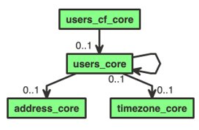
Detail Mode
Example: /api/x/objects/$cs_diagram?mode=detail&obj= users_core,users_cf_core, ​
This mode shows every relationship between objects along with the name of the relationship and field.
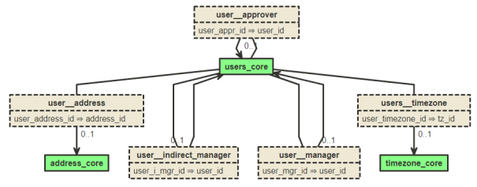
Relations Mode
Example: /api/x/objects/$cs_diagram?mode=relation&obj= users_core,users_cf_core, ​
This mode presents each of the relationships along with the field that relates the objects.
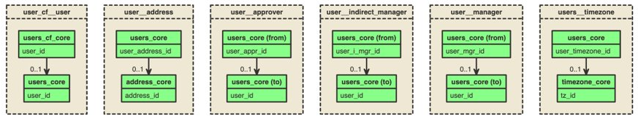
Multiplicity
Each relationship also shows the Multiplicity that relationship represents between the two entities. Multiplicity defines how object participate in a relationship and it is the number of instances of one object related to one instance of the other object.
- 0..* - An object instance can have zero or many related instances in another object. for example, A user can have zero or more transcripts.
- 1 - An object instance has exactly 1 related instance in another object. For example, a user can have only one manager.
- 0..1 - An object instance can have zero or one related instance in another object. For example, a user can have zero or one indirect manager.
New End Point
https://[portalname].csod.com/services/api/x/dataexporter/api/objects/$cs_diagram
Considerations
- Adding a scope is not required, but the user must have access to $metadata endpoint.​
- Query string is limited to 1024 characters.​
- Up to 32 objects may be requested per call.
API Documentation and Starter Guide
Documentation for the Data Explorer APIs is available in the Reporting API tile in API Explorer
- https://apiexplorer.csod.com/apiconnectorweb/apiexplorer#/
If you are not logged into your Cornerstone portal, you may want to do so since the documentation for certain API endpoints adjust based on your portal's schema.

Reporting API
The Reporting API allows you to retrieve data from your Cornerstone Real-time Data Warehouse. All fields from the Real-Time Data Warehouse (Reporting Database) are exposed. That means all fields available for Custom Reporting and Reporting 2.0 are also available via Reporting API. The Reporting API adheres to the OData protocol and dynamically adjusts to reflect any customer’s schema (i.e., custom fields are included).
OData (Open Data Protocol)
OData is an open protocol (OASIS standard) that defines best practices for building and consuming RESTful APIs. OData supports enhanced querying and filtering options, making it possible to perform powerful data queries right from the beginning. Cornerstone is currently using OData version 4.0. Please note that not every published OData option (www.odata.org) is available. Only selected fields can be queried from a Reporting view. Please see the API Explorer for more details on the options you have with Cornerstone's implementation of OData.
Joins
There is no option to perform any joins between reporting views in a single service call. Because of this, there are two recommended solutions to bring in data from various views into a single report:
- Iterative Loops - Build a looping mechanism to pull in information from multiple tables.
- Extract, Transform, Load (ETL) to Internal Server - In this approach, you can pull various views into a local database in which you are able to create and manage your own queries, views, and security.
API Documentation and Starter Guide
Documentation for all available APIs is available in the API Explorer for general access.
- https://apiexplorer.csod.com/apiconnectorweb/apiexplorer#/
If you are not logged into your Cornerstone portal, you may want to do so since the documentation for certain Reporting API endpoints, such as those related to custom fields, adjust based on your portal's schema.

A eLearning protocol that enables recording of a wide range of learning experiences, including native mobile applications and team-based e-learning.
A data system that stores xAPI learning records.
This term relates to Tin Can (xAPI). A statement is a simple construct to track an aspect of a learning experience. A set of several statements may be used to track complete details about a learning experience. A statement consists of the following: <actor (learner)> <verb> <object>, with <result>, in <context>

