Only the current registration number for any training item will be credited for any given period
When this option is selected, the affected certification only considers training items on the immediate transcript for any user upon registration, thus the certification will ignore any previously completed registrations of a training item when applying credit to any period (initial and renewal). When editing a certification, this option cannot be modified if the certification has at least one registered user.

Relative Certification Type
Scenario A: “Only the current registration…” option IS selected
On 10/20/2021, Sally was assigned a Relative certification configured as follows:
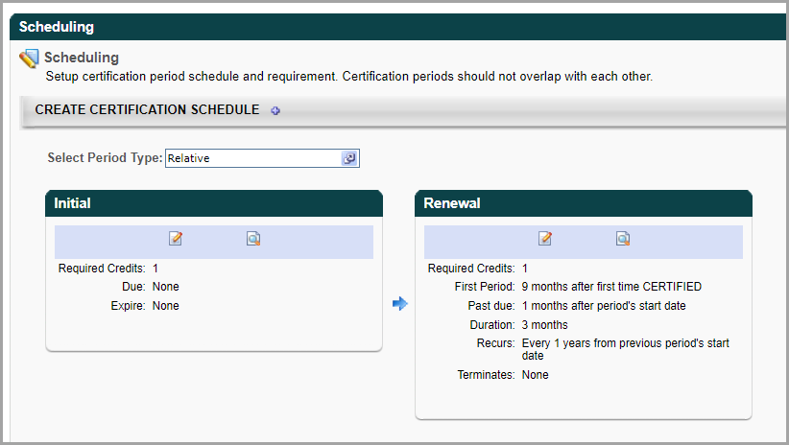
Prior to the certification assignment, Sally had already completed the material that is part of the initial period and the renewal period on the following dates:
Registration 1 (Reg1) - 1/1/2016
Registration 2 (Reg2) - 10/1/2018
Only the current registration number for any training item will be credited for any given period IS selected.
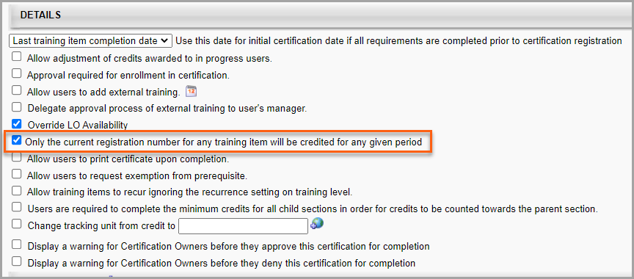
Result:
Sally’s certification status is Expired, and she is in the first renewal period (R1).
Reason:
Since “Only the current registration number for any training item will be credited for any given period” IS selected, each period only considers the current registration number for training when crediting the period.
In this example, when the certification was assigned on 10/20/2021, the current registration number for the material was Reg2, which was completed on 10/1/2018. So, Reg1 completion (1/1/2016) is ignored.
Therefore, Sally’s initial period is credited with the 10/1/2018 completion and moves into the first renewal period (R1) as follows:
R1 Start Date: 7/1/2019 (10/1/2018 + 9 months per “First Period” setting)
R1 Due Date: 8/1/2019 (7/1/2019 + 1 month)
R1 Exp Date: 10/1/2019 (7/1/2019 + 3 months)
Since Sally has not yet completed R1, she is expired (Exp: 10/1/2019).
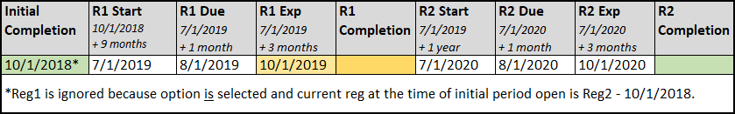
Scenario B: “Only the current registration…” option IS NOT selected
On 10/20/2021, Sally was assigned a Relative certification configured as follows:
Prior to the certification assignment, Sally had already completed the material that is part of the initial period and the renewal period on the following dates:
Registration 1 (Reg1) - 1/1/2016
Registration 2 (Reg2) - 10/1/2018
Only the current registration number for any training item will be credited for any given period IS NOT selected.
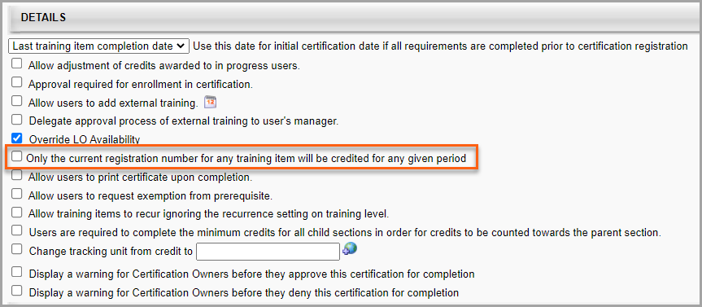
Result:
Sally’s certification status is Expired, and she is in the second renewal period (R2).
Reason:
Since “Only the current registration number for any training item will be credited for any given period” IS NOT selected, each period considers each registration completion in consecutive order starting with the first registration when crediting the period.
In this example, when the certification was assigned on 10/20/2021, there were two completions available - Reg1 on 1/1/2016 and Reg2 on 10/1/2018.
Therefore, Sally’s initial period is credited with the 1/1/2016 completion, the first renewal period (R1) is credited with the 10/1/2018 completion, and moves into the second renewal period (R2) as follows:
R2 Start Date: 10/1/2017 (10/1/2016 + 1 year per “Recurs” setting)
R2 Due Date: 11/1/2017 (10/1/2017 + 1 month)
R2 Exp Date: 1/1/2018 (10/1/2017 + 3 months)
Since Sally has not yet completed R2, she is expired (Exp: 1/1/2018).
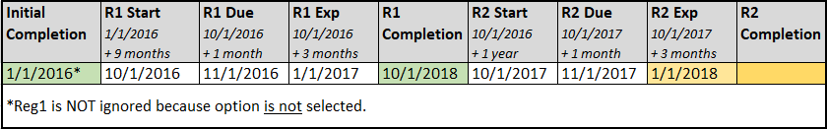

Relative with Rolling
Scenario A: “Only the current registration…” option IS selected
On 10/20/2021, Sally was assigned a Relative with Rolling certification configured as follows:
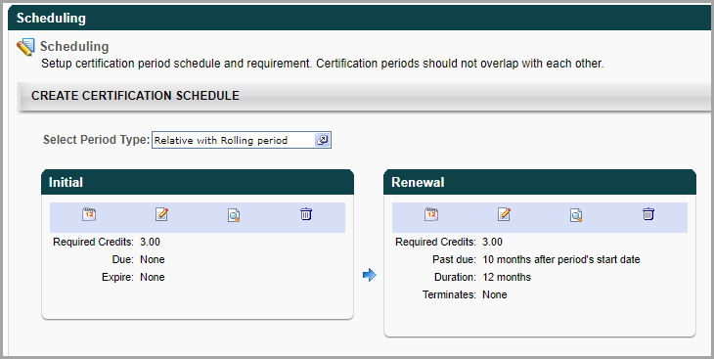
Prior to the certification assignment, Sally had already completed the material that is part of the initial period and the renewal period on the following dates:
Registration 1 (Reg1) - 1/1/2016
Registration 2 (Reg2) - 10/1/2018
Only the current registration number for any training item will be credited for any given period IS selected.
Result:
Sally’s certification status is Expired, and she is in the first renewal period (R1).
Reason:
Since “Only the current registration number for any training item will be credited for any given period” IS selected, each period only considers the current registration number for training when crediting the period.
In this example, when the certification was assigned on 10/20/2021, the current registration number for the material was Reg2, which was completed on 10/1/2018. So, Reg1 completion (1/1/2016) is ignored.
Therefore, Sally’s initial period is credited with the 10/1/2018 completion and moves into the first renewal period (R1) as follows:
R1 Start Date: 10/1/2018 (Period opens immediately upon prior period completion)
R1 Due Date: 8/1/2019 (10/1/2018 + 10 months)
R1 Exp Date: 10/1/2019 (10/1/2018 + 12 months)
Since Sally has not yet completed R1, she is expired (Exp: 10/1/2019).
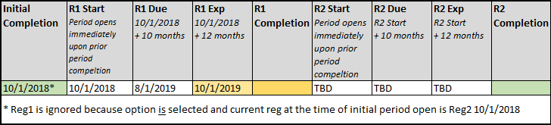

Scenario B: “Only the current registration…” option IS NOT selected
On 10/20/2021, Sally was assigned a Relative with Rolling certification configured as follows:
Prior to the certification assignment, Sally had already completed the material that is part of the initial period and the renewal period on the following dates:
Registration 1 (Reg1) - 1/1/2016
Registration 2 (Reg2) - 10/1/2018
Only the current registration number for any training item will be credited for any given period IS NOT selected.
Result:
Sally’s certification status is Expired, and she is in the second renewal period (R2).
Reason:
Since “Only the current registration number for any training item will be credited for any given period” IS NOT selected, each period considers each registration completion in consecutive order starting with the first registration when crediting the period.
In this example, when the certification was assigned on 10/20/2021, there were two completions available - Reg1 on 1/1/2016 and Reg2 on 10/1/2018.
Therefore, Sally’s initial period is credited with the 1/1/2016 completion, the first renewal period (R1) is credited with the 10/1/2018 completion, and moves into the second renewal period (R2) as follows:
R2 Start Date: 10/1/2018 (Period opens immediately upon prior period completion)
R2 Due Date: 8/1/2019 (10/1/2018 + 10 months)
R2 Exp Date: 10/1/2019 (10/1/2018 + 12 months)
Since Sally has not yet completed R2, she is expired (Exp: 10/1/2019).
