Troubleshooting Deep Links

Troubleshooting with SAML

ADFS 2.0
Try each of the troubleshooting steps below, and test your links each time you make a change to your SSO Deep Linking setup:
- Confirm that you are working with ADFS 2.0.
Deep Linking is not supported in ADFS 1.0.
- Confirm that you have performed the Rollup 2.0 update.
- Confirm that the ADFS webconfig file enables deep linking.
- Go to Microsoft’s Windows Server Technet site and follow the steps in the Configuration Required section.
http://technet.microsoft.com/en-us/library/jj127245%28WS.10%29.aspx
- If you have tried all of the steps above but your links still don’t behave as expected, send Cornerstone GPS an image of the webconfig file, the error and a Fiddler Trace.

All Other SAML Providers
If you use Okta, PingIdentity, OneLogin, or another provider, contact your provider’s technical team and send us a screenshot and Fiddler Trace of the Deep Link that isn’t functioning.

Troubleshooting with AES
Try each of the troubleshooting steps below and test your links each time you make a change to your SSO Deep Linking setup:
- Check the SSO Base URL setup to confirm it can accept the query string ?link=
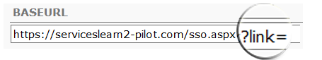
Query String - returned to CSOD as part of the SSO token, this navigates users to the Destination URL of the Learning Object or Portal Page.
Client Server SSO Code location

- Confirm that your code is passing the destination URL to the DEST parameter in the token.

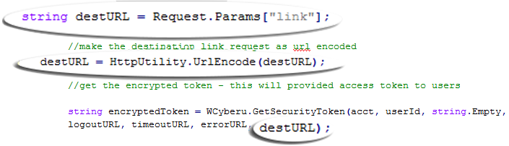
Confirm the Parameter exists
Confirm the Parameter is being encoded

Confirm the Parameter is contained in the token

- If you’ve tried all of the steps above but links still don’t behave as expected, send Cornerstone both a screenshot of the code where the DEST parameter is passed in the token, and a Fiddler Trace

