Deep Linking Setup Guide

What is Deep Linking?
Deep Linking uses Single Sign On (“SSO”) technology to easily connect your user population to a specific page/course within the Cornerstone portal, without requiring them to re-enter their login credentials. The SSO protocol must be already be established to access Cornerstone before you can set up Deep Linking.
In order to set up Deep Linking, you’ll need to be familiar with two important terms:
- SSO Base URL – This is created by your Technical Team; who, according to your current SSO set up, can edit your SSO code accordingly and provide the correct Base URL to use for your portal. You’ll need to set up and know your SSO Base URL before Deep Linking can function*.
- Destination URL – This is the unique identifying URL that is assigned to each page in Cornerstone. Destination URLs for Portal Modules are listed in the Deep Link Admin section of CSOD. Destination URLs for Learning Objects can be found by clicking the Course Title in the Course Catalog and then looking in the BASEURL field at the bottom of the pop-up window.
Deep Links are created by combining the SSO Base URL for the Portal with a Destination URL.
In addition to their use as part of the SSO process, Deep Links can be embedded in emails, and on websites, and work in conjunction with Email Tags.
Some Email Tags in Cornerstone support Deep Linking and can SSO a user into their Portal before taking them directly to a location defined by the email tag. Examples of these email tags include:
Email Tags for Deep Linking
Email Tag | What It Does
TRANSCRIPT.LINK | Opens the Transcript page for the associated Training
LAUNCH.TRAINING | Launch a training directly from the email

*For more information on setting up a Base URL with your technical team, please see the “Creating a Base URL and Activating Deep Linking” document.
Setting Up an SSO Base URL for Your Portal
Once you receive the Base URL from your Technical Team, you can insert it in the Deep Linking Module on Cornerstone.
- Click the Admin tab and select Catalog from the list of options.
- Click Deep Links to navigate to the Deep Linking page.
If you have already designated an SSO Base URL for your portal, it will appear in this area. Otherwise you can add a new SSO Base URL by clicking on the Plus icon.
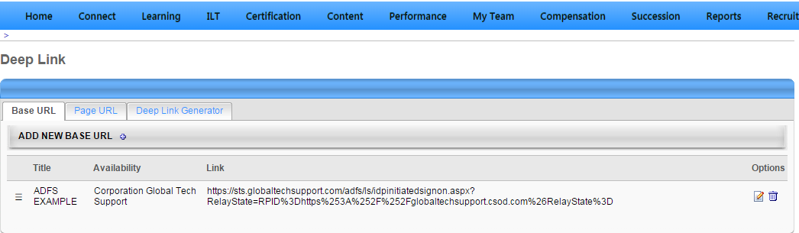
- Click the Page URL tab
- If you have any specific custom pages you would like to create a deep link to, you can add them here. Click on the plus icon and add the URL link of that page after the https://clientname.csod.com
- Click on the Deep Link Generator Tab
- Choose the Page you would like to generate the deep link for
- Depending on the page you choose, you may also be able to select a more specific page (eg. The specific LO if you chose LO Details)
- Click Generate Links
- This will generate a deep link for this page for all Base URLs you have configured in HTML format. The first default link is a general link, and will take a user to the page if they are logged into the portal. This will not be able to log a user in and take them directly to the page, only configuring a Base URL will be able to do that.
If you would just like the direct deep URL link for the page, without the hyperlink tags, the information will show between the “<ahref=’” and the first “’>”.

